Name of journal: World Journal of Gastroenterology
ESPS Manuscript NO: 17387
Columns: EDITORIAL

Inflammatory pouch disease: The spectrum of pouchitis

Zezos P et al. The spectrum of pouchitis

Petros Zezos, Fred Saibil

Petros Zezos, Fred Saibil, Division of Gastroenterology, Department of Medicine, Sunnybrook Health Sciences Centre, University of Toronto, Toronto, Ontario M4N 3M5, Canada

Author contributions: Zezos P and Saibil F substantial contributions to conception and design, acquisition of data; analysis and interpretation of data, drafting the article or revising it critically for important intellectual content; and final approval of the version to be published.

Supported by unrestricted grants from Janssen Inc. (Canada), Abbvie (Canada), Ferring Canada Inc., and Actavis Canada Inc. (partly, to Dr Zezos).

Conflict-of-interest statement: The authors declare no conflict of interest.

Open-Access: This article is an open-access article which was selected by an in-house editor and fully peer-reviewed by external reviewers. It is distributed in accordance with the Creative Commons Attribution Non Commercial (CC BY-NC 4.0) license, which permits others to distribute, remix, adapt, build upon this work non-commercially, and license their derivative works on different terms, provided the original work is properly cited and the use is non-commercial. See: http://creativecommons.org/licenses/by-nc/4.0/

Correspondence to: Petros Zezos, MD, PhD, Division of Gastroenterology, Department of Medicine, Sunnybrook Health Sciences Centre, University of Toronto, H52-2075 Bayview Avenue, Toronto, Ontario M4N 3M5, Canada. zezosp13@hotmail.com Telephone: +1-416-4804727
Fax: +1-416-4805977

Received: March 4, 2015
Peer-review started: March 5, 2015
First decision: April 13, 2015
Revised: April 29, 2015
Accepted: June 26, 2015

Article in press:
Published online:

Abstract
Restorative proctocolectomy with ileal-pouch anal anastomosis (IPAA) is the operation of choice for medically refractory ulcerative colitis (UC), for UC with dysplasia, and for familial adenomatous polyposis (FAP). IPAA can be a treatment option for selected patients with Crohn’s colitis without perianal and/or small bowel disease. The term “pouchitis” refers to nonspecific inflammation of the pouch and is a common complication in patients with IPAA; it occurs more often in UC patients than in FAP patients. This suggests that the pathogenetic background of UC may contribute significantly to the development of pouchitis. The symptoms of pouchitis are many, and can include increased bowel frequency, urgency, tenesmus, incontinence, nocturnal seepage, rectal bleeding, abdominal cramps, and pelvic discomfort. The diagnosis of pouchitis is based on the presence of symptoms together with endoscopic and histological evidence of inflammation of the pouch. However, “pouchitis” is a general term representing a wide spectrum of diseases and conditions, which can emerge in the pouch. Based on the etiology we can sub-divide pouchitis into 2 groups: idiopathic and secondary. In idiopathic pouchitis the etiology and pathogenesis are still unclear, while in secondary pouchitis there is an association with a specific causative or pathogenetic factor. Secondary pouchitis can occur in up to 30% of cases and can be classified as infectious, ischemic, non-steroidal anti-inflammatory drugs-induced, collagenous, autoimmune-associated, or Crohn's disease. Sometimes, cuffitis or irritable pouch syndrome can be misdiagnosed as pouchitis. Furthermore, idiopathic pouchitis itself can be sub-classified into types based on the clinical pattern, presentation, and responsiveness to antibiotic treatment. Treatment differs among the various forms of pouchitis. Therefore, it is important to establish the correct diagnosis in order to select the appropriate treatment and further management. In this editorial, we present the spectrum of pouchitis and the specific features related to the diagnosis and treatment of the various forms.

Key words: Pouchitis; Idiopathic pouchitis; Secondary pouchitis; Ulcerative colitis, Crohn’s disease

© The Author(s) 2015. Published by Baishideng Publishing Group Inc. All rights reserved.

Core tip: Proctocolectomy with ileal-pouch and anal anastomosis is the operation of choice for refractory ulcerative colitis, for colitis with dysplasia, for familial polyposis and for selected Crohn’s colitis patients. Pouchitis symptoms are non-specific, and cannot be used alone to identify the cause. Furthermore, the name “pouchitis” is a general term representing many conditions, with differing causes and treatments. To manage pouchitis appropriately, one must be able to establish the correct diagnosis. In this paper, we have reviewed the diagnostic methods, including endoscopy, histology and other investigative tools, with the goal of being able to provide the correct diagnosis and treatment.

Zezos P, Saibil F. Inflammatory pouch disease: The spectrum of pouchitis. World J Gastroenterol 2015; In press

POUCHITIS: DEFINITIONS AND CLASSIFICATION
Restorative proctocolectomy with ileal-pouch and anal anastomosis (IPAA) is the operation of choice for refractory ulcerative colitis (UC), for UC with dysplasia, and for familial adenomatous polyposis (FAP). Additionally, IPAA can be a treatment option for a selected group of patients with Crohn’s colitis without perianal and/or small bowel disease^{[1]}.
Pouchitis is a common complication in patients with IPAA, but the term is nonspecific, and encompasses a variety of etiologies and pathogenesis. Interestingly, while pouchitis may occur in up to 50% of patients with UC, it is rarely seen in patients with FAP^{[2,3]}. This suggests that the pathogenetic background of UC may contribute significantly to the development of pouchitis.
The symptoms of pouchitis are nonspecific^{[4]} and can include increased bowel frequency, urgency, tenesmus, incontinence, nocturnal seepage, rectal bleeding, abdominal cramps, and pelvic discomfort. Extraintestinal manifestations, involving joints, eyes, skin and liver may also be present, more commonly in UC patients with IPAA^{[5]}.
The diagnosis of pouchitis is based on the presence of symptoms plus endoscopic and histological evidence of inflammation of the pouch. In general, pouchitis can present in 3 forms - acute, relapsing or chronic.
However, “pouchitis” is a general term like “colitis”, and represents a wide spectrum of diseases and conditions, which can emerge in the pouch (Table 1). Based on etiology, we can identify 2 main diagnostic pouchitis groups - idiopathic and secondary. In “idiopathic” pouchitis, the etiology and pathogenesis are unclear, while in “secondary” pouchitis, there is an association with a specific causative or pathogenetic factor^{[6]}. Secondary pouchitis occurs in up to 30% of cases and can be infectious, ischemic, non-steroidal anti-inflammatory drug (NSAID)-induced, collagenous, autoimmune-associated, or due to Crohn's disease. Sometimes, cuffitis or irritable pouch syndrome are misdiagnosed as pouchitis. Furthermore, idiopathic pouchitis can be sub-classified in types based on the clinical pattern, presentation, and responsiveness to antibiotic treatment.

IDIOPATHIC POUCHITIS
In the majority of patients with pouchitis, the etiology and pathogenesis are not clear and the disease is identified as idiopathic pouchitis. The pathogenesis of pouchitis in these patients may be triggered by dysbiosis, leading to an altered mucosal immune response.

Pathogenesis
The intestinal microbiota, the intestinal epithelial cells and the immune system of the gut epithelium play a vital role in pouch homeostasis^{[7]}. Following ileostomy closure, the ileal mucosa of the pouch is exposed to feces containing higher bacterial concentrations than in the ileum of a healthy individual; this is due to relative fecal stasis in the pouch^{[7]}. During the first year following ileostomy closure, adaptive changes occur gradually in the pouch microbiota and mucosa. The pouch microbiota shift to a colon-like composition^{[8]} and colonic metaplasia of the pouch mucosa occurs, where mucosal goblet cells and columnar epithelial cells acquire colonic morphologic and functional characteristics^{[9]}. Current evidence suggests that the interactions of the altered composition and/or the quantity of the luminal microbiota (dysbiosis), with the altered characteristics of the mucosa (colonic metaplasia), in conjunction with abnormalities of innate and adaptive mucosal immunity, play a key role in the pathogenesis of pouchitis (Figure 1)^{[7,10,11]}.

Microbiota: Pouchitis in UC patients is usually responsive to antibiotic therapy, which is presumed to indicate that bacteria are involved in the pathogenesis. However, microbiological investigations of the bacterial communities with cultures of stool or mucosal biopsies have failed to reveal the culprit species. Furthermore, even the new molecular microbiological techniques have failed to identify a certain species or a group of species which can specifically be associated with pouchitis in patients with either a UC or FAP pouch^{[12]}. However, studies have shown that pouch microbiota differ between UC patients and FAP patients^{[13]}. Bacterial diversity seems to play a protective role since it is significantly greater in FAP patients compared to UC patients without pouchitis, and it was also greater in UC patients without pouchitis compared to UC patients with pouchitis^{[12]}. In addition, there may be a temporary alteration in the composition of the microbial community during pouchitis compared to the non-inflamed pouch, both in UC and FAP pouch^{[13]}. Sulfate-reducing bacteria may play a role in UC patients with pouchitis. These bacteria exclusively colonize pouches in UC patients and not in FAP patients; the reasons are unknown^{[14]}. Since idiopathic pouchitis is seen mostly in UC patients, these bacteria may well play a role in pouchitis pathogenesis.

Immune responses: The interactions between the pouch microbiota and host immune responses, innate and adaptive, play also significant role in pouchitis pathogenesis. Innate mucosal immune reactions are implicated in pouchitis pathogenesis, while the adaptive mucosal immunity reactions probable are an epi-phenomenon after the activation of a nonspecific inflammatory cascade or pathway^{[15,16]}. Mucosal barrier dysfunction, with increased intestinal permeability, is also believed to play a role in pouchitis^{[17]}. In a recent study, Landy et al^{[18]} found abnormalities in tight junction protein (TJP) expression in UC pouches and differences in dendritic cell (DC) expression of gut-homing markers and toll-like receptors (TLRs) between the inflamed and non-inflamed ileal pouch in patients with UC, but not FAP.

Genetics: So far, only a few small studies have analyzed genetic susceptibility to pouchitis. Polymorphisms in the interleukin-1 receptor antagonist gene allele 2, tumor necrosis factor (TNF) allele 2, TLR 1 and NOD2/CARD15 have been associated with pouchitis. In addition, the carriers of the toll-like receptor (TLR) 9-1237C and the CD14-260T alleles were found significantly more often to have the chronic relapsing form of pouchitis^{[11]}.

Risk factors
Reported risk factors for pouchitis include genetic susceptibility (polymorphisms of IL-1ra and NOD2/CARD15, non-carrier status of TNF allele 2), extensive UC, backwash ileitis, preoperative thrombocytosis or corticosteroid use, extraintestinal manifestations, especially PSC, the presence of p-ANCA, non-smoking status, and the use of NSAIDs^{[10]}. Different risk factors may be associated with the different types of pouchitis, suggesting different pathogenic pathways in the various forms of idiopathic pouchitis and secondary pouchitis.

Classification
Idiopathic pouchitis can be categorized as acute, acute relapsing, or chronic. It can also be classified as antibiotic-responsive, antibiotic-dependent and antibiotic-refractory (Table 2)^{[10,19]}. It is important to emphasize that approximately 20%-30% of patients with chronic antibiotic-refractory pouchitis are mis-classified, and actually have secondary pouchitis. The management of these conditions differs from that for idiopathic pouchitis and is specific to the underlying etiology.

SECONDARY POUCHITIS
Clostridium difficile pouchitis
Clostridium difficile (C. difficile) infection (CDI) is a common cause of diarrhea in hospitalized patients, including those with IBD^{[20]}. It is now also a common cause of antibiotic-associated diarrhea in the general population with increasing incidence^{[21]}. CDI can also affect IBD patients post-surgically, both in ileostomates, with increased stoma output, and in patients with IPAA, in whom CDI may range from simple asymptomatic colonization to chronic antibiotic-refractory pouchitis^{[22,23]}. Fulminant Clostridium difficile-associated pouchitis has also been described^{[24]} . Management choices should reflect standard practices for the treatment of this infection.

Infectious pouchitis
In a recent study, bacterial pathogens other than C. difficile have been identified in some patients with chronic refractory pouchitis^{[25]}. Fecal samples were analyzed in 15 patients with active refractory pouchitis and the cultures revealed Escherichia coli, Klebsiella, unclassifiable coliforms, Pseudomonas, and Morganella in isolation or in combination. Treatment was based on antibiotic sensitivity results; clinical response and remission was achieved in 12 out of 15 cases (80%). This study showed that fecal culture, fecal coliform sensitivity testing and targeted antibiotic treatment can be beneficial in some patients with refractory pouchitis. It is important to notify the lab to perform sensitivities on all predominant organisms, and to not discard cultures of what appear to be commensals.

Candidal pouchitis
Although fungal pouchitis as a distinct form of pouchitis has not yet been described, fungal infection might be involved in a subgroup of patients with chronic refractory pouchitis. Navaneethan et al^{[6]} reported that they have occasionally seen pouchitis in the setting of systemic candidiasis, although fungal invasion of the pouch tissue on histology was rare. In addition, they mention that clotrimazole has been shown to benefit patients with refractory pouchitis who had previously failed to respond to standard antibiotic therapies^{[6]}. Although there is as yet no completed study, the authors stated that a study was in progress assessing the effectiveness and safety of topical clotrimazole enema in pediatric and adult patients with pouchitis (http://clinicaltrials.gov/ct2/show/NCT00061282)^{[6]}.

CMV pouchitis
CMV infection in patients with IPAA can cause chronic pouchitis with a clinical presentation similar to idiopathic pouchitis, with the only difference being that patients with CMV-associated pouchitis more often have fever compared to those with idiopathic pouchitis^{[26]}.

Ischemic pouchitis: Pouch ischemia may also be a cause of pouchitis. Characteristically, ischemic pouchitis is more often found in the efferent limb of the pouch^{[27]}. Factors related to the surgical construction of the pouch have been implicated, including disruption of the vessels supplying the distal ileum during colectomy or the tension of the mesentery and/or the vessels that supply the distal ileum during the IPAA construction. However, besides the mechanical factors, the underlying disease may also play role, since ischemic pouchitis is more common in UC patients than in those with FAP^{[28]}. Ischemic pouchitis may also be related to oxidative stress of the endothelial cells, due to ischemia-reperfusion injury, which eventually results in inflammation of the pouch mucosa^{[29]}. Patients with ischemic pouchitis are often mis-classified as having chronic antibiotic-refractory pouchitis. Most of these patients have minimal symptoms, and do not require management. Compared with normal subjects, patients with IPAA have significantly lower plasma concentrations of lipophyllic antioxidants alpha-carotene, beta-carotene and lycopene and higher free radical activity suggesting increased oxidative stress. These differences do not appear to be related to diet and do not correlate with histological severity of pouch inflammation.

NSAID-induced pouchitis: It is well known that NSAID use can induce mucosal injury in the GI tract and can exacerbate disease activity in IBD patients. Not surprisingly, in a subset of patients with IPAA, NSAIDs can cause erosions in the pouch mucosa, which can result in either a pure NSAID-induced pouchitis per se or exacerbation of a pre-existing idiopathic pouchitis. NSAID use should always be elucidated in patients with chronic antibiotic-refractory pouchitis^{[30]}. Elimination of NSAIDs should result in resolution.

Autoimmune pouchitis: In a subgroup of patients with antibiotic-refractory chronic pouchitis, there is emerging evidence implicating autoimmunity as a factor. In these patients the pouchitis has some particular features, including: no response to conventional antibiotics; presence of extraintestinal manifestations such as arthralgia or PSC; concurrent autoimmune disorders such as asthma, psoriasis, type I diabetes, rheumatoid arthritis, autoimmune thyroid diseases, psoriasis, systemic lupus erythematosus; presence of serum autoantibodies (pANCA); and responsiveness to immunosuppressive therapies (steroids, thiopurines, biologics)^{[5]}.
Autoimmune pouchitis includes the PSC-associated and IgG4-associated forms of pouchitis. PSC has been described as a risk factor for the development of pouchitis in UC patients with IPAA. PSC-associated pouchitis predisposes to chronic antibiotic-resistant pouchitis. IgG4-associated pouchitis represents another subgroup of autoimmune pouchitis that predisposes to a more severe chronic antibiotic-resistant pouchitis. It is characterized by elevated serum IgG4 and/or infiltration of the pouch mucosa with IgG4-expressing plasma cells, even in the absence of concurrent autoimmune pancreatic disease^{[5]}.

Crohn's pouchitis: Crohn's disease of the pouch can occur in patients with prior Crohn’s colitis without previous small intestinal or perianal disease. More interestingly, Crohn's disease of the pouch can develop de novo in UC patients after colectomy with IPAA. CD of the pouch can exhibit the inflammatory, fistulizing or fibrostenotic phenotypes of classic CD and can affect any part of the gastrointestinal tract including the proximal GI tract, the neo-terminal ileum, the pouch and the perianal area. CD pouchitis is a more complex disease than the idiopathic variant or the other secondary forms of pouchitis. Separation of this diagnosis from the other forms of pouchitis, as well as from the surgery-associated complications is required^{[31]}. With a view to pouch preservation, management should be relatively aggressive; unless antibiotics are highly effective, immunomodulators and/or biologics should be used, with the goal of mucosal healing.
Cuffitis: Cuffitis refers to inflammation of the rectal cuff in the area between the anastomosis and dentate line. Cuffitis may be a variant of UC or simply represent a flare of UC in the rectal cuff, and is particularly common in IPAA constructed with stapled anastomosis without mucosectomy. With this technique a 1-2 cm segment of rectal columnar epithelium remains in situ, increasing the risk for cuffitis and requiring surveillance for dysplasia. The symptoms of cuffitis can be very similar to those of pouchitis plus the presence of bloody bowel movements. Thus, differential diagnosis from pouchitis is required since the management can be different^{[32-34]}.

Irritable pouch syndrome: The irritable pouch syndrome is a functional disorder of unclear cause in patients with IPAA. The patients present with symptoms of pouchitis without endoscopic or histologic evidence of inflammation in the pouch mucosa. It is a diagnosis of exclusion; aside from idiopathic and secondary pouchitis, other diagnoses which should be excluded include celiac disease, lactose or fructose intolerance, and proximal small-bowel bacterial overgrowth, and possibly others^{[35]}.

DIAGNOSIS AND DIFFERENTIAL DIAGNOSIS
“Pouchitis” represents a wide spectrum of inflammatory and non-inflammatory disorders of the pouch, with different pathogenetic mechanisms, presentations, courses, prognoses and treatments. It is therefore important to establish the correct diagnosis in order to optimize the management and treatment. The symptoms of pouchitis are non- specific. As is often the case in IBD, the severity of the symptoms does not necessarily correlate with the severity of endoscopic and/or histologic findings^{[36]}. It is generally accepted that the diagnosis and differential diagnosis of pouchitis should be based on a combination of clinical, endoscopic and histological findings^{[37]}.
Two scoring systems have been developed to diagnose pouchitis and to assess disease severity, the pouchitis disease activity index^{[38]} and the pouchitis activity score (PAS)^{[39]}. Both combine the scoring of clinical symptoms, endoscopic findings and histologic features (Tables 3 and 4) and are commonly used in clinical trials. On the other hand, in clinical practice, endoscopy is the most accurate and valuable tool to diagnose the presence, describe the features and assess the severity of inflammation in the pouch mucosa.
Pouchoscopy guides the next steps of the diagnostic work-up and, finally, the treatment. During pouchoscopy it is important to identify and carefully evaluate the pouch outlet, the pouch body, the efferent limb, the tip of the pouch (in J pouch), the pouch inlet, the afferent limb, the staple lines and the anal transitional zone or cuff (Figure 2)^{[40]}. The endoscopist should collect information about the anatomical construction of the pouch and the severity, extent, and distribution of mucosal inflammation in the various parts of the pouch. The presence of edema, granularity, erythema, friability, spontaneous bleeding, erosions and ulcerations should be recorded^{[41]}. Additionally, one should record the presence of afferent loop ileitis, cuffitis, or inflammatory polyps.
Although one might expect a totally normal mucosa in the pouch, mild patchy edema and erythema are considered to be acceptable in a “normal” pouch (Figure 3 A and B)^{[42]}. A normal-appearing mucosa in a symptomatic patient should raise the suspicion of irritable pouch syndrome. In active pouchitis, a spectrum of findings occurs. Most typical is a mucosa with findings resembling those of active ulcerative colitis (Figure 4 A and B).
Patients with CDI pouchitis typically lack the classical endoscopic or histologic features of pseudo-membranes^{[43]}. Immune-mediated pouchitis, including the PSC-associated and IgG4-associated forms, often produces diffuse inflammation in the pouch body, together with a long segment of inflammation in the afferent limb^{[44]}.
Ischemic pouchitis is characterized by an asymmetric distribution of the inflammation in the pouch body. The pouchitis is present in the efferent limb only, sparing the afferent limb of the pouch, with a sharp demarcation of inflamed and non-inflamed parts of the pouch body^{[27]}.
Patients with typical CD of the pouch may have: segmental inflammation of the pouch body and/or afferent limb^{[45]}; strictures at the pouch inlet/outlet or in the afferent limb (Figure 5 A-H); and the presence of 1 or more fistulas (perianal, pouch-vaginal or pouch-vesical)^{[46]}.
With a finding of afferent limb ileitis, one must consider the following possibilities: NSAID-induced ileitis, CD ileitis, and immune-related ileitis. Immune ileitis is continuous, whereas the lesions in NSAIDs or CD ileitis can be patchy/segmental and often extend to the distal neo-terminal ileum (more than 10 cm beyond the pouch inlet, Figure 5). On endoscopy, cuffitis is characterized by inflammation of the rectal cuff only, while the pouch should be normal or near-normal, with minimal inflammation ^{[34]}.
Histology, abdominal and pelvic imaging, stool examination and cultures, and serology can also contribute to the differential diagnosis, especially in chronic antibiotic-refractory pouchitis. Infectious causes can be excluded with stool culture and Clostridium difficile toxin assay. Antibiotic sensitivity testing in stool cultures can help identify effective antibiotics. The serology panel may include pANCA, celiac tests and serum IgG4 levels.
Histology can help by characterizing the inflammation as acute or chronic, and by providing information useful for the differential diagnosis. However, it is important to recognize that there is a default “physiologic” inflammation in the pouch mucosa that represents an adaptive response of the ileal mucosa to the pouch construction and the environment (fecal stasis). The histologic features of the “normal” pouch include villous atrophy and crypt-cell hyperplasia, mild acute and chronic inflammatory infiltration by neutrophils, eosinophils, lymphocytes, plasma cells, and histiocytes, and colonic metaplasia of the mucosa with increased numbers of Paneth and goblet cells. True pouchitis is associated with increased villous atrophy, acute and/or chronic inflammatory infiltrates, crypt abscesses, and ulceration^{[47]}.
Specific histological features often help with the differential diagnosis. The presence of granulomas is typically indicative of CD, while viral inclusion bodies provide evidence for CMV infection, which can be confirmed with immunostaining for CMV antigen or tissue PCR for CMV, confirming the diagnosis of CMV pouchitis^{[26,48]}. Pyloric metaplasia is a sign of chronic mucosal inflammation which can be associated with chronic antibiotic-refractory pouchitis or CD pouchitis^{[49,50]}. Increased crypt apoptosis and lamina propria infiltration with IgG4 (+) plasma cells are observed in autoimmune-pouchitis^{[51,52]}. In ischemic pouchitis a characteristic feature on histology is the presence of extracellular hemosiderin or hematoidin pigment deposits, while the classic histologic features of ischemic enteritis are not always present^{[27]}.
Abdominal imaging is a valuable tool for the diagnosis and differential diagnosis of ileal pouch disorders, particularly when CD is the cause. Computed tomography (CT) enterography and magnetic resonance imaging (MRI) enterography are useful for the evaluation of the location, number, and degree of strictures, the presence of abscesses, or, simply, the presence of inflammation of the pouch and the proximal small bowel. Contrast pelvic MRI or anorectal ultrasound can be used for the evaluation of the anatomy and abnormalities around the pouch body and the anal transitional zone, such as fistulas, sinus tracts, and abscesses^{[53]}.

MANAGEMENT
Antibiotics are the first-line treatment for idiopathic pouchitis. In patients with IPAA and a first attack of acute pouchitis, a course of empiric antibiotic treatment with metronidazole or ciprofloxacin can be justified, without the need of endoscopy and biopsy, since the majority of these patients will have a rapid favorable response. In approximately 40% of cases, acute pouchitis will present as a single episode without recurrence^{[54]}. However, in 60% of the patients, acute pouchitis will follow a relapsing course after the first episode, and 20%-30% of them will develop a frequently relapsing form or refractory pouchitis^{[54,55]}.
In general, when symptoms of pouchitis appear in patients with IPAA, it is recommended, if possible, that endoscopy with biopsies be performed to establish the diagnosis, before initiating treatment. If endoscopy must be delayed, empiric treatment with antibiotics can be initiated. Stool culture and testing for C. difficile toxin should be obtained. In more chronic forms of pouchitis, relapsing or refractory, along with endoscopy and biopsies, the diagnostic evaluation should be expanded to cover the diagnosis and differential diagnoses of secondary or other causes of “pouchitis” (Figure 6). Subsequently, the treatment will be tailored to the specific diagnosis (Figure 7).

PREVENTION AND TREATMENT
Primary prophylaxis of a first episode of pouchitis
The prevention of pouchitis begins in the operative room during surgical construction of the pouch. A suitable-sized, not too long pouch, is less susceptible to pouchitis^{[56]}. Excessive weight gain postoperatively has been associated with an increased risk for worse pouch outcomes, including pouchitis^{[57,58]}. Moreover, the increase in fruit consumption and intake of antioxidants, vitamin A, and vitamin C may protect from pouchitis^{[59]}. The use of probiotics, i.e., VSL#3, has been shown to be beneficial in the primary prevention of pouchitis^{[60]}. The administration of Lactobacillus rhamnosus GG has also shown to be effective in the primary prophylaxis^{[61]}. However, these treatments are expensive and the long-term benefit or safety is as yet unknown^{[58]}.

Treatment of acute idiopathic pouchitis
Patients with a first episode of acute pouchitis typically respond rapidly to antibiotic therapy. Metronidazole, ciprofloxacin, tinidazole, and rifaximin have all been used in the treatment of acute pouchitis in clinical practice^{[62]}. First-line therapy includes a 2-wk treatment with metronidazole (15–20 mg/kg/d) or ciprofloxacin (1 g/d). High-dose VSL#3 has been reported to be effective for treating mild acute pouchitis^{[62,63]}. It is noteworthy that patients who experience pouchitis symptoms immediately post-IPAA and do not respond to the antibiotic therapy, surgery-associated complications, such as pouch anastomotic leaks, should be suspected^{[19]}.

Secondary prophylaxis of subsequent episodes of pouchitis
Relapse of pouchitis or recurrent pouchitis is common (60%) after treatment and resolution of the initial episode, and some of the patients will develop treatment-refractory disease. Long-term administration of the probiotic VSL#3 has been shown to be effective in maintaining antibiotic-induced pouchitis remission in 85% of treated patients in a 9-mo period^{[62,64]}. However, other studies have failed to confirm this beneficial effect of VSL#3^{[65]}. Rifaximin may be an alternative maintenance treatment^{[66]}.

Treatment of chronic antibiotic-refractory pouchitis
Chronic antibiotic-refractory pouchitis may respond to longer courses of antibiotic combinations such as ciprofloxacin and rifaximin^{[67]}, ciprofloxacin and metronidazole^{[68]} or ciprofloxacin and tinidazole^{[69]}. In patients with antibiotic-resistant pouchitis, a thorough investigation is recommended. Fecal cultures and antibiotic sensitivity testing may be needed to choose the appropriate effective antibiotics. Additionally, the investigation should aim to identify and treat causes of secondary pouchitis.
Despite the atypical endoscopic findings treatment of C. difficile infection in pouch patients, management choices should reflect standard practices for the treatment of this infection^{[70,71]}. Finally, recent studies have suggested that fecal microbiota transplantation might be an alternative or adjunctive treatment for refractory CDI pouchitis^{[72]}. CMV-pouchitis can be treated with oral or intravenous anti-CMV agents (ganciclovir)^{[26]}. Management should reflect current practice.
If NSAID-associated pouchitis is suspected, a trial of discontinuation of NSAIDs is recommended, and should result in prompt resolution. The safety of selective COX-2 inhibitors in IPAA patients is still unknown and if those suffering from arthralgias do not respond to acetaminophen (paracetamol), they can be tried on sulfasalazine^{[73]}.
Ischemic pouchitis may be treated with allopurinol. Allopurinol is a scavenger of oxygen-derived free radicals and previous studies have shown its beneficial effect both in an animal model and in treating active pouchitis^{[74]}.
Autoimmune pouchitis, both PSC- and IgG4-associated, can be treated with corticosteroids (prednisone or budesonide), immunomodulators (azathioprine, 6-mercaptopurine), or anti-TNF biologics (infliximab, adalimumab, others). The same treatment options apply for Crohn's pouchitis together with endoscopic or surgical interventions for fistulizing or stenosing disease^{[75,76]}. With a view to pouch preservation, management should be relatively aggressive; unless antibiotics are highly effective, immunomodulators and/or biologics should be used, with the goal of mucosal healing.
Cuffitis can be treated similarly to ulcerative proctitis with topical 5-ASA or topical steroids; suppositories should be sufficient. Cuffitis refractory to topical treatment should raise the suspicion of other conditions in the perianal and peri-pouch area. Therefore, investigation with the appropriate additional imaging studies is recommended to rule out surgical complications or CD manifestations including fistulas, sinus tracts or abscesses^{[77]}.
Finally, the treatment of irritable pouch syndrome is empiric similar to the irritable bowel syndrome, and therapies can include dietary modifications, anti-diarrheals, antispasmodics, and tricyclic antidepressants.

FUTURE TRENDS AND RESEARCH
The pouch itself and pouchitis, both acute and chronic, can serve as models to study IBD pathogenesis. Despite some differences, there are many similarities between idiopathic pouchitis and ulcerative colitis. Therefore, by studying the changes in the pouch environment that might eventually lead to pouchitis we can extract information that may help us to understand the pathogenesis of UC, as it proceeds from normal mucosa to chronic inflammation.
So far, there are no reliable animal models of pouch/pouchitis. There are technical difficulties in the creation of a pouch and translational difficulties in interpreting the results into clinical practise due to differences in the genetic background, the bacterial flora and the gut inflammation between animals and humans. On the other hand, in the human pouch model these obstacles are lacking. Pouchitis can serve as an excellent clinical model to study the pathogenetic pathways of UC, CD and other conditions that affect the bowel including C. difficile, CMV or NSAIDs^{[78]}.
Undoubtedly, the gut microbiome has an important role in both IBD in general and in pouchitis pathogenesis. The development of new techniques for identifying the luminal and mucosal bacterial compositions in the gut before and after pouch construction, as well as potential pathogens involved in pouchitis will contribute to understanding the IBD and pouchitis pathogenesis. The pouch may be an ideal environment to study the gut microbiota and the role of dysbiosis in IBD pathogenesis^{[79]}.
Finally, in a recent study^{[80]} more than half of asymptomatic patients with IPAA had abnormal endoscopic and/or histologic findings on surveillance pouchoscopy, suggesting that even asymptomatic pouch patients should have pouchoscopy at regular intervals in order to diagnose and consider treating sub-clinical pouch complications at an early stage.

CONCLUSION
Pouchitis represents a disease spectrum with differences in pathogenesis, clinical manifestations, course and treatment. It is therefore important for the clinician to be aware of the various phenotypes of pouchitis and to be familiar with the clinical, endoscopic and histologic features of each one in order to plan the appropriate management and apply the suitable treatment. Pouchoscopy is the best way to assess the patient with pouchitis symptoms in order to reach the correct diagnosis, treat accordingly, and follow the course. It is important to realize that one third of chronic treatment-refractory pouchitis cases are related to secondary etiologies or triggering factors that can be treated or modified, thus altering the course of pouchitis and avoiding pouch failure.

REFERENCES
1 Melton GB, Fazio VW, Kiran RP, He J, Lavery IC, Shen B, Achkar JP, Church JM, Remzi FH. Long-term outcomes with ileal pouch-anal anastomosis and Crohn's disease: pouch retention and implications of delayed diagnosis. Ann Surg 2008; 248: 608-616 [PMID: 18936574 DOI:10.1097/SLA.0b013e318187ed64]
2 Fazio VW, Ziv Y, Church JM, Oakley JR, Lavery IC, Milsom JW, Schroeder TK. Ileal pouch-anal anastomoses complications and function in 1005 patients. Ann Surg 1995; 222: 120-127 [PMID: 7639579]
3 Ferrante M, Declerck S, De Hertogh G, Van Assche G, Geboes K, Rutgeerts P, Penninckx F, Vermeire S, D'Hoore A. Outcome after proctocolectomy with ileal pouch-anal anastomosis for ulcerative colitis. Inflamm Bowel Dis 2008; 14: 20-28 [PMID: 17973304]
4 Shen B, Fazio VW, Remzi FH, Delaney CP, Bennett AE, Achkar JP, Brzezinski A, Khandwala F, Liu W, Bambrick ML, Bast J, Lashner B. Comprehensive evaluation of inflammatory and noninflammatory sequelae of ileal pouch-anal anastomoses. Am J Gastroenterol 2005; 100: 93-101 [PMID: 15654787]
5 Seril DN, Yao Q, Shen B. The association between autoimmunity and pouchitis. Inflamm Bowel Dis 2014; 20: 378-388 [PMID: 24374879 DOI: 10.1097/01.MIB.0000435761.82705.6a]
6 Navaneethan U, Shen B. Secondary pouchitis: those with identifiable etiopathogenetic or triggering factors. Am J Gastroenterol 2010; 105: 51-64 [PMID: 19755972 DOI: 10.1038/ajg.2009.530]
7 Batista D, Raffals L. Role of intestinal bacteria in the pathogenesis of pouchitis. Inflamm Bowel Dis 2014; 20: 1481-1486 [PMID: 25046009 DOI: 10.1097/MIB.0000000000000055]
8 Kohyama A, Ogawa H, Funayama Y, Takahashi K, Benno Y, Nagasawa K, Tomita S, Sasaki I, Fukushima K. Bacterial population moves toward a colon-like community in the pouch after total proctocolectomy. Surgery 2009; 145: 435-447 [PMID: 19303993 DOI: 10.1016/j.surg.2008.12.003]
9 Campbell AP, Merrett MN, Kettlewell M, Mortensen NJ, Jewell DP. Expression of colonic antigens by goblet and columnar epithelial cells in ileal pouch mucosa: their association with inflammatory change and faecal stasis. J Clin Pathol 1994; 47: 834-838 [PMID: 7962653]
10 Shen B. Acute and chronic pouchitis--pathogenesis, diagnosis and treatment. Nat Rev Gastroenterol Hepatol 2012; 9: 323-333 [PMID: 22508158 DOI: 10.1038/nrgastro.2012.58]
11 Landy J, Al-Hassi HO, McLaughlin SD, Knight SC, Ciclitira PJ, Nicholls RJ, Clark SK, Hart AL. Etiology of pouchitis. Inflamm Bowel Dis 2012; 18: 1146-1155 [PMID: 22021180 DOI: 10.1002/ibd.21911]
12 McLaughlin SD, Walker AW, Churcher C, Clark SK, Tekkis PP, Johnson MW, Parkhill J, Ciclitira PJ, Dougan G, Nicholls RJ, Petrovska L. The bacteriology of pouchitis: a molecular phylogenetic analysis using 16S rRNA gene cloning and sequencing. Ann Surg 2010; 252: 90-98 [PMID: 20562611 DOI: 10.1097/SLA.0b013e3181e3dc8b]
13 Zella GC, Hait EJ, Glavan T, Gevers D, Ward DV, Kitts CL, Korzenik JR. Distinct microbiome in pouchitis compared to healthy pouches in ulcerative colitis and familial adenomatous polyposis. Inflamm Bowel Dis 2011; 17: 1092-1100 [PMID: 20845425 DOI: 10.1002/ibd.21460]
14 Duffy M, O'Mahony L, Coffey JC, Collins JK, Shanahan F, Redmond HP, Kirwan WO. Sulfate-reducing bacteria colonize pouches formed for ulcerative colitis but not for familial adenomatous polyposis. Dis Colon Rectum 2002; 45: 384-388 [PMID: 12068199]
15 Shen B. Pouchitis: what every gastroenterologist needs to know. Clin Gastroenterol Hepatol 2013; 11: 1538-1549 [PMID: 23602818 DOI: 10.1016/j.cgh.2013.03.033]
16 Schmidt C, Giese T, Ludwig B, Menges M, Schilling M, Meuer SC, Zeuzem S, Stallmach A. Increased cytokine transcripts in pouchitis reflect the degree of inflammation but not the underlying entity. Int J Colorectal Dis 2006; 21: 419-426 [PMID: 16133004]
17 Amasheh S, Dullat S, Fromm M, Schulzke JD, Buhr HJ, Kroesen AJ. Inflamed pouch mucosa possesses altered tight junctions indicating recurrence of inflammatory bowel disease. Int J Colorectal Dis 2009; 24: 1149-1156 [PMID: 19488769 DOI: 10.1007/s00384-009-0737-8]
18 Landy J, Al-Hassi HO, Ronde E, English NR, Mann ER, Bernardo D, Ciclitira PJ, Clark SK, Knight SC, Hart AL. Innate immune factors in the development and maintenance of pouchitis. Inflamm Bowel Dis 2014; 20: 1942-1949 [PMID: 25222658 DOI: 10.1097/MIB.0000000000000182]
19 Shen B, Remzi FH, Lavery IC, Lashner BA, Fazio VW. A proposed classification of ileal pouch disorders and associated complications after restorative proctocolectomy. Clin Gastroenterol Hepatol 2008; 6: 145-58; quiz 124 [PMID: 18237865 DOI: 10.1016/j.cgh.2007.11.006]
20 Navaneethan U, Venkatesh PG, Shen B. Clostridium difficile infection and inflammatory bowel disease: understanding the evolving relationship. World J Gastroenterol 2010; 16: 4892-4904 [PMID: 20954275]
21 Freeman J, Bauer MP, Baines SD, Corver J, Fawley WN, Goorhuis B, Kuijper EJ, Wilcox MH. The changing epidemiology of Clostridium difficile infections. Clin Microbiol Rev 2010; 23: 529-549 [PMID: 20610822 DOI: 10.1128/CMR.00082-09]
22 Seril DN, Ashburn JH, Lian L, Shen B. Risk factors and management of refractory or recurrent clostridium difficile infection in ileal pouch patients. Inflamm Bowel Dis 2014; 20: 2226-2233 [PMID: 25222656 DOI: 10.1097/MIB.0000000000000205]
23 Seril DN, Shen B. Clostridium difficile infection in patients with ileal pouches. Am J Gastroenterol 2014; 109: 941-947 [PMID: 24989088 DOI: 10.1038/ajg.2014.22]
24 Shen B, Remzi FH, Fazio VW. Fulminant Clostridium difficile-associated pouchitis with a fatal outcome. Nat Rev Gastroenterol Hepatol 2009; 6: 492-495 [PMID: 19654602 DOI: 10.1038/nrgastro.2009.105]
25 McLaughlin SD, Clark SK, Shafi S, Petrovska L, Tekkis PP, Ciclitira PJ, Nicholls RJ. Fecal coliform testing to identify effective antibiotic therapies for patients with antibiotic-resistant pouchitis. Clin Gastroenterol Hepatol 2009; 7: 545-548 [PMID: 19418603 DOI: 10.1016/j.cgh.2009.01.002]
26 McCurdy JD, Loftus EV, Tremaine WJ, Smyrk TC, Bruining DH, Pardi DS, Raffals LE, Kisiel JB, Coelho-Prabhu N, Kane SV, Faubion WA, Papadakis KA. Cytomegalovirus infection of the ileoanal pouch: clinical characteristics and outcomes. Inflamm Bowel Dis 2013; 19: 2394-2399 [PMID: 23974995 DOI: 10.1097/MIB.0b013e3182a52553]
27 Shen B, Plesec TP, Remer E, Kiran P, Remzi FH, Lopez R, Fazio VW, Goldblum JR. Asymmetric endoscopic inflammation of the ileal pouch: a sign of ischemic pouchitis? Inflamm Bowel Dis 2010; 16: 836-846 [PMID: 19998461 DOI: 10.1002/ibd.21129]
28 Laake KO, Line PD, Grzyb K, Aamodt G, Aabakken L, Røset A, Hvinden AB, Bakka A, Eide J, Bjørneklett A, Vatn MH. Assessment of mucosal inflammation and blood flow in response to four weeks' intervention with probiotics in patients operated with a J-configurated ileal-pouch-anal-anastomosis (IPAA). Scand J Gastroenterol 2004; 39: 1228-1235 [PMID: 15743000]
29 El Muhtaseb MS, Talwar D, Duncan A, St J O'reilly D, McKee RF, Anderson JH, Foulis A, Finlay IG. Free radical activity and lipid soluble anti-oxidant vitamin status in patients with long-term ileal pouch-anal anastomosis. Colorectal Dis 2009; 11: 67-72 [PMID: 18400037 DOI: 10.1111/j.1463-1318.2008.01517.x]
30 Shen B, Fazio VW, Remzi FH, Bennett AE, Lopez R, Lavery IC, Brzezinski A, Sherman KK, Lashner BA. Effect of withdrawal of nonsteroidal anti-inflammatory drug use on ileal pouch disorders. Dig Dis Sci 2007; 52: 3321-3328 [PMID: 17410449]
31 Li Y, Wu B, Shen B. Diagnosis and differential diagnosis of Crohn's disease of the ileal pouch. Curr Gastroenterol Rep 2012; 14: 406-413 [PMID: 22855236 DOI: 10.1007/s11894-012-0282-4]
32 Sherman J, Greenstein AJ, Greenstein AJ. Ileal j pouch complications and surgical solutions: a review. Inflamm Bowel Dis 2014; 20: 1678-1685 [PMID: 24983986 DOI: 10.1097/MIB.0000000000000086]
33 Hashimoto T, Itabashi M, Ogawa S, Hirosawa T, Bamba Y, Kaji S, Ubukata M, Nakao S, Kameoka S. A treatment strategy for preventing pouchitis as a postoperative complication of ulcerative colitis: the significance of the management of cuffitis. Surg Today 2014; 44: 1730-1734 [PMID: 25022954 DOI: 10.1007/s00595-014-0974-5]
34 Wu B, Lian L, Li Y, Remzi FH, Liu X, Kiran RP, Shen B. Clinical course of cuffitis in ulcerative colitis patients with restorative proctocolectomy and ileal pouch-anal anastomoses. Inflamm Bowel Dis 2013; 19: 404-410 [PMID: 23328773 DOI: 10.1097/MIB.0b013e31828100ed]
35 Shen B, Achkar JP, Lashner BA, Ormsby AH, Brzezinski A, Soffer EE, Remzi FH, Bevins CL, Fazio VW. Irritable pouch syndrome: a new category of diagnosis for symptomatic patients with ileal pouch-anal anastomosis. Am J Gastroenterol 2002; 97: 972-977 [PMID: 12003434]
36 Ben-Bassat O, Tyler AD, Xu W, Kirsch R, Schaeffer DF, Walsh J, Steinhart AH, Greenberg GR, Cohen Z, Silverberg MS, McLeod RS. Ileal pouch symptoms do not correlate with inflammation of the pouch. Clin Gastroenterol Hepatol 2014; 12: 831-837.e2 [PMID: 24075890 DOI: 10.1016/j.cgh.2013.09.027]
37 Shen B, Achkar JP, Lashner BA, Ormsby AH, Remzi FH, Bevins CL, Brzezinski A, Petras RE, Fazio VW. Endoscopic and histologic evaluation together with symptom assessment are required to diagnose pouchitis. Gastroenterology 2001; 121: 261-267 [PMID: 11487535]
38 Sandborn WJ, Tremaine WJ, Batts KP, Pemberton JH, Phillips SF. Pouchitis after ileal pouch-anal anastomosis: a Pouchitis Disease Activity Index. Mayo Clin Proc 1994; 69: 409-415 [PMID: 8170189]
39 Heuschen UA, Allemeyer EH, Hinz U, Autschbach F, Uehlein T, Herfarth C, Heuschen G. Diagnosing pouchitis: comparative validation of two scoring systems in routine follow-up. Dis Colon Rectum 2002; 45: 776-86; discussion 786-8 [PMID: 12072630]
40 Cima RR, Pemberton JH. Medical and surgical management of chronic ulcerative colitis. Arch Surg 2005; 140: 300-310 [PMID: 15781797]
41 Fukushima K, Fujii H, Yamamura T, Sugita A, Kameoka S, Nagawa H, Futami K, Watanabe T, Hatakeyama K, Sawada T, Yoshioka K, Kusunoki M, Konishi F, Watanabe M, Takahashi K, Ogawa H, Funayama Y, Hibi T, Sasaki I. Pouchitis atlas for objective endoscopic diagnosis. J Gastroenterol 2007; 42: 799-806 [PMID: 17940832]
42 Schouten WR. Pouchitis. Mediators Inflamm 1998; 7: 175-181 [PMID: 9705605]
43 Issa M, Vijayapal A, Graham MB, Beaulieu DB, Otterson MF, Lundeen S, Skaros S, Weber LR, Komorowski RA, Knox JF, Emmons J, Bajaj JS, Binion DG. Impact of Clostridium difficile on inflammatory bowel disease. Clin Gastroenterol Hepatol 2007; 5: 345-351 [PMID: 17368234]
44 Shen B, Bennett AE, Navaneethan U, Lian L, Shao Z, Kiran RP, Fazio VW, Remzi FH. Primary sclerosing cholangitis is associated with endoscopic and histologic inflammation of the distal afferent limb in patients with ileal pouch-anal anastomosis. Inflamm Bowel Dis 2011; 17: 1890-1900 [PMID: 21830267 DOI: 10.1002/ibd.21594]
45 Wolf JM, Achkar JP, Lashner BA, Delaney CP, Petras RE, Goldblum JR, Connor JT, Remzi FH, Fazio VW. Afferent limb ulcers predict Crohn's disease in patients with ileal pouch-anal anastomosis. Gastroenterology 2004; 126: 1686-1691 [PMID: 15188163]
46 Sagar PM, Dozois RR, Wolff BG. Long-term results of ileal pouch-anal anastomosis in patients with Crohn's disease. Dis Colon Rectum 1996; 39: 893-898 [PMID: 8756845]
47 Navaneethan U, Shen B. Diagnosis and management of pouchitis and ileoanal pouch dysfunction. Curr Gastroenterol Rep 2010; 12: 485-494 [PMID: 20890738 DOI: 10.1007/s11894-010-0143-y]
48 Casadesus D, Tani T, Wakai T, Maruyama S, Iiai T, Okamoto H, Hatakeyama K. Possible role of human cytomegalovirus in pouchitis after proctocolectomy with ileal pouch-anal anastomosis in patients with ulcerative colitis. World J Gastroenterol 2007; 13: 1085-1089 [PMID: 17373744]
49 Agarwal S, Stucchi AF, Dendrinos K, Cerda S, O'Brien MJ, Becker JM, Heeren T, Farraye FA. Is pyloric gland metaplasia in ileal pouch biopsies a marker for Crohn's disease? Dig Dis Sci 2013; 58: 2918-2925 [PMID: 23543088 DOI: 10.1007/s10620-013-2655-4]
50 Kariv R, Plesec TP, Gaffney K, Lian L, Fazio VW, Remzi FH, Lopez R, Goldblum JR, Shen B. Pyloric gland metaplasia and pouchitis in patients with ileal pouch-anal anastomoses. Aliment Pharmacol Ther 2010; 31: 862-873 [PMID: 20121720 DOI: 10.1111/j.1365-2036.2010.04249.x]
51 Jiang W, Goldblum JR, Lopez R, Lian L, Shen B. Increased crypt apoptosis is a feature of autoimmune-associated chronic antibiotic refractory pouchitis. Dis Colon Rectum 2012; 55: 549-557 [PMID: 22513433 DOI: 10.1097/DCR.0b013e31824ab7c6]
52 Navaneethan U, Bennett AE, Venkatesh PG, Lian L, Hammel J, Patel V, Kiran RP, Remzi FH, Shen B. Tissue infiltration of IgG4+ plasma cells in symptomatic patients with ileal pouch-anal anastomosis. J Crohns Colitis 2011; 5: 570-576 [PMID: 22115377 DOI: 10.1016/j.crohns.2011.05.011]
53 Tang L, Cai H, Moore L, Shen B. Evaluation of endoscopic and imaging modalities in the diagnosis of structural disorders of the ileal pouch. Inflamm Bowel Dis 2010; 16: 1526-1531 [PMID: 20049948 DOI: 10.1002/ibd.21199]
54 Suzuki H, Ogawa H, Shibata C, Haneda S, Watanabe K, Takahashi K, Funayama Y, Sasaki I. The long-term clinical course of pouchitis after total proctocolectomy and IPAA for ulcerative colitis. Dis Colon Rectum 2012; 55: 330-336 [PMID: 22469801 DOI: 10.1097/DCR.0b013e3182417358]
55 Madiba TE, Bartolo DC. Pouchitis following restorative proctocolectomy for ulcerative colitis: incidence and therapeutic outcome. J R Coll Surg Edinb 2001; 46: 334-337 [PMID: 11768572]
56 Brisinda G, Vanella S, Valenza V, Crocco A, Perotti G, Di Giuda D, Maria G. Surgical prophylaxis of pouchitis in ulcerative colitis. Dig Dis Sci 2011; 56: 1257-1265 [PMID: 21127981 DOI: 10.1007/s10620-010-1429-5]
57 Wu XR, Zhu H, Kiran RP, Remzi FH, Shen B. Excessive weight gain is associated with an increased risk for pouch failure in patients with restorative proctocolectomy. Inflamm Bowel Dis 2013; 19: 2173-2181 [PMID: 23899541 DOI: 10.1097/MIB.0b013e31829bfc26]
58 Liu Z, Song H, Shen B. Pouchitis: prevention and treatment. Curr Opin Clin Nutr Metab Care 2014; 17: 489-495 [PMID: 25023187 DOI: 10.1097/MCO.0000000000000094]
59 Ianco O, Tulchinsky H, Lusthaus M, Ofer A, Santo E, Vaisman N, Dotan I. Diet of patients after pouch surgery may affect pouch inflammation. World J Gastroenterol 2013; 19: 6458-6464 [PMID: 24151365 DOI: 10.3748/wjg.v19.i38.6458]
60 Gionchetti P, Rizzello F, Helwig U, Venturi A, Lammers KM, Brigidi P, Vitali B, Poggioli G, Miglioli M, Campieri M. Prophylaxis of pouchitis onset with probiotic therapy: a double-blind, placebo-controlled trial. Gastroenterology 2003; 124: 1202-1209 [PMID: 12730861]
61 Gosselink MP, Schouten WR, van Lieshout LM, Hop WC, Laman JD, Ruseler-van Embden JG. Delay of the first onset of pouchitis by oral intake of the probiotic strain Lactobacillus rhamnosus GG. Dis Colon Rectum 2004; 47: 876-884 [PMID: 15108026]
62 Holubar SD, Cima RR, Sandborn WJ, Pardi DS. Treatment and prevention of pouchitis after ileal pouch-anal anastomosis for chronic ulcerative colitis. Cochrane Database Syst Rev 2010; : CD001176 [PMID: 20556748 DOI: 10.1002/14651858.CD001176]
63 Gionchetti P, Rizzello F, Morselli C, Poggioli G, Tambasco R, Calabrese C, Brigidi P, Vitali B, Straforini G, Campieri M. High-dose probiotics for the treatment of active pouchitis. Dis Colon Rectum 2007; 50: 2075-282; discussion 2075-282; [PMID: 17934776]
64 Gionchetti P, Rizzello F, Venturi A, Brigidi P, Matteuzzi D, Bazzocchi G, Poggioli G, Miglioli M, Campieri M. Oral bacteriotherapy as maintenance treatment in patients with chronic pouchitis: a double-blind, placebo-controlled trial. Gastroenterology 2000; 119: 305-309 [PMID: 10930365]
65 Shen B, Brzezinski A, Fazio VW, Remzi FH, Achkar JP, Bennett AE, Sherman K, Lashner BA. Maintenance therapy with a probiotic in antibiotic-dependent pouchitis: experience in clinical practice. Aliment Pharmacol Ther 2005; 22: 721-728 [PMID: 16197493]
66 Shen B, Remzi FH, Lopez AR, Queener E. Rifaximin for maintenance therapy in antibiotic-dependent pouchitis. BMC Gastroenterol 2008; 8: 26 [PMID: 18573211 DOI: 10.1186/1471-230X-8-26]
67 Abdelrazeq AS, Kelly SM, Lund JN, Leveson SH. Rifaximin-ciprofloxacin combination therapy is effective in chronic active refractory pouchitis. Colorectal Dis 2005; 7: 182-186 [PMID: 15720360]
68 Mimura T, Rizzello F, Helwig U, Poggioli G, Schreiber S, Talbot IC, Nicholls RJ, Gionchetti P, Campieri M, Kamm MA. Four-week open-label trial of metronidazole and ciprofloxacin for the treatment of recurrent or refractory pouchitis. Aliment Pharmacol Ther 2002; 16: 909-917 [PMID: 11966499]
69 Shen B, Fazio VW, Remzi FH, Bennett AE, Lopez R, Brzezinski A, Oikonomou I, Sherman KK, Lashner BA. Combined ciprofloxacin and tinidazole therapy in the treatment of chronic refractory pouchitis. Dis Colon Rectum 2007; 50: 498-508 [PMID: 17279300]
70 Nitzan O, Elias M, Chazan B, Raz R, Saliba W. Clostridium difficile and inflammatory bowel disease: role in pathogenesis and implications in treatment. World J Gastroenterol 2013; 19: 7577-7585 [PMID: 24282348 DOI: 10.3748/wjg.v19.i43.7577]
71 Cornely OA, Crook DW, Esposito R, Poirier A, Somero MS, Weiss K, Sears P, Gorbach S. Fidaxomicin versus vancomycin for infection with Clostridium difficile in Europe, Canada, and the USA: a double-blind, non-inferiority, randomised controlled trial. Lancet Infect Dis 2012; 12: 281-289 [PMID: 22321770 DOI: 10.1016/S1473-3099(11)70374-7]
72 Patel LN, Schairer J, Shen B. Fecal transplantation therapy for Clostridium difficile-associated pouchitis. Int J Colorectal Dis 2014; 29: 263-264 [PMID: 24132529 DOI: 10.1007/s00384-013-1771-0]
73 Abi Karam G, Awada H, Nasr F, Uthman I. Ileal pouchitis and arthritis. Semin Arthritis Rheum 2003; 33: 215 [PMID: 14723216]
74 Levin KE, Pemberton JH, Phillips SF, Zinsmeister AR, Pezim ME. Role of oxygen free radicals in the etiology of pouchitis. Dis Colon Rectum 1992; 35: 452-456 [PMID: 1568395]
75 Shen B. Crohn's disease of the ileal pouch: reality, diagnosis, and management. Inflamm Bowel Dis 2009; 15: 284-294 [PMID: 18816633 DOI: 10.1002/ibd.20661]
76 Haveran LA, Sehgal R, Poritz LS, McKenna KJ, Stewart DB, Koltun WA. Infliximab and/or azathioprine in the treatment of Crohn's disease-like complications after IPAA. Dis Colon Rectum 2011; 54: 15-20 [PMID: 21160308 DOI: 10.1007/DCR.0b013e3181fc9f04]
77 Shen B, Lashner BA, Bennett AE, Remzi FH, Brzezinski A, Achkar JP, Bast J, Bambrick ML, Fazio VW. Treatment of rectal cuff inflammation (cuffitis) in patients with ulcerative colitis following restorative proctocolectomy and ileal pouch-anal anastomosis. Am J Gastroenterol 2004; 99: 1527-1531 [PMID: 15307872]
78 Wu H, Shen B. Pouchitis: lessons for inflammatory bowel disease. Curr Opin Gastroenterol 2009; 25: 314-322 [PMID: 19349860 DOI: 10.1097/MOG.0b013e32832b36eb]
79 Manichanh C, Borruel N, Casellas F, Guarner F. The gut microbiota in IBD. Nat Rev Gastroenterol Hepatol 2012; 9: 599-608 [PMID: 22907164 DOI: 10.1038/nrgastro.2012.152]
80 Zhu H, Wu XR, Queener E, Kiran RP, Remzi FH, Shen B. Clinical value of surveillance pouchoscopy in asymptomatic ileal pouch patients with underlying inflammatory bowel disease. Surg Endosc 2013; 27: 4325-4332 [PMID: 23877758 DOI: 10.1007/s00464-013-3054-9]
P-Reviewer: Burke D, Jeen YT, Raffals LE S-Editor: Yu J L-Editor: E-Editor:

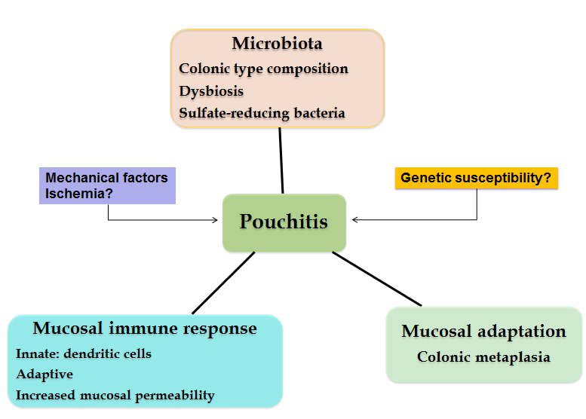
Figure 1 Idiopathic pouchitis pathogenesis.

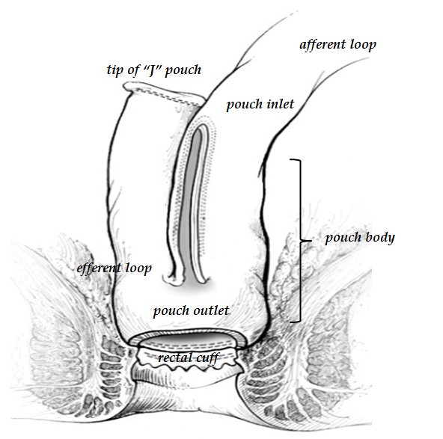
Figure 2 The J-pouch anatomy (adapted and modified from Cima et al^{[40]}).

A
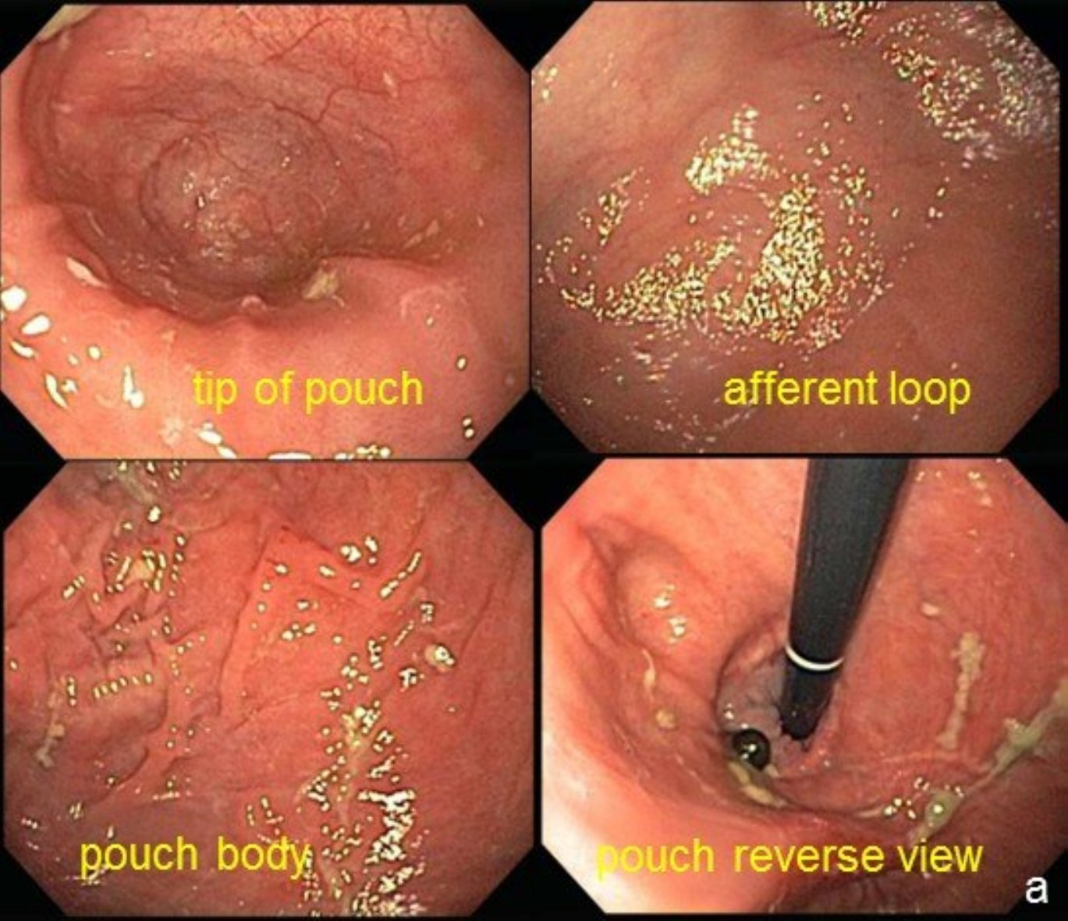
B
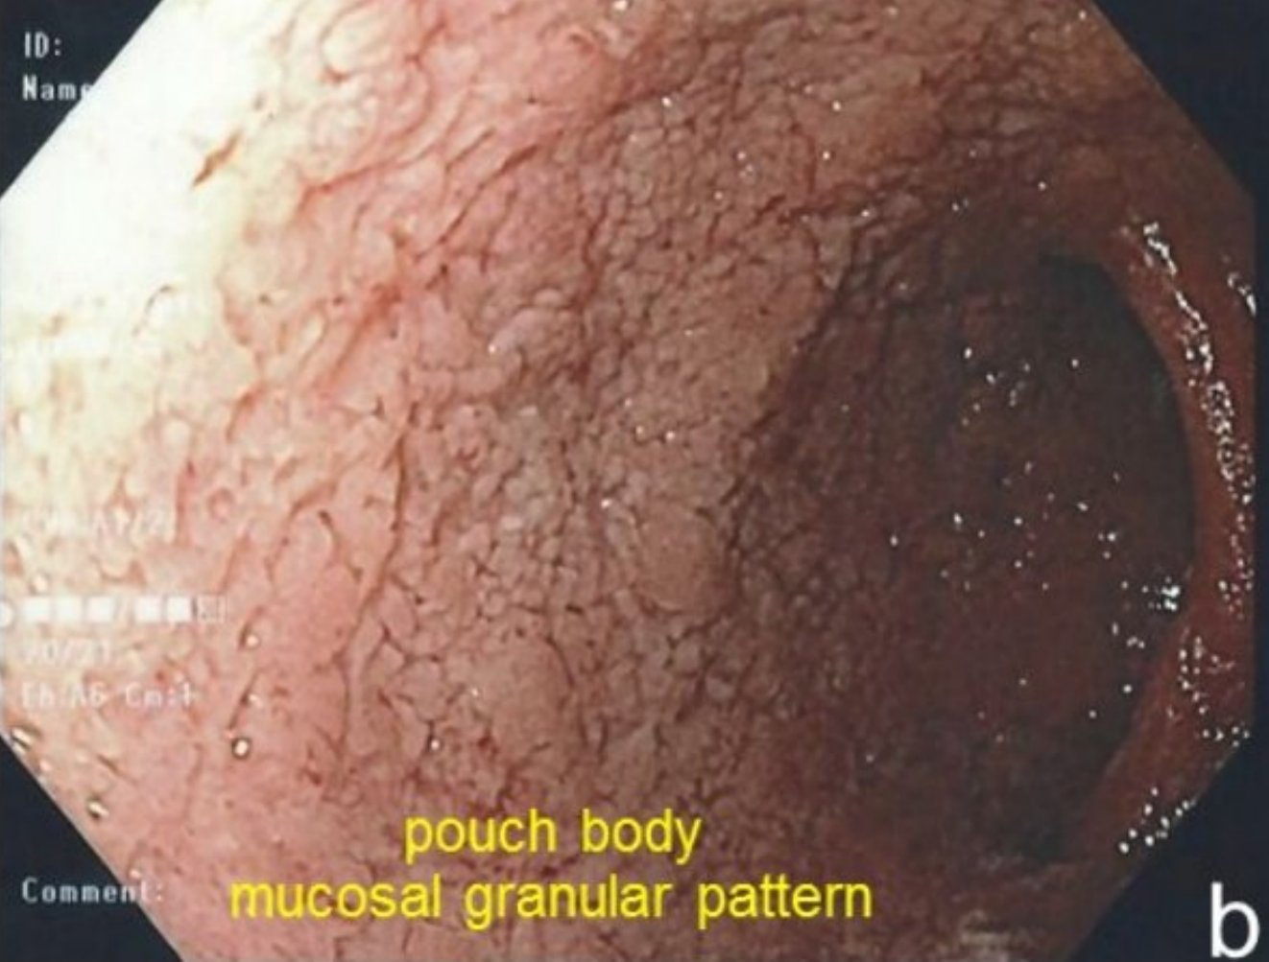
Figure 3 Normal pouch mucosa (A), mucosal granular pattern (edema) with disappearance of the mucosal vascular pattern (B).

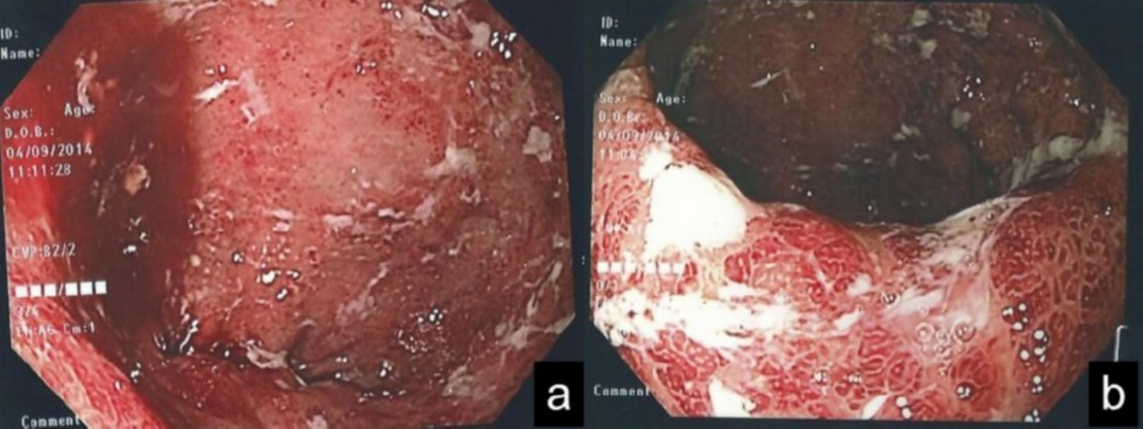
Figure 4 Active pouchitis (A, B). The mucosal vascular pattern has been lost and the mucosa is characterized by diffuse redness, severe edema with erosions and ulcers.

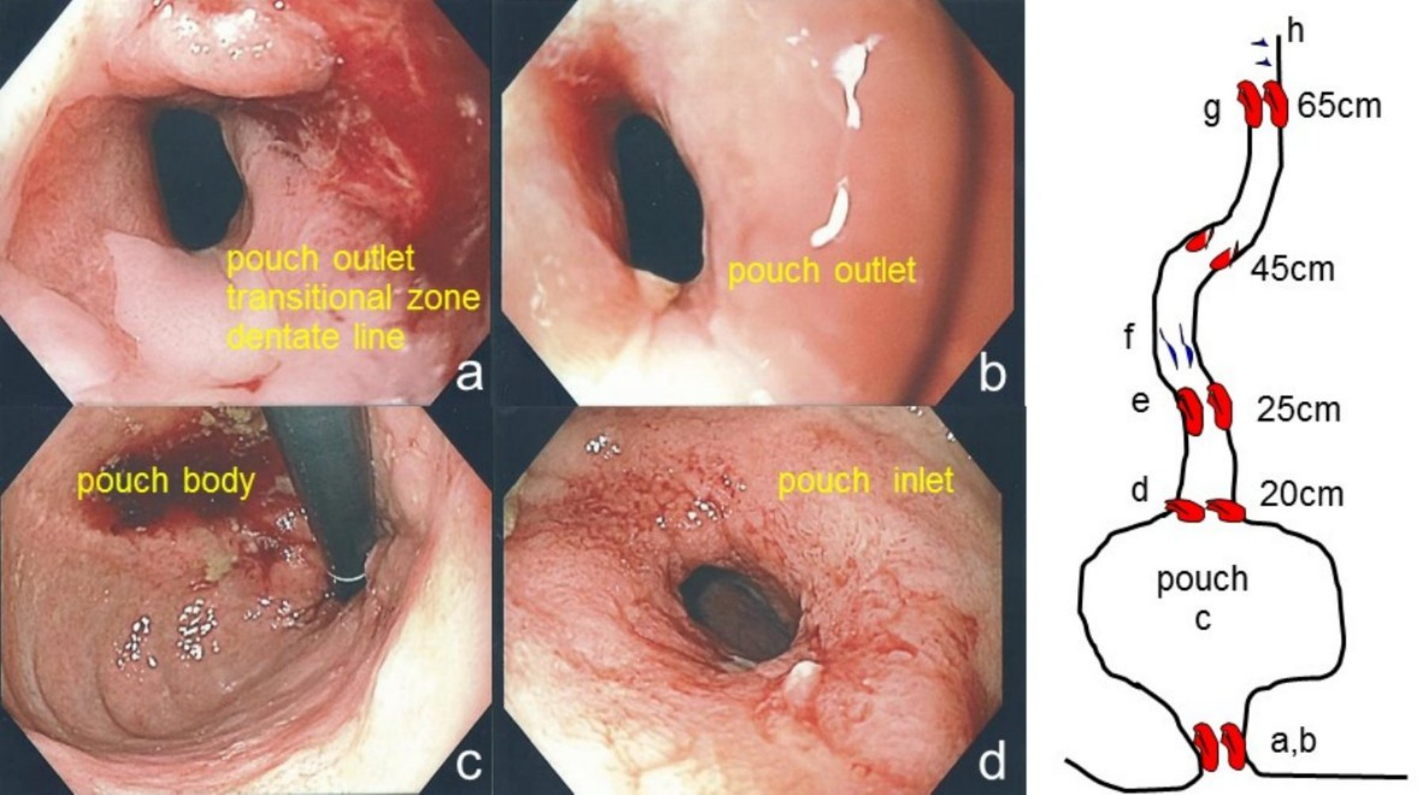
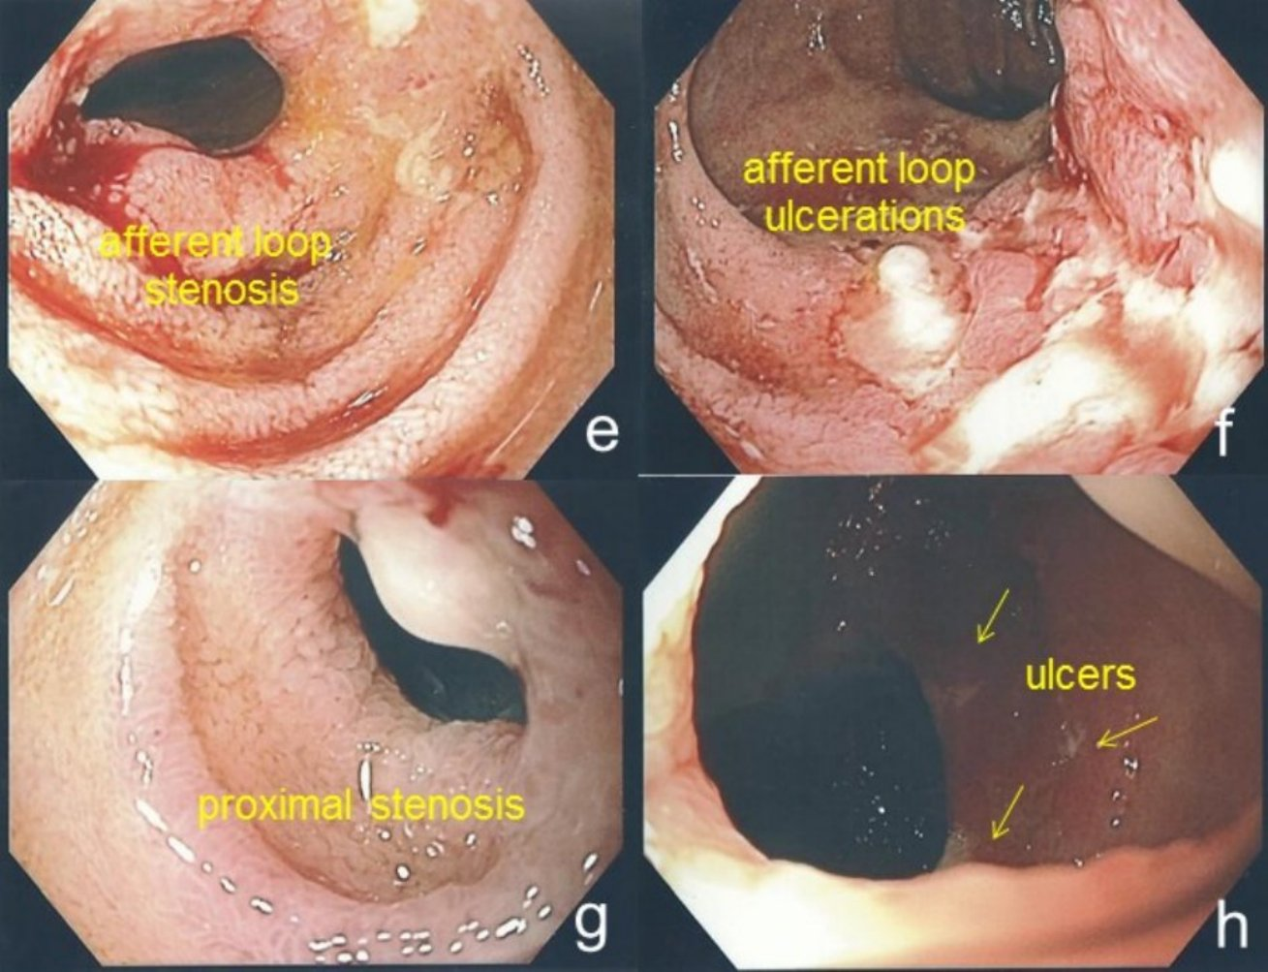
Figure 5 Crohn’s ileo-pouchitis. Stenosis of the pouch outlet (A, B), normal appearing mucosa of the pouch (C), stenosis of the pouch inlet (D), stenosis of the afferent limb at 25 cm (E), linear deep ulcerations in the ileum (F), proximal stenosis of the ileum at 45 cm (G) and ulcers more proximally (H).

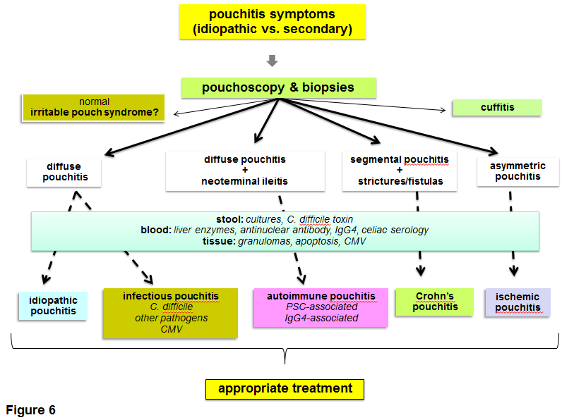
Figure 6 Pouchitis diagnostic algorithm (adapted and modified from Shen et al^{[15]}). C. difficile: Clostridium difficile.
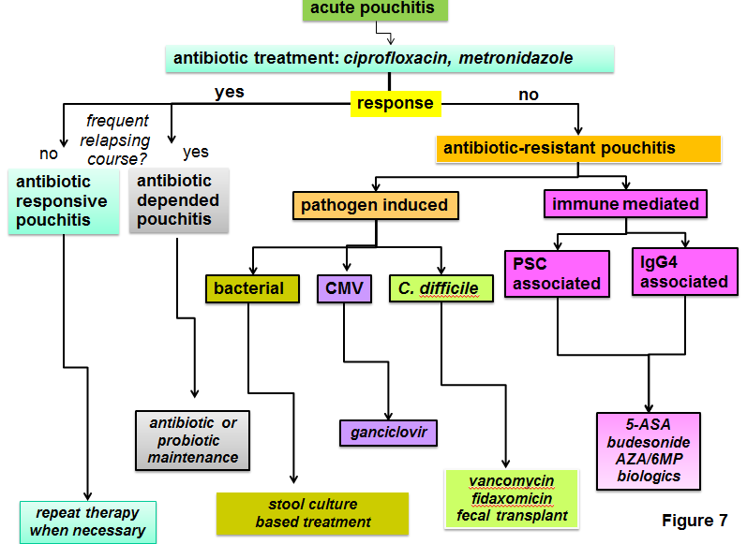
Figure 7 Pouchitis treatment algorithm (adapted and modified from Shen et al^{[15]}). C. difficile: Clostridium difficile.

Table 1 Classification of “pouchitis” according to the etiology

Idiopathic pouchitis
Secondary pouchitis
- Infectious
Bacterial pathogens:
Clostridium difficile, Campylobacter jejuni, Salmonella typhii, Escherichia coli, Klebsiella, Pseudomonas, others
Fungi: Candida
Viruses: CMV
- Ischemic
- NSAID-associated
- Collagenous
- Autoimmune-associated
- Crohn’s disease-associated
Other diagnoses
- Cuffitis
- Irritable pouch syndrome
NASID: Non-steroidal anti-inflammatory drug.

Table 2 The variety of idiopathic pouchitis classifications

Activity | - Active  - Inactive
Presentation | - Acute < 4 wk duration  - Chronic > 4 wk duration
Clinical pattern | - Single episode  - Infrequent < 4 episodes a year  - Relapsing > 4 episodes a year  - Continuous
Response to treatment | - Responsive  - Refractory
Response to antibiotics | - Antibiotic-responsive:  - infrequent episodes (< 4 episodes per year) responding to a 2-wk course of a single antibiotic  - Antibiotic-dependent  - frequent episodes or persistent episodes of pouchitis requiring long-term, continuous therapy for maintaining remission  - Chronic antibiotic-refractory  - not responding to a 4-wk course of metronidazole or ciprofloxacin, requiring prolonged therapy of ≥ 4 wk consisting more than 2 antibiotics, oral or topical 5-ASA, corticosteroids, AZA/6-MP, or biologics

Table 3 The pouchitis disease activity index
Criteria | Score
Clinical  Stool frequency  Usual postoperative stool frequency  1–2 stool ⁄ d > postoperative usual  3 or more stool ⁄ d > postoperative usual  Rectal bleeding  None or rare  Present daily  Fecal urgency or abdominal cramps  None  Occasional  Usual  Fever (temperature > 37.8 °C)  Absent  Present | 0  1  2  0  1  0  1  2  0  1
Endoscopic findings  Edema  Granularity  Friability  Loss of vascular pattern  Mucous exudates  Ulceration | 1  1  1  1  1  1
Histological findings - Acute histological inflammation  Polymorphonuclear leucocyte infiltration  Mild  Moderate without crypt abscess  Severe with crypt abscess  Ulceration per low-power field (mean)  < 25% / 25–50% />50% | 1  2  3  1/2/3
Total pouchitis disease activity index (max 18) Pouchitis ≥ 7
Table 4 The pouchitis activity score
Criteria | Score
Clinical  Stool frequency/24 h: < 8/8-10/10-13/> 13  Urgency: absent/present  Rectal bleeding: absent/present | 0/2/4/6  0/3  0/3
Endoscopic findings  Edema: absent/present  Granularity: absent/present  Friability: absent/mild/severe  Erythema: absent/mild/severe  Mucosal flattening: absent/present  Ulcerations/erosions: absent/mild/severe | 0/1  0/1  0/1/2  0/2/3  0/2  0/2/3
Histological findings  Acute histological inflammation  Polymorphonuclear leucocyte infiltration  absent/discrete and patchy/moderate ± crypt abscesses or cryptitis/  extensive ± crypt abscesses or cryptitis  Ulcerations/erosions  absent/mild and superficial/moderate/extensive  Chronic histological inflammation  Polymorphonuclear leucocyte infiltration  absent/mild and patchy/moderate/extensive  Villous atrophy  absent/minimal/partial/subtotal-total | 0/1/2/  3  0/1/2/3  0/1/2/3  0/1/2/3
Total pouchitis activity score (max 36)
Pouchitis ≥ 13

