Name of journal: World Journal of Gastrointestinal Endoscopy
ESPS Manuscript NO: 18099
Manuscript Type: Case Report

Challenges of banding jejunal varices in an 8 years old child

Belsha D et al. Banding jejunal varices in a child

Dalia Belsha, Mike Thomson

Dalia Belsha, Mike Thomson, Department of Paediatric Gastroenterology, Sheffield Children Hospital, Sheffield S10 2TH, United Kingdom

Author contributions: Belsha D Wrote the case report; Thomson M contributed to reviewing the case report and the discussion around it; both authors contributed equally to the work.

Institutional review board statement: Case report has been accepted by the institutional board review to be submitted for publication.

Informed consent statement: Patient and guardian consent has been obtained for publishing the case report.

Conflict-of-interest statement: The authors declare no conflict of interest.

Open-Access: This article is an open-access article which was selected by an in-house editor and fully peer-reviewed by external reviewers. It is distributed in accordance with the Creative Commons Attribution Non Commercial (CC BY-NC 4.0) license, which permits others to distribute, remix, adapt, build upon this work non-commercially, and license their derivative works on different terms, provided the original work is properly cited and the use is non-commercial. See: http://creativecommons.org/licenses/by-nc/4.0/

Correspondence to: Dr. Dalia Belsha, MBChB, MRCPCH, Paediatric Gastroenterology Registrar, Sheffield Children Hospital, Weston Bank, Sheffield S10 2TH, United Kingdom. dalia.belsha@nhs.net
Telephone: +44-785-3287092
Fax: +44-114-2267956

Received: April 6, 2015
Peer-review started: April 8, 2015
First decision: May 14, 2015
Revised: June 30, 2015
Accepted: July 16, 2015
Article in press:
Published online:

Abstract
Endoscoic variceal ligation (EVL) by the application of bands on small bowel varices is a relatively rare procedure in gastroenterology and hepatology. There are no previously reported paediatric cases of EVL for jejunal varices. We report a case of an eight year old male patient with a complex surgical background leading to jejunal varices and short bowel syndrome, presenting with obscure but profound acute gastrointestinal bleeding. Wireless capsule endoscopy and double balloon enteroscopy (DBE) confirmed jejunal varices as the source of bleeding. The commercially available variceal banding devices are not long enough to be used either with DBE or with push enteroscopes. With the use of an operating gastroscope, four bands were placed successfully on the afferent and efferent ends of the leads of the 2 of the varices. Initial hemostasis was achieved with obliteration of the varices after three separate applications. This case illustrates the feasibility of achieving initial hemostasis in the pediatric population.

Key words: Endoscopic variceal ligation; Variceal banding; Pediatrics; Varices; Endoscopic hemostasis; Gastrointestinal hemorrhage

© The Author(s) 2015. Published by Baishideng Publishing Group Inc. All rights reserved.

Core tip: Banding jejunal varices in the pediatric population is feasible, safe and can achieve initial hemostasis in complex surgical patients.

Belsha D, Thomson M. Challenges of banding jejunal varices in an 8 years old child. World J Gastrointest Endosc 2015; In press

INTRODUCTION
Ectopic varices are defined as large porto-systemic venous collaterals occurring anywhere in the abdomen except in the cardio-esophageal region^{[1]}.
They account for up to 5% of all variceal bleeding^{[2]}. Ectopic varices have been reported to occur at numerous sites, including 18% in the jejunum or ileum, 17% in the duodenum, 14% in the colon, 8% in the rectum, and 9% in the peritoneum^{[3]}. Jejunal variceal bleeding, although rare, can be life threatening. There are only a few reports on the managements of jejunal varices in the paediatric population^{[4]}. We present a rare case of severe and recurrent gastrointestinal bleeding secondary to jejunal varices in an 8 years old patient. The management strategies including the use of endoscopic variceal ligation (EVL) are discussed.

CASE REPORT
An 8 years old male patient was transferred from another tertiary hospital for assessment for obscure but profound acute gastrointestinal bleeding (AGIB).
He had a complex background of gastroschisis at birth associated with duodenal and colonic atresia. He had a repair of gastroschisis on day 1 of life and subsequently underwent a duodenojejunal anastamosis with right hemicolectomy and ileostomy formation, followed by ileo-colonic anastamosis and closure of the stoma. He had short gut syndrome and received nutritional supplementation via a balloon gastrostomy.
He had had multiple episodes of GI bleeding since he was 18 mo of age, which were thought to be associated with a superior mesenteric vein thrombosis. These were intermittent in nature and managed conservatively. The patient had a period of two years without a GI bleed prior to this presentation.
In 2014 however, the patient had 17 episodes of AGIB. Seven episodes were significant, mainly of hematochezia with clots or large melena. His lowest recorded hemoglobin was 22 g/L. The patient had multiple blood transfusions and was given 4 weekly iron infusions. He underwent CT angiography which revealed distorted adjacent vascular structures around the pancreas with the splenic vein looping over the superior edge of the pancreas.
Normal enhancement was noticed in the portal vein, its left and right branches, the splenic vein (SV) and the superior mesenteric vein (SMA). However; there is unusual prominent venous structure draining in to the right side of the confluence of the SMV and the SV. There were multiple serpiginous vessels in the left side of the bowel mesentery with in particular a clump of varices/collaterals in the small bowels mesentery (Figure 1). All connections from these apparent varices couldn’t be established, however; there was at least a connection to a looping vessel which extends into the left side of the SMV. Further looping vessels were seen in the anterior aspect of the mesentery from a proximal loop of the jejunum. Theses dilated blood vessels and collaterals around the mesentery of the small bowel raised the suspicion of mesenteric varices in the upper abdomen, but no active bleeding source was recognised. The patient was put intermittently on octreotide infusion but wasn’t given primary or secondary prophylaxis as it was felt that the varices were more confined to some areas and secondary to mesenteric venous obstruction/ abnormalities rather than strong evidence of generalised portal hypertension.
On arrival to our hospital in the same year, upper GI endoscopy revealed no esophago-gastric varices but identified portal gastropathy. Ileo-colonoscopy was normal apart from an erythematous ileo-colonic anastamotic rim. WCE identified a suspicious area (around 50 cm from the pylorus) of nodular shaped lesions with bluish discoloration, suspicious of varices. Two days later, further profound hematochezia occurred and therefore octreotide infusion (5 mcg/kg per hour) was commenced. Trans-oral double balloon enteroscopy (DBE) confirmed a normal esophagus, mild evidence of portal gastropathy, a normal duodenum, and jejunal examination revealed 4 moderately large isolated jejunal varices around 40-50 cm post-pylorus (Figures 2 and 3). Four bands were placed successfully on the afferent and efferent ends of the leads of the 2 of the varices using an operating gastroscope (Figures 4 and 5). The commercially available variceal banding devices are not long enough to be used either with DBE which was initially used diagnostically. Trans-anal DBE was performed and showed a small potential varix approximately 120 cm proximal to the ileo-colonic anastamosis and this was not considered a risk and was not bleeding therefore was not banded. This area was marked for future reference with methylene blue tattoo injection. One week later a further endoscopy revealed the 2 banded varices to be thrombosed and now absent and sloughing within the bands was noted which were beginning to fall off the mucosa. The remaining 2 variceal vessels were then also banded. Two weeks subsequently the patient was well with no further bleed and a further endoscopy revealed friable variceal beds but no active bleeding. One further varix was banded at that time with hemostasis identified.
However the patient developed recurrence of bleed two weeks later possibly from an ileo-colonic source. The patient had shunting procedure few weeks later (mesenterico-caval shunt).

DISCUSSION
Our patient presented with the classical clinical signs reported previously in the literature for jejunal varices, evidence of abnormal vasculature in the mesentery with or without portal hypertention, a history of abdominal surgery, and hematochezia with or without hematemesis^{[5]}.
The exact pathology for developing jejunal varices in our case is not fully understood. It is likely to be a combination of superior mesenteric vein thrombosis (subsequently re-canalised however) and adhesions. A history of abdominal surgery appears to predispose to the development of ectopic varices around adhesions^{[6]}. It seems that small-bowel anastomotic and adhesion-related varices can form within adhesions in the setting of mesenteric venous obstruction with or without portal hypertension^{[5]}.
Collateral formation within adhesions from previous surgery is the usual mechanism for the development of ectopic varices^{[3]}, with a likely mechanism that adhesions bring the parietal surface of the viscera in contact with the abdominal wall and portal hypertension results in the formation of varices below the intestinal mucosa^{[7]}.
The mainstay for the diagnosis of jejunal varices in our case was a combination of CT angiography and wireless capsule endoscopy.
Jejunal varices in wireless capsule endoscopy appear as serpiginous or nodular shapes, with or without a bluish discoloration. The variceal mucosa appears mosaic-like, shining, or normal compared with surrounding mucosa^{[8]}.
Capsule endoscopy is invaluable for the diagnosis of small-bowel varices. It is highly sensitive for detecting fresh blood in the small bowel. Clinical suspicion, capsule endoscopy image recognition, and alertness during capsule endoscopy interpretation are keys to diagnosis^{[8]}.
Several approaches for the treatment of jejunal varices have been described including surgery^{[9]}, portal venous stenting^{[10-12]}, percutaneous embolisation^{[13,14]} and thne endoscopic options^{[5,15-18]}.
Surgical treatment options for small bowel variceal bleeds include resection of the afferent area of bowel and re-anastomosis^{[13]}. However this can be challenging in patients with short gut and multiple adhesion as in our case.
Transjugular intrahepatic portal-systemic shunt (TIPS) or a decompressive shunting procedure is recommended in patients with overt systemic portal hypertension^{[13,19,20]}. With the addition of coil or emboilization has been reported to be particularly useful for ectopic varices, as these can continue to bleed despite successful portal pressure reduction^{[21]}.
The effectiveness of beta-blockers for primary prophylaxis and octreotide treatment for acute hemorrhage of anastomotic and segmental varices is uncertain^{[5]}.
It has been reported that endoscopic treatment including sclerosing agents can be used for treatment of actively bleeding duodenal or jejunal varices or to prevent re-bleeding from focal varices with hemorrhage. However, while hemostasis is feasible, ulceration and re-bleeding rates can be high^{[5]}. The use of N-butyl-2-cyanoacrylate (Histoacryl®) injection has been described in several case reports, for hemostasis of actively bleeding duodenal varices^{[15,22,23]}. In one series all the varices had developed around the anastamotic sites and only two had elevated systemic portal pressure^{[18]}. Another case report describes successful treatment of bleeding jejunal varices using cyanoacrylate sclerotherapy via enteroscopy in an adult patient^{[16]}.
Endoscopic band ligation (EVL) has a theoretical increased risk of complications in the small bowel because of its thin wall, e.g., perforation. However, there are several reports of successfully treated duodenal varices by EVL in adults without complications. In a review of 19 cases (all adults) with duodenal EVL only 3 (15.8%) rebled after treatment with no deaths reported due to complications or rebleeding¹⁶. In a report of 4 patients with duodenal EVL, 2 achieved complete resolution of varices after one treatment session, one had remaining varices on surveillance endoscopy but no bleeding in a 9 mo period and one case required surgical resection after several banding sessions^{[17]}.
The standard ligation balloon devices available are too short to be adapted for an enteroscope or a colonoscope but are applicable to standard upper GI endsocopes. The operating gastroscope (GIF-2TQ260M) allowed 3 way tip deviation and is stiffer than conventional upper GI endsocopes allowing successful banding to occur.
In this case, EVL was used successfully to achieve initial hemostasis with obliteration of the varices after three separate applications, however bleeding subsequently occurred from an ileo-colonic source.
Frequently ectopic variceal bleeding is difficult to manage and traditionally surgery or shunting is required depending on the underlying disease and the patency of the portal vein.
Endoscopic treatment as a minimally invasive approach is feasible and safe in this case and represents a viable alternative.
To the best of our knowledge, this is the first reported case in the literature describing EVL in the management of jejunal variceal bleeding in the pediatric population.
This case illustrates the technical feasibility and apparent safety of EVL in the management of jejunal variceal bleeding in children.

COMMENTS
Case characteristics
Recurrent severe gastrointestinal bleeding.

Clinical diagnosis
Jejunal varices.

Differential diagnosis
Upper GI endoscopy ruled out esophageal and gastric variceal bleeding. Ilio-colonosconoscopy and wireless capsule ruled out other diagnosis like polyps or other vascular malformation. Wireless capsule showed features suggestive of ectopic varices.

Laboratory diagnosis
Extensive investigations including complete blood count, Lipase, Liver enzymes, kidney function, radiological images with CT angiography. The diagnosis was confirmed with wireless capsule endoscopy and endoscopy of the affected small bowel.

Imaging diagnosis
Imaging study using CT scan demonstrated thickening and irregularity of the mesentery surrounding in keeping with the diagnosis of mesenteric panniculitis.

Pathological diagnosis
Variceal bleeding was the diagnosis as per the wireless capsule endoscopy and the endoscopic finding.

Treatment
The patient was treated with pharmacological agents including octreotide. Blood transfusion was needed frequently to stabilise the patient. Endoscopic variceal ligation was successfully applied to achieve initial hemostasis.

Related reports
Clark et al reported successful endoscopic ectopic variceal ligation: a series of 4 cases and review of the literature in adult population.

Experiences and lessons
Jejunal varices is a rare disorder that can present with recurrent severe gastrointestinal bleeding in complex surgical paediatric patient, the authors describe a novel intervention in paediatric using endoscopic variceal ligation to achieve initial hemostasis.

Peer-review
In this case report the authors present the case of an 8 years old child treated with endoscopic band ligation for jejunal varices. This kind of pathology is rare and the therapeutic options could be challenging.

REFERENCES
1 Rockey DC. Occult and obscure gastrointestinal bleeding: causes and clinical management. Nat Rev Gastroenterol Hepatol 2010; 7: 265-279 [PMID: 20351759 DOI: 10.1038/nrgastro.2010.42.]
2 Akhter NM, Haskal ZJ. Diagnosis and management of ectopic varices. Gastrointestinal Intervention 2012; 1: 3-10 [DOI: 10.1016/j.gii.2012.08.001]
3 Lebrec D, Benhamou JP. Ectopic varices in portal hypertension. Clin Gastroenterol 1985; 14: 105-121 [PMID: 3872747]
4 Thomas V, Jose T, Kumar S. Natural history of bleeding after esophageal variceal eradication in patients with extrahepatic portal venous obstruction; a 20-year follow-up. Indian J Gastroenterol 2009; 28: 206-211 [PMID: 20425640 DOI: 10.1007/s12664-009-0086-0.]
5 Tang SJ, Jutabha R, Jensen DM. Push enteroscopy for recurrent gastrointestinal hemorrhage due to jejunal anastomotic varices: a case report and review of the literature. Endoscopy 2002; 34: 735-737 [PMID: 12195333]
6 Sharma D, Misra SP. Ectopic varices in portal hypertension. Indian J Surg 2005; 67: 246-252
7 Sato T, Akaike J, Toyota J, Karino Y, Ohmura T. Clinicopathological features and treatment of ectopic varices with portal hypertension. Int J Hepatol 2011; 2011: 960720 [PMID: 21994879 DOI: 10.4061/2011/960720]
8 Tang SJ, Zanati S, Dubcenco E, Cirocco M, Christodoulou D, Kandel G, Haber GB, Kortan P, Marcon NE. Diagnosis of small-bowel varices by capsule endoscopy. Gastrointest Endosc 2004; 60: 129-135 [PMID: 15229446]
9 Yuki N, Kubo M, Noro Y, Kasahara A, Hayashi N, Fusamoto H, Ito T, Kamada T. Jejunal varices as a cause of massive gastrointestinal bleeding. Am J Gastroenterol 1992; 87: 514-517 [PMID: 1553940]
10 Sakai M, Nakao A, Kaneko T, Takeda S, Inoue S, Yagi Y, Okochi O, Ota T, Ito S. Transhepatic portal venous angioplasty with stenting for bleeding jejunal varices. Hepatogastroenterology 2005; 52: 749-752 [PMID: 15966197]
11 Hiraoka K, Kondo S, Ambo Y, Hirano S, Omi M, Okushiba S, Katoh H. Portal venous dilatation and stenting for bleeding jejunal varices: report of two cases. Surg Today 2001; 31: 1008-1011 [PMID: 11766071]
12 Ota S, Suzuki S, Mitsuoka H, Unno N, Inagawa S, Takehara Y, Sakaguchi T, Konno H, Nakamura S. Effect of a portal venous stent for gastrointestinal hemorrhage from jejunal varices caused by portal hypertension after pancreatoduodenectomy. J Hepatobiliary Pancreat Surg 2005; 12: 88-92 [PMID: 15754107]
13 Lim LG, Lee YM, Tan L, Chang S, Lim SG. Percutaneous paraumbilical embolization as an unconventional and successful treatment for bleeding jejunal varices. World J Gastroenterol 2009; 15: 3823-3826 [PMID: 19673028]
14 Sasamoto A, Kamiya J, Nimura Y, Nagino M. Successful embolization therapy for bleeding from jejunal varices after choledochojejunostomy: report of a case. Surg Today 2010; 40: 788-791 [PMID: 20676866 DOI: 10.1007/s00595-009-4129-z]
15 Paterlini A, Rolfi F, Buffoli F, Cesari P, Graffeo M, Benedini D, Lanzani G, Bonera E. Endoscopic treatment of a bleeding duodenal varix using N-butyl-2-cyanoacrylate. Endoscopy 1993; 25: 434 [PMID: 8404716]
16 Gunnerson AC, Diehl DL, Nguyen VN, Shellenberger MJ, Blansfield J. Endoscopic duodenal variceal ligation: a series of 4 cases and review of the literature (with video). Gastrointest Endosc 2012; 76: 900-904 [PMID: 22840294 DOI: 10.1016/j.gie.2012.05.020.]
17 Getzlaff S, Benz CA, Schilling D, Riemann JF. Enteroscopic cyanoacrylate sclerotherapy of jejunal and gallbladder varices in a patient with portal hypertension. Endoscopy 2001; 33: 462-464 [PMID: 11396768]
18 Gubler C, Glenck M, Pfammatter T, Bauerfeind P. Successful treatment of anastomotic jejunal varices with N-butyl-2-cyanoacrylate (Histoacryl): single-center experience. Endoscopy 2012; 44: 776-779 [PMID: 22833023 DOI: 10.1055/s-0032-1309834.]
19 Stafford Johnson DB, Narasimhan D. Case report: successful treatment of bleeding jejunal varices using mesoportal recanalization and stent placement: report of a case and review of the literature. Clin Radiol 1997; 52: 562-565 [PMID: 9240715]
20 Shibata D, Brophy DP, Gordon FD, Anastopoulos HT, Sentovich SM, Bleday R. Transjugular intrahepatic portosystemic shunt for treatment of bleeding ectopic varices with portal hypertension. Dis Colon Rectum 1999; 42: 1581-1585 [PMID: 10613477]
21 Tripathi D, Jalan R. Transjugular intrahepatic portosystemic stent-shunt in the management of gastric and ectopic varices. Eur J Gastroenterol Hepatol 2006; 18: 1155-1160 [PMID: 17033434]
22 Yoshida Y, Imai Y, Nishikawa M, Nakatukasa M, Kurokawa M, Shibata K, Shimomukai H, Shimano T, Tokunaga K, Yonezawa T. Successful endoscopic injection sclerotherapy with N-butyl-2-cyanoacrylate following the recurrence of bleeding soon after endoscopic ligation for ruptured duodenal varices. Am J Gastroenterol 1997; 92: 1227-1229 [PMID: 9219810]
23 Labenz J, Börsch G. Successful endoscopic hemostasis of duodenal variceal bleeding with histoacryl. Endoscopy 1993; 25: 194 [PMID: 8491144]

P-Reviewer: Abu-Zidan FM, Kaehler G, Procopet B S-Editor: Ji FF L-Editor: E-Editor:

Figure 1 CT angiography with multiple serpiginous vessels in the left side of the bowel mesentery.

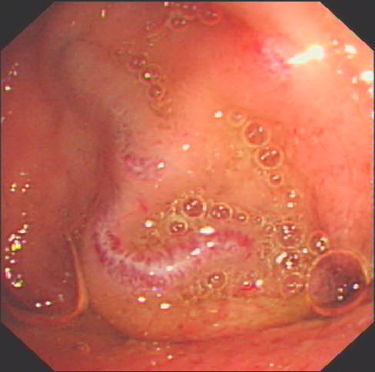

Figure 2 Suspicion of varices.

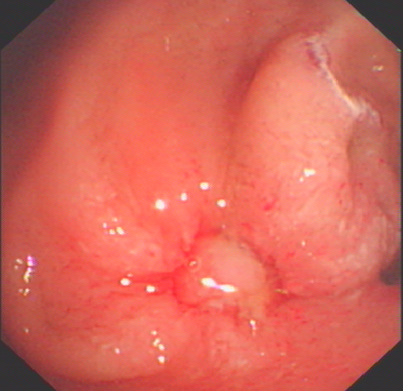

Figure 3 Appearance of jejunal varices using the double balloon enterosocpy.

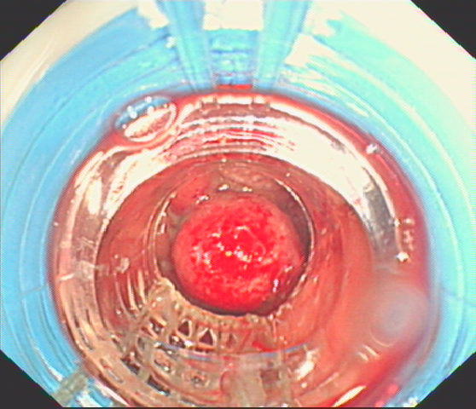

Figure 4 Banding of the jejunal varices using the operative gastroscope.

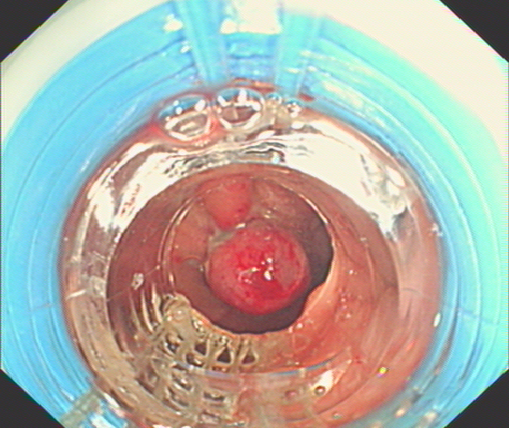

Figure 5 Banding of the jejunal varices using the operative gastroscope.

