Name of Journal: World Journal of Stem Cells
Manuscript NO: 89034
Manuscript Type: ORIGINAL ARTICLE

Basic Study
Effects of different concentrations of nicotinamide on hematopoietic stem cells cultured in vitro

Ren Y et al. Concentration of NAM affects HSC expansion

Yan Ren, Yan-Ni Cui, Hong-Wei Wang

Yan Ren, Yan-Ni Cui, The Second Clinical Medical College, Shanxi Medical University, Taiyuan 030001, Shanxi Province, China

Yan Ren, Yan-Ni Cui, Hong-Wei Wang, Department of Hematology, The Second Hospital of Shanxi Medical University, Taiyuan 030001, Shanxi Province, China

Hong-Wei Wang, Department of Hematology, Key Laboratory of Molecular Diagnosis and Treatment of Blood Diseases in Shanxi Province, Taiyuan 030001, Shanxi Province, China

Co-first authors: Yan Ren and Yan-Ni Cui.

Author contributions: Ren Y and Cui YN designed and coordinated the study; Ren Y performed experiments and wrote the manuscript; Cui YN acquired and analyzed the data; Wang HW contributed to ideas, supervision, review and editing; and all authors approved the final version of the article.

Supported by the Science and Technology Department of Shanxi Province, No. YDZJSX2021B009; Health Commission of Shanxi Province, No. 2021XM07; and Shanxi Provincial Department of Education, No. 2023KY380.

Corresponding author: Hong-Wei Wang, PhD, Professor, Department of Hematology, The Second Hospital of Shanxi Medical University, No. 382 Wuyi Road, Taiyuan 030001, Shanxi Province, China. wanghw68@hotmail.com

Received: October 18, 2023
Revised: December 14, 2023
Accepted: January 12, 2024
Published online:

Abstract
BACKGROUND
In vitro expansion to increase numbers of hematopoietic stem cells (HSCs) in cord blood could improve clinical efficacy of this vital resource. Nicotinamide (NAM) can promote HSC expansion ex vivo, but its effect on hematopoietic stem and progenitor cells (HSPCs, CD34⁺CD38⁻) and functional subtypes of HSCs – short-term repopulating HSCs (ST-HSCs, CD34⁺CD38⁻CD45RA⁻CD49f⁺) and long-term repopulating HSCs (LT-HSCs, CD34⁺CD38⁻CD45RA⁻CD49f⁺CD90⁺) – is not yet known. As a sirtuin 1 (SIRT1) inhibitor, NAM participates in regulating cell adhesion, polarity, migration, proliferation, and differentiation. However, SIRT1 exhibits dual effects by promoting or inhibiting differentiation in different tissues or cells. We propose that the concentration of NAM may influence proliferation, differentiation, and SIRT1 signaling of HSCs.

AIM
To evaluate the effects and underlying mechanisms of action of different concentrations of NAM on HSC proliferation and differentiation.

METHODS
CD34⁺ cells were purified from umbilical cord blood using MacsCD34 beads, and cultured for 10–12 d in a serum-free medium supplemented with cytokines, with different concentrations of NAM added according to experimental requirements. Flow cytometry was used to detect phenotype, cell cycle distribution, and apoptosis of the cultured cells. Real-time polymerase chain reaction was used to detect the transcription levels of target genes encoding stemness-related factors, chemokines, components of hypoxia pathways, and antioxidant enzymes. Dichloro-dihydro-fluorescein diacetate probes were used to evaluate intracellular production of reactive oxygen species (ROS). Determination of the effect of different culture conditions on the balance of cytokine by cytometric bead array.

RESULTS
Compared with the control group, the proportion and expansion folds of HSPCs (CD34⁺CD38⁻) incubated with 5 mmol/L or 10 mmol/L NAM were significantly increased (all P < 0.05). The ST-HSCs ratio and fold expansion of the 5 mmol/L NAM group were significantly higher than those of the control and 10 mmol/L NAM groups (all P < 0.001), whereas the LT-HSCs ratio and fold expansion of the 10 mmol/L NAM group were significantly higher than those of the other two groups (all P < 0.05). When the NAM concentration was > 10 mmol/L, cell viability significantly decreased. In addition, compared with the 5 mmol/L NAM group, the proportion of apoptotic cells in the 10 mmol/L NAM group increased and the proportion of cells in S and G2 phase decreased. Compared with the 5 mmol/L NAM group, the HSCs incubated with 10 mmol/L NAM exhibited significantly inhibited SIRT1 expression, increased intracellular ROS content, and downregulated expression of genes encoding antioxidant enzymes (superoxide dismutase 1, peroxiredoxin 1).

CONCLUSION
Low concentrations (5 mmol/L) of NAM can better regulate the balance between proliferation and differentiation, thereby promoting expansion of HSCs. These findings allow adjustment of NAM concentrations according to expansion needs.

Key Words: Hematopoietic stem cells; Nicotinamide; Concentration; Proliferation; Differentiation; Sirtuin 1

Ren Y, Cui YN, Wang HW. Effects of different concentrations of nicotinamide on hematopoietic stem cells cultured in vitro. World J Stem Cells 2024; In press

Core tip: This study reveals the dominant subgroups of hematopoietic stem cells (HSCs) and molecular mechanisms underlying the effects of different nicotinamide (NAM) concentrations. Activation or inhibition of sirtuin 1 (SIRT1) is determined by the concentration of NAM. High concentrations inhibit SIRT1 but are not conducive to self-renewal of HSCs, whereas low concentrations balance HSC proliferation and differentiation by regulating the SIRT1–HIF1A pathway and reactive oxygen species production, effectively promoting in vitro expansion of the stem cells. These findings could allow adjustment of NAM concentrations according to expansion needs and may help predict small molecules that synergistically promote expansion with NAM.

INTRODUCTION
Hematopoietic stem cells (HSCs) can self-renew and give rise to mature cells of all hematopoietic lineages following extensive proliferation and differentiation^{[1,2]}. Umbilical cord blood (UCB) is an important source of HSCs because it can be obtained through noninvasive means, has low requirements for the matching of human leukocyte antigens, and has a low incidence of chronic graft-versus-host disease. However, the limited cell dose in a single UCB sample can lead to delayed engraftment after transplantation^{[3]}. Obtaining a sufficient number of HSCs through ex vivo expansion has the potential to overcome such challenges.
Small molecules represent novel modalities for ex vivo expansion of HSCs^{[4-6]}, and the roles of different molecules in HSC transplantation are diverse. As a form of vitamin B-3, nicotinamide (NAM) can delay differentiation and maintain stemness, as well as promote neutrophil recovery in patients after transplantation^{[7-9]}. In humans, CD34⁺CD38⁻ cells are classic hematopoietic stem and progenitor cells (HSPCs), and HSCs can be functionally divided into short-term repopulating HSCs (ST-HSCs, CD34⁺CD38⁻CD45RA⁻CD49f⁺) and long-term repopulating HSCs (LT-HSCs, CD34⁺CD38⁻CD45RA⁻CD49f⁺CD90⁺)^{[10-12]}. Preclinical models indicate that the recovery of blood cells immediately after transplantation is repopulated primarily by ST-HSCs while long-term sustenance of trilineage hematopoiesis is the contribution of LT-HSCs that have the ability to self-renew. LT-HSCs drive sustained lifelong hematopoiesis, these cells are relatively quiescent, hence resulting in a prolonged period of leukopenia^{[10-15]}. Thus, the primary goal of UCB expansion is twofold; namely, to reduce the time taken to achieve blood cell reconstitution following transplantation, and ensuring sustained long-term trilineage hematopoiesis. NAM promotes in vitro expansion of HSPCs, but its effects on ST-HSCs and LT-HSCs have yet to be elucidated. Emerging studies suggest that NAM mediates the metabolic transition of aging stem cells by upregulating the expression of young genes such as sirtuin 1 (SIRT1), thereby maintaining stemness^{[16-22]}. This contradicts the viewpoint that NAM acts as a SIRT1 inhibitor^{[23]}. Furthermore, SIRT1 exhibits a dual effect of promoting or inhibiting differentiation in different tissues or cells^{[24]}. Based on these observations, we propose that the proliferation, differentiation, and SIRT1 signaling pathway of HSCs may be influenced by the concentration of NAM.
In this study, we evaluated the effects of different concentrations of NAM on the proliferation and differentiation of HSCs during in vitro culture. Proliferation is reflected by fold expansion of total nucleated cells (TNCs) and differentiation is reflected by phenotype analysis of HSPC, ST-HSC and LT-HSC populations. Apoptosis ratio and cell cycle distribution were used to reveal the influencing factors of cell quantity differences; reactive oxygen species (ROS) production and cytokine levels were evaluated to reveal the relevant factors of differentiation differences; and real-time polymerase chain reaction (RT-PCR) detection of genes related to stemness, antioxidant enzymes, and homing were used to explore the molecular mechanisms underlying the actions of NAM. NAM at 5 mmol/L and 10 mmol/L could inhibit differentiation and maintain HSPCs, with the higher concentration being more conducive to the maintenance of LT-HSCs. However, owing to significant proapoptotic effects, this high concentration of 10 mmol/L NAM reduced cell survival and self-renewal, whereas the lower concentration of 5 mmol/L of NAM could better regulate the balance between proliferation and differentiation, thereby promoting the effective expansion of HSCs. In general, the differential sensitivities of LT-HSCs and ST-HSCs to NAM may be used to improve the outcome of ex vivo expansion.

MATERIALS AND METHODS
Sample preparation and isolation of CD34⁺ cells from human UCB
A gynecologist collected UCB samples from consenting donors according to ethical procedures approved by the Second Hospital of Shanxi Medical University (Shanxi, China). UCB mononuclear cells (MNCs) were isolated by Ficoll (Tianjin Haoyang Biological Products Technology) and density-gradient centrifugation. Specifically, UCB depleted of erythrocytes (by adding hydroxyethyl starch) was slowly pipetted on Ficoll at a ratio of 2:1 and centrifuged (2000 rpm, 20 min), followed by collection of the interface layer as MNCs. The MNCs were washed and suspended in column buffer [phosphate buffered saline (PBS) and 0.5% bovine serum albumin; Gibco], then CD34⁺ cells labeled with CD34 MicroBeads (Miltenyi Biotec) were separated out by loading the cell suspension onto LS Columns (Miltenyi Biotec) associated with a magnetic field.

Cell culture
Before being seeded onto 24-well plates (Corning), CD34⁺ cells were resuspended in serum-free medium (5 × 10⁴/mL), which was composed of Iscove Modified Dulbecco Medium (IMDM; Gibco), supplemented with 10 ng/mL human stem cell factor (Miltenyi Biotec), 100 ng/mL thrombopoietin (Miltenyi Biotec), 1% penicillin–streptomycin–glutamine (Gibco), and NAM at different concentrations. According to relevant research data^{[25,26]} and preliminary experimental results (Supplementary Figure 1), we set the concentration of NAM to 5 mmol/L, 10 mmol/L,or 15 mmol/L. Based on the different concentrations of NAM, the cells were divided into the control group (no NAM), low concentration group (5 mmol/L NAM), and high concentration group (10 mmol/L NAM). Cells were incubated in a humidified incubator at 37 °C, 5% CO₂, and 5% O₂ for 10–12 d.

Cell survival rate and cell size detection
Trypan Blue cell viability counting was performed. Trypan Blue (Thermo Fisher Scientific) can only pass through an incomplete cell membrane, and dead cells were dyed clear blue. After mixing 10 μL cell suspension with 10 μL Trypan Blue, the viability and size of the cells in suspension were measured by a Countess 3 Automated Cell Counter (Thermo Fisher Scientific).

Phenotypic analysis
After incubation with NAM for 10–12 d, the cells were collected and washed with PBS. Next, the cells were stained in PBS supplemented with the following antibody and fluorophore combinations for 30 min at 4°C: ECD-labeled anti-human CD34 (IM2709U; Beckman), FITC-labeled anti-human CD38 (A07778; Beckman), Pacific Blue-labeled anti-human CD45RA (A82946; Beckman), APC-CY7-labeled anti-human CD49f (313628; Biolegend), and PerCP-CY5-labeled anti-human CD90 (IM3703; Beckman). After a washing step, the stained cells were analyzed by Navios flow cytometer (Beckman Coulter). For each sample, at least 30000 events were recorded. Isotype controls were also prepared for every experiment.

Colony-forming cell assay
According to the cell count, we adjusted the concentration of CD34⁺ cells of each group to 10⁵/mL, add 50 μL cells to 450 μL IMDM (Gibco) for mixing, and added 150 μL cells to 1.5 mL MethodCultTM medium (Stem Cell Technologies). We connected a 1.6-mm needle to a 2-mL disposable sterile syringe and distributed the MethodCultTM mixture containing cells into a 35-mm culture dish (Corning), so that the medium was evenly distributed on the surface of each dish. The cells were cultured in 5% CO₂ at 37 °C for 14 d, and culture dishes were visually scored for colony-forming unit (CFU)-granulocyte/macrophage, CFU-erythrocyte (CFU-E) and CFU-granulocyte/erythrocyte/macrophage/megakaryocyte (CFU-GEMM).

Apoptosis detection
The cultured cells were collected and washed twice with precooled PBS. Cells were stained for 15 min at room temperature with PE-Annexin V Apoptosis Detection Kit (BD Biosciences). Specifically, 5 μL PE-Annexin V and 5 μL 7-amino-actinomycin D were added to each sample. Samples were analyzed by Navios flow cytometer within 1 h.

Cell cycle analysis
The cultured cells were washed with precooled PBS, resuspended in 70% ethanol at 4°C for 2–6 h, and washed with PBS and incubated with 0.4 mL propidium iodide staining solution (Biosciences) for 30 min at 37°C in the dark. The 0.4 mL of propidium iodide staining solution was composed of 384 μL staining buffer, 15 μL 25× propidium solution, and 1 μL RNase (10 mg/mL). A minimum of 40 000 cells were collected at a low speed for each sample.

ROS detection
The cultured cells were resuspended at a density of 5 × 10⁵ to 1 × 10⁶ cells/mL, and the dichloro-dihydro-fluorescein diacetate (DCFH-DA) probe was diluted with serum-free medium (Beyotime Biotechnology). The cells were resuspended in diluted DCFH-DA and incubated for 20 min in a 37°C incubator. The cells were mixed upside down every 3–5 min to ensure full contact between the probe and the cell. The cells were washed with serum-free medium three times to fully remove DCFH-DA that had not entered the cells. The fluorescence intensity of ROS was measured within 2 h by Navios flow cytometer. The median level of mean fluorescence intensity of ROS was obtained in Kaluza software (Beckman) for each sample after adjusting them to the same measuring cell number.

RT-PCR
Total RNA was extracted from the cells cultured with or without NAM by the Trizol method. For cDNA synthesis, total RNA was reverse transcribed with a cDNA synthesis kit (Bio-Rad). PCR was performed using a SYBR Premix Ex TaqTMII (Tli RNaseH Plus; TaKaRa) and the CFX96 RT-PCR detection system (Bio-Rad). Each reaction was repeated at least three times to demonstrate reproducibility, and data were analyzed using the CFX96 Real-Time System. Normalized values were obtained by subtracting the threshold cycle (Ct) of GAPDH from the Ct values of the target genes, yielding △Ct values, and the △△Ct formula was used as an indication of the relative transcriptional level. The primer sequences used were: CD34 forward (5’-CTACAACACCTAGTACCCTTGGA-3’) and reverse (5’-GGTGAACACTGTGCTGATTACA-3’); CD133 forward (5’-AGTCGGAAACTGGCAGATAGC-3’) and reverse (5’-GGTAGTGTTGTACTGGGCCAAT-3’); CXCR4 forward (5’-GGGCAATGGATTGGTCATCCT-3’) and reverse (5’-TGCAGCCTGTACTTGTCCG-3’); SIRT1 forward (5’- CAAACTTTGCTGTAACCCTGT-3’) and reverse (5’-CAGCCACTGA AGTTCTTTCAT-3’); HIF1A forward (5’-GGTCTAGGAAACTCAAAACCTGA-3’) and reverse (5’-TCCTCACACGCAAATAGCTGA-3’); superoxide dismutase (SOD)1 forward (5’-GGTGGGCCAAAGGATGAAGAG-3’) and reverse (5’-CCACAAGCCAAACGACTTCC-3’); SOD2 forward (5’-GCTCCGGTTTTGGGGTATCTG-3’) and reverse (5’-GCGTTGATGTGAGGTTCCAG-3’); peroxiredoxin 1 (PRDX1) forward (5’-CCACGGAGATCATTGCTTTCA-3’) and reverse (5’-AGGTGTATTGACCCATGCTAGAT-3’); β-actin forward (5’-AGAGCTACGAGCTGCCTGAC-3’) and reverse (5’-AGCACTGTGTTGGCGTACAG-3’).

Cytokine assay
This assay was conducted according to the Instruction Manual of BD™ Cytometric Bead Array Human Th1/Th2/Th17 Cytokine Kit (Catalog No. 560484). The fresh cytokine standards were prepared to run with each experiment. We added 50 μL sample and 50 μL Human Th1/Th2/Th17 PE Detection Reagent to the sample tubes and incubate the assay tubes for 3 h at room temperature, protected from light. Data were analyzed using FCAP Array software.

Statistical analysis
The significant differences between each group were analyzed using SPSS 22.0 for all experimental data. The comparison was analyzed between two groups with an independent sample t test and among three groups with single-factor analysis of variance. The values were plotted as the mean ± SD. Probability values P < 0.05 were considered significant.

RESULTS
Effect of different concentrations of NAM on the quality of HSCs
We measured the proportion of CD34⁺CD38⁻ (HSPCs), CD34⁺CD38⁻CD45RA⁻CD49f⁺ (ST-HSCs), and CD34⁺CD38⁻CD45RA⁻CD49f⁺CD90⁺ (LT-HSCs) subsets in the control group (no NAM) and different NAM groups (5, 10 and 15 mmol/L). The proportion of HSPCs in the control group was 14.28% ± 0.36%, while the 5 mmol/L and 10 mmol/L NAM groups accounted for 15.03% ± 0.36% and 15.37% ± 0.46% respectively, which was significantly higher than in the control group (all P < 0.05), whereas there was no significant difference between the first two groups (Figure 1A). The proportion of ST-HSCs was highest in the 5 mmol/L NAM group (9.51% ± 0.35%), followed by the 10 mmol/L NAM group (4.33% ± 0.31%) (P < 0.001), and both groups had significantly higher proportions of ST-HSCs than the control group (3.63% ± 0.11%) (all P < 0.05) (Figure 1B). The proportion of LT-HSCs in the 10 mmol/L NAM group (1.26% ± 0.16%) was significantly higher than that in the control group (0.39% ± 0.04%) and the 5 mmol/L NAM group (0.34% ± 0.03%), and there was no significant difference between the latter two groups (Figure 1C). The lower the differentiation and senescence of stem cells, the smaller their diameter^{[27]}, and the results of cell size testing in each group confirmed (Figure 1D). Cell viability for the 15 mmol/L NAM group was poor and the cultures contained a lot of cell debris, which led to nonspecific antibody binding that was unsuitable for phenotype analysis (Figure 1E). In addition, the results of the CFU assay show that the total number of colonies and the number of CFU-E and CFU-GEMM in the 5 mmol/L NAM group was significantly higher than in the control group, while the total colony-forming ability of the 10 mmol/L NAM group was impaired compared to the control group, but the number of CFU-GEMM still significantly increased (Figure 1F and G). These results are consistent with other reports that NAM treatment can inhibit the differentiation of HSCs^{[8]}.

Effect of different concentrations of NAM on the quantity of HSCs
Fold expansion of TNCs and the degree of cell differentiation were reliable indicators for evaluating the ex vivo expansion efficiency of HSCs. Under the microscope, small and round HSCs were visible, and the number of cells in the 15 mmol/L NAM group was significantly lower than in the other groups (Figure 2A). The 5 mmol/L NAM group had the highest fold expansion of TNCs, followed by the control group; both of which were significantly higher than the 10 mmol/L and 15 mmol/L NAM groups, with the 15 mmol/L NAM group having the lowest fold expansion of TNCs (Figure 2B). The fold expansion of HSPCs in the 5 mmol/L (107.25% ± 2.71%) and 10 mmol/L (100.65% ± 2.13%) NAM groups was significantly higher than that in the control group (61.10% ± 2.12%) (all P < 0.001) (Figure 2C). The fold expansion of ST-HSCs was highest in the 5 mmol/L NAM group (122.17% ± 4.09%) and was significantly higher than in the control (48.11% ± 1.54%) and 10 mmol/L NAM (30.82% ± 2.50%) groups (all P < 0.001) (Figure 2D). Fold expansion of LT-HSCs was highest in the 10 mmol/L NAM group, and was significantly higher than in the control and 5 mmol/L NAM groups (all P < 0.005) (Figure 2E).

Effect of different concentrations of NAM on HSC apoptosis and cell cycle distribution
To investigate whether NAM affected other biological behaviors of HSCs, we measured the proportion of apoptotic cells and cell cycle distribution in each group. The proportion of apoptotic cells in the 10 mmol/L NAM group was significantly higher than in the control and 5 mmol/L NAM groups, with a significant decrease in the proportion in the control group compared with the 5 mmol/L NAM group (all P < 0.001) (Figures 3A and B). In addition, the proportion of cells in S and G₂ phase in the 5 mmol/L NAM group was significantly higher than those in the control and 10 mmol/L NAM groups, with a significant decrease in the proportion in the control group compared with the 10 mmol/L NAM group (Figure 3C). This indicated that the effect of NAM on HSC proliferation and apoptosis was concentration dependent. The high proportion of apoptosis in the 10 mmol/L NAM group may be one of the reasons for its impaired overall colony-formation ability.

Molecular mechanism of NAM affecting the proliferation and differentiation of HSCs
In vivo, primitive HSCs can be distinguished by their low mitochondrial activity, as they primarily rely on glycolytic metabolism as their energy source to maintain a dormant state. Ex vivo culture conditions cannot completely mimic the niche of HSCs, but do drive metabolic transitions toward oxidative phosphorylation and activation of inflammatory pathways, leading to an increase in ROS and inflammatory cytokines, which results in rapid differentiation^{[28-33]}. In this study, compared with freshly isolated CD34⁺ cells, the control and NAM groups exhibited a significant increase in intracellular ROS levels, with the control group having the highest ROS level and the NAM groups having a significantly lower ROS content than the control group (Figure 4A). Additionally, the concentration of interleukin-6 in the cell supernatant was significantly increased, with that of the 5 mmol/L and 10 mmol/L NAM groups not exceeding 3 ng/mL and being significantly lower than that of the control group (Figure 4B).
The expression of stemness, chemotaxis, hypoxia pathway and antioxidant enzyme genes are common indicators for exploring the mechanisms of action of different small molecule compounds in HSC amplification systems^{[34-39]}. To further explore the molecular mechanisms by which NAM affects the proliferation and differentiation of HSCs, we compared the expression of genes encoding stemness-related factors, chemokines, components of hypoxia pathways, and antioxidant enzymes in each group of cells (Figure 4C). The hypoxia pathway SIRT1–HIF1A was significantly upregulated in the 5 mmol/L NAM group compared with the other two groups. Compared with the control group, the 5 mmol/L NAM group showed significant upregulation of antioxidant enzymes PRDX1 and SOD1, consistent with the results of the ROS detection mentioned above. In addition, compared with the control and 5 mmol/L NAM groups, the 10 mmol/L NAM group had significantly inhibited SIRT1 expression. The expression of the chemokine CXCR4 was significantly increased in the 5 mmol/L and 10 mmol/L NAM groups compared with the control group.

DISCUSSION
The basic HSCs in vitro culture consists of a serum-free medium supplemented with cytokines, and the addition of small molecule substances can significantly enhance amplification efficiency^{[15,40]}. For example, NAM can significantly increase the proportion of CD34⁺CD38⁻ cells (HSPCs). However, the CD34⁺CD38⁻ phenotype is an unpredictable surface marker for in vivo repopulation of cell cultures, resulting in separation of phenotype from in vivo hematopoietic reconstitution ability^{[41,42]}. According to reconstruction dynamics in primary and secondary recipients after transplantation, HSCs can be divided into LT-HSCs and ST-HSCs. LT-HSCs are believed to be located at the top of the hematopoietic system and can differentiate downstream to produce ST-HSCs, pluripotent progenitor cells, lineage-specific progenitor cells, and terminally differentiated hematopoietic cells. LT-HSCs can provide delayed but persistent hematopoiesis, whereas ST-HSCs contribute to early and temporary hematopoiesis recovery^{[43,44]}. Therefore, compared with HSPCs, these two subpopulations can more accurately evaluate the in vivo hematopoietic reconstitution ability and the expansion efficiency of NAM on HSCs.
In this study, we evaluated the amplification efficiency of different concentrations of NAM on HSPCs, ST-HSCs, and LT-HSCs, and found that 5 mmol/L and 10 mmol/L NAM are beneficial for maintaining HSPCs. The lower concentration (5 mmol/L) of NAM was more conducive to expansion of ST-HSCs, whereas the higher concentration (10 mmol/L) had a more significant effect on promoting expansion of LT-HSCs. Based on these findings, the working concentration of NAM can be adjusted according to the expansion requirements.
The key to promoting self-renewal of HSCs lies in regulating the balance between proliferation and differentiation, which requires activating dormant stem cells to enter the proliferative cell cycle while also preventing excessive oxidative phosphorylation and ROS production. For example, the HSC self-renewal agonist UM171 stimulates ex vivo HSC expansion by establishing a critical balance between proinflammatory and anti-inflammatory mediators^{[45]}.
In our research, low concentrations of NAM caused HSCs to exit G0 phase and enter the proliferative cell cycle, leading to an increase in cell numbers. In addition, the low concentrations of NAM inhibited differentiation by reducing ROS production. This indicates that low concentrations of NAM can better regulate the balance between proliferation and differentiation, thereby promoting effective expansion of HSCs. When the concentration of NAM exceeds 10 mmol/L, apoptosis and cell necrosis increase, which is not conducive to the survival and self-renewal of HSCs. The high intracellular ROS levels detected in our 10 mmol/L NAM group contradict the fact that high concentrations of NAM are beneficial for maintaining LT-HSCs. This may be due the cytotoxicity of high concentrations of NAM, and this was confirmed by the significant increase in apoptotic cells and significant decrease in cell viability in the 10 mmol/L and 15 mmol/L NAM groups.
Activating SIRT1 can protect cells from oxidative stress damage and regulate cell proliferation by upregulating the SIRT1–HIF1A pathway^{[46,47]}, whereas inhibiting SIRT1 may be related to delaying differentiation^{[48]}. NAM is considered a SIRT1 inhibitor that delays stem cell differentiation. We measured the transcription levels of SIRT1 in each group of cells and found that compared with the control group, SIRT1 was significantly upregulated in the 5 mmol/L NAM group and significantly downregulated in the 10 mmol/L NAM group. This indicates that NAM can only inhibit SIRT1 expression at high concentrations, whereas low concentrations of NAM do not inhibit SIRT1 but may upregulate transcription of this crucial regulator. Activation of SIRT1 may promote cell proliferation by upregulating the SIRT1–HIF1A pathway, which is consistent with the higher proportion of S phase cells and fold expansion of TNCs observed in the 5 mmol/L NAM group in our above results.

CONCLUSION
Different concentrations of NAM have distinct effects on proliferation and differentiation of HSCs. Although a high concentration of NAM is more conducive to the expansion of LT-HSCs, the cells are affected by oxidative stress and apoptosis, which may negatively impact hematopoietic reconstitution after transplantation. Low concentrations of NAM can better regulate the balance between proliferation and differentiation, thereby promoting effective expansion of HSCs. In addition, the transcription level of SIRT1 is correlated with the concentration of NAM. Upregulation of SIRT1–HIF1A can promote proliferation, whereas inhibition of SIRT1 may achieve a delayed differentiation effect.

ARTICLE HIGHLIGHTS
Research background
The in vitro expansion strategy of increasing the number of hematopoietic stem cells (HSCs) in cord blood is expected to improve its clinical efficacy. Nicotinamide (NAM) is one of the small molecules that can promote the expansion of hematopoietic stem and progenitor cells (HSPCs) ex vivo, but its mechanism of action and its effects on short-term repopulating HSCs (ST-HSCs) and long-term repopulating HSCs (LT-HSCs) have not yet been established. Revealing the dominant subgroups of NAM and elucidating the relevant mechanisms not only helps to recommend the working concentration of NAM according to demand, but also helps to reveal the signaling pathways involved in the regulation of HSC proliferation and differentiation.

Research motivation
The effects of different concentrations of NAM on proliferation and differentiation of HSCs, as well as whether it affects sirtuin 1 (SIRT1) transcription levels, have not been reported. There are various small molecule substances used for in vitro culture of HSCs (including UM171, SR1, VPA, NAM and ID8), which may affect the maintenance, proliferation, differentiation and homing of HSCs by regulating different pathways, and different molecular pathways may have synergistic effects. This study aimed to provide a theoretical basis for the future joint application of multiple small molecules by elucidating the molecular mechanism of NAM. Our work is crucial for selecting the working concentration of NAM and predicting small molecules that have a synergistic effect with NAM.

Research objectives
To evaluate the effects and mechanisms of different concentrations of NAM on HSC proliferation and differentiation.

Research methods
In this study, we added different concentrations of NAM to serum-free culture medium inoculated with CD34⁺ cells. We then measure the number, molecular phenotype, cycle distribution, and apoptosis of each group of cells and explore the mechanism by detecting the levels of reactive oxygen species (ROS), inflammatory factors and related gene transcription.

Research results
We evaluated the expansion efficiency of different concentrations of NAM on HSPCs, ST-HSCs as well as LT-HSCs, and the results showed that 5 mmol/L and 10 mmol/L NAM were beneficial for maintaining HSPCs, with low concentrations (5 mmol/L) of NAM being more conducive to ST-HSCs expansion, while high concentrations (10 mmol/L) of NAM had a more significant effect on promoting LT-HSCs expansion. Low concentrations of NAM can better regulate the balance between proliferation and differentiation, thereby promoting effective expansion of HSCs.

Research conclusions
Low concentration of NAM did not inhibit but upregulated the transcription of SIRT1, promoting cell proliferation by activating the SIRT1–HIF1A pathway, delaying stem cell differentiation by increasing ROS clearance, and ultimately promoting effective expansion of HSCs.

Research perspectives
Drugs that specifically target LT-HSCs or ST-HSCs may help in the development of tailored HSC grafts that either facilitate sustained blood cell reconstitution or rapidly improve blood cell counts as a bridge after anticancer radiotherapy or chemotherapy. Our findings could allow adjustment of NAM concentrations according to expansion needs and may help predict small molecules that synergistically promote expansion with NAM.

ACKNOWLEDGEMENTS
We thank Dr Yong-Hong Wang (Department of Maternity, The Second Hospital of Shanxi Medical University) for providing samples.

REFERENCES
1 Tajer P, Pike-Overzet K, Arias S, Havenga M, Staal FJT. Ex Vivo Expansion of Hematopoietic Stem Cells for Therapeutic Purposes: Lessons from Development and the Niche. Cells 2019; 8 [PMID: 30781676 DOI: 10.3390/cells8020169]
2 Zimran E, Papa L, Hoffman R. Ex vivo expansion of hematopoietic stem cells: Finally transitioning from the lab to the clinic. Blood Rev 2021; 50: 100853 [PMID: 34112560 DOI: 10.1016/j.blre.2021.100853]
3 Ren Y, Cui Y, Tan Y, Xu Z, Wang H. Expansion strategies for umbilical cord blood haematopoietic stem cells in vitro. Vox Sang 2023; 118: 913-920 [PMID: 37831598 DOI: 10.1111/vox.13505]
4 Sakurai M, Ishitsuka K, Ito R, Wilkinson AC, Kimura T, Mizutani E, Nishikii H, Sudo K, Becker HJ, Takemoto H, Sano T, Kataoka K, Takahashi S, Nakamura Y, Kent DG, Iwama A, Chiba S, Okamoto S, Nakauchi H, Yamazaki S. Chemically defined cytokine-free expansion of human haematopoietic stem cells. Nature 2023; 615: 127-133 [PMID: 36813966 DOI: 10.1038/s41586-023-05739-9]
5 Ding S, Gray NS, Wu X, Ding Q, Schultz PG. A combinatorial scaffold approach toward kinase-directed heterocycle libraries. J Am Chem Soc 2002; 124: 1594-1596 [PMID: 11853431 DOI: 10.1021/ja0170302]
6 Fares I, Chagraoui J, Gareau Y, Gingras S, Ruel R, Mayotte N, Csaszar E, Knapp DJ, Miller P, Ngom M, Imren S, Roy DC, Watts KL, Kiem HP, Herrington R, Iscove NN, Humphries RK, Eaves CJ, Cohen S, Marinier A, Zandstra PW, Sauvageau G. Cord blood expansion. Pyrimidoindole derivatives are agonists of human hematopoietic stem cell self-renewal. Science 2014; 345: 1509-1512 [PMID: 25237102 DOI: 10.1126/science.1256337]
7 Ghafouri-Fard S, Niazi V, Taheri M, Basiri A. Effect of Small Molecule on ex vivo Expansion of Cord Blood Hematopoietic Stem Cells: A Concise Review. Front Cell Dev Biol 2021; 9: 649115 [PMID: 33898442 DOI: 10.3389/fcell.2021.649115]
8 Horwitz ME, Stiff PJ, Cutler C, Brunstein C, Hanna R, Maziarz RT, Rezvani AR, Karris NA, McGuirk J, Valcarcel D, Schiller GJ, Lindemans CA, Hwang WYK, Koh LP, Keating A, Khaled Y, Hamerschlak N, Frankfurt O, Peled T, Segalovich I, Blackwell B, Wease S, Freedman LS, Galamidi-Cohen E, Sanz G. Omidubicel vs standard myeloablative umbilical cord blood transplantation: results of a phase 3 randomized study. Blood 2021; 138: 1429-1440 [PMID: 34157093 DOI: 10.1182/blood.2021011719]
9 Horwitz ME, Wease S, Blackwell B, Valcarcel D, Frassoni F, Boelens JJ, Nierkens S, Jagasia M, Wagner JE, Kuball J, Koh LP, Majhail NS, Stiff PJ, Hanna R, Hwang WYK, Kurtzberg J, Cilloni D, Freedman LS, Montesinos P, Sanz G. Phase I/II Study of Stem-Cell Transplantation Using a Single Cord Blood Unit Expanded Ex Vivo With Nicotinamide. J Clin Oncol 2019; 37: 367-374 [PMID: 30523748 DOI: 10.1200/JCO.18.00053]
10 Notta F, Doulatov S, Laurenti E, Poeppl A, Jurisica I, Dick JE. Isolation of single human hematopoietic stem cells capable of long-term multilineage engraftment. Science 2011; 333: 218-221 [PMID: 21737740 DOI: 10.1126/science.1201219]
11 Kent D, Dykstra B, Eaves C. Isolation and assessment of long-term reconstituting hematopoietic stem cells from adult mouse bone marrow. Curr Protoc Stem Cell Biol 2007; Chapter 2: Unit 2A.4 [PMID: 18785176 DOI: 10.1002/9780470151808.sc02a04s3]
12 Kent DG, Dykstra BJ, Eaves CJ. Isolation and Assessment of Single Long-Term Reconstituting Hematopoietic Stem Cells from Adult Mouse Bone Marrow. Curr Protoc Stem Cell Biol 2016; 38: 2A.4.1-2A.4.24 [PMID: 27532815 DOI: 10.1002/cpsc.10]
13 Simsek T, Kocabas F, Zheng J, Deberardinis RJ, Mahmoud AI, Olson EN, Schneider JW, Zhang CC, Sadek HA. The distinct metabolic profile of hematopoietic stem cells reflects their location in a hypoxic niche. Cell Stem Cell 2010; 7: 380-390 [PMID: 20804973 DOI: 10.1016/j.stem.2010.07.011]
14 Suda T, Takubo K, Semenza GL. Metabolic regulation of hematopoietic stem cells in the hypoxic niche. Cell Stem Cell 2011; 9: 298-310 [PMID: 21982230 DOI: 10.1016/j.stem.2011.09.010]
15 Cheung AM, Nguyen LV, Carles A, Beer P, Miller PH, Knapp DJ, Dhillon K, Hirst M, Eaves CJ. Analysis of the clonal growth and differentiation dynamics of primitive barcoded human cord blood cells in NSG mice. Blood 2013; 122: 3129-3137 [PMID: 24030380 DOI: 10.1182/blood-2013-06-508432]
16 Ho TT, Warr MR, Adelman ER, Lansinger OM, Flach J, Verovskaya EV, Figueroa ME, Passegué E. Autophagy maintains the metabolism and function of young and old stem cells. Nature 2017; 543: 205-210 [PMID: 28241143 DOI: 10.1038/nature21388]
17 Akunuru S, Geiger H. Aging, Clonality, and Rejuvenation of Hematopoietic Stem Cells. Trends Mol Med 2016; 22: 701-712 [PMID: 27380967 DOI: 10.1016/j.molmed.2016.06.003]
18 Dorshkind K, Montecino-Rodriguez E, Signer RA. The ageing immune system: is it ever too old to become young again? Nat Rev Immunol 2009; 9: 57-62 [PMID: 19104499 DOI: 10.1038/nri2471]
19 Orkin SH, Zon LI. Hematopoiesis: an evolving paradigm for stem cell biology. Cell 2008; 132: 631-644 [PMID: 18295580 DOI: 10.1016/j.cell.2008.01.025]
20 Vannini N, Campos V, Girotra M, Trachsel V, Rojas-Sutterlin S, Tratwal J, Ragusa S, Stefanidis E, Ryu D, Rainer PY, Nikitin G, Giger S, Li TY, Semilietof A, Oggier A, Yersin Y, Tauzin L, Pirinen E, Cheng WC, Ratajczak J, Canto C, Ehrbar M, Sizzano F, Petrova TV, Vanhecke D, Zhang L, Romero P, Nahimana A, Cherix S, Duchosal MA, Ho PC, Deplancke B, Coukos G, Auwerx J, Lutolf MP, Naveiras O. The NAD-Booster Nicotinamide Riboside Potently Stimulates Hematopoiesis through Increased Mitochondrial Clearance. Cell Stem Cell 2019; 24: 405-418.e7 [PMID: 30849366 DOI: 10.1016/j.stem.2019.02.012]
21 Jung JJ, Buisman SC, de Haan G. Do hematopoietic stem cells get old? Leukemia 2017; 31: 529-531 [PMID: 27773926 DOI: 10.1038/leu.2016.301]
22 Liu Y, Van Zant G, Liang Y. Measuring the aging process in stem cells. Methods Mol Biol 2015; 1235: 19-32 [PMID: 25388383 DOI: 10.1007/978-1-4939-1785-3_3]
23 Sun X, Cao B, Naval-Sanchez M, Pham T, Sun YBY, Williams B, Heazlewood SY, Deshpande N, Li J, Kraus F, Rae J, Nguyen Q, Yari H, Schröder J, Heazlewood CK, Fulton M, Hatwell-Humble J, Das Gupta K, Kapetanovic R, Chen X, Sweet MJ, Parton RG, Ryan MT, Polo JM, Nefzger CM, Nilsson SK. Nicotinamide riboside attenuates age-associated metabolic and functional changes in hematopoietic stem cells. Nat Commun 2021; 12: 2665 [PMID: 33976125 DOI: 10.1038/s41467-021-22863-0]
24 Vaca P, Berná G, Martín F, Soria B. Nicotinamide induces both proliferation and differentiation of embryonic stem cells into insulin-producing cells. Transplant Proc 2003; 35: 2021-2023 [PMID: 12962883 DOI: 10.1016/s0041-1345(03)00735-8]
25 Son MJ, Son MY, Seol B, Kim MJ, Yoo CH, Han MK, Cho YS. Nicotinamide overcomes pluripotency deficits and reprogramming barriers. Stem Cells 2013; 31: 1121-1135 [PMID: 23526681 DOI: 10.1002/stem.1368]
26 Horwitz ME, Chao NJ, Rizzieri DA, Long GD, Sullivan KM, Gasparetto C, Chute JP, Morris A, McDonald C, Waters-Pick B, Stiff P, Wease S, Peled A, Snyder D, Cohen EG, Shoham H, Landau E, Friend E, Peleg I, Aschengrau D, Yackoubov D, Kurtzberg J, Peled T. Umbilical cord blood expansion with nicotinamide provides long-term multilineage engraftment. J Clin Invest 2014; 124: 3121-3128 [PMID: 24911148 DOI: 10.1172/JCI74556]
27 Li X, Zeng X, Xu Y, Wang B, Zhao Y, Lai X, Qian P, Huang H. Mechanisms and rejuvenation strategies for aged hematopoietic stem cells. J Hematol Oncol 2020; 13: 31 [PMID: 32252797 DOI: 10.1186/s13045-020-00864-8]
28 Mantel CR, O'Leary HA, Chitteti BR, Huang X, Cooper S, Hangoc G, Brustovetsky N, Srour EF, Lee MR, Messina-Graham S, Haas DM, Falah N, Kapur R, Pelus LM, Bardeesy N, Fitamant J, Ivan M, Kim KS, Broxmeyer HE. Enhancing Hematopoietic Stem Cell Transplantation Efficacy by Mitigating Oxygen Shock. Cell 2015; 161: 1553-1565 [PMID: 26073944 DOI: 10.1016/j.cell.2015.04.054]
29 Filippi MD, Ghaffari S. Mitochondria in the maintenance of hematopoietic stem cells: new perspectives and opportunities. Blood 2019; 133: 1943-1952 [PMID: 30808633 DOI: 10.1182/blood-2018-10-808873]
30 Vannini N, Girotra M, Naveiras O, Nikitin G, Campos V, Giger S, Roch A, Auwerx J, Lutolf MP. Specification of haematopoietic stem cell fate via modulation of mitochondrial activity. Nat Commun 2016; 7: 13125 [PMID: 27731316 DOI: 10.1038/ncomms13125]
31 Ito K, Hirao A, Arai F, Matsuoka S, Takubo K, Hamaguchi I, Nomiyama K, Hosokawa K, Sakurada K, Nakagata N, Ikeda Y, Mak TW, Suda T. Regulation of oxidative stress by ATM is required for self-renewal of haematopoietic stem cells. Nature 2004; 431: 997-1002 [PMID: 15496926 DOI: 10.1038/nature02989]
32 Carroll D, St Clair DK. Hematopoietic Stem Cells: Normal Versus Malignant. Antioxid Redox Signal 2018; 29: 1612-1632 [PMID: 29084438 DOI: 10.1089/ars.2017.7326]
33 Wilkinson AC, Ishida R, Kikuchi M, Sudo K, Morita M, Crisostomo RV, Yamamoto R, Loh KM, Nakamura Y, Watanabe M, Nakauchi H, Yamazaki S. Long-term ex vivo haematopoietic-stem-cell expansion allows nonconditioned transplantation. Nature 2019; 571: 117-121 [PMID: 31142833 DOI: 10.1038/s41586-019-1244-x]
34 Felker S, Shrestha A, Bailey J, Pillis DM, Siniard D, Malik P. Differential CXCR4 expression on hematopoietic progenitor cells versus stem cells directs homing and engraftment. JCI Insight 2022; 7 [PMID: 35531956 DOI: 10.1172/jci.insight.151847]
35 Calloni R, Cordero EA, Henriques JA, Bonatto D. Reviewing and updating the major molecular markers for stem cells. Stem Cells Dev 2013; 22: 1455-1476 [PMID: 23336433 DOI: 10.1089/scd.2012.0637]
36 Zhang QS, Deater M, Schubert K, Marquez-Loza L, Pelz C, Sinclair DA, Grompe M. The Sirt1 activator SRT3025 expands hematopoietic stem and progenitor cells and improves hematopoiesis in Fanconi anemia mice. Stem Cell Res 2015; 15: 130-140 [PMID: 26046330 DOI: 10.1016/j.scr.2015.05.007]
37 Henry E, Picou F, Barroca V, Dechamps N, Sobrino S, Six E, Gobeaux C, Auberger P, Hérault O, Pflumio F, Arcangeli ML. The Antioxidant TEMPOL Protects Human Hematopoietic Stem Cells From Culture-Mediated Loss of Functions. Stem Cells Transl Med 2023; 12: 676-688 [PMID: 37616262 DOI: 10.1093/stcltm/szad049]
38 Wielockx B, Grinenko T, Mirtschink P, Chavakis T. Hypoxia Pathway Proteins in Normal and Malignant Hematopoiesis. Cells 2019; 8 [PMID: 30781787 DOI: 10.3390/cells8020155]
39 Ratajczak MZ, Suszynska M. Emerging Strategies to Enhance Homing and Engraftment of Hematopoietic Stem Cells. Stem Cell Rev Rep 2016; 12: 121-128 [PMID: 26400757 DOI: 10.1007/s12015-015-9625-5]
40 Branco A, Bucar S, Moura-Sampaio J, Lilaia C, Cabral JMS, Fernandes-Platzgummer A, Lobato da Silva C. Tailored Cytokine Optimization for ex vivo Culture Platforms Targeting the Expansion of Human Hematopoietic Stem/Progenitor Cells. Front Bioeng Biotechnol 2020; 8: 573282 [PMID: 33330414 DOI: 10.3389/fbioe.2020.573282]
41 Danet GH, Lee HW, Luongo JL, Simon MC, Bonnet DA. Dissociation between stem cell phenotype and NOD/SCID repopulating activity in human peripheral blood CD34(+) cells after ex vivo expansion. Exp Hematol 2001; 29: 1465-1473 [PMID: 11750106 DOI: 10.1016/s0301-472x(01)00750-0]
42 Dorrell C, Gan OI, Pereira DS, Hawley RG, Dick JE. Expansion of human cord blood CD34(+)CD38(-) cells in ex vivo culture during retroviral transduction without a corresponding increase in SCID repopulating cell (SRC) frequency: dissociation of SRC phenotype and function. Blood 2000; 95: 102-110 [PMID: 10607692]
43 Ratajczak MZ. Phenotypic and functional characterization of hematopoietic stem cells. Curr Opin Hematol 2008; 15: 293-300 [PMID: 18536565 DOI: 10.1097/MOH.0b013e328302c7ca]
44 Grahn THM, Niroula A, Végvári Á, Oburoglu L, Pertesi M, Warsi S, Safi F, Miharada N, Garcia SC, Siva K, Liu Y, Rörby E, Nilsson B, Zubarev RA, Karlsson S. S100A6 is a critical regulator of hematopoietic stem cells. Leukemia 2020; 34: 3323-3337 [PMID: 32555370 DOI: 10.1038/s41375-020-0901-2]
45 Chagraoui J, Lehnertz B, Girard S, Spinella JF, Fares I, Tomellini E, Mayotte N, Corneau S, MacRae T, Simon L, Sauvageau G. UM171 induces a homeostatic inflammatory-detoxification response supporting human HSC self-renewal. PLoS One 2019; 14: e0224900 [PMID: 31703090 DOI: 10.1371/journal.pone.0224900]
46 Tan P, Wang M, Zhong A, Wang Y, Du J, Wang J, Qi L, Bi Z, Zhang P, Lin T, Zhang J, Yang L, Chen J, Han P, Gong Q, Liu Y, Chen C, Wei Q. SRT1720 inhibits the growth of bladder cancer in organoids and murine models through the SIRT1-HIF axis. Oncogene 2021; 40: 6081-6092 [PMID: 34471236 DOI: 10.1038/s41388-021-01999-9]
47 Ren Y, Cui Y, Feng J, Tan Y, Ren F, Zhang Y, Wang H. Synergistic effect and molecular mechanism of PVA and UM171 in ex vivo expansion of primitive hematopoietic stem cells. J Cell Biochem 2023 [PMID: 37992216 DOI: 10.1002/jcb.30505]
48 Peled T, Shoham H, Aschengrau D, Yackoubov D, Frei G, Rosenheimer G N, Lerrer B, Cohen HY, Nagler A, Fibach E, Peled A. Nicotinamide, a SIRT1 inhibitor, inhibits differentiation and facilitates expansion of hematopoietic progenitor cells with enhanced bone marrow homing and engraftment. Exp Hematol 2012; 40: 342-55.e1 [PMID: 22198152 DOI: 10.1016/j.exphem.2011.12.005]

Footnotes
Institutional review board statement: This study was approved by the Second Hospital of Shanxi Medical University (Approval No. 20230055).

Conflict-of-interest statement: All the authors report no relevant conflicts of interest for this article.

Data sharing statement: No additional data are available.

Open-Access: This article is an open-access article that was selected by an in-house editor and fully peer-reviewed by external reviewers. It is distributed in accordance with the Creative Commons Attribution NonCommercial (CC BY-NC 4.0) license, which permits others to distribute, remix, adapt, build upon this work non-commercially, and license their derivative works on different terms, provided the original work is properly cited and the use is non-commercial. See: https://creativecommons.org/Licenses/by-nc/4.0/

Provenance and peer review: Unsolicited article; Externally peer reviewed.
Peer-review model: Single blind

Peer-review started: October 18, 2023
First decision: December 2, 2023
Article in press:

Specialty type: Cell and tissue engineering
Country/Territory of origin: China
Peer-review report’s scientific quality classification
Grade A (Excellent): 0
Grade B (Very good): B, B
Grade C (Good): C, C
Grade D (Fair): 0
Grade E (Poor): 0

P-Reviewer: Li SC, United States; Rezus E, Romania; Roomi AB, Iraq; Salceda R, Mexico S-Editor: Wang JJ L-Editor: Kerr C P-Editor:

Figure Legends
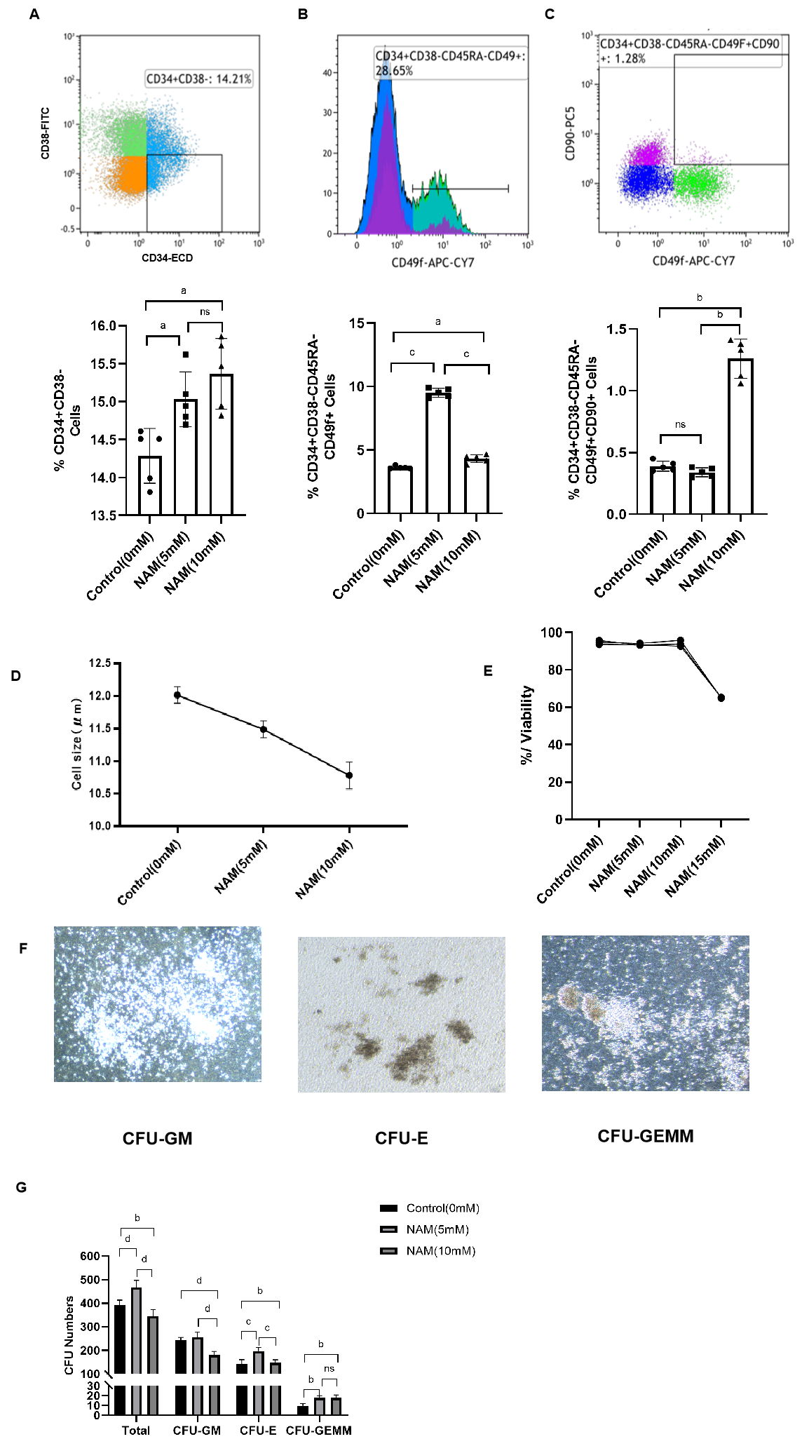
Figure 1 Proportion of hematopoietic stem and progenitor cells, short-term repopulating hematopoietic stem cells and long-term repopulating hematopoietic stem cells populations in each group of cultured cells. A: Phenotype (up) and proportion (down) of hematopoietic stem and progenitor cells; B: Phenotype (up) and proportion (down) of short-term repopulating hematopoietic stem cells (ST-HSCs); C: Phenotype (up) and proportion (down) of long-term repopulating HSCs; D: Cell size for each group of cells; E: Viability of each group of cells; F: Typical images of representative morphologies of various type of colonies as indicated; G: Colony formation assay showing the number of various types of cell colonies as indicated. The number of colony-forming unit (CFU)-erythroid, CFU-macrophage and CFU-granulocyte/erythroid/macrophage/megakaryocyte were scored. ªP < 0.05; ^{b}P < 0.01; ^{c}P < 0.001; ^{d}P < 0.0001; ns: Not significant. NAM: Nicotinamide; CFU-E: Colony-forming unit-erythroid; CFU-GM: Colony-forming unit-granulocyte, macrophage; CFU-GEMM: Colony-forming unit-granulocyte/erythroid/macrophage/megakaryocyte.

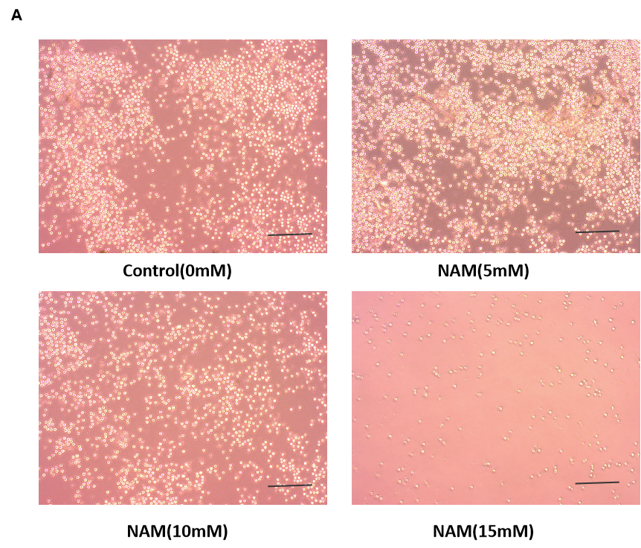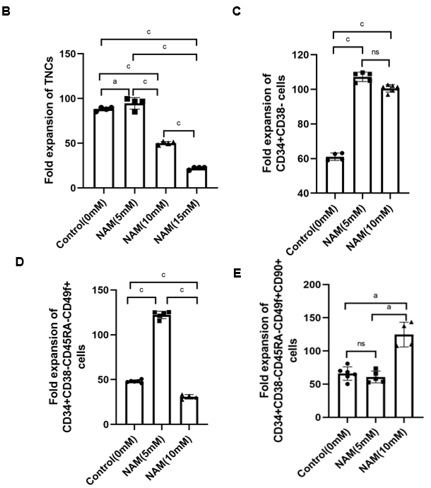
Figure 2 Expansion efficiency of subsets of hematopoietic stem cells in different concentrations of nicotinamide. A: Microscopic observation of cultured cells in each group (Bar = 200 μm); B: Fold expansion of total nucleated cells; C: Fold expansion of hematopoietic stem and progenitor cells; D: Fold expansion of short-term repopulating hematopoietic stem cells; E: Fold expansion of long-term repopulating hematopoietic stem cells. ªP < 0.05; ^{c}P < 0.001; ns: Not significant. NAM: Nicotinamide; TNC: Total nucleated cells.

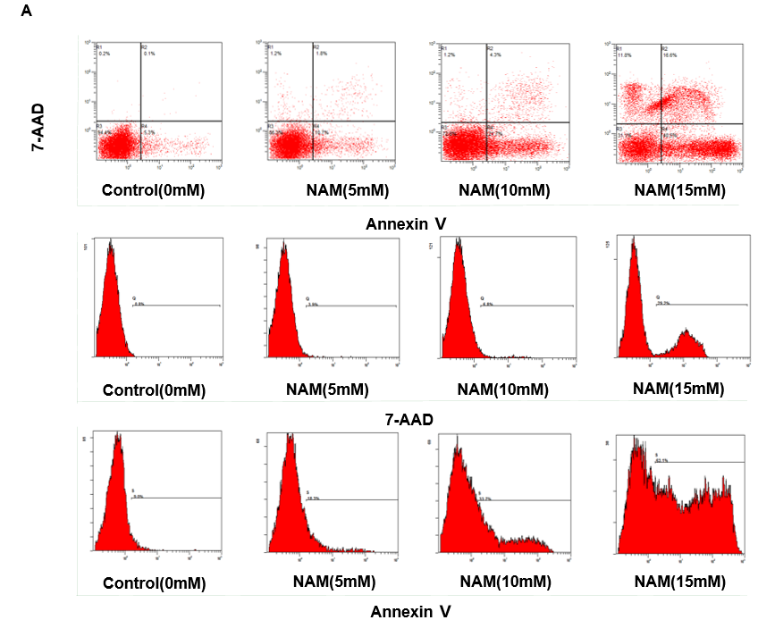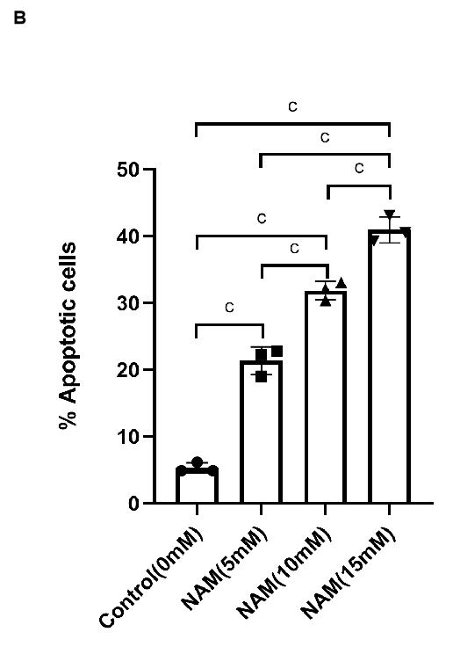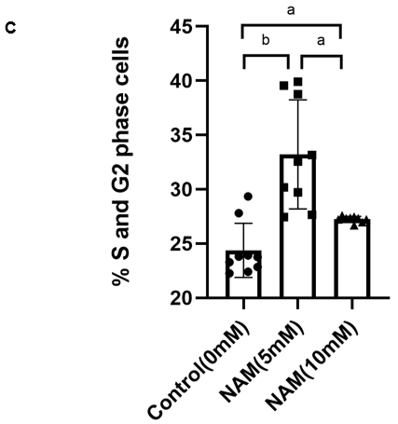
Figure 3 Effect of different concentrations of nicotinamide on the proportion of apoptotic cells and cell cycle distribution. A: Representative flow cytometry for apoptosis detection in each group; B: Proportion of apoptotic cells in each group; C: Comparison of cell cycle distribution among different groups. ªP < 0.05; ^{b}P < 0.01; ^{c}P < 0.001. NAM: Nicotinamide.

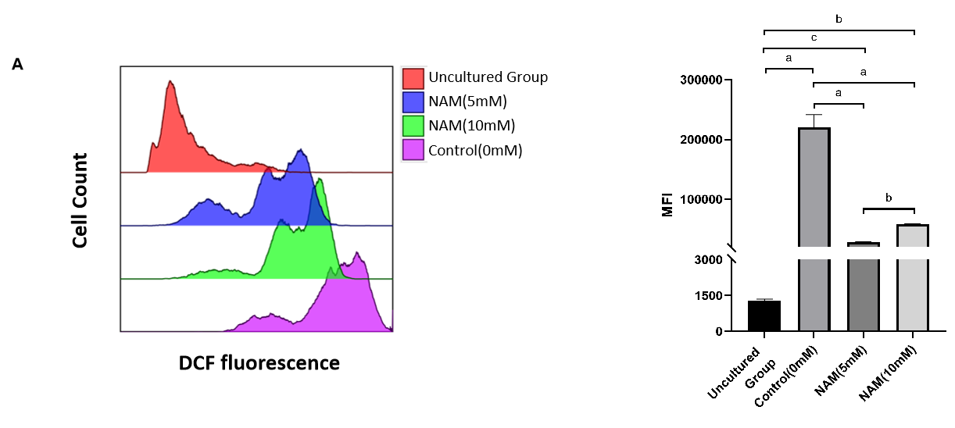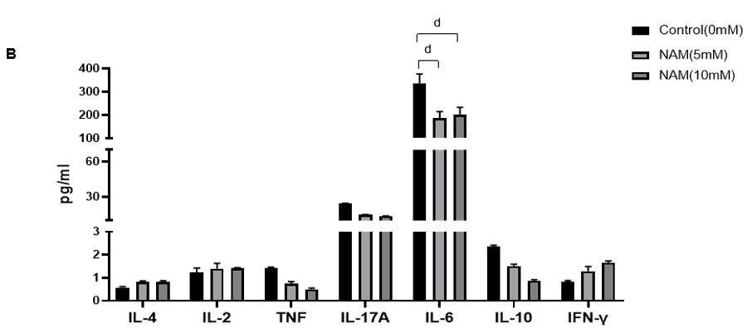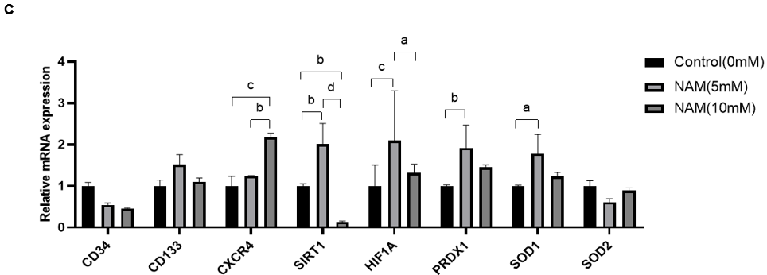
Figure 4 Effect of different concentrations of nicotinamide on reactive oxygen species content, cytokine levels, and gene expression in cultured hematopoietic stem cells. A: Reactive oxygen species in different groups of cells determined by mean fluorescence intensity; B: Cytokine levels in the supernatant of cultured cells in each group; C: Comparison of expression of genes encoding stemness-related factors, chemokines, components of hypoxia pathways, and antioxidant enzymes among different groups. ªP < 0.05; ^{b}P < 0.01; ^{c}P < 0.001; ^{d}P < 0.0001. NAM: Nicotinamide; PRDX1: Peroxiredoxin 1; SOD: Superoxide dismutase; IL: Interleukin; TNF: Tumor necrosis factor; IFN: Interferon.

