Name of journal: World Journal of Otorhinolaryngology
ESPS Manuscript NO: 19587
Manuscript Type: CASE REPORT

Thyroid lymphoma: A case report and literature review

Mehta K et al. Thyroid lymphoma

Kinneri Mehta, Cynthia Liu, Roy A Raad, Robin Mitnick, Ping Gu, David Myssiorek

Kinneri Mehta, David Myssiorek, Department of Otolaryngology, the New York University Langone Medical Center, New York, NY 10016, United States

Cynthia Liu, Department of Pathology, the New York University Langone Medical Center, New York, NY 10016, United States

Roy A Raad, Robin Mitnick, Department of Radiology, the New York University Langone Medical Center, New York, NY 10016, United States

Ping Gu, Department of Medical Oncology, the New York University Langone Medical Center, New York, NY 10016, United States

Author contributions: All authors contributed to the acquisition of data, writing, and revision of this manuscript.

Supported by The New York University Medical Center Institutional Review Board, New York, NY 10016, United States.

Institutional review board statement: All study participants, or their legal guardian, provided informed written consent prior to study enrollment.

Informed consent statement: The patient involved in this case study gave her written informed consent authorizing use and disclosure of her protected health information.

Conflict-of-interest statement: No conflict of interest to declare.

Open-Access: This article is an open-access article which was selected by an in-house editor and fully peer-reviewed by external reviewers. It is distributed in accordance with the Creative Commons Attribution Non Commercial (CC BY-NC 4.0) license, which permits others to distribute, remix, adapt, build upon this work non-commercially, and license their derivative works on different terms, provided the original work is properly cited and the use is non-commercial. See: http://creativecommons.org/licenses/by-nc/4.0/

Correspondence to: David Myssiorek, Medicine Doctor, Fellow of the American College of Surgeons, Department of Otolaryngology, the New York University Clinical Cancer Center, 160 E34th Street, 7th Floor, New York, NY 10016, United States. david.myssiorek@nyumc.org
Telephone: +1-212-7316085
Fax: +1-212-7315520

Received: May 13, 2015
Peer-review started: May 21, 2015
First decision: June 24, 2015
Revised: July 19, 2015
Accepted: August 13, 2015
Article in press:
Published online:

Abstract
Thyroid lymphoma is an unusual pathology. Different subtypes of lymphoma can present as primary thyroid lymphoma. This review illustrates via imaging, findings and treatment the need for accurate diagnosis and timely treatment. Patients and methods: patient’s chart, pathological findings and radiological images were reviewed in a retrospective analysis. Over several days, this 80 years old woman developed airway obstruction and rapid enlargement of her thyroid secondary to diffuse large B-cell lymphoma. She rapidly responded to her oncological protocol. Primary thyroid lymphoma is a rare disease. It is an important diagnosis to consider in patients presenting with rapidly enlarging neck masses. It is a treatable condition with fairly favorable overall survival even with the most aggressive histological subtypes.

Key words: Thyroid; Lymphoma; Review; Diagnosis; Treatment

© The Author(s) 2015. Published by Baishideng Publishing Group Inc. All rights reserved.

Core tip: An elderly woman presented with an enlarging neck mass and airway obstruction requiring intubation. After imaging and histologic work-up, the final diagnosis of the neck mass was primary thyroid lymphoma (PTL). PTL is an important diagnosis to be considered in patients presenting with rapidly enlarging neck masses, usually demonstrating significant response to chemotherapy and favorable prognosis. Tissue biopsy rather than fine needle aspiration is the current gold standard for definitive histologic diagnosis, adding the benefit of subtyping, a crucial prognostic indicator. Computed tomography or magnetic resonance imaging is helpful for staging these lymphomas. The role of surgery in treating this entity has been diminished.

A Raad R, Gu P, Liu C, Mehta K, Mitnick R, Myssiorek D. Thyroid lymphoma: A case report and literature review. World J Otorhinolaryngol 2015; In press
INTRODUCTION
Primary thyroid lymphoma (PTL) is a rare malignancy that has been estimated to constitute approximately 1%-5% of thyroid malignancies and 1%-2% of extranodal lymphomas^{[1-7]}. Its annual incidence is reportedly similar to that of anaplastic thyroid carcinoma, estimated as 2 per million per year^{[4,6]}. A number of retrospective studies and case reports have demonstrated PTL more commonly affects women with reported mean age of incidence in the sixties^{[3-5,8]}.
Herein, we present an illustrative case of thyroid lymphoma, its evaluation, differential diagnosis, treatment and follow up.

CASE REPORT
An 80 years old Chinese woman was brought to the emergency department for shortness of breath. The patient presented to an outside hospital with shortness of breath of one week duration two months prior to presentation. At that time, physical examination and computed tomography (CT) scan revealed an enlarged thyroid gland as well as right neck lymphadenopathy. She developed severe respiratory distress on hospital day two, was intubated and transferred to the intensive care unit (ICU). Ultrasound-guided fine needle aspiration (FNA) biopsy of the right neck mass as well as the enlarged thyroid gland was reportedly “benign” demonstrating “large lymphocytic predominance and atypical lymphoid cells” possibly due to Hashimoto’s thyroiditis, with “no phenotypic evidence of non-Hodgkin lymphoma”.
Ten days after the initial biopsy, the patient underwent a total thyroidectomy. The specimen was red-brown and spongy, contained two calcified nodules, and had scattered firm, yellow-gray areas comprising 40% of the gland. Pathology of the gland showed “lymphocytic thyroiditis and Hürthle cell adenoma with prominent areas of calcification and parathyroid parenchyma also present”. The pathology report attested that there was “no evidence of malignancy”.
After a complicated post-operative hospital course, with re-intubation due to respiratory distress, the patient was transferred to rehabilitation thirteen days following her surgery and was discharged in stable condition.
A few weeks following her discharge, she presented to our hospital with three days of worsening dyspnea and enlarging nodules in her neck. Despite stridor on arrival and multiple neck masses on exam, she had an oxygen saturation of 99% on room air. Neck CT scan revealed marked enlargement of the thyroid parenchyma with indistinct margins, mild laryngeal compression and soft tissue extension into the upper mediastinum to the left of the trachea. It also demonstrated extensive lymphadenopathy involving levels IA, IIA, IIB, V and the supraclavicular area (Figure 1).
Airway compromise and CT findings demonstrating ragged involvement of the trachea prompted an emergent awake fiberoptic intubation and open left neck lymph node biopsy. The pathology revealed diffuse large B-cell lymphoma, non-germinal center B-cell type. Immunohistochemical staining revealed the neoplastic cells being CD20 (+), CD10 (-), Bcl-2 (+), Bcl-6 (+), MUM1 (+), EBER (-), with a high proliferation index (Ki-67: 70%-80%), thought to indicate a more aggressive clinical course (Figure 2). Flow cytometry revealed a population of CD5 (-), CD10 (-), dim lambda light chain restricted large B-cells, most compatible with large B-cell lymphoma.
Staging included bone marrow biopsy, echocardiogram, and CT of the chest and abdomen. Flow cytometry, morphology and cytogenetic testing did not show evidence of marrow involvement. Chest CT demonstrated a soft tissue infiltrative mass measuring approximately 5.1 cm × 6.4 cm in the thyroid gland region, consistent with known B-cell lymphoma. Cycle one of R-CHOP chemotherapy (Rituximab, Cyclophosphamide, Doxorubicin, Vincristine, Prednisone) was initiated.
The patient was successfully extubated 48 h after initiating chemotherapy. Follow-up neck CT demonstrated marked decrease in the size of the thyroid gland with numerous left neck pathologic lymph nodes that remained prominent or mildly enlarged, however also decreased in size (Figure 3). The patient was discharged on day six of R-CHOP cycle one. The patient received additional cycles of R-CHOP as an outpatient, completing a total of six cycles. Staging whole-body 18-Fluorine fluorodeoxyglucose (FDG) PET/CT scan confirmed stage II diffuse large B-cell lymphoma. The scan demonstrated focal increased uptake in the region of the right thyroid gland, bilateral cervical lymph nodes, decreased in size and in number since the neck CT scan from one week prior, and minimally FDG avid residual uptake in the left supraclavicular zone and left subpectoral lymph nodes, also decreased in size (Figure 4).
Differential diagnosis for sudden growth of a thyroid mass includes spontaneous hemorrhage in a benign goiter, development of anaplastic thyroid carcinoma or thyroid lymphoma^{[9]}. In one of the largest retrospective studies of PTL to date, Derringer et al^{[8]} reported that all patients presented with a mass in the thyroid gland, which was noticeably enlarging in 72% of cases. Symptoms such as dyspnea, choking, coughing and hemoptysis, occurring secondary to compression or infiltration of neck organs by the mass, occurred in 31% of cases. Less commonly, classic B symptoms of fever, nights sweats and weight loss, also occur at presentation in approximately 10% of cases^{[6]}. The duration of symptoms before diagnosis ranges from a few days to 36 mo, with a shorter duration in those with diffuse large B-cell lymphoma^{[10]}.

DISCUSSION
Pathogenesis: Hashimoto’s thyroiditis
As numerous retrospective studies have demonstrated, there is an association between chronic lymphocytic thyroiditis, also known as Hashimoto’s thyroiditis (HT), and the development of PTL. In a retrospective study of 171 patients diagnosed with PTL in Tokyo, Japan, authors report the incidence rate of PTL in HT patients as 16 persons per year per 10000 persons, significantly higher than the incidence of PTL in the Japanese general population^{[11]}. Agrawal et al^{[1]} report that circulating anti-thyroid peroxidase antibodies have been found in 60%-80% of patients with PTL again further suggesting underlying lymphocytic thyroiditis as a predisposing factor for the development of PTL. Green et al^{[6]} report that in patients with HT, the risk of PTL is at least 60 times higher than in patients without thyroiditis.
HT can be histologically seen in > 90% of cases of PTL. The pathogenesis of this relationship remains more or less obscure. It has been postulated that the relationship between these diseases is related to the presence of lymphocytes in HT, which provide the cells in which lymphoma may develop and to the chronic antigenic stimulation that is seen in HT, which predisposes malignant transformation of these lymphocytes^{[6]}. In the effort of further clarifying the argument that PTL may evolve from HT, Moshynska et al^{[12]} investigated a sequence similarity between HT and PTL: they reported clonal similarity in the IG heavy chain rearrangement sequences in the clonal bands of HT and PTL from the same patients, providing additional evidence that PTL may evolve from HT.
It is conceivable that the theory of antigenic stimulation explains the potential pathogenesis of PTL, especially given the potential parallel with gastric mucosal-associated lymphoid tissue (MALT) lymphoma in which H. Pylori provides the chronic antigenic stimulation^{[13]}. Takakuwa et al^{[5]} showed that aberrant somatic hypermutation which has previously been attributed to the development of proto-oncogenes in other types of diffuse large B-cell lymphoma (DLBCL), may play a role in the process of thyroid lymphogenesis in patients with HT, as well.
Head and neck irradiation is a known risk factor for the development of most thyroid cancers. It is unknown whether this predisposes patients to PTL. One study has suggested a potential link between EBV and the development of PTL^{[14]}. HT is the only well known risk factor for the development of PTL.

Histological subtypes
Four main subtypes of PTL include extranodal marginal zone lymphoma of MALT, DLBCL without marginal zone lymphoma, DLBCL with marginal zone lymphoma (mixed) and follicular lymphoma (FL). Less common histological subtypes include Hodgkin lymphoma, small lymphocytic lymphoma and Burkitt lymphoma^{[8]}.

Diffuse large B-cell lymphoma
Not only is DLBCL the most common type of lymphoma worldwide, it is also the most common subtype of thyroid lymphoma, comprising 60%-85% cases of PTL^{[15]}. Histologically, DLBCL of the thyroid consists of a relatively uniform population of large, abnormal lymphoid cells with lymphoepithelial foci and decreased or absent colloid and the presence of nuclear abnormalities^{[10]}. DLBCL is typically positive for B-cell antigens, CD20 and CD19, and is often Bcl-6 positive, Approximately half of cases are Bcl-2 positive^{[5,10]}. CD5, CD10 and CD23 are usually negative^{[5]}. Evaluation of Bcl-6 and MUM1 expression can help further classify DLBCL into germinal center B-cell type (GCB) and non-GCB type. This is helpful in determining prognosis. DLBCL with CD10 (+) or CD10(-)/Bcl-6(+)/Mum1(-) phenotype is classified as GC type, while CD10(-)/Bcl-6+/Mum1(+) is classified as NGC type^{[16]}. Positive cytoplasmic staining for nm23-H1 and non-GCB subgroup DLBCL is also associated with poorer prognosis^{[5,17]}.

Extranodal marginal zone lymphoma of MALT lymphoma
The second most common subtype of PTL is MALT lymphoma. In contrast to DLBCL, patients are five times less likely to die with MALT compared to DLBCL PTL^{[5]}. Histologically, MALT lymphoma of the thyroid is described as highly cellular with a prominent population of intermediate-sized lymphoid cells, lymphoepithelial lesions, reactive lymphoid follicles and a plasma-cell component. MALT thyroid lymphomas are typically positive for the B-cell phenotype.
The distinction of MALT thyroid lymphoma in the background of HT is a challenge when there is a predominance of small lymphoid cells. Although lymphoepithelial lesions are highly associated with MALT, they are not a specific finding^{[18]}. Takano et al^{[19]} described a novel method using vectorette polymerase chain reaction (PCR) to distinguish MALT thyroid lymphoma from HT based on the monoclonality of the immunoglobulin heavy chain immunoreactive growth hormone (IGH) gene, which was detected in 76.7% of lymphomas and conversely, not detected in 10 samples of tissue from patients with HT.

Mixed histology
In addition to pure DLBCL, and pure MALT lymphoma of the thyroid, there are also cases with mixed presentation of DLBCL and MALT features. The mixed histological subtype accounts for approximately one-third of cases of PTL^{[10]}.

Follicular lymphoma
The fourth major subtype, follicular lymphoma (FL), accounts for approximately 10% or less of PTL cases. Histologically, FL usually demonstrates a typically follicular lymphoma morphology, with neoplastic nodules of mixed centrocytes and centroblasts^{[12]}. FL can be distinguished from MALT by positive staining for CD10 and Bcl-6, the presence of typical follicular architecture and the lack of immunoglobulin heavy chain expression^{[5]}.
In FL, Bcl-2 positive staining is associated with disseminated disease, whereas Bcl-2 negative staining is more likely to be localized.

Prognosis of thyroid lymphoma
Prognostically, when stratified by histologic subtype, the 5-year disease specific survival of DLBCL is 75%. MALT responds very well to treatment and has a 5-year disease specific survival of > 95%, and FL falls in between the two with a 5-year disease specific survival of 87%^{[4]}. Not only is the accurate identification of PTL subtype by histology very important for prognostic reasons, more importantly, therapeutic intervention largely depends on histologic subtype as well as stage; therefore, accurate histologic diagnosis is critical.

Diagnosis
Since the introduction of fine needle aspiration (FNA) for the assessment of thyroid masses in the 1980s, FNA has been established as one of the first diagnostic procedures performed for patients with a thyroid mass or nodule and did allow the diagnosis of PTL to be made without surgical intervention in many cases. However, the role in PTL is questionable and the accuracy of FNA for PTL has been reported to range from 25% to 90%^{[3]}. False-negative results may be caused by sampling error as HT may coexist with MALT^{[20]}.
Furthermore, when FNA is combined with flow cytometry, it can give a complete diagnosis in 82% of cases. Nonetheless, tissue biopsy remains the gold standard for histological diagnosis^{[15]}, especially in distinguishing thyroiditis from MALT lymphoma and in ensuring that aggressive histologies are not missed, especially in mixed histology disease^{[10]}. When FNA suggests but does not confirm PTL, open biopsy is suggested for further histological confirmation^{[14,21]}.
Imaging studies may play a potential role in diagnostic and pretreatment evaluation. Ultrasound has long been the standard imaging modality for thyroid pathology, but its utility in PTL is debated. Ultrasonographic patterns of PTL have been classified into three types; nodular, diffuse and mixed^{[22]}. Posterior acoustic enhancement, or posterior echoes, are characteristic of all three types and can help distinguish lymphoma from other thyroid pathology^{[10,22,23]}. The nodular type is characteristically limited to one lobe, with a defined separation between lymphomatous and non-lymphomatous tissue, and hypoechoic, homogeneous and pseudocystic internal echoes^{[10,22]}. In comparison, the diffuse type demonstrates enlargement of both lobes, with hypoechoic internal echoes and indistinct borders between lymphomatous and non-lymphomatous tissue^{[10,22]}. In a prospective study of 165 patients with suspected PTL based on ultrasound, 47.9% were pathologically confirmed. The positive predictive value of ultrasound was higher for the nodular type (64.9%) and the mixed type (63.2%) than for the diffuse type (33.7%), possibly secondary to resemblance of the diffuse type to thyroiditis^{[10]}. Though the individual utility of these ultrasonographic findings is limited, when used for guidance purposes with FNA or core needle biopsy, ultrasound may play a more important role in PTL.
As patients with PTL may present with rapidly enlarging masses and symptoms of compression, CT scan is often obtained in the emergency room. Previous reports of imaging characteristics of PTL as outlined by Kim et al^{23]} suggest PTL appears as a homogeneously enhancing mass without invasion of the surrounding structures on CT scan; however, two cases they described demonstrated heterogeneous enhancement compared to surrounding muscles without calcification or hemorrhage[. Klyachkin et al^{[24]} reported that imaging studies were of little help in diagnosing PTL and that CT scan cannot differentiate non-Hodgkin’s thyroid lymphoma from other thyroid tumors. Nonetheless, CT scan remains important for staging as well as for the assessment of airway compromise.

Treatment
Over the past thirty years, the treatment paradigm for PTL has shifted. Although previously managed surgically, PTL treatment has evolved with the introduction of effective chemotherapeutic regimens. Treatment of PTL is now dependent on histological subtype. In a retrospective study analyzing patterns of care over the last two decades, Cha et al^{[3]} found that before 2006, the mainstay of treatment was surgery and 8 of 10 patients with high grade lymphoma (DLBCL, Mixed, Burkitt) were treated with thyroidectomy followed by adjuvant treatment, while after 2006, only 1 of 11 patients received surgery and the rest were diagnosed by biopsy with subsequent chemotherapy. In a study of 1 408 patients with PTL over 32 years, similar declines in the use of surgery were noted. 81% of patients were surgically treated between 1983-1987 and only 61% were surgically treated between 1997-2005^{[4]}.
Though surgery still plays a role in diagnosis, and possibly in early stage locoregional treatment of more indolent disease as well as in palliative treatment for compressive symptoms, chemotherapy with or without radiotherapy is the mainstay of treatment. Current treatment recommendations for PTL are histology specific. MALT lymphoma is a more indolent disease, and some have proposed that it can be treated with single modality, locoregional therapy (surgery/radiotherapy). Thieblemont et al^{[25]} found that overall and disease free survival at five years of 100% in five patients with stage IE or IIE MALT PTL treated with thyroidectomy alone. Surgery and radiation were associated with improved disease specific survival for early stage disease, and a study of 62 patients from Mayo clinic found thyroidectomy with adjuvant chemotherapy provided long-term cure for PTL contained within the capsule^{[4]}. Meanwhile, Klyachkin et al^{[24]} attest that the role of surgery for stage IE and IIE is still debated and survival rates do not seem to be improved when radical surgery is added to the treatment regimen.
Localized therapy such as surgery or radiotherapy may be an option for indolent disease such as MALT or FL. DLBCL is typically a more aggressive form of PTL and chemotherapy is required. CHOP is the most commonly used treatment regimen. Rituximab, approved by the FDA in 2006, is a monoclonal B-cell antibody that selectively binds to CD20 antigen on pre-B and mature B-lymphocytes^{[5]}. In a trial of 197 patients, Coiffier et al^{[26]} compared outcomes with CHOP alone and CHOP plus rituximab therapy, finding significant benefit of R-CHOP compared to CHOP alone in the treatment of both patients with low risk disease and those with high-risk disease.
In addition to the combination of CHOP and rituximab, combined modality treatment with chemotherapy and radiation has also been considered in the literature. In a review of 12 reported studies of a total of 211 patients, Doria et al^{[7]} found a benefit of combined chemoradiation therapy with significantly lower relapse rates. In another study of 51 patients with stage IE or IIE thyroid lymphoma, the 5-year failure-free survival by treatment was 76% for surgery/radiation, 50% for chemotherapy alone and 91% for combined multimodality treatment^{[7]}.
Although PTL is a rare disease, it is an important diagnosis to consider in patients presenting with rapidly enlarging neck masses. It is a treatable condition with fairly favorable overall survival even in with the most aggressive histological subtype.
In conclusion, this case supports the literature in regard to epidemiology, presentation and other characteristics of PTL. Additionally, it raises questions regarding efficacy of FNA, the possibility of sampling error and the potential for human error in pathologic tissue examination. If our patient had pathologic evidence of DLBCL at her initial presentation, the case also demonstrates the futility of surgical intervention with thyroidectomy given the rapid recurrence of symptoms in the absence of systemic intervention. Though the rarity of PTL precludes clinical trials of treatment regimens, it appears that data extrapolated from retrospective studies and other extranodal lymphomas has great value in the treatment of PTL. Based on FNA, if PTL is suspected, it is suggested that definitive pathology be obtained, which can be accomplished by core biopsy or open biopsy. Once the diagnosis is established, the treatment of PTL is similar to systemic lymphoma treatment.

COMMENTS
Case characteristics
A 80 years old woman with a rapidly enlarging neck mass and airway compromise.

Clinical diagnosis
The patient had a primary non Hodgkin B-cell thyroid lymphoma.

Differential diagnosis
The differential diagnosis for sudden and rapid growth of a thyroid mass includes spontaneous hemorrhage into a benign goiter, anaplastic thyroid carcinoma and thyroid lymphoma.

Laboratory diagnosis
Flow cytometry performed on the left lymph node sample revealed a population of CD5 (-), CD10 (-), dim lambda light chain restricted large B-cells, most compatible with large B-cell lymphoma.

Imaging diagnosis
Neck computed tomography (CT) demonstrated a large infiltrative thyroid mass with associated airway compromise and extensive bilateral cervical/supraclavicular lymphadenopathy, however neck CT and 18-Fluorine fluorodeoxyglucose positron emission tomography/CT one week following resection demonstrated decreasing size and number of the lymph nodes.

Pathological diagnosis
Fine needle aspiration and subsequent left neck lymph node biopsy revealed diffuse large B-cell lymphoma, non-germinal center B-cell type.

Treatment
Patients with an IPI greater than 1 should be managed with six courses of R-CHOP, and these results can be applied to primary thyroid lymphoma.

Related reports
Please see the references.

Term explanation
All terms used in this manuscript are standard medical/pathological nomenclature.

Experience and lessons
This case demonstrates the aggressive nature of primary thyroid lymphoma and how to arrive at a diagnosis in patients with rapidly evolving thyroid masses. It denotes the possible pitfalls of histologic analysis, the futility of surgical intervention and the effectiveness of chemotherapy in treating this disease.

Peer-review
This manuscript is a rare case report and literature review, which is significant to guide clinicians both to raise awareness of this kind of disease and to standardize its diagnosis and treatment.

REFERENCES
1 Agarwaf N, Wangnoo SK, Sidiqqi A, Gupt M. Primary thyroid lymphoma: a series of two cases and review of literature. J Assoc Physicians India 2013; 61: 496-498 [PMID: 24772759]
2 Alzouebi M, Goepel JR, Horsman JM, Hancock BW. Primary thyroid lymphoma: the 40 year experience of a UK lymphoma treatment centre. Int J Oncol 2012; 40: 2075-2080 [PMID: 22367111]
3 Cha H, Kim JW, Suh CO, Kim JS, Cheong JW, Lee J, Keum KC, Lee CG, Cho J. Patterns of care and treatment outcomes for primary thyroid lymphoma: a single institution study. Radiat Oncol J 2013; 31: 177-184[PMID: 24501704 DOI: 10.3857/roj.2013.31.4.177]
4 Graff-Baker A, Roman SA, Thomas DC, Udelsman R, Sosa JA. Prognosis of primary thyroid lymphoma: demographic, clinical, and pathologic predictors of survival in 1,408 cases. Surgery 2009; 146: 1105-1115[PMID: 19958938 DOI: 10.1016/j.surg.2009.09.020]
5 Graff-Baker A, Sosa JA, Roman SA. Primary thyroid lymphoma: a review of recent developments in diagnosis and histology-driven treatment. Curr Opin Oncol 2010; 22: 17-22[PMID: 19844180 DOI: 10.1097/CCO.0b013e3283330848]
6 Green LD, Mack L, Pasieka JL. Anaplastic thyroid cancer and primary thyroid lymphoma: a review of these rare thyroid malignancies. J Surg Oncol 2006; 94: 725-736[PMID: 17131397 DOI: 10.1002/jso.20691]
7 Mack LA, Pasieka JL. An evidence-based approach to the treatment of thyroid lymphoma. World J Surg 2007; 31: 978-986[PMID: 17235456 DOI: 10.1007/s00268-005-0768-z]
8 Derringer GA, Thompson LD, Frommelt RA, Bijwaard KE, Heffess CS, Abbondanzo SL. Malignant lymphoma of the thyroid gland: a clinicopathologic study of 108 cases. Am J Surg Pathol 2000; 24: 623-639[PMID: 10800981 DOI: 10.1097/00000478-200005000-00001]
9 Eng OS, Lesniak S, Davidov T, Trooskin SZ. Diagnosing thyroid lymphoma: steroid administration may result in rapid improvement of dyspnea: a report of two cases. Int J Endocrinol Metab 2014; 12: e11463 [PMID: 24696693 DOI: 10.5812/ijem.11463]
10 Stein SA, Wartofsky L. Primary thyroid lymphoma: a clinical review. J Clin Endocrinol Metab 2013; 98: 3131-3138[PMID: 23714679 DOI: 10.1210/jc.2013-1428]
11 Watanabe N, Noh JY, Narimatsu H, Takeuchi K, Yamaguchi T, Kameyama K, Kobayashi K, Kami M, Kubo A, Kunii Y, Shimizu T, Mukasa K, Otsuka F, Miyara A, Minagawa A, Ito K, Ito K. Clinicopathological features of 171 cases of primary thyroid lymphoma: a long-term study involving 24553 patients with Hashimoto's disease. Br J Haematol 2011; 153: 236-243 [PMID: 21371004 DOI: 10.1111/j.1365-2141.2011.08606.x]
12 Moshynska OV, Saxena A. Clonal relationship between Hashimoto thyroiditis and thyroid lymphoma. J Clin Pathol 2008; 61: 438-444[PMID: 18006670 DOI: 10.1136/jcp.2007.051243]
13 Ansell SM, Grant CS, Habermann TM. Primary thyroid lymphoma. Semin Oncol 1999; 26: 316-323[PMID: 10375088]
14 Matsuzuka F, Miyauchi A, Katayama S, Narabayashi I, Ikeda H, Kuma K, Sugawara M. Clinical aspects of primary thyroid lymphoma: diagnosis and treatment based on our experience of 119 cases. Thyroid 1993; 3: 93-99[PMID: 8369658 DOI: 10.1089/thy.1993.3.93 DOI: 10.1089/thy.1993.3.93]
15 Katna R, Shet T, Sengar M, Menon H, Laskar S, Prabhash K, D'Cruz A, Nair R. Clinicopathologic study and outcome analysis of thyroid lymphomas: experience from a tertiary cancer center. Head Neck 2013; 35: 165-171[PMID: 22368156 DOI: 10.1002/hed.22928]
16 Hans CP, Weisenburger DD, Greiner TC, Gascoyne RD, Delabie J, Ott G, Müller-Hermelink HK, Campo E, Braziel RM, Jaffe ES, Pan Z, Farinha P, Smith LM, Falini B, Banham AH, Rosenwald A, Staudt LM, Connors JM, Armitage JO, Chan WC. Confirmation of the molecular classification of diffuse large B-cell lymphoma by immunohistochemistry using a tissue microarray. Blood 2004; 103: 275-282[PMID: 14504078 DOI: 10.1182/blood-2003-05-1545]
17 Niitsu N, Okamoto M, Nakamura N, Nakamine H, Bessho M, Hirano M. Clinicopathologic correlations of stage IE/IIE primary thyroid diffuse large B-cell lymphoma. Ann Oncol 2007; 18: 1203-1208[PMID: 17429099 DOI: 10.1093/annonc/mdm094]
18 Morgen EK, Geddie W, Boerner S, Bailey D, Santos Gda C. The role of fine-needle aspiration in the diagnosis of thyroid lymphoma: a retrospective study of nine cases and review of published series. J Clin Pathol 2010; 63: 129-133[PMID: 20154034 DOI: 10.1136/jcp.2009.071423]
19 Takano T, Miyauchi A, Matsuzuka F, Yoshida H, Notomi T, Kuma K, Amino N. Detection of monoclonality of the immunoglobulin heavy chain gene in thyroid malignant lymphoma by vectorette polymerase chain reaction. J Clin Endocrinol Metab 2005; 90: 720-723[PMID: 15536159 DOI: 10.1210/jc.2004-0951]
20 Sangalli G, Serio G, Zampatti C, Lomuscio G, Colombo L. Fine needle aspiration cytology of primary lymphoma of the thyroid: a report of 17 cases. Cytopathology 2001; 12: 257-263[PMID: 11488875 DOI: 10.1046/j.1365-2303.2001.00338.x]
21 Meyer-Rochow GY, Sywak MS, Reeve TS, Delbridge LW, Sidhu SB. Surgical trends in the management of thyroid lymphoma. Eur J Surg Oncol 2008; 34: 576-580[PMID: 17604588 DOI: 10.1016/j.ejso.2007.04.016]
22 Nam M, Shin JH, Han BK, Ko EY, Ko ES, Hahn SY, Chung JH, Oh YL. Thyroid lymphoma: correlation of radiologic and pathologic features. J Ultrasound Med 2012; 31: 589-594[PMID: 22441916]
23 Kim EH, Kim JY, Kim TJ. Aggressive primary thyroid lymphoma: imaging features of two elderly patients. Ultrasonography 2014; 33: 298-302[PMID: 25060184 DOI: 10.14366/usg.14025]
24 Klyachkin ML, Schwartz RW, Cibull M, Munn RK, Regine WF, Kenady DE, McGrath PC, Sloan DA. Thyroid lymphoma: is there a role for surgery? Am Surg 1998; 64: 234-238[PMID: 9520813]
25 Thieblemont C, Mayer A, Dumontet C, Barbier Y, Callet-Bauchu E, Felman P, Berger F, Ducottet X, Martin C, Salles G, Orgiazzi J, Coiffier B. Primary thyroid lymphoma is a heterogeneous disease. J Clin Endocrinol Metab 2002; 87: 105-111[PMID: 11788631 DOI: 10.1210/jcem.87.1.8156]
26 Coiffier B, Lepage E, Briere J, Herbrecht R, Tilly H, Bouabdallah R, Morel P, Van Den Neste E, Salles G, Gaulard P, Reyes F, Lederlin P, Gisselbrecht C. CHOP chemotherapy plus rituximab compared with CHOP alone in elderly patients with diffuse large-B-cell lymphoma. N Engl J Med 2002; 346: 235-242[PMID: 11807147 DOI: 10.1056/NEJMoa011795]

P-Reviewer: Kan LX, Zhang Q S-Editor: Ji FF L-Editor: E-Editor:

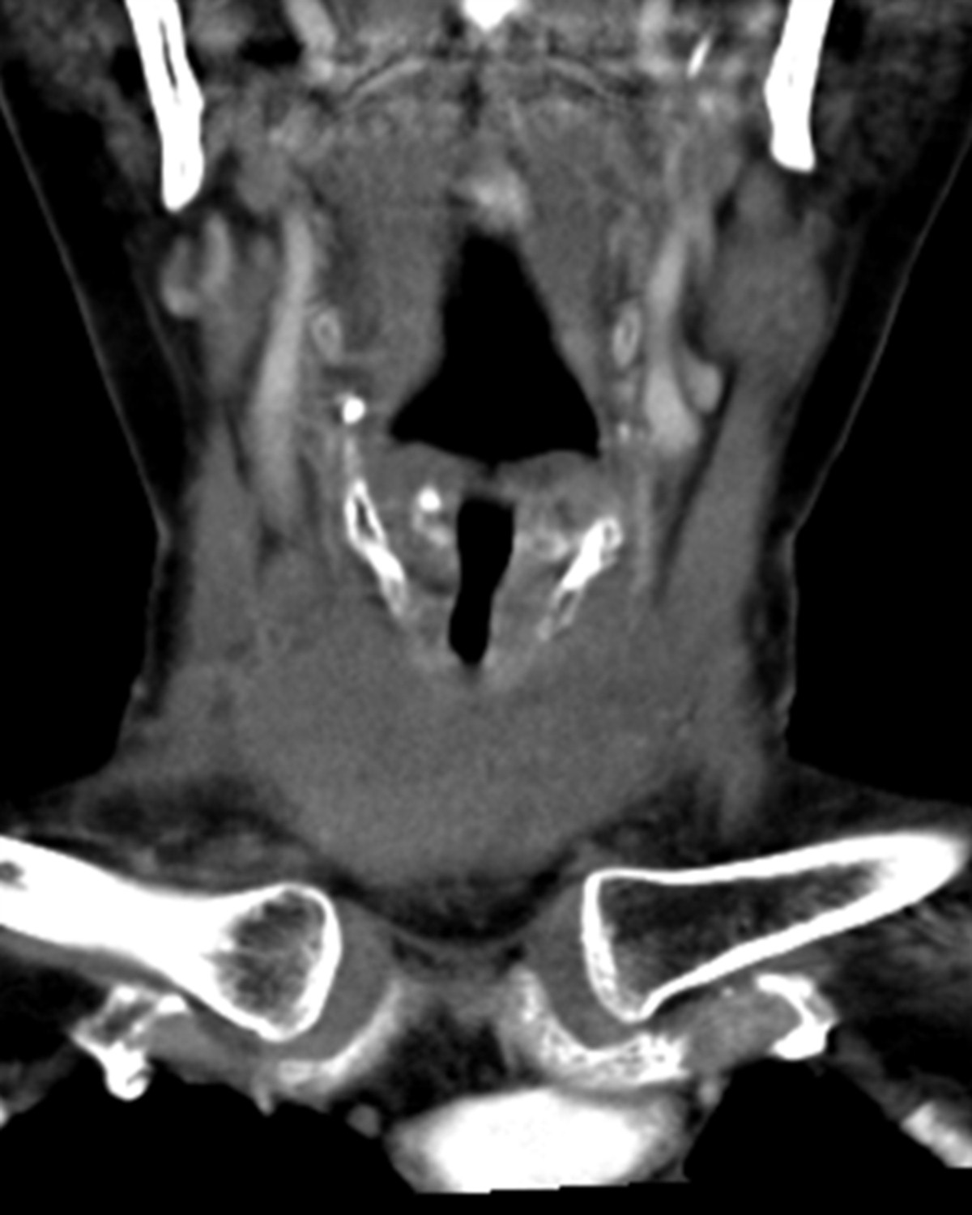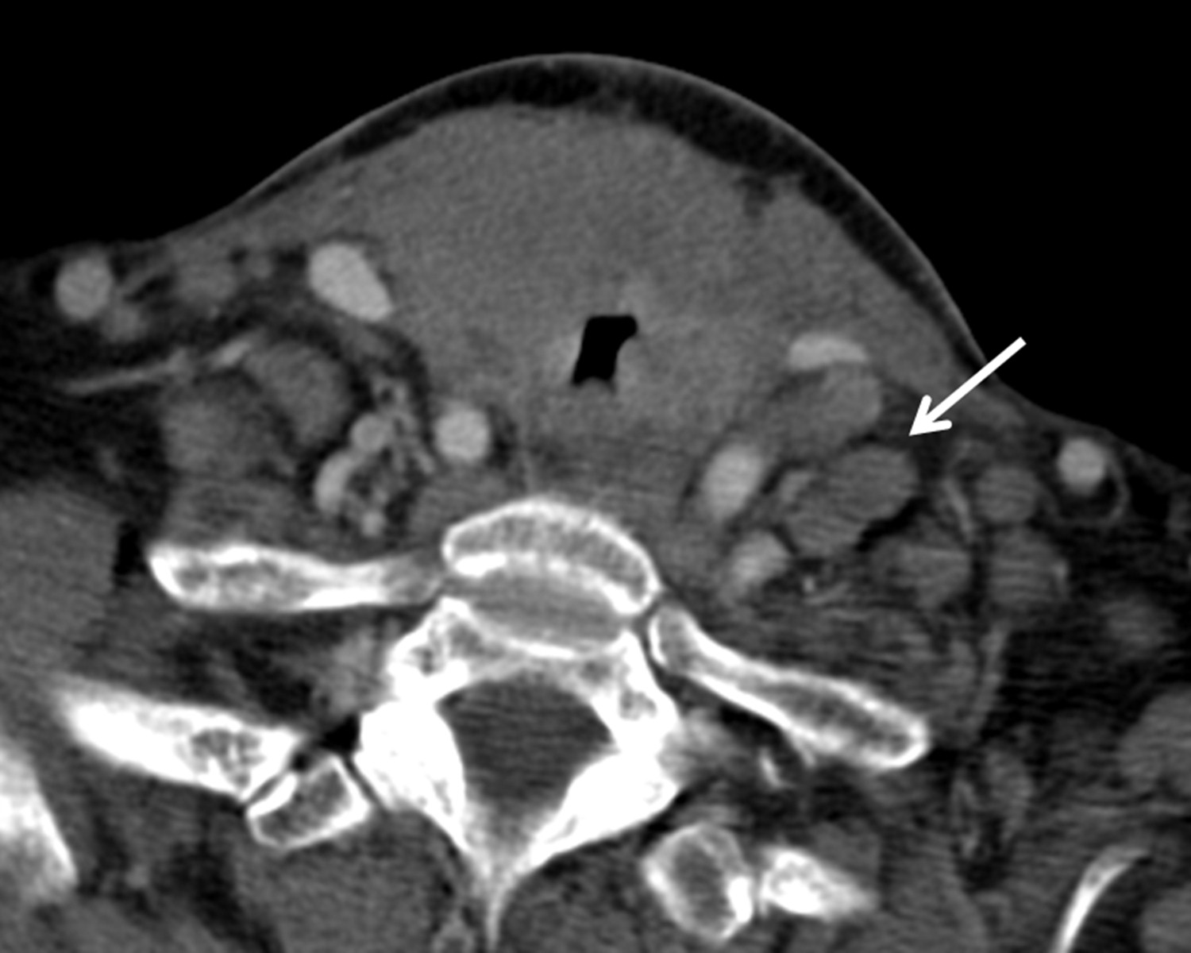
Figure 1 Axial and coronal contrast-enhanced neck computed tomography images demonstrate a large ill-defined low-attenuation mass infiltrating the thyroid gland with associated significant airway narrowing. Arrow indicates cervical adenopathy.

Figure 2 Histological and immunohistochemical photographs of left cervical lymph node. A: Hematoxylin and eosin staining, 400 ×; B: Anti-CD20 staining, 400 ×; C: Anti-MUM-1 staining, 400 ×; D: Anti-ki-67 staining, 400 ×.

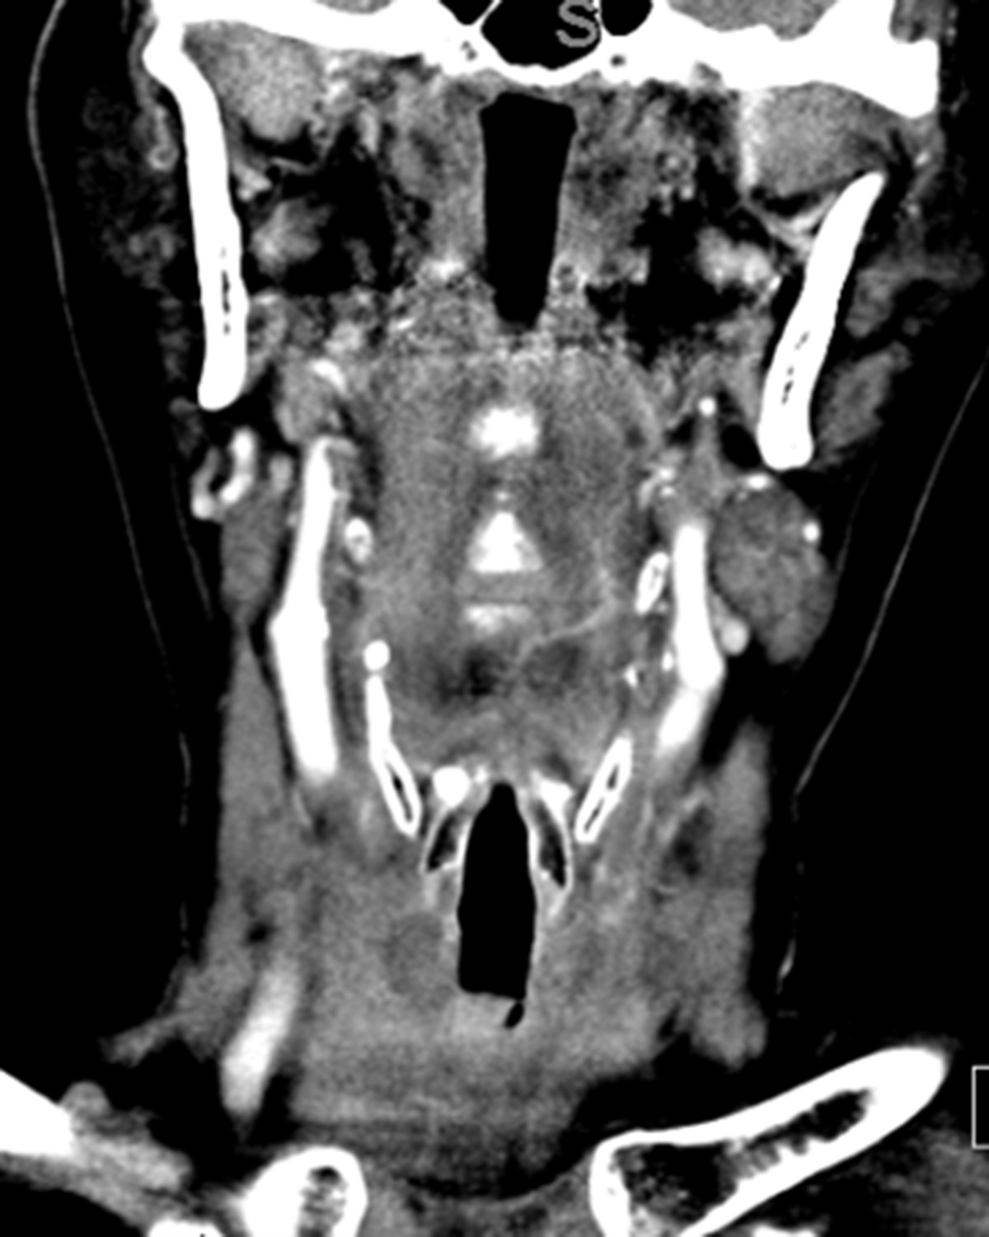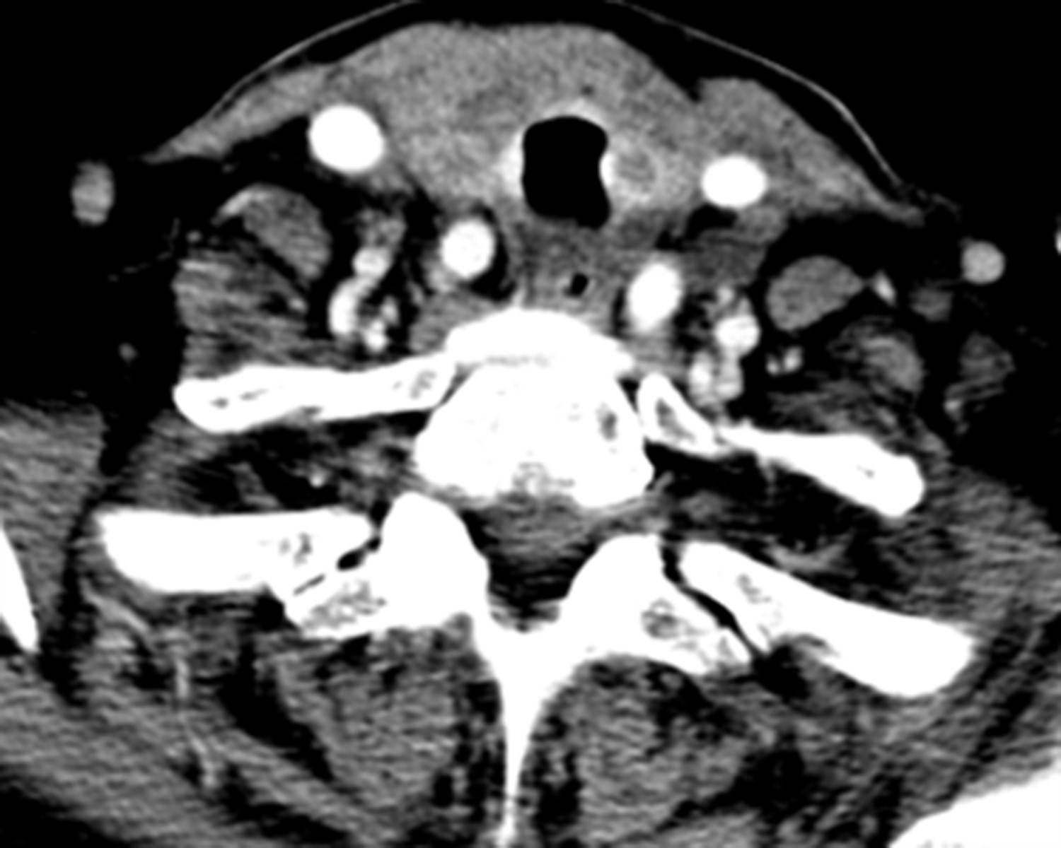
Figure 3 Post treatment computed tomography images of the neck demonstrating improvement in the airway narrowing and adenopathy (5 d after initiating therapy).

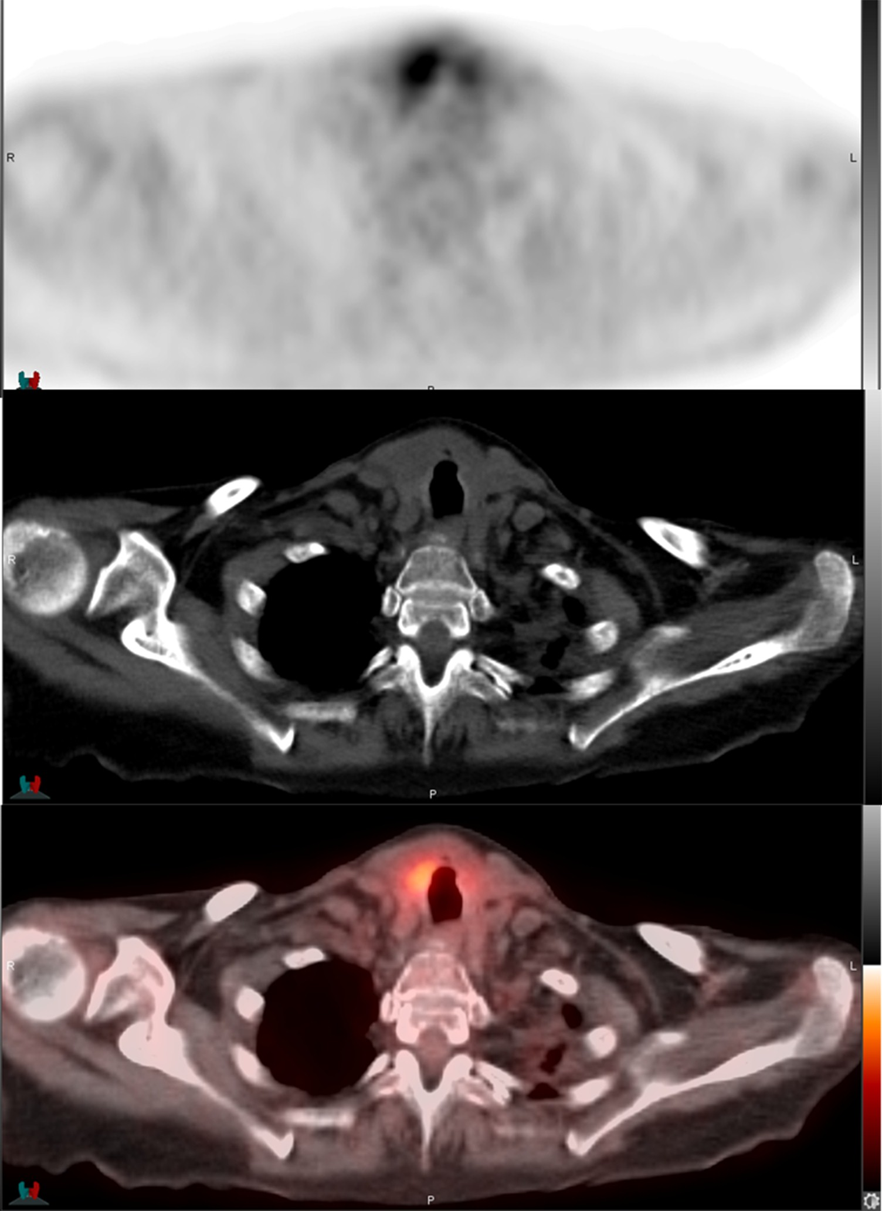
Figure 4 Axial positron emission tomography, computed tomography, and fusion images. They performed 2 wk following initiation of therapy, demonstrating focal intense FDG uptake (SUV_{max} = 6.4) within an enlarged right hemithyroid demonstrating heterogeneous CT density, consistent with the biopsy-proven lymphomatous infiltration of the right hemithyroid. PET: Positron emission tomography; CT: Computed tomography; SUV_{max}: Maximum.

