Name of Journal: World Journal of Clinical Cases
Manuscript NO: 56287
Manuscript Type: ORIGINAL ARTICLE

Retrospective Study
High serum lactate dehydrogenase and dyspnea: Positive predictors for adverse event with critical COVID-19 patients in Yichang

Lv XT et al. Positive predictors of critical COVID-19 patients

Xiao-Ting Lv, Yong-Ping Zhu, Ai-Guo Cheng, Yong-Xu Jin, Hai-Bo Ding, Cai-Yun Wang, Shu-Yu Zhang, Gong-Ping Chen, Qing-Quan Chen, Qi-Cai Liu

Xiao-Ting Lv, Yong-Xu Jin, Hai-Bo Ding, Cai-Yun Wang, Gong-Ping Chen, Department of Respiratory and Critical Care Medicine, the First Affiliated Hospital of Fujian Medical University, Fuzhou 350005, Fujian Province, China

Xiao-Ting Lv, Institute of Respiratory Disease, Fujian Medical University, Fuzhou 350005, Fujian Province, China

Yong-Ping Zhu, Department of Cardiovascular Surgery, Fujian Medical University Attached Union Hospital, Fuzhou 350001, Fujian Province, China

Ai-Guo Cheng, Department of Critical Medicine, the Third People's Hospital of Yichang, Yichang 443000, Hubei Province, China

Shu-Yu Zhang, Qing-Quan Chen, Department of Laboratory Medicine, Fujian Medical University, Fuzhou 350004, Fujian Province, China

Qi-Cai Liu, Department of Reproductive Medicine Centre, First Affiliated Hospital of Fujian Medical University, Fuzhou 350005, Fujian Province, China

Author contributions: Lv XT, Zhu YP, Chen GP and Liu QC contributed equally to this work; Chen GP, Chen QQ, and Liu QC designed the research study; Cheng AG, Jin YX, Ding HB, Wang CY and Zhang SY performed the research; Cheng AG, Jin YX, Ding HB and Lv XT contributed reagents and analytic tools; Lv XT and Zhu YP analyzed the data and wrote the manuscript; all authors have read and approve the final manuscript.

Supported by National Natural Science Foundation of China, No. 81800070; Development Fund Program of Fujian Provincial Health and Family Planning Commission, China, No. 2017-1-43.

Corresponding author: Qi-Cai Liu, MD, Chief Technician, Doctor, Teacher, Department of Reproductive Medicine Centre, First Affiliated Hospital of Fujian Medical University, No. 20 Chazhong Road, Taijiang District, Fuzhou 350005, Fujian Province, China. lqc673673673@163.com

Received: April 26, 2020
Revised: September 4, 2020
Accepted: September 16, 2020
Published online:

Abstract
BACKGROUND
A series of coronavirus disease 2019 (COVID-19) caused by the severe acute respiratory syndrome coronavirus 2 (SARS-CoV-2) break out in China, which constitutes a Public Health Emergency of International Concern. It was well known that COVID-19 patients may have increased serum lactate dehydrogenase (LDH) levels in early stage. The clinical changes of LDH may have predictive value in disease evolution and prognosis in critically ill COVID-19 patients.

AIM
To explore the serum LDH and clinical characteristics in patients with COVID-19 and its predictive value for prognosis.

METHODS
A retrospective study was performed to analyze the clinical data of forty-seven critical COVID-19 patients which were enrolled in the intensive care unit ward of the Third People's Hospital of Yichang City from January 27 to March 25, 2020 and divided into groups of survivors and non-survivors. The patients were diagnosed according to World Health Organization interim guidance and critical cases met any one of the following: respiratory failure and required mechanical ventilation, the occurrence of shock, and the combined failure of other organs that required intensive care unit monitoring and treatments, according to the diagnostic criteria of critical COVID-19. Clinical data including symptoms, detection of SARS-CoV-2, chest computed tomography images, changes of serum LDH in different clinical phases, and prognosis were collected. Statistical analysis was performed. Continuous variables were expressed as median (interquartile range) and compared by Mann-Whitney U test. Comparisons were made by Chi-square test for categorical variables. Survival data were analyzed by using Kaplan-Meier survival curves and log-rank tests.

RESULTS
According to Chest computed tomography images, we observed alveolitis and fibrosis stages in all the critical patients of our study. Most of non-survivors died in the fibrosis stage. Non-survivors had fewer days of hospitalization, shorter disease duration, shorter duration of alveolitis and fibrosis, and more patients with dyspnea symptoms at its onset (P = 0.05). Both first and lowest LDH values in alveolitis stage were more pronounced in non-survivors than those in survivors(449.0 U/L vs 288.0 U/L, P = 0.0243; 445.0 U/L vs 288.0 U/L, P = 0.0199, respectively), while the first, lowest and highest values of serum LDH in the non-survivors were all significantly increased compared to non-survivors in fibrosis phase (449.0 U/L vs 225.5 U/L, P = 0.0028; 432.0 U/L vs 191.0 U/L, P = 0.0007; 1303.0 U/L vs 263.5 U/L, P = 0.0001, respectively). The cut-off points of first LDH values in alveolitis and fibrosis phase for distinction of non-survivors from survivors were 397.0 U/L and 263.0 U/L respectively. In fibrosis stage, non-survivors had more days with high LDH than survivors (7.0 d vs 0.0 d, P = 0.0002). Importantly, patients with high LDH had a significantly shorter median survival days than patients with low LDH in alveolitis phase (22.0 d vs 36.5 d, P = 0.0002), while patients with high LDH also had a significantly shorter median survival days than patients with low LDH in fibrosis phase (27.5 d vs 40.0 d, P = 0.0008). Proportion of non-survivors with detectable SARS-CoV-2 until death in alveolitis stage was significantly increased than that in fibrosis stage (100% vs 35.7%, P = 0.0220).

CONCLUSION
High LDH and dyspnea symptom were positive predictors for adverse event in critical COVID-19. The rapid progressive fibrosis stage was more perilous than alveolitis stage, even if SARS-CoV-2 was undetectable.

Key Words: COVID-19; SARS-CoV-2; Lactate dehydrogenase; Pulmonary fibrosis; Dyspnea; Overall survival

Lv XT, Zhu YP, Cheng AG, Jin YX, Ding HB, Wang CY, Zhang SY, Chen GP, Chen QQ, Liu QC. High serum lactate dehydrogenase and dyspnea: Positive predictors for adverse event with critical COVID-19 patients in Yichang. World J Clin Cases 2020; In press

Core Tip: We explored the serum lactate dehydrogenase (LDH) and clinical characteristics in critical coronavirus disease 2019 (COVID-19) patients and its predictive value for prognosis. We retrospective evaluated 47 critical COVID-19 patients and divided them into non-survivors and survivors groups. Clinical data including symptoms, detection of severe acute respiratory syndrome coronavirus 2 (SARS-CoV-2), chest computed tomography images, changes of serum LDH in different clinical phases, and prognosis was collected. In our study, high LDH was obviously positively correlated with worsening overall survival. High LDH and dyspnea symptom were positive predictors for adverse event in critical COVID-19 patients. The rapid progressive fibrosis stage may be more perilous than alveolitis stage, even if SARS-CoV-2 was undetectable.

INTRODUCTION
The large-scale new corona virus disease pneumonia (coronavirus disease 2019, COVID-19) broke out in Wuhan City, China and the basic reproductive number was 2.68 (95%CI: 2.47-2.86)^{[1,2]}. Millions of cases were reported worldwide, and the fatality rate was up to 7%^{[3]}. The pathogen, officially named severe acute respiratory syndrome coronavirus 2 (SARS-CoV-2), was confirmed to relate to Middle East syndrome and severe acute respiratory syndrome (SARS)^{[3-6]}. However, the prognosis of critically ill and severe patients is extremely poor. It was well known that some patients had increased lactate dehydrogenase (LDH) levels in the early stage of COVID-19^{[7]} and predictors of poor outcome were increased age, comorbidities and high LDH in SARS in 2003^{[8]}. Whether serum LDH can be used as a marker related to COVID-19 treatment response as well as SARS is inconclusive.
Computed tomography (CT) images and pathological findings of critical COVID-19 patients have characteristic manifestations in alveolitis and fibrosis stages. Chest CT images are characterized by multiple ground-glass opacity (GGO) and early infiltration in acute alveolitis stage. Furtherly, critical cases often subsequently progressed into fibrosis stage and showed consolidation, reticular pattern, and other fibrosis patterns in Chest CT^{[7,9-11]}. Meanwhile, autopsy results with critical COVID-19 patients died in 14 d demonstrated typical pathological changes of acute respiratory distress syndrome such as desquamation of pneumocytes, hyaline membrane formation, interstitial monocytes and lymphocytes inflammatory infiltrates^{[12]}, while pathological findings of patients died in 17-19 d showed lighter exudation of alveolar fluid and cellulose, less hyaline membrane, obvious changes of proliferation of type II alveolar epithelial cells and alveolar fleshy change and interstitial fibrosis^{[13]}. The pathological findings were in concord with CT images in different stages of COVID-19. Early recognition and isolation of critical COVID-19 patients in alveolitis and fibrosis stages is crucial in controlling this outbreak.
The aim of this study was to describe the clinical characteristics, as well as to explore the clinical changes of LDH in alveolitis and fibrosis stages according to the CT findings in critically ill COVID-19 patients of intensive care unit (ICU) ward and its predictive value for clinical prognosis.

MATERIALS AND METHODS
Study design and participants
A total of 47 patients were enrolled in the ICU ward of the Third People's Hospital of Yichang City (one of the highly impacted epidemic areas in China) from January 27 to March 25, 2020. The Third People's Hospital of Yichang is a teaching hospital affiliated to Sanxia University and is also an infectious disease specialist hospital responsible for the treatment of COVID-19 patients as assigned by the government. The patients were diagnosed according to World Health Organization interim guidance^{[14]} and critical cases met any one of the following: respiratory failure and required mechanical ventilation, the occurrence of shock, and the combined failure of other organs that required ICU monitoring and treatments, according to the diagnostic criteria of critical COVID-19^{[7]}. The protocols for the study and informed consents were approved by the ethics committee of First Affiliated Hospital of Fujian Medical University [Approval No. (2020) 153]. All the discharged survivors were in accordance with twice negative nucleic acid tests of throat swab samples^{[7]}.

Cases collection
General information included the gender, age, days of hospitalization, disease duration, duration of viral shedding, days from illness onset to hospital admission, duration of alveolitis and fibrosis phases, the complications of chronic obstructive pulmonary disease, hypertension, coronary heart disease, cerebrovascular disease, diabetes, renal dysfunction, malignant tumors and other underlying diseases, the numbers of complications, the initial symptoms such as fever, cough, dyspnea, fatigue and so on. Chest CT images were used to make a distinction between the alveolitis and fibrosis phases.

Laboratory inspection
The serum concentrations of LDH were detected by the detection Kit (No. A0701) ordered from Sichuan Chengdu New Health City Biological Co., Ltd. (China), according to the manufacturer’s instruction. The recommended reference range for the normal population is (109-245) U/L. Throat swab samples of the patients were collected and fluorescent polymerase chain reaction was used to detect the coronavirus ribonucleic acid of SARS-CoV-2 by using the new coronavirus 2019-nCov nucleic acid detection kit (No. DA0930-DA0932) provided by Sun Yat-sen University Daan Gene Co., Ltd. (China). Patients with positive results from the ribonucleic acid detection were identified as confirmed cases.

Statistical analysis
Statistical analysis was performed using the Statistic Package for Social Science 18.0 software package (Statistic Package for Social Science Inc., Chicago, IL, United States). Continuous variables were expressed as median (interquartile range) and compared by Mann-Whitney U test. Comparisons were made by Chi-square test for categorical variables. Survival data were analyzed by using Kaplan-Meier survival curves and log-rank test. For all tests, P < 0.05 was considered to be statistically significant.

RESULTS
Clinical characteristics of patients with critical COVID-19
Forty-seven COVID-19 patients were divided into non-survivors (n = 17) and survivors (n = 30) groups. The baseline characteristics of the patients with critical COVID-19 were summarized in Table 1. Non-survivors had fewer days of hospitalization, shorter disease duration and more dyspnea symptoms than the survivors (P = 0.01). There was no significant difference between two groups in the age (P = 0.595), gender (P = 0.330), days from illness onset to hospital admission (P = 0.689), duration of viral shedding (P = 0.118), complications as well as the number of complications (P = 0.139).
According to Chest CT images, we observed alveolitis and fibrosis stages in all the critical patients of our study. Chest CT images of the alveolitis showed that patients with critical COVID-19 had bilateral lung involvement, mainly with peripheral and diffused distribution and focal GGO. As it progressed into fibrosis stage, Chest CT showed consolidation and pulmonary interstitial fibrosis changes such as air bronchogram sign, bronchiectasis and reticular pattern. Some non-survivors showed more consolidation lesions than the survivors (Figure 1). According to the imaging findings, we found that the duration of inflammation and fibrosis was shorter in non-survivors than survivors (P = 0.020 and 0.016).

High serum LDH levels were positively related to poor prognosis of patients with critical COVID-19
Our results (Figure 2) showed that both first and lowest LDH values in alveolitis stage were more pronounced in non-survivors than those in survivors (449.0 U/L vs 288.0 U/L, P = 0.0243; 445.0 U/L vs 288.0 U/L, P = 0.0199, respectively). And there was no difference found at the highest value of serum LDH between non-survivors and survivors in this stage (499.0 U/L vs 349.0 U/L, P = 0.1360). The cutoff point of the first serum LDH concentration in the alveolitis stage for differentiating non-survivors from survivors was 397.0 U/L, according to receiver operating characteristic curve analysis. The ratio of days with high LDH (more than 397.0 U/L) to disease duration in the non-survivors was markedly higher compared to survivors (0.14 vs 0.00, P = 0.0284), though the days with high LDH was not statistically significant between these two groups in the alveolitis stage.
In fibrosis phase, the first, lowest and highest values of serum LDH in the non-survivors were all significantly increased compared to non-survivors (449.0 U/L vs 225.5 U/L, P = 0.0028; 432.0 U/L vs 191.0 U/L, P = 0.0007; 1303.0 U/L vs 263.5 U/L, P = 0.0001, respectively). And the cutoff value of serum LDH for differentiating non-survivors from survivors was 263.0 U/L. Non-survivors had more days with LDH above 263.0 U/L than survivors (7.0 vs 0.0 d, P = 0.0002) in fibrosis phase. Moreover, the ratio of days with high LDH to disease duration in the non-survivors was higher than that in the survivors (0.31 vs 0.00, P = 0.0001). Our results revealed that serum LDH was increased in non-survivors, and the elevated levels of serum LDH were positively related to the adverse event in acute alveolitis and fibrosis phrases.

High serum LDH was correlated with worsening overall survival in patients with critical COVID-19
Kaplan-Meier analysis and log-rank test showed that patients with high LDH (≥ 397.0 U/L) had a significantly shorter median survival days compared to low LDH (< 397.0 U/L) in alveolitis phase (22.0 d vs 36.5 d, P = 0.0002) (Figure 3A). Meanwhile, patients with high LDH (≥ 263.0 U/L) also had a significantly shorter median survival days compared to low LDH (< 263.0 U/L) in fibrosis phase (27.5 d vs 40.0 d, P = 0.0008) (Figure 3B).

Proportion of non-survivors with detectable SARS-CoV-2 until death in the stages of alveolitis and fibrosis
All the non-survivors died in the alveolitis stage had a detectable SARS-CoV-2 until death, but only some patients (35.7%) died in the fibrosis stage had detectable SARS-CoV-2 results. Proportion of non-survivors with detectable SARS-CoV-2 until death in alveolitis stage was significantly increased than that in fibrosis stage (P = 0.0220) (Figure 4).

DISCUSSION
Our results showed that fewer days of hospitalization, shorter course of disease, shorter duration of alveolitis and fibrosis, and more dyspnea symptoms at its onset were positively associated with the adverse event of critical COVID-19. In addition, the first and lowest values of LDH in alveolitis and fibrosis phase, the highest LDH value in fibrosis phase of non-survivors were higher than those in the survivors, together with more days with high LDH (≥ 263.0 U/L) in fibrosis phase and the higher ratio of days with high LDH levels (≥ 397.0 U/L) in alveolitis phase and (≥ 263.0 U/L in fibrosis phase, respectively) to disease duration. The elevated levels of first LDH in the acute alveolitis and fibrosis phrase were obviously correlated with worsening overall survival. The rapid progressive fibrosis stage may be more perilous than alveolitis stage, even if the SARS-CoV-2 was undetectable.
It was reported that older age was correlated with unfavorable outcomes in COVID-19, SARS and Middle East syndrome^{[15-18]}. Previous study confirmed that SARS-CoV-infected aged macaques developed an exacerbated innate host response with an increased expression of genes associated with inflammation^{[18]}. The current study showed there was no significant difference between non-survivors and survivors in the age of patients in Yichang, and the median age of survivors with critical COVID-19 was older than survivors in COVID-19 patients in Wuhan (67.0 years vs 52.0 years)^{[15]}. These results supported the older age may be a predictor of death with critical COVID-19. Also there was no significant difference between the two groups in gender as well as median days of illness onset to hospital admission, as those in COVID-19 patients in Wuhan^{[15]}.
The median days of illness onset to hospital admission (5.0 d) were similar in survivors and non-survivors, yet those in Wuhan were 11.0 d. The concern about COVID-19 in Wuhan city helped patients receiving earlier recognition and treatment in Yichang. Otherwise, our results indicated that shorter course of disease, shorter duration of alveolitis and fibrosis were associated with death consequences in Yichang, which suggested non-survivors had more rapid progression, no matter in what stages.
Based on Chest CT appearance, critical patients had diffused GGO at alveolitis stage, and massive consolidation lesions at fibrosis phase. Less GGO and consolidation lesions could be found in survivors than non-survivors. Obviously, most non-survivors in our study mostly died in the fibrosis phase (14/17), and few died in the stage of alveolitis (3/17). It was reported the virus was continuously detectable until death in all non-survivors^{[15]}. Our study demonstrated that alveolitis stage was significantly associated with detectable SARS-CoV-2 in non-survivors and only 35.7% non-survivors with detectable SARS-CoV-2 until death in fibrosis phase. The replicated SARS-CoV injured alveolar epithelial cells, leading to alveolitis and fibrotic lesions^{[19]}. Combined with shorter duration of fibrosis stage in non-survivors, the rapid progressive fibrosis stage may be more perilous than alveolitis stage, even if the SARS-CoV-2 was undetectable. As accumulating evidence suggested that a subgroup of patients with severe COVID-19 might had a cytokine storm syndrome^{[20]}, it was hard for those died in alveolitis stage to eradicate virus, and duration of viral shedding for them may be longer.
In addition, dyspnea symptom at its onset was associated with fatal outcome of COVID-19 in our study. Dyspnea was also an independent clinical factor for H1N1 pneumonia^{[21]}. There are many possible causes for dyspnea. One hand, pathological findings in COVID-19 patients showed pulmonary edema and hyaline membrane formation associated formation^{[12]}. Aquaporin 5 (AQP5) and AQP1, located in the endothelial cells and secretory cells of terminal bronchiole and the alveolar type I cells, play an important role in water clearance in lungs. It was reported that porcine reproductive and respiratory syndrome virus infection usually caused pulmonary inflammation and edema in the infected lungs^{[13]}. The expression of AQPs and Na, K-adenosine triphosphatase may be downregulated, causing lung edema with apoptosis of alveolar epithelial cells in porcine reproductive and respiratory syndrome virus infection. The replicated SARS-CoV may have alveolitis and fibrotic changes, leading to acute lung injury that may develop into life-threatening acute respiratory distress syndrome^{[18,19]}. On the other hand, a substantial portion of SARS patients had evidence of respiratory muscle weakness leading to air trapping, whereas inspiratory muscle weakness may lead to atelectasis, at least 40% of patients suffered from acute respiratory failure requiring supplemental oxygen^{[22]}. Respiratory muscle weakness may be one cause for dyspnea.
LDH has been reported to be a useful inflammatory biomarker of community acquired pneumonia, Mycoplasma pneumoniae pneumonia, and complicated pneumonia^{[23-25]}. Our findings indicated that COVID-19 was associated with high levels of LDH, and elevated serum LDH could be used as the severity and poor prognosis indicators for patients with critical COVID-19 in different stages. Moreover, the best threshold of LDH level for predicting COVID-19 in alveolitis and fibrosis phase were 397.0 U/L and 263.0 U/L, respectively. Among non-survivors, the first and lowest values of LDH in alveolitis and fibrosis phase, the highest LDH value in fibrosis phase were higher than those in the survivors, together with more days with high LDH (≥ 263.0 U/L) in fibrosis phase and the higher ratio of days with high LDH levels (≥ 397.0 U/L in alveolitis phase and ≥ 263.0 U/L in fibrosis phase, respectively) to disease duration. Laboratory results showed that increase of LDH (28.3%) were more common in patients with COVID-19^{[3]}. The level of LDH in severe patients was significantly higher than those of the mild patients in Wuhan^{[15,26]}.
Possible sources of serum elevated LDH levels during infection may be the immunologic changes after SARS-COV-2 infection of the upper and lower respiratory tract to develop early acute respiratory inflammatory response with consequent release of pro-inflammatory cytokines, including interleukin-1β, followed by inflammasome activation and production of active mature interleukin -1β which is a mediator of lung inflammation and fibrosis^{[27]}. High levels of serum LDH were also reported to be associated with the severe form of H1N1 influenza and serum LDH level above 500 U/L were significantly more common in patients with pneumonia^{[21,28]}. Lung parenchymal cells and/or local inflammatory cells may be potential sources of elevated LDH in serum^{[29,30]} and elevated serum values of LDH indirectly indicate lung tissue damage^{[31,32]}. Therefore, the best threshold of LDH level for predicting COVID-19 in acute alveolitis phase was higher than that in fibrosis phase. The first, lowest and highest values of LDH in alveolitis and fibrosis phase, together with more days with high LDH and the higher ratio of days with high LDH levels, were important for predicting the severity of critical COVID-19. As critical COVID-19 in ICU ward often combined with bacterial infection, LDH can convert pyruvate to lactate and might be the key enzyme for pneumococcal pyruvate metabolism and thus pneumococcal survival in blood^{[33]}.

CONCLUSION
High serum LDH and dyspnea symptom in the early stages of infection could be expected to predict the severity and the poor prognosis for patients with critical COVID-19. The non-survivors developed rapidly in both alveolitis stage and fibrosis stage, and the progressive fibrosis stage may be more perilous than alveolitis stage, even if SARS-CoV-2 was undetectable.

ARTICLE HIGHLIGHTS
Research background
Millions of new corona virus disease pneumonia (coronavirus disease 2019, COVID-19) cases were reported worldwide. Moreover, the prognosis of critically ill and severe COVID-19 patients is extremely poor.

Research motivation
COVID-19 patients may have an increased serum lactate dehydrogenase (LDH) levels in early stage. The clinical changes of LDH may have predictive value in disease evolution and prognosis in critically ill COVID-19 patients.

Research objectives
To describe the clinical characteristics and explore the clinical changes of LDH in alveolitis and fibrosis stages according to the computed tomography findings in critically ill COVID-19 patients and its predictive value for clinical prognosis.

Research methods
We analyze the clinical data of forty-seven critical COVID-19 patients which were enrolled in the intensive care unit ward of the Third People's Hospital of Yichang City and divided into groups of non-survivors and survivors. Clinical data including symptoms, detection of severe acute respiratory syndrome coronavirus 2 (SARS-CoV-2), chest computed tomography images, changes of serum LDH in different clinical phases, and prognosis was collected.

Research results
Most of non-survivors died in the fibrosis stage. Non-survivors had fewer days of hospitalization, shorter disease duration, shorter duration of alveolitis and fibrosis, and more patients with dyspnea symptoms at its onset. Both first and lowest LDH values in alveolitis and fibrosis stage were more pronounced in non-survivors than those in survivors. Importantly, patients with high LDH had a significantly shorter median survival days in alveolitis and fibrosis phase.

Research conclusions
High serum LDH and dyspnea symptom in the early stages of infection were positive predictors for the severity and the poor prognosis of critical COVID-19. The rapid progressive fibrosis stage was more perilous than alveolitis stage, even if SARS-CoV-2 was undetectable.

Research perspectives
The immunologic mechanism of serum elevated LDH during SARS-COV-2 infection need to investigate furtherly.

ACKNOWLEDGEMENTS
Thanks to all the medical teams that went to Hubei province to battle the COVID-19 epidemic in China. The authors thank Yujie Lin for reviewing and editing the article.

REFERENCES
1 Heymann DL, Shindo N; WHO Scientific and Technical Advisory Group for Infectious Hazards. COVID-19: what is next for public health? Lancet 2020; 395: 542-545 [PMID: 32061313 DOI: 10.1016/S0140-6736(20)30374-3]
2 Wu JT, Leung K, Leung GM. Nowcasting and forecasting the potential domestic and international spread of the 2019-nCoV outbreak originating in Wuhan, China: a modelling study. Lancet 2020; 395: 689-697 [PMID: 32014114 DOI: 10.1016/S0140-6736(20)30260-9]
3 Li LQ, Huang T, Wang YQ, Wang ZP, Liang Y, Huang TB, Zhang HY, Sun W, Wang Y. COVID-19 patients' clinical characteristics, discharge rate, and fatality rate of meta-analysis. J Med Virol 2020; 92: 577-583 [PMID: 32162702 DOI: 10.1002/jmv.25757]
4 Malik YS, Sircar S, Bhat S, Sharun K, Dhama K, Dadar M, Tiwari R, Chaicumpa W. Emerging novel coronavirus (2019-nCoV)-current scenario, evolutionary perspective based on genome analysis and recent developments. Vet Q 2020; 40: 68-76 [PMID: 32036774 DOI: 10.1080/01652176.2020.1727993]
5 Lu R, Zhao X, Li J, Niu P, Yang B, Wu H, Wang W, Song H, Huang B, Zhu N, Bi Y, Ma X, Zhan F, Wang L, Hu T, Zhou H, Hu Z, Zhou W, Zhao L, Chen J, Meng Y, Wang J, Lin Y, Yuan J, Xie Z, Ma J, Liu WJ, Wang D, Xu W, Holmes EC, Gao GF, Wu G, Chen W, Shi W, Tan W. Genomic characterisation and epidemiology of 2019 novel coronavirus: implications for virus origins and receptor binding. Lancet 2020; 395: 565-574 [PMID: 32007145 DOI: 10.1016/S0140-6736(20)30251-8]
6 Rothan HA, Byrareddy SN. The epidemiology and pathogenesis of coronavirus disease (COVID-19) outbreak. J Autoimmun 2020; 109: 102433 [PMID: 32113704 DOI: 10.1016/j.jaut.2020.102433]
7 National Health Commission. Guideline of Diagnosis and Treatment for COVID-19 (7th Edition). Available from: http://www.gov.cn/zhengce/zhengceku/2020-03/04/5486705/files/ae61004f930d47598711a0d4cbf874a9.pdf
8 Auyeung TW, Lee JS, Lai WK, Choi CH, Lee HK, Lee JS, Li PC, Lok KH, Ng YY, Wong WM, Yeung YM. The use of corticosteroid as treatment in SARS was associated with adverse outcomes: a retrospective cohort study. J Infect 2005; 51: 98-102 [PMID: 16038758 DOI: 10.1016/j.jinf.2004.09.008]
9 Zhou M, Zhang X, Qu J. Coronavirus disease 2019 (COVID-19): a clinical update. Front Med 2020; 14: 126-135 [PMID: 32240462 DOI: 10.1007/s11684-020-0767-8]
10 Ye Z, Zhang Y, Wang Y, Huang Z, Song B. Chest CT manifestations of new coronavirus disease 2019 (COVID-19): a pictorial review. Eur Radiol 2020; 30: 4381-4389 [PMID: 32193638 DOI: 10.1007/s00330-020-06801-0]
11 Pan F, Ye T, Sun P, Gui S, Liang B, Li L, Zheng D, Wang J, Hesketh RL, Yang L, Zheng C. Time Course of Lung Changes at Chest CT during Recovery from Coronavirus Disease 2019 (COVID-19). Radiology 2020; 295: 715-721 [PMID: 32053470 DOI: 10.1148/radiol.2020200370]
12 Xu Z, Shi L, Wang Y, Zhang J, Huang L, Zhang C, Liu S, Zhao P, Liu H, Zhu L, Tai Y, Bai C, Gao T, Song J, Xia P, Dong J, Zhao J, Wang FS. Pathological findings of COVID-19 associated with acute respiratory distress syndrome. Lancet Respir Med 2020; 8: 420-422 [PMID: 32085846 DOI: 10.1016/S2213-2600(20)30076-X]
13 Yao XH, Li TY, He ZC, Ping YF, Liu HW, Yu SC, Mou HM, Wang LH, Zhang HR, Fu WJ, Luo T, Liu F, Guo QN, Chen C, Xiao HL, Guo HT, Lin S, Xiang DF, Shi Y, Pan GQ, Li QR, Huang X, Cui Y, Liu XZ, Tang W, Pan PF, Huang XQ, Ding YQ, Bian XW. [A pathological report of three COVID-19 cases by minimal invasive autopsies]. Zhonghua Bing Li Xue Za Zhi 2020; 49: 411-417 [PMID: 32172546 DOI: 10.3760/cma.j.cn112151-20200312-00193]
14 World Health Organization. Clinical management of severe acute respiratory infection when novel coronavirus (2019-nCoV) infection is suspected: interim guidance, 28 January 2020. Available from: https://apps.who.int/iris/bitstream/handle/10665/330893/WHO-nCoV-Clinical-2020.3-eng.pdf?sequence=1&isAllowed=y
15 Zhou F, Yu T, Du R, Fan G, Liu Y, Liu Z, Xiang J, Wang Y, Song B, Gu X, Guan L, Wei Y, Li H, Wu X, Xu J, Tu S, Zhang Y, Chen H, Cao B. Clinical course and risk factors for mortality of adult inpatients with COVID-19 in Wuhan, China: a retrospective cohort study. Lancet 2020; 395: 1054-1062 [PMID: 32171076 DOI: 10.1016/S0140-6736(20)30566-3]
16 Choi KW, Chau TN, Tsang O, Tso E, Chiu MC, Tong WL, Lee PO, Ng TK, Ng WF, Lee KC, Lam W, Yu WC, Lai JY, Lai ST; Princess Margaret Hospital SARS Study Group. Outcomes and prognostic factors in 267 patients with severe acute respiratory syndrome in Hong Kong. Ann Intern Med 2003; 139: 715-723 [PMID: 14597455 DOI: 10.7326/0003-4819-139-9-200311040-00005]
17 Hong KH, Choi JP, Hong SH, Lee J, Kwon JS, Kim SM, Park SY, Rhee JY, Kim BN, Choi HJ, Shin EC, Pai H, Park SH, Kim SH. Predictors of mortality in Middle East respiratory syndrome (MERS). Thorax 2018; 73: 286-289 [PMID: 28724637 DOI: 10.1136/thoraxjnl-2016-209313]
18 Smits SL, de Lang A, van den Brand JM, Leijten LM, van IJcken WF, Eijkemans MJ, van Amerongen G, Kuiken T, Andeweg AC, Osterhaus AD, Haagmans BL. Exacerbated innate host response to SARS-CoV in aged non-human primates. PLoS Pathog 2010; 6: e1000756 [PMID: 20140198 DOI: 10.1371/journal.ppat.1000756]
19 Xie L, Liu Y, Xiao Y, Tian Q, Fan B, Zhao H, Chen W. Follow-up study on pulmonary function and lung radiographic changes in rehabilitating severe acute respiratory syndrome patients after discharge. Chest 2005; 127: 2119-2124 [PMID: 15947329 DOI: 10.1378/chest.127.6.2119]
20 Mehta P, McAuley DF, Brown M, Sanchez E, Tattersall RS, Manson JJ; HLH Across Speciality Collaboration, UK. COVID-19: consider cytokine storm syndromes and immunosuppression. Lancet 2020; 395: 1033-1034 [PMID: 32192578 DOI: 10.1016/S0140-6736(20)30628-0]
21 Kanchana S, Kanchana S, Vijitsopa T, Thammakumpee K, Yamwong S, Sawanyawisuth K. Clinical factors predictive of pneumonia caused by pandemic 2009 H1N1 influenza virus. Am J Trop Med Hyg 2013; 88: 461-463 [PMID: 23382162 DOI: 10.4269/ajtmh.12-0132]
22 Hui DS, Joynt GM, Wong KT, Gomersall CD, Li TS, Antonio G, Ko FW, Chan MC, Chan DP, Tong MW, Rainer TH, Ahuja AT, Cockram CS, Sung JJ. Impact of severe acute respiratory syndrome (SARS) on pulmonary function, functional capacity and quality of life in a cohort of survivors. Thorax 2005; 60: 401-409 [PMID: 15860716 DOI: 10.1136/thx.2004.030205]
23 Tao RJ, Luo XL, Xu W, Mao B, Dai RX, Li CW, Yu L, Gu F, Liang S, Lu HW, Chen KB, Bai JW, Ji XB, Gu SY, Sun XL, Dai FH, Jiang P, Cao WJ, Xu JF. Viral infection in community acquired pneumonia patients with fever: a prospective observational study. J Thorac Dis 2018; 10: 4387-4395 [PMID: 30174887 DOI: 10.21037/jtd.2018.06.33]
24 Saraya T, Ohkuma K, Tsukahara Y, Watanabe T, Kurai D, Ishii H, Kimura H, Goto H, Takizawa H. Correlation between clinical features, high-resolution computed tomography findings, and a visual scoring system in patients with pneumonia due to Mycoplasma pneumoniae. Respir Investig 2018; 56: 320-325 [PMID: 29764747 DOI: 10.1016/j.resinv.2018.03.001]
25 Breuer O, Picard E, Benabu N, Erlichman I, Reiter J, Tsabari R, Shoseyov D, Kerem E, Cohen-Cymberknoh M. Predictors of Prolonged Hospitalizations in Pediatric Complicated Pneumonia. Chest 2018; 153: 172-180 [PMID: 28943281 DOI: 10.1016/j.chest.2017.09.021]
26 Wan S, Xiang Y, Fang W, Zheng Y, Li B, Hu Y, Lang C, Huang D, Sun Q, Xiong Y, Huang X, Lv J, Luo Y, Shen L, Yang H, Huang G, Yang R. Clinical features and treatment of COVID-19 patients in northeast Chongqing. J Med Virol 2020; 92: 797-806 [PMID: 32198776 DOI: 10.1002/jmv.25783]
27 Conti P, Ronconi G, Caraffa A, Gallenga CE, Ross R, Frydas I, Kritas SK. Induction of pro-inflammatory cytokines (IL-1 and IL-6) and lung inflammation by Coronavirus-19 (COVI-19 or SARS-CoV-2): anti-inflammatory strategies. J Biol Regul Homeost Agents 2020; 34: 327-331 [PMID: 32171193 DOI: 10.23812/CONTI-E]
28 Perez-Padilla R, de la Rosa-Zamboni D, Ponce de Leon S, Hernandez M, Quiñones-Falconi F, Bautista E, Ramirez-Venegas A, Rojas-Serrano J, Ormsby CE, Corrales A, Higuera A, Mondragon E, Cordova-Villalobos JA; INER Working Group on Influenza. Pneumonia and respiratory failure from swine-origin influenza A (H1N1) in Mexico. N Engl J Med 2009; 361: 680-689 [PMID: 19564631 DOI: 10.1056/NEJMoa0904252]
29 Drent M, Cobben NA, Henderson RF, Wouters EF, van Dieijen-Visser M. Usefulness of lactate dehydrogenase and its isoenzymes as indicators of lung damage or inflammation. Eur Respir J 1996; 9: 1736-1742 [PMID: 8866602 DOI: 10.1183/09031936.96.09081736]
30 Liu TY, Lee WJ, Tsai CM, Kuo KC, Lee CH, Hsieh KS, Chang CH, Su YT, Niu CK, Yu HR. Serum lactate dehydrogenase isoenzymes 4 plus 5 is a better biomarker than total lactate dehydrogenase for refractory Mycoplasma pneumoniae pneumonia in children. Pediatr Neonatol 2018; 59: 501-506 [PMID: 29337082 DOI: 10.1016/j.pedneo.2017.12.008]
31 Mura M, Andrade CF, Han B, Seth R, Zhang Y, Bai XH, Waddell TK, Hwang D, Keshavjee S, Liu M. Intestinal ischemia-reperfusion-induced acute lung injury and oncotic cell death in multiple organs. Shock 2007; 28: 227-238 [PMID: 17666944 DOI: 10.1097/01.shk.0000278497.47041.e3]
32 Ding CY, Peng L, Lin YX, Yu LH, Wang DL, Kang DZ. Elevated Lactate Dehydrogenase Level Predicts Postoperative Pneumonia in Patients with Aneurysmal Subarachnoid Hemorrhage. World Neurosurg 2019; 129: e821-e830 [PMID: 31203058 DOI: 10.1016/j.wneu.2019.06.041]
33 Gaspar P, Al-Bayati FA, Andrew PW, Neves AR, Yesilkaya H. Lactate dehydrogenase is the key enzyme for pneumococcal pyruvate metabolism and pneumococcal survival in blood. Infect Immun 2014; 82: 5099-5109 [PMID: 25245810 DOI: 10.1128/IAI.02005-14]

Footnotes
Institutional review board statement: This study was reviewed and approved by the Ethics Committee of the First Affiliated Hospital of Fujian Medical University [ (No. (2020) 153)].

Informed consent statement: Patients were not required to give informed consent to the study because the analysis used anonymous clinical data that were obtained after each patient gave their informed verbal consent prior to study inclusion.

Conflict-of-interest statement: We have no financial relationships to disclose.

Data sharing statement: No additional data are available.

Open-Access: This article is an open-access article that was selected by an in-house editor and fully peer-reviewed by external reviewers. It is distributed in accordance with the Creative Commons Attribution NonCommercial (CC BY-NC 4.0) license, which permits others to distribute, remix, adapt, build upon this work non-commercially, and license their derivative works on different terms, provided the original work is properly cited and the use is non-commercial. See: http://creativecommons.org/Licenses/by-nc/4.0/

Manuscript source: Invited manuscript

Peer-review started: April 26, 2020
First decision: August 23, 2020
Article in press:

Specialty type: Medicine, research and experimental
Country/Territory of origin: China
Peer-review report’s scientific quality classification
Grade A (Excellent): 0
Grade B (Very good): B, B
Grade C (Good): 0
Grade D (Fair): 0
Grade E (Poor): 0

P-Reviewer: Maurea S, Phan T S-Editor: Zhang L L-Editor: P-Editor:

Figure Legends
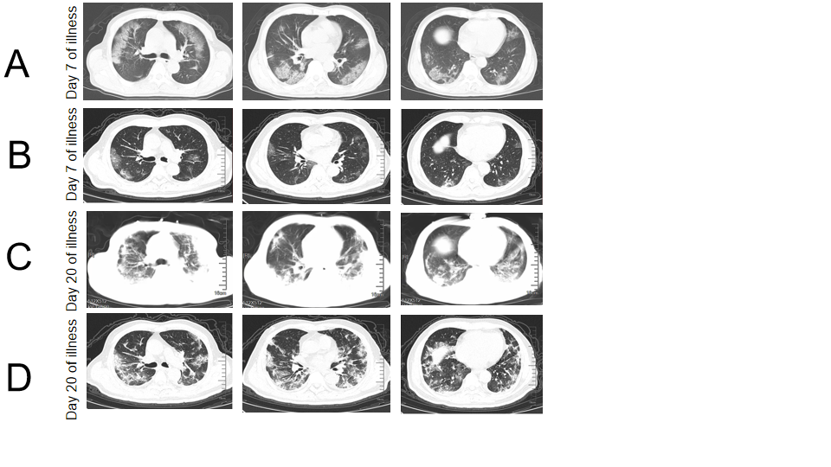
Figure 1 Chest computed tomography of critical coronavirus disease 2019 patients with different severity. A: Chest computed tomography (CT) of a 71-year-old man (non-survivor, case 1) showed multifocal and bilateral ground-glass opacity (GGO) in alveolitis stage (Day 7 of illness); B: Chest CT of a 73-year-old male patient (survivor, case 2) exhibited slight GGO in alveolitis stage (Day 7 of illness); C: Classified into fibrosis stage (Day 20 of illness) and Chest CT (case 1) showed bilateral massive shadows of high density and GGO, accompanied by air bronchogram sign and reticular pattern in fibrosis stage; and D: Chest CT (case 2) showed that bilateral and multifocal lesions were observed with a combination of mixed GGO, reticular pattern, bronchiectasis and few consolidation (Day 20 of illness).

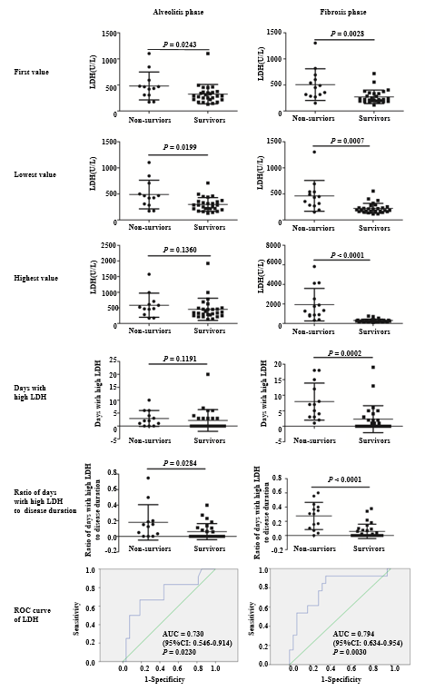
Figure 2 The relationship between serum lactate dehydrogenase levels and the prognosis of patients with critical coronavirus disease 2019. The first, lowest and highest values of serum lactate dehydrogenase (LDH), together with the days with high LDH (≥ 397.0 U/L in alveolitis phase and ≥ 263.0 U/L in fibrosis phase according to the receiver operating characteristic curve analysis, respectively) and the ratio of the days with high LDH to disease duration were analyzed by Mann-Whitney U test between non-survivors and survivors in their alveolitis phase and fibrosis phase. P < 0.05 was considered statistically significant. LDH: lactate dehydrogenase.

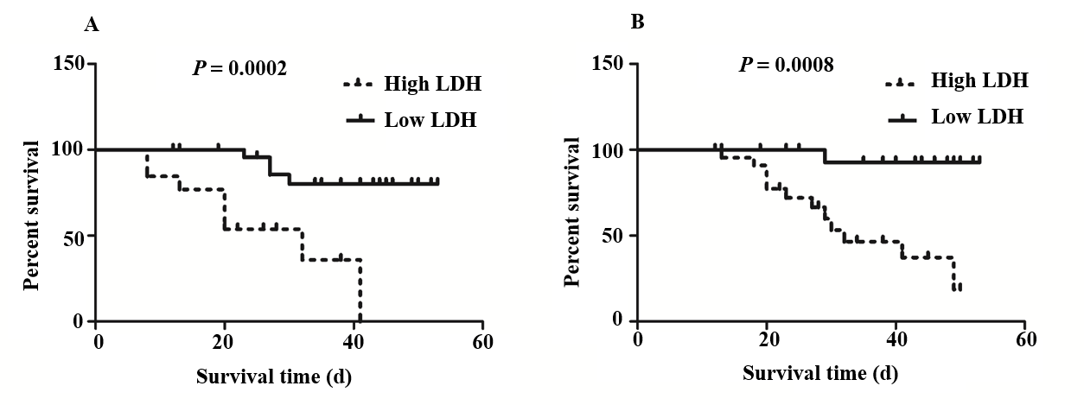
Figure 3 Association between the first value of serum lactate dehydrogenase and survival days of patients with critical coronavirus disease 2019. Kaplan-Meier analysis and log-rank test were performed to analyze the association between the first values of serum lactate dehydrogenase (LDH) and the survival days of patients with critical coronavirus disease 2019. A: Patients with high LDH (≥ 397.0 U/L) had a significantly shorter survival days compared to low LDH (< 397.0 U/L) in alveolitis phase; B: Patients with high LDH (≥ 263.0 U/L) also had a significantly shorter survival days compared to low LDH (< 263.0 U/L) in fibrosis phase. LDH: lactate dehydrogenase.

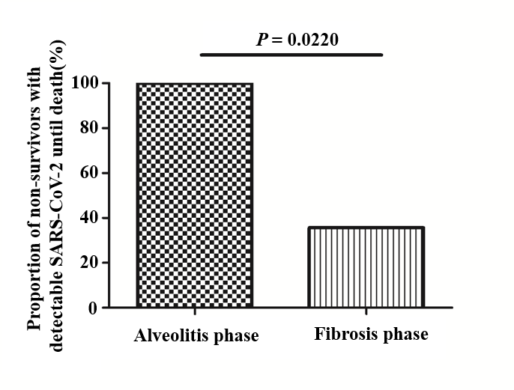
Figure 4 Proportion of non-survivors with detectable severe acute respiratory syndrome coronavirus 2 until death in alveolitis and fibrosis phase. All the non-survivors (100.0%) who died in the alveolitis stage had a persistent positive test of severe acute respiratory syndrome coronavirus 2 until death. And only 5 patients (35.7%) who died in the pulmonary fibrosis stage had positive results in virus nucleic acid tests. SARS-CoV-2: severe acute respiratory syndrome coronavirus 2.

Table 1 Clinical characteristics of patients with critical coronavirus disease 2019
Clinical features | Groups |  | P value
 | Non-survivors (n = 17) | Survivors (n = 30)
Age (yr) | 69.0 (63.5-78.0) | 67.0 (55.5-77.0) | 0.595
Male (%) | 11 (64.7) | 15 (50.0) | 0.33
Days of hospitalization (d) | 14.0 (8.0-24.5) | 33.0 (16.8-38.3) | 0.001⁵
Disease duration (d)¹ | 23.0 (15.5-29.5) | 38.0 (24.5-45.3) | 0.005⁵
Duration of viral shedding (d) | 8.0 (6.0-18.0) | 11.0 (8.8-20.5) | 0.118
Days from illness onset to hospital admission (d) | 5.0 (2.0-10.0) | 5.0 (3.75-7.25) | 0.689
Duration of alveolitis phase (d) | 12.0 (8.0-17.5) | 17.0 (13.8-21.0) | 0.020ª
Duration of fibrosis phase (d) | 10.0 (5.5-15.5) | 19.0 (10.0-26.0) | 0.016ª
Complication of COPD (%) | 3 (17.6) | 3 (10.0) | 0.764
Complication of hypertension (%) | 10 (58.8) | 11 (36.7) | 0.142
Complication of coronary heart disease (%) | 7 (41.2) | 6 (20.0) | 0.222
Complication of cerebrovascular disease (%) | 3 (17.6) | 7 (23.3) | 0.931
Complication of diabetes (%) | 5 (29.4) | 7 (23.3) | 0.912
Complication of renal dysfunction (%) | 2 (11.8) | 5 (16.7) | 0.978
Complication of malignant tumors (%) | 2 (11.8) | 3 (10.0) | 1.000
Complication of others (%)² | 7 (41.2) | 6 (20.0) | 0.222
Number of complications | 2.0 (1.5-3.5) | 1.5 (0.0-3.0) | 0.139
Fever (%) (temperature ≥ 37.3℃) | 13 (76.5) | 26 (86.7) | 0.624
Cough (%) | 7 (41.2) | 20 (66.7) | 0.089
Dyspnea (%) | 9 (52.9) | 4 (13.3) | 0.010ª
Fatigue (%) | 5 (29.4) | 4 (13.3) | 0.337
Other symptoms (%)³ | 5 (29.4) | 4 (13.3) | 0.337
¹Time from illness onset to death or discharge, days; ²Thyroid dysfunction, prostatic hyperplasia, schizophrenia; ³Arthralgia, sputum, dizziness, nausea, chest pain, diarrhea; ªP < 0.05; ^{b}P < 0.01. COPD: Chronic obstructive pulmonary disease.

