Name of Journal: World Journal of Clinical Cases
Manuscript NO: 86776
Manuscript Type: CASE REPORT

Near obstructing painful anorectal mass and facial rash in a man with monkeypox: A case report

Akpoigbe et al. Anorectal mass and monkeypox

Kesiena Akpoigbe, Jones Yannick, Joan Culpepper-Morgan

Kesiena Akpoigbe, Joan Culpepper-Morgan, Department of Gastroenterology, Columbia University Medical Center Health + Hospitals/Harlem Affiliation, New York, NY 10037, United States

Jones Yannick, Department of Internal Medicine, Columbia University Medical Center Health + Hospitals/Harlem Affiliation, New York, NY 10037, United States

Author contributions: Akpoigbe K contributed to general concept, content development, writing of the manuscript, literature review, intellectual contribution; Culpepper-Morgan J contributed to approval of manuscript, content development, writing of manuscript, intellectual contribution; Jones Y contributed to information collection, intellectual contribution, writing of manuscript.

Corresponding author: Kesiena Akpoigbe, MD, Doctor, Department of Gastroenterology, Columbia University Medical Center Health + Hospitals/Harlem Affiliation, 506 Lenox Avenue, New York, NY 10037, United States. kessakpos@yahoo.com

Received: July 14, 2023
Revised: September 21, 2023
Accepted: September 28, 2023
Published online: October 26, 2023

Abstract
BACKGROUND
Monkeypox (MPX) is a zoonotic infection that is endemic in Western and Central Africa along the Congo River basin. It has a high case fatality rate especially in younger age groups. It belongs to the virus family orthopoxvirus like smallpox. It is transmitted from wild animals to humans but human to human transmission has been established. It is often a self-limited infection in endemic regions. Recently, attention has been given to MPX with the spread of infection to Europe and the United States of America (USA). There is currently sporadic infection of MPX in the USA especially amongst men who have sex with men (MSM). It is a serious life-threatening infection in human immunodeficiency virus/acquired immunodeficiency syndrome co-infected individuals especially those who are treatment naïve with severe immunosuppression.

CASE SUMMARY
We report a 38-year old man who presented with rectal pain, and anal, torso, and facial rash. Abdominal computed tomography scan showed a near obstructive rectal mass with peri-anal fistula. MPX was positive. He was started on tecovirimat (TPOXX) and HAART therapy. Additional treatment provided included vaccinia immunoglobulin following his clinical deterioration.

CONCLUSION
This case highlights a rare presentation of MPX with peri-anal fistula and near obstructive rectal mass, and the significance of MPX as a differential diagnosis in proctitis in MSM in addition to other sexually transmitted infection like gonorrhea and chlamydia.

Key Words: Proctitis; Monkeypox; Human Immunodeficiency Virus; Men who have sex with Men; Tecovirimat; Vaccinia Immunoglobulin; Case report

©The Author(s) 2023. Published by Baishideng Publishing Group Inc. All rights reserved.

Citation: Akpoigbe K, Yannick J, Culpepper-Morgan J. Near obstructing painful anorectal mass and facial rash in a man with monkeypox: A case report. World J Clin Cases 2023; 11(30): 7418-7423
URL: https://www.wjgnet.com/2307-8960/full/v11/i30/7418.htm
DOI: https://dx.doi.org/10.12998/wjcc.v11.i30.7418

Core Tip: Monkeypox (MPX) is a differential diagnosis of proctitis in Men who have sex with Men (MSM). In immunocompetent MSM, MPX is likely to be self-limited. However, severe MPX infection characterized by a total body rash and painful obstructing rectal mass, can be fatal in patients with human immunodeficiency virus/acquired immunodeficiency syndrome. The gastroenterologist must be aware of this presentation and be able to distinguish MPX from other infections.

INTRODUCTION
Monkeypox (MPX) is an uncommon self-limited zoonotic infection that is endemic in West and Central Africa in immunocompetent patients^{[1-3]}. It has a case fatality rate of 6%^{[4]}. It is a deoxyribonucleic acid (DNA) orthopoxvirus related to smallpox. Zoonotic transmission typically occurs after contact with wild animals. However, human to human transmission has been established^{[5,6]}. Animal to human transmission occurs via direct contact with infected animal body fluids or inoculation from mucocutaneous lesion^{[5]}. The first animal to human case was reported in 1970 in a 9-mo-old in the Democratic Republic of the Congo. The first zoonotic case in the USA was reported in Wisconsin in 2003 after contact with prairie dogs^{[7]}.
The incubation period varies depending on the mode of transmission of the infection. It is about 14 d but ranges from 4-21 d^{[8,9]}. Shorter duration have been reported with penetrating contact^{[10]}. Infection usually presents with constitutional symptoms like fever, body aches, and a characteristic vesicular eruption similar to what is found in smallpox and varicella infection. These rashes often develop and evolve simultaneously and sometimes can be isolated without other systemic signs. They develop initially as painful macules which progresses to papules and then vesicles that involve the torso and limbs. Genital rash including anal and oral lesions have been reported recently with MPX infection^{[11,12-15]}. These usually precede rashes at other locations of the body. Proctitis or tonsillitis may develop in those who practice anal-receptive or oral sex^{[16,17]}. Severe infection from encephalitis and death have been reported. Cases in immunocompromised patients especially those with human immunodeficiency virus (HIV)/acquired immunodeficiency syndrome (AIDS) are reportedly severe but few details are available^{[4]}.
Reports of human to human contact have been sporadic until recently. During 2022 there was an exponential rise in sexually transmitted MPX infections in men who have sex with men (MSM) in the United States, United Kingdom, Australia, Israel, and Europe. In New York City alone, of the 1092 cases reported 97% were MSM^{[11]}. We report a fatal case of MPX infection presenting as obstructive mass lesion of the anus and rectum in an MSM patient with HIV/AIDS.

CASE PRESENTATION
Chief complaints
Painful rash involving his face, scalp, torso, and perianal area.

History of present illness
A 39-year-old African American man presented the emergency department with increasing swelling of his eyelids and lips for the past 2 wk associated with a painful rash involving his face, scalp, torso, and perianal area. He also complained of great pain moving his bowels and passing bright red blood per rectum intermittently. No recent travel or contact with sick persons.

History of past illness
Admitted a recent diagnosis of HIV. He was not compliant with antiretroviral therapy (HAART).

Personal and family history
The patient initially denied having sex with men (MSM) but later said to be having anal receptive intercourse with men.

Physical examination
On physical examination he was afebrile but warm to the touch. His skin had innumerable coalescing vesiculopustular patches at various stages of erosion and crusting. His nasal bridge, eyebrows, and scalp were ulcerated (Figure 1A). A coalescing lesion with crusting and purulent discharge surrounded his anus (Figure 1B). Rectal exam was refused due to pain.

Laboratory examinations
Electrolytes, blood urea nitrogen, and creatinine were normal. Hemoglobin was 5.4 g/dL. Leukocytes 5.32 × 10³/uL, Neutrophils 49.1%, Lymphocytes 24.1%, Eosinophils 2.1%, Monocytes 11.5%, and Basophils 0.4%. Absolute CD4 count was 29 cells/uL. Liver tests were normal with: Albumin at 3.6 g/dL, total protein 6.6 g/dL, Alkaline phosphatase 21 IU/L, Aspartate transaminase 21 IU/L, Alanine transaminase 20 IU/L, and total bilirubin 0.3 mg/dL. Rectal tissue swab for MPX DNA PCR was positive. HIV viral load was 90,000, and anal, rectal, and oral swab for chlamydia and gonorrhea were negative likewise urine sample. Nevertheless, IgM for Herpes Simplex 1 and 2, and Herpes 8 were negative. Human papilloma virus was not assessed given his positivity for MPX.

Imaging examinations
Abdominal computed tomography showed marked circumferential thickening of the rectum measuring up to 2.6 cm with near obliteration of the lumen, adjacent pericolonic mesenteric stranding, and perianal fistulas extending from the distal rectum to the medial gluteal cleft (Figure 1C and D). Endoluminal evaluation with flexible sigmoidoscopy was not done due to the high risk of perforation as the risk outweighs the benefit.

FINAL DIAGNOSIS
Monkey pox infection with proctitis.

TREATMENT
The patient was started on oral immunotherapy with tecovirimat (TPOXX) and antiretroviral therapy with Biktarvy® (bictegravir, emtricitabine, tenofovir alafenamide). He was offered MPX vaccine but declined. Polyethylene glycol (PEG) was given for his constipation and parenteral opiates were initially provided for his pain. This exacerbated his near obstruction and pain medications were changed to tramadol and gabapentin with good relief and eventual ease of bowel passage. He was transfused two units of blood and discharged to a respite home for recovery. He was started on AIDS prophylaxis therapies including Bactrim and Azithromycin. However, the patient continued to deteriorate and was readmitted with continued, facial swelling, rectal pain, and spreading of his rash. He began to spike fevers and became secondarily infected with Salmonella, Covid19, and MRSA. After consultation with the Centers for Disease Control and Prevention the patient was started on intravenous TPOXX and given smallpox immunoglobulin (Vaccinia). Patient was also commenced on methylprednisolone due to suspicion of immune reconstitution syndrome since he was recently started on antiviral therapy and his viral load was undetectable within 6 wk.

OUTCOME AND FOLLOW-UP
He developed acute hypoxemic respiratory failure requiring intensive care unit admission. The cause was multifactorial requiring intubation with new bilateral pulmonary infiltrates due to but not limited to acute respiratory distress syndrome secondary to septic shock, pneumonia (bacteria, viral, atypical, and PJP), and inflammatory. He was commenced on vasopressors but developed cardiac arrest three times and bedside point of care ultra sound scan showed severely decreased cardiac function. Patient expired from overwhelming sepsis with multiorgan failure.

DISCUSSION
The symptoms of MPX develop over days with initial papules becoming vesiculopustules and eventually resolving to hemorrhagic crusts that detach. Median time to crusting is 12 d. Most patients have fever, cough, and lymphadenopathy^{[7]}. Our patient did not have fever until he became superinfected with bacterial organisms. This places him in the group of patients who present without constitutional symptoms but with rash^{[9]}. Proctitis likely occurred by direct tissue invasion of the virus during anal receptive intercourse^{[16,17]}. In MSM with MPX infection approximately 50% will have anal involvement^{[2]}. Our patient had an extensive rectal mass with near obliteration of the canal from proctitis with extensive fistulae. Rectal fistulas and perforations are rare in immunocompetent MSM with MPX infection.
Hospitalization rates for MPX infection is low, 4% in one study. Most hospitalizations were for isolation and pain control^{[18]}. The case fatality rate is estimated maximally to be 6% affecting the very young, immunosuppressed, or pregnant. HIV positive men on HAART and HIV negative MSM on PreP have similarly benign outcomes^{[4,11]}. Death from MPX has been described in patients infected with HIV/AIDS who are not on HAART therapy^{[4]}. The exact cause of death in these patients was not reported. Our patient has had a prolonged 2-mo course with active infection. He had been poorly responsive to the envelope protein inhibitor TPOXX despite now also being on HAART. He developed superinfections with encapsulated organisms which often precedes a fatal outcome in AIDS patients. He did not, however, have any more rectal bleeding and with the aid of PEG was able to move his bowels. Patient has also received vaccinia immunoglobulin which is used for cases not responding to TPOXX. One limitation of the case report was the lack of endoscopic and histological assessment of the monkey pox lesion in the rectum. This has been demonstrated to show deep ulcerated mucosa with viral apoptotic effect including changes in DNA structures and inclusion bodies^{[19]}.

CONCLUSION
MPX should be considered highly in the differential diagnosis of proctitis in MSM. In immunocompetent MSM MPX is likely to be self-limited. However, severe MPX infection characterized by a total body painful rash and large rectal mass, can be fatal in patients with HIV/AIDS. There is currently vaccination against MPX infection with preference given to MSM. Treatment is with TPOXX may be given in addition to supportive therapy. It is unclear if the course of our immunosuppressed patient would have been altered by early acceptance of the vaccine. Nevertheless, vaccination and HAART therapy should be strongly recommended in this high-risk group.

REFERENCES
1 Ngbolua KN, Ngambika GK, Mbembo-wa-Mbembo B, Séraphin KP, Fabrice KK, Bongo GN, Colette MA, Ruphin DD. First Report on Three Cases of Monkey pox in Nord Ubangi Province (Democratic Republic of the Congo). Britain International of Exact Sciences (BIoEx) Journal 2020; 2 [DOI: 10.33258/bioex.v2i1.117]
2 Eseigbe EE, Akude C, Osagie IA, Eseigbe P. Human Monkey Pox Virus Infection in Plateau State, North Central Nigeria: A Report of Two Cases. West Afr J Med 2021; 38: 1242-1246 [PMID: 35038257 DOI: 10.55891/wajm.v38i12.55]
3 Berthet N, Descorps-Declère S, Besombes C, Curaudeau M, Nkili Meyong AA, Selekon B, Labouba I, Gonofio EC, Ouilibona RS, Simo Tchetgna HD, Feher M, Fontanet A, Kazanji M, Manuguerra JC, Hassanin A, Gessain A, Nakoune E. Genomic history of human monkey pox infections in the Central African Republic between 2001 and 2018. Sci Rep 2021; 11: 13085 [PMID: 34158533 DOI: 10.1038/s41598-021-92315-8]
4 Yinka-Ogunleye A, Aruna O, Dalhat M, Ogoina D, McCollum A, Disu Y, Mamadu I, Akinpelu A, Ahmad A, Burga J, Ndoreraho A, Nkunzimana E, Manneh L, Mohammed A, Adeoye O, Tom-Aba D, Silenou B, Ipadeola O, Saleh M, Adeyemo A, Nwadiutor I, Aworabhi N, Uke P, John D, Wakama P, Reynolds M, Mauldin MR, Doty J, Wilkins K, Musa J, Khalakdina A, Adedeji A, Mba N, Ojo O, Krause G, Ihekweazu C; CDC Monkeypox Outbreak Team. Outbreak of human monkeypox in Nigeria in 2017-18: a clinical and epidemiological report. Lancet Infect Dis 2019; 19: 872-879 [PMID: 31285143 DOI: 10.1016/S1473-3099(19)30294-4]
5 Alakunle E, Moens U, Nchinda G, Okeke MI. Monkeypox Virus in Nigeria: Infection Biology, Epidemiology, and Evolution. Viruses 2020; 12 [PMID: 33167496 DOI: 10.3390/v12111257]
6 Jabeen C, Umbreen G. Monkeypox Transmission, Need and Treatment of Humans with an Antiviral Drug. IJSSM 2017; 4 [DOI: 10.3126/ijssm.v4i2.16684]
7 Reed KD, Melski JW, Graham MB, Regnery RL, Sotir MJ, Wegner MV, Kazmierczak JJ, Stratman EJ, Li Y, Fairley JA, Swain GR, Olson VA, Sargent EK, Kehl SC, Frace MA, Kline R, Foldy SL, Davis JP, Damon IK. The detection of monkeypox in humans in the Western Hemisphere. N Engl J Med 2004; 350: 342-350 [PMID: 14736926 DOI: 10.1056/nejmoa032299]
8 Huhn GD, Bauer AM, Yorita K, Graham MB, Sejvar J, Likos A, Damon IK, Reynolds MG, Kuehnert MJ. Clinical characteristics of human monkeypox, and risk factors for severe disease. Clin Infect Dis 2005; 41: 1742-1751 [PMID: 16288398 DOI: 10.1086/498115]
9 Minhaj FS, Ogale YP, Whitehill F, Schultz J, Foote M, Davidson W, Hughes CM, Wilkins K, Bachmann L, Chatelain R, Donnelly MAP, Mendoza R, Downes BL, Roskosky M, Barnes M, Gallagher GR, Basgoz N, Ruiz V, Kyaw NTT, Feldpausch A, Valderrama A, Alvarado-Ramy F, Dowell CH, Chow CC, Li Y, Quilter L, Brooks J, Daskalakis DC, McClung RP, Petersen BW, Damon I, Hutson C, McQuiston J, Rao AK, Belay E, Andrea M. McCollum. Morbidity and Mortality Weekly Report Monkeypox Outbreak-Nine States, May 2022 [DOI: 10.1111/ajt.16669]
10 Reynolds MG, Yorita KL, Kuehnert MJ, Davidson WB, Huhn GD, Holman RC, Damon IK. Clinical manifestations of human monkeypox influenced by route of infection. J Infect Dis 2006; 194: 773-780 [PMID: 16941343 DOI: 10.1086/505880]
11 Hoffmann C, Jessen H, Wyen C, Grunwald S, Noe S, Teichmann J, Krauss AS, Kolarikal H, Scholten S, Schuler C, Bickel M, Roll C, Kreckel P, Köppe S, Straub M, Klausen G, Lenz J, Esser S, Jensen B, Rausch M, Unger S, Pauli R, Härter G, Müller M, Masuhr A, Schäfer G, Seybold U, Schellberg S, Schneider J, Monin MB, Wolf E, Spinner CD, Boesecke C. Clinical characteristics of monkeypox virus infections among men with and without HIV: A large outbreak cohort in Germany. HIV Med 2023; 24: 389-397 [PMID: 36059149 DOI: 10.1111/hiv.13378]
12 Pfäfflin F, Wendisch D, Scherer R, Jürgens L, Godzick-Njomgang G, Tranter E, Tober-Lau P, Stegemann MS, Corman VM, Kurth F, Schürmann D. Monkeypox in-patients with severe anal pain. Infection 2023; 51: 483-487 [PMID: 35960457 DOI: 10.1007/s15010-022-01896-7]
13 Gedela K, Da Silva Fontoura D, Salam A, Gorman G, Golden J, O'Hara G, Elowaidy A, Tittle V, Girometti N, Whitlock G, Patel S, Suchak T, Nugent D, Asboe D, Boffito M, McOwan A. Infectious Proctitis due to Human Mpox. Clin Infect Dis 2023; 76: e1424-e1427 [PMID: 36052417 DOI: 10.1093/cid/ciac713]
14 Yakubovsky M, Shasha D, Reich S, Tau L, Friedel N, Halutz O, Dekel M, Meijer S, Ben-Ami R, Paran Y. Mpox Presenting as Proctitis in Men Who Have Sex With Men. Clin Infect Dis 2023; 76: 528-530 [PMID: 36066470 DOI: 10.1093/cid/ciac737]
15 Chow EPF, Lee D, Bond S, Fairley CK, Maddaford K, Wigan R, Fehler G, Lange SA, De Petra V, Bissessor M, Bradshaw CS, Howden BP, Hocking JS, Williamson DA, Chen MY. Nonclassical Pathogens as Causative Agents of Proctitis in Men who Have Sex With Men. Open Forum Infect Dis 2021; 8: ofab137 [PMID: 34671693 DOI: 10.1093/ofid/ofab137]
16 Patel A, Bilinska J, Tam JCH, Da Silva Fontoura D, Mason CY, Daunt A, Snell LB, Murphy J, Potter J, Tuudah C, Sundramoorthi R, Abeywickrema M, Pley C, Naidu V, Nebbia G, Aarons E, Botgros A, Douthwaite ST, van Nispen Tot Pannerden C, Winslow H, Brown A, Chilton D, Nori A. Clinical features and novel presentations of human monkeypox in a central London centre during the 2022 outbreak: descriptive case series. BMJ 2022; 378: e072410 [PMID: 35902115 DOI: 10.1136/bmj-2022-072410]
17 Tarín-Vicente EJ, Alemany A, Agud-Dios M, Ubals M, Suñer C, Antón A, Arando M, Arroyo-Andrés J, Calderón-Lozano L, Casañ C, Cabrera JM, Coll P, Descalzo V, Folgueira MD, García-Pérez JN, Gil-Cruz E, González-Rodríguez B, Gutiérrez-Collar C, Hernández-Rodríguez Á, López-Roa P, de Los Ángeles Meléndez M, Montero-Menárguez J, Muñoz-Gallego I, Palencia-Pérez SI, Paredes R, Pérez-Rivilla A, Piñana M, Prat N, Ramirez A, Rivero Á, Rubio-Muñiz CA, Vall M, Acosta-Velásquez KS, Wang A, Galván-Casas C, Marks M, Ortiz-Romero PL, Mitjà O. Clinical presentation and virological assessment of confirmed human monkeypox virus cases in Spain: a prospective observational cohort study. Lancet 2022; 400: 661-669 [PMID: 35952705 DOI: 10.1016/S0140-6736(22)01436-2]
18 Thornhill JP, Barkati S, Walmsley S, Rockstroh J, Antinori A, Harrison LB, Palich R, Nori A, Reeves I, Habibi MS, Apea V, Boesecke C, Vandekerckhove L, Yakubovsky M, Sendagorta E, Blanco JL, Florence E, Moschese D, Maltez FM, Goorhuis A, Pourcher V, Migaud P, Noe S, Pintado C, Maggi F, Hansen AE, Hoffmann C, Lezama JI, Mussini C, Cattelan A, Makofane K, Tan D, Nozza S, Nemeth J, Klein MB, Orkin CM; SHARE-net Clinical Group. Monkeypox Virus Infection in Humans across 16 Countries - April-June 2022. N Engl J Med 2022; 387: 679-691 [PMID: 35866746 DOI: 10.1056/NEJMoa2207323]
19 Mavilia MG, Putra I, Song X, Cappa J. Endoscopic and Histologic Assessment of Monkey Pox-associated Proctitis. Clin Gastroenterol Hepatol 2023; 21: A19 [PMID: 36064097 DOI: 10.1016/j.cgh.2022.08.031]

Footnotes
Informed consent statement: Informed written consent was obtained from the patient for publication of this report and any accompanying images.

Conflict-of-interest statement: All the authors declare that they have no conflict of interest.

CARE Checklist (2016) statement: The authors have read the CARE Checklist (2016), and the manuscript was prepared and revised according to the CARE Checklist (2016).

Open-Access: This article is an open-access article that was selected by an in-house editor and fully peer-reviewed by external reviewers. It is distributed in accordance with the Creative Commons Attribution NonCommercial (CC BY-NC 4.0) license, which permits others to distribute, remix, adapt, build upon this work non-commercially, and license their derivative works on different terms, provided the original work is properly cited and the use is non-commercial. See: https://creativecommons.org/Licenses/by-nc/4.0/

Provenance and peer review: Unsolicited article; Externally peer reviewed.
Peer-review model: Single blind
Corresponding Author's Membership in Professional Societies: American College of Gastroenterology, 57175.

Peer-review started: July 14, 2023
First decision: August 30, 2023
Article in press: September 28, 2023

Specialty type: Gastroenterology and hepatology
Country/Territory of origin: United States
Peer-review report’s scientific quality classification
Grade A (Excellent): 0
Grade B (Very good): B, B
Grade C (Good): C
Grade D (Fair): 0
Grade E (Poor): E

P-Reviewer: Choi YS, South Korea; Ghimire R, Nepal; Kato S, Japan; Sarier M, Turkey S-Editor: Liu JH L-Editor: A P-Editor: Yuan YY

Figure Legends
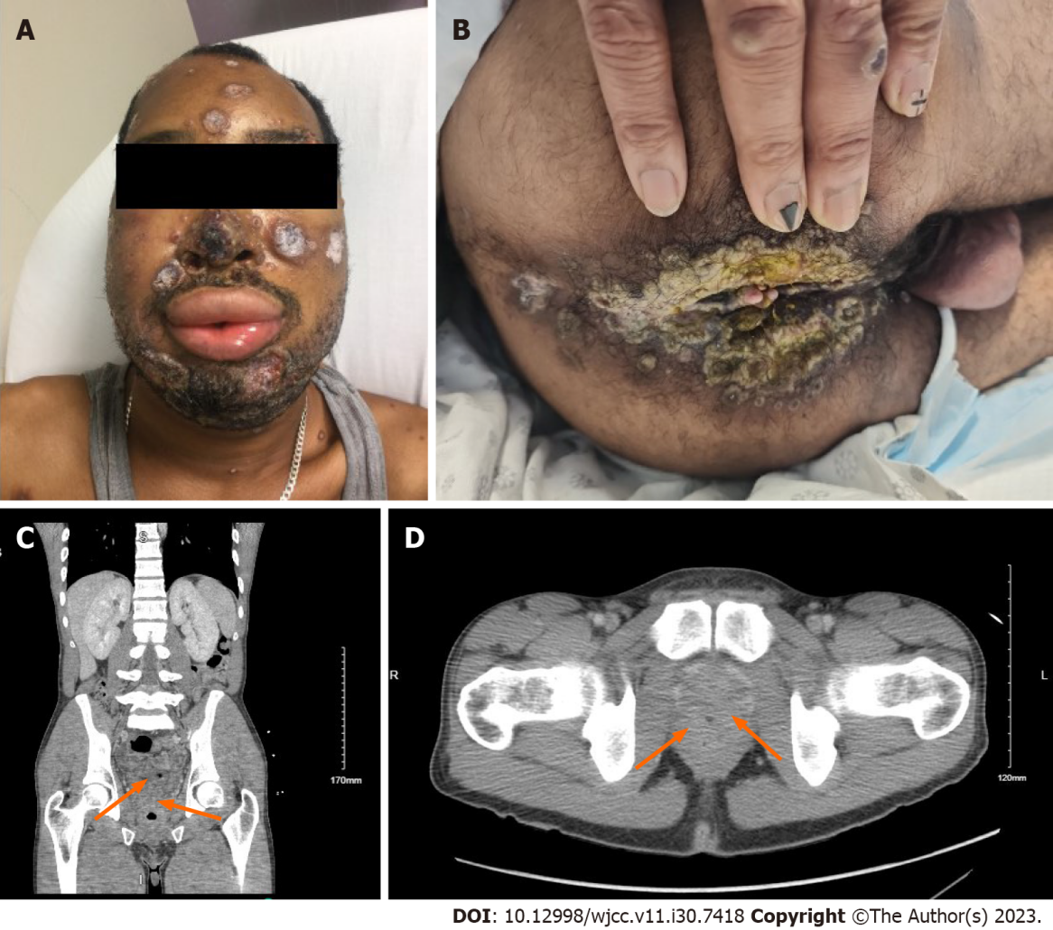
Figure 1 Physical examination and computed tomography images. A: Multiple coalescing facial rash with ulceration; B: Anal rash with exudates; C: Computed tomography (CT) imaging with near occlusion of the rectal lumen (arrows); D: CT imaging with near occlusion of the rectal lumen (arrows).

Published by Baishideng Publishing Group Inc
7041 Koll Center Parkway, Suite 160, Pleasanton, CA 94566, USA
Telephone: +1-925-3991568
E-mail: bpgoffice@wjgnet.com
Help Desk: https://www.f6publishing.com/helpdesk
https://www.wjgnet.com

© 2023 Baishideng Publishing Group Inc. All rights reserved.

