Name of Journal: World Journal of Hepatology
Manuscript NO: 63927
Manuscript Type: EDITORIAL

Meeting report of the editorial board meeting for World Journal of Hepatology 2021

Ma L et al. World Journal of Hepatology meeting report

Li Ma, Xiang Li

Li Ma, Xiang Li, Editorial Office, Baishideng Publishing Group Inc, Pleasanton, CA 94566, United States

Author contributions: Ma L contributed to taking meeting minutes and drafting and revising this manuscript; Li X contributed to organizing the meeting and revising the manuscript.

Corresponding author: Li Ma, PhD, Vice Editor-in-Chief, Editorial Office, Baishideng Publishing Group Inc, 7041 Koll Center Parkway, Suite 160, Pleasanton, CA 94566, United States. l.ma@wjgnet.com

Received: February 5, 2021
Revised: February 17, 2021
Accepted: February 19, 2021
Published online: February 27, 2021

Abstract
The 2021 online editorial board meeting of the World Journal of Hepatology was held on January 16, 2021. Xiang Li, Director of Production Office on behalf of the Baishideng Publishing Group, organized the meeting. Three Editors-in-Chiefs (EiCs) and 15 Baishideng Publishing Group staff attended the meeting. The meeting goal was to brief EiCs on journal performance and gather ideas for journal development in 2021. In 2020, World Journal of Hepatology published 204 articles, a 20% increase compared to 2019, authors were from 32 countries and regions, and the average citation per article was three times. However, attracting high quality original article submissions remains a challenge. The EiCs provided feedback and suggestions centered on four topics: (1) Improve journal quality by building editorial; (2) Improve board engagement by establishing a clear policy and consistent internal communications; (3) Improve peer review quality and efficiency and (4) Refine the current journal marketing strategy to increase visibility and discoverability.

Key Words: World Journal of Hepatology; Baishideng; Editorial board meeting; Journal development

©The Author(s) 2021. Published by Baishideng Publishing Group Inc. All rights reserved.

Citation: Ma L, Li X. Meeting report of the editorial board meeting for World Journal of Hepatology 2021. World J Hepatol 2021; 13(2): 162-165
URL: https://www.wjgnet.com/1948-5182/full/v13/i2/162.htm
DOI: https://dx.doi.org/10.4254/wjh.v13.i2.162

Core Tip: The 2021 World Journal of Hepatology editorial board meeting was held on January 16, 2021. The meeting goal was to brief board members on journal performance and gather ideas for journal development in 2021. The discussion focused on (1) improving journal quality by building editorial; (2) improving board engagement by establishing a clear policy and consistent communications; (3) improving peer review quality and efficiency and (4) refining current journal marketing strategy.
INTRODUCTION
Every year World Journal of Hepatology (WJH) editorial office organizes the editorial board meeting at the American Association for the Study of Liver Disease annual meeting. Due to the coronavirus disease 2019 pandemic, the 2021 meeting moved to online format. WJH editorial office hosted the meeting on January 16, 2021 to review journal performance in 2020 and identify strategies to further WJH’s mission, which is to publish high impact research in the field of hepatology. The meeting was moderated by Dr. Li Ma, Company Vice-Editor-in-Chief. The first part of the meeting consisted of presentations on journal status review and plans for 2021, and the second part consisted of open discussions with Editors-in-Chiefs (EiCs) for their feedback and suggestions.

ATTENDEES
This online meeting brought together three EiCs: Namely Dr. Ke-Qin Hu, Dr. Koo Jeong Kang, Dr. Nikolaos Pyrsopoulos, and 15 Editors (Li Ma, Xiang Li, Jin-Lei Wang, Ze-Mao Gong, Ya-Juan Ma, Jia-Ping Yan, Yun-XiaoJian Wu, Dong-Mei Wang, Jia-Ru Fan, Chen-Chen Gao, Le Zhang, Ji-Hong Liu, Yu-Jie Ma, Yan-Liang Zhang, Li-Li Wang) from Baishideng Publishing Group Inc (Figure 1).

REPORTS
WJH year in review 2020
Xiang Li began the meeting by offering an overview of WJH’s journal statistics, status quo of editorial board, challenges journal faces, and update from publisher. She showed in 2020 that WJH published 204 papers, an 20% increase compared to 2019 (181 papers). The 2020 editorial board consists of 195 members from 45 countries and regions. The top three countries are China, Italy and United States. Forty-four percent of Editorial board members reviewed at least one manuscript in 2020. She highlighted that the main challenge is to attract high quality, high impact original research submissions. Xiang Li finally highlighted new features Baishideng Publishing Group has launched to serve better the authors, including open peer review, shortened peer review time by using artificial intelligence empowered search techniques and post publication promotion by marketing articles to targeted audiences^{[1]}.
Dr. Ma presented the journal’s 2021 priorities: (1) Commissioning and publishing high impact original articles in the important areas of hepatology; (2) Encouraging editorial board members to recommend and submit to the journal; and (3) Improving the overall quality and relevance of WJH.

OPEN DISCUSSION FROM EDITOR-IN-CHIEFS FOCUSED ON FOUR MAIN TOPICS
Peer review
Dr. Hu inquired about the low response rate of peer review invitations; he commented that the current key word matching search using the in-house database is suboptimal. He presented the following possible solutions: (1) Allow authors to suggest reviewers; editor should cross check if suggested reviewers are suitable candidates; and (2) Prioritize editorial board member as peer reviewers. Dr. Ma addressed the above question that the current peer reviewer search strategy offers a fair and unbiased review process, but there is room for improvement. Dr. Pyrsopoulos added that it is also worth improving peer review quality when poor language is used by the peer reviewer, and the editorial office should contact the reviewer for professional and constructive comment.

Journal quality
Dr. Hu pointed out that WJH should aim to build up a strong editorial and suggested that the editorial office should group upcoming manuscripts in topics or inform EiCs in advance so they can help group the topics. EiCs can assist with writing or help finding suitable authors to write an editorial or commentary. Dr. Pyrsopoulos brought up the topic of how to handle better invited manuscript rejection, as authors may feel disappointed when an invited article is rejected. On a different note, he suggested the importance of tracking the evolution of journal citations to monitor journal health.

Maintain an active editorial board
Statistics presented by Xiang Li showed that about 50% of editorial board members are inactive and that they did not review a paper for the journal in 2020. Both Dr. Hu and Dr. Pyrsopoulos suggest that the Editorial Office should send a kind reminder to these editors about the duties and commitments. In addition, internal metrics should be set to monitor editorial board member activities. Along with the above points, a “Dashboard” should be created to show editorial board member their statistics, including the number of invitations sent, response time, time taken to review and review quality grading by the handling editor. Orientation should be prepared for editorial board members to familiarize them with journal history, policy and peer review best practice. In addition, a quarterly editorial board member newsletter can inform everyone about journal news, initiatives and policy updates. Lastly, but most importantly, there should be a recognition mechanism for those editorial board members who contribute to journal growth by submitting their research or performing peer review.
Dr. Kang reminded everyone that a high-quality and active editorial board is more crucial to journal growth. He inquired about the percentage of surgeons serving on the board and surgery related papers published in WJH and proposed increasing liver surgeon representation. Dr. Pyrsopoulos emphasized the advantages of having a large editorial board to increase submissions.

Journal marketing
Dr. Pyrsopoulos and Dr. Hu gave a very comprehensive overview on how to increase journal visibility. They commented that the editorial office needs to think about how to market and position the journal. Research online advertising channels, such as social media, increase the discoverability in search engines. Offline channels include society conferences (American Association for the Study of Liver Disease, European Association for the Study of the Liver, Asian Pacific Association for the Study of the Liver), setting up a booth to meet and connect with authors and donating and supporting the conference.

ACTIONS AND FUTURE PLANS FROM THE EDITORIAL OFFICE
First, the WJH editorial office would like to collaborate with EiCs to select two editorial worthy articles in 2021 Q1 and Q2 and to coordinate a suitable candidate to write editorial.
Second, research suitable venues online (website advertising) and offline (leading Hepatology meetings) should be utilized to promote the journal. A volunteer editorial board member will need to be recruited to help manage content of a dedicated WJH twitter account.
Third, editorial board member engagement needs to improve and editorial board member review rate should increase from 44% to 70%. An annual editorial board member activity “dashboard” email that contains review number, speed and reviewed article status would be helpful. Thank you letters should be sent to recognize their valuable time. It is important to send bi-annual editorial board newsletters to convey journal news, internal information exchange, publisher update, etc.
Fourth, EiCs should collaborate to identify and address author submission pain points in order to improve author publishing experiences.
Fifth, liver surgery editorial board member representation should be expanded and experts from this field should be invited to submit articles.

CONCLUSION
All EiCs expressed commitment and enthusiasm to help the journal grow. Dr. Hu is committed to moving the journal to higher ranking and improving journal quality, and he is interested to provide guidance to make the submission system more streamlined and user friendly. Dr. Pyrsopoulos and Dr. Kang said that they will continue to contribute their search and encourage their peers to contribute; they will work together with the editorial office to have WJH recognized by leading databases. They also expressed wishes to continue the in person editorial board meeting when possible at future American Association for the Study of Liver Diseases annual meeting, as it is a great way to catch up with other members and the editorial office. Dr. Li Ma thanked the EiCs for their contributions in the past years^{[2-6]}, enlightening ideas and time to attend the meeting. The next online editorial board meeting is tentatively set for June 2021. All editorial members are welcome to attend, stay tuned for more details!

ACKNOWLEDGEMENTS
WJH editorial office thanks all the EiCs for their leadership, guidance and contributions to the journal growth.

REFERENCES
1 Hu KQ, Kang KJ, Pyrsopoulos N, Li X. New Year's greeting and overview of World Journal of Hepatology in 2021. World J Hepatol 2021; 13: 1-5 [PMID: 33584985 DOI: 10.4254/wjh.v13.i1.1]
2 Hu KQ, Cui W, Rouster SD, Sherman KE. Hepatitis C virus antigens enzyme immunoassay for one-step diagnosis of hepatitis C virus coinfection in human immunodeficiency virus infected individuals. World J Hepatol 2019; 11: 442-449 [PMID: 31183004 DOI: 10.4254/wjh.v11.i5.442]
3 Patel P, Rotundo L, Orosz E, Afridi F, Pyrsopoulos N. Hospital teaching status on the outcomes of patients with esophageal variceal bleeding in the United States. World J Hepatol 2020; 12: 288-297 [PMID: 32742571 DOI: 10.4254/wjh.v12.i6.288]
4 Rotundo L, Pyrsopoulos N. Liver injury induced by paracetamol and challenges associated with intentional and unintentional use. World J Hepatol 2020; 12: 125-136 [PMID: 32685105 DOI: 10.4254/wjh.v12.i4.125]
5 Ahn KS, Kang KJ. Molecular heterogeneity in intrahepatic cholangiocarcinoma. World J Hepatol 2020; 12: 1148-1157 [PMID: 33442444 DOI: 10.4254/wjh.v12.i12.1148]
6 Choi CJ, Weiss SH, Nasir UM, Pyrsopoulos NT. Cannabis use history is associated with increased prevalence of ascites among patients with nonalcoholic fatty liver disease: A nationwide analysis. World J Hepatol 2020; 12: 993-1003 [PMID: 33312424 DOI: 10.4254/wjh.v12.i11.993]

Footnotes
Conflict-of-interest statement: None declared.

Open-Access: This article is an open-access article that was selected by an in-house editor and fully peer-reviewed by external reviewers. It is distributed in accordance with the Creative Commons Attribution NonCommercial (CC BY-NC 4.0) license, which permits others to distribute, remix, adapt, build upon this work non-commercially, and license their derivative works on different terms, provided the original work is properly cited and the use is non-commercial. See: http://creativecommons.org/Licenses/by-nc/4.0/

Manuscript source: Unsolicited manuscript

Peer-review started: February 5, 2021
First decision: February 10, 2021
Article in press: February 19, 2021

Specialty type: Gastroenterology and hepatology
Country/Territory of origin: United States
Peer-review report’s scientific quality classification
Grade A (Excellent): A
Grade B (Very good): 0
Grade C (Good): C
Grade D (Fair): 0
Grade E (Poor): 0

P-Reviewer: Costache RS, Morozov S S-Editor: Wang JL L-Editor: Filipodia P-Editor: Wang LL

Figure Legends
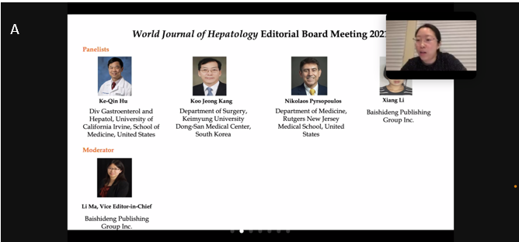
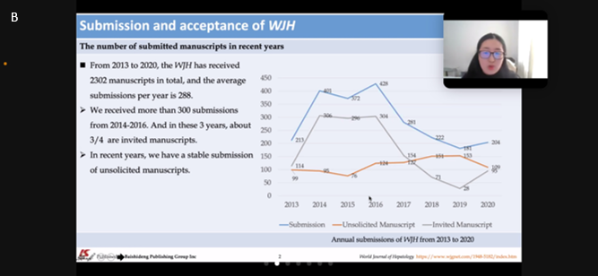
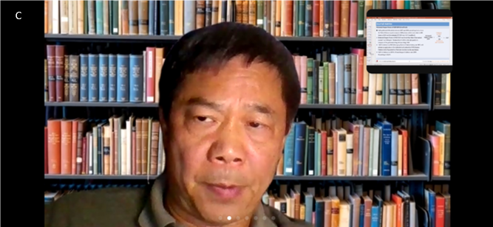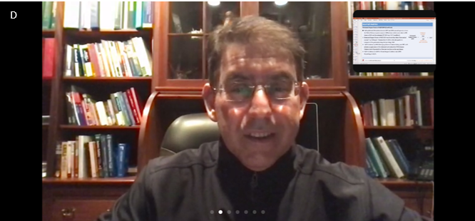
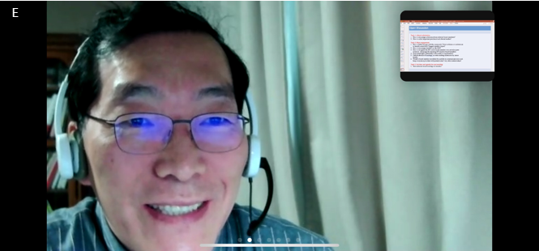 Figure 1 2021 World Journal of Hepatology editorial board meeting presenters. A: Dr. Li Ma; B: Xiang Li; C: Dr. Ke-Qin Hu; D: Dr. Nikolaos Pyrsopoulos; E: Dr. Koo Jeong Kang.

Published by Baishideng Publishing Group Inc
7041 Koll Center Parkway, Suite 160, Pleasanton, CA 94566, USA
Telephone: +1-925-3991568
E-mail: bpgoffice@wjgnet.com
Help Desk: https://www.f6publishing.com/helpdesk
https://www.wjgnet.com

© 2021 Baishideng Publishing Group Inc. All rights reserved.

