Name of Journal: World Journal of Clinical Cases
Manuscript NO: 61560
Manuscript Type: CASE REPORT

Particular tumor of the pancreas: A case report

Zhu MH et al. Particular tumor of the pancreas

Ming-Hui Zhu, Chang-Fu Nie

Ming-Hui Zhu, Department of General Surgery, Zhengzhou People's Hospital, Zhengzhou 450008, Henan Province, China

Chang-Fu Nie, Department of Hepatopancreatobiliary Surgery, the Affiliated Cancer Hospital of Zhengzhou University, Zhengzhou 450008, Henan Province, China

Author contributions: Zhu MH and Nie CF were the patient’s surgeons and had participated in the surgical treatment of the patient, review of articles, as well as collecting radiological and pathological data; Nie CF contributed to the revisioning and polishing of the paper; Both authors approved the final version.

Supported by Henan Science and Technology Research Project, No. 162102310045.

Corresponding author: Chang-Fu Nie, PhD, Chief Doctor, Department of Hepatopancreatobiliary Surgery, the Affiliated Cancer Hospital of Zhengzhou University, No. 127 Dongming Road, Zhengzhou 450008, Henan Province, China. zhuminghui258@163.com

Received: December 11, 2020
Revised: January 31, 2021
Accepted: August 23,2021
Published online: October 26, 2021

Abstract
BACKGROUND
Granular cell tumor (GCT) of the pancreas is a rare neurogenic tumor. The first case of pancreatic GCT was described in 1975, and up to now, only 7 cases have been reported.

CASE SUMMARY
A 53-year-old male had a pancreatic mass for 1 mo. He was not treated at the local hospital, but referred to Henan Tumor Hospital for surgery. Preoperative imaging revealed a 2.0 cm × 2.5 cm-sized mass located in the body of the pancreas. At the microscopic level, a large number of eosinophilic particles are present in the oval tumor cells. The immunohistochemistry of this tumor cell display CD56 (+), blood vessels CD34 (+), Ki-67 (+) < 10%, and S-100 (+).

CONCLUSION
GCT of the pancreas should be recognized as a preoperative differential diagnosis of pancreatic tumors. Surgical resection of the tumor should be attempted; however, GCT of the pancreas has a certain rate of tumor metastasis and recurrence. Therefore, GCT of the pancreas requires regular and long-term follow-up.

Key Words: Granular cell tumor; Pancreas; Diagnosis; Case report

©The Author(s) 2021. Published by Baishideng Publishing Group Inc. All rights reserved.

Citation: Zhu MH, Nie CF. Particular tumor of the pancreas: A case report. World J Clin Cases 2021; 9(30): 9101-9107
URL: https://www.wjgnet.com/2307-8960/full/v9/i30/9101.htm
DOI: https://dx.doi.org/10.12998/wjcc.v9.i30.9101

Core Tip: Granular cell tumor (GCT) of the pancreas is a rare neurogenic tumor. We present a rare case of pancreatic GCT, which recovered successfully after surgical treatment. We reviewed 7 previous cases of the same tumor and conclude that most of the pancreatic GCTs are benign, but there is a potential malignancy. Surgery is an important treatment for this disease, and there is a certain rate of tumor metastasis and recurrence after surgery, so regular reexamination should be insisted on.

INTRODUCTION
Granular cell tumors (GCTs) arise from Schwann cells^{[1]} and have been located almost everywhere in the body, including visceral or cutaneous locations^{[2]}, chest wall regions^{[3]}, and in the oral cavity^{[4]}, pituitary, central nervous system^{[5]}, and respiratory system^{[6]}. Granular cells contain unique acidic protein, S-100 protein, which is present in Schwann cell and satellite cells of ganglia. GCTs of the pancreas are so extraordinarily rare that only 7 cases have been reported in all literatures. Now we report the eighth case of pancreatic GCT, including clinical, imageological, and histological features.

CASE PRESENTATION
Chief complaints
A 53-year-old male patient was referred to our hospital after a physical examination 1 mo earlier revealed a mass in his pancreas.

History of present illness
There's nothing special about his past medical history.

History of past illness
The patient's past medical history is unremarkable.

Physical examination
The patient’s skin and sclera were not yellowish, abdominal muscles were not tense, with/without tenderness and rebound pain. The patient’s liver and spleen were not palpable under the ribs, and the entire abdomen was not palpable. Murphy’s sign was negative. Percussion and auscultation in the abdomen were normal.

Laboratory examinations
Serum tumor marker (carbohydrate antigen 19-9: 15.73 KU/L) was moderately elevated. The liver and kidney function were within the normal range, and the other biochemical tests were within the normal range. Urine analysis results were also normal. An electrocardiogram, chest radiograph and arterial blood gas tests showed no abnormalities.

Imaging examinations
On T1-weighted magnetic resonance imaging (MRI), the tumor in the head of the pancreas showed mild, low signal intensity (Figure 1A). On the contrary, the peripheral tissues around the tumor were equal signal while the central area of tumor was hypointense on the T2-weighted image (Figure 1B). The portal vein was not invaded by the pancreatic head tumor, neither was celiac artery.

Further diagnostic work-up
After coming to our hospital, the tumor was assessed by abdominal ultrasound test, and a hypoechoic area whose size was 25 mm × 25 mm was identified. The morphological structure was normal and the boundary was clear in the body of the pancreas. Electronic gastroscope showed a duodenal bulb compressional bulge and surface mucosal hyperemia. Positron emission tomography/computed tomography (CT) examination showed increased metabolism at the L1/2 level of the descending part of the duodenum and head of pancreas and soft tissue nodules indicating the lesion was likely to be a malignant tumor (Figure 2).

Preoperative diagnosis
The diagnosis prior to operation was pancreatic tumor of unknown properties.

FINAL DIAGNOSIS
Postoperative pathological results and immunohistochemical results indicated pancreatic GCT.

TREATMENT
In view of the above results, the patient was diagnosed with a pancreatic tumor and a pancreatoduodenectomy was performed. Laparotomy showed that the tumor was hard, located in the pancreatic head, with oppression of the duodenum, and was about 3.0 cm × 2.5 cm × 2.0 cm. No capsule was evident around the tumor. Common bile duct was mildly expanded to a diameter of about 1.2 cm and full of green turbidity bile. Gall bladder, intestinal canal, and omentum majus had mutually tight adhesion. There were no metastatic lesions found on the adjacent organs and peritoneum. No swelling lymph nodes were seen around the lesion location. Histological examination confirmed that the tumor was completely removed and the margin of the resection specimen was negative for tumor cells. None of 4 regional lymph nodes examined showed metastasis. After 2 wk of receiving anti-inflammatory, compensation fluid, nutritional therapy, and symptomatic treatment, the patient was discharged from the hospital free of symptoms.

OUTCOME AND FOLLOW-UP
The patient recovered smoothly after surgery, and the postoperative condition was not unstable. The patient was asymptomatic during the 2 years of follow-up after the operation. The patient was advised to continue to follow-up every 3 to 6 mo.

DISCUSSION
The first report of GCT, localized in the skeletal muscle of the tongue, was in 1926 by Abrikossoff. GCT is a rare tissue tumor derived from Schwann cells. Despite reports that GCTs can be localized anywhere in the body, GCTs of pancreatic origin are rare. The characteristics of the 7 previously reported cases of pancreatic GCT are summarized in Table 1. By reason of the rarity of pancreatic GCT, its epidemiology, clinical symptoms, imaging findings, and serological examination have not been clarified. Therefore, it is difficult to distinguish pancreatic GCT from pancreatic tumor, including pancreatic cancer, pancreatic neuroendocrine tumor, pancreatic cystadenoma, and cystadenocarcinoma. Their clinical manifestations are not typical. On CT and MRI examination, the tumors are round, oval or dumbbell cystic lesion whose cystic wall is thickness. There are some fences that can be obviously enhanced during dynamic CT and MRI inside of cystic lesion. In the past, some experts thought that GCT was benign tumor, as the majority of GCTs are benign However, increasingly the literature has indicated that GCT has some characteristics of malignant tumors, such as metastasis and recurrence, despite having a benign histological appearance. In fact, only about half of reportedly malignant cases, whose incidence is only 1% to 2%, are diagnosed with metastases^{[7,8]}. Previous cases of GCT metastasis to liver, lung, brain, bone, abdominal wall, pancreas, and other sites have been reported^{[9-15]}. Morphological examination cannot predict the biological behavior of GCT. However, when the tumor shows local recurrence, invasive growth, rapid growth over a short period, or a diameter greater than 4 cm, we should be highly alert to the possibility of malignancy.

In our patient, diffuse oval tumor cells were seen histopathologically in the presence case of GCT and lots of eosinophilic granules exist in the cytoplasm of tumor cells (Figure 3). Periodic Acid-Schiff staining (Figure 4A), staining for S-100 protein, and neuron specific enolase by immunohistochemistry in GCT cells were positive, which further support for the diagnosis of GCT (Figure 4B). However, it was not easy to make an accurate preoperative diagnosis of pancreatic GCT, because GCT is so rare that its characteristics have been fully elucidated. Not all of the pancreatic GCT can be accurately diagnosed. Among the 7 cases of pancreatic GCT reported in the past, 4 cases of pancreatic GCTs which were misdiagnosed as pancreatic cancer and subsequently surgically removed^{[16-18]}. Given that we did not know enough about imaging characteristics of pancreatic GCT, we also misdiagnosed the case as pancreatic tumor. As far as we know, no literature on the MRI features of pancreatic GCTs has been reported. According to the past literature, the MRI characteristic of GCT are different according to the location, for example, Jagannathan^{[19]} described a GCT of the breast showing as slightly hyperintense lesion in T2 weighted^{[19]}, on the contrary, Kudawara et al^{[20]} described a case of GCT that shows hypointense signal on a T2-weighted image^{[20].} These findings of MRI in other locations were not fully consistent with our report, and therefore we cannot reach an unified conclusion about the MRI characteristics of GCT to suite for all locations. It has been reported that endoscopic ultrasound- or CT-guide fine-needle aspiration, not the most reliable method, may be helpful in diagnosis of pancreatic GCT^{[21,22]}, histopathological testing of the tissue specimen is the gold standard for the final and exact diagnosis. Complete resection of the lesion was the main treatment for our patient, and the prognosis is for him is good. However, malignant GCTs has about 32% recurrence rate^{[23]}, so postoperative follow-up on a regular basic is also very important.

CONCLUSION
We diagnosed and treated a case of pancreatic GCT. By imaging examination, we founded a tumor located in patient’s pancreatic head. Subsequently, the patient underwent a surgery and the tumor was completely removed. Finally, the pathology inspection confirmed that the tumor was pancreatic GCT. Because pancreatic GCT is a rare disease, it is quite difficult to make an accurate preoperative diagnosis. In future, we should consider this possibility of the pancreatic GCT in the differential diagnosis in any pancreatic tumor that is less enhanced than the pancreas regardless of pancreatic duct obstruction.

REFERENCES
1 Fisher ER, Wechsler H. Granular cell myoblastoma--a misnomer. Electron microscopic and histochemical evidence concerning its Schwann cell derivation and nature (granular cell schwannoma). Cancer 1962; 15: 936-954 [PMID: 13893237 DOI: 10.1002/1097-0142(196209/10)15:5<936::aid-cncr2820150509>3.0.co;2-f]
2 De Simone N, Aggon A, Christy C. Granular cell tumor of the breast: clinical and pathologic characteristics of a rare case in a 14-year-old girl. J Clin Oncol 2011; 29: e656-e657 [PMID: 21646617 DOI: 10.1200/JCO.2011.35.9448]
3 Gavriilidis P, Michalopoulou I, Baliaka A, Nikolaidou A. Granular cell breast tumour mimicking infiltrating carcinoma. BMJ Case Rep 2013; 2013 [PMID: 23420726 DOI: 10.1136/bcr-2012-008178]
4 Vered M, Carpenter WM, Buchner A. Granular cell tumor of the oral cavity: updated immunohistochemical profile. J Oral Pathol Med 2009; 38: 150-159 [PMID: 19192059 DOI: 10.1111/j.1600-0714.2008.00725.x]
5 Li P, Yang Z, Wang Z, Zhou Q, Li S, Wang X, Wang B, Zhao F, Liu P. Granular cell tumors in the central nervous system: a report on eight cases and a literature review. Br J Neurosurg 2016; 30: 611-618 [PMID: 27188824 DOI: 10.1080/02688697.2016.1181152]
6 Durán Toconás JC, Obeso Carillo GA, Cañizares Carretero MÁ. Granular cell tumours: an uncommon endobronchial neoplasm. Arch Bronconeumol 2011; 47: 214 [PMID: 21440353 DOI: 10.1016/j.arbres.2011.01.011]
7 Aoyama K, Kamio T, Hirano A, Seshimo A, Kameoka S. Granular cell tumors: a report of six cases. World J Surg Oncol 2012; 10: 204 [PMID: 23021251 DOI: 10.1186/1477-7819-10-204]
8 Donate-Moreno MJ, Pastor-Navarro H, Carrión-López P, Pascual-Martín A, Salinas-Sánchez AS, Lorenzo-Romero JG, Polo-Ruiz L, Virseda-Rodríguez JA. Late recurrence of ovarian granulosa cell tumor at the retroperitoneal and renal hilum level in a single-kidney patient--case report. Eur J Gynaecol Oncol 2007; 28: 487-490 [PMID: 18179143]
9 Thirumala SD, Putti TC, Medalie NS, Wasserman PG. Skeletal metastases from a granulosa-cell tumor of the ovary: report of a case diagnosed by fine-needle aspiration cytology. Diagn Cytopathol 1998; 19: 375-377 [PMID: 9812234 DOI: 10.1002/(sici)1097-0339(199811)19:5<375::aid-dc13>3.0.co;2-o]
10 Dubuc-Lissoir J, Berthiaume MJ, Boubez G, Van Nguyen T, Allaire G. Bone metastasis from a granulosa cell tumor of the ovary. Gynecol Oncol 2001; 83: 400-404 [PMID: 11606104 DOI: 10.1006/gyno.2001.6367]
11 Liu K, Layfield LJ, Coogan AC. Cytologic features of pulmonary metastasis from a granulosa cell tumor diagnosed by fine-needle aspiration: a case report. Diagn Cytopathol 1997; 16: 341-344 [PMID: 9143828 DOI: 10.1002/(sici)1097-0339(199704)16:4<341::aid-dc7>3.0.co;2-g]
12 Williams RJ, Kamel HM, Jilaihawi AN, Prakash D. Metastatic granulosa cell tumour of the diaphragm 15 years after the primary neoplasm. Eur J Cardiothorac Surg 2001; 19: 516-518 [PMID: 11306325 DOI: 10.1016/s1010-7940(01)00605-4]
13 Abadeer RA, Fleming JB, Deavers MT, Rashid A, Evans DB, Wang H. Metastatic adult granulosa cell tumor mimicking a benign pancreatic cyst. Ann Diagn Pathol 2010; 14: 457-460 [PMID: 21074697 DOI: 10.1016/j.anndiagpath.2009.10.010]
14 Ylagan LR, Middleton WD, Dehner LP. Fine-needle aspiration cytology of recurrent granulosa cell tumor: case report with differential diagnosis and immunocytochemistry. Diagn Cytopathol 2002; 27: 38-41 [PMID: 12112814 DOI: 10.1002/dc.10134]
15 Ismi O, Vayisoglu Y, Karabacak T, Unal M. Supraclavicular metastases from a sex cord stromal tumor of the ovary. Tumori 2009; 95: 254-257 [PMID: 19579877]
16 Seidler A, Burstein S, Drweiga W, Goldberg M. Granular cell tumor of the pancreas. J Clin Gastroenterol 1986; 8: 207-209 [PMID: 3745859 DOI: 10.1097/00004836-198604000-00024]
17 Bin-Sagheer ST, Brady PG, Brantley S, Albrink M. Granular cell tumor of the pancreas: presentation with pancreatic duct obstruction. J Clin Gastroenterol 2002; 35: 412-413 [PMID: 12394234 DOI: 10.1097/00004836-200211000-00014]
18 Nojiri T, Unemura Y, Hashimoto K, Yamazaki Y, Ikegami M. Pancreatic granular cell tumor combined with carcinoma in situ. Pathol Int 2001; 51: 879-882 [PMID: 11844055 DOI: 10.1046/j.1440-1827.2001.01286.x]
19 Jagannathan DM. Benign granular-cell tumor of the breast: Case report and literature review. Radiol Case Rep 2015; 10: 1116 [PMID: 27398126 DOI: 10.2484/rcr.v10i2.1116]
20 Kudawara I, Ueda T, Yoshikawa H. Granular cell tumor of the subcutis: CT and MRI findings. A report of three cases. Skeletal Radiol 1999; 28: 96-99 [PMID: 10197455 DOI: 10.1007/s002560050481]
21 Rösch T, Braig C, Gain T, Feuerbach S, Siewert JR, Schusdziarra V, Classen M. Staging of pancreatic and ampullary carcinoma by endoscopic ultrasonography. Comparison with conventional sonography, computed tomography, and angiography. Gastroenterology 1992; 102: 188-199 [PMID: 1727753 DOI: 10.1016/0016-5085(92)91800-j]
22 Méklati el-HM, Lévy P, O'Toole D, Hentic O, Sauvanet A, Ruszniewski P, Couvelard A, Vullierme MP, Caujolle B, Palazzo L. Granular cell tumor of the pancreas. Pancreas 2005; 31: 296-298 [PMID: 16163068 DOI: 10.1097/01.mpa.0000178282.58158.bf]
23 Fanburg-Smith JC, Meis-Kindblom JM, Fante R, Kindblom LG. Malignant granular cell tumor of soft tissue: diagnostic criteria and clinicopathologic correlation. Am J Surg Pathol 1998; 22: 779-794 [PMID: 9669341 DOI: 10.1097/00000478-199807000-00001]
24 Wellmann KF, Tsai CY, Reyes FB. Granular-cell myoblastoma in pancreas. N Y State J Med 1975; 75: 1270 [PMID: 166341]
25 Sekas G, Talamo TS, Julian TB. Obstruction of the pancreatic duct by a granular cell tumor. Dig Dis Sci 1988; 33: 1334-1337 [PMID: 2844481 DOI: 10.1007/BF01536688]
26 Kanno A, Satoh K, Hirota M, Hamada S, Umino J, Itoh H, Masamune A, Egawa S, Motoi F, Unno M, Ishida K, Shimosegawa T. Granular cell tumor of the pancreas: A case report and review of literature. World J Gastrointest Oncol 2010; 2: 121-124 [PMID: 21160931 DOI: 10.4251/wjgo.v2.i2.121]

Footnotes
Informed consent statement: All studies in this article have passed ethical review, and relevant materials have been approved by the patient and authorized to use.

Conflict-of-interest statement: The authors declare that they have no conflict of interest.

CARE Checklist (2016) statement: The authors have read the CARE Checklist (2016), and the manuscript was prepared and revised according to the CARE Checklist (2016).

Open-Access: This article is an open-access article that was selected by an in-house editor and fully peer-reviewed by external reviewers. It is distributed in accordance with the Creative Commons Attribution NonCommercial (CC BY-NC 4.0) license, which permits others to distribute, remix, adapt, build upon this work non-commercially, and license their derivative works on different terms, provided the original work is properly cited and the use is non-commercial. See: http://creativecommons.org/Licenses/by-nc/4.0/

Manuscript source: Unsolicited manuscript

Peer-review started: December 11, 2020
First decision: January 17, 2021
Article in press: August 23,2021

Specialty type: Medicine, research and experimental
Country/Territory of origin: China
Peer-review report’s scientific quality classification
Grade A (Excellent): 0
Grade B (Very good): 0
Grade C (Good): C
Grade D (Fair): 0
Grade E (Poor): 0

P-Reviewer: Funel N S-Editor: Fan JR L-Editor: Filipodia P-Editor:Guo X

Figure Legends
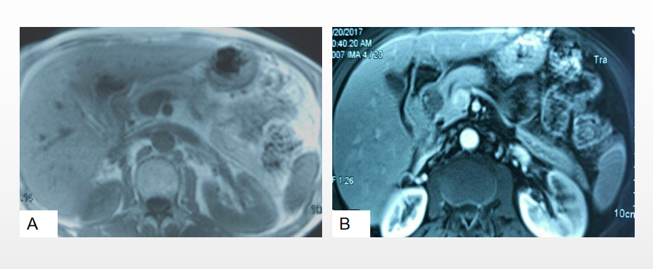
Figure 1 Magnetic resonance imaging findings of pancreatic granular cell tumor. A: The tumor showed a slight hypointensy on the T1 weighted image; B: The surrounding and center of the tumor were equal signal and hypointense on T2 weighted image, respectively.
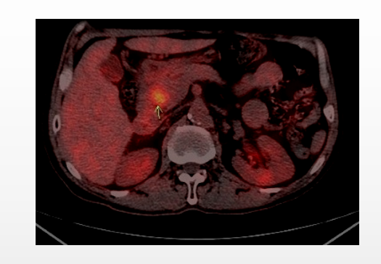
Figure 2 The L1/2 level of the descending part of the duodenum and head of pancreas and soft tissue nodules, and the two is unclear, the computed tomography value is about 45 U, the sectional area of about 24 mm × 22 mm, uptake in the SUV, the maximum value of about 4.8, two hour delay imaging, radiation higher than before, the maximum value of 5.2 SUV, a visible display of pancreatic duct.
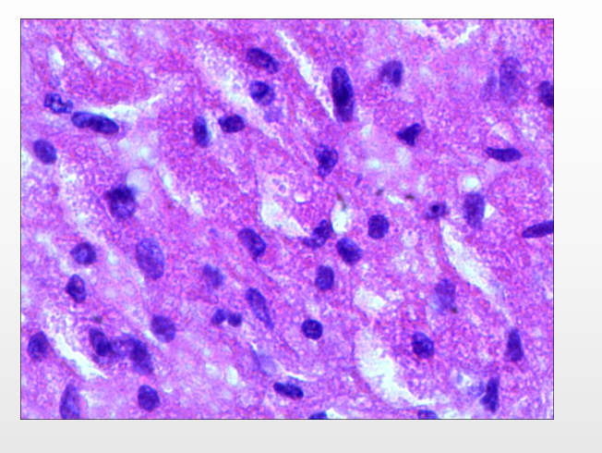
Figure 3 The tumor cells that consisted of a large number cytoplasmiceosinophilic were oval.
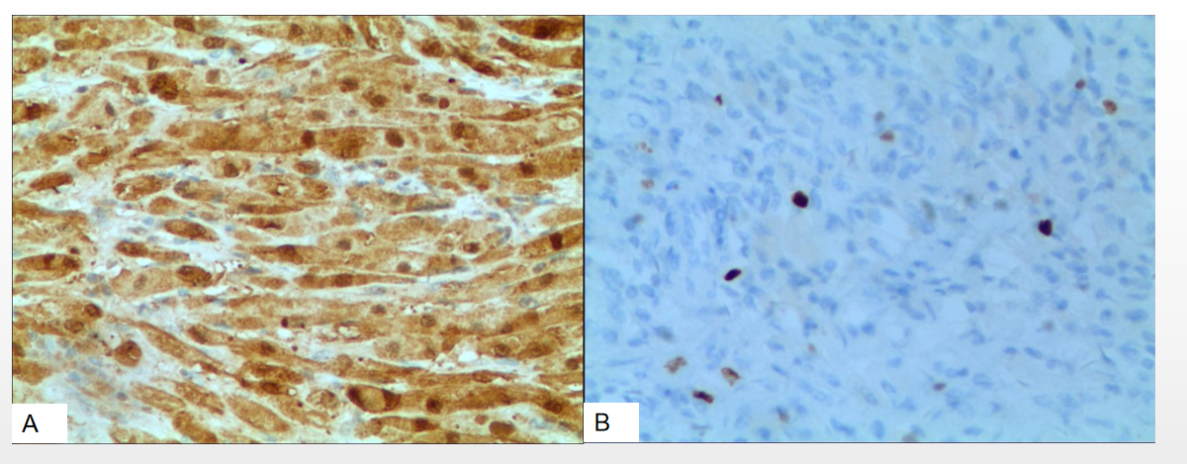
Figure 4 Periodic Acid-Schiff staining and immunohistochemistry showed positive staining of S-100 protein in tumor cells. A: Periodic Acid-Schiff staining; B: Immunohistochemistry.
Table 1 Summary of the characteristics of the 7 cases of the granular cell tumor of the pancreas found in the literature
Ref. | Age | Sex | Locarization | Size in mm | Treatment
Wellman et al^{[24]}, 1975 | 29 | M | Head | 6 mm × 4 mm × 3 mm | -
Sekas et al^{[25]}, 1988 | 31 | F | Head | 5 | Pancreaticojejunostomy
Seidler et al^{[16]}, 1986 | 62 | F | Tail | 7 mm × 5 mm | Distal pancreatectomy
Bin-Sagheer et al^{[17]}, 2002 | 50 | F | Body-tail | - | Distal pancreatectomy
Méklati et al^{[22]}, 2005 | 26 | F | Body-tail | 5 | Distal pancreatectomy
Nojiri et al^{[18]}, 2001 | 58 | M | Head | 13 | Pancreatoduodenectomy
Kanno et al^{[26]}, 2010 | 39 | F | Boay | 20 | Distal pancreatectomy
Present case | 53 | M | Head | 30 mm × 25 mm × 20 mm | Pancreatoduodenectomy

Published by Baishideng Publishing Group Inc
7041 Koll Center Parkway, Suite 160, Pleasanton, CA 94566, USA
Telephone: +1-925-3991568
E-mail: bpgoffice@wjgnet.com
Help Desk: https://www.f6publishing.com/helpdesk
https://www.wjgnet.com

© 2021 Baishideng Publishing Group Inc. All rights reserved.

