Name of Journal: World Journal of Clinical Cases
Manuscript NO: 62073
Manuscript Type: CASE REPORT

Sarcomatoid carcinoma of the pancreas — a rare tumor with an uncommon presentation and course: a case report and review of literature

Toledo PF et al. Sarcomatoid carcinoma of the pancreas

Paulina Fernanda Toledo, Zoltan Berger, Laura Carreño, Gonzalo Cardenas, Jaime Castillo, Omar Orellana

Paulina Fernanda Toledo, Department of Gastroenterology, Hospital Clinico Universidad de Chile, Santiago 834456, independencia, Chile

Zoltan Berger, Department of Internal Medicine, Section Gastroenterology, Hospital Clinico Universidad de Chile, Santiago 834456, independencia, Chile

Laura Carreño, Department of Pathology, Hospital Clínico de la Universidad de Chile, Santiago 834456, Independencia, Chile

Gonzalo Cardenas, Department of Radiology, Hospital Clínico Universidad de Chile, Santiago 834456, independencia, Chile

Jaime Castillo, Omar Orellana, Department of Surgery, Hospital Clínico Universidad de Chile, Santiago 834456, Independencia, Chile

Author contributions: Toledo PF reviewed the literature and drafted the manuscript; Berger Z was the patient’s gastroenterologist who maintained medical follow-up and was responsible for critical revision of the article for important intellectual content; Carreño L performed the analyses and interpretation of the anatomopathological findings of the described tumor; Cárdenas G analyzed and interpreted the imaging findings; Castillo J and Orellana O were the patient’s digestive surgeons; all authors issued final approval for the version to be submitted.

Corresponding author: Zoltan Berger, MD, PhD, Professor, Department of Internal Medicine, Section Gastroenterology, Hospital Clinico Universidad de Chile, Santos Dumont 999, Santiago 834456, independencia, Chile. berger.zoltan@gmail.com

Received: December 28, 2020
Revised: February 17, 2021
Accepted: March 24, 2021
Published online:

Abstract
BACKGROUND
Sarcomatoid carcinoma of the pancreas (SCP) is a rare type of pancreatic neoplasm, and only a few cases have been described in the literature. Histologically, it is composed mostly of atypical spindle cells with apparent sarcomatous features.

CASE SUMMARY
This is a report of a 61-year-old Chilean woman who underwent medical investigation for acute abdominal pain. Computed tomography identified a solid tumor in the tail of the pancreas with features suspicious of malignancy. En-bloc distal pancreatectomy and splenectomy were performed to excise the tumor. Histopathology and immunohistochemistry were confirmatory of sarcomatoid carcinoma with lymphovascular invasion. After surgery, the patient did not receive chemotherapy. Previous studies indicate a poor prognosis for this type of malignancy. However, our patient has survived for 35 mo with no recurrence to date.

CONCLUSION
The case presented herein is a patient with an SCP with a rare presentation and long-term survival after surgery despite not receiving adjuvant chemotherapy.

Key Words: pancreatic neoplasms; sarcomatoid carcinoma; pancreatic ductal carcinoma; survival; abdominal pain; case report

Toledo PF, Berger Z, Carreño L, Cardenas G, Castillo J, Orellana O. Sarcomatoid carcinoma of the pancreas — a rare tumor with an uncommon presentation and course: A case report and review of literature. World J Clin Cases 2021; In press

Core Tip: Sarcomatoid carcinoma of the pancreas (SCP) is an extremely rare and aggressive histologic subtype of undifferentiated pancreatic carcinoma. The prognosis of this neoplasm is similar to or even worse than that of typical pancreatic ductal adenocarcinoma (PDAC). However, the clinical course and surgical outcomes of SCP remain poorly characterized owing to its rarity. Because there is no standard regimen for treating SCP, patients with this disease are administered the same regimens as those with more common PDACs. In the present study, we report a case of SCP; although some patients have a rapid recurrence and early death, long-term survival may be possible.

INTRODUCTION
Pancreatic cancer is considered a disease with uniformly poor outcomes^{[1]}. The worldwide 5-year survival rate for pancreatic cancer patients is approximately 6%^{[2]}. Pancreatic ductal adenocarcinoma (PDAC) is by far the most common solid pancreatic tumor, which represents 85 to 90% of all pancreatic neoplasms; thus, most attributes of pancreatic cancer are related to this tumor^{[3]}. However, several morphological variants of PDAC are recognized in the latest (2019) World Health Organization (WHO) classification of pancreatic tumors based on distinctive histologic features^{[2,4]}. Sarcomatoid carcinoma of the pancreas (SCP) is among these variants. SCP is an extremely uncommon tumor that accounts for 0.1% to 5.7% of all pancreatic malignancies^{[5]}. It is an undifferentiated carcinoma that shares similar molecular pathogenesis with PDAC and therefore a similarly poor prognosis^{[2]}. Despite aggressive surgical management, the median postoperative survival has consistently been reported as less than 1 year^{[6]}. Most examples of SCP are found in the literature only as case reports.
We report an exceptional case of SCP detected in a patient who underwent consultation in our emergency room with acute abdominal pain. The patient has survived for a long time to date without disease recurrence despite not receiving chemotherapy. We, therefore, discuss this case and review the relevant literature.

CASE PRESENTATION
Chief complaints
A 61-year-old female was admitted to our hospital suffering from 48 h of acute abdominal pain, characterized by epigastralgia without irradiation and no response to spasmolytics or analgesics.

History of present illness
The patient had been suffering intermittent episodes of mild discomfort of the gastrointestinal tract such as bearable diffuse abdominal pain and feeling of flatulence that persisted for one year. The pain pattern was not related to defecation or eating, there was no nausea, vomiting, weight loss, melaena, change in bowel habit, urinary symptoms, or fever. She was managed conservatively as thought to be a functional gastrointestinal disorder.
She describes the pain as aggravating suddenly and sharp in nature. She presented to the emergency department after 48 h of the pain acutely worsened. The pain was in the epigastrium and across the anterior abdomen, was sharp and constant with no radiation.

History of past illness
She had no antecedents of alcohol, tobacco, or drug abuse.

Personal and family history
She had a medical history of arterial hypertension and trigeminal neuralgia and had no surgical history. In her family history, there were two cases of colorectal cancer (mother and sister) without other illnesses.

Physical examination
The patient experienced epigastric tenderness upon palpation, although she had no rebound tenderness, muscle tension, or a palpable mass. She had no other relevant findings.

Laboratory examinations
Laboratory test results including complete blood count, liver function tests, serum amylase and lipase, biochemistry, were within normal ranges.

Imaging examinations
An abdominal computed tomography (CT) scan showed a solid mass of the tail of the pancreas that contacted the lesser curvature of the gastric body. Magnetic resonance imaging (MRI) showed a pancreatic head, uncinate process, neck, and body of normal morphology. A solid nodular mass 29 mm in diameter was confirmed in the pancreatic tail, hypointense in T1, heterogeneous with hyperintense areas in T2, with enhancement after the administration of i.v. contrast predominantly towards the latter phase. Severe atrophy of the tail of the pancreas and upstream dilation of the main pancreatic duct was observed. The intra- and extrahepatic bile ducts were of normal caliber. This hypovascular nodule was highly suspicious of malignancy, probably PDAC. No regional or distant metastases were visualized in the abdomen (Figure 1).
Complementary imaging studies for staging were performed. Thorax CT revealed 10 solid nodules between 3-6 mm distributed in both lungs, which, due to their distribution, were suspicious of secondary implants.

FINAL DIAGNOSIS
Video-thoracoscopy was performed, and these nodules had the characteristic appearance of benign anthracotic nodules, a type of pneumoconiosis caused by repeated exposure to air pollution or coal dust particles^{[7]}. Biopsies were performed, and the benign nature was confirmed by histology.
Given these findings of no extra-abdominal disease, no metastasis surgery was performed. Distal pancreatectomy with en bloc splenectomy was performed. Following surgery, the patient recovered successfully and was discharged from the hospital after 5 d.
Gross examination of the resected specimen revealed the tumor was localized in the tail of the pancreas, measured 3.2 cm × 2.9 cm, and consisted of a solid mass. Margins of surgical resection were free of tumor. Microscopically, the tumor was consistent with ductal adenocarcinoma with sarcomatoid features (Figure 2). Immunohistochemistry showed that the tumor had both epithelial and mesenchymal markers that were positive for pan-cytokeratin (Figure 2D), vimentin (Figure 2C), and smooth muscle actin (SMA) and negative for CD68. Thus, a diagnosis of SCP was confirmed.
The tumor was confined to the tail of the pancreas with no invasion to the spleen. All surgical margins were free of tumor tissue. There was no evidence of perineural invasion but lymphovascular permeation and one of thirty peripancreatic lymph nodes were positive for metastatic cancer.

TREATMENT
The oncologic committee disclosure was that the patient should receive postoperative adjuvant chemotherapy with gemcitabine and capecitabine. Unfortunately, this could not be carried out for extra medical reasons since the patient's medical insurance did not cover this treatment.

OUTCOME AND FOLLOW-UP
As our patient did not have access to adjuvant chemotherapy, we performed follow-up every 6 mo with general laboratory exams and imaging of the abdomen. The last image obtained was an abdominal CT after 35 mo of curative surgery, which did not reveal tumor recurrence.

DISCUSSION
Sarcomatoid carcinomas are uncommon aggressive histologic variants of carcinoma. Although they may rarely arise in almost any organ, the lung, breast, and kidney are the most common primary sites^{[8]}. Several terms have been used to describe this malignancy, including carcinosarcoma, pseudosarcoma, pseudocarcinoma, and spindle cell carcinoma^{[9]}. The multiple names demonstrate the varied understanding of this disease, which these terms have been often used interchangeably, and their definitions vary among the reports^{[10]}. According to the WHO classification (5th edition, 2019) of pancreatic tumors assigns SCP under the category of undifferentiated carcinomas (UCP)^{[4]}. UCP is a subtype of PDAC representing a set of rare tumors that accounts for as many as 5% of all pancreatic malignancies^{[11]}. UPC is categorized into two different types: undifferentiated carcinoma [with three variants: anaplastic undifferentiated carcinoma, sarcomatoid carcinoma (SCP), and carcinosarcoma] and undifferentiated carcinoma with osteoclast-like giant cells^{[5,12]}. Hence, we present a case of SCP that is an extremely rare type of tumor, with only a few cases reported in the literature^{[5,9,10,13-21]}
SCP is defined histologically as a poorly differentiated tumor composed by the proliferation of spindle cells with evidence of epithelial differentiation. Sarcomatoid carcinomas can exhibit a monophasic or biphasic appearance. The monophasic pattern often referred to as spindle cell carcinoma, is akin to a soft tissue sarcoma without epithelioid areas. The biphasic pattern features a mixture of mesenchymal-like and epithelial-like cells with a transition zone. The sarcomatous tissue of these tumors shows evidence of epithelial differentiation, such as epithelial markers and epithelial ultrastructural features, rather than a specific line of mesenchymal differentiation^{[14]}.
The diagnosis often represents a clinicopathologic challenge, and immunohistochemistry plays a key role in the histopathological diagnosis where an epithelial immunohistochemical profile assembles PDAC^{[6,22]}. In immunohistochemistry, undifferentiated cells often express both broad lineage carcinoma (pan-cytokeratin) and sarcoma (vimentin and desmin) markers and display a loss of E-cadherin^{[12]}. Its pathogenesis remains unclear^{[23,24]}.
Owing to the rarity of the disease, the clinical course, surgical outcomes, and optimal treatment strategies for SCP are poorly characterized^{[5]}.
To date, the largest study to analyze the histological spectrum of pancreatic carcinoma with sarcoma-like transformation was reported in 1977 by Alguacil-Garcia and Weiland^{[25]} who identified four distinctive histological types of sarcoma-like carcinoma based on light microscopic analysis only. Of twelve cases they reported an average survival of 8.3 mo for patients with nonresectable lesions.
In addition to our patient, 16 cases of SCP with confirmed both epithelial and sarcomatoid elements have been reported (Table 1).
Although SCP and “Carcinosarcoma” have different pathologic features, both share similar clinical features. Carcinosarcomas are considered to be “truly” biphasic neoplasms composed of intermingled carcinomatous and sarcomatous components, which have epithelial and mesenchymal differentiation. These two components are typically separated without a transition zone^{[14]}.
In previously published reports, the terms SPC and Carcinosarcoma have been often used interchangeably, and their definitions vary among the reports. On this basis, we excluded some articles in our summary of case reports (Table 1), when the terminology of “carcinosarcoma”, “sarcoma-like” or “carcinosarcomatous histology” was used.
Recent publications have described the clinical and radiological features of UCP. Shiihara et al^{[6]} aimed to identify the detailed clinicopathological features of UCP and revealed that these patients likely have abdominal pain or discomfort as an initial symptom, whereas jaundice was less common. It tends to present more commonly in men vs women with a ratio of 2.5:1 and occurs more frequently in the head of the pancreas^{[25]}. Zhao et al^{[26]} reported the radiologic features of SCP and found that the mean size of SCP was 5.1 cm, and most of the lesions appeared to be round or ellipsoidal in shape and were ill-defined. Vascular invasion by CT and MRI was reported in 5 of 10 Lesions^{[26]}. At the time of diagnosis, a bulky tumor is frequently detected, with the involvement of organs in the vicinity^{[27]}. One of the imaging key signs for PDAC is the abrupt “cut-off” of the main pancreatic duct (MPD), with upstream MPD dilatation and substantial pancreatic atrophy^{[28]}. Zhao et al^{[26]} reported that eight of ten patients with SCP had upstream dilatation of the MPD. Among them, in three patients MPD was compressed by the lesions and no atrophy of the distal pancreatic parenchyma. In the other five patients, upstream MPD dilatation and distal pancreatic parenchyma atrophy were detected synchronously in only two patients while no atrophy was detected in the remaining three patients^{[26]}.
Because there is no standard regimen for treating SCP, patients with this disease are administered the same regimens as those with more common PDACs. Gemcitabine has been reported to be effective in the event of portal vein thrombosis or tumor recurrence, whereas a cisplatin/etoposide/ifosfamide regimen was also found to produce notable results^{[6]}. Imaoka et al^{[29]} conducted a multicenter retrospective cohort study to investigate the efficacy of chemotherapy in patients with UCP (n = 50) showing a median overall survival (OS) of 4.08 mo. The most frequently used first-line treatment regimens were gemcitabine, S-1, and gemcitabine plus nab-paclitaxel. Although there was no significant difference in OS among these first-line regimens, gemcitabine plus nab-paclitaxel significantly improved median progression-free survival compared with gemcitabine alone^{[29]}.
Although treatment for PDAC remains challenging, complete R0 surgical extirpation is the only chance of cure^{[5]}. Although SCP shares similar molecular carcinogenesis with PDAC, its prognosis is much worse^{[6]}. Despite aggressive surgical management, the median postoperative survival has consistently been reported as less than 1 year, and almost all recurrences involve unresectable multiple metastases^{[6,17,21,23,30]}. Of the previously reported cases of SCP (Table 1), we calculated the mean survival time of the patients using the Kaplan-Meier method, showing a median OS of 9 mo (range 0-27), with 5-year and 10-year survival rates of 41.25% and 20.63% respectively (Figure 3).
Furthermore, the impact of adjuvant chemotherapy on the survival of SCP has not been well defined. Imaoka et al^{[29]} report that a paclitaxel-containing regimen would offer relatively longer survival in patients with unresectable UCP.
Given its aggressive biological behavior and poor prognosis, it is of prime importance to make early diagnoses for patients with SCP^{[22]}. Although some patients have a rapid recurrence and early death, long-term survival has been reported^{[5,10]}. Blair et al^{[5]} reported 8 cases of SCP, of which two experienced long-term survival (> 5 years), with the longest surviving nearly 16 years despite the presence of lymph node metastasis representing the longest survival time of SPC patients in the literature. Nevertheless, both long-term survivors had the tumor in the body/tail of the pancreas, underwent R0 resections, and received adjuvant therapy.
There are two reports of exceptional survival after ten years of follow-up. One of them a patient who received adjuvant chemotherapy with gemcitabine who remained free of tumor recurrence and metastasis for 10 years but after this period the patient presented a colonic obstruction due to metastatic disease^{[18]}. In the other case of SCP with a stage T3N1M0, after surgery the patient completed a 6-month course of adjuvant chemotherapy with gemcitabine and was then followed up with abdomen CT. At 10 years after the operation, the authors report he is alive with no recurrence^{[10]}.
SCP reported in the present paper is a very rare case of primary pancreatic neoplasm. Based on the limited number of reported cases, the prognosis is poor. To our knowledge, the good evolution of our patient, tumor-free survival of 35 mo after surgery despite not receiving adjuvant chemotherapy treatment, is rather exceptional particularly after having lymphovascular invasion. Although our patient had a smaller tumor size compared to the other long-term survival cases, Paal et al^{[25]} reported in 35 cases of UCP that overall tumor size is not a reliable prognostic indicator. In this case, the clinical presentation with acute abdominal pain aided in obtaining a relatively early diagnosis and better surgical results.

CONCLUSION
Sarcomatoid carcinoma is a rare aggressive tumor with a poor prognosis. With an early diagnosis with early surgical eradication of the tumor and adjuvant chemotherapy, evolution may be exceptionally favorable with long survival. The patient described in this case study is alive and without metastasis 35 mo after surgery despite not receiving chemotherapy.

ACKNOWLEDGEMENTS
We are very grateful to the patient who provided informed consent for publication of the case.

REFERENCES
1 Kamisawa T, Wood LD, Itoi T, Takaori K. Pancreatic cancer. Lancet 2016; 388: 73-85 [PMID: 26830752 DOI: 10.1016/S0140-6736(16)00141-0]
2 McGuigan A, Kelly P, Turkington RC, Jones C, Coleman HG, McCain RS. Pancreatic cancer: A review of clinical diagnosis, epidemiology, treatment and outcomes. World J Gastroenterol 2018; 24: 4846-4861 [PMID: 30487695 DOI: 10.3748/wjg.v24.i43.4846]
3 Mostafa ME, Erbarut-Seven I, Pehlivanoglu B, Adsay V. Pathologic classification of "pancreatic cancers": current concepts and challenges. Chin Clin Oncol 2017; 6: 59 [PMID: 29307199 DOI: 10.21037/cco.2017.12.01]
4 Nagtegaal ID, Odze RD, Klimstra D, Paradis V, Rugge M, Schirmacher P, Washington KM, Carneiro F, Cree IA; WHO Classification of Tumours Editorial Board. The 2019 WHO classification of tumours of the digestive system. Histopathology 2020; 76: 182-188 [PMID: 31433515 DOI: 10.1111/his.13975]
5 Blair AB, Burkhart RA, Griffin JF, Miller JA, Weiss MJ, Cameron JL, Wolfgang CL, He J. Long-term survival after resection of sarcomatoid carcinoma of the pancreas: an updated experience. J Surg Res 2017; 219: 238-243 [PMID: 29078888 DOI: 10.1016/j.jss.2017.05.065]
6 Shiihara M, Higuchi R, Izumo W, Furukawa T, Yamamoto M. A Comparison of the Pathological Types of Undifferentiated Carcinoma of the Pancreas. Pancreas 2020; 49: 230-235 [PMID: 32011534 DOI: 10.1097/MPA.0000000000001483]
7 Mirsadraee M. Anthracosis of the lungs: etiology, clinical manifestations and diagnosis: a review. Tanaffos 2014; 13: 1-13 [PMID: 25852756]
8 Hornick JL. Biphasic Tumors and Tumors With Mixed Patterns. In: Practical Soft Tissue Pathology: a Diagnostic Approach. Elsevier, 2019: 249-267
9 Kane JR, Laskin WB, Matkowskyj KA, Villa C, Yeldandi AV. Sarcomatoid (spindle cell) carcinoma of the pancreas: A case report and review of the literature. Oncol Lett 2014; 7: 245-249 [PMID: 24348857 DOI: 10.3892/ol.2013.1683]
10 Kimura T, Fujimoto D, Togawa T, Ishida M, Iida A, Sato Y, Goi T. Sarcomatoid carcinoma of the pancreas with rare long-term survival: a case report. World J Surg Oncol 2020; 18: 105 [PMID: 32450860 DOI: 10.1186/s12957-020-01879-8]
11 Clark CJ, Graham RP, Arun JS, Harmsen WS, Reid-Lombardo KM. Clinical outcomes for anaplastic pancreatic cancer: a population-based study. J Am Coll Surg 2012; 215: 627-634 [PMID: 23084492 DOI: 10.1016/j.jamcollsurg.2012.06.418]
12 Haeberle L, Esposito I. Pathology of pancreatic cancer. Transl Gastroenterol Hepatol 2019; 4: 50 [PMID: 31304427 DOI: 10.21037/tgh.2019.06.02]
13 Ren CL, Jin P, Han CX, Xiao Q, Wang DR, Shi L, Wang DX, Chen H. Unusual early-stage pancreatic sarcomatoid carcinoma. World J Gastroenterol 2013; 19: 7820-7824 [PMID: 24282372 DOI: 10.3748/wjg.v19.i43.7820]
14 Zhou DK, Gao BQ, Zhang W, Qian XH, Ying LX, Wang WL. Sarcomatoid carcinoma of the pancreas: A case report. World J Clin Cases 2019; 7: 236-241 [PMID: 30705901 DOI: 10.12998/wjcc.v7.i2.236]
15 Yao J, Qian JJ, Zhu CR, Bai DS, Miao Y. Laparoscopic left pancreatectomy for pancreatic sarcomatoid carcinoma: A case report and review of the literature. Oncol Lett 2013; 6: 568-570 [PMID: 24137372 DOI: 10.3892/ol.2013.1411]
16 Xie Y, Xiang Y, Zhang D, Yao X, Sheng J, Yang Y, Zhang X. Sarcomatoid carcinoma of the pancreas: A case report and review of the literature. Mol Med Rep 2018; 18: 4716-4724 [PMID: 30221744 DOI: 10.3892/mmr.2018.9489]
17 Bukhari N, Joudeh A. Early Stage Anaplastic Sarcomatoid Carcinoma of The Pancreas, A Case Report. Am J Case Rep 2019; 20: 597-601 [PMID: 31023997 DOI: 10.12659/AJCR.915334]
18 Omrani S, Hajri M, Ferjaoui W, Guizani R, Talbi G, Gharbi L, Bayar R, khalfallah MT. Pancreatic sarcomatoid carcinoma : An unusual evolution. Med Case Rep Rev 2020; 3: 1-2 [DOI: 10.15761/MCRR.1000141]
19 Higashi M, Takao S, Sato E. Sarcomatoid carcinoma of the pancreas: a case report with immunohistochemical study. Pathol Int 1999; 49: 453-456 [PMID: 10417690 DOI: 10.1046/j.1440-1827.1999.00877.x]
20 Hu QL, Li HQ, Xia TY. A case of sarcomatoid carcinoma of the pancreas. Shijie Huaren Xiaohua Zazhi 2015; 23: 707-710 [DOI: 10.11569/wcjd.v23.i4.707]
21 Kim KH, Kang DY, Lee MK, Yang HW, Han HY. Sarcomatoid Carcinoma of the Pancreas - A Case Report. Korean J Pathol 2006; 40: 306-310
22 Yepuri N, Pruekprasert N, Naous R. High-grade malignant pancreatic neoplasm with sarcomatoid features. AME Case Rep 2018; 2: 39 [PMID: 30363708 DOI: 10.21037/acr.2018.08.02]
23 Huey RW, Makawita S, Xiao L, Matamoros A, Estrella JS, Overman MJ, Varadhachary GR, Raghav K. Sarcomatoid carcinoma presenting as cancers of unknown primary: a clinicopathological portrait. BMC Cancer 2019; 19: 965 [PMID: 31623602 DOI: 10.1186/s12885-019-6155-6]
24 Alguacil-Garcia A, Weiland LH. The histologic spectrum, prognosis, and histogenesis of the sarcomatoid carcinoma of the pancreas. Cancer 1977; 39: 1181-1189 [PMID: 912652 DOI: 10.1002/1097-0142(197703)39:3<1181::AID-CNCR2820390325>3.0.CO;2-T]
25 Paal E, Thompson LD, Frommelt RA, Przygodzki RM, Heffess CS. A clinicopathologic and immunohistochemical study of 35 anaplastic carcinomas of the pancreas with a review of the literature. Ann Diagn Pathol 2001; 5: 129-140 [PMID: 11436166 DOI: 10.1053/adpa.2001.25404]
26 Zhao S, Su W, Deng L, Chen Y, Zuo C, Shao C, Ren F. Pancreatic sarcomatoid carcinoma: CT, MRI, and ¹⁸F-FDG PET/CT features. Clin Radiol 2020; 75: 397.e7-397.e14 [PMID: 32044096 DOI: 10.1016/j.crad.2020.01.003]
27 Hoshimoto S, Matsui J, Miyata R, Takigawa Y, Miyauchi J. Anaplastic carcinoma of the pancreas: Case report and literature review of reported cases in Japan. World J Gastroenterol 2016; 22: 8631-8637 [PMID: 27784976 DOI: 10.3748/wjg.v22.i38.8631]
28 Elbanna KY, Jang HJ, Kim TK. Imaging diagnosis and staging of pancreatic ductal adenocarcinoma: a comprehensive review. Insights Imaging 2020; 11: 58 [PMID: 32335790 DOI: 10.1186/s13244-020-00861-y]
29 Imaoka H, Ikeda M, Maehara K, Umemoto K, Ozaka M, Kobayashi S, Terashima T, Inoue H, Sakaguchi C, Tsuji K, Shioji K, Okamura K, Kawamoto Y, Suzuki R, Shirakawa H, Nagano H, Ueno M, Morizane C, Furuse J. Clinical outcomes of chemotherapy in patients with undifferentiated carcinoma of the pancreas: a retrospective multicenter cohort study. BMC Cancer 2020; 20: 946 [PMID: 33004032 DOI: 10.1186/s12885-020-07462-4]
30 Gelos M, Behringer D, Philippou S, Mann B. Pancreatic carcinosarcoma. Case report of multimodal therapy and review of the literature. JOP 2008; 9: 50-55 [PMID: 18182744]
31 Cresson DH, Reddick RL. Sarcomatoid carcinoma of the pancreas presenting as gastric carcinoma: clinicopathologic and ultrastructural findings. J Surg Oncol 1987; 36: 268-274 [PMID: 3695533 DOI: 10.1002/jso.2930360411]
32 Darvishian F, Sullivan J, Teichberg S, Basham K. Carcinosarcoma of the Pancreas. Arch Pathol Lab Med 2002; 126: 1114-1117 [DOI: 10.5858/2002-126-1114-COTP]
33 De la Riva S, Muñoz-Navas MA, Betés M, Súbtil JC, Carretero C, Sola JJ. Sarcomatoid carcinoma of the pancreas and congenital choledochal cyst. Gastrointest Endosc 2006; 64: 1005-1006; discussion 1006 [PMID: 17140915 DOI: 10.1016/j.gie.2006.06.004]
34 Lai CW, Chen CW, Lee YH, Chen JH. Sarcomatoid carcinoma of the pancreas. Tzu Chi Med J 2015; 27: 46-47 [DOI: 10.1016/j.tcmj.2014.09.003]
35 Nambiar RK, Roshni S, Lijeesh AL, Mony RP. Sarcomatoid carcinoma of pancreas with liver metastases – A case report with review of literature. J Med Ther 2017; 1: 1-3 [DOI: 10.15761/jmt.1000112]
36 Ruess DA, Kayser C, Neubauer J, Fichtner-Feigl S, Hopt UT, Wittel UA. Carcinosarcoma of the Pancreas: Case Report With Comprehensive Literature Review. Pancreas 2017; 46: 1225-1233 [PMID: 28902796 DOI: 10.1097/MPA.0000000000000904]
Footnotes
Informed consent statement: Informed written consent was obtained from the patient for publication of this report and any accompanying images.

Conflict-of-interest statement: The authors declare that they have no conflicts of interest.

CARE Checklist (2016) statement: The authors have read the CARE Checklist (2016), and the manuscript was prepared and revised accordingly.

Open-Access: This article is an open-access article that was selected by an in-house editor and fully peer-reviewed by external reviewers. It is distributed in accordance with the Creative Commons Attribution NonCommercial (CC BY-NC 4.0) license, which permits others to distribute, remix, adapt, build upon this work non-commercially, and license their derivative works on different terms, provided the original work is properly cited and the use is non-commercial. See: http://creativecommons.org/Licenses/by-nc/4.0/

Manuscript source: Unsolicited manuscript

Corresponding Author's Membership in Professional Societies: American Society for Gastrointestinal Endoscopy, No. 172297; and Sociedad Chilena de Gastroenterología.

Peer-review started: December 28, 2020
First decision: January 9, 2021
Article in press:

Specialty type: Gastroenterology and hepatology
Country/Territory of origin: Chile
Peer-review report’s scientific quality classification
Grade A (Excellent): 0
Grade B (Very good): 0
Grade C (Good): C
Grade D (Fair): D
Grade E (Poor): 0

P-Reviewer: Nie M, Tian C S-Editor: Gong ZM L-Editor: P-Editor:

Figure Legends
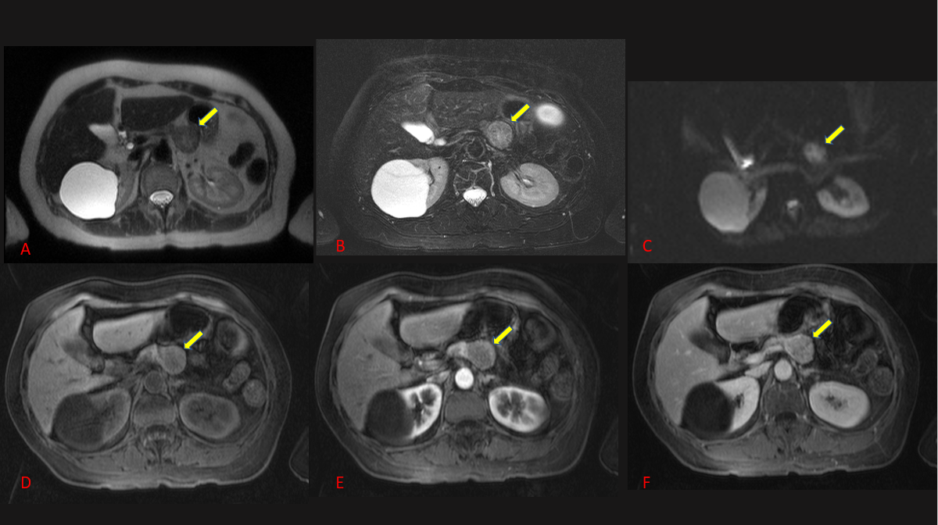
Figure 1 Magnetic resonance imaging scan of the abdomen showing a distal pancreatic mass of 29 mm. A: On the T2-weighted image, the lesion contained mixed signals (yellow arrow); B: T2 fat saturation; C: Diffusion-weighted; D: T1-weighted fat sat gadolinium; E and F: T1-weighted image during arterial and portal phase that shows a hypovascular lesion.

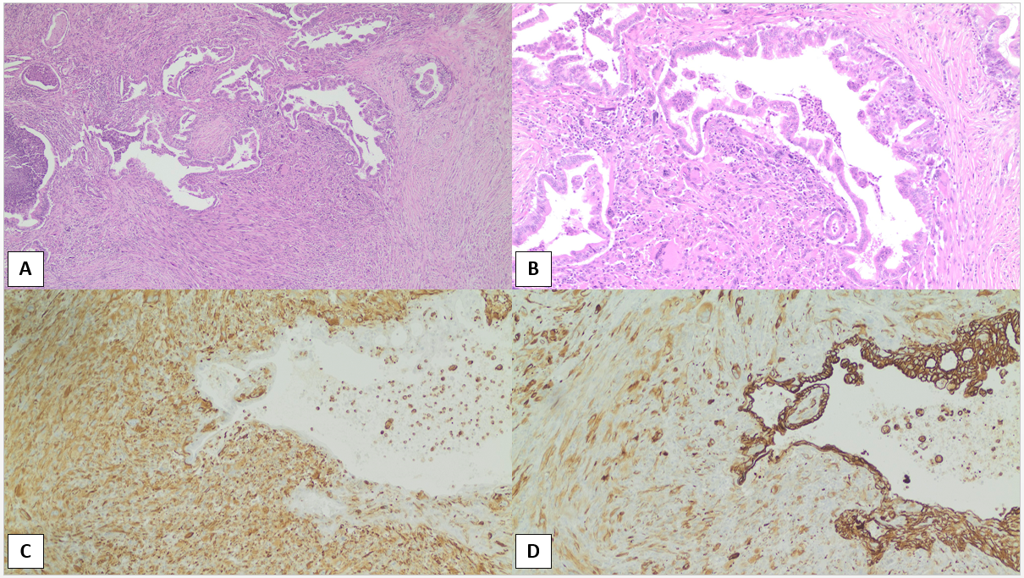
Figure 2 Histological examination and immunohistochemical staining. A and B: Histological examination of the pancreatic neoplasm reveals infiltration by malignant cells displaying a glandular and spindle-cell pattern. Hematoxylin and eosin, 4 × (A); Hematoxylin and eosin, 10 × (B). Glandular component lined by atypical epithelium and sarcomatous spindle cell component with pleomorphic giant cells; C: Immunohistochemical staining for pan-cytokeratin, 10 ×. Glandular and sarcomatoid components are positive for this epithelial marker; D: Immunohistochemical stain for vimentin, 10 ×. Vimentin is the most common mesenchymal marker. The epithelial glandular component is negative, and the sarcomatoid component is strongly positive.
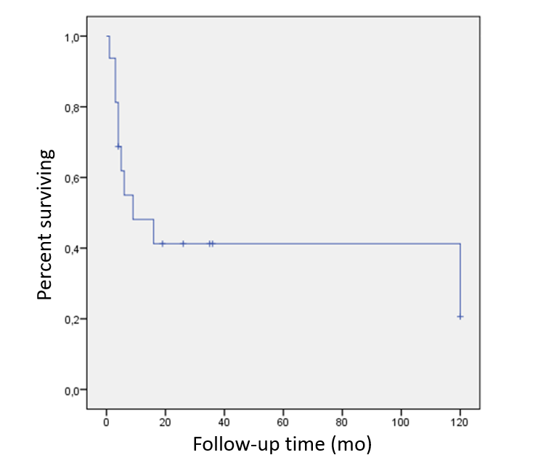
Figure 3 Survival curves using the Kaplan-Meier method showing the overall survival of reported cases of sarcomatoid carcinomas. The median overall survival times in patients with sarcomatoid carcinoma of the pancreas were 9 mo (range 0-27). The 5-year and 10-year survival rates were 41.25% and 20.63% respectively.

Table 1 Summary of reported cases of sarcomatoid carcinoma of the pancreas
Ref. | Age (yr)/ gender | Involved part of the pancreas | Tumor extension | Therapeutic schedule | Tumor size, cm | Sarcomatoid component | Follow-up time/results
Cresson et al^{[31]}, 1987 | 69/male | Head and tail | NA | Mitomycin, adriamycin, and 3000 rads of external radiation to the stomach | NA | Tubular structures, desmosomes, and hemijunctions under electron microscope | 5 mo/ hemorrhage after surgery of metastasis in the jejunum
Higashi et al^{[9]}, 1999 | 74/male | Head | Head of the pancreas and the adjacent duodenum, with blood vessel and perineural  Sarcomatoid | Pylorus preserving pancreatoduodenectomy | 4.5 × 4 × 3 | CK AE1/AE3(+), EMA(+), MUC1-ARA (+), S100(+), SMA(+), desmina, vimentin, (–) | 3 mo/died after surgery of peritoneal carcinomatosis
Darvishian et al^{[32]}, 2002 | 74/male | Head | peripancreatic adipose tissue and the duodenal wall. | Pancreatoduodenectomy | 4.0 × 3.0 | Vimentin (+), CK (+), CEA (+),SMA(+), desmin(+) and CD68 (-) | 4 mo/alive and well
De la Riva et al^{[33]}, 2006 | 72/female | Head | NA | NA | NA | CK and vimentin(+) | 9 mo/d deceased with hepatic metastasis
Kim et al^{[21]}, 2006 | 48/male | Body and tail | Local invasion. With retroperitoneal lymph node with metastasis | Pancreatectomy with splenectomy and colonic segmental resection | 20 ×15 ×13 | scattered OGC; positive for vimentin, pan- CK, CK, 7, CK8/18, EMA, CEA, CD34, CD56, CD68, CD117, desmin, SMA, myogenin, S100 | 4 mo/ deceased secondary to hepatic and peritoneal metastases
Ren et al^{[13]}, 2013 | 48/male | Tail | Free surgical margins | Surgery N/A. Digital subtraction angiography interventional chemotherapy was then implemented. Gemcitabine, oxaliplatin, and floxuridine were intravenously injected via the superior mesenteric artery and celiac trunk artery. | 10 cm × 8 cm × 3.5 | vimentin, α-1-antichymotrypsin, CK-19, CK-18, and pan-CK (+). CD68 and lysozyme (-) | 36 mo/alive and well
Yao et al^{[15]}, 2013 | 48/male | Tail | Free surgical margins | laparoscopic spleen-preserving left pancreatectomy, adjuvant gemcitabine 1 cycle | 10 × 8 × 5 | CK 18 and vimentin (+) | 3 mo/tumor recurrence and death
Kane et al^{[9]}, 2014 | 85/male | Body | Local invasion with free surgical margins | A distal pancreatectomy, splenectomy, and partial gastrectomy | 3.3 × 3.0 × 2.6 | pan-CK, CK5.2 (+), S100, SMA, EMA (-) | 26 mo/alive and well
Lai et al^{[34]}, 2015 | 55/male | Body and tail | NA | Distal pancreatectomy, splenectomy, and colonic segmental resection | 14 | CK, CK7, and vimentin (+) | NA
Nambiar et al^{[35]}, 2017 | 41/male | Head and uncinate | Liver metastasis | Gemcitabine | 2.2 × 2.1 | CK (+) and vimentin(+) | 1 mo/on chemotherapy when reported
Ruess et al^{[36]}, 2017 | 73/female | Head of pancreas | Free surgical margins | extended pylorus-preserving pancreatoduodenectomy | 4.2 | pan-CK1/3 (+), CK7(+), CK19 (+). Vimentin (+). S100 (+) | 4 mo/death after surgery
Xie et al^{[16]}, 2018 | 63/male | Head of pancreas | invasion of the distal common bile duct. local invasion of the peripheral nerves. The lymph nodes, blood vessels, and resection margins were free from tumor tissue. | Pancreatoduodenectomy. 15 d of thymopeptides (1 mg per day). | 2.5 × 2 × 1.8 cm | vimentin, CK7, and CK19 | 16 mo/hepatic metastasis
Bukhari and Joudeh^{[17]}, 2019 | 64/male | Head | Free surgical margins | pancreatoduodenectomy with cholecystectomy and adjuvant gemcitabine | 2.4 × 2 × 1.9 | CK CAM 5.2, Vimentin (+) | 19 mo/alive and well
Zhou et al^{[14]}, 2019 | 59/male | Head | pancreatic head with extension into the main pancreatic duct. Free surgical margins. Three out of 23 lymph nodes were positive for metastasis | Pancreatoduodenectomy | 2.5 × 2.5 × 2.0 | CK19 (+) and vimentin (+) | 6 mo/liver metastasis and peritoneal metastasis
Kimura et al^{[10]}, 2020 | 58/male | Body | Three lymph nodes out of 40 with direct invasion | distal pancreatectomy with splenectomy. A six-month course of gemcitabine | 5 | CK(+) and vimentin(+). pSmad2/3, Snail, and fibronectin | 120 mo (10 yr)/alive and well
Omrani et al^{[18]}, 2020 | 73/male | Tail | NA | en bloc resection of the tail of the pancreas, spleen, a part of the stomach, and postoperative adjuvant chemotherapy with gemcitabine | 10 | OCG were positive for CK19 and CK7 | 120 mo (10 yr)/colonic metastasis
Our case | 61/female | Tail | Free surgical margin, one lymph node compromised | distal pancreatectomy and en-bloc splenectomy | 3.2 × 2.9 | pan-CK (+) and vimentin (+) | 35 mo/alive and well
CEA: carcinoembryonic antigen; (-): no positivity; (+): positivity; CK: cytokeratin; EMA: epithelial membrane antigen; NA: not available; OCG: osteoclastic giant cells; SMA: smooth muscle actin; MUC1-ARA: apoprotein MUC1.

