Name of Journal: World Journal of Gastroenterology
Manuscript NO: 41540
Manuscript Type: ORIGINAL ARTICLE

Basic Study
Involvement of the methylation-associated silencing of formin 2 in colorectal carcinogenesis

Li DJ et al. Methylation-associated silencing of FMN2 in CRC

Dao-Jiang Li, Zhi-Cai Feng, Xiao-Rong Li, Gui Hu

Dao-Jiang Li, Xiao-Rong Li, Gui Hu, Department of Gastrointestinal Surgery, the third Xiangya Hospital, Central South University, Changsha 410013, Hunan Province, China

Zhi-Cai Feng, Department of Burns and Plastic Surgery, the third Xiangya Hospital, Central South University, Changsha 410013, Hunan Province, China

ORCID number: Dao-Jiang Li (0000-0003-0986-4190); Zhi-Cai Feng (0000-0003-2485-7466); Xiao-Rong Li (0000-0001-8585-3632); Gui Hu (0000-0002-0901-9686).

Author contributions: Li DJ, Hu G and Li XR contributed to conception, design of the study, analyzed data and coordinated the research; Li DJ and Feng ZC performed the majority of the experiment and analyzed the data; all authors drafted the article and made revisions related to the intellectual content of the manuscript, and approved the final version of the article to be published.

Supported by the National Nature Science Foundation of China, No. 81773130; the Key Projects of Postgraduate Independent Exploration and Innovation of Central South University, No. 2018zzts050; and the New Xiangya Talent Projects of the Third Xiangya Hospital of Central South University, No. JY201508.

Institutional review board statement: This study was reviewed and approved by the Ethics Committee of Central South University. Informed consent was obtained from all individual participants included in the study.

Conflict-of-interest statement: To the best of our knowledge, no conflict of interest exists.

Data sharing statement: No additional data are available.

Open-Access: This article is an open-access article which was selected by an in-house editor and fully peer-reviewed by external reviewers. It is distributed in accordance with the Creative Commons Attribution Non Commercial (CC BY-NC 4.0) license, which permits others to distribute, remix, adapt, build upon this work non-commercially, and license their derivative works on different terms, provided the original work is properly cited and the use is non-commercial. See: http://creativecommons.org/licenses/by-nc/4.0/

Manuscript source: Unsolicited manuscript

Correspondence to: Gui Hu, Department of Gastrointestinal Surgery, the third Xiangya Hospital, Central South University, Tongzi Po Road, No. 172, Changsha 410013, Hunan Province, China. xy3zzz@csu.edu.cn.
Telephone: +86-731-13908472002
Fax: +86-731-88618832

Received: August 20, 2018
Peer-review started: August 20, 2018
First decision: October 11, 2018
Revised: October 14, 2018
Accepted: November 7, 2018
Article in press:
Published online:

Abstract
AIM
to investigate whether promoter methylation was responsible for the silencing of formin 2 (FMN2) in colorectal cancer (CRC) and to analyze the association between FMN2 methylation and CRC.

METHODS
We first identified the expression levels and methylation levels of FMN2 in large-scale human colorectal cancer expression datasets, including GEO and TCGA, and we analyzed the relationship between the expression and methylation levels. Then, the methylation levels in 4 CpG regions adjacent to the FMN2 promoter were assessed by MethylTargetTM assays in CRC cells and in paired colorectal tumor samples and adjacent nontumor tissue samples. Furthermore, we inhibited DNA methylation in CRC cells with 5-Aza-2’-deoxycytidine and assessed the expression of FMN2 by qRT-PCR. Last, the association between FMN2 methylation patterns and clinical indicators was analyzed.

RESULTS
A statistically significant downregulation of FMN2 expression in large-scale human colorectal cancer expression datasets was found. Subsequent analysis showed that a high frequency of hypermethylation occurred in the FMN2 gene promoter in CRC tissues; operating characteristic curve analysis revealed that FMN2 gene methylation had a good capability for discriminating between CRC and nontumor tissue samples (AUC = 0.8432, P < 0.0001). MethylTargetTM assays showed that CRC cells and tissues displayed higher methylation of these CpG regions than did nontumor tissue samples. Correlation analysis showed a strong inverse correlation between methylation and FMN2 expression, and the inhibition of DNA methylation with 5-Aza significantly increased endogenous FMN2 expression. Analysis of the association between FMN2 methylation patterns and clinical indicators showed that FMN2 methylation was significantly associated with age, N stage, lymphovascular invasion, and pathologic tumor stage. Notably, the highest methylation of FMN2 occurred in tissues from cases of early-stage colorectal cancer, including cases with no regional lymph node metastasis (N0), cases in stages I and II, and cases with no lymphovascular invasion, but the methylation level began to decrease with tumor progression. Additionally, FMN2 promoter hypermethylation was more common in patients > 60 years old and in colon cancer tissue.

CONCLUSION
These results suggest that DNA hypermethylation may be an important early event in CRC, most likely playing a critical role in cancer initiation, and can serve as an ideal diagnostic biomarker in elderly patients with early-stage colon cancer.

Key words: Formin 2; Colorectal cancer; Methylation; Methylation-associated silencing; Early-stage cancer

© The Author(s) 2018. Published by Baishideng Publishing Group Inc. All rights reserved.

Core tip: Colorectal cancer is the leading cause of cancer death in world. We identified a statistically significant downregulation of formin 2 (FMN2) expression in large-scale human colorectal cancer expression datasets and our clinical samples. Then we firstly showed that a high frequency of hypermethylation occurred in the FMN2 gene promoter and responsible for the downregulation of FMN2 expression. Additionally, the highest methylation of FMN2 occurred in tissues from cases of early-stage colorectal cancer and patients > 60 years old. FMN2 hypermethylation may be an important early event in colorectal cancer and can serve as an ideal diagnostic biomarker in elderly patients with early-stage colorectal cancer.

Li DJ, Feng ZC, Li XR, Hu G. Involvement of the methylation-associated silencing of formin 2 in colorectal carcinogenesis. World J Gastroenterol 2018; In press

INTRODUCTION
Colorectal cancer is a common malignancy and a major cause of incidence and mortality in many countries, especially more developed countries^{[1]}. Over the years, researchers have identified colorectal cancer as a gradual process that lasts for several years, since it begins as a single mutation in a cell until it becomes a detectable malignancy^{[2]}. Therefore, the main secondary preventive strategy for colorectal cancer is the early detection of preneoplastic or neoplastic lesions in the large bowel^{[3]}.
Formin 2 (FMN2) is a member of the formin homology protein family; the encoded protein is thought to have essential roles in the organization of the actin cytoskeleton and in cell polarity^{[4]}. More recently, FMN2 was reported to be involved in cancer, for example, serving as a potential oncogene in leukemia^{[5]}. FMN2 can enhance the expression of the cell cycle inhibitor p21 by preventing its degradation. In addition, FMN2 is induced by the activation of other oncogenes, hypoxia, and DNA damage^{[6]}. To date, only two studies have explored the relationship between FMN2 and colorectal cancer. The first study was in 2012; to identify the genetic determinants of colon tumorigenesis, Liu P^{[7]} and colleagues carried out a genome-wide association study of azoxymethane-induced colon tumorigenesis and subsequently confirmed through fine mapping that FMN2 is associated with colon tumor susceptibility. Another study^{[8]} assessed the expression of FMN2 in tumor and adjacent nontumor tissue by immunohistochemistry, with results showing that FMN2 was predominantly localized in the cytoplasm of the tumor cells; that the rate of positive FMN2 protein expression in the colorectal cancer (CRC) and paracarcinoma tissues was 53.73% (180/335) and 80.90% (271/335), respectively, with a significant difference (P < 0.05); and that the level of the FMN2 protein in CRC patients was associated with tumor differentiation, TNM stage and lymph node metastasis. However, the mechanism leading to the downregulation of FMN2 expression in colorectal cancer has not been studied. In this article, we try to show that the high frequency of hypermethylation occurring in the promoter of the FMN2 gene in CRC tissues is responsible for the silencing of FMN2, and we further explore the association between FMN2 methylation and clinical indicators. The highest level of FMN2 methylation occurs in early-stage colorectal cancer tissues; thus, FMN2 may provide a new biomarker for the secondary prevention of colorectal cancer.

MATERIALS AND METHODS
Cell lines and tissue samples
Human CRC cell lines (SW620 and SW480) were cultured in L15 medium (KeyGEN BioTECH, Nanjing, China) supplemented with 10% fetal bovine serum (FBS) (Biological Industries, Israel), and HCT116 and HT-29 cells were cultured in McCoy‘s 5A medium (KeyGEN BioTECH, Nanjing, China) supplemented with 10% FBS. Cells were grown in a 5% CO₂ cell culture incubator at 37 °C. Clinical samples were obtained from patients treated at the Third Xiangya Hospital of Central South University (Hunan, China) under informed consent and approval by the Ethics Committee of Central South University (more details about the clinical samples can be found in Table 1).

RNA purification and reverse transcription PCR
Total RNA was extracted using TRIzol reagent (Invitrogen, United States). The reverse transcription reaction was performed using ReverTra Ace qPCR RT Master Mix with gDNA Remover (TOYOBO, Japan), This kit includes reagents for reverse transcription and for the removal of genomic DNA (DNase I treatment). cDNA was amplified by KOD SYBR® qPCR mix (TOYOBO, Japan) on a LightCycler® 480II system (Roche) according to the manufacturer’s instructions (FMN2 primers: For: GCGAACGCTGTTGGAGAAG and Rev: CTGATTACACGGTTCCCTGAAG).

Treatment with 5-aza-2’-deoxycytidine (5-Aza)
Cells were grown in appropriate culture conditions. For demethylation treatment, colorectal cells were treated with 5-aza-2’-deoxycytidine (Sigma, United States) for 96 h (5 µmol/L), with daily replacement of the drug and medium. Untreated cells were used as the control group.

DNA extraction and bisulfate treatment
DNA was isolated with an Easypure Genomic DNA kit (TransGen Biotech, Beijing, China) according to the manufacturer’s instructions. The DNA concentration was assessed by spectrophotometry and confirmed by gel electrophoresis; DNA was stored at -20 °C. An EZ DNA Methylation GoldTM Kit (Zymo Research Corporation, CA, United States) was used to convert all unmethylated cytosine to uracils.

DNA methylation analysis
MethylTargetTM assays (targeted bisulfite sequencing) developed by Genesky BioTech (Shanghai, China) were carried out as previously described^{[9,10]}. Briefly, CpG islands adjacent to the promoter region of the FMN2 gene were analyzed, and based on these CpG islands, 4 CpG regions from CpG islands in FMN2 were sequenced (the details, including the relative distance from the transcriptional start site, amplification primers, and product size, of these CpG regions can be found in Table 2 and 3). Genomic DNA was converted with bisulfite, and PCR was performed to amplify the targeted DNA sequences. The products were sequenced on an Illumina MiSeq benchtop sequencer (Illumina, CA, United States).

Bioinformatics
Cosmic^{[11]}, a database cataloguing somatic mutations in human cancer, was used to assess methylation mutations in human cancer tissues. Datasets for colorectal cancer, including GEO GSE20842, GSE8671, and GSE4183, as well as TCGA^{[12]}, were used to assess the expression level of FMN2. Data about DNA methylation, the patients and the samples were downloaded from the TCGA database (https://cancergenome.nih.gov/).

Statistical analysis
GraphPad Prism 7 software was used to analyze the data. The methylation and expression levels in normal, adenoma and cancerous tissues, as well as the methylation level in different clinical materials, was assessed by two-tailed unpaired Student’s t tests; box-whisker plots depict the means, 1st and 3rd quartiles and minimum/maximum. The error bars in the figures represent SDs. Spearman’s correlation coefficient (r) was used to determine the correlation. OS and DFS were estimated using the Kaplan–Meier method. Receiver operating characteristic curves were constructed based on the level of FMN2 methylation. The data were considered nonsignificant for P > 0.05.

RESULTS
Analysis of FMN2 expression in large-scale human colorectal cancer expression datasets
Previous studies demonstrated that FMN2 is underexpressed in colorectal cancer. To further confirm the expression characteristics of FMN2 in colorectal cancer, we expanded our analysis to published, large-scale human colorectal cancer expression datasets. GSE20842, which contains 65 paired samples of tumor and mucosal tissue samples from 65 CRC patients, was used to assess FMN2 expression; we found a statistically significant downregulation of FMN2 expression from normal colorectal tissue to carcinoma tissue (P < 0.0001) (Figure 1A). An identical pattern was observed in human CRC samples from TCGA (P < 0.0001); however, it is noteworthy that we found that the expression level of FMN2 is significantly lower in early-stage colorectal cancer tissues (stage I + II vs stage III + IV, P = 0.02) (Figure 1B), which indicates that FMN2 downregulation may be an important early event in CRC. In confirmation of this finding, GSE8671, which contains 32 colorectal adenoma and corresponding normal colonic mucosa samples, was downloaded to analyze FMN2 expression; we found a statistically significant downregulation of FMN2 expression from normal colorectal tissue to adenoma tissue (P < 0.0001) (Figure 1C). In addition, we downloaded the GSE4183 dataset, which contains colonic biopsies of 15 patients with CRC, 15 patients with adenoma and 8 healthy normal controls, to simultaneously assess the reduction of FMN2 in adenomas and cancer tissues. As shown in Figure 1D, adenoma tissues displayed a greater reduction in expression (P = 0.0002) than did tumor tissues (p=0.01).

High frequency of hypermethylation occurred in the FMN2 gene promoter in CRC tissues
Somatic mutation in cancer is an important reason for the aberrant expression of genes, so the Catalogue of Somatic Mutations in Cancer (COSMIC), the world's largest and most comprehensive resource for exploring the impact of somatic mutations in human cancer, was used to analyze the somatic mutations of FMN2 in colorectal cancer tissues. The result indicated that methylation was the main somatic mutation and that FMN2 gene promoter hypermethylation occurred in 37.37% of CRC tissues. In addition, COSMIC indicated that FMN2 methylation mainly occurred in CRC tissues and was the most common somatic mutation among all human tumor tissues and that FMN2 was one of the top 20 genes with an extremely high frequency of hypermethylation in CRC. Then, FMN2 gene promoter DNA methylation profiles were downloaded from TCGA; the results revealed a statistically significant hypermethylation of FMN2 in tumor tissues compared with adjacent nontumor tissue samples (P < 0.0001) (Figure 1E). We next assessed the accuracy of the FMN2 methylation signature for the detection of CRC via receiver operating characteristic curve analysis, and the analysis revealed a good capability for discriminating between CRC and nonneoplastic tissue specimens (AUC = 0.8432, 95%CI: 0.8022-0.8841; P < 0.0001) (Figure 1F).

Targeted bisulfite sequencing was used to analyze the features of methylation-associated FMN2 silencing in colorectal cancer tissue and cells
The majority of research indicates that promoter hypermethylation is a key mediator underlying the downregulation of gene expression. The high frequency of hypermethylation in the FMN2 gene promoter and the significant inverse correlation between methylation levels and the expression of FMN2 in 372 colorectal cancer tissues (Figure 2A) remind us that methylation is the main cause of FMN2 gene silencing. To investigate this topic, 9 paired colorectal tumor samples and adjacent nontumor tissue samples (for details, see Table 1) were selected for RT-qPCR and MethylTargetTM assays. We first examined FMN2 expression using RT-qPCR in these paired samples. A significant reduction in FMN2 expression was observed in 7 of the 9 CRC tissues (Figure 2B). Then, based on the CpG islands adjacent to the FMN2 promoter region, 4 CpG regions (FMN2-1, FMN2-2, FMN2-3 and FMN2-4, the details of which can be found in Table 2) from CpG islands were amplified and sequenced. The result demonstrated that CRC tissues revealed a stronger methylation pattern than noncancerous tissues and identified 3 CpG regions, namely, FMN2-2, FMN2-3 and FMN2-4, with a statistically significant difference (p=0.0069, p=0.0094 and p=0.0005, respectively) (Figure 2C-F; Table 2). Notably, tumor tissues (cases 1, 3-7, 9) exhibiting lower FMN2 expression than the corresponding noncancerous tissues displayed an increase in methylation at these islands compared with the noncancerous tissues, whereas CRC cases 2 and 8, with moderate FMN2 expression, revealed a methylation pattern similar to that of the corresponding noncancerous tissues. Correlation analysis revealed a strong inverse correlation between the methylation of island 2 (r = -0.86), island 4 (r = -0.71) and island 3 (r = -0.78) and FMN2 expression (data not shown). In addition, we assessed the methylation level of each CG site in CpG island regions and found that 8 of 14 CG sites in FMN2-1 and all CG sites in FMN2-2 (13/13), FMN2-3 (23/23) and FMN2-4 (27/27) revealed a significantly stronger methylation pattern in the tumor tissues than in the corresponding noncancerous tissues (Table 4).
We next wondered whether promoter hypermethylation at these loci and FMN2 expression are causally related. To answer this question, 4 CRC cell lines (HCT116, HT29, SW480 and SW620) were selected for MethylTargetTM assays. The result revealed a high level of DNA methylation in all CRC cell lines, whereas only limited methylation was observed in normal colon tissue from a healthy individual (Figure 3A). Then, we treated HCT116, HT29 and SW480 cells with 5-aza-deoxycytidine (5-Aza); the inhibition of DNA methylation by 5-Aza significantly increased the endogenous FMN2 expression (Figure 3B).

FMN2 promoter hypermethylation is an early event in colorectal cancer
To analyze the clinicopathological significance of FMN2 promoter methylation, we divided the patients into a high-methylation group and a low-methylation group according to the median value of methylation. The association between clinicopathological factors and FMN2 methylation was analyzed (Table 5). High FMN2 methylation was associated with age (P = 0.0006), N stage (P = 0.0293), pathologic tumor stage (P = 0.0161) and lymphovascular invasion (P = 0.0180). Notably, the association analysis showed that the highest methylation level of FMN2 occurred in tissues from cases of early-stage colorectal cancer, including cases with no regional lymph node metastasis (N0), cases in stages I and II, and cases with no lymphovascular invasion; the methylation level began to decrease with tumor progression. To understand our conclusions more intuitively, we then performed unpaired t-tests based on the pathological data. An identical pattern is shown in Figure 4A-C; DNA methylation of the FMN2 gene increased from normal tissues to cancer tissues, reaching the highest level in early-stage cancer (N0, stages I and II, and no lymphovascular invasion) and decreasing stepwise in advanced-stage carcinomas. However, it is worth noting that the methylation level of FMN2 in advanced-stage carcinomas is still significantly higher than that in normal tissue (P < 0.0001). Additionally, we analyzed the methylation level of FMN2 according to the primary tumor site, and the result showed that there are statistically significant differences among the means (P < 0.0001) and that tumors located in the sigmoid colon and rectum have a relatively low FMN2 methylation level (Figure 4D). Furthermore, we found that FMN2 promoter hypermethylation is not associated with overall survival (OS) or disease-free survival (DFS) (Figure 4E and F). All these results indicated that FMN2 promoter hypermethylation mainly occurred in elderly and early-stage patients with colon cancer.

DISCUSSION
In this article we first reported that a high frequency of hypermethylation occurred in the promoter of the FMN2 gene in CRC tissues and that hypermethylation is responsible for the silencing of FMN2, which suggests that the epigenetic silencing of FMN2 may be an important event in CRC. To the best of our knowledge, although FMN2 was one of the top 20 genes with an extremely high frequency of hypermethylation in CRC (COSMIC, https://cancer.sanger.ac.uk/cosmic), this study is the first and only to investigate the regulation of the FMN2 gene by methylation.
Previously, studies and investigations of publicly available data sets in FireBrowse (http://firebrowse.org/) have demonstrated differential FMN2 RNA expression in human tumors, depending on the tumor type. For example, FMN2 is overexpressed in approximately 95% of pre-B acute lymphoblastic leukemias^{[5]} but is underexpressed in kidney renal clear cell carcinoma (FireBrowse); the mechanism underlying these phenomena has not been studied. In our research, we identified that FMN2 is underexpressed in CRC tissues and were the first to explore the underlying mechanism. Epigenetic modifications of DNA, such as DNA promoter hypermethylation, have critical roles in mediating gene expression in mammalian development and human disease^{[13]}. Methylation-mediated silencing of some genes in CRC has been reported in previous studies; for example, lgr5 methylation, by effecting lgr5 expression and colorectal cancer stem cell differentiation, may serve as a novel prognostic marker in colorectal cancer patients^{[14]}. SMYD3 promoter hypomethylation suppressed SMYD3 expression and was associated with the risk of colorectal cancer^{[15]}. Based on the fact that a high frequency of hypermethylation occurred in the FMN2 gene promoter in CRC tissues, we found that both the downregulation of FMN2 expression and the high frequency of hypermethylation occurred at the earliest stages of carcinogenesis; furthermore, these parameters had a significant inverse correlation in both our study and in published, large-scale human colorectal cancer electronic datasets. We also carried out MethylTargetTM assays in paired CRC tissues and inhibited DNA methylation with 5-Aza in CRC cells, which identified that hypermethylation and FMN2 expression are causally related.
It is particularly important to determine which CpG island adjacent to the promoter affects the expression of a gene, because this knowledge can provide directions for future research and potential targets for treatment. For example, Tavazoie SF^{[16]} found that the Mest/miR-335 promoter contained three CpG islands upstream of the transcriptional start site; among these CpG islands, island 3 demonstrated a strong inverse correlation between methylation and miR-335 expression (r² = -0.81). The methylation status of island 3 plays a key role in inhibiting miR-335 expression. An identical pattern was observed in our study; we found that although the methylation status of FMN2-2, -3 and -4 was significantly increased in the 8 CRC tissues, the methylation of FMN2-1 was not significantly higher than that in the paired nontumor tissues. All these findings suggest that during colorectal cancer progression, FMN2 expression may be mainly mediated by the methylation of a specific CpG island region in the FMN2 promoter.
In addition, we found that the hypermethylation of FMN2 was significantly associated with age, N stage, pathologic tumor stage and lymphovascular invasion. Notably, the association analysis showed that the highest methylation level of FMN2 occurred in tissues from cases of early stages of colorectal cancer, including cases with no regional lymph node metastasis (N0), cases in stage I and II, and cases with no lymphovascular invasion and that the methylation level began to decrease with tumor progression. Identical results have been reported in previous research. In endometrial tumorigenesis, Schneider-Stock^{[17]} found that DNA methylation of the APC gene increased from atypical hyperplasia (23.5%) to endometrial carcinoma, reaching its highest level of 77.4% in early-stage cancer (FIGO stages I and II) and decreasing stepwise to 24.2% in advanced-stage carcinomas (FIGO stages III and IV). Epigenetic inactivation of the candidate tumor suppressor USP44 is a frequent and early event in colorectal neoplasia^{[18]}, and P16 methylation is an early event in cervical carcinogenesis^{[19]}. All these studies, along with ours, have identified that DNA hypermethylation can be an early event in tumorigenesis. Hypermethylation most likely plays a critical role in cancer initiation, and creates an environment conducive to the overwhelming accumulation of simultaneous genetic and epigenetic mutations^{[20]}. Additionally, we identified that patients younger than 60 years old and patients with tumors located in the sigmoid colon and rectum exhibit relatively low FMN2 methylation levels, which indicates that the methylation-associated silencing of FMN2 may be involved in specific patients. In addition, Grady^{[21]} identified that the patterns of DNA methylation in the colon vary by anatomical location, patient gender, and patient age.
In summary, we identified that the RNA expression of FMN2 is reduced in CRC tissues and were the first to reveal that the hypermethylation of specific CpG islands adjacent to the FMN2 promoter is the mechanism underlying FMN2 silencing. Although the FMN2 methylation is significantly stronger in tumor tissues than in paired nontumor tissues, the methylation level began to decrease with tumor progression, which suggests that DNA hypermethylation is an early event in CRC tumorigenesis and can serve as a biomarker for the detection of colorectal cancer.

ARTICLE HIGHLIGHTS
Research background
Colorectal cancer is a critical contributor to cancer mortality and morbidity, some critical genes and pathways were important in the initiation and progression of colorectal cancer (CRC). Recent studies have shown that formin 2 (FMN2) may be down-regulated in colorectal cancer. Whether FMN2 is abnormally expressed in colorectal cancer and what causes its abnormal expression is unclear. Revealing the role of FMN2 in colorectal cancer may provide potential therapeutic targets.

Research motivation
Epigenetic modifications of DNA, especially promoter hypermethylation, have critical roles in mediating some gene expression in the initiation and progression of colorectal cancer. Whether abnormal DNA methylation changes can occur in the promoter of the FMN2 gene in colorectal cancer and whether such changes can be responsible for the silencing of FMN2 is poorly known. So the main topic in this article is to try to solve this question that epigenetic silencing of FMN2 may be an important event in CRC. All can provide the basis and direction for future research.

Research objectives
This study focuses on whether FMN2 is underexpressed in colorectal cancer, and whether methylation changes occur in CpG islands located in the promoter region of FMN2. If changes occur, what are the characteristics of fragments and CpG sites in these CpG islands? What is the core fragment of the change? Does methylation change silence the expression of FMN2, and is there a correlation between methylation changes in FMN2 and clinical indicators of colon cancer? The answers to these questions can better explain the role of FMN2 in colorectal cancer.

Research methods
Large-scale human colorectal cancer expression datasets, including GEO and TCGA, was used to assess the expression levels and methylation levels of FMN2 in colorectal cancer. Then, the mRNA levels of FMN2 in our own clinical samples was analyzed by real-time quantitative polymerase chain reaction, the methylation levels in 4 CpG regions adjacent to the FMN2 promoter were assessed by MethylTargetTM assays in CRC cells and in paired colorectal tumor samples and adjacent nontumor tissue samples. Furthermore, we performed demethylation treatment in CRC cells with 5-Aza-2’-deoxycytidine and assessed the expression of FMN2 by qRT-PCR. Last, the association between FMN2 methylation patterns and clinical indicators was analyzed.

Research results
FMN2 is underexpressed in colorectal cancer, and the most obvious low expression occurs in early colon cancer tissues. Subsequent analysis coming from large-scale human colorectal cancer datasets showed that FMN2 was one of the top 20 genes with an extremely high frequency of hypermethylation in CRC, methylation was the main somatic mutation and FMN2 gene promoter hypermethylation occurred in 37.37% of CRC tissues. Our own experiments confirmed that CRC cells and tissues displayed higher methylation levels in CpG regions of FMN2 than did nontumor tissue samples. Correlation analysis showed a strong inverse correlation between methylation and FMN2 expression. CRC cells was treated by demethylation reagent, 5-Aza-2’-deoxycytidine, can significantly increase endogenous FMN2 expression. The highest methylation of FMN2 occurred in tissues from cases of early-stage colorectal cancer, including cases with no regional lymph node metastasis (N0), cases in stages I and II, and cases with no lymphovascular invasion. Additionally, FMN2 promoter hypermethylation was more common in patients > 60 years old and in colon cancer tissue.

Research conclusions
In this article we confirmed the low expression of FMN2 in colorectal cancer and first reported that a high frequency of hypermethylation occurred in the promoter of the FMN2 gene in CRC tissues and that hypermethylation is responsible for the silencing of FMN2. It is worth noting that we found that the low expression and hypermethylation of FMN2 occur more prominently in early colon cancer tissues, which suggest that DNA hypermethylation leading to the low expression of the FMN2 gene may be an important early event in CRC, most likely playing a critical role in cancer initiation, and can serve as an ideal diagnostic biomarker in elderly patients with early-stage colon cancer.

Research perspectives
In the era of big data, the rational use of tumor databases such as TCGA, GEO and COSMIC can provide us with valuable information. The emergence of some new technologies can provide more accurate data for our experiments, such as MethylTargetTM assays developed by Genesky BioTech was used in this article can be used very well for methylation analysis. Involvement of the methylation-associated silencing of FMN2 in colorectal carcinogenesis may be a valuable research direction. Future research can select more clinical specimens to explore whether it can be used as a good clinical diagnostic index, and can also develop demethylation treatment. The article on the relationship between FMN2 and colorectal is rare, so further study studying whether FMN2 participates in the process of colorectal and its underlying mechanisms are very important.

REFERENCES
1 Siegel RL, Miller KD, Jemal A. Cancer statistics, 2018. CA Cancer J Clin 2018; 68: 7-30 [PMID: 29313949 DOI: 10.3322/caac.21442]
2 Zeuner A, Todaro M, Stassi G, De Maria R. Colorectal cancer stem cells: from the crypt to the clinic. Cell Stem Cell 2014; 15: 692-705 [PMID: 25479747 DOI: 10.1016/j.stem.2014.11.012]
3 Roncucci L, Mariani F. Prevention of colorectal cancer: How many tools do we have in our basket? Eur J Intern Med 2015; 26: 752-756 [PMID: 26499755 DOI: 10.1016/j.ejim.2015.08.019]
4 Faix J, Grosse R. Staying in shape with formins. Dev Cell 2006; 10: 693-706 [PMID: 16740473 DOI: 10.1016/j.devcel.2006.05.001]
5 Charfi C, Voisin V, Levros LC Jr, Edouard E, Rassart E. Gene profiling of Graffi murine leukemia virus-induced lymphoid leukemias: identification of leukemia markers and Fmn2 as a potential oncogene. Blood 2011; 117: 1899-1910 [PMID: 21135260 DOI: 10.1182/blood-2010-10-311001]
6 Yamada K, Ono M, Perkins ND, Rocha S, Lamond AI. Identification and functional characterization of FMN2, a regulator of the cyclin-dependent kinase inhibitor p21. Mol Cell 2013; 49: 922-933 [PMID: 23375502 DOI: 10.1016/j.molcel.2012.12.023]
7 Liu P, Lu Y, Liu H, Wen W, Jia D, Wang Y, You M. Genome-wide association and fine mapping of genetic loci predisposing to colon carcinogenesis in mice. Mol Cancer Res 2012; 10: 66-74 [PMID: 22127497 DOI: 10.1158/1541-7786.MCR-10-0540]
8 Chen Wenping, Shi Hai, Zhou Yi, Li Xiaohua, Chu Dake, Liu Zhaoxu. Expression and significance of Formin2 protein in colorectal cancer. Chinese J of Dig Surge 2015: 335-338 [DOI:10.3760/cma.j.issn.1673-9752.2015.04.015]
9 Zhou S, Zhang Y, Wang L, Zhang Z, Cai B, Liu K, Zhang H, Dai M, Sun L, Xu X, Cai H, Liu X, Lu G, Xu G. CDKN2B methylation is associated with carotid artery calcification in ischemic stroke patients. J Transl Med 2016; 14: 333 [PMID: 27905995 DOI: 10.1186/s12967-016-1093-4]
10 Pu W, Wang C, Chen S, Zhao D, Zhou Y, Ma Y, Wang Y, Li C, Huang Z, Jin L, Guo S, Wang J, Wang M. Targeted bisulfite sequencing identified a panel of DNA methylation-based biomarkers for esophageal squamous cell carcinoma (ESCC). Clin Epigenetics 2017; 9: 129 [PMID: 29270239 DOI: 10.1186/s13148-017-0430-7]
11 Forbes SA, Beare D, Boutselakis H, Bamford S, Bindal N, Tate J, Cole CG, Ward S, Dawson E, Ponting L, Stefancsik R, Harsha B, Kok CY, Jia M, Jubb H, Sondka Z, Thompson S, De T, Campbell PJ. COSMIC: somatic cancer genetics at high-resolution. Nucleic Acids Res 2017; 45: D777-D783 [PMID: 27899578 DOI: 10.1093/nar/gkw1121]
12 Cancer Genome Atlas Network Comprehensive molecular characterization of human colon and rectal cancer. Nature 2012; 487: 330-337 [PMID: 22810696 DOI: 10.1038/nature11252]
13 Schübeler D. Function and information content of DNA methylation. Nature 2015; 517: 321-326 [PMID: 25592537 DOI: 10.1038/nature14192]
14 Su S, Hong F, Liang Y, Zhou J, Liang Y, Chen K, Wang X, Wang Z, Wang Z, Chang C, Han W, Gong W, Qin H, Jiang B, Xiong H, Peng L. Lgr5 Methylation in Cancer Stem Cell Differentiation and Prognosis-Prediction in Colorectal Cancer. PLoS One 2015; 10: e0143513 [PMID: 26599100 DOI: 10.1371/journal.pone.0143513]
15 Li B, Pan R, Zhou C, Dai J, Mao Y, Chen M, Huang T, Ying X, Hu H, Zhao J, Zhang W, Duan S. SMYD3 promoter hypomethylation is associated with the risk of colorectal cancer. Future Oncol 2018; 14: 1825-1834 [PMID: 29969917 DOI: 10.2217/fon-2017-0682]
16 Png KJ, Yoshida M, Zhang XH, Shu W, Lee H, Rimner A, Chan TA, Comen E, Andrade VP, Kim SW, King TA, Hudis CA, Norton L, Hicks J, Massagué J, Tavazoie SF. MicroRNA-335 inhibits tumor reinitiation and is silenced through genetic and epigenetic mechanisms in human breast cancer. Genes Dev 2011; 25: 226-231 [PMID: 21289068 DOI: 10.1101/gad.1974211]
17 Ignatov A, Bischoff J, Ignatov T, Schwarzenau C, Krebs T, Kuester D, Costa SD, Roessner A, Semczuk A, Schneider-Stock R. APC promoter hypermethylation is an early event in endometrial tumorigenesis. Cancer Sci 2010; 101: 321-327 [PMID: 19900189 DOI: 10.1111/j.1349-7006.2009.01397.x]
18 Sloane MA, Wong JW, Perera D, Nunez AC, Pimanda JE, Hawkins NJ, Sieber OM, Bourke MJ, Hesson LB, Ward RL. Epigenetic inactivation of the candidate tumor suppressor USP44 is a frequent and early event in colorectal neoplasia. Epigenetics 2014; 9: 1092-1100 [PMID: 24837038 DOI: 10.4161/epi.29222]
19 Huang LW, Pan HS, Lin YH, Seow KM, Chen HJ, Hwang JL. P16 methylation is an early event in cervical carcinogenesis. Int J Gynecol Cancer 2011; 21: 452-456 [PMID: 21436693 DOI: 10.1097/IGC.0b013e31821091ea]
20 Taby R, Issa JP. Cancer epigenetics. CA Cancer J Clin 2010; 60: 376-392 [PMID: 20959400 DOI: 10.3322/caac.20085]
21 Kaz AM, Wong CJ, Dzieciatkowski S, Luo Y, Schoen RE, Grady WM. Patterns of DNA methylation in the normal colon vary by anatomical location, gender, and age. Epigenetics 2014; 9: 492-502 [PMID: 24413027 DOI: 10.4161/epi.27650]
P-Reviewer: Bordonaro M, Leon J, Noda H S-Editor: Wang XJ
L-Editor: E-Editor:

Specialty type: Gastroenterology and hepatology
Country of origin: China
Peer-review report classification
Grade A (Excellent): 0
Grade B (Very good): B, B
Grade C (Good): C
Grade D (Fair): 0
Grade E (Poor): 0

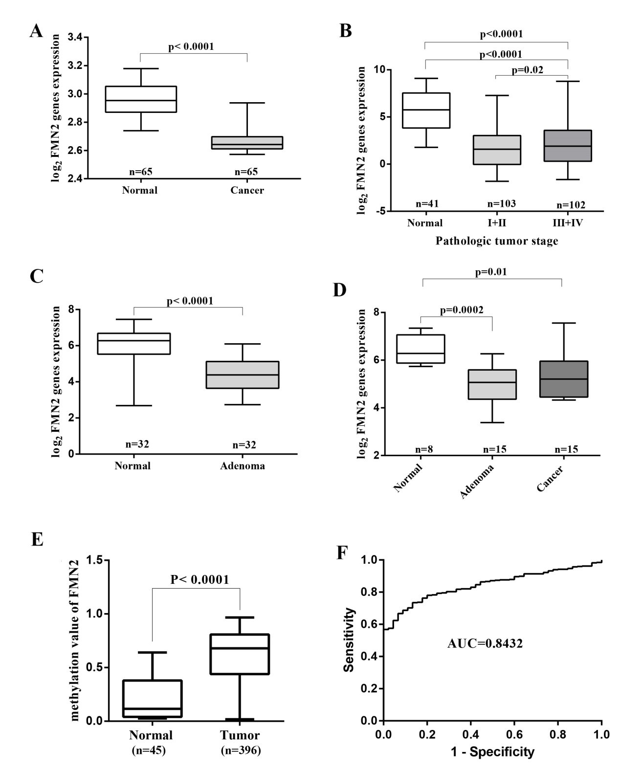
Figure 1 Colorectal tissues show decreased formin 2 expression and a high frequency of hypermethylation in the formin 2 promoter. A: Normalized expression of formin 2 (FMN2) mRNA in carcinoma and adjacent normal tissues, presented as box-whisker plots (unpaired t test, GEO: GSE20842); B: Normalized expression of FMN2 mRNA in tissue from different stages of carcinoma (according to the AJCC Cancer Staging Manual) and in normal tissue, presented as box-whisker plots (unpaired t test, colorectal cancer samples from TCGA); C: Normalized expression of FMN2 mRNA in adenoma and corresponding normal colonic mucosal tissues, presented as box-whisker plots (unpaired t test, GEO: GSE8671); D: Normalized expression of FMN2 mRNA in normal, adenoma and carcinoma tissues, presented as box-whisker plots (unpaired t test, GEO: GSE4183); E: The FMN2 gene shows an increased methylation level in colorectal cancer tissues compared with normal tissues (unpaired t test, colorectal cancer samples from TCGA); F: Receiver operating characteristic curve analysis was used to assess the clinical diagnostic utility of FMN2 DNA methylation for the prediction of colorectal cancer.

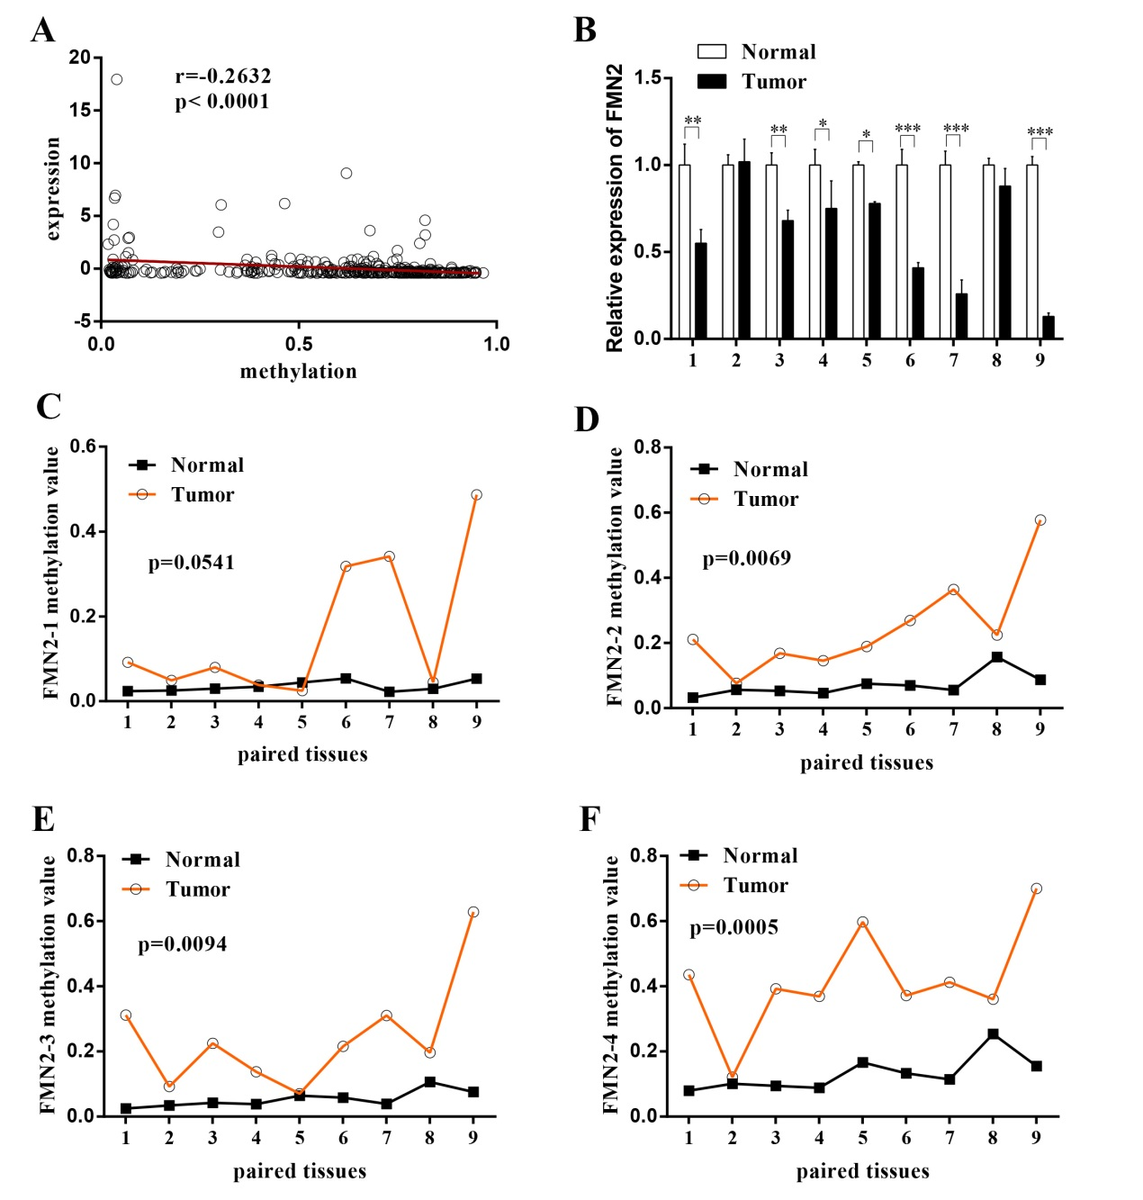

Figure 2 Hypermethylation of formin 2 correlates with decreased expression of formin 2 during colorectal cancer. A: The expression of the formin 2 (FMN2) gene is significantly inversely correlated with the methylation level (Pearson correlation analysis; B: Quantitative real-time RT-PCR for FMN2 was carried out on 9 colorectal cancer surgical specimens (filled bars) and paired noncancerous tissues (unfilled bars). The expression levels in the tumor samples were independently calculated relative to those in the nontumor samples, which are normalized to 1. Vertical bar, SD; ªP < 0.05, ^{b}P < 0.03, ^{c}P < 0.01 (unpaired t test); C-F: Results of MethylTargetTM assays on 9 paired noncancerous tissues and colorectal cancer tissues. Four CpG regions (FMN2-1, FMN2-2, FMN2-3 and FMN2-4) from CpG islands adjacent to the FMN2 promoter were sequenced (unpaired t test. More details about the 4 CpG regions can be found in Table 2).

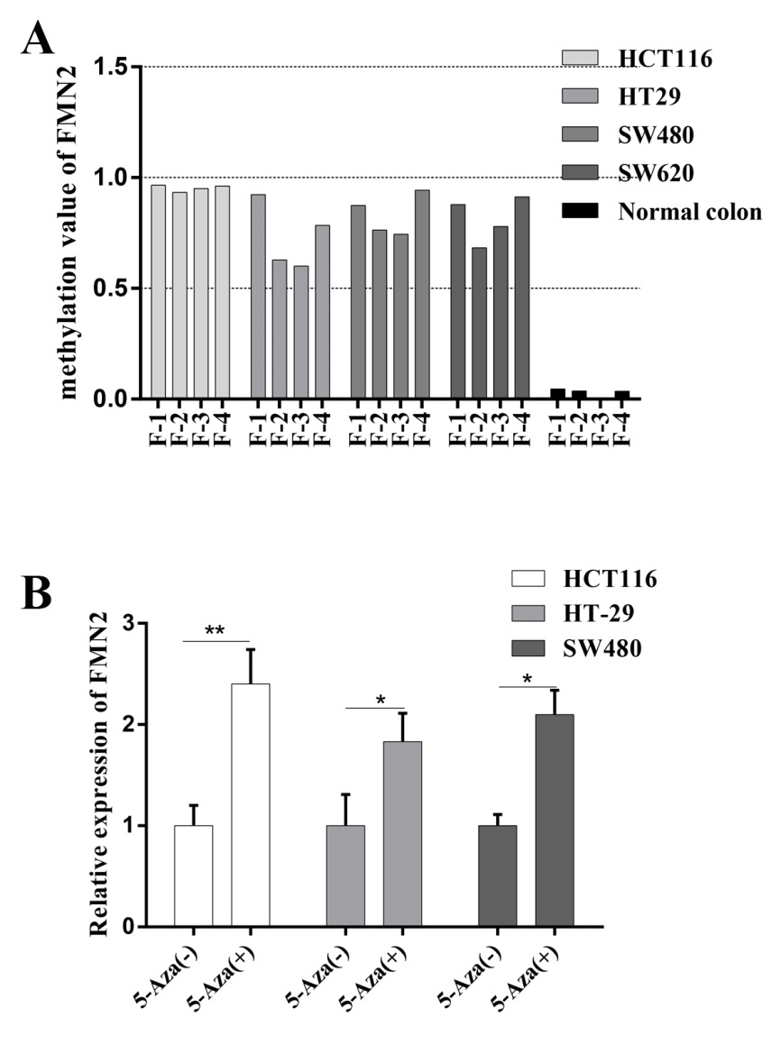
Figure 3 Promoter hypermethylation and formin 2 expression are causally related. A: Results of MethylTargetTM assays on 4 colorectal cancer cell lines and normal colon cells from a healthy individual; B: The inhibition of DNA methylation with 5-Aza significantly increased the endogenous FMN2 expression (unpaired t test).

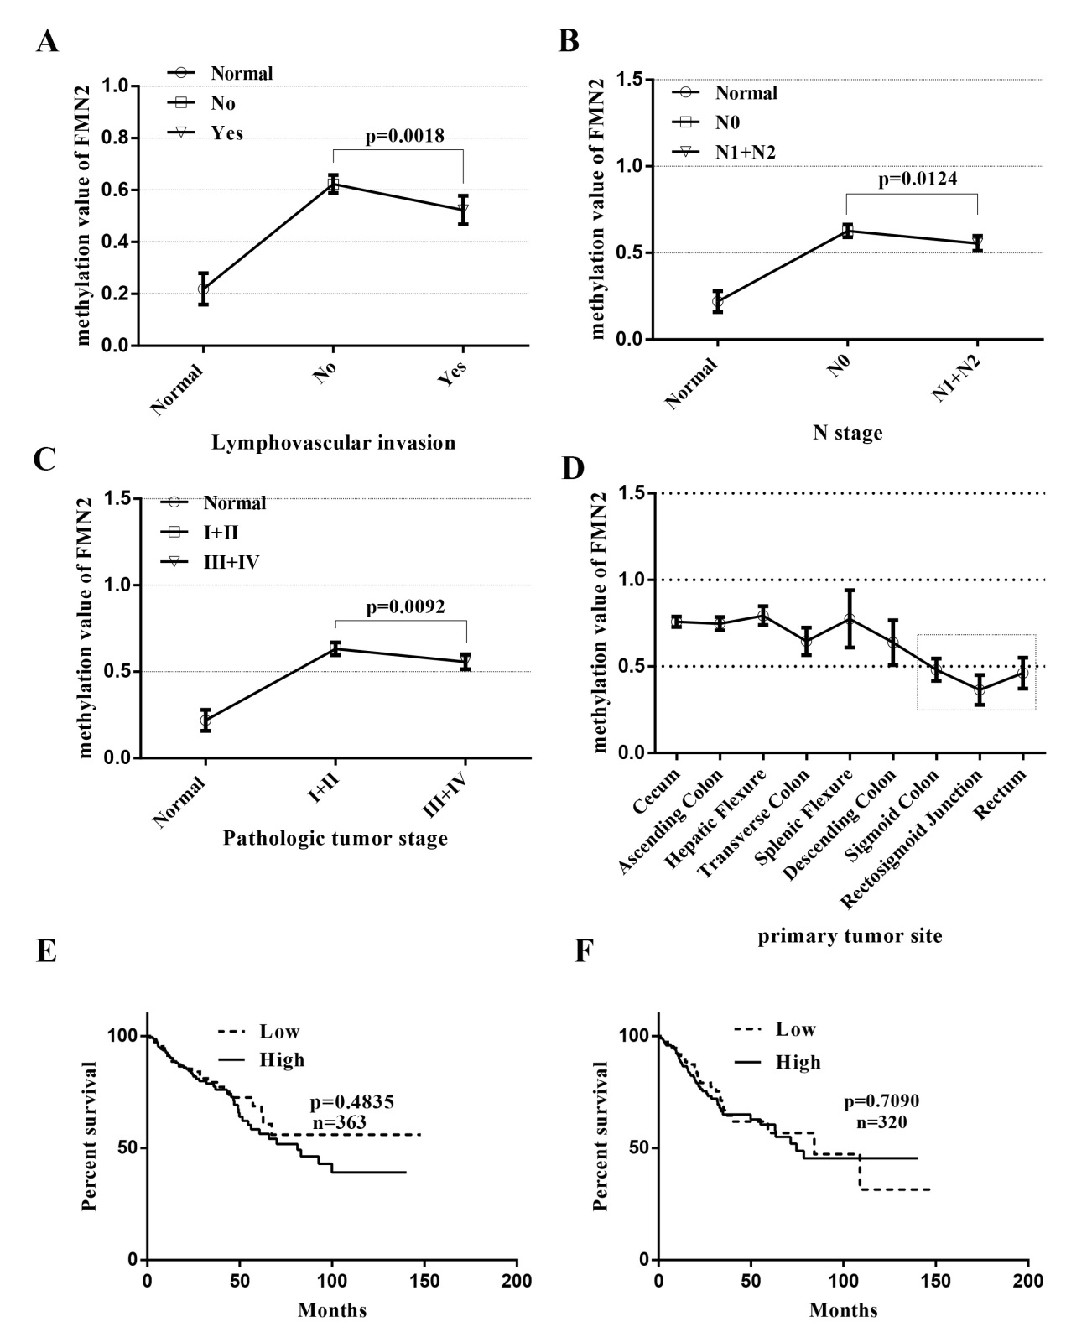
Figure 4 Formin 2 promoter hypermethylation mainly occurred in early-stage colon cancer patients. A: Formin 2 (FMN2) promoter methylation level in colorectal cancer (CRC) tissues with (yes) and without (no) lymphovascular invasion, presented as column means with 95%CI, mean connected. (unpaired t test; normal: n = 45, CRC tissues with and without lymphovascular invasion: n = 231 and n = 107, respectively); B FMN2 promoter methylation level in CRC tissues with (N1 + N2) and without (N0) regional lymph node metastasis, presented as column means with 95%CI, mean connected (unpaired t test, Normal: n = 45, CRC tissues with and without regional lymph node metastasis: n = 212 and n = 173, according to the AJCC Cancer Staging Manual); C: FMN2 promoter methylation level in CRC tissues from different stages, presented as column means with 95%CI, mean connected (unpaired t test; Normal: n = 45, Stage I + II: n = 197, Stage III+IV: n = 172, according to the AJCC Cancer Staging Manual); D: FMN2 promoter methylation level in different organ sites, presented as column means with 95%CI, mean connected; E and F: FMN2 hypermethylation had no effect on the overall survival or disease-free survival of CRC patients.

Table 1 Clinical material used in this article
No. | Sex | Age | Lymph node | TNM | Pathology | Differentiation | MSI | Organ
1 | M | 67 | 5 (14) | T4aN2aM0 | Adenocarcinoma | Moderate | No | Rectum
2 | M | 53 | 0 (22) | T2N0M0 | Adenocarcinoma | Moderate | - | Rectum
3 | M | 72 | 4 (20) | T4aN2aM0 | Adenocarcinoma | Poor | - | Right colon
4 | M | 52 | 0 (16) | T3N0M0 | Adenocarcinoma | Moderate | - | Rectum
5 | M | 52 | 3 (25) | T3N1bM0 | Adenocarcinoma | Moderate | - | Sigmoid colon
6 | F | 57 | 0 (15) | T4aN0M0 | Adenocarcinoma | Moderate | - | Left colon
7 | F | 51 | 0 (14) | T4aN0M0 | Adenocarcinoma | Moderate | No | Rectum
8 | F | 66 | 19 (27) | T3N2bM0 | Adenocarcinoma | Poor | No | Rectum
9 | F | 71 | 0 (16) | T4bN0M1b | Adenocarcinoma | Moderate | No | Rectum

Table 2 Details of the 4 CpG regions in the CpG islands of formin 2
Target | TSS | Start | End | Length | Target strand | Distance2TSS
FMN2_1 | 240255184 | 240255353 | 240255531 | 179 | + | 169
FMN2_2 | 240255184 | 240255809 | 240256007 | 199 | + | 625
FMN2_3 | 240255184 | 240256241 | 240256483 | 243 | + | 1057
FMN2_4 | 240255184 | 240256757 | 240257017 | 261 | + | 1573
Start: The starting position of the product on the reference genome; TSS: The mRNA transcription initiation site; End: The end position of the product on the reference genome; Length: the product length; Target strand: The product orientation; Distance2TSS: The distance from the product to the TSS.

Table 3 Primers used for the MethylTargetTM assays
Primer name | Primer
FMN2_1_F | GAGGGTYGGGATGGTTTGAG
FMN2_1_R | CCCCCRCTCCCCTTCTTT
FMN2_2F | GAGTGTGYGGATTTTTTTGAGGT
FMN2_2R | AAATATCTAAAAACAAATCCTCTTACTCC
FMN2_3F | GATTTGTTYGAGAGTTTGGTTGT
FMN2_3R | AAACRCATCCTCAAAAACATCCT
FMN2_4F | TTTTTGAGTYGAGGGTTTAGAATTG
FMN2_4R | CACRTTCTAAAAACCATCCRCAAC

Table 4 Methylation level of each CG site in the CpG island regions
Target | Position | Type | P-value (t test) | OR (L95-U95) (logistic) | C mean | N mean
FMN2_1_ | 25 | CG | 0.007774578 | 2.1731 (0.9323-5.0653) | 0.17 | 0.04
FMN2_1_ | 27 | CG | 0.01061292 | 1.5266 (0.8980-2.5953) | 0.16 | 0.03
FMN2_1_ | 30 | CG | 0.1359111 | 1.3535 (0.7970-2.2986) | 0.15 | 0.03
FMN2_1_ | 32 | CG | 0.01875771 | 1.7416 (0.8662-3.5016) | 0.16 | 0.04
FMN2_1_ | 35 | CG | 0.03998355 | 1.2722 (0.8959-1.8068) | 0.18 | 0.05
FMN2_1_ | 38 | CG | 0.01419169 | 1.6993 (0.8462-3.4125) | 0.16 | 0.03
FMN2_1_ | 46 | CG | 0.003990128 | 2.2454 (0.9140-5.5161) | 0.15 | 0.02
FMN2_1_ | 90 | CG | 0.1134924 | 1.3103 (0.6401-2.6825) | 0.16 | 0.03
FMN2_1_ | 108 | CG | 0.06252571 | 1.2532 (0.7873-1.9948) | 0.17 | 0.04
FMN2_1_ | 114 | CG | 0.1134924 | 1.1858 (0.8641-1.6273) | 0.18 | 0.05
FMN2_1_ | 117 | CG | 0.05030852 | 1.3499 (0.8867-2.0550) | 0.19 | 0.04
FMN2_1_ | 123 | CG | 0.01061292 | 2.2247 (0.9162-5.4017) | 0.16 | 0.03
FMN2_1_ | 126 | CG | 0.09391197 | 1.2852 (0.7471-2.2110) | 0.16 | 0.03
FMN2_1_ | 134 | CG | 0.01875771 | 2.4645 (0.6195-9.8050) | 0.16 | 0.02
FMN2_2 | 27 | CG | 0.000493624 | 1.3442 (1.0433-1.7321) | 0.28 | 0.07
FMN2_2 | 51 | CG | 0.01419169 | 1.2762 (0.9670-1.6843) | 0.17 | 0.04
FMN2_2 | 63 | CG | 0.007774578 | 1.4062 (0.9872-2.0030) | 0.37 | 0.25
FMN2_2 | 70 | CG | 0.000781571 | 1.3753 (1.0378-1.8226) | 0.24 | 0.05
FMN2_2 | 74 | CG | 0.000493624 | 1.3079 (1.0283-1.6636) | 0.31 | 0.07
FMN2_2 | 78 | CG | 0.000287947 | 1.3676 (1.0603-1.7639) | 0.25 | 0.05
FMN2_2 | 81 | CG | 0.00185109 | 1.3630 (0.9664-1.9224) | 0.21 | 0.05
FMN2_2 | 107 | CG | 0.000493624 | 1.3025 (0.9942-1.7063) | 0.24 | 0.06
FMN2_2 | 131 | CG | 0.007774578 | 1.2706 (0.9662-1.6708) | 0.15 | 0.03
FMN2_2 | 137 | CG | 0.002756067 | 1.3002 (0.9986-1.6928) | 0.21 | 0.05
FMN2_2 | 143 | CG | 0.00123406 | 1.3743 (1.0297-1.8341) | 0.20 | 0.04
FMN2_2 | 164 | CG | 0.000287947 | 1.3527 (1.0108-1.8101) | 0.29 | 0.07
FMN2_2 | 170 | CG | 0.00123406 | 1.2431 (1.0019-1.5424) | 0.28 | 0.08
FMN2_3 | 24 | CG | 0.005635541 | 1.3854 (0.9994-1.9207) | 0.20 | 0.05
FMN2_3 | 31 | CG | 0.005635541 | 1.4241 (0.9731-2.0841) | 0.23 | 0.04
FMN2_3 | 47 | CG | 0.002756067 | 1.3776 (0.9695-1.9574) | 0.24 | 0.06
FMN2_3 | 50 | CG | 0.003990128 | 1.3787 (1.0219-1.8599) | 0.22 | 0.05
FMN2_3 | 57 | CG | 0.00123406 | 1.3592 (1.0212-1.8091) | 0.25 | 0.06
FMN2_3 | 60 | CG | 0.003990128 | 1.5630 (0.9433-2.5897) | 0.19 | 0.04
FMN2_3 | 68 | CG | 0.00185109 | 1.3474 (1.0273-1.7673) | 0.23 | 0.06
FMN2_3 | 75 | CG | 0.00123406 | 1.3787 (0.9962-1.9082) | 0.26 | 0.06
FMN2_3 | 80 | CG | 0.00123406 | 1.3582 (0.9518-1.9380) | 0.24 | 0.05
FMN2_3 | 92 | CG | 0.00185109 | 1.3665 (0.9746-1.9159) | 0.23 | 0.05
FMN2_3 | 98 | CG | 0.00123406 | 1.3200 (0.9414-1.8509) | 0.27 | 0.06
FMN2_3 | 105 | CG | 0.000781571 | 1.4801 (0.9296-2.3566) | 0.22 | 0.04
FMN2_3 | 107 | CG | 0.007774578 | 1.2402 (1.0141-1.5168) | 0.21 | 0.05
FMN2_3 | 119 | CG | 0.00123406 | 1.4326 (0.9810-2.0921) | 0.19 | 0.04
FMN2_3 | 131 | CG | 0.000493624 | 1.7790 (0.9589-3.3006) | 0.22 | 0.04
FMN2_3 | 147 | CG | 0.007774578 | 1.3343 (0.9443-1.8856) | 0.20 | 0.04
FMN2_3 | 153 | CG | 0.000493624 | 1.5405 (0.9677-2.4523) | 0.22 | 0.05
FMN2_3 | 158 | CG | 8.22707E-05 | 1.9417 (0.8981-4.1979) | 0.31 | 0.08
FMN2_3 | 170 | CG | 4.11353E-05 | 1714240.0000 (0.0000-Inf) | 0.32 | 0.08
FMN2_3 | 174 | CG | 4.11353E-05 | 11577516733.0000 (0.0000-Inf) | 0.34 | 0.08
FMN2_3 | 183 | CG | 0.000287947 | 1.6836 (0.9224-3.0731) | 0.28 | 0.06
FMN2_3 | 187 | CG | 0.000287947 | 1.4526 (0.9861-2.1399) | 0.27 | 0.06
FMN2_3 | 203 | CG | 0.000781571 | 1.4980 (0.9815-2.2861) | 0.25 | 0.05
FMN2_4 | 36 | CG | 0.003990128 | 1.1409 (1.0248-1.2702) | 0.41 | 0.14
FMN2_4 | 42 | CG | 0.002756067 | 1.2068 (1.0353-1.4068) | 0.38 | 0.12
FMN2_4 | 47 | CG | 0.000781571 | 1.2264 (1.0309-1.4589) | 0.37 | 0.10
FMN2_4 | 61 | CG | 0.005386639 | 1.1552 (1.0206-1.3075) | 0.38 | 0.10
FMN2_4 | 66 | CG | 0.0003108 | 243.9222 (0.0000-Inf) | 0.40 | 0.09
FMN2_4 | 69 | CG | 8.22707E-05 | 1.7294 (0.6520-4.5874) | 0.42 | 0.09
FMN2_4 | 72 | CG | 0.003990128 | 1.2209 (1.0296-1.4477) | 0.40 | 0.13
FMN2_4 | 80 | CG | 4.11353E-05 | 2515571.0000 (0.0000-Inf) | 0.48 | 0.18
FMN2_4 | 84 | CG | 0.00185109 | 1.2366 (1.0241-1.4931) | 0.39 | 0.12
FMN2_4 | 94 | CG | 0.002756067 | 1.2121 (1.0363-1.4178) | 0.38 | 0.12
FMN2_4 | 98 | CG | 0.003990128 | 1.1618 (1.0236-1.3186) | 0.36 | 0.11
FMN2_4 | 110 | CG | 0.00185109 | 1.1712 (1.0253-1.3378) | 0.44 | 0.19
FMN2_4 | 123 | CG | 0.000781571 | 1.2218 (1.0321-1.4463) | 0.40 | 0.10
FMN2_4 | 127 | CG | 0.00185109 | 1.2220 (1.0324-1.4464) | 0.39 | 0.11
FMN2_4 | 131 | CG | 8.22707E-05 | 1.3179 (1.0259-1.6931) | 0.38 | 0.08
FMN2_4 | 136 | CG | 0.003990128 | 1.1979 (1.0209-1.4054) | 0.34 | 0.09
FMN2_4 | 150 | CG | 4.11353E-05 | 1217702.0000 (0.0000-Inf) | 0.54 | 0.22
FMN2_4 | 152 | CG | 0.003990128 | 1.1644 (1.0196-1.3297) | 0.39 | 0.12
FMN2_4 | 166 | CG | 0.000164541 | 1.3446 (0.9896-1.8269) | 0.45 | 0.16
FMN2_4 | 168 | CG | 0.001710676 | 1.2557 (1.0089-1.5628) | 0.44 | 0.16
FMN2_4 | 176 | CG | 4.11353E-05 | 26059.6300 (0.0000-Inf) | 0.52 | 0.21
FMN2_4 | 186 | CG | 0.000781571 | 1.1735 (1.0224-1.3469) | 0.54 | 0.20
FMN2_4 | 189 | CG | 0.003990128 | 1.1348 (1.0221-1.2600) | 0.49 | 0.18
FMN2_4 | 213 | CG | 0.00185109 | 1.1572 (1.0241-1.3076) | 0.47 | 0.14
FMN2_4 | 221 | CG | 0.002756067 | 1.1534 (1.0276-1.2947) | 0.45 | 0.13
FMN2_4 | 234 | CG | 0.00185109 | 1.1981 (1.0181-1.4099) | 0.32 | 0.08
FMN2_4 | 236 | CG | 0.000493624 | 1.2631 (1.0149-1.5720) | 0.36 | 0.08

Table 5 Relationship between formin 2 methylation levels and clinicopathological data
Factor | No. | FMN2 |  | P-value
 |  | Low, n (%) | High, n (%)
Age
< 60 | 136 | 66 (45.83) | 70 (28.69) | 0.0006¹
≥ 60 | 252 | 78 (54.17) | 174 (71.31)
Gender
Male | 210 | 72 (50.00) | 138 (56.56) | 0.2105
Female | 178 | 72 (50.00) | 106 (43.44)
Height
< 170 | 138 | 52 (48.60) | 86 (47.25) | 0.8250
≥ 170 | 151 | 55 (51.40) | 96 (52.75)
Weight
< 80 | 156 | 56 (49.12) | 100 (51.55) | 0.6812
≥ 80 | 152 | 58 (50.88) | 94 (48.45)
T
T1 | 11 | 5 (3.47) | 6 (2.47) | 0.4830
T2 | 54 | 16 (11.11) | 38 (15.71)
T3 | 270 | 106 (73.61) | 164 (67.77)
T4 | 51 | 17 (11.81) | 34 (14.05)
N
N0 | 212 | 69 (47.92) | 143 (59.34) | 0.0293¹
N1 + N2 | 173 | 75 (52.08) | 98 (40.66)
M
M0 | 264 | 98 (80.33) | 166 (85.13) | 0.2651
M1 | 53 | 24 (19.67) | 29 (14.87)
Stage
I + II | 197 | 62 (45.26) | 135 (58.19) | 0.0161¹
III + IV | 172 | 75 (54.74) | 97 (41.81)
Lymphovascular invasion
Yes | 107 | 77 (60.63) | 154 (72.99) | 0.0180¹
No | 231 | 50 (39.37) | 57 (27.01)
Vascular invasion
Yes | 78 | 31 (24.80) | 47 (22.71) | 0.6627
No | 241 | 94 (75.20) | 160 (77.29)
Perineural Invasion
Yes | 59 | 20 (24.39) | 39 (26.53) | 0.7225
No | 170 | 62 (75.61) | 108 (73.47)
Tumor status
Tumor-free | 246 | 86 (71.07) | 160 (77.29) | 0.2094
Tumor present | 82 | 35 (28.93) | 47 (22.71)
KRAS mutation
Yes | 28 | 8 (42.11) | 20 (54.05) | 0.3972
No | 28 | 11 (57.89) | 17 (45.95)
¹Indicates a statistically significant result. TNM and stage are defined according to the AJCC Cancer Staging Manual. Tumor status: The state or condition of an individual's neoplasm at a particular point in time.

