Name of journal: World Journal of Gastroenterology
ESPS Manuscript NO: 30625
Manuscript Type: ORIGINAL ARTICLE

Basic Study

miR-145 exerts tumor-suppressive and chemo-resistance lowering effects by targeting CD44 in gastric cancer

Zeng JF et al. Effects of miR-145 on gastric cancer

Jian-Feng Zeng, Xiao-Qiu Ma, Lin-Pei Wang, Wei Wang

Jian-Feng Zeng, Lin-Pei Wang, Wei Wang, Department of General Surgery, The Second Affiliated Hospital of Fujian Medical University, Quanzhou 362000, Fujian Province, China

Xiao-Qiu Ma, Department of Medical Oncology, The 180th Hospital of the People’s Liberation Army, Quanzhou 362000, Fujian Province, China

Author contributions: Wang LP and Wang W contributed to the study design; Zeng JF and Ma XQ performed the majority of experiments, collected the data and wrote the manuscript; all authors approved the final manuscript to be published.

Supported by Quanzhou excellent personnel training, No.10A16, Natural Science Foundation of Fujian Province, No.JA08084; Fujian Medical University, No.092D014.

Institutional review board statement: This study was reviewed and approved by The Second Affiliated Hospital of Fujian Medical University Institutional Review Board, Quanzhou, China.

Conflict-of-interest statement: The authors declare that there are no potential conflicts of interest relevant to this article.

Data sharing statement: No additional data are available.

Open-Access: This article is an open-access article which was selected by an in-house editor and fully peer-reviewed by external reviewers. It is distributed in accordance with the Creative Commons Attribution Non Commercial (CC BY-NC 4.0) license, which permits others to distribute, remix, adapt, build upon this work non-commercially, and license their derivative works on different terms, provided the original work is properly cited and the use is non-commercial. See: http://creativecommons.org/licenses/by-nc/4.0/

Manuscript source: Unsolicited manuscript

Correspondence to: Dr. Wei Wang, Department of General Surgery, The Second Affiliated Hospital of Fujian Medical University, Zhongshanbei Road 34, Quanzhou 362000, Fujian Province, China. wanglinpei@126.com
Telephone: +86-595-22780153
Fax: +86-595-22780153

Received: October 10, 2016
Peer-review started: October 12, 2016
First decision: December 2, 2016
Revised: January 9, 2017
Accepted: February 6, 2017
Article in press:
Published online:

Abstract
AIM
To determine the potential roles of CD4 and miR-145 in gastric cancer.

METHODS
The levels of CD44 and miR-145 were determined in gastric cancer cells. Quantitative real-time polymerase chain reaction was used to measure to the level of CD44 mRNA. The luciferase reporter assay and Western blot were performed to examine the effect of miR-145 on CD44 expression. The tumor sphere assay and MTT (3-[4,5-dimethylthiazol-2-yl]-2,5-diphenyltetrazolium bromide) assay were carried out to evaluate the self-renewal and chemo-resistance properties of gastric cancer cells.

RESULTS
The expression of CD44 was greatly increased and miR-145 decreased in gastric cancer cells that were highly enriched in cancer stem cells (CSCs). The results demonstrated that miR-145 directly regulated CD44 by targeting the CD44 3’-untranslated region (3’-UTR). In gastric cancer cells, overexpression of miR-145 repressed the activity of CD44 3’-UTR, and disruption of miR-145/CD44 3’-UTR interactions abrogated the silencing effects. In addition, miR-145 inhibition stimulated CD44 3’-UTR activity and disruption of miR-145/CD44 3’-UTR interactions abrogated this stimulatory effect. Enforced CD44 expression greatly increased tumor sphere formation and chemo-resistance in gastric cancer cells. Furthermore, inhibition of CSCs and chemo-sensitivity of gastric cancer cells treated with miR-145 were significantly abrogated by overexpression of CD44.

CONCLUSION
miR-145 targeting CD44 plays critical roles in the regulation of tumor growth and chemo-resistance in gastric cancer.

Key words: miR-145; CD44; Gastric cancer stem cells; Chemo-resistance

© The Author(s) 2017. Published by Baishideng Publishing Group Inc. All rights reserved.

Core tip: The levels of CD44 and miR-145 are strongly related to stemness properties in gastric cancer. The aim of this investigation was to determine the underlying molecular mechanism involved in this relationship. The findings demonstrated that miR-145 regulates CD44 expression by directly targeting its 3’-untranslated region, which may play a critical role in the regulation of tumor growth and chemo-resistance in gastric cancer.

Zeng JF, Ma XQ, Wang LP, Wang W. miR-145 exerts tumor-suppressive and chemo-resistance lowering effects by targeting CD44 in gastric cancer. World J Gastroenterol 2017; In press

INTRODUCTION
Despite advances in medical technology to improve gastric cancer outcome, gastric cancer is still the fourth most common cancer worldwide^{[1]}. The 5-year survival rate in gastric cancer patients is still less than 35%, and remains the third leading cause of cancer-related deaths^{[1,2]}. Seventy percent of gastric cancer-related deaths occurred in developing country, with China having about 40% of them^{[3]}. In China, this low survival rate is mainly due to the disappointing early detection rate, tumor recurrence, and high chemotherapy resistance^{[4]}. Accumulating evidence has indicated that a subset of cancer cells with high self-renewal and stemness properties, known as cancer stem cells (CSCs), are the key contributors to chemo-resistance and are responsible for tumor progression as well as recurrence after conventional therapy^{[5]}.
CD44, an integral cell membrane glycoprotein, was initially identified as a lymphocyte homing receptor on circulating lymphocytes, and exhibits homing, adhesion and migration functions^{[6,7]}. CD44 participates in a wide variety of cellular functions including lymphocyte activation, recirculation and homing, hematopoiesis and tumor metastasis^{[8]}. The protein is not only involved in cell-cell adhesion, cell-matrix interactions, and tumor survival, but has also been accepted as a CSCs marker for gastric cancer in many studies^{[9]}. CD44 expression is up-regulated in advanced gastric lesions^{[10]}. Depletion of CD44 inhibited the stem cell-like properties, which was accompanied by the down-regulation of Oct4^{[10]}. Conversely, CD44 (+) gastric cancer cells showed the stem cell properties of self-renewal and the ability to form differentiated progeny^{[11,12]}. CD44 is highly polymorphic, possesses a number of alternative splice variants and undergoes extensive post-translational modifications^{[13]}.

miRNAs (microRNAs) are noncoding small RNAs that function as a crucial post-transcriptional regulatory mechanism in various cellular functions. Emerging data have shown that miRNAs play pivotal roles in regulating most biological processes in both normal development and various diseases, including cancer^{[14]}. They act as cancer signatures, oncogenes, or tumor suppressors by targeting their downstream targets. miRNAs are also involved in many aspects of gastric cancer progression^{[15]}. Multiple miRNAs have been implicated in the pathogenesis of gastric cancer. For example, Petrocca et al^{[16]} demonstrated that the miR-106b-25 cluster is involved in E2F1 post-transcription in the development of TGFβ resistance in gastric cancer. In addition, Li et al^{[17]} reported that miR-25 positively regulates gastric cancer cell migration, invasion and proliferation by directly targeting transducer of EGFR2, 1 (epidermal growth factor receptor2, 1). Furthermore, miR-20a and miR-17 were shown to be upregulated in gastric cancer tissues^{[18]}. Also, miR-21-5p was found be a useful predictor of recurrence in early gastric cancer^{[19]}.
miR-145, a tumor-suppressive miRNA, is associated with tumor growth and metastasis in several types of cancer. Recently, Chen et al^{[20]} showed that miR-145 regulates cell migration and invasion in gastric cancer primarily by directly targeting FSCN1 (fascin actin-bundling protein 1). Furthermore, miR-145 regulates embryonic stem cell differentiation and simultaneously tunes multiple stemness genes, including KLF4, Oct4, and Sox2^{[21]}. However, the potential mechanism of miR-145 in gastric cancer stem cell properties and chemo-resistance is unclear. In the current study, we found that miR-145 is decreased, while the expression of CD44 is markedly increased in gastric cancer cells with stemness properties. CD44 is a target directly regulated by miR-145. Overexpression of miR-145 in gastric cancer greatly inhibited gastric cancer cell stemness properties and chemo-resistance. We also found that the tumor suppressive and chemo-resistance lowering effects of miR-145 in gastric cancer cells were significantly reversed by overexpression of CD44. These findings, for the first time, demonstrate that miR-145 inhibited the stem-like properties of gastric cancer mainly by directly targeting CD44.

MATERIALS AND METHODS
Plasmid construction
The human CD44 3’- UTR was amplified from MGC-803 cDNA by polymerase chain reaction (PCR) amplification using the following primer pairs: 5’-TACGAGCTCCACCTACACCATTATCTTGGAAAGA-3’ (Forward); 5’-TCAACGCGTCCAATAAGTGCTTTCAACTCAGCA-3’ (Reverse). CD44 3’UTR was cloned downstream of the luciferase coding sequence in the pMIR-REPORT (Ambion) vector at the SacI/MluI restriction sites to construct the human CD44-3’UTR-luciferase reporter. Mutations were introduced into the miR-binding sites using a QuikChange Mutagenesis Kit (TransGen, Beijing, China). The mutation primers were as follows: 5’-ACTTGAAAGAAAGTCGACATTAGGCCACTAT-3’ (Forward); 5’-GACTTTCTTTCAAGTTGAAAAGAAAATAAAAAG-3’ (Reverse) (mutation sites underlined). For the CD44 expression plasmids, sequences were amplified by PCR using the following primers: 5’-TACACGCGTATGGACAAGTTTTGGTGGCA-3’ (Forward); 5’-TCAGCTAGCCACCCCAATCTTCATGTCCAC-3’ (Reverse). The amplified fragment was cloned into the MluI /NheI sites in the pLV-CS 2.0.

Cell cultures
The human gastric cancer cell line, MGC-803, was purchased from the Institute of Cell Biology (Shanghai, China, http://www.cellbank.org.cn). Cells were maintained in Royal Park Memorial Institute-1640 (RPMI-1640) medium. All cell culture media were supplemented with 10% fetal bovine serum (FBS), and 1% penicillin-streptomycin (all from Invitrogen, Carlsbad, CA, United States).

Tumor sphere culture
Tumor sphere cultures were grown in ultralow attachment six-well plates (Corning, Lowell, MA, United States) using a cell suspension (500 cells/mL) in serum-free DMEM/F12 media (Invitrogen), supplemented with 20 ng/mL epidermal growth factor (EGF, Sigma-Aldrich), 4 μg/mL insulin (Sigma-Aldrich), B27 supplement (1 ×, Invitrogen), and 1% penicillin-streptomycin in a humidified incubator at 37 ℃ in 5% CO₂.

Luciferase reporter assay
Cells were transfected with pWT-CD44-3’UTR-luc or pMT-CD44-3’UTR-luc (WT, wild type; MT, mutant type), β-galactosidase and miR-145 mimics or an miR-145 inhibitor (RiboBio, Guangzhou, China) using Lipofectamine 2000 transfection reagent (Invitrogen). Luciferase activity was measured 36 h after transfection, and the transfection efficiency was normalized to internal β-galactosidase activity.

RNA extraction, RT-PCR and quantitative real-time PCR
Total RNA was extracted using TRIZOL Reagent (Invitrogen) and reverse transcribed with R-PCR Quick Master Mix (Toyoba) to produce cDNA. Real-time PCR was performed using SYBR Green-based detection in a LightCycler®480 (Roche) according to the manufacturer’s instructions using the following primer pairs: CD44 (NM_000610.3) (Forward: 5’-CTCATGGATCTGAATCAGATGGA-3’, Reverse: 5’-ACTGCAATGCAAACTGCAAGA-3’); GAPDH (glyceraldehyde-3 phosphate dehydrogenase, NM_001289745.1) (Forward: 5’-TCTCCTCTGACTTCAACAGCGA-3’, Reverse: 5’-GTCCACCACCCTGTTGCTGT-3’). GAPDH levels were used as normalization controls.

Chemo-resistance assay
The MTT assay (Cell titer 96® Aqueous One Solution Cell Proliferation Assay, Promega) was used to assess the rates of resistance to drugs. Briefly, MGC-803 cells were transfected with or without miR-145 or/and CD44, and after 12 h of transfection the gastric cancer cells (2 × 10³/well) were seeded in 96-well plates. The cells were then treated with the indicated concentration of chemotherapeutic drugs [5-FU (5-Fluorouracil, Sigma-Aldrich) and cisplatin (Sigma-Aldrich)]. The MTT assay was performed 72 h later using the iMarkmicroplate Absorbance Reader (Bio-RAD, Richmond, CA, United States) according to the manufacturer’s instructions.

Cell extraction and Western blotting
Western blots were performed according to the protocols described previously^{[22]}. The Immobilon Western Chemiluminescent HRP Substrate Kit (Millipore) was used to evaluate the results. The primary antibodies were CD44 (Abcam, Cambridge, 1:3000), and β-actin (Sigma-Aldrich, 1:5000).

Statistical analysis
Results are expressed as the mean ± SEM. Statistical signiﬁcance was determined by the Student’s t test or a one-way or two-way analysis of variance (ANOVA) followed by Tukey’s test as appropriate, using Graphpad Prism statistical software (Graphpad Software). P < 0.05 was considered statistically signiﬁcant.

RESULTS
miR-145 and CD44 expression in gastric cancer cells with self-renewal properties
The tumor sphere assay has been widely used to identity stem cells in vitro. Tumor spheres of MGC-803 cells were cultured as described in the Materials and Methods section. Tumor spheres with a tight appearance were observed in serum-free medium (Figure 1). To investigate the function of miR-145 and CD44 in gastric cancer, we first determined the expression of miR-145 and CD44 in monolayer MGC-803 cells and MGC-803 spheres using real-time PCR. The results showed that miR-145 expression was significantly inhibited in MGC-803 spheres compared with monolayer MGC-803 cells (87.9%, Figure 1B, P < 0.001). In addition, the spheres expressed much higher levels of CD44 mRNA and protein than the monolayer cells. When calculated as fold changes relative to the monolayer MGC-803 cells, CD44 mRNA and protein expression levels increased by approximately 8-fold and 7-fold, respectively (Figure 1C and D, P < 0.001). Moreover, the results showed that the expression of other cancer stem cell markers, such as Sox2, Nanog and Oct4, significantly increased in sphere cells (Figure 1E, P < 0.05, P < 0.01).

miR-145 directly targets the CD44 3’UTR in gastric cancer cells
The above results indicated an inverse relationship between the expression of miR-145 and CD44. The prediction of MRE (miRNA-recognition elements) site for miR-145 on the CD44-3’UTR was performed with the TargetScan (http://www.targetscan.org) algorithms (Figure 2A). To determine whether miR-145 regulated CD44 through an interaction with the CD44-3’UTR, we first co-transfected chemically synthesized miR-145 mimics or a miR-145 inhibitor with luciferase reporter pWT-CD44-3’UTR in MGC-803 cells. Transfection of the miR-145 mimics significantly reduced CD44-3’UTR activity (Figure 2B, P < 0.001). Conversely, inhibition of miR-145 resulted in a significant increase in CD44-3’UTR activity (Figure 2B, P < 0.05). To verify the specificity of the interactions, we mutated the MRE site for miR-145 on the CD44-3’UTR. Using the mutant, we demonstrated that mutation of the MRE for miR-145 abrogated the regulatory effects by the miR-145 mimics or miR-145 inhibitor (Figure 2C). To further evaluate the regulation of miR-145 on CD44 expression, we transfected miR-145 mimics in MGC-803 cells. Consistent with the results from the luciferase reporter assay, CD44 expression was down-regulated by 71.74% in MGC-803 cells transfected with miR-145 mimics (Figure 2D, P < 0.01). In contrast, miR-145 inhibition resulted in significant increases in CD44 expression (Figure 2D, P < 0.05). Together, these results show that miR-145 regulated CD44 expression by targeting the CD44 3’UTR (Figure 2).

Overexpression of CD44 abolishes the inhibitory effect of miR-145 on the self-renewal properties of gastric cancer cells
miR-145 is known to exert suppressive effects on many cancer types, including gastric cancer^{[23]}. The tumor sphere assay was used to investigate whether repression of CD44 is necessary for miR-145 to inhibit gastric cancer cells. The plasmid of pLV-CD44 was constructed and confirmed the overexpression of CD44 (Figure 3A). The tumor sphere assay has been widely used to identify the self-renewal properties of stem cells in vitro. As expected, miR-145 mimics significantly decreased tumor sphere formation in MGC-803 cells, and the inhibition efficiency of tumor sphere formation was 74.74% (Figure 3B, P < 0.001). Conversely, enforced expression of CD44 resulted in a significant increase in tumor sphere formation (Figure 3B, P < 0.001). Furthermore, simultaneous re-expression of CD44 compromised miR-145-suppressed tumor sphere formation in MGC-803 cells (Figure 3B, P < 0.001), even higher than the control (Figure 3B, P < 0.01). Collectively, the above results demonstrated that the repression of CD44 is necessary for miR-145 to inhibit the self-renewal properties of gastric cancer cells (Figure 3).

Overexpression of CD44 abolishes the chemo-resistance lowering effect of miR-145 on gastric cancer cells
A large proportion of patients with gastric cancer fail chemotherapeutic approaches due to intrinsic or acquired drug resistance, particularly multidrug resistance. Chemo-resistance is another important characteristic of cancer stem cells. We next investigated whether miR-145 or miR-145-regulated CD44 were involved in the chemo-resistance of gastric cancer cells. For this purpose, MGC-803 cells transfected with or without miR-145 mimics or/and pLV-CD44 for 24 h and then various concentrations of two chemotherapeutic drugs, 5-FU and cisplatin, were used to treat the cells. As shown in Figure 4 A, B, miR-145 enhanced chemo-sensitivity to these drugs. Conversely, enforced expression of CD44 resulted in a significant increase in chemo-resistance (Figure 4A and B, P < 0.05). Furthermore, simultaneous re-expression of CD44 compromised chemo-sensitivity mediated by miR-145 in MGC-803 cells (Figure 4A and B, P < 0.001), and was more sensitive than the control (Figure 4A and B, P < 0.05). Collectively, the above results demonstrated that repression of CD44 is necessary for the chemo-resistance lowering effect of miR-145 in gastric cancer cells.
Drug resistance is closely related to increased drug efflux mediated by an energy-dependent mechanism involving the ABC (ATP binding cassette) transporters, mainly ABCB1 (ATP binding cassette subfamily B member 1), ABCC1 (ATP binding cassette subfamily C member 1) and ABCG2 (ATP binding cassette subfamily G member^{[24]}. Moreover, it has been reported that ABCG2 plays an important role in regulating chemo-resistance in gastric cancer^{[22]}. To evaluate the role of ABCG2 in miR-145 regulated gastric cancer cell chemo-resistance, the expression of ABCG2 was determined in MGC-803 cells. As shown in Figure 3C, ABCG2 expression was repressed in MGC-803 cells following treatment with miR-145 mimics (P < 0.05). Interestingly, enforced expression of CD44 resulted in significant up-regulation of ABCG2 expression (Figure 4C, P < 0.01). Furthermore, simultaneous re-expression of CD44 compromised the down-regulation mediated by miR-145 in MGC-803 cells (Figure 4C, P < 0.001). Collectively, the above results demonstrated that the involvement of ABCG2 is associated with the chemo-resistance lowering effect of miR-145 in gastric cancer cells.

DISCUSSION
Although many factors may contribute to the relapse and chemo-resistance of gastric cancer, it is reasonable to speculate that gastric CSCs play a critical role in these processes. Our results further suggest that the tumor suppressor miR-145, oncogene CD44 and their relationship are critically involved in regulating gastric cancer development.
SOX2, OCT4 and Nanog make up the core transcriptional network responsible for the regulation of stem cell self-renewal and pluripotency^{[25,26]}. Several groups demonstrated that Sox2, OCT-4 and Nanog are enriched in gastric CSCs. Gastric CSCs identified using the CD44 surface marker in MKN-45 gastric carcinoma cells had elevated levels of Nanog, Sox2 and Oct4^{[27]}. The results showed the tumorshperes expressed much higher levels of Sox2, OCT-4 and Nanog in our experimental system (Figure 1E). It demonstrated that the spheres enrich the cancer gastric CSCs population. At the same time, miR-145 expression was repressed in the spheres (Figure 1B). We speculated that miR-145 paly an inhibitory role in stemness properties of gastric cancer cells.
There is a large body of evidence to show that deregulation of miRNAs has been implicated in various human cancers, including gastric cancer. However, the underlying mechanisms by which miRNAs modulate the carcinogenesis process have not been completely elucidated. Previous studies have reported that miR-145 is down-regulated in various human malignancies, including breast cancer, lung cancer and gastric cancer^{[28-30]}. Lu et al^{[31]} found that miR-145 functions as a tumor suppressor and targets two oncogenes, namely ANGPT2 and NEDD9, in renal cell carcinoma. Other studies have shown that miR-145 suppresses cell migration and invasion by inhibiting N-cadherin and FSCN1 in gastric cancer cells^{[20,23]}. The current data showed that miR-145 also regulates the expression of CD44 by targeting the CD44 3’UTR. The latter was confirmed by the following observations; (1) there is the inverse correlation between miR-145 and CD44 expression in gastric tumor sphere; (2) miR-145 regulates CD44 protein expression in MGC-803; and (3) CD44 3’UTR is regulated by miR-145.
CD44 was a useful marker for identifying and isolating gastric CSCs from a panel of human gastric cancer cell lines, and CD44-positive gastric cancer cells exhibited the stem cell properties of self-renewal and chemo-resistance^{[10-12]}. The expression of CD44 was positively correlated with a more aggressive tumor phenotype and poorer overall prognosis^{[32]}. It is suggested that CD44 is not only a cell surface marker, but may also be a driving factor in the development of CSCs^{[10]}. Recently, one report highlights the value of changing the perspective of CD44 expression from that of a simple marker to a signaling molecule^{[33]}. In the present study, CD44 overexpression increased self-renewal activity and enhanced chemo-resistance in gastric cancer cells. CD44 positively regulated the expression of Oct4 and phospho-ERK, both of which are vital for regulating the pluripotency of cancer stem cells^{[9]}. ERK activity has been shown to play an important role in regulating ABCG2 expression^{[22]}. Our results demonstrated that enforced CD44 expression stimulates ABCG2 mRNA expression (Figure 4C). We speculate that the up-regulation of ABCG2 by CD44 is mediated by ERK. It was reported that ABCG2 not only plays a major role in multidrug resistance but can also be characterized as a CSCs marker^{[34]}. The more precise mechanisms by which CD44 stimulates ABCG2 expression warrant further investigation. In addition to the well-known effects of ABCG2 on cytotoxics and targeted agents, ABCG2 is also increasingly linked with failure of PDT (photodynamic therapy) and CSCs marker^{[34,35]}. Interestingly, ABCG2 is reported to regulate self-renewal and stem cell mark expression but not tumorigenicity or radiation resistance in glioma cells, while the role of ABCG2 in resistance to radiation therapy remains to be further investigated^{[36]}. Furthermore, overexpression of CD44 abolishes the inhibitory and chemo-sensitive effects of miR-145 in gastric cancer cells. Collectively, these findings demonstrate that miR-145 suppresses cell self-renewal properties and improves chemo-sensitivity in gastric cancer primarily by directly targeting CD44. Probably, miR-145 targeting CD44 could make it a potential target for preventing recurrence and chemo-resistance in patient with gastric cancer, this needs to be further verified using more gastric cell lines and in vivo assay.

COMMENTS
Background
The current research on gastric cancer includes tumor sphere culture, luciferase reporter assay, and chemo-resistance assay with the purpose of discovering the potential mechanism in gastric cancer pathogenesis. Cancer stem cells (CSCs), or cancer cells with stem cell-like properties, have been reported in many human tumors including gastric cancer and are considered to be responsible for tumor initiation, progression, chemo-resistance, metastasis and relapse. CD44, either individually or in combination with other molecules is used to identify or isolate CSCs from solid and hematological tumors. microRNAs (miRNAs) have emerged as critical factors in the regulation of CSCs. From a therapeutic point of view, the elucidation of miRNA networks helps to reverse, delay or prevent gastric carcinogenesis.

Research frontiers-
miR-145 regulates embryonic stem cell differentiation and simultaneously targets stemness genes. miR-145 is associated with tumor growth and metastasis in gastric cancer. CD44 expression is up-regulated in advanced gastric lesions. Depletion of CD44 inhibited the stem cell-like properties, which was accompanied by down-regulation of stemness gene expression. However, the potential underlying mechanism is unclear.

Innovations and breakthroughs
Numerous reports on miRNAs have provided a new avenue in understanding the regulatory mechanism in CSCs. Understanding how CSCs are intricately regulated is important for the development of novel mechanism-based therapeutics that specifically target CSCs. The present investigation found that miR-145 which targets CD44 plays a critical role in the inhibition of gastric cancer cells with stem cell properties.

Applications
CD44 and gastric cancer have a close relationship. If miR-145 can inhibit CD44 expression and thus abrogate the stem cell-like properties, this should improve chemo-resistance and limit the recurrence of gastric cancer.

Peer-review
This is an interesting study describing a novel mechanism by which miR-145 modulates gastric cancer cell growth and chemo-resistance through direct inhibition of CD44 expression. The aim is clearly stated, the findings are well described and the data are convincing.

REFERENCES
1 Torre LA, Bray F, Siegel RL, Ferlay J, Lortet-Tieulent J, Jemal A. Global cancer statistics, 2012. CA Cancer J Clin 2015; 65: 87-108 [PMID: 25651787 DOI: 10.3322/caac.21262]
2 Wilke H, Stahl M. [Therapy in gastric cancer. From an oncological perspective]. Chirurg 2009; 80: 1023-1027 [PMID: 19902288 DOI: 10.1007/s00104-009-1735-7]
3 Wadhwa R, Song S, Lee JS, Yao Y, Wei Q, Ajani JA. Gastric cancer-molecular and clinical dimensions. Nat Rev Clin Oncol 2013; 10: 643-655 [PMID: 24061039 DOI: 10.1038/nrclinonc.2013.170]
4 Robb WB, Mariette C. Predicting the response to chemotherapy in gastric adenocarcinoma: who benefits from neoadjuvant chemotherapy? Recent Results Cancer Res 2012; 196: 241-268 [PMID: 23129379 DOI: 10.1007/978-3-642-31629-6_17]
5 Saikawa Y, Fukuda K, Takahashi T, Nakamura R, Takeuchi H, Kitagawa Y. Gastric carcinogenesis and the cancer stem cell hypothesis. Gastric Cancer 2010; 13: 11-24 [PMID: 20373071 DOI: 10.1007/s10120-009-0537-4]
6 Haynes BF, Liao HX, Patton KL. The transmembrane hyaluronate receptor (CD44): multiple functions, multiple forms. Cancer Cells 1991; 3: 347-350 [PMID: 1721518]
7 Chanmee T, Ontong P, Kimata K, Itano N. Key Roles of Hyaluronan and Its CD44 Receptor in the Stemness and Survival of Cancer Stem Cells. Front Oncol 2015; 5: 180 [PMID: 26322272 DOI: 10.3389/fonc.2015.00180]
8 Xu H, Tian Y, Yuan X, Wu H, Liu Q, Pestell RG, Wu K. The role of CD44 in epithelial-mesenchymal transition and cancer development. Onco Targets Ther 2015; 8: 3783-3792 [PMID: 26719706 DOI: 10.2147/OTT.S95470]
9 Brungs D, Aghmesheh M, Vine KL, Becker TM, Carolan MG, Ranson M. Gastric cancer stem cells: evidence, potential markers, and clinical implications. J Gastroenterol 2016; 51: 313-326 [PMID: 26428661 DOI: 10.1007/s00535-015-1125-5]
10 Zhang X, Hua R, Wang X, Huang M, Gan L, Wu Z, Zhang J, Wang H, Cheng Y, Li J, Guo W. Identification of stem-like cells and clinical significance of candidate stem cell markers in gastric cancer. Oncotarget 2016; 7: 9815-9831 [PMID: 26769843 DOI: 10.18632/oncotarget.6890]
11 Chen W, Zhang X, Chu C, Cheung WL, Ng L, Lam S, Chow A, Lau T, Chen M, Li Y, Nie Y, Wong BC, Pang R. Identification of CD44+ cancer stem cells in human gastric cancer. Hepatogastroenterology 2013; 60: 949-954 [PMID: 23478146 DOI: 10.5754/hge12881]
12 Takaishi S, Okumura T, Tu S, Wang SS, Shibata W, Vigneshwaran R, Gordon SA, Shimada Y, Wang TC. Identification of gastric cancer stem cells using the cell surface marker CD44. Stem Cells 2009; 27: 1006-1020 [PMID: 19415765 DOI: 10.1002/stem.30]
13 Cichy J, Puré E. The liberation of CD44. J Cell Biol 2003; 161: 839-843 [PMID: 12796473 DOI: 10.1083/jcb.200302098]
14 Zheng N, Yang P, Wang Z, Zhou Q. OncomicroRNAs-Mediated Tumorigenesis: Implication in Cancer Diagnosis and Targeted Therapy. Curr Cancer Drug Targets 2017; 17: 40-47 [PMID: 26881930]
15 Jiang C, Chen X, Alattar M, Wei J, Liu H. MicroRNAs in tumorigenesis, metastasis, diagnosis and prognosis of gastric cancer. Cancer Gene Ther 2015; 22: 291-301 [PMID: 25998522 DOI: 10.1038/cgt.2015.19]
16 Petrocca F, Visone R, Onelli MR, Shah MH, Nicoloso MS, de Martino I, Iliopoulos D, Pilozzi E, Liu CG, Negrini M, Cavazzini L, Volinia S, Alder H, Ruco LP, Baldassarre G, Croce CM, Vecchione A. E2F1-regulated microRNAs impair TGFbeta-dependent cell-cycle arrest and apoptosis in gastric cancer. Cancer Cell 2008; 13: 272-286 [PMID: 18328430 DOI: 10.1016/j.ccr.2008.02.013]
17 Li BS, Zuo QF, Zhao YL, Xiao B, Zhuang Y, Mao XH, Wu C, Yang SM, Zeng H, Zou QM, Guo G. MicroRNA-25 promotes gastric cancer migration, invasion and proliferation by directly targeting transducer of ERBB2, 1 and correlates with poor survival. Oncogene 2015; 34: 2556-2565 [PMID: 25043310 DOI: 10.1038/onc.2014.214]
18 Zhang X, Kong Y, Xu X, Xing H, Zhang Y, Han F, Li W, Yang Q, Zeng J, Jia J, Liu Z. F-box protein FBXO31 is down-regulated in gastric cancer and negatively regulated by miR-17 and miR-20a. Oncotarget 2014; 5: 6178-6190 [PMID: 25115392 DOI: 10.18632/oncotarget.2183]
19 Park SK, Park YS, Ahn JY, Do EJ, Kim D, Kim JE, Jung K, Byeon JS, Ye BD, Yang DH, Park SH, Hwang SW, Jung HY, Myung SJ. MiR 21-5p as a predictor of recurrence in young gastric cancer patients. J Gastroenterol Hepatol 2016; 31: 1429-1435 [PMID: 26824898 DOI: 10.1111/jgh.13300]
20 Chen JJ, Cai WY, Liu XW, Luo QC, Chen G, Huang WF, Li N, Cai JC. Reverse Correlation between MicroRNA-145 and FSCN1 Affecting Gastric Cancer Migration and Invasion. PLoS One 2015; 10: e0126890 [PMID: 26010149 DOI: 10.1371/journal.pone.0126890]
21 Xu N, Papagiannakopoulos T, Pan G, Thomson JA, Kosik KS. MicroRNA-145 regulates OCT4, SOX2, and KLF4 and represses pluripotency in human embryonic stem cells. Cell 2009; 137: 647-658 [PMID: 19409607 DOI: 10.1016/j.cell.2009.02.038]
22 Huang W, Wan C, Luo Q, Huang Z, Luo Q. Genistein-inhibited cancer stem cell-like properties and reduced chemoresistance of gastric cancer. Int J Mol Sci 2014; 15: 3432-3443 [PMID: 24573253 DOI: 10.3390/ijms15033432]
23 Gao P, Xing AY, Zhou GY, Zhang TG, Zhang JP, Gao C, Li H, Shi DB. The molecular mechanism of microRNA-145 to suppress invasion-metastasis cascade in gastric cancer. Oncogene 2013; 32: 491-501 [PMID: 22370644 DOI: 10.1038/onc.2012.61]
24 Peña-Solórzano D, Stark SA, König B, Sierra CA, Ochoa-Puentes C. ABCG2/BCRP: Specific and Nonspecific Modulators. Med Res Rev 2016; : [PMID: 28005280 DOI: 10.1002/med.21428]
25 Kanehisa M, Goto S, Sato Y, Kawashima M, Furumichi M, Tanabe M. Data, information, knowledge and principle: back to metabolism in KEGG. Nucleic Acids Res 2014; 42: D199-D205 [PMID: 24214961 DOI: 10.1093/nar/gkt1076]
26 Kaufhold S, Garbán H, Bonavida B. Yin Yang 1 is associated with cancer stem cell transcription factors (SOX2, OCT4, BMI1) and clinical implication. J Exp Clin Cancer Res 2016 35: 84 [PMID: 27225481 DOI: 10.1186/s13046-016-0359-2]
27 Golestaneh AF, Atashi A, Langroudi L, Shafiee A, Ghaemi N, Soleimani M. miRNAs expressed differently in cancer stem cells and cancer cells of human gastric cancer cell line MKN-45. Cell Biochem Funct 2012; 30: 411-418 [PMID: 22374783 DOI: 10.1002/cbf.2815]
28 Chen Z, Zeng H, Guo Y, Liu P, Pan H, Deng A, Hu J. miRNA-145 inhibits non-small cell lung cancer cell proliferation by targeting c-Myc. J Exp Clin Cancer Res 2010; 29: 151 [PMID: 21092188 DOI: 10.1186/1756-9966-29-151]
29 Götte M, Mohr C, Koo CY, Stock C, Vaske AK, Viola M, Ibrahim SA, Peddibhotla S, Teng YH, Low JY, Ebnet K, Kiesel L, Yip GW. miR-145-dependent targeting of junctional adhesion molecule A and modulation of fascin expression are associated with reduced breast cancer cell motility and invasiveness. Oncogene 2010; 29: 6569-6580 [PMID: 20818426 DOI: 10.1038/onc.2010.386]
30 Takagi T, Iio A, Nakagawa Y, Naoe T, Tanigawa N, Akao Y. Decreased expression of microRNA-143 and -145 in human gastric cancers. Oncology 2009; 77: 12-21 [PMID: 19439999 DOI: 10.1159/000218166]
31 Lu R, Ji Z, Li X, Zhai Q, Zhao C, Jiang Z, Zhang S, Nie L, Yu Z. miR-145 functions as tumor suppressor and targets two oncogenes, ANGPT2 and NEDD9, in renal cell carcinoma. J Cancer Res Clin Oncol 2014; 140: 387-397 [PMID: 24384875 DOI: 10.1007/s00432-013-1577-z]
32 Wang W, Dong LP, Zhang N, Zhao CH. Role of cancer stem cell marker CD44 in gastric cancer: a meta-analysis. Int J Clin Exp Med 2014; 7: 5059-5066 [PMID: 25664005]
33 Jordan AR, Racine RR, Hennig MJ, Lokeshwar VB. The Role of CD44 in Disease Pathophysiology and Targeted Treatment. Front Immunol 2015; 6: 182 [PMID: 25954275 DOI: 10.3389/fimmu.2015.00182]
34 Jiang Y, He Y, Li H, Li HN, Zhang L, Hu W, Sun YM, Chen FL, Jin XM. Expressions of putative cancer stem cell markers ABCB1, ABCG2, and CD133 are correlated with the degree of differentiation of gastric cancer. Gastric Cancer 2012; 15: 440-450 [PMID: 22395309 DOI: 10.1007/s10120-012-0140-y]
35 Westover D, Li F. New trends for overcoming ABCG2/BCRP-mediated resistance to cancer therapies. J Exp Clin Cancer Res 2015; 34: 159 [PMID: 26714461 DOI: 10.1186/s13046-015-0275-x]
36 Wee B, Pietras A, Ozawa T, Bazzoli E, Podlaha O, Antczak C, Westermark B, Nelander S, Uhrbom L, Forsberg-Nilsson K, Djaballah H, Michor F, Holland EC. ABCG2 regulates self-renewal and stem cell marker expression but not tumorigenicity or radiation resistance of glioma cells. Sci Rep 2016; 6: 25956 [PMID: 27456282 DOI: 10.1038/srep25956]
P-Reviewer: Kaabachi W, McCoy MJ S-Editor: Yu J L-Editor: E-Editor:

Specialty type: Gastroenterology and hepatology
Country of origin: China
Peer-review report classification
Grade A (Excellent): 0
Grade B (Very good): B
Grade C (Good): C
Grade D (Fair): 0
Grade E (Poor): 0

A  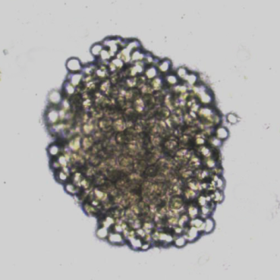 | B |  | C
D  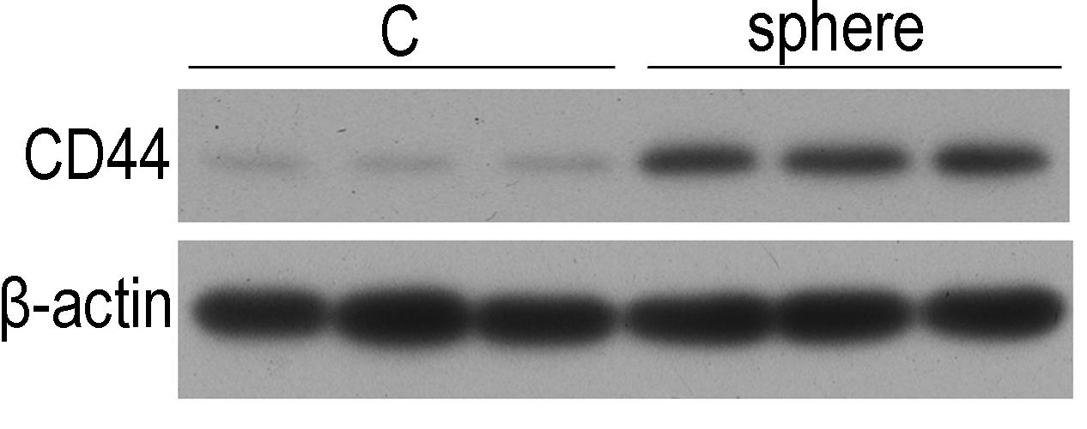 |  | E
Figure 1 miR-145 and CD44 expression in gastric cancer cells with self-renewal properties. ªP < 0.05, ^{b}P < 0.01, ^{c}P < 0.001 vs the monolayer cells; data are the mean ± SEM of at least three independent experiments. A: Representative photograph of a tumor sphere of MGC-803 cells. MGC-803 cells were cultured in the stem cell medium as described in the Materials and Methods section; B: miR-145 expression in tumor spheres and monolayer cells. miR-145 expression was determined by real-time polymerase chain reaction (PCR); C: CD44 mRNA expression in tumor spheres and monolayer cells. CD44 mRNA expression was determined by real-time PCR; D: CD44 protein expression in tumor spheres and monolayer cells. Cells were harvested for Western blot analysis; E: The expression of several gastric cancer stem cell markers in tumor spheres and monolayer cells. Sox2, Oct4 and Nanog mRNA expression was determined by real-time PCR.

A  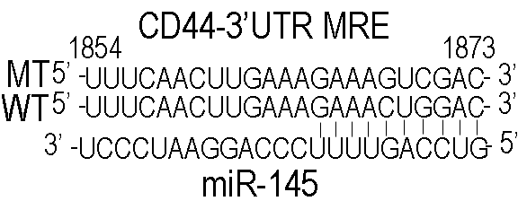 | B |  | C
D  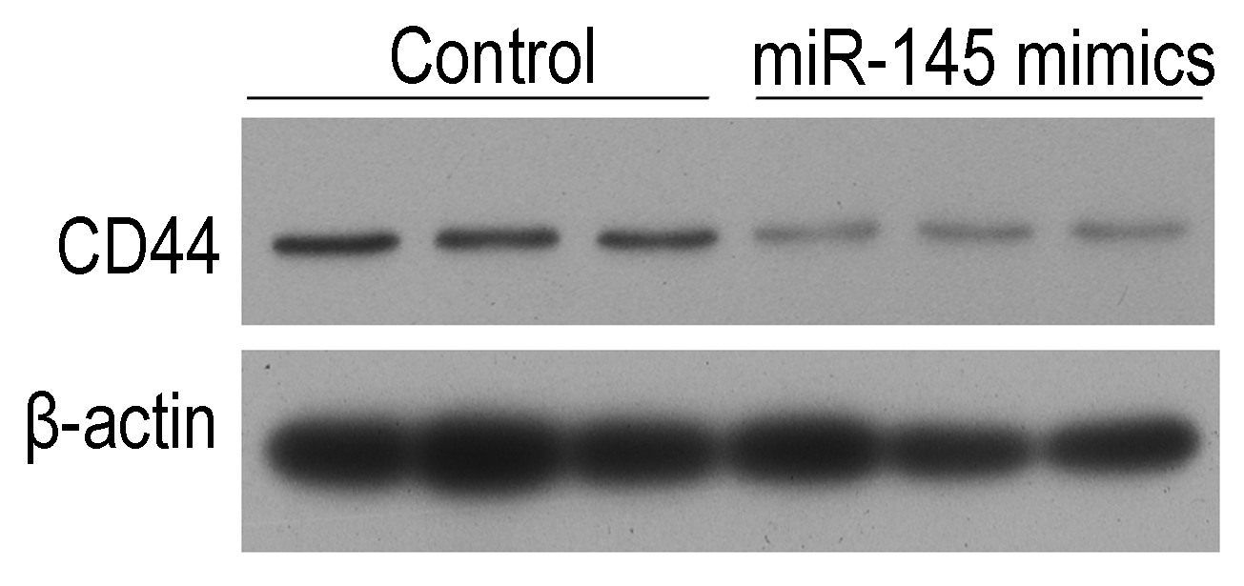 |  | E  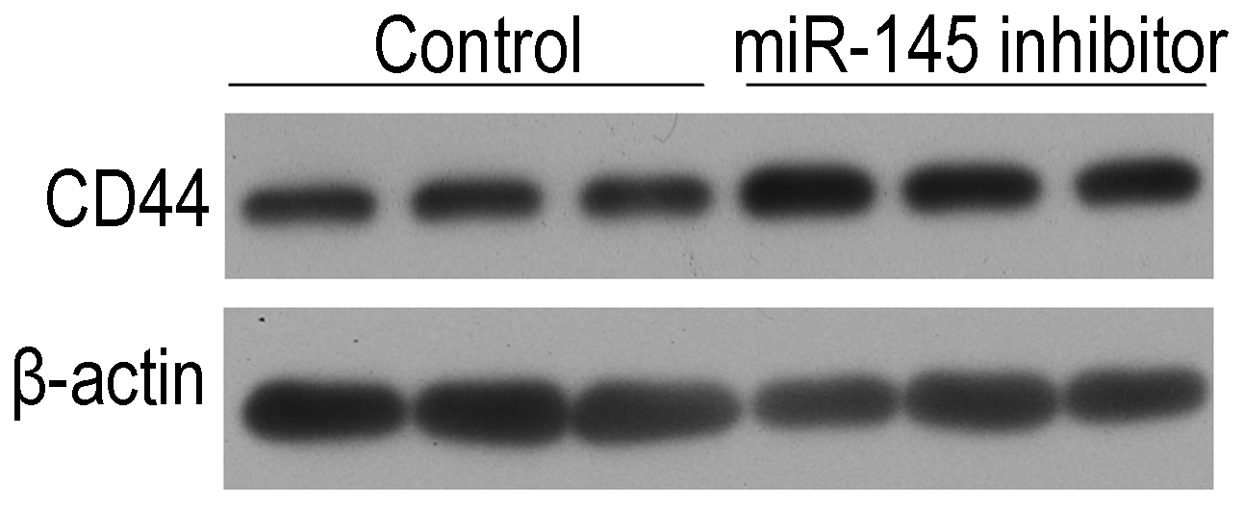
Figure 2 miR-145 directly targets the CD44 3’UTR in gastric cancer cells. ªP < 0.05, ^{b}P < 0.01, ^{c}P < 0.001 vs the control; data are the mean ± SEM of at least three independent experiments. A: A putative MRE for miR-145 on the 3’UTR of CD44; B: miR-145 negatively regulated CD44 3’UTR activity; C: MRE site-mutation abolished the effects of miR-145 on CD44 3’UTR activity. MGC-803 cells were co-transfected with pMT-CD44-3’UTR-luc or pWT-CD44-3’UTR-luc with or without miR-145 mimics or an miR-145 inhibitor, respectively, and the transfected cells were harvested 36 h later for luciferase reporter assays as described; D: miR-145 mimics inhibited CD44 protein expression.; E: The miR-145 inhibitor increased CD44 protein expression. MGC-803 cells were transfected with or without miR-145 mimics or a miR-145 inhibitor, respectively, and the transfected cells were harvested 48 h later for Western blot analysis. RLU: Relative luciferase activity.

A  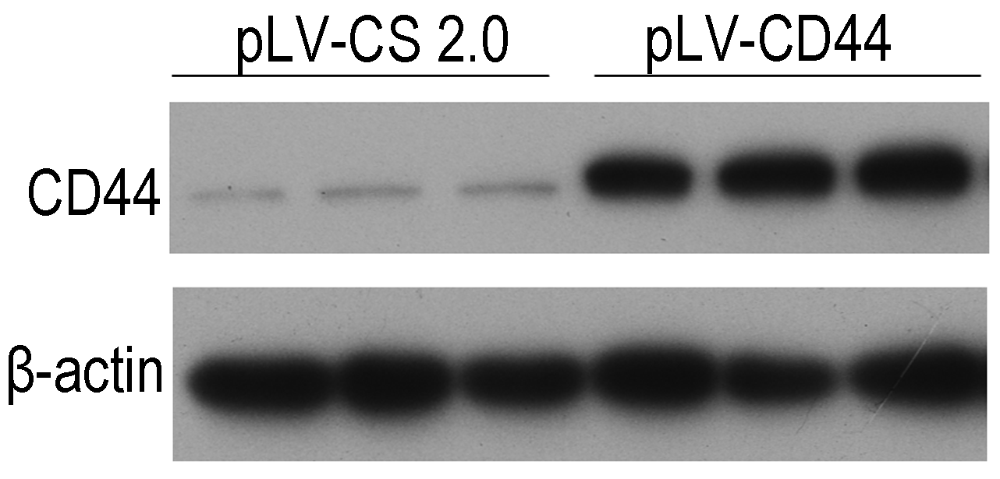 | B
Figure 3 Overexpression of CD44 abolished the inhibitory effect of miR-145 on tumor sphere formation in gastric cancer cells. ^{c}P < 0.001 vs cells transfected with the control; ^{b}P < 0.01 vs cells transfected with miR-145 mimics; data are the mean ± SEM of at least three independent experiments. A: Transfection with pLV-CD44 plasmid significantly increased CD44 protein expression; B: CD44 overexpression abolished the inhibitory effect of miR-145 on tumor sphere formation. MGC-803 cells were co-transfected with pLV-CD44 with or without miR-145 mimics, respectively, and the transfected cells were collected 12 h later for tumor sphere formation assays as described.

A | C
B
Figure 4 Overexpression of CD44 abolishes the chemo-resistance lowering effect of miR-145 in gastric cancer cells. ªP < 0.05, ^{b}P < 0.01 vs cells transfected with the control; ^{c}P < 0.001 vs cells transfected with miR-145 mimics; data are the mean ± SEM of at least three independent experiments. A: CD44 overexpression reduced MGC-803 cell chemo-resistance to cisplatin; B: CD44 overexpression reduced MGC-803 cell chemo-resistance to 5-FU. MGC-803 cells were co-transfected with pLV-CD44 with or without miR-145 mimics, respectively, the transfected cells were collected 12 h later, and then various concentrations of cisplatin or 5-FU were used to treat the cells. Cell viability was determined as described; C: ABCG2 expression following transfection of miR-145 or pLV-CD44. MGC-803 cells were co-transfected with pLV-CD44 with or without miR-145 mimics, respectively, the transfected cells were collected 36 h later, and ABCG2 mRNA expression was determined by real-time polymerase chain reaction.

