Name of Journal: World Journal of Clinical Cases
Manuscript NO: 37586
Manuscript Type: Original Article

Observational Study
Correlations between microbial communities in stool and clinical indicators in patients with metabolic syndrome

Lin L et al. Microbial polymorphisms of patients with metabolic syndrome

Lang Lin, Zai-Bo Wen, Dong-Jiao Lin, Jiang-Ting Dong, Jie Jin, Fei Meng

Lang Lin, Zai-Bo Wen, Dong-Jiao Lin, Jiang-Ting Dong, Department of Gastroenterology, Cangnan People's Hospital, Cangnan 325800, Zhejiang Province, China

Jie Jin, Fei Meng, Department of Research Service, Zhiyuan Medical Inspection Institute CO., LTD, Hangzhou 310030, Zhejiang Province, China

ORCID number: Lang Lin (0000-0001-5879-7487); Zai-Bo Wen (0000-0003-1290-0404); Dong-Jiao Lin (0000-0001-5186-8182); Jiang-Ting Dong (0000-0002-6433-0143); Jie Jin (0000-0003-1481-5107); Fei Meng (0000-0003-1233-4270).

Author contributions: Lin L formulated the problem; Wen ZB, Lin DJ and Dong JT collected samples; Meng F performed 16S rDNA sequencing; Jin J analyzed the data; Lin L and Jin J wrote the paper.

Supported by the Medical and Health Science and Technology Plan Project of Zhejiang Province, No. 2015KY371; and the Public Technology Application Research of Zhejiang Province Science and Technology Hall, No. 2016C33242.

Institutional review board statement: This study has been approved by the ethics committee.

Informed consent statement: All study participants, or their legal guardian, provided informed written consent prior to study enrollment.

Conflict-of-interest statement: To the best of our knowledge, no conflicts of interest exist.

Data sharing statement: No additional data are available.

STROBE statement: The STROBE Statement had been adopted.

Open-Access: This article is an open-access article which was selected by an in-house editor and fully peer-reviewed by external reviewers. It is distributed in accordance with the Creative Commons Attribution Non Commercial (CC BY-NC 4.0) license, which permits others to distribute, remix, adapt, build upon this work non-commercially, and license their derivative works on different terms, provided the original work is properly cited and the use is non-commercial. See: http://creativecommons.org/licenses/by-nc/4.0/

Manuscript source: Unsolicited manuscript

Correspondence to: Lang Lin, MSc, Chief Doctor, Department of Gastroenterology, Cangnan People's Hospital, Lingxi Town, Yucang Road No.195, Cangnan 325800, Zhejiang Province, China. cnxiaohua1965@sina.cn
Telephone: +86-577-64767351
Fax: +86-577-64767351

Received: January 2, 2018
Peer-review started: January 2, 2018
First decision: January 18, 2018
Revised: February 2, 2018
Accepted: March 7, 2018
Article in press:
Published online:

Abstract
AIM
To analyze the bacterial community structure and distribution of intestinal microflora in people with and without metabolic syndrome and combined these data with clinical indicators to determine relationships between selected bacteria and metabolic diseases.

METHODS
Faecal samples were collected from 20 patients with metabolic syndrome and 16 controls at Cangnan People's Hospital, Zhejiang Province, China. DNA was extracted and the V3-V4 regions of the 16S rRNA genes were amplified for high throughput sequencing. Clear reads were clustered at the 97% sequence similarity level. α and β diversity were used to describe the bacterial community structure and distribution in patients. Combined with the clinical indicators, further analysis was performed.

RESULTS
Bacteroidetes, Firmicutes, Actinobacteria, Proteobacteria, Fusobacteria were the dominant phyla, and Prevotella, Bacteroides and Faecalibacterium was the top three genera in faecal samples. α diversity analysis showed that the species richness of metabolic syndrome samples (group D) was significantly higher than the control (group C) (P < 0.05), and the microbial diversity of group C was greater than that of group D. According to the principal co-ordinates analysis, the samples of group C clustered more tightly, indicating that the distribution of bacteria in healthy patients was similar. The correlation analysis showed that alkaline phosphatase was negatively correlated with the abundance of Prevotella (P < 0.05). There was a negative correlation between low-density lipoprotein and the abundance of Ruminococcus (P < 0.05) and a positive correlation between the high-density lipoprotein and the abundance of Ruminococcus (P < 0.05). The total protein and the alanine aminotransferase was positively correlated with the abundance of Peptostreptococcus (P < 0.05).

CONCLUSION
The changes microbial communities can be used as an indicator of metabolic syndrome, and Prevotella may be a target microorganism in patients with metabolic syndrome.

Key words: Metabolic syndrome; Fecal samples; Bacterial community structure; Prevotella

© The Author(s) 2018. Published by Baishideng Publishing Group Inc. All rights reserved.

Core tip: We amplified the V3-V4 regions of the 16S rDNA from faecal samples to analysis the bacterial community structure and distribution of intestinal microflora in patients with metabolic syndrome combined with clinical indicators. The results showed that the species of metabolic syndrome patients was significantly higher than that of controls, and the microbial diversity of controls was greater than that of metabolic syndrome patients. The correlation analysis showed that alkaline phosphatase was negatively correlated with the abundance of Prevotella, indicating that Prevotella may be a target microorganism in patients with metabolic syndrome.

Lin L, Wen ZB, Lin DJ, Dong JT, Jin J, Meng F. Correlations between microbial communities in stool and clinical indicators in patients with metabolic syndrome. World J Clin Cases 2018; In press

INTRODUCTION
Metabolic syndrome is one of the most pressing global health problems currently. This syndrome occurs in adults but has also been reported in adolescents, and its prevalence is estimated to be nearly 4.2%^{[1]}. Metabolic syndrome is a cluster of disorders and metabolic symptoms that finally leads to an increased risk of cardiovascular disease^{[2]}. The increasing number of people with metabolic syndrome is considered to be associated with the global epidemic of diabetes and obesity, especially abdominal obesity^{[3]}. It has also been noted that the prevalence of metabolic syndrome increases with the severity of obesity^{[4]}. It is known that an overabundance of circulating fatty acids can lead to insulin resistance which, in turn, could lead to metabolic syndrome. In fact, the WHO had defined that glucose intolerance, insulin resistance, obesity, hypertension and dyslipidaemia are essential component of metabolic syndrome^{[5]}.
The gut microbiota of humans has received serious attention in recent years, as it is an important component of human microbial communities. The gut microbiota establishes and maintains normal intestinal health and can improve or exacerbate a series of diseases ranging from stomach cancer to autoimmune disorders^{[6]}. Sokol et al^{[7]} reported that a high level of Faecalibacterium prausnitzii in a healthy person could protect gut mucosa. Conversely, Staphylococcus aureus, a type of opportunistic human pathogen, is able to cause various diseases, such as pseudomembranous colitis^{[8]}. Karlsson^{[9]} noted that gut microbiota composition could instruct the metabolic status of patients with type 2 diabetes. Metagenomic studies have been widely conducted on human microbiomes and have identified various gut microbiota that are specifically related to the metabolic syndrome; for example, Prevotella copri contributes to insulin resistance, while Akkermansia municiphila is involved in increasing insulin sensitivity^{[10,11]}.
Based on the Illumina Miseq sequencing platform, our study analysed the bacterial community structure of intestinal microflora in patients with metabolic syndrome. Furthermore, we analyzed α and β diversity, the differences and distributions of microbial communities and the particular bacterial species related to metabolic diseases by comparing healthy controls with patients with metabolic syndrome. By combining microbial community analyses with the clinical indicators, we aimed to determine a relationship between selected bacteria and metabolic diseases.

MATERIALS AND METHODS
Patients and samples
Twenty patients with metabolic syndrome were recruited from the hospital outpatient and inpatient department according to the international Diabetes Federation (IDF) criteria, and the patient's faecal samples were collected and numbered from D1 to D20. The detailed clinical data were showed in Table 1. At the same time, 16 (C1-C16) faecal samples were collected from the normal people. All faecal samples (> 3 g) were placed in a 1.5 mL saline tube (containing a DNase inhibitor). Immediately after collection, all of the samples were stored at -80 ℃. This study had received a strict medical ethics review, and all patients were informed and consented to participate in the study.

DNA extraction and concentration determination of fecal samples
Nucleic acid extraction was performed according to the QIAamp DNA Stool Mini Kit manufacturer’s instructions, and DNA was finally dissolved in Buffer AE. Quantified the DNA concentration by using Qubit dsDNA HS assay kit, identified the DNA quality and integrity by Agilent 2100 Bioanalyzer with DNA 1000 chip.

16S rDNA high throughput sequencing
The primer sequences of the V3 and V4 regions of 16 s rDNA were designed after comparing the sequence of multiple bacteria. Upstream primer: 5'-TCGTCGGCAGCGTCAGATGTGT-3'; downstream primer: 5'-GTCTCGTGGGCTCGGAGATGTG-3'. Primers were stored at -20 ℃ after synthesis.

The libraries were constructed with a two-step polymerase chain reaction (PCR) amplification protocol. The reaction mixture for first step was as follows: 1 μL of upstream primer (5 μmol/L), 1 μL of downstream primer (5 μmol/L), 10 ng of DNA template, 10 μL of HiFi buffer (2 ×), and 7 μL of sterile water. The thermal cycling was as follows: pre-denaturation at 95 ℃ for 3 min, denaturation at 95 ℃ for 30 s, annealing at 60 ℃ for 30 s, extension at 72 ℃ for 30 s, and extension at 72 ℃ for 5 min. After PCR amplification, the PCR products were purified by magnetic beads purification. At the second step, primers N701-N712 and S501-S508 were used (Table 2). The reaction mixture was as follows: 1 μL of upstream primer (10 μmol/L), 1 μL of downstream primer (10 μmol/L), 2 μL of the purified amplification products from the first-round, 12.5 μL of HiFi buffer (2 ×), and 8.5 μL of sterile water. The thermal cycling was as follows: pre-denaturation at 95 ℃ for 3 min, denaturation at 95 ℃ for 30 s, annealing at 65 ℃ for 30 s, extension at 72 ℃ for 30 s followed by extension at 72 ℃ for 5 min. After the second round of PCR amplification, the products were purified by magnetic beads, and 30 μL sterile water was used for DNA elution. The concentration of libraries was quantified by an Agilent 2100 Bioanalyzer instrument with a DNA high-sensitivity chip.

High throughput sequencing and data processing
High throughput sequencing was performed with the Illumina MiSeq (Illumine, San Diego, CA, United States) platform to produce 2 × 250 bp paired end reads. Raw tags were obtained by such methods as error rate checking, joint processing, and merging on the original sequencing primers. Raw tags were filtered using Qiime. Usearch was used to remove chimeric sequences and to obtain the final valid tags by comparing with the database. The operational taxonomic units (OTU) clusters were performed with Uparse based on a 97% sequence identity. Furthermore, in order to analyses the distribution and diversity of microbes in different samples, α diversity and β diversity were performed for all samples. α diversity analyzed the distribution and abundance of microorganisms in the sample by calculating, for instance, the ACE, the Shannon index, and the Simpson index. β diversity analysis was used to evaluate the diversity of the microbial composition in the sample. Principal Co-ordinates Analysis (PCoA) was performed based on a distance matrix of weighted UniFrac values.

Statistical analysis
T-tests were used to analyse the differences in bacterial abundance between the two groups. The abundance of Odoribacter, Prevotella, Ruminococcus, Faecalibacterium, Actinomycetaceae, Mobiluncus, Agromyces, Chryseobacterium and Peptostreptococcus were significantly different between the two groups. Correlation analysis showed that alkaline phosphatase was negatively correlated with the abundance of Prevotella (P < 0.05). There was also a negative correlation between the low-density lipoproteins and the abundance of Ruminococcus (P < 0.05), while a positive correlation was observed between the high-density lipoproteins and the abundance of Ruminococcus (P < 0.05). The total proteins and alanine aminotransferase were positively correlated with the abundance of Peptostreptococcus (P < 0.05).

RESULTS
Quality control of experimental data
Twenty faecal samples from metabolic syndrome patients (group D) and 16 faecal samples from normal people (group C) were collected in this study. The hypervariable region (V3, V4 and V5) of 16S rDNA of bacteria was amplified with the corresponding universal primers. After a series of procedure, for instance quality inspection, sample mixing, library building and QC, the qualified library were obtained and subjected to high throughput sequencing. Raw reads was purified with a series of quality control operations, such as error rate check, joint handling, merger and optimization. At last, effective tags were obtained for the following analyze revealed that Group C (control) consisted of an average of 59833 ± 11661 high quality sequences, and group D (metabolic syndrome) consisted of an average of 53857 ± 10901 high quality sequences. The average length of all of the sequences was 426 ± 2 nt. The sequences were subjected to OTU clustering at 97% similarity level using the Qiime software. After disregarding all OTUs that consisted of less than 2 sequences, the number of OTUs in group C and D were 928 to 2433, and 1161 to 2932, respectively. Classification of the bacteria was accomplished by Greengenes.

Composition and distribution of microorganisms in faeces
At the phylum level, the dominant bacteria of groups C and D were similar. The five phyla with the highest abundance were Bacteroidetes, Firmicutes, Actinobacteria, Proteobacteria and Fusobacteria (not detected in C4), which comprised 99.37-99.97% of all the OTUs. All of these microbes are common intestinal microflora^{[12]} (Figure 1). Based on the group classification tree, we observed that the relative abundance of Firmicutes in group C was larger than that in group D (P < 0.05). Although the relative abundance of Bacteroidetes, Fusobacteria, Proteobacteria and Actinobacteria in group D was higher than group C, this difference was not significant (P > 0.05) (Figure 2).
At the genus level, the dominant species in both groups were Prevotella, Bacteroides and Faecalibacterium. Among these species, only the abundance of Prevotella and Faecalibacterium were significantly different between the two groups. Ruminococcus, Coprococcus, Bifidobacterium, Blautia, Lactobacllus, Fusobacterium were also highly abundant and dominant in both groups. The abundance of species in group D was slightly higher than in group C (Figure 3).

Rarefaction and rank abundance curves
Rarefaction curves were used to evaluate whether the amount of sequencing data was sufficient to capture all species contained in the sample and to indirectly reflect the abundance of species. Rarefaction curves of two groups are shown in Figure 4.
Rank abundance curves intuitively reflect the richness of the species in the sample and the distribution of uniformity. The higher the richness of species is, the greater the span of the curve on the horizontal axis, in the vertical direction, the gentler the curve, the more uniform the species distribution.

α diversity analysis
The t-test results and the box diagram showed that the abundance and diversity of the species in the two groups were significantly different (P < 0.05). The species richness of group D was significantly higher, while the microbial diversity of group C was greater (Table 3, Figure 5).

β diversity analysis
The samples were clustered into two groups, except for samples 6, 7, 8, 9 and 15 in group C and samples 8, 9, 11, 15 and 20 in group D, indicating generally good within-group similarities. Results of principal co-ordinates analysis showed that the samples of group C formed a tighter cluster, indicating that bacteria in healthy patients shared more similarities, while the samples of group D were more scattered. The results show how the bacterial community structure can be distinguished based on the different health conditions of patients (Figures 6 and 7).

DISCUSSION
Patients with metabolic syndrome were usually obese and suffered from atherosclerosis, dyslipidaemia, hypertension, insulin resistance, impaired glucose tolerance or other symptoms. For persons with this condition, the metabolism of proteins, fats, carbohydrates and other substances may be dysfunctional, which leads to changes in the composition of the symbiotic microbial flora in human body which, in turn, impacts certain important functions in humans. Therefore, the composition of microbial flora and the human body's health are closely related. There have been many studies on the correlations between metabolic syndrome and microbial flora. However, the correlation between microbial and clinical indicators of metabolic syndrome has rarely been reported. This paper analyzed the differences of microbial distribution between patients with and without metabolic syndrome, and focused on the relationship between clinical indicators and microbes in patients with metabolic syndrome. Our aim was to find a better means of detecting diseases based on the changes of microbial flora in humans.
Our results showed that the composition of the bacterial communities in persons with and without metabolic syndrome was similar. The dominant bacteria were Bacteroidetes, Firmicutes, Actinobacteria, Proteobacteria and Fusobacteria, all of which are common intestinal flora. There were significant differences in the abundance of Firmicutes in the two groups, being significantly lower in group D. Sun, et al^{[13]} showed a decrease of abundance of the Firmicutes, and an increase of Bacteroidetes in obese people, which was similar to our findings, except we observed no significant increase in the abundance of Bacteroides in group D. The ACE index indicated a higher species richness of microbes in group D than group C; the Shannon index showed no significant difference between the two groups, while the Simpson index showed that the microbial diversity of group C was higher than that of the group D. These results indicate that various factors in patients with metabolic syndrome might lead to changes in the composition of microbial flora. At the genus level, the abundance of Prevotella, Ruminococcus and Peptostreptococcus were different among the two groups and showed certain correlations with the clinical data (Table 4).
An early symptom of type II diabetes or metabolic syndrome is insulin resistance^{[14]}. Prevotella is a bacterium of the mouth and vagina that dominates during periodontal disease and periodontal abscess^{[15]}, and can enter the intestine with food and saliva. Diet is closely related to Prevotella. Studies had shown that long-term high-fat diets can lead to excess energy in the body, which leads to obesity. Adipose tissue in obese patients secrete a variety of inflammatory factors such that the body enters a low inflammation state continuously, which leads to insulin resistance^{[16]}. Zhao^{[17]} observed that branched-chain amino acids increased in people with insulin resistance. As insulin resistance further develops, the body begins to lack insulin while the branched-chain amino acids increase gradually. Animal studies have confirmed the relationship between Prevotella and branched-chain amino acids^{[18]}. For example, feeding mice with Prevotella for three weeks leads to an increase in the level of branched-chain amino acids in the body, and the formation of glucose tolerance and insulin resistance. We observed that the abundance of Prevotella in group D was significantly higher than group C, and we speculate that Prevotella may be a target microorganism in patients with metabolic syndrome. The increase in the abundance of Prevotella would lead to increased branched-chain amino acids and the metabolism of carbohydrates because Prevotella actively interacts with a variety of microbes to accelerate the metabolism of carbohydrates in the body^{[19]}. The synthesis of branched-chain amino acids depends on a type of enzyme that is expressed in many kinds of microorganisms. Therefore, the presence of Prevotella and other microorganisms might lead to increased levels of branched-chain amino acids in the blood. However, we observed that Prevotella and alkaline phosphatase were negatively correlated. Clinical determination of alkaline phosphatase is primarily used for the diagnosis of orthopaedic and hepatobiliary diseases, especially jaundice. Whether the Prevotella in the patients with metabolic syndrome is related to orthopaedic and hepatobiliary diseases is worthy of further study.
Ruminococccus is a dominant group in the mammalian gut and has been associated with intestinal health^{[20]} and insulin resistance. Ruminococccus has the ability to colonize efficiently and to decompose starch, which could inhibit insulin resistance^{[21]}. High-density lipoprotein, low-density lipoprotein and triglyceride are important indicators of insulin resistance^{[22]}. A previous study showed that the abundance of Ruminococccaceae decreased in obese mice fed a high-fat diet^{[23]}. Furthermore, there was a significantly positive correlation between Ruminococccaceae and gallbladder stones and low density lipoprotein (LDL)^{[24]}. We observed that the abundance of Ruminococccus and low-density lipoprotein were positively correlated, while this abundance was negatively correlated with high-density lipoprotein, and the correlation was significant. The abundance of Ruminococccus and glucose and lipid metabolism are closely related. There was no significant correlation between Ruminococccus and total cholesterol in this study.
Peptostreptococcus is a common anaerobic bacterium in the human body and is an opportunistic pathogen appearing when the immune system is disrupted. Studies have shown that the abundance of Peptostreptococcus in patients with type II diabetes is significantly reduced^{[25]}. The abundance of Peptostreptococcus has also been linked to liver abscess and other bacterial infectious diseases. We observed that Peptostreptococcus and alanine aminotransferase were positively correlated, and we speculate that the lowered immunity in diabetic patients increased the abundance of Peptostreptococcus, causing liver infection and affecting some liver functions. Furthermore, the metabolic disorders inherent to diabetes could also lead to impaired liver function.
The microbial flora in the human body was involved in the metabolism of glucose and lipids. The blockage of this and other pathways leads to the occurrence of metabolic syndrome. Metabolic syndrome would further aggravate the body’s metabolic disorders, leading to further disruptions in the microbial flora of metabolic syndrome patients. Thus, the microbial flora could be used to guide the detection of metabolic syndrome. In this study, the data on the composition of microbial communities of normal and metabolic syndrome patients were combined with the clinical indicators of metabolic syndrome. We observed that the changes in the microbial communities can be used as an indicator of metabolic syndrome. Conversely, this study suffered from two primary shortcomings: our sample size was small, and it was not representative.

ARTICLE HIGHLIGHTS
Research background
The prevalence of metabolic syndrome has been one of the most pressing global health problems. The WHO defined that glucose intolerance, insulin resistance, obesity, hypertension and dyslipidaemia are essential component of metabolic syndrome. Metagenomic studies had identified various specific gut microbiota relate to metabolic syndrome. Based on the Illumina Miseq sequencing platform, 16s rDNA was widely studied on the distribution and diversity of microbial communities, however the analysis on the clinical indicators was not enough. Recently, the microbial community, based on 16s rDNA sequencing, has attracted substantial attention. Metagenomic studies had identified that various specific gut microbiota were relate to metabolic syndrome, such as Akkermansia municiphila. The changes of microbes in the community and the relationship between microbial community and the clinical indicators of metabolic syndrome can be used as an indicator of metabolic syndrome detection.

Research motivation
Except for the distribution and diversity of microbial communities, we aimed to find out a relationship between these special bacteria and metabolic diseases through the analysis of clinical data.

Research objectives
The main objectives were twenty patients with metabolic syndrome which were recruited from the hospital outpatient and inpatient department according to the international Diabetes Federation (IDF) criteria. The patient's faecal samples were collected and analyzed by 16S rDNA sequencing.

Research methods
16S rDNA gene sequencing is a non-culture method based on the high-throughput sequencing platforms. At present, 16S rDNA gene sequencing has been widely utilized for metagenomic analysis of the environment, including analysis of the composition of the human and animal guts and fecal microbiota. In this study, we analyzed the bacterial community structure, and found out a relationship between these special bacteria and metabolic diseases. The microbial flora could be used to guide the detection of metabolic syndrome and the changes of microbes in the community can be used as an indicator. Furthermore, Prevotella might be a target microorganism in patients with metabolic syndrome.

Research results
Firstly, Bacteroidetes, Firmicutes, Actinobacteria, Proteobacteria, Fusobacteria were the dominant phyla, and Prevotella, Bacteroides and Faecalibacterium was the top three genera in faecal samples. Secondly, compared with the health people (group C), patients with metabolic syndrome (group D) had much more species richness in faecal samples. However, the microbial diversity of group C was greater than that of group D. Thirdly, clinical data had correlation with the distribution and diversity of microbial communities. For example, the alkaline phosphatase and low-density lipoprotein was negatively correlated with the abundance of Prevotella and Ruminococcus respectively (P < 0.05). In contrast, there was a positive correlation between the high-density lipoprotein and the abundance of Ruminococcus (P < 0.05), additionally, another positive correlation were detected among the total protein, the alanine aminotransferase and Peptostreptococcus (P < 0.05).

Research conclusions
In this study, the data on the composition of microbial communities of normal and metabolic syndrome patients were combined with the clinical indicators of metabolic syndrome. The species richness of metabolic syndrome samples (group D) was significantly higher than the healthy people (group C) (P < 0.05), and the microbial diversity of group C was greater than that of group D.

Research perspectives
The changes microbial communities can be used as an indicator of metabolic syndrome, and Prevotella may be a target microorganism in patients with metabolic syndrome.

REFERENCES
1 Cook S, Weitzman M, Auinger P, Nguyen M, Dietz WH. Prevalence of a metabolic syndrome phenotype in adolescents: findings from the third National Health and Nutrition Examination Survey, 1988-1994. Arch Pediatr Adolesc Med 2003; 157: 821-827 [PMID: 12912790 DOI: 10.1001/archpedi.157.8.821]
2 Malik S, Wong ND, Franklin SS, Kamath TV, Litalien GJ, Pio JR, Williams GR. Impact of the metabolic syndrome on mortality from coronary heart disease, cardiovascular disease, and all causes in United States adults. Circulation 2004; 110: 1245-1250 [PMID: 15326067 DOI: 10.1161/01.CIR.0000140677.20606.0E]
3 Wu CC, Liou HH, Su PF, Chang MY, Wang HH, Chen MJ, Hung SY. Abdominal obesity is the most significant metabolic syndrome component predictive of cardiovascular events in chronic hemodialysis patients. Nephrol Dial Transplant 2011; 26: 3689-3695 [PMID: 21357211 DOI: 10.1093/ndt/gfr057]
4 Weiss R, Dziura J, Burgert TS, Tamborlane WV, Taksali SE, Yeckel CW, Allen K, Lopes M, Savoye M, Morrison J, Sherwin RS, Caprio S. Obesity and the metabolic syndrome in children and adolescents. N Engl J Med 2004; 350: 2362–2374 [PMID: 15175438 DOI: 10.1056/NEJMoa031049]
5 Alberti KG, Zimmet PZ. Definition, diagnosis and classification of diabetes mellitus and its complications. Part 1: diagnosis and classification of diabetes mellitus provisional report of a WHO consultation. Diabet Med 1998; 15: 539-553 [PMID: 9686693 DOI: 10.1002/(SICI)1096-9136(199807)15:73.0.CO;2-S]
6 Prakash S, Rodes L, Coussa-Charley M, Tomaro-Duchesneau C. Gut microbiota: next frontier in understanding human health and development of biotherapeutics. Biologics 2011; 5: 71-86 [PMID: 21847343 DOI: 10.2147/BTT.S19099]
7 Sokol H, Seksik P, Furet JP, Firmesse O, Nion-Larmurier I, Beaugerie L, Cosnes J, Corthier G, Marteau P, Doré J. Low counts of Faecalibacterium prausnitzii in colitis microbiota. Inflamm Bowel Dis 2009; 15: 1183-1189 [PMID: 19235886 DOI: 10.1002/ibd.20903]
8 Froberg MK, Palavecino E, Dykoski R, Gerding DN, Peterson LR, Johnson S. Staphylococcus aureus and Clostridium difficile cause distinct pseudomembranous intestinal diseases. Clin Infect Dis 2004; 39: 747-750 [PMID: 15356793 DOI: 10.1086/423273]
9 Karlsson FH, Tremaroli V, Nookaew I, Bergström G, Behre CJ, Fagerberg B, Nielsen J, Bäckhed F. Gut metagenome in European women with normal, impaired and diabetic glucose control. Nature 2013; 498: 99-103 [PMID: 23719380 DOI: 10.1038/nature12198]
10 Li J, Lin S, Vanhoutte PM, Woo CW, Xu A. Akkermansia Muciniphila Protects Against Atherosclerosis by Preventing Metabolic Endotoxemia-Induced Inflammation in Apoe-/- Mice. Circulation 2016; 133: 2434-2446 [PMID: 27143680 DOI: 10.1161/CIRCULATIONAHA.115.019645]
11 de Groot PF, Frissen MN, de Clercq NC, Nieuwdorp M. Fecal microbiota transplantation in metabolic syndrome: History, present and future. Gut Microbes 2017; 8: 253-267 [PMID: 28609252 DOI: 10.1080/19490976.2017.1293224]
12 Hu YL. Investigation of probiotics on the growth and fecal bacterial community of weaned piglets with molecular biotechnology. Huazhong Agricultural University, 2014
13 Sun HM, Sun Q. The progress of exercise intervention in metabolic syndrome with intestinal flora as the target. Zhongguo Yundong Yixue Zazhi 2016; 35: 490-493
14 Zhong ZB, Chi LX. Normal blood glucose-hyperinsulinemia research progress. Medical Review 2012; 18: 418-420
15 Tanaka S, Yoshida M, Murakami Y, Ogiwara T, Shoji M, Kobayashi S, Watanabe S, Machino M, Fujisawa S. The relationship of Prevotella intermedia, Prevotella nigrescens and Prevotella melaninogenica in the supragingival plaque of children, caries and oral malodor. J Clin Pediatr Dent 2008; 32: 195-200 [PMID: 18524268]
16 Yang X, Zou DJ. The common origin of obesity and type II diabetes: energy overload triggers liver insulin resistance. Zhongguo tangniaobing Zazhi 2016; 2: 116-119
17 Zhao HS. Branched-chain amino acid down-regulates hepatocyte AKT2 protein levels, promotes high-fat diet-induced mouse liver insulin resistance. The Fourth Military Medical University, 2016
18 Pedersen HK, Gudmundsdottir V, Nielsen HB, Hyotylainen T, Nielsen T, Jensen BA, Forslund K, Hildebrand F, Prifti E, Falony G, Le Chatelier E, Levenez F, Doré J, Mattila I, Plichta DR, Pöhö P, Hellgren LI, Arumugam M, Sunagawa S, Vieira-Silva S, Jørgensen T, Holm JB, Trošt K; MetaHIT Consortium, Kristiansen K, Brix S, Raes J, Wang J, Hansen T, Bork P, Brunak S, Oresic M, Ehrlich SD, Pedersen O. Human gut microbes impact host serum metabolome and insulin sensitivity. Nature 2016; 535: 376-381 [PMID: 27409811 DOI: 10.1038/nature18646]
19 Petersen LM, Bautista EJ, Nguyen H, Hanson BM, Chen L, Lek SH, Sodergren E, Weinstock GM. Community characteristics of the gut microbiomes of competitive cyclists. Microbiome 2017; 5: 98 [PMID: 28797298 DOI: 10.1186/s40168-017-0320-4]
20 Huws SA, Kim EJ, Lee MR, Scott MB, Tweed JK, Pinloche E, Wallace RJ, Scollan ND. As yet uncultured bacteria phylogenetically classified as Prevotella, Lachnospiraceae incertae sedis and unclassified Bacteroidales, Clostridiales and Ruminococcaceae may play a predominant role in ruminal biohydrogenation. Environ Microbiol 2011; 13: 1500-1512 [PMID: 21418494 DOI: 10.1111/j.1462-2920.2011.02452.x]
21 Ze X, Duncan SH, Louis P, Flint HJ. Ruminococcus bromii is a keystone species for the degradation of resistant starch in the human colon. ISME J 2012; 6: 1535-1543 [PMID: 22343308 DOI: 10.1038/ismej.2012.4]
22 Zhang DM, Zhang Y, Li T. The Relation between Triglyceride/High Density Lipoprotein Cholesterol Ratio and Insulin Resistance in Diabetics. J Clin Med Sci 2006; 34: 141-142
23 Daniel H, Gholami AM, Berry D, Desmarchelier C, Hahne H, Loh G, Mondot S, Lepage P, Rothballer M, Walker A, Böhm C, Wenning M, Wagner M, Blaut M, Schmitt-Kopplin P, Kuster B, Haller D, Clavel T. High-fat diet alters gut microbiota physiology in mice. ISME J 2014; 8: 295-308 [PMID: 24030595 DOI: 10.1038/ismej.2013.155]
24 Liu C. The serum metabonomic and composition of gut microbiota study on obesity-prone and obesity-resistant mice. Nanchang University, 2016
25 Wu XK, Ma CF, Yu PB, Wang XL, Han L, Li MX, Xu JR. Significance of the quantitative analysis of Lactobacillus and Peptostreptococcus productus of gut microbiota in patients with type 2 diabetes. Xi'an Jiaotong Daxue Xuebao (Yixue Ban) 2015; 36: 93-97

P-Reviewer: Chang ST, Crenn PP, Tziomalos K S-Editor: Cui LJ
L-Editor: E-Editor:

Specialty type: Medicine, research and experimental
Country of origin: China
Peer-review report classification
Grade A (Excellent): A, A
Grade B (Very good): 0
Grade C (Good): 0
Grade D (Fair): D
Grade E (Poor): 0

Table 1 Detailed clinical data of two groups
 | Group C | Goup D
Gender | 18:2 (male:female) | 12:4 (male:female)
Age | 46.70 ± 14.47 | 47.25 ± 16.34
Weight (kg) | 83.63 ± 12.26 | 68.82 ± 10.32
BMI | 28.66 ± 4.12 | 26.45 ± 3.11
Abdominal circumference (cm) | 102.85 ± 10.94 | 89.64 ± 8.34
Blood pressure (mmhg) | 139.60 ± 21.41/81.90 ± 7.75 | 127.44 ± 16.74/74.63 ± 6.46
Total bilirubin (μmol/L) | 17.67 ± 8.67 | 15.26 ± 7.34
Indirect bilirubin (μmol/L) | 13.26 ± 6.89 | 9.46 ± 4.72
Direct bilirubin (μmol/L) | 4.64 ± 3.37 | 3.52 ± 3.13
Fasting blood sugar (mmol/L) | 6.77 ± 1.48 | 5.22 ± 1.31
Postprandial blood sugar (mmol/L) | 11.20 ± 9.83 | 6.35 ± 2.64
Total protein (g/L) | 69.02 ± 6.52 | 73.46 ± 8.36
Globulin (g/L) | 27.09 ± 4.59 | 32.64 ± 3.56
Albumin (g/L) | 42.41 ± 5.88 | 51.14 ± 6.23
ALB/GLB | 1.63 ± 0.39 | 1.78 ± 0.23
Aspartate transaminase (U/L) | 39.57 ± 23.16 | 31.23 ± 13.54
Alanine aminotransferase (U/L) | 50.44 ± 26.82 | 37.26 ± 14.46
Glutamyl transpeptidase (U/L) | 146.13 ± 155.94 | 36.23 ± 13.63
AST/ALT | 0.86 ± 0.39 | 1.21 ± 0.23
Low density lipoprotein (mmol/L) | 3.06 ± 0.57 | 2.45 ± 0.24
High density lipoprotein (mmol/L) | 1.20 ± 0.37 | 1.65 ± 0.28
LDL/HDL | 2.38 ± 1.11 | 1.98 ± 2.1
Creatinine (μmol/L) | 83.54 ± 23.39 | 73.83 ± 16.34
Triglyceride (mmol/L) | 5.66 ± 8.20 | 1.53 ± 1.25
Total cholesterol (mmol/L) | 5.60 ± 3.15 | 4.76 ± 2.74
Alkaline phosphatase (U/L) | 52.46 ± 12.95 | 89.32 ± 25.32
Urea nitrogen (mmol/L) | 6.04 ± 2.12 | 5.14 ± 2.16
Uric acid (μmol/L) | 436.77 ± 141.57 | 378.35 ± 89.34
BMI: Body mass index; ALB/GLB: Aspartate transaminase/alanine aminotransferase; AST/ALT: Aspartate transaminase/alanine aminotransferase; LDL/HDL: High density lipoprotein/low density lipoprotein.

Table 2 Primers of N701-N712 and S501-S508
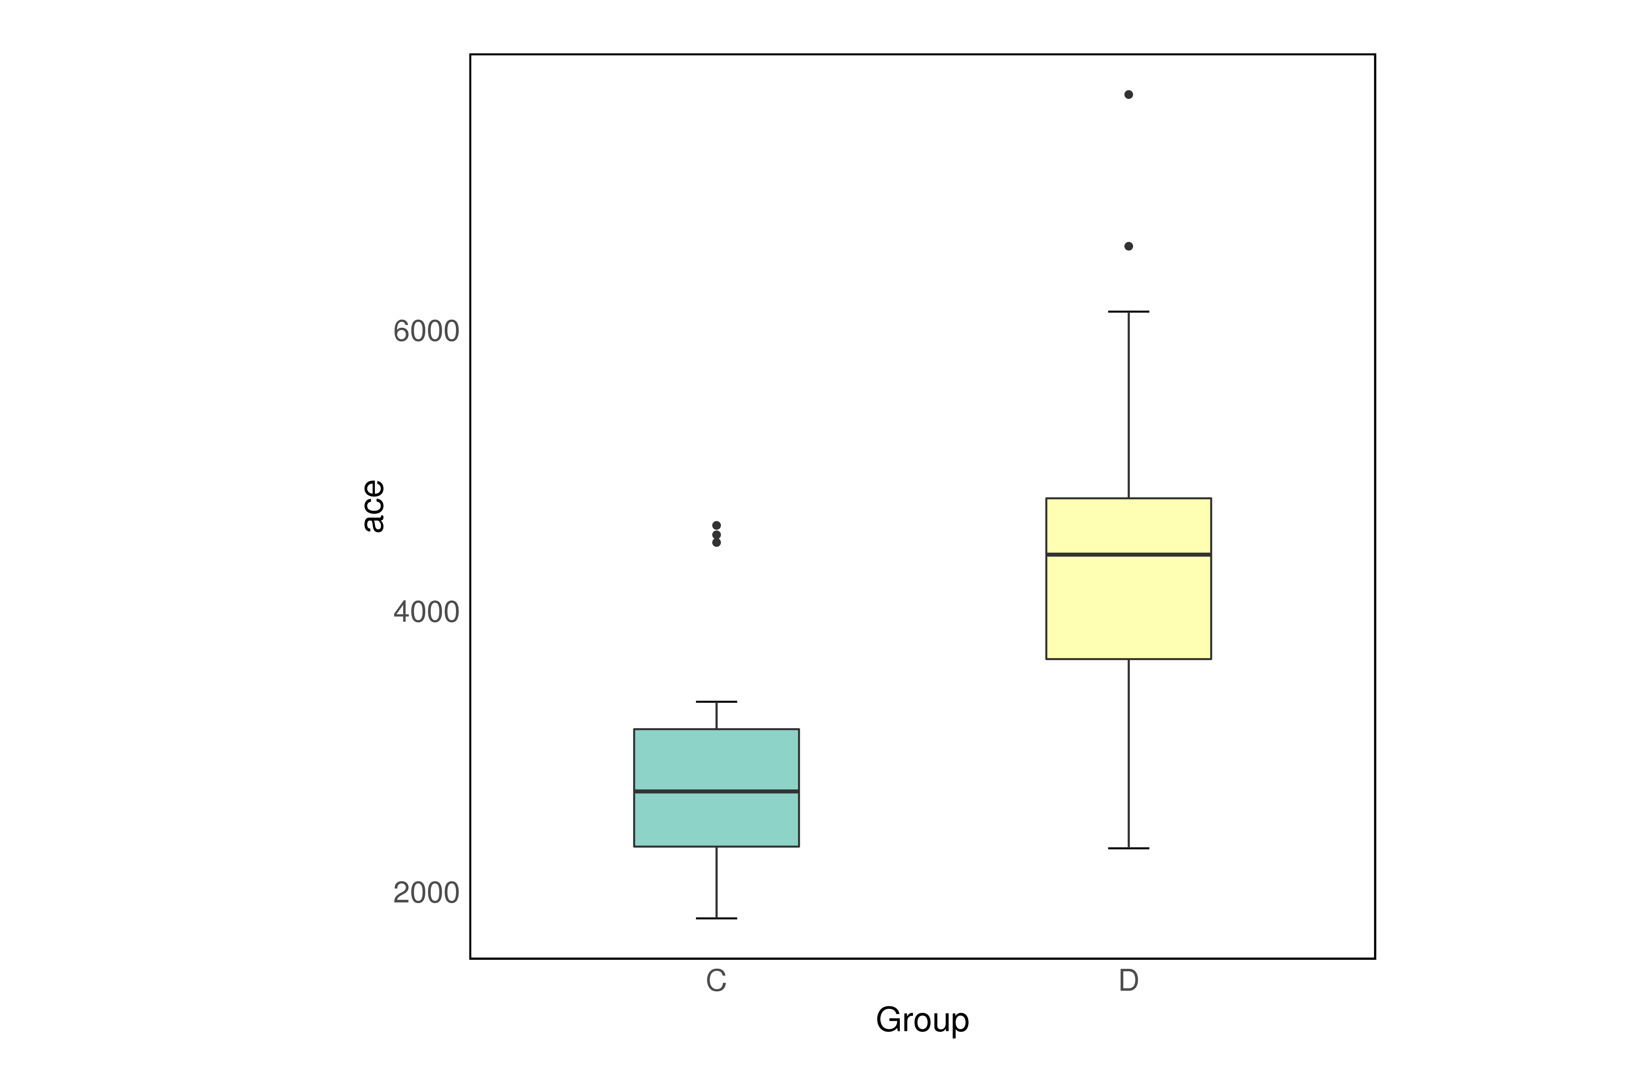Primer name | Primer sequence (5'-3')
N701 | CAAGCAGAAGACGGCATACGAGATTCGCCTTAGTCTCGTGGGCTCGG
N702 | CAAGCAGAAGACGGCATACGAGATCTAGTACGGTCTCGTGGGCTCGG
N703 | CAAGCAGAAGACGGCATACGAGATTTCTGCCTGTCTCGTGGGCTCGG
N704 | CAAGCAGAAGACGGCATACGAGATGCTCAGGAGTCTCGTGGGCTCGG
N705 | CAAGCAGAAGACGGCATACGAGATAGGAGTCCGTCTCGTGGGCTCGG
N706 | CAAGCAGAAGACGGCATACGAGATCATGCCTAGTCTCGTGGGCTCGG
N707 | CAAGCAGAAGACGGCATACGAGATGTAGAGAGGTCTCGTGGGCTCGG
N708 | CAAGCAGAAGACGGCATACGAGATCCTCTCTGGTCTCGTGGGCTCGG
N709 | CAAGCAGAAGACGGCATACGAGATAGCGTAGCGTCTCGTGGGCTCGG
N710 | CAAGCAGAAGACGGCATACGAGATCAGCCTCGGTCTCGTGGGCTCGG
N711 | CAAGCAGAAGACGGCATACGAGATTGCCTCTTGTCTCGTGGGCTCGG
N712 | CAAGCAGAAGACGGCATACGAGATTCCTCTACGTCTCGTGGGCTCGG
S501 | AATGATACGGCGACCACCGAGATCTACACTAGATCGCTCGTCGGCAGCGTC
S502 | AATGATACGGCGACCACCGAGATCTACACCTCTCTATTCGTCGGCAGCGTC
S503 | AATGATACGGCGACCACCGAGATCTACACTATCCTCTTCGTCGGCAGCGTC
S504 | AATGATACGGCGACCACCGAGATCTACACAGAGTAGATCGTCGGCAGCGTC
S505 | AATGATACGGCGACCACCGAGATCTACACGTAAGGAGTCGTCGGCAGCGTC
S506 | AATGATACGGCGACCACCGAGATCTACACACTGCATATCGTCGGCAGCGTC
S507 | AATGATACGGCGACCACCGAGATCTACACAAGGAGTATCGTCGGCAGCGTC
S508 | AATGATACGGCGACCACCGAGATCTACACCTAAGCCTTCGTCGGCAGCGTC

Table 3 α diversity analysis data of two groups
 | Group C | Group D | P value
ACE | 2935.84 | 4496.51 | < 0.05
Simpson | 0.96 | 0.93 | < 0.05
Shannon | 6.98 | 6.59 | > 0.05
ACE index: Used to assess species abundance, the larger the value, the higher the abundance; Simpson index: Used to assess species diversity, the larger the value, the higher the diversity; Shannon index: Used to assess species diversity, the larger the value, the lower the diversity.

Table 4 Relative abundance of top 9 genus in two groups and total samples
Genus | Group C (%) | Group D (%) | Total samples (%)
Prevotella | 21.85 | 31.80 | 27.38
Bacteroides | 19.54 | 16.34 | 17.77
Faecalibacterium | 7.84 | 5.54 | 6.56
Bifidobacterium | 2.28 | 3.18 | 2.78
Fusobacterium | 1.66 | 3.12 | 2.47
Ruminococcus | 3.48 | 1.50 | 2.38
Coprococcus | 2.29 | 1.90 | 2.07
Lactobacillus | 1.76 | 1.74 | 1.75
Blautia | 1.84 | 1.50 | 1.65
The top 9 genus was ranked according to the relative abundance in total samples, and their relative abundance in group C and group D was showed respectively.
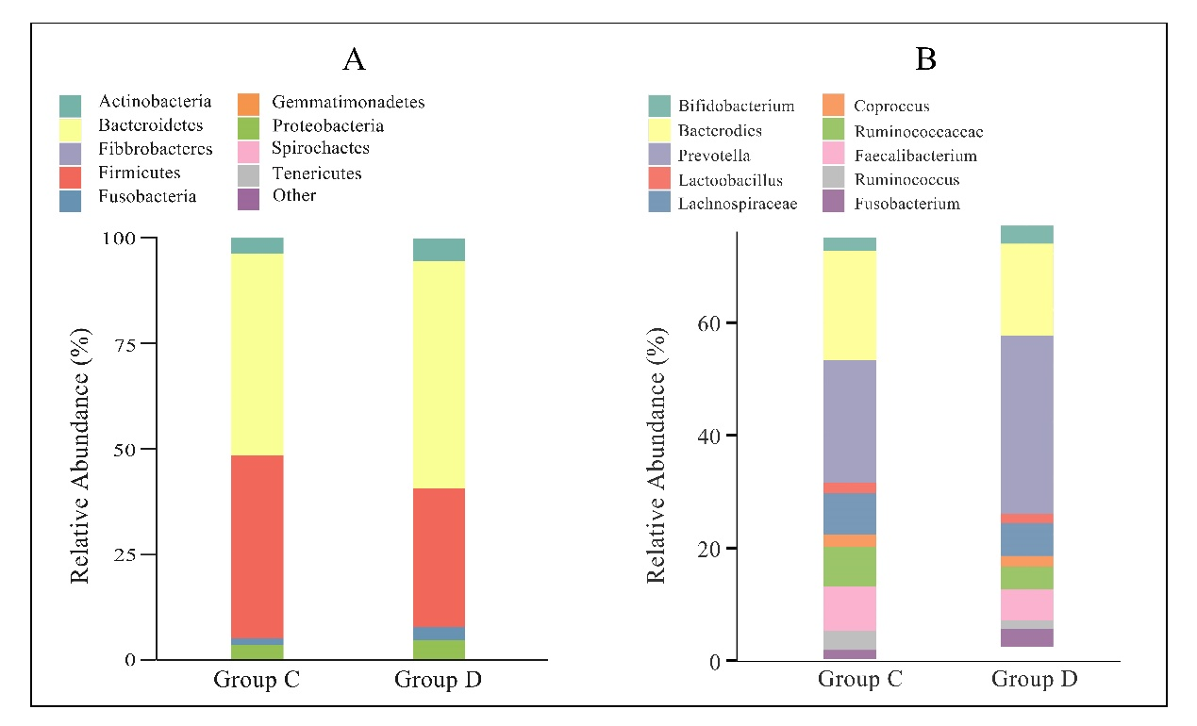
Figure 1 Relative abundance of top 10 species at phylum and genus level between two groups. A: Relative abundance of top 10 species at phylum level between two groups; B: Relative abundance of top 10 species at genus level between two groups. Each column represents one group and different colors indicate different phylum or genus in the microbiota composition. The top 10 were listed. Relative abundance: the average of sample abundances in a group.
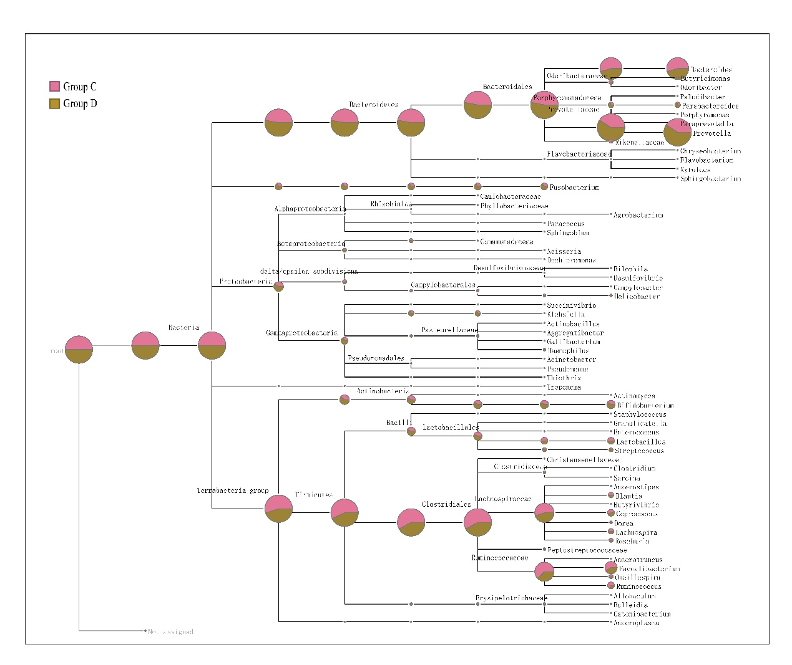
Figure 2 Species classification tree between two groups. Different colors in circles indicated different groups, the size of the sector indicated the relative abundance of the group in that category.

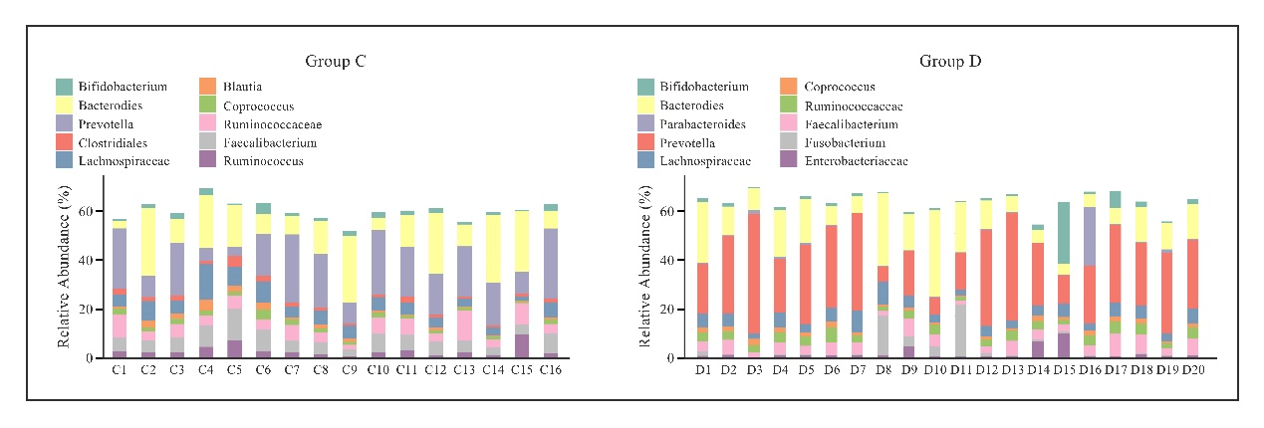
Figure 3 Abundance of top 10 species at genus level in two groups respectively. Each column represents one sample and different colors indicate different genus in the microbiota composition. The top 10 genus were listed.

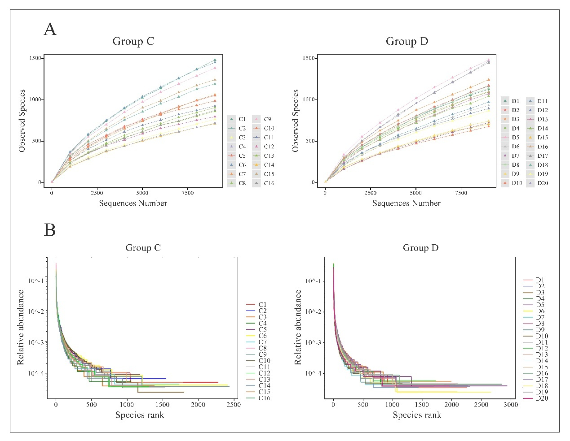
Figure 4 Rarefaction curve and rank abundance curve of two groups. A: Rarefaction curve of two groups. The abscissa was the number of sequencing samples taken at random, the ordinate was the number of species corresponding to the number of samples sequenced. The different samples were marked with different colors; B：Rank abundance curve of two groups. The abscissa was the ordinal number sorted by the abundance of operational taxonomic units, the ordinate was the relative abundance of the operational taxonomic units in the corresponding sample. The different samples were marked with different colors.

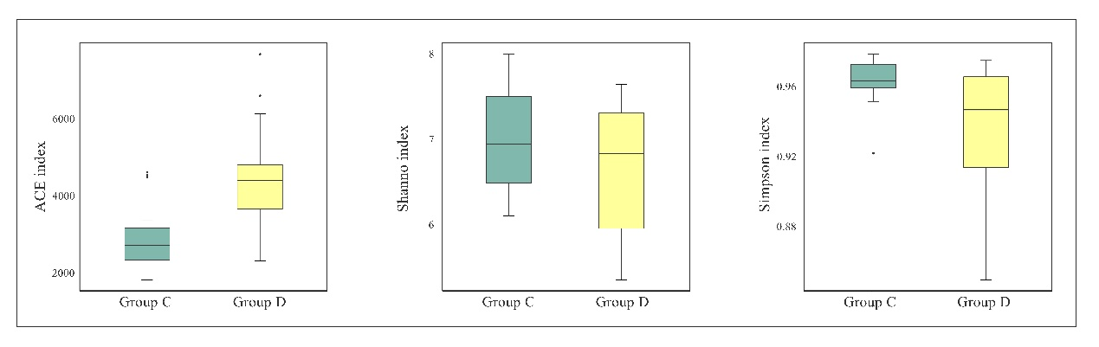
Figure 5 Box diagram of ACE, Simpson and Shannon index of two groups. Green and yellow boxplots denoted the relative abundance or diversity of samples in two groups respectively. The t-test was used to analyze the significant difference between the indices of different groups.

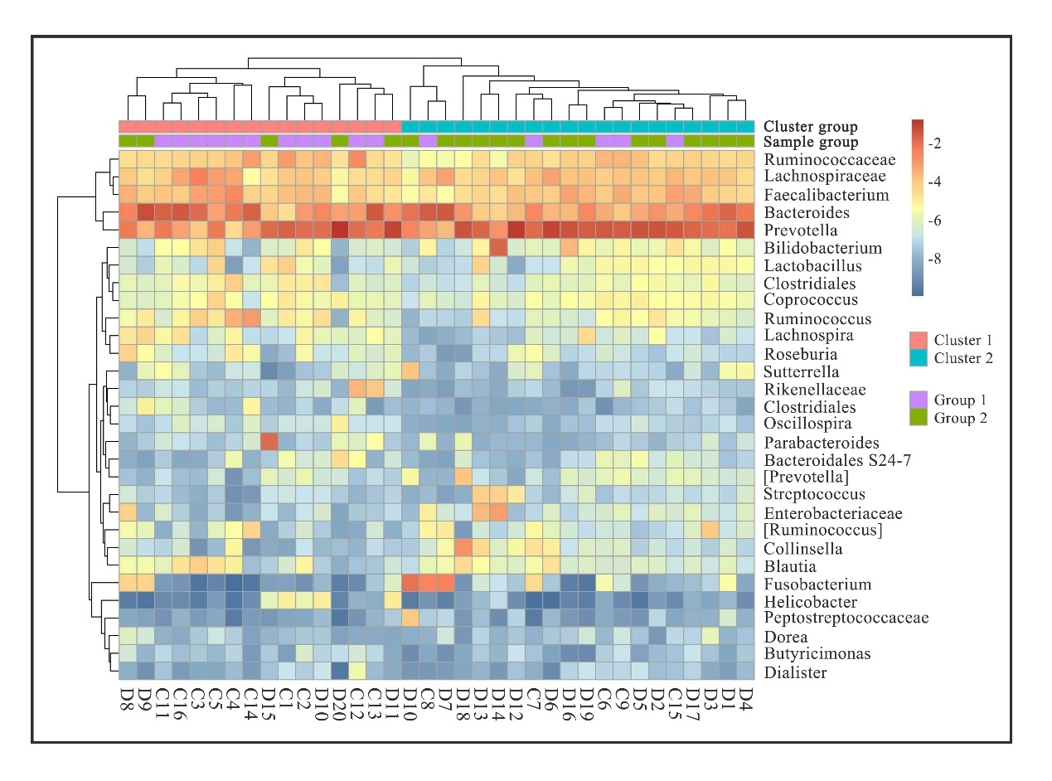
Figure 6 Clustering map of species abundance of two groups. The vertical direction was the sample information and the horizontal direction was the species annotation information. The corresponding valued of the heat map is the log 2 converted relative abundance of each line of species.
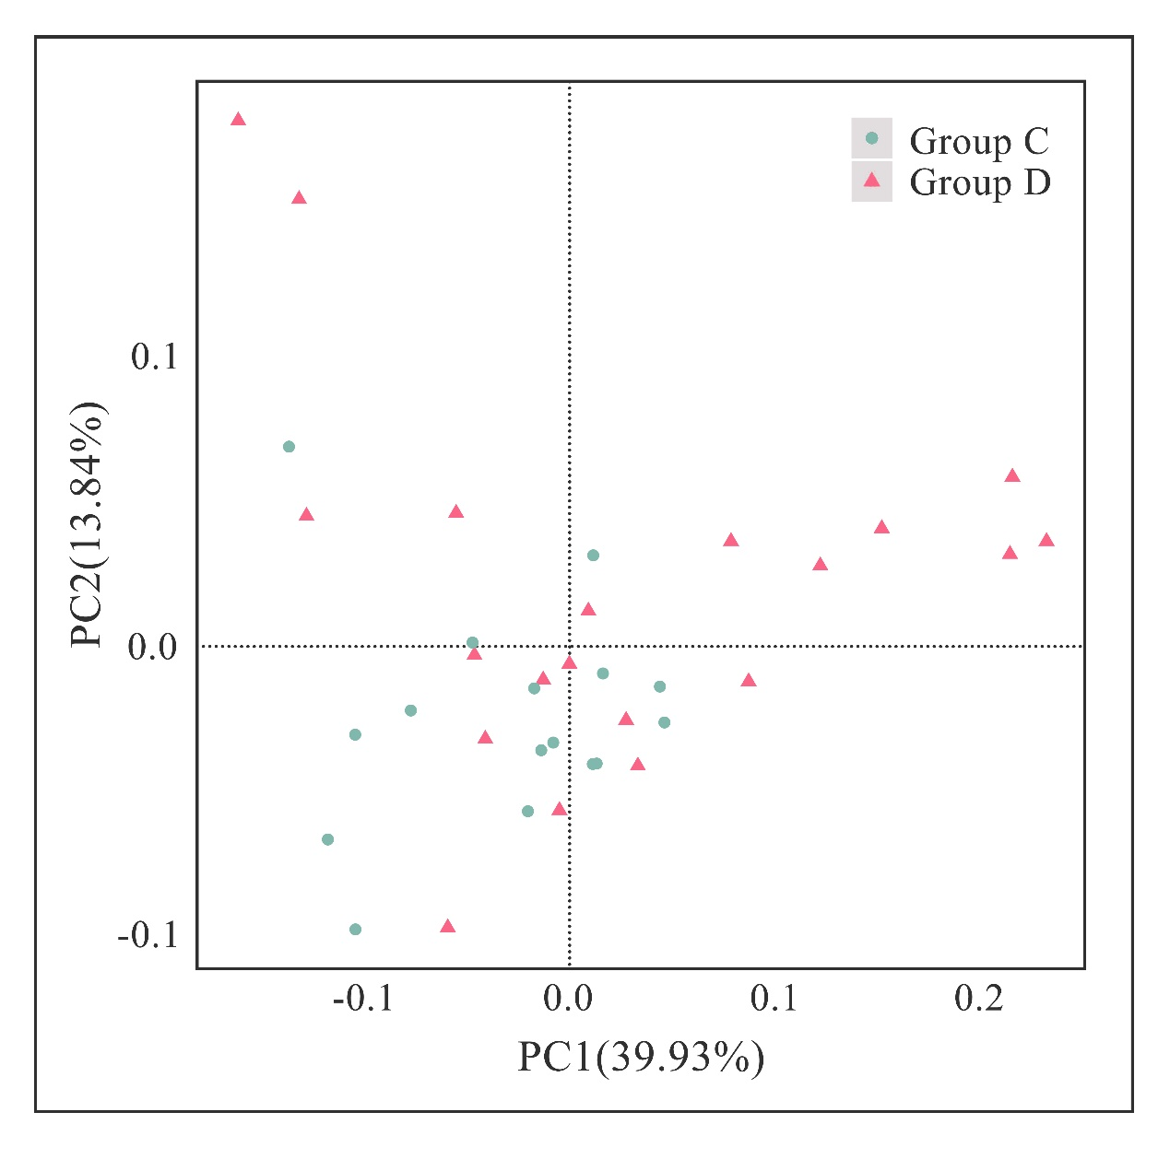
Figure 7 Principal component analysis results of two groups. The abscissa indicated the first principal component, the percentage indicated the contribution of the first principal component to the sample difference; the ordinate indicated the second principal component, and the percentage indicated the contribution of the second principal component to the sample difference; each point in the figure represented a sample, and the same group of samples used the same color. PCA: Principal component analysis.

