Name of Journal: World Journal of Clinical Cases
Manuscript NO: 65826
Manuscript Type: CASE REPORT

Malignant peripheral nerve sheath tumor in an elderly patient with superficial spreading melanoma: A case report

Yang CM et al. Malignant peripheral nerve sheath tumor of left knee

Chong-Miao Yang, Jia-Min Li, Rui Wang, Li-Gong Lu

Chong-Miao Yang, Jia-Min Li, Department of Medical Imaging, Zhuhai Hospital Affiliated with Jinan University, Zhuhai People’s Hospital, Zhuhai 519000, Guangdong Province, China

Chong-Miao Yang, Jia-Min Li, Zhuhai Hospital Affiliated with Jinan University, Jinan University, Guangzhou 510000, Guangdong Province, China

Rui Wang, Department of Pathology, Zhuhai Hospital Affiliated with Jinan University, Zhuhai People’s Hospital, Zhuhai 519000, Guangdong Province, China

Li-Gong Lu, Zhuhai Interventional Medical Center, Zhuhai Precision Medical Center, Zhuhai People’s Hospital of Jinan University, Zhuhai 519000, Guangdong Province, China

Author contributions: Yang CM and Li JM were the patient’s radiologists, reviewed the literature and contributed to manuscript drafting; Li JM reviewed the case and followed up with the patient; Wang R was the patient’s pathologist; Lu LG was responsible for revision of the manuscript and approval of the manuscript; all authors issued final approval for the submission of this article.

Corresponding author: Li-gong Lu, BMed, MD, PhD, Professor, Zhuhai Interventional Medical Center, Zhuhai Precision Medical Center, Zhuhai People's Hospital of Jinan University, No. 79 Kangning Road, Zhuhai 519000, Guangdong Province, China. luligong1969@126.com

Received: March 29, 2021
Revised: May 6, 2021
Accepted: May 26, 2021
Published online:

Abstract
BACKGROUND
Malignant peripheral nerve sheath tumor (MPNST) is a type of spindle cell sarcoma originating from the peripheral nerve, which usually results in the corresponding nerve sign on magnetic resonance imaging (MRI). Patients with MPNST may also have neurofibromatosis type 1.

CASE SUMMARY
A 78-year-old male was admitted to the hospital due to a tumor in his left knee. He had a previous history of superficial spreading melanoma on the left thigh. Color Doppler ultrasonography showed a hypoechoic mass in the subcutaneous soft tissues of the medial left knee with an abundant rich blood flow. Computed tomography scanning did not show obvious signs of bone destruction, but the skin adjacent to the tumor was slightly thickened. MRI examination revealed that the hypervascular lesion was well-circumscribed, lobulated, invaded the surrounding soft tissues and demonstrated heterogeneous enhancement but lacked an entering and exiting nerve sign. The MRI result indicated the invasiveness of the tumor. The patient underwent a left knee joint mass expanded resection and the first histopathological examination showed a MPNST with positive surgical margins. Therefore, the second extended resection was performed, and the patient had a good outcome in the short term.

CONCLUSION
MRI is a useful technique for revealing the biological characteristics of MPNST and provides clinical support for evaluation of the surgical area before operation.

Key Words: Malignant peripheral nerve sheath tumor; Superficial spreading melanoma; Case report; Magnetic resonance imaging; Extended resection

Yang C, Li J, Wang R, Lu L. Malignant peripheral nerve sheath tumor in an elderly patient with superficial spreading melanoma: A case report. World J Clin Cases 2021; In press

Core Tip: Malignant peripheral nerve sheath tumor is a rare peripheral nerve sarcoma originating from the peripheral nerve. We report the first patient with a malignant peripheral nerve sheath tumor and a clinical history of superficial spreading melanoma. Various imaging examinations showed no signs of nerve origin, but magnetic resonance imaging examination showed invasion of surrounding soft tissues, suggesting the aggressiveness of the tumor. An extended resection was performed. The patient received adjuvant radiotherapy following histopathological confirmation of malignant peripheral nerve sheath tumor. Magnetic resonance imaging provided clinical support for evaluation of the surgical area before the operation.

INTRODUCTION
Malignant peripheral nerve sheath tumor (MPNST) is a type of spindle cell sarcoma originating from the peripheral nerve that is secondary to neurofibromatosis, or heterogeneous differentiation components of the nerve sheath are observed under the microscope. Hence, MPNST was previously called neurogenic sarcoma and neurofibrosarcoma^{[1]}. In some studies, patients who did not have a history of neurofibromatosis type 1 (NF-1) had a better prognosis than those who did have NF-1^{[2,3]}. This case report describes an elderly man who had previously undergone resection of a melanoma on his left thigh, and several years later an MPNST occurred in his left knee joint without local or systemic metastasis. This report describes the diagnosis and management of this patient and provides a literature review.

CASE PRESENTATION
Chief complaints
A 78-year-old male patient was admitted to our hospital due to a soft mass with a rapid growth over 10 d.

History of present illness
In 2020, he accidentally noticed a soft mass the size of a pigeon egg on the inner side of his left knee joint with good mobility and no local redness, swelling or pain. He visited the local clinic, and Color Doppler ultrasound examination suggested that the tumor was a pilomatricoma. No further treatment was performed at that time. However, when the tumor increased over 10 d, the patient felt occasional numbness and discomfort in the left lower extremity.

History of past illness
The patient was previously diagnosed with a superficial spreading melanoma on his left thigh, which was excised in our hospital in 2015. The postoperative positron emission tomography-computed technology examination showed no evidence of regional lymph node metastasis and distant metastasis, so the subsequent radiotherapy or chemotherapy was not performed.

Personal and family history
The patient had no relevant family medical history.

Physical examination
A painless, tough tumor 5 cm × 5 cm × 4 cm in diameter within his left knee joint with a clear boundary, rough surface and hot flushed skin was noted. There were no obvious abnormalities in sensation, blood supply and movement of the left lower limb.

Laboratory examinations
Before operation, the patient’s erythrocyte sedimentation rate increased (30 mm/h, normal range: 0-15 mm/h) and C-reactive protein was slightly high (10.3 mg/L, normal range: 0-10 mg/L). Other laboratory examination results were normal, including hematological, coagulation, kidney and liver functions as well as electrolytes.

Imaging examinations
Color Doppler ultrasonography (Figure 1) revealed a hypoechoic mass with an unclear boundary in the subcutaneous soft tissues of the medial left knee with abundant dotted and band-shaped blood flow signals in and around the lesion. Computed tomography scanning (Figure 2) showed a subcutaneous lesion in the left medial femoral area with an average computed tomography value of 34 HU, which was significantly lower than the adjacent soft tissue (62 HU). The skin adjacent to the tumor was slightly thickened, and no obvious signs of bone destruction were observed. Magnetic resonance imaging (MRI) examination (Figure 3) revealed a subcutaneous and lobulated tumor, measuring 4.51 cm × 2.75 cm × 3.00 cm in maximum size, irregular in shape but well-circumscribed with a rich blood supply and the absence of a visible entering or exiting nerve. The lesion was heterogeneously hypointense on T1-weighted images (T1WI) (Figure 3A) and fat-saturated T2-weighted images (T2WI) (Figure 3B) in the sagittal plane. It also showed heterogeneous enhancement with nonenhanced focal areas on contrast-enhanced T1WI in the sagittal and coronal plane (Figure 3C and 3D). The hyperintense grid-like fascia on fat-saturated T2WI (Figure 3B) and enhanced thickened skin (Figure 3D) on contrast-enhanced T1WI suggested peritumoral edema and the invasion of surrounding soft tissues.

FINAL DIAGNOSIS
Clinical features and all imaging results, especially MRI result, suggested the possibility of malignance of the mass of the left knee joint.

TREATMENT
After careful evaluation of the patient’s symptoms, previous medical history and the MRI finding of peripheral tissue edema, the surgeon decided to perform an extended resection of the left knee joint mass. The first frozen section report showed a spindle cell tumor, which was approximately 10.5 cm × 5.0 cm ×2.7 cm in size with positive surgical margins. Hence, the scope of surgical resection was expanded again to the 2 cm of the remaining surrounding tissues, and then the second frozen section report showed negative surgical margins. The postoperative pathological report (Figure 4) suggested MPNST, which was positive for vimentin S100, CD99 (partial positivity) and Ki-67 (approximately 40% positivity in the hot spot area) and negative for HMB 45 and Melan-A.

OUTCOME AND FOLLOW-UP
The patient was in a stable condition without any related complications after operation. He was discharged from the hospital with recommendation of the adjuvant radiotherapy of the surgical area 2 wk after removal of the stitches. He received radiotherapy in another hospital and recovered well according to telephone follow-up at 3 mo after discharge.

DISCUSSION
MPNST is an uncommon sarcoma and usually demonstrates aggressive biological behavior. In general, appropriate surgery, radiation and chemotherapy are the conventional clinical treatments. However, large tumor size (especially > 5 cm), positive excision margins, high-level tumor grade, association with NF-1, local recurrence and metastases are predictive prognostic markers of inferior consequences of this disease^{[4]}. A small minority of limb MPNSTs are found in the absence of NF-1. In Jordan, a recurrent MPNST occurred at the same site on the forearm of a 51-year-old man who had no preexisting NF-1 but had a positive family history of cancer^{[5]}. Similarly, an elderly man, without a previous diagnosis of NF-1 or positive family history, presented with a giant MPNST in the left axilla and minute lung metastasis before surgery^{[6]}. Both patients died several months after surgery due to the invasive behavior and poor prognosis of MPNST.
Compared with these two cases, tumor size in our patient was smaller, and he received early surgical intervention before the occurrence of symptoms or metastasis. His positive history of melanoma may have been related to the occurrence of MPNST, which is a good reminder for clinicians. It is noteworthy that the MRI result revealed the invasiveness of the tumor and provided clinical evidence for an extended resection. Moreover, surgical resection is insufficient for the management of MPNSTs. Some researchers have proposed that neoadjuvant radiotherapy could improve disease control and total survival^{[1,7,8]}. This may be the reason why this patient had a good postoperative recovery.
In terms of radiological features, it is generally accepted that all peripheral nerve sheath tumors originate from a single nerve branch^{[9-11]}, which leads to corresponding imaging signs. However, in this case, the lesion lacked an entering and exiting nerve sign or a thickened nerve nearby on any of the radiological images. In compliance with our findings, Van Herendael et al^{[11]} suggested that the presence of a nerve sign was less frequent in malignant neurogenic tumors on MR images. There are also other MRI characteristics of MPNSTs, for example large size (> 5 cm), ill-delineated edges, perilesional edema and internal cystic degeneration/necrosis. Combined with the patient’s history, our finding of an abundant blood supply in the lesion was indicative of a malignant tumor. Moreover, the presence of unenhanced focal areas on sagittal contrast-enhanced T1WI in this case was probably caused by intralesional necrosis and hemorrhage^{[10,11]}. Due to the rarity and unspecific imaging manifestations of MPNST, clinical manifestations combined with postoperative pathological results are important for diagnosis of the disease. Specific pathological features, including tightly packed spindle cells with neoplasm necrosis, invasive growth into surrounding tissues and alternating loose and dense cellular areas as well as S100 protein and Ki-67 positive staining^{[12]} were found in our case.

CONCLUSION
This report describes a patient with a solitary MPNST and a history of melanoma in the lower extremity, without radiological evidence of genetic origin. Clinicians should be aware of the possibility of MPNST in patients with a history of other epithelioid tumors. MRI results could reveal the biological characteristics of the MPNST. Prompt intervention such as extended excision plus postoperative radiotherapy could be beneficial to the outcome of this rare tumor.

ACKNOWLEDGEMENTS
We thank our colleagues at the Department of General Surgery and Department of Pathology, Zhuhai Hospital Affiliated with Jinan University, Zhuhai People’s Hospital.

REFERENCES
1 Stucky CC, Johnson KN, Gray RJ, Pockaj BA, Ocal IT, Rose PS, Wasif N. Malignant peripheral nerve sheath tumors (MPNST): the Mayo Clinic experience. Ann Surg Oncol 2012; 19: 878-885 [PMID: 21861229 DOI: 10.1245/s10434-011-1978-7]
2 Ducatman BS, Scheithauer BW, Piepgras DG, Reiman HM, Ilstrup DM. Malignant peripheral nerve sheath tumors. A clinicopathologic study of 120 cases. Cancer 1986; 57: 2006-2021 [PMID: 3082508 DOI: 10.1002/1097-0142(19860515)57:10<2006::aid-cncr2820571022>3.0.co;2-6]
3 Watson KL, Al Sannaa GA, Kivlin CM, Ingram DR, Landers SM, Roland CL, Cormier JN, Hunt KK, Feig BW, Ashleigh Guadagnolo B, Bishop AJ, Wang WL, Slopis JM, McCutcheon IE, Lazar AJ, Torres KE. Patterns of recurrence and survival in sporadic, neurofibromatosis Type 1-associated, and radiation-associated malignant peripheral nerve sheath tumors. J Neurosurg 2017; 126: 319-329 [PMID: 27035165 DOI: 10.3171/2015.12.JNS152443]
4 Farid M, Demicco EG, Garcia R, Ahn L, Merola PR, Cioffi A, Maki RG. Malignant peripheral nerve sheath tumors. Oncologist 2014; 19: 193-201 [PMID: 24470531 DOI: 10.1634/theoncologist.2013-0328]
5 Abdel Al S, Abou Chaar MK, Asha W, Al-Najjar H, Al-Hussaini M. Fungating malignant peripheral nerve sheath tumor arising from a slow-growing mass in the forearm: a case report and review of the literature. J Med Case Rep 2020; 14: 91 [PMID: 32631436 DOI: 10.1186/s13256-020-02427-4]
6 Kusumoto E, Yamaguchi S, Sugiyama M, Ota M, Tsutsumi N, Kimura Y, Sakaguchi Y, Kusumoto T, Ikejiri K, Nakayama Y, Momosaki S. Huge epithelioid malignant peripheral nerve sheath tumor in the left axilla: a case report. Surg Case Rep 2015; 1: 64 [PMID: 26366361 DOI: 10.1186/s40792-015-0065-x]
7 Kahn J, Gillespie A, Tsokos M, Ondos J, Dombi E, Camphausen K, Widemann BC, Kaushal A. Radiation therapy in management of sporadic and neurofibromatosis type 1-associated malignant peripheral nerve sheath tumors. Front Oncol 2014; 4: 324 [PMID: 25452937 DOI: 10.3389/fonc.2014.00324]
8 Bernthal NM, Putnam A, Jones KB, Viskochil D, Randall RL. The effect of surgical margins on outcomes for low grade MPNSTs and atypical neurofibroma. J Surg Oncol 2014; 110: 813-816 [PMID: 25111615 DOI: 10.1002/jso.23736]
9 Murphey MD, Smith WS, Smith SE, Kransdorf MJ, Temple HT. From the archives of the AFIP. Imaging of musculoskeletal neurogenic tumors: radiologic-pathologic correlation. Radiographics 1999; 19: 1253-1280 [PMID: 10489179 DOI: 10.1148/radiographics.19.5.g99se101253]
10 Zhai H, Lv Y, Kong X, Liu X, Liu D. Magnetic resonance neurography appearance and diagnostic evaluation of peripheral nerve sheath tumors. Sci Rep 2019; 9: 6939 [PMID: 31061436 DOI: 10.1038/s41598-019-43450-w]
11 Van Herendael BH, Heyman SR, Vanhoenacker FM, De Temmerman G, Bloem JL, Parizel PM, De Schepper AM. The value of magnetic resonance imaging in the differentiation between malignant peripheral nerve-sheath tumors and non-neurogenic malignant soft-tissue tumors. Skeletal Radiol 2006; 35: 745-753 [PMID: 16775712 DOI: 10.1007/s00256-006-0160-y]
12 Koeller KK, Shih RY. Intradural Extramedullary Spinal Neoplasms: Radiologic-Pathologic Correlation. Radiographics 2019; 39: 468-490 [PMID: 30844353 DOI: 10.1148/rg.2019180200]

Footnotes
Informed consent statement: Informed written consent was obtained from the patient for publication of this report and any accompanying images.

Conflict-of-interest statement: All authors declare no conflicts of interest.

CARE Checklist (2016) statement: The authors have read the CARE Checklist (2016), and the manuscript was prepared and revised according to the CARE Checklist (2016).

Open-Access: This article is an open-access article that was selected by an in-house editor and fully peer-reviewed by external reviewers. It is distributed in accordance with the Creative Commons Attribution NonCommercial (CC BY-NC 4.0) license, which permits others to distribute, remix, adapt, build upon this work non-commercially, and license their derivative works on different terms, provided the original work is properly cited and the use is non-commercial. See: http://creativecommons.org/Licenses/by-nc/4.0/

Manuscript source: Unsolicited manuscript

Peer-review started: March 29, 2021
First decision: April 28, 2021
Article in press:

Specialty type: Radiology, nuclear medicine and medical imaging
Country/Territory of origin: China
Peer-review report’s scientific quality classification
Grade A (Excellent): 0
Grade B (Very good): B
Grade C (Good): 0
Grade D (Fair): 0
Grade E (Poor): 0

P-Reviewer: Naswhan AJ S-Editor: Wang JL L-Editor: Filipodia P-Editor:

Figure Legends
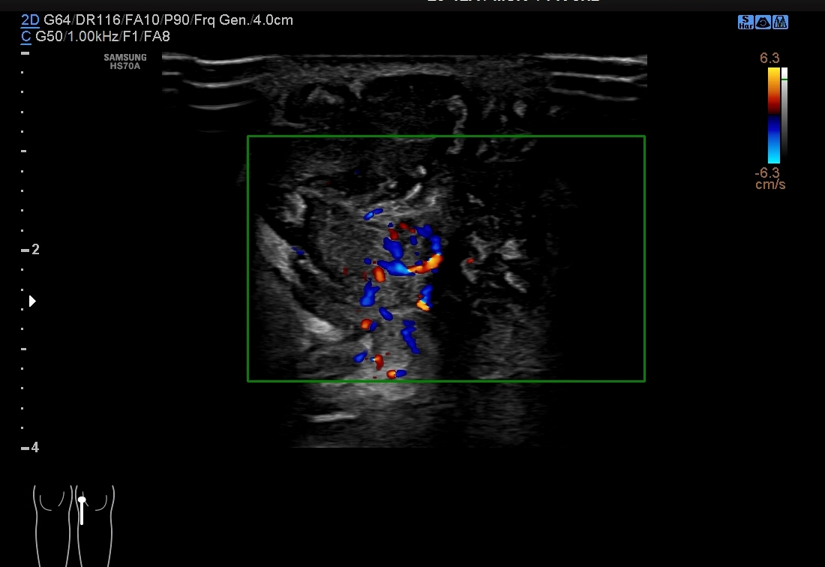
Figure 1 Color Doppler ultrasonography findings. Color Doppler ultrasonography revealed an ill-defined hypoechoic mass in the subcutaneous soft tissues of the medial left knee with abundant dotted and band-shaped blood flow signals in and around the lesion.
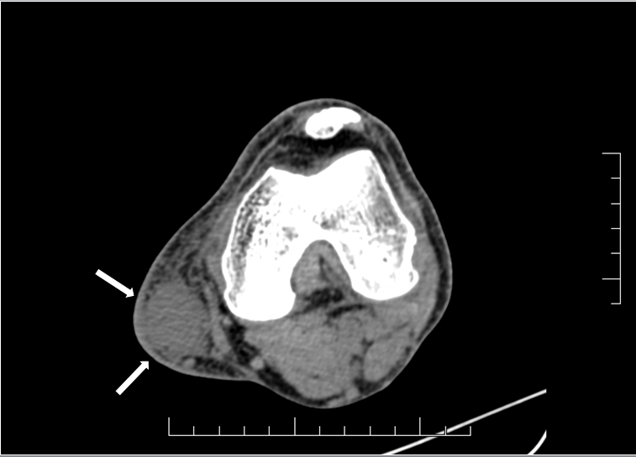
Figure 2 Axial computed tomography image. The axial computed tomography image revealed that the oval well-defined lesion (white arrows) on the medial side of the left knee had a lower computed tomography value (34 HU) than adjacent anatomical structures (62 HU), which were compressed and displaced.
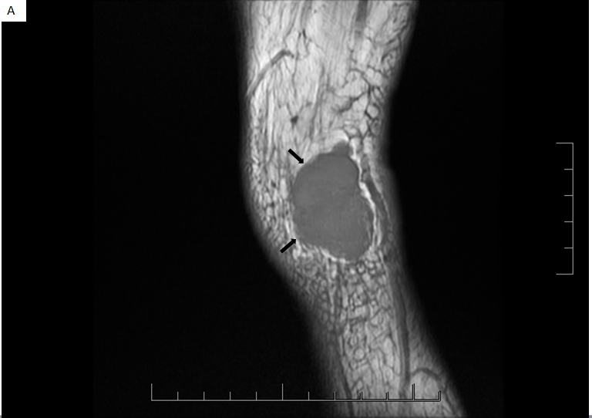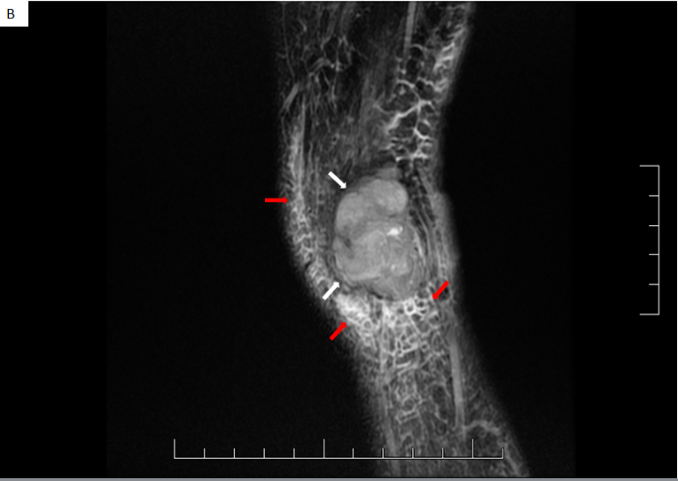
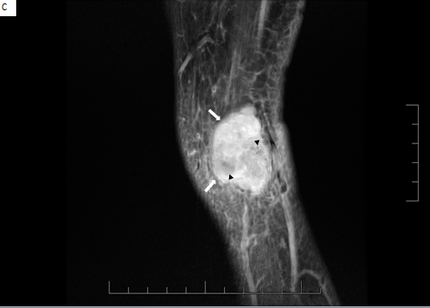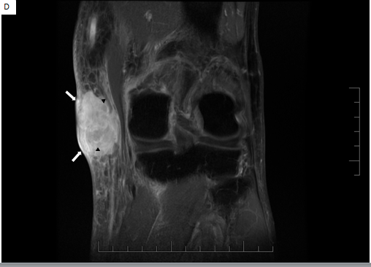
Figure 3 magnetic resonance images of the malignant peripheral nerve sheath tumor. A: The sagittal T1-weighted images of the left knee showed a heterogeneously hypointense mass (black arrows), with an irregular shape, clear boundary, internal lobules and the absence of a visible entering or exiting nerve; B: The lesion (white arrows) showed heterogeneous hypointensity on the fat-saturated T2-weighted images and the hyperintense grid-like fascia (red arrows) suggested peritumoral edema; C and D: The lesion with thickened skin (white arrows) also showed heterogeneous enhancement with non-enhanced focal areas (black arrowheads) on contrast-enhanced T1-weighted images in the sagittal and coronal plane.
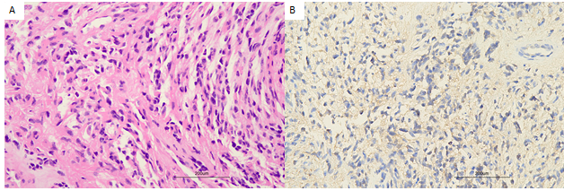
Figure 4 Postoperative pathological examination. A: Hematoxylin-eosin staining photomicrograph (original magnification × 200) of the mass showed tightly packed spindle cells; B: Immunofluorescence examination (original magnification × 200) demonstrated S100 positivity on immunohistochemical analysis.

