Name of journal: World Journal of Gastroenterology
ESPS Manuscript NO: 31422
Manuscript Type: ORIGINAL ARTICLE

Basic Study
Cullin 4A is associated with the epithelial to mesenchymal transition and poor prognosis in perihilar cholangiocarcinoma

Zhang TJ et al. CUL4A in PHCC EMT and prognosis

Tong-Jun Zhang, Dong Xue, Cheng-De Zhang, Ze-Dong Zhang, Qing-Ran Liu, Jian-Qiang Wang

Tong-Jun Zhang, Cheng-De Zhang, Ze-Dong Zhang, Qing-Ran Liu, Department of Interventional Vascular Surgery, The People’s Hospital of Binzhou, Binzhou 256610, Shandong Province, China

Dong Xue, Jian-Qiang Wang, Department of General Surgery, The People’s Hospital of Binzhou, Binzhou 256610, Shandong Province, China

Author contributions: Zhang TJ, Xue D, Zhang CD, Zhang ZD, Liu QR, Wang JQ substantially contributed to the conception and design of the study, acquisition, analysis and interpretation of data; all authors drafted the article and made critical revisions related to the intellectual content of the manuscript, and approved the final version of the article to be published.

Institutional review board statement: All perihilar cholangiocarcinoma specimens from the patients were taken after informed consent and ethical permission was obtained for participation in the study.

Conflict-of-interest statement: To the best of our knowledge, no conflict of interest exists.

Data sharing statement: No additional data are available.

Open-Access: This article is an open-access article which was selected by an in-house editor and fully peer-reviewed by external reviewers. It is distributed in accordance with the Creative Commons Attribution Non Commercial (CC BY-NC 4.0) license, which permits others to distribute, remix, adapt, build upon this work non-commercially, and license their derivative works on different terms, provided the original work is properly cited and the use is non-commercial. See: http://creativecommons.org/licenses/by-nc/4.0/

Manuscript source: Unsolicited manuscript

Corresponding author: Dong Xue, MD, PhD, Department of General Surgery, The People’s Hospital of Binzhou, NO.515 The Seventh Huanghe Road, Binzhou 256610, Shandong Province, China. xdbzsurgeon@163.com
Telephone: +86-54-33283293
Fax: +86-54-33282503

Received: November 15, 2016
Peer-review started: November 17, 2016
First decision: December 19, 2016
Revised: January 5, 2017
Accepted: March 2, 2017
Article in press:
Published online
Abstract
AIM
To explore the functional role of Cullin 4A (CUL4A), a core subunit of E3 ubiquitin ligase, in perihilar cholangiocarcinoma (PHCC).

METHODS
The expression of CUL4A in PHCC cell lines was evaluated by Western blotting and qRT-PCR. Besides, immunohistochemistry (IHC) was adopted to investigate the relationship between CUL4A expression and PHCC clinicopathological characteristics. Univariate analysis and multivariate regression analysis were performed to analyze the risk factors related to PHCC overall survival (OS) and progression-free survival (PFS). Wound healing, Transwell and Matrigel assays were utilized to explore the function of CUL4A in PHCC metastasis. Furthermore, expression of the epithelial to mesenchymal transition (EMT) markers was verified in CUL4A silencing and overexpressed cells. The relationship between CUL4A expression and E-cadherin expression was also analyzed on IHC assay. Finally, the role of ZEB1 in regulating CUL4A mediated PHCC was detected by IHC assay, Western Blot assay, Transwell assay and Matrigel assay.

RESULTS
CUL4A overexpression was detected in PHCC cell lines and clinical specimens. Clinicopathological analysis revealed a close correlation between CUL4A overexpression and tumour differentiation, T, N and TNM stages in PHCC. Kaplan–Meier analysis revealed that high CUL4A expression was correlated with poor OS and PFS of PHCC patients. Univariate analysis identified the following 4 parameters as risk factors related to OS rate of PHCC: T, N, TNM stages and high CUL4A expression; as well as 3 related to PFS: N stage, TNM stage and high CUL4A expression. Further analysis with multivariate logistic regression identified high CUL4A expression as the only independent prognostic factor of PHCC. Moreover, CUL4A silence in PHCC cell lines dramatically inhibited metastasis and the EMT. Conversely, CUL4A overexpression promoted these processes. Mechanistically, ZEB1 was discovered to regulate the function of CUL4A in promoting the EMT and metastasis.

CONCLUSION
CUL4A is an independent prognostic factor for PHCC, it can promote the EMT through regulating ZEB1 expression. CUL4A may be a potential therapeutic target of PHCC.

Key words: Cullin 4A; metastasis; prognosis; perihilar cholangiocarcinoma; epithelial to mesenchymal transition; ZEB1

© The Author(s) 2017. Published by Baishideng Publishing Group Inc. All rights reserved.

Core tip: Cullin 4A (CUL4A), a core subunit of E3 ubiquitin ligase, was confirmed to promote the metastasis and the epithelial to mesenchymal transition (EMT) of perihilar cholangiocarcinoma (PHCC) in the present study. Besides, high CUL4A expression was revealed to be correlated with poor overall survival (OS) rate and progression-free survival (PFS) rate of PHCC patients. Furthermore, CUL4A expression was detected to be the only independent risk factor of PHCC OS and PFS, Mechanistically, ZEB1 was verified to mediate the function of CUL4A in regulating PHCC metastasis and the EMT.

Zhang TJ, Xue D, Zhang CD, Zhang DZ, Liu RQ, Wang JQ. Cullin 4A associates with epithelial to mesenchymal transition and poor prognosis in perihilar cholangiocarcinoma. World J Gastroenterol 2017; In press
Introduction
Cholangiocarcinoma (CCA), a primary epithelial cancer originating from the hepatobiliary tract and exhibiting characteristics of cholangiocyte differentiation, is classified into intrahepatic CCA, perihilar CC (PHCC) and distal CCA based on its anatomical location^{[1]}. During the past 2-3 decades, the incidence and mortality rates of PHCC, accounting for 50% of CCA^{[2]}, have been steadily increasing^{[3]}. The vast majority of patients diagnosed with PHCC usually present with advanced disease that developed without an identifiable aetiology. Curative surgical resection, the only effective treatment to achieve a possible cure in PHCC, can be achieved in less than 19%-75% of patients^{[4]}. Even worse, currently available chemotherapy and radiotherapy regimens are usually unresponsive to advanced PHCC. When left untreated, the survival time is only 6 to 12 mo^{[5]}. Therefore, to improve the prognosis of PHCC patients, it is essential to further elucidate the underlying molecular mechanisms of PHCC progression and identify more effective prognostic biomarkers that might also serve as potential targets for PHCC treatment.
Cullin 4A (CUL4A), a core subunit of E3 ubiquitin ligase, encodes a member of the cullin ubiquitin-ligase family, which includes 7 members in mammals (Cul1, 2, 3, 4A, 4B, 5, and 7)^{[6]}. CUL4A controls diverse cellular processes, including proliferation, differentiation, apoptosis and metastasis. Additionally, CUL4A has been shown to mediate the ubiquitin-dependent proteolysis of several well-defined tumour suppressor genes, such as p21, p27, DDB2, and p53, indicating that CUL4A may be a potential oncogene^{[7,8]}. Furthermore, CUL4A amplification and overexpression have been found in several human cancers, including primary human breast cancers,^{[9]} esophageal squamous cell carcinomas^{[10]}, adrenocortical carcinomas^{[11]}, childhood medulloblastoma^{[12]}, hepatocellular carcinomas^{[13]}, and primary malignant pleural mesotheliomas^{[14]}. Furthermore, strong CUL4 expression is an independent prognostic factor for survival in node-negative breast cancer, prostate cancer and intrahepatic CCA^{[15-17]}. However, to the best of our knowledge, its functional role in PHCC has not been previously investigated.
Metastasis, the final stage of solid cancer progression, is responsible for the vast majority of cancer-related deaths. However, the exact mechanism for cancer metastasis remains unclear. The biology of most PHCC cases is aggressive, involving rapid invasion and metastases. The epithelial to mesenchymal transition (EMT) is a cellular process during which epithelial cells lose their polarity and cell-cell adhesion, undergo changes in cell shape and cytoskeletal organization and acquire mesenchymal characteristics^{[18]}. It has been confirmed that the EMT is closely involved in increasing cell migratory and invasive properties, inducing stem cell properties, preventing apoptosis and senescence, and resisting chemotherapy and immunotherapy^{[19-21]}. Therefore, the EMT process is now considered a potential target in tumour metastasis prevention and treatment.
With respect to these notions, the present study investigated the expression of CUL4A and its clinical significance in PHCC. The role and mechanisms by which CUL4A promotes the EMT and PHCC cells motility were also explored. These results not only further elucidated the metastasis mechanism of PHCC as well as identified CUL4A may serve as a potential target for PHCC treatment.

Materials and Methods
Patients and follow up
Primary PHCC tissues (n = 78), 12 of which had with matched adjacent normal bile duct tissues, were obtained from PHCC patients who underwent curative surgery at the Department of General Surgery, The People’s Hospital of Binzhou, China, between 2003 and 2010. Informed consent was obtained from each patient, and the study protocol was approved by the Clinical Research Ethics Committee of The People’s Hospital of Binzhou. The diagnosis of PHCC was confirmed by routine pathology. Pathologic tumour-node-metastasis (pTNM) staging was classified according to the 7th staging classification of American Joint Committee on Cancer criteria. Patient latest follow-up was terminated in May 2016. Overall survival (OS) was defined as the interval between the date of surgery and death or when censored at the latest date. Progression-free survival (PFS) was defined as the time from the date of surgery to the date of disease relapse/progression or the date of death or when censored at the latest date. Patients died from causes other than PHCC were censored.

Immunohistochemistry and scoring
The immunohistochemistry (IHC) analysis of CUL4A, ZEB1 and E-Cadherin expression in clinical samples was performed as previously described^{[22]}. Scoring was performed by two pathologists who were blinded to the pathology and clinical features in The People’s Hospital of Binzhou. The scoring system includes the extent and intensity of staining. Briefly, the intensity was assigned a score of 0, 1, 2, or 3, representing negative, weak, moderate, or strong expression, respectively. Whereas, the extent was assigned a score of 0, 1, 2, or 3, representing negative, less than 10%, 10%-50%, and more than 50% of cells stained. The overall quantitation of the IHC score was obtained by multiplying the average intensity and score of five different high-power fields (× 400 magnification).

PHCC cell lines
The human normal biliary epithelial cell line, HIBEpiC, and human PHCC cell lines, QBC939 and FRH0201, were purchased from the Cell Bank of the Chinese Academy of Sciences (Shanghai, China). HIBEpiC was grown in DMEM supplemented with 10% FBS and 1% penicillin/streptomycin. QBC939 and FRH0201 were cultured in RPMI-1640 medium, supplemented with 10% FBS and 1% penicillin/streptomycin in an atmosphere of 5% CO₂ at 37 °C.

Quantitative reverse-transcriptase polymerase chain reaction
TRIzol reagent (15596-026, Invitrogen) was used to extract total RNA according to the manufacturer's instructions, and 5 μg of total RNA was used for cDNA synthesis. Assays were performed in triplicate on an ABI PRISM 7900HT sequence detection system according to standard protocols as recommended by the manufacturer. Melting curve analysis was conducted to distinguish specific products from non-specific products and primer dimers. The GAPDH gene was amplified as an internal control in each sample.

Western blot analysis
Total cellular proteins were isolated using RIPA buffer (Thermo Fisher Scientific, United States) according to the manufacturers’ protocols. Aliquots (12 μg) of total protein were electrophoresed on sodium dodecyl sulphate-polyacrylamide gel electrophoresis. The separated proteins were transferred to polyvinylidene difluoride membranes (Millipore). The membranes were blocked with 5% BSA for 2 h and incubated with each primary antibody overnight at 4 °C. The signals from the primary antibody were amplified by HRP conjugated anti-mouse IgG or anti-rabbit IgG, and the bands were visualized with a FluorChem E system (Protein Simple, United States).

Establishment of cell lines with stable CUL4A overexpression or knockdown
The shRNA sequences and cDNA of wildtype CUL4A cells were cloned into pLenti-vectors. The shRNA sequences of CUL4A were 5′- GATCCCCGGTTTATCCACGGTAAAGATTCAAGAGATCTTTACCGTGGATAAACCTTTTTGGAAA-3′ (Forward) and 5′-AGCTTTTCCAAAAAGGTTTATCCACGGTAAAGATCTCTTGAATCTTTACCGTGGATAAACCGGG-3′ (Reverse), respectively. Then, pLenti-shCUL4A and pLenti vectors were transfected into QBC939 cells lentivirally. pLenti-CUL4A vector and pLenti vector were transfected into FRH0201 cells lentivirally. For the lentiviral transfection, lentiviral plasmid vectors including pLenti-vector, pLenti-shCUL4A and pLenti-CUL4A were co-transfected with packaging vectors and the viral particles were produced by 293T cells. Then, lentiviral stocks were concentrated using ultracentrifugation. Subsequently, PHCC cells (QBC939 and FRH0201 cells) were incubated with the infection medium mixed with polybrene (4 μg/mL) at a multiplicity of infection (MOI) of 20. Finally, puromycin (1-3 μg/mL) was used to select resistant cells. The QBC939 cell line with stable knockdown of CUL4A (QBC939-pLenti-shCUL4A), its corresponding control cell line (QBC939-pLenti-Vector), the FRH0201 cell line with CUL4A stable overexpression (FRH0201-pLenti-CUL4A) and its corresponding control cell line (FRH0201-pLenti-Vector) were established. The expression of CUL4A in these cell lines was examined with a quantitative reverse-transcriptase polymerase chain reaction (qRT-PCR) assay.
siNC, siZEB1.1 and siZEB1.2 were purchased from GENEWIZ (Suzhou, China). Transfection was performed with Lipofectamine 2000 (Invitrogen, USA) according to the manufacturer’s instructions.

Wound healing assay
Cells were cultured in medium that was deprived of serum and grown to confluence in a 6-well plate. Then, a wound was made in the middle of a culture plate with a 200 μl sterile pipette tips. The wound-healing process was photographed using phase-contrast microscopy at 0, 24 and 48 h. The quantification was performed by measuring the uncovered areas compared with the controls.

Migration and invasion assays
A Boyden chamber (8 μm pore size, BD Biosciences, United States) was used to test cell motility. In the Matrigel invasion assay, the Boyden chambers were coated with Matrigel (40 lg/well; BD Biosciences, Bedford, MA, United States) and incubated for at least 1 h at 37 ℃ before the cells were seeded. Cells (5 × 10⁴) were suspended in 200 μl of serum-free medium and plated in the upper chamber, whereas 600 μl of medium with 10% FBS was added to the lower well. After 24 h of incubation, the cells were removed from the upper side of the chamber, and cells attached to the lower surface of the membrane were fixed with methanol for 30 min, and then stained with 10% giemsa (Solarbo, United States). The statistical results of cell numbers per image field were obtained from three independent experiments that were averaged from five image fields.

Selection of cut-off scores
To select the clinically essential cut-off scores for CUL4A, receiver operating characteristic (ROC) curve analysis was performed according to the 0, 1-criterion. Previous studies have verified the reproducibility of ROC curve analysis in determining a biologically or clinically relevant cutoff score^{[23,24]}. The OS and PFS data were dichotomized according to death due to PHCC or censored (lost to follow-up, alive or death from other causes) for evaluating with the ROC curve analysis. Based on the cut-off score, the patients were categorized into the high CUL4A expression and low CUL4A expression groups, tumours labelled with high CUL4A expression were those with scores equal to or higher than the cut-off value, while low CUL4A expression indicated those with scores below the cut-off value.

Statistical analysis
Statistical analysis was performed using SPSS 19.0 software (SPSS, Inc., Chicago, IL). Data are shown as median ± SD. ROC analysis was utilized to get optimal cutoff scores of CUL4A expression for survival analysis. Differences among variables were assessed by two-tailed Student t-test or a one-way analysis of variance (ANOVA). Linear regressions were tested by using the Spearman rank correlation. The Kaplan–Meier method was used to estimate survival, and the survival difference was compared using the log-rank test. P < 0.05 was considered to be statistically significant.

Results
Expression of CUL4A is up-regulated in human PHCC
To explore the role of CUL4A in PHCC development, we evaluated the expression of CUL4A in various human PHCC cell lines. As shown in Figure 1A, elevated CUL4A expression was observed in PHCC cell lines compared to a human normal biliary epithelial cell line (HIBEpiC). This result was further verified by qRT-PCR in the studied cell lines (Figure 1B). To determine the clinical significance of CUL4A expression in PHCC, the relationship between CUL4A expression and clinicopathological features was analysed. Validation with IHC also determined that an increased CUL4A IHC score could be found in primary PHCC tumours relative to adjacent non-tumoural intrahepatic bile ducts (4.04 ± 2.45 vs 1.47 ± 0.96, P = 0.001) (Figure 1C). Additionally, statistical analyses revealed a strong correlation between the expression of CUL4A and the tumour differentiation (P < 0.001), T stage, N stage (P < 0.001) and TNM stage (P < 0.001) (Table 1). PHCC patients with higher CUL4A expression had a higher tendency to have poorer differentiation and a higher incidence of advanced T, N and TNM stages. There were no statistically significant connections between CUL4A expression and the other clinicopathological parameters, such as the age, gender, tumour size, and M stage (P > 0.05, Table 1). These results indicated that CUL4A over-expression is positively correlated with PHCC progression.

Definition of the cut-off score for high CUL4A expression in PHCC
To better assess the expression of CUL4A in PHCC, we employed ROC curve analysis to define an optimal cut-off value for high CUL4A expression, based on the results of IHC evaluation. The ROC curves for the OS and PFS clearly illustrate the point on the curve closest to (0.0, 1.0), which maximizes both the sensitivity and specificity for the outcome (Figure 2A). Tumours with scores equal to or higher than the obtained cut-off value were considered to have high CUL4A expression, resulting in the highest number of tumours that were correctly classified as having or not having the positive clinical outcome. As a result, the cut-off score of the OS for high CUL4A expression is 3.30, and the cut-off score of the PFS for high CUL4A expression is 3.90. To increase the sensitivity of the cut-off score, one was defined as high CUL4A expression when the IHC score was not lower than 3.30 (Figure 2C). According to the obtained IHC score cutoff, the 78 PHCC patients were classified into two groups, the high CUL4A group (n = 38) and low CUL4A group (n = 40).

CUL4A overexpression predicts poor prognosis of PHCC
To evaluate the prognostic potential of CUL4A expression in PHCC, Kaplan–Meier analysis was performed, which showed that high CUL4A expression was associated with the poorer OS rate of PHCC patients (P < 0.001; Figure 2D and E). Moreover, high CULA4 expression was correlated with a lower PFS in PHCC patients (P < 0.001; Figure 3B). Univariate analysis identified the following 4 prognostic factors for OS: T stage (HR = 2.181, 95%CI: 1.129-4.213, P = 0.020), N stage (HR = 3.120, 95%CI: 1.613-6.036, P < 0.001), TNM stage (HR = 3.001, 95%CI: 1.671-5.387, P < 0.001) and CUL4A expression level (HR = 2.823, 95%CI: 1.577-5.053, P < 0.001) as well as 3 prognostic factors for FPS: N stage (HR = 2.917, 95%CI: 1.515-5.619, P = 0.001), TNM stage (HR = 2.729, 95%CI: 1.538-4.842, P = 0.001) and CUL4A expression level (HR = 2.964, 95%CI: 1.691-5.196, P < 0.001). Other clinicopathological features, such as gender, age and others, were not statistically significant prognosis factors (Table 2). Furthermore, multivariate analysis identified a high CUL4A expression level as the only independent prognosis factor of OS (HR = 2.117, 95%CI:1.086-4.125, P = 0.028) and PFS (HR = 2.248, 95%CI: 1.240-4.446, P = 0.009) (Table 2).Taken together, these results suggested that CUL4A could serve as a potential predictive factor for recurrence and poor survival of PHCC patients.

Functional role of CUL4A in migration and invasion of PHCC cells
To further investigate the functional role of CUL4A in PHCC cell metastasis, a wound healing assay was first performed. As is shown in Figure 3A, CUL4A depletion dramatically suppressed the migration of QBC939 cells. This result was also confirmed in a Transwell assay (Figure 3B, up). Furthermore, the invasiveness of QBC939 cells with CUL4A depletion was markedly reduced in a matrigel assay (Figure 3B, down). Consistently, CUL4A ectopic expression significantly increased the migration and invasion in FRH0201 cells (Figure 3C and D). In conclusion, CUL4A could promote the migration and invasion of PHCC cells.

CUL4A facilitates the invasion and metastasis of PHCC through EMT induction
Mounting evidences has confirmed that the EMT endows tumour cells with migratory and invasive properties^{[20,25]}. To explore whether CUL4A could promote the EMT process, we evaluated EMT markers in PHCC cells with CUL4A depletion and control cells. CUL4A depletion in QBC939 cells and FRH0201 cells enhanced the expression of E-Cadherin, a hall mark of the EMT in Western blotting assays, which is accompanied by decreased expression of Vimentin (Figure 4A). Consistently, CUL4A overexpression in QBC939 cells and FRH0201 cells dramatically increased the expression of an epithelial marker (E-Cadherin) and decreased that of a mesenchymal marker (Vimentin) in Western blotting assays (Figure 4A). Moreover, the expression of E-cadherin in PHCC tissues was also investigated by IHC, which verified high E-cadherin expression in tumour adjacent tissues relative to primary tumour tissues (Figure 4B and C). In addition, an negative correlation between CUL4A expression and E-Cadherin expression was observed in PHCC tissues in IHC assays (Figure 4D). Together, these results indicate that CUL4A could promote metastasis through, at least partially, the induction of the EMT in PHCC.

CUL4A activates the EMT via ZEB1
Various transcriptional factors are involved in regulating the EMT process^{[20]}. A previous study revealed that ZEB1 is the transcriptional factor in the CUL4A-regulated EMT in breast cancer^{[26]}, the present study further investigated the functional role of ZEB1 in the CUL4A related EMT in PHCC. To investigate the role of ZEB1 in the CUL4A-related EMT and metastasis, we analysed the phenotypic changes in CUL4A overexpressed FRH0201 cells with ZEB1 knockdown. First, ZEB1 expression was analysed by IHC assay, which revealed that ZEB1 was overexpressed in primary tumour tissues compared with tumour adjacent tissues (Figure 5A). Furthermore, the positive correlation between ZEB1 expression and CUL4A expression was confirmed (Figure 5B). Additionally, it was verified that ZEB1 expression was negatively correlated with E-cadherin expression (Figure 5C). In-vitro assays, ZEB1 deficiency obviously reversed the decreased expression of E-cadherin and increased the expression of Vimentin induced by CUL4A overexpression (Figure 5D). Furthermore, the increased migratory and invasive capacities induced by CUL4A overexpression were also inhibited by ZEB1 knockdown in the FRH0201 cell line (Figure 5E and F). In conclusion, these findings suggest that ZEB1 mediates the CUL4A-induced EMT, migration and invasion in PHCC.

Discussion
CUL4, one of three founding cullins conserved from yeast to humans, uses a large β-propeller protein, DDB1, as a linker to interact with a subset of WD40 proteins that serve as substrate receptors, forming as many as 90 E3 complexes in mammals^{[27]}. In addition to the function of CUL4A-DDB1 ligases in ubiquitinating several important proteins^{[28]}, many studies have revealed its role in tumour development and progression. In the current study, we delineated, for the first time, that the CUL4A gene is amplified and overexpressed in PHCC cell lines and tissues. The association study of CUL4A and clinicopathologic characteristics revealed that CUL4A expression was significantly correlated with tumour differentiation and the T, N and TNM stages of PHCC. Furthermore, an essential finding of this study was that PHCC patients with high CUL4A expression had worse prognoses than those with low CUL4A expression. Multivariable Cox’s regression analysis indicated that CUL4A was the only independent prognostic factor of OS and PFS. Functional analysis with CUL4A suppression in PHCC cell lines showed marked reductions in cell invasion and migration. In agreement with this, ectopic expression of CUL4A in FRH0201 cells promoted cell migratory and invasive abilities. Therefore, our results indicate that CUL4A may serve as a potential prognostic marker of PHCC and an important oncogene in PHCC metastasis.
Accumulating evidence has indicated that the EMT mediates tumour progression including local invasion, dissemination from the primary tumour, intravasation into blood circulation, and metastasis. The EMT is a complex process requiring extensive changes in cell adhesion and morphology as well as activation of signalling paths. These considerations indicate that EMT induction is likely to be a centrally important mechanism for the progression of carcinomas to a metastatic stage and the maintenance of malignancy^{[29]}. EMT inhibtion may be a potential strategy for cancer treatment. In the present study, CUL4A depletion caused rapid regression of EMT features, which is characterized by decreased cell motility and invasive phenotypes. Conversely, gain of CUL4A promoted a global acquisition of mesenchymal characteristics and accelerated metastatic progression. In addition, loss of E-cadherin is considered a fundamental event in the EMT^{[20]}. E-cadherin is expressed in epithelial cells, and its expression is decreased during the EMT in embryonic development, tissue fibrosis, and cancer^{[30]}. In this report, loss of E-cadherin was accompanied by CUL4A overexpression in PHCC cells and specimens, indicating CUL4A may represent an upstream molecule that can induce the EMT. Vimentin is another commonly used EMT-associated marker that has been clarified in tumour samples to evaluate mesenchymal specific features^{[21]}. In the present study, Western blot assay discovered that the expression of Vimentin was up-regulated in CUL4A overexpressed cells, however, the expression of Vimentin was decreased in CUL4A silencing cells. These results suggested that CUL4A could promote EMT in PHCC.
Among the transcriptional factors regulating EMT, ZEB1 is an essential E-cadherin repressors which can directly bind to and repress the activity of E-cadherin promoter^{[20]}. Previous study revealed that CUL4A could promote ZEB1 transcription by modulating histone H3K4me3 at the promoter of ZEB1 in breast cancer^{[26]}. Mechanistically, this report also showed that CUL4A could regulate EMT via ZEB1 in PHCC cell lines and tissues. Furthermore, ZEB1 interference dramatically reduced the metastasis and EMT caused by CUL4A overexpression in FRH0201 cells. Interestingly, previous studies revealed that depletion of ZEB1, either chemically or by RNAi, resulted in a partial epithelial metaplasia and drug sensitivity in mesenchymal-like cells^{[31,32]}. Considering the positive correlation between CUL4A and ZEB1 in PHCC that was demonstrated in this study, inhibition of CUL4A may be a potential therapeutic strategy for PHCC that can increase the chemotherapy sensitivity and effectiveness through downregulating the expression of ZEB1, especially for patients with CUL4A overexpression.
In conclusion, the present study indicates that CUL4A is overexpressed in PHCC tumour tissues than normal intrahepatic bile ducts, and it is obviously correlated with the poor prognosis of PHCC patients. Moreover, CUL4A plays a critical role in PHCC metastasis by facilitating PHCC cell motility and cell invasion as well as consequent induction of the EMT via, at least partially, up-regulating transcriptional regulation factor ZEB1. CUL4A may serve as a valuable prognostic biomarker and a potential therapeutic target of PHCC.

COMMENTS
Background
During the past 2-3 decades, the incidence and mortality rates of PHCC, accounts for 50% of CCA, have been steadily increasing. The vast majority of patients diagnosed with PHCC are usually presented with advanced disease developed without an identifiable etiology. Curative surgical resection, the only effective treatment to achieve possible cure in PHCC, can be achieved in less than 19%-75% of patients. What is worse, currently available chemotherapy and radiotherapy regimens are usually unresponsive to advanced PHCC. Left untreated, survival is only 6 to 12 mo.

Research frontiers
Cullin 4A (CUL4A), a core subunit of E3 ubiquitin ligase, has been implicated to play an essential role in cellular transformation, however, its role in perihilar cholangiocarcinoma (PHCC) has not been identified.

Innovations and breakthrough
The present study indicates that CUL4A is overexpressed in PHCC tumour tissues than normal intrahepatic bile ducts and is obviously correlated with poor prognosis of PHCC patients. Moreover, CUL4A plays a critical role in PHCC metastasis by facilitating PHCC cell motility and cell invasion as well as consequent induction of EMT via up-regulating transcriptional regulation factor ZEB1.

Applications
CUL4A may serve as a potential prognostic marker for evaluating the overall survival and progression-free survival of perihilar cholangiocarcinoma. Besides, CUL4A may also be a therapeutic target of perihilar cholangiocarcinoma patients.

Terminology
Epithelial to mesenchymal transition (EMT) is a cellular process during which epithelial cells lose their polarity and cell-cell adhesion, undergo changes in cell shape and in cytoskeletal organization and acquire mesenchymal characteristics. It has been confirmed that EMT is closely involved in increasing cell migratory and invasive properties, inducing stem cell properties, preventing apoptosis and senescence, and resisting to chemotherapy and immunotherapy.

Peer-review
The authors have put together an excellent paper that is a mix of solid basic science with a clinical correlation. My only slight concern is the number of patients who were censored because they died of 'other causes' it is not made clear how many of these patients existed.

REFERENCES
1 Razumilava N, Gores GJ. Cholangiocarcinoma. Lancet 2014; 383: 2168-2179 [PMID: 24581682 DOI: 10.1016/s0140-6736(13)61903-0]
2 DeOliveira ML, Cunningham SC, Cameron JL, Kamangar F, Winter JM, Lillemoe KD, Choti MA, Yeo CJ, Schulick RD. Cholangiocarcinoma: thirty-one-year experience with 564 patients at a single institution. Ann Surg 2007; 245: 755-762 [PMID: 17457168 DOI: 10.1097/01.sla.0000251366.62632.d3]
3 Rizvi S, Gores GJ. Pathogenesis, diagnosis, and management of cholangiocarcinoma. Gastroenterology 2013; 145: 1215-1229 [PMID: 24140396 DOI: 10.1053/j.gastro.2013.10.013]
4 Kang MJ, Jang JY, Chang J, Shin YC, Lee D, Kim HB, Kim SW. Actual Long-Term Survival Outcome of 403 Consecutive Patients with Hilar Cholangiocarcinoma. World J Surg 2016; 40: 2451-2459 [PMID: 27206402 DOI: 10.1007/s00268-016-3551-9]
5 Brito AF, Abrantes AM, Encarnação JC, Tralhão JG, Botelho MF. Cholangiocarcinoma: from molecular biology to treatment. Med Oncol 2015; 32: 245 [PMID: 26427701 DOI: 10.1007/s12032-015-0692-x]
6 Sugasawa K. The CUL4 enigma: culling DNA repair factors. Mol Cell 2009; 34: 403-404 [PMID: 19481520 DOI: 10.1016/j.molcel.2009.05.009]
7 Xin H, Herrmann A, Reckamp K, Zhang W, Pal S, Hedvat M, Zhang C, Liang W, Scuto A, Weng S, Morosini D, Cao ZA, Zinda M, Figlin R, Huszar D, Jove R, Yu H. Antiangiogenic and antimetastatic activity of JAK inhibitor AZD1480. Cancer Res 2011; 71: 6601-6610 [PMID: 21920898 DOI: 10.1158/0008-5472.CAN-11-1217]
8 Li J, Wang QE, Zhu Q, El-Mahdy MA, Wani G, Praetorius-Ibba M, Wani AA. DNA damage binding protein component DDB1 participates in nucleotide excision repair through DDB2 DNA-binding and cullin 4A ubiquitin ligase activity. Cancer Res 2006; 66: 8590-8597 [PMID: 16951172 DOI: 10.1158/0008-5472.CAN-06-1115]
9 Chen LC, Manjeshwar S, Lu Y, Moore D, Ljung BM, Kuo WL, Dairkee SH, Wernick M, Collins C, Smith HS. The human homologue for the Caenorhabditis elegans cul-4 gene is amplified and overexpressed in primary breast cancers. Cancer Res 1998; 58: 3677-3683 [PMID: 9721878]
10 Shinomiya T, Mori T, Ariyama Y, Sakabe T, Fukuda Y, Murakami Y, Nakamura Y, Inazawa J. Comparative genomic hybridization of squamous cell carcinoma of the esophagus: the possible involvement of the DPI gene in the 13q34 amplicon. Genes Chromosomes Cancer 1999; 24: 337-344 [PMID: 10092132]
11 Bartek J, Lukas J. Cell cycle. Order from destruction. Science 2001; 294: 66-67 [PMID: 11588240 DOI: 10.1126/science.1066237]
12 Bonnet M, Loosveld M, Montpellier B, Navarro JM, Quilichini B, Picard C, Di Cristofaro J, Bagnis C, Fossat C, Hernandez L, Mamessier E, Roulland S, Morgado E, Formisano-Tréziny C, Dik WA, Langerak AW, Prebet T, Vey N, Michel G, Gabert J, Soulier J, Macintyre EA, Asnafi V, Payet-Bornet D, Nadel B. Posttranscriptional deregulation of MYC via PTEN constitutes a major alternative pathway of MYC activation in T-cell acute lymphoblastic leukemia. Blood 2011; 117: 6650-6659 [PMID: 21527520 DOI: 10.1182/blood-2011-02-336842]
13 Yasui K, Arii S, Zhao C, Imoto I, Ueda M, Nagai H, Emi M, Inazawa J. TFDP1, CUL4A, and CDC16 identified as targets for amplification at 13q34 in hepatocellular carcinomas. Hepatology 2002; 35: 1476-1484 [PMID: 12029633 DOI: 10.1053/jhep.2002.33683]
14 Hung MS, Mao JH, Xu Z, Yang CT, Yu JS, Harvard C, Lin YC, Bravo DT, Jablons DM, You L. Cul4A is an oncogene in malignant pleural mesothelioma. J Cell Mol Med 2011; 15: 350-358 [PMID: 19929949 DOI: 10.1111/j.1582-4934.2009.00971.x]
15 Ren S, Xu C, Cui Z, Yu Y, Xu W, Wang F, Lu J, Wei M, Lu X, Gao X, Liang Y, Mao JH, Sun Y. Oncogenic CUL4A determines the response to thalidomide treatment in prostate cancer. J Mol Med (Berl) 2012; 90: 1121-1132 [PMID: 22422151 DOI: 10.1007/s00109-012-0885-0]
16 Liu TT, You HL, Weng SW, Wei YC, Eng HL, Huang WT. Recurrent Amplification at 13q34 Targets at CUL4A, IRS2, and TFDP1 As an Independent Adverse Prognosticator in Intrahepatic Cholangiocarcinoma. PLoS One 2015; 10: e0145388 [PMID: 26684807 DOI: 10.1371/journal.pone.0145388]
17 Schindl M, Gnant M, Schoppmann SF, Horvat R, Birner P. Overexpression of the human homologue for Caenorhabditis elegans cul-4 gene is associated with poor outcome in node-negative breast cancer. Anticancer Res 2007; 27: 949-952 [PMID: 17465225]
18 Tiwari N, Gheldof A, Tatari M, Christofori G. EMT as the ultimate survival mechanism of cancer cells. Semin Cancer Biol 2012; 22: 194-207 [PMID: 22406545 DOI: 10.1016/j.semcancer.2012.02.013]
19 Polyak K, Weinberg RA. Transitions between epithelial and mesenchymal states: acquisition of malignant and stem cell traits. Nat Rev Cancer 2009; 9: 265-273 [PMID: 19262571 DOI: 10.1038/nrc2620]
20 Thiery JP, Acloque H, Huang RY, Nieto MA. Epithelial-mesenchymal transitions in development and disease. Cell 2009; 139: 871-890 [PMID: 19945376 DOI: 10.1016/j.cell.2009.11.007]
21 Iwatsuki M, Mimori K, Yokobori T, Ishi H, Beppu T, Nakamori S, Baba H, Mori M. Epithelial-mesenchymal transition in cancer development and its clinical significance. Cancer Sci 2010; 101: 293-299 [PMID: 19961486 DOI: 10.1111/j.1349-7006.2009.01419.x]
22 Ning S, Guo S, Xie J, Xu Y, Lu X, Chen Y. TROP2 correlates with microvessel density and poor prognosis in hilar cholangiocarcinoma. J Gastrointest Surg 2013; 17: 360-368 [PMID: 23207686 DOI: 10.1007/s11605-012-2105-1]
23 Zlobec I, Steele R, Terracciano L, Jass JR, Lugli A. Selecting immunohistochemical cut-off scores for novel biomarkers of progression and survival in colorectal cancer. J Clin Pathol 2007; 60: 1112-1116 [PMID: 17182662 DOI: 10.1136/jcp.2006.044537]
24 Lind PA, Wennberg B, Gagliardi G, Rosfors S, Blom-Goldman U, Lideståhl A, Svane G. ROC curves and evaluation of radiation-induced pulmonary toxicity in breast cancer. Int J Radiat Oncol Biol Phys 2006; 64: 765-770 [PMID: 16257129 DOI: 10.1016/j.ijrobp.2005.08.011]
25 Tsuji T, Ibaragi S, Hu GF. Epithelial-mesenchymal transition and cell cooperativity in metastasis. Cancer Res 2009; 69: 7135-7139 [PMID: 19738043 DOI: 10.1158/0008-5472.CAN-09-1618]
26 Wang Y, Wen M, Kwon Y, Xu Y, Liu Y, Zhang P, He X, Wang Q, Huang Y, Jen KY, LaBarge MA, You L, Kogan SC, Gray JW, Mao JH, Wei G. CUL4A induces epithelial-mesenchymal transition and promotes cancer metastasis by regulating ZEB1 expression. Cancer Res 2014; 74: 520-531 [PMID: 24305877 DOI: 10.1158/0008-5472.CAN-13-2182]
27 Jackson S, Xiong Y. CRL4s: the CUL4-RING E3 ubiquitin ligases. Trends Biochem Sci 2009; 34: 562-570 [PMID: 19818632 DOI: 10.1016/j.tibs.2009.07.002]
28 Waning DL, Li B, Jia N, Naaldijk Y, Goebel WS, HogenEsch H, Chun KT. Cul4A is required for hematopoietic cell viability and its deficiency leads to apoptosis. Blood 2008; 112: 320-329 [PMID: 18339895 DOI: 10.1182/blood-2007-11-126300]
29 Kalluri R, Weinberg RA. The basics of epithelial-mesenchymal transition. J Clin Invest 2009; 119: 1420-1428 [PMID: 19487818 DOI: 10.1172/JCI39104]
30 Hay ED, Zuk A. Transformations between epithelium and mesenchyme: normal, pathological, and experimentally induced. Am J Kidney Dis 1995; 26: 678-690 [PMID: 7573028]
31 Li Y, VandenBoom TG, Kong D, Wang Z, Ali S, Philip PA, Sarkar FH. Up-regulation of miR-200 and let-7 by natural agents leads to the reversal of epithelial-to-mesenchymal transition in gemcitabine-resistant pancreatic cancer cells. Cancer Res 2009; 69: 6704-6712 [PMID: 19654291 DOI: 10.1158/0008-5472.CAN-09-1298]
32 Singh A, Greninger P, Rhodes D, Koopman L, Violette S, Bardeesy N, Settleman J. A gene expression signature associated with "K-Ras addiction" reveals regulators of EMT and tumor cell survival. Cancer Cell 2009; 15: 489-500 [PMID: 19477428 DOI: 10.1016/j.ccr.2009.03.022]
P-Reviewer: Bramhall S, Gentilini A S-Editor: Gong ZM
L-Editor: E-Editor:
Specialty type: Gastroenterology and hepatology
Country of origin: China
Peer-review report classification
Grade A (Excellent): A
Grade B (Very good): 0
Grade C (Good): C
Grade D (Fair): 0
Grade E (Poor): 0

Table 1 Correlation between CUL4A expression and clinicopathologic parameters of perihilar cholangiocarcinoma
Parameters | n | CUL4A IHC score |  | P value
Age (yr) |  |  |  | 0.902
< 65 | 54 | 4.07 ± 2.46
≥ 65 | 24 |  | 3.99 ± 2.47
Gender |  |  |  | 0.606
Male | 45 |  | 3.92 ± 2.34
Female | 33 |  | 4.21 ± 2.62
Tumour size (cm) |  |  |  | 0.330
< 3 | 36 |  | 3.75 ± 2.55
≥ 3 | 42 |  | 4.30 ± 2.36
Differentiation grade |  |  |  | < 0.001
Well+ moderate | 66 |  | 3.56 ± 2.30
Poor+ undifferentiated | 12 |  | 6.68 ± 1.24
T stage |  |  |  | 0.001
T1+ T2 | 63 |  | 3.62 ± 2.34
T3+ T4 | 15 |  | 5.81 ± 2.12
N stage |  |  |  | < 0.001
N0 | 64 |  | 3.35 ± 2.08
N1 + N2 | 14 |  | 7.21 ± 1.13
M stage |  |  |  | 0.980
M0 | 76 |  | 4.04 ± 2.46
M1 | 2 |  | 4.00 ± 2.83
TNM stage |  |  |  | < 0.001
Ⅰ + Ⅱ | 54 |  | 3.14 ± 2.03
Ⅲ + Ⅳ | 24 |  | 6.08 ± 2.07

Table 2 Multivariate analysis of clinicopathologic features for overall survival and progression-free survival of perihilar cholangiocarcinoma patients
Parameters | Overall survival |  |  | Progression-free survival
 | HR | 95%CI | P value | HR | 95%CI | P value
Univariate analysis
Age: ≥ 65 yr vs < 65 yr | 1.218 | 0.676-2.193 | 0.512 | 1.097 | 0.616-1.954 | 0.753
Gender: male vs female | 1.003 | 0.569-1.767 | 0.993 | 0.931 | 0.538-1.610 | 0.798
Differentiation: Well + moderate vs Poor + undifferentiated | 0.432 | 0.171-1.092 | 0.076 | 0.461 | 0.196-1.083 | 0.075
Tumour size: ≥ 3 cm vs < 3 cm | 1.049 | 0.598-1.839 | 0.869 | 1.008 | 0.586-1.733 | 0.977
T stage: (T3 + T4) vs (T1 + T2) | 2.181 | 1.129-4.213 | 0.020 | 1.871 | 0.977-3.583 | 0.059
N stage: N1 + N2 vs N0 | 3.120 | 1.613-6.036 | 0.001 | 2.917 | 1.515-5.619 | 0.001
M stage: M1 vs M0 | 4.761 | 0.54-38.170 | 0.142 | 2.766 | 0.363-21.092 | 0.326
TNM stage: (Ⅲ + Ⅳ) vs (Ⅰ + Ⅱ) | 3.001 | 1.671-5.387 | < 0.001 | 2.729 | 1.538-4.842 | 0.001
CUL4A: High vs Low | 2.823 | 1.577-5.053 | < 0.001 | 2.964 | 1.691-5.196 | < 0.001
Multivariate analysis
T stage: (T3 + T4) vs (T1 + T2) | 0.811 | 0.271-2.424 | 0.708 | - | - | -
N stage: N1 + N2 vs N0 | 0.969 | 0.305-3.081 | 0.957 | 1.106 | 0.428-2.857 | 0.836
TNM stage: (Ⅲ + Ⅳ) vs (Ⅰ+Ⅱ) | 2.483 | 0.632-9.752 | 0.193 | 1.699 | 0.735-3.928 | 0.215
CUL4A: High vs Low | 2.117 | 1.086-4.125 | 0.028 | 2.248 | 1.240-4.446 | 0.009

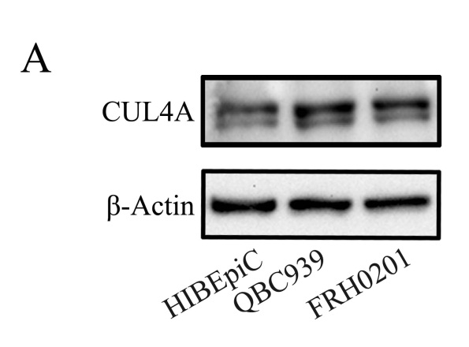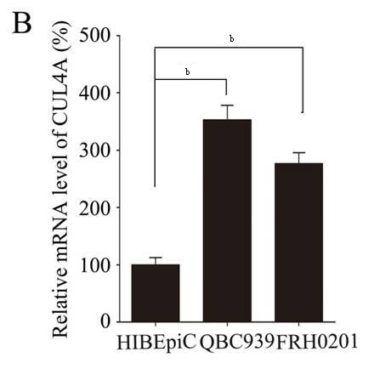
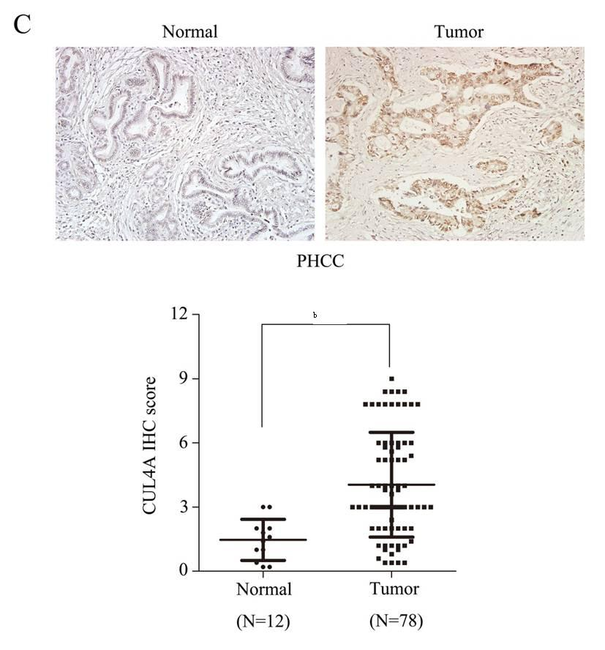
Figure 1 CUL4A is overexpressed in perihilar cholangiocarcinoma. A. Expression of CUL4A was detected in normal biliary epithelial cells (HIBEpic) and PHCC cell lines by Western blotting assays; B. Expression of CUL4A was detected in normal biliary epithelial cells (HIBEpiC) and PHCC cell lines by qRT-PCR assay; C. Representative images of CUL4A IHC staining in PHCC tumour cancer tissues and normal adjacent tissues. Corresponding semiquantification of CUL4A expression is shown. Numbers in (B) indicate the fold changes of band densities based on at least three independent experiments. ^{b}P < 0.01 based on the Student t-test. Data are represented as mean ± SD. CUL4A: Cullin 4A; PHCC: perihilar cholangiocarcinoma.

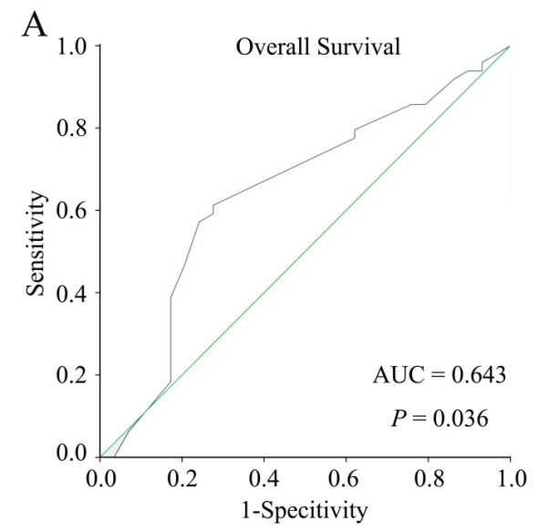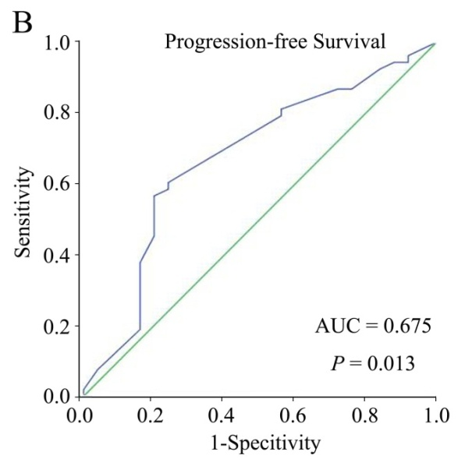
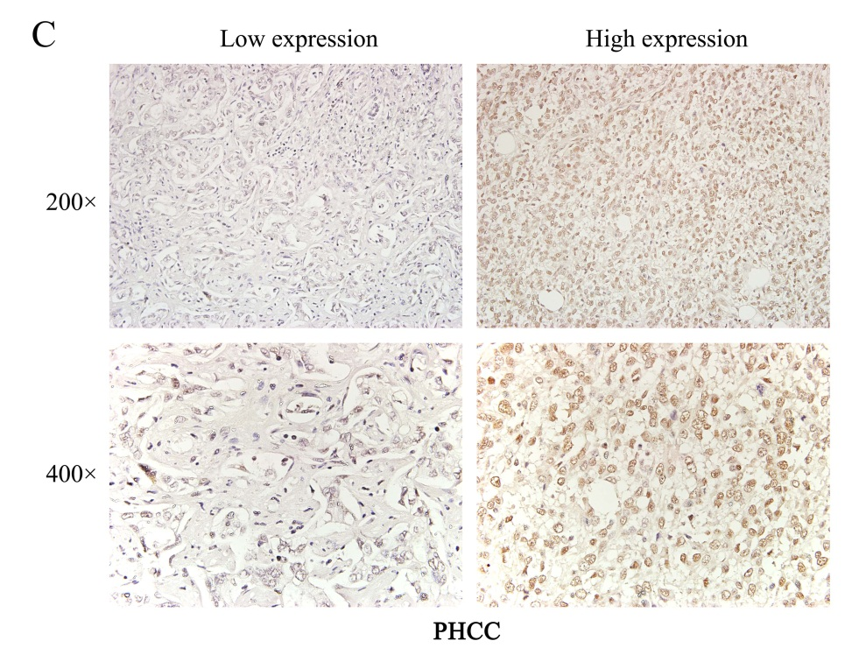
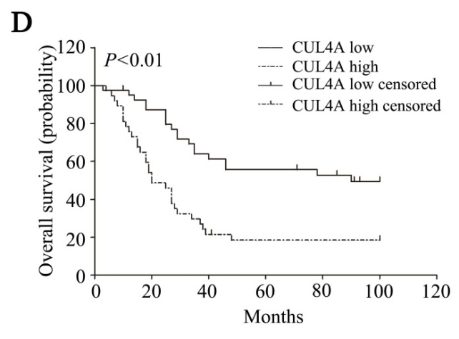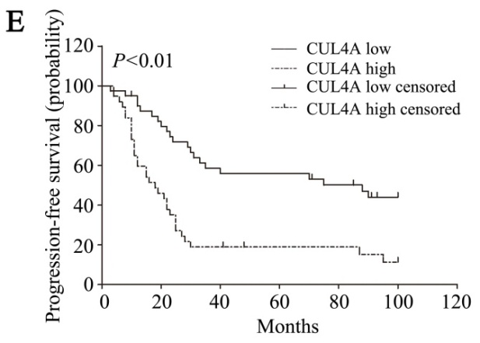
Figure 2 Cullin 4A correlates with poor perihilar cholangiocarcinoma prognosis. A and B: The cut-off points of CUL4A expression for the overall survival (A) and progression-free survival (B) were analysed by the ROC curve; C: Representative images of low and high CUL4A expression. D and E: Kaplan–Meier analysis and the log-rank test were adopted to investigate the overall survival (D) and progression-free survival (E) differences between the low high CUL4A expression groups. P < 0.01 in D and E based on the log-rank test. CUL4A: Cullin 4A; PHCC: perihilar cholangiocarcinoma.

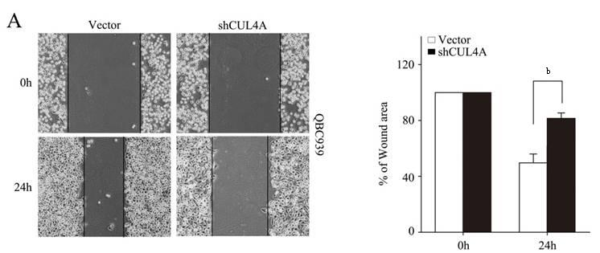
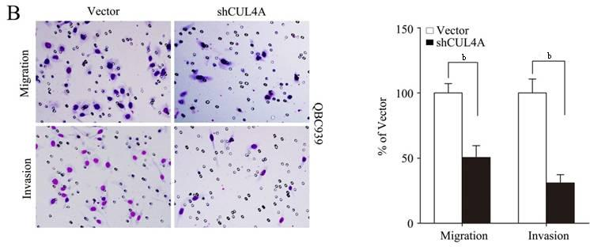
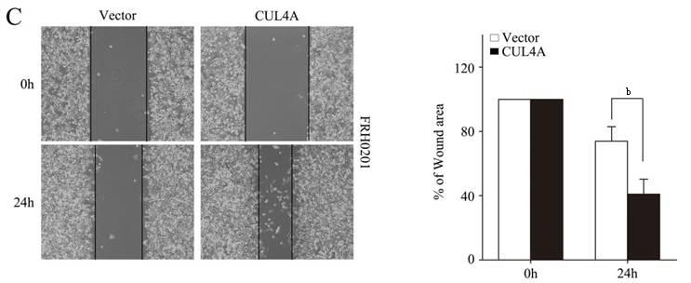
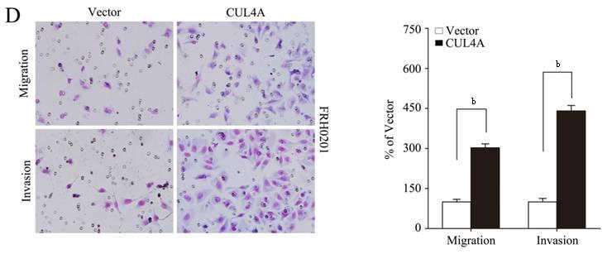
Figure 3 Cullin 4A could promote the migration and invasion of perihilar cholangiocarcinoma cell lines. QBC939-shCUL4A and FRH0201-CUL4A cells or control vector cells were subjected to wound healing (A and C), Transwell migration (B and D, top), and Matrigel invasion (B and D, bottom) assays. A: Quantification was performed by measuring the uncovered areas compared with the controls. B: Quantification of migrated cells through the membrane and invaded cells through the matrigel of each cell line are shown as proportions of their vector controls. C: Quantification was carried out by measuring the uncovered areas compared with the controls. D: Quantification of migrated cells through the membrane and invaded cells through matrigel for each cell line are shown as proportions of their vector controls. ^{b}P < 0.01 based on the Student t-test. All results are from at least three independent experiments. Data are represented as mean ± SD. CUL4A: Cullin 4A.

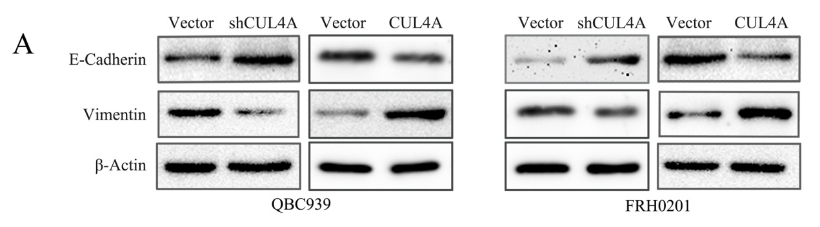
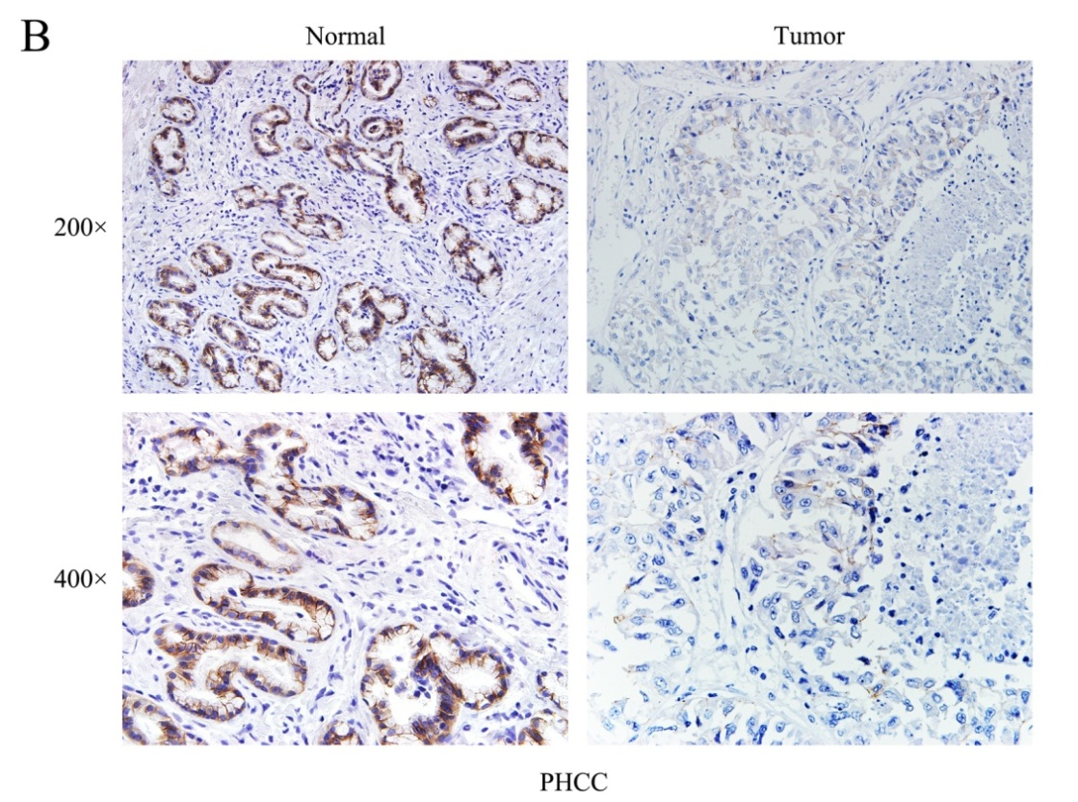
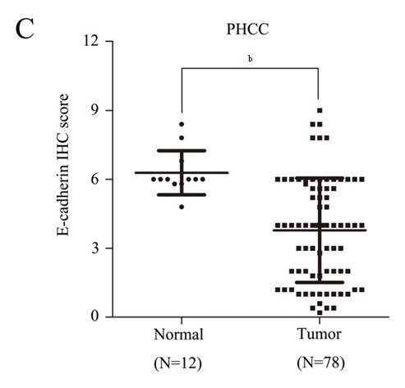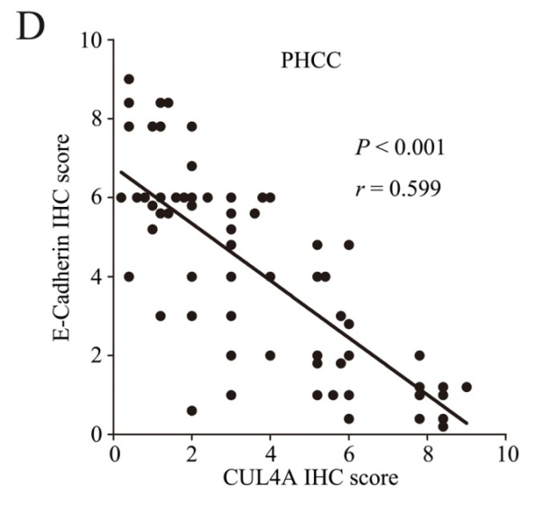
Figure 4 Cullin 4A could induce the epithelial to mesenchymal transition in perihilar cholangiocarcinoma. A: Expression levels of an epithelial marker (E-cadherin) and mesenchymal marker (Vimentin) were analyzed by Western blotting; B: Representative IHC images of E-cadherin expression in PHCC tissues and adjacent normal tissues; C: Statistical analysis of the semiquantification of E-Cadherin expression in PHCC tissues and adjacent normal tissues; D: Linear regression analyses of IHC scores between CUL4A and E-Cadherin in PHCC. ^{b}P < 0.01 based on the Student t-test. CUL4A: Cullin 4A; PHCC: perihilar cholangiocarcinoma.

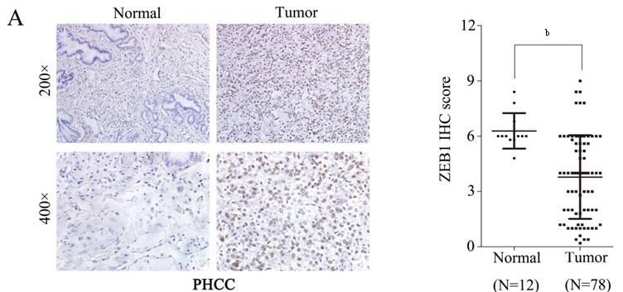
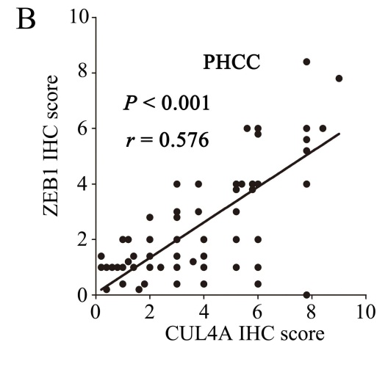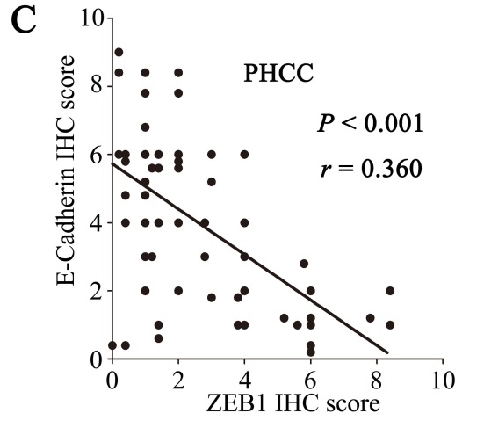
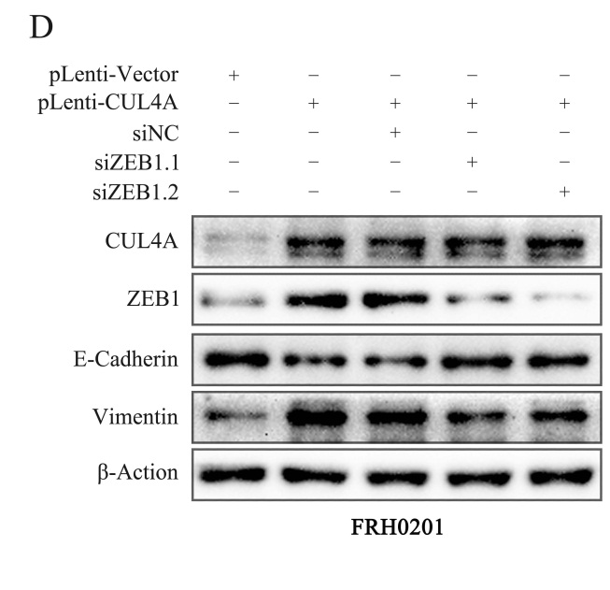
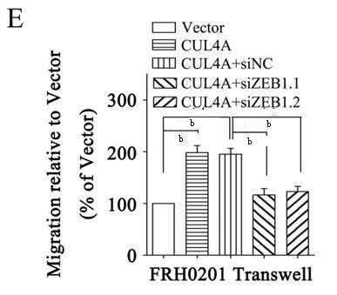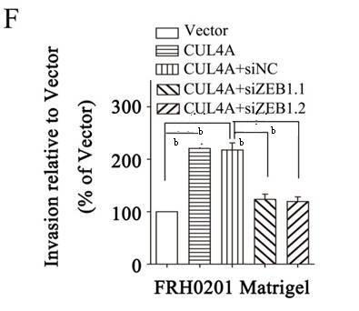
Figure 5 ZEB1 could mediate the metastasis regulated by cullin 4A in perihilar cholangiocarcinoma. A: Representative IHC images of ZEB1 expression in PHCC tissues and adjacent normal tissues. Corresponding semiquantification of ZEB1 expression is shown; B: Linear regression analyses of IHC scores between CUL4A and E-Cadherin in PHCC; C: Linear regression analyses of IHC scores between CUL4A and ZEB1 in PHCC; D: Western blotting assay was performed to investigate theE-cadherin and Vimentin expression after ZEB1 interference in CUL4A overexpressing FRH0201 cells; E and F: The Transwell and Migration assays were performed to analyse the migration and invasion ability changes in CUL4A overexpressing FRH0201 cells with ZEB1 depletion. ^{b}P < 0.01 based on the Student t-test. All results are from at least three independent experiments. Data are represented as mean ± SD. CUL4A: Cullin 4A; PHCC: perihilar cholangiocarcinoma.

