Name of Journal: World Journal of Hepatology
Manuscript NO: 58556
Manuscript Type: ORIGINAL ARTICLE

Basic Study
Screening and identification of bioactive compounds from citrus against non-structural protein 3 protease of hepatitis C virus genotype 3a by fluorescence resonance energy transfer assay and mass spectrometry

Khan M et al. Screening of citrus compounds against NS3-HCV-G3a

Mahim Khan, Waqar Rauf, Fazal-e- Habib, Moazur Rahman, Mazhar Iqbal

Mahim Khan, Waqar Rauf, Fazal-e- Habib, Moazur Rahman, Mazhar Iqbal, Health Biotechnology Division, National Institute for Biotechnology and Genetic Engineering College, Pakistan Institute of Engineering and Applied Sciences (NIBGE-C, PIEAS), Faisalabad 38000, Punjab, Pakistan

Moazur Rahman, School of Biological Sciences, University of the Punjab, Lahore 54810, Punjab, Pakistan

Author contributions: Khan M was involved in this project from the design to execution and writing of this manuscript, optimized the expression and purification of hepatitis C virus non-structural protein 3 protease, extracted antioxidant compounds and tested their inhibition using the in vitro fluorescence resonance energy transfer assay, contributed to the LCMS/MS analysis to identify phenolics/flavonoids in plant extracts and evaluated their interaction using a modeling approach; Rauf W contributed to the design and execution of the experiments and LCMS/MS data analysis; Habib F performed the LCMS/MS analysis; Rahman M provided help with the purification of hepatitis C virus non-structural protein 3 and manuscript writing; Iqbal M conceived the idea, planned all of the experiments, and contributed to the data analysis, and manuscript writing.

Corresponding author: Mazhar Iqbal, PhD, Professor, Health Biotechnology Division, National Institute for Biotechnology and Genetic Engineering College, Pakistan Institute of Engineering and Applied Sciences (NIBGE-C, PIEAS), Jhang Road, Faisalabad 38000, Punjab, Pakistan. hamzamgondal@gmail.com

Received: July 27, 2020
Revised: September 3, 2020
Accepted: September 16, 2020
Published online: November 27, 2020

Abstract
BACKGROUND
Hepatitis C virus genotype 3a (HCV G3a) is highly prevalent in Pakistan. Due to the elevated cost of available Food and Drug Administration-approved drugs against HCV, medicinal natural products of potent antiviral activity should be screened for the cost-effective treatment of the disease. Furthermore, from natural products, active compounds against vital HCV proteins like non-structural protein 3 (NS3) protease could be identified to prevent viral proliferation in the host.

AIM
To develop cost-effective HCV genotype 3a NS3 protease inhibitors from citrus fruit extracts.

METHODS
Full-length NS3 without co-factor non-structural protein 4A (NS4A) and codon optimized NS3 protease in fusion with NS4A were expressed in Escherichia coli. The expressed protein was purified by metal ion affinity chromatography and gel filtration. Citrus fruit extracts were screened using fluorescence resonance energy transfer (FRET) assay against the protease and polyphenols were identified as potential inhibitors using electrospray ionization-mass spectrometry (MS)/MS technique. Among different polyphenols, highly potent compounds were screened using molecular modeling approaches and consequently the most active compound was further evaluated against HCV NS4A-NS3 protease domain using FRET assay.

RESULTS
NS4A fused with NS3 protease domain gene was overexpressed and the purified protein yield was high in comparison to the lower yield of the full-length NS3 protein. Furthermore, in enzyme kinetic studies, NS4A fused with NS3 protease proved to be functionally active compared to full-length NS3. So it was concluded that co-factor NS4A fusion is essential for the purification of functionally active protease. FRET assay was developed and validated by the half maximal inhibitory concentration (IC₅₀) values of commercially available inhibitors. Screening of citrus fruit extracts against the native purified fused NS4A-NS3 protease domain showed that the grapefruit mesocarp extract exhibits the highest percentage inhibition 91% of protease activity. Among the compounds identified by LCMS analysis, hesperidin showed strong binding affinity with the protease catalytic triad having S-score value of -10.98.

CONCLUSION
Fused NS4A-NS3 protease is functionally more active, which is effectively inhibited by hesperidin from the grapefruit mesocarp extract with an IC₅₀ value of 23.32 µmol/L.

Key Words: Hepatitis C virus genotype 3a; Non-structural protein 3 protease; Fluorescence resonance energy transfer assay; Citrus extract; Mass spectrometry; Hesperidin

Citation: Khan M, Rauf W, Habib F, Rahman M, Iqbal M. Screening and identification of bioactive compounds from citrus against non-structural protein 3 protease of hepatitis C virus genotype 3a by fluorescence resonance energy transfer assay and mass spectrometry. World J Hepatology 2020; 12(11): 976-992
URL: https://www.wjgnet.com/1948-5182/full/v12/i11/976.htm
DOI: https://dx.doi.org/10.4254/wjh.v12.i11.976

Core Tip: The manuscript describes the screening of active metabolites in citrus fruit extracts against hepatitis C virus genotype3a non-structural protein 3 (HCV-G3a NS3) protease. In this study, conditions have been optimized to get highly purified and functionally active protein HCV NS3. Further, fluorescence resonance energy transfer assay was used to screen the citrus extracts against NS3 protease. By using liquid chromatography coupled with tandem mass spectrometry/mass spectrometry analysis and bioinformatics modeling approaches, the observed activity of citrus extracts against HCV genotype3a NS3 protease was ascribed to hesperidin. Fluorescence resonance energy transfer assay confirmed the inhibitory potential of hesperidin against NS4A-NS3 protease domain with an half maximal inhibitory concentration value of 23.32 µmol/L.
INTRODUCTION
Hepatitis C virus (HCV) is responsible for chronic hepatitis C disease in humans^{[1]}. HCV infection remains asymptomatic and the virus persists in approximately 80% of untreated cases, which may ultimately lead to liver cirrhosis and finally hepatocellular carcinoma^{[2]}. HCV is a major global cause of morbidity and mortality affecting more than 170 million people^{[3]}. Annually, 400000 patients die worldwide due to HCV infection^{[4]}. In Pakistan, the prevalence of HCV infection is estimated to range from 4%-6%^{[5-7]}. Seven pathogenic HCV genotypes with subtypes have been identified^{[8]} and genotype 3a is predominant in Pakistan^{[7]}.
In recent years, direct acting antiviral drugs have revolutionized HCV treatment. Sofosbuvir (a non-structural protein [NS] 5B inhibitor) and daclatasvir (a non-structural protein 5A [NS5A] inhibitor) have demonstrated sustained virologic response of more than 90% and have far fewer adverse events compared to previous treatment options. Sofosbuvir was the first nucleotide analogue that was found to be effective alone against HCV without interferon combination, which opened new gateways for development of additional direct acting antiviral drugs with excellent therapeutic outcomes^{[9]}. The earlier Food and Drug Administration (FDA)-approved NS3 protease inhibitors, boceprevir and telaprevir were only effective against HCV genotype 1 (mainly prevalent in western countries) and less effective against genotype 3a, most prevalent genotype in Pakistan. However, the recently FDA-approved NS3 protease inhibitor glecaprevir has shown broad or pan-genotypic activity against HCV with much reduced side effects, especially in combination with pibrentasvir (ABT-530, NS5A inhibitor) as a single tablet. However, the high cost of protease inhibitors limits their use in resource-limited countries rendering the global eradication of HCV infection a difficult goal.
According to recent World Health Organization report, globally, the landscape for traditional and complimentary medicines has been steadily expanding^{[10]} and a large number of world populations rely on traditional medicines that use natural products for treatment of viral and other infections^{[11]}.
Efforts have been made to identify extracts and natural products isolated from citrus family to inhibit HCV genotype 3a NS3 protease, because citrus fruits are considered as a treasure trove of several active natural metabolites, including coumarins, alkaloids, flavonoids, limonoids, essential oils, phenolic acids and carotenoids. The anti-oxidative^{[12-18]}, anti-inflammatory^{[19-21]}, and anti-cancer properties^{[22-24]}, as well as cardiovascular^{[25]}, neuroprotective^{[26,27]} and hepatoprotective effects^{[28,29]} of citrus and their extracts have been extensively reported^{[30-33]}. Moreover, citrus metabolites have been used in many Asian countries as traditional medicinal herbs for treatment of digestive disorders, common cold and influenza, constipation and diarrhea, fluid retention, irritable bowel syndrome, persistent headaches, skin disorders, anxiety, depression, allergies, osteoarthritis, rheumatoid, prostate disorders as well as stomach and breast cancer^{[34,35]}.
In the current study, we have successfully produced a highly purified, stable and functionally active HCV NS3 protease of genotype 3a in fusion with its co-factor NS4A. After validating the fluorescence resonance energy transfer (FRET) assay using commercially available protease inhibitors, the extracts from citrus × paradisi (grapefruit), citrus sinesis (orange), citrus aurantinum (bitter orange), citrus reticulata (mandarin) and citrus limon (lemon) were collected, enriched and evaluated. The most active extract was analyzed and characterized using high-performance liquid chromatography coupled with tandem mass spectrometry (LCMS/MS). Candidate compounds from most active extracts were docked against the HCV NS3 protease structure to identify the most promising natural product, which was acquired and further evaluated to inhibit HCV NS3 protease using a FRET assay. As a result, this study has pinpointed the most active natural product from citrus family against NS3 protease of HCV genotype 3a.

MATERIALS AND METHODS
Plasmid constructs
The pET11a-His₆-NS3 construct was provided by Dr. Ikram Anwar (former PhD student, Drug Discovery and Structural Biology Lab, NIBGE, Pakistan). In pET11a-His₆-NS3, the nucleotide sequence of full-length NS3 (encoding both protease and helicase domains comprising amino acid 1 to amino acid 631) of hepatitis C virus genotype 3a was cloned into Bam HI/Hind III restriction sites of pET11a vector (Novagen, Madison, WI, United States) using respective restriction enzymes^{[36]}. The NS3 sequence in the pET11a-His₆-NS3 construct was placed in the reading frame with the N-terminal His₆-tag (Supplementary Figure 1A).
Another construct inserted with the NS3 protease domain in fusion with the core of NS4A activator peptide at the C-terminal was named pET11a-His₇-NS4A-NS3 (Supplementary Figure 1B) and synthesized by GenScript (Piscataway, NJ, United States); further description is given in the Supplementary information.

Expression of full-length NS3 and NS3 protease in Escherichia coli
For expression of full-length His₆-NS3 (contain a serine protease and an RNA helicase) competent cells of BL21-CodonPlus (DE3)-RIL and Escherichia coli BL21 (DE3) were transformed with pET11a-His₆-NS3. For expression of the NS3 protease, pET11a-His₇-NS4A-NS3 was transformed into E. coli BL21 (DE3) cells considering the codon-optimized nucleotide sequence of NS3 protease. Further details of the expression experiments are given in the Supplementary information.

Purification of full-length NS3 and NS4A-NS3 protease domain
For purification, E. coli cell paste of pET11a-His₆-NS3/BL21-CodonPlus (DE3)-RIL or pET11a-His₇-NS4A-NS3/BL21 (DE3) was resuspended in ice-cold 25 mmol/L 4-(2-hydroxyethyl)-1-piperazineethanesulfonic acid (HEPES) pH 7.6 added with 20% glycerol, 0.5 mol/L NaCl, 2.5 mmol/L β-mercaptoethanol and 0.4% Triton X-100^{[36]} or 25 mmol/L HEPES (pH 7.5), 1 mol/L NaCl, 25 mmol/L Imidazole and 10 % glycerol (buffer A). Both proteins were purified by Nickel affinity chromatography and gel filtration; the detailed procedure is presented in the Supplementary information.

Activity measurement of full-length NS3 and NS4A-NS3 protease domain
The FRET assay was performed to determine protease activity, using the depsipeptide substrate Ac-Asp-Glu-Asp-(EDANS)-Glu-Glu-Abu-ψ-[COO]-Ala-Ser-Lys(DABCYL)-NH2 (AnaSpec, San Jose, CA, United States). The NS3 Protease domain cleaves the depsipeptide substrate, which results in the generation of fluorescence that can be read continuously on a fluorescence plate reader (THE SPARK®; TECAN, Morrisville, NC, United States) at their desired excitation (355 nm) and emission (510 nm) wavelengths. The synthetic peptide KKGCVVIVGHIELGK obtained from LifeTein LLC (Somerset, NJ, United States)^{[37]} corresponding to the central part of HCV NS4A was the co-factor necessary for NS3 protease activity. To increase its solubility, two N-terminal lysine residues were also added^{[37,38]}. To analyze the activity of His₆-NS3, the enzyme was further diluted to 1 nM in an assay buffer (50 mmol/L HEPES pH 7.5; 10 mmol/L DTT; 0.4% triton X-100, 40% glycerol, and 3% dimethylsulfoxide conc. in each well) and pre-incubated with NS4A-peptide (25 µmol/L) at 30 °C for 10 min. Whereas, NS4A-NS3 protease domain was diluted to a final concentration of 0.5 nmol/L in the assay buffer and then was incubated for 10 min at 30 °C (no separate cofactor was added). To initiate the reaction, substrate (10 µL) was added in a 2-fold serial dilution with maximum concentration of 4 µmol/L. Lastly, two places in 96-well plates were used as a control containing reaction mixture without substrate. Inner filter effect corrections of substrate were done as previously described^{[39]}. To determine the kinetics of enzyme (Km, kcat and kcat/Km), the Michaelis-Menton equation was fitted to the data by non-linear regression using GraphPad Prism® software (GraphPad Software Inc., San Diego, CA, United States).

Validation of NS4A-NS3 protease domain and FRET inhibition assay
Inhibition experiments using NS4A-NS3 protease domain of genotype-3a were performed according to a previous protocol^{[40]}. After correcting inner filter corrections, the assay was validated using commercial-based inhibitors: Ciluprevir, telaprevir, asuanaprevir, and danoprevir (AdooQ® Bioscience, Irvine, CA, United States). To this end, the NS4A-NS3 protease domain was pre-incubated with inhibitor before adding depsipeptide substrate (1 µmol/L). Half maximal inhibitory concentration (IC₅₀) values were obtained using GraphPad Prism® software (GraphPad Software Inc.)^{[41]}. The reaction was monitored at wavelengths 355 nm (excitation) and 510 nm (emission), for 20, 30, or 60 min. All activity measurements were done in triplicate. The final percentage of enzyme inhibition was calculated as average from three independent experiments^{[42]}. Errors were calculated as the standard deviation (SD), and IC₅₀ values were calculated as previously described.

Preparation of extracts
Five varieties of citrus fruits (citrus × paradisi [grapefruit], citrus sinesis [orange], citrus aurantinum [bitter orange], citrus reticulata [mandarin], and citrus limon [lemon]) were used in this study. The different parts of dried and crushed citrus plants materials were provided by Jiaherb Inc. (Pine Brook, NJ, United States) and Sanjiang Bio (Walnut, CA, United States). These powdered extracts were packed in opaque storage bags and stored at -20 °C for future use^{[43]}. The extraction procedure is further described in the Supplementary information.

Inhibition of HCV NS4A-NS3 protease activity by plant extracts
An opaque 96-well plate was used to perform enzyme inhibition assays as described in the Supplementary information. All extracts were tested at a final 3-fold dilution ranging from 1.566 µg/mL to 3.33 mg/mL. The inhibition was calculated as the average from three independent experiments^{[42]}. Errors were calculated as the SD, and IC₅₀ values were calculated as mentioned above.

LCMS analysis of extracts
For electrospray ionization (ESI)-MS/MS analysis, the dried extracts, which indicated the best inhibition activity by FRET assay, were dissolved in LCMS-grade methanol and subjected to ESI-MS/MS analysis using the LTQ XL Linear Ion Trap Mass Spectrometer (Thermo Fisher Scientific, Waltham, MA, United States), equipped with an ESI probe as explained in the Supplementary information.

Modeling predictions of compounds using bioinformatics software
Compounds identified by ESI-MS/MS analysis were tested in docking studies using molecular operating environment (MOE) software by means of the following communications, i.e. Intel [R] xenon [R] CPU E5620@2.40 GHz system, which has 3.8GB RAM having 11.4 [X 86_64] operating system^{[44,45]}. Structures of identified compounds were constructed using chembiodraw ultra 14.0 software. HCV NS4A-NS3 protease domain (receptor protein) was modeled by SWISS-MODEL. Three dimensional (3D) protonation and energy minimization were performed using standard MOE parameters. Then docking analysis with default MOE parameters was used to check the interaction of selected ligands to the receptor protein and find the correct ligand conformation. After docking, best conformations were analyzed depending on least S-score values for hydrogen bonding/π-π interactions^{[46]}.

Evaluation of pure natural product (hesperidin)
After the identification of specific natural product (hesperidin) by ESI-MS/MS analysis and its further interaction with NS3 protease by molecular docking, hesperidin (90% pure; Jiaherb) was subjected to inhibitory activity analysis. Inhibition experiments using the NS4A-NS3 protease domain were performed as previously described^{[40]} and IC₅₀ values were calculated.

RESULTS
Expression and purification of full-length NS3 and NS4A-NS3 protease domain
To test the efficacy of selected inhibitors against the HCV-NS3 protease domain, full-length NS3 (containing the serine protease and an RNA helicase domains) and a NS4A-NS3 protease domain were produced by recombinant means. To this end, expression of full-length His₆-NS3 from pET11a-His₆-NS3 expression vector (Supplementary Figure 1) was performed in E. coli BL21 (DE3) and BL21-CodonPlus (DE3)-RIL as described in the Methods section. High expression levels of His₆-NS3 were obtained in BL21-CodonPlus (DE3)-RIL compared to BL21 (DE3) cells, as detected by the appearance of a 68.3 kDa band on a Coomassie blue-stained sodium dodecyl sulfate polyacrylamide gel electrophoresis (SDS-PAGE) gels (Figure 1A and B). Therefore, further expression of His₆-NS3 was performed in BL21-CodonPlus (DE3)-RIL. For the NS4A-NS3 protease domain (22.5 kDa), high expression levels were achieved in E. coli BL21 (DE3) using the pET11A-His₇-NS4A-NS3 expression vector (Figure 1C, Supplementary Figures 1 and 2).
Full-length His₆-NS3 and His₇-NS4A-NS3 protease domain were purified to homogeneity by Ni-NTA affinity chromatography. A high level of purity (> 95%) was achieved for the His₇-NS4A-NS3 protease domain compared to His₆-NS3, as determined by Coomassie blue-stained SDS-PAGE gels (Supplementary Figure 3). To remove impurities from the affinity-purified His₆-NS3 samples, gel filtration was performed that yielded a protein of high purity (Figure 1D, Peaks 1 and 2). For the His₇-NS4A-NS3, native NS4A-NS3 protease domain of high purity was obtained by cleaving the His₇-tag from the protein with TEV protease and purification by nickel-affinity chromatography and gel filtration (Supplementary Figures 1D and 4). Purification yield of full-length His₆-NS3 and NS4A-NS3 protease domain 0.55 and 6 mg per liter culture volume was obtained, respectively.

Activity analyses of full-length His₆-NS3 and NS4A-NS3 protease domain
The activity of the purified full-length His₆-NS3 and NS4A-NS3 protease domain were measured using a FRET-based assay as described in the Methods section. An increase in activity of the NS4A-NS3 protease domain was observed upon an increase in depsipeptide substrate concentration (0.0625 to 6 µM) whereas with full-length His₆-NS3, no obvious activity was detected although the experiment was repeated several times (Supplementary Figure 5A and B). Moreover, the kinetic data revealed that the NS4A-NS3 protease domain exhibited a Km of 6.39 µM and catalytic efficiency (k_{cat}/K_{m}) of 0.015 µM⁻¹.s⁻¹ (15 nM⁻¹.s⁻¹) (Figure S5C) and qualified for conducting assays for an intensive search for inhibitors.
Furthermore, before embarking upon inhibition of the NS4A-NS3 protease domain by natural extracts/compounds, validation of the inhibition assay was done using commercial inhibitors. BILN 2061, VX-950, asuanaprevir and danoprevir inhibited the activity of the NS4A-NS3 protease domain with IC_{50s} of 52.28 ± 13.08, 69.59 ± 13.42, 69.42 ± 13.48 and 24.42 ± 8.04 nM, respectively (Figure 2). The obtained IC₅₀ values validated the assay and suggested that the activity of the purified NS4A-NS3 protease domain was inhibited by commercial inhibitors and the conditions for FRET assay were properly optimized.

Screening of citrus extracts against NS4A-NS3 protease domain of genotype 3a using the FRET assay
After validating the FRET assay, 14 extracts of citrus fruit varieties were collected. Extracts from different parts of citrus (described in methods) were evaluated against the NS4A-NS3 protease domain of genotype 3a. Among them, top five extracts exhibited highest percentage inhibition of protease activity were selected. Selected extracts strongly inhibited the activity of NS4A-NS3 protease domain, i.e. grapefruit mesocarp extract, showed highest 91% inhibition of protease with an IC₅₀ value of 7.51 ± 0.87 µg/mL; orange extract (exhibited 86% inhibition of protease with an IC₅₀ value of 33.39 ± 1.52 µg/mL; bitter orange extract showed 85% inhibition of protease with an IC₅₀ value of 40.24 ± 1.60 µg/mL; mandarin extract showed 82% inhibition with an IC₅₀ value of 65.40 ± 1.81; and lemon extract inhibited 80% of protease activity with an IC₅₀ value of 74.60 ± 1.86 µg/mL. Among these extracts, grapefruit mesocarp extract showed highest percentage inhibition (91%) with lowest IC₅₀ value of 7.51 ± 0.87 µg/mL against NS4A-NS3 protease domain of genotype 3a using the FRET assay (Figure 3).

ESI-MS/MS analysis of grapefruit mesocarp extract
The grapefruit mesocarp extract exhibiting the best activity against NS4A-NS3 protease domain was subjected to ESI-MS/MS analysis to reveal the identification of active natural product(s). Among the tested extraction solvents, n-hexane proved to be the best in minimizing the noise and showing maximum polyphenol natural products at negative ion mode (Figure 4). The full scan mass spectrum followed by the fragmentation through collision induced dissociation (CID) of the ion peaks of extract in negative ion mode [M-H]¹⁻ revealed the presence of aliphatic and aromatic organic acids (with and without glycans), lactones (bergapten at m/z 215 and (R)-marmin at m/z 331), flavonoids, i.e. alpinetin at m/z 269, hesperitin at m/z 301, polymethoxyflavone at m/z 435, naringenin arabinofuranose at m/z 535, naringin at m/z 579, hesperidin at m/z 609, neohesperidin at m/z 610 and anthocyanin (cyanidin-3-O-sophoroside chloride at m/z 645). At positive ionization mode [M+H]¹⁺ the synephrine, limonene and tangeretin were identified. These compounds were recognized by tandem mass spectrometry and hesperidin analysis data (as a representative) as described below.
Among all of the identified compounds, hesperidin flavonoid was the most abundant natural product in grapefruit mesocarp extract, giving a base peak at m/z 609.3 in negative ion mode. To confirm the hesperidin structure, the molecular ion at m/z 609.3 was fragmented (@CID 15.0) that yielded the daughter ions at m/z 463 (as a minor peak) and at m/z 301 as a base peak by losing one and two glycans, respectively, as described in Figure 5A. The peak at m/z 301 (hesperitin) was further subjected to MS³ fragmentation (@CID20.0), which produced 19 daughter ions, i.e. m/z 286 (-CH₃•), further generating the fragments at m/z 268 (-H₂O), m/z 258 (-CO) and m/z 257 after double bond rearrangement (Figure 5B). The ion peak at m/z 258 generated two signals at m/z 151 and m/z 125 by the loss of B and C rings, respectively. The hesperitin (m/z 301) generated a peak at m/z 283 by loss of H₂O producing the alkyne adduct and/or a fragment with extended conjugation on C ring, which further produced an entity at m/z 241 after losing CO₂. The alkyne adduct at m/z 283 can yield m/z 268 by losing a methyl radical. The ion peaks at m/z 257, m/z 242 and m/z 227 were produced by the loss of CO₂, followed by that of CH₃• and O•, respectively, from hesperitin (m/z 301). The ion peak at m/z 151 can be produced directly from m/z 301 and/or any of the other adducts having C ring intact through retro Diels-Alder reactions. Notably, m/z 151 accompanied by m/z 125 are the signature ion peaks generated from most of the flavonoid aglycones during their tandem mass spectrometry^{[47]}. The fragment at m/z 301 also generated fused ring adducts at m/z 259, m/z 215, m/z 199 and m/z 185. All of the ion peaks confirmed the hesperidin structure^{[47,48]}. Additionally, the data were fully correlated with fragmentation of authentic hesperidin sample.

Modeling predictions of compounds using bioinformatics software
The homology model of HCV NS4A-NS3 protease domain was developed using the HCV NS3/NS4A protease crystal structure (PDB ID: 3P8N) as a template that has 76.80% sequence identity with the template confirming a high-quality model. The homology model (Figure 6A) was in a closed flap conformation with GMQE and QMean scores of 0.81 and -1.77, respectively. The model was further validated by the values of the ramachandran plot analysis (http://mordred.bioc.cam.ac.uk/) (98% in the most favored region). Analysis with verify 3D software showed that 84.62% of the residues averaged a 3D-1D score of ≥ 0.2, and the overall quality factor measured ERRAT software was 93.4%.
Among the identified citrus phytochemicals from the grapefruit mesocarp extract, hesperidin exhibited a good docking score [S-score = -10.98] and most importantly, it bound tightly with the catalytic residues of HCV NS4A-NS3 protease domain (HIS 57, ASP 81, and SER 139) (Figure 6B). Hence, it may be worth further exploring against NS4A-NS3 protease domain of HCV genotype 3a.

Evaluation of pure flavonoids
The ESI-MS/MS analysis of the most active extract (grapefruit mesocarp) followed by simulation data, reveals that hesperidin is the most abundant and highly active inhibitor of the NS4A-NS3 protease domain of genotype-3a. The investigations inspired us to acquire hesperidin from commercial sources (Jiaherb) and evaluate its inhibition potential. Inhibition experiments with NS4A-NS3 protease domain of genotype-3a were performed according to the protocol described in methods. Hesperidin was tested at a concentration range of 1.23 µg/mL-1.67 mg/mL in the FRET assay, which gave IC₅₀ value of 23.32 µmol/L (Figure 6C).

DISCUSSION
A multifunctional NS3 of HCV comprising of serine protease domain at N-terminal and a C-terminal RNA helicase domain. The protease domain requires the NS4A activator peptide to cleave 3 of its 4 polyprotein processing sites^{[49,50]} and therefore provides an attractive target for inhibition of viral replication^{[51]}; the protease is much more efficient at cleaving the fourth in the presence of NS4A. In the present study, full-length NS3 without cofactor NS4A and NS3 protease domain in fusion with co-factor NS4A from a codon-optimized NS4A-NS3 protease domain open reading frame were expressed in E. coli and purified (Figure 1). The NS4A-NS3 protease domain showed a higher purification yield than full-length NS3. Full-length NS3 did not display any detectable protease activity. This might be because the NS4A was not fused with the sequence of full-length NS3 and a separate synthetic NS4A peptide was used in activity assay buffer which may not bind to the proper site in NS3 to increase protease cleavage efficiency^{[52]}. Another possible reason is that the fusion provides a higher effective local concentration of the activator. On the other hand, the native NS4A-NS3 protease domain, containing fused cofactor, showed significant activity with K_{m} and k_{cat}/K_{m} of 6.39 µmol/L and 0.015 µM⁻¹.s⁻¹, respectively. Moreover, inhibition of the NS4A-NS3 protease domain using known commercial inhibitors (BILN 2061, VX-950, asuanaprevir and danoprevir) validated the activity assay (Figure 2), which suggests that native purified protein can be employed to search for natural inhibitors/compounds against HCV.
Citrus fruits are important for human health because of their highly nutritious and pharmacological activities^{[51]}. They are rich in bioactive compounds including flavonoids^{[53]}. Flavonoids have inhibitory action against a number of viruses as well. For example, quercetin, rutin, morin, dihydroquercetin, dihydrofisetin, pelargonidin chloride, leucocyanidin and catechin have activity against up to seven viruses, including herpes simplex virus leucocyanidin^{[54]}, respiratory syncytial virus^{[55,56]}, poliovirus^{[57,58]}, sindbis virus^{[59]} and dengue virus^{[60]}. Because of their abundance and possible medicinal uses, citrus extracts were included in the present study. Different plant parts (mesocarp, seeds, pericarp and pulp) of grapefruit, orange, bitter orange, mandarin and lemon were used to extract the bioactive compounds from them. FRET assay inhibition study of the tested extracts revealed that grapefruit mesocarp extract proves to be the more active against NS4A-NS3 protease domain having lowest IC₅₀ value (7.51 ± 0.87 µg/mL) (Figure 3).
ESI-MS/MS analysis of the grapefruit mesocarp extract demonstrated significantly higher abundance of hesperidin as compared to other metabolites (Figure 4). The structure of hesperidin was confirmed using the tandem mass spectrometric technique (Figure 5). Molecular docking studies of the identified flavonoids against the NS4A-NS3 protease domain (HCV 3a) revealed that hesperidin demonstrated a potential inhibitory activity against the NS4A-NS3 protease domain, exhibiting S-score value of -10.98 and strong binding affinity with the catalytic site residues (his 57, asp 81 and ser 139) (Figure 6A and B). These assumptions were proved when hesperidin (90% purity) was evaluated against NS4A-NS3 protease domain using the FRET assay, which gave sub-nanomolar IC₅₀ (23.32 µmol/L) (Figure 6C). This indicated that the predominant inhibition of grapefruit mesocarp extract was due to the presence of hesperidin in it. Notably, hesperidin was tested against different viruses, i.e. sindbis virus, vaccinia virus, parainfluenza virus, herpes simplex virus types 1 and 2, poliovirus, and vesicular stomatitis virus^{[59,61,62]}. Hesperetin has exhibited an inhibitory effect with an IC₅₀ value of 20.5 µg/mL (about 68 µM) against sindbis virus infection, by plaque assay^{[59]}. Moreover, previously docking studies on hesperidin and narirutin showed their inhibition potential against avian influenza virus H1N1^{[63]}, which were consistent with our results, and their inhibitory activity was experimentally confirmed in another study^{[64]}. In this study, we found that hesperidin actively inhibited HCV NS3 protein with an IC₅₀ value of 23.32 µmol/L. Additionally, hesperidin was reported to be active involving host-factor, i.e. suppression of mitogen-activated protein kinase signaling pathways in H1N1 infection and this pathway is also activated by HCV^{[65,66]}.
Various natural products exhibit the potential to be anti-HCV protease inhibitors. Among them, epigallocatechin-3 gallate targets both viral cell entry and RNA replication steps^{[67]} into both primary human hepatocytes and hepatoma cell lines^{[68]}. It also exhibits an antiviral activity against all HCV genotypes, tested in the HCV pseudotyped particles (HCVpp system)^{[69]}. Other natural products including quercetin, honokiol, 3-hydroxy caruilignan C and excoecariphenol D corilagin exhibit anti-HCV behaviors, which have been tested in vivo or in cellular models. Quercetin exhibited inhibition of HCV NS3 protease^{[70]}. It has an ability to minimize the production of virus by inhibiting both NS3 as well as heat shock proteins which are required for the replication of HCV^{[71]}. Honokiol prevents HCV infection by interfering with their cell entry and replication process^{[72]}, 3-hydroxy caruilignan C also exhibited anti-HCV activity at both RNA and protein levels^{[73]}. Excoecariphenol D corilagin inhibited HCV NS3-4A protease with an IC₅₀ values within a range of 3.45-9.03 µmol/L, whereas excoecariphenol D and corilagin significantly showed potential inhibition of HCV RNA in huh 7.5 cells^{[74]}. Our findings suggested that hesperidin showed lowest IC₅₀ value = 23.32 µmol/L (Figure 6C) as compared to previously reported natural products including epigallocatechin-3 gallate (IC₅₀ value = 5-21 µmol/L), honokiol (IC₅₀ value = 4.5 µmol/L), 3-hydroxy caruilignan C (IC₅₀ value = 37.5 µmol/L) and excoecariphenol D corilagin (IC₅₀ value = 12.6 and 13.5 µmol/L)^{[75]}.
Although FDA-approved, direct-acting antiviral drugs such as mavyret are available in market, they are very expensive and are not affordable for many HCV patients in resource limited and developing countries. So, there is a need to study natural products and to identify potent phytochemicals, which inhibits HCV replication and can be developed into inexpensive anti-HCV drugs. In conclusion, the present study identified hesperidin as a potential new inhibitor of HCV protease. Because hesperidin is an important bioflavonoid widely found in grapefruit mesocarp^{[76]}, its cheap availability may make it an interesting candidate as anti-HCV drug prospects which might replace other more expensive drugs.

CONCLUSION
In this study, HCV NS3 protease fused with co-factor NS4A was found to be functionally more active compared to full-length NS3. Citrus fruit extracts were screened using FRET assay against NS4A fused protease. Among these extracts, grapefruit mesocarp showed the highest percentage inhibition (91% of protease activity). LCMS data revealed the high abundance of hesperidin in the most active extract, which was subsequently subjected to docking studies showing strong binding interaction of hesperidin with the catalytic site residues of NS4A-NS3 protease domain (S-score = -10.98). Hesperidin inhibited NS4A-NS3 protease domain with an IC₅₀ value of 23.32 µM in FRET assay.

ARTICLE HIGHLIGHTS
Research background
Hepatitis C virus genotype 3a (HCV G3a) is highly prevalent in many countries including Pakistan. FDA-approved drugs have significantly contributed in effective control of the disease but are expensive and not affordable to a large proportion of the infected population.

Research motivation
Medicinal natural products having antiviral potential could be screened for the cost-effective treatment of the disease. Using such products, inhibition assays against vital viral proteins like non-structural protein (NS) 3 protease could be developed to prevent viral proliferation in the host.

Research objectives
This study developed cost-effective HCV G3a NS3 protease inhibitors from citrus fruit extracts.

Research methods
Codon optimized NS3 protease domain fused with NS4A as well as full-length NS3 constructs were cloned in pET11a expression vector. Both constructs were expressed in Escherichia coli BL21 (DE3) cells and purification was performed using Ni-affinity chromatography followed by gel filtration. The fluorescence resonance energy transfer assay was developed and validated using commercial inhibitors. Furthermore, extracts from different citrus species, were screened on the basis of percentage inhibition. The components of the most active extract were identified using electro spray ionization- mass spectrometry/mass spectrometry technique. Docking was performed with Molecular operating environment software to screen out the potent natural product, which was acquired in purified form and evaluated against NS3/4A protease using fluorescence resonance energy transfer assay.

Research results
We successfully overexpressed and purified genotype 3a NS3 protease domain fused with NS4A and the yield was also higher than full-length NS3 protein. Inhibition of NS3 protease fused with NS4A protein was tested against different citrus extracts and grapefruit mesocarp extract showed highest percentage inhibition of protease activity (91%). Hesperidin was identified as the inhibiting compound in the extract having docking S-score value of -10.98.

Research conclusions
NS3 protease fused with co-factor NS4A was found functionally more active. Hesperidin from the grapefruit mesocarp extract showed the inhibition against NS4A-NS3 protease domain with an IC₅₀ value of 23.32 µmol/L.

Research perspectives
Hesperidin flavonoid may be further explored as potential antiviral agent against HCV as an affordable option for infected population.

ACKNOWLEDGEMENTS
We would like to thank Dr. David Waugh, (Head, Protein Engineering Core, Macromolecular Crystallography Laboratory, NCI, NIH, United States) for providing the help to MK in cloning and optimizing the expression and purification of HCV NS3 protease as well as proof reading of the MS. Thanks to Taekjip Ha (Distinguished Professor, Department of Biophysics, Johns Hopkins University, Baltimore, MD 21218) and Chun Ying Lee (Graduate Student in Myong's lab, Department of Biophysics, Johns Hopkins University, Baltimore, MD 21218) for providing training and facility to MK to develop FRET assay. Thanks to Dr. Cheryl Winkler (Head, Molecular Genetic Epidemiology Studies Section, Basic Research Laboratory, NCI, NIH, United States), for hosting MK at NCI, NIH, to complete the research work and proof reading of the MS.

REFERENCES
1 Kim CW, Chang KM. Hepatitis C virus: virology and life cycle. Clin Mol Hepatol 2013; 19: 17-25 [PMID: 23593605 DOI: 10.3350/cmh.2013.19.1.17]
2 Bartenschlager R, Lohmann V, Penin F. The molecular and structural basis of advanced antiviral therapy for hepatitis C virus infection. Nat Rev Microbiol 2013; 11: 482-496 [PMID: 23748342 DOI: 10.1038/nrmicro3046]
3 Lee H-J, Shin B-Y, Moon J-S, Ho C-C, Shin J-S, Kim S-K, Lee S-K. Decremental effect of non-host humoral milieu interfacing viral envelope on the RNA level and surface antigenicity of hepatitis C virus (HCV) in vitro. Mol Cell Toxicol 2019; 15: 239-244 [DOI: 10.1007/s13273-019-0027-7]
4 Pietschmann T, Brown RJP. Hepatitis C Virus. Trends Microbiol 2019; 27: 379-380 [PMID: 30709707 DOI: 10.1016/j.tim.2019.01.001]
5 Afridi SQ, Zahid MN, Shabbir MZ, Hussain Z, Mukhtar N, Tipu MY, Akhtar F, Yaqub T. Prevalence of HCV genotypes in district Mardan. Virol J 2013; 10: 90 [PMID: 23514695 DOI: 10.1186/1743-422X-10-90]
6 Anwar MI, Rahman M, Hassan MU, Iqbal M. Prevalence of active hepatitis C virus infections among general public of Lahore, Pakistan. Virol J 2013; 10: 351 [PMID: 24308812 DOI: 10.1186/1743-422X-10-351]
7 Umer M, Iqbal M. Hepatitis C virus prevalence and genotype distribution in Pakistan: Comprehensive review of recent data. World J Gastroenterol 2016; 22: 1684-1700 [PMID: 26819533 DOI: 10.3748/wjg.v22.i4.1684]
8 Nishiya AS, de Almeida-Neto C, Ferreira SC, Alencar CS, Di-Lorenzo-Oliveira C, Levi JE, Salles NA, Mendrone A Jr, Sabino EC. HCV genotypes, characterization of mutations conferring drug resistance to protease inhibitors, and risk factors among blood donors in São Paulo, Brazil. PLoS One 2014; 9: e86413 [PMID: 24466079 DOI: 10.1371/journal.pone.0086413]
9 Lawitz E, Mangia A, Wyles D, Rodriguez-Torres M, Hassanein T, Gordon SC, Schultz M, Davis MN, Kayali Z, Reddy KR, Jacobson IM, Kowdley KV, Nyberg L, Subramanian GM, Hyland RH, Arterburn S, Jiang D, McNally J, Brainard D, Symonds WT, McHutchison JG, Sheikh AM, Younossi Z, Gane EJ. Sofosbuvir for previously untreated chronic hepatitis C infection. N Engl J Med 2013; 368: 1878-1887 [PMID: 23607594 DOI: 10.1056/NEJMoa1214853]
10 WHO. WHO global report on traditional and complementary medicine 2019. Available from: https://www.who.int/traditional-complementary-integrative-medicine/WhoGlobalReportOnTraditionalAndComplementaryMedicine2019.pdf?ua=1
11 Newman DJ, Cragg GM. Natural Products as Sources of New Drugs from 1981 to 2014. J Nat Prod 2016; 79: 629-661 [PMID: 26852623 DOI: 10.1021/acs.jnatprod.5b01055]
12 Zou Z, Xi W, Hu Y, Nie C, Zhou Z. Antioxidant activity of Citrus fruits. Food Chem 2016; 196: 885-896 [PMID: 26593569 DOI: 10.1016/j.foodchem.2015.09.072]
13 Cho J. Antioxidant and neuroprotective effects of hesperidin and its aglycone hesperetin. Arch Pharm Res 2006; 29: 699-706 [PMID: 16964766 DOI: 10.1007/BF02968255]
14 Ramful D, Bahorun T, Bourdon E, Tarnus E, Aruoma OI. Bioactive phenolics and antioxidant propensity of flavedo extracts of Mauritian citrus fruits: potential prophylactic ingredients for functional foods application. Toxicology 2010; 278: 75-87 [PMID: 20100535 DOI: 10.1016/j.tox.2010.01.012]
15 Halliwell B. Antioxidants in human health and disease. Annu Rev Nutr 1996; 16: 33-50 [PMID: 8839918 DOI: 10.1146/annurev.nu.16.070196.000341]
16 Halliwell B, Gutteridge JM, Cross CE. Free radicals, antioxidants, and human disease: where are we now? J Lab Clin Med 1992; 119: 598-620 [PMID: 1593209 DOI: 10.5555/uri:pii:002221439290284R]
17 Aruoma OI. Nutrition and health aspects of free radicals and antioxidants. Food Chem Toxicol 1994; 32: 671-683 [PMID: 8045480 DOI: 10.1016/0278-6915(94)90011-6]
18 Aruoma OI. Methodological considerations for characterizing potential antioxidant actions of bioactive components in plant foods. Mutat Res 2003; 523-524: 9-20 [PMID: 12628499 DOI: 10.1016/s0027-5107(02)00317-2]
19 Kang SR, Park KI, Park HS, Lee DH, Kim JA, Nagappan A, Kim EH, Lee WS, Shin SC, Park MK. Anti-inflammatory effect of flavonoids isolated from Korea Citrus aurantium L. on lipopolysaccharide-induced mouse macrophage RAW 264.7 cells by blocking of nuclear factor-kappa B (NF-κB) and mitogen-activated protein kinase (MAPK) signalling pathways. Food Chem 2011; 129: 1721-1728 [DOI: 10.1016/j.foodchem.2011.06.039]
20 Lee H-J, Kang G-J, Yoon W-J, Kang H-K, Kim Y-S, Kim S-M, Yoo E-S. Anti-inflammatory effect of unripe fruit of Citrus grandis Osbeck in RAW 264.7 and HaCaT cells. Korean J Pha 2006; 37: 74-80
21 Emim JA, Oliveira AB, Lapa AJ. Pharmacological evaluation of the anti-inflammatory activity of a citrus bioflavonoid, hesperidin, and the isoflavonoids, duartin and claussequinone, in rats and mice. J Pharm Pharmacol 1994; 46: 118-122 [PMID: 8021799 DOI: 10.1111/j.2042-7158.1994.tb03753.x]
22 Rawson NE, Ho C-T, Li S. Efficacious anti-cancer property of flavonoids from citrus peels. Food Sci Hum Well 2014; 3: 104-109 [DOI: 10.1016/j.fshw.2014.11.001]
23 Guthrie N, Carroll KK. Inhibition of mammary cancer by citrus flavonoids. Adv Exp Med Biol 1998; 439: 227-236 [PMID: 9781306 DOI: 10.1007/978-1-4615-5335-9_16]
24 Guthri N, Morley K, Hasegawa S, Manner GD, Vandenberg T. Inhibition of human breast cancer cells by citrus limonoids. ACS Publications 2000 [DOI: 10.1021/bk-2000-0758.ch012]
25 Putri H, Nagadi S, Larasati YA, Wulandari N, Hermawan A, Nugroho AE. Cardioprotective and hepatoprotective effects of Citrus hystrix peels extract on rats model. Asian Pac J Trop Biomed 2013; 3: 371-375 [PMID: 23646300 DOI: 10.1016/S2221-1691(13)60079-9]
26 Sohi S, Shri R. Neuropharmacological potential of the genus Citrus: A review. J Pharmacogn Phytochem 2018; 7: 1538-1548
27 Rahnama S, Rabiei Z, Alibabaei Z, Mokhtari S, Rafieian-Kopaei M, Deris F. Anti-amnesic activity of Citrus aurantium flowers extract against scopolamine-induced memory impairments in rats. Neurol Sci 2015; 36: 553-560 [PMID: 25367404 DOI: 10.1007/s10072-014-1991-2]
28 Akachi T, Shiina Y, Ohishi Y, Kawaguchi T, Kawagishi H, Morita T, Mori M, Sugiyama K. Hepatoprotective effects of flavonoids from shekwasha (Citrus depressa) against D-galactosamine-induced liver injury in rats. J Nutr Sci Vitaminol (Tokyo) 2010; 56: 60-67 [PMID: 20354348 DOI: 10.3177/jnsv.56.60]
29 Bhavsar SK, Joshi P, Shah MB, Santani D. Investigation into hepatoprotective activity of Citrus limon. Pharm Biol 2007; 45: 303-311 [DOI: 10.1080/13880200701214995]
30 Lv X, Zhao S, Ning Z, Zeng H, Shu Y, Tao O, Xiao C, Lu C, Liu Y. Citrus fruits as a treasure trove of active natural metabolites that potentially provide benefits for human health. Chem Cent J 2015; 9: 68 [PMID: 26705419 DOI: 10.1186/s13065-015-0145-9]
31 Duarte A, Fernandes MJ, Bernardes JP, Miguel MG. Citrus as a component of the Mediterranean diet. Journal of Spatial and Organizational Dynamics 2016; 4: 289-304
32 Benavente-García O, Castillo J. Update on uses and properties of citrus flavonoids: new findings in anticancer, cardiovascular, and anti-inflammatory activity. J Agric Food Chem 2008; 56: 6185-6205 [PMID: 18593176 DOI: 10.1021/jf8006568]
33 Rauf A, Uddin G, Ali J. Phytochemical analysis and radical scavenging profile of juices of Citrus sinensis, Citrus anrantifolia, and Citrus limonum. Org Med Chem Lett 2014; 4: 5 [PMID: 25024932 DOI: 10.1186/2191-2858-4-5]
34 Suryawanshi JAS. An overview of Citrus aurantium used in treatment of various diseases. Afr J Plant Sci 2011; 5: 390-395 [DOI: 10.5897/AJPS.9000015]
35 Gupta V, Kohli K, Ghaiye P, Bansal P, Lather A. Pharmacological potentials of Citrus paradisi-an overview. Int J Phytother Res 2011; 1: 8-17
36 Anwar MI, Iqbal M, Yousef MS, Rahman M. Over-expression and characterization of NS3 and NS5A of Hepatitis C virus genotype 3a. Microb Cell Fact 2013; 12: 111 [PMID: 24238670 DOI: 10.1186/1475-2859-12-111]
37 Taremi SS, Beyer B, Maher M, Yao N, Prosise W, Weber PC, Malcolm BA. Construction, expression, and characterization of a novel fully activated recombinant single-chain hepatitis C virus protease. Protein Sci 1998; 7: 2143-2149 [PMID: 9792101 DOI: 10.1002/pro.5560071011]
38 Ehrenberg AE, Schmuck B, Anwar MI, Gustafsson SS, Stenberg G, Danielson UH. Accounting for strain variations and resistance mutations in the characterization of hepatitis C NS3 protease inhibitors. J Enzyme Inhib Med Chem 2014; 29: 868-876 [PMID: 24517372 DOI: 10.3109/14756366.2013.864651]
39 Liu Y, Kati W, Chen CM, Tripathi R, Molla A, Kohlbrenner W. Use of a fluorescence plate reader for measuring kinetic parameters with inner filter effect correction. Anal Biochem 1999; 267: 331-335 [PMID: 10036138 DOI: 10.1006/abio.1998.3014]
40 Poliakov A, Hubatsch I, Shuman CF, Stenberg G, Danielson UH. Expression and purification of recombinant full-length NS3 protease-helicase from a new variant of Hepatitis C virus. Protein Expr Purif 2002; 25: 363-371 [PMID: 12182815 DOI: 10.1016/s1046-5928(02)00042-6]
41 Edwards W, Reichert D, Welch M, d'Avignon A. β-Cyclodextrin dimers as potential tumor pretargeting agents. Chem Commun 2001: 1312-1313 [DOI: 10.1039/b102814f]
42 Christopeit T, Øverbø K, Danielson UH, Nilsen IW. Efficient screening of marine extracts for protease inhibitors by combining FRET based activity assays and surface plasmon resonance spectroscopy based binding assays. Mar Drugs 2013; 11: 4279-4293 [PMID: 24177674 DOI: 10.3390/md11114279]
43 Tan SP, Parks SE, Stathopoulos CE, Roach PD. Extraction of flavonoids from bitter melon. Food Nutr Sci 2014; 2014 [DOI: 10.4236/fns.2014.55054]
44 Khan M, Qasim M, Ashfaq UA, Idrees S, Shah M. Computer aided screening of Accacia nilotica phytochemicals against HCV NS3/4a. Bioinformation 2013; 9: 710-714 [PMID: 23976825 DOI: 10.6026/97320630009710]
45 Wadood A, Ghufran M, Jamal SB, Naeem M, Khan A, Ghaffar R. Phytochemical analysis of medicinal plants occurring in local area of Mardan. Biochem Anal Biochem 2013; 2: 1-4 [DOI: 10.4172/2161-1009.1000144]
46 Khan M, Masoud MS, Qasim M, Khan MA, Zubair M, Idrees S, Ashraf A, Ashfaq UA. Molecular screening of phytochemicals from Amelanchier Alnifolia against HCV NS3 protease/helicase using computational docking techniques. Bioinformation 2013; 9: 978-982 [PMID: 24391361 DOI: 10.6026/97320630009978]
47 Zeng X, Su W, Bai Y, Chen T, Yan Z, Wang J, Su M, Zheng Y, Peng W, Yao H. Urinary metabolite profiling of flavonoids in Chinese volunteers after consumption of orange juice by UFLC-Q-TOF-MS/MS. J Chromatogr B Analyt Technol Biomed Life Sci 2017; 1061-1062: 79-88 [PMID: 28711784 DOI: 10.1016/j.jchromb.2017.07.015]
48 Ćirić A, Prosen H, Jelikić-Stankov M, Đurđević P. Evaluation of matrix effect in determination of some bioflavonoids in food samples by LC-MS/MS method. Talanta 2012; 99: 780-790 [PMID: 22967624 DOI: 10.1016/j.talanta.2012.07.025]
49 Suzuki T, Ishii K, Aizaki H, Wakita T. Hepatitis C viral life cycle. Adv Drug Deliv Rev 2007; 59: 1200-1212 [PMID: 17825945 DOI: 10.1016/j.addr.2007.04.014]
50 Landro JA, Raybuck SA, Luong YP, O'Malley ET, Harbeson SL, Morgenstern KA, Rao G, Livingston DJ. Mechanistic role of an NS4A peptide cofactor with the truncated NS3 protease of hepatitis C virus: elucidation of the NS4A stimulatory effect via kinetic analysis and inhibitor mapping. Biochemistry 1997; 36: 9340-9348 [PMID: 9235976 DOI: 10.1021/bi963054n]
51 Verma ML, Sharma S, Saini R, Rani V, Kushwaha R. Bioflavonoids: Synthesis, functions and biotechnological applications. Biotechnological Production of Bioactive Compounds: Elsevier, 2020: 69-105 [DOI: 10.1016/B978-0-444-64323-0.00003-5]
52 Tomei L, Failla C, Vitale RL, Bianchi E, De Francesco R. A central hydrophobic domain of the hepatitis C virus NS4A protein is necessary and sufficient for the activation of the NS3 protease. J Gen Virol 1996; 77: 1065-1070 [PMID: 8609472 DOI: 10.1099/0022-1317-77-5-1065]
53 Alves CQ, David JM, David JP, Kijjoa A. Flavonoids and other compounds from Dioclea virgata (Rich.) Amsh. Biochem Syst Ecol 2018; 78: 43-45 [DOI: 10.1016/j.bse.2018.03.011]
54 Lyu SY, Rhim JY, Park WB. Antiherpetic activities of flavonoids against herpes simplex virus type 1 (HSV-1) and type 2 (HSV-2) in vitro. Arch Pharm Res 2005; 28: 1293-1301 [PMID: 16350858 DOI: 10.1007/BF02978215]
55 Barnard DL, Huffman JH, Meyerson LR, Sidwell RW. Mode of inhibition of respiratory syncytial virus by a plant flavonoid, SP-303. Chemotherapy 1993; 39: 212-217 [PMID: 8508691 DOI: 10.1159/000239128]
56 Vargas JE, Puga R, de Faria Poloni J, Saraiva Macedo Timmers LF, Porto BN, Norberto de Souza O, Bonatto D, Condessa Pitrez PM, Tetelbom Stein R. A network flow approach to predict protein targets and flavonoid backbones to treat respiratory syncytial virus infection. Biomed Res Int 2015; 2015: 301635 [PMID: 25879022 DOI: 10.1155/2015/301635]
57 Gonzalez M, Martínez-Abarca F, Carrasco L. Flavonoids: potent inhibitors of poliovirus RNA synthesis. Antivir Chem Chemother 1990; 1: 203-209 [DOI: 10.1177/095632029000100304]
58 Vrijsen R, Everaert L, Van Hoof LM, Vlietinck AJ, Vanden Berghe DA, Boeyé A. The poliovirus-induced shut-off of cellular protein synthesis persists in the presence of 3-methylquercetin, a flavonoid which blocks viral protein and RNA synthesis. Antiviral Res 1987; 7: 35-42 [PMID: 3026245 DOI: 10.1016/0166-3542(87)90037-4]
59 Paredes A, Alzuru M, Mendez J, Rodríguez-Ortega M. Anti-Sindbis activity of flavanones hesperetin and naringenin. Biol Pharm Bull 2003; 26: 108-109 [PMID: 12520185 DOI: 10.1248/bpb.26.108]
60 Sánchez I, Gómez-Garibay F, Taboada J, Ruiz BH. Antiviral effect of flavonoids on the dengue virus. Phytother Res 2000; 14: 89-92 [PMID: 10685103 DOI: 10.1002/(sici)1099-1573(200003)14:2<89::aid-ptr569>3.0.co;2-c]
61 Andersen DO, Weber ND, Wood SG, Hughes BG, Murray BK, North JA. In vitro virucidal activity of selected anthraquinones and anthraquinone derivatives. Antiviral Res 1991; 16: 185-196 [PMID: 1665961 DOI: 10.1016/0166-3542(91)90024-l]
62 Semple SJ, Pyke SM, Reynolds GD, Flower RL. In vitro antiviral activity of the anthraquinone chrysophanic acid against poliovirus. Antiviral Res 2001; 49: 169-178 [PMID: 11428243 DOI: 10.1016/s0166-3542(01)00125-5]
63 Sharma A, Tendulkar AV, Wangikar PP. Drug discovery against H1N1 virus (influenza A virus) via computational virtual screening approach. Med Chem Res 2011; 20: 1445-1449 [DOI: 10.1007/s00044-010-9375-5]
64 Saha RK, Takahashi T, Suzuki T. Glucosyl hesperidin prevents influenza a virus replication in vitro by inhibition of viral sialidase. Biol Pharm Bull 2009; 32: 1188-1192 [PMID: 19571383 DOI: 10.1248/bpb.32.1188]
65 Ding Z, Sun G, Zhu Z. Hesperidin attenuates influenza A virus (H1N1) induced lung injury in rats through its anti-inflammatory effect. Antivir Ther 2018; 23: 611-615 [PMID: 29623897 DOI: 10.3851/IMP3235]
66 Kumar R, Khandelwal N, Thachamvally R, Tripathi BN, Barua S, Kashyap SK, Maherchandani S, Kumar N. Role of MAPK/MNK1 signaling in virus replication. Virus Res 2018; 253: 48-61 [PMID: 29864503 DOI: 10.1016/j.virusres.2018.05.028]
67 Chen C, Qiu H, Gong J, Liu Q, Xiao H, Chen XW, Sun BL, Yang RG. (-)-Epigallocatechin-3-gallate inhibits the replication cycle of hepatitis C virus. Arch Virol 2012; 157: 1301-1312 [PMID: 22491814 DOI: 10.1007/s00705-012-1304-0]
68 Ciesek S, von Hahn T, Colpitts CC, Schang LM, Friesland M, Steinmann J, Manns MP, Ott M, Wedemeyer H, Meuleman P, Pietschmann T, Steinmann E. The green tea polyphenol, epigallocatechin-3-gallate, inhibits hepatitis C virus entry. Hepatology 2011; 54: 1947-1955 [PMID: 21837753 DOI: 10.1002/hep.24610]
69 Calland N, Albecka A, Belouzard S, Wychowski C, Duverlie G, Descamps V, Hober D, Dubuisson J, Rouillé Y, Séron K. (-)-Epigallocatechin-3-gallate is a new inhibitor of hepatitis C virus entry. Hepatology 2012; 55: 720-729 [PMID: 22105803 DOI: 10.1002/hep.24803]
70 Gonzalez O, Fontanes V, Raychaudhuri S, Loo R, Loo J, Arumugaswami V, Sun R, Dasgupta A, French SW. The heat shock protein inhibitor Quercetin attenuates hepatitis C virus production. Hepatology 2009; 50: 1756-1764 [PMID: 19839005 DOI: 10.1002/hep.23232]
71 Bachmetov L, Gal-Tanamy M, Shapira A, Vorobeychik M, Giterman-Galam T, Sathiyamoorthy P, Golan-Goldhirsh A, Benhar I, Tur-Kaspa R, Zemel R. Suppression of hepatitis C virus by the flavonoid quercetin is mediated by inhibition of NS3 protease activity. J Viral Hepat 2012; 19: e81-e88 [PMID: 22239530 DOI: 10.1111/j.1365-2893.2011.01507.x]
72 Lan KH, Wang YW, Lee WP, Lan KL, Tseng SH, Hung LR, Yen SH, Lin HC, Lee SD. Multiple effects of Honokiol on the life cycle of hepatitis C virus. Liver Int 2012; 32: 989-997 [PMID: 22098176 DOI: 10.1111/j.1478-3231.2011.02621.x]
73 Wu SF, Lin CK, Chuang YS, Chang FR, Tseng CK, Wu YC, Lee JC. Anti-hepatitis C virus activity of 3-hydroxy caruilignan C from Swietenia macrophylla stems. J Viral Hepat 2012; 19: 364-370 [PMID: 22497816 DOI: 10.1111/j.1365-2893.2011.01558.x]
74 Li Y, Yu S, Liu D, Proksch P, Lin W. Inhibitory effects of polyphenols toward HCV from the mangrove plant Excoecaria agallocha L. Bioorg Med Chem Lett 2012; 22: 1099-1102 [PMID: 22196120 DOI: 10.1016/j.bmcl.2011.11.109]
75 Calland N, Dubuisson J, Rouillé Y, Séron K. Hepatitis C virus and natural compounds: a new antiviral approach? Viruses 2012; 4: 2197-2217 [PMID: 23202460 DOI: 10.3390/v4102197]
76 Devi KP, Rajavel T, Nabavi SF, Setzer WN, Ahmadi A, Mansouri K, Nabavi SM. Hesperidin: A promising anticancer agent from nature. Ind Crops Prod 2015; 76: 582-589 [DOI: 10.1016/j.indcrop.2015.07.051]

Footnotes
Institutional review board statement: It is certified that the protocol of the study, screening and identification of bioactive compounds from citrus against non-structural protein 3 protease of hepatitis C virus genotype 3a by fluorescence resonance energy transfer assay and mass spectrometry was approved by the institutional review board.

Conflict-of-interest statement: There is no financial, commercial or other conflict of interest with any author.

Data sharing statement: All data generated or analyzed during this study are included in this manuscript and its supplementary material. Any additional information, if required, may be asked from the corresponding author (hamzamgondal@gmail.com).

Open-Access: This article is an open-access article that was selected by an in-house editor and fully peer-reviewed by external reviewers. It is distributed in accordance with the Creative Commons Attribution NonCommercial (CC BY-NC 4.0) license, which permits others to distribute, remix, adapt, build upon this work non-commercially, and license their derivative works on different terms, provided the original work is properly cited and the use is non-commercial. See: http://creativecommons.org/Licenses/by-nc/4.0/

Manuscript source: Unsolicited manuscript

Corresponding Author's Membership in Professional Societies: The American Chemical Society, No. 30176895.

Peer-review started: July 27, 2020
First decision: August 22, 2020
Article in press: September 16, 2020

Specialty type: Gastroenterology and hepatology
Country/Territory of origin: Pakistan
Peer-review report’s scientific quality classification
Grade A (Excellent): 0
Grade B (Very good): B
Grade C (Good): 0
Grade D (Fair): 0
Grade E (Poor): 0

P-Reviewer: Rybicka M S-Editor: Zhang L L-Editor: Filipodia P-Editor: Li JH

Figure Legends
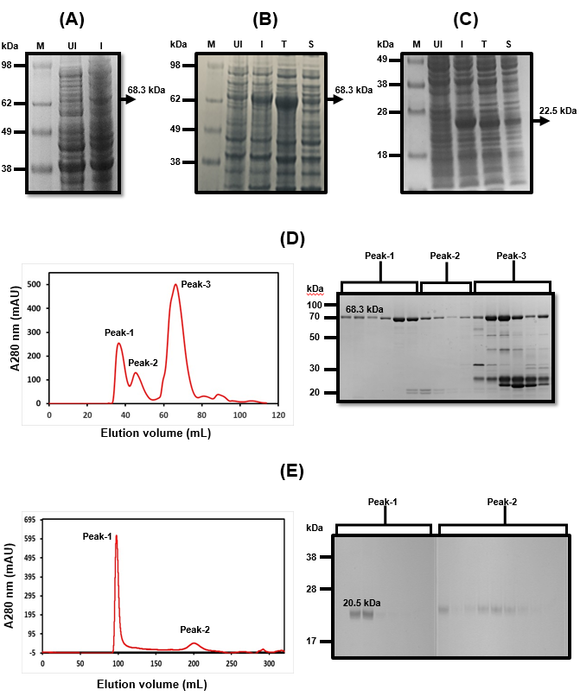
Figure 1 Expression and purification of full-length His6-NS3 and non-structural protein 4a-non-structural protein 3 protease domain. A: Analysis of the full-length His₆–NS3 protein (68.3 kDa) expressed in Escherichia coli BL21 (DE3) using pET11a-His₆-NS3. Lane M: SeeBlueTM Pre-Stained Protein Marker (LC5625); Lane UI: Uninduced BL21 (DE3) cells and Lane I: Induced BL21 (DE3) cells; B: Analysis of soluble and insoluble fractions of the His₆–NS3 protein expressed in E. coli BL21-CodonPlus (DE3)-RIL cells using pET11a-His₆-NS3. Lane M: Invitrogen Cat 1891868 See Blue® Plus2 Pre-Stained ladder; Lane UI: Uninduced cells; Lane I: Induced cells; Lane T: Total cell lysate of induced cells; Lane S: Soluble fraction of lysed cells; C: Analysis of soluble and insoluble fractions of the His₇–non-structural protein 4a-non-structural protein 3 (NS4A-NS3) protease domain expressed in E. coli BL21 (DE3) cells using pET11a-His₇-NS4A-NS3. Lane M: SeeBlueTM Pre-Stained Protein Marker (LC5625); Lane UI: Uninduced cells; Lane I: Induced cells; Lane T: Total cell lysate of induced cells; Lane S: Soluble fraction of lysed cells; D: Analysis of the Ni-NTA His₆–NS3 protein by gel filtration, presence of proteins in peak 1, 2 and 3 is analyzed by sodium dodecyl sulfate polyacrylamide gel electrophoresis; and E: Analysis of the native NS4–NS3 protease domain by gel filtration, presence of proteins in peak 1 and 2 is analyzed by sodium dodecyl sulfate polyacrylamide gel electrophoresis.
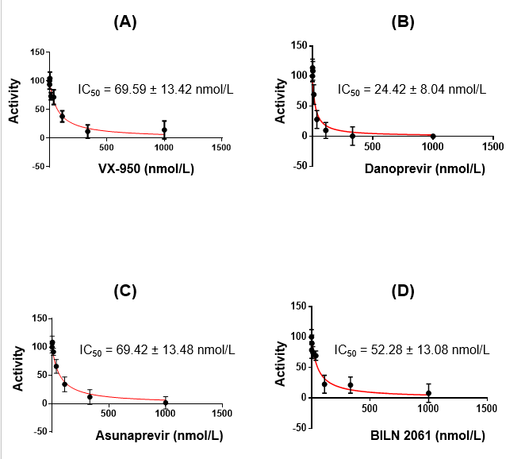
Figure 2 Inhibition of non-structural protein 4a-non-structural protein 3 protease domain by commercial inhibitors. A: VX-950; B: Danoprevir; C: Asunaprevir; and D: BILN 2061 and determination of inhibition constant (IC₅₀).
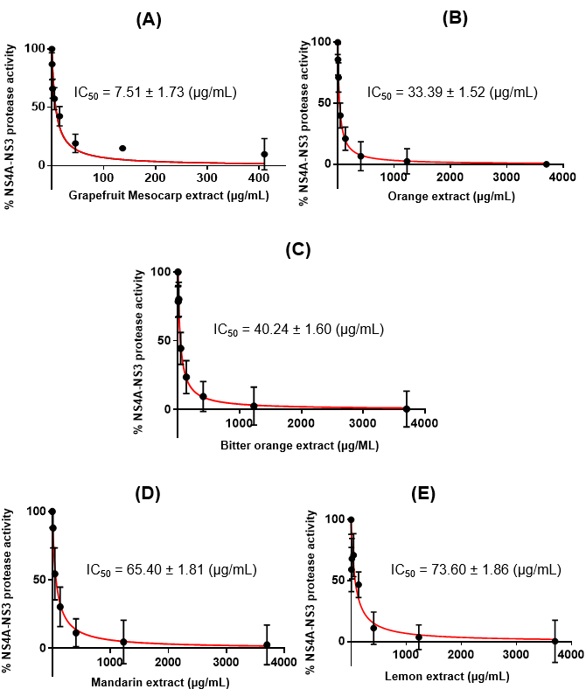
Figure 3 Percentage inhibition pattern and inhibition constant calculation of non-structural protein 4a-non-structural protein 3 protease domain by different citrus fruit extracts inhibitors. A: Grapefruit mesocarp extract; B: Orange extract; C: Bitter orange extract; D: Mandarin extract; and E: Lemon extract. IC₅₀: Inhibition constant.
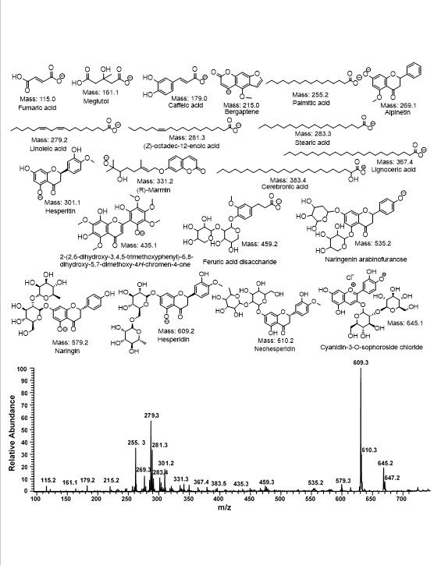
Figure 4 Electrospray ionization mass spectrometry analysis of grapefruit mesocarp extract on negative ion mode.
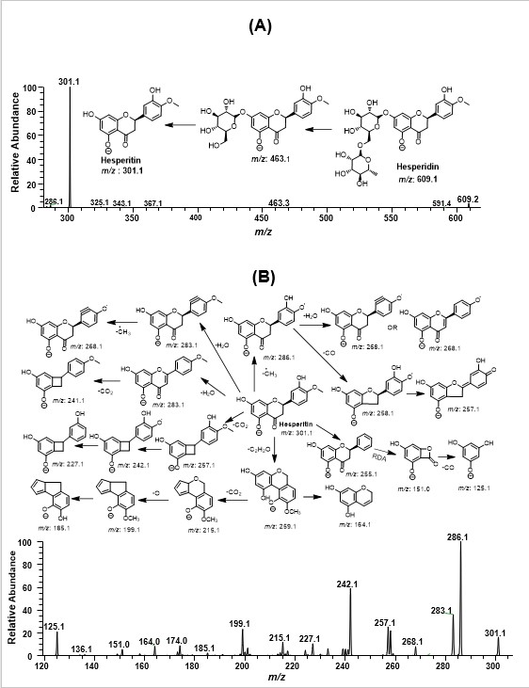
Figure 5 Proposed fragmentation of hesperidin based on quasi-electrospray ionization -MS^{n} (up to MS³) spectra in negative ion mode.

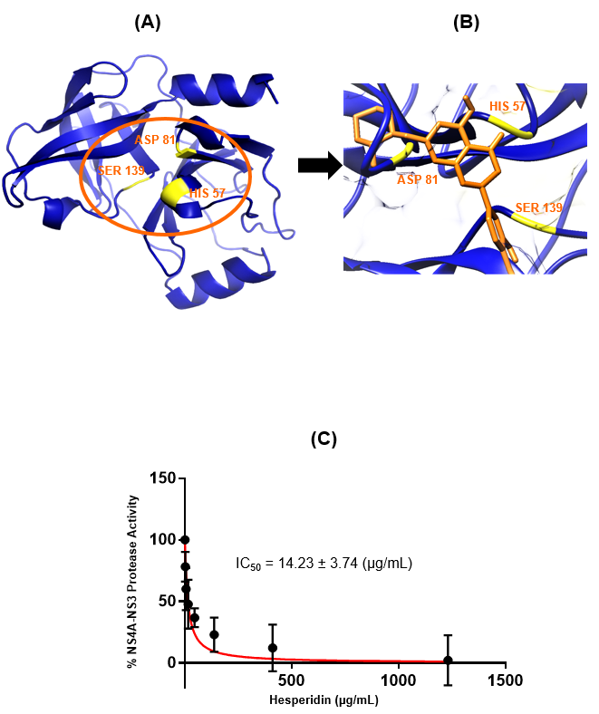
Figure 6 Inhibition studies of hepatitis C virus non-structural protein 4a-non-structural protein 3 protease domain by hesperidin. A: Hepatitis C virus (HCV) non-structural protein 4a-non-structural protein 3 (NS4A-NS3) protease domain model built by Swiss Model in the blue color cartoon. The active site residues are represented in yellow color for clarification; B: Docking of Hesperidin inside the receptor-binding site of HCV NS4A-NS3 protease domain (HIS 57, ASP 81 and SER 139). Hesperidin is represented in orange color. Blue ribbon represents protease domain of HCV NS3; and C: Inhibition constant (IC₅₀) calculation of HCV NS4A-NS3 protease domain by hesperidin.

