Name of journal: World J of Gastrointestinal Pathophysiology
ESPS Manuscript NO: 4217
Columns: Minireviews

Quality of ulcer healing of gastric ulcer: Natural product beyond acid suppression

Kangwan N et al. QOUH with natural products

Napapan Kangwan, Jong-Min Park, Eun-Hee Kim, Ki Baik Hahm

Napapan Kangwan, Jong-Min Park, Eun-Hee Kim, Ki Baik Hahm, CHA Cancer Prevention Research Center, CHA Cancer Institute, CHA University, Seoul 135-081, South Korea

Napapan Kangwan, Eun-Hee Kim, College of Pharmacy, CHA University, Pocheon 487-010, South Korea

Ki Baik Hahm, Department of Gastroenterology, CHA University Bundang Medical Center, Seongnam 463-828, South Korea

Author contributions: Kangwan N, Kim EH and Hahm KB contributed to the study design, data acquisition and analysis, and manuscript preparation; Park JM drafted and revised the article critically for important intellectual content; all authors have read and approved the final manuscript for publication.

Supported by The National Center of Efficacy Evaluation for the Development of Health Products Targeting Digestive Disorders (NCEED) Grant (A102063) from the Ministry of Health and Welfare, South Korea

Correspondence to: Professor Ki Baik Hahm, MD, PhD, AGAF, CHA Cancer Prevention Research Center, CHA University, 605, Yoeksam1-dong, Gangnam-gu, Seoul 135-081, South Korea. hahmkb@cha.ac.kr
Telephone: +82-2-34682869 Fax: +82-2-34682649

Received: June 20, 2013 Revised: September 30, 2013
Accepted: October 17, 2013

Published online:
Abstract
Gastric ulcer has been a chronic disease featured with unexpected complications including bleeding, stenosis, and perforation as well as high incidence of recurrence. Clinical treatments for gastric ulcer have allowed rapid development of potent antiulcer drugs during last several decades. Even through gastric ulcer healing is successful with a conventional treatment including H₂-receptor antagonist (H₂-RA) and proton pump inhibitor (PPI) has been essential for either ulcer healing or prevention of complications. Additionally, Helicobacter pylori eradication therapy is effective in reducing ulcer recurrence whereas leads to physiological changes in gastric mucosa which effect on ulcer healing process. However, in spite of these advancements, not a few patients suffered from recurrence or intractability in spite of continuous anti-ulcer therapy. When a new concept of quality of ulcer healing (QOUH) was initiated that should consider the reconstruction of mucosal structure and its function for preventing ulcer recurrence. Though several gastroprotectants provided these achievements of QOUH, which PPI or other acid suppressants did not accomplish, we have found gastroprotectants originated from natural products such as newer formulation from either Artemisia or S-allyl cysteine (SAC) from garlic was very effective in QOUH as well as improvement of clinical symptoms with fewer side effects. In this review, we will introduce the importance of QOUH in ulcer healing and the achievements from natural products.

© 2013 Baishideng. All rights reserved.

Key words: Quality of ulcer healing; Natural products; Gastric ulcers; Acid suppression; S-allyl cysteine; Artemisia isopropanol extract

Core tip: Clinical treatments for gastric ulcer have allowed rapid development of potent antiulcer drugs such as H₂-receptor antagonist or proton pump inhibitor, which has been essential for either ulcer healing or prevention of complications. However, many patients have still suffered from recurrence or intractability in spite of continuous anti-ulcer therapy. The concept of quality of ulcer healing is that we should consider the reconstruction of mucosal structure and its function for preventing ulcer recurrence. In this review, we will introduce the importance of the quality of ulcer healing in ulcer healing and the achievements from natural products.

Kangwan N, Park JM, Kim EH, Hahm KB. Quality of ulcer healing of gastric ulcer: Natural product beyond acid suppression

Available from:
DOI:
INTRODUCTION
Gastric ulcers affect many people in worldwide and there are characterized by the presence of deep necrotic lesion involving the entire mucosal thickness and the muscularis mucosae^{[1, 2]}. Gastric ulcer has been a chronic disease featured with repeated healing and recurrence in the original location or elsewhere of throughout the patient’s lifetime. Basically its development is a result from an imbalance between mucosal defensive mechanisms including mucus, bicarbonate, prostaglandins (PGs), and mucosal blood flow and damaging factors including acid and pepsin, in the luminal surface of gastric mucosa^{[2]}. Among these factors, the two major damaging causes implicated in gastric ulcer and ulcer recurrence are infection with Helicobacter pylori (H. pylori) and long-term use of nonsteroidal anti-inflammatory drugs (NSAIDs)^{[3, 4]}. Toxins of H. pylori and NSAIDs disturb the ulcer healing mechanism by inhibiting epithelial cell proliferation, migration and angiogenesis and by blocking growth factor triggered signaling pathways^{[5-7]}. Gastric ulcers respond to conventional treatment including H₂-RA, acid suppressant drugs and antibiotic drugs for eradication of H. pylori as well as the withdrawal of NSAIDs are intervened in treatment. However, several studies have shown that, in the ulcer healing process, either acid inhibition or H. pylori eradication insufficient for complete ulcer healing since the decrease of PGs and the increase of oxygen free radical lead to varying quality of ulcer healing and be intimately associated with ulcer recurrence^{[8, 9]}.
In 1993, Arakawa et al^{[10]} have proposed the concept and definition of quality of ulcer healing (QOUH) based on histological maturity of regenerated tissue in ulcer area, for which the additional intervention might be prerequisite including PGs, radical scavengers, and the way of spurting regeneration as well as the removal of inflammation. Since several studies have reported that low recurrence rate is intimately associated with the achievement of QOUH, efforts to achieve QOUH might impose ideal healing of ulcer as well as functional restoration. The QOUH is achieved by several kinds of gastroprotectant drugs including rebamipide, sucralfate, misoprostol, ecabet sodium, sofalcone and antacids^{[6, 11-15]}. Rebamipide is one of gastroprotectant drugs that are able to intervene effectively in the process of ulcer healing and effectively improve QOUH in chronic acetic acid ulcer model. The combination of omeprazole and rebamipide accelerated quality of ulcer healing through increasing level of PGE₂ and decreasing level of IL-8 and malondialdehyde (MDA) in gastric mucosa, but not omeprazole alone^{[6]}. In addition, rebamipide inhibited H. pylori CagA-induced effects on gastric epithelial cells, including morphologic changes associated with ZO-1, IL-8 production, and NF-κB activation in gastric epithelial cells^{[16]}.
Antacid talcid activates epidermal growth factor (EGF) and EGF-R expression in normal and ulcerated gastric mucosa. Since EGF and EGF-R are crucial for cell proliferation, migration, re-epithelialization and gland reconstruction within the scar. In addition, antacids, especially hydrotalcite are due to activation of prostaglandin synthesis; binding to and inactivation of pepsin, lysolecithin, bile acids and H. pylori toxins; activation of heat shock proteins and, activation of the genes encoding EGF, bFGF and their receptors^{[17]}, after which several studies had performed diverse studies revealing the significance of gastric defense system to overcome these limitations of acid suppressant treatment with ecabet sodium, Artemisia extracts, and sucralfate.
Recently we have identified that natural product substances have more an increasing interest because of fewer side effects, low cost and potential source for antiulcer treatment through improving QOUH and preventing ulcer recurrence. In this review, we discussed numerous natural products including isopropanol or ethanol extracts of Artemisia and extracts from garlic as well as special licorice extract and their secondary metabolites with potential gastroprotectants to archive the QOUH and resistance to ulcer recurrence.

THE MECHANISMS OF GASTRIC ULCEROGENESIS AND QOUH
Mechanism of gastric ulcerogenesis
Gastric ulcers are deep defect in gastric wall involving the mucosal thickness and the muscularis mucosae. Gastric ulcer results from the tissue necrosis induced by various conditions such as aspirin, indomethacin, bile acids, alcohol intake, ischemia, stress, aging and H. pylori infection, so called excess increment of damaging factors far exceeding defense capacity. These conditions are known to disturb the mechanisms of gastric mucosal defense and develop characteristic morphologic, ultrastructural and functional changes. When gastric mucosa expose to damaging agents, it encompasses disruption of the unstirred mucus/bicarbonate/phospholipid layer, exfoliation of the surface epithelium with loss of its barrier and the deeper gastric mucosal layers including microvascular endothelial cells, progenitor cells and parietal and chief cells. When the capillary endothelium were damaged leading to microvascular stasis which cessation of oxygen and nutrient delivery and hypoxia. Microvascular damage occurs early during mucosal injury, leading to hypoxia and necrosis of glandular cells, thus adding an ischemic component to the direct toxic injury of cells. Vasoconstriction event produced by release of vasoactive and proinflammatory mediators from damaged mast cells, macrophages and endothelial cells further impair the mucosal microcirculation and ultimately result in mucosal necrosis in form of ulcers^{[2, 17]}.

Gastric ulcer healing
An ulcer healing is an orchestrated process of filling the mucosal defect with epithelial and connective tissue cells including cell proliferation, migration, differentiation, regeneration, active angiogenesis, and extracellular matrix deposition leading to scar formation. Structure of gastric ulcer consists of ulcer margin which is epithelial tissue form by adjacent non-necrotic mucosa, and the granulation tissue which is connective tissue^{[2]} as shown in Figure 1. At the ulcer margin, epithelial cells proliferate and migrate onto the granulation tissue to cover (re-epithelialize) the ulcer and initiate reconstruction of the glands within the ulcer scar.
The processes of re-epithelialization and gland reconstruction are controlled by growth factors including EGF, hepatocyte growth factor (HGF) and insulin like growth factor-1 (IGF-1) as well as trefoil factors including pS2, TFF2, and ITF, prostaglandins generated through activated cyclooxygenase-2 (COX-2), and other cytokines produced locally by regenerating cells in an orderly and integrated manner. These factors, mainly EGF and prostaglandins, trigger cell proliferation via signal transduction pathways involving both direct activation and transactivation of the EGF receptor. Granulation tissue develops at the ulcer base. It consists of fibroblasts, macrophages and proliferating endothelial cells forming microvessels under the control of angiogenic growth factors including vascular endothelial growth factor (VEGF), bFGF and angiopoietins. The angiogenesis is essential for the restoration of the blood microcirculation in the mucosa and is thus crucial for oxygen and nutrient supply.
The major mechanism underlying the activation of angiogenic growth factors and expression of their receptors is hypoxia, which activates the transcription factor, hypoxia-inducible factor 1 (HIF-1α). HIF-1α, in turn, up-regulates VEGF transcriptional expression and thus increases the local production of VEGF essential for angiogenesis. The final outcome of the healing process reflects a dynamic interaction between the epithelial component from the “healing” zone at the ulcer margin and the connective tissue component (including microvessels) originating from the granulation tissue and from bone marrow derived stem cells attracted to the site of injury^{[2, 17]}.

Gastric ulcer recurrence
Numerous neutrophils and macrophages persist in and beneath the regenerated epithelium even after ulcer healing, basis for ulcer recurrence. This persistent chronic inflammation may have a key role in causing future ulcer recurrence. Watanabe et al^{[18]} have demonstrated that inflammatory cytokines, IL-1β and tumor necrosis factor (TNF)-α, administered systemically in rats with macroscopically healed gastric ulcer, cause ulcer recurrence at the site of the previous ulcer. In this model of gastric ulcer recurrence have found that increased expression of adhesion molecules, intercellular adhesion molecule ICAM-1 in endothelial cells and leukocytic β2 integrins, lymphocyte function-associated antigen and Mac-1 in leukocytes, and cytokines, IL-1β and TNF-α, and chemokine, monocyte chemotactic protein (MCP)-1. This increase occurred in the regenerated tissue of the healed ulcer site, ulcer scar, 12 h after injection of an inflammatory cytokine, and was followed by massive infiltration of macrophages and neutrophils, ultimately resulting in ulcer recurrence. Anti-neutrophil antiserum prevents ulcer recurrence in this model, suggesting that neutrophils which producing noxious protease and active oxygen species, are the final mediator of tissue injury. These molecules regulate migration of neutrophils from arterioles into the interstitial space. Antibody against MCP-1 prevents gastric ulcer recurrence in this model, suggesting that the overexpression of MCP-1 in resident macrophages accumulated in the interstitial space of the ulcer scar is a first step in the mechanism of ulcer recurrence, because neutrophils and macrophages infiltrate the interstitial space of the ulcer scar only after overexpression of MCP-1^{[19]}.

FACTORS AFFECTING ON “QOUH”
Tarnawski et al^{[1]} and Arakawa et al^{[10]} have first proposed the concept of QOUH. Since QOUH is defined as histological maturity of regenerated tissue replaced at an ulcer site, evaluation of QOUH should be done to assess functional and endoscopic maturity additionally to histological maturity^{[10]}. High QOUH is ideal ulcer healing featuring with the fine granular ulcer scar, high functional restoration of mucosa and granulation tissue, and the resistance to recurrence^{[10]}. In clinical study, QOUH has assessed by chromoendoscopy. The recurrence is minimum from high quality of ulcer scar (flat scar), while it frequently occur from poor one (nodular scar)^{[20]}. Accumulation of macrophages and expression of cytokines are much prominent in poor quality scar compared to high quality scar. Since, acetic acid ulcer model in rat has been developed^{[21]}. This model is used a standard model for screening of new antiulcer drugs. Because this model closely resembles human ulcers in terms of both pathological features and healing mechanisms, and ulcer responds well to various antiulcer drugs^{[22]}.
NSAIDs are a major cause of ulcer complications and death in worldwide. Arakawa et al^{[23]} has demonstrated that indomethacin administered during the initial period of acetic acid-induced gastric ulcer healing affects future ulcer recurrence. Cumulative ulcer recurrence rate was significantly higher in rats initially treated with indomethacin than in controls. Increased polymorphonuclear neutrophil (PMN) infiltration was the major histologic abnormality persisting after cessation of indomethacin. Therefore, the administration of indomethacin during the initial period of the ulcer healing promoted persistent PMN infiltration and increased ulcer recurrence rates, possibly via a prostaglandin-dependent mechanism^{[23]}. On the other hand, Wang et al^{[4]} has demonstrated that the effects of aspirin on ulcer recurrence and healing quality. Aspirin was administrated by gavage from day 25 to day 54 after ulcer induction by acetic acid-induced ulcer in rat. The gastric juice volume was significantly increased in aspirin group compared with those of fasting or saline control groups while the pH, mucus, mucosal blood flow and PGE₂ were significantly decreased in aspirin treated rats compared with those of other two groups. COX-2 was significantly augmented in aspirin group compared with others. The QOUH in aspirin group was poorer than that of fasting or saline control groups. The imbalance between protective factors and aggressive factors resulted in poor QOUH and ulcer recurrence. Therefore, improvement of QOUH may contribute to decrease incidence of ulcer recurrence and development of a new antiulcer treatment.

Prostaglandins
Prostaglandins (PGs) play a critical role of regulation gastric acid secretion and maintain gastric mucosal integrity. The achievement of QOUH is thought to be PG-dependent. Exogenous PGs could reverse events involved in ulcer recurrence, inflammatory response, retarded ulcer healing, and defective angiogenesis^{[4, 13, 16]}.

Vascular endothelial growth factor (VEGF) and angiopoietin 1
Angiogenesis is crucial for gastric ulcer healing which is stimulated by VEGF and angiopoietin-1. Joe et al^{[24]} have found that local gene therapy with VEGF and Ang1 into the ulcer base, with limited duration of target gene expression, significantly increased neovascularization and accelerated ulcer healing in rats. Furthermore, Co-injection of both plasmids encoding rhVEGF 165 and rhAng1 resulted in formation of more mature vessels and more complete restoration of gastric glandular structures within the ulcer scar, reflecting better QOUH.

Heat shock protein
Heat shock protein (HSP) acts as molecular chaperones and exhibits various functions including protection against apoptosis, protease inhibition and cross-linkage to other proteins. The induction of HSPs are important for protection against apoptosis, protease inhibition, refolding, and activity of partially denatured proteins, other reports indicate that their beneficial effect may be especially important for the later phase of regeneration, when oxidative stress caused by infiltrating inflammatory cells may oppose tissue repair, signifying that HSP27 induction might be one of mechanisms lower recurrence of gastric ulcer after IL-1β in gastroprotectant administration^{[25]}.

Inflammatory cells and cytokines
The number of macrophages infiltrating scar tissue is five times higher than neutrophils in a non-flat scar, suggesting that these macrophages may play a key role in pathophysiology of QOUH, and thus future ulcer recurrence. These macrophages produce increased amounts of IL-1β, TNF-α, and MCP-1. The proinflammatory cytokines, IL-1β and TNF-α further activate and stimulate macrophages, thus constituting a self-perpetuating circuit. The increased stimulation of production of these cytokines induced by NSAIDs, stress, or H. pylori may cause these macrophages to increase cytokine production and/or release, leading in turn to attraction and accumulation of neutrophils. Neutrophils by releasing proteases and active oxygen species damage the scar tissue and induce ulcer recurrence^{[19]}.

ANTI-ULCER TREAMENT TO ACHIEVE QOUH
Clinical treatments for gastric ulcer have allowed rapid development of antiulcer drugs and gastric ulcer healing is successful with a conventional treatment including H₂-RA, PPI, and the eradication of H. pylori infection. However, numerous studies have shown that, during the ulcer healing process, either acid inhibition or H. pylori eradication is not complete to prevent relapse as well as complications, in which these treatments were found to be insufficient to remove or clear accumulated inflammations beneath ulcer scar, decreased PGs, and excessive oxidative stress, all of which affected the QOUH and ulcer recurrence. Therefore, a new concept of QOUH was initiated that should consider the reconstruction of mucosal structure and ideal functional restoration as well as clearing gastric inflammations to prevent ulcer recurrence.
Most gastric ulcer recurrence develops after complete of conventional treatment in patients whose ulcers heal with an H₂-RA than in patients treated with other drugs. Tarnawski et al^{[26]} found that inhibition of acid secretion significantly accelerates ulcer healing, however acid suppresors used alone cannot improve the quality of healing. While, combination treatment both sucralfate (sucrose aluminum sulfate) and omeprazole treatment can improve the QOUH. Stimulating actions of sucralfate on EGF and angiogenesis may be the basis for improving the QOUH^{[27, 28]}. Several kinds of gastroprotectant drugs are available in clinic including rebamipide, ecabat sodium, Artemisia extracts, that achieving QOUH and preventing ulcer recurrence. For instance, rebamipide is a gastroprotective drug that induces mucosal prostaglandin generation, accelerates ulcer healing, and reduces relapse of acetic acid ulcer model in rats. Arakawa et al^{[29]} has reported that administration of rebamipide during the initial period of acetic acid-induced gastric ulcer affected healing and future ulcer relapse. The ulcer healing rate was higher in rats given rebamipide alone or those given rebamipide and cimetidine during and after administration, but not in rats given cimetidine alone. The relapse rate was significantly lower in rats initially given rebamipide alone or those given rebamipide and cimetidine than in rats initially given cimetidine alone. Therefore, rebamipide is beneficial for improving of QOUH and reduction of future ulcer relapse^{[29]}. Additionally, rebamipide as well as omeprazole and the combination regimen may improve QOUH through increasing the level of PGE₂, decreasing the levels of IL-8 and MDA in gastric mucosa, and this may potentially result in reduced recurrence of ulcer; moreover, the combination regimen was identified as having more antiulcer effects than monotherapy^{[6]}.
Eradication of H. pylori leads to healing of acute inﬂammation of the gastric mucosa followed by changes in the gastric environment such as gastric acid secretion. Therefore, gastroprotectant drug such as repamipide should be given to post-eradication physiological changes in gastric mucosa to promote ulcer healing and prevent ulcer recurrence^{[30]}. Kato et al^{[31]} has shown that the administration of rebamipide with teprenone is combination with dual therapy on H. pylori eradication. A total of 102 H. pylori-positive gastric ulcer patients were assigned at random to two groups; in addition to dual therapy (amoxicillin 500 mg thrice daily and lansoprazole 30 mg every morning for two weeks, one group received rebamipide 100 mg thrice daily for eight weeks, while the other group received teprenone 50 mg thrice daily for eight weeks. The ulcer healing rate was 85.7% in the rebamipide group and 79.5% in the teprenone group. The eradication rate was 68.4% in the rebamipide group and 47.7% in the teprenone groups. These findings suggest that the efficacy of dual therapy may be increased by the administration of rebamipide. Lafutidine is one of antiulcer drugs with antisecretory and gastroprotective activities^{[32]}, was mediated by capsaicin-sensitive sensory neurons (CSSN). Lafutidine (30 mg/kg) significantly accelerated the ulcer healing, and the recurrence rate was much lower than that for the vehicular control. In CSSN-desensitized rats, lafutidine also accelerated the ulcer healing significantly, but the low recurrence rate shown in normal rats was counteracted. The recurrence rate of the combination of famotidine and teprenone (100 mg/kg) was lower than that of famotidine alone. Therefore, the low recurrence rate of ulcers after lafutidine treatment in rats seems to depend on the gastroprotective mechanisms involving CSSN^{[33]}.

GASTROPROTECTIVE EFFECT OF NATURAL PRODUCTS TO ACHIEVE QOUH
Natural products and their compounds are highly effective in the antiulcer treatment, possessing as gastroprotectant action and gentle on the body’s systems without any side effects. While many synthetic and prescription drugs provide symptomatic relief, they also have harsh side effects. Our previous studies have shown gastroprotectant from Artemisia ethanol extract treatment was quite efficient in either accelerating the ulcer healing at the early phase of ulcer healing or hindering the recurrence of gastric ulcer after complete ulcer healing, whereas acid suppressant was somewhat inferior in these aspect of ulcer healing compared to gastroprotectant the achievement of ideal QOUH could only be accomplished with intervention of the enhancement of gastric defense systems. Molecular bases for QOUH achievement with Artemisia treatment, which were, efficient remodeling of regenerated gastric mucosa, intervention of several growth factors, abundant gastric mucins, including trefoil proteins like trefoil peptide (pS2/TFF1), and significant suppressions of inflammatory cytokines like IL-2, TNF-α, COX-2, and nitrosative stress. Also, as mechanisms of for Artemisia extract showing resistance to ulcer recurrence, which were excellent remodeling activity, enrichments of molecular chaperones like HSP27 as well as significant decreases in inflammatory cytokines like COX-2, IL-2, and TNF-α, and quenching nitrosative stress were revealed.
In our recent study, S-allyl cysteine (SAC), an organic compound that is a natural constituent of fresh garlic, has been shown to exert anti-inflammatory and anti-oxidative effects by numerous studies, SAC significantly increased the total antioxidant concentration and decreased levels of MDA, lipid peroxidation marker in water immersion restraint stress (WIRS)-induced gastritis in vivo, suggesting that SAC prevents stress-induced gastritis through enhancing antioxidative activity. SAC significantly inhibited TNF-α-induced pro-inflammatory signaling including COX-2, inducible nitric oxide synthase, and cytosolic phospholipase A. Moreover, SAC suppressed TNF-α-induced phosphorylation and subsequent degradation of IκBα by preventing IKKβ activation, thereby inhibiting TNF-α-induced nuclear translocation of NF-κB p65. Our results suggest that SAC can be a gastroprotective agent against stress-induced gastric mucosal damage by potentiating antioxidative activity and suppressing NF-κB activation and subsequent proinflammatory cascades. Also, in acetic acid ulcer model, healing rate was higher in rats treated SAC 30 mg/kg than PPI administration as shown in Figure 2. Additionally, we have added more evidence that isopropanol extracts of Artemisia possessed higher antioxidative actions as well as anti-inflammatory actions (data not shown), inferring higher achievement of QOUH in gastric ulcer models. Therefore, though acid suppressant is gold standard treatment for gastric ulcer, the antisecretory agents alone were not sufficient for reaching QOUH, necessitating the combined use of antisecretory and gastroprotective agent for antiulcer treatment.
Other studies have shown the gastroprotective effect of Pongamia pinnata root flavonoids (PRF) that significantly inhibited ulcerative formation and increased the EGF and TGF-α expression of para-ulcer mucosa tissue and improves the EGF contents in blood serum which might be one of possible mechanisms that PRF improves QOUH^{[34]}. The stem bark of Lafoensia pacari is a traditional medicine in Brazil that is widely used for the treatment of gastroduodenal ulcers. The gastroprotective and ulcer healing of methanol extract of Lafoensia pacari (MELP) were evaluated using ethanol, indomethacin, cold-restraint stress-induced and acetic acid ulcer models in experimental animals. This study has shown that MELP possesses preventive and curative effects against gastric ulcer. These effects are partly dependent on its antioxidant, antisecretory properties and inhibition of pro-inﬂammatory cytokines and independent of gastric motility and mucus secretion^{[35]}. The ethanolic extract (EET) of roots from Arctium lappa (bardana) has shown that accelerates the healing of acetic acid-induced gastric ulcer in rat. Oral administration of EET reduced the gastric lesion area, and promoted regeneration of the gastric mucosa. EET also restored the superoxide dismutase activity, prevented the reduction of glutathione levels, reduced lipid hydroperoxides levels, inhibited the myeloperoxidase activity and reduced the microvascular permeability. In addition, EET reduced the free radical generation and increased scavenging of 2,2-diphenyl-1-picrylhydrazyl (DPPH) free radicals in vitro. Furthermore, intraduodenal EET decreased volume and acidity of gastric secretion. Therefore, the gastroprotective effect of EET mediated by decrease in the volume and total acidity of gastric secretion, cell proliferation, reduction of inﬂammatory process and antioxidant-dependent mechanisms^{[36]}.
Pimple et al^{[37]} has investigated that the gastroprotective effect of Luffa acutangula methanolic extract (LAM) and aqueous extract (LAW) on type II diabetes rats. LAM significantly increased mucosal glycoprotein and antioxidant enzyme level in gastric mucosa of diabetic rats than LAW. LAM was efficient in reversing the delayed healing of gastric ulcer in diabetic rats close to the normal level. LAM exhibited better ulcer healing effect than glibenclamide and LAW, because of its both antihyperglycemic and mucosal defensive actions. Morus alba is a well-known Chinese herb and is traditionally used for the prevention and treatment of several diseases which this plant possesses antidiabetic, hypolipidemic, antimicrobial, antioxidant and antiulcer activities. Five new compounds were isolated; one of these was a new steroid named albo steroid. This new compound exhibits signiﬁcant antiulcer activity in pylorus-ligation- and ethanol-induced ulcer models. Furthermore, this compound showed signiﬁcant dose-dependent reversal of ethanol-diminished activity in antioxidant enzymes, such as SOD, CAT, GPx and GSH, and reduced the ethanol-elevated levels of GR and LPO^{[38]}. Finally, VSL#3 is a probiotic preparation containing a mixture of eight bacterial species including Lactobacilli, Bifidobacteria and Streptococcus species which has been shown highly effective in accelerated gastric ulcer healing by stimulating the expression and secretion of angiogenesis promoting growth factors, primarily VEGF. The expression and protein production of VEGF was significantly increased on day 7 in the ulcerated tissues of VSL#3 treated animals. In addition, animals treated with VEGF neutralizing antibody significantly delayed gastric ulcer healing in VSL#3 treated animals^{[39]}.

CONCLUSION
We can’t ignore the principal role of acid suppressant in the treatment of gastric ulcer. Based on the experimental documentation, we suggest the combined use of acid suppressant and gastroprotectant should be considered to improve the quality of ulcer healing, facilitating rapid symptom relief, accelerated healing, and resistance to ulcer recurrence as well as complete functional restoration. In conclusion, our novel finding that gastroprotectant treatment were not merely supplementary in the treatment of gastric diseases, otherwise signifying that gastroprotectants might be essential and prerequisite for better healing, for which phytoceuticals or phytochemicals can be ideal candidate supported with safety and effectiveness.

REFERENCES
1 Tarnawski A, Stachura J, Krause WJ, Douglass TG, Gergely H. Quality of gastric ulcer healing: a new, emerging concept. J Clin Gastroenterol 1991; 13 Suppl 1: S42-S47 [PMID: 1719066]
2 Tarnawski AS. Cellular and molecular mechanisms of gastrointestinal ulcer healing. Dig Dis Sci 2005; 50 Suppl 1: S24-S33 [PMID: 16184417 DOI: 10.1007/s10620-005-2803-6]
3 Hirayama F, Takagi S, Kusuhara H, Iwao E, Yokoyama Y, Ikeda Y. Induction of gastric ulcer and intestinal metaplasia in mongolian gerbils infected with Helicobacter pylori. J Gastroenterol 1996; 31: 755-757 [PMID: 8887049]
4 Wang GZ, Huang GP, Yin GL, Zhou G, Guo CJ, Xie CG, Jia BB, Wang JF. Aspirin can elicit the recurrence of gastric ulcer induced with acetic acid in rats. Cell Physiol Biochem 2007; 20: 205-212 [PMID: 17595529 DOI: 10.1159/000104167]
5 Jones MK, Wang H, Peskar BM, Levin E, Itani RM, Sarfeh IJ, Tarnawski AS. Inhibition of angiogenesis by nonsteroidal anti-inflammatory drugs: insight into mechanisms and implications for cancer growth and ulcer healing. Nat Med 1999; 5: 1418-1423 [PMID: 10581086 DOI: 10.1038/70995]
6 Pai R, Wyle FA, Cover TL, Itani RM, Domek MJ, Tarnawski AS. Helicobacter pylori culture supernatant interferes with epidermal growth factor-activated signal transduction in human gastric KATO III cells. Am J Pathol 1998; 152: 1617-1624 [PMID: 9626065]
7 Tarnawski AS, Jones MK. Inhibition of angiogenesis by NSAIDs: molecular mechanisms and clinical implications. J Mol Med (Berl) 2003; 81: 627-636 [PMID: 13679997 DOI: 10.1007/s00109-003-0479-y]
8 Tarnawski A, Hollander D, Krause WJ, Dabros W, Stachura J, Gergely H. "Healed" experimental gastric ulcers remain histologically and ultrastructurally abnormal. J Clin Gastroenterol 1990; 12 Suppl 1: S139-S147 [PMID: 2212540]
9 Niv Y. H pylori recurrence after successful eradication. World J Gastroenterol 2008; 14: 1477-1478 [PMID: 18330934]
10 Arakawa T, Kobayashi K. Quality of ulcer healing--a new concept to rank healed peptic ulcers. Gastroenterol Jpn 1993; 28 Suppl 5: 158-162 [PMID: 8103020]
11 Masuelli L, Tumino G, Turriziani M, Modesti A, Bei R. Topical use of sucralfate in epithelial wound healing: clinical evidences and molecular mechanisms of action. Recent Pat Inflamm Allergy Drug Discov 2010; 4: 25-36 [PMID: 19832693]
12 Kato T, Araki H, Onogi F, Ibuka T, Sugiyama A, Tomita E, Nagaki M, Moriwaki H. Clinical trial: rebamipide promotes gastric ulcer healing by proton pump inhibitor after endoscopic submucosal dissection--a randomized controlled study. J Gastroenterol 2010; 45: 285-290 [PMID: 19957195 DOI: 10.1007/s00535-009-0157-0]
13 Qi Z, Jie L, Haixia C, Xiaoying Z. Effect of rebamipide on quality of peptic ulcer healing in rat. Dig Dis Sci 2009; 54: 1876-1883 [PMID: 19082723 DOI: 10.1007/s10620-008-0577-3]
14 Shimoyama T, Fukuda S, Liu Q, Nakaji S, Munakata A, Sugawara K. Ecabet sodium inhibits the ability of Helicobacter pylori to induce neutrophil production of reactive oxygen species and interleukin-8. J Gastroenterol 2001; 36: 153-157 [PMID: 11291877]
15 Tarnawski AS, Tomikawa M, Ohta M, Sarfeh IJ. Antacid talcid activates in gastric mucosa genes encoding for EGF and its receptor. The molecular basis for its ulcer healing action. J Physiol Paris 2000; 94: 93-98 [PMID: 10791688]
16 Lee KH, Kim JY, Kim WK, Shin DH, Choi KU, Kim DW, Lee WJ, Choi JH, Lee SH, Kim GH, Song GA, Jeon TY, Kim CD, Hong KW, Park do Y. Protective effect of rebamipide against Helicobacter pylori-CagA-induced effects on gastric epithelial cells. Dig Dis Sci 2011; 56: 441-448 [PMID: 20556513 DOI: 10.1007/s10620-010-1299-x]
17 Tarnawski A, Ahluwalia A, Jones MK. Gastric cytoprotection beyond prostaglandins: cellular and molecular mechanisms of gastroprotective and ulcer healing actions of antacids. Curr Pharm Des 2013; 19: 126-132 [PMID: 22950493]
18 Watanabe T, Higuchi K, Tominaga K, Fujiwara Y, Arakawa T. Acid regulates inflammatory response in a rat model of induction of gastric ulcer recurrence by interleukin 1beta. Gut 2001; 48: 774-781 [PMID: 11358894]
19 Arakawa T, Watanabe T, Tanigawa T, Tominaga K, Fujiwara Y, Morimoto K. Quality of ulcer healing in gastrointestinal tract: its pathophysiology and clinical relevance. World J Gastroenterol 2012; 18: 4811-4822 [PMID: 23002355 DOI: 10.3748/wjg.v18.i35.4811]
20 Si JM, Cao Q, Wu JG. Quality of gastric ulcer healing evaluated by endoscopic ultrasonography. World J Gastroenterol 2005; 11: 3461-3464 [PMID: 15948255]
21 Takagi K, Okabe S, Saziki R. A new method for the production of chronic gastric ulcer in rats and the effect of several drugs on its healing. Jpn J Pharmacol 1969; 19: 418-426 [PMID: 5307474]
22 Okabe S, Amagase K. An overview of acetic acid ulcer models--the history and state of the art of peptic ulcer research. Biol Pharm Bull 2005; 28: 1321-1341 [PMID: 16079471]
23 Arakawa T, Watanabe T, Fukuda T, Higuchi K, Takaishi O, Yamasaki K, Kobayashi K, Tarnawski A. Indomethacin treatment during initial period of acetic acid-induced rat gastric ulcer healing promotes persistent polymorphonuclear cell-infiltration and increases future ulcer recurrence. Possible mediation of prostaglandins. Dig Dis Sci 1996; 41: 2055-2061 [PMID: 8888721]
24 Jones MK, Kawanaka H, Baatar D, Szabó IL, Tsugawa K, Pai R, Koh GY, Kim I, Sarfeh IJ, Tarnawski AS. Gene therapy for gastric ulcers with single local injection of naked DNA encoding VEGF and angiopoietin-1. Gastroenterology 2001; 121: 1040-1047 [PMID: 11677194]
25 Young Oh T, Ok Ahn B, Jung Jang E, Sang Park J, Jong Park S, Wook Baik H, Hahm KB. Accelerated Ulcer Healing and Resistance to Ulcer Recurrence with Gastroprotectants in Rat Model of Acetic Acid-induced Gastric Ulcer. J Clin Biochem Nutr 2008; 42: 204-214 [PMID: 18545642 DOI: 10.3164/jcbn.2008030]
26 Arakawa T, Kobayashi K, Dajani EZ. Refractory peptic ulcers. J Assoc Acad Minor Phys 1992; 3: 95-102 [PMID: 1386767]
27 Tsukamoto Y, Tsuchida T, Goto H, Hase S, Arisawa T, Niwa Y. Short report: effect of sucralfate on angiogenesis in granulation tissue of acetic acid-induced gastric ulcers in rats. Aliment Pharmacol Ther 1993; 7: 581-584 [PMID: 7506583]
28 Szabo S, Vattay P, Scarbrough E, Folkman J. Role of vascular factors, including angiogenesis, in the mechanisms of action of sucralfate. Am J Med 1991; 91: 158S-160S [PMID: 1715670]
29 Arakawa T, Watanabe T, Fukuda T, Yamasaki K, Kobayashi K. Rebamipide, novel prostaglandin-inducer accelerates healing and reduces relapse of acetic acid-induced rat gastric ulcer. Comparison with cimetidine. Dig Dis Sci 1995; 40: 2469-2472 [PMID: 7587834]
30 Terano A, Arakawa T, Sugiyama T, Yoshikawa T, Haruma K, Asaka M, Shimosegawa T, Sakaki N, Ishii H, Sakamoto C, Takahashi S, Kinoshita Y, Fujioka T, Kobayashi K. A pilot study to evaluate a new combination therapy for gastric ulcer: Helicobacter pylori eradication therapy followed by gastroprotective treatment with rebamipide. J Gastroenterol Hepatol 2006; 21: 103-109 [PMID: 16706820 DOI: 10.1111/j.1440-1746.2005.04191.x]
31 Kato M, Asaka M, Sugiyama T, Kudo M, Nishikawa K, Sukegawa M, Hokari K, Katagiri M, Sato F, Kagaya H, Takeda H. Effects of rebamipide in combination with lansoprazole and amoxicillin on Helicobacter pylori-infected gastric ulcer patients. Dig Dis Sci 1998; 43: 198S-202S [PMID: 9753250]
32 Higuchi K, Watanabe T, Tominaga K, Shiba M, Nakagawa K, Uno H, Kitada K, Satoh H, Chono S, Oshitani N, Fujiwara Y, Arakawa T. Lafutidine can improve the quality of gastric ulcer healing in humans: a randomized, controlled, multicenter trial. Inflammopharmacology 2006; 14: 226-230 [PMID: 17186182 DOI: 10.1007/s10787-006-0299-0]
33 Onodera S, Tanaka M, Aoyama M, Arai Y, Inaba N, Suzuki T, Nishizawa A, Shibata M, Sekine Y. Antiulcer effect of lafutidine on indomethacin-induced gastric antral ulcers in refed rats. Jpn J Pharmacol 1999; 80: 229-235 [PMID: 10461768]
34 Liu KY, Zhu Y, Huang XZ. [Effect of Pongamia pinnata root flavonoids on the quality of ulcer healing and expression of EGF and TGF-alpha in the rat model of gastric ulcer induced by acetic acid]. Zhongguo Ying Yong Sheng Li Xue Za Zhi 2012; 28: 435-438 [PMID: 23252298]
35 Tamashiro Filho P, Sikiru Olaitan B, Tavares de Almeida DA, Lima JC, Marson-Ascêncio PG, Donizeti Ascêncio S, Rios-Santos F, Martins DT. Evaluation of antiulcer activity and mechanism of action of methanol stem bark extract of Lafoensia pacari A. St.-Hil. (Lytraceae) in experimental animals. J Ethnopharmacol 2012; 144: 497-505 [PMID: 23069941 DOI: 10.1016/j.jep.2012.09.019]
36 da Silva LM, Allemand A, Mendes DA, Dos Santos AC, André E, de Souza LM, Cipriani TR, Dartora N, Marques MC, Baggio CH, Werner MF. Ethanolic extract of roots from Arctium lappa L. accelerates the healing of acetic acid-induced gastric ulcer in rats: Involvement of the antioxidant system. Food Chem Toxicol 2013; 51: 179-187 [PMID: 23036453 DOI: 10.1016/j.fct.2012.09.026]
37 Pimple BP, Kadam PV, Patil MJ. Protective effect of Luffa acutangula extracts on gastric ulceration in NIDDM rats: role of gastric mucosal glycoproteins and antioxidants. Asian Pac J Trop Med 2012; 5: 610-615 [PMID: 22840448 DOI: 10.1016/S1995-7645(12)60126-6]
38 Ahmad A, Gupta G, Afzal M, Kazmi I, Anwar F. Antiulcer and antioxidant activities of a new steroid from Morus alba. Life Sci 2013; 92: 202-210 [PMID: 23270943 DOI: 10.1016/j.lfs.2012.11.020]
39 Dharmani P, De Simone C, Chadee K. The probiotic mixture VSL#3 accelerates gastric ulcer healing by stimulating vascular endothelial growth factor. PLoS One 2013; 8: e58671 [PMID: 23484048 DOI: 10.1371/journal.pone.0058671]

P-Reviewers Leung FW, Kim BW, Rocha JBT S-Editor Wen LL L-Editor E-Editor

NSAIDs, H.pylori, gastric acid, stress

Mucosa
Muscularis mucosae
Submucosa
Muscularis
Granulation tissue
Ulcer margin

Re-epithelialization and gland reconstruction
-Growth factors : EGF, HGF,
IGF-1, TFF
-Cytokines: Il-1β, TNF-α,
MCP-1
Angiogenesis
-VEGF, bFGF, angiopoietins

Vessels

Migration and proliferation
connective tissue cells.
-Growth factors : TGFβ, PDGF,EGF-Cytokines: Il-1β, TNF-α

Figure 1 Schematic representation of intracellular pathway on ulcer healing mechanism. SAC: Artemisia or S-allyl cysteine; PPI: Roton pump inhibitor; NSAIDs: Nonsteroidal anti-inflammatory drugs; TNF-α: Tumor necrosis factor-α; MCP-1: Monocyte chemotactic protein-1; EGF: Epidermal growth factor; HGF: Hepatocyte growth factor; VEGF: Vascular endothelial growth factor; IL-1β: Interleukin-1β; IGF-1: Insulin like growth factor-1.

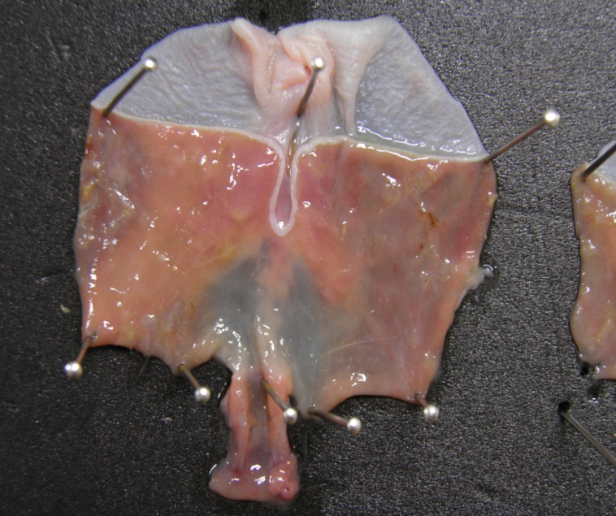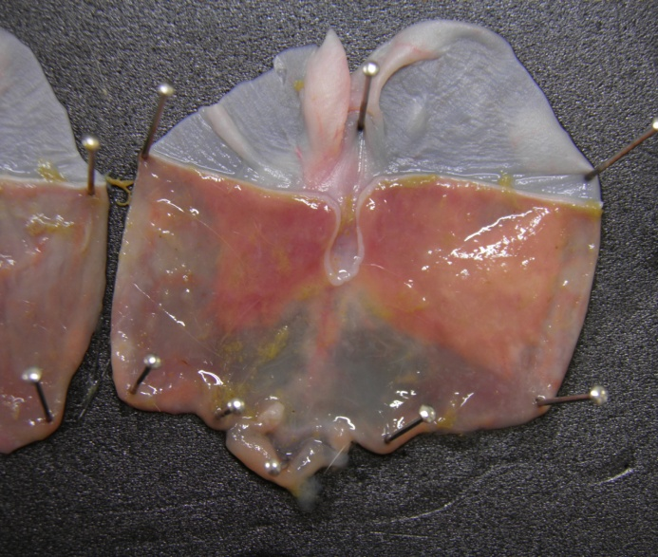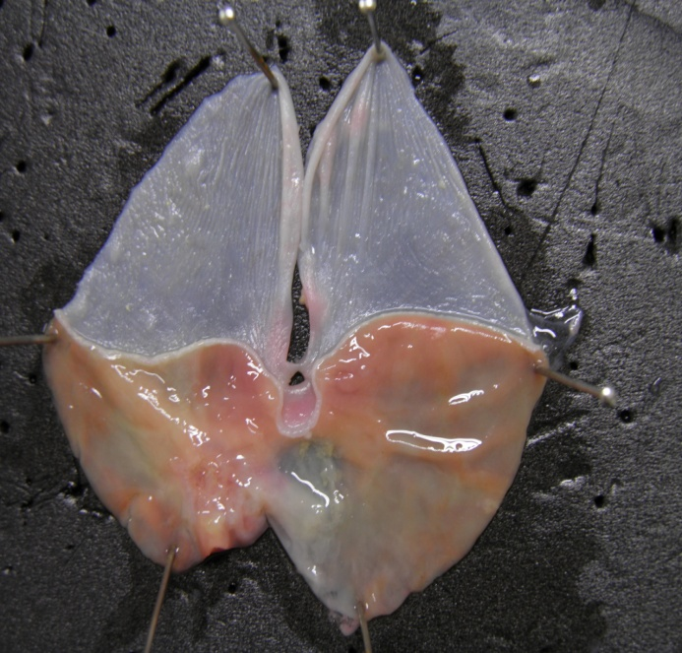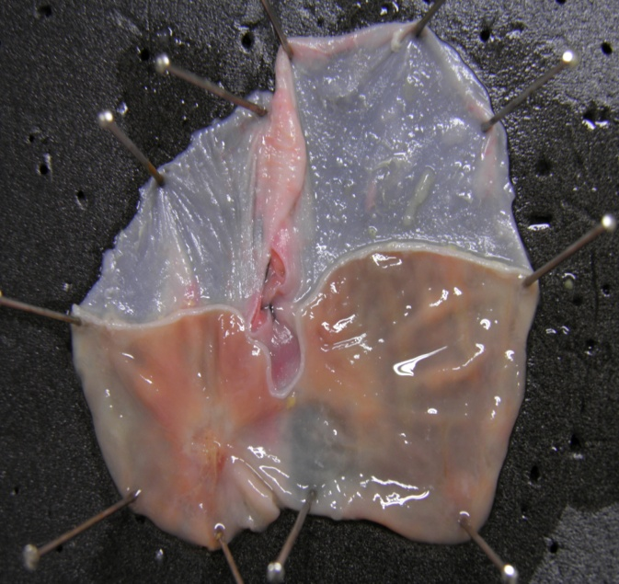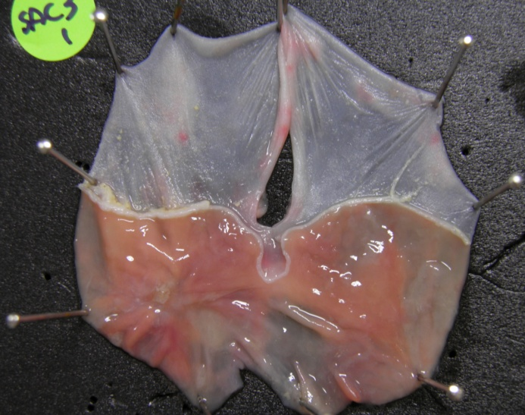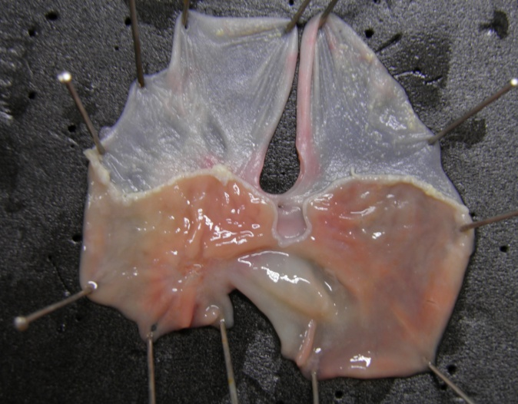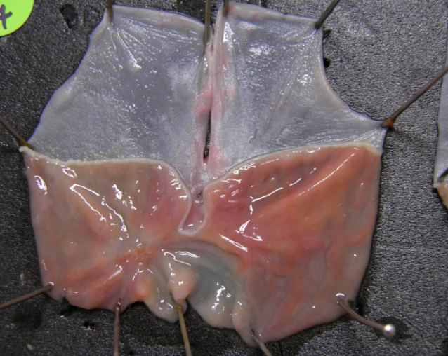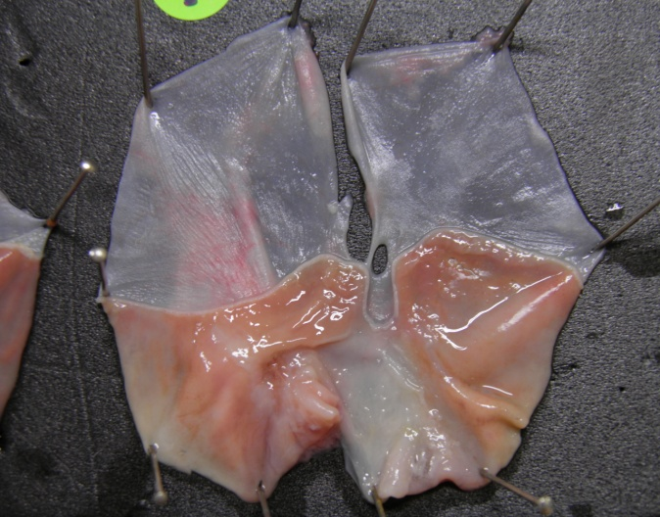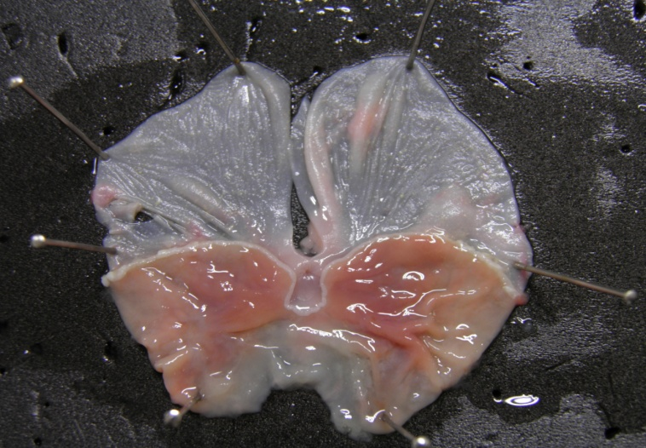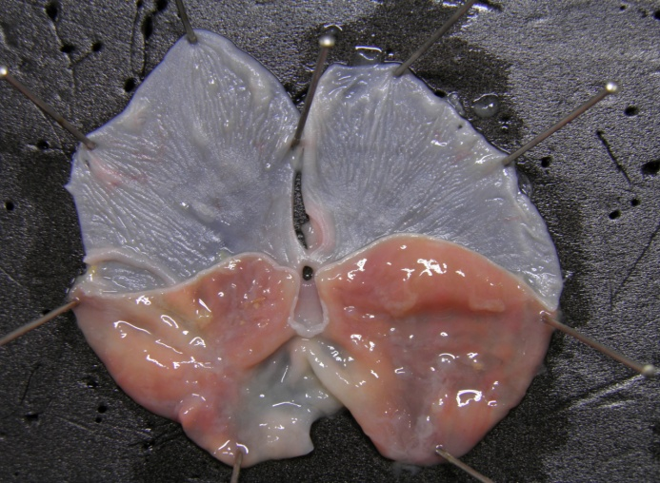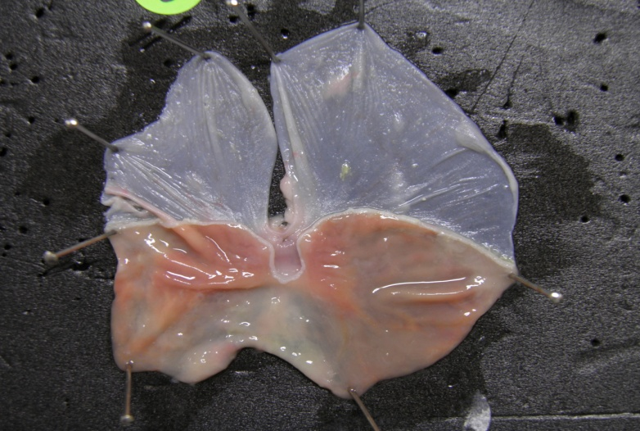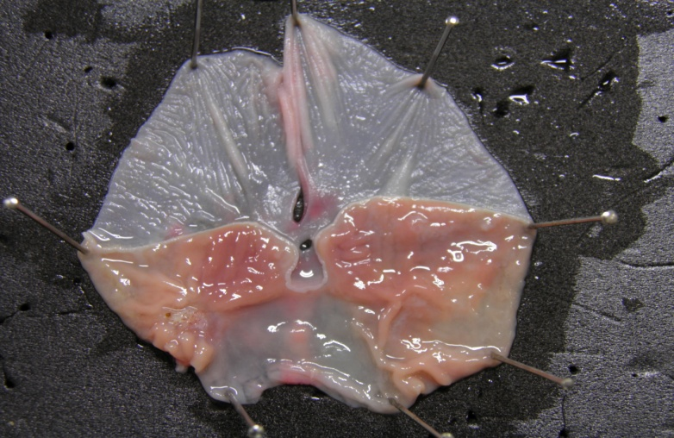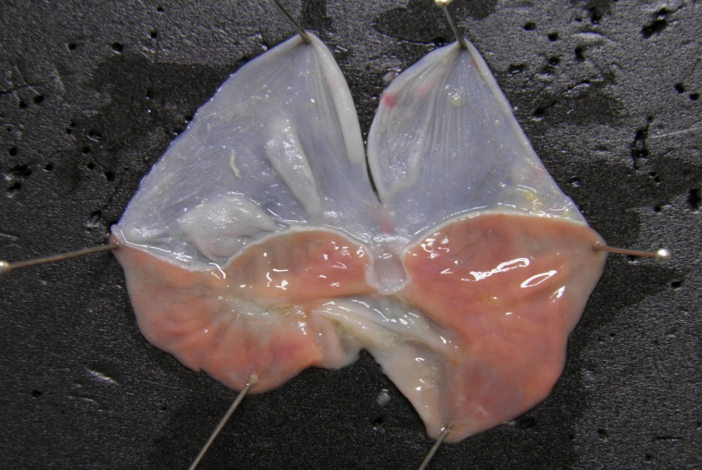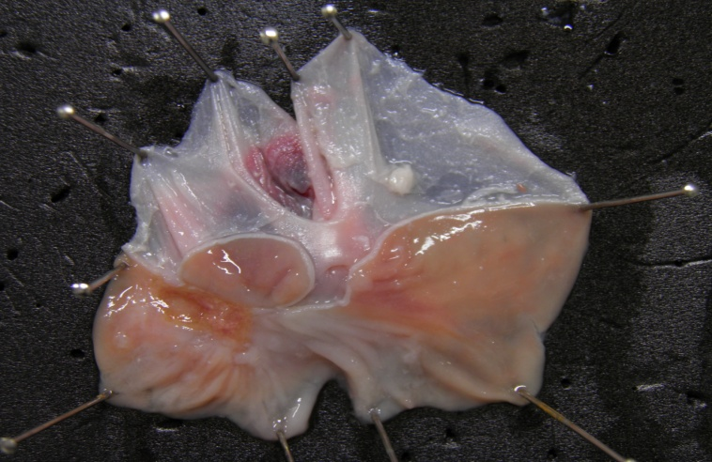
Normal
-
SAC 3mg/kg
SAC 30 mg/kg
PPI 10mg/kg
Acetic acid-induced gastric ulceration (4 weeks)

Figure 2 Gross features of gastric ulcer stage assessed at 4 weeks after acetic acid serosa injection according to group. SAC: Artemisia or S-allyl cysteine; PPI: Proton pump inhibitor.

