Treatment plan for gastric “indefinite for neoplasm/dysplasia" lesions could be based on predictive factors

Kang HS et al. Diagnosis in gastric ‘Indefinite for neoplasm/dysplasia’ lesion

Informed consent statement:

Patients were not required to give informed consent to the study because only medical records were used in this retrospective study.

Name: Ho Suk Kang

Signature 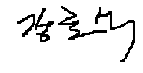 Date 2018.10.16

