Name of journal: World Journal of Clinical Cases
Manuscript NO.: 54804
Manuscript Type: CASE REPORT

Novel approach for the diagnosis of occult cytomegalovirus cholangitis after pediatric liver transplantation: A case report

Liu Y et al. Occult cytomegalovirus cholangitis after pediatric LT

Ying Liu, Li-Ying Sun, Zhi-Jun Zhu, Wei Qu

Ying Liu, Zhi-Jun Zhu, Wei Qu, Liver Transplantation Center, National Clinical Research Center for Digestive Diseases, Beijing Friendship Hospital, Capital Medical University, Beijing 100050, China

Li-Ying Sun, Intensive Care Unit, Beijing Friendship Hospital, Capital Medical University, Beijing 100050, China

Author contributions: Sun LY conceived and designed the study; Liu Y was involved in concept/design, data collection, data analysis/interpretation, drafting the article and critical revision of the manuscript; Zhu ZJ and Qu W participated in performance of the research; all authors issued final approval for the version to be submitted.

Supported by the Beijing Municipal Science and Technology Commission, No. Z181100001718220.

Corresponding author: Li-Ying Sun, MD, PhD, Chief Doctor, Professor, Intensive Care Unit, National Clinical Research Center for Digestive Diseases, Beijing Friendship Hospital, Capital Medical University, Yongan Road No.95, Xicheng District, Beijing 100050, China. sunxlx@outlook.com

Received: March 1, 2020
Revised: May 9, 2020
Accepted: May 21, 2020
Published online: June 26, 2020

Abstract
BACKGROUND
Cytomegalovirus (CMV) infection is a common infection in liver transplant recipients, which is related to chronic rejection and biliary complications. It is often diagnosed based on serum CMV-DNA or CMV pp65. To our knowledge, this is the first report of the successful treatment of occult CMV cholangitis in a pediatric liver transplantation (LT) recipient.

CASE SUMMARY
A 7-mo-old baby girl received LT due to biliary atresia and cholestasis cirrhosis. At 1 mo following LT, the patient suffered from aggravated jaundice with no apparent cause. As imaging results showed intrahepatic and extrahepatic bile duct dilatation, the patient was diagnosed with biliary complications and percutaneous cholangiography and biliary drainage was performed. However, there was little biliary drainage and her liver function deteriorated. CMV-DNA was isolated from the bile with the surprising outcome that 3 × 10⁶ copies/mL were present, whereas the CMV-DNA in serum was negative. Following antiviral therapy with ganciclovir, she gradually recovered and bilirubin decreased to normal levels. During the 4-year follow-up period, her liver function remained normal.

CONCLUSION
Bile CMV sampling can be used for the diagnosis of occult CMV infection, especially in patients with negative serum CMV-DNA and CMV pp65. Testing for CMV in the biliary tract may serve as a novel approach for the diagnosis of cholestasis post-LT. Timely diagnosis and treatment will decrease the risk of graft loss.

Key words: Occult cytomegalovirus cholangitis; Biliary complications; Pediatric; Liver transplantation; Bile cytomegalovirus-DNA detection; Case report

Citation: Liu Y, Sun LY, Zhu ZJ, Qu W. Novel approach for the diagnosis of occult cytomegalovirus cholangitis after pediatric liver transplantation: A case report. World J Clin Cases 2020; 8(12): 2597-2602
URL: https://www.wjgnet.com/2307-8960/full/v8/i12/2597.htm
DOI: https://dx.doi.org/10.12998/wjcc.v8.i12.2597

Core tip: Cytomegalovirus (CMV) is related to chronic rejection and biliary complications that can occur after liver transplantation. Although often treated prophylactically, CMV infection and CMV disease still remain a challenge. Here we report the successful treatment of occult CMV cholangitis in a pediatric liver transplantation recipient. Our study suggests that testing for CMV in the biliary tract especially in patients with negative serum CMV-DNA and CMV pp65 may be a novel approach for the diagnosis of occult CMV cholangitis after pediatric liver transplantation. Timely diagnosis and treatment will decrease the risk of graft loss.

INTRODUCTION
Biliary complications represent one of the most prevalent problems after liver transplantation (LT) and are the main cause of liver retransplantation^{[1,2]}. Biliary complications post-LT can be the result of many factors, including surgical techniques, local ischemia, infection and immune injury.
Cytomegalovirus (CMV) infection is a common infection in liver transplant recipients. It can occur in the liver, lungs, gut and even present as a systemic infection^{[3]}. CMV can be sensitively detected in body fluids and biopsies than in the blood. A study found that some patients were positive for biliary CMV, but negative for serum pp65 and CMV-DNA^{[4]}. Therefore, occult CMV infection can be considered a pathogenic factor in the occurrence of biliary complications. In this report, we describe the successful treatment of occult CMV cholangitis after pediatric LT which was achieved by isolating CMV-DNA from bile, which has not been reported previously.

CASE PRESENTATION
Chief complaints
A 7-mo-old baby girl who suffered from aggravated jaundice for 1 mo was admitted to our hospital.

History of present illness
The patient’s symptoms started 1 mo previously with no apparent cause. She had no fever, abdominal pain and other gastrointestinal symptoms.

History of past illness
She received a pediatric LT (donation after cardiac death) at another LT center in China due to bile acid (BA) and cholestasis cirrhosis on November 15, 2015. Her initial recovery went well and liver function returned to normal levels. On postoperative day (POD) 22, her liver function appeared abnormal for no apparent reason (Table 1). A liver biopsy was performed on POD 26. The results showed hydropic degeneration of the liver, local steatosis and cholestasis, suggesting that ischemia and drug-induced liver injury should be excluded. Moreover, abdominal ultrasound suggested that blood flow in the liver graft was normal with a small amount of effusion and no indication of bile duct dilatation. The doctors at that hospital suspected an acute rejection of her graft; therefore, she was treated with a pulse therapy of methylprednisolone and intravenous gamma globulin. However, she did not recover from aggravated jaundice and was transferred to our hospital.

Physical examination upon admission
The patient’s temperature was 36.4°C, heart rate was 104 beats per min (bpm), respiratory rate was 30 breaths per min, and blood pressure was 91/53 mmHg. Her sclera and skin were severely yellow and no abdominal tenderness was observed.

Laboratory examinations
Her liver function tests showed that alanine aminotransferase was 141 IU/L, aspartate aminotransferase was 319 IU/L, alkaline phosphatase (ALP) was 482 IU/L, gamma-glutamyl transpeptidase (GGT) was 1349 IU/L, total bilirubin (TB) was 263 μmol/L and direct bilirubin (DB) was 170 μmol/L. Albumin was normal, while cholesterol was 15.78 mmol/L and her tacrolimus trough level was 6.5 ng/mL. CMV-DNA in serum and urine were both negative.

Imaging examinations
Abdominal ultrasound showed intrahepatic and extrahepatic bile duct dilatation. Magnetic resonance cholangiopancreatography suggested an intrahepatic bile duct dilatation and biliary anastomotic stricture.

FINAL DIAGNOSIS
The patient was diagnosed with a biliary complication resulting in jaundice. Consequently, percutaneous transhepatic cholangio drainage (PTCD) was performed on POD 77. As biliary cholangiography revealed biliary anastomotic stricture, biliary drainage was completed after balloon dilatation (Figure 1). However, bile drainage volume was quite limited (about 10 mL/d) and its appearance was very pale. Her liver function did not improve after these treatments. TB increased from 200 to 240 μmol/L and DB increased from 130 to 160 μmol/L. Therefore, a liver biopsy was performed on POD 93. The results showed hydropic degeneration and cholestasis of the liver with negative CMV immunohistochemical stains (Figure 2).

TREATMENT
Although the serum CMV-DNA was negative, we collected a bile sample from PTCD drainage to test for CMV-DNA and unexpectedly found that bile CMV-DNA was 3 × 10⁶ copies/mL. Accordingly, antiviral therapy with ganciclovir was administered at a dose of 10 mg/kg/d. After 2 wk of antiviral therapy, her bilirubin, ALP and GGT began to decline.

OUTCOME AND FOLLOW-UP
After 3-wk of treatment, bile CMV-DNA was tested again and was found to be negative. The child was then discharged after removal of her PTCD tube. Her TB, DB, ALP and GGT all gradually decreased to normal levels in August 2016 (Figures 3 and 4). During the 4-year follow-up period, her liver function has been normal.

DISCUSSION
Biliary complications represent a major problem accompanying LT, with an incidence of 10%-25%^{[5,6]}. CMV infection in LT recipients has been associated with many complications and an increased risk of graft loss and death. Indirect complications of CMV include increased risk of hepatic allograft rejection and vanishing bile duct syndrome^{[7,8]}. CMV produces inflammatory responses in the vascular endothelium and bile duct, which is related to chronic rejection and biliary complications that can occur after LT^{[9,10]}. Although often treated prophylactically, CMV infection and CMV disease still remain a challenge, and continue to be a significant cause of morbidity, economic drain, and fatal disease.
Gotthardt reported that biliary CMV has been detected in LT recipients and was associated with non-anastomotic strictures^{[4]}. Occult CMV infection may be associated with the occurrence of biliary complications. Gotthardt suggested that a noteworthy association may exist between occult biliary CMV infection and the development of non-anastomotic biliary complications in orthotopic LT patients.
Chronic CMV latency in bile duct epithelial cells may lead to chronic inflammation, and thus fibrosis of the bile duct system^{[9]}. In our case, the patient’s primary disease was biliary atresia. CMV is considered to be a potential cause of the autoimmune destruction of the bile duct in biliary atresia^{[11]}. In the study by Gotthardt et al^{[4]}, biliary CMV was more common in patients with a recipient-positive status. Therefore, biliary CMV was likely to be a reactivation and not an infection. The detection of pp65 antigen and CMV-DNA in serum lacks sensitivity^{[12,13]}. Therefore, bile CMV sampling can be used for diagnosis, especially in patients with jaundice post-LT. As this was a case report, a larger sample size and multicenter investigation are needed in future studies.

CONCLUSION
To the best of our knowledge, this is the first report of the successful treatment of occult CMV cholangitis in a pediatric LT recipient. Our case suggests that detection of CMV in the bile and/or empirical treatment of CMV especially in patients with negative serum CMV-DNA and CMV pp65 may represent a potential option for the treatment of cholestasis post-LT and, in this way, decrease the risk of graft loss.

REFERENCES
1 Dubbeld J, van Hoek B, Ringers J, Metselaar H, Kazemier G, van den Berg A, Porte RJ. Biliary complications after liver transplantation from donation after cardiac death donors: an analysis of risk factors and long-term outcome from a single center. Ann Surg 2015; 261: e64 [PMID: 24401915 DOI: 10.1097/SLA.0000000000000513]
2 Nemes B, Gámán G, Doros A. Biliary complications after liver transplantation. Expert Rev Gastroenterol Hepatol 2015; 9: 447-466 [PMID: 25331256 DOI: 10.1586/17474124.2015.967761]
3 Aberg F, Mäkisalo H, Höckerstedt K, Isoniemi H. Infectious complications more than 1 year after liver transplantation: a 3-decade nationwide experience. Am J Transplant 2011; 11: 287-295 [PMID: 21219571 DOI: 10.1111/j.1600-6143.2010.03384.x]
4 Gotthardt DN, Senft J, Sauer P, Weiss KH, Flechtenmacher C, Eckerle I, Schaefer Y, Schirmacher P, Stremmel W, Schemmer P, Schnitzler P. Occult cytomegalovirus cholangitis as a potential cause of cholestatic complications after orthotopic liver transplantation? A study of cytomegalovirus DNA in bile. Liver Transpl 2013; 19: 1142-1150 [PMID: 23894112 DOI: 10.1002/lt.23713]
5 Moy BT, Birk JW. A Review on the Management of Biliary Complications after Orthotopic Liver Transplantation. J Clin Transl Hepatol 2019; 7: 61-71 [PMID: 30944822 DOI: 10.14218/JCTH.2018.00028]
6 Liu Y, Sun LY, Zhu ZJ, Wei L, Qu W, Zeng ZG. Bile microbiota: new insights into biliary complications in liver transplant recipients. Ann Transl Med 2020; 8: 354 [PMID: 32355798 DOI: 10.21037/atm.2020.02.60]
7 Dogan N, Hüsing-Kabar A, Schmidt HH, Cicinnati VR, Beckebaum S, Kabar I. Acute allograft rejection in liver transplant recipients: Incidence, risk factors, treatment success, and impact on graft failure. J Int Med Res 2018; 46: 3979-3990 [PMID: 29996675 DOI: 10.1177/0300060518785543]
8 Verma Y, Gupta E, Kumar N, Hasnain N, Bhadoria AS, Pamecha V, Khanna R. Earlier and higher rates of cytomegalovirus infection in pediatric liver transplant recipients as compared to adults: An observational study. J Lab Physicians 2018; 10: 221-225 [PMID: 29692591 DOI: 10.4103/JLP.JLP_140_17]
9 Halme L, Hockerstedt K, Lautenschlager I. Cytomegalovirus infection and development of biliary complications after liver transplantation. Transplantation 2003; 75: 1853-1858 [PMID: 12811245 DOI: 10.1097/01.TP.0000064620.08328.E5]
10 Lattanzi B, Ott P, Rasmussen A, Kudsk KR, Merli M, Villadsen GE. Ischemic Damage Represents the Main Risk Factor for Biliary Stricture After Liver Transplantation: A Follow-Up Study in a Danish Population. In Vivo 2018; 32: 1623-1628 [PMID: 30348725 DOI: 10.21873/invivo.11423]
11 Brindley SM, Lanham AM, Karrer FM, Tucker RM, Fontenot AP, Mack CL. Cytomegalovirus-specific T-cell reactivity in biliary atresia at the time of diagnosis is associated with deficits in regulatory T cells. Hepatology 2012; 55: 1130-1138 [PMID: 22105891 DOI: 10.1002/hep.24807]
12 Jang EY, Park SY, Lee EJ, Song EH, Chong YP, Lee SO, Choi SH, Woo JH, Kim YS, Kim SH. Diagnostic performance of the cytomegalovirus (CMV) antigenemia assay in patients with CMV gastrointestinal disease. Clin Infect Dis 2009; 48: e121-e124 [PMID: 19441977 DOI: 10.1086/599116]
13 Morinaga Y, Sawayama Y, Hidaka M, Mori S, Taguchi J, Takatsuki M, Eguchi S, Miyazaki Y, Yanagihara K. Diagnostic Utility of Cytomegalovirus Nucleic Acid Testing during Antigenemia-Guided Cytomegalovirus Monitoring after Hematopoietic Stem Cell Transplantation or Liver Transplantation. Tohoku J Exp Med 2019; 247: 179-187 [PMID: 30890664 DOI: 10.1620/tjem.247.179]

Footnotes
Informed consent statement: Informed written consent was obtained from the patient for publication of this report and any accompanying images.

Conflict-of-interest statement: The authors declare that they have no conflict of interest.

CARE Checklist (2016) statement: The authors have read the CARE Checklist (2016), and the manuscript was prepared and revised according to the CARE Checklist (2016).

Open-Access: This article is an open-access article that was selected by an in-house editor and fully peer-reviewed by external reviewers. It is distributed in accordance with the Creative Commons Attribution NonCommercial (CC BY-NC 4.0) license, which permits others to distribute, remix, adapt, build upon this work non-commercially, and license their derivative works on different terms, provided the original work is properly cited and the use is non-commercial. See: http://creativecommons.org/licenses/by-nc/4.0/

Manuscript source: Unsolicited Manuscript

Peer-review started: March 2, 2018
First decision: April 22, 2018
Article in press:

Specialty type: Medicine, research and experimental
Country/Territory of origin: China
Peer-review report’s scientific quality classification
Grade A (Excellent): 0
Grade B (Very good): B
Grade C (Good): C
Grade D (Fair): 0
Grade E (Poor): 0

P-Reviewer: Dinç T, Lambrecht NW S-Editor: Zhang H L-Editor: Webster JR E-Editor: Ma YJ

Figure Legends
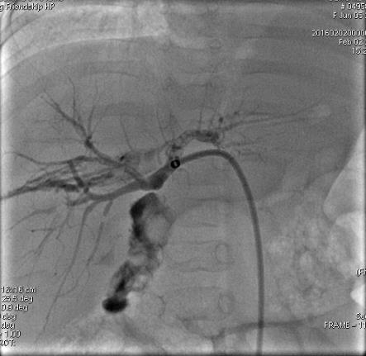
Figure 1 Biliary cholangiography showing biliary anastomotic stricture (arrow). Biliary drainage was completed after balloon dilatation on postoperative day 77.
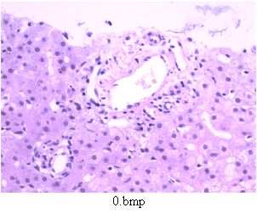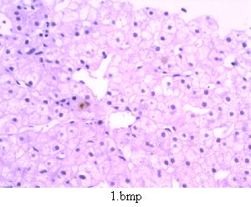
Figure 2 Liver biopsy showing hydropic degeneration and cholestasis of the liver on postoperative day 93.

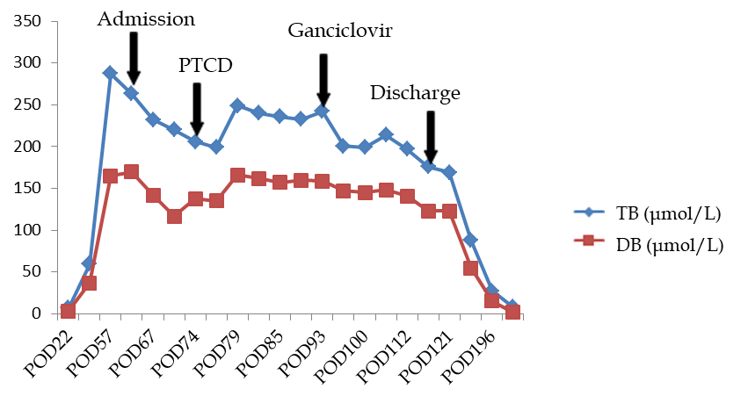
Figure 3 Changes in total bilirubin and direct bilirubin before and after treatment. PTCD: Percutaneous transhepatic cholangio drainage; TB: Total bilirubin; DB: Direct bilirubin; POD: Postoperative day.

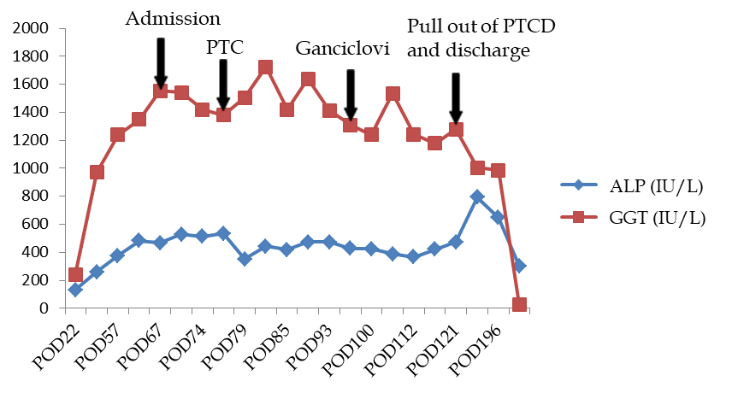
Figure 4 Changes in alkaline phosphatase and gamma-glutamyl transpeptidase before and after treatment. PTCD: Percutaneous transhepatic cholangio drainage; ALP: Alkaline phosphatase; GGT: Gamma-glutamyl transpeptidase; POD: Postoperative day.

Table 1 Variations in liver function prior to admission to our hospital
Date | POD 22 | POD 26 | POD 57
ALT (IU/L) | 71.2 | 316.9 | 104.3
AST (IU/L) | 69.7 | 331.7 | 244.8
ALP (IU/L) | 131.2 | 261 | 376
GGT (IU/L) | 242.1 | 969.8 | 1240.8
TB (μmol/L) | 6.8 | 59.56 | 287.5
DB (μmol/L) | 3.2 | 36.68 | 165.06
BA (μmol/L) | 12.96 | 240.2 | 180.21
Tacrolimus level (ng/mL) |  | 8.4
POD: Postoperative day; ALT: Alanine aminotransferase; AST: Aspartate aminotransferase; ALP: Alkaline phosphatase; GGT: Gamma-glutamyl transpeptidase; TB: Total bilirubin; DB: Direct bilirubin; BA: Bile acid.

