Name of Journal: World Journal of Orthopedics
Manuscript NO: 83507
Manuscript Type: MINIREVIEWS

Background, techniques, applications, current trends, and future directions of minimally invasive endoscopic spine surgery: A review of literature

Tang K et al. Review of endoscopic MIS

Kevin Tang, Samuel Goldman, Fedan Avrumova, Darren R Lebl

Kevin Tang, Samuel Goldman, Fedan Avrumova, Darren R Lebl, Department of Spine Surgery, Hospital for Special Surgery, New York, NY 10021, United States

Author contributions: Tang K, Goldman S, and Avrumova F did the designed the collection and assembly of data; all authors interpreted the data, writing and approved the final manuscript.

Corresponding author: Darren R Lebl, MD, Associate Professor, Department of Spine Surgery, Hospital for Special Surgery, 535 East 70th Street, New York, NY 10021, United States. research@leblspinemd.com

Received: January 28, 2023
Revised: March 2, 2023
Accepted: April 12, 2023
Published online: April 18, 2023

Abstract
Across many of the surgical specialties, the use of minimally invasive techniques that utilize indirect visualization has been increasingly replacing traditional techniques which utilize direct visualization. Arthroscopic surgery of the appendicular skeleton has evolved dramatically and become an integral part of musculoskeletal surgery over the last several decades, allowing surgeons to achieve similar or better outcomes, while reducing cost and recovery time. However, to date, the axial skeleton, with its close proximity to critical neural and vascular structures, has not adopted endoscopic techniques at as rapid of a rate. Over the past decade, increased patient demand for less invasive spine surgery combined with surgeon desire to meet these demands has driven significant evolution and innovation in endoscopic spine surgery. In addition, there has been an enormous advancement in technologies that assist in navigation and automation that help surgeons circumvent limitations of direct visualization inherent to less invasive techniques. There are currently a multitude of endoscopic techniques and approaches that can be utilized in the treatment of spine disorders, many of which are evolving rapidly. Here we present a review of the field of endoscopic spine surgery, including the background, techniques, applications, current trends, and future directions, to help providers gain a better understanding of this growing modality in spine surgery.

Key Words: Endoscopic; Spine Surgery; Applications; Minimally invasive surgery; Endoscopy; Spine

©The Author(s) 2023. Published by Baishideng Publishing Group Inc. All rights reserved.

Citation: Tang K, Goldman S, Avrumova F, Lebl DR. Background, techniques, applications, current trends, and future directions of minimally invasive endoscopic spine surgery: A review of literature. World J Orthop 2023; 14(4): 197-206
URL: https://www.wjgnet.com/2218-5836/full/v14/i4/197.htm
DOI: https://dx.doi.org/10.5312/wjo.v14.i4.197

Core Tip: Endoscopy is a rapidly evolving minimally invasive technique in the field of spine surgery. This review aims to summarize the history, current techniques, and discuss the benefits, limitations, and future directions of this minimally invasive technique.

INTRODUCTION
Minimally invasive surgery (MIS) with integration of endoscopic techniques has continued to expand its application across various surgical specialties due to its applications of smaller surgical corridors and cannulas^{[1]}. Modern endoscopic approaches allow surgeons to reduce incision size, decrease blood loss, and report less postoperative pain, however, a significant learning curve associated with its adoption does exist^{[2-6]}. Currently, most endoscopic procedures are performed within either an existing 3-dimensional (3D) cavity or the enlargement of a potential space, including endoscopy of the gastrointestinal tract, nasal sinuses, cerebral ventricles, and thoraco-abdominal compartments. However, spinal endoscopy involves a different approach as surgical manipulation within confined spaces is performed. Endoscopic spine surgery has been developed as a MIS technique for decompression in patients with lumbar disc herniation and lumbar stenosis, as decompression by lumbar spinal fusion is the gold standard treatment for a variety of lumbar degenerative diseases^{[7,8]}. Reports as early as 2008 describe the first use of endoscopic technology in fusion surgeries, specifically for transforaminal lumbar interbody fusion (TLIF) procedures^{[9]}, as previous approaches reported limitations. The first TLIF approach was described as an open technique in 1998 by Harms et al^{[10]}. This was a unilateral approach to the disc space through the ipsilateral facet joint, enabling the placement of an interbody spacer to achieve indirect decompression of impinged nerve roots^{[11]}. With technical refinements and the development of a tubular retractor, the first MIS TLIF was performed and reported as a combination of less tissue disruption and shorter recovery time resulting in reduced postoperative pain, improved clinical outcomes, and lower costs^{[9-12]}. However, recent research has identified potential limitations in the use of MIS TLIF procedures, as it has been suggested that the retraction of muscles during surgery may lead to muscle degeneration and long-term weakness^{[8]}. Although, MIS endoscopy in spine is a novel technique that may distinguish itself from other approaches, it is still in its nascency and several limitations are important to recognize such as: the steep learning curve when transitioning from traditional open surgery to endoscopic techniques^{[13]}, limited field of view and lack of resolution, thus making identification of anatomic structures difficult^{[1,14]}, and disorientation due to indirect visualization, resulting in the surgeon being unable to accommodate orientation and perspective^{[1]}. It has been proposed that the implementation of advanced optical systems and the refinement of surgical instruments could effectively mitigate the aforementioned challenges^{[15]}. As endoscopic spine surgery becomes increasingly prevalent, it is critical to understand the applications, progression and continued safety and efficacy of endoscopy in minimally invasive spine surgery. This review addresses previous and current techniques of endoscopic applications in MIS, specifically TLIF procedures, and discusses benefits, limitations, and future perspectives.

HISTORY OF ENDOSCOPIC SPINE SURGERY
The use of endoscopes in spine surgery dates back to the early 20th century, when they were first utilized for diagnostic purposes (Table 1). In 1931, Burman used arthroscopic tools to perform “myeloscopies” in cadavers which allowed direct visualization of the spinal cord and nerve roots^{[16]}. In 1936, Stern developed a tool called the “spinascope”, which was used by Pool in 1938 to visualize nerve roots of the cauda equina and their accompanying blood vessels in patients using an incision “not over 2.5 mm”^{[17,18]}. The breakthrough of fiber optic technology revolutionized the field of endoscopy during the 1970s. Prior to the 1970s, endoscopes were limited by their ability to transmit light and image quality was poor. The use of fiber optic cables in endoscopes allowed for the transmission of bright, high-quality images and enabled surgeons to visualize the inside of the body in greater detail. It also made it possible to design smaller and more flexible endoscopes, which made it easier for surgeons to access and maneuver within small and confined spaces in the body, such as the spinal canal. The foundation for endoscopic spine surgery was formed by the evolution of a needle–based technique called percutaneous endoscopic discectomy in the 1970s. In 1973, Kambin demonstrated a technique for percutaneous nonvisualized indirect spinal canal decompression—percutaneous nucleotomy-through a posterolateral approach using a Craig cannula^{[19]}. Two years later, Hijikata ran an independent study which demonstrated the same technique using a 2.6-mm cannula^{[20]}. The evolution of this technique was characterzied by the addition of the endoscope.
During the 1980’s, advancements in technology and techniques became more prominent as the introduction of TLIF was introduced by Harms and Rolinger, which was a lateral approach to the disc space, and reduced the amount of thecal sac and nerve root retraction^{[21]}. Furthermore, this technique afforded a less invasive alternative to traditional posterior lumbar interbody fusion. That following year, Forst and Hausman were the first to introduce the endoscope into the intervertebral disc space^{[22]}. Over time, Kambin published the first endoscopic view of the nucleus pulposus in 1988 and it was followed by Schreiber and Suezawa in 1989, who were the first to perform a percutaneous nucleotomy using endoscopy^{[23-25]}. In the 1990’s, advancements were made in spine endoscopy techniques and technology based on two different approaches, the extraforaminal and interlaminar approaches. A deeper understanding of the “Kambin Triangle” allowed for the expansion of endoscopic spine surgery beyond the limits of percutaneous nucleotomy. Kambin's triangle provided a pathway for the use of larger instruments and channels near foraminal pathology without risking injury to the exiting nerve^{[19-26]}. The concept of a safe zone between the exiting and traversing nerve roots in the foramen allowed endoscopic spine surgery to extend into the foramen. In 1993, Mayer and Brock introduced the use of an angled lens scope to improve visualization of annular pathology^{[26]}. In the mid 1990’s, the introduction of multichannel endoscopes with larger working channels were then introduced by Tsou et al^{[27]} and were later developed and studied in the years to come.
Furthermore, the YESS endoscope was first designed for the “inside-out” technique by Yeung in 1997, and foraminoscopy was first developed which was described by Mathews in 1996 and Ditsworth in 1998^{[29-31]}. In the same year, Harms et al^{[10]} described the first TLIF approach as an open technique, which was a unilateral approach to the disc space through the ipsilateral facet joint, enabling the placement of an interbody spacer to achieve indirect decompression of impinged nerve roots. During that same year, Kambin and Zhou^{[31]} described workflows for decompressing the lumbar nerve root through anulectomy and relieving lateral recess stenosis. After the turn of the new millennium, further developments and techniques in endoscopic spine surgery were further refined and unveiled. Hoogland introduced the “outside-in” technique using a transforaminal approach in 2003^{[32]}. Two years later, Schubert and Hoogland then described a method for transforaminal endoscopic removal of a sequestered disc fragment using reamers which enlarged the foraminal window by removing the ventral portion of the superior articular process^{[33]}. In 2007, Ruetten et al^{[34]} facilitated the direct endoscopic decompression of foraminal pathology, based on the introduction of multichannel endoscopes with larger working channels by Tsou et al^{[27]} in 1997 and several clinical studies including those by Yeung and Tsou in 2002.
More recently, studies have further examined techniques and workflow to avoid risk of exiting root injuries. In 2013, Choi et al^{[36]} reported a workflow to avoid such injury such as, measuring the distance from the exiting root to the facet at the lower disc level based on preoperative magnetic resonance imaging scans. Alternative surgical methods, such as microdiscectomy or conventional open discectomy, should be considered if the distance is too small. With current advancements in technology and refinement in techniques, risk of injury and potential barriers are underway of being well studied and understood.

TECHNIQUES IN ENDOSCOPIC SPINE SURGERY
There are various endoscopic techniques that can be used to treat spine disorders. These techniques involve using a camera to indirectly view the surgical area (Figure 1), with the camera being inserted into the body through a channel called a working channel (Figures 1 and 2). The size and number of working channels are used to classify different types of spinal endoscopy. The capabilities and benefits of these techniques depend on the size and number of working channels, with a trade-off between having larger or more channels, which can allow for the use of multiple instruments but may cause more tissue disruption, and having smaller or fewer channels, which may cause less tissue disruption but limit the use of multiple instruments. The three most common techniques are full endoscopy, microendoscopy, and biportal endoscopy (Table 2). Full endoscopy involves the use of a single working channel, which holds the endoscope and one surgical instrument in the same tubular device (Figure 2). The working channel only allows for the use of one instrument at a time, so the operator must change the instrument if they want to use a different one. The small size of the working channel means that the camera and the instrument must be moved together, with some modifications allowing for limited independent movement of the instrument's distal end. To create space around the surgical area during full endoscopy, an aqueous environment is typically used to separate tissues. One advantage of this technique is that it causes less collateral tissue damage compared to other techniques. However, the single working channel limits the ability to use multiple instruments concurrently and independently control the camera and instrument movements, which can be limiting during spine procedures. In order to retract tissue during surgery, some full endoscopy techniques use beveled working channels that allow the surgeon to use the working channel as a retractor. The size of the working channel can also limit the ability to implant devices.
Microendoscopy involves the use of a single, larger working channel that allows for the concurrent use of multiple instruments and independent control of the endoscope. In this category of techniques, a rigid endoscope (microendoscope) is attached to a tubular retractor that includes tissue dilators to reduce the need for muscle retraction. The most common system in this category is the METRx tube assembly. This increased flexibility allows the surgeon to use multiple instruments simultaneously and have both hands free. The larger working channel size also allows for the use of a wider range of tools and the implantation of devices such as interbody cages and bone graft. The main disadvantage of microendoscopy is that it may cause more tissue disruption due to the larger portal size, though the clinical impact of this is not well understood. Another disadvantage is that it is currently performed in a dry environment, without the use of an aqueous field to aid in tissue separation and visualization.
Biportal endoscopy involves the use of two working channels: one for the endoscope and one for instruments. This approach is similar to arthroscopy techniques used in other arthroscopic procedures and allows for independent control of the scope and instruments, as well as greater freedom of instrument positioning. Biportal endoscopy may be more familiar to surgeons who have experience with other peripheral joint arthroscopy techniques, as many of the principles are similar. Like full endoscopy, biportal procedures use an aqueous environment to create a space around the surgical site. The main disadvantages of biportal endoscopy are the need for multiple access portals, which can cause more tissue disruption, and the limited ability to implant devices. Additionally, the lack of a contained joint space and the need to exchange and co-locate instruments through multiple portals can make the procedure technically more challenging.

SURGICAL APPROACHES IN ENDOSCOPIC SPINE SURGERY
There are two primary approaches most commonly used for endoscopic spine surgery: The posterolateral (or interlaminar) approach and the extraforaminal (or transforaminal) approach. The interlaminar approach involves making a paramedian incision to access the lamina and interlaminar space, allowing the surgeon to directly reach the spinal structures within the central canal and lateral recesses. This technique is similar to open microscopic lumbar/thoracic decompression, which is familiar to many spine surgeons. The decompression process in this technique is also similar to that of open microscopic decompression. This approach is suitable for a wide range of spinal disorders, as many of these conditions involve neural compression in the central and/or lateral recess zones. The transforaminal approach is a posterior-lateral percutaneous approach to the disc or epidural space through the foraminal window that aims to preserve normal musculoskeletal structures. The transforaminal approach involves making a far lateral incision for cannula set up to allow instruments to access the transforaminal and lateral foraminal zones in an area known as Kambin's triangle (Figure 2). This approach provides direct access to the foramen and is often used for isolated, unilateral foraminal conditions or neural compression in the lateral recess or central canal due to ventral disc pathology (Figure 3). One key benefit of this approach is that it can provide direct access to the area of concern without requiring a large skin incision, extensive muscle retraction, unnecessary bone removal, or general anesthesia. However, the transforaminal approach has the disadvantage of being limited in its ability to address many types of lateral recess or central stenosis caused by dorsal pathology.

UPTICK IN STUDIES ON ENDOSCOPIC SPINE SURGERY
In the last few years, investigation into endoscopic spine surgical techniques has erupted with over 250 related publications on the technique in 2020 compared to less than 50 in 2012^{[37]}. The evolution of different techniques within endoscopic spine surgery such as full endoscopy, microendoscopy, and biportal endoscopy has contributed to this tremendous growth, with recent publications exploring efficacy in numerous procedures through the cervical, thoracic, and lumbar spines. Lumbar disc herniation is one of the most common spinal pathologies and numerous randomized controlled trials (RCTs) have shown similar patient pain scores and functional outcomes with microdiscectomy, the gold standard procedure, and endoscopic surgery for lumbar disc herniation^{[38-40]}. A prominent, early clinical trial, by Ruetten et al^{[41]} demonstrated similar pain and disability ratings between 178 patients randomly assigned to either endoscopic discectomy or microdiscectomy for lumbar disc herniation. Endoscopic approaches for TLIF have not been extensively studied because endoscopic techniques generally lessen collateral tissue damage and minimize the need for fusion. Moreover, the size of interbody cages used in fusions are usually too large for the endoscopic access channel, thus more expandable cages are being developed for use^{[37]}. Kim et al^{[42]} Examined 87 patients who underwent biportal endoscopic TLIF or MIS TLIF and found significantly lower visual analog scale (VAS) scores in the endoscopic group at two months but no differences in fusion or pain scores at later time points. Furthermore, a case series by Kamson et al^{[43]} demonstrated significant improvement in VAS scores and patient satisfaction in 85 patients who were elected for an endoscopic TLIF. Due to the lack of RCTs (likely due to prior lack of expandable interbody cages), more research is needed to deem endoscopic techniques effective for TLIF procedures. Endoscopic surgery has also been examined in the context of several other common spinal pathologies and procedures including lumbar spinal stenosis, posterior cervical discectomy and foraminotomy, and spondylolisthesis^{[44-46]}. Many of these studies have found endoscopic techniques to be equivalent to open surgery and other MIS techniques with inconsistent benefits of shorter operative times and hospital length of stay^{[43,45,46]}.

CURRENT TRENDS IN USAGE
Although literature examining endoscopic spine surgery has increased globally, the technique is still much more commonly utilized in Asia and Europe compared to the United States^{[47,50]}. A recent study evaluating geographical usage trends in endoscopic spine surgery found that 70.3% of Asian surgeons and 55.2% of non-Asian surgeons utilized endoscopic techniques (P = 0.015). Additionally, Asian surgeons used endoscopic decompression techniques which required extensive training twice as much as non-Asian surgeons^{[50]}. The basis of the significant difference in volume of endoscopic procedures between Asia and the United States/Europe is multifaceted. In a recent minireview, Yoon and Wang supported the statement above and discussed the reasons for the low usage rate of endoscopic spine surgery in the United States: (1) A lack of United States billing codes for endoscopic spine surgery; (2) Poor surgeon reimbursement for endoscopic procedures; (3) A lack of profit/interest for medical device companies; and (4) Philosophical differences in goals for spine surgery^{[47]}. In the United States, it is clear financial motivation from surgeons and medical device companies is towards fusion procedures and not endoscopic techniques^{[37,47]}. Because endoscopic procedures minimize the need for fusion, medical device companies will get less revenue (due to less plates, interbody cages, and screws sold to hospitals), and surgeons will be compensated less making United States adoption extremely challenging.
Another reason for less usage of endoscopic techniques for spinal surgery in the United States is due to a limited number of training and educational programs on the topic. In the United States, there are no formal training programs/fellowships with endoscopic techniques for spinal surgeons^{[47]}. There are occasional cadaver workshops for interested surgeons in the United States, however Kim et al^{[48]} found that these workshops simply introduce the instrumentation and basic technique. The workshops do not offer practical guidelines such as diagnostic workup, surgical indications, and specific procedural steps for management of different spinal pathologies with the endoscopic technique. Due to the training/educational behaviors and steep learning curve related to endoscopic techniques in spine surgery, even highly motivated surgeons in the United States face several challenges when attempting to familiarize and implement endoscopic spine techniques into their repertoire. Overall, financial, educational, and training barriers contribute to the limited utilization of endoscopic spine techniques in the United States.

LIMITATIONS
Although the development of enhanced lighting and visualization techniques are critical to the progression and safety of endoscopic approaches in spine surgery, particularly minimally invasive spine surgery, there are barriers to adoption that do exist. Firstly, most surgeons will experience a steep learning curve when transitioning from traditional open surgery to endoscopic techniques^{[13]}. Secondly, the limited field of view and lack of resolution makes identification of anatomic structures difficult to view. Lastly, disorientation from indirect visualization may result in the surgeon being unable to accommodate orientation and perspective^{[1]}. The transition from traditional open surgery to minimally invasive endoscopic surgery is associated with a steep learning curve. The air-tight and tubular approach requires surgeon manipulation and attention shift from the surgical field to indirect use of two-dimensional monitor viewing, in addition to careful hand–eye coordination^{[13]}. Furthermore, Hirano et al^{[14]} described the endoscopic surgical approach to be the opposite of open posterior lumbar decompressions, as microsurgery is done from the outside in, whereas posterior lumbar decompressions are done from the inside out. However, further development of endoscopic instruments may help improve the safety of endoscopic TLIF and reduce the learning curve^{[4]}. In addition, it has been reported that novel surgeons may obtain hands-on training with cadaver simulation when adopting endoscopic surgery for practice^{[13,50-52]}.
Aside from the steep learning curve, another common challenge of MIS endoscopic technique is the limited field of view and lack of resolution, therefore making identification of anatomic structures difficult. As anatomical landmarks are absent, there is the possiblity of inadequate exposure during surgery with insufficient decompression, inaccurate placement of cages, and an increased risk of pedicle screw malpositioning^{[14]}. Furthermore, multiple fluoroscopies are required to ensure accurate pedicle screw placement, which may increase the radiation exposure to patients and medical staff^{[9,14]}. Basil et al^{[1]} reported anatomical disorientation is due to the optical angle of the endoscopic generally being between 0° to 30° depending on the spinal level at which the endoscope is used. Thus, endoscopes with larger optical angles can lead to greater surgical disorientation because the human eye is accustomed to a 0° optical angle when viewing the world^{[1,53]}. As the next stages of developments in surgical optical systems occur visualization will improve, helping mitigate such challenges.

CONCLUSION
Like many other surgical subspecialties in recent years, spine surgery has migrated towards minimally invasive techniques, allowing surgeons to achieve the same goals as they do with open surgery, but with decreased collateral tissue damage and better patient outcomes^{[13]}. Many studies have illustrated adequate functional restoration and decompression of the spine with surgeons utilizing endoscopic techniques^{[42-47]}. Regarding surgical results, the current literature suggests endoscopic techniques are in line with other MIS techniques but not clearly superior. Therefore, more long-term, RCTs comparing endoscopic techniques with other MIS spine techniques are needed to demonstrate additional benefits in the usage of endoscopic techniques. If these studies demonstrate superiority with endoscopic techniques compared to other MIS techniques, then the barriers for adoption of endoscopic techniques in the United States such as medical device company financial motivations and lack of training centers for endoscopic spine surgery may be overcome. Medical device companies in the United States make a large portion of their money in spine surgery from selling hospitals interbody cages, pedicle screws, and rods used during fusion procedures. Historically, endoscopic spine surgery has achieved decompression while minimizing the need for fusion, thus creating an impediment for adoption in the United States. However, recent technological advancements such as biportal endoscopic surgery and expandable interbody cages have popularized endoscopic TLIF procedures. This may be an avenue to allow medical device companies to profit from selling their instrumentation while enabling better patient outcomes with endoscopic techniques. In summary, due to the migration towards minimally invasive techniques, and the ongoing focus on patient-centered care in spine surgery, it is likely endoscopic techniques will integrate even further into the United States and offer an additional MIS technique for patients and surgeons.

REFERENCES
1 Basil GW, Kumar V, Wang MY. Optimizing visualization in endoscopic spine surgery. Oper Neurosurg 2021; 15: S59-S66 [PMID: 34128069 DOI: 10.1093/ons/opaa382]
2 Yang Y, Liu ZY, Zhang LM, Pang M, Chhantyal K, Wu WB, Chen ZH, Luo CX, Rong LM, Liu B. Microendoscopy-Assisted Minimally Invasive Versus Open Transforaminal Lumbar Interbody Fusion for Lumbar Degenerative Diseases: 5-Year Outcomes. World Neurosurg 2018; 116: e602-e610 [PMID: 29778600 DOI: 10.1016/j.wneu.2018.05.049]
3 Kolcun JPG, Brusko GD, Basil GW, Epstein R, Wang MY. Endoscopic transforaminal lumbar interbody fusion without general anesthesia: operative and clinical outcomes in 100 consecutive patients with a minimum 1-year follow-up. Neurosurg Focus 2019; 46: E14 [PMID: 30933915 DOI: 10.3171/2018.12.FOCUS18701]
4 Ahn Y, Youn MS, Heo DH. Endoscopic transforaminal lumbar interbody fusion: a comprehensive review. Expert Rev Med Devices 2019; 16: 373-380 [PMID: 31044627 DOI: 10.1080/17434440.2019.1610388]
5 Kafadar A, Kahraman S, Akbörü M. Percutaneous endoscopic transforaminal lumbar discectomy: a critical appraisal. Minim Invasive Neurosurg 2006; 49: 74-79 [PMID: 16708335 DOI: 10.1055/s-2006-932184]
6 Wang H, Huang B, Li C, Zhang Z, Wang J, Zheng W, Zhou Y. Learning curve for percutaneous endoscopic lumbar discectomy depending on the surgeon's training level of minimally invasive spine surgery. Clin Neurol Neurosurg 2013; 115: 1987-1991 [PMID: 23830496 DOI: 10.1016/j.clineuro.2013.06.008]
7 Bagan B, Patel N, Deutsch H, Harrop J, Sharan A, Vaccaro AR, Ratliff JK. Perioperative complications of minimally invasive surgery (MIS): comparison of MIS and open interbody fusion techniques. Surg Technol Int 2008; 17: 281-286 [PMID: 18802914 DOI: 10.1016/j.spinee.2006.06.260]
8 Kim JE, Choi DJ. Biportal Endoscopic Transforaminal Lumbar Interbody Fusion with Arthroscopy. Clin Orthop Surg 2018; 10: 248-252 [PMID: 29854350 DOI: 10.4055/cios.2018.10.2.248]
9 Kolcun JPG, Brusko GD, Wang MY. Endoscopic transforaminal lumbar interbody fusion without general anesthesia: technical innovations and outcomes. Ann Transl Med 2019; 7: S167 [PMID: 31624733 DOI: 10.21037/atm.2019.07.92]
10 Harms JG, Jeszenszky D. Die posteriore, lumbale, interkorporelle Fusion in unilateraler transforaminaler Technik. Oper Orthop Traumatol 1998; 10: 90-102 [PMID: 17332991 DOI: 10.1007/s00064-006-0112-7]
11 Karikari IO, Isaacs RE. Minimally invasive transforaminal lumbar interbody fusion: a review of techniques and outcomes. Spine (Phila Pa 1976) 2010; 35: S294-S301 [PMID: 21160393 DOI: 10.1097/BRS.0b013e3182022ddc]
12 Parker SL, Adogwa O, Bydon A, Cheng J, McGirt MJ. Cost-effectiveness of minimally invasive versus open transforaminal lumbar interbody fusion for degenerative spondylolisthesis associated low-back and leg pain over two years. World Neurosurg 2012; 78: 178-184 [PMID: 22120269 DOI: 10.1016/j.wneu.2011.09.013]
13 Franco D, Mouchtouris N, Gonzalez GA, Hines K, Mahtabfar A, Sivaganesan A, Jallo J. A Review of Endoscopic Spine Surgery: Decompression for Radiculopathy. Curr Pain Headache Rep 2022; 26: 183-191 [PMID: 35122596 DOI: 10.1007/s11916-022-01017-x]
14 Hirano Y, Mizuno J, Takeda M, Itoh Y, Matsuoka H, Watanabe K. Percutaneous endoscopic lumbar discectomy - early clinical experience. Neurol Med Chir (Tokyo) 2012; 52: 625-630 [PMID: 23006872 DOI: 10.2176/nmc.52.625]
15 Zada G, Liu C, Apuzzo ML. "Through the looking glass": optical physics, issues, and the evolution of neuroendoscopy. World Neurosurg 2012; 77: 92-102 [PMID: 22120548 DOI: 10.1016/j.wneu.2011.10.051]
16 Burman MS. Myeloscopy or the direct visualization of the spinal canal and its contents. J Bone Joint Surg 1931; 13: 695-696 [DOI: 10.1055/b-0034-87917]
17 Stern EL. The spinascope: A new instrument for visualizing the spinal canal and its contents. Med Rec (NY) 1936; 143: 31-32
18 Pool JL. Direct visualization of dorsal nerve roots of the cauda equina by means of a myeloscope. Arch NeurPsych 1938; 39: 1308-1312 [DOI: 10.1001/archneurpsyc.1938.02270060198013]
19 Kambin P. Posterolateral percutaneous lumbar discectomy and decompression in Kambin P (ed): Arthroscopic Microdiscectomy: Minimal Intervention in Spinal Surgery. Williams & Wilkins 1991; 8: 287-295 [DOI: 10.2106/00004623-199173060-00005]
20 Hijikata S. Percutaneous nucleotomy: a new treatment method for lumbar disc herniation. J Toden Hosp 1975: 713-715 [DOI: 10.1097/00007632-199310001-00024]
21 Cyna A. A response to 'Improving anaesthetists' communication skills, Harms C, Young J R, Amsler F, Zettler C, Scheidegger D and Kindler C H, Anaesthesia 2004; 59: 166-72. Anaesthesia 2004; 59: 522; author reply 522-522; author reply 523 [PMID: 15096271 DOI: 10.1111/j.1365-2044.2004.03791.x]
22 Forst R, Hausmann B. Nucleoscopy--a new examination technique. Arch Orthop Trauma Surg (1978) 1983; 101: 219-221 [PMID: 6870510 DOI: 10.1007/bf00436774]
23 Kambin P, Brager MD. Percutaneous posterolateral discectomy. Anatomy and mechanism. Clin Orthop Relat Res 1987: 145-154 [PMID: 3652568 DOI: 10.1097/00003086-198710000-00016]
24 Schreiber A, Suezawa Y, Leu H. Does percutaneous nucleotomy with discoscopy replace conventional discectomy? Eight years of experience and results in treatment of herniated lumbar disc. Clin Orthop Relat Res 1989: 35-42 [PMID: 2910617]
25 Suezawa Y, Jacob HA. Percutaneous nucleotomy. An alternative to spinal surgery. Arch Orthop Trauma Surg (1978) 1986; 105: 287-295 [PMID: 3778164 DOI: 10.1007/bf00449928]
26 Mayer HM, Brock M. Percutaneous endoscopic lumbar discectomy (PELD). Neurosurg Rev 1993; 16: 115-120 [PMID: 8345904 DOI: 10.1007/bf00258242]
27 Tsou PM, Alan Yeung C, Yeung AT. Posterolateral transforaminal selective endoscopic discectomy and thermal annuloplasty for chronic lumbar discogenic pain: a minimal access visualized intradiscal surgical procedure. Spine J 2004; 4: 564-573 [PMID: 15363430 DOI: 10.1016/j.spinee.2004.01.014]
28 Yeung AT. The Evolution and Advancement of Endoscopic Foraminal Surgery: One Surgeon's Experience Incorporating Adjunctive Techologies. SAS J 2007; 1: 108-117 [PMID: 25802587 DOI: 10.1016/SASJ-2006-0014-RR]
29 Mathews HH. Transforaminal endoscopic microdiscectomy. Neurosurg Clin N Am 1996; 7: 59-63 [PMID: 8835146]
30 Ditsworth DA. Endoscopic transforaminal lumbar discectomy and reconfiguration: a postero-lateral approach into the spinal canal. Surg Neurol 1998; 49: 588-97; discussion 597-8 [PMID: 9637618 DOI: 10.1016/s0090-3019(98)00004-4]
31 Kambin P, Zhou L. History and current status of percutaneous arthroscopic disc surgery. Spine (Phila Pa 1976) 1996; 21: 57S-61S [PMID: 9112325 DOI: 10.1097/00007632-199612151-00006]
32 Hoogland T. Transforaminal endoscopic discectomy with foraminoplasty for lumbar disc herniation. Surg Tech Orthop Traumatol 2003; 40: 55-120 [DOI: 10.5005/jp/books/12000_22]
33 Schubert M, Hoogland T. Endoscopic transforaminal nucleotomy with foraminoplasty for lumbar disk herniation. Oper Orthop Traumatol 2005; 17: 641-661 [PMID: 16369758 DOI: 10.1007/s00064-005-1156-9]
34 Ruetten S, Komp M, Merk H, Godolias G. Full-endoscopic interlaminar and transforaminal lumbar discectomy versus conventional microsurgical technique: a prospective, randomized, controlled study. Spine (Phila Pa 1976) 2008; 33: 931-939 [PMID: 18427312 DOI: 10.1097/BRS.0b013e31816c8af7]
35 Yeung AT, Tsou PM. Posterolateral endoscopic excision for lumbar disc herniation: Surgical technique, outcome, and complications in 307 consecutive cases. Spine (Phila Pa 1976) 2002; 27: 722-731 [PMID: 11923665 DOI: 10.1097/00007632-200204010-00009]
36 Choi I, Ahn JO, So WS, Lee SJ, Choi IJ, Kim H. Exiting root injury in transforaminal endoscopic discectomy: preoperative image considerations for safety. Eur Spine J 2013; 22: 2481-2487 [PMID: 23754603 DOI: 10.1007/s00586-013-2849-7]
37 Simpson AK, Lightsey HM 4th, Xiong GX, Crawford AM, Minamide A, Schoenfeld AJ. Spinal endoscopy: evidence, techniques, global trends, and future projections. Spine J 2022; 22: 64-74 [PMID: 34271213 DOI: 10.1016/j.spinee.2021.07.004]
38 Kong L, Shang XF, Zhang WZ, Duan LQ, Yu Y, Ni WJ, Huang Y. Percutaneous endoscopic lumbar discectomy and microsurgical laminotomy: A prospective, randomized controlled trial of patients with lumbar disc herniation and lateral recess stenosis. Orthopade 2019; 48: 157-164 [PMID: 30076437 DOI: 10.1007/s00132-018-3610-z]
39 Choi KC, Shim HK, Hwang JS, Shin SH, Lee DC, Jung HH, Park HA, Park CK. Comparison of Surgical Invasiveness Between Microdiscectomy and 3 Different Endoscopic Discectomy Techniques for Lumbar Disc Herniation. World Neurosurg 2018; 116: e750-e758 [PMID: 29787880 DOI: 10.1016/j.wneu.2018.05.085]
40 Jarebi M, Awaf A, Lefranc M, Peltier J. A matched comparison of outcomes between percutaneous endoscopic lumbar discectomy and open lumbar microdiscectomy for the treatment of lumbar disc herniation: a 2-year retrospective cohort study. Spine J 2021; 21: 114-121 [PMID: 32683107 DOI: 10.1016/j.spinee.2020.07.005]
41 Ruetten S, Komp M, Merk H, Godolias G. Full-endoscopic cervical posterior foraminotomy for the operation of lateral disc herniations using 5.9-mm endoscopes: a prospective, randomized, controlled study. Spine (Phila Pa 1976) 2008; 33: 940-948 [PMID: 18427313 DOI: 10.1097/BRS.0b013e31816c8b67]
42 Kim JE, Yoo HS, Choi DJ, Park EJ, Jee SM. Comparison of Minimal Invasive Versus Biportal Endoscopic Transforaminal Lumbar Interbody Fusion for Single-level Lumbar Disease. Clin Spine Surg 2021; 34: E64-E71 [PMID: 33633061 DOI: 10.1097/BSD.0000000000001024]
43 Kamson S, Lu D, Sampson PD, Zhang Y. Full-Endoscopic Lumbar Fusion Outcomes in Patients with Minimal Deformities: A Retrospective Study of Data Collected Between 2011 and 2015. Pain Physician 2019; 22: 75-88 [PMID: 30700071]
44 McGrath LB, White-Dzuro GA, Hofstetter CP. Comparison of clinical outcomes following minimally invasive or lumbar endoscopic unilateral laminotomy for bilateral decompression. J Neurosurg Spine 2019: 1-9 [PMID: 30641853 DOI: 10.3171/2018.9.SPINE18689]
45 Minamide A, Yoshida M, Simpson AK, Nakagawa Y, Iwasaki H, Tsutsui S, Takami M, Hashizume H, Yukawa Y, Yamada H. Minimally invasive spinal decompression for degenerative lumbar spondylolisthesis and stenosis maintains stability and may avoid the need for fusion. Bone Joint J 2018; 100-B: 499-506 [PMID: 29629597 DOI: 10.1302/0301-620X.100B4.BJJ-2017-0917.R1]
46 Ji-Jun H, Hui-Hui S, Zeng-Wu S, Liang Z, Qing L, Heng-Zhu Z. Posterior full-endoscopic cervical discectomy in cervical radiculopathy: A prospective cohort study. Clin Neurol Neurosurg 2020; 195: 105948 [PMID: 32512476 DOI: 10.1016/j.clineuro.2020.105948]
47 Yoon JW, Wang MY. The evolution of minimally invasive spine surgery: JNSPG 75th Anniversary Invited Review Article. Spine 2019; 30: 149-158 [DOI: 10.3171/2018.11.spine181215]
48 Kim JS, Yeung A, Lokanath YK, Lewandrowski KU. Is Asia truly a hotspot of contemporary minimally invasive and endoscopic spinal surgery? J Spine Surg 2020; 6: S224-S236 [PMID: 32195430 DOI: 10.21037/jss.2019.12.13]
49 Ahn SS, Kim SH, Kim DW. Learning Curve of Percutaneous Endoscopic Lumbar Discectomy Based on the Period (Early vs. Late) and Technique (in-and-out vs. in-and-out-and-in): A Retrospective Comparative Study. J Korean Neurosurg Soc 2015; 58: 539-546 [PMID: 26819689 DOI: 10.3340/jkns.2015.58.6.539]
50 Hsu HT, Chang SJ, Yang SS, Chai CL. Learning curve of full-endoscopic lumbar discectomy. Eur Spine J 2013; 22: 727-733 [PMID: 23076645 DOI: 10.1007/s00586-012-2540-4]
51 Ruan W, Feng F, Liu Z, Xie J, Cai L, Ping A. Comparison of percutaneous endoscopic lumbar discectomy versus open lumbar microdiscectomy for lumbar disc herniation: A meta-analysis. Int J Surg 2016; 31: 86-92 [PMID: 27260312 DOI: 10.1016/j.ijsu.2016.05.061]
52 Klein SM, Nielsen KC, Ahmed N, Buckenmaier CC, Steele SM. In situ images of the thoracic paravertebral space. Reg Anesth Pain Med 2004; 29: 596-599 [PMID: 15635519 DOI: 10.1097/00115550-200411000-00013]
53 Kwak JM, Kholinne E, Gandhi M, Adikrishna A, Hong H, Sun Y, Koh KH, Jeon IH. Improvement of arthroscopic surgical performance using a new wide-angle arthroscope in the surgical training. PLoS One 2019; 14: e0203578 [PMID: 30856176 DOI: 10.1371/journal.pone.0203578]

Footnotes
Conflict-of-interest statement: All the authors report no relevant conflicts of interest for this article.

Open-Access: This article is an open-access article that was selected by an in-house editor and fully peer-reviewed by external reviewers. It is distributed in accordance with the Creative Commons Attribution NonCommercial (CC BY-NC 4.0) license, which permits others to distribute, remix, adapt, build upon this work non-commercially, and license their derivative works on different terms, provided the original work is properly cited and the use is non-commercial. See: https://creativecommons.org/Licenses/by-nc/4.0/

Provenance and peer review: Invited article; Externally peer reviewed.
Peer-review model: Single blind
Corresponding Author's Membership in Professional Societies: American Academy of Orthopaedic Surgeons Adult Spine Evaluation Committee; Scoliosis Research Society Abstract Review Committee, Research Committee; Cervical Spine Research Society Instructional Course Planning Committee; North American Spine Society Evidence Bases Guidelines Development Committee.

Peer-review started: January 28, 2023
First decision: February 20, 2023
Article in press: April 12, 2023

Specialty type: Orthopedics
Country/Territory of origin: United States
Peer-review report’s scientific quality classification
Grade A (Excellent): A
Grade B (Very good): B
Grade C (Good): 0
Grade D (Fair): 0
Grade E (Poor): 0

P-Reviewer: Zang L, China; Zhang XF, China S-Editor: Xing YX L-Editor: A P-Editor: Xing YX

Figure Legends
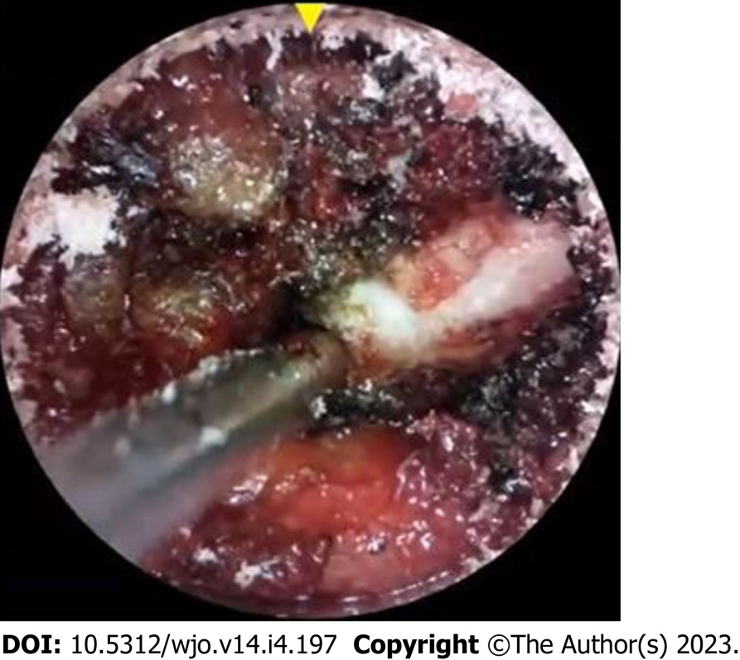
Figure 1 Direct endoscopic view from tubular/retractor-based camera that provides a two-dimensional image on a screen with digital zoom.

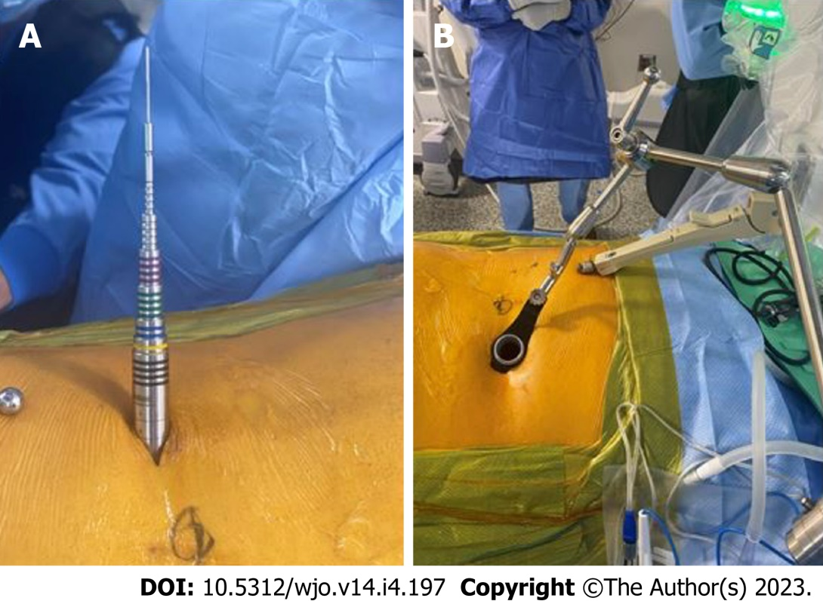
Figure 2 Minimally invasive surgery endoscopic technique. A: Endoscopic cannula inserted in posterior lumbar region; B: Tubular/retractor-based setup where the camera can be inserted into the body through a channel called a working channel.

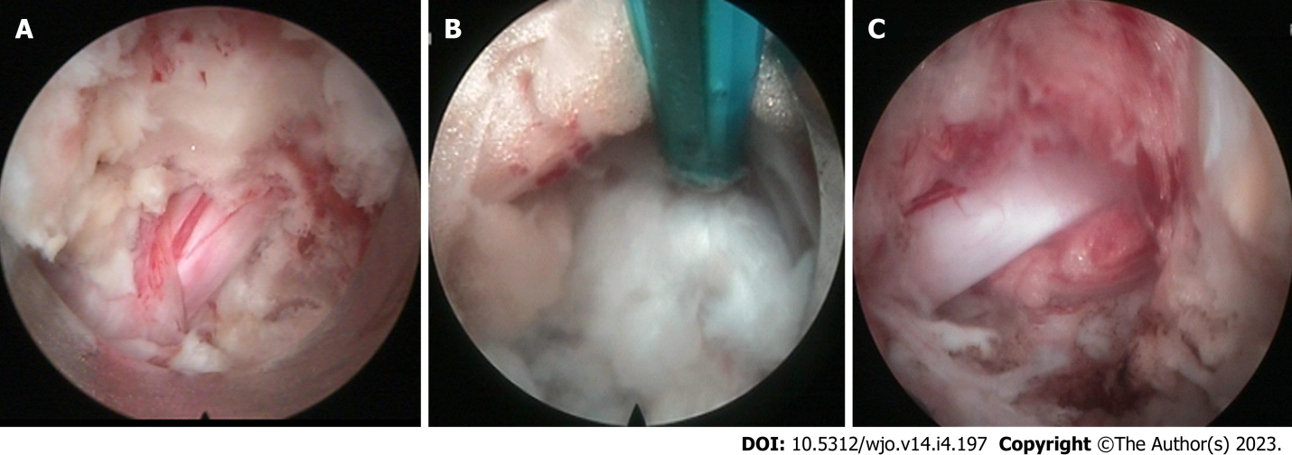
Figure 3 Direct two-dimensional endoscopic view (top of image as anatomically medial, bottom as lateral, left as cranial, and right as caudal) with dura mater exposed. A: Disc has compressed nerve ventrally; B: Disc irrigated, exposed, and removed to alleviate nerve compression; and C: Nerve has been decompressed.
Table 1 Chronological timeline showing the technical and procedural advancements of endoscopic spine surgery
Decades | Events
1930’s | 1931: Burman's “myeloscopies” in cadavers, successfully visualized the spinal cord and the nerve roots
 | 1936: Stern's development of new instrumentation, termed “spinascope”
 | 1938: Pool's myeloscopies through incisions “not over 2.5 mm”, visualized the nerve roots in great detail
1940’s-1950’s | Technological advancements in optical lens systems and the development of fiber-optics
1960’s | 1963: Smith's injection of chymopapain intradiscally called "chemonucleolysis", led to “intradiscal decompression"
1970’s | 1973: Kambin's and Gellmann's feasibility study of mechanical nuclear debulking by inserting Craig cannula via posterolateral approach
 | 1975: Hijikata preformed first percutaneous nucleotomy (posterolateral approach, < 2.6 mm)
 | 1977-1978: Gazi and Caspar introduced microsurgical techniques
1980’s | 1982: Harms and Rolinger introduced transforaminal lumbar interbody fusions
 | 1983: Forst's and Hausman's introduction of arthroscopy into intervertebral disc space
 | 1986: Kambin further developed percutaneous discectomy
 | 1988: Kambin;s first endoscopy view of herniated nucleus pulposus
 | 1989: Schreiber, Suezawa, and Leu were the first preformed percutaneous nucleotomy under visual control and endoscope (discoscopy)
1990’s | 1990: Kambin created, "Kambin Triangle", a percutaneous technique
 | 1990: Spine surgeons started doing minimally invasive spine surgery by magnification loupe or under microscope
 | 1991: Kambin and Sampson developed cannula (10 mm-23 mm) for interlaminar and transforaminal endoscopy
 | 1996: (Foraminoscopy) Matthew's preformed a more lateral mass route and prefomed foraminal epidural endoscopic surgery
 | 1997: Yeung had designed YESS endoscope and developed technique of “inside out” technique
 | 1998: (Foraminoascopy) Ditsworth's preformed endoscopic transforaminal procedure
 | 1998: Harms described the first TLIF approach as an open technique
 | 1998: Destandau and Foley developed tubular retractor system and endoscopy aided spine surgery through interlaminar approach
2000’s | 2003: Hoogland introduced the outside- in technique using transforaminal approach
 | 2005-2006: Rutten and Choi extended indications and developed interlaminar endoscopic discectomy
2010’s | 2013: Choi presented work flow to avoid risk of exiting root injury, a step forward in endoscopic spinal surgery
TLIF: Transforaminal lumbar interbody fusion.

Table 2 Pros and cons of full endoscopy, microendoscopy, and biportal endoscopy
Technique | Pros | Cons
Full endoscopy | Least amount of tissue damage out of the three | Cannot move camera and tool independently
Microendoscopy | Space for more tools, space for implanting devices | Large portal size
 |  | Dry environment only
Biportal endoscopy | Independence of tools | Most tissue damage out of the three
 |  | Locating tools more
 | Familiarly with other arthroscopic techniques | Challenging

Published by Baishideng Publishing Group Inc
7041 Koll Center Parkway, Suite 160, Pleasanton, CA 94566, USA
Telephone: +1-925-3991568
E-mail: bpgoffice@wjgnet.com
Help Desk: https://www.f6publishing.com/helpdesk
https://www.wjgnet.com

© 2023 Baishideng Publishing Group Inc. All rights reserved.

