Name of Journal: World Journal of Stem Cells
Manuscript NO: 90346
Manuscript Type: ORIGINAL ARTICLE

Basic Study
Expansion of human umbilical cord derived mesenchymal stem cells in regenerative medicine

Rajput SN et al. MSCs for regenerative medicine

Shafiqa Naeem Rajput, Bushra Kiran Naeem, Anwar Ali, Asmat Salim, Irfan Khan

Shafiqa Naeem Rajput, Asmat Salim, Irfan Khan, Dr. Panjwani Center for Molecular Medicine and Drug Research, International Center for Chemical and Biological Sciences, University of Karachi, Karachi 75270, Sindh, Pakistan

Bushra Kiran Naeem, Surgical Unit 4, Dr. Ruth KM Pfau Civil Hospital, Karachi 74400, Pakistan

Anwar Ali, Department of Physiology, University of Karachi, Karachi 75270, Pakistan

Irfan Khan, Center for Regenerative Medicine and Stem Cells Research, The Aga Khan University, Karachi 74800, Sindh, Pakistan

Author contributions: Rajput SN performed experiments and wrote the original manuscript; Naeem BK helped in data evaluation and writing; Ali A contributed to the experimentation and writing; Salim A reviewed the manuscript; Salim A and Khan I evaluated and analyzed the data; Khan I conceived and designed the studies and finalized the manuscript.

Supported by Higher Education Commission, Islamabad, Pakistan grant, No. 20-17590/NRPU/R&D/HEC/2021 2021.

Corresponding author: Irfan Khan, PhD, Assistant Professor, Center for Regenerative Medicine and Stem Cells Research, The Aga Khan University, Stadium Road, P.O. Box 3500, Karachi 74800, Sindh, Pakistan. irfankhan.bangash@aku.edu

Received: November 30, 2023
Revised: February 1, 2024
Accepted: March 18, 2024
Published online:

Abstract
BACKGROUND
Stem cells are undifferentiated cells that possess the potential for self-renewal with the capacity to differentiate into multiple lineages. In humans, their limited numbers pose a challenge in fulfilling the necessary demands for regeneration and repair in damaged tissues or organs. Studies suggested that mesenchymal stem cells (MSCs), necessary for repair and regeneration via transplantation, require doses ranging from 10 to 400 million cells. Furthermore, the limited expansion of MSCs after isolation further restricts their therapeutic application.

AIM
To optimize a novel protocol to achieve qualitative and quantitative expansion of MSCs to achieve the desirable number of cells for cellular transplantation and minimize the limitations in stem cell therapy protocols.

METHODS
Human umbilical cord (hUC) tissue derived MSCs were obtained and re-cultured in the lab. These cultured cells were subjected to the following evaluation procedures: Immunophenotyping, immunocytochemical staining, trilineage differentiation, population doubling time and number, gene expression markers for proliferation, cell cycle progression, senescence-associated β-galactosidase assay, human telomerase reverse transcriptase (hTERT) expression, mycoplasma, cytomegalovirus and endotoxin detection.

RESULTS
Analysis of pluripotent gene markers Oct4, Sox2, and Nanog in recultured hUC-MSC revealed no significant differences. The immunophenotypic markers CD90, CD73, CD105, CD44, vimentin, CD29, Stro-1, and Lin28 were positively expressed by these recultured expanded MSCs, and were found negative for CD34, CD11b, CD19, CD45, and HLA-DR. The recultured hUC-MSC population continued to expand through passage 15. Proliferative gene expression of Pax6, BMP2, and TGFb1 showed no significant variation between recultured hUC-MSC groups. Nevertheless, a significant increase (P < 0.001) in the mitotic phase of the cell cycle was observed in recultured hUC-MSCs. Cellular senescence markers (hTERT expression and β-galactosidase activity) did not show any negative effect on reculture hUC-MSCs. Additionally, quality control assessments consistently confirmed the absence of mycoplasma, cytomegalovirus, and endotoxin contamination.

CONCLUSION
This study proposes the development of a novel protocol for efficiently expanding stem cell population. This would address the growing demand of larger stem cell doses needed for cellular transplantation and will significantly improve the feasibility of stem cell based therapies.

Key Words: Human umbilical cord; Mesenchymal stem cells; Expansion; Cell proliferation; In vitro expansion; Senescence

Rajput SN, Naeem BK, Ali A, Salim A, Khan I. Expansion of human umbilical cord derived mesenchymal stem cells in regenerative medicine. World J Stem Cells 2024; In press

Core Tip: Therapeutic transplantation of mesenchymal stem cells (MSCs) requires one to four million cells/kg of body weight. Ex vivo expansion of stable MSCs at higher passage numbers limits their clinical applications due to senescence, variation in genetic stability and short life span. This study results in the development of a cutting-edge protocol for scaling the stem cell population ex vivo in less time. It rapidly increase the cell number in vitro to fulfill in vivo therapeutic cell doses. This method might decrease immune rejection. Since these MSCs were isolated from the same recultured human umbilical cord, they have persistent MSC stemness and may decrease tissue vs graft rejection due to the less rigorous HLA screening required in allogenic transplantation, which could make it more cost-effective. Certainly, more studies that are exploratory should be carried out to further elucidate the mechanism via preclinical and clinical applications.

INTRODUCTION
Stem cell research establishes cell based therapies for the degenerative disorders, which cannot be cured by conventional medicines^{[1-4]}. The capability of self-renewal and the ability of multiple lineage differentiation place stem cells at the front of regenerative therapies^{[5]}. Mesenchymal stem cells (MSCs) have been explored for many years for the regeneration of degenerated tissues^{[6-10]}. The challenges of utilizing MSC in therapeutic applications have become crucial due to the limited presence of MSCs in nearly all tissues of the body^{[11,12]}. It has been shown that the isolated number of MSCs were insufficient for clinical proceedings to mitigate degenerative disorders, such as those of the musculoskeletal, nervous, cardiovascular, and immune systems^{[11]}. The seeding density is pivotal for MSCs to differentiate into distinctive end-stage cell type^{[13]}. The immunoregulatory, anti-inflammatory and immunosuppressive potential make MSCs an ideal candidate for transplantation^{[14]}. MSCs are characterized on the basis of plastic adherence property and expression of CD73, CD90, CD105, CD29 and Stro-1 markers^{[15]}. The combination of CD characterized membrane attack complex are active functionally at transplanted area, which proposed that CD characterization of MSCs prior to transplantation results in increased regenerative outcomes^{[16]}.
Numerous sustainable and reproducible approaches for the large-scale expansion of MSCs have been employed using stacked flasks^{[17]}, spinning flasks^{[18]}, roller bottles^{[19]}, and bioreactors^{[20]}. These techniques require optimization of variables including medium composition, seeding density, oxygen pressure, agitation speed, pH, and microcarrier use^{[20]}. One of the most important components of MSC expansion is choosing a culture procedure that allows rapid MSC expansion without affecting its characteristics^{[21]}. The reported clinical significance of human umbilical cord (hUC) derived MSCs underlies their easy collection, storage for longer time periods, and devoid of side effects that are usually associated with adult stem cells^{[22,23]}. The hUC-MSCs are safe for use in autologous and allogeneic regenerative medicine applications due to their high rate of proliferation, immunological tolerance, differentiation potential towards multiple cell lineages and lack of tumorigenicity^{[24-27]}. However, there are cell viability limitations to achieve desired therapeutic outcomes^{[28]}. The survival rate of transplanted cells depends on the time of treatment and diagnosis to achieve required therapeutic effects.
An earlier study demonstrated that autologous transplantation of hUC-MSCs to patients suffering from neuroblastoma proved to be successful without any side effects^{[29]}. Distribution of hUC stem cells after transplantation is critical for the treatment of neurodegenerative diseases to achieve therapeutic outcomes^{[30]}. Study report showed that early transplantation of allogeneic hUC-MSCs restored myelination^{[31]}. The autologous or allogeneic transplantation of hUC-MSCs cannot always combat progression of degeneration, which might require frequent doses to achieve efficient tolerance. In a case study, allogeneic transplantation of hUC-MSCs produce successful outcomes after second dose, with long term survival^{[32]}. Cell-based therapy approach face challenge of large numbers of MSCs availability^{[33]}. MSCs expansion requires extensive cell passaging^{[34]}. The mechanisms involved in the molecular changes and spontaneous cell transformation during in-vitro expansion of the MSCs and sub culturing are still unknown. These mechanisms eventually lead towards alterations in genetic and epigenetic cellular functions^{[35]}. Therefore, in order to improve the ex-vivo cell proliferation at higher passages, strategies need to be adopted to diminish limitations of MSCs senescence upon extensive sub culturing for therapeutic applications^{[36]}. It has been observed that cell demand cannot be met by donated tissues or organs for the treatment of diseased population. The transplantation of stem cells in tissue requires one to four million cells per kg body weight for an optimal therapeutic dose^{[37]}. Therefore, prior to ex-vivo expansion, stem cells are required to be isolated, proliferated and expanded to achieve therapeutic dose with intact characterization markers^{[38]}.
Pluripotent stem cell from inner cell mass of embryo do not differentiate into cells of extra embryonic tissue but reported to differentiate into ectoderm, endoderm and mesoderm lineages. Pluripotency factors like cMYC, Oct4, Nanog, Klf4, Sox2 have potential to retain stemness and can differentiate into adult, fetal, extra embryonic and embryonic stem cells^{[39]}. Reports suggested that the transplanted stem cells engraft to specific site and must retain the ability to survive, proliferate, differentiate, and integrate in recipient tissue for regeneration^{[40]}. The combination of tissue engineering technology along with the development of organoids by micro engineering approach, cell transplantation and material science to restore damaged tissues plays a vital role in advancing stem cell therapeutics^{[41]}. Umbilical cord stem cells (UCSCs) are the best known source which acquire least ethical restrictions and are rich to produce MSCs with high regeneration capability^{[42]}. Stem cells express less number of major histocompatibility complex receptors which enables tolerance at graft sites^{[43]}. The UCSCs are reported to be the best alternative for regenerative therapy of patients with less matched HLA^{[44]}. The transplantation of desired numbers of hUC-MSCs takes less time for engraft maturation, as higher number of cells are available on transplanted site, it also decrease the risks of mortality and infections^{[45]}. The aim of improving homing and engraftment of umbilical cord tissue derived MSCs need further exploration. Novel methods for ex-vivo expansion of MSCs can produce the desired number of cells for therapeutic applications^{[46]}. In the present study, ex vivo expansion of MSCs from recultured hUC was evaluated for gaining maximum number of MSCs in culture with sustained characterization, enabling them to develop a curative cell dose for clinical therapies. This study has succeeded to develop an innovative MSCs expansion procedure to meet the demand of MSCs for in vivo implantation.

MATERIALS AND METHODS
Ethics statement and donor selection
The ethical approval for the present study was obtained from the Dr. Panjwani Center for Molecular Medicine and Drug Research, International Center for Chemical and Biological Sciences, University of Karachi (IEC document No. 40/2020/QD-VINMEC) in accordance with the Helsinki Declaration. Healthy donors with cesarean sections at Zainab Panjwani Memorial Hospital Karachi, age group between 20 and 30 years were identified and screened for the absence of infectious diseases such as hepatitis, malaria, acquired immunodeficiency syndrome, and human immunodeficiency virus. Similarly, individuals with genetic abnormalities, immunodeficiency, coagulopathy, metabolic or storage disease (type-1 diabetes), cancer, blood disorders, jaundice, liver disease, and other diseases were excluded from the study.

hUC sample collection, processing and MSCs isolation
Six hUC samples were obtained in hUC collection buffer. The samples were immediately processed within 2-4 h of collection in a biological safety cabinet level II, type A2, in the cell culture facility of the Center for Bioequivalence Studies and Clinical Research. The hUC samples were dissected and cultivated under aseptic conditions. After thorough cleaning and removal of blood precipitates, hUC was cut longitudinally into small cubic pieces of approximately 3 mm × 3 mm and incubated at 37 °C with 5% CO₂ into labelled T-75 culture flasks. The non-adherent hematopoietic cells and other heterogeneous non-adherent cellular populations were removed by regular media changes with fresh minimum essential medium alpha (MEM α) supplied with 10% foetal bovine serum, 1% antibiotics (penicillin and streptomycin), and 1% sodium pyruvate, every third day. When MSCs attained 80%-90% confluence, the hUC explant was carefully removed, and isolated MSCs at that stage were termed passage 0 (P⁰).

Selection of cell culture media for MSC expansion
Different commercially available cell culture media were evaluated to optimize the optimal growth conditions that support the clonal and uniform expansion of MSCs. To select the best possible growth medium before proceeding with the novel MSC expansion method, five different cell culture growth media were evaluated by sub-culturing 0.7 × 10⁶ cells per T-25 flask at passages 3-6 for three days. The five complete growth media include Dulbecco’s Modified Eagle’s Medium (DMEM), DMEM Nutrient Mixture F-12 HAM, Iscove’s Modified Dulbecco’s Medium, MEM, and MEM α. All cell culture media were supplied with 10% foetal bovine serum, 1% antibiotics (penicillin and streptomycin), and 1% sodium pyruvate.

Sub-culturing of hUC-MSCs
MSCs were harvested by enzymatic digestion using 2 mL of 0.25% Trypsin-EDTA solution. The cell suspension was collected in a 15 mL sterile falcon tube and centrifuged (5804R, Eppendorf, Germany) for 10 min at 1000 rpm. The supernatant was discarded, and 1 mL of complete medium was added to resuspend the pellet. The equal distribution of cells into the flasks was ensured by cell counting and then flasks were incubated in a humidified incubator at 37 ºC with 5% CO₂. The MSCs subsequently expanded up to passage 15 following sub-culturing to determine cell-seeded and harvested densities to calculate population doubling time (PDT) and population doubling number (PDN).

Novel large-scale expansion method for scaling MSCs by reculturing hUC
In order to establish a novel approach, the hUC explant yielding 80%-90% confluent MSC colonies was transferred into the new cell culture flask in fresh MEM α. This reculturing of explant was repeated until the hUC was exhausted to release cells. The MSCs released from reculturing hUC explants were marked by their respective recultured numbers and were tested for gene expression, phenotypic, and multipotent differentiation potential in each group. Re-cultured hUC-MSCs were also evaluated for comparative analysis in growth, proliferation, colony-forming unit, senescence, and human telomerase activity.

Characterization profiling of recultured hUC-MSCs
Morphological characterization of recultured hUC-MSCs: The morphological characteristics of MSCs at every hUC recultured number for each donor (n = 6) were keenly observed under a phase contrast microscope (Ts2, Nikon, Japan) for cell size and morphology up to passage 15. The images were captured with a charge-coupled device camera (Nikon, Japan).

Immunophenotypic analysis by flow cytometry: The recultured hUC-MSCs were compared for expression of markers via flow cytometer (FACS CelestaTM, Becton Dickinson, United States) base immunophenotyping. The experiment was performed using BDTM Human MSC Analysis Kit (Cat # 562245) as per the manufacturer’s instructions.

Immunocytochemistry: The recultured hUC-MSC at passages 1-6 were characterized to determine the expression of stemness markers via immunocytochemical staining for CD73, CD105, vimentin, CD29 CD90, Stro-1, Lin28, CD45, and HLA-DR. The aqueous fluoromount medium (Cat. No. F4680, Sigma-Aldrich) was used to mount the slide, and fluorescent microscopy (NiE, Nikon Tokyo, Japan) visualization was performed using appropriate filters/wavelength to obtain high-definition images via cooled color digital CCD camera. Images were analyzed and processed with Nikon NIS element (Japan) and Adobe Photoshop. Details of the antibodies are listed in Table 1.

Quantitative gene expression profiling by real-time polymerase chain reaction
Gene expression analysis in MSCs from all recultured hUC groups was done for pluripotency, proliferation, telomerase activity, and for the genes that are associated with MSCs stemness, and senescence. Quantitative genes analysis was performed using a thermal cycler (Eppendorf, Master Cycler Gradient, 5331, Germany) following standard protocols.

Multilineage differentiation of recultured hUC-MSCs
Recultured hUC-MSCs at passages 1-6 were plated in the seeding density of 3 × 10³ in six-well plates in triplicates and characterized for their differentiation ability into osteogenic, chondrogenic, and adipogenic lineages. The induction was performed by culturing cells into fresh osteogenic, chondrogenic, and adipogenic media. The osteocytes were stained for calcium deposits by Alizarin red staining solution, Alcian blue solution was used to stain glycosaminoglycan present in chondrocytes, and Oil red O was used to stain oil droplets in adipocytes. Cells were observed under a bright field microscope and images were captured by using a camera (CCD) and processed using the Ti2, Nikon, Japan.

Doubling time estimation
Estimation of PDT and PDN was performed for recultured hUC-MSCs till passage 15 by applying following formulae: PDT = (t - t0) × log2/log(N - N0), where culture time was represented by t (time in hours from cell harvest), t0 is the initial time, N denotes the harvested cell number during the culture period, and N0 is the cell number at culture initiation. PDN = 3.31 × log(N/N0), where N denotes the harvested cell number during the culture period, N0 is the cell number at culture initiation.

Proliferation markers estimation of recultured hUC-MSC
Total RNA was isolated, cDNA was synthesized, and quantitative real-time polymerase chain reaction (qPCR) were performed by using Advanced SYBR Green Supermix for the gene expression analysis. Genes involved in cell proliferation were analyzed (Table 2).

Cell cycle analysis of recultured hUC-MSCs
All recultured hUC-MSCs groups were evaluated for the cell cycle. For each successive-recultured hUC-MSCs (1-6 passage), (1-2) × 10⁶ cells of each group were pelleted for cell cycle analysis. Cells were harvested, fixed, and stored at -20 °C. For cell cycle analysis, cells were retrieved, incubated and then treated with 5 μL nucleotide-specific 7-amino-actinomycin D dye as per manufacturer instructions. The stained cells were immediately analyzed by flow cytometer, collecting 25000 events per sample and proceeded for cell cycle analysis. The data was reported as a percentage of cells present at each cell cycle phase (G0/G1, S, and G2/M). FACS Diva Software was used for the analysis of cell cycle results.

Colony forming unit assay of recultured hUC-MSC
Recultured hUC-MSC (8 × 10⁴ cells) were seeded in triplicates in the well plate (10 cm²) at 37 ºC in CO₂ incubator. The cell plates were observed 2 times a week for the formation of visible discrete colonies consisting of 40-50 cells per colony. The colonies were assayed by staining for 25-30 min with toluidine blue (0.1%). Data was recorded as the total number of colonies at each successively recultured hUC-MSCs number. The plates were observed by microscopy to distinguish the proficiency of each distinct recultured hUC-MSC to form colony forming unit (CFU).

Senescence associated β-galactosidase assay in recultured hUC-MSCs
The experiment was performed by seeding 3 × 10³ cells per well in a 24-well plate. After formation of monolayer, cell fixation was performed by 4% PFA solution, staining was done by X-Gal (5-bromo-4-chloro-3-indolyl-β-D-galactopyranoside). The 24 well plates were covered with a zip-lock bag to avoid any effect of CO₂ on color formation. Cells were observed under phase contrast and bright field microscopes to confirm the blue color formation.

Gene expression dynamics for telomerase in recultured hUC-MSC
Total RNA was isolated from each recultured group of hUC-MSC by Trizol reagent, and cDNA was synthesized. The real-time PCR primers used for the study, human telomerase reverse transcriptase (hTERT) was normalized against hydroxymethyl-bilane synthase (HMBS). All samples were run in comparison with hTERT with a parallel expression of the housekeeping gene HMBS as a control. The oligonucleotides sequence specific to hTERT are mentioned in Table 2.

Mycoplasma and cytomegalovirus detection in recultured hUC-MSCs
MSC was isolated from each recultured hUC group, and all samples were analyzed for the presence of mycoplasma and cytomegalovirus contamination. For the detection of mycoplasma and cytomegalovirus contamination, strains of mycoplasma, Mycoplasma hominis (M. hominis) and M. arginini, and human cytomegalovirus were quantified by qPCR using the primer sequences mentioned in Table 2.

Endotoxin assay evaluation in recultured hUC-MSC
Endotoxin tests were carried out using commercially available endotoxin kits (PierceTM Chromogenic Endotoxin Quant Kit, Cat# A39552). The assay proceeded briefly as the lyophilized substrate was reconstituted in 3.4 mL of endotoxin-free water, and all standards and reagents were prepared following the manufacturer’s instructions. The concentration of endotoxin in each sample was determined by plotting a standard curve.

Statistical analysis
The version 8 of GraphPad Prism from Microsoft (GraphPad Software, San Diego, California, United States) was used to perform the statistical analyses. Tuckey’s test and a two-way ANOVA were used. In an examination of multiple comparisons, a P value of 0.05 or higher was considered statistically significant. The degree of significance is indicated using the P values ªP < 0.05, ^{b}P < 0.01, and ^{c}P < 0.001.

RESULTS
hUC collection, dissection, and MSC isolation
The donors of hUC were found to be healthy (Table 3). MSCs isolated, cultured (Figure 1) from six hUC, and the explant was maintained ex-vivo in complete MEM α. The outgrowth of hUC-MSCs from the explant against the adherent surface of the culture flask presented a fibroblast-like shape and later formed colonies that further spread to form a monolayer as shown in Figure 2. At that stage, MSCs were considered P⁰.

Ex-vivo expansion of recultured hUC-MSCs and analysis of cell morphology:
The step of reculturing hUC explant was repeated 10 times and every time pure homogenous plastic adherent MSCs population was obtained successfully, exhibiting fibroblastic-like interconnected spindle-shaped morphology as illustrated in Figure 3A. The graphical representation in Figure 3B shows the time taken by each recultured hUC-MSC to reach 80%-90% confluence. The results showed that significantly ªP < 0.05, ^{b}P < 0.01, and ^{c}P < 0.001 shorter period was taken by recultured hUC (about 5-7 d) to gradually propagate. However, a significant increase in time was observed at hUC recultured number 11 and 12 time of recultured hUC that may be due to complete exhaustion to give expanded population. Therefore, we selected to perform all the experiments till reculture 10 of hUC.

Recultured hUC-MSC characterization
Immunophenotype characteristics of recultured hUC-MSC: The MSC populations derived from recultured hUC groups were analyzed for MSC positive markers including CD90, CD73, CD105, CD44, and MSC negative markers CD34, CD45 CD11b, CD19, and HLA-DR. The quantified flow cytometry graphical comparison of MSCs positive and negative markers expression showed no significant differences in all three groups of recultured hUC-MSC assessed at recultured 1-4, 5-7, and 8-10 at passages 1-6 as shown in Figure 4.

Immunocytochemical characteristics of recultured hUC-MSC: Recultured hUC-MSCs were seeded and stained with specified fluorescently labeled MSC positive and negative antibodies. The recultured hUC expended MSCs exhibited positive expression of CD73, CD105, vimentin, CD29, CD90, Stro-1, and Lin28 while lacking the hematopoietic markers CD45 and HLA-DR as illustrated in Figure 5A and B. These findings showed that recultured hUC-MSCs successfully maintained their stemness properties.

Multilineage differentiation potential of recultured hUC-MSCs: Recultured hUC-MSCs differentiated efficiently into osteocytes, chondrocytes, and adipocytes. Representative images in Figure 6 showed a comparison of control recultured expanded hUC-MSCs for osteogenic, chondrogenic, and adipogenic lineages. Alizarin red staining confirmed the osteogenic differentiation, stained red color, which represents mineralized bone matrix Figure 6A. Chondrogenic differentiation was assessed by blue color, which indicates cartilage extracellular matrix when stained with Alcian blue stain Figure 6B. Oil red O staining was performed to confirm adipogenesis by forming lipid vacuole typical for mature adipocytes in red color as shown in Figure 6C.

Gene expression analysis of recultured hUC-MSCs pluripotency markers: The analysis of genes responsible to maintain core pluripotency, stemness, and proliferation in recultured hUC- MSCs were analyzed by qPCR. The results in Figure 7 show no significant differences at the transcriptional level of stemness genes Oct-4, Sox-2, and Nanog at each successive recultured 1-4, 5-7, and 8-10 hUC-MSCs group at passages 1-6.

Proliferation in recultured hUC-MSC: Morphological features at passages 1-15 are shown in Figure 8A, which appears fibroblast like monolayer at early passages 1-6, while at late passage recultured MSC appeared with flattened morphology. However, the depicted heat map showed no significant differences in PDT and PDN which was estimated for each successive recultured hUC-MSCs at their respective passage number till passage 15 as shown in Figure 8B-D. Cells from hUC that had been recultured 10 times revealed a significant proportion of adherent MSC-like cells with steady rate of proliferation and growth. Figure 8B and C shows mean doubling time of 2-8 h at P1 through P15 while Figure 8D shows mean PDN i.e., around 1.3 million cells. The total number of cells obtained from the protocol was greater than 200 million cells from each donor sample.

Gene expression analysis of recultured hUC-MSCs for proliferation markers: Gene expression analysis for proliferation-related genes i.e., paired-box 6 (PAX6), bone morphogenetic protein 2 (BMP2), and transforming growth factor β1 (TGFβ1) revealed no significant difference when quantified at each recultured 1-4, 5-7, and 8-10 hUC-MSC group as shown in Figure 9.

Cell cycle profiling of recultured hUC-MSCs: The recultured hUC-MSCs groups showed a significant increase in cell cycle progression successively Figure 10A. The consecutive recultured results revealed a considerable rise in the G2/M phase of the cell cycle at recultured 1-4 with 21.35% hUC-MSC population; recultured 5-7 showed 44.516% cell population and recultured 8-10 represented 60.516% hUC-MSC population. In contrast, a significant decrease in G0/G1 phase was observed to the cell population of 75.35%, 50.4% and 33.66% at recultured numbers 1-4, 5-7, and 8-10, respectively. However, no significant difference was noted in S phase, which showed a mean of 3.31% cell population at repeatedly recultured hUC-MSC as shown in Figure 10B and C.

Quality control assessment of recultured hUC-MSCs
Recultured hUC-MSC effect on colony forming unit: A representative CFU assay (Figure 11) was performed for analysis of quality of consecutively recultured (1-10) hUC-MSCs by plating cells at a density of 800 cells per 9.6 cm² plate. After 10 d of incubation, plates were stained with Crystal violet to observe discrete purple color colonies shown in Figure 11A. The colony counting was performed by CFU assay on rapidly proliferating recultured hUC-MSCs. The results in the graph revealed that no significant differences were observed among MSCs obtained from each time of recultured hUC (Figure 11B).

Cell senescence analysis by β-galactosidase staining: Senescence-associated β-galactosidase assay (SA β-Gal) was performed by seeding cells at sequentially recultured 1-4, 5-7, and 8-10 group hUC-MSCs. MSCs released from recultured hUC were incubated with a SA β-Gal stain. The results showed that none of the cells were marked with blue color, representing no cellular senescence at all recultured hUC-MSCs. The maintained good quality of hUC-MSCs from each recultured number is represented in Figure 12A. Additionally, no difference was observed in the cellular morphology of SA β-Gal stained cells, which remains unstained and exhibited spindle shape morphology with no senescence. Therefore, no adverse effect on recultured hUC-MSC growth and properties in the cell culture system was observed.

Evaluation of human telomerase activity in recultured hUC-MSCs: To further quantify the maintenance of aging-related cellular senescence of recultured hUC-MSCs, a qPCR assay was performed to evaluate hTERT expression. The results revealed that the level of telomerase expressed at each recultured hUC-MSCs was found to be the same at recultured 1-4 and 5-7 showed no significant difference in telomerase expression with no effect on age-related growth retardation. The normalized expression of telomerase was found to be significantly increased at recultured 8-10 of hUC-MSCs, as illustrated in Figure 12B.

Mycoplasma and cytomegalovirus detection in recultured hUC-MSCs: The freshly isolated recultured 1-4, 5-7, and 8-10 hUC-MSCs were processed for the detection of mycoplasma and cytomegalovirus by qPCR. The results were found to be negative for the presence of mycoplasma and cytomegalovirus. To authenticate these results quantification was performed for all three groups of recultured hUC-MSCs in all six hUC samples shown in Figure 13A and B.

Endotoxin evaluation in recultured hUC-MSCs: The evaluation of purity with endotoxin quantification kit ensured no endotoxin contamination for 1-4, 5-7, and 8-10 recultured hUC-MSC groups, revealing the endotoxin concentration is less than threshold. These results obey the maintained quality standards of recultured hUC-MSC shown in Figure 13C.

DISCUSSION
The therapeutic application of MSCs demands the characterization of stem cell products based on their molecular and cellular characteristics^{[47]}. The paracrine activity of MSCs via the secretome and their unique stem cell features such as proangiogenic, anti-inflammatory, immunomodulatory, and antioxidant potential are the mechanisms behind the utilization of MSCs for therapeutic purposes^{[48,49]}. Studies have observed the significant therapeutic promise of MSCs to treat fatal disorders in numerous clinical trials^{[50-53]}. Research suggested that MSCs derived from the umbilical cord are ideal for transplantation and play a pivotal role in the future of medicine^{[54,55]}.
The current study was designed to establish the novel recultured hUC method to scale MSCs for therapeutic use. It is observed that the morphology of MSCs from successively recultured hUC has remained the same, showing spindle shaped fibroblast-like mononucleated and clustered colonies that expanded as homogenous monolayers at every primary isolated recultured hUC-MSC. This expansion of MSCs in our study was obtained in a relatively short time until the hUC was recultured for the 10th time, which provides an efficient number of MSCs isolation. A similar spindle-shaped MSC morphology has been observed earlier^{[56]}.
The most significant pluripotency genes are the Oct-4, Sox-2, and Nanog^{[57]}. Recultured expanded MSCs fully exhibited pluripotent genes, Nanog, Sox-2, and Oct-4, in all experimental recultured groups, and showed no variations. These genes are the primary regulators of other genes that balance self-renewal and differentiation in stem cell^{[58]}. Oct-4 and Sox-2 must bind to the Nanog promoter and directly control Nanog expression. Differentiation and reprogramming factors regulate the fate of stem cell^{[59]}. Researchers can either induce differentiation of ESCs or MSCs or convert somatic cells into induced pluripotent stem cells by modifying the culture conditions and adding growth and differentiation regulators, including Oct3/4, Sox-2, Klf4, and c-Myc, also called the Yamanaka cocktail^{[58]}.
The recultured hUC-MSCs were characterized each time and tested for immunphenotype expression of positive and negative MSC markers. It has been observed that recultured hUC-MSCs possess a high expression of MSC positive markers that are CD90, CD73, CD105, CD44 and lack of MSC negative markers CD34, CD11b, CD19, CD45, HLA-DR. These MSCs met the requirements for the minimum standards set by the International Society for Cell and Gene Therapy^{[60]}.
The immunocytochemical staining analysis of recultured hUC-MSCs showed positive expression of CD90, CD73, CD105, CD44, vimentin, CD29, Stro-1, and Lin28 and negative expression of CD45 and HLA-DR. It has been reported that CD90, CD70, CD105, CD117, CD29, vimentin, Stro-1, and Lin28 were expressed by MSCs from cord tissue^{[60-62]}. MSCs can differentiate into mesodermal lineages as well as non-mesodermal lineages^{[63]}. Study investigated that MSCs are capable to differentiate into osteogenic, chrondrogenic, and adipogenic lineages. However, current techniques of inducing differentiation has been improved, and MSCs derived from different tissue sources can be differentiated into any type of body cell^{[64]}. It has been found that after 21 d of induction with osteogenic, chondrogenic, and adipogenic induction media, the MSCs differentiated, as confirmed by the presence of calcium deposits, proteoglycan formation, and oil droplets, respectively^{[22]}. Thus, MSCs obtained from the recultured protocol possess stem cell markers and have shown their ability to differentiate, indicating that the cells preserve their stemness features. MSCs have been investigated as a viable therapeutic option for a variety of degenerative diseases due to their multilineage differentiation and capacity to respond to environment-mediated abnormalities^{[11,65]}.
The cell PDT and PDN were investigated for each recultured number up to passage 15, we observed that MSC’s growth rate has been preserved after reculturing 10 times and subsequently sub-culturing each recultured number 15 times (passage 15). Thus, we found it interesting in our investigation that recultured hUC-MSCs continue to proliferate at their usual rates throughout reculturing. Our results revealed no significant difference in evaluating the PDT and PDN between all recultured numbers. Previously, it was reported that MSCs possess higher proliferative ability and a substantially faster rate of doubling at an initial 10 passages before they stop reproducing at passage 15^{[66,67]}. For MSCs, the average PDT was less than 24 h and remained constant for at least five passages^{[68]}. Choudhery et al^{[68]} showed that umbilical cord MSCs have a shorter PDT than adipose tissue MSCs^{[69]}. Since the number of cell population doublings (NCPD) typically represents the true age of a culture in vitro, previous research has mostly focused on identifying the upper limit of NCPD at which the culture stops replicating and loses the potential to differentiate^{[70,71]}.
The proliferation markers PAX6, BMP2, and TGFβ1 showed no significant difference in recultured hUC-MSC groups. It has been reported that PAX6 is essentially involved in cell proliferation, migration, and adhesion during tissue development^{[72-75]}. The involvement of BMP2 in inducing proliferation at the early developmental stage plays a consistent role in cell proliferation before differentiation^{[76,77]}. It is reported that TGF, a prevalent immunosuppressive substance, controls the development and biological function, and regulates the proliferation of numerous types of immune reactive cell^{[78-80]}. Studies showed that MSCs had pluripotency-associated intrinsic gene expression, maintained differentiation capacity, and displayed an unmodified karyotype for a maximum of 25-30 passages^{[81]}.
At 1-4, 5-7, and 8-10 recultured hUC, isolated MSCs were assessed for cell cycle kinetics. With the increase in the recultured group from 1 to 10, it has been observed that there is a gradually enhanced mitotic phase (G2/M) of the cell cycle and a decrease in G0/G1. A study revealed that MSCs were predominantly in the G2/M phase, and the main heterogeneity of hUC-MSCs, with or without inflammatory cytokines, is controlled by cell cycle progression^{[82]}. Sabapathy et al^{[80]} exhibited the same result, and no alteration in the cell cycle pattern was noted. The cell cycle is regarded as the central machinery for cell fate determination^{[83,84]}.
The colony formation capability of recultured 1-4, 5-7, and 8-10 hUC-MSCs group has also been investigated. The CFU assay demonstrates that each time hUC was recultured, there is no variation in the number of colonies among them. At all hUC recultured numbers, isolated MSCs exhibit spindle-shaped cells that replicate quickly and predominate in the early days of cell plating at low density, become confluent, and produce colonies. Panwar et al^{[83]} also suggested that the quality of cell scaling has been heavily dependent on the success of MSC colony formation^{[85,86]}. It has been documented that MSCs with first passages had higher colony forming efficiencies than MSCs with later passages^{[87]}. It was studied earlier that CFU counts constantly declined throughout culture expansion and were hardly detectable after more than 20 passages^{[88]}.
The presence of SA β-gal staining identify the cell senescence feature. In this investigation, none of the hUC-MSCs expressed SA β-gal. The senescent MSCs must be identified during expansion because they are less successful when transplanted than MSC populations with a lower percentage of senescent cell^{[89,90]}. The study investigated whether a traditional sign of senescence in MSCs encompasses an arrest in growth within the cell cycle phase at G1, expanded or widened morphology, greater levels of SA β-gal, and altered surface markers^{[91-93]}.
The evaluation of hTERT expression in all 1-4, 5-7, and 8-10 recultured hUC-MSC groups revealed that the levels of hTERT remain the same among the recultured groups R1-4 and R5-R7. However, significant upregulation of hTERT with increasing recultured group (R8-10) has been observed. Thus, it revealed that recultured hUC-MSCs have not shown signs of aging in MSCs. The study reported that telomerase inhibits telomere erosion and promotes telomere extension by continuously restoring the missing TAG repeated sequence at the chromosomal termini^{[94]}. Another study revealed that telomere degradation in human MSCs due to the lack of hTERT activity causes cell senescence^{[95-97]}.
In this study, we also evaluated the recultured hUC-MSC groups to further check the quality control of isolated MSCs for mycoplasma strains human and cytomegalovirus. The present study showed the absence of M. arginini and M. hominis in all three recultured hUC-MSC groups. The studies reported that it is critical to evaluate cell cultures for mycoplasma and human cytomegalovirus. These pathogenic microorganisms have a long incubation period in hosts after infection. They have evolved several strategies for surviving, evading the host’s protection mechanisms, and slowing down cellular growth^{[98,99]}. Cell cultures’ most common mycoplasma contaminants include M. arginini and M. hominis^{[100,101]}.
The endotoxin presence was evaluated in all the recultured hUC-MSC groups, and the results showed that endotoxin was not present. The earlier study showed endotoxin-free MSCs for skin regeneration^{[102]}. It has been studied that endotoxins, like other pathogen-associated molecular patterns can influence cell metabolism, which may have an impact on many cellular activities^{[103-105]}. It has been reported that endotoxins, which are recognized by both toll-like receptors and pro-inflammatory substances produced by MSCs and immune cells, can affect MSC behavior in vitro cultures and in in vivo studies^{[106]}.
The hUC-MSCs are preserved for infants in clinical practice so they can be used in future allogeneic or autologous therapeutic applications^{[106]}. This implies that hUC-MSC based therapies may soon be phased out^{[107]}. The recultured hUC-MSCs might be administered and efficiently used as a cell therapy in upcoming regenerative studies.

CONCLUSION
This study investigated a repetitive culturing method to expand the hUC-MSC population. This approach has the potential to establish new protocol for efficiently increasing the number of MSCs required for transplantation. In this research, hUC-MSCs were expanded using a recultured method, which lead to the development of a novel protocol for expansion of MSCs population that can meet the demand of the in-vitro cell doses, required for in-vivo implantation. Since these MSCs were isolated from the same recultured hUC, they maintain their mesenchymal stem cell characteristics as defined by the International Society of Cellular Therapy.

ARTICLE HIGHLIGHTS
Research background
Stem cells are at the forefront for their intriguing potential in regenerative medicine. Organ or tissue regeneration requires 10 to 400 million mesenchymal stem cells (MSCs) per dose for transplantation. MSCs are undifferentiated cells with the potential to self-renew, capability to differentiate into multiple lineages, and immune modulation potential, which is considered ideal for cell-based therapeutics. The ex-vivo propagation and proliferation of MSCs are vital to fulfill the requisite cell number. Despite the current challenges in cell-based therapies, the safety levels of umbilical cord tissue derived MSCs render them a promising therapeutic approach in regenerative medicine.

Research motivation
MSC expansion is associated with extensive subculturing and cell passage. However, genetic instability during their ex-vivo expansion makes them less efficacious due to senescence. MSCs from different donors result in tissue vs graft rejection during transplantation. Recultured human umbilical cord (hUC) improves the culturing capability of MSCs for expansion and could provide novel sight for cell-based therapeutic applications which could be economical to maintain good manufacturing practices.

Research objectives
The objective of the proposed study was to establish an efficacious method for ex-vivo expansion of hUC-MSCs.

Research methods
MSCs from the hUC were isolated, and the hUC explant was recultured to get maximum number of cells. Isolated hUC-MSC at every recultured group were characterized on the bases of morphology. Immunophenotyping of positive and negative markers expressed by MSC, immunocytochemical staining and trilineage differentiation. The regulatory genes specific to the MSCs stemness, proliferation, and senescence markers were determined at every recultured group. The senescence was evaluated by beta galactosidase staining. The recultured hUC-MSCs were quantitatively characterized by population doubling time, population doubling number, colony forming unit, and cell cycle analysis. The absence of mycoplasma, cytomegalovirus, and endotoxin was evaluated in recultured hUC isolated MSC.

Research results
Recultured hUC derived MSCs interestingly showed no significant difference between each recultured hUC-MSC for pluripotent gene expression markers. These expanded MSCs showed positive immunophenotypic marker and lacked the expression of negative markers. Simultaneously, recultured hUC-MSCs showed positive expression for multilineage differentiation into osteogenic, chondrogenic, and adipogenic lineages. The proliferation of recultured hUC-MSCs was observed until passage 15. Nevertheless, a significantly increased mitotic phase of the cell cycle was observed in all recultured hUC-MSC groups. Delayed cellular senescence was observed by increased expression of human telomerase reverse transcriptase (hTERT). The senescence-associated β-galactosidase activity was not detected in repeatedly recultured hUC-MSCs. The quality of recultured hUC-MSCs was maintained and showed negative expression of mycoplasma, cytomegalovirus, and endotoxin.

Research conclusions
This study leads to the development of a novel protocol for scaling stem cells population. In-vitro expansion of the cell dose required for in-vivo implantation could be achieved in a short time. It can decrease tissue versus graft rejection due to the less rigorous HLA screening performed in stem cell banks. Since these MSCs were isolated from the same recultured hUC, they thus exhibit enduring MSC stemness, and adhere with the recommendation of International Society of Cellular Therapy.

Research perspectives
This approach will help to isolate and propagate a larger number of cells required for clinical applications, and translational medicine. This approach will enable the faster availability of the required number of cells from the same initial source, thus reducing the need for extensive donor screening and resource allocation. This protocol offers cost effectiveness by potentially reducing reliance on multiple donors and complex HLA matching procedure.

REFERENCES
1 Rajabzadeh N, Fathi E, Farahzadi R. Stem cell-based regenerative medicine. Stem Cell Investig 2019; 6: 19 [PMID: 31463312 DOI: 10.21037/sci.2019.06.04]
2 Duarte RF, Labopin M, Bader P, Basak GW, Bonini C, Chabannon C, Corbacioglu S, Dreger P, Dufour C, Gennery AR, Kuball J, Lankester AC, Lanza F, Montoto S, Nagler A, Peffault de Latour R, Snowden JA, Styczynski J, Yakoub-Agha I, Kröger N, Mohty M; European Society for Blood and Marrow Transplantation (EBMT). Indications for haematopoietic stem cell transplantation for haematological diseases, solid tumours and immune disorders: current practice in Europe, 2019. Bone Marrow Transplant 2019; 54: 1525-1552 [PMID: 30953028 DOI: 10.1038/s41409-019-0516-2]
3 Hoang DM, Pham PT, Bach TQ, Ngo ATL, Nguyen QT, Phan TTK, Nguyen GH, Le PTT, Hoang VT, Forsyth NR, Heke M, Nguyen LT. Stem cell-based therapy for human diseases. Signal Transduct Target Ther 2022; 7: 272 [PMID: 35933430 DOI: 10.1038/s41392-022-01134-4]
4 Regmi S, Pathak S, Kim JO, Yong CS, Jeong JH. Mesenchymal stem cell therapy for the treatment of inflammatory diseases: Challenges, opportunities, and future perspectives. Eur J Cell Biol 2019; 98: 151041 [PMID: 31023504 DOI: 10.1016/j.ejcb.2019.04.002]
5 Casado-Díaz A. Stem Cells in Regenerative Medicine. J Clin Med 2022; 11 [PMID: 36143106 DOI: 10.3390/jcm11185460]
6 Ouchi T, Nakagawa T. Mesenchymal stem cell-based tissue regeneration therapies for periodontitis. Regen Ther 2020; 14: 72-78 [PMID: 31970269 DOI: 10.1016/j.reth.2019.12.011]
7 Fu X, Liu G, Halim A, Ju Y, Luo Q, Song AG. Mesenchymal Stem Cell Migration and Tissue Repair. Cells 2019; 8 [PMID: 31357692 DOI: 10.3390/cells8080784]
8 Ayala-Cuellar AP, Kang JH, Jeung EB, Choi KC. Roles of Mesenchymal Stem Cells in Tissue Regeneration and Immunomodulation. Biomol Ther (Seoul) 2019; 27: 25-33 [PMID: 29902862 DOI: 10.4062/biomolther.2017.260]
9 Shang F, Yu Y, Liu S, Ming L, Zhang Y, Zhou Z, Zhao J, Jin Y. Advancing application of mesenchymal stem cell-based bone tissue regeneration. Bioact Mater 2021; 6: 666-683 [PMID: 33005830 DOI: 10.1016/j.bioactmat.2020.08.014]
10 Le Blanc K, Ringdén O. Immunomodulation by mesenchymal stem cells and clinical experience. J Intern Med 2007; 262: 509-525 [PMID: 17949362 DOI: 10.1111/j.1365-2796.2007.01844.x]
11 Maldonado VV, Patel NH, Smith EE, Barnes CL, Gustafson MP, Rao RR, Samsonraj RM. Clinical utility of mesenchymal stem/stromal cells in regenerative medicine and cellular therapy. J Biol Eng 2023; 17: 44 [PMID: 37434264 DOI: 10.1186/s13036-023-00361-9]
12 Salem HK, Thiemermann C. Mesenchymal stromal cells: current understanding and clinical status. Stem Cells 2010; 28: 585-596 [PMID: 19967788 DOI: 10.1002/stem.269]
13 Chen Y, Shao JZ, Xiang LX, Dong XJ, Zhang GR. Mesenchymal stem cells: a promising candidate in regenerative medicine. Int J Biochem Cell Biol 2008; 40: 815-820 [PMID: 18295530 DOI: 10.1016/j.biocel.2008.01.007]
14 Gao F, Chiu SM, Motan DA, Zhang Z, Chen L, Ji HL, Tse HF, Fu QL, Lian Q. Mesenchymal stem cells and immunomodulation: current status and future prospects. Cell Death Dis 2016; 7: e2062 [PMID: 26794657 DOI: 10.1038/cddis.2015.327]
15 Dominici M, Le Blanc K, Mueller I, Slaper-Cortenbach I, Marini F, Krause D, Deans R, Keating A, Prockop Dj, Horwitz E. Minimal criteria for defining multipotent mesenchymal stromal cells. The International Society for Cellular Therapy position statement. Cytotherapy 2006; 8: 315-317 [PMID: 16923606 DOI: 10.1080/14653240600855905]
16 Sharma AK, Bury MI, Marks AJ, Fuller NJ, Meisner JW, Tapaskar N, Halliday LC, Matoka DJ, Cheng EY. A nonhuman primate model for urinary bladder regeneration using autologous sources of bone marrow-derived mesenchymal stem cells. Stem Cells 2011; 29: 241-250 [PMID: 21732482 DOI: 10.1002/stem.568]
17 Gupta P, Hall GN, Geris L, Luyten FP, Papantoniou I. Human Platelet Lysate Improves Bone Forming Potential of Human Progenitor Cells Expanded in Microcarrier-Based Dynamic Culture. Stem Cells Transl Med 2019; 8: 810-821 [PMID: 31038850 DOI: 10.1002/sctm.18-0216]
18 Mennan C, Garcia J, Roberts S, Hulme C, Wright K. A comprehensive characterisation of large-scale expanded human bone marrow and umbilical cord mesenchymal stem cells. Stem Cell Res Ther 2019; 10: 99 [PMID: 30885254 DOI: 10.1186/s13287-019-1202-4]
19 Wilkinson AC, Ishida R, Kikuchi M, Sudo K, Morita M, Crisostomo RV, Yamamoto R, Loh KM, Nakamura Y, Watanabe M, Nakauchi H, Yamazaki S. Long-term ex vivo haematopoietic-stem-cell expansion allows nonconditioned transplantation. Nature 2019; 571: 117-121 [PMID: 31142833 DOI: 10.1038/s41586-019-1244-x]
20 Vymetalova L, Kucirkova T, Knopfova L, Pospisilova V, Kasko T, Lejdarova H, Makaturova E, Kuglik P, Oralova V, Matalova E, Benes P, Koristek Z, Forostyak S. Large-Scale Automated Hollow-Fiber Bioreactor Expansion of Umbilical Cord-Derived Human Mesenchymal Stromal Cells for Neurological Disorders. Neurochem Res 2020; 45: 204-214 [PMID: 31828497 DOI: 10.1007/s11064-019-02925-y]
21 Tozetti PA, Caruso SR, Mizukami A, Fernandes TR, da Silva FB, Traina F, Covas DT, Orellana MD, Swiech K. Expansion strategies for human mesenchymal stromal cells culture under xeno-free conditions. Biotechnol Prog 2017; 33: 1358-1367 [PMID: 28486779 DOI: 10.1002/btpr.2494]
22 Xie Q, Liu R, Jiang J, Peng J, Yang C, Zhang W, Wang S, Song J. What is the impact of human umbilical cord mesenchymal stem cell transplantation on clinical treatment? Stem Cell Res Ther 2020; 11: 519 [PMID: 33261658 DOI: 10.1186/s13287-020-02011-z]
23 Toupadakis CA, Wong A, Genetos DC, Cheung WK, Borjesson DL, Ferraro GL, Galuppo LD, Leach JK, Owens SD, Yellowley CE. Comparison of the osteogenic potential of equine mesenchymal stem cells from bone marrow, adipose tissue, umbilical cord blood, and umbilical cord tissue. Am J Vet Res 2010; 71: 1237-1245 [PMID: 20919913 DOI: 10.2460/ajvr.71.10.1237]
24 Carneiro DC, Araújo LT, Santos GC, Damasceno PKF, Vieira JL, Santos RRD, Barbosa JDV, Soares MBP. Clinical Trials with Mesenchymal Stem Cell Therapies for Osteoarthritis: Challenges in the Regeneration of Articular Cartilage. Int J Mol Sci 2023; 24 [PMID: 37373096 DOI: 10.3390/ijms24129939]
25 Lv Z, Cai X, Bian Y, Wei Z, Zhu W, Zhao X, Weng X. Advances in Mesenchymal Stem Cell Therapy for Osteoarthritis: From Preclinical and Clinical Perspectives. Bioengineering (Basel) 2023; 10 [PMID: 36829689 DOI: 10.3390/bioengineering10020195]
26 Wang J, Sanati F, Firoozmand A, Fu P, Kolk M, Reese-Koc J, de Lima M, Boughan K, Cooper B, Caimi P, Gallogly M, Otegbeye F, Tomlinson B, Metheny L. Phase I study of intra-osseous co-transplantation of a single-unit cord blood and mesenchymal stromal cells with reduced intensity conditioning regimens. Front Oncol 2023; 13: 1186532 [PMID: 37207167 DOI: 10.3389/fonc.2023.1186532]
27 Escolar ML, Poe MD, Provenzale JM, Richards KC, Allison J, Wood S, Wenger DA, Pietryga D, Wall D, Champagne M, Morse R, Krivit W, Kurtzberg J. Transplantation of umbilical-cord blood in babies with infantile Krabbe's disease. N Engl J Med 2005; 352: 2069-2081 [PMID: 15901860 DOI: 10.1056/NEJMoa042604]
28 Garzón I, Pérez-Köhler B, Garrido-Gómez J, Carriel V, Nieto-Aguilar R, Martín-Piedra MA, García-Honduvilla N, Buján J, Campos A, Alaminos M. Evaluation of the cell viability of human Wharton's jelly stem cells for use in cell therapy. Tissue Eng Part C Methods 2012; 18: 408-419 [PMID: 22166141 DOI: 10.1089/ten.TEC.2011.0508]
29 Ning B, Cheuk DK, Chiang AK, Lee PP, Ha SY, Chan GC. Autologous cord blood transplantation for metastatic neuroblastoma. Pediatr Transplant 2016; 20: 290-296 [PMID: 26694195 DOI: 10.1111/petr.12647]
30 Ehrhart J, Darlington D, Kuzmin-Nichols N, Sanberg CD, Sawmiller DR, Sanberg PR, Tan J. Biodistribution of Infused Human Umbilical Cord Blood Cells in Alzheimer's Disease-Like Murine Model. Cell Transplant 2016; 25: 195-199 [PMID: 26414627 DOI: 10.3727/096368915X689604]
31 Zhang G, Zhang Y. "Mouse Clone Model" for evaluating the immunogenicity and tumorigenicity of pluripotent stem cells. Stem Cell Res Ther 2015; 6: 255 [PMID: 26687081 DOI: 10.1186/s13287-015-0262-3]
32 Thompson PA, Perera T, Marin D, Oran B, Popat U, Qazilbash M, Shah N, Parmar S, Rezvani K, Olson A, Kebriaei P, Anderlini P, Rondon G, Alousi A, Ciurea S, Champlin RE, Bajel A, Szer J, Shpall EJ, Ritchie D, Hosing CM. Double umbilical cord blood transplant is effective therapy for relapsed or refractory Hodgkin lymphoma. Leuk Lymphoma 2016; 57: 1607-1615 [PMID: 26472485 DOI: 10.3109/10428194.2015.1105370]
33 Yang Q, Pinto VMR, Duan W, Paxton EE, Dessauer JH, Ryan W, Lopez MJ. In vitro Characteristics of Heterogeneous Equine Hoof Progenitor Cell Isolates. Front Bioeng Biotechnol 2019; 7: 155 [PMID: 31355191 DOI: 10.3389/fbioe.2019.00155]
34 Jervis M, Huaman O, Cahuascanco B, Bahamonde J, Cortez J, Arias JI, Torres CG, Peralta OA. Comparative analysis of in vitro proliferative, migratory and pro-angiogenic potentials of bovine fetal mesenchymal stem cells derived from bone marrow and adipose tissue. Vet Res Commun 2019; 43: 165-178 [PMID: 31201618 DOI: 10.1007/s11259-019-09757-9]
35 Kureel SK, Mogha P, Khadpekar A, Kumar V, Joshi R, Das S, Bellare J, Majumder A. Soft substrate maintains proliferative and adipogenic differentiation potential of human mesenchymal stem cells on long-term expansion by delaying senescence. Biol Open 2019; 8 [PMID: 31023646 DOI: 10.1242/bio.039453]
36 Mendes Filho D, Ribeiro PDC, Oliveira LF, de Paula DRM, Capuano V, de Assunção TSF, da Silva VJD. Therapy With Mesenchymal Stem Cells in Parkinson Disease: History and Perspectives. Neurologist 2018; 23: 141-147 [PMID: 29953040 DOI: 10.1097/NRL.0000000000000188]
37 Chang YS, Ahn SY, Yoo HS, Sung SI, Choi SJ, Oh WI, Park WS. Mesenchymal stem cells for bronchopulmonary dysplasia: phase 1 dose-escalation clinical trial. J Pediatr 2014; 164: 966-972.e6 [PMID: 24508444 DOI: 10.1016/j.jpeds.2013.12.011]
38 Mahla RS. Stem Cells Applications in Regenerative Medicine and Disease Therapeutics. Int J Cell Biol 2016; 2016: 6940283 [PMID: 27516776 DOI: 10.1155/2016/6940283]
39 Olszewski C, Maassen J, Guenther R, Skazik-Voogt C, Gutermuth A. Mechanotransductive Differentiation of Hair Follicle Stem Cells Derived from Aged Eyelid Skin into Corneal Endothelial-Like Cells. Stem Cell Rev Rep 2022; 18: 1668-1685 [PMID: 34515937 DOI: 10.1007/s12015-021-10249-0]
40 Li S, Bi Y, Duan Z, Chang Y, Hong F, Chen Y. Stem cell transplantation for treating liver diseases: progress and remaining challenges. Am J Transl Res 2021; 13: 3954-3966 [PMID: 34149992]
41 Xu M, Qin M, Cheng Y, Niu X, Kong J, Zhang X, Huang D, Wang H. Alginate microgels as delivery vehicles for cell-based therapies in tissue engineering and regenerative medicine. Carbohydr Polym 2021; 266: 118128 [PMID: 34044944 DOI: 10.1016/j.carbpol.2021.118128]
42 Lal MR, Kovilam O. Role of umbilical cord stem cells in tissue engineering. In: Sharma CP. Regenerated Organs. United States: Academic Press, 2021: 331-338
43 Halm D, Leibig N, Martens J, Stark GB, Groß T, Zimmermann S, Finkenzeller G, Lampert F. Direct comparison of the immunogenicity of major histocompatibility complex-I and -II deficient mesenchymal stem cells in vivo. Biol Chem 2021; 402: 693-702 [PMID: 33544464 DOI: 10.1515/hsz-2020-0306]
44 Gluckman E, Koegler G, Rocha V. Human leukocyte antigen matching in cord blood transplantation. Semin Hematol 2005; 42: 85-90 [PMID: 15846574 DOI: 10.1053/j.seminhematol.2005.01.006]
45 Mehta RS, Rezvani K, Olson A, Oran B, Hosing C, Shah N, Parmar S, Armitage S, Shpall EJ. Novel Techniques for Ex Vivo Expansion of Cord Blood: Clinical Trials. Front Med (Lausanne) 2015; 2: 89 [PMID: 26697430 DOI: 10.3389/fmed.2015.00089]
46 Jung SC, Park S. New Sources, Differentiation, and Therapeutic Uses of Mesenchymal Stem Cells 2.0. Int J Mol Sci 2023; 24 [PMID: 36835347 DOI: 10.3390/ijms24043938]
47 Park S, Jung SC. New Sources, Differentiation, and Therapeutic Uses of Mesenchymal Stem Cells. Int J Mol Sci 2021; 22 [PMID: 34069777 DOI: 10.3390/ijms22105288]
48 Alvites RD, Branquinho MV, Sousa AC, Lopes B, Sousa P, Prada J, Pires I, Ronchi G, Raimondo S, Luís AL, Geuna S, Varejão ASP, Maurício AC. Effects of Olfactory Mucosa Stem/Stromal Cell and Olfactory Ensheating Cells Secretome on Peripheral Nerve Regeneration. Biomolecules 2022; 12 [PMID: 35740943 DOI: 10.3390/biom12060818]
49 Jovic D, Yu Y, Wang D, Wang K, Li H, Xu F, Liu C, Liu J, Luo Y. A Brief Overview of Global Trends in MSC-Based Cell Therapy. Stem Cell Rev Rep 2022; 18: 1525-1545 [PMID: 35344199 DOI: 10.1007/s12015-022-10369-1]
50 Zakrzewski W, Dobrzyński M, Szymonowicz M, Rybak Z. Stem cells: past, present, and future. Stem Cell Res Ther 2019; 10: 68 [PMID: 30808416 DOI: 10.1186/s13287-019-1165-5]
51 Nourian Dehkordi A, Mirahmadi Babaheydari F, Chehelgerdi M, Raeisi Dehkordi S. Skin tissue engineering: wound healing based on stem-cell-based therapeutic strategies. Stem Cell Res Ther 2019; 10: 111 [PMID: 30922387 DOI: 10.1186/s13287-019-1212-2]
52 Kwon SG, Kwon YW, Lee TW, Park GT, Kim JH. Recent advances in stem cell therapeutics and tissue engineering strategies. Biomater Res 2018; 22: 36 [PMID: 30598836 DOI: 10.1186/s40824-018-0148-4]
53 Shang Y, Guan H, Zhou F. Biological Characteristics of Umbilical Cord Mesenchymal Stem Cells and Its Therapeutic Potential for Hematological Disorders. Front Cell Dev Biol 2021; 9: 570179 [PMID: 34012958 DOI: 10.3389/fcell.2021.570179]
54 Marino L, Castaldi MA, Rosamilio R, Ragni E, Vitolo R, Fulgione C, Castaldi SG, Serio B, Bianco R, Guida M, Selleri C. Mesenchymal Stem Cells from the Wharton's Jelly of the Human Umbilical Cord: Biological Properties and Therapeutic Potential. Int J Stem Cells 2019; 12: 218-226 [PMID: 31022994 DOI: 10.15283/ijsc18034]
55 Todtenhaupt P, Franken LA, Groene SG, van Hoolwerff M, van der Meeren LE, van Klink JMM, Roest AAW, de Bruin C, Ramos YFM, Haak MC, Lopriore E, Heijmans BT, van Pel M. A robust and standardized method to isolate and expand mesenchymal stromal cells from human umbilical cord. Cytotherapy 2023; 25: 1057-1068 [PMID: 37516948 DOI: 10.1016/j.jcyt.2023.07.004]
56 Heurtier V, Owens N, Gonzalez I, Mueller F, Proux C, Mornico D, Clerc P, Dubois A, Navarro P. The molecular logic of Nanog-induced self-renewal in mouse embryonic stem cells. Nat Commun 2019; 10: 1109 [PMID: 30846691 DOI: 10.1038/s41467-019-09041-z]
57 Li K, Jiang Y, Yang Z, Heng BC, Tian H, Ge Z. Can Upregulation of Pluripotency Genes Enhance Stemness of Mesenchymal Stem Cells? Stem Cell Rev Rep 2021; 17: 1505-1507 [PMID: 33877573 DOI: 10.1007/s12015-021-10154-6]
58 Wang Z, Oron E, Nelson B, Razis S, Ivanova N. Distinct lineage specification roles for NANOG, OCT4, and SOX2 in human embryonic stem cells. Cell Stem Cell 2012; 10: 440-454 [PMID: 22482508 DOI: 10.1016/j.stem.2012.02.016]
59 Pham H, Tonai R, Wu M, Birtolo C, Chen M. CD73, CD90, CD105 and Cadherin-11 RT-PCR Screening for Mesenchymal Stem Cells from Cryopreserved Human Cord Tissue. Int J Stem Cells 2018; 11: 26-38 [PMID: 29843192 DOI: 10.15283/ijsc17015]
60 Vlahova F. Characterising the heterogeneity of human mid-trimester amniotic fluid stem cells. University College London, 2019
61 Li C, Mills Z, Zheng Z. Novel cell sources for bone regeneration. MedComm (2020) 2021; 2: 145-174 [PMID: 34766140 DOI: 10.1002/mco2.51]
62 Vono R, Jover Garcia E, Spinetti G, Madeddu P. Oxidative Stress in Mesenchymal Stem Cell Senescence: Regulation by Coding and Noncoding RNAs. Antioxid Redox Signal 2018; 29: 864-879 [PMID: 28762752 DOI: 10.1089/ars.2017.7294]
63 Salgado AJ, Oliveira JM, Martins A, Teixeira FG, Silva NA, Neves NM, Sousa N, Reis RL. Tissue engineering and regenerative medicine: past, present, and future. Int Rev Neurobiol 2013; 108: 1-33 [PMID: 24083429 DOI: 10.1016/B978-0-12-410499-0.00001-0]
64 Shafique S, Ali SR, Rajput SN, Salim A, Khan I. Cardiac Transcription Regulators Differentiate Human Umbilical Cord Mesenchymal Stem Cells into Cardiac Cells. Altern Lab Anim 2023; 51: 12-29 [PMID: 36484201 DOI: 10.1177/02611929221143774]
65 Padhiar C, Muthuchamy M, Dhanraj AK, Raghavan S, Abhaya M, Wilson A. Sequential passage and characterization of mesenchymal stem cells derived from single and pooled human umbilical cord tissue. J Appl Biol Biotechnol 2023 [DOI: 10.7324/JABB.2023.11509]
66 Wagner W, Horn P, Castoldi M, Diehlmann A, Bork S, Saffrich R, Benes V, Blake J, Pfister S, Eckstein V, Ho AD. Replicative senescence of mesenchymal stem cells: a continuous and organized process. PLoS One 2008; 3: e2213 [PMID: 18493317 DOI: 10.1371/journal.pone.0002213]
67 Lu LL, Liu YJ, Yang SG, Zhao QJ, Wang X, Gong W, Han ZB, Xu ZS, Lu YX, Liu D, Chen ZZ, Han ZC. Isolation and characterization of human umbilical cord mesenchymal stem cells with hematopoiesis-supportive function and other potentials. Haematologica 2006; 91: 1017-1026 [PMID: 16870554]
68 Choudhery MS, Badowski M, Muise A, Harris DT. Comparison of human mesenchymal stem cells derived from adipose and cord tissue. Cytotherapy 2013; 15: 330-343 [PMID: 23318344 DOI: 10.1016/j.jcyt.2012.11.010]
69 Baxter MA, Wynn RF, Jowitt SN, Wraith JE, Fairbairn LJ, Bellantuono I. Study of telomere length reveals rapid aging of human marrow stromal cells following in vitro expansion. Stem Cells 2004; 22: 675-682 [PMID: 15342932 DOI: 10.1634/stemcells.22-5-675]
70 Bonab MM, Alimoghaddam K, Talebian F, Ghaffari SH, Ghavamzadeh A, Nikbin B. Aging of mesenchymal stem cell in vitro. BMC Cell Biol 2006; 7: 14 [PMID: 16529651 DOI: 10.1186/1471-2121-7-14]
71 Ochi S, Manabe S, Kikkawa T, Osumi N. Thirty Years' History since the Discovery of Pax6: From Central Nervous System Development to Neurodevelopmental Disorders. Int J Mol Sci 2022; 23 [PMID: 35682795 DOI: 10.3390/ijms23116115]
72 Park JW, Yang J, Xu RH. PAX6 Alternative Splicing and Corneal Development. Stem Cells Dev 2018; 27: 367-377 [PMID: 29343211 DOI: 10.1089/scd.2017.0283]
73 Ypsilanti AR, Rubenstein JL. Transcriptional and epigenetic mechanisms of early cortical development: An examination of how Pax6 coordinates cortical development. J Comp Neurol 2016; 524: 609-629 [PMID: 26304102 DOI: 10.1002/cne.23866]
74 Simpson TI, Price DJ. Pax6; a pleiotropic player in development. Bioessays 2002; 24: 1041-1051 [PMID: 12386935 DOI: 10.1002/bies.10174]
75 Kang W, Liang Q, Du L, Shang L, Wang T, Ge S. Sequential application of bFGF and BMP-2 facilitates osteogenic differentiation of human periodontal ligament stem cells. J Periodontal Res 2019; 54: 424-434 [PMID: 30851068 DOI: 10.1111/jre.12644]
76 Zhao C, Jiang W, Zhou N, Liao J, Yang M, Hu N, Liang X, Xu W, Chen H, Liu W, Shi LL, Oliveira L, Wolf JM, Ho S, Athiviraham A, Tsai HM, He TC, Huang W. Sox9 augments BMP2-induced chondrogenic differentiation by downregulating Smad7 in mesenchymal stem cells (MSCs). Genes Dis 2017; 4: 229-239 [PMID: 29503843 DOI: 10.1016/j.gendis.2017.10.004]
77 Istomine R, Alvarez F, Almadani Y, Philip A, Piccirillo CA. The Deubiquitinating Enzyme Ubiquitin-Specific Peptidase 11 Potentiates TGF-β Signaling in CD4(+) T Cells to Facilitate Foxp3(+) Regulatory T and T(H)17 Cell Differentiation. J Immunol 2019; 203: 2388-2400 [PMID: 31554694 DOI: 10.4049/jimmunol.1801689]
78 Si Y, Bai J, Wu J, Li Q, Mo Y, Fang R, Lai W. LncRNA PlncRNA-1 regulates proliferation and differentiation of hair follicle stem cells through TGF-β1-mediated Wnt/β-catenin signal pathway. Mol Med Rep 2018; 17: 1191-1197 [PMID: 29115537 DOI: 10.3892/mmr.2017.7944]
79 Niu J, Yue W, Le-Le Z, Bin L, Hu X. Mesenchymal stem cells inhibit T cell activation by releasing TGF-β1 from TGF-β1/GARP complex. Oncotarget 2017; 8: 99784-99800 [PMID: 29245940 DOI: 10.18632/oncotarget.21549]
80 Sabapathy V, Ravi S, Srivastava V, Srivastava A, Kumar S. Long-term cultured human term placenta-derived mesenchymal stem cells of maternal origin displays plasticity. Stem Cells Int 2012; 2012: 174328 [PMID: 22550499 DOI: 10.1155/2012/174328]
81 Huang Y, Li Q, Zhang K, Hu M, Wang Y, Du L, Lin L, Li S, Sorokin L, Melino G, Shi Y, Wang Y. Single cell transcriptomic analysis of human mesenchymal stem cells reveals limited heterogeneity. Cell Death Dis 2019; 10: 368 [PMID: 31068579 DOI: 10.1038/s41419-019-1583-4]
82 Vallier L. Cell Cycle Rules Pluripotency. Cell Stem Cell 2015; 17: 131-132 [PMID: 26253197 DOI: 10.1016/j.stem.2015.07.019]
83 Panwar U, Mishra K, Patel P, Kothari S, Bharadva S, Ghosh K, Characterization and Molecular Verification of Surface Markers Expression and Pluripotency of Wharton's Jelly Derived Mesenchymal Stem Cells (WJ-MSCs). Cell Tiss Biol 2021; 15: 434-444 [DOI: 10.1134/S1990519X21050096]
84 Digirolamo CM, Stokes D, Colter D, Phinney DG, Class R, Prockop DJ. Propagation and senescence of human marrow stromal cells in culture: a simple colony-forming assay identifies samples with the greatest potential to propagate and differentiate. Br J Haematol 1999; 107: 275-281 [PMID: 10583212 DOI: 10.1046/j.1365-2141.1999.01715.x]
85 Schellenberg A, Stiehl T, Horn P, Joussen S, Pallua N, Ho AD, Wagner W. Population dynamics of mesenchymal stromal cells during culture expansion. Cytotherapy 2012; 14: 401-411 [PMID: 22149184 DOI: 10.3109/14653249.2011.640669]
86 Liu J, Ding Y, Liu Z, Liang X. Senescence in Mesenchymal Stem Cells: Functional Alterations, Molecular Mechanisms, and Rejuvenation Strategies. Front Cell Dev Biol 2020; 8: 258 [PMID: 32478063 DOI: 10.3389/fcell.2020.00258]
87 Li Y, Wu Q, Wang Y, Li L, Bu H, Bao J. Senescence of mesenchymal stem cells (Review). Int J Mol Med 2017; 39: 775-782 [PMID: 28290609 DOI: 10.3892/ijmm.2017.2912]
88 Campisi J, d'Adda di Fagagna F. Cellular senescence: when bad things happen to good cells. Nat Rev Mol Cell Biol 2007; 8: 729-740 [PMID: 17667954 DOI: 10.1038/nrm2233]
89 Stenderup K, Justesen J, Clausen C, Kassem M. Aging is associated with decreased maximal life span and accelerated senescence of bone marrow stromal cells. Bone 2003; 33: 919-926 [PMID: 14678851 DOI: 10.1016/j.bone.2003.07.005]
90 Zhao K, Zhou T, Yang J, Li Y, Qin J, Wang S, Li D, Chen J, Zheng WV. Lutein shows a protective effect against the aging of mesenchymal stem cells by downregulating inflammation. Int Immunopharmacol 2023; 116: 109749 [DOI: 10.1016/j.intimp.2023.109749]
91 Masutomi K, Yu EY, Khurts S, Ben-Porath I, Currier JL, Metz GB, Brooks MW, Kaneko S, Murakami S, DeCaprio JA, Weinberg RA, Stewart SA, Hahn WC. Telomerase maintains telomere structure in normal human cells. Cell 2003; 114: 241-253 [PMID: 12887925 DOI: 10.1016/S0092-8674(03)00550-6]
92 Liu TM, Ng WM, Tan HS, Vinitha D, Yang Z, Fan JB, Zou Y, Hui JH, Lee EH, Lim B. Molecular basis of immortalization of human mesenchymal stem cells by combination of p53 knockdown and human telomerase reverse transcriptase overexpression. Stem Cells Dev 2013; 22: 268-278 [PMID: 22765508 DOI: 10.1089/scd.2012.0222]
93 Raz V, Vermolen BJ, Garini Y, Onderwater JJ, Mommaas-Kienhuis MA, Koster AJ, Young IT, Tanke H, Dirks RW. The nuclear lamina promotes telomere aggregation and centromere peripheral localization during senescence of human mesenchymal stem cells. J Cell Sci 2008; 121: 4018-4028 [PMID: 19056671 DOI: 10.1242/jcs.034876]
94 Zimmermann S, Voss M, Kaiser S, Kapp U, Waller CF, Martens UM. Lack of telomerase activity in human mesenchymal stem cells. Leukemia 2003; 17: 1146-1149 [PMID: 12764382 DOI: 10.1038/sj.leu.2402962]
95 Gray DA, Dugar G, Gamba P, Strahl H, Jonker MJ, Hamoen LW. Extreme slow growth as alternative strategy to survive deep starvation in bacteria. Nat Commun 2019; 10: 890 [PMID: 30792386 DOI: 10.1038/s41467-019-08719-8]
96 Meisel R, Heseler K, Nau J, Schmidt SK, Leineweber M, Pudelko S, Wenning J, Zimmermann A, Hengel H, Sinzger C, Degistirici Ö, Sorg RV, Däubener W. Cytomegalovirus infection impairs immunosuppressive and antimicrobial effector functions of human multipotent mesenchymal stromal cells. Mediators Inflamm 2014; 2014: 898630 [PMID: 24782599 DOI: 10.1155/2014/898630]
97 Lee DS, Yi TG, Lee HJ, Kim SN, Park S, Jeon MS, Song SU. Mesenchymal stem cells infected with Mycoplasma arginini secrete complement C3 to regulate immunoglobulin production in B lymphocytes. Cell Death Dis 2014; 5: e1192 [PMID: 24763049 DOI: 10.1038/cddis.2014.147]
98 Pereyre S, Sirand-Pugnet P, Beven L, Charron A, Renaudin H, Barré A, Avenaud P, Jacob D, Couloux A, Barbe V, de Daruvar A, Blanchard A, Bébéar C. Life on arginine for Mycoplasma hominis: clues from its minimal genome and comparison with other human urogenital mycoplasmas. PLoS Genet 2009; 5: e1000677 [PMID: 19816563 DOI: 10.1371/journal.pgen.1000677]
99 Kim DW, Choi CH, Park JP, Lee SJ. Nanospheres Loaded with Curcumin Improve the Bioactivity of Umbilical Cord Blood-Mesenchymal Stem Cells via c-Src Activation During the Skin Wound Healing Process. Cells 2020; 9 [PMID: 32549381 DOI: 10.3390/cells9061467]
100 Wheeler A. Comparing endotoxin detection methods. Pharm Technol 2017; 41: 58-62
101 Nomura Y, Fukui C, Morishita Y, Haishima Y. A biological study establishing the endotoxin limit for in vitro proliferation of human mesenchymal stem cells. Regen Ther 2017; 7: 45-51 [PMID: 30271851 DOI: 10.1016/j.reth.2017.08.004]
102 Croes M, Oner FC, Kruyt MC, Blokhuis TJ, Bastian O, Dhert WJ, Alblas J. Proinflammatory Mediators Enhance the Osteogenesis of Human Mesenchymal Stem Cells after Lineage Commitment. PLoS One 2015; 10: e0132781 [PMID: 26176237 DOI: 10.1371/journal.pone.0132781]
103 He X, Wang H, Jin T, Xu Y, Mei L, Yang J. TLR4 Activation Promotes Bone Marrow MSC Proliferation and Osteogenic Differentiation via Wnt3a and Wnt5a Signaling. PLoS One 2016; 11: e0149876 [PMID: 26930594 DOI: 10.1371/journal.pone.0149876]
104 Ballen KK, Gluckman E, Broxmeyer HE. Umbilical cord blood transplantation: the first 25 years and beyond. Blood 2013; 122: 491-498 [PMID: 23673863 DOI: 10.1182/blood-2013-02-453175]
105 Hass R, Kasper C, Böhm S, Jacobs R. Different populations and sources of human mesenchymal stem cells (MSC): A comparison of adult and neonatal tissue-derived MSC. Cell Commun Signal 2011; 9: 12 [PMID: 21569606 DOI: 10.1186/1478-811X-9-12]
106 Eswaramoorthy SD, Ramakrishna S, Rath SN. Recent advances in three-dimensional bioprinting of stem cells. J Tissue Eng Regen Med 2019; 13: 908-924 [PMID: 30866145 DOI: 10.1002/term.2839]
107 Hassan MNFB, Yazid MD, Yunus MHM, Chowdhury SR, Lokanathan Y, Idrus RBH, Ng AMH, Law JX. Large-Scale Expansion of Human Mesenchymal Stem Cells. Stem Cells Int 2020; 2020: 9529465 [PMID: 32733574 DOI: 10.1155/2020/9529465]

Footnotes
Institutional review board statement: The ethical approval for the present study was obtained from the Dr. Panjwani Center for Molecular Medicine and Drug Research, International Center for Chemical and Biological Sciences, University of Karachi (IEC document No. 40/2020/QD-VINMEC) in accordance with the Helsinki Declaration.

Conflict-of-interest statement: All the authors report no relevant conflicts of interest for this article.

Data sharing statement: All the data is presented in the manuscript. The raw data will be provided upon request.

Open-Access: This article is an open-access article that was selected by an in-house editor and fully peer-reviewed by external reviewers. It is distributed in accordance with the Creative Commons Attribution NonCommercial (CC BY-NC 4.0) license, which permits others to distribute, remix, adapt, build upon this work non-commercially, and license their derivative works on different terms, provided the original work is properly cited and the use is non-commercial. See: https://creativecommons.org/Licenses/by-nc/4.0/

Provenance and peer review: Invited article; Externally peer reviewed.
Peer-review model: Single blind

Peer-review started: November 30, 2023
First decision: January 15, 2024
Article in press:

Specialty type: Cell and tissue engineering
Country/Territory of origin: Pakistan
Peer-review report’s scientific quality classification
Grade A (Excellent): A
Grade B (Very good): B
Grade C (Good): 0
Grade D (Fair): 0
Grade E (Poor): 0

P-Reviewer: Brody AR, United States; Li SC, United States S-Editor: Wang JJ L-Editor: A P-Editor:
Figure Legends
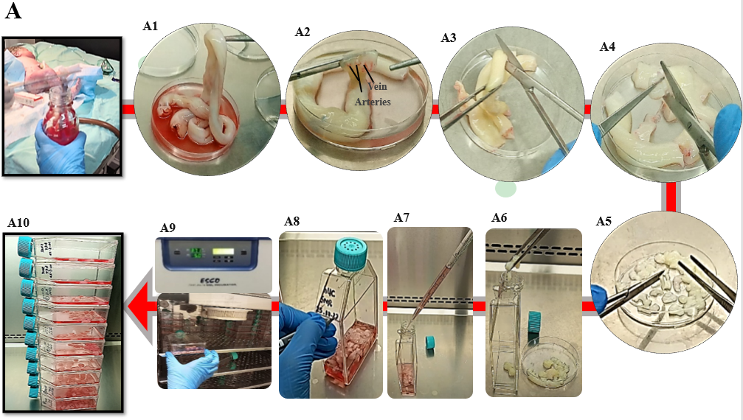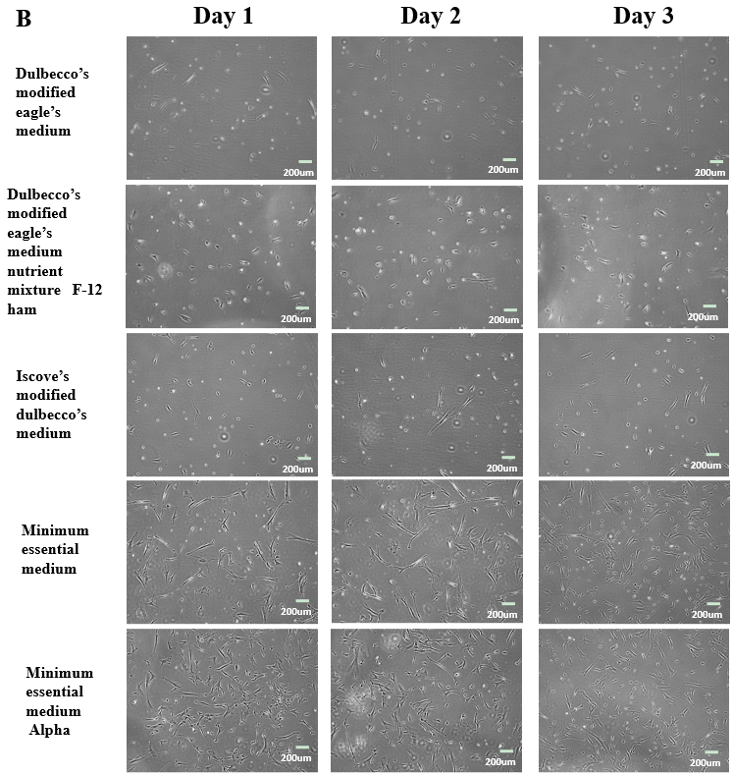
Figure 1 Human umbilical cord processing. A: Representative images of human umbilical cord (hUC) collection, and culture. A1: The hUC manually collected and processed aseptically; A2: The collected cord samples washed 5 to 6 times in 1× phosphate buffered saline, the embedded connective tissue of hUC consists of one vein and two arteries; A3: The cord samples were cut horizontally into roughly 5 cm sections; A4: An incision was made vertically to expose arteries and vein of hUC; A5: Cord sample were diced approximately into 3 mm × 3 mm pieces; A6: Cord pieces were transferred into T-75 flasks; A7: Complete minimal essential medium alpha (MEM α) was added 8-10 mL; A8: Flask was marked with respective hUC donor number; A9: The flasks were incubated undisturbed for up to 7 d at 37 °C supplied by 5% CO₂; A10: Fresh medium was supplied without disturbing attached explant; B: Representative images of mesenchymal stem cells (MSCs) cultured in different mediums; sub-culture MSCs on different cultural mediums for 3 d, morphologically observed showed rapid adherent growth, and proliferation in MEM α.

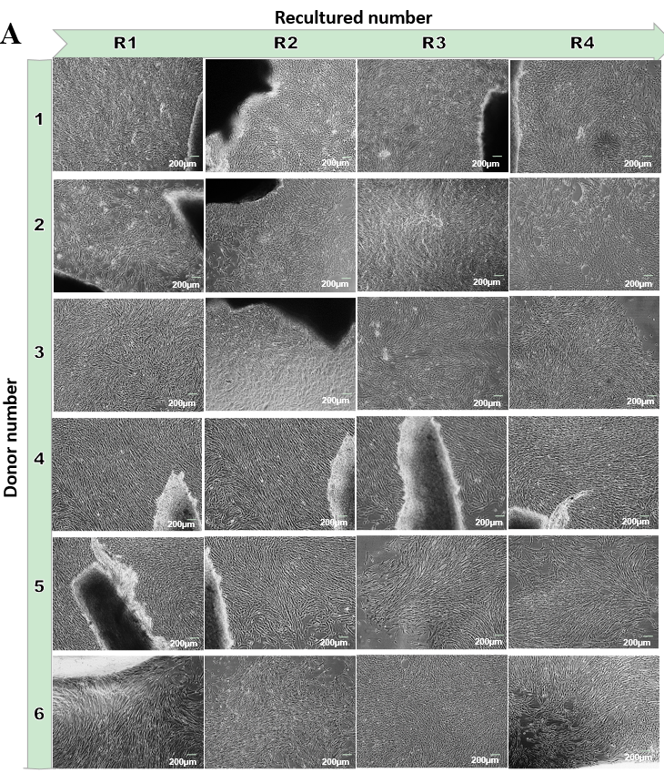
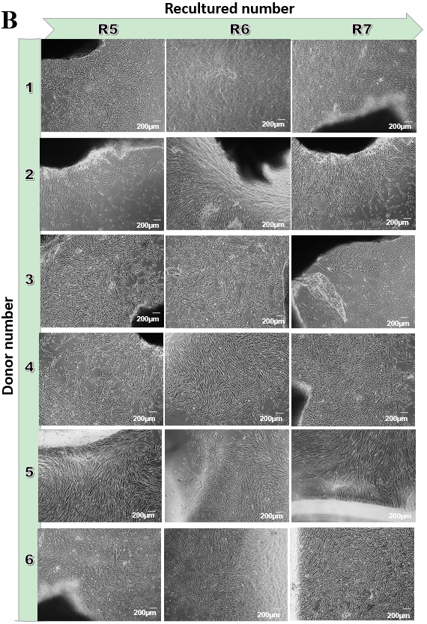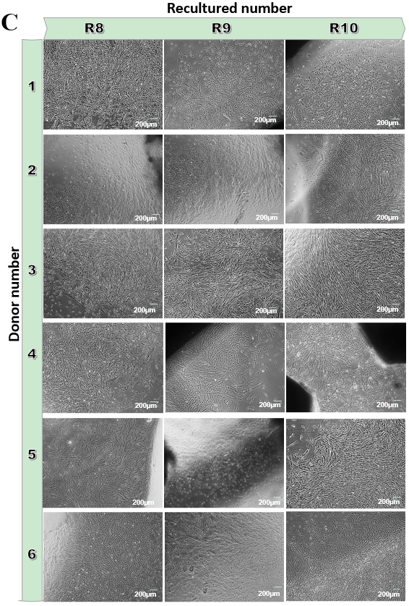
Figure 2 Morphology of human umbilical cord-mesenchymal stem cell at recultured 1-4 from respective donors. A: Homogeneous population of human umbilical cord (hUC)-mesenchymal stem cells (MSCs) at recultured (R) number 1, 2, 3 and 4 migrating from explant at day 19, 9, 8 and 7 respectively; B: Expanded homogeneous population of hUC-MSCs at recultured (R) numbers 5, 6, and 7 at day 8, 7 and 9 respectively; C: Scaled population of hUC-MSCs migrated successively from hUC recultured (R) numbers 8, 9, and 10 at 4, 5 and 8 d respectively. Microphotographs were captured at 80%-90% confluency.

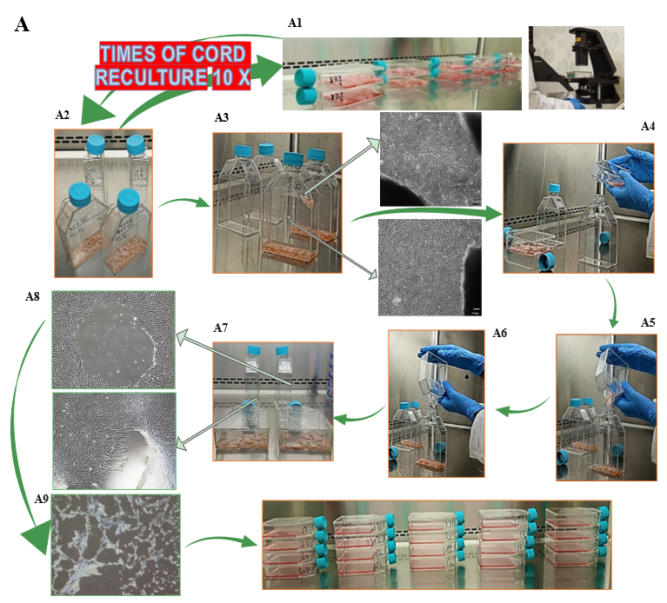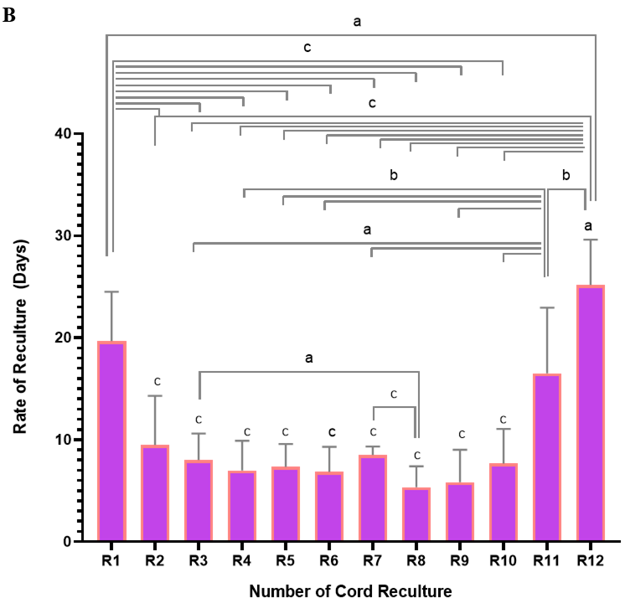
Figure 3 Effect of reculturing human umbilical cord for mesenchymal stem cells expansion and reculturing rate. A: Novel design of recultured human umbilical cord (hUC)-mesenchymal stem cells scaling method; A1: Microscopic observation of explant containing flask at respective recultured days mentioned in Figure 2; A2: Selection of flasks that occupied maximal 80%-90 % confluent colonies of mesenchymal stem cells (MSCs) releasing from the explant; A3: Microscopic observation of explant releasing MSCs; A4: Maintaining sterile culture conditions marking new flasks as subsequent recultured number and gently tap the explant-containing flask to propel all surface sticky cord pieces towards the canted neck of the flask; A5: Inclined explant containing MSC confluent flask at an angular position of 45-90 degree over the new flask with marked successive recultured number aseptically; A6: Transfer all the explant pieces into the new flask; A7 and A8: Microscopic representation of confluent hUC-MSCs after removing the explant; A9: Sub-culturing of explant removed adherent MSCs showing cellular detachment by trypsinization; A10: Scaled MSCs for experimentation; B: The graphical representation of recultured hUC-MSC: The two-way ANOVA with multiple comparisons of recultured hUC between R1-R12 times. The recultured numbers 1-10 showed a significant decrease in time to recultured hUC, hence increased MSC expansion. At R11 and R12 a significant increase in time was observed to get MSCs. ªP < 0.05, ^{b}P < 0.01, and ^{c}P < 0.001.

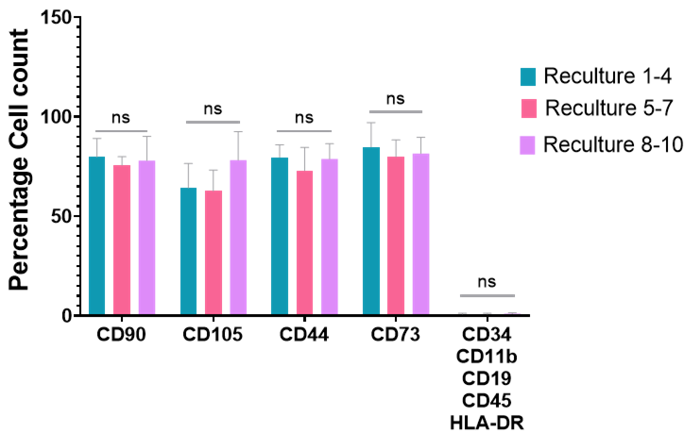
Figure 4 Flowcytometry quantified immunophenotypic expressions of recultured human umbilical cord-mesenchymal stem cells. Statistical analysis represented no variations in the expression of mesenchymal stem cell (MSC) positive expression markers and negative markers at each recultured human umbilical cord-MSCs at passage 6. The data showed from three independent experiments ± SD. ns: No significance.

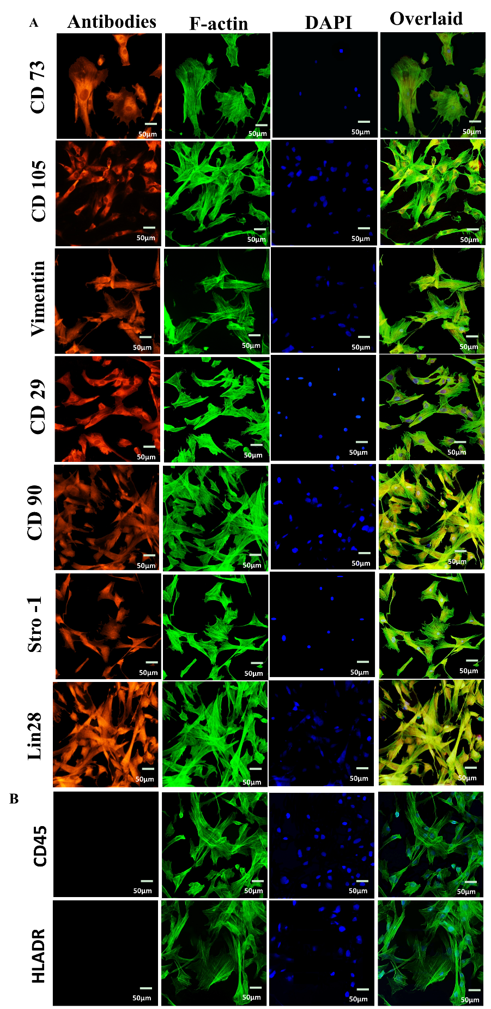
Figure 5 Immuno cytochemical profiling of recultured human umbilical cord-mesenchymal stem cells. A: The recultured human umbilical cord (hUC)-mesenchymal stem cells (MSCs) were positive for CD73, CD105, vimentin, CD29, CD90, Stro-1, and Lin28. The cells were stained with specific antibodies against MSCs markers. Nuclei were stained with DAPI. The cells were visualized for F-actin by staining with phalloidin labeled with Alexa Flour 488; B: The hUC-MSCs were negative for CD45 and HLA-DR MSCs negative markers by immunocytochemical staining.

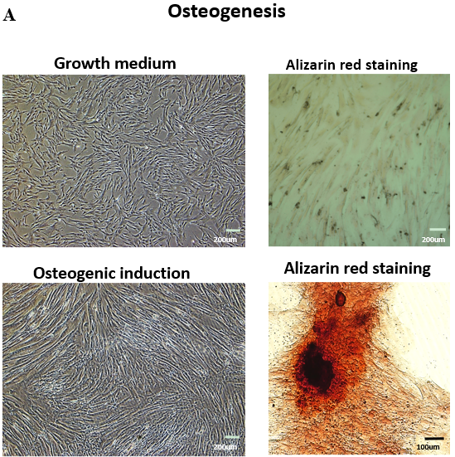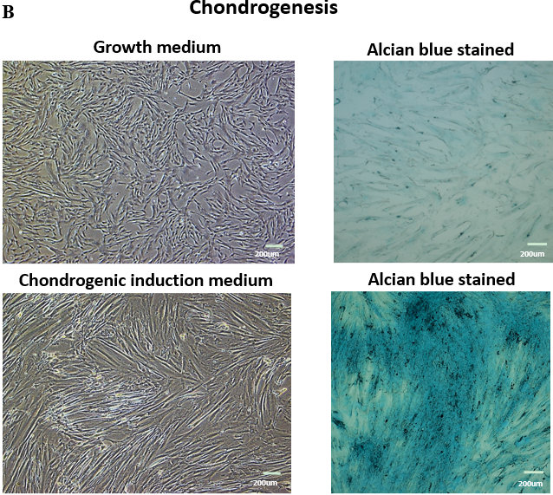
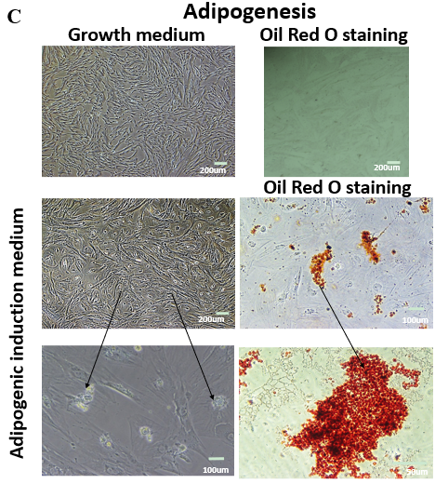
Figure 6 Trilineage differentiation of mesenchymal stem cells. A: The differentiation of recultured human umbilical cord-mesenchymal stem cells (hUC-MSCs) towards osteocytes, the stained cells showed the presence of calcium and minerals deposits by Alizarin red staining as compared to the control cells; B: The chondrogenic differentiation of recultured hUC-MSCs, was confirmed by Alcian blue stained cells showed showing the presence of glycosaminoglycan and proteoglycan in comparison to the control cells; C: The hUC-MSCs differentiated into adipocytes were confirmed by staining the cells with Oil red O, the accumulated lipid droplets indicated the differentiation of recultured hUC-MSCs towards adipogenic lineage, compared to the control cells.

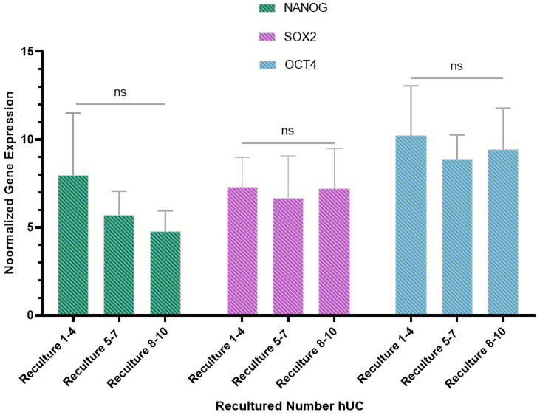
Figure 7 Pluripotency gene expression of recultured human umbilical cord-mesenchymal stem cells. The recultured human umbilical cord-mesenchymal stem cells (hUC-MSCs) results showed that all the hUC recultured MSCs express the mesenchymal pluripotency markers octamer-binding transcription factor, sex-determining region Y-box 2, and Nanog. Statistical analysis showed non-significant changes in the expression levels of these markers. The data is collected from three independent experiments ± SD, ns: No significance. Sox-2: Sex-determining region Y-box 2; Oct-4: Octamer-binding transcription factor.

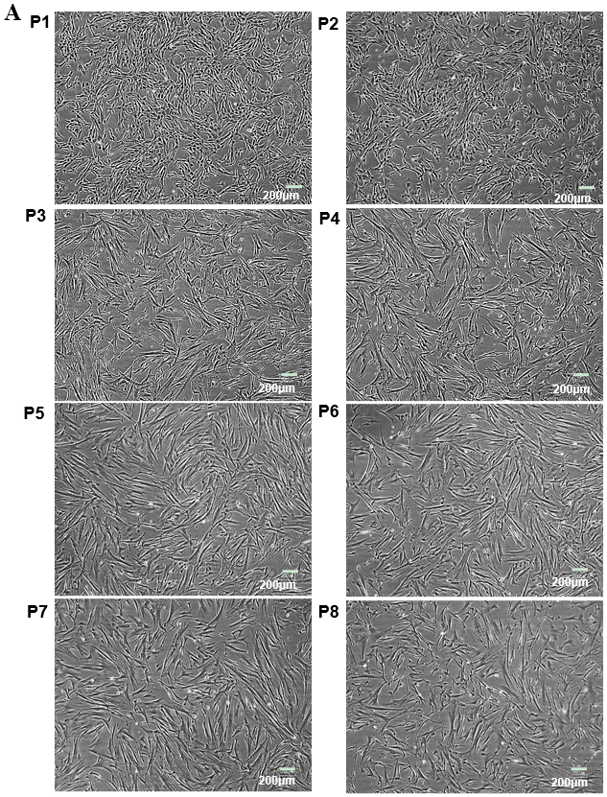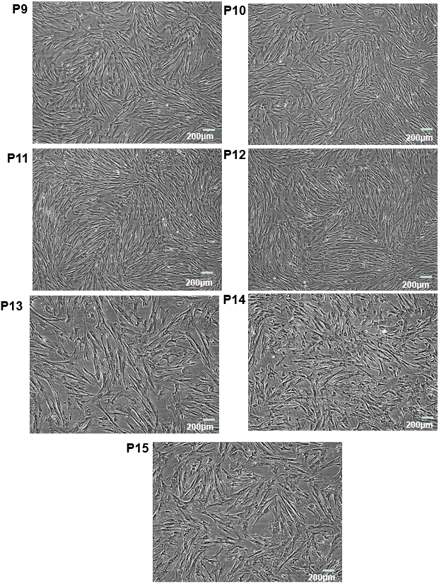
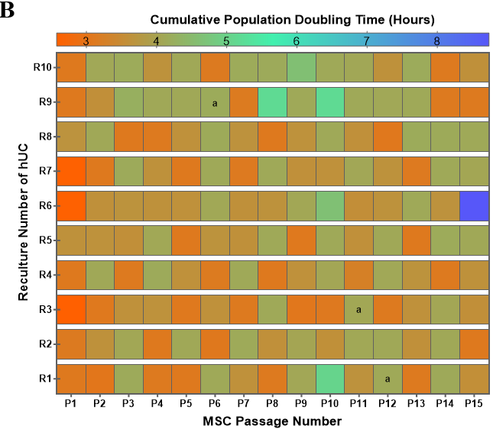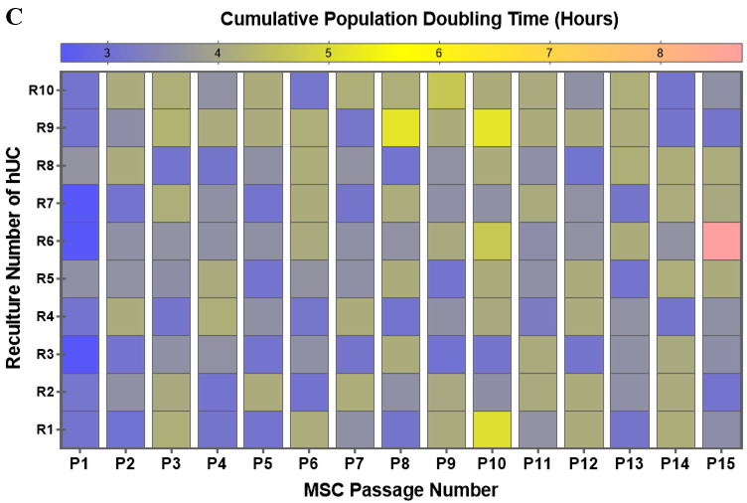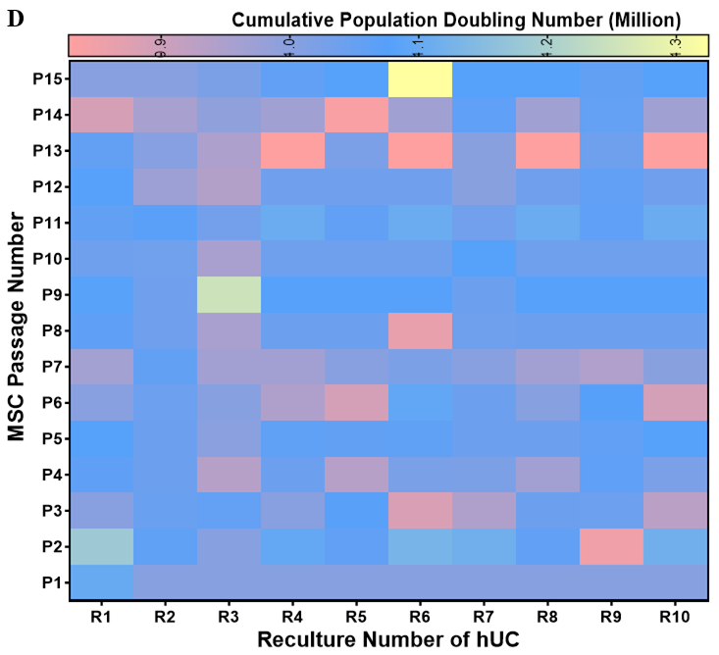
Figure 8 Passaging and population doubling analysis of recultured human umbilical cord-mesenchymal stem cells. A: Microscopic morphology of recultured human umbilical cord-mesenchymal stem cells (hUC-MSCs) at passage 1-15: The hUC-MSCs cultured in minimal essential medium alpha at a seeding density of 1000 cells/cm². The representative images were captured at 80%-90% confluency. Experiments were performed in duplicates; B: The comparative effect of population doubling time with passage at every reculture number of hUC-MSC. The data of six independent experiments shows mean ± SD with the significant P-values. ªP < 0.05; C: The comparative population doubling time on recultured hUC number on respective passage number. The heat map for multiple comparison between recultured hUC for each MSC passage number showed no significant effect on population doubling time; D: The effect of recultured hUC and MSCs passaging on population doubling number. hUC: Human umbilical cord; MSC: Mesenchymal stem cell.

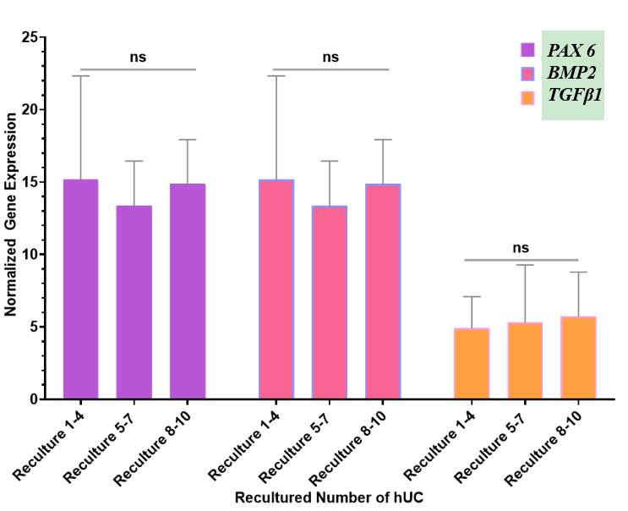
Figure 9 The proliferation gene expression analysis of recultured human umbilical cord-mesenchymal stem cells. The three different ranges of recultured human umbilical cord derived mesenchymal stem cells (MSCs) were analyzed to evaluate gene expression of proliferation markers of MSCs. The normalized mRNA expression of paired-box 6, bone morphogenetic protein 2, and transforming growth factor β1 showed no significant difference at recultured 1-4, 5-7, and 8-10. GAPDH was used as a housekeeping gene to normalize the gene expression. ns: No significance. BMP2: Bone morphogenetic proteins; PAX6: Paired-box 6; TGFβ1: Transforming growth factor beta1; hUC: Human umbilical cord.

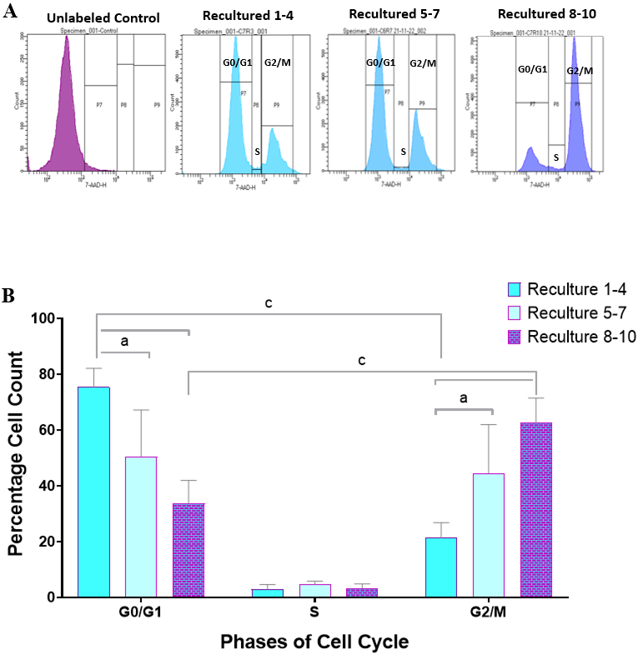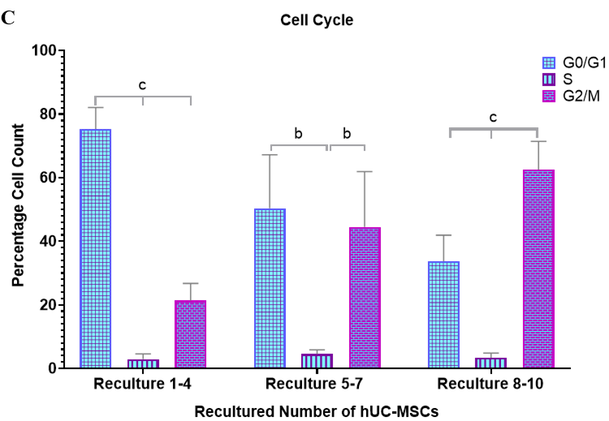
Figure 10 Cell cycle analysis of recultured human umbilical cord-mesenchymal stem cells. A: The effect of recultured human umbilical cord-mesenchymal stem cells (hUC-MSCs) on cell cycle progression: The cell cycle progression was analyzed by flow cytometry. The histogram showed decrease in G₀/G1 phase of the cell cycle between recultured group 1-4, 5-7, and 8-10. In contrast, no difference was observed in S phase of cell cycle among all three recultured hUC groups. However, the gradual increase in the percentages of hUC-MSCs present in G2/M phase among all three recultured groups (1-4, 5-7 and 8-10) was clearly observed; B: The effects of recultured hUC-MSCs on cell cycle phases: The quantification of cellular percentages in the G0/G1, S and G2/M phases of cell cycle between each recultured groups was evaluated by flow cytometry. The result showed significant decrease in G₀/G1 phase of cell cycle at recultured number 1-4, 5-7 and 8-10. Conversely, significant increase in G2/M phase at recultured 1-4, 5-7 and 8-10 numbers of hUC-MSCs were observed. The cells percentage showed no significant difference in S phase of cell cycle at all recultured groups; C: The effects of recultured hUC-MSCs on cell cycle progression: The effects of recultured hUC-MSC showed significantly increased G2/M phase of cell cycle at recultured 5-7 and 8-10. At the same time, results showed significantly decreased G0/G1 phase at recultured number 8-10 of hUC-MSCs. The data of six independent experiments is shown as mean ± SD with significant P-values. ªP < 0.05, ^{b}P < 0.01, and ^{c}P < 0.001. The graphical representation shows cumulative data from six representative hUC samples analyzed. hUC: Human umbilical cord; MSC: Mesenchymal stem cell.

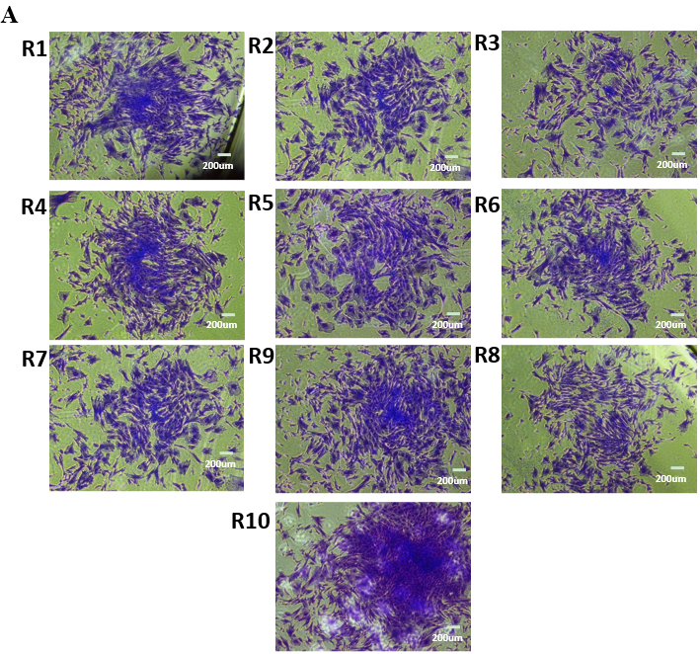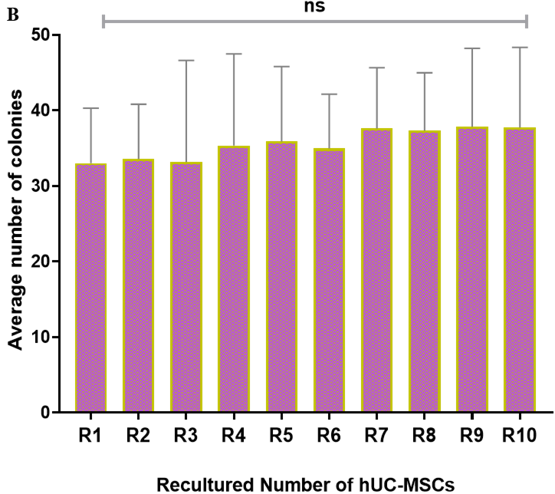
Figure 11 Colony forming unit assay. A: Formation of colonies at recultured human umbilical cord-mesenchymal stem cells (hUC-MSCs) number: Representation of phase contrast microscopy of spindle-shaped rapidly proliferated colonies of recultured hUC-MSCs at each recultured number (R1-R10); B: Analysis of recultured hUC-MSCs by colony forming unit (CFU): Statistical analysis showed no significant difference in CFU at each recultured hUC-MSCs; all the recultured population of MSCs showed self-replicated spindle-shaped cells that possess proficiency to form discrete colonies. The experiments were performed in triplicates, ns: No significance. hUC: Human umbilical cord; MSC: Mesenchymal stem cell.

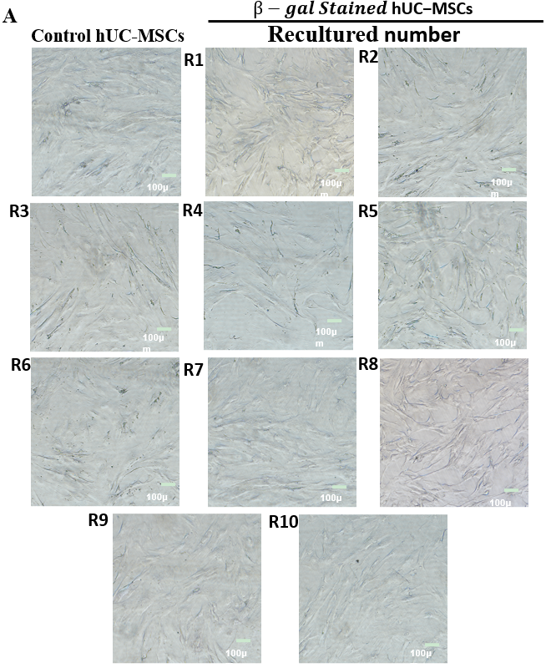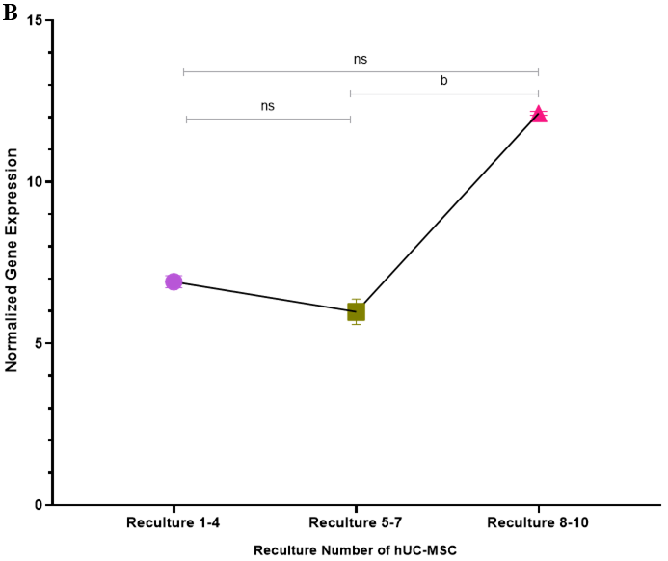
Figure 12 Cell senescence analysis. A: The effect of recultured human umbilical cord-mesenchymal stem cells (hUC-MSCs) on cellular senescence: The β-galactosidase senescence-staining was observed under bright field microscope. The results showed that none of the cells were stained blue, at primary isolated recultured hUC-MSCs isolated (R1-R10), indicating no signal of senescence; B: The graphical representation of human telomerase reverse transcriptase (hTERT) expression in recultured hUC-MSCs: To evaluate the normalized telomerase activity quantitative real-time polymerase chain reaction was performed in triplicate at passages 1-6. The X-axis represents the MSCs derived from recultured hUC at three recultured range and Y-axis represents hTERT expression normalized to housekeeping gene hydroxymethyl-bilane synthase. The hTERT expression at recultured 1-4 and 5-7 showed no significant difference. However, a significant increase in hTERT activity at recultured 8-10 was observed. Values are presented as mean ± SD from three independent experiments. ns: No significance, ^{b}P < 0.01. hUC: Human umbilical cord; MSC: Mesenchymal stem cell.

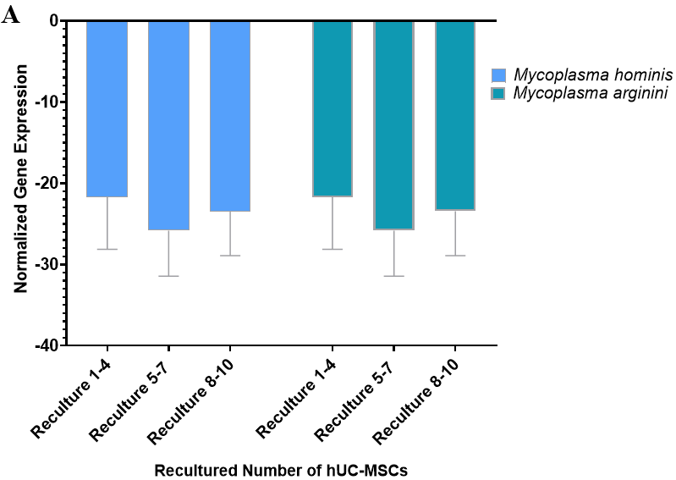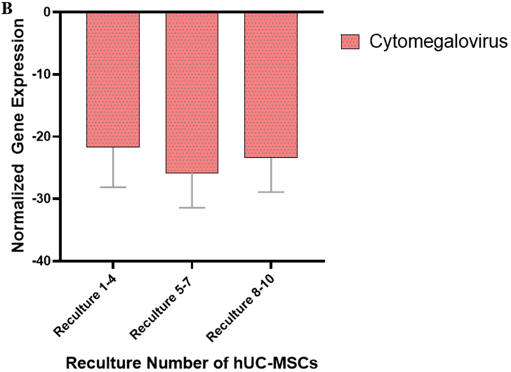
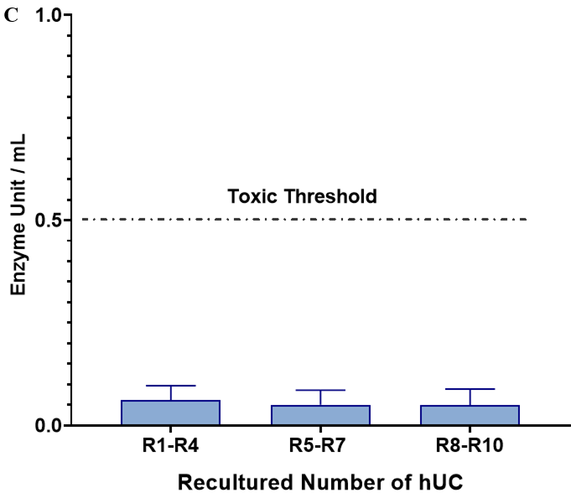
Figure 13 Mycoplasma, cytomegalovirus and endotoxin analysis. A and B: The normalized gene expression of mycoplasma and cytomegalovirus in recultured human umbilical cord-mesenchymal stem cells (hUC-MSCs): To evaluate the normalized gene expression of Mycoplasma hominis (M. hominis) and M. arginini and cytomegalovirus, quantification was performed by real-time polymerase chain reaction in triplicate at passages 1-6. The X-axis represents the MSCs derived from recultured hUC at three recultured ranges and Y-axis represents M. hominis and M. arginini and cytomegalovirus expression normalized to housekeeping gene hydroxymethyl-bilane synthase. The expression at each recultured group showed negative expression of both strains of Mycoplasma. Values are presented as mean ± SD from six independent experiments. Statistically non-significant normalized expression was obtained; C: Recultured hUC-MSCs endotoxin analysis: The level of endotoxin in recultured hUC-MSC by using the Pierce LAL Chromogenic Endotoxin Quantification Kit. The concentration of endotoxin is below 0.5 EU/mL. hUC: Human umbilical cord; MSC: Mesenchymal stem cell.

Table 1 Mesenchymal stem cell specific antibodies used in immunocytochemistry
Primary antibody markers | Molecular function and binding | Working dilution | Manufacturer information
CD73 | Hyaluronan receptor | 1:100 | 550256, BD Pharmingen, United States
CD105 | Endoglin | 1:100 | 560839, BD Pharmingen, United States
Vimentin | Epithelial-mesenchymal transition | 1:100 | V6389, Sigma-Aldrich, United States
CD29 | Membrane glycoprotein | 1:100 | MAB-1981, Chemicon International, United States
CD90 | Thymocyte antigen 1 | 1:100 | CL005AP, EMD Millipore Corp., United States
Stro-1 | Mesenchymal cell precursor marker | 1:100 | 14-6688-82, Molecular Probes, Invitrogen, United States
Lin28 | Cell surface MSC marker | 1:100 | PA1-096, Molecular Probes, Invitrogen, United States
CD45 | Lymphocyte antigen | 1:100 | CBL415, BD Pharmingen, United States
HLA-DR | MHC class II immunogenic marker | 1:100 | 14-9956-82, Molecular Probes, Invitrogen, United States
Secondary antibody | Conjugated label | Working dilution | Manufacturer information
Goat anti-rabbit IgG | Alexa Fluor 546 | 1:200 | A-11010 Molecular Probes, Invitrogen, United States
Goat anti-mouse IgG | Alexa Fluor 546 | 1:200 | A-11030 Molecular Probes, Invitrogen, United States
MHC: Major histocompatibility complex; IgG: Immunoglobulin G.

Table 2 Gene expression primer sequences for quantitative polymerase chain reaction
Marker name | Primer sequence | Annealing temperature (°C)
 | MSC pluripotency markers
GAPDH | F: 5’-CACCATGGGGAAGGTGAAGG-3’ | 57.8
 | R: 5’-AGCATCGCCCCACTTGATTT-3’
NANOG | F: 5’-AAGGCAAACAACCCACTTCTG-3’ | 56
 | R: 5’-CCAGTTGTTTTTCTGCCACCT-3’
Sox-2 | F: 5’-CCCTGCAGTACAACTCCATGAC-3’ | 57.7
 | R: 5’-GGTAGTGCTGGGACATGTGAAG-3’
Oct-4 | F: 5’-GATGTCAGGGCTCTTTGTCCA-3’ | 57.1
 | R: 5’-TACTCTCCCCAGCTTGCTTTG-3’
MSC proliferation markers
PAX 6 | F: 5’-AGCTCGGTGGTGTCTTTGTC-3’ | 60
 | R: 5’-CACTCCCGCTTATACTGGGC-3’
BMP2 | F: 5’-AGCTGGGCCGAGGA-3’ | 58
 | R: 5’-TCGGCTGGCTGCCCT-3’
TGF β1 | F: 5’-CAAGGCACAGGGGACCAG-3’ | 58
 | R: 5’-CAGGTTCCTGGTGGGCAG-3’
Senescence marker
HMBS | F: 5’-GGCAATGCGGCTGCAA-3’ | 57
 | R: 5’-GGGTACCCACGCGAATCAC-3’
hTERT | F: 5’-GACGTGGAAGATGAGCGTG-3’ | 57
 | R: 5’-GACGACGTACACACTCATC-3’
Mycoplasma strains
Mycoplasma hominis | F: 5’-CAATGGCTAATGCCGGATACGC-3’ | 58
 | R: 5’-GGTACCGTCAGTCTGCAAT-3’
Mycoplasma arginini | F: 5’-AGAGTTTGATCCTGGCTCAGGA-3’ | 58
 | R: 5’-TCAACCAGGTGTTCTTTCCC-3’
 | Cytomegalovirus
Human cytomegalovirus IE | F: 5’-CCAAGGCCACGACGTTCCTGCAGACTA-3’ | 58
 | R: 5’-TGCTCCTTGATTCTATGCCGCACCA-3’
GAPDH: Glyceraldehyde-3-phosphate dehydrogenase; Sox-2: Sex-determining region Y-box 2; BMP2: Bone morphogenetic proteins; Oct-4: Octamer-binding transcription factor; PAX6: Paired-box 6; TGFβ1: Transforming growth factor beta1; HMBS: Hydroxymethyl-bilane synthase; hTERT: Human telomerase reverse transcriptase; MSC: Mesenchymal stem cell.

Table 3 Donor’s information and sample inclusion
Donor | Age | Anti-HCV¹ | Anti-HBV¹ | SYPHILUS¹
1 | 22 | - | - | -
2 | 25 | - | - | -
3 | 26 | - | - | -
4 | 21 | - | - | -
5 | 27 | - | - | -
6 | 29 | - | - | -
¹Non-reactive: Negative (-).
HCV: Hepatitis C virus; HBV: Hepatitis B virus.

