Name of Journal: World Journal of Cardiology
Manuscript NO: 88819
Manuscript Type: ORIGINAL ARTICLE

Retrospective Cohort Study
Development and validation of a nomogram model for predicting the risk of pre-hospital delay in patients with acute myocardial infarction

Cao JY et al. Nomogram for PHD in AMI patients

Jiao-Yu Cao, Li-Xiang Zhang, Xiao-Juan Zhou

Jiao-Yu Cao, Li-Xiang Zhang, Xiao-Juan Zhou, Department of Cardiology, The First Affiliated Hospital of USTC, Division of Life Science and Medicine, University of Science and Technology of China, Hefei 230001, Anhui Province, China

Co-first authors: Jiao-Yu Cao and Li-Xiang Zhang.

Author contributions: Cao JY and Zhang LX contributed equally to this work; Cao JY and Zhou XJ designed the research study; Cao JY and Zhang LX performed the research; Zhang LX contributed analytic tools; Cao JY and Zhang LX analyzed the data and wrote the manuscript; All authors have read and approve the final manuscript.

Corresponding author: Jiao-Yu Cao, MMed, Chief Nurse, Department of Cardiology, The First Affiliated Hospital of USTC, Division of Life Science and Medicine, University of Science and Technology of China, No. 1 Swan Lake Road, Hefei 230001, Anhui Province, China. caojiaoyu@126.com

Received: October 10, 2023
Revised: January 2, 2024
Accepted: February 2, 2024
Published online: February 26, 2024

Abstract
BACKGROUND
Acute myocardial infarction (AMI) is a severe cardiovascular disease caused by the blockage of coronary arteries that leads to ischemic necrosis of the myocardium. Timely medical contact is critical for successful AMI treatment, and delays increase the risk of death for patients. Pre-hospital delay time (PDT) is a significant challenge for reducing treatment times, as identifying high-risk patients with AMI remains difficult. This study aims to construct a risk prediction model to identify high-risk patients and develop targeted strategies for effective and prompt care, ultimately reducing PDT and improving treatment outcomes.

AIM
To construct a nomogram model for forecasting pre-hospital delay (PHD) likelihood in patients with AMI and to assess the precision of the nomogram model in predicting PHD risk.

METHODS
A retrospective cohort design was employed to investigate predictive factors for PHD in patients with AMI diagnosed between January 2022 and September 2022. The study included 252 patients, with 180 randomly assigned to the development group and the remaining 72 to the validation group in a 7:3 ratio. Independent risk factors influencing PHD were identified in the development group, leading to the establishment of a nomogram model for predicting PHD in patients with AMI. The model's predictive performance was evaluated using the receiver operating characteristic curve in both the development and validation groups.

RESULTS
Independent risk factors for PHD in patients with AMI included living alone, hyperlipidemia, age, diabetes mellitus, and digestive system diseases (P < 0.05). A nomogram model incorporating these five predictors accurately predicted PHD occurrence. The receiver operating characteristic curve analysis indicated area under the receiver operating characteristic curve values of 0.787 (95% confidence interval: 0.716–0.858) and 0.770 (95% confidence interval: 0.660-0.879) in the development and validation groups, respectively, demonstrating the model's good discriminatory ability. The Hosmer–Lemeshow goodness-of-fit test revealed no statistically significant disparity between the anticipated and observed incidence of PHD in both development and validation cohorts (P > 0.05), indicating satisfactory model calibration.

CONCLUSION
The nomogram model, developed with independent risk factors, accurately forecasts PHD likelihood in AMI individuals, enabling efficient identification of PHD risk in these patients.

Key Words: Pre-hospital delay; Acute myocardial infarction; Risk prediction; Nomogram

©The Author(s) 2024. Published by Baishideng Publishing Group Inc. All rights reserved.

Citation: Cao JY, Zhang LX, Zhou XJ. Development and validation of a nomogram model for predicting the risk of pre-hospital delay in patients with acute myocardial infarction. World J Cardiol 2024; 16(2): 80-91
URL: https://www.wjgnet.com/1949-8462/full/v16/i2/80.htm
DOI: https://dx.doi.org/10.4330/wjc.v16.i2.80

Core Tip: The study developed a nomogram model to predict pre-hospital delay (PHD) in acute myocardial infarction (AMI) patients. Independent risk factors for PHD were identified, and a nomogram was constructed using these predictors. The model showed good discriminatory ability and satisfactory calibration. This nomogram can effectively identify PHD risk in AMI patients.

INTRODUCTION
Acute myocardial infarction (AMI), a cardiovascular condition often stemming from coronary artery disease, arises when the abrupt blockage of the coronary artery disrupts blood circulation, leading to localized myocardial ischemic necrosis. Existing research underscores the critical impact of timely medical contact, revealing that every hour of delay increases the risk of death in patients with AMI by approximately 10%^{[1]}. Swift restoration of blood flow in the infarct-related artery is pivotal for effective AMI treatment, with the efficacy of infarct-related artery recanalization treatment being significantly time-dependent. The shorter the duration between AMI onset and treatment, the more favorable the therapeutic outcomes^{[2]}.
The temporal aspect of AMI treatment encompasses pre-hospital delay time (PDT) and in-hospital delay time^{[3,4]}. While measures such as optimizing hospital emergency procedures and establishing green channels have successfully reduced in-hospital delay time^{[5]}, PDT remains a challenge due to various influencing factors. Creating a universally applicable treatment protocol to minimize PDT proves challenging, given the diverse circumstances. Treating all patients with pre-hospital AMI with efficient measures poses a logistical challenge, potentially straining first aid resources and impacting the treatment of other emergency cases.
Therefore, the crux of shortening PDT lies in the identification of high-risk patients with AMI and the swift implementation of emergency measures^{[6]}. This study aims to delve into the determinants of pre-hospital delay (PHD) in patients with AMI, with a specific focus on constructing a robust risk prediction model. The ultimate objective was to gain insights and leverage them for devising targeted and efficient strategies to mitigate PDT in patients with AMI, ensuring prompt and effective care.

MATERIALS AND METHODS
Research objects
This retrospective cohort study spanned from January 2022 to September 2022 and focused on patients with AMI admitted to a tertiary hospital in Anhui Province, China. The inclusion criteria mandated that patients were transported by ambulance and diagnosed with AMI based on clinical symptoms, electrocardiogram, and myocardial enzyme dynamic observation. The exclusion criteria comprised patients with missing data or mental disorders. The study received approval from the Institutional Review Board (IRB) of the research institution (ID: 2023-RE-124), and due to its retrospective nature, informed consent requirements were exempted by the IRB.

Data collection methods
Data encompassed diverse factors such as age, sex, coronary artery lesions, Killip classification, family monthly income, body mass index, stent count, comorbidities (hypertension, cerebral infarction, hyperlipidemia, diabetes, renal insufficiency, digestive system diseases), Timi classification, medical expenses payment method, history of AMI, onset time (daytime: 8:00–17:00, nighttime: 17:01–07:59), living arrangements, work status, heart failure, education level, marital status, alcohol consumption, smoking, atrial fibrillation—totaling 26 indicators. Predefined as the interval from myocardial infarction symptom onset to seeking medical care, PDT was set at 6 h, a threshold for thrombolytic therapy^{[7]}. Thus, patients were categorized into two groups: PDT ≤ 6 h (non-PHD) and PDT > 6 h (PHD).

Statistical analysis
Data analysis utilized Epidata 3.1 and SPSS 23.0. Quantitative variables with normal distribution were presented as mean ± standard deviation; non-normally distributed variables were denoted as M(P25, P75), signifying the median value alongside the 25th and 75th percentiles. Counting data were expressed as case numbers and percentages. Independent risk factors influencing PHD were identified through univariate and multivariate logistic regression analysis. The nomogram model was constructed using R software (version 4.0.1), and its predictive efficacy was assessed using the receiver operating characteristic (ROC) curve. The degree of calibration of the nomogram model was evaluated through calibration curve and Hosmer–Lemeshow goodness-of-fit tests. Clinical applicability was assessed through decision curve analysis (DCA). P < 0.05 was considered statistically significant.

RESULTS
Comparison of population characteristics between development and validation groups
Out of the total 252 patients with AMI, 84 (33.33%) experienced PHD. The study population was randomly divided into a development group (n = 180) and a validation group (n = 72) in a 7:3 ratio. Upon comparing demographic and clinical characteristics between the two groups, no statistically significant disparities were observed (P > 0.05), between both groups, indicating homogeneity (Table 1).

Univariate and multivariate analysis of PHD risk in patients with AMI
In the development group, univariate and multivariate Logistic regression methods were employed to identify risk factors associated with post-hospital discharge (PHD) in patients with AMI. Univariate analysis revealed significant associations (P < 0.05) with PHD for variables like living alone, nighttime onset, combined hypertension and hyperlipidemia, urban residence, age, combined diabetes, smoking, combined digestive system diseases, and female sex. Multivariate analysis identified living alone, hyperlipidemia, advancing age, diabetes, and digestive system diseases as independent risk factors for PHD in patients with AMI (P < 0.05), as detailed in Table 2.

Development of nomogram prediction model for PHD risk in patients with AMI
Construction of the nomogram prediction model for PHD risk in the development group involved utilizing the "rms" package in R software. Five predictors were identified through multivariate Logistic regression analysis, as depicted in Figure 1. The nomogram developed in this study is a valuable tool for assessing the risk of PHD in patients with AMI. The interpretation of the nomogram involves a systematic process. Each indicator in the nomogram corresponds to a specific vertical line that ascends from the respective score on the horizontal axis labeled "Points." Along each indicator's line, a specific score is assigned based on the patient's characteristics. Four specific scores from different indicators are added together to calculate the total score.
The total score is located on the horizontal axis labeled "Total Points." A vertical line is drawn downward from the total score to intersect with the axis labeled "Risk of Pre-hospital Delay." The value corresponding to the intersection point indicates the estimated risk of pre-hospital delay for the patient. As an example, consider a 65-year-old patient with the following scores: age (65 years): 60 points, hyperlipidemia: 27.5 points, digestive system diseases: 35 points, living with family (not living alone): 0 points. The total score for this patient would be 122.5 points. Locating 122.5 points on the "Total Points" axis and drawing a line downward intersects with the "Risk of Pre-hospital Delay" axis. The corresponding value on the "Risk of Pre-hospital Delay" axis (e.g., 0.67 points) indicates the estimated risk of pre-hospital delay for this patient.

ROC curve analysis of the nomogram model
To evaluate the discrimination performance, the nomogram model's area under the ROC curve was calculated. In the development group, the area under the ROC curve was 0.787 (95% confidence interval: 0.716–0.858), and in the validation group, it was 0.770 (95% confidence interval: 0.660–0.879). These results signify favorable discrimination, as illustrated in Figure 2.

Calibration curve analysis of the nomogram model
The calibration curve and the Hosmer–Lemeshow goodness of fit test were used to assess the calibration degree of the nomogram model. The results from the Hosmer–Lemeshow goodness of fit test indicated no statistically significant deviation between the predicted probability of PHD from the nomogram model and the actual occurrence in both the development and validation groups (P > 0.05). This implies that the nomogram model exhibits favorable calibration, as depicted in Figure 3.

Clinical applicability of the nomogram model
The clinical applicability of the nomogram model was assessed using the DCA curve. The DCA curve analysis indicated that the nomogram model achieved the highest clinical net rate when the threshold probability of PHD in the development group ranged from 0.09 to 0.68 and that in the validation group ranged from 0.16 to 0.59. This performance surpassed both "full intervention" and "no intervention" schemes, affirming the favorable clinical applicability of the nomogram model, as shown in Figure 4.

DISCUSSION
AMI represents a common emergency with high morbidity and mortality, particularly affecting a younger demographic, posing a substantial threat to patients' lives^{[8]}. Studies have underscored the significance of recanalization in restoring cardiovascular supply, enhancing cardiac oxygen delivery, and improving patient prognosis^{[9]}. However, the success of reperfusion therapy is contingent upon its timeliness; the earlier the patient reaches the hospital, the better the treatment outcomes^{[10]}. Despite the recognized importance of prompt intervention, delays in treatment time, including PHD and in-hospital delay, contribute to a significant proportion of cases where myocardial infarction patients fail to receive timely treatment^{[11]}. Currently, 30%-40% of patients with AMI experience PHD, presenting a challenge due to numerous interference factors that impede the development of a unified and efficient treatment process^{[12,13]}. To address this challenge and reduce the time interval from symptom onset to percutaneous coronary intervention, it is imperative to identify individuals at high risk before discharge and administer specific interventions to enhance the efficacy of treatment for myocardial infarction. In the present study, potential risk factors influencing the occurrence of post-hospital discharge were identified through univariate analysis and subsequently adjusted using multivariate logistic regression analysis. Consequently, five distinct risk factors were identified as independent predictors of PHD in patients with AMI: advanced age, living alone, comorbidity with digestive system diseases, comorbidity with hyperlipidemia, and comorbidity with diabetes.
This study has provided evidence supporting the role of age as an independent determinant of PHD in patients with AMI, aligning with findings reported by Ouellet et al^{[14]}. Atypical symptoms in the elderly were identified as a significant cause of PHD^{[15]}. Older patients, often burdened with comorbidities such as hypertension, diabetes, and cerebrovascular disease, may present with atypical symptoms and symptoms of pre-infarction angina pectoris, contributing to a misperception of a general mild disease. Additionally, traditional ideas influencing the elderly's choice to be sent to the hospital by their children can lead to delays in medical treatment. This hesitation, especially prevalent in cases where children are not around to assist, may result in the use of self-administered oral drugs or waiting for symptoms to naturally disappear, further increasing the risk of PHD with serious consequences^{[16]}. The study substantiates the association between living alone and an elevated risk of PHD, establishing it as an independent risk factor.
The challenges posed by China's burgeoning aging population, marked by a rising number of elderly individuals residing alone and empty nesters, necessitate innovative approaches to address healthcare concerns, particularly in cases of acute and severe illnesses^{[17,18]}. For patients living alone, the potential delay in medical treatment due to the inability to take necessary self-help measures, especially in cases affecting their activities, poses a serious risk, with potential life-threatening consequences. In this context, the study highlights the potential utility of remote monitoring systems, such as smart watches and bracelets, to control the health of elderly individuals living alone in real-time. This technological intervention holds promise in effectively reducing the risk of PHD in patients living alone, thereby enhancing timely medical intervention and improving outcomes.
The study also brings attention to the significant impact of co-occurring digestive system diseases as an autonomous risk factor for PHD in patients with AMI. Diseases like chronic gastritis and gastrointestinal ulcers are identified for their potential to cause pain and mask symptoms of myocardial infarction^{[19]}, leading to missed treatment opportunities. To address this, the study advocates for tailored AMI health education for patients with digestive system diseases, particularly ulcer diseases. Concrete measures proposed include the preparation of a basic knowledge manual about heart disease, emphasizing causes, symptoms, and preventive measures. Additionally, the involvement of medical staff for in-home health talks, encouraging participation in mutual support groups, and imparting knowledge on developing good daily habits are suggested strategies to empower the elderly living alone with digestive system diseases to better understand and cope with heart disease.
Furthermore, the study substantiates a positive association between hyperlipidemia and the susceptibility to PHD among patients with AMI. This finding aligns with a cross-sectional investigation on PHD in patients with AMI in Saudi Arabia, as reported by Alahmadi et al^{[20]}. Hyperlipidemia, a common cause of AMI, is elucidated as a contributor to atherosclerosis, leading to the formation of lipid plaques on arterial walls. The instability of these plaques can result in rupture and thrombus formation, culminating in the occurrence of AMI. The study underscores the multifaceted impact of hyperlipidemia on vascular function, inducing endothelial cell injury and inflammatory reactions, ultimately affecting the occurrence and prognosis of AMI and increasing the risk of PHD. Previous studies^{[21-23]} have highlighted prolonged PDT in patients with AMI with diabetes, aligning with the current study's findings indicating that diabetes can increase the risk of PHD in patients with AMI. The study by Ängerud et al^{[24]} emphasized a significantly longer median PDT in diabetic patients compared to non-diabetic patients (75 min), suggesting the need for targeted strategies to address the unique challenges faced by this subgroup. Additionally, the study in China proposed that the atypical presentation of chest pain symptoms in diabetic patients, with a higher proportion of NSTEMI patients, contributes to the PHD risk in this population^{[25]}.
The cumulative evidence from this study highlights the necessity for comprehensive strategies addressing the diverse risk factors influencing PHD in patients with AMI, including technological interventions, tailored education programs, and targeted management approaches for specific comorbidities. The integration of clinical prediction models into medical practice, particularly nomograms, has become pivotal in risk and benefit assessments, providing a more objective and precise means of information acquisition^{[26,27]}. Within cardiovascular research, nomograms have proven effective in predicting various outcomes, ranging from in-hospital mortality to the risk of specific complications post-diagnosis^{[28-31]}. Despite these advancements, there exists a notable gap in literature pertaining to nomogram studies specifically examining the risk of post-hospital discharge in patients with AMI. Addressing this void, our study utilized univariate and multivariate Logistic regression to identify independent risk factors for PHD in patients with AMI, culminating in the development of a nomogram model tailored to predict this risk. Notably, our findings underscore the nomogram model's favorable calibration, discrimination, and clinical applicability, as evidenced by the Hosmer-Lemeshow goodness of fit test, ROC curve analysis, and DCA curve.
The nomogram model developed in this study fills a crucial gap in predicting the risk of PHD in patients with AMI, providing a valuable tool for rapid risk assessment and more targeted treatment strategies. By identifying high-risk patients, the nomogram facilitates swift and effective intervention, ultimately enhancing patient prognosis.
However, it is imperative to acknowledge certain limitations inherent in this study. The retrospective nature of the research introduces potential issues such as incomplete data, low data quality, and case selection bias, which may impact result accuracy. Additionally, the study's reliance on data from a single medical institution raises concerns about its representativeness for broader populations. The limited sample size and consideration of only a subset of predictors further necessitate caution in generalizing the results. Future endeavors should prioritize large-scale, multi-center, and multi-regional studies to enhance result representativeness and generalizability.

CONCLUSION
In conclusion, this study, despite its limitations, successfully identified five independent risk factors associated with PHD in patients with AMI. The subsequent construction of a nomogram model exhibited robust predictive value, offering valuable insights for pre-hospital treatment strategies in patients with AMI and mitigating the risk of PHD. The results emphasize the significance of incorporating nomograms into clinical practice for enhanced risk assessment and tailored interventions in the context of AMI.

ARTICLE HIGHLIGHTS
Research background
Acute myocardial infarction (AMI), a lethal heart condition, results from coronary artery blockages that cause myocardial ischemia and necrosis. Treatment delays heighten death risks, making prompt medical response critical. This study focuses on reducing pre-hospital delays by identifying high-risk AMI patients, developing a risk prediction model, and implementing tailored strategies for timely care.

Research motivation
The timely management of AMI is crucial for improving patient outcomes, yet pre-hospital delay time (PDT) poses a significant challenge, leading to increased morbidity and mortality rates. This research is motivated by the need to understand the determinants of PDT in AMI patients and develop a robust risk prediction model. By identifying high-risk individuals and implementing targeted strategies to reduce PDT, this study aims to enhance the delivery of prompt and effective care. Its significance lies in addressing a critical knowledge gap in cardiovascular medicine and offering practical solutions to optimize AMI treatment outcomes for future research in this field.

Research objectives
The main objective is to investigate determinants of pre-hospital delay (PHD) in AMI patients and construct a risk prediction model. Realizing these objectives has significant implications for future research in this field, allowing refinement of models, development of evidence-based guidelines, and optimization of AMI treatment strategies for improved patient outcomes.

Research methods
This retrospective cohort study investigated determinants of PHD in AMI patients and developed a risk prediction model. Data on 26 indicators were collected from AMI patients admitted to a tertiary hospital in Anhui Province, China. Statistical analysis involved logistic regression, nomogram modeling, receiver operating characteristic curve analysis, calibration tests, and decision curve analysis. The study contributes to advancing AMI management research.

Research results
This study identified risk factors for post-hospital discharge in acute myocardial infarction patients. Living alone, hyperlipidemia, age, diabetes, and digestive system diseases were significant predictors. A nomogram model accurately predicted the risk of post-hospital discharge. This model can help healthcare professionals identify high-risk patients and provide targeted interventions, but further validation is needed in larger populations.

Research conclusions
This study concludes that the newly developed nomogram model, incorporating independent risk factors, accurately predicts the likelihood of post-hospital discharge in acute myocardial infarction patients. This model offers a valuable tool for efficiently identifying individuals at risk of post-hospital discharge, providing potential benefits for targeted interventions and improved patient outcomes in clinical practice.

Research perspectives
Future research should address limitations of the retrospective design, limited sample size, and subset of predictors. Large-scale, multi-center studies with comprehensive data are needed to enhance generalizability. Exploring additional risk factors and refining predictive models can improve accuracy for forecasting post-hospital discharge outcomes in acute myocardial infarction patients, benefiting clinical decision-making.

REFERENCES
1 Beaudoin FL, Straube S, Lopez J, Mello MJ, Baird J. Prescription opioid misuse among ED patients discharged with opioids. Am J Emerg Med 2014; 32: 580-585 [PMID: 24726759 DOI: 10.1016/j.ajem.2014.02.030]
2 Xu WH, Liu XM. Influencing factors and coping strategies of prehospital delay in patients with acute myocardial infarction. Cardio-cerebrovascular Disease Prevention and Treatment 2022; 22: 79-83 [DOI: 10.3969/j.issn.1009-816x.2022.05.020]
3 Du LF, Lian HW, Ma QB. Distribution of delay time of emergency percutaneous coronary intervention in the patients with ST-segment elevation myocardial infarction. Chinese J Emerg Med 2016; 36: 146-149 [DOI: 10.3969/j.issn.1002-1949.2016.02.010]
4 Fu R, Song CX, Dou KF, Yang JG, Xu HY, Gao XJ, Liu QQ, Xu H, Yang YJ. Differences in symptoms and pre-hospital delay among acute myocardial infarction patients according to ST-segment elevation on electrocardiogram: an analysis of China Acute Myocardial Infarction (CAMI) registry. Chin Med J (Engl) 2019; 132: 519-524 [PMID: 30807351 DOI: 10.1097/CM9.0000000000000122]
5 Imamura T. Optimal risk stratification and therapeutic strategy for acute myocardial infarction. Clin Cardiol 2021; 44: 737 [PMID: 34013995 DOI: 10.1002/clc.23645]
6 Gebhard CE, Gebhard C, Maafi F, Bertrand MJ, Stähli BE, Maredziak M, Bengs S, Haider A, Zhang ZW, Smith DC, Ly HQ. Impact of summer season on pre-hospital time delays in women and men undergoing primary percutaneous coronary intervention. Sci Total Environ 2019; 656: 322-330 [PMID: 30513423 DOI: 10.1016/j.scitotenv.2018.11.363]
7 Fang XY, Albarqouni L, von Eisenhart Rothe AF, Hoschar S, Ronel J, Ladwig KH. Is denial a maladaptive coping mechanism which prolongs pre-hospital delay in patients with ST-segment elevation myocardial infarction? J Psychosom Res 2016; 91: 68-74 [PMID: 27894465 DOI: 10.1016/j.jpsychores.2016.10.008]
8 Wang HJ, Dou KF. Consensus of China experts on the evaluation index system of medical quality in adults with acute ST-segment elevation myocardial infarction. Zhonghua Xin Xue Guan Bing Za Zhi 2018; 46: 849-856 [DOI: 10.3760/cma.j.issn.0253-3758.2018.11.007]
9 Chen GY, Li KL, Tan JM. Clinical study of recombinant human pro-urokinase for injection in the treatment of acute ST-segment elevation myocardial infarction. Medical Innovation of China 2017; 14: 130-132 [DOI: 10.3969/j.issn.1674-4985.2017.33.037]
10 Tarantini G, Van de Werf F, Bilato C, Gersh B. Primary percutaneous coronary intervention for acute myocardial infarction: Is it worth the wait? The risk-time relationship and the need to quantify the impact of delay. Am Heart J 2011; 161: 247-253 [PMID: 21315205 DOI: 10.1016/j.ahj.2010.11.003]
11 Tang YF, Wang XH, Zhang P, Cao X, Yang HH. Risk factors and assessment tools for delay in seeking medical care in patients with acute coronary syndrome. PLA Journal of Nursing 2015; 32: 25-28 [DOI: 10.3969/j.issn.1008-9993.2015.14.007]
12 Guo JJ, Qin LJ, Zang ST, Ren Y. Research progress on influencing factors and intervention measures of prehospital delay in patients with acute myocardial infarction. Chinese J Emerg Med 2020; 29: 1498-1502 [DOI: 10.3760/cma.j.issn.1671-0282.2020.11.025]
13 Xia F, Ding N, Miao ZL, Yang D, Han Y. Effect of prehospital delay on cardiac function in patients with acute anterior myocardial infarction undergoing emergency percutaneous coronary intervention. The Journal of Practical Medicine 2021; 37: 1824-1826 [DOI: 10.3969/j.issn.1006-5725.2021.14.010]
14 Ouellet GM, Geda M, Murphy TE, Tsang S, Tinetti ME, Chaudhry SI. Prehospital Delay in Older Adults with Acute Myocardial Infarction: The ComprehenSIVe Evaluation of Risk Factors in Older Patients with Acute Myocardial Infarction Study. J Am Geriatr Soc 2017; 65: 2391-2396 [PMID: 29044463 DOI: 10.1111/jgs.15102]
15 Lee SH, Kim HK, Jeong MH, Lee JM, Gwon HC, Chae SC, Seong IW, Park JS, Chae JK, Hur SH, Cha KS, Kim HS, Seung KB, Rha SW, Ahn TH, Kim CJ, Hwang JY, Choi DJ, Yoon J, Joo SJ, Hwang KK, Kim DI, Oh SK; KAMIR Investigators. Pre-hospital delay and emergency medical services in acute myocardial infarction. Korean J Intern Med 2020; 35: 119-132 [PMID: 31766823 DOI: 10.3904/kjim.2019.123]
16 Liu DX, Gao P, Duan YW, Wang YQ, Yin NN, Han YP. Analysis of influencing factors of delay in hospitalization in patients with acute ST segment elevation myocardial infarction. Hebei Pharmaceutical 2021; 43: 264-266 [DOI: 10.3969/j.issn.1002-7386.2021.02.024]
17 Xiang YB, Yin LX, Zuo ML, Shuai P, Zou JL. Effects of living alone and co-living on cardiovascular disease indexes in 829 elderly people aged 60 years and over in Sichuan Province. Occupational Health and Injury 2019; 34: 70-74
18 Wu HX, Ye Q. Causative analysis and nursing strategy of pre-hospital delayed treatment in elderly patients with acute myocardial infarction. General Nursing 2017; 15: 2113-2115 [DOI: 10.3969/j.issn.1674-4748.2017.17.029]
19 Yan WJ. Misdiagnosis of acute myocardial infarction with atypical initial symptoms. Clinical Misdiagnosis & Mistherapy 2017; 30: 28-32 [DOI: 10.3969/j.issn.1002-3429.2017.02.009]
20 Alahmadi AF, ALSaedi MF, Alahmadi AE, Alharbi MG, Alharbi IH, Radman Al-Dubai SA. Pre-hospital delay among patients with acute myocardial infarction in Saudi Arabia. A cross-sectional study. Saudi Med J 2020; 41: 819-827 [PMID: 32789422 DOI: 10.15537/smj.2020.8.25185]
21 Wah W, Pek PP, Ho AF, Fook-Chong S, Zheng H, Loy EY, Chua TS, Koh TH, Chow KY, Earnest A, Pang J, Ong ME. Symptom-to-door delay among patients with ST-segment elevation myocardial infarction in Singapore. Emerg Med Australas 2017; 29: 24-32 [PMID: 27728959 DOI: 10.1111/1742-6723.12689]
22 Peng YG, Feng JJ, Guo LF, Li N, Liu WH, Li GJ, Hao G, Zu XL. Factors associated with prehospital delay in patients with ST-segment elevation acute myocardial infarction in China. Am J Emerg Med 2014; 32:349-355 [PMID:24512889 DOI: 10.1016/j.ajem.2013.12.053]
23 Li PW, Yu DS. Predictors of pre-hospital delay in Hong Kong Chinese patients with acute myocardial infarction. Eur J Cardiovasc Nurs 2018; 17: 75-84 [PMID: 28657336 DOI: 10.1177/1474515117718914]
24 Ängerud KH, Thylén I, Sederholm Lawesson S, Eliasson M, Näslund U, Brulin C; SymTime Study Group. Symptoms and delay times during myocardial infarction in 694 patients with and without diabetes; an explorative cross-sectional study. BMC Cardiovasc Disord 2016; 16: 108 [PMID: 27386934 DOI: 10.1186/s12872-016-0282-7]
25 Fu R, Li SD, Song CX, Yang JA, Xu HY, Gao XJ, Xu Y, Zeng JP, Li JN, Dou KF, Yang YJ. Clinical significance of diabetes on symptom and patient delay among patients with acute myocardial infarction-an analysis from China Acute Myocardial Infarction (CAMI) registry. J Geriatr Cardiol 2019; 16: 395-400 [PMID: 31217792 DOI: 10.11909/j.issn.1671-5411.2019.05.002]
26 Kurman RJ, Shih IeM. Pathogenesis of ovarian cancer: lessons from morphology and molecular biology and their clinical implications. Int J Gynecol Pathol 2008; 27: 151-160 [PMID: 18317228 DOI: 10.1097/PGP.0b013e318161e4f5]
27 Pan X, Yang W, Chen Y, Tong L, Li C, Li H. Nomogram for predicting the overall survival of patients with inflammatory breast cancer: A SEER-based study. Breast 2019; 47: 56-61 [PMID: 31351202 DOI: 10.1016/j.breast.2019.05.015]
28 Jia J, Tao SM. Risk prediction model of in-hospital mortality in critically ill patients with acute ST-segment elevation myocardial infarction based on plasma osmolality. Journal of Kunming Medical University 2022; 43: 58-65 [DOI: 10.12259/j.issn.2095-610X.S20221212]
29 Zhou CL, Jin XY, Zhao J, Ning HG, Zhang XM, Ren C, Liu LM, Zhou LH, Liu LN. Study on nomogram prediction model of heart failure after PCI in patients with acute myocardial infarction. Journal of Cardiovascular Rehabilitation Medicine 2022; 31: 586-590 [DOI: 10.3969/j.issn.1008-0074.2022.05.12]
30 Wei RJ. Construction of risk prediction model for malignant ventricular rhythm in early acute myocardial infarction. Guilin Medical College 2022: 12-15
31 Zhang BB, He T, Wu N, Ren YQ, Zhang JY, Jiang WJ, Li BG. Risk factors of new onset atrial fibrillation in patients with acute myocardial infarction and construction of nomogram model for risk prediction. Journal of Practical Cardio-cerebral-pulmonary Vascular Diseases 2021; 29: 14-18 [DOI: 10.12114/j.issn.1008-5971.2021.00.232]

Footnotes
Institutional review board statement: This study obtained ethical approval from the Medical Ethics Committee of the First Affiliated Hospital of the University of Science and Technology of China, under the approval ID: 2023-RE-124.

Informed consent statement: Due to the retrospective nature of the study, the necessity for informed consent from the study participants was exempted by the Medical Ethics Committee of the First Affiliated Hospital of the University of Science and Technology of China.

Conflict-of-interest statement: All authors declare that they have no conflicts of interest.

Data sharing statement: No additional data are available.

STROBE statement: The authors have read the STROBE Statement—checklist of items, and the manuscript was prepared and revised according to the STROBE Statement—checklist of items.

Open-Access: This article is an open-access article that was selected by an in-house editor and fully peer-reviewed by external reviewers. It is distributed in accordance with the Creative Commons Attribution NonCommercial (CC BY-NC 4.0) license, which permits others to distribute, remix, adapt, build upon this work non-commercially, and license their derivative works on different terms, provided the original work is properly cited and the use is non-commercial. See: https://creativecommons.org/Licenses/by-nc/4.0/

Provenance and peer review: Unsolicited article; Externally peer reviewed.
Peer-review model: Single blind

Peer-review started: October 10, 2023
First decision: December 18, 2023
Article in press: February 2, 2024

Specialty type: Cardiac and cardiovascular systems
Country/Territory of origin: China
Peer-review report’s scientific quality classification
Grade A (Excellent): 0
Grade B (Very good): B
Grade C (Good): 0
Grade D (Fair): 0
Grade E (Poor): 0

P-Reviewer: Bloomfield D, United States S-Editor: Liu JH L-Editor: A P-Editor: Zhao S

Figure Legends
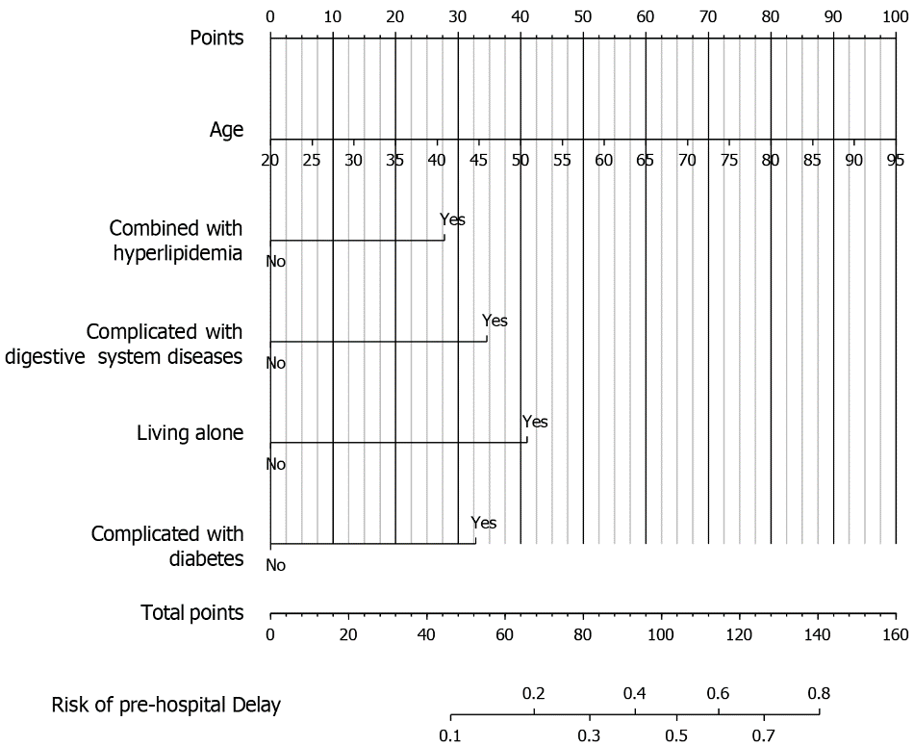
Figure 1 The nomogram prediction model for the risk of pre-hospital delay. Each indicator in the nomogram corresponds to a specific vertical line that ascends from the respective score on the horizontal axis labeled "Points." Along each indicator's line, a specific score is assigned based on the patient's characteristics. Four specific scores from different indicators are added together to calculate the total score. The total score is located on the horizontal axis labeled "Total Points." A vertical line is drawn downward from the total score to intersect with the axis labeled "Risk of Pre-hospital Delay." The value corresponding to the intersection point indicates the estimated risk of pre-hospital delay for the patient.
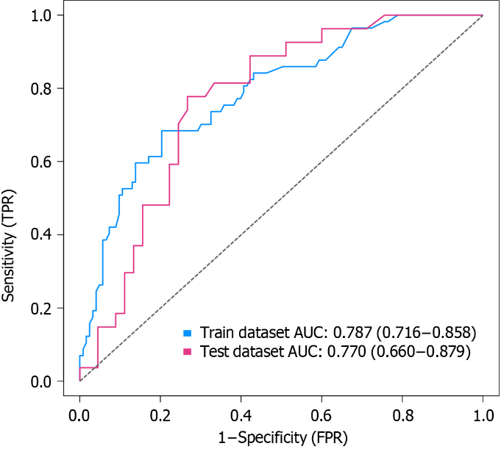
Figure 2 Receiver operating characteristic curve analysis of the nomogram model. The figure displays the receiver operating characteristic (ROC) curve analysis of the developed nomogram model. The area under the ROC curve (AUC) is used as a measure of the model's discriminatory ability. The false positive rate is plotted on the x-axis, while the true positive rate is plotted on the y-axis. The AUC values indicate the accuracy of the model in distinguishing between individuals who experienced pre-hospital delay and those who did not. A higher AUC value suggests a better predictive performance of the model. TPR: True positive rate; FPR: False positive rate.
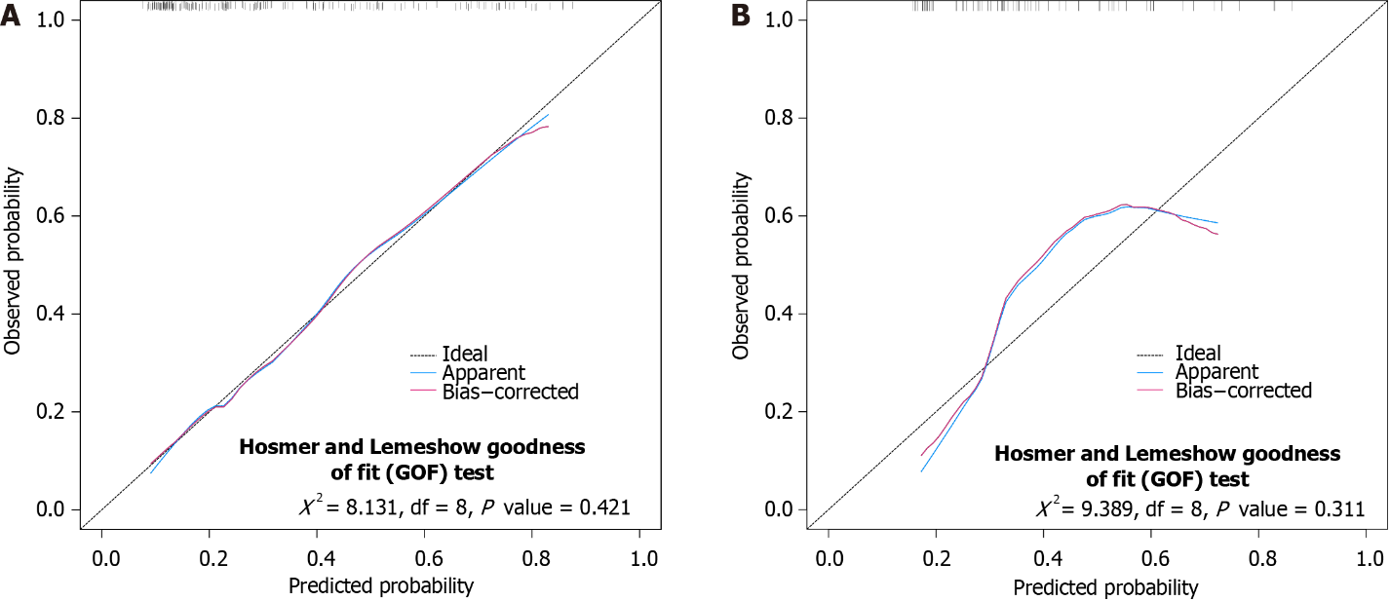
Figure 3 Calibration curve of the nomogram model. A and B: The figure illustrates the calibration curve analysis of the developed nomogram model in both the development group (A) and the validation group (B). The calibration curve assesses the agreement between the predicted and observed probabilities of pre-hospital delay likelihood. The x-axis represents the predicted probabilities, while the y-axis represents the observed probabilities. The goodness-of-fit is evaluated to determine the accuracy of the model. A well-calibrated model would show a close alignment of the predicted probabilities with the observed probabilities along the 45-degree diagonal line. GOF: Goodness-of-fit.
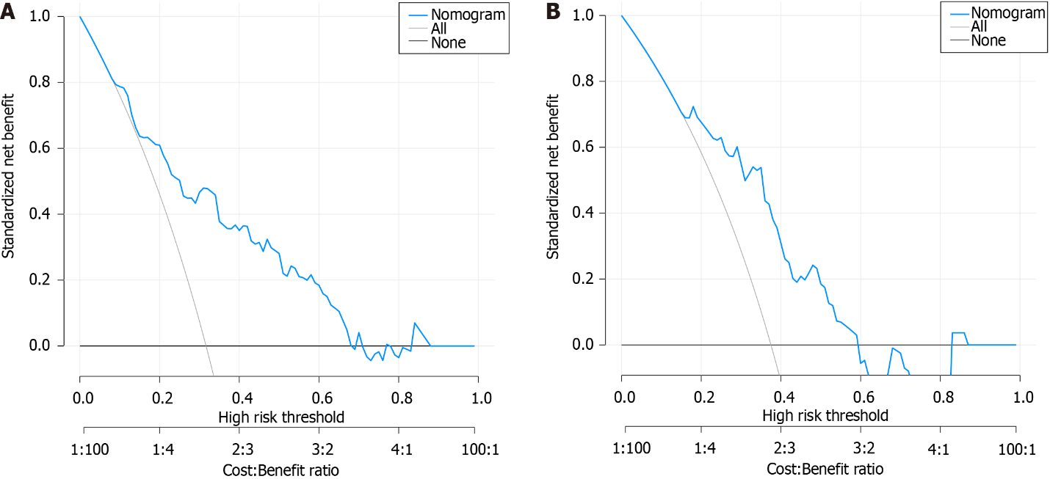
Figure 4 Decision curve analysis curve of the nomogram model. A and B: The figure presents the decision curve analysis (DCA) curve of the developed nomogram model in both the development group (A) and the validation group (B). The DCA curve measures the net benefit of the model by plotting the threshold probability on the x-axis against the net benefit on the y-axis. The net benefit is calculated by weighting the true-positive and false-positive classifications based on the clinical consequence of each classification. The DCA curve assesses the clinical usefulness of the nomogram model by comparing it to the strategies of treating all or no patients with the condition of interest. A higher net benefit value indicates a better clinical utility of the model.

Table 1 Comparison of related data between development group and validation group, n (%)
Variable | Category | Total | Development group | Validation group | P value
n |  | 252 | 180 | 72
Sex (%) | Male | 197 (78.2) | 142 (78.9) | 55 (76.4) | 0.664
 | Female | 55 (21.8) | 38 (21.1) | 17 (23.6)
Age, mean (SD) |  | 61.09 (14.55) | 60.94 (14.82) | 61.46 (13.94) | 0.798
Killip grade (%) | 1 | 195 (77.4) | 141 (78.3) | 54 (75.0) | 0.914
 | 2 | 42 (16.7) | 29 (16.1) | 13 (18.1)
 | 3 | 10 (4.0) | 7 (3.9) | 3 (4.2)
 | 4 | 5 (2.0) | 3 (1.7) | 2 (2.8)
Monthly household income (%) | < 3000 yuan | 125 (49.6) | 82 (45.6) | 43 (59.7) | 0.125
 | 3000–5000 yuan | 85 (33.7) | 66 (36.7) | 19 (26.4)
 | > 5000 yuan | 42 (16.7) | 32 (17.8) | 10 (13.9)
Number of stents placed, mean (SD) |  | 1.47 (0.91) | 1.40 (0.89) | 1.64 (0.94) | 0.059
Number of coronary artery lesions, mean (SD) |  | 1.89 (0.79) | 1.83 (0.79) | 2.03 (0.79) | 0.078
Combined with hypertension (%) | No | 114 (45.2) | 88 (48.9) | 26 (36.1) | 0.066
 | Yes | 138 (54.8) | 92 (51.1) | 46 (63.9)
Combined with cerebral infarction (%) | No | 227 (90.1) | 166 (92.2) | 61 (84.7) | 0.072
 | Yes | 25 (9.9) | 14 (7.8) | 11 (15.3)
Combined with hyperlipidemia (%) | No | 214 (84.9) | 156 (86.7) | 58 (80.6) | 0.221
 | Yes | 38 (15.1) | 24 (13.3) | 14 (19.4)
Diabetes mellitus (%) | No | 164 (65.1) | 121 (67.2) | 43 (59.7) | 0.259
 | Yes | 88 (34.9) | 59 (32.8) | 29 (40.3)
Combined with renal insufficiency (%) | No | 227 (90.1) | 162 (90.0) | 65 (90.3) | 0.947
 | Yes | 25 (9.9) | 18 (10.0) | 7 (9.7)
Combined digestive system diseases (%) | No | 217 (86.1) | 155 (86.1) | 62 (86.1) | 1
 | Yes | 35 (13.9) | 25 (13.9) | 10 (13.9)
Timi classification (%) | 0 | 136 (54.0) | 100 (55.6) | 36 (50.0) | 0.491
 | 1 | 15 (6.0) | 11 (6.1) | 4 (5.6)
 | 2 | 27 (10.7) | 21 (11.7) | 6 (8.3)
 | 3 | 74 (29.4) | 48 (26.7) | 26 (36.1)
Payment method (%) | Self-paid | 17 (6.7) | 11 (6.1) | 6 (8.3) | 0.525
 | Medical insurance reimbursement | 235 (93.3) | 169 (93.9) | 66 (91.7)
History of acute myocardial infarction (%) | No | 242 (96.0) | 175 (97.2) | 67 (93.1) | 0.126
 | Yes | 10 (4.0) | 5 (2.8) | 5 (6.9)
Time of onset (%) | Daytime | 110 (43.7) | 73 (40.6) | 37 (51.4) | 0.117
 | Nighttime | 142 (56.3) | 107 (59.4) | 35 (48.6)
Living alone (%) | No | 227 (90.1) | 162 (90.0) | 65 (90.3) | 0.947
 | Yes | 25 (9.9) | 18 (10.0) | 7 (9.7)
Type of residence (%) | Rural | 94 (37.3) | 67 (37.2) | 27 (37.5) | 0.967
 | Town | 158 (62.7) | 113 (62.8) | 45 (62.5)
Regular jobs (%) | No | 170 (67.5) | 120 (66.7) | 50 (69.4) | 0.671
 | Yes | 82 (32.5) | 60 (33.3) | 22 (30.6)
History of heart failure (%) | No | 227 (90.1) | 165 (91.7) | 62 (86.1) | 0.183
 | Yes | 25 (9.9) | 15 ( 8.3) | 10 (13.9)
Education level (%) | Junior high school and below | 153 (60.7) | 108 (60.0) | 45 (62.5) | 0.321
 | Senior high school | 45 (17.9) | 36 (20.0) | 9 (12.5)
 | University and above | 54 (21.4) | 36 (20.0) | 18 (25.0)
Marriage (%) | Married | 228 (90.5) | 165 (91.7) | 63 (87.5) | 0.114
 | Divorce or widow | 20 (7.9) | 11 ( 6.1) | 9 (12.5)
 | Unmarried | 4 (1.6) | 4 (2.2) | 0 (0.0)
Drinking (%) | No | 177 (70.2) | 125 (69.4) | 52 (72.2) | 0.663
 | Yes | 75 (29.8) | 55 (30.6) | 20 (27.8)
Smoking (%) | No | 133 (52.8) | 93 (51.7) | 40 (55.6) | 0.576
 | Yes | 119 (47.2) | 87 (48.3) | 32 (44.4)
Body mass index, mean (SD) |  | 24.46 (3.35) | 24.54 (3.37) | 24.25 (3.33) | 0.526
Combined with atrial fibrillation (%) | No | 236 (93.7) | 169 (93.9) | 67 (93.1) | 0.806
 | Yes | 16 (6.3) | 11 (6.1) | 5 (6.9)

Table 2 Results of univariate and multivariate Logistic regression analysis on risk of pre-hospital delay in development group
Variables | Univariate logistic regression |  | Multivariate logistic regression
 | OR (95%CI) | P value | OR (95%CI) | P value
BMI | 0.956 (0.867, 1.050) | 0.35
Killip Grade 1 | Reference
Killip Grade 2 | 1.061 (0.429, 2.464) | 0.894
Killip Grade 3 | 3.143 (0.666, 16.536) | 0.145
Killip Grade 4 | 4.714 (0.440, 103.073) | 0.211
Timi Grade 0 | Reference
Timi Grade 1 | 1.855 (0.501, 6.615) | 0.337
Timi Grade 2 | 0.890 (0.294, 2.420) | 0.826
Timi Grade 3 | 1.012 (0.474, 2.109) | 0.975
Living alone | 3.059 (1.138, 8.476) | 0.027 | 4.654 (1.386, 16.957) | 0.015
Daytime onset | Reference
Nighttime onset | 2.831 (1.434, 5.853) | 0.004 | 2.200 (0.968, 5.188) | 0.064
Combined with atrial fibrillation | 1.875 (0.520, 6.497) | 0.317
Combined with hypertension | 2.862 (1.493, 5.649) | 0.002 | 1.990 (0.906, 4.473) | 0.089
Combined with hyperlipidemia | 2.467 (1.024, 5.957) | 0.042 | 3.151 (1.095, 9.373) | 0.035
Have a regular job | 0.791 (0.395, 1.541) | 0.497
Number of diseased coronary artery | 1.109 (0.743, 1.656) | 0.61
Marital status: married | Reference
Marriage: Divorced or widowed | 0.792 (0.168, 2.864) | 0.739
Marriage: Unmarried | 0.704 (0.034, 5.648) | 0.764
Prior history of AMI | 3.361 (0.542, 26.068) | 0.191
Family monthly income < 3000 yuan | Reference
The monthly income of the family = 3000–5000 yuan | 0.922 (0.449, 1.872) | 0.822
Family monthly income > 5000 yuan | 1.560 (0.660, 3.636) | 0.304
Type of residence: town | 0.387 (0.201, 0.737) | 0.004 | 0.576 (0.258, 1.281) | 0.175
Complicated with cerebral infarction | 1.691 (0.533, 5.112) | 0.353
Age | 1.043 (1.020, 1.069) | < 0.001 | 1.034 (1.004, 1.065) | 0.027
Complicated with renal insufficiency | 1.845 (0.668, 4.959) | 0.225
Complicated with diabetes | 3.211 (1.662, 6.278) | 0.001 | 3.208 (1.466, 7.228) | 0.004
Education level is junior high school or below | Reference
High school education | 1.669 (0.766, 3.610) | 0.193
Education level is university or above | 0.417 (0.146, 1.035) | 0.076
Smoking | 0.404 (0.207, 0.771) | 0.007 | 0.682 (0.279, 1.652) | 0.395
Complicated with digestive system diseases | 2.733 (1.154, 6.533) | 0.022 | 3.937 (1.433, 11.236) | 0.009
Complicated with heart failure | 1.490 (0.478, 4.355) | 0.471
Female sex | 2.737 (1.309, 5.753) | 0.007 | 1.419 (0.531, 3.776) | 0.482
Drinking | 0.841 (0.413, 1.659) | 0.622
Payment method: medical insurance reimbursement | 1.252 (0.347, 5.886) | 0.747
Number of stents placed | 1.300 (0.916, 1.856) | 0.142
AMI: Acute myocardial infarction; BMI: Body mass index; OR: Odds ratio.

Published by Baishideng Publishing Group Inc
7041 Koll Center Parkway, Suite 160, Pleasanton, CA 94566, USA
Telephone: +1-925-3991568
E-mail: office@baishideng.com
Help Desk: https://www.f6publishing.com/helpdesk
https://www.wjgnet.com

© 2024 Baishideng Publishing Group Inc. All rights reserved.

