Name of Journal: World Journal of Gastroenterology
Manuscript NO: 42515
Manuscript Type: ORIGINAL ARTICLE

Basic Study

Abdominal paracentesis drainage ameliorates severe acute pancreatitis in rats by regulating the polarization of peritoneal macrophages

Liu RH et al. APD ameliorates SAP by regulating macrophages

Ruo-Hong Liu, Yi Wen, Hong-Yu Sun, Chun-Yu Liu, Yu-Fan Zhang, Yi Yang, Qi-Lin Huang, Jia-Jia Tang, Can-Chen Huang, Li-Jun Tang

Ruo-Hong Liu, Yi Wen, Hong-Yu Sun, Chun-Yu Liu, Yi Yang, Qi-Lin Huang, Can-Chen Huang, Li-Jun Tang, PLA Center of General Surgery and Pancreatic Injury and Repair Key Laboratory of Sichuan Province, Chengdu Military General Hospital, Chengdu 610083, Sichuan Province, China

Ruo-Hong Liu, Yi Wen, Li-Jun Tang, Third Military Medical University (Army Medical University), Chongqing 400037, China

Yu-Fan Zhang, Jiaotong Hospital Affiliated with the Sichuan Provincial People's Hospital, Chengdu 611730, Sichuan Province, China

Jia-Jia Tang, Department of Ultrasound, Chinese Academy of Medical Sciences and Peking Union Medical College Hospital, Beijing 100032, China

ORCID number: Ruo-Hong Liu (0000-0003-0885-8397); Yi Wen (0000-0001-9801-0853); Hong-Yu Sun (0000-0002-8587-0499); Chun-Yu Liu (0000-0002-4768-0459); Yu-Fan Zhang (0000-0002-3015-4962); Yi Yang (0000-0002-0189-6246); Qi-Lin Huang (0000-0002-0819-4829); Jia-Jia Tang (0000-0001-6036-6133); Can-Chen Huang (0000-0002-5598-4225); Li-Jun Tang (0000-0001-6000-9515).

Author contributions: Liu RH, Wen Y and Sun HY contributed equally to this work; Liu RH and Wen Y performed the majority of the experiments; Liu CY and Huang CC contributed to the animal experiments; Yang Y and Huang QL helped with the in vitro experiment; Zhang YF and Tang JJ contributed to data collection and manuscript preparation; Liu RH and Sun HY drafted the manuscript; and Tang LJ revised and approved the manuscript.

Supported by the National Natural Science Foundation of China, No. 81772001, No. 8177071311 and No. 81502696; the National Clinical Key Subject of China, No. 41792113; the Technology Plan Program of Sichuan Province, No. 2015SZ0229, No. 2018JY0041 and No. 18YYJC0442; and the Science and Technology Development Plan of Sichuan Province, No. 2016YJ0023.

Institutional animal care and use committee statement: All animal protocols were approved by the Animal Welfare Committee of Chengdu Military General Hospital, Chengdu, China, No. A20170312004.

Conflict-of-interest statement: The authors declare that there are no conflicts of interest related to this study.

Data sharing statement: No additional data are available.

ARRIVE guidelines statement: In the manuscript, the ARRIVE guidelines were adopted.

Open-Access: This article is an open-access article which was selected by an in-house editor and fully peer-reviewed by external reviewers. It is distributed in accordance with the Creative Commons Attribution Non Commercial (CC BY-NC 4.0) license, which permits others to distribute, remix, adapt, build upon this work non-commercially, and license their derivative works on different terms, provided the original work is properly cited and the use is non-commercial. See: http://creativecommons.org/licenses/by-nc/4.0/

Manuscript source: Unsolicited manuscript

Correspondence to: Li-Jun Tang, MD, PhD, Chief Doctor, PLA Center for General Surgery and Pancreatic Injury and the Repair Key Laboratory of Sichuan Province, Chengdu Military General Hospital, No. 270 Tianhui Road, Rongdu Avenue, Jinniu, Chengdu 610083, Sichuan Province, China. tanglj2016@163.com
Telephone: +86-28-86570265

Received: September 27, 2018
Peer-review started: September 27, 2018
First decision: October 14, 2018
Revised: October 20, 2018
Accepted: November 9, 2018
Article in press:
Published online:

Abstract

AIM
To investigate the role of peritoneal macrophage (PM) polarization in the therapeutic effect of abdominal paracentesis drainage (APD) on severe acute pancreatitis (SAP).

METHODS

SAP was induced by 5% Na-taurocholate retrograde injection in SD rats. APD was performed by inserting a drainage tube with a vacuum ball into the lower right abdomen of the rats immediately after the induction of SAP. To verify the effect of APD on macrophages, PMs were isolated and cultured in an environment, with the peritoneal inflammatory environment simulated by the addition of peritoneal lavage in complete RPMI 1640 medium. HE staining, the levels of pancreatitis biomarkers amylase and lipase, and the levels of inflammatory mediators in the blood and peritoneal lavage were examined. The polarization phenotypes of the PMs were identified by detecting the marker expression of M1/M2 macrophages via flow cytometry, RT-PCR and immunohistochemical staining. The proteins expression of macrophages that had infiltrated the pancreas was determined by western blot.

RESULTS

APD treatment significantly reduced the histopathological scores and levels of amylase, lipase, tumor necrosis factor-α and interleukin (IL)-1β, indicating that APD ameliorates the severity of SAP. Importantly, we found that APD treatment polarized PMs towards the M2 phenotype, as evidenced by the reduced number of M1 macrophages and the reduced levels of pro-inflammatory mediators, such as IL-1β and L-selectin, as well as the increased number of M2 macrophages and increased levels of anti-inflammatory mediators, such as IL-4 and IL-10. Furthermore, in an in vitro study wherein peritoneal lavage from the APD group was added to the cultured PMs to simulate the peritoneal inflammatory environment, PMs also exhibited a dominant M2 phenotype, resulting in a significantly lower level of inflammation. Finally, APD treatment increased the proportion of M2 macrophages and upregulated the expression of the anti-inflammatory protein Arg-1 in the pancreases of SAP model rats.

CONCLUSION

These findings suggest that APD treatment exerts anti-inflammatory effects by regulating the M2 polarization of PMs, providing novel insight into the mechanism underlying its therapeutic effect.

Key words: Abdominal paracentesis drainage; Peritoneal macrophages; Polarization; Severe acute pancreatitis

© The Author(s) 2018. Published by Baishideng Publishing Group Inc. All rights reserved.

Core tip: In the present study, we provided evidence for the first time that abdominal paracentesis drainage (APD) ameliorates inflammation in rats with severe acute pancreatitis (SAP) by regulating peritoneal macrophage M2 polarization. The important findings are that (1) by removing pancreatitis-associated ascitic fluids, APD could improve the inflammatory environment of the peritoneal cavity; (2) the improved environment in the peritoneal cavity could polarize peritoneal macrophages towards the M2 phenotype; and (3) APD could promote M2 polarization of macrophages in the pancreas of SAP model rats. These findings provide new insights into the mechanisms underlying the effectiveness of APD, which may advance the clinical use of APD to benefit patients with SAP.

Liu RH, Wen Y, Sun HY, Liu CY, Zhang YF, Yang Y, Huang QL, Tang JJ, Huang CC, Tang LJ. Abdominal paracentesis drainage ameliorates severe acute pancreatitis in rats by regulating the polarization of peritoneal macrophages. World J Gastroenterol 2018; In press

INTRODUCTION
Severe acute pancreatitis (SAP) is a lethal inflammatory condition that is frequently accompanied by many complications, such as systemic inflammatory response syndrome (SIRS) and multiple organ dysfunction syndrome (MODS), which lead to a high risk of death in SAP patients. To date, the mortality rate for SAP remains high at 30%^{[1]}. The key issue is that there is no effective strategy for controlling the activated inflammatory cascade and restoring immune homeostasis during SAP. Numerous studies have suggested that pancreatitis-associated ascitic fluids (PAAF) play an important role in the pathogenesis of SAP because they contain tumor necrosis factors, interleukins, endotoxins and other substances^{[2-4]}. Our previous studies suggested that abdominal paracentesis drainage (APD) ameliorates SAP in patients safely and effectively by removing PAAF^{[5-7]}. However, the mechanism underlying APD treatment remains poorly understood.
Macrophages are the main inflammatory cells implicated in the initiation and progression of the early stage of SAP^{[8,9]}. They can be polarized into the following two different functional phenotypes in response to the microenvironment: classically activated macrophages (M1) or alternatively activated macrophages (M2). M1 macrophages produce pro-inflammatory cytokines, including interleukin-1β (IL-1β), interleukin-6 (IL-6) and tumor necrosis factor (TNF)-α, while the M2 phenotype produces anti-inflammatory cytokines, such as IL-10^{[10]}. Macrophages can also transition between the M1 and M2 phenotypes in response to certain signals^{[11,12]}. Therefore, the polarization of macrophages towards the M2 phenotype has emerged as an interesting strategy to control the progression of inflammation^{[13]}. Among the macrophages associated with SAP, peritoneal macrophages (PMs) are known to play a crucial role in the progression from local to systemic inflammation. PMs widely interact with PAAF, and the function of PMs is regulated by PAAF^{[14]}. Although the activation of macrophages is tightly associated with the severity of SAP, whether APD can change the polarization state of PMs by removing PAAF in rats with SAP is uncertain.
Based on the above considerations, in the present study, we sought to determine the polarization phenotypes of PMs and the corresponding inflammatory response in a rat model of SAP following APD treatment. Our study offers new insights into the mechanism by which APD treatment ameliorates SAP.

MATERIALS AND METHODS
Experimental animals
The animal protocol was designed to minimize pain or discomfort to the animals. Adult male Sprague Dawley rats weighing 200-250 g were purchased from Chengdu Dossy Experimental Animals Co., Ltd. (Chengdu, China). All rats were housed and fed in a pathogen-free facility under 12-h day and night cycles throughout the experiment. Animal experiments were performed according to the guidelines of the Animal Welfare Committee of Chengdu Military General Hospital.

In vivo experiments
Eighteen rats were divided into the following three equal groups according to a random number table: The SAP group, the APD group and a sham operation group (SHAM). Pancreatitis was induced in the SAP and APD groups by retrograde injection of 5% Na-taurocholate (0.1 mL/100 g body weight, Sigma, United States)^{[15]} via the pancreatic duct using a syringe pump. In the APD group, a drainage tube with a vacuum ball was inserted into the lower right abdomen immediately after pancreatitis was induced^{[16]}. Rats in the sham group did not receive any operation except opening and closure of the abdomen. Anesthesia was performed with an anesthesia machine using isoflurane (RWD Life Science, Shenzhen, China). Rats were sacrificed 12 h after the model was established. Blood samples were collected, and pancreatic tissues were harvested. According to previously described methods^{[17]}, PMs were isolated by peritoneal lavage after the ascetic fluid of SAP rats was drained.

Pancreatic histological analysis
The pancreas was dissected along the pancreatic duct, and a 0.5 cm × 0.5 cm sample was fixed in 4% paraformaldehyde solution. After being embedded in paraffin, the samples were cut into 4-μm thick sections and stained with hematoxylin and eosin (HE). Then, the slides were observed under an optical microscope, and the histopathology was scored using a previously described scoring system^{[18]}. The scores were averaged for 5 individual slides from every pancreas.

ELISA
Enzyme-linked immunosorbent assays (ELISAs) were performed with the serum samples from each group using commercial rat-specific kits for amylase, lipase, IL-1β and TNF-α (Dakewe Biotech Co., Ltd. Shenzhen, China) according to the supplier's specifications.

Cell isolation
The ascetic fluid in the abdomens of SAP rats or the residual liquid in APD rats was drained followed by intraperitoneal injection of 20 mL of precooled PBS solution. After five minutes of abdominal kneading, 15 mL of lavage fluid containing peritoneal cells was transferred into the anticoagulant tube via a syringe. The cells were washed with PBS, resuspended in RPMI-1640 (Gibco, CA, United States) with 20% fetal bovine serum (Gibco, CA, United States) and cultured at 37 °C in 5% CO₂ for 1 h. The adherent cells were used in the subsequent experiments.

Flow cytometry
To detect the polarization phenotype of the macrophages in the abdomen, the PMs were analyzed by flow cytometry. PMs were washed with staining buffer (1% BSA in PBS containing 0.01% NaN₃, Thermo Fisher, United States) and incubated with 10% mouse serum for 20 min on ice. Subsequently, the cells were incubated with reagents from the LIVE/DEAD™ Fixable Dead Cell Stain Kit (Thermo Fisher, United States), FITC-conjugated anti-CD163 (Bio-Rad, United States), and PE-conjugated anti-CD86 (BD Biosciences, United States) at the manufacturer’s recommended dilution for 40 min on ice. For intracellular staining, the cells were fixed and permeabilized with fixation buffer from a Fixation/Permeabilization Solution Kit (BD Biosciences, United States) for 1 h at 4 °C in the dark, washed with permeabilization buffer and incubated with Alexa-Flour647-conjugated anti-CD68 (Bio-Rad, United States) antibody in permeabilization buffer for 1 h at 4 °C in the dark. The samples were then washed and resuspended in permeabilization buffer and analyzed with a FACS Canto II system (BD Biosciences). The results were analyzed with BD FACS DIVA software (BD Biosciences, United States).

RNA isolation and qPCR
Total RNA from the abovementioned PMs was extracted using a commercial RNA extraction kit (Axygen, United States). The RNA was quantified by measuring the absorbance at 260 nm and 280 nm using a spectrophotometer (NanoDrop Technologies, United States). cDNA was synthesized from a 100-ng RNA sample using the Primescript^{RT} reagent kit with a gDNA eraser (Takara, Tokyo, Japan) and stored at -80 °C.
Real-time quantitative PCR was performed with a CFX96 Real-Time PCR Detection System using the SYBR Green Master Mix (Bio-Rad, United States). The primers used were as follows: INOS Forward: 5’-CAGCCCTCAGAGTACAACGAT-3’, Reverse: 5’-CAGCAGGCACACGCAATGAT-3’; CD206 Forward: 5’-ATTCCGGTCGCTGTTCAACT-3’, Reverse: 5’-AACGGAGATGGCGCTTAGAG-3’; TNF-α Forward: 5’-CGTCGTAGCAAACCACCAAG-3’, Reverse: 5’-CACAGAGCAATGACTCCAAAG-3’; CD163 Forward: 5’-CAACCGATGCTCAGGAAGAG-3’, Reverse: 5’-GATGGCACTTCCACATCCAA-3’. GAPDH was used as a reference gene, and the primers for GAPDH were the commercial Rat GAPDH Endogenous Reference Gene Primers (BBI Life Science, China).

Luminex assay
The concentrations of IL-1β, CXCL2, IL-4, IL-10 and TNF-α in the lavage fluid were determined by Luminex assays. A premixed commercial kit was used according to the manufacturer’s recommendation (RD, United States). The assays were performed using the Luminex X-200 System (Luminex Corp, United States).

Immunofluorescence staining
The distribution of the two phenotypes of macrophages in the pancreas was assayed by immunofluorescence staining. Pancreatic tissues were washed with PBS twice, fixed with 4% paraformaldehyde for 24 h and dehydrated in a 30% sucrose solution. Then, the tissues were embedded in Tissue Freezing Medium and cut into 7-μm thick sections. The slides were washed with PBS and permeabilized with 0.1% Triton X-100. Subsequently, the slides were incubated with goat serum at 37 °C for 30 min. The samples were stained by incubation with Alexa-Flour647-conjugated anti-CD68 (Bio-Rad, United States) and FITC-conjugated anti-CD163 (Bio-Rad, United States) or Alexa-Flour647-conjugated anti-CD68 and PE-conjugated anti-CD86 (BD Biosciences, United States) at the manufacturer’s recommended dilution at 4 °C overnight; then, the samples were stained with DAPI to visualize the nuclei. The distribution of the two phenotypes of macrophages in the pancreas was examined by laser scanning confocal microscopy.

Western blot analysis
Pancreatic tissues were dissociated in a commercial lysis buffer kit containing protease inhibitor and phenylmethylsulfonyl fluoride (PMSF) (Solarbio Science & Technology Co., Ltd, China) using a homogenizer. The tissue lysates were centrifuged at 12000 rpm for 30 min at 4 °C, and the supernatant was collected for analysis. The protein concentration was measured using a commercial BCA protein assay kit (Solarbio Science and Technology Co., Ltd, China) according to the manufacturer’s instructions. Proteins were mixed into the premixed protein sample buffer (Bio-Rad, United States) at equal concentrations and heated for 10 min at 100 °C to denature the protein. Electrophoresis was performed on 10% or 8% SDS-polyacrylamide gels followed by transference of the protein onto a PVDF membrane. After blocking with 5% nonfat milk in TBS solution for 1 h at room temperature, the blots were incubated in the following primary antibodies overnight at 4 °C: mouse anti-Arg1 (1:200, Santa Cruz, United States), mouse anti-CD163 (1:200, Bio-Rad, United States), mouse anti-CD86 (1:200, BD Biosciences, United States), mouse anti-NOS2 (Santa Cruz, United States), and mouse anti-GAPDH (Thermo Fisher, United States). Afterwards, the blots were incubated with goat anti-mouse horseradish peroxidase (HRP)-conjugated secondary antibody (1:5000, Abcam, United Kingdom) for 1 h at room temperature. Then, the blots were developed using the enhanced chemiluminescence (ECL) method (Merck Milipore, Germany) in a bioimaging system (UVP, United Kingdom).

In vitro experiments.
Primary cultured PMs were isolated from an additional ten rats as described above , washed with PBS and resuspended in RPMI-1640 (Gibco, CA, United States) with 20% fetal bovine serum (Gibco, CA, United States). All cells were plated at 1 × 10⁶ cells per well in a 6-well plate and then cultured at 37 °C in 5% CO₂ for 3 d; adherent cells were identified as macrophages. Flow cytometry was used to identify the purity of the clones.
To test the effect of the abdominal inflammatory environment on PMs, primary cultured PMs were treated with medium containing 10% lavage fluid from SAP and APD rats separately for 12 h, and PBS was used as a control. The polarization phenotypes of the primary cultured PMs were determined by flow cytometry as mentioned above.

Statistical analysis
Statistical analyses were performed using SPSS 18.0 (SPSS Inc., United States), and the data are reported as the mean ± SD. Data were compared by Student’s t-tests or one-way ANOVA followed by the SNK test for multiple comparisons, and nonparametrically distributed variables were compared by the Mann–Whitney test. P < 0.05 was considered statistically significant.

RESULTS
Therapeutic effects of APD on SAP in rats
The SAP rat model induced by Na-taurocholate retrograde injection (Figure 1A) is a stable animal model that has many similarities with the clinical manifestations of SAP in humans. To simulate the APD treatment, a drainage tube was inserted into the lower right abdomen of SAP rats (Figure 1A). Histologically, apparent morphological damage in the form of acinar cell necrosis and inflammatory infiltration was observed in rats with SAP, while the tissue damage was significantly reduced in the APD treatment group (Figure 1B). This result was supported by the lower histopathological score in the APD group than in the SAP group (Figure 1C).
Subsequently, we measured the serum amylase and lipase levels, as they are known biomarkers of SAP. As shown in Figure 1, the APD group showed lower levels of amylase and lipase when compared with the SAP group (Figure 1D and E). In the APD and SAP groups, the concentrations of amylase and lipase were 0.906 ± 0.102 vs 1.302 ± 0.052 ng/mL and 10.118 ± 1.019 vs 12.251 ± 0.458 U/L, respectively.
Pro-inflammatory cytokines, such as TNF-α and Il-1β, are known to induce systemic inflammation in SAP. Compared with SAP rats, in APD rats, the levels of TNF-α and Il-1β were significantly lower, while the levels of the anti-inflammatory cytokines IL-10 and transforming growth factor-β were higher (Figure 1F-H), reflecting an amelioration of systematic inflammation in APD rats.
These results suggest that APD treatment could exert a protective role against the progression of SAP, as supported by the observed improved tissue damage and reduced systematic inflammation.

APD polarizes PMs towards the M2 phenotype in the peritoneal cavity
PMs play important roles in the progression of SAP. To assess the direct effect of APD on PMs, we first investigated the polarization phenotypes of the PMs in each group by flow cytometry. CD68 was used as a marker of all macrophages; CD68+CD86+ macrophages were identified as M1 macrophages, while CD68+CD163+ cells were identified as M2 macrophages. Flow cytometry plots revealed a significantly lower proportion of M1 PMs in APD rats compared to SAP rats, while a slight increase occurred in the proportion of M2 PMs (Figure 2B). Meanwhile, the M1/M2 ratio tended to be lower in the APD group than in the SAP group (Figure 2 B).
To further confirm the polarization phenotype of PMs at the genetic level, the expression of the M1-associated gene iNOS and the M2-associated gene CD206 were determined by qPCR. As expected, the expression of CD206 gene increased in the APD group, while it was inhibited in the SAP group. Although the expression of the iNOS gene was upregulated in both groups, it increased markedly in the SAP group (Figure 2E). These data indicate that APD treatment polarized PMs towards the M2 phenotype in the peritoneal cavity of SAP model rats.

APD reduced the levels of pro-inflammatory cytokines and increased the levels of anti-inflammatory cytokines in the peritoneal cavity
APD treatment drained the PAAF from SAP rats, thus altering the inflammatory environment of the peritoneal cavity. To compare the inflammatory environments in SAP and APD rats, we measured the production of representative pro-inflammatory and anti-inflammatory cytokines in the peritoneal lavage of each group by Luminex (Figure 3). The protein levels of the pro-inflammatory mediators IL-1β and L-selectin were significantly lower in APD rats than in SAP rats, while the levels of the anti-inflammatory cytokines IL-4 and IL-10 were increased. Although there were no significant differences in the levels of the pro-inflammatory cytokines IL-6 and CXCL2, the mean levels of these cytokines were greater in SAP rats than in APD rats. These results indicate that APD treatment promoted anti-inflammatory cytokine production and inhibited pro-inflammatory cytokine production.

PMs were polarized to the M2 phenotype in the simulated peritoneal inflammatory environment of APD rats in vitro
The phenotypes of PMs depend on the inflammatory environment. To investigate whether the peritoneal inflammatory environment affects PMs polarization in vitro, we simulated this environment by adding peritoneal lavage from the SAP and APD groups to primary cultured PMs. PBS was used as a negative control. Then, the PMs were evaluated by flow cytometry. The dot plot of FCM (Figure 4) indicated that the number of M2 macrophages increased slightly in PMs cultured in the APD environment, while no increase was found in cells cultured in the SAP environment. Although the numbers of M1 macrophages rose in both groups, they increased dramatically in the SAP environment. These data indicated that the altered peritoneal inflammatory environment induced by APD treatment enhanced M2 macrophage polarization in PMs.

APD promoted M2 polarization of macrophages in the pancreases of SAP rats
Given that macrophages are associated with intrapancreatic injury during SAP, we evaluated the effect of APD on the polarization response of macrophages in the pancreas by immunofluorescence staining and western blotting. As shown in Figure 5A, the number of M2 macrophages clearly increased, while the number of M1 macrophages decreased in the pancreases of APD rats compared with those of SAP rats. The morphological changes were confirmed by western blotting (Figure 5B). The pancreatic levels of M2-associated protein Arg-1 and CD163 were higher in APD rats than in SAP rats. In contrast, the levels of M1-associated protein iNOS and CD86 were lower in APD rats than in SAP rats. The data showed that APD could promote M2 polarization of macrophages in the pancreases of SAP rats.
Based on the above findings, a schematic model was proposed to elucidate the possible mechanism responsible for the beneficial effects of APD on SAP (Figure 6). Once SAP occurs, the inflammatory cells are activated following acinar cell injury and exudate full of pro-inflammatory mediators collects in the peritoneal cavity, which can polarize the PMs towards the M1 phenotype and lead to the overexpression of pro-inflammatory mediators by PMs. By removing the PAAF, APD could improve the inflammatory environment of the peritoneal cavity and thus regulate M2 polarization of PMs in the peritoneal cavity. Meanwhile, APD could also promote M2 polarization of macrophages in pancreatic tissues. These events could upregulate the expression of anti-inflammatory cytokines, which ultimately ameliorate pancreatic injury.

DISCUSSION
In the present study, we provided evidence for the first time that APD ameliorates inflammation in rats with SAP by regulating PM M2 polarization. The important findings are that (1) by removing PAAF, APD can improve the inflammatory environment of the peritoneal cavity; (2) the improved environment in the peritoneal cavity can polarize PMs towards the M2 phenotype; and (3) APD can promote M2 polarization of macrophages in the pancreases of SAP rats. These findings provide new insight into the mechanisms underlying the effectiveness of APD in the treatment of SAP, which may advance the clinical use of APD to benefit patients with SAP.
APD treatment before percutaneous catheter drainage has been proven to exert a beneficial effect on patients with SAP in our serial reports. Here, we demonstrated that APD treatment ameliorates the levels of inflammatory factors, including TNF-α, IL-1β, and IL-6, in the serum and ascitic fluid of patients and rats with SAP^{[16]}. Consistent with these results, in this paper, we found that APD not only decreased the levels of pro-inflammatory cytokines, such as IL-1β, and the adhesion molecule L-selectin but also increased the levels of anti-inflammatory cytokines, such as IL-4 and IL-10. This is in line with the findings of a recent study by Zhu and colleagues^{[19]} in which it was shown that the levels of pro-inflammatory cytokines in ascites, including IL-1β, IL-6, IL-8 and TNF-α, decreased after early-stage drainage of the PAAF, while the level of the anti-inflammatory cytokine IL-10 increased significantly. Similar results were also reported by Souza^{[20]}, and these two studies suppose M2 macrophages as causative factors.
As is known, macrophages will acquire distinct functional phenotypes when responding to environmental cues. Because APD improves the inflammatory environment of the peritoneal cavity, we speculated that APD may influence the activation state of PMs. In fact, our results indicate that the proportion of M1 PMs in APD rats decreased significantly while the proportion of M2 PMs increased slightly when compared with the proportions in SAP rats. From a recent point of view, it has been suggested that macrophages do not exist as distinct M1 or M2 phenotypes but rather as a continuum of overlapping functional states, and the transition between the M1 to M2 phenotype is a dynamic process^{[10]}. Therefore, we calculated the M1/M2 ratio to reflect the dynamic balance of macrophage polarization. The results indicate that the M1/M2 ratios in SAP rats and APD rats were 7.286 ± 4.22 vs 1.278 ± 0.481, respectively. Although M1 polarization was dominant in both groups, there was a trend to skew the balance towards the M2 phenotype in the APD group.
The mechanism by which APD polarizes PMs towards an M2 phenotype in the peritoneal cavity remains unknown; however, based on the above findings, we infer that APD might eliminate the comprehensively inflammatory environment, which provides an environment suitable for the survival of M2 macrophages and enhances the M2 polarization of PMs. The increase in the number of M2 macrophages in turn leads to the production of anti-inflammatory cytokines. To validate the effect of APD on the polarization of macrophages, lavage from each group was used to treat the primary cultured PMs. Consistent with the in vivo experiments, the number of M2 PMs increased in the APD group.
Studies have shown that polarizing macrophages towards the M2 phenotype ameliorates many chronic inflammation and autoimmune diseases^{[21],} such as SLE^{[22]}, rheumatoid arthritis^{[23]} and colitis^{[24]}. Many methods have been used to induce M2 polarization^{[25]}. However, most of the reports are in vitro experiments, and the therapeutic effect of M2 macrophages on acute inflammatory disease^{[26]} is rarely reported. Although Xu et al^{[27]} induced M2 polarization in primary culture liver macrophages from rats with acute pancreatitis, they did not report any therapeutic effect of these cells in SAP. One possible reason is that a large amount of pro-inflammatory cytokines are released when the inflammatory cascade is activated, which overwhelmingly skews the M1/M2 balance towards M1 polarization in vivo. Our successful induction of the M2 polarization of PMs in SAP rats in vivo is a new attempt to utilize the advantages of M2 macrophages to ameliorate acute inflammatory diseases.
In addition, our findings demonstrate that the number of M2 macrophages also increased in the pancreases of SAP rats; however, only trace amounts of macrophages in the peripheral blood and bone marrow were polarized (data not shown). The data imply that the increase in the number of M2 macrophages in the pancreas is independent of the number of CD68+CD163+ cells in the peripheral blood and bone marrow. In our analysis, M2 macrophages may have migrated from the peritoneal cavity to the pancreas and regulated the immune responses in the pancreases of SAP rats. PMs have been reported to selectively migrate to the specific sites of inflammation in a colitis rat model^{[21],} indicating that PMs could directly migrate to the focal zone in the peritoneal cavity. Moreover, the protein level of Arg-1, which is a key modulator in regulating T-lymphocyte functions and maintaining immunological tolerance^{[28]} also increased. However, whether the M2 macrophages in the pancreas are PMs migrating from the peritoneal cavity still needs to be proven.
In conclusion, our findings suggest that APD treatment exerts anti-inflammatory effects to ameliorate SAP by regulating PM M2 polarization, thereby increasing the number of M2 macrophages and arg-1 protein levels in the pancreas; these findings provide novel insights into the mechanisms underlying the therapeutic effect of APD.

ARTICLE HIGHLIGHTS
Research background
Severe acute pancreatitis (SAP) is a highly lethal disease with limited therapeutic options and is characterized by a critical systemic inflammatory response. Pancreatitis-associated ascitic fluids (PAAF) play an important role in the pathogenesis of SAP because of the pro-inflammatory mediators the PAAF contains. Our previous studies suggested that APD ameliorates SAP by removing the PAAF. However, the mechanism underlying the success of APD treatment remains poorly understood. In the present study, we aimed to explore the possible mechanism by which APD ameliorates SAP.

Research motivation
The key issue in treating SAP is controlling the activated inflammatory cascade and restoring immune homeostasis. Peritoneal macrophages (PMs), crucial inflammatory cells in the abdominal cavity, are implicated in the initiation and progression of SAP in the early stage, and the function of PMs is regulated by the PAAF. In this study, we found that APD treatment exerts anti-inflammatory effects by regulating the M2 polarization of PMs, providing novel insights into the mechanisms underlying the therapeutic effect of APD.

Research objectives
The aim of this study was to determine the polarization phenotypes of PMs and the corresponding inflammatory responses in a rat model of SAP following APD treatment and to explore the possible mechanism by which APD treatment ameliorates SAP.

Research methods
The effect of APD on the polarization response of PMs was determined in a SAP rat model induced by 5% Na-taurocholate retrograde injection and in a peritoneal inflammatory environment simulated by adding peritoneal lavage to culture medium in vitro. HE staining and the levels of amylase, lipase, and inflammatory mediators were examined. The M1/M2 phenotype ratio of PMs was identified by flow cytometry and RT-PCR. The distribution of macrophages and their protein expression in the pancreas were determined by immunofluorescence staining and western blotting.

Research results
APD treatment ameliorates SAP by significantly reducing the pathological scores and the levels of amylase, lipase, tumor necrosis factor-α, and interleukin (IL)-1β. Importantly, APD treatment polarizes PMs towards the M2 phenotype and increases the anti-inflammatory mediators IL-4 and IL-10 in the peritoneal lavage. Furthermore, PMs exhibited a trend towards the M2 phenotype in a simulated peritoneal inflammatory environment in vitro. Finally, APD treatment increased the number of M2 macrophages and upregulated the expression of the anti-inflammatory protein Arg-1 in the pancreas of SAP rats.

Research conclusions

These findings suggest that APD treatment exerts anti-inflammatory effects by regulating the M2 polarization of PMs, providing novel insights into the mechanisms underlying its therapeutic effect.

Research perspectives
Our study provided evidence for the first time that APD ameliorates inflammation in rats with SAP by regulating PM M2 polarization. However, solid evidence that APD polarizes PMs to the M2 phenotype and the underlying molecular mechanism still need to be explored. Furthermore, future research should focus on the effect of M2 macrophages on immune homeostasis restoration and tissue repair in the injured pancreas.

REFERENCE
1 Forsmark CE, Vege SS, Wilcox CM. Acute Pancreatitis. N Engl J Med 2016; 375: 1972-1981 [PMID: 27959604 DOI: 10.1056/NEJMra1505202]
2 Wang J, Xu P, Hou YQ, Xu K, Li QH, Huang L. Pancreatitis-associated ascitic fluid induces proinflammatory cytokine expression in THP-1 cells by inhibiting anti-inflammatory signaling. Pancreas 2013; 42: 855-860 [PMID: 23774701 DOI: 10.1097/MPA.0b013e318279fe5c]
3 Takeyama Y, Nishikawa J, Ueda T, Hori Y, Yamamoto M, Kuroda Y. Involvement of peritoneal macrophage in the induction of cytotoxicity due to apoptosis in ascitic fluid associated with severe acute pancreatitis. J Surg Res 1999; 82: 163-171 [PMID: 10090825 DOI: 10.1006/jsre.1998.5535]
4 Gutierrez PT, Folch-Puy E, Bulbena O, Closa D. Oxidised lipids present in ascitic fluid interfere with the regulation of the macrophages during acute pancreatitis, promoting an exacerbation of the inflammatory response. Gut 2008; 57: 642-648 [PMID: 18203805 DOI: 10.1136/gut.2007.127472]
5 Liu L, Yan H, Liu W, Cui J, Wang T, Dai R, Liang H, Luo H, Tang L. Abdominal Paracentesis Drainage Does Not Increase Infection in Severe Acute Pancreatitis: A Prospective Study. J Clin Gastroenterol 2015; 49: 757-763 [PMID: 26053169 DOI: 10.1097/MCG.0000000000000358]
6 Liu WH, Ren LN, Chen T, Liu LY, Jiang JH, Wang T, Xu C, Yan HT, Zheng XB, Song FQ, Tang LJ. Abdominal paracentesis drainage ahead of percutaneous catheter drainage benefits patients attacked by acute pancreatitis with fluid collections: a retrospective clinical cohort study. Crit Care Med 2015; 43: 109-119 [PMID: 25251762 DOI: 10.1097/CCM.0000000000000606]
7 Liu L, Liu W, Yan H, Cui J, Zhou J, Wang T, Tang L. Abdominal Paracentesis Drainage Does Not Bring Extra Risk to Patients With Severe Acute Pancreatitis. J Clin Gastroenterol 2016; 50: 439 [PMID: 26890331 DOI: 10.1097/MCG.0000000000000488]
8 Mikami Y, Takeda K, Shibuya K, Qiu-Feng H, Shimamura H, Yamauchi J, Egawa S, Sunamura M, Yagi H, Endo Y, Matsuno S. Do peritoneal macrophages play an essential role in the progression of acute pancreatitis in rats? Pancreas 2003; 27: 253-260 [PMID: 14508132 DOI: 10.1097/00006676-200310000-00011]
9 Mayerle J, Dummer A, Sendler M, Malla SR, van den Brandt C, Teller S, Aghdassi A, Nitsche C, Lerch MM. Differential roles of inflammatory cells in pancreatitis. J Gastroenterol Hepatol 2012; 27 Suppl 2: 47-51 [PMID: 22320916 DOI: 10.1111/j.1440-1746.2011.07011.x]
10 Murray PJ. Macrophage Polarization. Annu Rev Physiol 2017; 79: 541-566 [PMID: 27813830 DOI: 10.1146/annurev-physiol-022516-034339]
11 Zhou D, Huang C, Lin Z, Zhan S, Kong L, Fang C, Li J. Macrophage polarization and function with emphasis on the evolving roles of coordinated regulation of cellular signaling pathways. Cell Signal 2014; 26: 192-197 [PMID: 24219909 DOI: 10.1016/j.cellsig.2013.11.004]
12 Labonte AC, Tosello-Trampont AC, Hahn YS. The role of macrophage polarization in infectious and inflammatory diseases. Mol Cells 2014; 37: 275-285 [PMID: 24625576 DOI: 10.14348/molcells.2014.2374]
13 Atri C, Guerfali FZ, Laouini D. Role of Human Macrophage Polarization in Inflammation during Infectious Diseases. Int J Mol Sci 2018; 19 [PMID: 29921749 DOI: 10.3390/ijms19061801]
14 Satoh A, Shimosegawa T, Masamune A, Fujita M, Koizumi M, Toyota T. Ascitic fluid of experimental severe acute pancreatitis modulates the function of peritoneal macrophages. Pancreas 1999; 19: 268-275 [PMID: 10505757 DOI: 10.1097/00006676-199910000-00007]
15 Aho HJ, Koskensalo SM, Nevalainen TJ. Experimental pancreatitis in the rat. Sodium taurocholate-induced acute haemorrhagic pancreatitis. Scand J Gastroenterol 1980; 15: 411-416 [PMID: 7433903]
16 Chen GY, Dai RW, Luo H, Liu WH, Chen T, Lin N, Wang T, Luo GD, Tang LJ. Effect of percutaneous catheter drainage on pancreatic injury in rats with severe acute pancreatitis induced by sodium taurocholate. Pancreatology 2015; 15: 71-77 [PMID: 25455348 DOI: 10.1016/j.pan.2014.10.005]
17 Pineda-Torra I, Gage M, de Juan A, Pello OM. Isolation, Culture, and Polarization of Murine Bone Marrow-Derived and Peritoneal Macrophages. Methods Mol Biol 2015; 1339: 101-109 [PMID: 26445783 DOI: 10.1007/978-1-4939-2929-0_6]
18 Schmidt J, Rattner DW, Lewandrowski K, Compton CC, Mandavilli U, Knoefel WT, Warshaw AL. A better model of acute pancreatitis for evaluating therapy. Ann Surg 1992; 215: 44-56 [PMID: 1731649]
19 Zhu L, Lu J, Yang J, Sun P. Early-phase peritoneal drainage and lavage in a rat model of severe acute pancreatitis. Surg Today 2016; 46: 371-378 [PMID: 25893772 DOI: 10.1007/s00595-015-1172-9]
20 Souza LJ, Coelho AM, Sampietre SN, Martins JO, Cunha JE, Machado MC. Anti-inflammatory effects of peritoneal lavage in acute pancreatitis. Pancreas 2010; 39: 1180-1184 [PMID: 20683217 DOI: 10.1097/MPA.0b013e3181e664f2]
21 Funes SC, Rios M, Escobar-Vera J, Kalergis AM. Implications of macrophage polarization in autoimmunity. Immunology 2018; 154: 186-195 [PMID: 29455468 DOI: 10.1111/imm.12910]
22 Schaper F, de Leeuw K, Horst G, Bootsma H, Limburg PC, Heeringa P, Bijl M, Westra J. High mobility group box 1 skews macrophage polarization and negatively influences phagocytosis of apoptotic cells. Rheumatology (Oxford) 2016; 55: 2260-2270 [PMID: 27632996 DOI: 10.1093/rheumatology/kew324]
23 Quero L, Hanser E, Manigold T, Tiaden AN, Kyburz D. TLR2 stimulation impairs anti-inflammatory activity of M2-like macrophages, generating a chimeric M1/M2 phenotype. Arthritis Res Ther 2017; 19: 245 [PMID: 29096690 DOI: 10.1186/s13075-017-1447-1]
24 Liu T, Ren J, Wang W, Wei XW, Shen GB, Liu YT, Luo M, Xu GC, Shao B, Deng SY, He ZY, Liang X, Liu Y, Wen YZ, Xiang R, Yang L, Deng HX, Wei YQ. Treatment of dextran sodium sulfate-induced experimental colitis by adoptive transfer of peritoneal cells. Sci Rep 2015; 5: 16760 [PMID: 26565726 DOI: 10.1038/srep16760]
25 Tran TH, Rastogi R, Shelke J, Amiji MM. Modulation of Macrophage Functional Polarity towards Anti-Inflammatory Phenotype with Plasmid DNA Delivery in CD44 Targeting Hyaluronic Acid Nanoparticles. Sci Rep 2015; 5: 16632 [PMID: 26577684 DOI: 10.1038/srep16632]
26 Işik A, Firat D, İdiz UO. Nüks/komplike ve akut olgularda yaklaşımlar. Turkiye Klinikleri Journal of General Surgery Special Topics 2018; 11: 112-114
27 Xu L, Yang F, Lin R, Han C, Liu J, Ding Z. Induction of m2 polarization in primary culture liver macrophages from rats with acute pancreatitis. PLoS One 2014; 9: e108014 [PMID: 25259888 DOI: 10.1371/journal.pone.0108014]
28 Bronte V, Serafini P, Mazzoni A, Segal DM, Zanovello P. L-arginine metabolism in myeloid cells controls T-lymphocyte functions. Trends Immunol 2003; 24: 302-306 [PMID: 12810105 DOI: 10.1016/S1471-4906(03)00132-7]
P-Reviewer: Isik AR, Smyrniotis V S-Editor: Wang XJ
L-Editor: E-Editor:

Specialty type: Gastroenterology and hepatology
Country of origin: China
Peer-review report classification
Grade A (Excellent): A
Grade B (Very good): B
Grade C (Good): 0
Grade D (Fair): 0
Grade E (Poor): 0

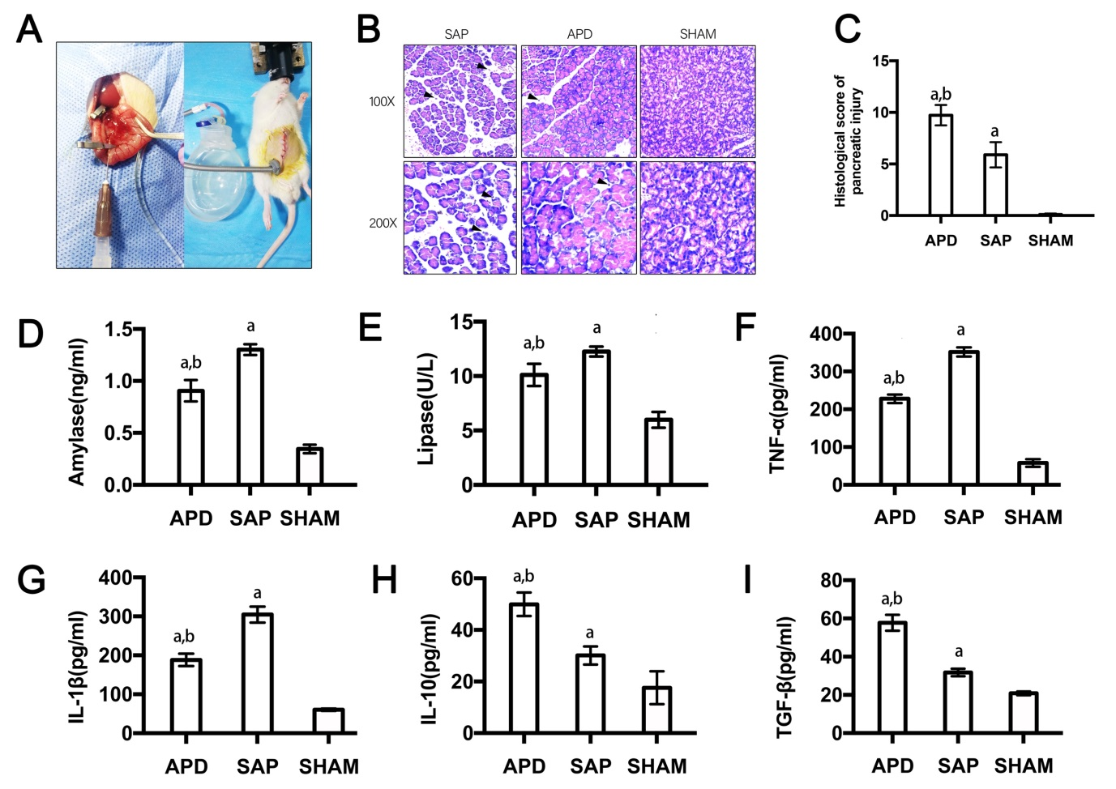
Figure 1 Abdominal paracentesis drainage ameliorates severe acute pancreatitis in a rat model. A: Model establishment. Retrograde injection of Na-taurocholate (left) and a rat after abdominal paracentesis drainage (APD) treatment (right); B and C: Histopathological analysis of the pancreas. Comprehensive disruption of the pancreatic structure with widespread infiltration of leukocytes, acinar cell vacuolization and necrosis was observed in severe acute pancreatitis (SAP) rats; localized leukocyte infiltration and relatively intact acinar structure was observed in APD rats; D-I: Plasma levels of amylase, lipase, tumor necrosis factor-α, interleukin (IL)-1β, IL-10, and transforming growth factor-β, respectively. Data indicate the mean ± SD of six mice (C-I). ªP < 0.05 vs sham, ^{b}P < 0.05 vs SAP.

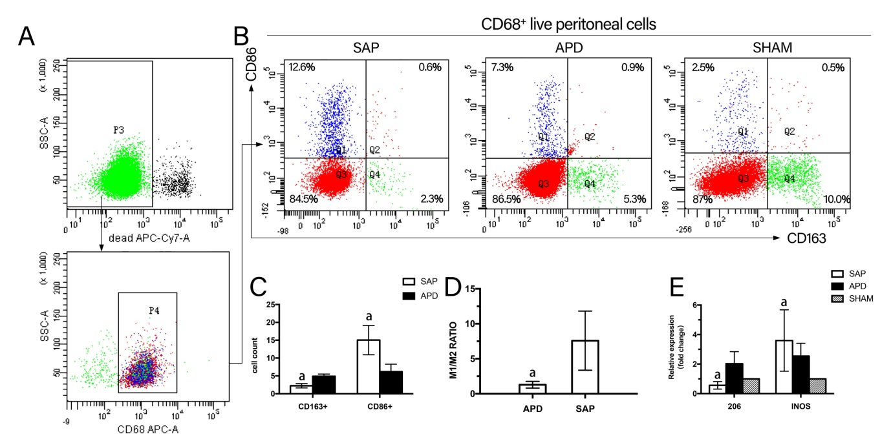
Figure 2 Different polarized phenotypes of peritoneal macrophages in each group. A: Gating strategy for the peritoneal macrophage population; B-D: Representative dot plot (B) and the percentages (C) and M1/M2 ratio (D) of CD68+CD86+ (M1) cells and CD68+CD163+ (M2) cells in each group; E: Relative expression levels of CD206 and iNOS gene in peritoneal cells measured by real-time PCR and normalized to GAPDH mRNA. The data represent at least three independent experiments (A-B) or indicate the mean ± SD of six mice (E). ªP < 0.05 vs abdominal paracentesis drainage.

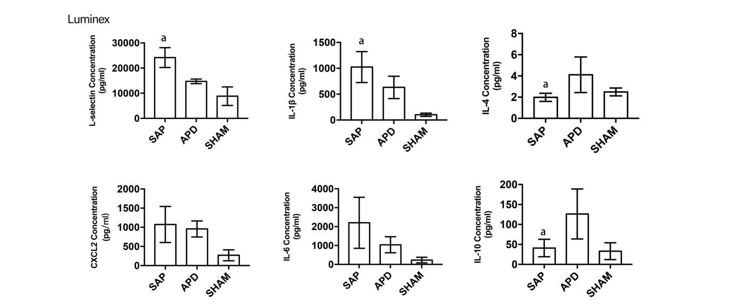
Figure 3 Abdominal paracentesis drainage alters the inflammatory environment in the peritoneal cavity. Protein levels in peritoneal lavage measured by Luminex. The results reflect the mean ± SD obtained from 6 animals in each group. ªP < 0.05 vs abdominal paracentesis drainage.

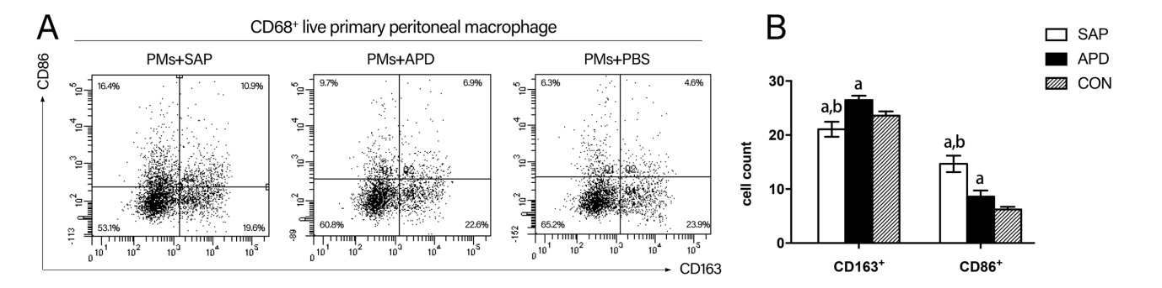
Figure 4 In vitro simulated peritoneal inflammatory environment of abdominal paracentesis drainage rats changes the polarized phenotype of peritoneal macrophages. Primary peritoneal macrophages were cultured in medium simulating different inflammatory environments. The percentages of CD86⁺ and CD163⁺ cells were measured by flow cytometry. The data are representative of at least three independent experiments. ªP < 0.05 vs CON, ^{b}P < 0.05 vs abdominal paracentesis drainage.

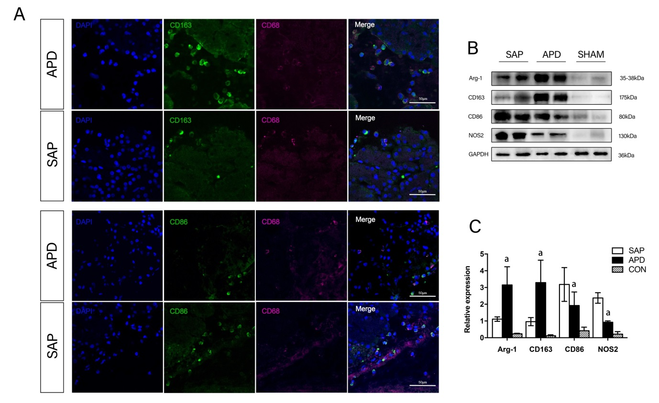
Figure 5 Number of M2 macrophages increased in the pancreases of abdominal paracentesis drainage rats and exerted anti-inflammatory effects. A: Pancreatic tissues from each group were stained with DAPI (blue), CD163 (green in upper two panels), CD86 (green in lower two panels) and CD68 (infrared represented by carmine). Representative images are shown; B and C: Protein levels of Arg-1, CD163, CD86 and iNOS in the pancreatic tissues of each group were measured by western blotting, and the relative expression of these proteins was normalized to GAPDH. Data are representative of at least three independent experiments. ªP < 0.05 vs abdominal paracentesis drainage.

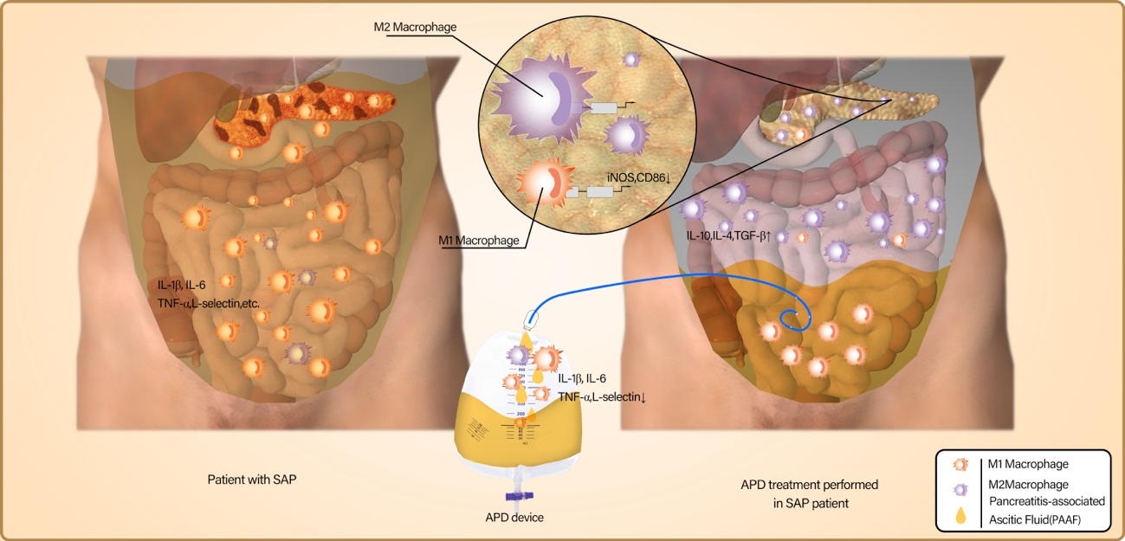
Figure 6 Possible mechanisms responsible for the beneficial effects of abdominal paracentesis drainage on severe acute pancreatitis. Once SAP occurs, the inflammatory cells are activated following acinar cell injuries and exudate full of pro-inflammatory mediators collects in the peritoneal cavity, which can polarize the peritoneal macrophages (PMs) towards the M1 phenotype and lead to the overexpression of pro-inflammatory mediators by PMs. By removing the pancreatitis-associated ascitic fluids, abdominal paracentesis drainage (APD) could improve the inflammatory environment of the peritoneal cavity, thus promoting M2 polarization of PMs in the peritoneal cavity. Meanwhile, APD could also promote M2 polarization of macrophages in pancreatic tissues. These events, could upregulate the expression of anti-inflammatory cytokines, which ultimately ameliorate pancreatic injury.

