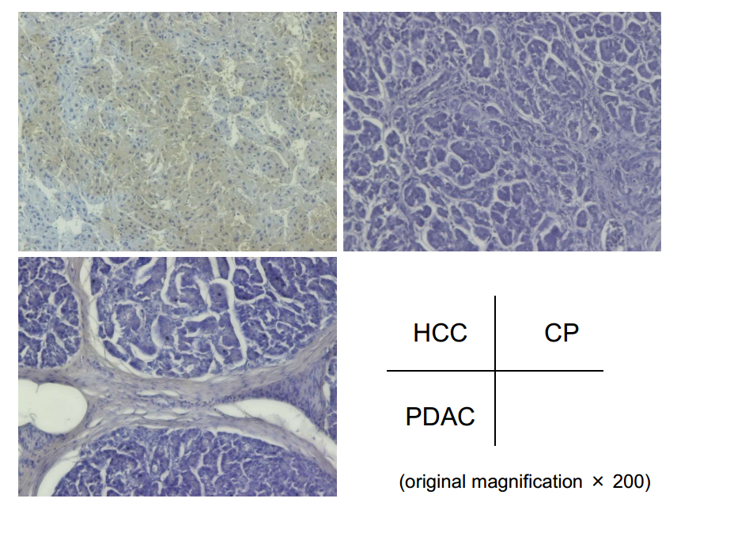
Supplementary Figure 1 Immunohistological staining for Mac-2bp in chronic pancreatitis and pancreatic ductal adenocarcinoma. The positive control [hepatocellular carcinoma (HCC)] (upper left), chronic pancreatitis (CP) (upper right), and pancreatic ductal adenocarcinoma (PDAC) (lower left). Mac-2bp was expressed faintly in CP and PDAC. HCC sample was obtained from a patient with chronic hepatitis C.

