Name of Journal: World Journal of Gastroenterology
ESPS Manuscript NO: 21933
Manuscript Type: ORIGINAL ARTICLE
Basic Study
Lack of hepcidin expression attenuates steatosis and causes fibrosis in the liver

Lu S et al. Hepcidin and liver injury

Sizhao Lu, Robert G Bennett, Kusum Kharbanda, Duygu Dee Harrison-Findik

Sizhao Lu, Robert G Bennett, Department of Biochemistry, University of Nebraska Medical Center, Omaha, NE 68198-5870, United States

Robert G Bennett, Division of Endocrinology, Department of Internal Medicine, University of Nebraska Medical Center, Omaha, NE 68198-4130, United States

Robert G Bennett, Kusum Kharbanda, Nebraska-Western Iowa VA Health Care System, 4101 Woolworth Av, Omaha, NE 68105, United States

Kusum Kharbanda, Duygu Dee Harrison-Findik, Division of Gastroenterology and Hepatology, Department of Internal Medicine, University of Nebraska Medical Center, Omaha, NE 68198-2000, United States

Author contributions: Lu S contributed to study design, data acquisition and drafting of the manuscript; Harrison-Findik DD obtained funding, contributed to study concept and supervision, and critical revision of the manuscript; Bennett Rg and Kharbanda K helped with technical support and critical reading of the manuscript.

supported by NIH grant No. R01AA017738 (to Harrison-Findik DD); and University of Nebraska Medical Center Graduate Assistantship/Fellowship (to Lu S).

Institutional animal care and use committee statement: All procedures involving animals were reviewed and approved by the Institutional Animal Care and Use Committee of University of Nebraska Medical Center (IACUC protocol number: 03-075-10-FC).

Data sharing statement: No additional data are available.

Conflict-of-interest statement: The authors declare no conflict of interest.

Open-Access: This article is an open-access article which was selected by an in-house editor and fully peer-reviewed by external reviewers. It is distributed in accordance with the Creative Commons Attribution Non Commercial (CC BY-NC 4.0) license, which permits others to distribute, remix, adapt, build upon this work non-commercially, and license their derivative works on different terms, provided the original work is properly cited and the use is non-commercial. See: http://creativecommons.org/licenses/by-nc/4.0/

Correspondence to: Duygu Dee Harrison-Findik, MD, Division of Gastroenterology and Hepatology, Department of Internal Medicine, University of Nebraska Medical Center, 92000 UNMC, Omaha, NE 68198-2000, United States. dharrisonfindik@unmc.edu
Telephone: +1-402-5596209
Fax: +1-402- 5599004

Received: August 2, 2015
Peer-review started: August 3, 2015
First decision: September 29, 2015
Revised: October 14, 2015
Accepted: November 13, 2015
Article in press:
Published online:

Abstract
Aim: To investigate the role of key iron-regulatory protein, hepcidin in non-alcoholic fatty liver disease (NAFLD).

Methods: Hepcidin (Hamp1) knockout and floxed control mice were administered a high fat and high sucrose (HFS) or a regular control diet for 3 or 7 mo. Steatosis, triglycerides, fibrosis, protein and gene expression in mice livers were determined by histological and biochemical techniques, western blotting and real-time PCR.

Results: Knockout mice exhibited hepatic iron accumulation. Despite similar weight gains, HFS feeding induced hepatomegaly in floxed, but not knockout, mice. The livers of floxed mice exhibited higher levels of steatosis, triglycerides and c-Jun N-terminal kinase (JNK) phosphorylation than knockout mice. In contrast, a significant increase in fibrosis was observed in knockout mice livers within 3 months of HFS administration. The hepatic gene expression levels of sterol regulatory element-binding protein-1c and fat-specific protein-27, but not peroxisome proliferator-activated receptor-alpha or microsomal triglyceride transfer protein, were attenuated in HFS-fed knockout mice. Knockout mice fed with regular diet displayed increased carnitine palmitoyltransferase-1a and phosphoenolpyruvate carboxykinase-1 but decreased glucose-6-phosphatase expression in the liver. In summary, attenuated steatosis correlated with decreased expression of lipogenic and lipid storage genes, and JNK phosphorylation. Deletion of Hamp1 alleles per se modulated hepatic expression of beta-oxidation and gluconeogenic genes.

Conclusion: Lack of hepcidin expression inhibits hepatic lipid accumulation and induces early development of fibrosis following high fat intake. Hepcidin and iron may play a role in the regulation of metabolic pathways in the liver, which has implications for NAFLD pathogenesis.

Key words: Hamp; Iron; non-alcoholic fatty liver disease; Non-alcoholic steatohepatitis; Metabolic genes; Steatosis; Steatohepatitis

© The Author(s) 2015. Published by Baishideng Publishing Group Inc. All rights reserved.

Core tip: Due to obesity epidemic the incidence of non-alcoholic fatty liver disease (NAFLD) is on the rise. Iron contributes to disease severity and the expression of key iron regulatory hormone, hepcidin is modulated in NAFLD patients. The underlying mechanisms are unknown. We have generated hepcidin knockout mice with iron overload phenotype. This study investigates the role of hepcidin in NAFLD by using high fat and high sucrose-fed knockout mice as an experimental model of NAFLD. Our findings showed attenuated steatosis and early fibrosis development suggesting a role for hepcidin in the regulation of metabolic processes in the liver, and in NAFLD.

Lu S, Bennett RG, Kharbanda K, Harrison-Findik DD. Lack of hepcidin expression attenuates steatosis and causes fibrosis in the liver. World J Gastroenterol 2015; In press

INTRODUCTION
Non-alcoholic fatty liver disease (NAFLD) encompasses a spectrum of liver disease ranging from simple benign steatosis to non-alcoholic steatohepatitis (NASH). NASH, a more aggressive form of disease, is characterized by the presence of lobular inflammation, fibrosis, hepatocellular ballooning and Mallory-Denk bodies^{[1,2]}. NASH with progressive fibrosis can progress to cirrhosis and end stage liver disease^{[1,3,4]}.
The precise mechanisms of NASH development are not well understood. Although a so-called “two-hit hypothesis”^{[5]} has been widely adopted^{[6,7]}, NASH can also develop in the absence of insulin resistance and simple benign steatosis (i.e., initial hit)^{[8]}. The potential candidates regarded as the “second hit” include oxidative stress, inflammation and changes in mitochondrial function^{[7,9–12]}. Iron is also considered as a “second hit” in liver injury^{[13]} and a role for iron has been reported in NASH pathogenesis. Patients with NAFLD/NASH frequently display elevated serum iron indices and hepatic iron content^{[14,15]}. A strong correlation between hepatic iron content and the level of liver fibrosis in NAFLD/NASH patients has been shown^{[16–18]}. Phlebotomy has also been suggested to alleviate insulin resistance in NAFLD patients^{[19]}.
The mechanisms by which iron contributes to NAFLD/NASH pathogenesis have mainly been attributed to oxidative stress, which can induce lipid peroxidation^{[20]} and ultimately the activation of fibrotic signaling^{[21]}. Studies with genetic haemochromatosis (GH) patients have shown the association of primary iron overload with fibrogenesis^{[22]}. By using dietary experimental models, some studies have also suggested a reverse connection between iron and steatosis in rat livers^{[23,24]}. In contrast, another study with a mouse dietary model of iron and high fat failed to show any significant effect of iron on steatosis^{[25]}. The consequences of altered iron homeostasis for lipid metabolism in the liver are therefore unclear.
In this study, we employed hepcidin knockout mice with iron overload phenotype as an experimental model to further study the role of iron metabolism in NAFLD/NASH. Hepcidin is the central regulator of iron homeostasis, which is primarily synthesized in hepatocytes as a circulatory protein^{[26]}. Unlike humans, which express only one hepcidin gene, HAMP, mice express two hepcidin genes, Hamp1 and Hamp2^{[27]}. Hamp1, the human equivalent of mouse hepcidin gene, is by itself sufficient to regulate iron metabolism^{[28,29]}. Hepcidin controls iron homeostasis by decreasing iron absorption from the absorptive enterocytes in the duodenum and the release of iron from the macrophages^{[30]}. The lack of hepcidin expression in knockout mice and in human iron disorders results in iron accumulation both in the liver and other organs^{[30-32]}. GH patients also display impaired hepcidin expression^{[33]}. Although changes in both serum and liver hepcidin expression levels have been reported in NAFLD/NASH patients^{[14,34–38]}, the significance of hepcidin in disease pathogenesis is unknown. Our findings in this study with hepcidin (Hamp1) knockout mice administered a high fat diet for different time points suggest a role for hepcidin in NAFLD/NASH pathogenesis. This mouse model may also serve as a novel experimental model of NAFLD/NASH.

MATERIALS AND METHODS

Animal studies
Animal experiments were approved by the Institutional Animal Care and Use Committee at the University of Nebraska Medical Center. Hamp1 floxed mice and ubiquitous Hamp1 knockout mice, lacking hepcidin expression in all the organs, were generated, as published previously^{[29]}. All mice are on C57BL/6J genetic background. Hamp floxed mice have been donated to the Jackson Laboratory (Catalog No. 026872, 026873).
Male mice (4-6-wk-old) were randomly separated into groups to feed with custom-made regular control (17.2% kcal. from fat, 100 g/kg sucrose) or high fat and high sucrose (HFS) [42% kcal. from fat (54% saturated, 9.7% trans-fat), 0.4% cholesterol, 340 g/kg sucrose] diets for 3 or 7 mo (Harlan Laboratories; TD.97184; TD.120654). Water was given ad libitum, and contained sucrose (40 g/L) with HFS-fed groups to imitate the western diet with fat and soda consumption.

Liver histology
Formalin-fixed, paraffin-embedded liver tissues were sectioned and stained with hematoxylin and eosin at UNMC Histology Core Facility. To determine fibrosis, sections were stained with Picrosirius Red, as published previously^{[39]} and histomorphometric analyses were performed using ImageJ ROI manager software.

Quantification of liver triglycerides
Triglycerides were isolated, as described^{[40]} and quantified using a commercial kit (Thermo Scientific DMA kit 2750) according to manufacturer’s instructions.

Real-time PCR
cDNA was synthesized from liver tissue RNA with Superscript II reverse transcriptase (Invitrogen), as described^{[41]}. Real-time PCR reactions were performed using iTaq Universal SYBR Green Supermix (Bio-Rad) with a StepOnePlus instrument (Life Technologies). Glyceraldehyde 3-phosphate dehydogenase (Gapdh) gene was used as the endogenous control and gene amplification was calculated using comparative Ct method, as described^{[41]}. Primer sequences are shown in table 1.

Western blotting
Western blots using whole liver tissue lysate proteins were performed, as published previously^{[41]}. Antibodies were obtained commercially (Cell Signaling, Sigma) and immune-reactive bands were detected by the ImmunStar™ kits (Bio-Rad).

Statistical analysis
The significance of differences between groups was determined by Student’s t-test or one-way ANOVA by using SPSS software. A value of P < 0.05 was accepted as statistically significant.

RESULTS
To study the interaction of hepcidin-induced iron overload and lipid metabolism, ubiquitous hepcidin (Hamp1) knockout and floxed control mice were administered either high fat and high sucrose (HFS) or regular (control) diets, as described in Material and Methods. Since NAFLD/NASH progression can occur over a long period of time, mice were fed up to 7 mo. We have previously shown that the deletion of both Hamp1 alleles induces significant iron overload in the livers of Hamp1 knockout mice by using inductively coupled mass spectrometry (ICP-MS)^{[29]}. ICP-MS analysis did not detect any significant level of iron in the livers of homozygous Hamp1 floxed control mice. Gradual iron deposition was also indicated macroscopically by the darker color of knockout mice livers compared to those of floxed control mice (Figure 1).
Macroscopic analyses have confirmed that HFS intake induced hepatomegaly and more pronounced visceral fat accumulation in floxed control mice compared to knockout mice (Figure 1). In agreement, the liver weights of floxed mice were significantly higher (3.5 ± 0.46 g) than those of knockout mice (2.42 ± 0.54 g) particularly following 7 mo of HFS administration (Figure 2A and B). However, HFS intake induced similar increases in body weights in both floxed (Figure 2C) and knockout (Figure 2D) mice after either 3 or 7 mo-long feeding, as compared to respective controls fed with regular diet.
To further understand these discrepancies between floxed and knockout mice, histological analysis were performed. Hematoxylin and eosin staining of livers showed significantly higher levels of steatosis in floxed than in knockout mice both after 3 and 7 month-long HFS feeding (Figure 3). The quantification of hepatic triglycerides further confirmed that HFS intake significantly increased hepatic triglyceride content to different extents in floxed and knockout mice (Figure 4A and B). At the end of 3 mo-long high fat intake, the level of hepatic triglyceride accumulation was 2.85-fold higher in floxed mice compared to knockout mice (1876.64 ± 370.84 and 657.98 ± 186.89 μmol/L per 100 g b.w.) (Figure 4A). Seven mo-long feeding yielded 2.07-fold higher hepatic triglyceride content in floxed than in knockout mice (1837.71 ± 118.12 and 886.91 ± 89.51 μmol/L per 100 g b.w) (Figure 4B).
Sirius Red staining of liver sections showed that knockout, but not floxed, mice developed fibrosis within 3 months of high fat intake (Figure 5A). The deletion of both Hamp1 alleles per se has also caused weaker but significant level of fibrosis in the livers of knockout mice (Figure 5A). Quantification by ImageJ analysis has shown a 2.56-fold higher level of fibrosis in the livers of high fat-fed knockout than regular diet-fed knockout mice at 3 mo (Figure 5B) In contrast to 3 mo, 7 mo of high fat intake induced fibrosis in the livers of floxed mice (Figure 6A). Compared to 3 mo, regular diet feeding for 7 mo slightly increased the level of fibrosis in knockout mice livers (Figure 6A). Knockout mice with 7 mo-long high fat intake developed the highest level of fibrosis, as shown by Image J quantification (Figure 6B). The hepatic expression patterns of alpha smooth muscle actin (αSMA) protein, a marker for hepatic stellate cell activation, were in agreement with our histological analysis. 3 mo-long HFS feeding elevated liver αSMA expression in knockout, but not floxed, mice, as shown by western blotting (Figure 7A). The deletion of Hamp1 alleles by itself increased hepatic αSMA expression (Figure 7A). In contrast to 3 mo, 7 month-long high fat intake increased αSMA expression in the livers of both floxed and knockout mice (Figure 7A).
Studies with JNK knockout mice fed with MCD diets have indicated a role for c-Jun N-terminal kinase (JNK) in steatosis^{[42]}. JNK is activated by phosphorylation on serine residues^{[43]}. The expression levels of phosphorylated JNK protein in the livers of Hamp1 transgenic mice were therefore determined by western blotting using specific anti-phospho JNK antibodies (Figure 7B). Three-month-long high fat intake significantly stimulated JNK phosphorylation in the livers of floxed, but not knockout, mice (Figure 7B). In contrast, the effect of high fat intake on JNK phosphorylation in the liver was weakened by 7 mo-long feeding (Figure 7B).
To further investigate the underlying mechanisms of attenuated fat accumulation in the livers of knockout mice with high fat intake, mRNA expression levels of genes, which are known to be involved in lipid metabolism, were examined by real-time PCR (Figures 8A-F). The transcription factor, sterol regulatory element-binding protein-1c (Srebp-1c) is involved in de novo lipogenesis and its expression is also regulated at the transcriptional level^{[44,45]}. The deletion of Hamp1 alleles did not significantly alter basal hepatic expression levels of Srebp-1c (Figures 8A and B). Three months of high fat intake stimulated Srebp-1c expression by 13.39-fold in floxed and 7.40–fold knockout mice compared to controls (Figure 8A). In contrast, 7 mo of high fat intake elevated Srebp-1c expression only by 3.72-fold in floxed mice (Figure 8B). Furthermore, 7 mo-long high fat feeding did not significantly alter liver Srebp-1c expression in knockout mice (Figure 8B).
Fat-specific protein-27 (Fsp27) protein is involved in lipid droplet formation^{[46]}. HFS feeding for 3 and 7 mo significantly induced Fsp27 expression in the livers of floxed mice by 3.83- and 5.36-fold, respectively compared to regular diet-fed floxed mice (Figures 8C and D). The livers of knockout mice fed with HFS for 3 or 7 mo displayed significantly lower induction of Fsp27 expression than floxed mice, which was more prominent at 7 mo (Figures 8C and D). Liver Fsp27 expression was not significantly altered in knockout mice fed with regular diets for 3 or 7 months compared to respective floxed controls (Figures 8C and D).
Microsomal triglyceride transfer protein (Mttp) protein is responsible for the production and secretion of VLDL particles^{[47]}. The mRNA expression level of Mttp in the liver was not significantly altered in floxed and knockout mice after 3 mo of high fat intake (Figure 8E). However, high fat exposure for 7 mo significantly suppressed Mttp expression in the livers of both floxed and knockout mice (Figure 8F).
Changes in fatty acid oxidation in the liver play an important role in NAFLD pathogenesis. Peroxisome proliferator-activated receptor-alpha (Pparα) activates the transcription of genes involved in the regulation of fatty acid β-oxidation^{[48]}. The mRNA expression levels of Pparα were up-regulated at similar levels in the livers of both floxed and knockout mice within 3 mo of high fat feeding (Figure 9A). In contrast, the livers of floxed and knockout mice with 7 mo of high fat exposure displayed significantly inhibited Pparα expression (Figure 9B). Carnitine palmitoyltransferase-1 (Cpt1) is the rate-limiting enzyme in mitochondrial β-oxidation pathway^{[49]}. Three month-long high fat administration did not exert a significant effect on hepatic Cpt1a expression in floxed and knockout mice (Figure 9C). On the other hand, the livers of knockout mice fed with regular diet for 7 mo expressed higher Cpt1a levels compared to floxed mice fed under similar conditions, suggesting a role for gradual iron deposition (Figure 9D). Seven month-long high fat intake did not alter hepatic Cpt1a expression in floxed mice (Figure 9D). In contrast, long-term high fat exposure significantly suppressed Cpt1a expression in the livers of knockout mice compared to knockout controls (Figure 9D).
Both phosphoenolpyruvate carboxykinase-1 (Pck1) and glucose-6-phosphatase (G6pc) are involved in gluconeogenesis. Similar to Cpt1a, the deletion of Hamp1 alleles significantly up-regulated basal Pck1 mRNA expression in the liver. In contrast, the absence of hepcidin expression suppressed basal hepatic G6pc mRNA expression (Figures 9E-H). Both 3 and 7 month-long high fat exposure significantly inhibited Pck1 and G6pc mRNA expression in the livers of both floxed and knockout mice (Figures 9E-H).

DISCUSSION
Changes in iron metabolism contribute to liver injury^{[22,50]}. The deposition of iron in the liver correlates with disease severity in NAFLD patients^{[15]}. The mechanisms by which excess iron contribute to NAFLD pathogenesis is unclear. Although inconclusive, some studies suggested a role for iron in the regulation of lipid metabolism^{[23–25]}. Since hepcidin is the central regulator of iron metabolism, we investigated its role in fatty liver disease. We and others showed iron accumulation in hepcidin (Hamp1) knockout mice^{[29,31,51]}. Hamp1 knockout mice were administered high fat diets for different time periods to generate pathological features in the liver, which are representative of NAFLD/NASH^{[2]}. Collectively, our findings showed a strong correlation between hepcidin and lipid metabolism, and fibrosis in the liver.
The absence of hepcidin expression in Hamp1 knockout mice exerted an inhibitory effect on hepatic lipid accumulation. This effect was not due to altered rates of diet consumption or weight gain and suggests the involvement of regulatory mechanisms. Previous studies showed a converse relationship between iron and lipid metabolism^{[22,23]}. Since lack of hepcidin expression causes iron overload, elevated hepatic iron content may have interfered with fat accumulation in HFS-fed knockout mice. Furthermore, our findings suggest a role for JNK in this process. Namely, we showed a direct correlation between JNK phosphorylation and steatosis levels in floxed mice livers. In contrast, the livers of Hamp1 knockout mice did not display significant JNK phosphorylation. Of note, the deletion of JNK1 reverses steatosis^{[52,53]} and JNK is activated by phosphorylation^{[43]}. Hepcidin-mediated changes in JNK activation may therefore be associated with attenuated steatosis in Hamp1 knockout mice, particularly in early stages of high fat exposure.
Besides iron and JNK, altered metabolic gene expression in high fat-fed knockout mice may play a role in the inhibition of lipid accumulation. This is supported by our findings, which showed that the hepatic expression level of genes involved in lipogenesis and lipid storage do not adequately respond to high fat intake in Hamp1 knockout mice. Namely, Srebp-1c and Fsp27 expression were blunted in the livers of HFS-fed knockout, but not floxed, mice. These findings are significant because Srebp-1c and Fsp27 expression are regulated at mRNA level^{[54]}. Furthermore, the deletion of Hamp1 alleles did not alter their basic expression levels. Iron-deficient rodents have been reported to display elevated lipogenic gene expression, which indirectly supports our findings^{[55–57]}. Hepatic lipid homeostasis is also regulated by lipid export via VLDL secretion. The hepatic expression levels of Mttp, which is important in this process, were comparable between control and knockout mice. Our findings therefore suggest that decreased lipogenesis and lipid storage, but not increased lipid secretion, might lead to attenuated steatosis in high fat-fed Hamp1 knockout mice.
Increased mitochondrial β-oxidation alleviates extra-hepatic fat burden in NAFLD by disposing of excess lipids^{[58]}. Pparα, which induces the transcription of genes involved in β-oxidation, is itself regulated at the transcriptional level^{[59,60]}. However, Pparα is not expected to contribute to liver pathology in Hamp1 knockout mice because HFS-fed floxed and knockout mice livers displayed similar levels of Pparα expression. Cpt1 is the rate-limiting enzyme in β-oxidation. Long-term high fat intake significantly suppressed Cpt1a expression only in knockout mice livers suggesting a role for it in attenuated steatosis in Hamp1 knockout mice. Interestingly, Hamp1 deletion by itself elevated hepatic Cpt1a expression. Besides β-oxidation, mitochondria is also important for iron metabolism^{[61]}. It is feasible that iron accumulation caused by Hamp1 deletion modulates metabolic gene expression in mitochondria. Of note, mitochondrial changes contribute to NAFLD/NASH pathology^{[11]}. Hamp1 deletion also altered the expression of gluconeogenic genes, Pck1 and G6pc. Hepcidin serves as a gluconeogenic sensor in mice during starvation^{[62]}. The reasons for the differential regulation of Pck1 and G6pc expression in knockout mice livers are unclear. Pck1 and G6pc are however regulated by various transcription factors including Foxo1^{[54]} and iron regulates Foxo1 in adipocytes^{[63]}. The net effect of hepcidin and iron on metabolic processes in the liver requires further investigation.
Despite amelioration of steatosis, high fat administration caused injury in the livers of Hamp1 knockout mice. In fact, knockout mice displayed an earlier and more pronounced development of fibrosis compared to control mice. Previous studies using methionine-choline-deficient diet (MCD) experimental models have shown that iron supplementation attenuates steatosis and triggers fibrosis^{[24,64]}. Of note, MCD diet does not reproduce the metabolic changes observed in NAFLD/NASH patients and induces weight loss^{[65,66]}. On the other hand, most high fat diet models induce metabolic changes but not fibrosis^{[66,67]}. Furthermore, introduction of iron in the diet can create secondary effects by up-regulating liver hepcidin synthesis and thereby inhibiting the expression of iron exporter, ferroportin^{[68–70]}. This will then lead to sequestration of iron in Kupffer cells and trigger inflammation. These artefacts are avoided in in our experimental system because iron accumulation is directly caused by the lack of hepcidin expression. Our high fat-fed Hamp1 knockout mice, which develop early fibrosis, may therefore be an advantageous NAFLD/NASH model.
Simple steatosis is considered to be a benign condition in NAFLD patients. In vivo and in vitro studies have also shown this to be a beneficial process because triglycerides synthesis protects the liver from lipotoxicity induced by free fatty acid accumulation^{[64,71]}. The decreased level of steatosis in synergy with iron might be responsible for early fibrosis development in the livers of HFS-fed Hamp1 knockout mice.
In summary, our findings strongly suggest a role for hepcidin in the regulation of hepatic lipid and carbohydrate metabolism. There are currently a limited number of NASH experimental models^{[66]}. Hamp1 knockout mice will therefore be useful to investigate the molecular mechanisms of metabolic processes and fibrosis in NASH pathogenesis.
Lack of hepcidin expression due to the deletion of Hamp1 alleles inhibited lipid accumulation in the liver following a high fat and high sucrose diet administration. Lack of c-jun kinase phosphorylation and the changes in the expression of metabolic genes, which are involved in lipogenesis and lipid storage, played a role in attenuated steatosis observed in hepcidin knockout mice. Knockout mice developed fibrosis within 3 mo of high fat exposure, which was more prominent at 7 mo. Deletion of Hamp1 alleles by itself modulated hepatic expression of genes involved in mitochondrial fatty acid oxidation and gluconeogenesis. In summary, hepcidin is associated with the regulation of metabolic processes in the liver and the lack of hepcidin expression triggers early fibrosis development. High fat-fed hepcidin knockout mice may therefore serve as a useful animal model to study different aspects of fatty liver disease pathogenesis.

COMMENTS
Background
Obesity-related metabolic syndrome and its hepatic manifestation, non-alcoholic fatty liver disease (NAFLD) are important public health problems. Hepcidin, synthesized primarily by the liver, is the key iron-regulatory hormone. The authors have previously shown a role for hepcidin in alcoholic liver disease. Hepcidin expression is modulated in NAFLD patients but its significance is unknown. Furthermore, there are only a few animal models of NAFLD, which resemble human disease pathology. The authors are one of the few laboratories with hepcidin transgenic mice models, which were employed in this study to investigate NAFLD pathogenesis.

Research frontiers
NAFLD is a wide spectrum of disease ranging from simple benign fat accumulation (steatosis) to non-alcoholic steatohepatitis (NASH), which is characterized by inflammation (steatohepatitis) and fibrosis in the liver. A correlation between hepatic iron levels and disease severity in NAFLD/NASH patients has been clearly demonstrated. Since hepcidin is the central iron regulator, it is essential to understand its role in NAFLD/NASH.

Innovations and breakthroughs
Those previously published study with hepcidin knockout mice generated in the laboratory has demonstrated significant iron accumulation in the liver. To establish a novel NAFLD/NASH experimental model, hepcidin knockout mice were fed with a high fat diet for different time periods. By showing that hepcidin is directly involved in lipid storage and fibrogenesis in the liver following high fat intake, the authors underlined the importance of hepcidin and iron homeostasis in NAFLD/NASH pathogenesis.

Applications
This study indicated a role for hepcidin in the regulation of metabolic processes and early fibrosis development in the liver. These findings will further understanding of the mechanisms involved in NAFLD/NASH progression and liver fibrosis. Furthermore, those high fat-fed hepcidin knockout mice, as a novel experimental NAFLD/NASH model, can be useful in the search for functional biomarkers and therapeutics for NAFLD/NASH.

Terminology
Hepcidin is essential for systemic iron homeostasis. Chronic high fat intake and obesity ultimately lead to metabolic syndrome, which is characterized by dyslipidemia and insulin resistance. Obesity also impairs metabolic functions and histology of the liver causing fat accumulation (steatosis), inflammation (steatohepatitis) and scar tissue formation (fibrogenesis), as observed in patients with NAFLD/NASH.

Peer-review
This manuscript investigated the role of key iron-regulatory protein, hepcidin in non-alcoholic fatty liver disease in Hepcidin (Hamp1) knockout and floxed control mice administered a high fat and high sucrose or a regular control diet for 3 or 7 mo. The authors suggest that Hepcidin and iron may play a role in the regulation of metabolic pathways in the liver, which has implications for NAFLD pathogenesis. This manuscript was well designed in vivo experiment and well written with all the results obtained.

REFERENCES
1 Anstee QM, Targher G, Day CP. Progression of NAFLD to diabetes mellitus, cardiovascular disease or cirrhosis. Nat Rev Gastroenterol Hepatol 2013; 10: 330-344 [PMID: 23507799 DOI: 10.1038/nrgastro.2013.41]
2 Brunt EM, Janney CG, Di Bisceglie AM, Neuschwander-Tetri BA, Bacon BR. Nonalcoholic steatohepatitis: a proposal for grading and staging the histological lesions. Am J Gastroenterol 1999; 94: 2467-2474 [PMID: 10484010 DOI: 10.1111/j.1572-0241.1999.01377.x]
3 Ekstedt M, Franzén LE, Mathiesen UL, Thorelius L, Holmqvist M, Bodemar G, Kechagias S. Long-term follow-up of patients with NAFLD and elevated liver enzymes. Hepatology 2006; 44: 865-873 [PMID: 17006923 DOI: 10.1002/hep.21327]
4 Hernandez-Gea V, Friedman SL. Pathogenesis of liver fibrosis. Annu Rev Pathol 2011; 6: 425-456 [PMID: 21073339 DOI: 10.1146/annurev-pathol-011110-130246]
5 Day CP, James OF. Steatohepatitis: a tale of two "hits"? Gastroenterology 1998; 114: 842-845 [PMID: 9547102 DOI: 10.1016/S0016-5085(98)70599-2]
6 Wree A, Broderick L, Canbay A, Hoffman HM, Feldstein AE. From NAFLD to NASH to cirrhosis-new insights into disease mechanisms. Nat Rev Gastroenterol Hepatol 2013; 10: 627-636 [PMID: 23958599 DOI: 10.1038/nrgastro.2013.149]
7 Basaranoglu M, Basaranoglu G, Sentürk H. From fatty liver to fibrosis: a tale of "second hit". World J Gastroenterol 2013; 19: 1158-1165 [PMID: 23483818 DOI: 10.3748/wjg.v19.i8.1158]
8 Tiniakos DG, Vos MB, Brunt EM. Nonalcoholic fatty liver disease: pathology and pathogenesis. Annu Rev Pathol 2010; 5: 145-171 [PMID: 20078219 DOI: 10.1146/annurev-pathol-121808-102132]
9 Malaguarnera M, Di Rosa M, Nicoletti F, Malaguarnera L. Molecular mechanisms involved in NAFLD progression. J Mol Med (Berl) 2009; 87: 679-695 [PMID: 19352614 DOI: 10.1007/s00109-009-0464-1]
10 Takaki A, Kawai D, Yamamoto K. Multiple hits, including oxidative stress, as pathogenesis and treatment target in non-alcoholic steatohepatitis (NASH). Int J Mol Sci 2013; 14: 20704-20728 [PMID: 24132155 DOI: 10.3390/ijms141020704]
11 Dowman JK, Tomlinson JW, Newsome PN. Pathogenesis of non-alcoholic fatty liver disease. QJM 2010; 103: 71-83 [PMID: 19914930 DOI: 10.1093/qjmed/hcp158]
12 Fabbrini E, Sullivan S, Klein S. Obesity and nonalcoholic fatty liver disease: biochemical, metabolic, and clinical implications. Hepatology 2010; 51: 679-689 [PMID: 20041406 DOI: 10.1002/hep.23280]
13 O'Brien J, Powell LW. Non-alcoholic fatty liver disease: is iron relevant? Hepatol Int 2012; 6: 332-341 [PMID: 22020821 DOI: 10.1007/s12072-011-9304-9]
14 Martinelli N, Traglia M, Campostrini N, Biino G, Corbella M, Sala C, Busti F, Masciullo C, Manna D, Previtali S, Castagna A, Pistis G, Olivieri O, Toniolo D, Camaschella C, Girelli D. Increased serum hepcidin levels in subjects with the metabolic syndrome: a population study. PLoS One 2012; 7: e48250 [PMID: 23144745 DOI: 10.1371/journal.pone.0048250]
15 Aigner E, Weiss G, Datz C. Dysregulation of iron and copper homeostasis in nonalcoholic fatty liver. World J Hepatol 2015; 7: 177-188 [PMID: 25729473 DOI: 10.4254/wjh.v7.i2.177]
16 Valenti L, Fracanzani AL, Bugianesi E, Dongiovanni P, Galmozzi E, Vanni E, Canavesi E, Lattuada E, Roviaro G, Marchesini G, Fargion S. HFE genotype, parenchymal iron accumulation, and liver fibrosis in patients with nonalcoholic fatty liver disease. Gastroenterology 2010; 138: 905-912 [PMID: 19931264 DOI: 10.1053/j.gastro.2009.11.013]
17 Nelson JE, Wilson L, Brunt EM, Yeh MM, Kleiner DE, Unalp-Arida A, Kowdley KV. Relationship between the pattern of hepatic iron deposition and histological severity in nonalcoholic fatty liver disease. Hepatology 2011; 53: 448-457 [PMID: 21274866 DOI: 10.1002/hep.24038]
18 Nelson JE, Brunt EM, Kowdley KV; Nonalcoholic Steatohepatitis Clinical Research Network. Lower serum hepcidin and greater parenchymal iron in nonalcoholic fatty liver disease patients with C282Y HFE mutations. Hepatology 2012; 56: 1730-1740 [PMID: 22611049 DOI: 10.1002/hep.25856]
19 Valenti L, Fracanzani AL, Dongiovanni P, Bugianesi E, Marchesini G, Manzini P, Vanni E, Fargion S. Iron depletion by phlebotomy improves insulin resistance in patients with nonalcoholic fatty liver disease and hyperferritinemia: evidence from a case-control study. Am J Gastroenterol 2007; 102: 1251-1258 [PMID: 17391316 DOI: 10.1111/j.1572-0241.2007.01192.x]
20 Browning JD, Horton JD. Molecular mediators of hepatic steatosis and liver injury. J Clin Invest 2004; 114: 147-152 [PMID: 15254578 DOI: 10.1172/JCI22422]
21 Ahmed U, Latham PS, Oates PS. Interactions between hepatic iron and lipid metabolism with possible relevance to steatohepatitis. World J Gastroenterol 2012; 18: 4651-4658 [PMID: 23002334 DOI: 10.3748/wjg.v18.i34.4651]
22 Ramm GA, Crawford DH, Powell LW, Walker NI, Fletcher LM, Halliday JW. Hepatic stellate cell activation in genetic haemochromatosis. Lobular distribution, effect of increasing hepatic iron and response to phlebotomy. J Hepatol 1997; 26: 584-592 [PMID: 9075666 DOI: 10.1016/S0168-8278(97)80424-2]
23 Cunnane SC, McAdoo KR. Iron intake influences essential fatty acid and lipid composition of rat plasma and erythrocytes. J Nutr 1987; 117: 1514-1519 [PMID: 3116180]
24 Kirsch R, Sijtsema HP, Tlali M, Marais AD, Hall Pde L. Effects of iron overload in a rat nutritional model of non-alcoholic fatty liver disease. Liver Int 2006; 26: 1258-1267 [PMID: 17105592 DOI: 10.1111/j.1478-3231.2006.01329.x]
25 Choi JS, Koh IU, Lee HJ, Kim WH, Song J. Effects of excess dietary iron and fat on glucose and lipid metabolism. J Nutr Biochem 2013; 24: 1634-1644 [PMID: 23643521 DOI: 10.1016/j.jnutbio.2013.02.004]
26 Ganz T, Nemeth E. Hepcidin and iron homeostasis. Biochim Biophys Acta 2012; 1823: 1434-1443 [PMID: 22306005 DOI: 10.1016/j.bbamcr.2012.01.014]
27 Pigeon C, Ilyin G, Courselaud B, Leroyer P, Turlin B, Brissot P, Loréal O. A new mouse liver-specific gene, encoding a protein homologous to human antimicrobial peptide hepcidin, is overexpressed during iron overload. J Biol Chem 2001; 276: 7811-7819 [PMID: 11113132 DOI: 10.1074/jbc.M008923200]
28 Lou DQ, Nicolas G, Lesbordes JC, Viatte L, Grimber G, Szajnert MF, Kahn A, Vaulont S. Functional differences between hepcidin 1 and 2 in transgenic mice. Blood 2004; 103: 2816-2821 [PMID: 14604961 DOI: 10.1182/blood-2003-07-2524]
29 Lu S, Seravalli J, Harrison-Findik D. Inductively coupled mass spectrometry analysis of biometals in conditional Hamp1 and Hamp1 and Hamp2 transgenic mouse models. Transgenic Res 2015; 24: 765-773 [PMID: 25904410 DOI: 10.1007/s11248-015-9879-3]
30 Ganz T. Systemic iron homeostasis. Physiol Rev 2013; 93: 1721-1741 [PMID: 24137020 DOI: 10.1152/physrev.00008.2013]
31 Lesbordes-Brion JC, Viatte L, Bennoun M, Lou DQ, Ramey G, Houbron C, Hamard G, Kahn A, Vaulont S. Targeted disruption of the hepcidin 1 gene results in severe hemochromatosis. Blood 2006; 108: 1402-1405 [PMID: 16574947 DOI: 10.1182/blood-2006-02-003376]
32 Nemeth E, Tuttle MS, Powelson J, Vaughn MB, Donovan A, Ward DM, Ganz T, Kaplan J. Hepcidin regulates cellular iron efflux by binding to ferroportin and inducing its internalization. Science 2004; 306: 2090-2093 [PMID: 15514116 DOI: 10.1126/science.1104742]
33 van Dijk BA, Laarakkers CM, Klaver SM, Jacobs EM, van Tits LJ, Janssen MC, Swinkels DW. Serum hepcidin levels are innately low in HFE-related haemochromatosis but differ between C282Y-homozygotes with elevated and normal ferritin levels. Br J Haematol 2008; 142: 979-985 [PMID: 18557745 DOI: 10.1111/j.1365-2141.2008.07273.x]
34 Bekri S, Gual P, Anty R, Luciani N, Dahman M, Ramesh B, Iannelli A, Staccini-Myx A, Casanova D, Ben Amor I, Saint-Paul MC, Huet PM, Sadoul JL, Gugenheim J, Srai SK, Tran A, Le Marchand-Brustel Y. Increased adipose tissue expression of hepcidin in severe obesity is independent from diabetes and NASH. Gastroenterology 2006; 131: 788-796 [PMID: 16952548 DOI: 10.1053/j.gastro.2006.07.007]
35 Aigner E, Theurl I, Theurl M, Lederer D, Haufe H, Dietze O, Strasser M, Datz C, Weiss G. Pathways underlying iron accumulation in human nonalcoholic fatty liver disease. Am J Clin Nutr 2008; 87: 1374-1383 [PMID: 18469261]
36 Senates E, Yilmaz Y, Colak Y, Ozturk O, Altunoz ME, Kurt R, Ozkara S, Aksaray S, Tuncer I, Ovunc AO. Serum levels of hepcidin in patients with biopsy-proven nonalcoholic fatty liver disease. Metab Syndr Relat Disord 2011; 9: 287-290 [PMID: 21417913 DOI: 10.1089/met.2010.0121]
37 Hamza RT, Hamed AI, Kharshoum RR. Iron homeostasis and serum hepcidin-25 levels in obese children and adolescents: relation to body mass index. Horm Res Paediatr 2013; 80: 11-17 [PMID: 23817203 DOI: 10.1159/000351941]
38 Sam AH, Busbridge M, Amin A, Webber L, White D, Franks S, Martin NM, Sleeth M, Ismail NA, Daud NM, Papamargaritis D, Le Roux CW, Chapman RS, Frost G, Bloom SR, Murphy KG. Hepcidin levels in diabetes mellitus and polycystic ovary syndrome. Diabet Med 2013; 30: 1495-1499 [PMID: 23796160 DOI: 10.1111/dme.12262]
39 Junqueira LC, Bignolas G, Brentani RR. Picrosirius staining plus polarization microscopy, a specific method for collagen detection in tissue sections. Histochem J 1979; 11: 447-455 [PMID: 91593]
40 Folch J, Lees M, Sloane Stanley GH. A simple method for the isolation and purification of total lipides from animal tissues. J Biol Chem 1957; 226: 497-509 [PMID: 13428781]
41 Harrison-Findik DD, Klein E, Crist C, Evans J, Timchenko N, Gollan J. Iron-mediated regulation of liver hepcidin expression in rats and mice is abolished by alcohol. Hepatology 2007; 46: 1979-1985 [PMID: 17763462 DOI: 10.1002/hep.21895]
42 Czaja MJ. JNK regulation of hepatic manifestations of the metabolic syndrome. Trends Endocrinol Metab 2010; 21: 707-713 [PMID: 20888782 DOI: 10.1016/j.tem.2010.08.010]
43 Ip YT, Davis RJ. Signal transduction by the c-Jun N-terminal kinase (JNK)--from inflammation to development. Curr Opin Cell Biol 1998; 10: 205-219 [PMID: 9561845 DOI: 10.1016/S0955-0674(98)80143-9]
44 Chen G, Liang G, Ou J, Goldstein JL, Brown MS. Central role for liver X receptor in insulin-mediated activation of Srebp-1c transcription and stimulation of fatty acid synthesis in liver. Proc Natl Acad Sci USA 2004; 101: 11245-11250 [PMID: 15266058 DOI: 10.1073/pnas.0404297101]
45 Amemiya-Kudo M, Shimano H, Yoshikawa T, Yahagi N, Hasty AH, Okazaki H, Tamura Y, Shionoiri F, Iizuka Y, Ohashi K, Osuga J, Harada K, Gotoda T, Sato R, Kimura S, Ishibashi S, Yamada N. Promoter analysis of the mouse sterol regulatory element-binding protein-1c gene. J Biol Chem 2000; 275: 31078-31085 [PMID: 10918064 DOI: 10.1074/jbc.M005353200]
46 Gong J, Sun Z, Li P. CIDE proteins and metabolic disorders. Curr Opin Lipidol 2009; 20: 121-126 [PMID: 19276890 DOI: 10.1097/MOL.0b013e328328d0bb]
47 Hussain MM, Nijstad N, Franceschini L. Regulation of microsomal triglyceride transfer protein. Clin Lipidol 2011; 6: 293-303 [PMID: 21808658 DOI: 10.2217/clp.11.21]
48 Berger J, Moller DE. The mechanisms of action of PPARs. Annu Rev Med 2002; 53: 409-435 [PMID: 11818483 DOI: 10.1146/annurev.med.53.082901.104018]
49 Bartlett K, Eaton S. Mitochondrial beta-oxidation. Eur J Biochem 2004; 271: 462-469 [PMID: 14728673 DOI: 10.1046/j.1432-1033.2003.03947.x]
50 Lunova M, Goehring C, Kuscuoglu D, Mueller K, Chen Y, Walther P, Deschemin JC, Vaulont S, Haybaeck J, Lackner C, Trautwein C, Strnad P. Hepcidin knockout mice fed with iron-rich diet develop chronic liver injury and liver fibrosis due to lysosomal iron overload. J Hepatol 2014; 61: 633-641 [PMID: 24816174 DOI: 10.1016/j.jhep.2014.04.034]
51 Nicolas G, Bennoun M, Devaux I, Beaumont C, Grandchamp B, Kahn A, Vaulont S. Lack of hepcidin gene expression and severe tissue iron overload in upstream stimulatory factor 2 (USF2) knockout mice. Proc Natl Acad Sci USA 2001; 98: 8780-8785 [PMID: 11447267 DOI: 10.1073/pnas.151179498]
52 Schattenberg JM, Singh R, Wang Y, Lefkowitch JH, Rigoli RM, Scherer PE, Czaja MJ. JNK1 but not JNK2 promotes the development of steatohepatitis in mice. Hepatology 2006; 43: 163-172 [PMID: 16374858 DOI: 10.1002/hep.20999]
53 Singh R, Wang Y, Xiang Y, Tanaka KE, Gaarde WA, Czaja MJ. Differential effects of JNK1 and JNK2 inhibition on murine steatohepatitis and insulin resistance. Hepatology 2009; 49: 87-96 [PMID: 19053047 DOI: 10.1002/hep.22578]
54 Rui L. Energy metabolism in the liver. Compr Physiol 2014; 4: 177-197 [PMID: 24692138 DOI: 10.1002/cphy.c130024]
55 Sherman AR. Lipogenesis in iron-deficient adult rats. Lipids 1978; 13: 473-478 [PMID: 692295]
56 Sherman AR, Guthrie HA, Wolinsky I, Zulak IM. Iron deficiency hyperlipidemia in 18-day-old rat pups: effects of milk lipids, lipoprotein lipase, and triglyceride synthesis. J Nutr 1978; 108: 152-162 [PMID: 619036]
57 Davis MR, Rendina E, Peterson SK, Lucas EA, Smith BJ, Clarke SL. Enhanced expression of lipogenic genes may contribute to hyperglycemia and alterations in plasma lipids in response to dietary iron deficiency. Genes Nutr 2012; 7: 415-425 [PMID: 22228222 DOI: 10.1007/s12263-011-0278-y]
58 Begriche K, Igoudjil A, Pessayre D, Fromenty B. Mitochondrial dysfunction in NASH: causes, consequences and possible means to prevent it. Mitochondrion 2006; 6: 1-28 [PMID: 16406828 DOI: 10.1016/j.mito.2005.10.004]
59 Pawlak M, Lefebvre P, Staels B. Molecular mechanism of PPARα action and its impact on lipid metabolism, inflammation and fibrosis in non-alcoholic fatty liver disease. J Hepatol 2015; 62: 720-733 [PMID: 25450203 DOI: 10.1016/j.jhep.2014.10.039]
60 Pineda Torra I, Jamshidi Y, Flavell DM, Fruchart JC, Staels B. Characterization of the human PPARalpha promoter: identification of a functional nuclear receptor response element. Mol Endocrinol 2002; 16: 1013-1028 [PMID: 11981036 DOI: 10.1210/mend.16.5.0833]
61 Richardson DR, Lane DJ, Becker EM, Huang ML, Whitnall M, Suryo Rahmanto Y, Sheftel AD, Ponka P. Mitochondrial iron trafficking and the integration of iron metabolism between the mitochondrion and cytosol. Proc Natl Acad Sci USA 2010; 107: 10775-10782 [PMID: 20495089 DOI: 10.1073/pnas.0912925107]
62 Vecchi C, Montosi G, Garuti C, Corradini E, Sabelli M, Canali S, Pietrangelo A. Gluconeogenic signals regulate iron homeostasis via hepcidin in mice. Gastroenterology 2014; 146: 1060-1069 [PMID: 24361124 DOI: 10.1053/j.gastro.2013.12.016]
63 Gabrielsen JS, Gao Y, Simcox JA, Huang J, Thorup D, Jones D, Cooksey RC, Gabrielsen D, Adams TD, Hunt SC, Hopkins PN, Cefalu WT, McClain DA. Adipocyte iron regulates adiponectin and insulin sensitivity. J Clin Invest 2012; 122: 3529-3540 [PMID: 22996660 DOI: 10.1172/JCI44421]
64 Yamaguchi K, Yang L, McCall S, Huang J, Yu XX, Pandey SK, Bhanot S, Monia BP, Li YX, Diehl AM. Inhibiting triglyceride synthesis improves hepatic steatosis but exacerbates liver damage and fibrosis in obese mice with nonalcoholic steatohepatitis. Hepatology 2007; 45: 1366-1374 [PMID: 17476695 DOI: 10.1002/hep.21655]
Is Analyse...
66 Schattenberg JM, Galle PR. Animal models of non-alcoholic steatohepatitis: of mice and man. Dig Dis 2010; 28: 247-254 [PMID: 20460919 DOI: 10.1159/000282097]
67 Imajo K, Yoneda M, Kessoku T, Ogawa Y, Maeda S, Sumida Y, Hyogo H, Eguchi Y, Wada K, Nakajima A. Rodent models of nonalcoholic fatty liver disease/nonalcoholic steatohepatitis. Int J Mol Sci 2013; 14: 21833-21857 [PMID: 24192824 DOI: 10.3390/ijms141121833]
68 Ramos E, Kautz L, Rodriguez R, Hansen M, Gabayan V, Ginzburg Y, Roth MP, Nemeth E, Ganz T. Evidence for distinct pathways of hepcidin regulation by acute and chronic iron loading in mice. Hepatology 2011; 53: 1333-1341 [PMID: 21480335 DOI: 10.1002/hep.24178]
69 Feng Q, Migas MC, Waheed A, Britton RS, Fleming RE. Ferritin upregulates hepatic expression of bone morphogenetic protein 6 and hepcidin in mice. Am J Physiol Gastrointest Liver Physiol 2012; 302: G1397-G1404 [PMID: 22517766 DOI: 10.1152/ajpgi.00020.2012]
70 Corradini E, Meynard D, Wu Q, Chen S, Ventura P, Pietrangelo A, Babitt JL. Serum and liver iron differently regulate the bone morphogenetic protein 6 (BMP6)-SMAD signaling pathway in mice. Hepatology 2011; 54: 273-284 [PMID: 21488083 DOI: 10.1002/hep.24359]
71 Listenberger LL, Han X, Lewis SE, Cases S, Farese RV, Ory DS, Schaffer JE. Triglyceride accumulation protects against fatty acid-induced lipotoxicity. Proc Natl Acad Sci USA 2003; 100: 3077-3082 [PMID: 12629214 DOI: 10.1073/pnas.0630588100]

P-Reviewer: Yu DY S-Editor: Ma YJ L-Editor: E-Editor:

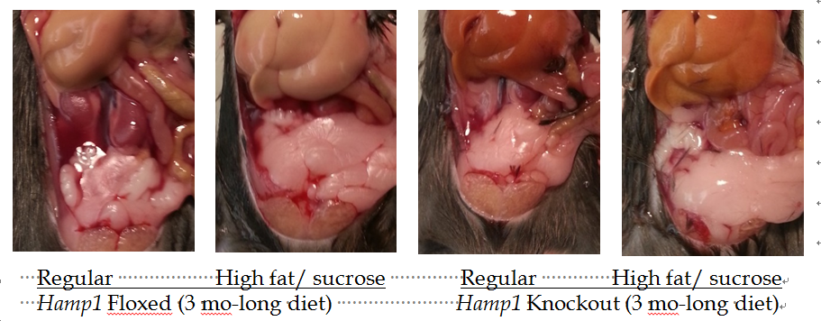
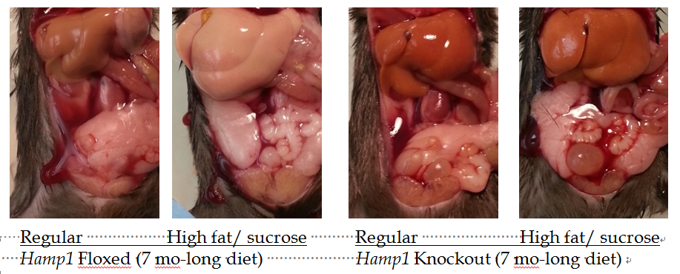

Figure 1 Macroscopic changes in Hamp1 floxed and knockout mice fed with either a high fat and high sucrose or a regular control diet for 3 or 7 mo. Representative images showing the abdominal cavity of mice were obtained with a digital camera (Nikon).

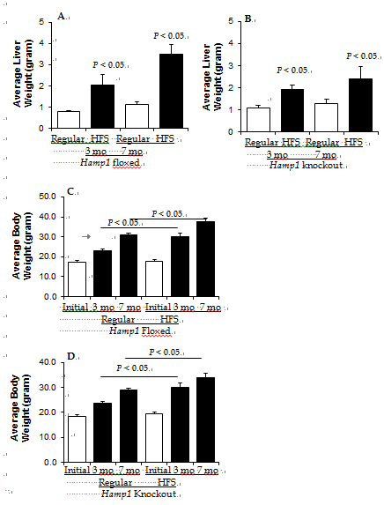
Figure 2 liver and body weights of Hamp1 floxed and knockout mice fed with high fat or regular diets. Average liver (A, B) and body (C, D) weights of floxed (A, C) and knockout (B, D) mice prior to (initial) and after feeding with high fat and sucrose (HFS) or regular control diets for 3 or 7 mo are shown as gram weight.
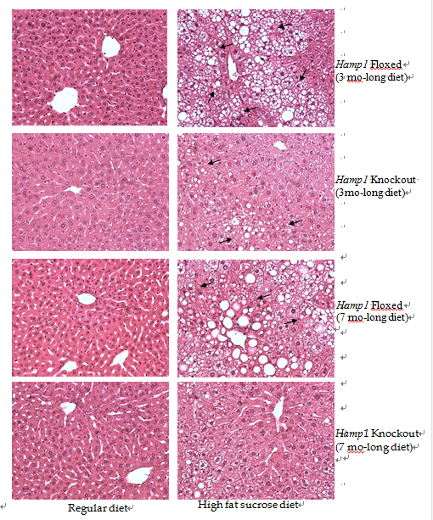
Figure 3 Liver histology in Hamp1 floxed and knockout mice fed high fat or regular diets. Liver sections from floxed and knockout mice fed with high fat and sucrose or regular diets for 3 (A) and 7 (B) mo were stained with hemotoxylin and eosin. Representative images obtained with a Nikon Eclipse E400 light microscope are shown (20 x). Arrows indicate steatosis.
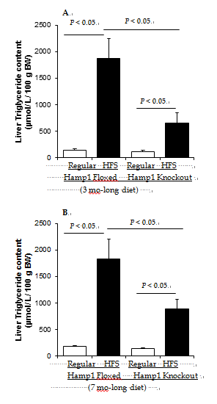

Figure 4 Liver triglyceride content in Hamp1 floxed and knockout mice fed high fat or regular diets. Hepatic triglyceride content in floxed and knockout mice fed with regular or high fat sucrose (HFS) diets for 3 (A) or 7 (B) mo was quantified using 50 mg of wet liver tissue. Liver triglyceride amount was expressed as μmol per liver per 100 g body weight (µmol/L per 100 g BW).

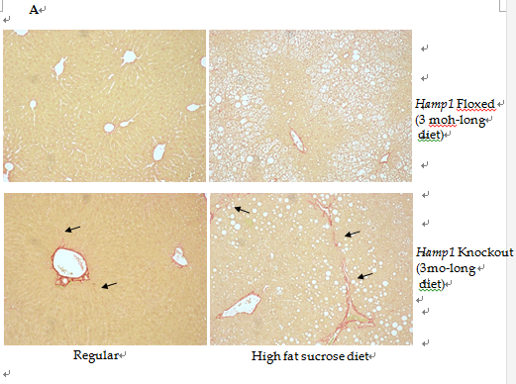
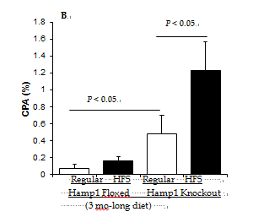
Figure 5 Fibrosis in Hamp1 floxed or knockout mice fed high fat or regular diets for 3 mo. A: Fibrosis in the livers of floxed and knockout mice fed on regular or high fat sucrose (HFS) diets for 3 mo was detected by Sirius Red staining of tissue sections. Representative images obtained with Nikon Eclipse E400 light microscope are shown; B: 10 independent images (10 x) taken from each group were quantified using ImageJ ROI manager software. The collagen proportional area (CPA) was determined by calculating the percentage of collagen-occupied pixels against the total pixel values.

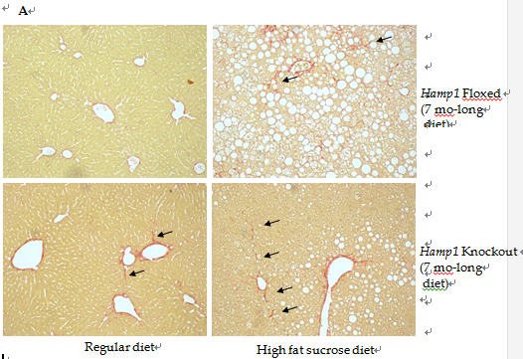
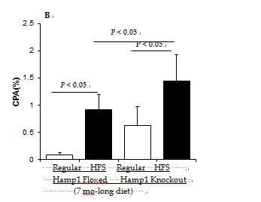
Figure 6 Fibrosis in Hamp1 floxed or knockout mice fed high fat or regular diets for 7 mo. Liver fibrosis in floxed and knockout mice fed on regular or high fat sucrose (HFS) diets for 7 mo was detected (A) and quantified (B), as described above.
Regular Diet
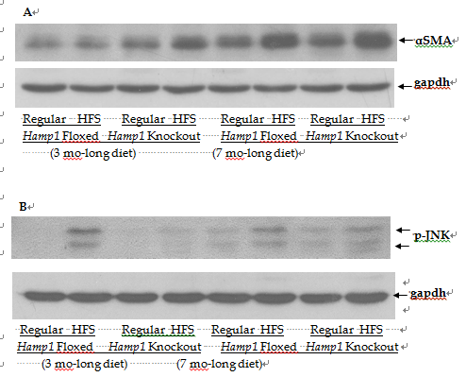
Figure 7 Protein expression levels of p-JNK and αSMA in Hamp1 floxed and knockout mice fed with high fat or regular diets for 3 or 7 mo. The expression levels of alpha smooth muscle action (αSMA) (A) and phosphorylated JNK (p-JNK) (B) proteins in the livers of floxed and knockout mice fed with regular or high fat sucrose (HFS) diets for 3 or 7 mo was determined by western blotting, as described in Material and Methods. An anti-gapdh antibody was used as control to determine equal protein loading.

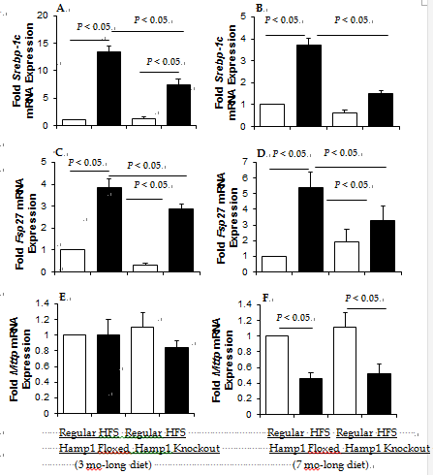
Figure 8 Expression of genes involved in lipogenesis, lipid storage and secretion. The mRNA expression levels of Srebp-1c (A, B), Fsp27 (C, D), and Mttp (E, F) in the livers of floxed and knockout mice fed with regular and high fat sucrose (HFS) diets, was determined by real-time PCR. Gene expression in high fat-fed floxed or knockout and regular diet-fed knockout mice for 3 (A, C, E) or 7 months (B, D, F) was expressed as fold change of that in floxed mice fed with a regular diet for the same time period.

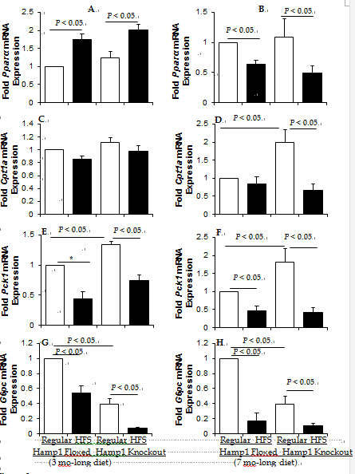
Figure 9 Expression of genes involved in β-oxidation and gluconeogenesis. The mRNA expression levels of Pparα (A, B), Cpt1a (C, D), Pck1 (E, F) and G6pc (G, H), in the livers of Hamp1 floxed and knockout mice fed with regular and high fat sucrose (HFS) diets, was determined by real-time PCR. Gene expression in high fat-fed floxed or knockout and regular diet-fed knockout mice for 3 (A, C, E, G) or 7 months (B, D, F, H) was expressed as fold change of that in floxed mice fed with a regular diet for the same time period.

Table 1 SYBR green real-time quantitative PCR primer sequences of mouse genes

Mouse genes | Forward Primer (5’-3’) | Reverse Primer (5’-3’)
Mttp | CTCTTGGCAGTGCTTTTTCTCT | GAGCTTGTATAGCCGCTCATT
Cpt1a | CTCCGCCTGAGCCATGAAG | CACCAGTGATGATGCCATTCT
Fsp27 | ATGAAGTCTCTCAGCCTCCTG | AAGCTGTGAGCCATGATGC
G6pc | CGACTCGCTATCTCCAAGTGA | GTTGAACCAGTCTCCGACCA
Pck1 | CTGCATAACGGTCTGGACTTC | CAGCAACTGCCCGTACTCC
Pparα | AGAGCCCCATCTGTCCTCTC | ACTGGTAGTCTGCAAAACCAAA
Srebp-1c | GCAGCCACCATCTAGCCTG | CAGCAGTGAGTCTGCCTTGAT
Gapdh | GTGGAGATTGTTGCCATCAACGA | CCCATTCTCGGCCTTGACTGT

