BAISHIDENG PUBLISHING GROUP CO., LIMITED COPYRIGHT ASSIGNMENT

Name of Journal: World Journal of Gastroenterology

ESPS Manuscript No: 4215

Title: Nonalcoholic Fatty Liver Disease is Associated with Coronary Artery Disease in Koreans

Authors (typed): Dae Hee Choi, M.D.¹, Sung Joon Lee, M.D.¹, Chang Don Kang, M.D.¹, Myoung Ok Park, M.D.¹, Dong Wook Choi, M.D.¹, Tae Suk Kim, M.D.¹, Wonho Lee, M.D.¹, Byung Ryul Cho, M.D.¹, Yong Hoon Kim, M.D.¹, Bong-ki Lee, M.D.¹, Dong Ryeol Ryu M.D.¹, Ji Won Lee, M.D.²

Department of Internal Medicine¹, Kangwon National University School of Medicine, Chuncheon, Korea
Department of Radiology², Kangwon National University School of Medicine, Chuncheon, Korea

1 Statement that the manuscript is not simultaneously being considered by other journals.

2 Statement that the manuscript has no redundant publication, plagiarism, data fabrication or falsification.

3 Statement that there is no conflict of interest in the paper.

4 Statement that the experiments were done in compliance with the laws regarding the use of animals and human subjects.

5 Statement that the material contained in this manuscript is original, except when appropriately referenced to other sources, and that written permission has been granted by any existing copyright holders.

6 Statement agreeing to transfer to Baishideng Publishing Group Co., Limited all rights of the manuscript, including: (1) all copyright ownership in both print and electronic formats; (2) the right to grant permission to republish or reprint the stated material in whole or in part, with or without a fee; (3) the right to print copies for free distribution or sale; and (4) the right to republish the stated material in a collection of articles or in any other format. Articles published by this publisher are distributed under the terms of the Creative Commons Attribution Non-commercial License, which permits use, distribution, and reproduction in any medium, provided the original work is properly cited, the use is non-commercial and is otherwise in compliance with the license.

7 Statement that there are no grammar, syntax, spelling, punctuation or logic errors.

8 Statement that figures and tables have been correctly placed and clearly indicated.

9 Statement that references are numbered in the order they appear in the text.

All authors must sign their names separately in his/her own handwriting in the order they appear in the title page of the manuscript.

Note: Co-first author and co-corresponding author are not acceptable by our journals. And please typewrite your name with the last name in full, and the first and any middle names in abbreviation, e.g., author “Eamonn M Quigley”, the abbreviated name should be put as Quigley EM (Last name: Quigley; first and middle names: EM); author “Jin-Lei Wang”, the abbreviated name should be put as Wang JL (Last name: Wang; first and middle names: JL).

A GENTLE REMINDER: You are recommended strongly to withdraw your paper in case of the following conditions: (1) Plagiarism; (2) Data falsification; (3) Redundant publication; and (4) Divergence about the qualification of authorship. Once the paper is published online, the author who wishes to withdraw the paper must pay 10000 USD to compensate for the loss incurred. The paper will then be withdrawn within four weeks.

1st Author (DH Choi)
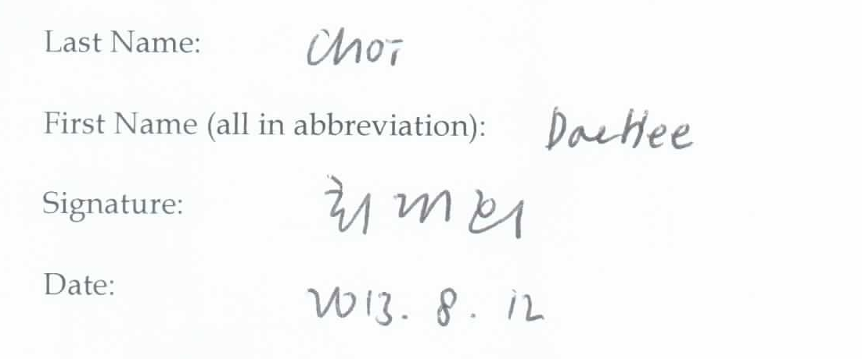
2nd Author (SJ Lee)
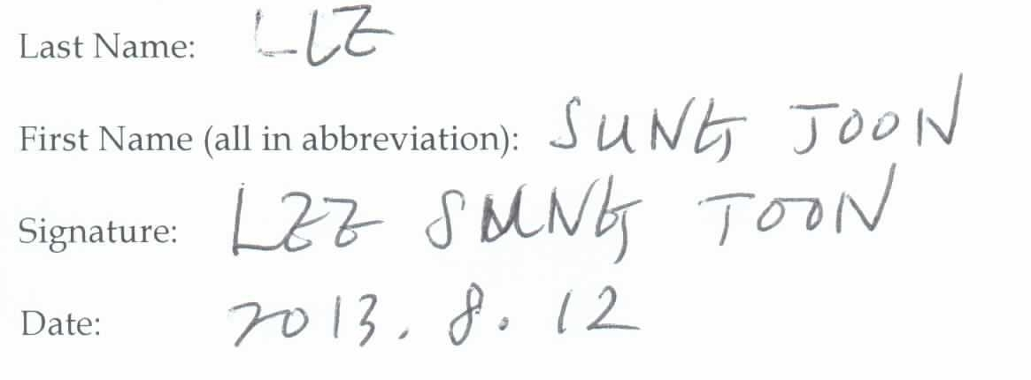
3rd Author (CD Kang)
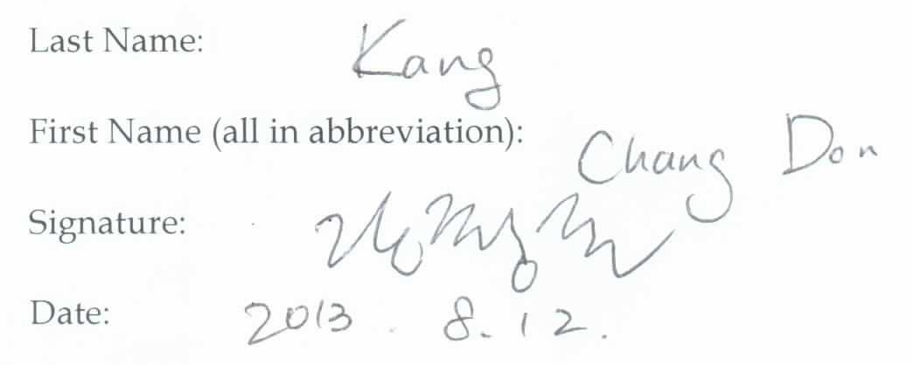
4th Author (MO Park)
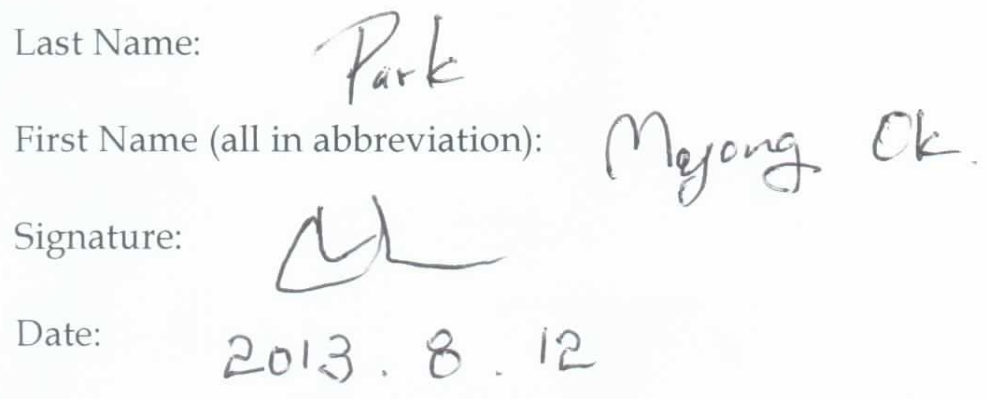

5th Author (DW Choi)
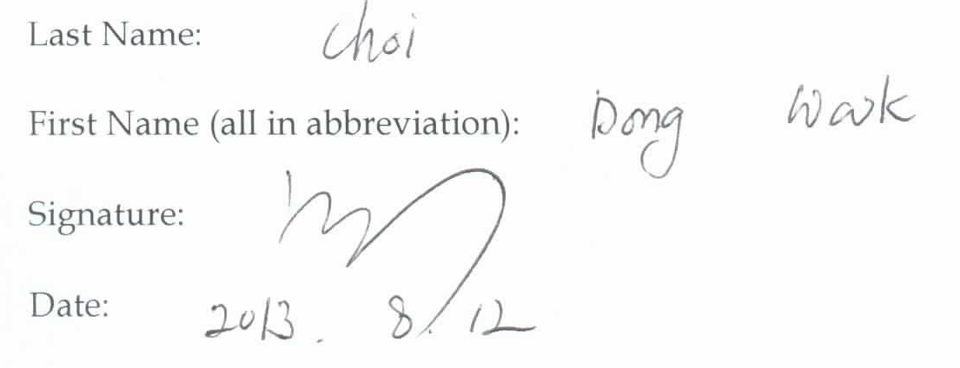
6th Author (TS Kim)
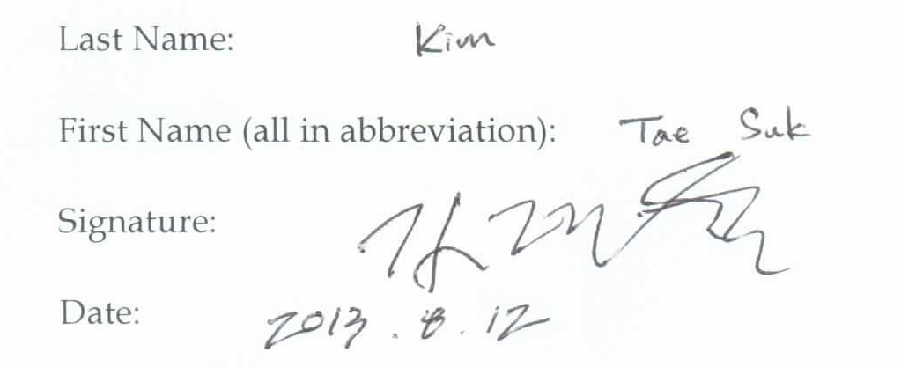
7th Author (W Lee)
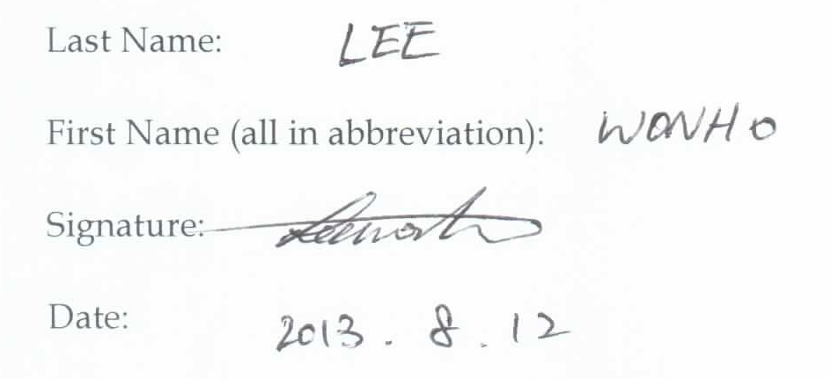
8th Author (BR Cho)
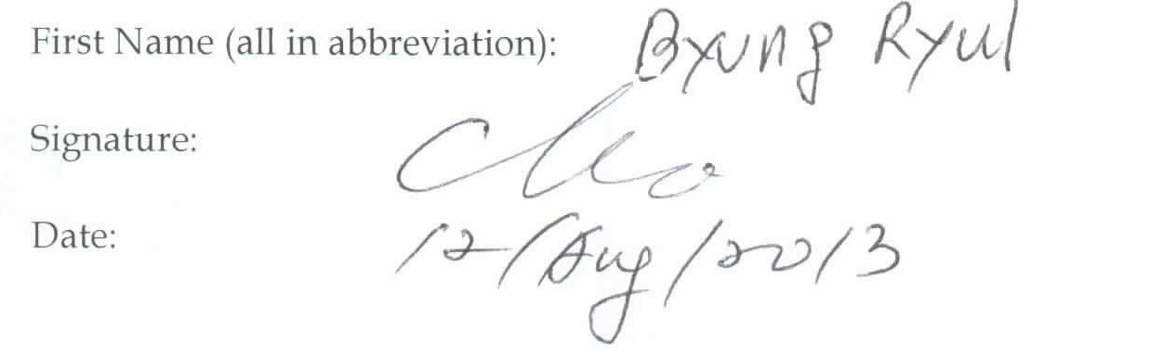
9th Author (YH Kim)
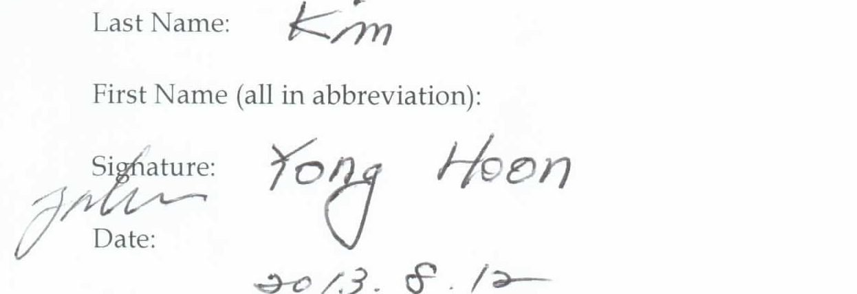10th Author (B Lee)
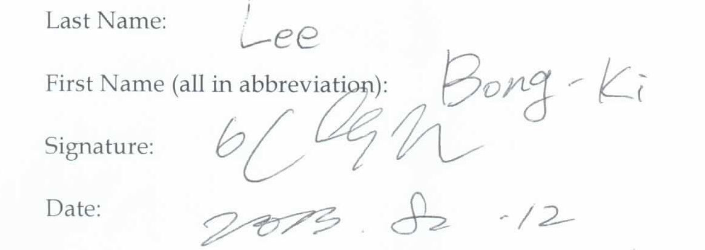

11th Author (DR Ryu)
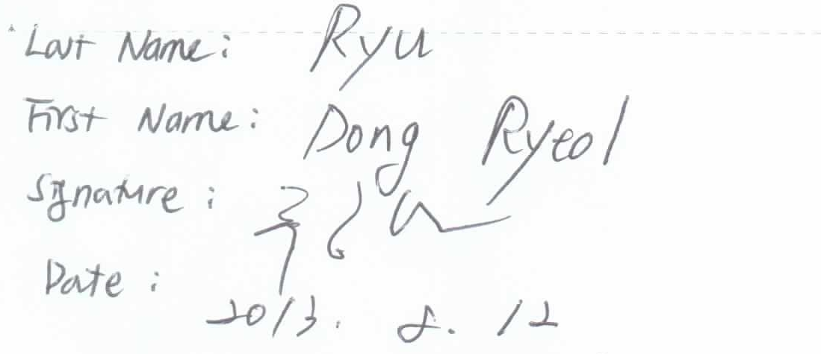
12th Author (JW Lee)
