Name of journal: World Journal of Clinical Cases
ESPS Manuscript NO: 11491
Columns: Case Report

Scalp block for brain abscess drainage in patient with uncorrected tetralogy of Fallot

Sethi S et al. Scalp block for brain abscess drainage

Sameer Sethi, Sonia Kapil

Sameer Sethi, Sonia Kapil, Department of Anesthesia, Post Graduate Institute of Medical Education And Research, Chandigarh 160012, India

Author contributions: Both authors contributed in preparation of manuscript.

Correspondence to: Dr. Sameer Sethi, Department of Anesthesia, Post Graduate Institute of Medical Education And Research, Sector 12, Chandigarh 160012, India. sethi.sameer@rediffmail.com

Telephone: +91-99-14208491 Fax: +91-01-72274401

Received: May 23, 2014 Revised: September 20, 2014
Accepted: October 14, 2014

Published online:

Abstract
We report a case of a 11 years old boy with diagnosed but uncorrected tetralogy of Fallot presented to us for brain abcess drainage. The child was managed successfully with scalp block with sedation.

© 2014 Baishideng Publishing Group Inc. All rights reserved.

Key words: Tetralogy of Fallot; Brain abcess; Ketamine; Scalp block; Conginital heart disease

Core tip: We present a case report describing the use of scalp block combined with the sedation for brain abscess drainage in a child with un-corrected tetralogy of Fallot. The goal should be to maintain the hemodynamic stability and avoid any increase of right to left shunt. Therefore, we decided to perform scalp block combined with sedation in this child. We used O₂ inhalation, analgesia and sedation with fentanyl midazolam and ketamine to alleviate anxiety and also to increase SVR, pulmonary perfusion and oxygenation.

Sethi S, Kapil S. Scalp block for brain abscess drainage in patient with uncorrected tetralogy of Fallot. World J Clin Cases2014; In press

INTRODUCTION
Tetralogy of Fallot (TOF), with an incidence of 10% of all congenital heart diseases^{[1]} , is the commonest cyanotic congenital heart disease^{[1]} and has a dilated aorta which overrides the large ventricular septal defect along with right ventricular outflow tract (RVOT) obstruction and hypertrophy of right ventricle. RVOT can be valvular, infundibular or both^{[2]}. There has been several case reports of successful management of TOF presenting for brain abscess drainage, caesarean section and major abdomial surgeries^{[3-5]}. We present a case report describing the use of scalp block combined with the sedation for brain abscess drainage in a child with un-corrected TOF.

CASE REPORT
An 11 years old male child weighing 44 kg presented to us in the emergency with history of fever upto 102 ºF, headache and vomiting since 10 d. The child was a known case of TOF but had not undergone any surgical repair. His effort tolerance was poor. History of cyanotic spells since childhood was present but was not on any kind of medication. On examination the child was conscious though irritable and crying. The child did not show any signs of raised ICP. Central cyanosis and clubbing was present. He had a pulse rate of 76 per minute with a blood pressure of 110/60 mmHg. On examination of the cardiovascular system the apex beat was found in the left 5th intercostal space in the mid clavicular line and was associated with left parasternal heave. 1st and 2nd heart sounds, along with a loud pulmonary component of 2nd heart sound were audible along with a pansystolic murmur (Grade 4/6) at the left lower sternal border. No focal deficit was found on neurological examination. Respiratory system and gastrointestinal system were normal on examination.
Chest X-ray (Figure 1) showed an enlarged cardiac shadow with left ventricular hypertrophy and dilated pulmonary arteries. ECG revealed sinus rhythm with right ventricular hypertrophy. ECHO showed a large VSD of 13 mm, 60% overriding of aorta, right ventricular hypertrophy and right ventricular tract outflow obstruction and ejection fraction of 0.6. Cardiac catheterization was not done. CECT (Figure 2) showed a left temporoparietal abcess with no uncal herniation along with midline shift of 2 mm. His hematocrit was 58% with a platelet count of 105 × 10⁹/L. The child’s serum electrolytes, coagulation studies and renal function tests were within normal limits. The baseline ABG revealed pH 7.419, Po₂ 35.5 mmHg, Pco₂ 31.8 mmHg, HCO₃ 20.1 mEq/L, SPO₂ 68.7%, BE-3.3. The child received infective endocraditis prophylaxis prior to the surgery and was allowed oral intake of fluids upto 2 h prior to surgery and normal saline was used as the maintenance fluid thereafter in the ward. In the operation theatre, standard monitoring was done with non invasive blood pressure, pulse oximetry, ECG, temperature. NeoStarTM triple lumen central venous catheter was in situ as it was inserted when the child presented to us in the emergency department. A 20 G arterial cannula (Becton Dickinson Critical Care Systems, Singapore) was inserted into the radial artery under local anesthesia. The baseline heart rate was 70 beats per min with an invasive blood pressure of 116/68 mmHg and a CVP of 10 cm of H₂O.Child had 64% Spo₂ with 50% O₂ on venturi face mask. Normal saline was used maintenance fluid in the dose of 4 mL/kg per hour.
The scalp block was given with 20 mL of 0.75% ropivacaine without adrenaline (3-4 mL for each nerve) to block supra trochlear, supra-orbital, zygomaticotemporal, auriculotemporal, greater and lesser occipital nerve. The block was supplemented with Fentanyl 20 µg I.V, followed by Ketamine 20 mg I.V and Midazolam 0.2mg I.V. at the time of burr hole. The child was kept on spontaneous respiration throughout the procedure with 50% oxygen and air mixture.At the time of dural opening, Ketamine 20 mg intravenouswas repeated. Normal saline was administered to keep CVP in range of 14-16 cm of H₂O.The procedure lasted for 30 min and the intraoperative course was uneventful with maintenance of hemodynamic parameters, and acid base status within normal limits with a SPO₂ 69.5%.

DISCUSSION
For the anesthetic management of these patients one should be careful about the drugs and events that may increase the R-L shunt^{[6]}. The severity of the disease directly correlates with the size of VSD, severity of pulmonary stenosis and functional status of the right ventricle^{[7]}. Complications of right to left shunts include chronic hypoxia leading to pulmonary vasoconstriction, altered acid base status, polycythemia, coagulopathy, infective endocarditis and cerebral abscess due to increased risk of paradoxical emboli. The reported incidence of brain abscess in patients with cyanotic heart disease is between 5% and 18.7%^{[8]}.
Anaesthetic management of these patients is always a challange for the anesthesists because of the cardiopulmonary and coagulation abnormalities, dehydration and electrolyte imbalance along with abscess-induced complications of seizures, meningitis and raised intracranial pressure^{[4]}.
General anesthesia with controlled ventilation has the advantage of better oxygenation but can be associated with the risk of hemodynamic instability along with compression of pulmonary vessels, impaired gas exchange and academia^{[9]}.
Most of the agents used for induction and maintenance of general anaesthesia may also lead to myocardial depression along with reduction of SVR.
The goal should be to maintain the hemodynamic stability and avoid the changes that would increase right to left shunt. Therefore, we decided to perform scalp block combined with sedation in this child.
Factors such as thorough pre-operative examination, ECHO, treatment of any chest infections, cardiologist consultation, and documentation of pre-operative cardiac and neurological status, correction of any coagulopathy were necessary and were taken care of in our child.
Prolonged fasting is better avoided in these patients, and intake of clear fluids up to two hours prior to the surgery should be allowed. We followed the same guidelines in our patient as well along with normal saline as a maintenance fluid in the ward. Prevention of dehydration is also important as these patients have increased hematocrit .The patients who have hematocrit ≥ 60% are susceptible for developing coagulopathy and preoperative phlebotomy is beneficial in such cases. Our child had hematocrit of 58% and preoperative phlebotomy was not performed as it was an emergency procedure but adequate precaution to prevent dehydration and liberal fluid administration was done to keep the CVP in range of 14-16 cm of H₂O. Fluid boluses of 20 mL/kg may be required to increase the blood pressure and RV preload^{[10]}.
Air bubbles are also a preventable cause of peri-operative morbidity in patients with shunting, as air or particulate matter may be shunted directly into the arterial bed^{[11,12]} and we took measures to prevent it.
We used O₂ inhalation, analgesia and sedation with fentanyl midazolam and ketamine to alleviate anxiety and also to increase SVR, pulmonary perfusion and oxygenation. Though O₂ inhalation, fentanyl and midazolam cannot increase SVR, but avoid increasing PVR. Ketamine may increase SVR in some level, or, more important, can prevent lowering of SVR and has helped in our patient by decreasing left to right shunt.
Ketamine has also been shown to be better in children who had pulmonary hypertension^{[13,14]} though this is not the cause of the cyanosis in these patients, rather it is the fall in SVR leading to left-right shunt which causes hypoxia. In one study of 18 neonates who had complex cardiac defects, ketamine was used most commonly when intubation was not required for surgery^{[15]}. Anesthetic agents like sevoflurane , isoflurane and fentanyl/midazolam infusions have no effect on shunt fraction of children having shunts^{[16-18]}.
Scalp block is a well established technique for craniotomy being increasingly used for epilepsy surgery, temporal lobectomy where the excision encroaches on eloquent cortex areas^{[19]}.
Scalp block may be given pre-operatively to reduce the hemodynamic response to pin holder application, and post-operatively before the emergence to decrease the severity of post-operative pain. They also decrease intra and postoperative opioid requirement^{[20,21]}.
We used 0.75% ropivacaine without adrenaline for administering scalp block as addition of adrenaline may cause tachycardia that is very dangerous in patients with uncorrected TOF, because it may cause infundibular spasm and cyanotic spell.
Scalp block along with sedation is being used successfully in our institute for patients with chronic SDH. Since the patient we encountered had to go an emergency procedure, with no time for cardiac catheterization and medical optimization of the patient, we decided to proceed with regional anaesthesia with sedation and invasive monitoring in the patient.
The avoidance of general anesthesia due to medical reasons in selected patients and with the thorough anatomical knowledge of nerve blocks, this underestimated regional technique of scalp block with sedation may be considered as an alternative technique in selective patients with un-repaired TOF and has proved to be extremely rewarding procedure for the neuroanaesthetist, whilst offering the best possible outcome for the patient.

COMMENTS
Case characteristics
An 11 years old male, a known case of tetralogy of Fallot (TOF), presented withfever (upto 102 ºF), headache and vomiting for the past 10 d.

Clinical diagnosis
On examination the child had central cyanosis, clubbing, loud P2, grade IV pansystolic murmur but there were no signs of raised intracranial pressure and no neurological focal deficit.

Differential diagnosis
It is a known case of TOF but had not undergone any surgical repair and has presented with brain abscess.

Laboratory diagnosis
The patient had high hematocrit with normal coagulation profile. The baseline ABG revealed pH 7.419, Po₂ 35.5 mmHg, Pco₂ 31.8 mmHg, HCO₃ 20.1 mEq/L, SPO₂ 68.7%, BE -3.3.

Imaging diagnosis
ECHO revealed a large VSD of 13 mm, 60% overriding of aorta, right ventricular tract outflow obstruction and ejection fraction of 0.6 while CECT (Figure 2) showed a left temporoparietal abcess with no uncal herniation and a midline shift of 2 mm.

Pathological diagnosis
Patient was diagnosed brain abscess with uncorrected TOF

Treatment
Child was not on any kind of medication and presented to us in emergency. The child had received infective endocarditis prophylaxis prior to the surgery.

Experiences and lessons
Uncorrected TOF presents as a challenge to the anaesthetists and a thorough knowledge about the physiological and pathological changes occurring with the disease is essential for the safe management of the patient in the peri-opertive period.
Regional anaesthesia should be considered as an alternative to the general anesthesia when feasible.

Peer review
A good paper that can be accepted.
REFERENCES
1 Moller JH, Neal WA. Fetal, neonatal and infant cardiac disease. Norwalk: Appleton and Lange, 1990. Available from: http: //www.amazon.com/Fetal-Neonatal-Infant-Cardiac-Disease/dp/083852575X
2 Behram RE, Kleigman RM, Nelson WE, Vaughan VC. Congenital cardiac disease with cyanosis. In: Nelson Textbook of Pediatrics. Philadelphia: WB Saunders, 1992: 1149-1153
3 Katsetos CP, Kontoyannis MB, Koumousidis A, Petropoulou O, Delos C, Katsoulis M. Uncorrected tetralogy of Fallot and pregnancy: a case report. Clin Exp Obstet Gynecol 2012; 39: 382-383 [PMID: 23157051]
4 Raha A, Ganjoo P, Singh A, Tandon MS, Singh D. Surgery for brain abscess in children with cyanotic heart disease: An anesthetic challenge. J Pediatr Neurosci 2012; 7: 23-26 [PMID: 22837772 DOI: 10.4103/1817-1745.97617]
5 Haack M, Machotta A, Boemke W, Höhne C. Anesthesia in an infant with uncorrected tetralogy of Fallot for transanal pull-through for Hirschsprung's disease. Paediatr Anaesth 2006; 16: 95-96 [PMID: 16409542 DOI: 10.1111/j.1460-9592.2005.01749.x]
6 Stoelting Robert K. Congenital heart disease. In: Anaesthesia and coexisting disease. 3rd ed. Churchill livingstone: 42-45
7 Webb GD, Smallhorn JF, Therrien J, Redington AN. Congenital heart disease. In: Zipes DP, LibbyP, Bonow RO, Braunwald E, editors. Braunwald's heart disease: a textbook of cardiovascular medicine. 7th ed. Philadelphia: W. B. Saunders, 2005: 1489-1552
8 Fischbein CA, Rosenthal A, Fischer EG, Nadas AS, Welch K. Risk factors of brain abscess in patients with congenital heart disease. Am J Cardiol 1974; 34: 97-102 [PMID: 4835759 DOI: 10.1016/0002-9149(74)90099-X]
9 Ahmed I. Tetrology of Fallot and pregnancy. RMJ 2004; 29: 76-79
10 Twite MD, Ing RJ. Tetralogy of Fallot: perioperative anesthetic management of children and adults. Semin Cardiothorac Vasc Anesth 2012; 16: 97-105 [PMID: 22275349 DOI: 10.1177/1089253211434749]
11 Hickey PR. Anaesthesia for treatment of congenital heart disease.In: Rouges MC, Tinker JH, Covino BG, Longnecker DE eds. Principles and Practice of Anaesthesiology. St. Louis, Missouri: Mosby Year Book, 1993: 1681-1718
12 Moore RA. Anaesthetizing the child with congenital heart disease for non-cardiac surgery. In: Barash PG, ed. ASA Referesher Course, Vol 22, 1994: 211-226
13 Williams GD, Maan H, Ramamoorthy C, Kamra K, Bratton SL, Bair E, Kuan CC, Hammer GB, Feinstein JA. Perioperative complications in children with pulmonary hypertension undergoing general anesthesia with ketamine. Paediatr Anaesth 2010; 20: 28-37 [PMID: 20078799 DOI: 10.1111/j.1460-9592.2009.03166.x]
14 Williams GD, Philip BM, Chu LF, Boltz MG, Kamra K, Terwey H, Hammer GB, Perry SB, Feinstein JA, Ramamoorthy C. Ketamine does not increase pulmonary vascular resistance in children with pulmonary hypertension undergoing sevoflurane anesthesia and spontaneous ventilation. Anesth Analg 2007; 105: 1578-1584, table of contents [PMID: 18042853 DOI: 10.1213/01.ane.0000287656.29064.89]
15 Walker A, Stokes M, Moriarty A. Anesthesia for major general surgery in neonates with complex cardiac defects. Paediatr Anaesth 2009; 19: 119-125 [PMID: 19207897 DOI: 10.1111/j.1460-9592.2008.02801.x]
16 Ikemba CM, Su JT, Stayer SA, Miller-Hance WC, Eidem BW, Bezold LI, Hall SR, Havemann LM, Andropoulos DB. Myocardial performance index with sevoflurane-pancuronium versus fentanyl-midazolam-pancuronium in infants with a functional single ventricle. Anesthesiology 2004; 101: 1298-1305 [PMID: 15564936 DOI: 10.1097/00000542-200412000-00009]
17 Laird TH, Stayer SA, Rivenes SM, Lewin MB, McKenzie ED, Fraser CD, Andropoulos DB. Pulmonary-to-systemic blood flow ratio effects of sevoflurane, isoflurane, halothane, and fentanyl/midazolam with 100% oxygen in children with congenital heart disease. Anesth Analg 2002; 95: 1200-126, table of contents [PMID: 12401594 DOI: 10.1097/00000539-200211000-00016]
18 Rivenes SM, Lewin MB, Stayer SA, Bent ST, Schoenig HM, McKenzie ED, Fraser CD, Andropoulos DB. Cardiovascular effects of sevoflurane, isoflurane, halothane, and fentanyl-midazolam in children with congenital heart disease: an echocardiographic study of myocardial contractility and hemodynamics. Anesthesiology 2001; 94: 223-229 [PMID: 11176085 DOI: 10.1097/00000542-200102000-00010]
19 Herrick IA, Gelb AW. Anesthesia for temporal lobe epilepsy surgery. Can J Neurol Sci 2000; 27 Suppl 1: S64-S67; discussion S64-S67 [PMID: 10830330]
20 Nguyen A, Girard F, Boudreault D, Fugère F, Ruel M, Moumdjian R, Bouthilier A, Caron JL, Bojanowski MW, Girard DC. Scalp nerve blocks decrease the severity of pain after craniotomy. Anesth Analg 2001; 93: 1272-1276 [PMID: 11682413 DOI: 10.1097/00000539-200111000-00048]
21 Pinosky ML, Fishman RL, Reeves ST, Harvey SC, Patel S, Palesch Y, Dorman BH. The effect of bupivacaine skull block on the hemodynamic response to craniotomy. Anesth Analg 1996; 83: 1256-1261 [PMID: 8942596 DOI: 10.1213/00000539-199612000-00022]

P-Reviewer: Ozcengiz D, Ong HT, Nagashima G S-Editor: Ji FF
L-Editor: E-Editor:

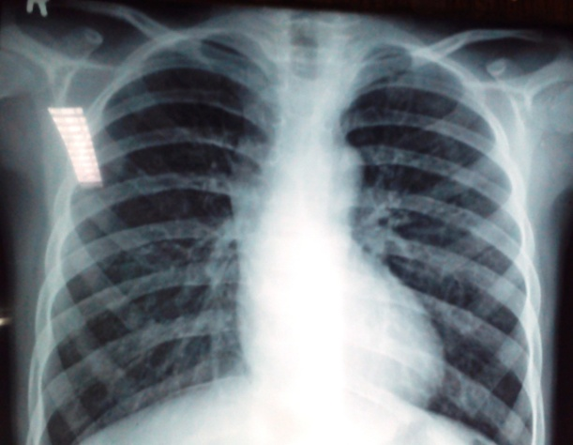
Figure 1 Chest X-ray of the patient showing enlarged cardiac silhouette.
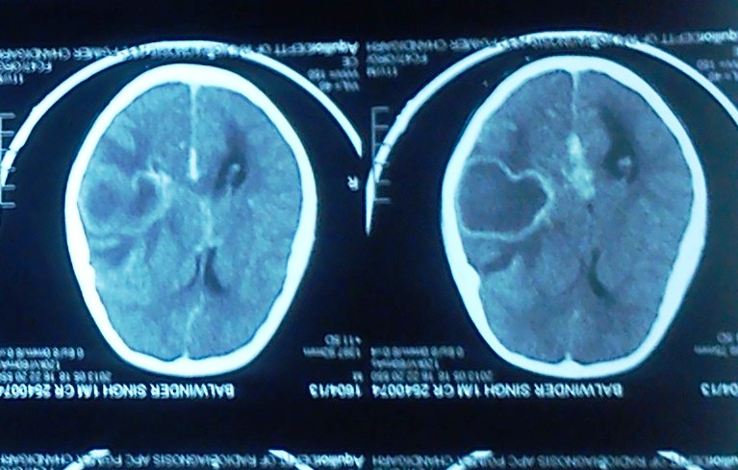
Figure 2 CECT of the patient showing left temporoparietal abcess .

