Name of Journal: World Journal of Clinical Cases
Manuscript NO: 38012
Manuscript Type: Case Report

Posterobasal left ventricular aneurysm after myocardial infarction with normal coronary arteries: Case-report

Kalinin RE et al. Ventricular aneurysm with normal coronary arteries

Roman Evgenyevich Kalinin, Igor Aleksandrovich Suchkov, Nina Dzhansugovna Mzhavanadze, Adelphina Felician Ncheye

Roman Evgenyevich Kalinin, Igor Aleksandrovich Suchkov, Nina Dzhansugovna Mzhavanadze, Adelphina Felician Ncheye, Department of Cardiovascular, Endovascular, Operative Surgery and Topographic Anatomy, Ryazan State Medical University, Ryazan 390026, Russia

ORCID number: Roman Evgenyevich Kalinin (0000-0002-0817-9573); Igor Aleksandrovich Suchkov (0000-0002-1292-5452); Nina Dzhansugovna Mzhavanadze (0000-0001-5437-1112); Adelphina Felician Ncheye (0000-0002-8429-2391).

Author contributions: Kalinin RE and Suchkov IA designed the report; Mzhavanadze ND and Ncheye AF collected the patient’s clinical data; Suchkov IA, Mzhavanadze ND and Ncheye AF analyzed the data and wrote the paper.

Informed consent statement: The patient was not required to give informed consent to this case report because the analysis used completely anonymous data; the consent was obtained before performing any medical investigation or start of treatment as required.

Conflict-of-interest statement: No conflict of interest.

CARE checklist (2013) statement: The authors have read the CARE Checklist (2013), and the manuscript was prepared and revised according to the CARE Checklist (2013).

Open-Access: This article is an open-access article which was selected by an in-house editor and fully peer-reviewed by external reviewers. It is distributed in accordance with the Creative Commons Attribution Non Commercial (CC BY-NC 4.0) license, which permits others to distribute, remix, adapt, build upon this work non-commercially, and license their derivative works on different terms, provided the original work is properly cited and the use is non-commercial. See: http://creativecommons.org/licenses/by-nc/4.0/

Manuscript source: Invited manuscript

Correspondence to: Igor Aleksandrovich Suchkov, MD, PhD, Professor, Department of Cardiovascular, Endovascular, Operative Surgery and Topographic Anatomy, Ryazan State Medical University, Vysokovoltnaya 9, Ryazan 390026, Russia. suchkov_med@mail.ru
Telephone: +7-9038-362417
Fax: +7-4912-460808

Received: January 22, 2018
Peer-review started: January 22, 2018
First decision: February 9, 2018
Revised: February 14, 2018
Accepted: April 1, 2018
Article in press:
Published online:
Abstract
We present a case of a 64-year-old woman with signs of debilitating condition including anginal chest pain, exertional dyspnea, and depression. The patient had previously suffered from a myocardial infarction after a loss of a close family member. Workup showed a posterobasal left ventricular aneurysm and moderate to severe mitral regurgitation in the absence of coronary atherosclerosis. Routine ultrasonography revealed abdominal aortic aneurysm and intraabdominal aortic deviation. The patient was immediately started on optimal medical treatment. On repeat assessment general condition was satisfactory, vital signs were normal, and investigations showed no signs of progressive heart failure or other significant clinical changes. Although prognosis in patients with myocardial infarction with normal coronary arteries is generally considered favorable, mechanical complications such as posterobasal left ventricular aneurysm with moderate to severe mitral regurgitation are possible.

Key words: Myocardial infarction; Posterobasal aneurysm; Abdominal aortic aneurysm

© The Author(s) 2018. Published by Baishideng Publishing Group Inc. All rights reserved.

Core tip: Patients with myocardial infarction with normal coronary arteries may develop mechanical complications such as posterobasal left ventricular aneurysm with moderate to severe mitral regurgitation.

Kalinin RE, Suchkov IA, Mzhavanadze ND, Ncheye AF. Posterobasal left ventricular aneurysm after myocardial infarction with normal coronary arteries: Case-report. World J Clin Cases 2018; In press

INTRODUCTION
The prevalence of myocardial infarction with normal coronary arteries (MINCA) is heterogenous and may vary from 1% to 12% of all myocardial infarctions (MI)^{[1]}. A study conducted by Cortell et al^{[2]} in 2009 showed that up to 13% of the patients with non-ST segment elevation myocardial infarction (NSTEMI) had no significant coronary atherosclerosis on angiography.
Early descriptions of MINCA made by Raymond R. et al. in 1988 included symptoms and electrocardiographic presentation similar to those in patients with coronary artery disease (CAD) with smaller areas of myocardial necrosis^{[3]}. Later in 1998 Khan et al^{[4]} published an article on MINCA in pre-menopausal females, which declared any absence of conventional CAD factors, history of ischemic pain or previous myocardial infarction.
Although MINCA is regarded as a cardiological “enigma” with no definitive risk factors or potential pathophysiological pathways, certain features may be attributed to this condition^{[5]}. Chandraseakaran et al^{[6]} in 2002 proposed that coronary angiospasm, intracoronary thrombosis or embolization from a distal source with spontaneous lysis, substance abuse, viral myocarditis, aortic dissection, hypercoagulable states, autoimmune vasculitis, and carbon monoxide poisoning may possibly attribute to the development of MINCA. Cortell et al^{[2]} in 2009 noted that rather young non-diabetic females with prior antiplatelet treatment who presented with NSTEMI had normal coronary angiograms. Daniel et al^{[1]}, 2016 mention higher prevalence of smoking, inflammatory disease, impaired glucose metabolism, and mental disorders among MINCA patients. Moreover, these authors found that female patients recalled emotional stress before admission, which together with psychiatric vulnerability indicated an acute stress-induced cardiomypathy (Takotsubo syndrome) as an important cause of such condition^{[7]}. Arnold et al^{[8]}, 2012 mention that both moderate and high levels of stress in patients with acute myocardial infarction were associated with worse long-term prognosis even after adjustment for such parameters as sociodemographics, clinical factors, depressive symptoms, revascularization status, and Global Registry of Acute Coronary Events discharge risk scores.
We present a case of a female patient with MINCA who developed a posterobasal left ventricular aneurysm with moderate to severe mitral regurgitation.

CASE REPORT
A 64-year-old woman presented with angina-like chest pain, exertional dyspnea, and anxiety at a local hospital in March 2017. The subject had a history of a NSTEMI with elevated troponin level in 2013 after a loss of a close family member several days prior to admission; the subject received conservative treatment, no reperfusion or revascularization were performed.
A physical examination in 2017 showed that the patient was oriented to people, place, time, and situation, with signs of anxiety. Blood pressure was 140/80 mmHg on antihypertensive drugs, pulse rate 74 beats per minute, regular, respiratory rate 18, temperature 36.6 °C. No history of cardiac disease or sudden cardiac death in the family. The patient was previously diagnosed with depression and received irregular treatment with sertraline. Laboratory investigations were essentially normal. Electrocardiogram (ECG) showed sinus rhythm with regular atrioventricular conduction. Transthoracic echocardiography showed dyskinesis and posterobasal left ventricular (LV) wall bulging 32 mm × 16 mm (Figure 1). Other findings included dilatation of ascending aorta (41 mm), LV dysfunction with ejection fraction 47% and moderate to severe mitral regurgitation (Figure 2). The patient continued to receive aspirin 75 mg QD, rosuvastatin 10mg QD, amlodipine 5 mg, lisinopril 10 mg QD, and was started on bisoprolol 2.5 mg BID, indapamide 1.5 mg QD, eplerenone 25 mg QD.
Upon receiving her consent, the patient was admitted to a cardiovascular surgery department. General condition was satisfactory: The patient was oriented, with no new complaints; vital signs were normal. The subject had fewer episodes of chest pain, which were mostly associated with anxiety; dyspnea episodes were less frequent and intense. Repeat ECG and echocardiography gave the same results as previous tests. Coronary angiography (Figure 3) revealed no significant organic changes; ventriculography (Figures 4 and 5) demonstrated posterior LV wall bulging. An asymptomatic infrarenal abdominal aneurysm with maximum diameter of 31 mm and deviation of aorta were incidentally found on routine abdominal ultrasonography (Figure 6).
As of January 2018 the patient did not consider any surgical interventions among treatment options and continued to receive conservative treatment under the supervision of both cardiologist and psychiatrist.

DISCUSSION
Exact rates of post-myocardial complications in patients with normal coronary arteries are not known. Initial reports showed that in general the incidence of malignant arrhythmias, heart failure, and hypotension in MINCA patients were rather low and the long-term prognosis was more favourable as compared to patients with CAD^{[3]}. Cortell et al^{[2]} also state that the overall prognosis for such cohort of patients was considered good. However, some authors mention life-threatening mechanical MINCA complications including subepicardial aneurysm associated with ventricular septal perforation or ventricular septal rupture^{[9,10]}.
In our case, myocardial infarction with normal coronary arteries has leaded to the development of a posterobasal left ventricular aneurysm with moderate to severe mitral regurgitation. Regardless of treatment modality, MINCA survivors require close monitoring in both acute phase and long-term period. Follow-up care should include imaging studies to evaluate the extent of disease progression as was done in our case. Possible concomitant conditions or complications should be addressed promptly.

ARTICLE HIGHLIGHTS
Case characteristics
Angina-like chest pain, exertional dyspnea, and anxiety.

Clinical diagnosis
Posterobasal left ventricular aneurysm and moderate to severe mitral regurgitation in the absence of coronary atherosclerosis.

Differential diagnosis
Differential diagnosis with coronary artery disease due to atherosclerosis. Angiography revealed no stenotic or occlusive lesions.

Imaging diagnosis
Electrocardiography, echocardiography, angiography, and duplex ultrasonography were used in this case.

Treatment
The patient received aspirin 75mg QD, rosuvastatin 10mg QD, amlodipine 5mg, lisinopril 10mg QD, and was started on bisoprolol 2,5mg BID, indapamide 1.5 mg QD, eplerenone 25mg QD.

Term explanation
MINCA: Myocardial infarction with normal coronary arteries.

Experiences and lessons
Myocardial infarction with normal coronary arteries may lead to the development of mechanical complications such as a posterobasal left ventricular aneurysm with moderate to severe mitral regurgitation, which requires close monitoring and follow-up care.

REFERENCES
1 Daniel M, Ekenbäck C, Agewall S, Brolin EB, Caidahl K, Cederlund K, Collste O, Eurenius L, Frick M, Younis-Hassan S, Henareh L, Jernberg T, Malmqvist K, Spaak J, Sörensson P, Hofman-Bang C, Tornvall P. Risk Factors and Markers for Acute Myocardial Infarction With Angiographically Normal Coronary Arteries. Am J Cardiol 2015; 116: 838-844 [PMID: 26251000 DOI: 10.1016/j.amjcard.2015.06.011]
2 Cortell A, Sanchis J, Bodí V, Núñez J, Mainar L, Pellicer M, Miñana G, Santas E, Domínguez E, Palau P, Llácer A. Non-ST-elevation acute myocardial infarction with normal coronary arteries: predictors and prognosis. Rev Esp Cardiol 2009; 62: 1260-1266 [PMID: 19889337]
3 Raymond R, Lynch J, Underwood D, Leatherman J, Razavi M. Myocardial infarction and normal coronary arteriography: a 10 year clinical and risk analysis of 74 patients. J Am Coll Cardiol 1988; 11: 471-477 [PMID: 3278033]
4 Khan IA, Ansari AW. Myocardial infarction in a pre-menopausal woman with angiographically normal coronary arteries. Postgrad Med J 1998; 74: 671-2 [PMID: 2431589]
5 Kardasz I, De Caterina R. Myocardial infarction with normal coronary arteries: a conundrum with multiple aetiologies and variable prognosis: an update. J Intern Med 2007; 261: 330-348 [PMID: 17391108 DOI: 10.1011/j.1365-2796.2007.01788.x]
6 Chandrasekaran B, Kurbaan AS. Myocardial infarction with angiographically normal coronary arteries. J ROY SOC MED 2002; 95: 398-400 [DOI: 10.1177/014107680209500805]
7 Pelliccia F, Kaski JC, Crea F, Camici PG. Pathophysiology of Takotsubo Syndrome. Circulation. 2017; 135; 24: 2426-41 [PMID: 1279964]
8 Arnold SV, Smolderen KG, Buchanan DM, Li Y, Spertus JA. Perceived stress in myocardial infarction: long-term mortality and health status outcomes. J Am Coll Cardiol 2012; 60: 1756-1763 [PMID: 23040574 DOI: 10.1016/j.jacc.2012.06.044]
9 Shiraishi H, Urao N, Tsukamoto M, Hyogo M, Keira N, Hirasaki S, Ishibashi K, Shirayama T, Nakagawa M. Subepicardial aneurysm associated with ventricular septal perforation showing a normal coronary angiogram. Circ J 2003; 67: 962-964 [PMID: 14578605]
10 Akilli H, Alibasic H, Kayrak M, Aribas A, Doga U. Normal coronary myocardial infarct is innocent or guilty? A case of ventricular septal rupture secondary to normal coronary myocardial infarction. JC Cases 2013; 8; 6: 187-189 [DOI: 10.1016/j.jccase.2013.08.007]

P-Reviewer: Teragawa H S-Editor: Wang XJ L-Editor: E-Editor:

Specialty type: Medicine, research and experimental
Country of origin: Russia
Peer-review report classification
Grade A (Excellent): 0
Grade B (Very good): 0
Grade C (Good): C
Grade D (Fair): 0
Grade E (Poor): 0
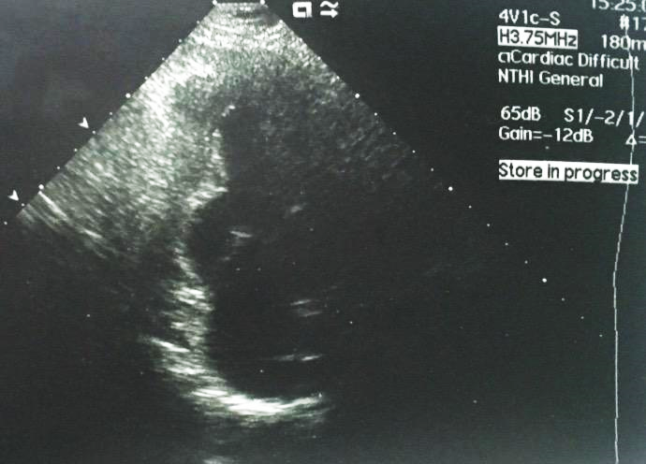

Figure 1 Transthoracic echocardiography showing posterobasal left ventricular aneurysm on apical two-chamber view.

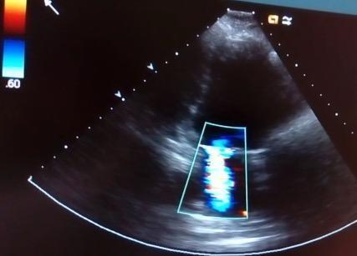

Figure 2 Transthoracic echocardiography showing mitral valve regurgitation jet on apical two-chamber view.

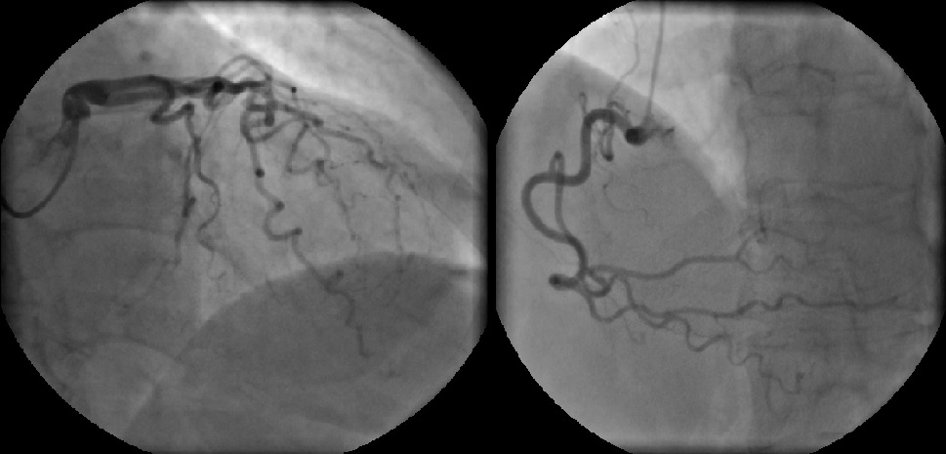
Figure 3 Coronary angiography with normal coronary arteries.

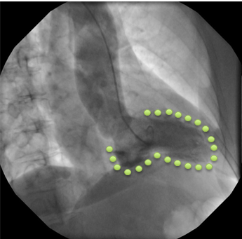
Figure 4 Left ventriculography demonstrating posterior wall bulging (systole) on the left.

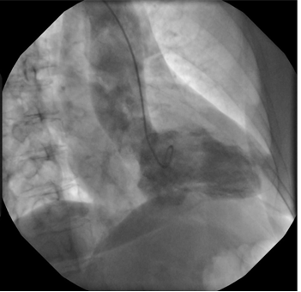
Figure 5 Left ventriculography demonstrating posterior wall bulging (diastole) on the right.
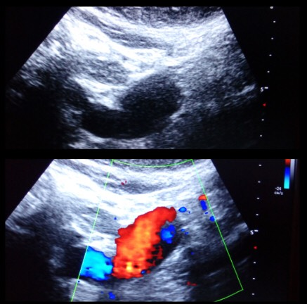
Figure 6 Infrarenal abdominal aneurysm with maximum diameter of 31 mm found incidentally on abdominal ultrasonography.

