Name of Journal: World Journal of Gastroenterology
Manuscript NO: 83145
Manuscript Type: SCIENTOMETRICS

Global research trends on diet and nutrition in Crohn’s disease

Shakhshir M et al. Diet and nutrition in Crohn’s disease

Muna Shakhshir, Sa’ed H Zyoud

Muna Shakhshir, Department of Nutrition, An-Najah National University Hospital, Nablus 44839, Palestine

Sa’ed H Zyoud, Department of Clinical and Community Pharmacy, College of Medicine and Health Sciences, An-Najah National University, Nablus 44839, Palestine

Sa’ed H Zyoud, Poison Control and Drug Information Center (PCDIC), College of Medicine and Health Sciences, An-Najah National University, Nablus 44839, Palestine

Sa’ed H Zyoud, Clinical Research Centre, An-Najah National University Hospital, Nablus 44839, Palestine

Author contributions: Zyoud SH designed the study, collected the data, analyzed the data, made major contributions to the manuscript’s literature search and interpretation, and drafted the manuscript; Shakhshir M made major contributions to the manuscript’s literature search and interpretation and made revisions to the initial draft; all authors provided a critical review and approved the final manuscript before submission.

Corresponding author: Sa’ed H Zyoud, PhD, Full Professor, Department of Clinical and Community Pharmacy, College of Medicine and Health Sciences, An-Najah National University, Academic Street, Nablus 44839, Palestine. saedzyoud@yahoo.com

Received: January 9, 2023
Revised: March 20, 2023
Accepted: May 4, 2023
Published online: May 28, 2023

Abstract
BACKGROUND
Crohn’s disease represents a challenge for patients concerned with the modified diet regimen as well as practitioners who seek the best nutritional therapy. Crohn’s disease can alter the body’s ability to digest food and to absorb nutrients, resulting in severe vitamin deficiencies, malnutrition and sometimes life-threatening complications. However, a comprehensive bibliometric analysis is lacking to map the current links between nutrition and Crohn’s disease in terms of the number of citations, geographic distribution and growth trends of publications.

AIM
To introduce the current state of research as well as hotspots in the field of nutrition and Crohn’s disease from a bibliometric standpoint.

METHODS
We searched the Scopus database and selected the relevant literature on nutrition and Crohn’s disease that met the inclusion criteria. We analyzed the publication trends and research hotspots by using video object segmentation viewer software.

RESULTS
We included 1237 publications. The number of documents published each year has increased steadily. The United States and the University of Otago, Christchurch, have had the highest productivity, with 208 (16.81%) and 29 (2.34%) documents, respectively. The “role of exclusive enteral nutrition for complicated Crohn’s disease” and “manipulation of the gut microbiota as a key target for Crohn’s disease” were the major research areas in 2016-2021, and they could be extensively investigated in the future. Meanwhile, research on “malnutrition in patients with Crohn’s disease” appeared to be an area that attracted more research attention before 2016.

CONCLUSION
This is the first bibliometric analysis to map the knowledge structure and trends regarding nutrition in Crohn’s disease research over the past two decades. The results provide a comprehensive summary and identification of the frontiers of nutrition and Crohn’s disease-related research, which may be used as a resource by researchers in the field.

Key Words: Nutrition; Diet; Crohn’s disease; Bibliometric; Microbiota; Malnutrition

©The Author(s) 2023. Published by Baishideng Publishing Group Inc. All rights reserved.

Citation: Shakhshir M, Zyoud SH. Global research trends on diet and nutrition in Crohn’s disease. World J Gastroenterol 2023; 29(20): 3203-3215
URL: https://www.wjgnet.com/1007-9327/full/v29/i20/3203.htm
DOI: https://dx.doi.org/10.3748/wjg.v29.i20.3203

Core Tip: There is much interest in using nutrition therapy approaches to treat Crohn’s disease, while the current state of knowledge is still inadequate to make general recommendations. Therefore, a bibliometric analysis of the global trend in research on nutrition and Crohn’s disease was conducted. This study outlines the current state of research themes and hotspots in nutrition and Crohn’s disease research because no bibliometric research has been conducted to determine worldwide trends in nutrition and Crohn’s disease. This facilitates researchers and healthcare providers in identifying potential future research directions.

INTRODUCTION
Crohn’s disease is a relapsing transmural inflammatory disease of the gut with an unclear etiology; it involves acute attacks followed by periods of remission^{[1,2]}. Crohn’s disease can affect the entire gastrointestinal tract, from the mouth to the anus^{[3]}. However, the disease affects the terminal ileum and the colon in most cases, which can result in complications such as stenosis, abscesses and fistula^{[4]}. The prevalence rate of Crohn’s disease ranges from 0.6 to 322 per 100000 people^{[5]}.
Malnutrition is frequently visible in approximately 65%-75% of patients with Crohn’s disease^{[6]}. Malabsorption, gut dysbiosis, small intestinal bacterial overgrowth and symptoms such as weight loss, reduced dietary intake, deficiency of individual nutrients or many nutrients are just a few of the mechanisms that can be related to Crohn’s disease-related malnutrition^{[7,8]}. In this case, nutrition, which may take the form of dietary adjustments, parenteral nutrition, or enteral nutrition, plays an important role in treating Crohn’s disease^{[7,9,10]}. Parenteral nutrition is a type of nutrition support that is given through an intravenous line. It is used when the digestive tract cannot properly absorb nutrients. In severe cases of Crohn’s disease, where the digestive tract is severely damaged, parenteral nutrition may be necessary^{[7,11]}. Furthermore, enteral nutrition is a type of nutrition support that is given through a feeding tube. It can help reduce inflammation and promote healing of the digestive tract. Enteral nutrition may be used as a primary treatment for Crohn’s disease or as a supplement to other treatments^{[7,11]}.
There is much interest in using nutritional approaches to control and reduce the symptoms of Crohn’s disease and to increase the remission time. Nevertheless, there is insufficient scientific support to give health care providers more options regarding dietary therapies. As a result, we performed a bibliometric analysis of the global trends in research on nutrition and Crohn’s disease. We summarize the current state of research themes and hotspots in nutrition and Crohn’s disease to look for global trends. Our findings will make it easier for researchers and newcomers to understand the current state of the field, to strategize future goals in research and to identify potential future research directions.

MATERIALS AND METHODS
Data sources
We conducted a shortlisted quantitative analysis with an approach based on previously published scientific outputs to characterize the development of research on nutrition and Crohn’s disease over the past two decades. On 30 December 2022, we searched the Scopus database for studies that had been published between 2002 and 2021. The Scopus database is often an essential source of information for bibliometric research and evaluations of scientific publications^{[12]}. Numerous successful bibliometric studies have been performed using the Scopus database as a data source^{[13-17]}.

Search strategy
We used relevant publications on nutrition^{[18,19]} and Crohn’s disease^{[20]} to choose keywords to search the Scopus database and to identify studies. Each of the chosen keywords relates to nutrition, and we used them as an entry for the “Article Title” field. Due to the possibility that the title/abstract/keyword search would retrieve unnecessary papers, we searched the titles with specific limits to reduce false-positive results^{[21-24]}. When writing the keywords, we used asterisks (*) and quote marks to narrow and broaden the search scope. The keywords we used were nutrt* or nutrient* or diet* or eat* or feeding-pertain to nutrition or diet per se rather than other related terminology such as specific names or classes of dietary compounds. Furthermore, we searched all terms related to Crohn’s disease in the “Article Title” and/or “Abstract” fields.

Bibliometric indicators
We imported the retrieved data into Microsoft Excel so that we could analyze and tabulate it. We retrieved relevant bibliometric data (such as the number of articles published per year, the types of documents retrieved, countries/regions, institutions, funding agencies, journals and their impact factors (IF), citation patterns and the h-index) for research publications related to nutrition and Crohn’s disease. We used descriptive statistics to analyze our findings. The Impact Index Per Article that is being shown refers to the top 10 papers with the highest number of citations, which were obtained from the Reference Citation Analysis (RCA, https://referencecitationanalysis.com/). RCA is a citation analysis database that is open and covers multiple disciplines. The company is located in Pleasanton, CA 94566, United States^{[25-27]}.

Data visualization
We analyzed and visualized the data by using VOSviewer software version 1.6.8, a free online tool^{[28-30]}. The software generated visualization maps that displayed the most commonly occurring keywords in the retrieved publications. The size of the node in each map represented the frequency of a particular keyword, indicating the relevance and popularity of the corresponding topic in the field. Based on these maps, the hot topics in the field were identified, revealing the areas that received the most attention and research focus. This analysis provided valuable insights into the current trends and research directions in the field, which can be used to guide future research and inform the decision-making processes. In addition, visualization maps were used to determine international collaboration. VOSviewer can determine the extent of the collaboration between two countries by considering the width of the connecting line and the total number of publications.

RESULTS
Analysis of publication trends
There were 1237 publications on nutrition and Crohn’s disease published between 2002 and 2021. The documents recovered were of 9 types, mainly research articles (n = 791; 63.95%), followed by reviews (n = 285; 23.04%). The total number of publications by year is shown in Figure 1. The number of publications per year increased from 28 in 2002 to 123 in 2021.

Analysis of the country distribution
The publications were from authors representing 108 countries/regions. The top 10 active countries are shown in Table 1. The top 10 countries contributed 905 (73.16%) of the recovered documents. Among the eligible countries, the United States had the highest number of publications (n = 208, 16.81%), followed by the United Kingdom (n = 192, 15.52%), China (n = 109, 8.81%), Japan (n = 98, 7.92%), and Canada (n = 88, 7.11%). Furthermore, we analyzed countries that had more than 20 publications on nutrition and Crohn’s disease. Based on our findings from 18 eligible countries, the United States, the United Kingdom, and Canada are the central countries with links to other countries (Figure 2).

Contributions of institutions
Based on the number of publications, Table 2 includes the top 10 institutions that have produced publications on nutrition and Crohn’s disease. The University of Otago, Christchurch (New Zealand), has had the highest scientific production (n = 29, 2.34%), followed by Tel Aviv University (Israel), with 25 publications (2.02%). Massachusetts General Hospital (United States) and Jinling Hospital (China) have the third highest production (n = 22, 1.78%).

Analysis of funding agencies
We identified 274 (22.15%) articles that were part of financed projects. The United States funding agencies were the most active in this field, with the National Institute of Diabetes and Digestive and Kidney Diseases (n = 34, 2.75%) being the most active. This was followed by the National Institutes of Health (n = 30, 2.43%), the National Natural Science Foundation for China Diseases (n = 30, 2.43%) and the Crohn’s and Colitis Foundation (n = 20, 1.62%) (Table 3).

Journal analysis
The top 10 journals that have published the most articles concerning nutrition and Crohn’s disease are listed in Table 4 with their IF in 2022. Nutrients was the most productive journal, with 57 documents contributing to 4.61% of the total publications, followed by Inflammatory Bowel Diseases (n = 55, 4.45%), Alimentary Pharmacology and Therapeutics (n = 39, 3.15%), Clinical Nutrition (n = 29, 2.34%), and the Journal of Pediatric Gastroenterology and Nutrition (n = 29, 2.34%).

Citation analysis
There was an average of 29.46 citations per document, for a total of 36444 citations. The h-index of the retrieved documents was 93. A total of 183 (14.8%) of the retrieved documents did not have citations, but 83 had been cited ≥ 100 times. The top 10 articles were cited 3912 times^{[31-40]}. There was a wide range in the total number of citations for these publications, from 310 to 603 (Table 5). The impact index per article for the top 10 most cited articles varied between 10.4 and 70.6 (Table 5).

Keyword analysis of research hotspots
The co-occurrence network map of author keywords with at least 10 occurrences is displayed in Figure 3. Of the 1589 keywords, 43 met the threshold and were mainly concentrated in three aspects: (1) The “role of exclusive enteral nutrition (EEN) for complicated Crohn’s disease” (red cluster); (2) “manipulation of the gut microbiota as a key target for Crohn’s disease” (green cluster); and (3) “malnutrition in patients with Crohn’s disease” (blue group).
We then divided the keywords by specific colors based on the average number of times they appeared in all publications (Figure 4). The blue color represents prior research (before 2016), while more recent studies are indicated by the yellow color (after 2018). Keywords in the groups of “role of EEN for complicated Crohn’s disease”; and “manipulation of the gut microbiota as a key target for Crohn’s disease” were the major areas in 2016-2021, and they could be extensively considered in the future. Meanwhile, research on “malnutrition in patients with Crohn’s disease” appeared to be a research area that attracted more attention before 2016.

DISCUSSION
This bibliometric analysis represents a comprehensive shortlisted overview of nutrition and Crohn’s disease research. In the last decade, there has been significant growth in worldwide research interest in this topic. The steady scientific progress over time shows that “manipulation of the gut microbiota as a key target for Crohn’s disease” and “EEN for complicated Crohn’s disease” are promising clinical approaches that should receive more investigation.
The research found that the United States is the dominant country in this field, potentially due to various factors. These factors could include a higher prevalence of Crohn’s disease in Western Europe and North America, where the disease affects 100 to 300 per 100000 people^{[5]}. Other reasons may involve the country’s investment in research, a diverse range of researchers in the field, access to well-resourced research environments, and a well-trained workforce. Researchers may profit from their country’s economic success, which may provide financial assistance and travel chances. This finding is consistent with past studies that have shown the United States to be the top in research productivity^{[41-43]}. Nonetheless, it is critical to remember that research productivity is only one component of scientific research. Other elements, such as research impact and societal ramifications, should be included when assessing the overall success of a research field or country.
Studying collaboration networks can offer useful insights into research partnerships and help pinpoint essential collaborators in a particular field. The United States and the United Kingdom have a distinct advantage in this regard because of their greater economic resources and scientific investments. Both countries have invested significantly in research and development, establishing world-class research institutions and universities. Additionally, they have implemented policies to foster global scientific and technological collaboration, leading to the formation of robust networks of researchers and institutions worldwide. Furthermore, these countries’ substantial funding and resources enable them to attract the best talent globally, which has facilitated scientific progress and innovation. The extensive cooperation and collaboration among researchers in these countries have resulted in diverse and strong networks that are crucial in addressing complex scientific challenges^{[44-47]}.
We may gain insight into the areas of interest and potential future research directions in this field by analyzing the cooccurrence of the keywords. Its key terms often refer to the most important aspects of a publication; the threshold was met by 43 of the 1589 keywords retrieved from the authors’ keywords. Therefore, it is helpful to define important concepts and create a framework for nutrition and Crohn’s disease studies by analyzing the associated keywords.
One of the main research hotspots in our study was the role of EEN for complicated Crohn’s disease. Enteral nutrition is the preferred feeding route in the induction of remission of active Crohn’s disease, as it is a minimally invasive procedure with low risk. On the other hand, enteral nutrition has a beneficial effect on the gut microbiota and intestinal inflammation. Therefore, enteral nutrition has several advantages over parenteral nutrition: It can maintain enterohepatic circulation, reduce the inflammatory response, decrease bacterial overgrowth and translocation and avoid intravenous access complications^{[4]}. EEN was first used in the 1970s and has been established over the last 20 years as an effective nutritional therapy that induces mucosal healing in approximately 80% of patients and provides 100% of daily nutrition requirements from high-energy artificial supplements and modified feeds with probiotics, amino acids, and fatty acids^{[48]}. On the other hand, a prospective study showed that 3 mo of EEN could effectively relieve stenosis^{[4,49]}. However, there is still variation in the use of EEN in different parts of the world. In addition, enteral nutrition and oral nutrition supplements are rarely recommended by doctors as first-line therapies, so much research is needed to address the uncertainty and barriers around the use of enteral nutrition globally^{[50,51]}.
Another research hotspot is the “manipulation of the gut microbiota as a key target of Crohn’s disease”. The intestinal microbiota is an important factor in developing irritable bowel disease. Long-standing inflammation in Crohn’s disease can cause small intestinal bacterial overgrowth due to intestinal stenosis, leading to fibrosis, scarring and contraction in both the transverse and longitudinal directions. Bacterial overgrowth is enabled by reduced intestinal secretion of soluble immunoglobulin A (sIgA), which permits an increase in adherence and pathogenicity of bacteria that form the normal gut microbiome, particularly Escherichia coli, Klebsiella spp. and Pseudomonas spp., and a decrease in protective bacterial strains such as Lactobacillus and Bifidobacterium spp., resulting in diarrhea, abdominal pain and distension, weight loss and fatigue. Bacterial overgrowth acts as a snare due to the increased risk of mucosal inflammation, bacterial translocation, and sepsis, so many experimental studies are needed to assess the effectiveness of probiotic supplements and palatability in patients to achieve clarity and standardization of therapy^{[52,53]}.
Another research hotspot is “malnutrition in patients with Crohn’s disease”. The prevalence of malnutrition and nutritional deficiencies in patients with Crohn’s disease is high because inflammation induces a catabolic response with endogenous proteolysis. Researchers have found weight loss due to decreased fat and muscle mass in 65%-75% of hospitalized patients; anemia due to iron, folic acid and vitamin B12 deficiency in 60%-80% of patients; and negative nitrogen balance in approximately 70% of patients^{[54]}. Protein-energy malnutrition is common due to increased energy and nutrient needs, particularly in acute attacks, in addition to cytokine-induced anorexia, nausea, diarrhea, reduced dietary intake, malabsorption, and food-drug interactions. Protein requirements will depend on the disease phase. An increased requirement will be essential only in the catabolic stage and for septic and severe undernutrition in the active Crohn’s disease phase. Screening for malnutrition is essential to select patients with the highest risk and develop the appropriate care plan. In addition, malnutrition is rarely treated as an additional disease, especially in low- and middle-income countries. Therefore, more studies are needed to manage and control this life-threatening issue^{[55]}.
One of the most important techniques for assessing the impact of an article or demonstrating its recognition is citation analysis^{[56,57]}. It is possible to determine which study areas have received the most attention from the scientific community by analyzing the most cited papers. Those interested in becoming authorities on nutrition-related studies of Crohn’s disease should become familiar with the most widely referenced works. We found several articles on the connections between nutrition and Crohn’s disease^{[31-40]} that highlighted a number of subtopics that are closely related to the aforementioned hotspots. For example, the article on this subject that has been cited the most has 603 references and was published in the American Journal of Gastroenterology. High dietary intakes of total lipids, omega-6 fatty acids, polyunsaturated fatty acids, and meat were associated with an elevated risk of Crohn’s disease, according to this systematic analysis^{[31]}. Conversely, fruit and high-fiber diets were linked to a lower risk of developing Crohn’s disease^{[31]}. The article by Lewis et al^{[37]}, published in Cell Host and Microbe, was the second most cited. This study established that fungi are involved in the dysbiosis of Crohn’s disease in addition to bacteria. Inflammation, exposure to antibiotics, and dietary modifications contribute to dysbiosis in different ways by altering the composition of the gut microbiota^{[37]}. These results shed light on the therapeutic options for Crohn’s disease by showing that dysbiosis develops from independent influences of diet, inflammation, and antibiotics^{[37]}. The third most cited paper was published in Nutrients^{[32]}. The study presented proof that the microbiota structure in the intestines can influence the likelihood of developing chronic illnesses in the gastrointestinal tract, including celiac disease, Crohn’s disease, ulcerative colitis, and irritable bowel syndrome. Nevertheless, the enduring advantages of probiotics and prebiotics are still uncertain, despite their potential as efficacious treatments for inflammatory disease symptoms^{[32]}.

Research strengths and limitations
Our study has several strengths. We systematically reviewed the literature on nutrition and Crohn’s disease. Our findings offer a comprehensive and quantitative analysis of the most important articles related to nutrition and Crohn’s disease. We have also acknowledged the important contributions that have been made to the development and progress of this specialized field. However, our study has several limitations. First, we only searched Scopus and we did not include data from other databases, such as PubMed, Web of Science, and Google Scholar. This approach could have led to the exclusion of papers relevant to the investigated topic. Second, the research strategy has certain errors, even though it has been validated. Consequently, researchers should keep in mind that both false-positive and false-negative results could have been included. Nevertheless, we believe that the use of title searches significantly reduces research errors. Third, regarding the credibility of the data gathered for our study, the precision and completeness of the keywords we used have a considerable impact. Hence, certain significant and influential articles could have been left off the representative list because the titles of those articles could contain specific types of nutrition or diet.

CONCLUSION
We employed bibliometric techniques to gather 1237 articles on nutrition and Crohn’s disease that were published from January 2002 to December 2021. Our findings highlight a network of collaboration among countries, institutions, journals and funding agencies, shedding light on the latest trends and areas of interest in the field of emerging nutrition and Crohn’s disease. Research in this area has been increasing steadily over the past decade. The United States and the United Kingdom are the leading contributors to this field, with the highest number of publications and a strong emphasis on international cooperation. The “role of EEN for complicated Crohn’s disease” and “manipulation of the gut microbiota as a key target for Crohn’s disease” are the current research hotspots. This bibliometric study provides a detailed analysis of nutrition and Crohn’s disease research, which can serve as a resource for academics and policymakers in this field.

ARTICLE HIGHLIGHTS
Research background
Crohn’s disease symptoms can include abdominal pain, diarrhea, fatigue, and weight loss. While Crohn’s disease has no cure, there are techniques to control symptoms, including food and nutrition.

Research motivation
Assessing the current status of research and hotspots in nutrition and Crohn’s disease is critical for identifying knowledge gaps and informing future research paths.

Research objectives
Using bibliometric analysis, the purpose of this study is to provide an overview of the current state of nutrition and Crohn’s disease research.

Research methods
We conducted a thorough and rigorous analysis utilizing SciVerse Scopus to identify relevant material on nutrition and Crohn’s disease. Next, we used VOSviewer software to examine prevalent areas of study and publishing patterns in related domains.

Research results
Over the past 20 years, there has been a rise in cross-border partnerships and interdisciplinary studies concerning the relationship between nutrition and Crohn’s disease. Currently, the key areas of research in this field are the use of exclusive enteral nutrition for complicated cases of Crohn’s disease and the manipulation of the gastrointestinal microbiome.

Research conclusions
There has been no bibliometric analysis of nutrition and Crohn’s disease research in the last two decades. This study provides a complete assessment of the knowledge structure and developments in this topic. As such, the findings are a helpful resource for academics because they provide a detailed assessment and emphasize the frontiers of nutrition and Crohn’s disease research.

Research perspectives
The purpose of this research is to identify current trends and focus areas in the field of nutrition and Crohn’s disease to guide future research and treatment practice. Using bibliometric analysis, this study provides a comprehensive assessment of the relevant literature, assisting researchers and clinicians in staying up to date on the most recent advances in this field.

ACKNOWLEDGEMENTS
The author thanks An-Najah National University Hospital for all administrative assistance during the implementation of the project.

REFERENCES
1 GBD 2017 Inflammatory Bowel Disease Collaborators. The global, regional, and national burden of inflammatory bowel disease in 195 countries and territories, 1990-2017: a systematic analysis for the Global Burden of Disease Study 2017. Lancet Gastroenterol Hepatol 2020; 5: 17-30 [PMID: 31648971 DOI: 10.1016/S2468-1253(19)30333-4]
2 Danese S, Parigi TL, Peyrin-Biroulet L, Ghosh S. Defining difficult-to-treat inflammatory bowel disease: why and how. Lancet Gastroenterol Hepatol 2021; 6: 520-522 [PMID: 34019799 DOI: 10.1016/S2468-1253(21)00141-2]
3 Jairath V, Feagan BG. Global burden of inflammatory bowel disease. Lancet Gastroenterol Hepatol 2020; 5: 2-3 [PMID: 31648974 DOI: 10.1016/S2468-1253(19)30358-9]
4 Adamji M, Day AS. An overview of the role of exclusive enteral nutrition for complicated Crohn’s disease. Intest Res 2019; 17: 171-176 [PMID: 30508476 DOI: 10.5217/ir.2018.00079]
5 Ng SC, Shi HY, Hamidi N, Underwood FE, Tang W, Benchimol EI, Panaccione R, Ghosh S, Wu JCY, Chan FKL, Sung JJY, Kaplan GG. Worldwide incidence and prevalence of inflammatory bowel disease in the 21st century: a systematic review of population-based studies. Lancet 2017; 390: 2769-2778 [PMID: 29050646 DOI: 10.1016/S0140-6736(17)32448-0]
6 Scaldaferri F, Pizzoferrato M, Lopetuso LR, Musca T, Ingravalle F, Sicignano LL, Mentella M, Miggiano G, Mele MC, Gaetani E, Graziani C, Petito V, Cammarota G, Marzetti E, Martone A, Landi F, Gasbarrini A. Nutrition and IBD: Malnutrition and/or Sarcopenia? A Practical Guide. Gastroenterol Res Pract 2017; 2017: 8646495 [PMID: 28127306 DOI: 10.1155/2017/8646495]
7 Caio G, Lungaro L, Caputo F, Zoli E, Giancola F, Chiarioni G, De Giorgio R, Zoli G. Nutritional Treatment in Crohn’s Disease. Nutrients 2021; 13 [PMID: 34066229 DOI: 10.3390/nu13051628]
8 Mentella MC, Scaldaferri F, Pizzoferrato M, Gasbarrini A, Miggiano GAD. Nutrition, IBD and Gut Microbiota: A Review. Nutrients 2020; 12 [PMID: 32235316 DOI: 10.3390/nu12040944]
9 de Castro MM, Pascoal LB, Steigleder KM, Siqueira BP, Corona LP, Ayrizono MLS, Milanski M, Leal RF. Role of diet and nutrition in inflammatory bowel disease. World J Exp Med 2021; 11: 1-16 [PMID: 33585174 DOI: 10.5493/wjem.v11.i1.1]
10 Verburgt CM, Ghiboub M, Benninga MA, de Jonge WJ, Van Limbergen JE. Nutritional Therapy Strategies in Pediatric Crohn’s Disease. Nutrients 2021; 13 [PMID: 33450982 DOI: 10.3390/nu13010212]
11 Roncoroni L, Gori R, Elli L, Tontini GE, Doneda L, Norsa L, Cuomo M, Lombardo V, Scricciolo A, Caprioli F, Costantino A, Scaramella L, Vecchi M. Nutrition in Patients with Inflammatory Bowel Diseases: A Narrative Review. Nutrients 2022; 14 [PMID: 35215401 DOI: 10.3390/nu14040751]
12 Baas J, Schotten M, Plume A, Cote G, Karimi R. Scopus as a curated, high-quality bibliometric data source for academic research in quantitative science studies. Quantitative Science Studies 2020; 1: 377-386 [DOI: 10.1162/qss_a_00019]
13 Keighobadi M, Nakhaei M, Sharifpour A, Khasseh AA, Safanavaei S, Tabaripour R, Aliyali M, Abedi S, Mehravaran H, Banimostafavi ES, Fakhar M. A Bibliometric Analysis of Global Research on Lophomonas Spp. in Scopus (1933-2019). Infect Disord Drug Targets 2021; 21: 230-237 [PMID: 32718299 DOI: 10.2174/1871526520666200727153142]
14 Beovich B, Olaussen A, Williams B. A bibliometric analysis of paramedicine publications using the Scopus database: 2010-2019. Int Emerg Nurs 2021; 59: 101077 [PMID: 34571451 DOI: 10.1016/j.ienj.2021.101077]
15 Morandi G, Guido D, Tagliabue A. A bibliometric study of scientific literature on the dietary therapies for epilepsy in Scopus. Nutr Neurosci 2015; 18: 201-209 [PMID: 24628043 DOI: 10.1179/1476830514Y.0000000118]
16 Zahri KNM, Zulkharnain A, Sabri S, Gomez-Fuentes C, Ahmad SA. Research Trends of Biodegradation of Cooking Oil in Antarctica from 2001 to 2021: A Bibliometric Analysis Based on the Scopus Database. Int J Environ Res Public Health 2021; 18 [PMID: 33669826 DOI: 10.3390/ijerph18042050]
17 Kanmodi KK, Nwafor JN, Salami AA, Egbedina EA, Nnyanzi LA, Ojo TO, Duckworth RM, Zohoori FV. A Scopus-Based Bibliometric Analysis of Global Research Contributions on Milk Fluoridation. Int J Environ Res Public Health 2022; 19 [PMID: 35886086 DOI: 10.3390/ijerph19148233]
18 Zyoud SH, Shakhshir M, Abushanab AS, Al-Jabi SW, Koni A, Shahwan M, Jairoun AA, Abu Taha A. Mapping the global research landscape on nutrition and the gut microbiota: Visualization and bibliometric analysis. World J Gastroenterol 2022; 28: 2981-2993 [PMID: 35978868 DOI: 10.3748/wjg.v28.i25.2981]
19 Zyoud SH, Al-Jabi SW, Koni A, Shakhshir M, Shahwan M, Jairoun AA. Mapping the landscape and structure of global research on nutrition and COVID-19: visualization analysis. J Health Popul Nutr 2022; 41: 25 [PMID: 35689295 DOI: 10.1186/s41043-022-00304-y]
20 Shen JL, Zhou Z, Cao JS, Zhang B, Hu JH, Li JY, Liu XM, Juengpanich S, Li MS, Feng X. Biologic therapy for Crohn’s disease over the last 3 decades. World J Clin Cases 2022; 10: 594-606 [PMID: 35097085 DOI: 10.12998/wjcc.v10.i2.594]
21 Sweileh WM. Analysis and mapping of global research publications on shift work (2012-2021). J Occup Med Toxicol 2022; 17: 22 [PMID: 36514070 DOI: 10.1186/s12995-022-00364-0]
22 Sweileh WM. Global research activity on mathematical modeling of transmission and control of 23 selected infectious disease outbreak. Global Health 2022; 18: 4 [PMID: 35062966 DOI: 10.1186/s12992-022-00803-x]
23 Sweileh WM. Global research publications on irrational use of antimicrobials: call for more research to contain antimicrobial resistance. Global Health 2021; 17: 94 [PMID: 34429128 DOI: 10.1186/s12992-021-00754-9]
24 Sweileh WM. Substandard and falsified medical products: bibliometric analysis and mapping of scientific research. Global Health 2021; 17: 114 [PMID: 34556126 DOI: 10.1186/s12992-021-00766-5]
25 Wang JL, Ma YJ, Ma L, Ma N, Guo DM, Ma LS. Baishideng’s Reference Citation Analysis database announces the first Article Influence Index of multidisciplinary scholars. World J Clin Cases 2022; 10: 10391-10398 [PMID: 36312463 DOI: 10.12998/wjcc.v10.i29.10391]
26 Wang JL, Ma YJ, Ma L, Ma N, Guo DM, Ma LS. Baishideng’s Reference Citation Analysis database announces the first Journal Article Influence Index of 101 core journals and a list of high-quality academic journals in gastroenterology and hepatology. World J Gastroenterol 2022; 28: 5383-5394 [PMID: 36312837 DOI: 10.3748/wjg.v28.i37.5383]
27 Wang JL, Ma YJ, Ma L, Ma N, Guo DM, Ma LS. Baishideng’s Reference Citation Analysis database announces the first Journal Article Influence Index of 104 core journals and a list of high-quality academic journals in orthopedics. World J Orthop 2022; 13: 891-902 [PMID: 36312521 DOI: 10.5312/wjo.v13.i10.891]
28 Van Eck NJ, Waltman L. Text mining and visualization using VOSviewer. 2011. [cited 21 March 2023]. Available from: https://arxiv.org/ftp/arxiv/papers/1109/1109.2058.pdf
29 van Eck NJ, Waltman L. VOSviewer manual. 2013. [cited 21 March 2023]. Available from: https://www.researchgate.net/publication/265012369_VOSviewer_Manual
30 van Eck NJ, Waltman L. Software survey: VOSviewer, a computer program for bibliometric mapping. Scientometrics 2010; 84: 523-538 [PMID: 20585380 DOI: 10.1007/s11192-009-0146-3]
31 Hou JK, Abraham B, El-Serag H. Dietary intake and risk of developing inflammatory bowel disease: a systematic review of the literature. Am J Gastroenterol 2011; 106: 563-573 [PMID: 21468064 DOI: 10.1038/ajg.2011.44]
32 Brown K, DeCoffe D, Molcan E, Gibson DL. Diet-induced dysbiosis of the intestinal microbiota and the effects on immunity and disease. Nutrients 2012; 4: 1095-1119 [PMID: 23016134 DOI: 10.3390/nu4081095]
33 North American Society for Pediatric Gastroenterology, Hepatology, and Nutrition; Colitis Foundation of America, Bousvaros A, Antonioli DA, Colletti RB, Dubinsky MC, Glickman JN, Gold BD, Griffiths AM, Jevon GP, Higuchi LM, Hyams JS, Kirschner BS, Kugathasan S, Baldassano RN, Russo PA. Differentiating ulcerative colitis from Crohn disease in children and young adults: report of a working group of the North American Society for Pediatric Gastroenterology, Hepatology, and Nutrition and the Crohn’s and Colitis Foundation of America. J Pediatr Gastroenterol Nutr 2007; 44: 653-674 [PMID: 17460505 DOI: 10.1097/MPG.0b013e31805563f3]
34 Zachos M, Tondeur M, Griffiths AM. Enteral nutritional therapy for induction of remission in Crohn’s disease. Cochrane Database Syst Rev 2007: CD000542 [PMID: 17253452 DOI: 10.1002/14651858.CD000542.pub2]
35 Forbes A, Escher J, Hébuterne X, Kłęk S, Krznaric Z, Schneider S, Shamir R, Stardelova K, Wierdsma N, Wiskin AE, Bischoff SC. ESPEN guideline: Clinical nutrition in inflammatory bowel disease. Clin Nutr 2017; 36: 321-347 [PMID: 28131521 DOI: 10.1016/j.clnu.2016.12.027]
36 Lomer MC, Thompson RP, Powell JJ. Fine and ultrafine particles of the diet: influence on the mucosal immune response and association with Crohn’s disease. Proc Nutr Soc 2002; 61: 123-130 [PMID: 12002786 DOI: 10.1079/pns2001134]
37 Lewis JD, Chen EZ, Baldassano RN, Otley AR, Griffiths AM, Lee D, Bittinger K, Bailey A, Friedman ES, Hoffmann C, Albenberg L, Sinha R, Compher C, Gilroy E, Nessel L, Grant A, Chehoud C, Li H, Wu GD, Bushman FD. Inflammation, Antibiotics, and Diet as Environmental Stressors of the Gut Microbiome in Pediatric Crohn’s Disease. Cell Host Microbe 2015; 18: 489-500 [PMID: 26468751 DOI: 10.1016/j.chom.2015.09.008]
38 Borrelli O, Cordischi L, Cirulli M, Paganelli M, Labalestra V, Uccini S, Russo PM, Cucchiara S. Polymeric diet alone vs corticosteroids in the treatment of active pediatric Crohn’s disease: a randomized controlled open-label trial. Clin Gastroenterol Hepatol 2006; 4: 744-753 [PMID: 16682258 DOI: 10.1016/j.cgh.2006.03.010]
39 Ananthakrishnan AN, Khalili H, Konijeti GG, Higuchi LM, de Silva P, Korzenik JR, Fuchs CS, Willett WC, Richter JM, Chan AT. A prospective study of long-term intake of dietary fiber and risk of Crohn’s disease and ulcerative colitis. Gastroenterology 2013; 145: 970-977 [PMID: 23912083 DOI: 10.1053/j.gastro.2013.07.050]
40 Martinez-Medina M, Denizot J, Dreux N, Robin F, Billard E, Bonnet R, Darfeuille-Michaud A, Barnich N. Western diet induces dysbiosis with increased E coli in CEABAC10 mice, alters host barrier function favouring AIEC colonisation. Gut 2014; 63: 116-124 [PMID: 23598352 DOI: 10.1136/gutjnl-2012-304119]
41 Zyoud SeH, Shakhshir M, Abushanab AS, Koni A, Shahwan M, Jairoun AA, Al-Jabi SW. Global research trends on the links between insulin resistance and obesity: a visualization analysis. Translational Medicine Communications 2022; 7: 18 [DOI: 10.1186/s41231-022-00124-6]
42 Zyoud SH, Al-Jabi SW, Amer R, Shakhshir M, Shahwan M, Jairoun AA, Akkawi M, Abu Taha A. Global research trends on the links between the gut microbiome and cancer: a visualization analysis. J Transl Med 2022; 20: 83 [PMID: 35148757 DOI: 10.1186/s12967-022-03293-y]
43 Yang J, Deng Y, Cai Y, Liu Y, Peng L, Luo Z, Li D. Mapping trends and hotspot regarding gastrointestinal microbiome and neuroscience: A bibliometric analysis of global research (2002-2022). Front Neurosci 2022; 16: 1048565 [PMID: 36466165 DOI: 10.3389/fnins.2022.1048565]
44 Dusdal J, Powell JJW. Benefits, Motivations, and Challenges of International Collaborative Research: A Sociology of Science Case Study. Science and Public Policy 2021; 48: 235-245 [DOI: 10.1093/scipol/scab010]
45 Widmer RJ, Widmer JM, Lerman A. International collaboration: promises and challenges. Rambam Maimonides Med J 2015; 6: e0012 [PMID: 25973264 DOI: 10.5041/RMMJ.10196]
46 Moradi R, Zargham-Boroujeni A, Soleymani MR. Factors related to the international research collaboration in the health area: A qualitative study. J Educ Health Promot 2020; 9: 267 [PMID: 33282972 DOI: 10.4103/jehp.jehp_497_20]
47 Meißner F, Weinmann C, Vowe G. Understanding and Addressing Problems in Research Collaboration: A Qualitative Interview Study From a Self-Governance Perspective. Front Res Metr Anal 2021; 6: 778176 [PMID: 35224422 DOI: 10.3389/frma.2021.778176]
48 Ashton JJ, Gavin J, Beattie RM. Exclusive enteral nutrition in Crohn’s disease: Evidence and practicalities. Clin Nutr 2019; 38: 80-89 [PMID: 29398336 DOI: 10.1016/j.clnu.2018.01.020]
49 Fuchigami T, Ohgushi H, Imamura K, Yao T, Omae T, Watanabe H, Nakano H. Effects of total parenteral nutrition on colonic lesions in Crohn’s disease: radiographic and endoscopic study. Gastroenterol Jpn 1982; 17: 521-529 [PMID: 6819178 DOI: 10.1007/BF02779129]
50 Viani K. Parenteral and enteral nutrition for pediatric oncology in low- and middle-income countries. Indian J Cancer 2015; 52: 182-184 [PMID: 26853395 DOI: 10.4103/0019-509X.175837]
51 Di Caro S, Fragkos KC, Keetarut K, Koo HF, Sebepos-Rogers G, Saravanapavan H, Barragry J, Rogers J, Mehta SJ, Rahman F. Enteral Nutrition in Adult Crohn’s Disease: Toward a Paradigm Shift. Nutrients 2019; 11 [PMID: 31540038 DOI: 10.3390/nu11092222]
52 Wu L, Estrada O, Zaborina O, Bains M, Shen L, Kohler JE, Patel N, Musch MW, Chang EB, Fu YX, Jacobs MA, Nishimura MI, Hancock RE, Turner JR, Alverdy JC. Recognition of host immune activation by Pseudomonas aeruginosa. Science 2005; 309: 774-777 [PMID: 16051797 DOI: 10.1126/science.1112422]
53 Spitz J, Hecht G, Taveras M, Aoys E, Alverdy J. The effect of dexamethasone administration on rat intestinal permeability: the role of bacterial adherence. Gastroenterology 1994; 106: 35-41 [PMID: 8276206 DOI: 10.1016/s0016-5085(94)94155-6]
54 Lochs H, Dejong C, Hammarqvist F, Hebuterne X, Leon-Sanz M, Schütz T, van Gemert W, van Gossum A, Valentini L; DGEM (German Society for Nutritional Medicine), Lübke H, Bischoff S, Engelmann N, Thul P; ESPEN (European Society for Parenteral and Enteral Nutrition). ESPEN Guidelines on Enteral Nutrition: Gastroenterology. Clin Nutr 2006; 25: 260-274 [PMID: 16698129 DOI: 10.1016/j.clnu.2006.01.007]
55 Han PD, Burke A, Baldassano RN, Rombeau JL, Lichtenstein GR. Nutrition and inflammatory bowel disease. Gastroenterol Clin North Am 1999; 28: 423-443, ix [PMID: 10372275 DOI: 10.1016/s0889-8553(05)70063-7]
56 Moed HF. Citation analysis in research evaluation. Springer Science & Business Media. 2006. [cited 21 March 2023]. Available from: https://link.springer.com/book/10.1007/1-4020-3714-7#book-header
57 Aksnes DW, Langfeldt L, Wouters P. Citations, Citation Indicators, and Research Quality: An Overview of Basic Concepts and Theories. SAGE Open 2019; 9: 21582440198 [DOI: 10.1177/2158244019829575]

Footnotes
Conflict-of-interest statement: The authors have no financial disclosures or conflicts of interest to declare.

PRISMA 2009 Checklist statement: The authors have read the PRISMA 2009 Checklist, and the manuscript was prepared and revised according to the PRISMA 2009 Checklist.

Open-Access: This article is an open-access article that was selected by an in-house editor and fully peer-reviewed by external reviewers. It is distributed in accordance with the Creative Commons Attribution NonCommercial (CC BY-NC 4.0) license, which permits others to distribute, remix, adapt, build upon this work non-commercially, and license their derivative works on different terms, provided the original work is properly cited and the use is non-commercial. See: https://creativecommons.org/Licenses/by-nc/4.0/

Provenance and peer review: Invited article; Externally peer reviewed.
Peer-review model: Single blind

Peer-review started: January 9, 2023
First decision: March 8, 2023
Article in press: May 4, 2023

Specialty type: Nutrition and dietetics
Country/Territory of origin: Palestine
Peer-review report’s scientific quality classification
Grade A (Excellent): 0
Grade B (Very good): B, B
Grade C (Good): C
Grade D (Fair): 0
Grade E (Poor): 0

P-Reviewer: Bukhari SM, Saudi Arabia; Leowattana W, Thailand; Valek V, Czech Republic S-Editor: Chen YL L-Editor: Filipodia P-Editor: Yu HG

Figure Legends
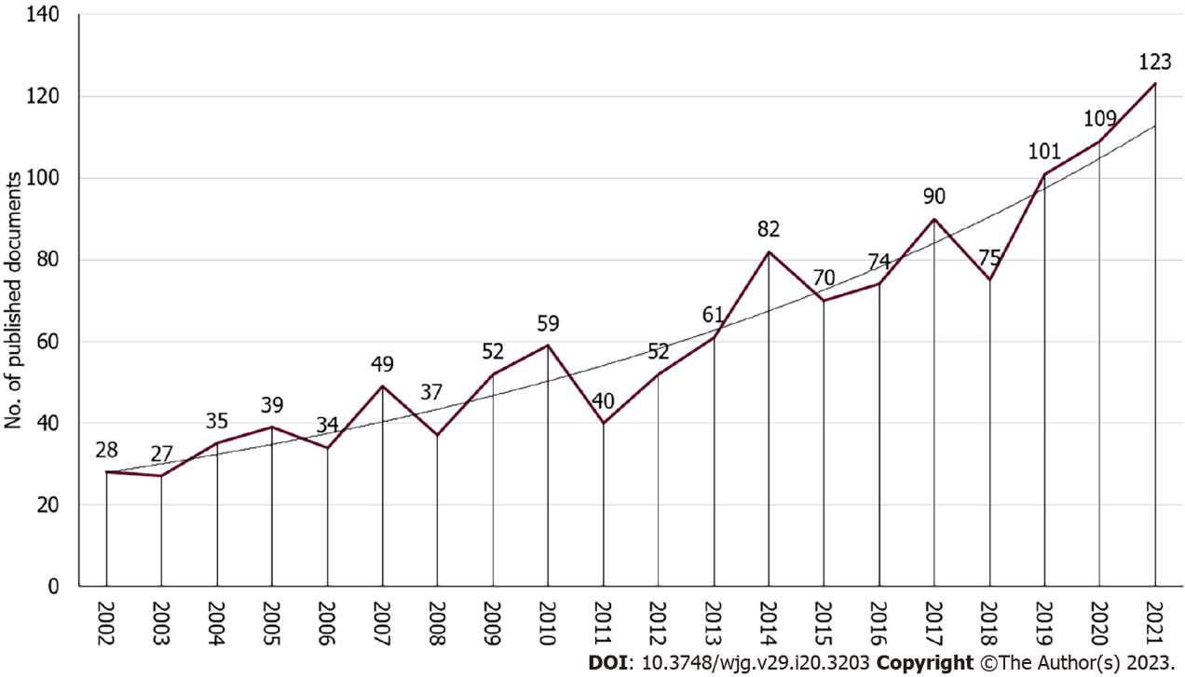
Figure 1 Growth trends of publications on nutrition and Crohn's disease from 2002 to 2021.

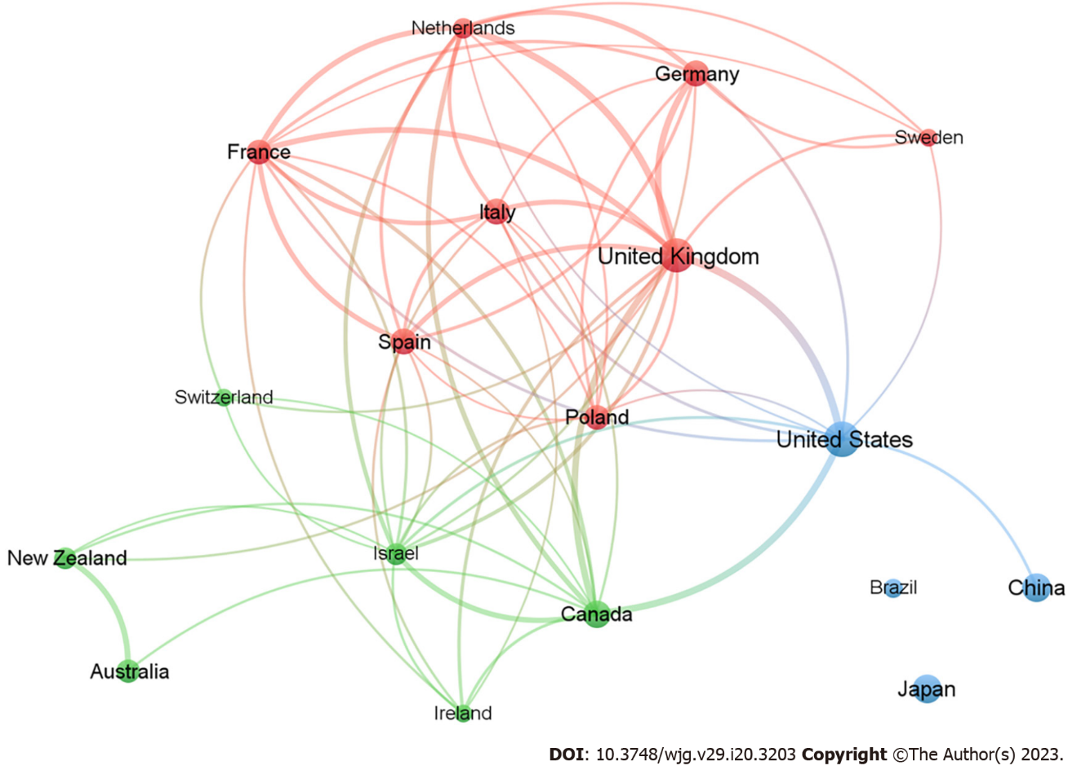
Figure 2 Network visualization map depicting international collaboration in research related to nutrition and Crohn’s disease during 2002-2021.

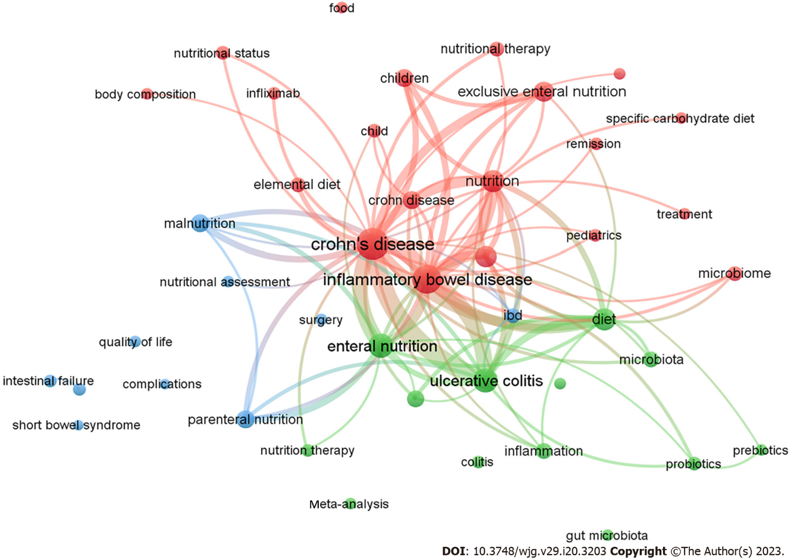
Figure 3 Analysis of the co-occurrence network of authors’ keywords. Keywords of the authors with at least 10 occurrences were analyzed.

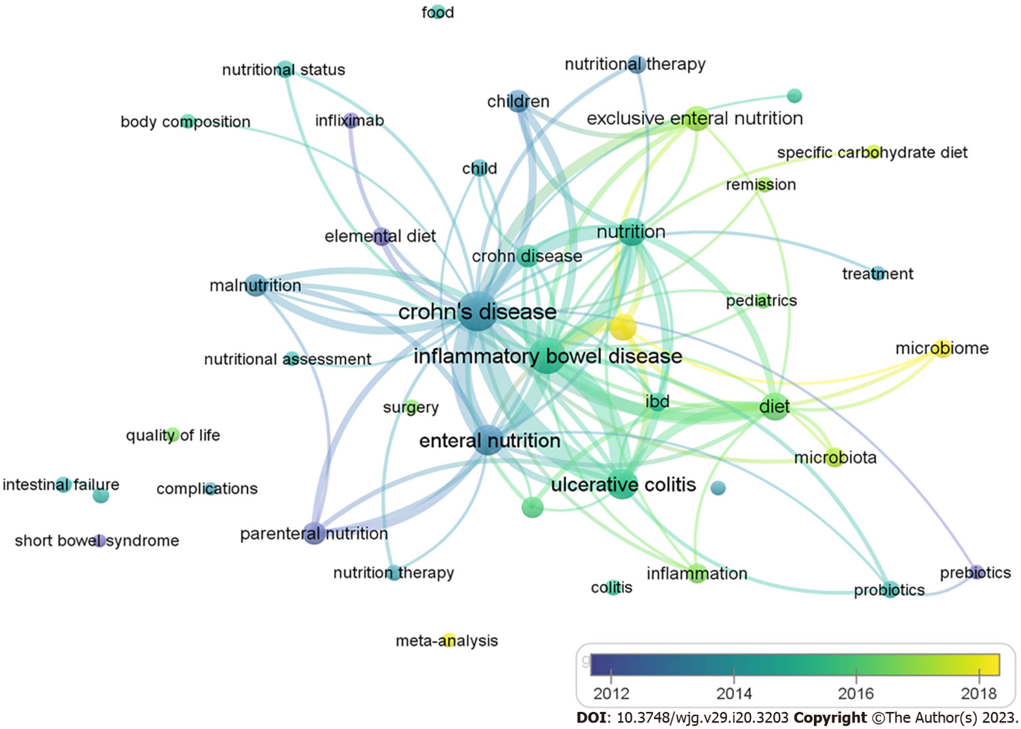
Figure 4 Co-occurrence overlay visualization of the authors’ keywords. Yellow highlights indicate the most recent keywords.

Table 1 Top 10 productive countries/regions involved in nutrition and Crohn’s disease from 2002 to 2021
Ranking | Country | No. of documents | %
1st | United States | 208 | 16.81
2nd | United Kingdom | 192 | 15.52
3rd | China | 109 | 8.81
4th | Japan | 98 | 7.92
5th | Canada | 88 | 7.11
6th | Germany | 73 | 5.90
7th | Spain | 71 | 5.74
8th | Italy | 70 | 5.66
9th | France | 67 | 5.42
10th | Poland | 61 | 4.93

Table 2 Top 10 productive institutions ranked by the number of publications
Ranking | Institute | Country | No. of documents | %
1st | University of Otago, Christchurch | New Zealand | 29 | 2.34
2nd | Tel Aviv University | Israel | 25 | 2.02
3rd | Massachusetts General Hospital | United States | 22 | 1.78
3rd | Jinling Hospital | China | 22 | 1.78
5th | UNSW Sydney | Australia | 21 | 1.70
6th | Harvard Medical School | United States | 20 | 1.62
7th | University of Glasgow | United Kingdom | 19 | 1.54
7th | Sydney Children’s Hospital, Randwick | Australia | 19 | 1.54
9th | Medical School of Nanjing University | China | 18 | 1.46
9th | University of Washington | United States | 18 | 1.46
Table 3 Top 10 funding agencies involved in nutrition and Crohn’s disease from 2002 to 2021
Ranking | Funding agencies | Country | No. of publication | %
1st | National Institute of Diabetes and Digestive and Kidney Diseases | United States | 34 | 2.75
2nd | National Institutes of Health | United States | 30 | 2.43
2nd | The National Natural Science Foundation of China | China | 30 | 2.43
4th | Crohn’s and Colitis Foundation | United States | 20 | 1.62
5th | Medical Research Council | United Kingdom | 16 | 1.29
6th | AbbVie | United States | 12 | 0.97
6th | National Cancer Institute | United States | 12 | 0.97
8th | Canadian Institutes of Health Research | Canada | 10 | 0.81
9th | Japan Society for the Promotion of Science | Japan | 10 | 0.81
8th | National Center for Research Resources | United States | 10 | 0.81
8th | Nestlé Health Science | Switzerland | 10 | 0.81
8th | Pfizer | United States | 10 | 0.81
Table 4 Ten most productive journals involved in nutrition and Crohn’s disease from 2002 to 2021
Ranking | Journal/source title | No. of documents | % | IF¹
1st | Nutrients | 57 | 4.61 | 6.706
2nd | Inflammatory Bowel Diseases | 55 | 4.45 | 7.290
3rd | Alimentary Pharmacology and Therapeutics | 39 | 3.15 | 9.524
4th | Clinical Nutrition | 29 | 2.34 | 7.643
4th | Journal of Pediatric Gastroenterology and Nutrition | 29 | 2.34 | 3.288
6th | Digestive Diseases and Sciences | 24 | 1.94 | 3.487
7th | Journal of Crohns and Colitis | 22 | 1.78 | 10.020
7th | World Journal of Gastroenterology | 22 | 1.78 | 5.374
9th | Gastroenterology | 17 | 1.37 | 33.883
9th | Nutrition in Clinical Practice | 17 | 1.37 | 3.204
¹Journal Citation Reports (Clarivate, 2022). IF: Impact index.
Table 5 Top 10 articles on total citations
Ranking | Title | Source title | Cited by | Impact index per article¹ | Ref.
1st | “Dietary intake and risk of developing inflammatory bowel disease: A systematic review of the literature” | American Journal of Gastroenterology | 603 | 29.2 | Hou et al^{[31]}, 2011
2nd | “Inflammation, Antibiotics, and Diet as Environmental Stressors of the Gut Microbiome in Pediatric Crohn’s Disease” | Cell Host and Microbe | 449 | 70.6 | Lewis et al^{[37]}, 2015
3rd | “Diet-induced dysbiosis of the intestinal microbiota and the effects on immunity and disease” | Nutrients | 425 | 36.5 | Brown et al^{[32]}, 2012
4th | “Differentiating ulcerative colitis from Crohn disease in children and young adults: Report of a Working Group of the North American Society for Pediatric Gastroenterology, Hepatology, and Nutrition and the Crohn’s and Colitis Foundation of America” | Journal of Pediatric Gastroenterology and Nutrition | 377 | 21.3 | North American Society for Pediatric Gastroenterology, Hepatology, and Nutrition^{[33]}, 2007
5th | “Enteral nutritional therapy for induction of remission in Crohn’s disease” | Cochrane Database of Systematic Reviews | 371 | 10.4 | Zachos et al^{[34]}, 2007
6th | “A prospective study of long-term intake of dietary fiber and risk of Crohn’s disease and ulcerative colitis” | Gastroenterology | 358 | 38.1 | Ananthakrishnan et al^{[39]}, 2013
7th | “Polymeric Diet Alone Versus Corticosteroids in the Treatment of Active Pediatric Crohn’s Disease: A Randomized Controlled Open-Label Trial” | Clinical Gastroenterology and Hepatology | 342 | 18.4 | Borrelli et al^{[38]}, 2006
8th | “ESPEN guideline: Clinical nutrition in inflammatory bowel disease” | Clinical Nutrition | 341 | 48.9 | Forbes et al^{[35]}, 2017
9th | “Western diet induces dysbiosis with increased e coli in CEABAC10 mice, alters host barrier function favouring AIEC colonization” | Gut | 336 | 38.4 | Martinez-Medina et al^{[40]}, 2014
10th | “Fine and ultrafine particles of the diet: Influence on the mucosal immune response and association with Crohn’s disease” | Proceedings of the Nutrition Society | 310 | 13.3 | Lomer et al^{[36]}, 2002
¹The impact index per article is presented based on Reference Citation Analysis (https://referencecitationanalysis.com/).

Published by Baishideng Publishing Group Inc
7041 Koll Center Parkway, Suite 160, Pleasanton, CA 94566, USA
Telephone: +19253991568
Email: bpgoffice@wjgnet.com
Help Desk: https://www.f6publishing.com/helpdesk
https://www.wjgnet.com

© 2023 Baishideng Publishing Group Inc. All rights reserved.

