Name of Journal: World Journal of Gastroenterology
Manuscript NO: 75518
Manuscript Type: ORIGINAL ARTICLE

Retrospective Cohort Study
Divergent trajectories of lean vs obese non-alcoholic steatohepatitis patients from listing to post-transplant: A retrospective cohort study

Qazi-Arisar FA et al. Lean vs obese NASH outcomes

Fakhar Ali Qazi-Arisar, Raj Uchila, Catherine Chen, Cathy Yang, Shi-Yi Chen, Ravikiran Sindhuvalada Karnam, Amirhossein Azhie, Wei Xu, Zita Galvin, Nazia Selzner, Leslie Lilly, Mamatha Bhat

Fakhar Ali Qazi-Arisar, Raj Uchila, Catherine Chen, Cathy Yang, Ravikiran Sindhuvalada Karnam, Amirhossein Azhie, Zita Galvin, Nazia Selzner, Leslie Lilly, Mamatha Bhat, Ajmera Transplant Program, Toronto General Hospital, University Health Network, Toronto M5G 2N2, Ontario, Canada

Fakhar Ali Qazi-Arisar, Raj Uchila, Ravikiran Sindhuvalada karnam, Zita Galvin, Nazia Selzner, Leslie Lilly, Mamatha Bhat, Division of Gastroenterology and Hepatology, Department of Medicine, University of Toronto, Toronto M5G 2N2, Ontario, Canada

Fakhar Ali Qazi-Arisar, National Institute of Liver and GI Diseases, Dow University of Health Sciences, Karachi 75330, Pakistan

Shi-Yi Chen, Wei Xu, Department of Biostatistics, Princess Margaret Cancer Center, University Health Network, Toronto M5G 2C1, Ontario, Canada

Wei Xu, Division of Biostatistics, Dalla Lana School of Public Health, University of Toronto, Toronto M5G 2C1, Ontario, Canada

Author contributions: Qazi-Arisar FA and Uchila R given their equal contribution in the manuscript; Bhat M was the guarantor and designed the study; Qazi-Arisar FA, Uchila R, Chen C, Yang C, Chen SY, Karnam RS and Azhie A participated in the acquisition, analysis, and interpretation of the data, and drafted the initial manuscript; Qazi-Arisar FA, Xu W, Galvin Z, Selzner N, Lilly L and Bhat M revised the article critically for important intellectual content.

Corresponding author: Mamatha Bhat, FRCP (C), MD, PhD, Assistant Professor, Ajmera Transplant Program, Toronto General Hospital, University Health Network, 585 University Ave, 11th Floor, Room 183, Toronto M5G 2N2, Ontario, Canada. mbhat33@gmail.com

Received: February 3, 2022
Revised: April 22, 2022
Accepted: June 15, 2022
Published online:

Abstract
BACKGROUND
Non-alcoholic steatohepatitis (NASH) cirrhosis is the second most common indication for liver transplantation (LT). The role of body mass index (BMI) on outcomes of NASH cirrhosis has been conflicting.

AIM
To compare the longitudinal trajectories of patients with lean vs obese NASH cirrhosis, from listing up to post-transplant, having adjusted their BMI for ascites.

METHODS
We retrospectively reviewed all adult NASH patients listed for LT in our program from 2012 to 2019. Fine-Gray Competing Risk analyses and Cox Proportional-Hazard Models were performed to examine the cumulative incidence of transplant and survival outcomes respectively.

RESULTS
Out of 265 NASH cirrhosis listed patients, 176 were included. Median age was 61.0 years; 46% were females. 111 patients underwent LT. Obese robust patients had better waitlist survival [hazard ratio (HR): 0.12; 95%CI: 0.05–0.29, P < 0.0001] with higher instantaneous rate of transplant (HR: 5.71; 95%CI: 1.26–25.9, P = 0.02). Lean NASH patients had a substantially higher risk of graft loss within 90 d post-LT (1.2% vs 13.8% P = 0.032) and death post-LT (2.4% vs 17.2% P = 0.029). 1- 3- and 5-year graft survival was poor for lean NASH (78.6%, 77.3% and 41.7% vs 98.6%, 96% and 85% respectively). Overall patient survival post-LT was significantly worse in lean NASH (HR: 0.17; 95%CI: 0.03–0.86, P = 0.0142) with 83% lower instantaneous rate of death in obese group.

CONCLUSION
Although lean NASH is considered to be more benign than obese NASH, our study suggests a paradoxical correlation of lean NASH with waitlist outcomes, and graft and patient survival post-LT.

Key Words: Outcomes; Frailty; Waitlist; Liver transplant; Survival

Qazi-Arisar FA, Uchila R, Chen C, Yang C, Chen SY, Karnam RS, Azhie A, Xu W, Galvin Z, Selzner N, Lilly L, Bhat M. Divergent trajectories of lean vs obese non-alcoholic steatohepatitis patients from listing to post-transplant: A retrospective cohort study. World J Gastroenterol 2022; In press

Core Tip: Non-alcoholic steatohepatitis continues to rise as an indication for liver transplantation (LT). In this study, we analyzed our single-center data of adult patients listed for LT between 2012 and 2019 and reported their outcomes on the waitlist as well as post-LT based on their body mass index.

INTRODUCTION
Non-alcoholic steatohepatitis (NASH) cirrhosis is currently the second most common indication for liver transplantation (LT) and is on track to become the leading indication by 2030 in the United States^{[1,2]}. The ability to cure hepatitis C with antivirals and the twin epidemics of diabetes and obesity have fueled the rise of NASH as an indication for LT worldwide.
NASH patients are often older at presentation and have some or all the components of metabolic syndrome such as diabetes, hypertension, dyslipidemia, and obesity. Non-alcoholic fatty liver disease (NAFLD) and NASH have also been described in the absence of obesity^{[3]}. About 25% of all NAFLD patients exhibit this lean phenotype^{[4]}. However, the role of body mass index (BMI) on outcomes of NASH cirrhosis has been conflicting. Several studies have disproved the perception of NAFLD being a 'milder' condition in lean individuals. In fact, lean patients with NASH have been shown to have more severe liver disease, more advanced fibrosis, shorter waitlist survival, and poorer post-transplant graft and patient survival^{[5-8]}.
However, these retrospective studies have been limited by their ability to accurately interpret BMI and the paucity of specific details regarding waitlist and post-transplant outcomes such as cardiometabolic disease, recurrent NASH, and graft fibrosis. Previous attempts to correct BMI for ascites have been shown to move at least 20% of patients to a lower BMI group^{[9]}. Therefore, our study's objective is to compare the longitudinal trajectories of patients with lean vs obese NASH cirrhosis, from listing up to post-transplant, having adjusted their BMI for ascites.

MATERIALS AND METHODS
The study was approved by the Research Ethics Board of the University Health Network (Toronto, Canada).

Patients
This was a single-centre retrospective study of all NASH cirrhosis patients listed for LT between November 12, 2012, and May 31, 2019, in the Multi-Organ Transplant Program at the University Health Network in Toronto, Canada. The study's start date was decided as November 13, 2012, as our program transitioned to the model for end stage liver disease (MELD)-Na system for listing on that day. All patients were followed until May 31, 2020, yielding a minimum follow-up of 1 year. In our program, NASH cirrhosis was diagnosed either based on findings of significant steatosis on histopathology (pre-transplant liver biopsy or explant pathology), or the presence of risk factors (diabetes, obesity, and metabolic syndrome) in the absence of significant alcohol consumption and evidence of other etiology on serology or histopathology.
We excluded candidates listed for hepatocellular carcinoma with exception points, all other candidates listed with exception points, patients with fulminant liver failure, NASH concomitant with a secondary etiology of chronic liver disease (such as alcohol, viral, autoimmune hepatitis, or cryptogenic cirrhosis), multiorgan transplants and those relisted for transplantation.
Data collected from the database on each recipient at the time of listing included age, gender, height, weight, BMI, Na MELD, Creatinine, estimated glomerular filtration rate (eGFR), biochemical parameters (bilirubin, albumin, international normalized ratio), frailty using clinical frailty scale, complications of cirrhosis including the severity of ascites and associated comorbidities were collected. The severity of ascites (mild, moderate, or severe) is graded according to what was recorded in the patient's clinical notes as determined either by physical or more often by radiological examination. Duration on the waitlist, intensive care unit (ICU) stay, sepsis, outcomes on the waitlist, reasons for delisting, and cause of death were also collected. Post-transplant data includes the type of transplant, re-hospitalization within 90 d, recurrence of NAFLD and NASH, time to recurrent NAFLD or NASH, metabolic, cardiovascular, and biliary complications, BMI at 1 and 5 years, patient, and graft survival details.
The above data was collected from the Organ Transplant Tracking Registry software, an internal transplant database linked to the electronic medical record of all patients evaluated at the University Health Network.
Our primary outcomes included patient and graft survival at 90 d, 1- 3- and 5 years.

Dry-weight BMI or adjusted BMI
The adjusted BMI was calculated by evaluating the patient's dry weight, which is estimated by post-paracentesis body weight or weight recorded before fluid retention if available or by subtracting a percentage of weight-based upon the severity of ascites (mild 5%; moderate 10%; severe 15%) as performed in several studies. The dry-weight BMI or adjusted BMI was then calculated by dividing the patient’s estimated dry weight (kg) by the square of the patient’s height (m) as performed in several studies^{[10,11]}. We categorized the variable of calculated adjusted BMI at listing into two groups: Group 1 comprising of overweight (BMI ≥ 25 and < 30 kg/m²) or obese group (BMI ≥ 30 kg/m²) and Group 2 comprising of underweight (< 18.5 kg/m²) or normal (≥ 18.5 and < 25 kg/m²) BMI group.
Adjusted BMI was determined for all the listed patients. The cohort of patients was analyzed according to their weight category.

Statistical analysis
A two-sided test with an overall sample size of 153 subjects (51 in the underweight or normal group, and 102 in the overweight or obese group) achieved 80% power at a 0.05 significance level when the estimated hazard ratio (HR) for the overall survival was 0.5 with the null hypothesis of HR = 1. To account for drop-offs, final sample size was increased to 54 and 122. These results assume that the HR was constant throughout the study and that Cox proportional hazards (PH) regression was used to analyze the data.
Descriptive statistics were performed for demographic and clinical variables. Counts and proportions were calculated for categorical variables and the differences between patients with lean vs obese NASH were compared using the Chi-squared test or Fisher’s exact test. Mean ± SD and median (range) were calculated for continuous variables and the differences between the two groups were compared using two-sample t-tests or Wilcoxon tests, depending on the distribution of the data.
Cumulative incidence of transplant by lean vs obese NASH was plotted and group differences were compared using Gray k-sample test and Fine-Gray Competing risk models. Kaplan-Meier plots for waitlist survival and post-transplant survival were also plotted and differences between patients with lean and obese NASH were compared using log-rank tests and Cox PH models. Complete-case analyses were performed on observations with complete sets of data while the data for observations that has one or more missing values were removed.
Sample size was calculated using PASS (PASS 2021 Power Analysis and Sample Size Software (2021). NCSS, LLC. Kaysville, Utah, United States, ncss.com/software/pass). SAS 9.4 (SAS Institute, Cary NC) was used to perform statistical analyses. Statistical significance was defined as a P value of ≤ 0.05.

RESULTS
Patient characteristics
Out of 265 patients listed for NASH cirrhosis, 176 met the eligibility criteria. The median age was 61 (32–71.4) years; 46% were females. A total of 111 patients underwent LT, 78 deceased donor LT (DDLT), and 33 living donor LT (LDLT). Table 1 describes the pre-LT clinical and laboratory variables.

Impact of ascites on BMI
Correcting for ascites volume resulted in patients moving into a lower BMI classification among all groups except the underweight group (BMI < 18 kg/m²). The change was larger among patients in the higher BMI groups with 72.2%, 62.9%, and 78.1% of patients moved to a lower BMI group from Obesity classes 3, 2, and 1, respectively as shown in Table 2.

Waitlist parameters and outcomes
Patients in lean NASH group were elderly at time of listing (median age 61.6 years vs 60.3 years, P = 0.048), worse renal functions at end of listing (median eGFR 48 mL/min/1.73 m² vs 57 mL/min/1.73 m², P = 0.017), carried more severe ascites (66.6% vs 45%, P = 0.03) and were more paracentesis dependent (72.2% vs 52.9%, P = 0.016). Other characteristics such as sex, clinical frailty scale, and frequency of complications were similar between the two groups.
Patients in the overweight/obese group spent a median of 139.5 d on the waitlist which was not dissimilar to the 117 d spent by their counterparts in the lean group. Waitlist events such as episodes of sepsis and ICU stay were similar in the two groups. With regards to waitlist outcomes, a similar number of patients were de-listed or transplanted in both groups. More patients belonging to the lean NASH group compared to the obese group died (31.5% vs 20.5% P = 0.26); however, the difference was not significant. Time to death or delisting was similar in both obese and lean groups (HR: 0.83; 95%CI: 0.46–1.50, P = 0.53). However, when sub-grouped based on BMI and frailty, patients with obese NASH and none/mild frailty had better survival than lean NASH with moderate to severe frailty (HR: 0.12; 95%CI: 0.05–0.29, P < 0.0001) (Figure 1).
With regards to transplant data, a comparable number of patients underwent DDLT and LDLT in both obese and lean groups (DDLT: 69.5% in overweight/obese group and 72.4% in the lean group; P = 0.77). The cumulative incidence of transplant was equal in both groups (HR: 1.33; 95%CI: 0.87–2.05, P = 0.16). However, obese NASH patients with none/mild frailty had a significantly better instantaneous rate of transplant than lean NASH with moderate to severe frailty (HR: 5.71; 95%CI: 1.26–25.9, P = 0.02) (Figure 2). The Median cold ischemia time in obese patients undergoing DDLT was significantly longer than that of lean patients (465 min vs 330.5 min; P = 0.024).

Post-transplant outcomes
Compared to listing, the obese group had a significant reduction in BMI 1 year post-transplant (β = -2.08, SE = 0.87, P = 0.006). At 5-year post-transplant, the overweight or obese group's BMI returned to the same level as listing time (β = 1.80, SE = 1.54, P = 0.52). No change in BMI was observed in the underweight or normal group (overall P = 0.3) (Figure 3). There was no difference in post-transplant parameters such as 90-d rehospitalization, biliary complications or recurrence of NASH in lean vs obese groups. However, renal function was significantly better in lean NASH patients at 5 years (median creatinine 111 μmol/L vs 153.5 μmol/L, P = 0.019) (Table 3).
The graft loss within 90 d post-transplant (1.2% vs 13.8% P = 0.032) and death following transplant (2.4% vs 17.2% P = 0.029) were significantly higher in lean patients compared to obese patients. The 1- 3- and 5-year graft survivals were significantly worse for lean patients 98.6%, 96% and 85% vs 78.6%, 77.3% and 41.7% respectively, all P < 0.05) (Table 3). There was a trend toward worse 1- 3- and 5-year patient survival (98.7%, 96% and 90% vs 89.7%, 81.8% and 58.3% P = 0.06, 0.07 and 0.07 respectively). The two groups were analysed to compare patient survival using Kaplan Meier Survival Plots and Cox PH models, which noted a statistically significant difference in overall survival between the two groups (HR: 0.17; 95%CI: 0.03–0.86, P = 0.0142). The instantaneous rate of death in the overweight/obese group is 83% lower than those in the underweight/normal weight group (Figure 4).

DISCUSSION
Our study highlights the paradoxical impact of pretransplant BMI on the survival of NASH patients post-liver transplant, with lean NASH patients demonstrating inferior 90-d, 1- 3- and 5-year graft survival, and overall patient survival.
Lean NAFLD prevalence varies from 12% to 20% depending on the population. The presence of comorbid conditions such as components of metabolic syndrome along with older age increases the morbidity and mortality of NASH cirrhotic patients. However, it is unclear if the same applies to lean NASH. The prevalence of metabolic syndrome is less common in lean NAFLD patients as compared to obese^{[4,12-14]}. A long-term follow-up study showed that biopsy-proven lean NAFLD patients are more likely to develop severe liver disease (F3/F4) than overweight patients^{[5]}. Literature is scant about the outcomes of lean NASH while on the waiting list for LT. A study comprising of 1090 patients revealed shorter cumulative survival in lean NAFLD compared to non-lean NAFLD (log-rank test = 5.6; P < 0.02)^{[6]} In a recent study, morbid obesity and diabetes were related to an increased risk of drop out of NASH patients from the waiting list^{[15]}.
Frailty, a common complication of cirrhosis, is seen more frequently in NASH cirrhosis patients as compared to other etiologies such as alcoholic liver disease^{[16]}. Frailty has previously been shown to determine a patient’s overall health, the number of hospitalizations, length of hospital stay, delisting, and waitlist mortality^{[17-21]}. especially in patients older than 65 years of age^{[22]} independent of portosystemic encephalopathy or ascites^{[23]}. However, the impact of frailty in the NASH cohort was not assessed. In a multicentre study, frailty was associated with a 2-fold higher risk of wait-list mortality among nonobese/class 1 obese patients, while more than 3-fold higher risk of wait-list mortality among class 2 or greater obese liver transplant candidates^{[24]}. However, NASH comprised only 17.5% of their patient population, while BMI was not corrected for ascites which was present in 37.1% of their patients. In a retrospective analysis, a higher frailty score was associated with an increased risk of delisting in NASH patients (HR: 1.46; 95%CI: 1.06–2.03, P = 0.02)^{[16]}. In our study, lean NASH patients with frailty had poor survival (HR: 0.12; 95%CI: 0.05–0.29, P < 0.0001) with lower instantaneous rate of transplant (HR: 5.71; 95%CI: 1.26–25.9, P = 0.02). Therefore, the convergence of frailty with lean NASH led to significantly worse outcomes on the waitlist as well as in the early period post-transplant.
Though lean NAFLD is considered to be benign, the dysfunctional adipose tissue, in particular, visceral adiposity is related with increase cardiometabolic risk in lean NAFLD. Further, alterations in TM6SF2, a gene conferring susceptibility to NASH and fibrosis, are shown to be increased in lean NAFLD than obese NAFLD patients. However, there is a paucity of data on post-transplant outcomes in lean patients specifically^{[25]}. In the post-transplant setting, a pivotal study looking at the patients on the UNOS database revealed that both short- and long-term survivals were low in patients who were morbidly obese before transplantation, owing to adverse cardiovascular events^{[26]}. However, none of the patients in this study belonged to the NASH group. On the contrary, obesity was noted to paradoxically favour the NASH patients compared to their non-NASH counterparts. A recent study found that lean patients have both poorer graft and patient survival than their obese counterparts^{[7]}. However, they did not adjust the BMI for ascites, whereas elevated BMI might have reflected fluid overload instead of true obesity. There is still much that is not known or understood, and hence it is challenging to explain the underlying molecular mechanisms linking lean NASH with worse outcomes post LT. Nonetheless, our study also confirms the enigmatic effect of obesity in the NASH subset. This study also highlighted the importance of correcting BMI for ascites. Despite correcting BMI for ascites, 69% of NASH patients belong to the overweight/obese group.
NASH has been associated with metabolic syndrome-related complications such as cardiovascular disease and chronic kidney disease (CKD)^{[27]}. Post-transplant the risk of metabolic complications increases further owing to the immunosuppressive medications. Furthermore, calcineurin inhibitors carry direct nephrotoxic effects. In general, obese NAFLD patients appear to have a higher risk of developing CKD than non-obese^{[28]}. In post-LT patients, obesity has been identified as a risk for post-operative severe acute kidney injury^{[29]} as well as renal disease progression needing a kidney transplant after LT^{[30]}. We further augmented this data by showing that median creatinine in our obese patients was significantly higher than in lean patients at 5 years (153.5 μmol/L vs 111 μmol/L, P = 0.019). The incidence of diabetes and hypertension were numerically higher in the obese group at 1 and 5 years, however, this difference was statistically insignificant. Further, the incidence of cardiovascular events was also not significantly different among the two groups. Further expansion of follow-up to 10 years might show a statistically meaningful difference. However, this analysis was not possible in the current study. Given the selection criteria with the start of the study from November 2012, none of the patients has achieved the 10-year benchmark yet.
This study has been limited by its retrospective design, smaller sample size, and lack of a comparison group from a non-NASH subset. We also acknowledge the limitation of missing data given the retrospective design, transfer of care to other local centres post-transplant, and a limited number of patients achieving the 5-year benchmark. The results of this study should be interpreted cautiously as it does not suggest the listing of all morbidly obese NASH cirrhotic patients for liver transplant. Nonetheless, under current practice, outcomes of carefully selected NASH patients with higher BMI are better than their lean counterparts. This conundrum could have been explained by improvement in patient selection protocols, post-transplant critical care support, and immunosuppressive treatment. Future larger studies would be required to validate the generalizability of our findings. Moreover, there is need of identifying the factors such as genetic variants, and body fat distribution/visceral adiposity, which can play role in this paradox.

CONCLUSION
Lean NASH is associated with adverse outcomes on the waiting list as well as early post-transplant, in conjunction with often comorbid frailty. Our study emphasizes the need to actively support the nutritional and physical functional status of lean NASH patients on the waiting list. Post-transplant, all NASH patients should have active lifestyle counselling regarding a healthy diet and regular exercise to improve long-term cardiometabolic outcomes.

ARTICLE HIGHLIGHTS
Research background
Non-alcoholic steatohepatitis (NASH) cirrhosis is the second leading indication for liver transplantation (LT). There is a conflicted role of body mass index (BMI) on outcomes of NASH cirrhosis while on waitlist and post liver transplant.

Research motivation
There are few reports on the waitlist and post liver transplant outcomes of lean vs obese NASH patients, and the impact of ascites adjusted BMI have not been fully clarified.

Research objectives
The objective of this study was to compare the longitudinal trajectories of patients with lean vs obese NASH cirrhosis, from listing up to post-transplant, having adjusted their BMI for ascites.

Research methods
A retrospective analysis of all adult NASH patients listed for LT at the University Health Network, Toronto between November 2012 and May 2019 was performed. We summarized the clinical characteristics of patients with lean and obese NASH. Competing risk analyses and Cox Proportional Hazard models were used to assess the cumulative incidence of transplant and survival outcomes.

Research results
Out of 265 patients listed for NASH cirrhosis, 176 were included. The median age was 61 (32–71.4) years; 46% were females. 111 patients underwent LT. Lean NASH patients were elderly at time of listing (median age 61.6 years vs 60.3 years, P = 0.048), worse renal functions at end of listing (median estimated glomerular filtration 48 mL/min/1.73 m² vs 57 mL/min/1.73 m², P = 0.017), carried more severe ascites (66.6% vs 45%, P = 0.03) and were more paracentesis dependent (72.2% vs 52.9%, P = 0.016). Obese robust patients had better waitlist survival [hazard ratio (HR): 0.12; 95%CI: 0.05–0.29, P < 0.0001] with higher instantaneous rate of transplant (HR: 5.71; 95%CI: 1.26–25.9, P = 0.02). Lean NASH patients had a substantially higher risk of graft loss within 90 d post-LT (1.2% vs 13.8% P = 0.032) and death post-LT (2.4% vs 17.2% P = 0.029). 1- 3- and 5-year graft survival was poor for lean NASH (78.6%, 77.3% and 41.7% vs 98.6%, 96% and 85% respectively). Overall patient survival post-LT was significantly worse in lean NASH (HR: 0.17; 95%CI: 0.03–0.86, P = 0.0142) with 83% lower instantaneous rate of death in obese group. Post-transplant renal function was significantly better in lean NASH patients at 5 years (median creatinine 111 μmol/L vs 153.5 μmol/L, P = 0.019).

Research conclusions
Although lean NASH was thought to be more benign than obese NASH, our study suggests a paradoxical correlation of lean NASH with waitlist outcomes, and graft and patient survival post-LT, in conjunction with often comorbid frailty.

Research perspectives
To understand the underlying molecular mechanisms linking lean NASH with worse outcomes, there is need of identifying the factors such as genetic variants, body fat distribution/visceral adiposity, which can play role in this paradox.

REFERENCES
1 Parikh ND, Marrero WJ, Wang J, Steuer J, Tapper EB, Konerman M, Singal AG, Hutton DW, Byon E, Lavieri MS. Projected increase in obesity and non-alcoholic-steatohepatitis-related liver transplantation waitlist additions in the United States. Hepatology 2019; 70: 487-495 [PMID: 28833326 DOI: 10.1002/hep.29473]
2 Vernon G, Baranova A, Younossi ZM. Systematic review: the epidemiology and natural history of non-alcoholic fatty liver disease and non-alcoholic steatohepatitis in adults. Aliment Pharmacol Ther 2011; 34: 274-285 [PMID: 21623852 DOI: 10.1111/j.1365-2036.2011.04724.x]
3 Non-alcoholic Fatty Liver Disease Study Group., Lonardo A, Bellentani S, Argo CK, Ballestri S, Byrne CD, Caldwell SH, Cortez-Pinto H, Grieco A, Machado MV, Miele L, Targher G. Epidemiological modifiers of non-alcoholic fatty liver disease: Focus on high-risk groups. Dig Liver Dis 2015; 47: 997-1006 [PMID: 26454786 DOI: 10.1016/j.dld.2015.08.004]
4 Young S, Tariq R, Provenza J, Satapathy SK, Faisal K, Choudhry A, Friedman SL, Singal AK. Prevalence and Profile of Nonalcoholic Fatty Liver Disease in Lean Adults: Systematic Review and Meta-Analysis. Hepatol Commun 2020; 4: 953-972 [PMID: 32626829 DOI: 10.1002/hep4.1519]
5 Hagström H, Nasr P, Ekstedt M, Hammar U, Stål P, Hultcrantz R, Kechagias S. Risk for development of severe liver disease in lean patients with nonalcoholic fatty liver disease: A long-term follow-up study. Hepatol Commun 2018; 2: 48-57 [PMID: 29404512 DOI: 10.1002/hep4.1124]
6 Cruz ACD, Bugianesi E, George J, Day CP, Liaquat H, Charatcharoenwitthaya P, Mills PR, Dam-Larsen S, Bjornsson ES, Haflidadottir S, Adams LA, Bendtsen F, Angulo P. Characteristics and Long-Term Prognosis of Lean Patients With Nonalcoholic Fatty Liver Disease. Gastroenterology 2014; 146: S-909 [DOI: 10.1016/s0016-5085(14)63307-2]
7 Satapathy SK, Jiang Y, Agbim U, Wu C, Bernstein DE, Teperman LW, Kedia SK, Aithal GP, Bhamidimarri KR, Duseja A, Maiwall R, Maliakkal B, Jalal P, Patel K, Puri P, Ravinuthala R, Wong VW, Abdelmalek MF, Ahmed A, Thuluvath PJ, Singal AK; Global NAFLD Consortium. Posttransplant Outcome of Lean Compared With Obese Nonalcoholic Steatohepatitis in the United States: The Obesity Paradox. Liver Transpl 2020; 26: 68-79 [PMID: 31665561 DOI: 10.1002/lt.25672]
8 Wang Q, You H, Ou X, Zhao X, Sun Y, Wang M, Wang P, Wang Y, Duan W, Wang X, Wu S, Kong Y, Saxena R, Gouw ASH, Jia J. Non-obese histologically confirmed NASH patients with abnormal liver biochemistry have more advanced fibrosis. Hepatol Int 2019; 13: 766-776 [PMID: 31559605 DOI: 10.1007/s12072-019-09982-z]
9 Leonard J, Heimbach JK, Malinchoc M, Watt K, Charlton M. The impact of obesity on long-term outcomes in liver transplant recipients-results of the NIDDK liver transplant database. Am J Transplant 2008; 8: 667-672 [PMID: 18294163 DOI: 10.1111/j.1600-6143.2007.02100.x]
10 European Association for the Study of the Liver. EASL Clinical Practice Guidelines on nutrition in chronic liver disease. J Hepatol 2019; 70: 172-193 [PMID: 30144956 DOI: 10.1016/j.jhep.2018.06.024]
11 Tandon P, Low G, Mourtzakis M, Zenith L, Myers RP, Abraldes JG, Shaheen AA, Qamar H, Mansoor N, Carbonneau M, Ismond K, Mann S, Alaboudy A, Ma M. A Model to Identify Sarcopenia in Patients With Cirrhosis. Clin Gastroenterol Hepatol 2016; 14: 1473-1480.e3 [PMID: 27189915 DOI: 10.1016/j.cgh.2016.04.040]
12 Fracanzani AL, Petta S, Lombardi R, Pisano G, Russello M, Consonni D, Di Marco V, Cammà C, Mensi L, Dongiovanni P, Valenti L, Craxì A, Fargion S. Liver and Cardiovascular Damage in Patients With Lean Nonalcoholic Fatty Liver Disease, and Association With Visceral Obesity. Clin Gastroenterol Hepatol 2017; 15: 1604-1611.e1 [PMID: 28554682 DOI: 10.1016/j.cgh.2017.04.045]
13 Akyuz U, Yesil A, Yilmaz Y. Characterization of lean patients with nonalcoholic fatty liver disease: potential role of high hemoglobin levels. Scand J Gastroenterol 2015; 50: 341-346 [PMID: 25540973 DOI: 10.3109/00365521.2014.983160]
14 Margariti A, Deutsch M, Manolakopoulos S, Tiniakos D, Papatheodoridis GV. The severity of histologic liver lesions is independent of body mass index in patients with nonalcoholic fatty liver disease. J Clin Gastroenterol 2013; 47: 280-286 [PMID: 23391869 DOI: 10.1097/MCG.0b013e31826be328]
15 Kardashian AA, Dodge JL, Roberts J, Brandman D. Weighing the risks: Morbid obesity and diabetes are associated with increased risk of death on the liver transplant waiting list. Liver Int 2018; 38: 553-563 [PMID: 28727287 DOI: 10.1111/liv.13523]
16 Bhanji RA, Narayanan P, Moynagh MR, Takahashi N, Angirekula M, Kennedy CC, Mara KC, Dierkhising RA, Watt KD. Differing Impact of Sarcopenia and Frailty in Nonalcoholic Steatohepatitis and Alcoholic Liver Disease. Liver Transpl 2019; 25: 14-24 [PMID: 30257063 DOI: 10.1002/lt.25346]
17 Dolgin NH, Smith AJ, Harrington SG, Movahedi B, Martins PNA, Bozorgzadeh A. Association Between Sarcopenia and Functional Status in Liver Transplant Patients. Exp Clin Transplant 2019; 17: 653-664 [PMID: 30295589 DOI: 10.6002/ect.2018.0018]
18 Kahn J, Wagner D, Homfeld N, Müller H, Kniepeiss D, Schemmer P. Both sarcopenia and frailty determine suitability of patients for liver transplantation-A systematic review and meta-analysis of the literature. Clin Transplant 2018; 32: e13226 [PMID: 29478305 DOI: 10.1111/ctr.13226]
19 Van Jacobs AC. Frailty Assessment in Patients with Liver Cirrhosis. Clin Liver Dis (Hoboken) 2019; 14: 121-125 [PMID: 31632663 DOI: 10.1002/cld.825]
20 Lai JC, Feng S, Terrault NA, Lizaola B, Hayssen H, Covinsky K. Frailty predicts waitlist mortality in liver transplant candidates. Am J Transplant 2014; 14: 1870-1879 [PMID: 24935609 DOI: 10.1111/ajt.12762]
21 Lai JC, Dodge JL, Sen S, Covinsky K, Feng S. Functional decline in patients with cirrhosis awaiting liver transplantation: Results from the functional assessment in liver transplantation (FrAILT) study. Hepatology 2016; 63: 574-580 [PMID: 26517301 DOI: 10.1002/hep.28316]
22 Wang CW, Covinsky KE, Feng S, Hayssen H, Segev DL, Lai JC. Functional impairment in older liver transplantation candidates: From the functional assessment in liver transplantation study. Liver Transpl 2015; 21: 1465-1470 [PMID: 26359787 DOI: 10.1002/lt.24334]
23 Lai JC, Rahimi RS, Verna EC, Kappus MR, Dunn MA, McAdams-DeMarco M, Haugen CE, Volk ML, Duarte-Rojo A, Ganger DR, O'Leary JG, Dodge JL, Ladner D, Segev DL. Frailty Associated With Waitlist Mortality Independent of Ascites and Hepatic Encephalopathy in a Multicenter Study. Gastroenterology 2019; 156: 1675-1682 [PMID: 30668935 DOI: 10.1053/j.gastro.2019.01.028]
24 Haugen CE, McAdams-DeMarco M, Verna EC, Rahimi RS, Kappus MR, Dunn MA, Volk ML, Gurakar A, Duarte-Rojo A, Ganger DR, O'Leary JG, Ladner D, Garonzik-Wang J, Segev DL, Lai JC. Association Between Liver Transplant Wait-list Mortality and Frailty Based on Body Mass Index. JAMA Surg 2019; 154: 1103-1109 [PMID: 31509169 DOI: 10.1001/jamasurg.2019.2845]
25 VanWagner LB, Armstrong MJ. Lean NAFLD: A not so benign condition? Hepatol Commun 2018; 2: 5-8 [PMID: 29404505 DOI: 10.1002/hep4.1143]
26 Nair S, Verma S, Thuluvath PJ. Obesity and its effect on survival in patients undergoing orthotopic liver transplantation in the United States. Hepatology 2002; 35: 105-109 [PMID: 11786965 DOI: 10.1053/jhep.2002.30318]
27 Kovalic AJ, Cholankeril G, Satapathy SK. Nonalcoholic fatty liver disease and alcoholic liver disease: metabolic diseases with systemic manifestations. Transl Gastroenterol Hepatol 2019; 4: 65 [PMID: 31620647 DOI: 10.21037/tgh.2019.08.09]
28 Chon YE, Kim HJ, Choi YB, Hwang SG, Rim KS, Kim MN, Lee JH, Ha Y, Lee MJ. Decrease in waist-to-hip ratio reduced the development of chronic kidney disease in non-obese non-alcoholic fatty liver disease. Sci Rep 2020; 10: 8996 [PMID: 32488147 DOI: 10.1038/s41598-020-65940-y]
29 Zhou J, Lyu L, Zhu L, Liang Y, Dong H, Chu H. Association of overweight with postoperative acute kidney injury among patients receiving orthotopic liver transplantation: an observational cohort study. BMC Nephrol 2020; 21: 223 [PMID: 32527305 DOI: 10.1186/s12882-020-01871-0]
30 Locke JE, Shelton B, Orandi B, Olthoff K, Pomfret E, Forde KA, Sawinski D, Gray M, Ascher N. Obesity is a risk factor for progression to kidney transplant waitlisting after liver transplantation. Clin Transplant 2021; 35: e14317 [PMID: 33866616 DOI: 10.1111/ctr.14317]

Footnotes
Institutional review board statement: The study was reviewed and approved by the Research Ethics board of the University Health Network (Toronto, Canada).

Informed consent statement: Given retrospective nature of study from chart review, written informed consent was not required.

Conflict-of-interest statement: Dr. Bhat reports other from Novo Nordisk, other from Ipsen, grants from Paladin, grants from Natera, grants from Oncoustics, grants from MedoAI, grants from Lallemand, personal fees from Novartis, personal fees from Lupin, outside the submitted work.

Data sharing statement: No additional data are available.

STROBE statement: The authors have read the STROBE Statement—checklist of items, and the manuscript was prepared and revised according to the STROBE Statement—checklist of items.

Open-Access: This article is an open-access article that was selected by an in-house editor and fully peer-reviewed by external reviewers. It is distributed in accordance with the Creative Commons Attribution NonCommercial (CC BY-NC 4.0) license, which permits others to distribute, remix, adapt, build upon this work non-commercially, and license their derivative works on different terms, provided the original work is properly cited and the use is non-commercial. See: https://creativecommons.org/Licenses/by-nc/4.0/

Provenance and peer review: Unsolicited article; Externally peer reviewed.

Peer-review model: Single blind

Corresponding Author's Membership in Professional Societies: American Association for the Study of Liver Diseases.

Peer-review started: February 3, 2022
First decision: April 10, 2022
Article in press:

Specialty type: Gastroenterology and hepatology
Country/Territory of origin: Canada
Peer-review report’s scientific quality classification
Grade A (Excellent): 0
Grade B (Very good): B
Grade C (Good): C, C
Grade D (Fair): 0
Grade E (Poor): 0

P-Reviewer: Gluvic Z, Serbia; Sibulesky L, United States; Tiejun W, China S-Editor: Fan JR L-Editor: A P-Editor: Fan JR

Figure Legends
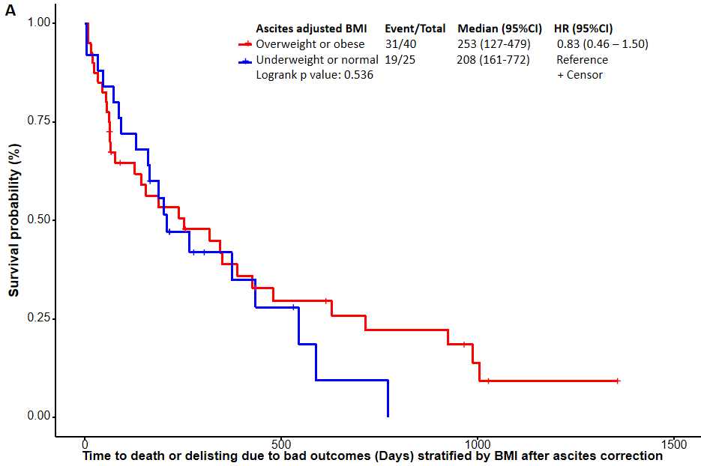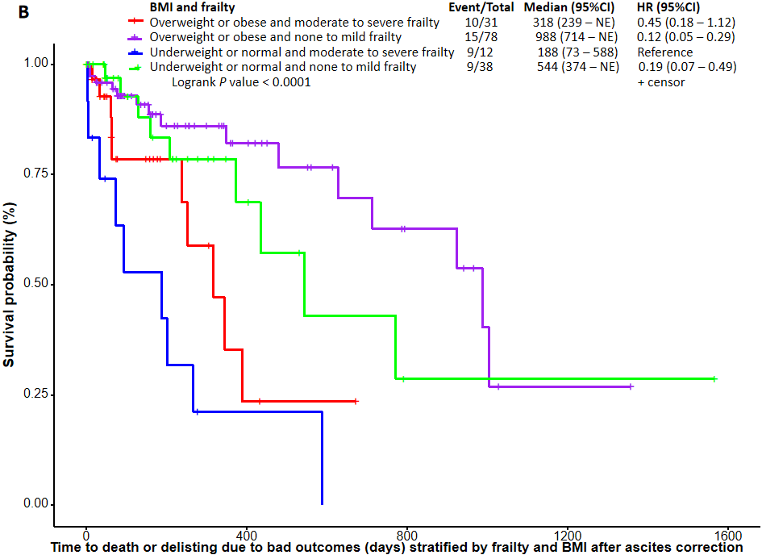
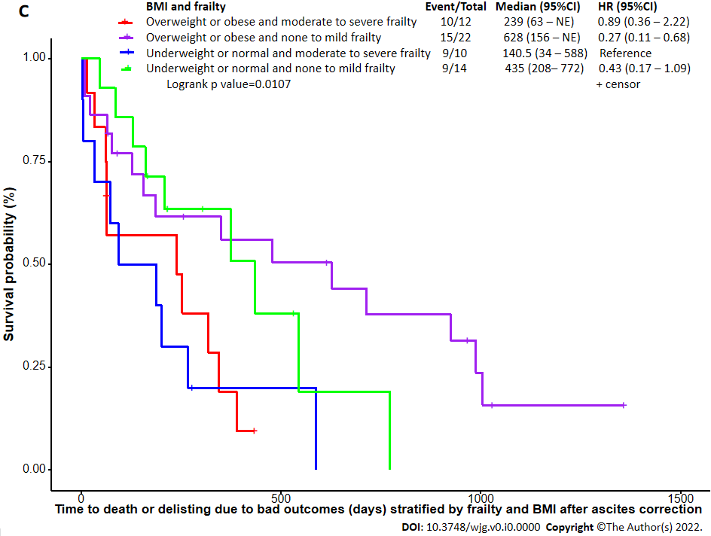
Figure 1 Kaplan-Meier–overall survival: Time to delisting or death on waitlist. A: Ascites adjusted body mass index (BMI) groups (non-transplanted patients only); B: Ascites adjusted BMI and frailty (full cohort); C: Ascites adjusted BMI and frailty (non-transplanted patients only). HR: Hazard ratio; BMI: Body mass index.
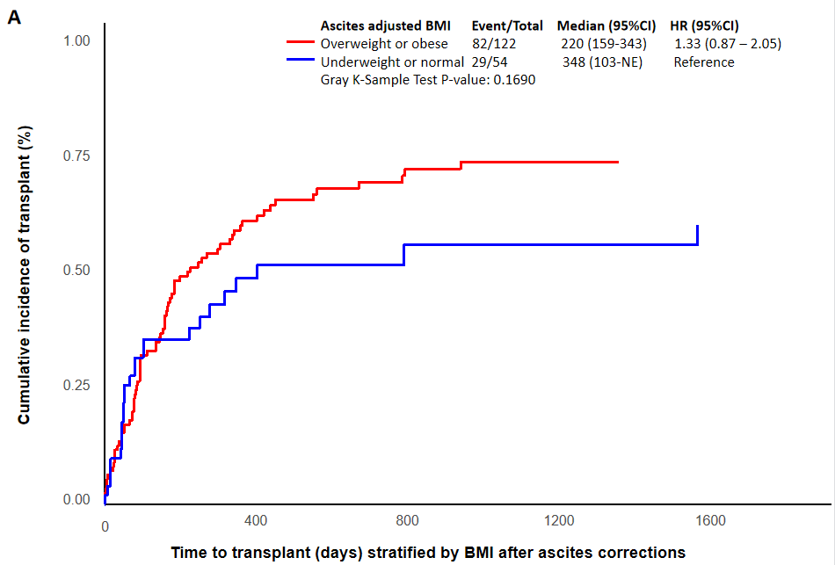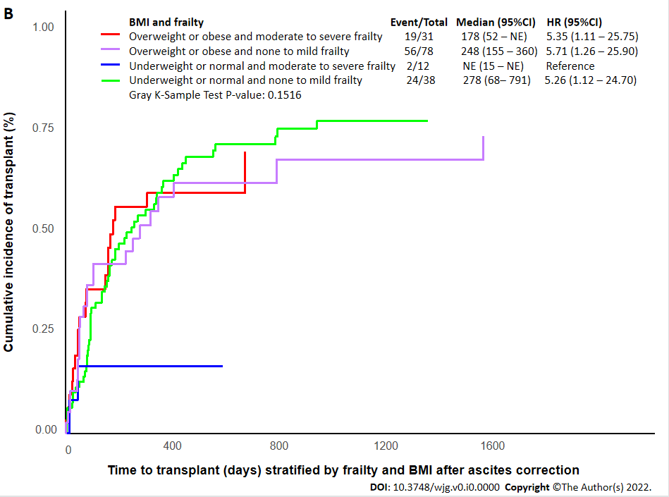
Figure 2 Competing risk analysis for time to transplant. A: Ascites adjusted body mass index (BMI) groups; B: Ascites adjusted BMI and frailty. HR: Hazard ratio; BMI: Body mass index.
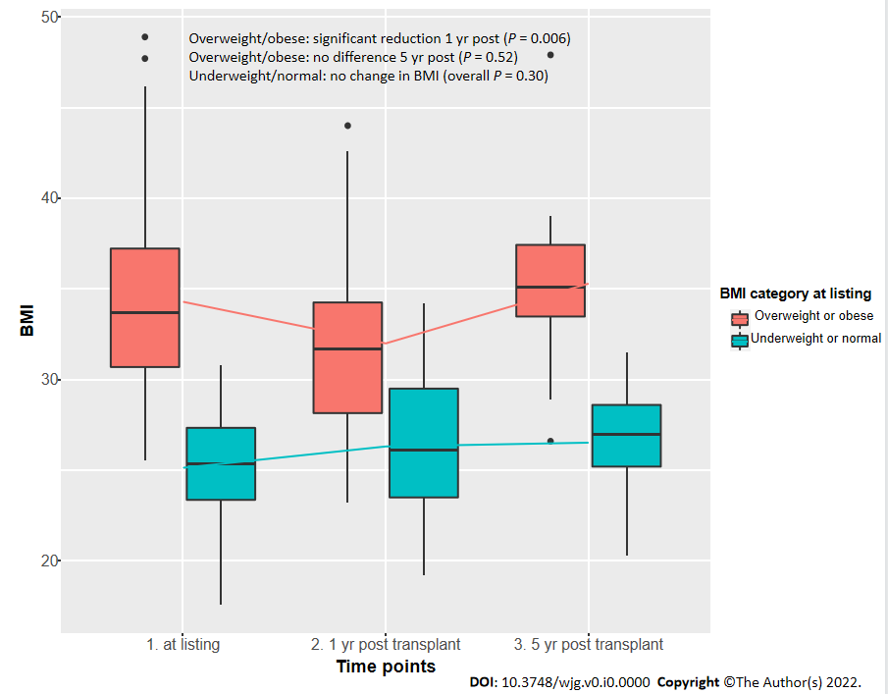
Figure 3 Change in body mass index from time of listing to post liver transplant at 1 and 5 yr. BMI: Body mass index.
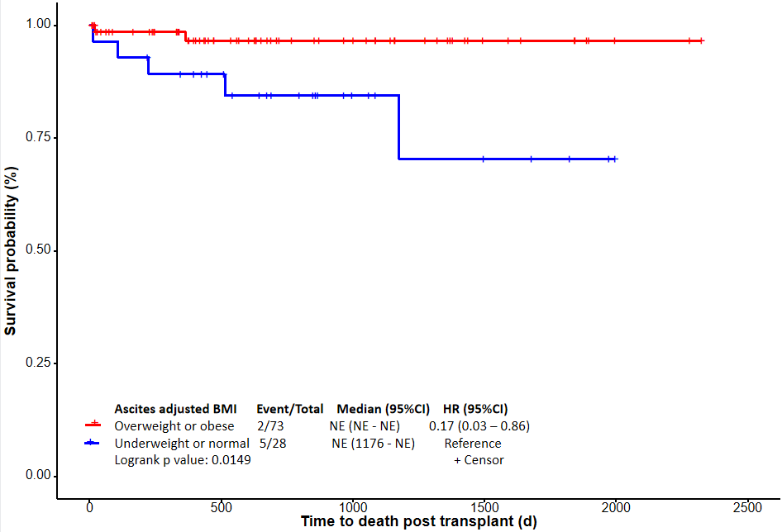
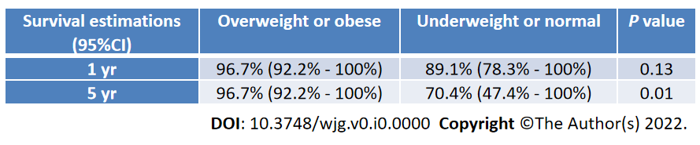
Figure 4 Kaplan-Meier–overall survival: Time to death post liver transplant stratified by ascites adjusted body mass index groups. Lower panel shows the 1- and 5-yr survival estimates. HR: Hazard ratio; BMI: Body mass index.
Table 1 Pre-liver transplant clinical and laboratory variables
 | Total (n = 176) | BMI groups after ascites correction |  | P value
 |  | Overweight or obese (n = 122) | Underweight or normal (n = 54)
Age at listing, median (range) years | 61.0 (32.0–71.4) | 60.3 (32.0–71.4) | 61.6 (45.2–71.0) | 0.048ª
Age at end of listing, median (range) years | 61.0 (32.0–72.0) | 61.0 (32.0–71.0) | 62.0 (48.0–72.0) | 0.09
Female sex, n (%) | 81 (46.02) | 53 (43.44) | 28 (51.85) | 0.30
Height at listing, median (range) cm | 168.0 (148.0–193.0) | 168.0 (148.0–188.0) | 168.0 (150.0–193.0) | 0.23
Weight at listing, median (range) kg | 88.3 (39.6–146.5) | 94.9 (69.0–146.5) | 72.0 (39.6–94.2) | < 0.001^{c}
Ascites adjusted weight at listing, median (range) kg | 77.4 (33.7–140.0) | 85.1 (60.5–140.0) | 64.4 (33.7–80.1) | < 0.001^{c}
Weight at end of listing, median (range) kg | 86.9 (39.6–161.8) | 92.9 (50.7–161.8) | 73.9 (39.6–94.2) | < 0.001^{c}
BMI at listing, median (range) kg/m² | 31.0 (17.6–48.9) | 33.7 (25.6–48.9) | 25.4 (17.6–30.8) | < 0.001^{c}
Ascites adjusted BMI at listing, median (range) kg/m² | 27.4 (15.0–45.3) | 29.2 (25.0–45.3) | 22.6 (15.0–24.9) | < 0.001^{c}
Na MELD (at listing), median (range) | 22.0 (10.0–48.0) | 21.0 (11.0–48.0) | 22.0 (10.0–43.0) | 0.34
Na MELD at end of listing, median (range) | 23.0 (6.0–45.0) | 23.0 (6.0–44.0) | 23.0 (10.0–45.0) | 0.41
Creatinine at listing, median (range) μmol/L | 98.5 (51.0–564.0) | 96.5 (55.0–564.0) | 103.0 (51.0–399.0) | 0.50
Creatinine at end of listing, median (range) μmol/L | 112.5 (44.0–719.0) | 115.0 (44.0–719.0) | 109.0 (49.0–483.0) | 0.50
eGFR at listing, median (range) mL/min/1.73 m² | 63.0 (17.0–120.0) | 65.5 (18.0–117.0) | 56.0 (17.0–120.0) | 0.11
eGFR at end of listing, median (range) mL/min/1.73 m² | 52.5 (17.0–116.0) | 57.0 (17.0–116.0) | 48.0 (20.0–98.0) | 0.017ª
Bilirubin at listing, median (range) μmol/L | 49.0 (8.0–955.0) | 51.0 (8.0–755.0) | 45.5 (14.0–955.0) | 0.11
Bilirubin at end of listing, median (range) μmol/L | 56.5 (3.0–927.0) | 58.0 (8.0–927.0) | 50.0 (3.0–802.0) | 0.19
INR at listing, median (range) | 1.5 (1.1–4.7) | 1.5 (1.1–4.7) | 1.5 (1.1–3.9) | 0.05
INR at end of listing, median (range) | 1.7 (1.1–7.6) | 1.7 (1.1–7.6) | 1.8 (1.1–5.0) | 0.46
Na at listing, median (range) mEq/L | 134.0 (116.0–147.0) | 135.0 (120.0–147.0) | 133.0 (116.0–142.0) | 0.014ª
Na at end of listing, median (range) mEq/L | 135.0 (116.0–159.0) | 135.0 (116.0–159.0) | 134.0 (120.0–152.0) | 0.10
Albumin at listing, median (range) g/L | 30.5 (9.0 – 47.0) | 29.5 (20.0–47.0) | 31.0 (9.0–42.0) | 0.08
Albumin at end of listing, median (range) g/L | 30.0 (10.0–54.0) | 30.0 (12.0–54.0) | 30.0 (10.0–50.0) | 0.28
Frailty score (n = 159), median (range) | 4.0 (2.0–8.0) | 4.0 (2.0–8.0) | 5.0 (3.0–8.0) | 0.25
None to mild, n (%) | 116 (72.96) | 78 (71.56) | 38 (76) | 0.56
Moderate to severe, n (%) | 43 (27.04) | 31 (28.44) | 12 (24)
Missing, n (%) | 17 (9.66) | 13 (10.66) | 4 (7.41)
Encephalopathy, n (%) | 141 (80.11) | 99 (81.15) | 42 (77.78) | 0.61
Ascites, n (%) | 161 (91.48) | 109 (089.34) | 052 (096.30) | 0.15
Degree of ascites, n (%)
None | 14 (07.95) | 13 (10.66) | 1 (1.85) | 0.030ª
Mild | 41 (23.30) | 30 (24.59) | 11 (20.37)
Moderate | 30 (17.05) | 24 (019.67) | 6 (11.11)
Severe | 91 (51.70) | 55 (45.08) | 36 (66.67)
Paracentesis, n (%) | 103 (58.86) | 64 (52.89) | 39 (72.22) | 0.016ª
SBP, n (%) | 46 (26.44) | 33 (27.05) | 13 (25.00) | 0.78
Variceal bleed, n (%) | 53 (30.11) | 34 (27.87) | 19 (35.19) | 0.33
Hepatorenal syndrome, n (%) | 48 (27.27) | 30 (24.59) | 18 (33.33) | 0.23
Hypertension, n (%) | 80 (45.45) | 58 (47.54) | 22 (40.74) | 0.40
Diabetes, n (%) | 104 (59.09) | 68 (55.74) | 36 (66.67) | 0.17
Hyperlipidemia, n (%) | 57 (32.39) | 35 (28.69) | 22 (40.74) | 0.12
CKD, n (%) | 18 (10.23) | 12 (9.84) | 6 (11.11) | 0.80
CAD, n (%) | 29 (16.48) | 22 (18.03) | 7 (12.96) | 0.40
Time on waiting list, median (range) days | 136.0 (1.0–1566.0) | 139.5 (1.0–1497.0) | 117.0 (1.0–1566.0) | 0.42
ICU stay within 90 d before end of listing, n (%) | 30 (17.05) | 21 (17.21) | 9 (16.67) | 0.93
No of hospitalizations within 90 d before end of listing, median (range), n (%) | 1.0 (0.0–5.0) | 1.0 (0.0–5.0) | 1.0 (0.0–5.0) | 0.42
< 2 | 151 (85.80) | 105 (86.07) | 46 (85.19) | 0.88
≥ 2 | 25 (14.20) | 17 (13.93) | 8 (14.81)
Bacteraemia/sepsis within 90 d before end of listing, n (%) | 19 (11.66) | 12 (10.62) | 7 (14.00) | 0.54
Outcome, n (%)
Active living | 1 (0.57) | 1 (0.82) | 0 (00) | 0.26
De-listed | 22 (12.50) | 14 (11.48) | 8 (14.81)
Died | 42 (23.86) | 25 (20.49) | 17 (31.48)
Transplanted | 111 (63.07) | 82 (67.21) | 29 (53.70)
Type of LT received, n (%)
DDLT | 78 (70.27) | 57 (69.51) | 21 (72.41) | 0.77
LDLT | 33 (29.73) | 25 (30.49) | 8 (27.59)
ªP < 0.05.
^{c}P < 0.001.
BMI: Body mass index; CAD: Coronary artery disease; CKD: Chronic kidney disease; DDLT: Deceased donor liver transplant; eGFR: Estimated glomerular filtration rate; ICU: Intensive care unit; INR: International normalized ratio; LT: Liver transplant; LDLT: Living donor liver transplant; MELD: Model for end stage liver disease; Na: Sodium; SBP: Spontaneous bacterial peritonitis.
Table 2 Percentage of patients who changed body mass index groups after ascites correction
Reduction in BMI after ascites correction |  |  |  |  | Original/uncorrected | Unchanged
Underweight | Normal | Overweight | Obesity 1 | Obesity 2
 |  |  |  |  | Underweight, 2 (1.1%) | 2 (100%)
5 (22.73%) |  |  |  |  | Normal, 22 (12.5%) | 17 (77.27%)
 | 29 (55.77%) |  |  |  | Overweight, 52 (29.55%) | 23 (44.23%)
 | 1 (1.82%) | 42 (76.36%) |  |  | Obesity 1, 55 (31.25%) | 12 (21.82%)
 |  |  | 17 (62.96%) |  | Obesity 2, 27 (15.34%) | 10 (37.04%)
 |  |  | 2 (11.11%) | 11 (61.11%) | Obesity 3, 18 (10.23%) | 5 (27.78%)
All BMI group had some level of decrease after correction  Especially higher BMI groups have more % reduction |  |  |  |  | Total (n = 176) | % of unchanged are higher among low BMI groups
BMI: Body mass index.
Table 3 Post transplant outcomes
 | Total (n = 111) | BMI after ascites correction |  | P value
 |  | Overweight or obese (n = 82) | Underweight or normal (n = 29)
Biliary stricture, n (%) | 22 (19.8) | 16 (19.5) | 6 (20.7) | 0.97
Biliary leak, n (%) | 10 (9) | 7 (8.5) | 3 (10.3) | 1.0
Hepatic artery thrombosis, n (%) | 2 (1.8) | 0 (0) | 2 (6.9) | 0.07
90-d re-hospitalization (n = 103), n (%) | 23 (22.3) | 17 (22.6) | 6 (21.4) | 0.89
Recurrent NAFLD, n (%) | 57 (51.4) | 44 (53.7) | 13 (44.8) | 0.59
Time to recurrent NAFLD, median (range) days | 568 (13–2135) | 489 (13–1821) | 757 (80–2135) | 0.21
Recurrent NASH, n (%) | 7 (6.3) | 5 (6.1) | 2 (6.9) | 1.0
Time to recurrent NASH, median (range) days | 812 (363–1119) | 802 (363–1119) | 957.5 (812–1103) | 0.28
BMI at 1 yr (n = 83), median (range) kg/m² | 30.3 (19.2–44.0) | 31.7 (23.2–44.0) | 26.1 (19.2–34.2) | < 0.001^{c}
BMI at 5 yr (n = 17), median (range) kg/m² | 33.9 (20.3–47.9) | 35.1 (26.6 – 47.9) | 27.0 (20.3–31.5) | 0.004^{b}
Creatinine at 1 yr (n = 70), median (range) μmol/L | 114.0 (54.0–279.0) | 117.5 (63.0–279.0) | 106.0 (54.0–178.0) | 0.21
Creatinine at 5 yr (n = 19), median (range) μmol/L | 143.0 (67.0-257.0) | 153.5 (78.0–257.0) | 111.0 (67.0–127.0) | 0.019ª
Diabetes at 1 yr (n = 82), n (%) | 36 (43.9) | 27 (45.8) | 9 (39.1) | 0.59
Diabetes at 5 yr (n = 20), n (%) | 10 (50) | 8 (53.3) | 2 (40) | 0.72
Hypertension at 1 yr (n = 83), n (%) | 44 (53) | 33 (55) | 11 (47.8) | 0.56
Hypertension at 5 yr (n = 20), n (%) | 12 (60) | 10 (66.7) | 2 (40) | 0.35
Cardiovascular events post LT, n (%) | 22 (19.8) | 14 (17) | 8 (27.6) | 0.45
Fibroscan Elastography (n = 48), median (range) kPa | 6.4 (2.3–21.8) | 6.8 (3.5–21.8) | 4.8 (2.3–14.5) | 0.011ª
Fibroscan CAP (n = 48), median (range) dB/m | 286.5 (181.0–400.0) | 298.0 (198.0–400.0) | 283.5 (181.0–400.0) | 0.26
Graft loss within 90 d post LT, n (%) | 5 (4.5) | 1 (1.2) | 4 (13.8) | 0.032ª
Graft survival post LT 1 yr (n = 101), n (%) | 94 (93.1) | 72 (98.6) | 22 (78.6) | 0.002^{b}
Graft survival post LT 3 yr (n = 72), n (%) | 65 (90.3) | 48 (96) | 17 (77.3) | 0.025ª
Graft survival post LT 5 yr (n = 32), n (%) | 22 (68.8) | 17 (85) | 5 (41.7) | 0.018ª
Deaths post LT, n (%) | 7 (6.3) | 2 (2.4) | 5 (17.2) | 0.029ª
Time to death post LT (n = 7), median (range) days | 224 (13–1176) | 192.5 (20–365) | 224 (13–1176) | 0.42
Death within 90 d post-LT, n (%) | 2 (1.8) | 1 (1.2) | 1 (3.4) | 0.38
Patient survival at 1 yr (n = 108), n (%) | 104 (96.3) | 78 (98.7) | 26 (89.7) | 0.06
Patient survival at 3 yr (n = 97), n (%) | 66 (91.7) | 48 (96) | 18 (81.8) | 0.07
Patient survival at 5 yr (n = 32), n (%) | 25 (78.1) | 18 (90) | 7 (58.3) | 0.07
ªP < 0.05.
^{b}P < 0.01.
^{c}P < 0.001.
BMI: Body mass index; CAP: Controlled attenuation parameter; LT: Liver transplant; NAFLD: Non-alcoholic fatty liver disease; NASH: Non-alcoholic steatohepatitis.

