Name of Journal: World Journal of Gastrointestinal Oncology
Manuscript NO: 89996
Manuscript Type: SCIENTOMETRICS

Insights into the history and tendency of glycosylation and digestive system tumor: A bibliometric-based visual analysis

Jiang J et al. Glycosylation and digestive system tumor

Jie Jiang, Zai Luo, Ren-Chao Zhang, Yue-Ling Wang, Jun Zhang, Ming-Yu Duan, Zheng-Jun Qiu, Chen Huang

Jie Jiang, Zai Luo, Ren-Chao Zhang, Jun Zhang, Zheng-Jun Qiu, Chen Huang, Department of Gastrointestinal Surgery, Shanghai General Hospital, Shanghai Jiao Tong University School of Medicine, Shanghai 200080, China

Yue-Ling Wang, Jiangnan University Wuxi School of Medicine, Wuxi 214122, Jiangsu Province, China

Ming-Yu Duan, Department of Education, Shanghai General Hospital, Shanghai Jiao Tong University School of Medicine, Shanghai 200080, China

Co-first authors: Jie Jiang and Zai Luo.

Co-corresponding authors: Zheng-Jun Qiu and Chen Huang.

Author contributions: Huang C and Qiu ZJ designed the experiments, they have equal contributions; Jiang J and Luo Z searched articles, extracted data and wrote this manuscript; Jiang J, Luo Z, Zhang RC and Wang YL examined the original study data; Duan MY, Zhang J made the visualized analysis; Qiu ZJ, Huang C and Luo Z reviewed and revised the manuscript; all authors read and approved the final manuscript.

Supported by the National Natural Science Foundation of China, No. 82072662; Shanghai Municipal Education Commission - Gaofeng Clinical Medicine Grant Support, No. 2019142; Shanghai Three-year Action Plan to Promote Clinical Skills and Clinical Innovation in Municipal Hospitals, No. SHDC2020CR4022; and the 2021 Shanghai “Rising Stars of Medical Talent” Youth Development Program: Outstanding Youth Medical Talents.

Corresponding author: Chen Huang, MD, PhD, Chief Doctor, Director, Surgeon, Department of Gastrointestinal Surgery, Shanghai General Hospital, Shanghai Jiao Tong University School of Medicine, No. 100 Haining Road, Shanghai 200080, China. Huangchen0204@sjtu.edu.cn

Received: November 20, 2023
Revised: January 18, 2024
Accepted: January 25, 2024
Published online: March 15, 2024

Abstract
BACKGROUND
Glycosylation, a commonly occurring post-translational modification, is highly expressed in several tumors, specifically in those of the digestive system, and plays a role in various cellular pathophysiological mechanisms. Although the importance and detection methods of glycosylation in digestive system tumors have garnered increasing attention in recent years, bibliometric analysis of this field remains scarce. The present study aims to identify the developmental trends and research hotspots of glycosylation in digestive system tumors.

AIM
To find and identify the developmental trends and research hotspots of glycosylation in digestive system tumors.

METHODS
We obtained relevant literature from the Web of Science Core Collection and employed VOSviewer 1.6.19 and CiteSpace (version 6.1.R6) to perform bibliometric analysis.

RESULTS
A total of 2042 documents spanning from 1978 to the present were analyzed, with the research process divided into three phases: the period of obscurity (1978-1990), continuous development period (1991-2006), and the rapid outbreak period (2007-2023). These documents were authored by researchers from 66 countries or regions, with the United States and China leading in terms of publication output. Reis Celso A had the highest number of publications, while Pinho SS was the most cited author. Co-occurrence analysis revealed the most popular keywords in this field are glycosylation, expression, cancer, colorectal cancer, and pancreatic cancer. Furthermore, the Journal of Proteome Research was the most prolific journal in terms of publications, while the Journal of Biological Chemistry had the most citations.

CONCLUSION
The bibliometric analysis shows current research focus is primarily on basic research in this field. However, future research should aim to utilize glycosylation as a target for treating tumor patients.

Key Words: Glycosylation; Cancer; Digestive system; Bibliometric analysis; CiteSpace; VOS viewer

©The Author(s) 2024. Published by Baishideng Publishing Group Inc. All rights reserved.

Citation: Jiang J, Luo Z, Zhang RC, Wang YL, Zhang J, Duan MY, Qiu ZJ, Huang C. Insights into the history and tendency of glycosylation and digestive system tumor: A bibliometric-based visual analysis. World J Gastrointest Oncol 2024; 16(3): 1059-1075
URL: https://www.wjgnet.com/1948-5204/full/v16/i3/1059.htm
DOI: https://dx.doi.org/10.4251/wjgo.v16.i3.1059

Core Tip: Glycosylation assumes a progressively pivotal role within the contemporary landscape of cancer research, necessitating a quantitative exploration of extant scholarly contributions on glycation. This study curated a corpus of 2042 documents, employing Citespace and VOSviewer to depict the evolutionary trajectory of glycosylation research. We have comprehensively analyzed the current research status of glycosylation in the digestive system from the perspectives of authors, countries, journals, citations and etc. Our analysis reveals a predominant concentration of current glycation investigations in foundational domains. however, a discernible trajectory points towards its emergence as a prospective frontier in the realms of cancer diagnosis and therapeutic intervention.

INTRODUCTION
Glycosylation is a complex post-translational modification that involves the enzymatic combination of saccharides with lipids, proteins, or other saccharides to form covalent glycosides^{[1-3]}. The credit for the discovery of glycosylation should be given to Landsteiner for this discovery of blood group antigens which were primarily carbohydrate-based antigens^{[4,5]}. n mammals, glycans can be synthesized using 10 monosaccharides, including glucose, galactose, fucose, mannose, xylose, glucuronic acid, iduronic acid, N-acetylgalactosamine, N-acetylglucosamine, and 5-N-acetylneuraminic acid. Oligosaccharides are formed into glycan chains through the action of glycosyltransferases and glycosidases, but a lack of these enzymes can lead to congenital severe glycosylation disease. There are many types of glycosylation, including O-glycosylation, N-glycosylation, glycosphingolipids, proteoglycans, and glycosaminoglycans, etc.. Among these, N-glycosylation and O-glycosylation are the most common^{[6]}. N-glycosylation involves attaching GlcNAc to the nitrogen atom of Asn, usually found in the Asn-X-Ser/Thr sequence (where X is any amino acid except proline)^{[7,8]}. O-glycosylation occurs on functional hydroxyl groups, which is often connected with the oxygen atoms on serine and threonine. The most common O-glycosylation is mucin-type (GalNAc type) O glycosylation, which is abundant in mucin^{[9]}.
Compared to normal tissue cells, tumor cells exhibit a significantly elevated degree of glycosylation^{[10]}. Hakomori postulated that this change in glycosylation degree is due to incomplete synthesis and neo-synthesis processes^{[11]}. The former is the result of normal glycosylated protein synthesis damage, while the latter results in new glycosylated proteins induced by cancer. The wide-spread increase in glycosylation in tumor cells plays a crucial role in a range of pathological mechanisms, such as inflammation, immune surveillance, signal transduction, and cancer metastasis^{[2,12]}. For example, Tn and sTn antigens mainly promote the metastasis of tumor cells, while T antigen mediates the cell adhesion and immune response of cancer cells, thus promoting tumor progression. In addition, galactose lectin-4, a type of β Galactoside binding protein has been shown to have an impact on cancer progression/metastasis, especially in digestive system cancers^{[13]}. Given the active expression of mucin in the digestive system, glycosylation is closely intertwined with the onset and progression of digestive system cancers^{[14-16]}.
Currently, the detection of tumor markers and targeted therapy associated with glycosylation is in its initial stage^{[17,18]}. Some glycoproteins and glycans have been used as biomarkers for cancer diagnosis and prognosis in clinics. CA19-9, also known as Lewis antigen, is a marker for various cancers such as gastric, colon, and pancreatic cancer^{[8,19]}. However, its specificity is limited as it is widely expressed in various diseases. Nonetheless, CA19-9 shows great potential in treatment. It is located on the epithelium and plays a crucial role in mediating adhesion and promoting cancer metastasis^{[20]}. Therefore, the development of a therapeutic antibody that impacts its adhesion is highly anticipated^{[18]}. In addition to CA199 mentioned above, abnormal fucosylation is very common in intrahepatic cholangiocarcinoma, which upregulates NOTCH and EGFR/NF-κB pathway promotes cell growth and migration, indicating its potential as a potential target^{[21]}. In summary, glycosylation is a vital process in biology that plays a significant role in various cellular mechanisms. Understanding the different types of glycosylation and their functions is essential for developing new therapies for glycosylation-related diseases.
Bibliometrics is a metrological discipline that employs qualitative and quantitative methods to conduct statistical analysis of documents. Through proper application of appropriate software, it can reveal the current hot spots in the research field and predict future development. Additionally, bibliometrics can generate visualizations of co-occurring words to illustrate their relationships^{[22,23]}. At present, bibliometrics has been widely applied to various fields, serving as a guide for researchers in their studies^{[24]}. Despite this, there is a dearth of bibliometric research on glycosylation in digestive system cancers. Therefore, our objective is to utilize bibliometrics to identify the research hotspots and development trends of glycosylation in digestive system cancer.

MATERIALS AND METHODS
Data source and collection
The present study utilized the Web of Science Core Collection (WOSCC) database, a globally recognized academic database that comprises various types of scholarly documents. To obtain all relevant literature, a search was conducted using the following strategies: TS = (glycosylation) AND TS = (gastric cancer OR colorectal cancer OR liver cancer OR pancreatic cancer OR esophageal cancer OR gallbladder carcinoma OR gastrointestinal tumor). The search was conducted on a single day, 20 February 2023, to avoid errors that may arise from daily updates. The search did not set a limitation on the release date, and all literature retrieved from the database, including articles and reviews, were included in the collection procedure. Language was not a confining factor during the search. A total of 2817 records were identified from the database, and these records were manually filtered to ensure that they had a clear relationship between glycosylation and tumors of the digestive system. Ultimately, 2042 studies were identified as meeting the criteria and exported as plain text files that contained information on titles, keywords, abstracts, countries, institutions, and publication years, etc.

Bibliometric analyzing and tools
The collected data were imported into two software programs, CiteSpace version 6.1.R6 and VOSviewer version 1.6.19, for further bibliometric analysis.
CiteSpace, developed by Chaomei Chen, is a software tool for science mapping and bibliometric visualization^{[25,26]}. It offers comprehensive features to explore the underlying relevance of article information, as well as reveal the development history and emerging trends in a particular field^{[26]}. In this study, CiteSpace was employed to visualize the collaboration network between countries, institutions, and authors, and to analyze the co-citation relevance of references, cited authors, and cited journals. Additionally, CiteSpace was used to conduct a burst analysis of keywords and references to identify the research focus and hotspots in the field. Moreover, the software was utilized to cluster the keywords and generate a timeline view to illustrate the shift in the field over the past four decades. Finally, a dual-map overlay of journals was created to analyze the disciplinary evolution and field relationships. The parameters set for CiteSpace analysis included a time span from 1978 to 2023, time slices of three years, and a selection criteria of g-index (k = 25), with other settings using default values.
VOSviewer, developed by Nees Jan van Eck and Ludo Waltman, is a freely available Java-based software tool for science visualization^{[27]}. Unlike CiteSpace, VOSviewer can generate density maps of keywords and create tables with more data, providing a more intuitive visualization of the data. In this study, VOSviewer was employed to generate density maps of keywords, which allowed for the identification of special hotspots in the field.

RESULTS
General analysis
A total of 2042 documents related to glycosylation and digestive system cancer were identified in the WOSCC from 1978 to 2023. The number of publications and documents in a certain field can reveal the trends in that field over time. The publication trend related to glycosylation and digestive system cancer is depicted in Figure 1. As shown in Figure 1, the first paper was published in 1978, while this field did not receive much attention before 1990. Burst in studies about glycosylation and digestive system cancer occurred after 2008. The number of publications and citations has exhibited a dramatic and exponential growth, suggesting that glycosylation may have a closer connection with cancer of the digestive system and play a critical role in it. For instance, the number of publications and citations peaked in 2021 and 2022, respectively. These findings imply that more resources will be devoted to this field in the future, and the achievements will eventually be translated into practical applications.

Country and institution analysis
Researchers from 66 countries or regions have contributed to the literature on glycosylation and digestive system tumors, as evidenced by Table 1. Of these, only six countries have published more than 100 articles, with the People's Republic of China being the most prolific (594, 29.09%), followed by the United States (549, 26.89%), Japan (295, 14.45%), Germany (135, 6.61%), France (102, 4.95%), and South Korea (101, 4.46%). The United States was the first to publish research on the relationship between glycosylation and digestive system tumors. However, China has since surpassed the United States in terms of the number of research articles published, indicating China's increasing attention to this field. Nonetheless, China's citation rate has not met expectations. Figure 2 provide further insight into national contributions and characteristics. Figure 2A presents a network visualization map of international cooperation between countries, with node size representing the total number of documents published and connection width indicating the degree of cooperation. The color represents the average year of publications, and it is apparent that China has the largest node, while the United States has more links of international cooperation. When combined with Table 1, it is clear that China has made significant strides in this field in recent years. Figure 2B is a thermograph of hotspots, which demonstrates that the United States, China, and Japan are the most prominent countries in this field. In terms of centrality, the United States (0.49), England (0.24), Netherlands (0.15), and Germany (0.15) ranked highest, indicating that these countries were more closely and frequently connected to other countries.
Regarding the affiliations of the authors, a total of 447 institutions contributed to the publications analyzed. The top ten institutions in terms of publication output are presented in Table 2, with only five of them having published more than 40 articles each. These top five institutions, in descending order of publication output, are Fudan University (88), Osaka University (56), University of Porto (51), University of Michigan (42), and Chinese Academy of Sciences (40). Notably, these top ten institutions are from diverse countries, indicating the global interest in this topic. However, the citation analysis revealed that institutions from China had relatively lower average citation numbers compared to those from other countries. In terms of centrality, there was no significant difference between the institutions. In Figure 3, we used CiteSpace to create network map, enabling us to recognize that the corrections between institutions was far denser than those between countries.

Author and co-cited author analysis
A total of over 10000 authors have co-authored on the articles analyzed. Table 3 presents the top 10 most productive authors and the most highly cited authors. Among them, only four authors - Reis Celso A (n = 39), Wuhrer M (n = 35), Miyoshi E (n = 34), and Liu YK (n = 20) have published more than 20 articles in the field. Furthermore, using a publication threshold of 5, only 384 authors met the criteria for inclusion. The cooperation relationships among authors are illustrated in Figure 4, with link colors representing the approximate duration of collaboration. Notably, the majority of the works were conducted after 2000. The authors with the highest centrality are Reis Celso A (0.08), Wuhrer M (0.08), and Miyoshi E (0.08), highlighting their critical and irreplaceable roles in the field.
Co-cited authors refer to those authors who are cited by the same paper simultaneously. Among the authors listed in Table 3, Pinho SS (356 times), Varki A (345 times), and Hakomori S (338 times) are the top three co-cited authors, with each exceeding 300 citations. These three co-cited authors are widely acknowledged as experts in the field, owing to their exceptional contributions.

Co-occurrence keywords and cluster analysis
In a keyword co-occurrence network, each keyword is represented as a node, and each co-occurrence of a pair of words is represented as a link, providing insights into the hotspots in a particular field^{[28]}. In our analysis, we merged similar keywords (e.g., "colorectal cancer" and "colorectal carcinoma"). Using CiteSpace and VOSviewer, we created density and network maps of the co-occurring keywords (Figure 5). Figure 5A depicts the connections between keywords, while Figure 5B illustrates the popularity of different keywords. In addition, the color-coded years in Figure 5A suggest that the research focus has shifted gradually from fundamental to clinical studies. Table 4 presents the top 20 most frequently used keywords, providing an overview of the hotspots and research focus on the topic of interest. The keyword "glycosylation" (n = 697) ranked first, laying the foundation for the entire research field, followed by "expression" (n = 516), "cancer" (n = 358), "colorectal cancer" (n = 298), "pancreatic cancer" (n = 273), and "hepatocellular carcinoma" (n = 243). The above keyword analysis reveals that the analyzed papers center around the theme of glycosylation in digestive system cancers.
We also conducted a keyword clustering analysis based on co-occurrence using CiteSpace and identified a total of 10 clusters. Of these, only four clusters contain more than 50 keywords, and the average publication year of each cluster is all after 2000. Figure 6A presents an overlapping of the different clusters, indicating a close interrelation between them. The largest cluster (Cluster 0) consists of 79 keywords and prominently features pancreatic cancer, mass spectrometry, protein glycosylation, and serum. The second most extensive cluster (Cluster 1) displays the highest frequency of colorectal cancer, hepatocellular carcinoma, marker, and gene. Cluster 2 encompasses glycan, sialyl Tn antigen, colon carcinoma cell, and statistics as the most commonly used keywords, while Cluster 3 features pathway, metabolism, proliferation, and phosphorylation.
Figure 6B represents the timeline view of clustered keywords, providing a comprehensive picture of the progression and patterns of research groups. The timeline analysis reveals that all the clusters had their inception prior to 2000, signifying an extensive time frame of growth and maturation. Interestingly, clusters 6 and 9 have a timeline that extends up to the present, highlighting their continued significance as hotspots and priorities in this field.
The authors conducted a burst analysis of keywords to reveal the trends and developments of research over time. Specifically, they identified the top 30 keywords with the strongest citation bursts in chronological order. The resulting graph in Figure 7 displays a blue line indicating the time span and a red segment representing the duration of the keyword burst. The most significant and earliest burst keyword was "monoclonal antibody" (18.51, 1991), indicating its pivotal role in research. Moreover, the keywords "glycoprotein" and "oligosaccharide" demonstrated the most prolonged duration of the burst, likely due to their importance in molecular chemical mechanisms. Interestingly, recent bursts of "breast cancer" and "ovarian cancer" suggest a potential connection between gynecologic tumors and digestive tumors.

Journal and co-cited journal analysis
The investigation of glycosylation in cancers of the digestive system has been a topic of interest for numerous academic journals. A total of 614 journals have published documents on this subject matter, with Table 5 providing a comprehensive overview of the top publishers. Among them, the Journal of Proteome Research is the leading publisher, having published the most papers, 69 in total, accounting for 3.38% of the total publications. The second most active publisher is Glycobiology, with 64 published papers (3.13%), followed by the Journal of Biological Chemistry with 48 papers (2.35%), Glycoconjugate Journal with 43 papers (2.11%), and PLoS One with 42 papers (2.06%). The data from Table 5 demonstrate that a small number of journals contribute to the majority of publications in this field, highlighting the significance of these journals in advancing research in glycosylation of digestive system cancers.
The concept of co-cited journals is analogous to that of co-cited authors. Impact factor (IF) is a metric used to gauge the significance of a co-cited journal based on the frequency of its citation^{[29]}. The higher the number of citations received by a journal, the higher its impact factor will be. Table 5 presents the top ten co-cited journals related to glycosylation in digestive system cancers. The Journal of Biological Chemistry stands out as the most frequently co-cited journal, with 6042 citations. This is followed by Cancer Research with 4037 citations, Proceedings of the National Academy of Sciences of the United States of America with 2626 citations, Glycobiology with 2616 citations, and Journal of Proteome Research with 2491 citations.
Upon examining the geographical distribution of the journals, it becomes evident that the majority of both the publishing and cited journals emanate from the United States, suggesting that the United States holds a dominant position in this field.
CiteSpace is a tool that enables the creation of a dual-map overlay of journals, providing insights into the citing and cited relationships between publications^{[30]}. The left side represents the map of citing journals and the right side represents the map of the cited journals. In Figure 8, there is mainly one orange path, which indicates that papers published in “Molecular, Biology, Genetics” journals mainly were frequently cited in papers published in “Molecular, Biology, Immunology” journals.

Co-cited reference analysis
The co-cited reference analysis feature of VOSviewer is noteworthy for its ability to identify seminal documents and offer insights into mainstream research. Furthermore, the theoretical significance of references can be validated through analysis. Table 6 showcases the top ten most cited references, revealing that the majority of papers were published after 2000. Notably, three of these papers were published in the "Nature Reviews Cancer" journal, underscoring its authority and impact in this domain. The article type of the majority of the top ten cited references are reviews, the reason of which might be that reviews have already contained the content of articles. Pinho SS’s article, Glycosylation in cancer: mechanisms and clinical implications^{[2]}, is the most frequently cited reference. This article is a systematic review of how glycosylation regulates the development of cancer and its possible applications in oncology, which greatly facilitated the follow-up research. The second most cited paper, titled “Glycosylation in cellular mechanisms of health and disease^{[6]}” was published in 2006 by Ohtsubo K. In this review, the author not only narrated the function of glycosylation in disease, but also discussed the biological mechanisms of glycosylation in normal tissues. The third one is titled ” Glycosylation defining cancer malignancy: New wine in an old bottle”^{[31]}, published by Hakomori S in 2002. This review mainly focused on whether glycosylation is the cause or the result of cancer. The review eventually found that glycosylation plays both roles in cancer. It also introduced a report that phenotypes of tumor cells were related to and induced by a specific glycosyl epitope. Hakomori S wrote another paper titled “Aberrant glycosylation in tumors and tumor-associated carbohydrate antigens”^{[32]} among the top ten most cited references, which demonstrates Hakomori S significant influence in this field. This review also refers to the aberrant glycosylation in tumors.
We also performed a burst analysis of co-cited references and created a Figure of the top 25 references with the most vigorous citation bursts (Figure 9). Notably, all references exhibited burst activity after 2005, indicating that research in this field did not receive significant attention during the early phase. The article titled "Global cancer statistics 2018: GLOBOCAN estimates of incidence and mortality worldwide for 36 cancers in 185 countries^{[33]}" showed the most robust citation burst and used statistical methods to provide estimates of cancer incidence and mortality. The second reference with citation burst, titled "Fucosylated haptoglobin is a novel marker for pancreatic cancer: a detailed analysis of the oligosaccharide structure and a possible mechanism for fucosylation^{[34]}" authored by Okuyama N, was also the fourth most cited reference. This reference discussed the oligosaccharide structure and mechanism for fucosylation, as well as suggested the potential application of fucosylated haptoglobin in pancreatic cancer. Moreover, this review hypothesized that pancreatic cancer cells or a factor that induces fucosylated haptoglobin production in the liver may result in the abnormal level of fucosylated haptoglobin. References in Figure 9 can be roughly classified into two groups: reviews on glycosylation in diseases and cancers (such as the above-mentioned reviews) and articles about experimental techniques and expertise. For instance, the article "Comparative Serum Glycoproteomics Using Lectin Selected Sialic Acid Glycoproteins with Mass Spectrometric Analysis: Application to Pancreatic Cancer Serum^{[35]}" presented a novel strategy to identify sialylated glycoprotein markers in human cancer serum, enabling us to quantitatively analyze changes in glycoprotein abundance and check for alterations in glycosylation degree and cancer-related carbohydrate structures.

DISCUSSION
Through a meticulous analysis of the annual publication output and citation count displayed in Figure 1, we can discern the research trend of glycosylation in digestive system tumors spanning the years 1978 to 2023. Figure 1 reveals a gradually ascending and increasingly popular research trend, which can be broadly segmented into three stages: an initial phase of obscurity, a period of continuous development, and a subsequent phase of rapid expansion. The first stage, occurring from 1978 to 1990, saw limited attention devoted to research on glycosylation in digestive tumors. Notably, the first article to establish a connection between glycosylation and digestive system cancers, authored by Yoshimoto Y and entitled "Glycosylation - one variable in recognition of hCG production by cancer^{[36]}" , attributed alterations in hCG content to changes in glycosylation. Despite the significance of this discovery, it failed to spark a research fervor at the time. The second stage, encompassing the years 1991 to 2006, marked a turning point in glycosylation research, with an annual average of 20 publications, and a focus on fundamental research and experimental technology. Many glycoproteins were also recognized as potential tumor markers during this time^{[37,38]}. The third and final stage, spanning from 2007 to present, has witnessed an explosion in research on glycosylation in digestive system tumors, with a publication output that has surged from 37 articles in 2007 to more than 150 in recent years. Notably, articles that discuss the application of glycosylation in treatment have emerged, signifying a transition to the clinical stage of research. For example, Beck et al^{[39]} identified that glycosylation can enhance the pharmacological properties and functions of therapeutic monoclonal antibodies, implying that glycosylation-related treatment modalities may offer hope to patients in the near future.
Next, we should pay attention to the contributions of various countries in publishing articles. Among them, China and the United States hold the top two positions in terms of the number of papers published, each having produced more than 500 papers, followed by Japan, Germany, and France. The popularity of the research in these countries reflects the substantial investment made in the research field. As a traditional scientific power, the United States' dominance in the number of published documents and the earliest issuance of papers is expected. Analysis of Table 2 shows that the United States holds the highest centrality and average citation, indicating its significant influence in the field. In contrast, China's inferiority in centrality and average citation may be attributed to two reasons: a lack of international cooperation and insufficient recognition of its articles worldwide. However, China's efforts to change and catch up are evident, as depicted in Figure 2A, with the yellow lines connecting the nodes of China, indicating an increase in international cooperation in recent years. The situation between institutions mirrors that of countries, though links between institutions are relatively more frequent and closer than those between countries.
The analysis of the publication and citation records reveals the authors who have made significant contributions to the field of glycosylation. Notably, Reis Celso A has the largest number of publications, while Pinho Ss has the highest number of citations. Of particular importance is their joint review paper titled “Glycosylation in cancer: mechanisms and clinical implications^{[2]},” which is the most frequently cited reference in the field. Their collaboration extends to more than 20 articles, underscoring their profound and enduring relationship in the field of glycosylation. Reis Celso A has also made notable contributions through his solo-authored paper titled “Intestinal metaplasia of human stomach displays distinct patterns of mucin (MUC1, MUC2, MUC5AC, and MUC6) expression^{[40]},” which challenges the classical sequential pathway of intestinal metaplasia. These findings highlight the valuable contributions of these authors to the glycosylation domain.
The analysis of journals and co-cited journals provides valuable insights into the authority and recognition of journals in the field of glycosylation. The top ten published and cited journals, namely Journal of Proteome Research, Glycobiology, Journal of Biological Chemistry, Analytic Chemistry, Cancer Research, and PLoS One, are noteworthy for their wide recognition and authority in the field. This observation suggests that these journals have made significant contributions to advancing knowledge in the glycosylation domain and have gained international recognition for their scholarly excellence. Moreover, the preponderance of journals from the United States among the published and cited journals underscores the country's academic prowess and standing in the field.
Glycosylation is a series of enzymatic translation occurring in the endoplasmic reticulum and Golgi apparatus, which plays a role in a variety of cell activities^{[6]}. Abnormal glycosylation, such as sialylation, fucosylation and complex branching structures, are considered to be common manifestations of cancer. In addition to CA199 mentioned earlier, AFP is exactly a good example. AFP is commonly used in clinical practice to differentiate liver cancer from liver cirrhosis diseases, due to its highly significant increase of fucosylation in liver cancer. In addition, protein glycosylation has been recommended as a potential early detection biomarker for pancreatic ductal adenocarcinoma^{[41]}. However, we need to note that gut microbiota and nutritional supplementation also have a certain impact on glycation. Glycosylated substances in the intestinal lumen not only serve as important mediators of communication between the host nervous system and microorganisms, but also produce microbial products mediated by the glycosylation of the epithelium. When there are changes in microbial ecology or nutritional supplementation, the glycosylation components also change, which requires us to distinguish them from the glycosylation changes caused by tumors^{[42,43]}. Nowadays, thanks to a series of cutting-edge achievements in technologies, it will greatly promote the application of glycosylation in digestive system cancer in terms of diagnosis and treatment^{[32]}.

CONCLUSION
In this investigation, we utilized CiteSpace and VOSviewer to visualize data and perform trend analysis of countries, authors, keywords, and other pertinent information. These tools serve as valuable resources for future researchers in the field of glycosylation and digestive system cancer. Currently, research on glycosylation in digestive system cancer is in the rapid outbreak stage, with over 150 articles being published yearly. Glycosylation has been established as a significant factor in the occurrence and progression of digestive system cancers. At present, research is primarily focused on the mechanism of glycosylation in cancer and its corresponding detection methods. However, there is a discernible shift towards glycosylation as a tumor marker and treatment target. It is expected that this area of research will become increasingly mainstream in the future. In essence, it is crucial to investigate how glycosylation can be utilized as a target for new tumor markers and the development of corresponding anticancer drugs, which could potentially bring new hope for cancer patients. Researchers must continue to dedicate themselves to fundamental research on glycosylation in order to address these issues.

ARTICLE HIGHLIGHTS
Research background
Glycosylation, a prevalent post-translational modification, exhibits heightened expression in numerous neoplastic entities, particularly within the digestive system, exerting influence over diverse cellular pathophysiological mechanisms.

Research motivation
Despite the growing prominence of the significance and detection methodologies associated with glycosylation in tumors of the digestive system in recent years, there is a notable scarcity in bibliometric analyses within this domain.

Research objectives
The present study aims to identify the developmental trends and research hotspots of glycosylation in digestive system tumors.

Research methods
We obtained relevant literature from the Web of Science Core Collection and employed VOSviewer 1.6.19 and CiteSpace (version 6.1.R6) to perform bibliometric analysis.

Research results
A total of 2042 documents spanning from 1978 to the present were analyzed, with the research process divided into three phases: the period of obscurity (1978-1990), continuous development period (1991-2006), and the rapid outbreak period (2007-2023).

Research conclusions
The bibliometric analysis presented herein imparts valuable insights into the pivotal domains and evolving trends within the study of glycosylation in digestive system cancers. The prevailing research emphasis is predominantly rooted in fundamental investigations within this domain. However, the prospective trajectory of research endeavors should pivot towards harnessing glycosylation as a targeted approach for the therapeutic intervention of tumor patients.

Research perspectives
This study addresses a lacuna in the understanding of the involvement of glycosylation in tumors of the digestive system. A thorough analysis has been conducted, encompassing aspects such as authorship, nations, journal distributions, citation patterns, and more, to provide a comprehensive overview of the current research landscape surrounding glycosylation in the digestive system. Presently, investigations are predominantly centered on elucidating the mechanisms of glycosylation in cancer and the corresponding detection methodologies. It is anticipated that, with sustained scholarly dedication, this realm of research will progressively attain mainstream prominence in the future.

REFERENCES
1 Fuster MM, Esko JD. The sweet and sour of cancer: glycans as novel therapeutic targets. Nat Rev Cancer 2005; 5: 526-542 [PMID: 16069816 DOI: 10.1038/nrc1649]
2 Pinho SS, Reis CA. Glycosylation in cancer: mechanisms and clinical implications. Nat Rev Cancer 2015; 15: 540-555 [PMID: 26289314 DOI: 10.1038/nrc3982]
3 Eichler J. Protein glycosylation. Curr Biol 2019; 29: R229-R231 [PMID: 30939300 DOI: 10.1016/j.cub.2019.01.003]
4 Landsteiner K. INDIVIDUAL DIFFERENCES IN HUMAN BLOOD. Science 1931; 73: 403-409 [PMID: 17755773 DOI: 10.1126/science.73.1894.403]
5 Schwarz HP, Dorner F. Karl Landsteiner and his major contributions to haematology. Br J Haematol 2003; 121: 556-565 [PMID: 12752096 DOI: 10.1046/j.1365-2141.2003.04295.x]
6 Ohtsubo K, Marth JD. Glycosylation in cellular mechanisms of health and disease. Cell 2006; 126: 855-867 [PMID: 16959566 DOI: 10.1016/j.cell.2006.08.019]
7 Schachter H. The joys of HexNAc. The synthesis and function of N- and O-glycan branches. Glycoconj J 2000; 17: 465-483 [PMID: 11421343 DOI: 10.1023/a:1011010206774]
8 Lumibao JC, Tremblay JR, Hsu J, Engle DD. Altered glycosylation in pancreatic cancer and beyond. J Exp Med 2022; 219 [PMID: 35522218 DOI: 10.1084/jem.20211505]
9 Arike L, Hansson GC. The Densely O-Glycosylated MUC2 Mucin Protects the Intestine and Provides Food for the Commensal Bacteria. J Mol Biol 2016; 428: 3221-3229 [PMID: 26880333 DOI: 10.1016/j.jmb.2016.02.010]
10 Buck CA, Glick MC, Warren L. Glycopeptides from the surface of control and virus-transformed cells. Science 1971; 172: 169-171 [PMID: 4323250 DOI: 10.1126/science.172.3979.169]
11 Hakomori S, Kannagi R. Glycosphingolipids as tumor-associated and differentiation markers. J Natl Cancer Inst 1983; 71: 231-251 [PMID: 6576183]
12 Oliveira-Ferrer L, Legler K, Milde-Langosch K. Role of protein glycosylation in cancer metastasis. Semin Cancer Biol 2017; 44: 141-152 [PMID: 28315783 DOI: 10.1016/j.semcancer.2017.03.002]
13 PubMed. Multifaceted role of galectin-4 in cancer: A systematic review. Available from: https://pubmed.ncbi.nlm.nih.gov/36932875/
14 Corfield AP, Carroll D, Myerscough N, Probert CS. Mucins in the gastrointestinal tract in health and disease. Front Biosci 2001; 6: D1321-D1357 [PMID: 11578958 DOI: 10.2741/corfield]
15 Mehta A, Herrera H, Block T. Glycosylation and liver cancer. Adv Cancer Res 2015; 126: 257-279 [PMID: 25727150 DOI: 10.1016/bs.acr.2014.11.005]
16 Fu C, Zhao H, Wang Y, Cai H, Xiao Y, Zeng Y, Chen H. Tumor-associated antigens: Tn antigen, sTn antigen, and T antigen. HLA 2016; 88: 275-286 [PMID: 27679419 DOI: 10.1111/tan.12900]
17 Silsirivanit A. Glycosylation markers in cancer. Adv Clin Chem 2019; 89: 189-213 [PMID: 30797469 DOI: 10.1016/bs.acc.2018.12.005]
18 Mereiter S, Balmaña M, Campos D, Gomes J, Reis CA. Glycosylation in the Era of Cancer-Targeted Therapy: Where Are We Heading? Cancer Cell 2019; 36: 6-16 [PMID: 31287993 DOI: 10.1016/j.ccell.2019.06.006]
19 Locker GY, Hamilton S, Harris J, Jessup JM, Kemeny N, Macdonald JS, Somerfield MR, Hayes DF, Bast RC Jr; ASCO. ASCO 2006 update of recommendations for the use of tumor markers in gastrointestinal cancer. J Clin Oncol 2006; 24: 5313-5327 [PMID: 17060676 DOI: 10.1200/JCO.2006.08.2644]
20 Juntavee A, Sripa B, Pugkhem A, Khuntikeo N, Wongkham S. Expression of sialyl Lewis(a) relates to poor prognosis in cholangiocarcinoma. World J Gastroenterol 2005; 11: 249-254 [PMID: 15633225 DOI: 10.3748/wjg.v11.i2.249]
21 PubMed. Aberrant fucosylation sustains the NOTCH and EGFR/NF-κB pathways and has a prognostic value in human intrahepatic cholangiocarcinoma. Available from: https://pubmed.ncbi.nlm.nih.gov/36789652/
22 Cooper ID. Bibliometrics basics. J Med Libr Assoc 2015; 103: 217-218 [PMID: 26512226 DOI: 10.3163/1536-5050.103.4.013]
23 Guler AT, Waaijer CJ, Palmblad M. Scientific workflows for bibliometrics. Scientometrics 2016; 107: 385-398 [PMID: 27122644 DOI: 10.1007/s11192-016-1885-6]
24 Ahmad P, Slots J. A bibliometric analysis of periodontology. Periodontol 2000 2021; 85: 237-240 [PMID: 33226679 DOI: 10.1111/prd.12376]
25 Chen C, Hu Z, Liu S, Tseng H. Emerging trends in regenerative medicine: a scientometric analysis in CiteSpace. Expert Opin Biol Ther 2012; 12: 593-608 [PMID: 22443895 DOI: 10.1517/14712598.2012.674507]
26 Chen C. Science Mapping: A Systematic Review of the Literature. JDIS 2017; 2: 1-40.
27 van Eck NJ, Waltman L. Software survey: VOSviewer, a computer program for bibliometric mapping. Scientometrics 2010; 84: 523-538 [PMID: 20585380 DOI: 10.1007/s11192-009-0146-3]
28 Radhakrishnan S, Erbis S, Isaacs JA, Kamarthi S. Novel keyword co-occurrence network-based methods to foster systematic reviews of scientific literature. PLoS One 2017; 12: e0172778 [PMID: 28328983 DOI: 10.1371/journal.pone.0172778]
29 Mueller PS, Murali NS, Cha SS, Erwin PJ, Ghosh AK. The effect of online status on the impact factors of general internal medicine journals. Neth J Med 2006; 64: 39-44 [PMID: 16517987]
30 Chen C, Dubin R, Kim MC. Emerging trends and new developments in regenerative medicine: a scientometric update (2000 - 2014). Expert Opin Biol Ther 2014; 14: 1295-1317 [PMID: 25077605 DOI: 10.1517/14712598.2014.920813]
31 Hakomori S. Glycosylation defining cancer malignancy: new wine in an old bottle. Proc Natl Acad Sci U S A 2002; 99: 10231-10233 [PMID: 12149519 DOI: 10.1073/pnas.172380699]
32 Hakomori S. Aberrant glycosylation in tumors and tumor-associated carbohydrate antigens. Adv Cancer Res 1989; 52: 257-331 [PMID: 2662714 DOI: 10.1016/s0065-230x(08)60215-8]
33 Bray F, Ferlay J, Soerjomataram I, Siegel RL, Torre LA, Jemal A. Global cancer statistics 2018: GLOBOCAN estimates of incidence and mortality worldwide for 36 cancers in 185 countries. CA Cancer J Clin 2018; 68: 394-424 [PMID: 30207593 DOI: 10.3322/caac.21492]
34 Okuyama N, Ide Y, Nakano M, Nakagawa T, Yamanaka K, Moriwaki K, Murata K, Ohigashi H, Yokoyama S, Eguchi H, Ishikawa O, Ito T, Kato M, Kasahara A, Kawano S, Gu J, Taniguchi N, Miyoshi E. Fucosylated haptoglobin is a novel marker for pancreatic cancer: a detailed analysis of the oligosaccharide structure and a possible mechanism for fucosylation. Int J Cancer 2006; 118: 2803-2808 [PMID: 16385567 DOI: 10.1002/ijc.21728]
35 Zhao J, Simeone DM, Heidt D, Anderson MA, Lubman DM. Comparative serum glycoproteomics using lectin selected sialic acid glycoproteins with mass spectrometric analysis: application to pancreatic cancer serum. J Proteome Res 2006; 5: 1792-1802 [PMID: 16823988 DOI: 10.1021/pr060034r]
36 Yoshimoto Y, Wolfsen AR, Odell WD. Glycosylation, a variable in the production of hCG by cancers. Am J Med 1979; 67: 414-420 [PMID: 474587 DOI: 10.1016/0002-9343(79)90787-3]
37 Kim YS, Gum J Jr, Brockhausen I. Mucin glycoproteins in neoplasia. Glycoconj J 1996; 13: 693-707 [PMID: 8909996 DOI: 10.1007/BF00702333]
38 Andrianifahanana M, Moniaux N, Schmied BM, Ringel J, Friess H, Hollingsworth MA, Büchler MW, Aubert JP, Batra SK. Mucin (MUC) gene expression in human pancreatic adenocarcinoma and chronic pancreatitis: a potential role of MUC4 as a tumor marker of diagnostic significance. Clin Cancer Res 2001; 7: 4033-4040 [PMID: 11751498]
39 Beck A, Wurch T, Bailly C, Corvaia N. Strategies and challenges for the next generation of therapeutic antibodies. Nat Rev Immunol 2010; 10: 345-352 [PMID: 20414207 DOI: 10.1038/nri2747]
40 Reis CA, David L, Correa P, Carneiro F, de Bolós C, Garcia E, Mandel U, Clausen H, Sobrinho-Simões M. Intestinal metaplasia of human stomach displays distinct patterns of mucin (MUC1, MUC2, MUC5AC, and MUC6) expression. Cancer Res 1999; 59: 1003-1007 [PMID: 10070955]
41 Xu Y, Wang Y, Höti N, Clark DJ, Chen SY, Zhang H. The next "sweet" spot for pancreatic ductal adenocarcinoma: Glycoprotein for early detection. Mass Spectrom Rev 2023; 42: 822-843 [PMID: 34766650 DOI: 10.1002/mas.21748]
42 Panther EJ, Dodd W, Clark A, Lucke-Wold B. Gastrointestinal Microbiome and Neurologic Injury. Biomedicines 2022; 10 [PMID: 35203709 DOI: 10.3390/biomedicines10020500]
43 Nwafor D, Goeckeritz J, Hasanpour Z, Davidson C, Lucke-Wold B. Nutritional Support Following Traumatic Brain Injury: A Comprehensive Review. Explor Res Hypothesis Med 2023; 8: 236-247 [PMID: 37795213 DOI: 10.14218/erhm.2022.00086]

Footnotes
Conflict-of-interest statement: All the authors report no relevant conflicts of interest for this article.

PRISMA 2009 Checklist statement: The authors have read the PRISMA 2009 Checklist, and the manuscript was prepared and revised according to the PRISMA 2009 Checklist.

Open-Access: This article is an open-access article that was selected by an in-house editor and fully peer-reviewed by external reviewers. It is distributed in accordance with the Creative Commons Attribution NonCommercial (CC BY-NC 4.0) license, which permits others to distribute, remix, adapt, build upon this work non-commercially, and license their derivative works on different terms, provided the original work is properly cited and the use is non-commercial. See: https://creativecommons.org/Licenses/by-nc/4.0/

Provenance and peer review: Unsolicited article; Externally peer reviewed.
Peer-review model: Single blind

Peer-review started: November 20, 2023
First decision: December 15, 2023
Article in press: January 25, 2024

Specialty type: Medical informatics
Country/Territory of origin: China
Peer-review report’s scientific quality classification
Grade A (Excellent): 0
Grade B (Very good): B
Grade C (Good): C
Grade D (Fair): 0
Grade E (Poor): 0

P-Reviewer: Lucke-Wold B, United States; Rasa HK, Turkey S-Editor: Gong ZM L-Editor: A P-Editor: Zhang XD

Figure Legends
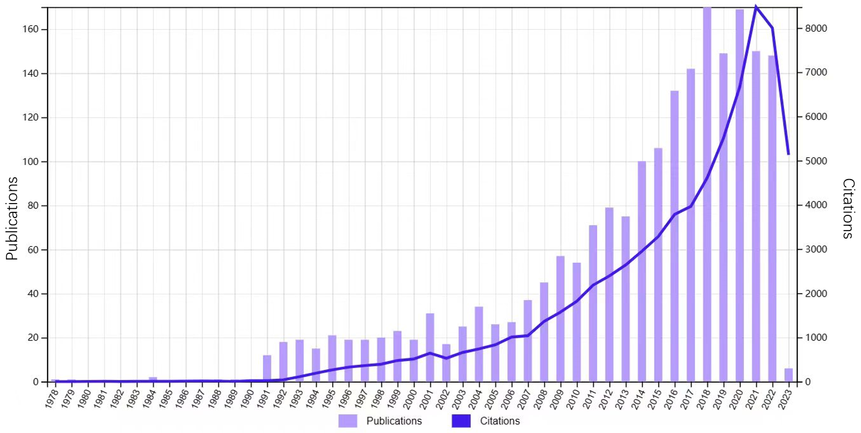
Figure 1 The annual number and cumulative of publications number from 1978 to 2023.
A
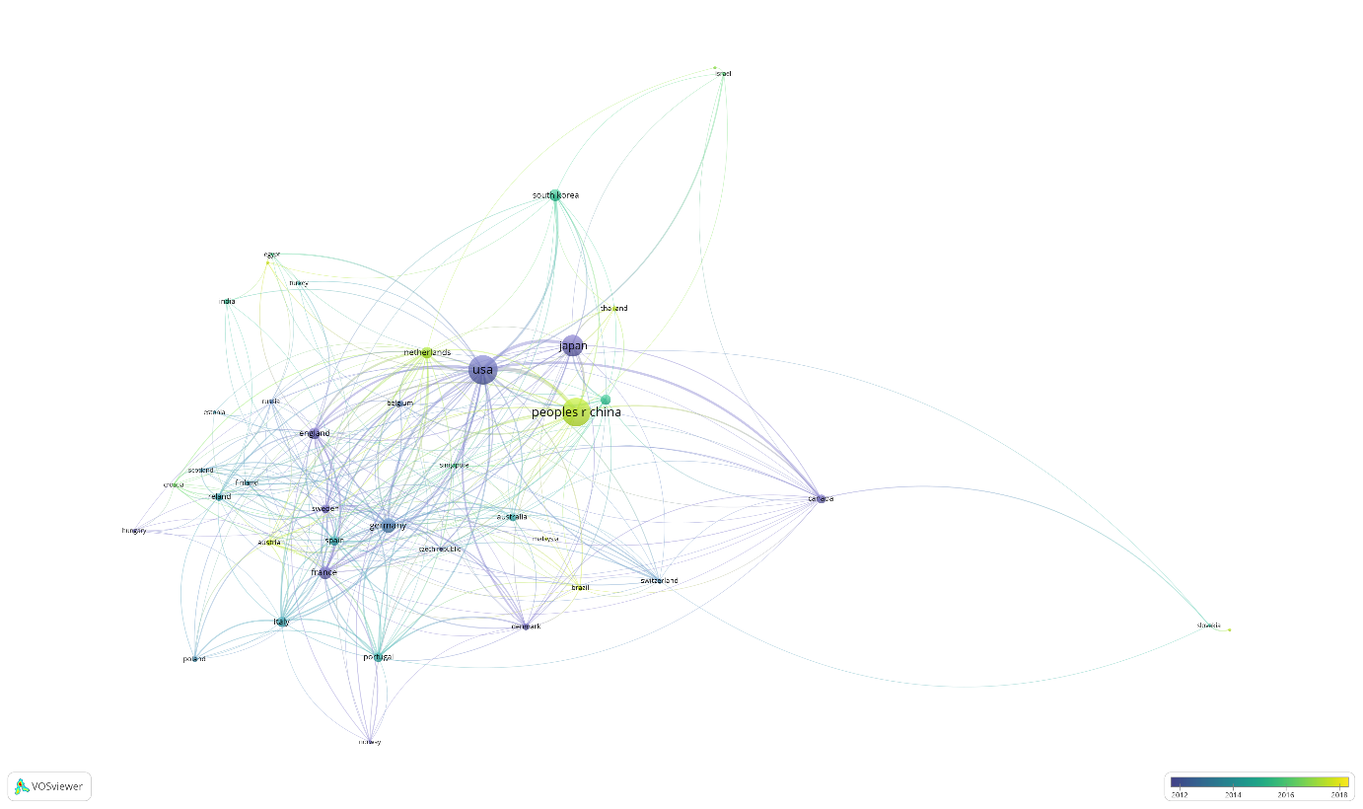
B
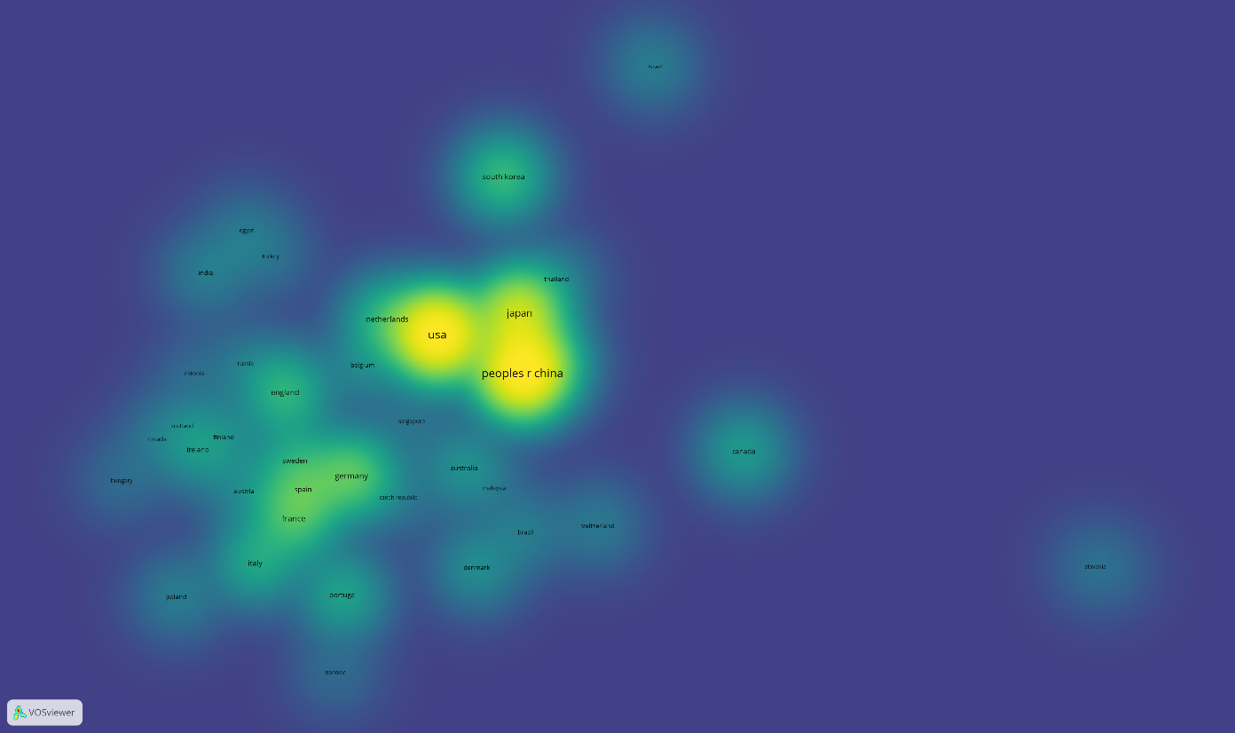
Figure 2 Collaboration network map and density map of countries. A: Collaboration network map; B: Density map.
Figure 3 A collaboration network map of institutions.
Figure 4 Collaboration map of author of research about glycosylation in cancers of digestive system.
A
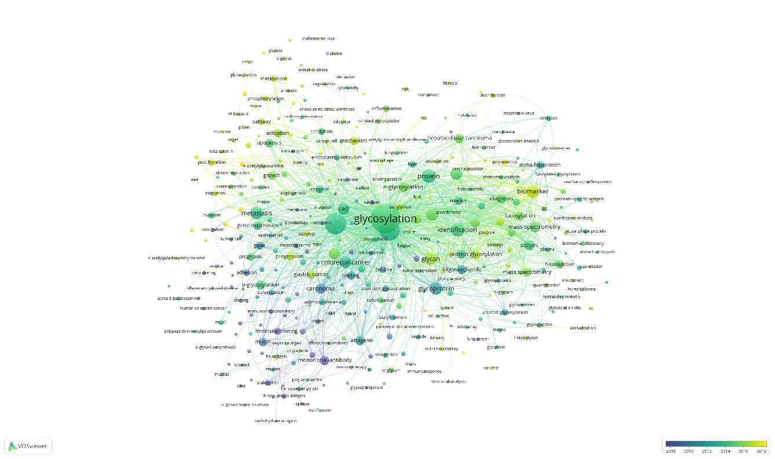
B
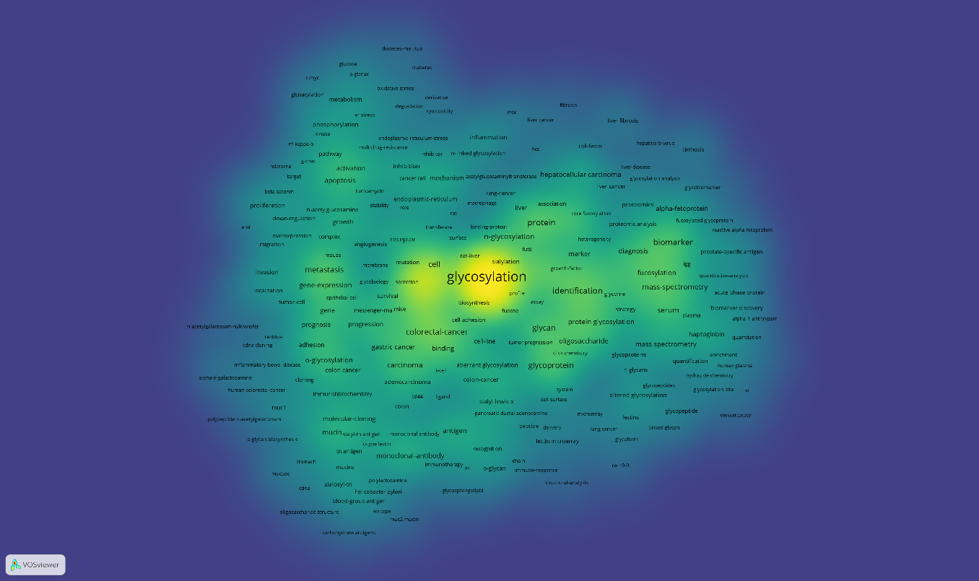
Figure 5 Collaboration network map and density map of the keyword analysis. A: Collaboration network map; B: Density map.

A
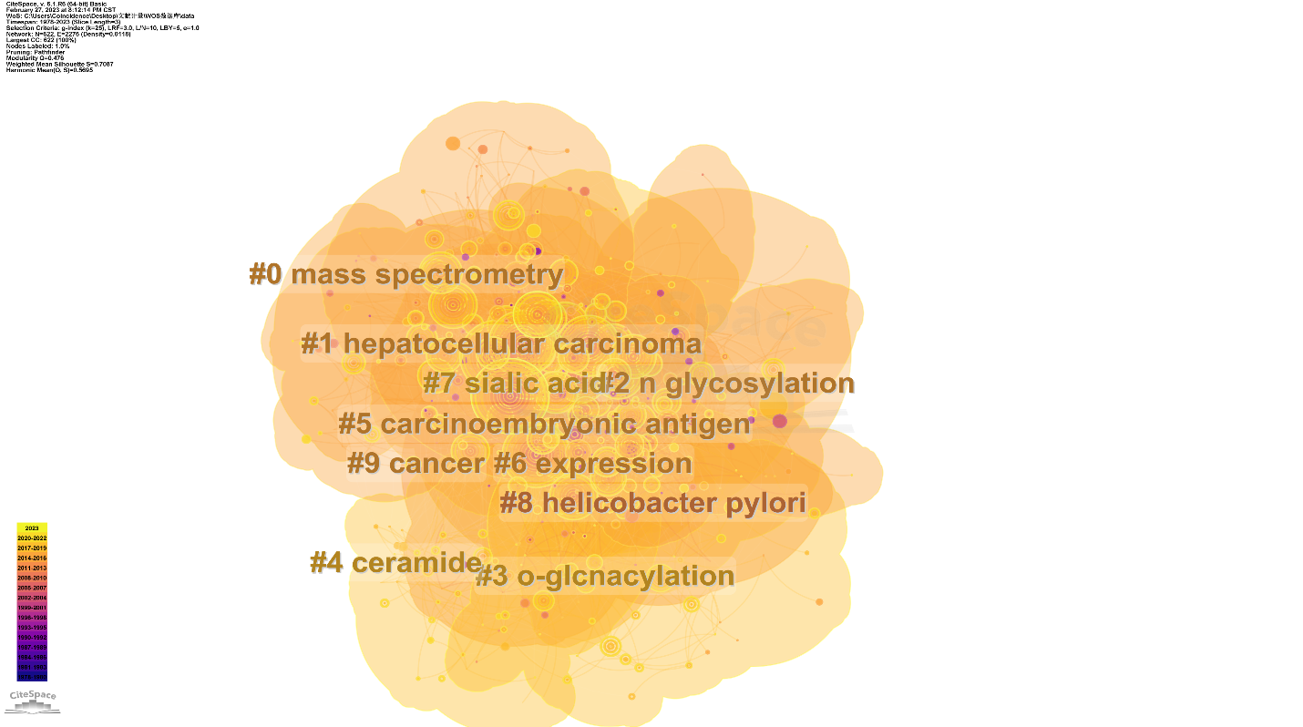
B
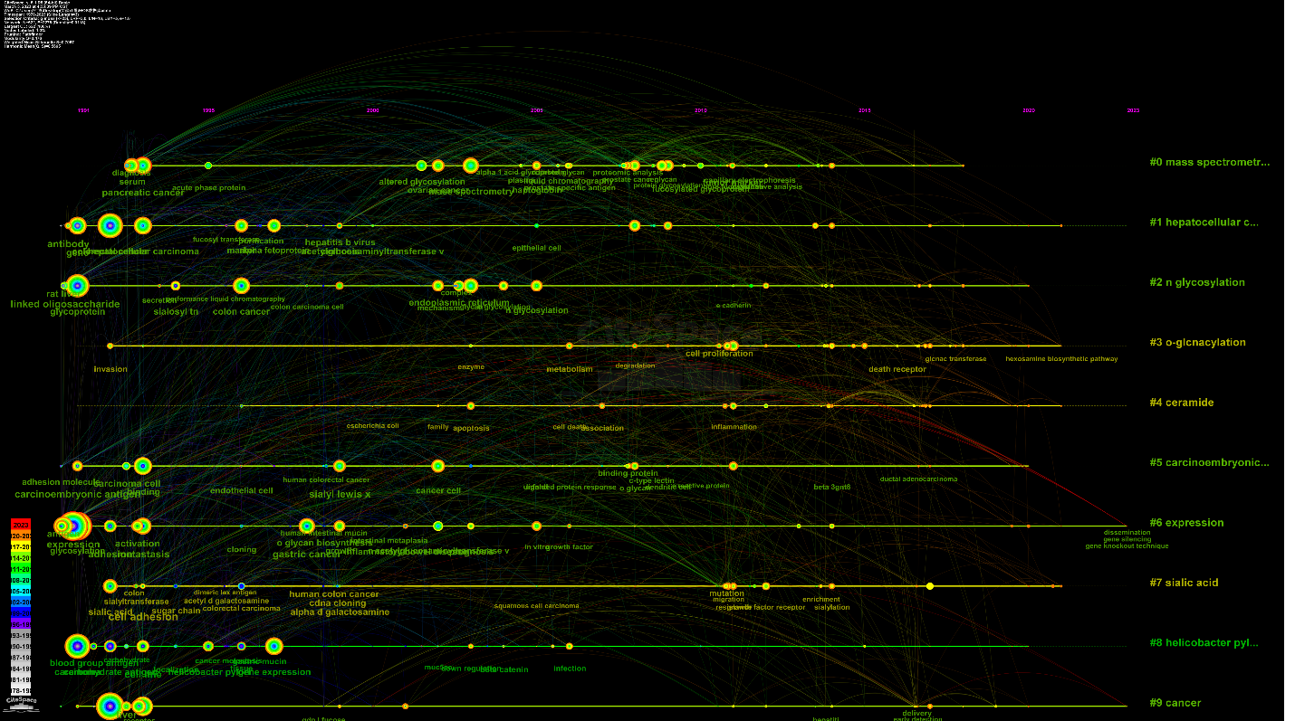
Figure 6 Network map of keyword clusters analysis and timeline view of keyword. A: Network map of keyword clusters analysis; B: Timeline view of keyword.
Top 30 Keywords with the Strongest Citation Bursts
Figure 7 Time trend of keyword burst.
Figure 8 A dual-map overlay of journals.
Top 25 References with the Strongest Citation Bursts
Figure 9 Citation bursts of references.
Table 1 List of top 10 countries publishing research on glycosylation in cancers of digestive system
Ranking | Country | Number of publications | Centrality | Citation | Average citation
1st | China | 594 | 0.01 | 12394 | 20.87
2nd | United States | 549 | 0.49 | 24676 | 44.95
3rd | Japan | 295 | 0.09 | 9797 | 33.21
4th | Germany | 135 | 0.15 | 8185 | 29.17
5th | France | 102 | 0.05 | 3938 | 37.94
6th | South Korea | 101 | 0.04 | 3870 | 37.01
7th | England | 91 | 0.24 | 3217 | 35.35
8th | Netherlands | 83 | 0.15 | 2850 | 34.34
9th | Italy | 67 | 0.03 | 2149 | 32.07
10th | Spain | 63 | 0.01 | 1776 | 28.19

Table 2 List of top 10 productive institutions related to glycosylation in cancers of digestive system
Ranking | Institution | Country | Count | Centrality
1st | Fudan University | China | 88 | 0.08
2nd | Osaka University | Japan | 56 | 0.1
3rd | University of Porto | Portugal | 51 | 0.06
4th | University of Michigan | United States | 42 | 0.08
5th | University of Chinese Academy of Sciences | China | 40 | 0.09
6th | Leiden University | Netherlands | 39 | 0.04
7th | Dalian Medical University | China | 29 | 0.01
8th | Chungnam National University | South Korea | 27 | 0.02
9th | National Institute of Advanced Industrial Science and Technology | Japan | 26 | 0.03
10th | Shanghai Jiao Tong University | China | 26 | 0.03

Table 3 List of top 10 productive and co-cited authors
Ranking | Author | Count | Centrality | Co-cited author | Count
1st | Reis CA | 39 | 0.08 | Pinho SS | 356
2nd | Wuhrer M | 35 | 0.07 | Varki A | 345
3rd | Miyoshi E | 34 | 0.07 | Hakomori S | 338
4th | Liu YK | 20 | 0 | Dennis JW | 283
5th | Peracaula R | 18 | 0.01 | Miyoshi E | 244
6th | Rudd Pauline M | 18 | 0.07 | Brockhausen I | 242
7th | Lubman David M | 17 | 0.02 | Itzkowitz SH | 198
8th | Zhang S | 17 | 0 | Dallolio F | 192
9th | Kim YS | 17 | 0 | Saldova R | 186
10th | Kamada Y | 16 | 0.02 | Ju TZ | 179

Table 4 List of top 20 keywords
Ranking | Keyword | Count
1st | Glycosylation | 697
2nd | Expression | 516
3rd | Cancer | 358
4th | Colorectal cancer | 298
5th | Pancreatic cancer | 273
6th | Hepatocellular carcinoma | 243
7th | Identification | 209
8th | Protein | 208
9th | Mass spectrometry | 193
10th | Cell | 161
11th | Glycoprotein | 153
12th | Glycan | 138
13th | Gastric cancer | 121
14th | Metastasis | 119
15th | Biomarker | 117
16th | Carcinoma | 116
17th | Monoclonal antibody | 112
18th | Protein glycosylation | 100
19th | Antigen | 98
20th | Serum | 94

Table 5 List of top 10 journals and co-cited journals
Ranking | Journal | Count | IF (2022) | Country | JCR (2022) | Co-cited journal | Citation | IF (2022) | Country | JCR (2022)
1st | Journal of Proteome Research | 69 | 5.37 | United States | Q1 | Journal of Biological Chemistry | 6042 | 5.485 | United States | Q2
2nd | Glycobiology | 64 | 5.954 | United States | Q2 | Cancer Research | 4037 | 13.312 | United States | Q1
3rd | Journal of Biological Chemistry | 48 | 5.485 | United States | Q2 | Proceedings of The National Academy of Sciences of The United States of America | 2626 | 12.779 | United States | Q1
4th | Glycoconjugate Journal | 43 | 3.009 | Netherlands | Q3 | Glycobiology | 2616 | 5.954 | United States | Q2
5th | PLoS One | 42 | 3.752 | United States | Q2 | Journal of Proteome Research | 2491 | 5.37 | United States | Q1
6th | Scientific Reports | 40 | 4.997 | England | Q2 | International Journal of Cancer | 1572 | 7.316 | Switzerland | Q1
7th | Analytic Chemistry | 34 | 8.008 | United States | Q1 | Nature | 1416 | 69.504 | United States | Q1
8th | Cancer Research | 31 | 13.312 | United States | Q1 | Analytic Chemistry | 1416 | 8.008 | United States | Q1
9th | International Journal of Molecular Sciences | 30 | 6.208 | Switzerland | Q1 | Molecular & Cellular Proteomics | 1369 | 7.381 | United States | Q1
10th | Oncotarget | 29 | 5.168 | United States | Q1 | PLoS One | 1307 | 3.752 | United States | Q2

Table 6 The top 10 co-cited references involved in research on glycosylation in digestive system tumor
Ranking | Year | Author | Journal | Title | Citation
1st | 2015 | Pinho SS | Nature Reviews Cancer | Glycosylation in cancer: mechanisms and clinical implications | 1819
2nd | 2006 | Ohtsubo K | Cell | Glycosylation in cellular mechanisms of health and disease | 1151
3rd | 2002 | Hakomori S | Proceedings of The National Academy of Sciences of The United States of America | Glycosylation defining cancer malignancy: New wine in an old bottle | 975
4th | 2006 | Okuyama N | International Journal of Cancer | Fucosylated haptoglobin is a novel marker for pancreatic cancer: A detailed analysis of the oligosaccharide structure and a possible mechanism for fucosylation
5th | 2005 | Dube DH | Nature Reviews Drug Discovery | Glycans in cancer and inflammation. Potential for therapeutics and diagnostics | 599
6th | 2005 | Fuster MM | Nature Reviews Cancer | The sweet and sour of cancer: Glycans as novel therapeutic target | 527
7th | 1989 | HAKOMORI SI | Advances in Cancer Research | Aberrant glycosylation in tumors and tumor-associated carbohydrate antigens | 505
8th | 2015 | Stowell SR | Annual Review of Pathology-Mechanisms of Disease | Protein Glycosylation in Cancer | 494
9th | 2007 | Saldova R | Glycobiology | Ovarian cancer is associated with changes in glycosylation in both acute-phase proteins and IgG | 490
10th | 2004 | Hollingsworth MA | Nature Reviews Cancer | Mucins in cancer: Protection and control of the cell surface | 464

Published by Baishideng Publishing Group Inc
7041 Koll Center Parkway, Suite 160, Pleasanton, CA 94566, USA
Telephone: +1-925-3991568
E-mail: office@baishideng.com
Help Desk: https://www.f6publishing.com/helpdesk
https://www.wjgnet.com

© 2024 Baishideng Publishing Group Inc. All rights reserved.

