Name of Journal: World Journal of Clinical Cases
Manuscript NO: 78810
Manuscript Type: ORIGINAL ARTICLE

Clinical and Translational Research
Molecular mechanisms of Baihedihuang decoction as a treatment for breast cancer related anxiety: A network pharmacology and molecular docking study

Li ZH et al. Breast cancer related anxiety

Zhong-Hui Li, Guo-Hua Yang, Fang Wang

Zhong-Hui Li, Guo-Hua Yang, Fang Wang, Department of Oncology, Wangjing Hospital, China Academy of Chinese Medical Sciences, Beijing 100102, China

Author contributions: Li ZH wrote the manuscript; Yang GH and Wang F provided key comments and revised the manuscript; all authors approved the final manuscript.

Corresponding author: Fang Wang, MD, Chief Doctor, Department of Oncology, Wangjing Hospital, China Academy of Chinese Medical Sciences, No. 6 Huajiadi Street, Chaoyang District, Beijing 100102, China. wf074500@163.com

Received: July 15, 2022
Revised: September 4, 2022
Accepted: October 12, 2022
Published online:

Abstract
BACKGROUND
The therapeutic effects of a combination of Chinese medicines called Baihedihuang decoction (BD) have been clinically verified, although its molecular targets in breast cancer related anxiety remain unknown.

AIM
To explore the molecular mechanisms of BD for breast cancer related anxiety treatment.

METHODS
We used the Traditional Chinese Medicine Systems Pharmacology database to screen the active ingredients and potential targets of BD, and constructed the "drug-ingredient-target" network map with the help of Cytoscape 3.8 software. Also, we used the Online Mendelian Inheritance in Man, DrugBank, and Gencards databases to collect the disease targets of breast cancer related anxiety, and used the STRING platform to perform protein interaction analysis and construct the protein-protein interaction network. Metascape platform was used for Gene Ontology and Kyoto Encyclopedia of Genes and Genomes pathway enrichment analysis of key targets. Molecular docking technology was used to verify the drug component/target disease network.

RESULTS
We screened 16 active ingredients of BD for breast cancer related anxiety, with 113 target proteins. There are 931 disease targets of breast cancer related anxiety, and finally, 43 key targets and 305 Kyoto Encyclopedia of Genes and Genomes pathways were generated. The main active ingredients of BD for breast cancer related anxiety are verbascoside, β-sitosterol, stigmasterol, catalpol, etc. CDK2, TP53, HTR2A, ESR1, etc. are its key targets, and the main involved signaling pathways may include neuroactive ligand-receptor interaction pathway, 5-hydroxytryptaminergic synapse, P53 signaling pathway, cGMP-PKG signaling pathway, the cAMP signaling pathway, etc. Finally, molecular docking was performed with Vina software to validate the key active ingredients in BD with the selected key action targets. The molecular docking results showed that verbascoside, β-sitosterol, stigmasterol and CDK2 could stably bind and interact through amino acid residues SER249, ARG260, PRO228, ALA282, SER276, LYS273, ASN272, etc.

CONCLUSION
The therapeutic effect of BD for breast cancer related anxiety is multi-level, multi-target, and multi-pathway. The findings of this study provide ideas and basis for further research.

Key Words: Network pharmacology; Molecular docking; Baihedihuang decoction; Breast cancer related anxiety; Mechanism of action

Li ZH, Yang G, Wang F. Molecular mechanisms of Baihedihuang decoction as a treatment for breast cancer related anxiety: A network pharmacology and molecular docking study. World J Clin Cases 2022; In press

Core Tip: Baihedihuang decoction (BD) has significant effects on breast cancer related anxiety; however, its molecular targets in this condition remain unknown. We conducted a network pharmacology and molecular docking study to determine whether BD ingredients target molecules and signaling pathways related to breast cancer related anxiety pathogenesis. The main active ingredients identified include verbascoside, β-sitosterol, stigmasterol, and catalpol. Target genes included CDK2, TP53, HTR2A, and ESR1, which are involved in cell cycle, apoptosis, cell autophagy, blood circulation, and other biological processes. Our results confirm that BD can treat breast cancer related anxiety through multi-component, multi-target, and multi-channel synergy.
INTRODUCTION
Breast cancer is one of the most common malignant tumors in American women and one of the main causes of cancer death. According to the statistics of the American Cancer Association, the prevalence and mortality of breast cancer are rising^{[1]}. Although the treatment of breast cancer has made great progress due to the development of medicine, surgery, radiotherapy, and chemotherapy for breast cancer still have a series of negative effects on women, affecting their mental state, reducing their quality of life, and causing irreparable traumatic experiences^{[2]}. Some studies have shown that nearly half of the patients with malignant tumors have anxiety and depression tendencies^{[3]}. The majority of patients with breast cancer are women, and their likelihood of anxiety and depression is higher than that of patients with other tumors. Patients with breast cancer not only have a relatively high incidence of anxiety and depression, but also have a high morbidity and mortality rate, and the morbidity and mortality rate of cancer patients with depression is 19% higher than that of cancer patients without^{[4]}. Clinical studies have shown that the incidence of depression in patients before breast cancer diagnosis is about 57%, and the incidence of depression after breast cancer surgery is about 63%. Surgical treatment can effectively improve the survival rate of patients, but due to the influences of physiological and psychological factors, postoperative patients are mostly accompanied by different degrees of depression and anxiety, with serious impacts on the survival quality of patients^{[5]}. This is harmful to the implementation of postoperative treatment plans and disease recovery^{[6,7]}. The pathogenesis of breast cancer related anxiety (BCA) is not clear, but according to animal experiments, it may involve the neurological, endocrine, and immune systems. Although there are many types of clinical drugs for the treatment of BCA, they have obvious adverse effects and poor patient compliance. In contrast, Chinese herbal medicine is effective and safe in supporting positive energy and alleviating the adverse effects of Western medical treatment, and the role of Chinese herbal medicine compounds in the treatment of BCA deserves further study^{[8]}.
The clinical treatment of BCA with Baihedihuang decoction (BD) is effective, but the related mechanism of action has been less studied. Network pharmacology is a powerful research method and it has been used in recent years to study the mechanism of action of the herbal compounding for diseases, and it also plays a non-negligible role in studying the laws of the herbal compounding and guiding the development of new drugs^{[9]}. In this study, we used network pharmacology to investigate the mechanism of anxiety effect of BD associated with breast cancer from various perspectives in order to lay a theoretical foundation for subsequent related research.

MATERIALS AND METHODS
Drug and gene data
The chemical composition of each herbal medicine in BD was searched in the Traditional Chinese Medicine Systems Pharmacology (TCMSP) database^{[10]}. According to the principle of pharmacokinetics, the compounds that meet the conditions of oral bioavailability ≥ 30% and drug likeness ≥ 0.18 should be screened, and the active ingredient-related protein targets should be found based on the TCMSP database^{[11]}. Since the chemical composition of Baihe and groundnut was altered accordingly after maceration, regaloside B, caffeate, catalpol, and verbascoside were added as active ingredients by searching the published relevant literature reports. Then, we standardized the protein target information in the Uniprot database (http://www. the Uniprot.org) and searched for their corresponding gene symbols. Finally, we used Cytoscape 3.8.1 software to construct a multi-level interaction of the herbal-compound-target" network schematic.

Screening of breast cancer-related anxiety targets
By using "breast cancer" and "anxiety" as keywords, we searched for targets in the Online Mendelian Inheritance in Man (OMIM). The disease-related targets in OMIM (http://www.omim.org), DrugBank (https://go.drugbank.com), and Genecards (https://www.genecards.org) disease gene databases were searched, and the search results were finally combined. Duplicate values were finally obtained for breast cancer-related anxiety depression targets.

Protein interaction network construction and key target screening
The STRING11.0 database (https://www.string-db.org) and Cytoscape3.8.1 software were used to construct a Protein interaction network (PPI) network map of BD-BCA targets, and then the active ingredient targets of BD and BCA were imported into Biso. The BCA targets were imported into BisoGenet, and the intersection network of the PPI networks was extracted by using the Merge function in Cytoscape. The attribute values of each node in the intersection network were analyzed, and the results were filtered step by step to obtain the key targets.

Pathway enrichment analysis
The screened targets were imported into the Metascape platform (https://metascape.org) for Gene Ontology (GO) and Kyoto Encyclopedia of Genes and Genomes (KEGG) pathway analysis. GO mainly describes the specific roles and functions of the targets, including cellular component and molecular function, and biological GO mainly illustrates the specific actions and functions of the targets, including cellular component, molecular function, and biological process. KEGG illustrates the signaling pathways of BD affecting BCA.

Molecular docking
The Program DataBase was searched for core genes to perform molecular docking experiments. The structures of the corresponding proteins were downloaded. PyMOL (version 2.4.0) software was used to remove water molecules and small ligand molecules from these receptor macromolecular structures. AutoDockTools (version 1.5.6) software was used to add polar hydrogen ions and set the grid box to determine the search range of the active pockets of the proteins, which were unknown. To include as many receptor structures as possible, the size of the active pocket had to be increased appropriately to improve the docking results. According to the core genes identified, the drug components that interacted with the core genes were sought in the constructed drug-disease network. The two-dimensional structures of these small ligand molecules were downloaded from the PubChem database, and the MM2 calculation tool in ChemBio3D (version 14.0) software was used to optimize the three-dimensional structure of the small ligand molecule with the smallest free energy. Vina software (version 1.1.2) was used to perform the docking work.

RESULTS
A total of 160 chemical components of BD were retrieved from the TCMSP database. After screening of compounds with an oral bioavailability not less than 30% and drug likeness not less than 0.18, a total of nine active ingredients were obtained. Then, after reviewing the relevant literature for supplementation, 9 active ingredients were obtained for Baihe and 7 for Dihuang (Table 1).

BD-BCA network construction
By using Cytoscape 3.8.1 software, the network diagram of 16 active ingredients of BD and their 113 targets after de-weighting was drawn, as shown in Figure 1.

BCA disease gene screening
By searching the OMIM, DrugBank, and Genecards disease databases, 931 BCA targets were obtained after screening and removing duplicate values. The number of intersections of drug targets and disease targets was 42, as shown in Figure 2.
The targets were submitted to the STRING11.0 database and Cytoscape3.8.1 software to obtain the PPI network map of BD for BCA target, as shown in Figure 3. The key targets were obtained after two screenings using BisoGenet to calculate the network topology characteristic attribute values of the intersection PPI, and the screening process is shown in Figure 4.

BD-BCA enrichment analysis
Gene enrichment analysis of the above 42 key nodes at the Metascape website included GO functional analysis, involving biological process, cellular component, and molecular function, and KEGG pathway analysis, and the top 20 Log 10 (P) values were selected from the analysis results for visualization. From the results, it can be seen that the biological processes of BD are mainly the chemical synaptic transmission process, blood circulation process, cellular response process to organic cyclic compounds, and the regulation process of postsynaptic membrane potential, as shown in Figure 5. The functions of relevant targets for BCA were mainly enriched in the molecular functions of neurotransmitter receptor activity, G protein-coupled amine receptor activity, and G protein-coupled adenosine receptor activity, and actions of relevant targets for BCA are mainly enriched in the moleculaneuroactive ligand-receptor interaction pathway, 5-hydroxytryptaminergic synapses, P53 signaling pathway, cGMP-PKG signaling pathway, and cAMP signaling pathway, as shown in Figure 6.

Molecular docking simulation of active ingredients and target genes
CDK2 was selected as the core target in the PPI core network, and stigmasterol, β-sitosterol, and verbascoside were selected as the key compounds based on the BD-BCA gene target map. Then, the screened compounds and CDK2 were molecularly docked using AutoDock Vina software, and finally visualized using PyMOL software (Figure 7). The smaller the binding energy, the higher the binding activity and the more easily the ligand binds to the receptor, and the results are shown in Table 2^{[12,13]}. The results indicate that the core target CDK2 binds better to the key compounds, stigmasterol, β-sitosterol, and verbascoside, and the predictions are relatively reliable.

DISCUSSION
Chinese medicine is an important component of complementary and alternative therapies and is more widely used in Asian countries. TCM has a diverse composition and is often useful in the treatment of various complex diseases through various biological pathways. While modern medicine has limited therapeutic effects and toxic side effects, studies have shown that TCM is more effective and safer than modern medicine in the treatment of BCA, and its use with modern therapies may also enhance its efficacy^{[14]}. Therefore, we used network pharmacology and molecular docking to explore the mechanism of action of BD for BCA to help provide a safer and more effective treatment option for BCA patients.
BD is a summary of clinical experience over the ages and is the most essential part of the great treasury of Chinese medicine. The clinical efficacy of BD with addition and subtraction in the treatment of BCA is remarkable, but the mechanism of action is still unclear. Hu et al^{[15]} found that Baihe has a sedative-hypnotic effect, which shortens the sleep latency in animal models of insomnia. Some experiments and related studies have shown that BD can exert antidepressant effects through apoptosis and neurotransmitter regulation, and also has some antitumor effects^{[16-18]}.
In this study, we screened the active ingredients of BD for the treatment of BCA through network pharmacology, mainly including verbascoside, β-sitosterol, catalpol, etc. It has been shown that sitosterol has antidepressant effects and can act on the HTR2A target by inhibiting the hyperfunction of 5-HT2A, thus inhibiting the phospholipase C system to restore the normal level of intracytoplasmic calcium ion concentration^{[19]}. β-sitosterol has anti-inflammatory and anti-tumor effects^{[20]}. Verbascoside can achieve antidepressant effects by stimulating the expression of 5-HT and DA genes and increasing the content of monoamine neurotransmitters in the brain^{[21]}. Catalpol may inhibit the apoptosis of rat hippocampal astrocytes by promoting the expression of the Bcl-2 gene and thus inhibit depressive activity^{[22]}.
The key targets are CDK2, TP53, HTR2A, ESR1, etc. The p53 protein encoded by the TP53 gene regulates cell division and proliferation, and it is also known as an "oncogene"^{[23]}. HTR2A is a common target in the neuroactive ligand-receptor interaction signaling pathway and 5-hydroxytryptaminergic synapses. It has been shown that inhibiting the function of 5-HT2A can further inhibit the phospholipase C system, thus restoring the normal level of calcium ion concentration in the cytoplasm and producing antidepressant effects^{[24]}. CDK2 is closely related to tumor development, and by selectively inhibiting the activity of CDK2, the concentration of E2F increases, which in turn leads to cell cycle arrest in the S phase or apoptosis, thus achieving the therapeutic purpose of tumor treatment^{[25,26]}. It has also been shown that CDK2 is closely related to the growth of breast cancer cells and can promote tamoxifen resistance in hormone receptor-positive breast cancer^{[27]}. The ER protein encoded by the ESR1 gene can regulate the metabolic level of estrogen by binding to the estrogen receptor, which is closely related to the level of female hormones and the development of breast cancer^{[28]}.
According to the KEGG pathway analysis, the main pathways involved in the treatment of BCA with BD include the 5-hydroxytryptaminergic synaptic pathway, P53 signaling pathway, cAMP signaling pathway, cGMP-PKG signaling pathway, etc. The 5-hydroxytryptaminergic synaptic pathway is composed of 5-hydroxytryptamine and various types of 5-hydroxytryptamine receptors on the presynaptic and postsynaptic membranes distributed in different parts of the brain, which can affect neurotransmitter releases, such as dopamine and γ-aminobutyric acid, and mediate higher brain activities such as learning, memory, and emotion, and its altered function can cause the occurrence of affective disorders such as anxiety disorders, depression, and Alzheimer's disease^{[29]}. P53 can regulate tumor development by participating in the regulation of cell signaling, induction of apoptosis, and autophagic processes. It has been shown that p53 transcriptionally up-regulates the expression of Bcl-2 family protein BAD when DNA is damaged, while p53 is carried by BAD to the outer mitochondrial membrane through interaction with BAD, and in turn increases the permeability of the outer mitochondrial membrane and induces apoptosis^{[30,31]}, which is corroborated with our derived key target TP53. Adenylate cyclase has a G-protein signaling coupling function, which catalyzes the hydrolysis of adenosine triphosphate into cAMP, activates PKA in turn, and phosphorylates a variety of target proteins^{[32]}. One study found that cAMP levels and PKA activity in the hippocampus of depressed rats were significantly lower than those in normal rats, and cAMP levels and PKA activity in CUMS depressed rats were significantly higher after administration of Baihezhiu Decoction^{[33]}. Therefore, the cAMP signaling pathway is closely related to the pathogenesis of depression. cGMP signaling pathway is involved in neuroplasticity, and its main downstream effector is protein kinase G (PKG)^{[34]}. In neuronal cells, the activation of PKG or increase in cGMP can prevent apoptosis, and the cGMP-PKG signaling pathway plays an important anti-apoptotic role^{[35,36]}. One study showed that hippocampal cGMP levels increased after 8 wk of fluoxetine and amitriptyline treatment, which in turn activated the downstream PKG-dominated cGMP signaling cascade response to exert antidepressant effects^{[34]}. This finding suggested that BD could act on the cGMP-PKG signaling pathway to exert antidepressant effects.

CONCLUSION
In summary, the active ingredients in BD, such as verbascoside, β-sitosterol, and stigmasterol, mainly act on CDK2, TP53, HTR2A, ESR1, and other key targets, thus regulating the neuroactive ligand-receptor interaction pathway, 5-hydroxytryptaminergic synapse, P53 signaling pathway, cGMP-PKG signaling pathway, cAMP signaling pathway, etc., which are involved in cell cycle, apoptosis, cell autophagy, blood circulation, and other biological processes. It has potential effects on cancer inhibition, anti-anxiety, etc. In addition, it has been demonstrated that the main active ingredients of BD can interact with the core targets, which indicates that it has the characteristics of multi-component, multi-target, and multi-pathway co-regulation. The network pharmacology approach can help to interpret and predict the targets of the Chinese medicine compound more graphically and provide new ideas for the development of new drugs. However, network pharmacology is also limited by the available database information and experimental data, and the final results cannot reflect the whole real cell network without guaranteeing the complete authenticity of the database and experimental results. To further study the treatment of BCA with BD, relevant clinical studies should be carried out based on this network pharmacology study in order to obtain stronger evidence-based medical evidence^{[37]}.

ARTICLE HIGHLIGHTS
Research background
The treatment effect of breast cancer related anxiety is not good and the side effects are obvious. The clinical effect of Baihedihuang decoction is better, but its mechanism is unknown.

Research motivation
To explore the mechanism of Baihedihuang decoction in treating breast cancer related anxiety.

Research objectives
To explore the relationship between drug targets of Baihedihuang decoction and breast cancer related anxiety disorders.

Research methods
Network pharmacology and molecular docking technology were mainly used in this study.

Research results
We screened 16 active ingredients of Baihedihuang decoction for breast cancer related anxiety, with 113 target proteins. Finally, molecular docking was performed with Vina software to validate the key active ingredients in Baihedihuang decoction with the selected key action targets. The molecular docking results showed that verbascoside, β-sitosterol, stigmasterol, and CDK2 could stably bind and interact through amino acid residues SER249, ARG260, PRO228, ALA282, SER276, LYS273, ASN272, etc.

Research conclusions
The therapeutic effect of Baihedihuang decoction for breast cancer related anxiety is multi-level, multi-target, and multi-pathway.

Research perspectives
The results of this study could serve as a fundamental basis for the further exploration in the in vitro and in vivo experiments for clinical promotions.

REFERENCES
1 Siegel RL, Miller KD, Jemal A. Cancer statistics, 2019. CA Cancer J Clin 2019; 69: 7-34 [PMID: 30620402 DOI: 10.3322/caac.21551]
2 Hajj A, Hachem R, Khoury R, Hallit S, ElJEBBAWI B, Nasr F, El Karak F, Chahine G, Kattan J, Rabbaa Khabbaz L. Clinical and genetic factors associated with anxiety and depression in breast cancer patients: a cross-sectional study. BMC Cancer 2021; 21: 872 [PMID: 34330229 DOI: 10.1186/s12885-021-08615-9]
3 Park EM, Gelber S, Rosenberg SM, Seah DSE, Schapira L, Come SE, Partridge AH. Anxiety and Depression in Young Women With Metastatic Breast Cancer: A Cross-Sectional Study. Psychosomatics 2018; 59: 251-258 [PMID: 29525523 DOI: 10.1016/j.psym.2018.01.007]
4 Endogenous Hormones and Breast Cancer Collaborative Group; Key TJ, Appleby PN, Reeves GK, Roddam AW, Helzlsouer KJ, Alberg AJ, Rollison DE, Dorgan JF, Brinton LA, Overvad K, Kaaks R, Trichopoulou A, Clavel-Chapelon F, Panico S, Duell EJ, Peeters PH, Rinaldi S, Fentiman IS, Dowsett M, Manjer J, Lenner P, Hallmans G, Baglietto L, English DR, Giles GG, Hopper JL, Severi G, Morris HA, Hankinson SE, Tworoger SS, Koenig K, Zeleniuch-Jacquotte A, Arslan AA, Toniolo P, Shore RE, Krogh V, Micheli A, Berrino F, Barrett-Connor E, Laughlin GA, Kabuto M, Akiba S, Stevens RG, Neriishi K, Land CE, Cauley JA, Lui LY, Cummings SR, Gunter MJ, Rohan TE, Strickler HD. Circulating sex hormones and breast cancer risk factors in postmenopausal women: reanalysis of 13 studies. Br J Cancer 2011; 105: 709-722 [PMID: 21772329 DOI: 10.1038/bjc.2011.254]
5 Li X, Wang Q, Wen J, Xiao Y. Effect of low-dose dexmedetomidine on intraoperative arousal in patients undergoing resection of gliomas in brain functional areas. Guangxi Yike Daxue Xuebao 2019; 36: 1254-1259 [DOI: 10.3389/fphar.2019.01509]
6 Cao M, Xu P. Effects of different chemotherapy drugs and regimens on glioma treatment. Guoji Shenjingbingxue Shenjing Waikexue Zazhi 2019; 46: 226-229 [DOI: 10.4103/glioma.glioma_26_19]
7 Miao N. Effects of cognitive behavioral intervention on fear of disease progression and negative emotion in patients with glioma. Huli Shijianyu Yanjiu 2019; 16: 134-135 [DOI: 10.1097/wnn.0000000000000215]
8 Zhang Q, Yang LN, Song HT. Traditional Chinese medicine treatment of adverse reactions of cancer radiotherapy and chemotherapy. Zhongguo Aizheng Fangzhi Zazhi 2014; 6: 208-210 [DOI: 10.4268/cjcmm20142002]
9 Chen L, Cao Y, Zhang H, Lv D, Zhao Y, Liu Y, Ye G, Chai Y. Network pharmacology-based strategy for predicting active ingredients and potential targets of Yangxinshi tablet for treating heart failure. J Ethnopharmacol 2018; 219: 359-368 [PMID: 29366769 DOI: 10.1016/j.jep.2017.12.011]
10 Ru J, Li P, Wang J, Zhou W, Li B, Huang C, Li P, Guo Z, Tao W, Yang Y, Xu X, Li Y, Wang Y, Yang L. TCMSP: a database of systems pharmacology for drug discovery from herbal medicines. J Cheminform 2014; 6: 13 [PMID: 24735618 DOI: 10.1186/1758-2946-6-13]
11 Li J, Zhao P, Li Y, Tian Y, Wang Y. Systems pharmacology-based dissection of mechanisms of Chinese medicinal formula Bufei Yishen as an effective treatment for chronic obstructive pulmonary disease. Sci Rep 2015; 5: 15290 [PMID: 26469778 DOI: 10.1038/srep15290]
12 Zhang L, Yan GH, Jiang C, Liu ZY, Guo XF, Chen CH, He LJ. Prediction of tanshinone Ⅱ by reverse molecular docking-B potential target of antiplatelet. Zhongguo Xiandai Yingyong Yaoxue 2017; 34: 221-224 [DOI: 10.21203/rs.3.rs-608336/v1]
13 Zhuang L, Zhai Y, Yao W. Study on the protective mechanism of Erzhi Pill on kidney based on network pharmacology. Yaoxue Xuebao 2019; 54: 877-885 [DOI: 10.1051/e3sconf/202124503055]
14 Gao C, Yang G, Zhang J. Clinical research progress in the treatment of cancer - related fatigue in breast cancer with traditional Chinese medicine. Beijing Zhongyiyao Xuebao 2022; 41: 585-588 [DOI: 10.1186/isrctn12702489]
15 Hu HP, Zhang J, Gan YH, Zhang HZ. Pharmacological experiments on antitussive, sedative and hypnotic effects of single fresh lily. Shizhen Guoyi Guoyao 2006; 9: 1704-1705 [DOI: 10.1001/archpsyc.63.10.1149]
16 Peng X, Yang X, Chen Y, Ding T. Study on the mechanism of Baihedihuang decoction in the treatment of depression based on the integrated pharmacology platform of traditional Chinese medicine. Zhongguo Zhongyao Zazhi 2018; 43: 1338-1344 [DOI: 10.1016/s0254-6272(12)60023-5]
17 Gao WY, Si N, Li ML, Gu XR, Zhang Y, Zhou YY, Wang HJ, Wei XL, Bian BL, Zhao HY. The integrated study on the chemical profiling and in vivo course to explore the bioactive constituents and potential targets of Chinese classical formula Qingxin Lianzi Yin Decoction by UHPLC-MS and network pharmacology approaches. J Ethnopharmacol 2021; 272: 113917 [PMID: 33609729 DOI: 10.1016/j.jep.2021.113917]
18 Zhao HQ, Liu J, Meng P, Wang YH. Effect of Baihedihuang decoction on hippocampal synaptic plasticity in rats with anxiety depression. Zhongguo Zhongyao Zazhi 2021; 46: 1205-1210 [DOI: 10.3389/fphar.2015.00251]
19 Liu XW, Xu J, Liu XQ, Zhang H. 5HT in the brain of chronic stress depression model rats_ (1A) and 5-HT_ (2A) receptor changes. Jichu Yixueyu Linchuang 2004; 2: 174-178 [DOI: 10.1111/j.1440-1819.1986.tb03146.x]
20 Xiao Z, Jia H, Liu XL. β-Research status of pharmacological activities of sitosterol. Shijie Zuixin Yixue Xinxi Wenzhai 2015; 15: 66-68 [DOI: 10.1006/phrs.2001.0907]
21 Deng HF, Sun ML, Wu Q, Chang QZ. Mullein glycoside improves depression like behavior in cums rats by regulating BDNF TrkB signaling pathway. Zhongguo Bingli Shengli Zazhi 2018; 34: 1633-1637 [DOI: 10.1039/d0fo00373e]
22 Jin QY, Wu HF, Zhang YY, Ma YY, Liu H. Effect of chronic unpredictable mild stress on apoptosis of rat hippocampal astrocytes. Anhui Yike Daxue Xuebao 2018; 53: 1226-1230 [DOI: 10.1111/ejn.15234/v1/review2]
23 Leroy B, Anderson M, Soussi T. TP53 mutations in human cancer: database reassessment and prospects for the next decade. Hum Mutat 2014; 35: 672-688 [PMID: 24665023 DOI: 10.1002/humu.22552]
24 Liu X, Xu J. Effects of antidepressants on 5-HT in the brain of chronic stress depression rats_ (1A) receptors and 5-HT_ (2A) receptor effect. Zhongguo Xingwei Yixue Kexue 2004; 6: 14-16 [DOI: 10.1080/10604450214700]
25 Tripathi SK, Muttineni R, Singh SK. Extra precision docking, free energy calculation and molecular dynamics simulation studies of CDK2 inhibitors. J Theor Biol 2013; 334: 87-100 [PMID: 23727278 DOI: 10.1016/j.jtbi.2013.05.014]
26 Bai XG, Xu LX, Li YL. Research progress of CDK2 small molecule inhibitors based on target protein the structure. Zhongguo Xinyao Zazhi 2011; 20: 1667-1672 [DOI: 10.1002/cmdc.201600636]
27 Feng J. Estrogen induced LncRNA MAFG-AS1 promotes the progression of ER positive breast cancer through mir-339-5p/cdk2 axis and mediates tamoxifen resistance. Zhonguo Yikedaxue Xuebao 2020 [DOI: 10.18632/aging.103966]
28 Pei J. Association between ESR gene polymorphism and breast cancer and meta analysis. Anhui Yikedaxue Xuebao 2014 [DOI: 10.1007/s10549-009-0690-9]
29 Köhler S, Cierpinsky K, Kronenberg G, Adli M. The serotonergic system in the neurobiology of depression: Relevance for novel antidepressants. J Psychopharmacol 2016; 30: 13-22 [PMID: 26464458 DOI: 10.1177/0269881115609072]
30 Hu WL, Wu M. Research and progress on the function of p53 in tumorigenesis. Zhongguo Kexue:Shengming Kexue 2017; 47: 52-58 [DOI: 10.1360/n052016-00363]
31 Jiang P, Du W, Heese K, Wu M. The Bad guy cooperates with good cop p53: Bad is transcriptionally up-regulated by p53 and forms a Bad/p53 complex at the mitochondria to induce apoptosis. Mol Cell Biol 2006; 26: 9071-9082 [PMID: 17000778 DOI: 10.1128/MCB.01025-06]
32 Xiang H, Gao Y, Liu SB. Compound chaigui formula supercritical CO2 Study on antidepressant mechanism of extract regulating cAMP signaling pathway. Zhongcaoyao Zazhi 2019; 50: 3368-3373 [DOI: 10.4268/cjcmm20141429]
33 Li DS, Yuan L, Liu Q. Effect of Baihe Zhimu Decoction on cyclic adenosine monophosphate signaling pathway in rats with depression. Wuhan Daxue Xuebao(Yixueban) 2015; 36: 867-871 [DOI: 10.1016/j.jep.2021.114586]
34 Reierson GW, Guo S, Mastronardi C, Licinio J, Wong ML. cGMP Signaling, Phosphodiesterases and Major Depressive Disorder. Curr Neuropharmacol 2011; 9: 715-727 [PMID: 22654729 DOI: 10.2174/157015911798376271]
35 Fiscus RR. Involvement of cyclic GMP and protein kinase G in the regulation of apoptosis and survival in neural cells. Neurosignals 2002; 11: 175-190 [PMID: 12393944 DOI: 10.1159/000065431]
36 Andoh T, Chiueh CC, Chock PB. Cyclic GMP-dependent protein kinase regulates the expression of thioredoxin and thioredoxin peroxidase-1 during hormesis in response to oxidative stress-induced apoptosis. J Biol Chem 2003; 278: 885-890 [PMID: 12414792 DOI: 10.1074/jbc.M209914200]
37 Zhou WXR, Cheng X, Zhang YX. Network pharmacology: a new concept of understanding drugs and discovering drugs. Zhongguo Yaolixueyu Dulixue Zazhi 2012; 26: 4-9 [DOI: 10.1002/jcph.1972.12.issue-10]

Footnotes

Conflict-of-interest statement: All authors declare that there is no conflict of interest regarding the publication of this paper.

Data sharing statement: Technical appendix, statistical code, and dataset available from the manuscript.

Open-Access: This article is an open-access article that was selected by an in-house editor and fully peer-reviewed by external reviewers. It is distributed in accordance with the Creative Commons Attribution NonCommercial (CC BY-NC 4.0) license, which permits others to distribute, remix, adapt, build upon this work non-commercially, and license their derivative works on different terms, provided the original work is properly cited and the use is non-commercial. See: https://creativecommons.org/Licenses/by-nc/4.0/

Provenance and peer review: Unsolicited article; Externally peer reviewed.
Peer-review model: Single blind

Peer-review started: July 15, 2022
First decision: August 21, 2022
Article in press:

Specialty type: Medicine, research and experimental
Country/Territory of origin: China
Peer-review report’s scientific quality classification
Grade A (Excellent): 0
Grade B (Very good): B, B
Grade C (Good): C, C
Grade D (Fair): 0
Grade E (Poor): 0

P-Reviewer: Arumugam VA, India; Odhar HA, Iraq S-Editor: Wang LL L-Editor: Wang TQ P-Editor: Wang LL

Figure Legends
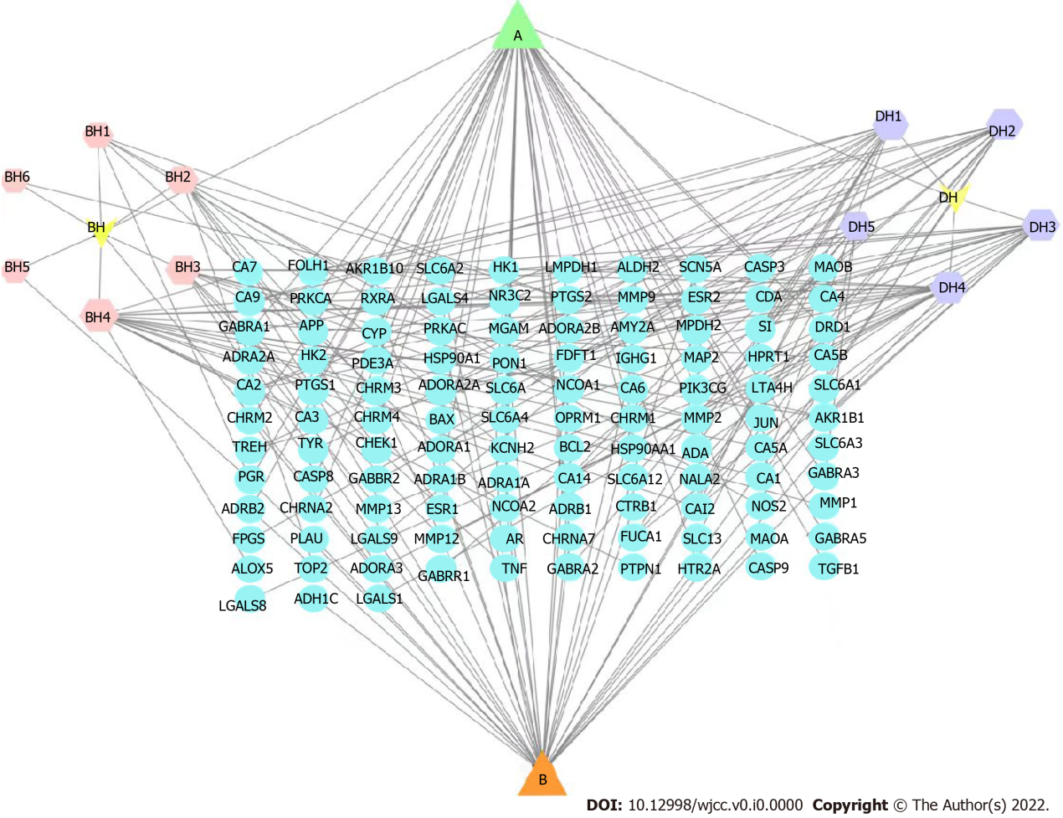
Figure 1 Baihedihuang decoction-breast cancer related anxiety network. The hexagon indicates the drug component, red represents Baihe, and purple represents Dihuang. The light green circles represent the gene targets. The triangles represent common components.

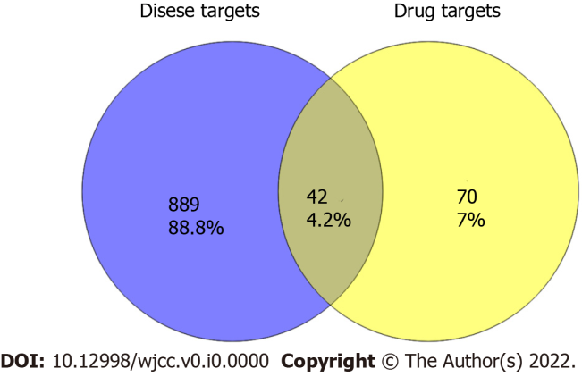
Figure 2 Baihedihuang decoction-breast cancer related anxiety intersection genes. The gene intersection between breast cancer related anxiety-related genes and the predicted targets of Baihedihuang decoction active ingredients represents the targets of Baihedihuang decoction in breast cancer related anxiety.

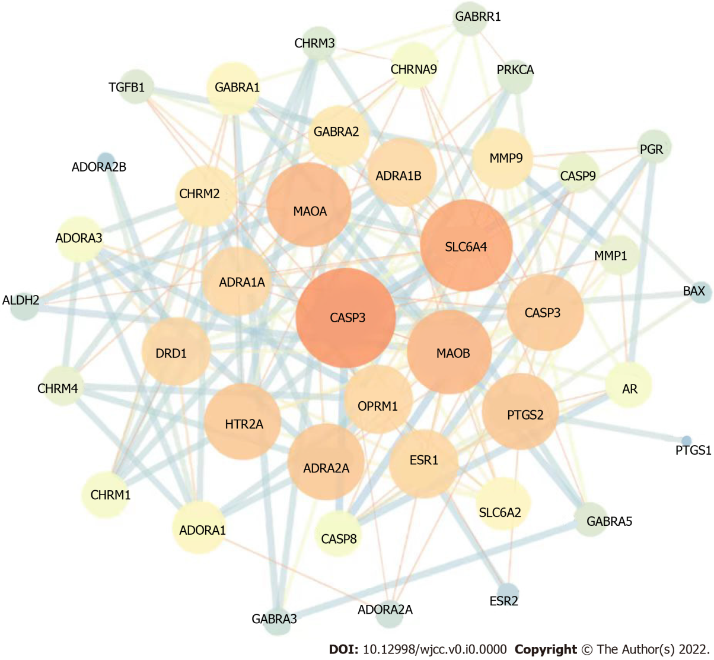
Figure 3 Baihedihuang decoction-Breast cancer related anxiety protein-protein interaction network. Lines of different colors and thicknesses represent different ways of proving the protein interaction relationship between nodes.

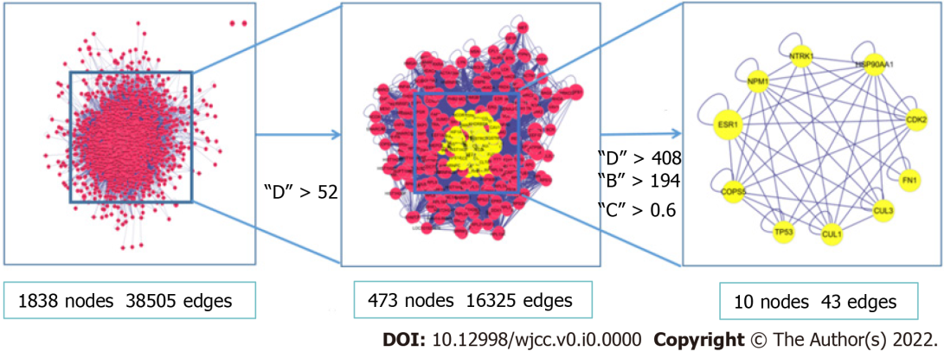
Figure 4 Diagram of the screening process of key nodes. The nodes for which all values exceeded the median were retained in the protein interaction network (PPI) network diagram. The filter conditions were as follows: D > 52. This secondary PPI network contained 30 nodes and 147 edges. The calculation was repeated with the following filter conditions: D > 408, B > 194, C > 0.6. The obtained core PPI network comprised 10 nodes and 47 edges. D: Connectivity centrality; C: Tightness centrality; B: Mesocentricity.

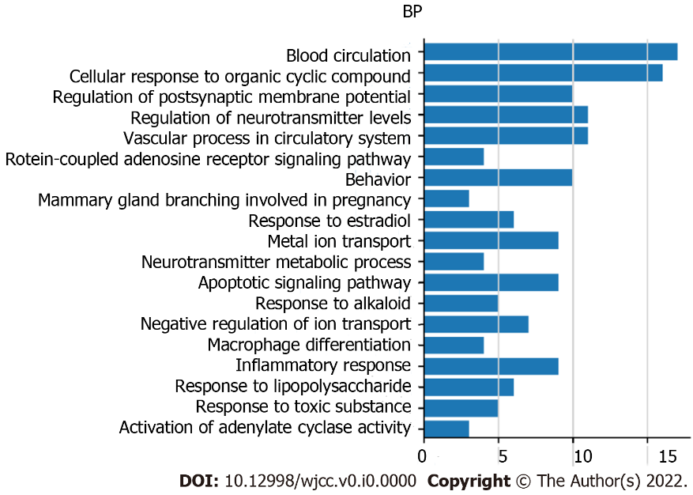
Figure 5 Biological process functional analysis. Biological process gene enrichment analysis of the above 42 key nodes was performed at the Metascape website, and the top 19 Log10 (P) values were selected from the analysis results for visualization. BP: Biological process.

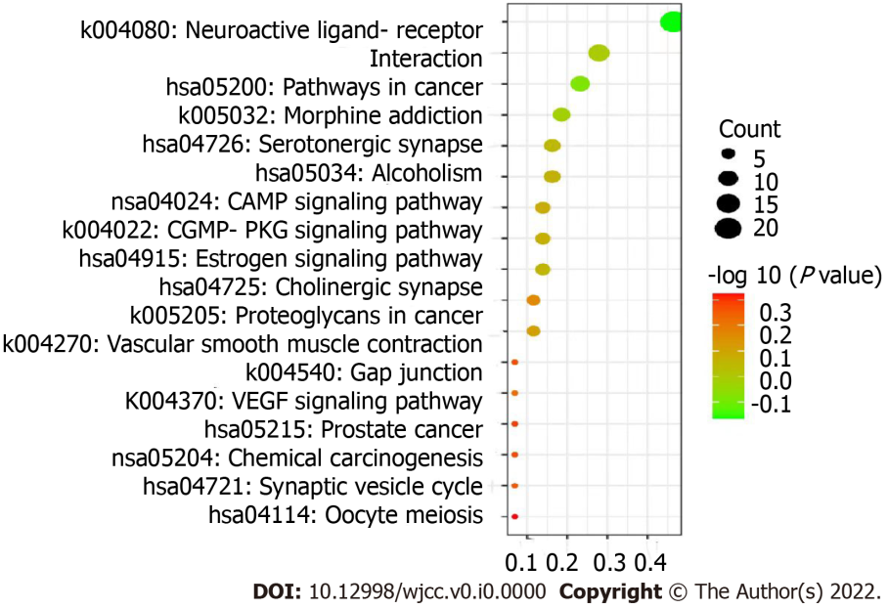
Figure 6 Kyoto Encyclopedia of Genes and Genomes pathway enrichment analysis. In the bubble chart, the ordinate is the name of the biological process or pathway, the abscissa is the proportion of genes, the size of the bubble represents the number of genes enriched in each gene ontology, and the color represents the significance of the enrichment.

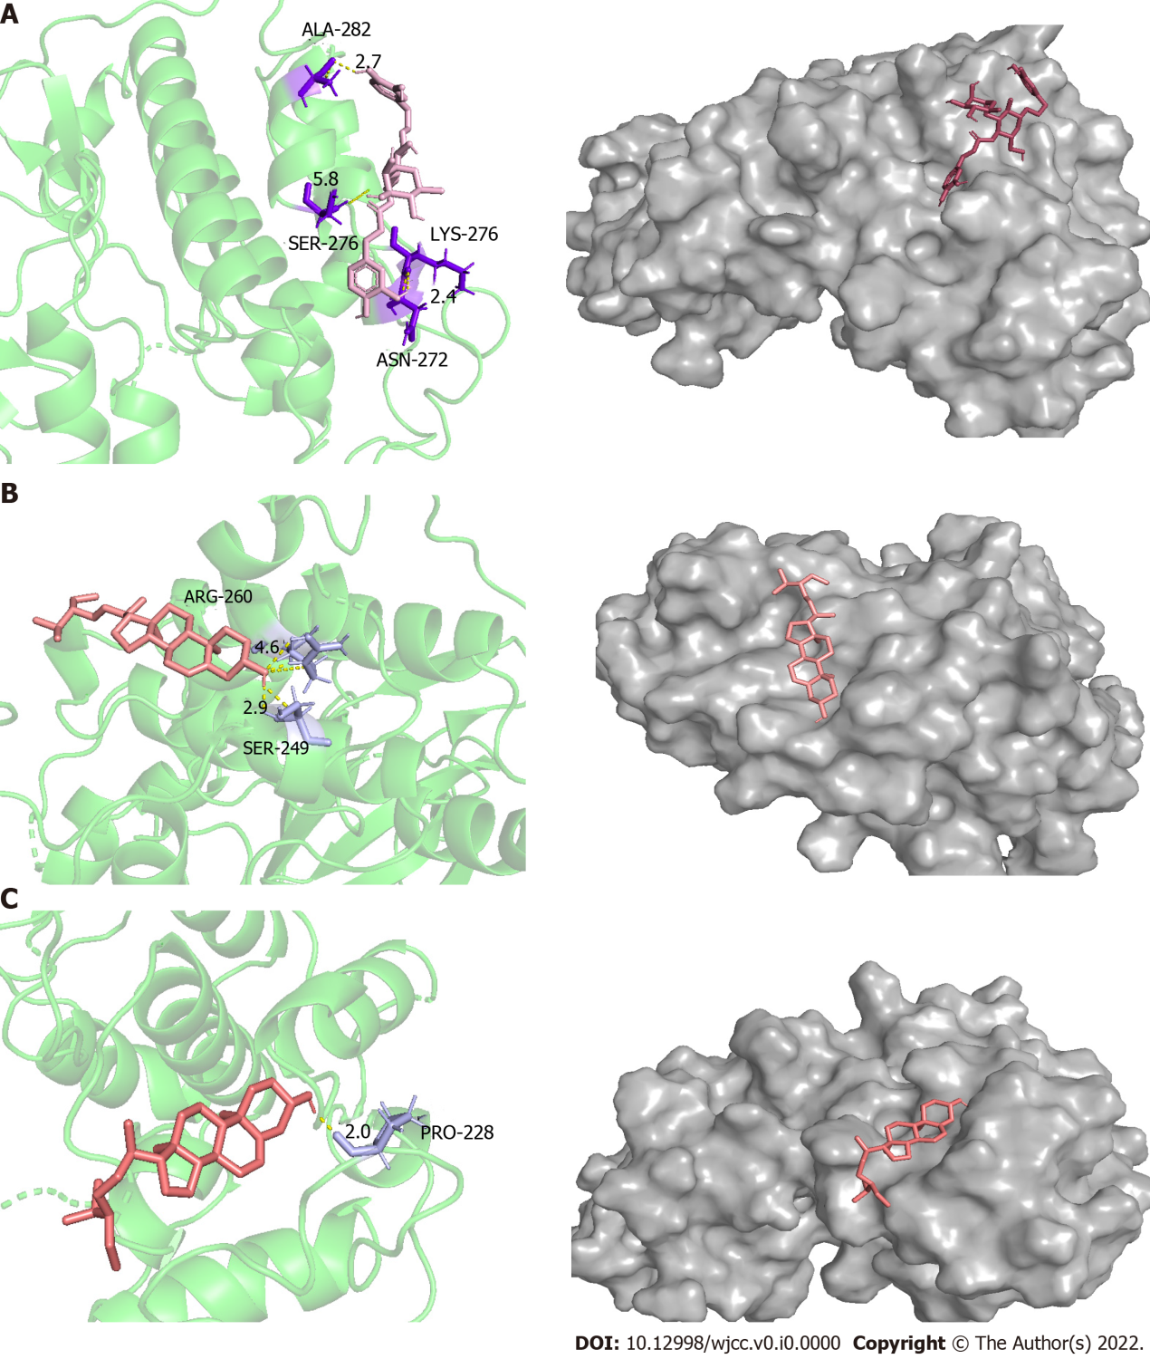
Figure 7 Docking models of the main active ingredients and core targets. A: Docking models of verbascoside and CDK2; B: Docking models of stigmasterol and CDK2; C: Docking models of β-sitosterol and CDK2.

Table 1 Active ingredients of Baihedihuang decoction
Herb name | Mol ID | Compound | OB | DL
Baihe | MOL002039 | Isopimaric acid | 36.2 | 0.28
 | MOL000449 | Stigmasterol | 43.83 | 0.76
 | MOL000358 | β-sitosterol | 36.91 | 0.75
 | MOL009449 | 26-O-beta-D-Glucopyranosyl-3beta | 32.43 | 0.8
 | MOL009458 | 3-Demethylcolchicine | 39.34 | 0.57
 | MOL009465 | 26-dihydroxy-5-cholesten-16 | 35.11 | 0.81
 | MOL009471 | 26-dihydroxy-cholestan-16 | 32.43 | 0.8
 | MOL009481 | Regaloside B | 15.63 | 0.51
 | MOL000414 | Caffeate | 54.97 | 0.05
Dihuang | MOL000449 | Stigmasterol | 43.83 | 0.76
 | MOL000358 | β-sitosterol | 36.91 | 0.75
 | MOL002819 | Catalpol | 5.07 | 0.44
 | MOL003690 | Ajugol | 16.87 | 0.32
 | MOL003333 | acteoside | 2.94 | 0.62
 | MOL000388 | Gamma-aminobutyric acid | 24.09 | 0.1
 | MOL003730 | Rehmannioside A | 25.95 | 0.87
Mol: Molecular; ID: Identification; OB: Oral bioavailability; DL: Drug-like properties.

Table 2 Molecular docking of key compounds and core targets
Compound | Target point | Combined energy (kJ·mol-1) | Number of hydrogen bonds | Hydrogen bonding residue(s)
Stigmasterol | Cyclin-dependent kinases-2 | -6.3 | 2 | SER249  ARG260
β-sitosterol | Cyclin-dependent kinases-2 | -7.3 | 1 | PRO228
Verbascoside | Cyclin-dependent kinases-2 | -7.2 | 4 | ALA282 SER276 LYS273 ASN272

