Predicting EARly outcomes of Liver transplantation in Young children: the EARLY study.

Authors: Rashid Alobaidi MD, Natalie Anton MD, Dominic Cave MD, Elham Khodayari Moez MSc, Ari R Joffe MD
Affiliations: Department of Pediatrics, Division of Pediatric Critical Care Medicine, University of Alberta and Stollery Children’s Hospital, Edmonton, Alberta, Canada; and School of Public Health, University of Alberta, Edmonton, Alberta, Canada.
Journal: World Journal of Hepatology
Additional File 1.Joffe (pdf)
Table S1. Descriptive variables pre-liver transplant, n=65.
Table S2. Descriptive variables at time of liver transplant in the operating room, n=65.
Table S3. Description of care the pediatric intensive care unit after liver transplant: n=65.

Table S4. Description of outcomes after liver transplant: n=65, survivors n=60.

Table S5. Outcomes after pediatric liver transplant using time period as a categorical variable.
Table S6. Outcomes after pediatric liver transplant using weight as a categorical variable.

Figure S1. Graphical representation of the relationship between the primary outcome post-operative ventilator days and the lowest anti-thrombin day 2-5 post-operative pediatric liver transplant.
Figure S2. Graphical representation of the relationship between the severe complication outcome and the lowest anti-thrombin day 2-5 post=operative pediatric liver transplant.

Figure S3. Graphical representation of the relationship between the any thrombosis outcome and the lowest anti-thrombin day 2-5 post-operative pediatric liver transplant.
Figure S4. Graphical representation of the relationship between the outcome 6-month first graft survival and the lowest anti-thrombin day 2-5 post-operative pediatric liver transplant.

Table S1. Descriptive variables pre-liver-transplant: n=65
Variable | Mean (SD); Median [IQR], n (%) | Details
Age (mos) | 11.9 (7.1); 9 [7-13.5]; range 3-35
Weight (kg) | 8.5 (2.1); 7.8 [7.1-9.4]; range 5.7-14.6
Weight category (≤7kg) | 15 (23%)
Height (n=63) | 69.7 (8.8); 68 [63-74]
Growth Failure (<5th) | 34 (52%)
Albumin | 29 (5.5); 28 [25 - 32]
PELD | 24 (12); 23 [16 – 31]
Encephalopathy | 12 (18%) | Moderate- 6 (9%); Severe- 6 (9%)
Indication: Biliary Atresia | 40 (62%) | Metabolic- 9 (14%); ALF- 5 (8%); Cholestasis- 7 (11%); Other- 4 (6%)
Previous Kasaiª | 34/38 (90%) | at age (n=26): 9.4 (2.8); 9 [7.8-12]
Year of Surgery | 2010.1 (3.1); 2010 [2008 – 2013]
2005-2010 [vs 2011-2015] | 37 (57%)
2005-Nov 2013 [vs Dec 2013-2015] | 48 (74%)
PELD: pediatric end-stage liver disease score; ALF: acute liver failure.
a. Within the biliary atresia group, previous Kasai, and Kasai age were not statistically associated with any of the primary or secondary outcomes.
Table S2. Descriptive variables at time of liver transplant in the operating room: n=65

Variable | Mean (SD), Median [IQR], n (%) | Details
Surgeon | 1- 29 (45%); 2-21 (32%); 3- 15 (23%)
Graft type | Whole- 15 (23%); Reduced size/split- 21 (32%); Living related- 29 (45%)
Surgery duration (n=59) | 430 (118); 405 [340 – 480]
Cold ischemic time (n=54) | 238 (200); 158 [71-393]
Warm ischemic time (n=55) | 43 (35); 36 [31-44]
Fluid in operating room: data available for n=53
Packed red cells | 44 (83%) | n=44: 32 (22); 26 [17-40] ml/kg
Frozen plasma | 28 (53%) | n=28; 61 (108);39 [21-70] ml/kg
Platelets | 8 (15%) | n=8; 32 (19); 26 [19-48] ml/kg
Cryoprecipitate | 4 (8%) | -
5% Albumin | 29 (55%) | n=29; 43 (27); 35 [20-65] ml/kg
Crystalloid | 40 (75%) | n=40; 71 (35); 63 [51-92] ml/kg
Comments in dictated operation notes
Hepatic artery | 21 (32%); Small vessels- 13 (20%); Vessel abnormality- 9 (14%)
Hepatic vein | Small vessels- 1 (2%); vessel abnormality- 3 (5%)
Portal vein | Small vessel- 20 (31%); vessel abnormality- 1 (2%); vessel clot- 6 (9%)
Biliary anatomy | Abnormal- 8 (12%)
Any comment | 39 (60%)
Artery vascularity | End-to-end anastomosis- 57 (88%); graft- 8 (12%)
Fascia closed | 44 (68%)

Table S3. Description of care the pediatric intensive care unit after liver transplant: n=65.

Variable | Mean (SD), Median [IQR], n (%) | Details
Measures of fluid status
First day negative balance (n=54) | 3.5 (1.7); 3 [2-5]
Furosemide used | 54 (83%)
First day use of furosemide (n=54) | 4.3 (5.2); 2 [2-4]
Lowest CVP day 1 (n=54) | 5.0 (2.4); 5 [3-7]
Lowest CVP day 2-5 (n=52) | 4.0 (3.0); 3 [2-6]
Highest Hemoglobin day 1 | 108 (11); 107 [100-117]
Highest Hemoglobin day 2-5 | 102 (13); 99 [92-109]
Measures of coagulation
Heparin used | 62 (95%)
Heparin started (hrs) n=62 | 13.3 (21.9); 3.5 [0-17.3]
Heparin therapeutic level obtained | Yes- 43 (66%); Never- 19 (30%); N/A- 3 (5%)
Heparin therapeutic level day n=43 | 4.5 (3.1); 4 [2-6]
Heparin therapeutic level by day 3 | 20 (31%)
Any other anticoagulant | 32 (49%) | Includes dipyridamole (29), dextran (2), and/or ASA (2)
Lowest Antithrombin day 1 n=49 | 36 (14); 36 [25-45] | Often not measured
Lowest Antithrombin day 2-5 n=62 | 39 (15); 37 [31-47]
Time to INR <2 (hrs) n=64 | 19 (33); 0 [0-34]
CVP: central venous pressure.

Table S4. Description of outcomes after liver transplant: n=65, survivors n=60.
Outcome | Mean (SD), Median [IQR], n (%) | Details
Length of stay outcomes
Ventilator days (n=60) | 12.5 (14.1); 7 [3-16.8]
PICU days (n=60) | 21 (21); 15 [6-25]
Hospital days (n=60) | 66 (46); 48 [33-86]
Reintubations (n=63) | 18 (29%)
Readmission to PICU | 5 (8%)
Complications
Mortality in PICU | 5 (8%)  Liver failure- 3 (60%); MODS- 1 (20%); Other- 1 (20%) | HAT; HAT and PVT; HAT and Hemorrhage; MODS; Primary graft failure. On days 3, 5, 6, 33, and 41. At 6 months: 7 (11%).
PICU Re-transplant | 9 (14%) | 1/9 had 2 re-transplants
PICU Graft survival | 52 (80%) | Of 65 first grafts
6 month graft survival | 51 (78%) | Of 65 first grafts
Reoperation | 33 (51%)ª | Number: 2.6 (2.4); 2 [1-4]; range 1-8
First re-operation | 33 (51%) | Day: 4.0 (3.1); 2.5 [2-6.8]; range 1-11
Second re-operation | 18 (28%) | Day: 7 (4); 6.5 [4-9]; range 1-16
Any infection | 38 (59%)
Bacteremia | 5 (8%) | On day 3 [3-10]; range 2-30
Urinary tract | 18 (28%) | On day 6 (7); 3 [1-9]
VAP | 21 (32%) | On day 6 (5); 3 [2-11]
URTI viral | 8 (12%) | On day 7 (9); 2 [1-11]
Intra-abdominal | 18 (28%) | On day 8 (4); 8 [4-12], range 1-15. Bowel perforation 5 (29%); bile leak 4 (24%); fluid collection 6 (35%); hematoma 2 (12%).
Any thrombosis | 19 (29%)
HAT | 12 (19%) | On day 4 (3); 3 [2-7], range 1-10. 10 treated in OR [3 thrombectomy; 7 re-transplant], 1 died prior to going to OR.
Hepatic vein stenosis | 2 (3%)
PVT | 11 (17%) | 9 treated in OR [7 thrombectomy (2 were after re-transplant); 2 re-transplant], 1 died prior to re-transplant.
Surgical complication
Bile leak | 15 (23%): 3 only from liver cut surface | On day 8 (7); 7 [2-12], range 1-24. 12 treated in OR.
Chylothorax | 9 (14%)
Bowel perforation | 5 (8%)
Other complications
AKI (RIFLE creatinine) | 21 (32%) | Dialysis-9 (14%); for 23 (38), 6 [3-29] days.
Hypertension | 8 (12%) | All on medical treatment
Any severe complication | 32 (49%) | Any one of: HAT, PVT, bile leak, bowel perforation, intra-abdominal infection, re-transplant, death.
AKI: acute kidney injury; HAT: hepatic artery thrombosis; OR: operating room; PICU: pediatric intensive care unit; PVT: portal vein thrombosis; RIFLE: risk, injury, failure, loss of kidney function, end-stage kidney diseases classification system); VAP: ventilator associated pneumonia; URTI: upper respiratory tract infection.
a. Indications for re-operation (excluding closure of fascia, or broviac insertion) include dictated OR report describing: intra-abdominal bleeding 7 (11%); compartment syndrome 8 (12%); biliary repair; PVT; HAT; bowel perforation 5; re-transplant 9.

Table S5. Outcomes after pediatric liver transplant using time period as a categorical variable.

Time Period (categorical) | HAT | Any thrombosis | Severe complication | Ventilator days | Mortality | Graft Survival | Heparin therapeutic level by d3 | Weight category
1 (2005-2010) | 6/37 (16%) | 12/37 (32%) | 20/37 (54%) | 12.4 (13.2) | 3/37 (8%) | 28/37 (76%) | 11/37 (30%) | 9/37 (24%)
2 (2011-2015) | 6/28 (21%) | 7/28 (25%) | 12/28 (43%) | 12.7 (15.4) | 2/28 (7%) | 24/28 (86%) | 9/28 (32%) | 6/28 (21%)
p-value | 0.75 | 0.59 | 0.46 | 0.95 | 0.99 | 0.37 | 0.99 | 0.99
Fisher’s exact test, or independent samples t-test, as appropriate. On multiple logistic regression (graft survival [p=0.069], severe complications [p=0.093], any thrombosis [p=0.499], HAT [p=0.869]), and multiple linear regression (ventilator days [p=0.705]), year category is not significant.

Table S6. Outcomes after pediatric liver transplant using weight as a categorical variable.

Weight category | HAT | Any thrombosis | Severe complication | Ventilator days | Mortality | Graft Survival | Heparin therapeutic level by d3 | Year category 2011-2015
1 (>7kg) | 8/50 (16%) | 12/50 (24%) | 24/50 (48%) | 10.5 (13.2) | 2/50 (4%) | 43/50 (86%) | 15/50 (30%) | 22/50 (44%)
2 (≤7kg) | 4/15 (27%) | 7/15 (47%) | 8/15 (53%) | 20.4 (15.2) | 3/15 (20%) | 9/15 (60%) | 5/15 (33%) | 6/15 (40%)
p-value | 0.45 | 0.11 | 0.78 | 0.03 | 0.08 | 0.06 | 0.99 | 0.99
Fisher’s exact test, or independent samples t-test, as appropriate. On multiple logistic regression (graft survival [p=0.290], severe complications [p=0.338], any thrombosis [p=0.530], HAT [p=0.913]) and multiple linear regression (ventilator days [p=0.106]), weight category is not significant.

Figure S1. Graphical representation of the relationship between the primary outcome post-operative ventilator days and the lowest anti-thrombin day 2-5 post-operative pediatric liver transplant.

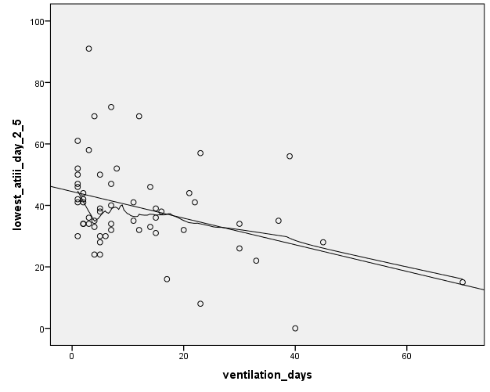

Figure S2. Graphical representation of the relationship between the severe complication outcome and the lowest anti-thrombin day 2-5 post-operative pediatric liver transplant.

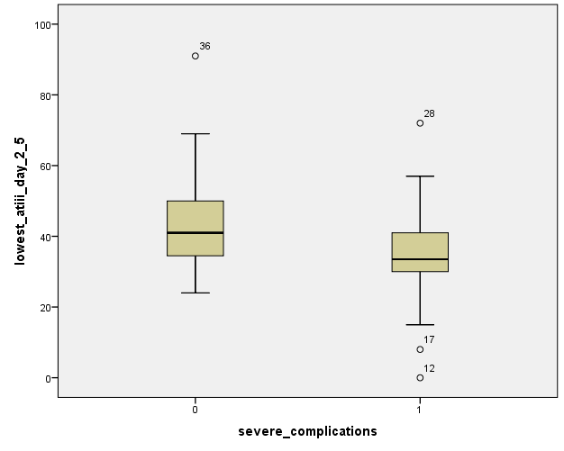

Figure S3. Graphical representation of the relationship between the any thrombosis outcome and the lowest anti-thrombin day 2-5 post-operative pediatric liver transplant.

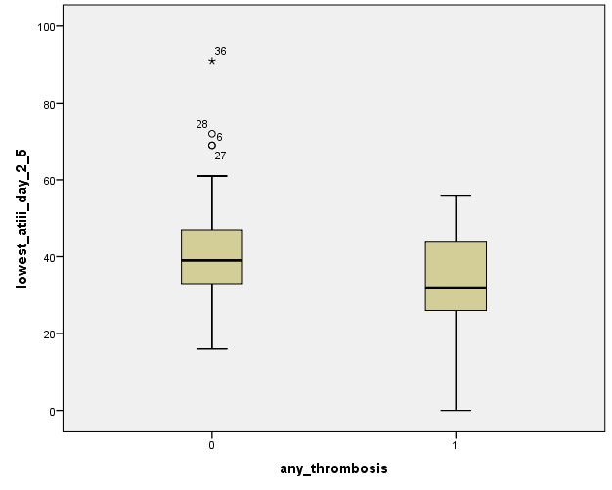
Figure S4. Graphical representation of the relationship between the outcome 6-month first graft survival and the lowest anti-thrombin day 2-5 post-operative pediatric liver transplant.

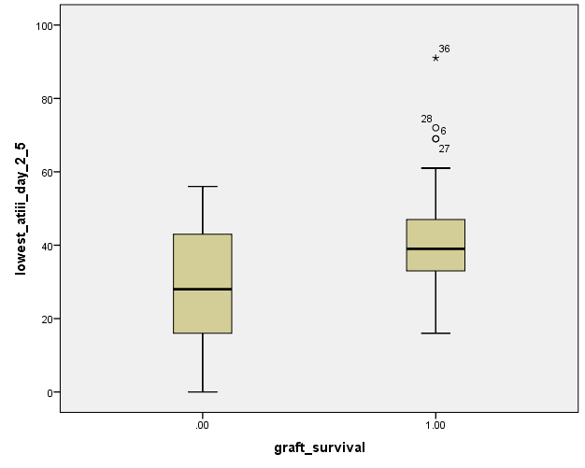

Predicting EARly outcomes of Liver transplantation in Young children: the EARLY study.

Authors: Rashid Alobaidi MD, Natalie Anton MD, Dominic Cave MD, Elham Khodayari Moez MSc, Ari R Joffe MD
Affiliations: Department of Pediatrics, Division of Pediatric Critical Care Medicine, University of Alberta and Stollery Children’s Hospital, Edmonton, Alberta, Canada; and School of Public Health, University of Alberta, Edmonton, Alberta, Canada.

Additional File 2.Joffe (pdf)

Journal: World Journal of Hepatology

File: The EARLY study case report form, and detailed variable definitions.

Case#
Year: _________________
Age (months): | Gender: □ M □ F
Weight:  %tile: | Height:  %tile: |  | Albumin:
Growth failure: below 5th percentile for either weight or height: Y/N
Indication for liver transplant:
□ Biliary atresia Previous Kasai: Y/N
Age at Kasai (mos):
□ Metabolic Specify:

□Acute Liver Failure Etiology:

□ Other Cholestasis Specify:

□Others Specify:

PELD Score: |  | Encephalopathy:  □ none/mild □ mod □severe

Graft type:
□ whole □ Reduced-size □ Split □Living-related
Surgeon: 1, 2, or 3:
Surgery duration: | Cold ischemic time:  Warm ischemic time:
Comments in OR note dictated by surgeon:  i) Hepatic artery:  Small  Abnormal  ii) Biliary Anatomy:  Abnormal | iii) Hepatic vein:  Small  Abnormal  iv) Portal Vein:  Small  Abnormal  Clot
Artery vascularity:  □ graft □ end-end | Abdomen (fascia) closed on admission to PICU:  □ yes □ No
Blood products as reported in anesthesia record or OR dictated report (ml/kg):

□ PRBC = □FFP =

□Albumin = □Cryoprecipitate =

□Platelets =

Heparin infusion started (hr): Therapeutic level attained (hr):
(Day):
INR < 2 (hr): | Other anticoagulant (hr): - Dipyridamole:  - Dextran:  - ASA:

First Day of recorded –ve balance: | Day first use of Furosamide:
Lowest CVP: d1:  d2-5: | Highest Hb: d1:  d2-5:
Lowest ATIII: d1:
d2-5:

PICU duration (days): | Ventilation time (days):
Mortality in 30 days: □yes □ No Cause:____________________________________
Postop day of death: ________________________

Infections:
□ Bacteremia

Day: Source:
□ UTI
Day:
□ VAP ETT aspirate:
Day:
□ URTI
Day:
□ Intra-abdominal
Source: perforation, bile leak, fluid collection
Day:

Complications:
□ Primary non-function □Re-transplant Survival: □yes □No
Day:
□ HAT: □OR □ Thrombolytics □Heparin □Re-transplant
Day:
□ HVT: □OR □ Thrombolytics □Heparin □Re-transplant
Day:
□ PVT: □OR □ Thrombolytics □Heparin □Re-transplant
Day:
□ Biliary Leak OR: □ Yes □ No
Day:
□ Chylothorax
Day:
□ AKI
Day:
Dialysis: yes or no.
□ HTN Treatment: □ Yes □ No
Day of treatment started:
□ Seizures Treatment: □ Yes □ No
Day:

□ Reoperation  Indication:  Day: | □ Re-transplant:  Indication:  Day:

Appendix: Study definitions

Definitions:

- Pediatric End-Stage Liver Disease (PELD) Score: calculated using the worst values within one month prior to transplant.
- PLED is a severity staging system for pediatric liver transplant candidates. It will be used to adjust for severity of illness prior to transplant.
- PELD score = 0.480 × Log_{e} (bilirubin mg/dL) + 1.857 × Log_{e} (INR) - 0.687 × Log_{e} (albumin g/dL) + 0.436 if patient is < 1 y (scores for patients < 1 y listed for liver transplantation; continue to include the value assigned for age of < 1 y until the patient is actually aged 2 y) + 0.667 if the patient has growth failure (<-2 standard deviation) × 10 (then round to the nearest whole number).
- An electronic tool will be used to calculate the score. The tool is available on US Department of Health and Human Services website: PELD: http://optn.transplant.hrsa.gov/resources/allocation-calculators/peld-calculator/
and
http://reference.medscape.com/calculator/peld-score-end-stage-liver-disease

- Encephalopathy Status:
- West Haven classification system will be used to label patients as either none/mild, moderate or severe.
- None/Mild is equivalent to Grade 0 and Grade I
- Moderate is equivalent to Grade II and Grade III
- Severe is equivalent to Grade IV
- The labeling will be based on clinical information obtained from patient chart.
- Clinical signs and symptoms warranting labeling patient with moderate encephalopathy:
- Somnolence, lethargy, apathy, drowsiness
- Disorientation, confusion
- Inappropriate behavior, slurred speech
- Patients with Coma will be labeled as severe.

- Acute kidney Injury:
- Patients will be labeled as having kidney injury as per RIFLE criteria if:
- GFR decreased > 50%, or increase creatinine x 2

- Hypertension:
- Blood pressure higher than 95%tile for age and height.
- Using parameters from the fourth report on the diagnosis, evaluation, and treatment of high blood pressure in children and adolescents. By the National High Blood Pressure Education Program Working Group on High Blood Pressure in Children and Adolescents. Pediatrics. Aug 2004

- Cold ischemic time:
The time between organ procurement, including cooling in perfusion solution and until after the organ reaches physiological temperature during implantation procedure. This is time from cross clamp of aorta in donor until liver is placed in the recipient.

Warm ischemic time:
The time from the liver being brought onto the operative field of the recipient, to when the portal vein is unclamped. This is the time from being placed in the recipient until the liver is reperfused.

- Heparin therapeutic level:
Anti Xa level between 0.3 to 0.6 units/ml plasma.

- Intrabdominal thrombosis: HAT, PVT
Based on finding from any of:
- Ultrasound report
- Angiogram report
- O.R. observations as recorded in OR dictation of surgeon

- Chylothorax:
Pleural fluid has:
- Triglycerides > 1.1 mmol/L, and
- Lymphocyte fraction > 80%

- Bacteremia:
- Single positive blood culture of non-skin flora organisms
- Two positive blood cultures of same potentially normal skin flora (coagulase negative Staphylococcus, Corynebacterium).

- Urinary tract infection (UTI):
Defined as culture growth of more than 10^5 cfu/ml of a single pathogen from in/out catheter or Foley catheter.

- Upper respiratory tract infections:
Based on positive nasopharyngeal aspirate by DFA or PCR

- Ventilator associated pneumonia (VAP):
Patients who have the following criteria:
- Fever > 38.3
- New or persistent CXR infiltrate
- Respiratory status changes (increased FIO2 requirements, respiratory rate or ventilator pressures), AND
- Clinician treatment with antibiotics for 5 days or more

- Intra-abdominal infection:
Based on positive cultures from:
- O.R. abdominal samples
- Fresh drainage tube
- AND Clinician treatment with antibiotics for 5 days or more

- Re-operation indication: excluding operation only to close fascia or insert broviak.
  - As recorded in the OR dictation of the surgeon. Included are: intra-abdominal bleeding; compartment syndrome; perforation; infection; thrombosis; bile leak; other. This criterion was to have as conservative an estimation as possible.

- Biliary leak:
  - Based on OR dictation report of the surgeon (if treated in OR), or HIDA scan (if not treated in OR).

- Comments about HA, HV, PV, or Biliary anatomy:
  - As recorded in the OR dictation report of the surgeon.

- Dealing with re-transplant (during the index PICU stay) data:
  - Outcomes: total ventilation days will include the total ventilation time during that PICU admission (i.e., including time after re-transplant). Complications will also include the entire PICU stay (i.e., including time after re-transplant).
    - Rationale: most re-transplants are for thrombosis, and thus dealing with the complications this way will not affect analyses for risk factors for severe complications, or thrombosis.
  - Predictors: will be those of the first transplant (i.e., weight, PELD, indication for transplant, graft type, surgeon, anatomy comments, and variables on d1 and d2-5).
    - Rationale: we are looking for potentially modifiable predictors of outcomes, and these would be what was present with the first transplant (i.e. before the outcome of the first transplant was known to require a re-transplant).

