Name of Journal: World Journal of Clinical Cases
Manuscript NO: 51881
Manuscript Type: ORIGINAL ARTICLE

Case Control Study
Oncogenic role of Tc17 cells in cervical cancer development

Zhang ZS et al. Tc17 cells affect cervical cancer development

Zun-Sheng Zhang, Ying Gu, Bing-Gang Liu, Hong Tang, Yu Hua, Jun Wang

Zun-Sheng Zhang, Ying Gu, Bing-Gang Liu, Hong Tang, Yu Hua, Jun Wang,
Department of Obstetrics and Gynecology, Shanghai Seventh People’s Hospital, Shanghai 200120, China

ORCID number: Zun-Sheng Zhang (0000-0002-9013-5536); Ying Gu (0000-0002-6499-6738); Bing-Gang Liu (0000-0001-8927-5200); Hong Tang (0000-0002-5933-8909); Yu Hua (0000-0002-8230-2920); Jun Wang (0000-0002-3726-3125).

Author contributions: Zhang ZS and Gu Y designed research; Tang H and Hua Y performed research; Liu BG analyzed data; Wang J wrote the paper.

Institutional review board statement: This study was reviewed and approved by the Shanghai Seventh People’s Hospital Ethics Committee.

Informed consent statement: All patients in our study provided informed consent.

Conflict-of-interest statement: The authors declare no conflict of interest.

STROBE statement: The authors have read the STROBE Statement-checklist of items, and the manuscript was prepared and revised according to the STROBE Statement-checklist of items.

Data sharing statement: No additional data are available.

Open-Access: This article is an open-access article which was selected by an in-house editor and fully peer-reviewed by external reviewers. It is distributed in accordance with the Creative Commons Attribution Non Commercial (CC BY-NC 4.0) license, which permits others to distribute, remix, adapt, build upon this work non-commercially, and license their derivative works on different terms, provided the original work is properly cited and the use is non-commercial. See: http://creativecommons.org/licenses/by-nc/4.0/

Manuscript source: Unsolicited manuscript

Corresponding author: Jun Wang, MSc, Attending Doctor, Department of Obstetrics and Gynecology, Shanghai Seventh People’s Hospital, No. 358, Datong Road, Gaoqiao Town, Pudong New Area, Shanghai 200120, China. wanchuang3069629@163.com
Telephone: +86-18560073105
Fax: +86-21-58670000

Received: October 7, 2019
Peer-review started: October 7, 2019
First decision: November 13, 2019
Revised: November 18, 2019
Accepted: November 30, 2019
Article in press:
Published online:

Abstract
BACKGROUND
As one of the subsets of CD8+ T cells, Tc17 cell has recently been identified that is characterized by the secretion of interleukin (IL)-17 and is related to inflammatory diseases.

AIM
To assess the status of Tc17 cells in cervical cancer and investigate the biological function of Tc17 cells in modulation of cancer development.

METHODS
Flow cytometry assay, immunohistochemistry, and immunofluorescence were used to detect the levels and phenotype of Tc17 cells in blood and tumor samples from patients with cervical cancer. Before to cell suspension culture, ELISA detection assay was utilized to measure the production levels of IL-6, IL-1β, IL-23, CXCL12, and IL-17 in tumor tissue supernatant and co-cultured supernatant of patients with cervical cancer. Additionally, we performed multivariate analysis to identify factors associated with overall survival using the Cox proportional hazards model.

RESULTS
Compared with normal tissues, Tc17 cells were specially accumulated in tumor tissues of cervical cancer patients. Cancer cells produced a greater amount of IL-6, IL-1β, and IL-23, which in turn promoted Tc17 cell polarization. Unlike the traditional cytotoxic CD8+ T cells, Tc17 cells secreted IL-17, which subsequently promotes CXCL12 expression in tumor cells, eventually enhancing the proliferation and migration of tumor cells. Accordingly, the ratio of tumor-infiltrating Tc17 cells is highly correlated with poor clinical outcome of patients with cervical cancer.

CONCLUSION
Our data identify the oncogenic role of Tc17 cells in cervical cancer development. We propose that the ratio of Tc17 cells can be a useful index in the prognosis of patients with cervical cancer.

Key words: cervical cancer; Tc17 cells; Interleukin-17; cancer development; biological function; oncogenic role

© The Author(s) 2019 Published by Baishideng Publishing Group Inc. All rights reserved.

Core tip: Inflammation contributes to cancer development. Here we find that cervical cancer-elicited inflammation increases Tc17-polarizing cytokine production, which attenuates the cytotoxic CD8+ T cell development. The high amount of interleukin-17 production by Tc17 cells leads to CXCL12 upregulation and cancer cell migration. Consistent with the oncogenic role of Tc17 cells in cancer development, the ratio of cancer-infiltrating Tc17 is highly associated with poor prognosis of patients with cervical cancers. Our data thus demonstrate that Tc17 cells can be induced in cervical cancers and serve as a meaningful index in the prognosis of patients with cervical cancer.

Zhang ZS, Gu Y, Liu BG, Tang H, Hua Y, Wang J. Oncogenic role of Tc17 cells in cervical cancer development. World J Clin Cases 2019; In press

Introduction
As the fourth world-wide malignant tumor, the incidence of new cervical cancer is about 130000, accounting for 28% of the total number of cases in the world. About 20000 women die of cervical cancer each year^{[1,2]}. Tumor progression has been recognized as the product of evolving crosstalk between immune cells and tumor cells. Through affecting immune cell activation or differentiation, cancer cells escape from host immune attack and enhance tumor resistance to immunotherapies^{[3,4]}.
As the primary component of tumor-infiltrating lymphocytes, T cells elicit crucial effector function in cancer eradication. Recent studies showed that T cells that produce interleukin (IL)-17 are detected in human tumors, which have a certain pro-inflammatory effect^{[3]}. On the one hand, Th17 cell polarizing factor may induce differentiation and proliferation of Tc17 cells, despite exhibiting reduced the cytotoxic activity of CD8⁺ T cells, thereby interrupting host immune surveillance^{[5,6]}. Moreover, on a monkey immunodeficiency virus infection model of mammals such as macaques and black-and-white marmosets, Tc17 cells play a pathological role in promoting disease progression^{[7,8]}. However, the role of Tc17 cells in human cervical cancer development remains unclear.
A large number of Tc17 cells were found in black and white monkey tumor tissues, which were induced by the cytokine IL-23^{[8]}. At the same time, other studies have shown that IL-6 may also be crucial for Tc17 cell differentiate^{[9]}. However, it is unclear whether other cytokines can induce Tc17 cell differentiation and how Tc17 cells affect reciprocally cancer development are still poorly understood.
In this study, we showed that Tc17 cells are highly enriched within cervical cancer tissue. Cervical cancer cells produced a great amount of IL-6, IL-1β, and IL-23, which induces Tc17 cell polarization. Increased levels of IL-17 induced by Tc17 cells leads to CXCL12 upregulation in tumor cells, resulting in tumor cell proliferation and migration. Moreover, the percentage of Tc17 cells are associated with tumor progression and clinical outcome of patients with cervical cancers. Our data demonstrate the oncogenic role of Tc17 cells in cancer development and provide a theoretical basis for the clinical treatment of cervical cancer.

MATERIALS AND METHODS

Patients and tissue specimen
Fresh blood, tumor, peritumoral, or matched adjacent tissues (at least 5 cm distant from the tumor site) were obtained from patients with cervical cancer who underwent surgical resection at the Shanghai Seventh People’s Hospital. None of these patients had received chemotherapy or radiotherapy before sampling. Individuals with autoimmune disease, infectious diseases, and multi-primary cancers were excluded. Blood from healthy donors was used for control experiments. The clinical stages of tumors were determined according to the TNM classification system of the International Union Against Cancer.

Isolation and stimulation of tumor cells
Fresh tissues were washed 3 times with Hank’s solution containing 1% fetal calf serum before being cut into small pieces. The specimens were then collected in RPMI 1640 containing 1 mg/mL collagenase IV and 10 mg/mL deoxyribonuclease I and mechanically dissociated using the gentle MACS Dissociator (Miltenyi Biotec, Bergisch Gladbach, Germany). Dissociated cell suspensions were further incubated for 1 hour at 37 °C under continuous rotation. The cell suspensions were then filtered through a 70 μm cell strainer (BD Labware, Bedford, MA, United States). Then, part of cells used for flow cytometry to detect the number of Tc17 cells, another cells were cultured with IL-17 (0-10 ng/mL), IL-22 (0-10 ng/mL), interferon (IFN)-γ (0-10 ng/mL), IL-17 plus IL-22, or 100% Tc17 cell-polarizing culture for 48 hours. The culture supernatants were harvested for ELISA.

In vitro monocyte-T-cell co-culture system
Peripheral blood mononuclear cells from cervical cancer patients were isolated by Ficoll density gradient centrifugation. Fresh peripheral blood CD8⁺ T cells were selected using positive isolation and negative isolation kits, respectively. In a 5- d incubation, bead-puriWed peripheral CD8⁺ T cells were co-cultured with autologous blood monocytes at 2:1 ratio in the presence or absence of recombinant human IL-6 (10 ng/ml), IL-1β (10 ng/ml) and IL-23 (10 ng/ml) in 200 μL RPMI 1640 medium supplemented with 10% FCS. After 5-d incubation, the supernatants were harvested for ELISA and the cells for intracellular cytokine staining.

Flow cytometry analysis
For detection of the intracellular molecule, T lymphocytes were stimulated for 5 h with phorbol myristate acetate (50 ng/ mL) plus ionomycin (1 μg/mL) in the presence of GolgiStop (BD Pharmingen, San Diego, CA). Intracellular cytokine staining was performed after fixation and permeabilization using Perm/Wash solution (BD Pharmingen). The lymphocytes were analyzed by multicolor flow cytometry with FACSCanto II (BD Biosciences). Data were analyzed with FlowJo software (TreeStar, Ashland, OR) or FACSDiva software (BD Biosciences).

Immunohistochemistry assay
Paraformaldehyde-fixed and paraffin-embedded samples were cut into 5 μm sections, which were incubated with rabbit anti-IL-17 antibody and stained by horseradish peroxidase anti-rabbit immunoglobulin G followed by diaminobenzidine. They were then incubated with mouse anti-CD8 antibody and stained using EnVision G2 System/AP Rabbit/Mouse (Permanent Red) (Dako, Glostrup, Denmark) and subsequently counterstained with hematoxylin. Slides were examined using an Olympus 71 inverted fluorescence microscope.

Immunofluorescence
Immunofluorescence was performed as described with minor modifications^{[10]}. In detail, Paraformaldehyde-Waxed cryostat sections of tumor tissues were washed in PBS and blocked for 30 min with 20 % rabbit serum in PBS. Sections were incubated with goat antihuman IL-17 antibody (Ab) diluted in 5 % rabbit serum. The bound Ab was detected with FITC-conjugated rabbit anti-goat Ab. After washing with PBS, sections were blocked for 30 min with 20% goat serum in PBS and incubated with mouse anti-human CD8 Ab diluted in 5% goat serum. The bound Ab was detected with TRITC-conjugated goat anti-mouse Ab. After washing with PBS, slides were examined with an Olympus 71 inverted fluorescence microscope.

ELISA
Cervical cancer tissues or their matched adjacent normal tissues were homogenized in 1 mL Protein Extraction Reagent (Rockford, IL, United States). Concentrations of IL-6, IL-1β, and IL-23 in the tissue supernatants; concentrations of CXCL12 in the coculture supernatants or tissue supernatants; and concentrations of IL-17 in the coculture supernatants were determined using ELISA kits according to the manufacturer’s instructions.

Statistical analysis
Comparisons between data groups were performed as stated in each figure legend in which the use of was GraphPad Prism ver.6. p < 0.05 was considered a significant difference between groups. The resulting data were presented as mean ± SE.

RESULTS

Tc17 cells specially accumulate in tumor tissues of cervical cancer patients
To assess the status of Tc17 cells in human cervical cancer tissues, we isolated immune cells from cancer tissues, matched adjacent normal tissues as well as peripheral blood. Compared with healthy donors, the percentage of Tc17 cells in the periphery blood from patients with cervical cancers were identical (Figure 1A). Of note, we found that Tc17 cells were selectively induced in tumors as relative to their matched adjacent normal tissues (Figure 1A). To further confirm this result, we analyzed the distribution of Tc17 cells in the paracancerous stroma, carcinoma nets, and intra-tumor sites. The results showed that Tc17 cells accumulated in all these sites, especially in carcinoma nets and intra-tumor sites (Figure 1B-D). Our data thus identify that Tc17 cells are specially induced under oncogenic role.

Cervical cancer cells produce a greater amount of Tc17-polaring cytokines
Previous studies reveal that IL-6, IL-1β, and IL-23 are essential for Tc17 cell differentiation^{[11,12]}. To investigate the mechanism of cervical cancer in the modulation of Tc17 cell development, we assessed the levels of Tc17-polarizing cytokines in cancer-associated tissues. As expected, the concentrations of IL-6, IL-1β, and IL-23 were significantly increased in peritumoral and intra-tumor tissue as relative to their matched normal tissues or peripheral blood (Figure 2A-C). Our data thus indicate that tumor-derived cytokines play a stimulatory role in the modulation of Tc17 polarization.

IL-6, IL-1β, and IL-23 acts synergistically to enhance Tc17 cell differentiation
To evaluate the potential role of these cytokines in Tc17 cell differentiation, we isolated peripheral blood CD8⁺ T cells and autologous blood monocytes of cervical cancer patients. After 5-day co-culture incubation, the supernatants were harvested for ELISA and the cells for intracellular cytokine staining. The results showed that the provision of exogenous IL-6, IL-1β, and IL-23 significantly increased the frequency of Tc17 cells either alone or in combination compared with coculture without any cytokine added (Figure 3A and B). In addition, ELISA results showed that IL-17 production was consistent with the percentage of Tc17 cells (Figure 3C). These findings showed that IL-6, IL-1β, and IL-23 acts synergistically to induce Tc17 cell polarization in vitro and suggest that a similar process might operate in vivo.

Tc17 cell-derived IL-17 promoted CXCL12 expression in tumor cells
To investigate the biological function of Tc17 cells in cervical cancer development, we isolated primary tumor cells and stimulated them with variable concentrations of IL-17, IL-22, IFN-γ, production of CXC12 was detected in the culture supernatants by ELISA. As shown in Figure 4A, CXCL12 expression in cancer cells was increased upon IL-17stimulation, while IL-22 or IFN-γ exhibited little effects on CXCL12 upregulation in cancer cells (Figure 4A). Moreover, unlike the co-culture supernatants from blood or nontumor tissue monocyte, TAM-derived Tc17 cell culture supernatants selectively induced CXCL12 production in cancer cells (Figure 4B). The effects on CXCL12 upregulation can be attenuated by anti– IL-17 neutralizing antibody but not anti–IL-22 neutralizing antibody (Figure 4B). These findings suggested that Tc17 cell–derived IL-17 induced chemokine CXCL12 production by tumor cells.

Tumor-infiltrating Tc17 cells are related to the poor outcome of patients with cervical cancer
Since CXCL12 upregulation drives cancer development, we thus assess the relationship between the number of Tc17 cells and the survival rate of patients with cervical cancer. We firstly analyzed the number of Tc17 cells per million total cells in each tissue of patients in different TNM stages. The results showed that as cancer progressed, the number of Tc17 cells significantly increased in each of the tested tissues (Figure 5A). Conversely, patient survival significantly reduced (Figure 5A and B). Simultaneously, we analyzed Tc17 cell percentage within the total CD8⁺ T cells in same samples, as cancer progressed, we found that the percentage of Tc17 cells significantly increased in these tested tissues, and negatively associated with patient survival (Figure 5C and D). These findings suggested that the number of Tc17 cells was related to the survival rate of patients, thereby predicting the clinical outcome of patients with cervical cancer.

DISCUSSION
Although Tc17 cell-mediated immune regulation has been studied in tumor progression from mouse or black-and-white monkey^{[13]}, the mechanism of Tc17 cells in human cervical cancer was rarely reported. In this study, we found that Tc17 cells play a stimulatory role in the progression of cervical cancer. Compared with normal tissues, cervical cancer cells produced greater amount of IL-6, IL-1β, and IL-23A, which are essential for Tc17 cell differentiation ^{[11,12]}. Tc17 induction in turn augments CXCL12 expression in tumor cells via activation of IL-17 signaling. Furthermore, the increased ratio of Tc17 cells in tumors predicted poor prognosis of patients with cervical cancers. Our data thus demonstrate Tc17 cells exhibit oncogenic role in cervical cancer development.
Recent studies show that persistent antigenic stimulation leads to CD8⁺ T cell exhaustion^{[14,15]}. Blockade of PD-1/PD-L1 strategy elicits promising for the treatment of cancer^{[16]}. However, accumulative studies revealed that tumor-elicited inflammation enhances resistance to cancer immunotherapy, which suggested that cancer cells adopt other strategies to escapes immune attack. Here we find that Tc17 cells specially accumulate in cervical cancer tissue. Unlike the necessary role of IL-6 and IFN-γ in stimulation of Tc17 cell expansion in colorectal or liver cancers^{[14,15]}, cervical cancer cells secrete abundant of Tc17-polaring cytokines including IL-6, IL-1β, and IL-23, suggesting the enhanced effects on Tc17 cell development is attributes to cancer microenvironment.
Murine tumor models have shown that Tc17 cells impairs immune surveillance and promotes de novo carcinogenesis and neovascularization of tumors^{[16,17]}. However, other groups identify the anti-tumor activity of Tc17 cells in mouse^{[18,19]}. Therefore, the precise underlying mechanism is still elusive. Our data reveal that increased IL-17 derived from Tc17 cells drives CXCL12 expression in tumor cells, which has been reported to enhance cell proliferation and migration, thereby exacerbating malignant formation. Finally, we assessed the relationship between the number of Tc17 cells and the survival rate of patients with cervical cancer. Similar studies have been conducted in mice and gastric cancer patients^{[20]}. The results showed that the increased ratio of Tc17 in tumors is highly correlated with poor outcome of patients with cervical cancer.
In conclusion, our data demonstrate that Tc17 cells specially induced by the microenvironment of cervical cancer. Tc17 cell promotes tumor development via activation of IL-17 signaling and is associated with the prognosis of patients with cervical cancer. We thus propose that Tc17 cells can be used as a useful clinical index in the prognosis of cervical cancers.

ARTICLE HIGHLIGHTS
Research background
The existence of Tc17 cells was recently shown in several types of inflammatory diseases.

Research motivation
The distribution and functions of Tc17 in cervical cancer have not been fully elucidated.

Research objectives
To investigate the role of Tc17 cells in the pathogenesis of cervical cancer.

Research methods
The frequency of Tc17 cells in blood and tumor samples from patients with cervical cancer was determined by flow cytometry. Besides, the levels and phenotype of Tc17 cells in tissue samples of the patients were assessed by immunohistochemistry staining.

Research results
Tc17 cells specially accumulate in tumor tissues of cervical cancer patients. Cervical cancer-elicited inflammation increases Tc17-polarizing cytokine production, which attenuates the cytotoxic CD8+ T cell development. The high amount of interleukin-17 production by Tc17 cells leads to CXCL12 upregulation and cancer cell migration.

Research conclusions
Consistent with the oncogenic role of Tc17 cells in cancer development, the ratio of cancer-infiltrating Tc17 is highly associated with poor prognosis of patients with cervical cancers.

Research perspectives
This study indicates that Tc17 in cervical cancers accompanied by their regulatory mechanisms is associated with cancer progression.

References
1 Chen W, Zheng R, Baade PD, Zhang S, Zeng H, Bray F, Jemal A, Yu XQ, He J. Cancer statistics in China, 2015. CA Cancer J Clin 2016; 66: 115-132 [PMID: 26808342 DOI: 10.3322/caac.21338]
2 Li S, Hu T, Lv W, Zhou H, Li X, Yang R, Jia Y, Huang K, Chen Z, Wang S, Tang F, Zhang Q, Shen J, Zhou J, Xi L, Deng D, Wang H, Wang S, Xie X, Ma D. Changes in prevalence and clinical characteristics of cervical cancer in the People's Republic of China: a study of 10,012 cases from a nationwide working group. Oncologist 2013; 18: 1101-1107 [PMID: 24043599 DOI: 10.1634/theoncologist.2013-0123]
3 Tu JF, Pan HY, Ying XH, Lou J, Ji JS, Zou H. Mast Cells Comprise the Major of Interleukin 17-Producing Cells and Predict a Poor Prognosis in Hepatocellular Carcinoma. Medicine (Baltimore) 2016; 95: e3220 [PMID: 27043690 DOI: 10.1097/MD.0000000000003220]
4 Yamaguchi Y, Seino Y, Takei H, Kurosumi M, Hayashi S. Detection of estrogen-independent growth-stimulating activity in breast cancer tissues: implication for tumor aggressiveness. Cancer Microenviron 2014; 7: 23-31 [PMID: 24203105 DOI: 10.1007/s12307-013-0139-x]
5 Ma J, Shi LL, Deng YK, Wang H, Cao PP, Long XB, Zhang XH, Liu Y, Zeng M, Liu Z. CD8(+) T cells with distinct cytokine-producing features and low cytotoxic activity in eosinophilic and non-eosinophilic chronic rhinosinusitis with nasal polyps. Clin Exp Allergy 2016; 46: 1162-1175 [PMID: 27176491 DOI: 10.1111/cea.12758]
6 Coughlan L, Lambe T. Measuring Cellular Immunity to Influenza: Methods of Detection, Applications and Challenges. Vaccines (Basel) 2015; 3: 293-319 [PMID: 26343189 DOI: 10.3390/vaccines3020293]
7 Fujita T, Burwitz BJ, Chew GM, Reed JS, Pathak R, Seger E, Clayton KL, Rini JM, Ostrowski MA, Ishii N, Kuroda MJ, Hansen SG, Sacha JB, Ndhlovu LC. Expansion of dysfunctional Tim-3-expressing effector memory CD8+ T cells during simian immunodeficiency virus infection in rhesus macaques. J Immunol 2014; 193: 5576-5583 [PMID: 25348621 DOI: 10.4049/jimmunol.1400961]
8 Nanjappa SG, Hernández-Santos N, Galles K, Wüthrich M, Suresh M, Klein BS. Intrinsic MyD88-Akt1-mTOR Signaling Coordinates Disparate Tc17 and Tc1 Responses during Vaccine Immunity against Fungal Pneumonia. PLoS Pathog 2015; 11: e1005161 [PMID: 26367276 DOI: 10.1371/journal.ppat.1005161]
9 Mei Z, Zhou L, Zhu Y, Jie K, Fan D, Chen J, Liu X, Jiang L, Jia Q, Li W. Interleukin-22 promotes papillary thyroid cancer cell migration and invasion through microRNA-595/Sox17 axis. Tumour Biol 2016; 37: 11753-11762 [PMID: 27022736 DOI: 10.1007/s13277-016-5030-1]
10 Li M, Pang Z, Xiao W, Liu X, Zhang Y, Yu D, Yang M, Yang Y, Hu J, Luo K. A transcriptome analysis suggests apoptosis-related signaling pathways in hemocytes of Spodoptera litura after parasitization by Microplitis bicoloratus. PLoS One 2014; 9: e110967 [PMID: 25350281 DOI: 10.1371/journal.pone.0110967]
11 Kimura A, Naka T, Kishimoto T. IL-6-dependent and -independent pathways in the development of interleukin 17-producing T helper cells. Proc Natl Acad Sci U S A 2007; 104: 12099-12104 [PMID: 17623780 DOI: 10.1073/pnas.0705268104]
12 Nigam P, Kwa S, Velu V, Amara RR. Loss of IL-17-producing CD8 T cells during late chronic stage of pathogenic simian immunodeficiency virus infection. J Immunol 2011; 186: 745-753 [PMID: 21148794 DOI: 10.4049/jimmunol.1002807]
13 Alvarez Arias DA, Kim HJ, Zhou P, Holderried TA, Wang X, Dranoff G, Cantor H. Disruption of CD8+ Treg activity results in expansion of T follicular helper cells and enhanced antitumor immunity. Cancer Immunol Res 2014; 2: 207-216 [PMID: 24778317 DOI: 10.1158/2326-6066.CIR-13-0121]
14 In TSH, Trotman-Grant A, Fahl S, Chen ELY, Zarin P, Moore AJ, Wiest DL, Zúñiga-Pflücker JC, Anderson MK. HEB is required for the specification of fetal IL-17-producing γδ T cells. Nat Commun 2017; 8: 2004 [PMID: 29222418 DOI: 10.1038/s41467-017-02225-5]
15 Khmaladze Ia, Kelkka T, Guerard S, Wing K, Pizzolla A, Saxena A, Lundqvist K, Holmdahl M, Nandakumar KS, Holmdahl R. Mannan induces ROS-regulated, IL-17A-dependent psoriasis arthritis-like disease in mice. Proc Natl Acad Sci U S A 2014; 111: E3669-E3678 [PMID: 25136095 DOI: 10.1073/pnas.1405798111]
16 Werthmöller N, Frey B, Rückert M, Lotter M, Fietkau R, Gaipl US. Combination of ionising radiation with hyperthermia increases the immunogenic potential of B16-F10 melanoma cells in vitro and in vivo. Int J Hyperthermia 2016; 32: 23-30 [PMID: 26754406 DOI: 10.3109/02656736.2015.1106011]
17 Tosello Boari J, Acosta Rodriguez EV. IL-1β/CD14 pathway induces IL-17 production: Dendritic cells activated with IL-1β set Th17 cells on fire by CD14-mediated mechanisms. Immunol Cell Biol 2016; 94: 903-904 [PMID: 27725667 DOI: 10.1038/icb.2016.87]
18 Li YX, Zhang L, Simayi D, Zhang N, Tao L, Yang L, Zhao J, Chen YZ, Li F, Zhang WJ. Human papillomavirus infection correlates with inflammatory Stat3 signaling activity and IL-17 level in patients with colorectal cancer. PLoS One 2015; 10: e0118391 [PMID: 25706309 DOI: 10.1371/journal.pone.0118391]
19 Li A, Gan Y, Wang R, Liu Y, Ma T, Huang M, Cui X. IL-22 Up-Regulates β-Defensin-2 Expression in Human Alveolar Epithelium via STAT3 but Not NF-κB Signaling Pathway. Inflammation 2015; 38: 1191-1200 [PMID: 25510212 DOI: 10.1007/s10753-014-0083-z]
20 Shimada K, Uzui H, Ueda T, Lee JD, Kishimoto C. N-Acetylcysteine Ameliorates Experimental Autoimmune Myocarditis in Rats via Nitric Oxide. J Cardiovasc Pharmacol Ther 2015; 20: 203-210 [PMID: 25147347 DOI: 10.1177/1074248414547574]
P-Reviewer: Ankathil R, Ortiz-Sanchez E, Rangel-Corona R S-Editor: Ma YJ L-Editor: E-Editor:

Specialty type: Medicine, research and experimental
Country of origin: China
Peer-review report classification
Grade A (Excellent): 0
Grade B (Very good): 0
Grade C (Good): C, C
Grade D (Fair): 0
Grade E (Poor): E

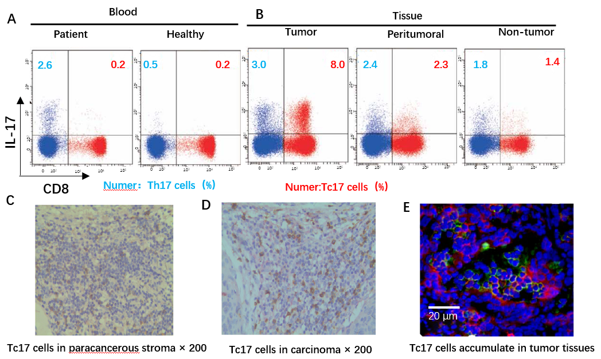
Figure 1 Tc17 cells accumulate in tumor tissues of cervical cancer patients. A: Dot plots of intracellular cytokine staining for Tc17 and Th17 in tumor cells; B: Immunohistochemistry staining for interleukin (IL)-17⁺ Tc17 cells of paracancerous stroma, the brown signal represents the staining of IL-17, and the red signal represents the staining of Tc17 (Envision, ×200); C: Immunohistochemistry staining for IL-17⁺ Tc17 cells of carcinoma nets, the brown signal represents the staining of IL-17, and the red signal represents the staining of Tc17 (Envision, ×200); D: Immunofluorescence staining for intra-tumoral IL-17⁺ Tc17 cells, the green signal represents the staining of IL-17, the red signal represents the staining of Tc17, and the blue signal represents the DAPI-stained nuclei (scale bar, 20 μm). IL: Interleukin.

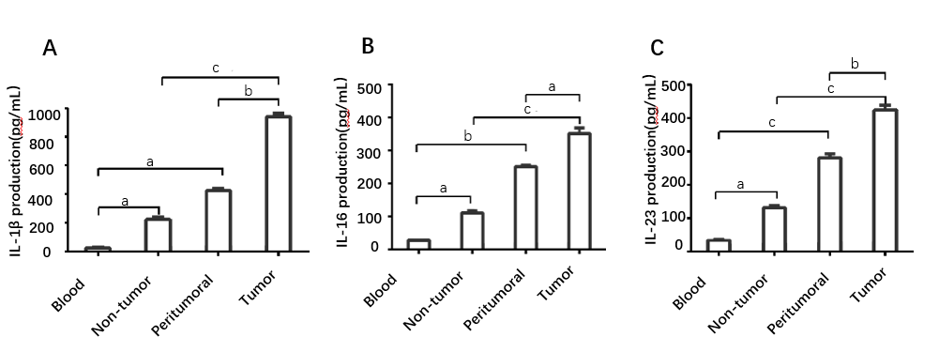
Figure 2 interleukin-6, interleukin-1β, and interleukin-23 accumulated in tumor tissues of cervical cancer patients. A-C: Before to cell suspension culture, ELISA was carried out showing that interleukin (IL)-6, IL-1β, and IL-23 were all significantly upregulated in supernatants of the tumor and peritumoral tumor tissues compared with the supernatants isolated from autologous non-tumor tissues or peripheral blood. Comparisons were performed using the t-test. an indicates ªp < 0.05; ^{b}p < 0.01. ^{c}p < 0.001. Error bars represent SE. il: Interleukin.

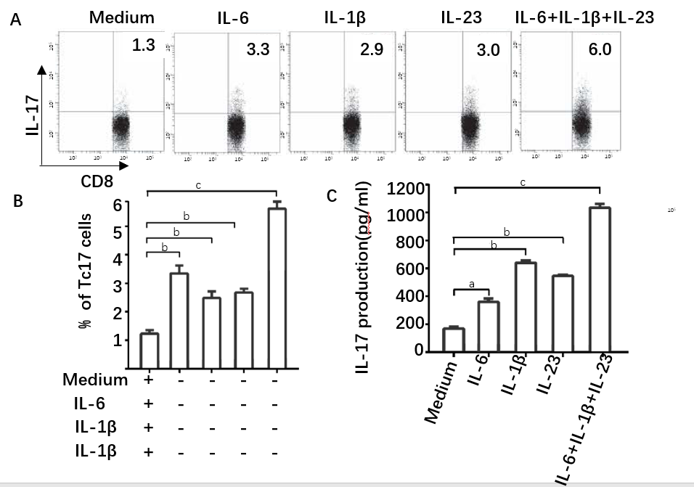
Figure 3 interleukin-6, interleukin-1β, and interleukin-23 induced differentiation of Tc17 cells. A-C: Peripheral CD8⁺ T cell and blood monocytes were co-cultured as described in materials and methods. Representative data and statistical analysis of Tc17 cell percentage in CD8⁺ T cells and interleukin-17 production in the culture supernatants from the co-culture systems. Comparisons were performed using the t-test. an indicates ªp < 0.05, ^{b}p < 0.01, ^{c}p < 0.001. Error bars represent SE. il: Interleukin.

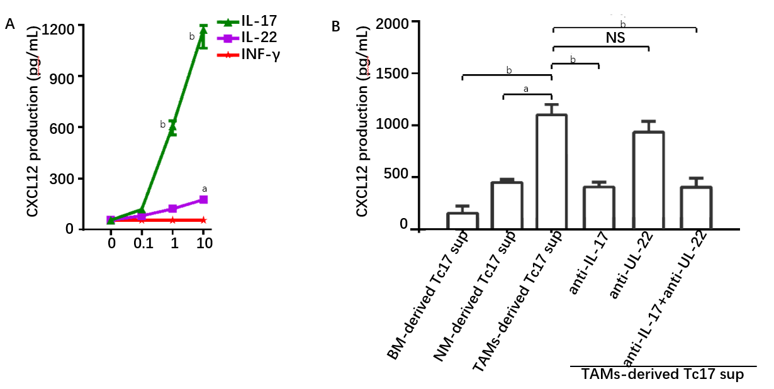
Figure 4 Tc17 cell-derived interleukin-17 induces tumor cells to produce CXCL12. A: Primary tumor cells were cultured with variable concentrations of interleukin (IL)-17, IL-22, interferon-γ, production of CXC12 was detected in the culture supernatants by ELISA and statistically analyzed; B: Primary tumor cells were cultured with variable concentrations of cytokines or monocyte-derived Tc17 cells culture supernatants, production of CXC12 was detected in the culture supernatants by ELISA and statistically analyzed. Comparisons were performed using the t-test. a indicates ªp < 0.05; ^{b}p < 0.01. Error bars represent SE. NS: No significant difference; NM: nontumor tissue monocyte-derived; BM: blood monocyte-derived; TAMs: tumor tissue monocyte-derived.

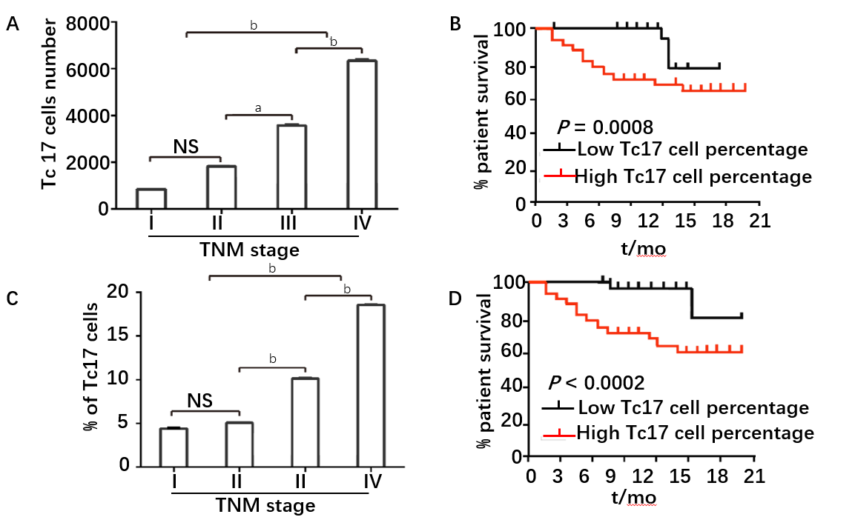
Figure 5 Analysis of the correlation between % of Tc17 cells and the survival rate of cervical cancer patients. A: The total number of Tc17 cells per million total cells in each tissue in different TNM stage; B: The association of Tc17 cell number with patient survival times; C: Tc17 cell percentage in CD8⁺ T cells in each stage of cancer progression; D: Survival significantly decreased as a function of Tc17 cell percentage. Comparisons were performed using the t-test. NS indicates no significant difference; an indicates _{a}p < 0.05; ^{b}p < 0.01. Error bars represent SE.

