Name of Journal: World Journal of Gastroenterology
Manuscript NO: 66170
Manuscript Type: ORIGINAL ARTICLE

Observational Study
Secular decreasing trends in gastric cancer incidence in Taiwan: A population-based cancer registry study

Lin YT et al. Gastric cancer incidence in Taiwan

Yen-Tzeng Lin, Chun-Ju Chiang, Ya-Wen Yang, Shih-Pei Huang, San-Lin You

Yen-Tzeng Lin, School of Medicine, College of Medicine, Fu Jen Catholic University, New Taipei City 242008, Taiwan

Chun-Ju Chiang, Ya-Wen Yang, Institute of Epidemiology and Preventive Medicine, College of Public Health, National Taiwan University, Taipei 10617, Taiwan

Shih-Pei Huang, Department of Medical Education & Bioethics, Graduate Institute of Medical Education & Bioethics, National Taiwan University College of Medicine, Taipei 10051, Taiwan

San-Lin You, School of Medicine & Big Data Research Center, Fu Jen Catholic University, New Taipei City 242008, Taiwan

Author contributions: Lin YT, Huang SP, and You SL conceived and designed the study; Chiang CJ and You SL acquired the data; Lin YT and Yang YW performed the data analyses; Lin YT, Huang SP, and You SL drafted the manuscript; Lin YT, Huang SP, and You SL assisted in interpretation of the data; Lin YT, Chiang CJ, Yang YW, Huang SP, and You SL critically revised the manuscript for intellectual content.

Corresponding author: Shih-Pei Huang, MD, PhD, Adjunct Assistant Professor, Doctor, Department of Medical Education & Bioethics, Graduate Institute of Medical Education & Bioethics, National Taiwan University College of Medicine, No. 1 Jen Ai Road, Section 1, Taipei 10051, Taiwan. esphuang.imbd@gmail.com

Received: March 23, 2021
Revised: May 11, 2021
Accepted: August 6, 2021
Published online:

Abstract
BACKGROUND
Gastric cancer remains a leading cause of cancer death worldwide. In Taiwan, gastric cancer is the sixth leading cause of cancer mortality in both males and females.

AIM
To evaluate secular trends in gastric cancer incidence according to age, sex, and Helicobacter pylori (H. pylori) treatment in Taiwan.

METHODS
In this population-based study, we used the national Taiwan Cancer Registry database. Annual percent changes in incidence rates were used to describe secular trends in incidence rates and sex ratios of gastric cancer in Taiwan. Pearson’s product-moment correlation coefficients were used to analyze the correlation between annual age-adjusted incidence rates and the annual number of patients treated with antibiotic therapy for H. pylori infection.

RESULTS
The annual percent changes showed continuously decreasing rates of gastric cancer among both males and females. However, the decreasing trends differed by sex, with an annual percent change of -2.58% in males and -2.14% in females. The age-specific incidence rates increased with age. Within the same age group, more recent time periods showed lower incidence rates than greater time periods. Similarly, the sex ratio was lower in later birth cohorts than in earlier birth cohorts. Age-adjusted incidence rates substantially decreased with increasing numbers of patients being treated with antibiotic therapy for H. pylori infection during 2005 to 2016 (r = 0.72).

CONCLUSION
We observed steadily decreasing trends with differential sex ratios in the incidence of gastric cancer in Taiwan. These results support H. pylori eradication programs in Taiwan.

Key Words: Gastric cancer; Population-based study; Taiwan Cancer Registry; Sex difference; Helicobacter pylori; Helicobacter pylori eradication

Lin YT, Chiang CJ, Yang YW, Huang SP, You SL. Secular decreasing trends in gastric cancer incidence in Taiwan: A population-based cancer registry study. World J Gastroenterol 2021; In press

Core Tip: Gastric cancer remains a leading cause of cancer death worldwide. In this population-based study, we used the national Taiwan Cancer Registry database to evaluate secular trends in gastric cancer incidence in Taiwan. Annual percent changes showed continuously decreasing rates of gastric cancer among both males and females, with an annual percent change of -2.58% in males and -2.14% in females. Age-specific incidence rates increased with age. Within the same age group, the sex ratio was lower in later birth cohorts than in earlier birth cohorts. Age-adjusted incidence rates substantially decreased with the increase in patients newly treated with anti-Helicobacter pylori treatment.

INTRODUCTION
Gastric cancer is one of the leading causes of cancer death worldwide. Data from GLOBOCAN 2020 shows an age-standardized incidence rate of gastric cancer of 15.8 per 100000 persons for males and 7.0 per 100000 persons for females, with a mortality rate of 11.0 per 100000 persons in males and 4.9 per 100000 persons in females^{[1]}. In Taiwan, gastric cancer was the sixth leading cause of cancer death for both males and females in 2018^{[2]}.
Gastric cancer is a multifactorial disease; its risk factors include alcohol drinking, tobacco smoking, gastric ulcer, and atrophic gastritis, whereas the intake of fresh fruits and vegetables is probably protective^{[3]}. A previous study demonstrated that anti-Helicobacter pylori (H. pylori) treatment has the potential to decrease the risk of gastric cancer^{[4]}. Moreover, a study by Chiang et al^{[5]} showed that the effectiveness of H. pylori eradication in reducing gastric cancer incidence and mortality was 53% [95% confidence interval (CI): 30% to 69%, P < 0.001] and 25% (95%CI: -14% to 51%, P = 0.18), respectively. This study aimed to investigate secular trends in the incidence of gastric cancer and its association with H. pylori eradication programs in Taiwan.

MATERIALS AND METHODS
Data sources
We obtained data on gastric cancer incidence from 1979 to 2016 from the national population-based Taiwan Cancer Registry (TCR) database. The TCR database has been collecting data on newly diagnosed cancer cases since 1979. The TCR’s accuracy was such that the percentage of death certificate only cases was 0.91%, and the proportion of morphologically verified cases reached 92.23%^{[6]}. In addition, the completeness of the TCR database was reported to be 98.44% in 2016^{[6]}. All cases of primary gastric cancer in this analysis were classified based on the International Classification of Diseases for Oncology, third edition (codes C16.0–C16.9)^{[7]}. We identified subjects who received anti-H. pylori treatment from 2005 to 2016, based on Anatomical Therapeutic Chemical Classification codes from Taiwan’s National Health Insurance Research Database, which included treatment with clarithromycin, amoxicillin, metronidazole, and tetracycline^{[8]}.

Statistical analysis
Age-specific and age-adjusted incidence rates per 100000 person-years were calculated according to the 2000 World Health Organization standard population^{[9]}. The incidence data were divided into ten 5-year age groups (25-29, 30-34, 35-39, 40-44, 45-49, 50-54, 55-59, 60-64, 65-69, and 70-74) and seven 5-year time periods. Birth cohorts were divided into five 10-year age groups (25-34, 35-44, 45-54, 55-64, and 65-74). We calculated age-adjusted incidence rates for the period from 1979 to 2016 and age-specific incidence rates for the period from 1981 to 2015, for birth cohorts representing the years 1906 to 2005.
To describe linear trends by time period, we computed the annual percent change (APC) in incidence rate and tested whether the corresponding changes in rates were significant. We also used the Pearson’s product-moment correlation coefficient to analyze the correlation between the annual age-adjusted incidence rate and the annual number of patients treated with antibiotic therapy for H. pylori infection. The research protocol was approved by the Institutional Review Board of Fu-Jen Catholic University (C107034).

RESULTS
Age-adjusted incidence rates
The age-adjusted incidence rates of gastric cancer show that rates for males were volatile between the years of 1981 to 2002 but steadily decreased from 2002 to 2016, with an average APC (AAPC) of -2.58% (Figure 1). However, the incidence rates for females slightly increased between the years of 1979 to 1997 and then gradually decreased from 1997 to 2016, with an AAPC of -2.14% (Figure 1).

Age-specific incidence rates
Looking at age-specific incidence rates by sex for the years of 1981 to 2015, we found that age-specific incidence rates of gastric cancer increased with age, with the highest incidence rate occurring among the oldest age group across all time periods (Figure 2). Among the same age group, more recent time periods showed lower incidence rates than earlier time periods. For example, among males aged 60-64 years, the incidence rate per 100000 persons during 2011-2015 was 44.42, which was lower than the incidence rate for 1996-2000, which had an incidence rate of 62.41. Moreover, among the same age group, the decreasing trend in age-specific incidence was more evident in males than in females (Figure 2).
The age-specific incidence rates by birth cohort for both males and females are shown in Figure 3. In both males and females, older birth cohorts had higher incidence rates than younger birth cohorts within the same age group. Moreover, among the same birth cohort, incidence rates increased more significantly by age in males than in females (Figure 3).

Sex ratios of age-adjusted incidence rates
We also found that the sex ratios of age-adjusted incidence rates decreased from 1981 to 2016 (Figure 4A). Males had higher age-adjusted incidence rates than females, with sex ratios ranging from 2.5 in 1979 to 1.9 in 2016, with an AAPC of -0.67% during the study period. During time periods prior to 1990, age-specific sex ratios were higher in older age groups, whereas the sex ratios were more consistent during time periods after 1996 (Figure 4B). Sex ratios of age-specific incidence rates by birth cohort showed that among the same age group, sex ratios were higher in earlier birth cohorts than in later birth cohorts. Whereas the sex ratios were close to 1 in the 35-44 age group, the sex ratios were all less than 1 in the 25-34 age group (Figure 4C).

Association with H. pylori treatment
Furthermore, we also investigated the association between gastric cancer incidence and H. pylori treatment (Figure 5). During 2005 to 2016, the age-adjusted incidence rates decreased substantially along with increasing numbers of patients newly treated with antibiotic therapy for H. pylori infection (r = 0.72).

DISCUSSION
This population-based study found an overall secular trend of declining gastric cancer incidence in Taiwan from 1979 to 2016. Age-adjusted incidence rates decreased after 2002, with a statistically significant trend in both males and females; although, our results were slightly lower than estimates from other East Asian countries in terms of proportion changes. For example, one study from Japan found a decreasing trend with an AAPC of -1.4%, while another study from China found an AAPC of -3.7%^{[10]}. Meanwhile, Taiwan showed an AAPC in incidence rate of -1.62% from 1996 to 2013^{[11]}. The downward trend in incidence was greater in males during earlier years, but this difference has since diminished in recent years. Furthermore, the downward trend observed from 2002 to 2016 was higher in males than in females, with an AAPC of -2.59% in males and -2.40% in females. Our proportion changes were slightly lower than estimates from other Asian countries, as shown in a study by Bertuccio et al^{[12]}. One possible reason for the discrepancy may be that our study period began in the 1980s, after the incidence of gastric cancer had already been steadily declining for several decades.
As the development of gastric cancer is a multistage process arising from different risk factors, the decline in incidence rates in Taiwan may be attributable to the following reasons. First, the Taiwanese government launched an H. pylori eradication program in 1997^{[13]}. Although anti-H. pylori treatments started in 1997, the number of patients treated with antibiotic therapy was unstable during the first decade. Therefore, we show results ranging from 2005 to 2016, which show a strong association between the number of patients treated with H. pylori treatment and age-adjusted incidence rates (r = 0.72) (Figure 5).
Several clinical studies have demonstrated the prophylactic role of H. pylori-eradication in the prevention of gastric cancer. For instance, in a Swedish study^{[14]} of 39154 patients undergoing hip replacement, prophylactic antibiotic treatment conferred a reduction in gastric cancer risk after 5 years (odds ratio: 0.6; 95%CI: 0.3 to 1.2). In addition, another Japanese study reported that H. pylori eradication inhibited the development of gastric cancer after endoscopic resection during a follow-up period of 3 years^{[15]}. Ever since the government approved H. pylori eradication, there has been a decreasing trend in peptic ulcers in Taiwan^{[13,16]}. The mass eradication of H. pylori infection was launched in 2004 among a high-risk Taiwanese population with prevalent H. pylori infection that were living on the Matsu Islands, and continued until 2018. As a result of this effort, the prevalence rates of H. pylori decreased from 64.2% to 15.0%, with reinfection rates of less than 1% per person-year^{[5]}. In one Taiwanese study of 80255 peptic ulcer patients, early H. pylori eradication conferred a reduction in early gastric cancer risk (hazard ratio: 0.77)^{[17]}. In addition, this study also showed that early H. pylori eradication reduced the standardized incidence ratio of gastric cancer from 1.60 to 1.05 (95%CI: 0.96 to 1.14). Together with results from these studies, our findings provide supportive evidence that the eradication of H. pylori infection may be associated with a substantial reduction in gastric cancer incidence.
Second, dietary and lifestyle habits in Taiwan have improved in the past few decades. Earlier studies showed that the consumption of foods containing nitrosamine^{[18]} and cigarette smoking^{[19]} were risk factors for gastric cancer. However, the increased use of refrigerators as a method of food preservation led to a decreased consumption of preserved foods containing nitrosamine and provided the constant availability of fresh food^{[20]}. In Taiwan, a national public survey claimed that the popularization rate of refrigerators was approximately 99.14% in 1991 compared to a popularization rate of only 74.19% in 1976, with 3.6% of families even owning two refrigerators^{[21]}. In regard to cigarette smoking, the Tobacco Hazards Prevention Act was implemented in January 2009, and the prevalence of smoking in adults over 40 years of age dropped from 12.25% in 2001 to 8.18% in 2013^{[22]}.
Our age-adjusted incidence rates were slightly lower than estimates from other East Asian countries in terms of proportion change. The reason may be that there has been no evident decline in alcohol consumption, another known risk factor for gastric cancer^{[23]}. Surveys in Taiwan showed that the prevalence of alcohol drinking among males was 38.2% in 2001 and 24.2% in 2013, while the prevalence among females was 9.2% in 2001 and 9.3% in 2013^{[24]}. Furthermore, obesity is also associated with an increased risk of gastric cancer^{[25-27]}. The body mass index of the Taiwanese population has increased over time. The prevalence of having a body mass index ≥ 24 kg/m² among males rose from 33.4% during 1993-1996 to 52.1% during 2013-2016 and among females, rose from 33.0% during 1993-1996 to 37.4% during 2013-2016^{[28]}.
We also showed a steady decrease in sex ratios. In our results examining sex ratios by birth cohort, younger age groups had lower sex ratios, especially in the 25-34 age group, which had a ratio lower than 1, indicating that males accounted for a lower incidence of gastric cancer. The trends in sex ratios by birth cohort are similar to the intestinal type of gastric cancer based on histopathology and non-cardia site based on anatomic site^{[29]}. We speculate that the decreasing trend in gastric cancer may be mainly attributed to declines in the intestinal type histology because the intestinal type of gastric cancer affects males and older age groups more frequently^{[30]}, leading to a greater decrease in incidence among males than among females. Furthermore, the dominant risk factors for gastric cancer, especially for non-cardia cancer, are diet, cigarette smoking, and H. pylori infection, whereas the risk factors for cardia cancer are obesity, gastroesophageal reflux, and Barrett’s esophagus^{[31]}. This may explain why the corresponding decrease in Taiwan is mainly in non-cardia gastric cancer, as the prevalence of risk factors such as poor diet, smoking, and H. Pylori infection are decreasing in Taiwan.
Regarding the sex ratios in age-specific incidence, we found a large curve in sex ratios around 45-59 years of age. Lindblad et al^{[32]} indicated that estrogen may prevent gastric cancer, and our results are in accordance with females in this age group being exposed to some protective factors against gastric cancer, such as estrogen and reproductive factors. The growth of gastric cancer cells may be stimulated during low concentrations of estrogen, such as in young females and postmenopausal women, while the growth of cancer cells may be inhibited in females with high concentrations of estrogen^{[33,34]}.
In this study, we summarize the descriptive epidemiology of gastric cancer incidence in Taiwan during a period of almost 40 years and show that gastric cancer incidence has steadily declined during this period. However, there are several limitations to our study. First, due to limitations of the database, we were unable to confirm whether the declines in gastric cancer incidence are attributable to differential histologic types and anatomic sites. An earlier study showed a decreased standardized incidence ratio of non-cardia gastric cancer after H. pylori eradication, but this eradication did not influence the overall risk for cardia gastric cancer^{[35]}. Also, as for pathological patterns, another study in Taiwan showed significantly decreasing trends in the incidence of adenocarcinoma. However, there was no evident decrease in the incidences of mucosa-associated lymphoid tissue lymphoma and diffuse large B-cell lymphoma^{[11]}. Therefore, further studies are needed to investigate the relationship between H. pylori and the histologic type and anatomic site of gastric cancer. Second, this study did not investigate ecological correlations since there was no adjustment for other confounders, such as dietary and lifestyle habits, due to the limitations of the databases.

CONCLUSION
In conclusion, we show continuously decreasing rates of gastric cancer in both sexes, increasing age-specific incidence rates with age, lower sex ratios in later birth cohorts, and decreasing age-adjusted incidence rates with increasing anti-H. pylori treatment. The results support the need to further address the issue of mass anti-H. pylori treatment in areas with a high prevalence rate of H. pylori infection in order to eliminate the threat of H. pylori-associated gastric cancer.

ARTICLE HIGHLIGHTS
Research background
Gastric cancer is a multifactorial cancer and is a leading cause of cancer death worldwide. In Taiwan, gastric cancer is the sixth leading cause of cancer mortality.

Research motivation
We desired to discover the association between gastric cancer incidence and potential factors, including anti-Helicobacter pylori (H. pylori) treatment.

Research objectives
The objective of this study was to observe secular trends in gastric cancer incidence according to age, sex, and the implementation of a nationwide H. pylori treatment program in Taiwan.

Research methods
We used the national Taiwan Cancer Registry database in this population-based study. Annual percent changes in incidence rates were used to describe secular trends in incidence rates and sex ratios of gastric cancer in Taiwan and to study the relationship between its incidence and potential risk factors, including anti-H. pylori treatment. Pearson’s product-moment correlation coefficients were used to analyze the correlation between annual age adjusted incidence rates and the annual number of patients treated with antibiotic therapy for H. pylori infection.

Research results
The annual percent changes showed steadily decreasing rates of gastric cancer in both sexes. However, the decreasing trends differed by sex, with an annual percent change of -2.58% in males and -2.14% in females. The age-specific incidence rates increased with age. Among the same age group, more recent time periods showed lower incidence rates than earlier time periods. Within the same age group, the sex ratio was lower in later birth cohorts than in earlier birth cohorts. In addition, age-adjusted incidence rates decreased substantially with increasing numbers of patients newly treated with antibiotic therapy during 2005 to 2016 for H. pylori infection (r = 0.72).

Research conclusions
We observed steadily decreasing trends with differential sex ratios in the incidence of gastric cancer in Taiwan. The results also support the association between trends in gastric cancer incidence and the implementation of H. pylori eradication programs in Taiwan.

Research perspectives
Further long-term cohort studies are needed to investigate the relationship between H. pylori treatment and gastric cancer histologic type and anatomic site and should include adjusting for other confounders, such as dietary and lifestyle habits and genetic susceptibility.

REFERENCES
1 Ferlay J, Ervik M, Lam F, Colombet M, Mery L, Pineros M, Znoar A, Soerjomataram I, Bray F. Global Cancer Observatory: Cancer Today. Lyon, France: International Agency for Research on Cancer, 2020
2 Ministry of Health and Welfare. Cancer Registry Annual Report. Department of Health, editor. Taiwan, Republic of China, 2021
3 Guggenheim DE, Shah MA. Gastric cancer epidemiology and risk factors. J Surg Oncol 2013; 107: 230-236 [PMID: 23129495 DOI: 10.1002/jso.23262]
4 IARC Helicobacter pylori Working Group. Helicobater pylori Eradication as a Strategy for Gastric Cancer Prevention. In: IARC Working Group Reports, No 8. International Agency for Research on Cancer, editor. Lyon, France, 2014
5 Chiang TH, Chang WJ, Chen SL, Yen AM, Fann JC, Chiu SY, Chen YR, Chuang SL, Shieh CF, Liu CY, Chiu HM, Chiang H, Shun CT, Lin MW, Wu MS, Lin JT, Chan CC, Graham DY, Chen HH, Lee YC. Mass eradication of Helicobacter pylori to reduce gastric cancer incidence and mortality: a long-term cohort study on Matsu Islands. Gut 2021; 70: 243-250 [PMID: 32792335 DOI: 10.1136/gutjnl-2020-322200]
6 Ministry of Health and Welfare. Cancer Registry Annual Report, 2016. In: Health Promotion Administration. Taiwan, Republic of China, 2016
7 Clarke CA, Undurraga DM, Harasty PJ, Glaser SL, Morton LM, Holly EA. Changes in cancer registry coding for lymphoma subtypes: reliability over time and relevance for surveillance and study. Cancer Epidemiol Biomarkers Prev 2006; 15: 630-638 [PMID: 16614102 DOI: 10.1158/1055-9965.EPI-05-0549]
8 Liou JM, Chang CY, Chen MJ, Chen CC, Fang YJ, Lee JY, Wu JY, Luo JC, Liou TC, Chang WH, Tseng CH, Wu CY, Yang TH, Chang CC, Wang HP, Sheu BS, Lin JT, Bair MJ, Wu MS; Taiwan Gastrointestinal Disease and Helicobacter Consortium. The Primary Resistance of Helicobacter pylori in Taiwan after the National Policy to Restrict Antibiotic Consumption and Its Relation to Virulence Factors-A Nationwide Study. PLoS One 2015; 10: e0124199 [PMID: 25942450 DOI: 10.1371/journal.pone.0124199]
9 Ahmad OB, Boschi-Pinto C, Lopez AD. Age standardization of rates: A new WHO standard. 2001. [cited 10 March 2021]. Available from: https://www.who.int/healthinfo/paper31.pdf
10 Luo G, Zhang Y, Guo P, Wang L, Huang Y, Li K. Global patterns and trends in stomach cancer incidence: Age, period and birth cohort analysis. Int J Cancer 2017; 141: 1333-1344 [PMID: 28614909 DOI: 10.1002/ijc.30835]
11 Chang JS, Kuo SH, Chu PY, Shan YS, Tsai CR, Tsai HJ, Chen LT. The Epidemiology of Gastric Cancers in the Era of Helicobacter pylori Eradication: A Nationwide Cancer Registry-Based Study in Taiwan. Cancer Epidemiol Biomarkers Prev 2019; 28: 1694-1703 [PMID: 31350264 DOI: 10.1158/1055-9965.EPI-19-0355]
12 Bertuccio P, Chatenoud L, Levi F, Praud D, Ferlay J, Negri E, Malvezzi M, La Vecchia C. Recent patterns in gastric cancer: a global overview. Int J Cancer 2009; 125: 666-673 [PMID: 19382179 DOI: 10.1002/ijc.24290]
13 Wu CY, Wu CH, Wu MS, Wang CB, Cheng JS, Kuo KN, Lin JT. A nationwide population-based cohort study shows reduced hospitalization for peptic ulcer disease associated with H pylori eradication and proton pump inhibitor use. Clin Gastroenterol Hepatol 2009; 7: 427-431 [PMID: 19264578 DOI: 10.1016/j.cgh.2008.12.029]
14 Akre K, Signorello LB, Engstrand L, Bergström R, Larsson S, Eriksson BI, Nyrén O. Risk for gastric cancer after antibiotic prophylaxis in patients undergoing hip replacement. Cancer Res 2000; 60: 6376-6380 [PMID: 11103800]
15 Uemura N, Mukai T, Okamoto S, Yamaguchi S, Mashiba H, Taniyama K, Sasaki N, Haruma K, Sumii K, Kajiyama G. Effect of Helicobacter pylori eradication on subsequent development of cancer after endoscopic resection of early gastric cancer. Cancer Epidemiol Biomarkers Prev 1997; 6: 639-642 [PMID: 9264278]
16 Lee YC, Lin JT. Screening and treating Helicobacter pylori infection for gastric cancer prevention on the population level. J Gastroenterol Hepatol 2017; 32: 1160-1169 [PMID: 28087975 DOI: 10.1111/jgh.13726]
17 Wu CY, Kuo KN, Wu MS, Chen YJ, Wang CB, Lin JT. Early Helicobacter pylori eradication decreases risk of gastric cancer in patients with peptic ulcer disease. Gastroenterology 2009; 137: 1641-1648 [PMID: 19664631 DOI: 10.1053/j.gastro.2009.07.060]
18 Hsiung HY, Fann JC, Yen AM, Chen SL, Chiu SY, Ku TH, Liu TY, Chen HH, Lin MW. Stage-specific Dietary Factors Associated with the Correa Multistep and Multifactorial Process of Human Gastric Carcinogenesis. Nutr Cancer 2016; 68: 598-610 [PMID: 27042805 DOI: 10.1080/01635581.2016.1156712]
19 Kneller RW, You WC, Chang YS, Liu WD, Zhang L, Zhao L, Xu GW, Fraumeni JF Jr, Blot WJ. Cigarette smoking and other risk factors for progression of precancerous stomach lesions. J Natl Cancer Inst 1992; 84: 1261-1266 [PMID: 1640486 DOI: 10.1093/jnci/84.16.1261]
20 Kelley JR, Duggan JM. Gastric cancer epidemiology and risk factors. J Clin Epidemiol 2003; 56: 1-9 [PMID: 12589864 DOI: 10.1016/s0895-4356(02)00534-6]
21 Directorate-General of Budget. Report on the survey of personal income & distribution in Taiwan area of the republic of China. [cited 4 August 2021]. In: Taiwan, Republic of China: Executive Yuan, 1994 [Internet]. Available from: https://win.dgbas.gov.tw/fies/doc/result/83.pdf
22 Shih YH, Chang HY, Lu MI, Hurng BS. Time trend of prevalence of self-reported cataract and its association with prolonged sitting in Taiwan from 2001 and 2013. BMC Ophthalmol 2014; 14: 128 [PMID: 25370503 DOI: 10.1186/1471-2415-14-128]
23 Scherübl H. Alcohol Use and Gastrointestinal Cancer Risk. Visc Med 2020; 36: 175-181 [PMID: 32775347 DOI: 10.1159/000507232]
24 Lai YJ, Hu HY, Lee YL, Ko MC, Ku PW, Yen YF, Chu D. Frequency of alcohol consumption and risk of type 2 diabetes mellitus: A nationwide cohort study. Clin Nutr 2019; 38: 1368-1372 [PMID: 30448092 DOI: 10.1016/j.clnu.2018.06.930]
25 Wang FW, Tu MS, Mar GY, Chuang HY, Yu HC, Cheng LC, Hsu PI. Prevalence and risk factors of asymptomatic peptic ulcer disease in Taiwan. World J Gastroenterol 2011; 17: 1199-1203 [PMID: 21448426 DOI: 10.3748/wjg.v17.i9.1199]
26 Lee HH, Wu HY, Chuang YC, Chang AS, Chao HH, Chen KY, Chen HK, Lai GM, Huang HH, Chen CJ. Epidemiologic characteristics and multiple risk factors of stomach cancer in Taiwan. Anticancer Res 1990; 10: 875-881 [PMID: 2382983]
27 Song M, Choi JY, Yang JJ, Sung H, Lee Y, Lee HW, Kong SH, Lee HJ, Kim HH, Kim SG, Yang HK, Kang D. Obesity at adolescence and gastric cancer risk. Cancer Causes Control 2015; 26: 247-256 [PMID: 25471061 DOI: 10.1007/s10552-014-0506-z]
28 Lai YJ, Hu HY, Lee YL, Ku PW, Yen YF, Chu D. Association between obesity and risk of chronic kidney disease: A nationwide Cohort study in Taiwan. Nutr Metab Cardiovasc Dis 2017; 27: 1008-1014 [PMID: 28986076 DOI: 10.1016/j.numecd.2017.08.006]
29 Wu H, Rusiecki JA, Zhu K, Potter J, Devesa SS. Stomach carcinoma incidence patterns in the United States by histologic type and anatomic site. Cancer Epidemiol Biomarkers Prev 2009; 18: 1945-1952 [PMID: 19531677 DOI: 10.1158/1055-9965.EPI-09-0250]
30 Vauhkonen M, Vauhkonen H, Sipponen P. Pathology and molecular biology of gastric cancer. Best Pract Res Clin Gastroenterol 2006; 20: 651-674 [PMID: 16997151 DOI: 10.1016/j.bpg.2006.03.016]
31 Crew KD, Neugut AI. Epidemiology of gastric cancer. World J Gastroenterol 2006; 12: 354-362 [PMID: 16489633 DOI: 10.3748/wjg.v12.i3.354]
32 Lindblad M, Ye W, Rubio C, Lagergren J. Estrogen and risk of gastric cancer: a protective effect in a nationwide cohort study of patients with prostate cancer in Sweden. Cancer Epidemiol Biomarkers Prev 2004; 13: 2203-2207 [PMID: 15598781]
33 Ur Rahman MS, Cao J. Estrogen receptors in gastric cancer: Advances and perspectives. World J Gastroenterol 2016; 22: 2475-2482 [PMID: 26937135 DOI: 10.3748/wjg.v22.i8.2475]
34 Sipponen P, Correa P. Delayed rise in incidence of gastric cancer in females results in unique sex ratio (M/F) pattern: etiologic hypothesis. Gastric Cancer 2002; 5: 213-219 [PMID: 12491079 DOI: 10.1007/s101200200037]
35 Doorakkers E, Lagergren J, Engstrand L, Brusselaers N. Helicobacter pylori eradication treatment and the risk of gastric adenocarcinoma in a Western population. Gut 2018; 67: 2092-2096 [PMID: 29382776 DOI: 10.1136/gutjnl-2017-315363]

Footnotes
Institutional review board statement: The study was reviewed and approved by the Fu Jen Catholic University Institutional Review Board.

Informed consent statement: This research protocol was approved by the Institutional Review Board of Fu-Jen Catholic University (C107034).

Conflict-of-interest statement: There are no conflicts of interest to report.

Data sharing statement: No additional data are available.

STROBE statement: The authors have read the STROBE statement, and the manuscript was prepared and revised according to the STROBE statement.

Open-Access: This article is an open-access article that was selected by an in-house editor and fully peer-reviewed by external reviewers. It is distributed in accordance with the Creative Commons Attribution NonCommercial (CC BY-NC 4.0) license, which permits others to distribute, remix, adapt, build upon this work non-commercially, and license their derivative works on different terms, provided the original work is properly cited and the use is non-commercial. See: http://creativecommons.org/Licenses/by-nc/4.0/

Manuscript source: Unsolicited manuscript

Peer-review started: March 23, 2021
First decision: April 29, 2021
Article in press:

Specialty type: Gastroenterology and hepatology
Country/Territory of origin: Taiwan
Peer-review report’s scientific quality classification
Grade A (Excellent): A
Grade B (Very good): B
Grade C (Good): C, C
Grade D (Fair): 0
Grade E (Poor): 0

P-Reviewer: Cai ZL, Dong QJ, Keikha M S-Editor: Liu M L-Editor: Wang TQ P-Editor:
Figure Legends
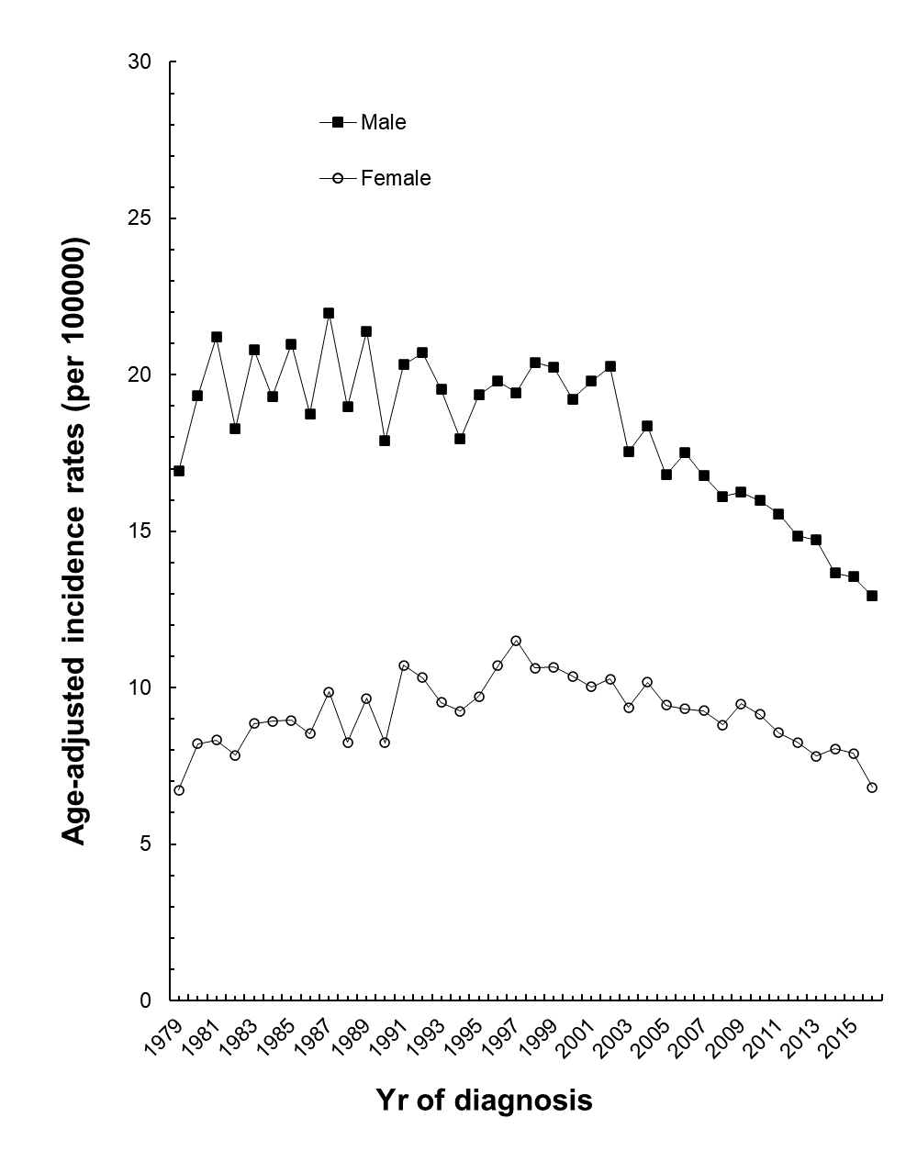
Figure 1 Secular trends in age-adjusted incidence rates of gastric cancer in Taiwan. 1979-2016, showing steadily decreasing rates in males from 2002 to 2016, with an Average Annual Percent Change (AAPC) of -2.58%, and gradually decreasing rates in females from 1997 to 2016, with an AAPC of -2.14%.
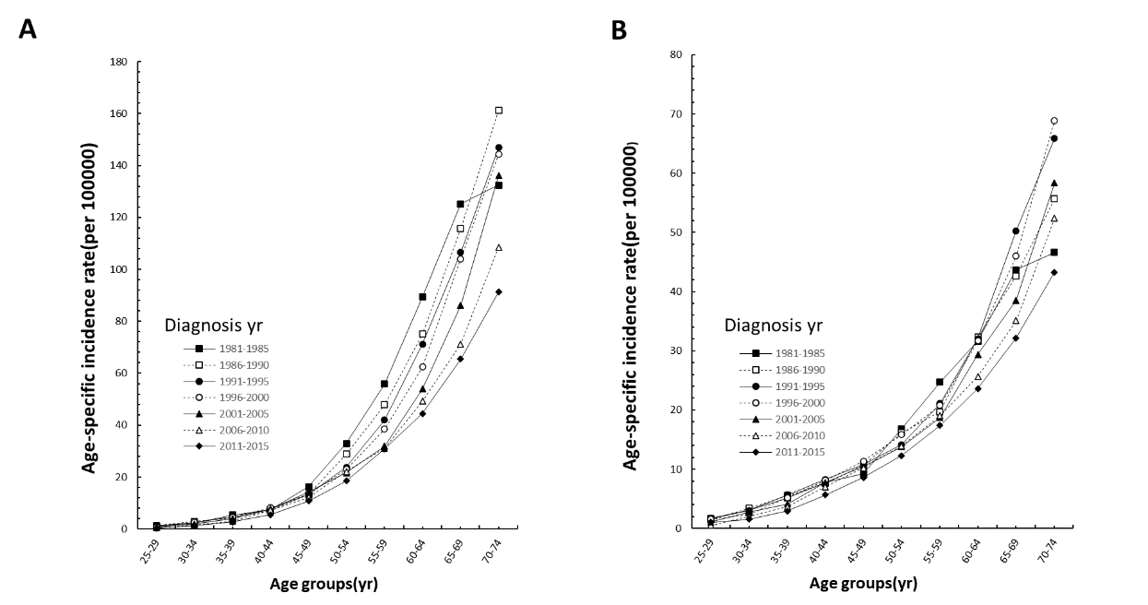
Figure 2 Age-specific incidence rates of gastric cancer in Taiwan by time period during 1981-2015. A: Among males; B: Females, showing lower incidence rates in more recent time periods than in earlier time periods. The decreasing trend was more evident in males than in females.
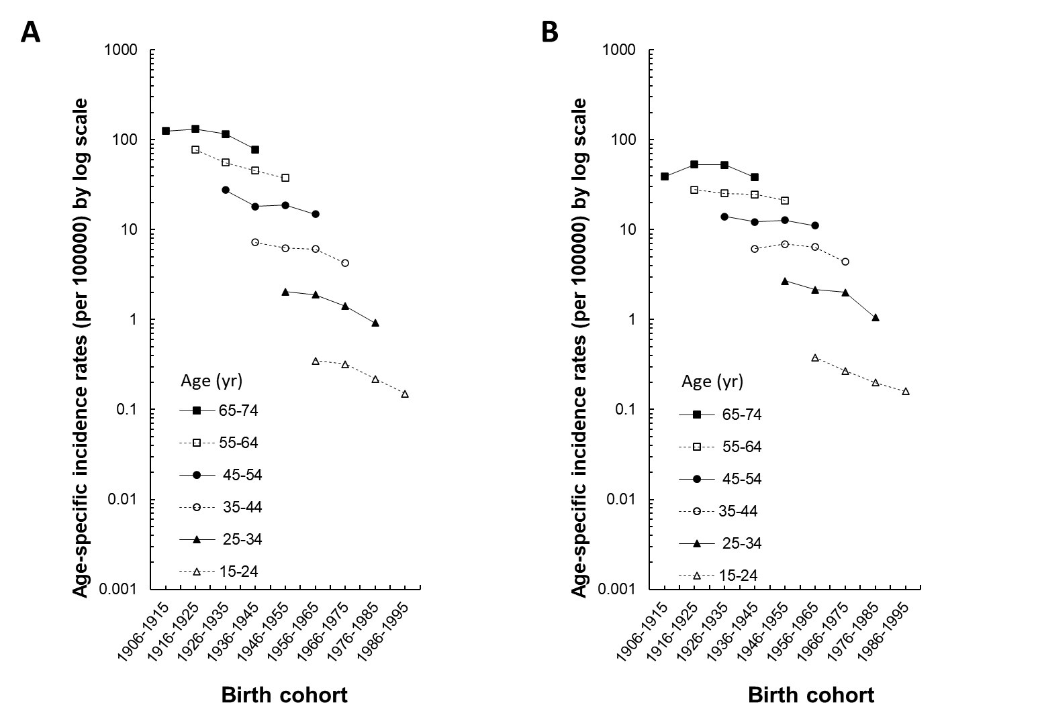
Figure 3 Age-specific incidence rates of gastric cancer in Taiwan by birth cohort during 1906-2005. A: Among males; B: Females, showing higher incidence rates in older birth cohorts than in younger birth cohorts within the same age group. Within the same birth cohort, incidence rates increased by age more evidently in males than in females.
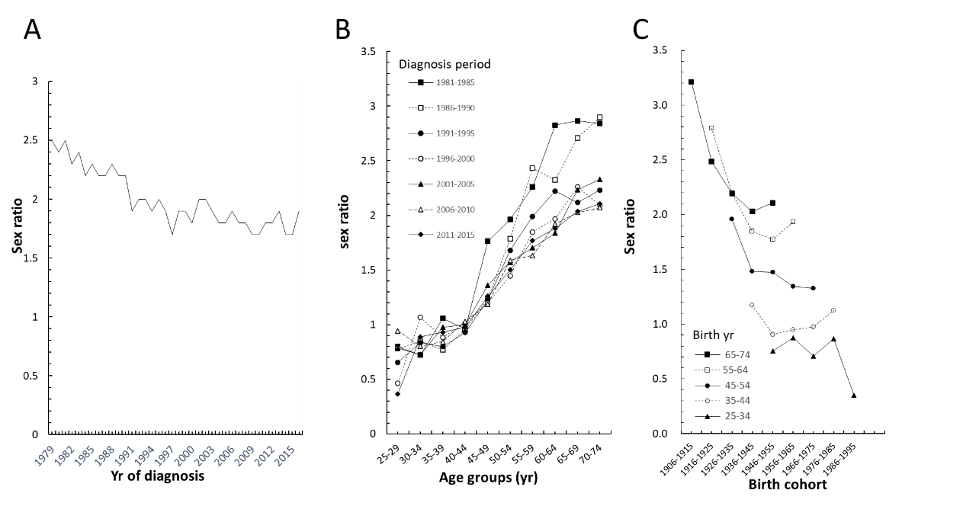
Figure 4 Sex ratios of gastric cancer in Taiwan during 1979-2016. A: Decreasing trends in age-adjusted incidence rates; B: Sex ratios by time period, showing a more consistent trend after 1996; C: Sex ratios in earlier birth cohorts were higher than later birth cohorts.
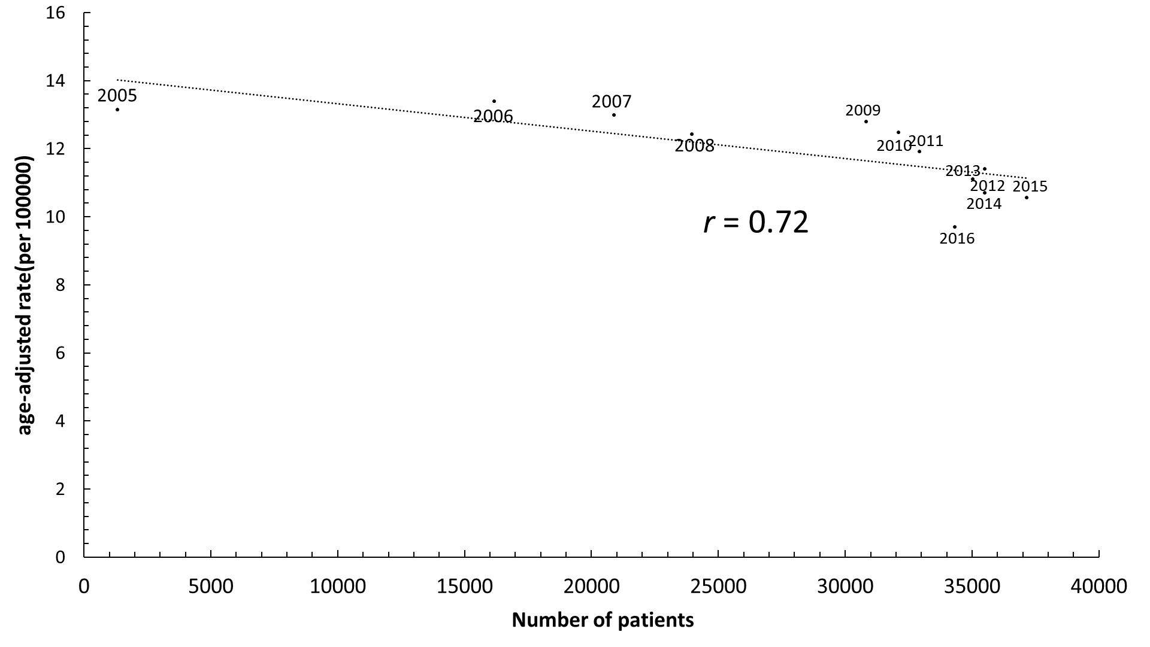
Figure 5 Correlation between numbers of patients with Helicobacter pylori infection newly treated with antibiotic therapy and age-adjusted incidence rates showed a substantial decrease with an r coefficient of 0.72 in Taiwan, 2005-2016.

