Name of Journal: World Journal of Clinical Cases
Manuscript NO: 64756
Manuscript Type: CASE REPORT

Muscular atrophy and weakness in the lower extremities in Behçet’s disease: A case report and review of literature

Kim KW et al. Muscular atrophy and weakness in Behçet’s disease

Koh-Woon Kim, Jae-Heung Cho

Koh-Woon Kim, Jae-Heung Cho, Department of Korean Medicine Rehabilitation, College of Korean Medicine, Kyung Hee University, Seoul 02447, South Korea

Author contributions: Kim KW was the patient’s attending physician; She reviewed the literature and contributed to manuscript drafting; Cho JH analyzed and interpreted the imaging findings and was responsible for the revision of the manuscript for important intellectual content; and all authors have read and approved the final manuscript.

Corresponding author: Jae-Heung Cho, PhD, Associate Professor, Doctor, Department of Korean Medicine Rehabilitation, College of Korean Medicine, Kyung Hee University, 26 Kyungheedae-ro, Dongdaemun-gu, Seoul 02447, South Korea. vetkong95@hanmail.net

Received: March 4, 2021
Revised: April 14, 2021
Accepted: May 20, 2021
Published online:

Abstract
BACKGROUND
In Behçet’s disease (BD), very few cases of muscular involvement have been reported previously. The natural history and therapeutic protocol for muscular involvement in BD are obscure due to the low incidence of peripheral neuropathy or myopathy in BD. The purpose of our study was to report a rare case of BD with chronic, focal forms of neuromyopathy and review the relevant literature.

CASE SUMMARY
We herein report the case of a 54-year-old man who presented with progressive muscular atrophy and weakness of both thighs 2 years after the presentation of the cardinal symptoms of BD. The past medical history, electrophysiological study, neurological examination, blood tests, magnetic resonance imaging study, and histological exam were performed for the differential diagnosis. Relevant literature on muscular involvement in BD was reviewed. Neurological examination revealed that muscular involvement was predominantly localized in the proximal parts of the lower extremities. Heterogeneous enhancement of several thigh muscles was observed on magnetic resonance imaging, which corresponded with the clinical manifestations. Histological study of one of the enhanced muscles showed denervation atrophy of the muscle with superimposed myopathic changes, while electrophysiological studies only suggested denervation.

CONCLUSION
To our knowledge, this is the first case of neurogenic muscular atrophy with a specific set of clinical, radiological, electrophysiological, and histological findings reported in BD.

Key Words: Behçet’s disease; Muscular atrophy; Muscular weakness; Neuropathy; Myopathy; Case report

Kim KW, Cho JH. Muscular atrophy and weakness in the lower extremities in Behçet’s disease: A case report and review of literature. World J Clin Cases 2021; In press

Core Tip: Muscular involvement in Behçet’s disease (BD) has been rarely reported, along with the low incidence of peripheral neuropathy or myopathy in BD. Here, we present a rare case of BD with chronic, focal forms of neuromyopathy and review the relevant literature. To our knowledge, this is the first case of neurogenic muscular atrophy with a specific set of clinical, radiological, electrophysiological, and histological findings reported in BD. Two years after the presentation of the cardinal symptoms of BD, the patient presented with progressive muscular atrophy and weakness. This case highlights that despite the rare involvement of muscles, it should be considered, particularly in BD patients, that muscular symptoms with or without the cardinal symptoms of BD might be correlated with BD.

INTRODUCTION
Behçet’s disease (BD) is a systemic vasculitis of unknown cause characterized by intermittent episodes of oral aphthous ulcers, genital ulcers, uveitis, and skin lesions^{[1]}. It is commonly accepted that various systemic manifestations other than the cardinal symptoms of BD may also be present in some patients with BD. For instance, other systems, including vascular, gastrointestinal, and neurological systems, can be affected^{[2,3]}. Neurological involvement is known to occur in 5%-20% of afflicted patients, with more frequent involvement of the central nervous system than the peripheral nervous system^{[4,5]}. Musculoskeletal involvement is one of the most frequent findings in BD, of which arthritis and arthralgia are the most common findings^{[6]}. However, muscular involvement is uncommon, and there are only a few case reports in the literature^{[7,8]}.
Due to the low incidence of peripheral neuropathy or myopathy in BD, the natural history and therapeutic protocol for muscular involvement in BD are obscure. Muscular involvement in BD is usually mild and manifests as myalgia or muscle weakness and mainly affects the lower extremities with pain and swelling, but in a few cases, it presented with arm and generalized weakness^{[8,9]}. The authors have described neutrophil-mediated vasculitis and myositis in BD, which is usually mild, short-lasting, and more localized than the generalized form^{[10,11]}. Muscle manifestations, such as myopathy and rhabdomyolysis induced by colchicine, can be induced by BD treatment^{[12,13]}. However, there have been no sufficiently informative reports on chronic, focal forms of neuromyopathy in BD.
Herein, we describe the clinical manifestation and corresponding radiological, electrophysiological, and histopathological findings of an uncommon case of BD in a 54-year-old man presenting with progressive muscular atrophy and weakness predominantly localized to the proximal parts of both legs. The purpose of our study was to report a rare case of BD with chronic, focal forms of neuromyopathy and review the relevant literature, thereby providing valuable information for the differential diagnosis of BD with muscular involvement.

CASE PRESENTATION
Chief complaints
A 54-year-old male patient was admitted to Kyung Hee University Medical Center complaining of progressive weakness and atrophy of the proximal parts of both legs.

History of present illness
The patient’ s symptoms started about a year ago, 2 years after the presentation of the cardinal symptoms of BD, which continued to progress over time; the patient could not walk without assistance on admission.

History of past illness
The patient had been experiencing recurrent oral and genital ulcers and skin folliculitis for several months before being diagnosed with BD approximately 3 years ago. Clinical pictures fulfilled the diagnostic criteria for BD.

Personal and family history
The patient had a free personal and family history.

Physical examination
On admission, the patient had multiple ulcers on the tongue and palate. Few erythema nodosum lesions were observed in the lower extremities. The genitalia were free of ulcers. The motor powers for flexion, abduction of the hip, and flexion of the knee were evaluated as Grade IV, and those for the dorsiflexion of the ankle and great toe were assessed as Grade II bilaterally, whereas muscular atrophy was localized bilaterally to the thighs. Deep tendon reflexes were diminished in both the knees and ankles. No additional abnormalities were found during the neurological examination.

Laboratory examinations
Laboratory findings were normal except for the slight elevation in erythrocyte sedimentation rate (29 mm/h) and creatine kinase (CK: 278 U/L) that remained unchanged compared with previous results. Cerebrospinal fluid analysis detected no significant abnormalities.
Electrophysiological study of the bilateral upper and lower extremities was performed 2 mo before admission, and motor nerve conduction study (NCS) showed low compound motor action potentials and slow motor nerve conduction velocities on the bilateral peroneal nerves. Although sensory NCS indicated conduction block of the left ulnar nerve near the elbow, the patient’s left arm showed no clinically correlating neurological symptoms or signs. No other abnormalities were found in the motor and sensory NCS. Electromyography of the lower extremity muscles showed denervation potentials with reduced interference patterns, while that of the upper extremity muscles showed normal results. Specific features indicative of muscle disease were not found in any of the four extremities.

Imaging examinations
Magnetic resonance imaging (MRI) of the proximal parts of both lower extremities showed slightly high signal intensity and heterogeneous enhancement at the adductor muscle groups and the vastus lateralis and intermedius muscles bilaterally, as well as at the right rectus femoris and sartorius muscles unilaterally (Figure 1). No significant abnormalities were found in MRI of the brain and spinal cord.

Further diagnostic work-up
The patient was further evaluated by histological examination of both thigh muscles for differential diagnosis. Examination of the biopsy samples of the right vastus lateralis muscle, sections stained with hematoxylin and eosin, showed marked myofiber size variability under light microscopy and also displayed myofiber degeneration that exhibited traces of regenerating myofibers with compensatory hypertrophy. Endomysial fibrosis and fatty changes were moderate. Other sections stained with adenosine triphosphatase and nicotinamide adenine dinucleotide phosphatase showed atrophy of both fiber types. Electron microscopy showed varied myofiber sizes with evidence of severe myofiber atrophy. The atrophic myofibers displayed redundant external lamina, while other myofibers showed rarefaction of myofilaments and vacuolar changes (Figure 2). These findings were indicative of denervation atrophy with superimposed myopathic changes.

FINAL DIAGNOSIS
The final diagnosis in the present case was a chronic, focal form of neurogenic muscular atrophy associated with BD.

TREATMENT
The patient was treated with cyclosporine (300 mg/d) for the first 2 mo after the initial diagnosis of BD about 3 years ago and then switched to prednisolone (30 mg/d) and colchicine (1.2 mg/d). Prednisolone had been tapered off to a lower dose (5 mg/d) for the next 3 mo, and it was maintained for about a year ago. Since then, the medication was intermittently administered as necessary. Intermittent administration of these drugs successfully suppressed the inflammatory process of the skin, but not oral lesions. Lower extremity weakness without pain started about a year ago and continued to progress over time, wherein the patient could not ambulate without assistance within the next year despite intermittent drug administration. Prednisolone and colchicine were discontinued from his regimen during the last 4 mo before admission.

OUTCOME AND FOLLOW-UP
After receiving the aforementioned tests, the patient refused further immunosuppressive therapy and was subsequently discharged.

DISCUSSION
BD is a relapsing disorder of unknown origin that is clinically diagnosed by the presence of specific symptoms including recurrent oral ulcers and at least two of the following symptoms: recurrent genital ulceration, eye lesions, skin lesions, and pathergy test positivity^{[14]}. Other systems including vascular, gastrointestinal, and neurological systems can be affected^{[2,3]}; muscular involvement is rare, and very few cases associated with muscular involvement in BD have been reported previously^{[7,8]}. To update the previous review^{[8]}, we further performed a review of the literature and searched from their inception to June 2018 and added 13 more relevant articles, which also showed that the muscular involvement of BD is usually mild, short-lasting, manifesting as a predominantly myositic lesion and mainly affecting the lower extremities. Herein, we report the clinical manifestations and corresponding radiological, electrophysiological, and histopathological findings of an uncommon case of BD in a 54-year-old man presenting with progressive muscular atrophy and weakness predominantly localized to the proximal parts of both legs.
The clinical presentation of this patient with BD was distinctive in two aspects: the involvement was predominantly localized to the proximal parts of the legs and that the progression occurred gradually in a chronic clinical course. The MRI study of both thighs showed heterogeneous enhancement in several muscles, results that corresponded to the clinical manifestations, and were suggestive of myopathy. A histological study of one of the inflicted muscles indicated both myopathic and neuropathic changes, in contrast to the results of the electrophysiological study, which did not suggest myopathic changes. This is the first reported case of BD with this specific set of clinical, radiological, electrophysiological, and histological findings.
Reports of BD patients with neuromuscular involvement are rare, making it difficult to compare the clinical manifestations of this patient with those of other patients with BD. Table 1 illustrates the distribution of muscle involvement in BD in a total of 25 articles, showing that clinical muscular involvement of BD presents as a predominantly myositic lesion and is usually mild, short-lasting, and localized in most cases to the lower extremities. In a previous review on muscular involvement in BD, Worthmann et al^{[8]} reported that myalgia in the lower extremities and acute forms of myopathy were the most common. Among the cases reviewed, the clinical manifestation of the patient described by Frayha et al^{[15]}, which describes a BD patient displaying chronic neurogenic muscular atrophy of the legs with multiple cranial nerve palsies, bears close resemblance to that of our patient. Although the asymptomatic involvement of other sites cannot be ruled out due to the limited radiological and histological examination performed on our patient, the lack of additional neurological deficits distinguishes our case from the BD patient described by Frayha et al^{[15]}.
The pathophysiological mechanism that causes muscle involvement in the proximal parts of the lower extremities remains unknown. Focal muscular involvement is rarely discussed in reports of other neuromuscular disorders, with the possible exceptions of proximal diabetic neuropathy and Charcot-Marie-Tooth disease^{[16-18]}. Interestingly, these patients also displayed late-onset development of symptoms, similar to our BD patient. However, the pathophysiology of this clinical manifestation has not been explicitly discussed in these reports. The possibility that the muscle involvement in our BD patient could have been caused by proximal diabetic neuropathy and Charcot-Marie-Tooth disease was excluded through differential diagnosis.
Denervation atrophy of the involved muscle with superimposed myopathic changes was a distinguishing quality of the neuromyopathy found in our BD patient. Among previous reports of histological findings in BD, case reports of myositis in BD usually emphasize the myopathic features, whereas case reports of neurogenic muscular atrophy in BD generally emphasize the denervational aspects. Although there has been a report of a BD patient displaying peripheral neuropathy with associated myopathy, which had been confirmed by electromyography recording, the acute onset and rapid progression observed in this patient clearly varied from the chronic clinical course observed in our BD patient^{[19]}. It is quite within the realms of the possibility that the myopathic changes in our BD patient resulted from chronic denervation of the muscles, but this is a rare occurrence considering the previous histopathological studies in muscular disease; for instance, a study reviewing 274 Korean patients with muscular disease reported 97 cases of neurogenic muscular atrophy, all of which were not accompanied by myopathic changes, except in a single case of Charcot-Marie-Tooth disease^{[20]}.
The possibility that the histopathological findings in our BD patient could have been caused by colchicine or steroid toxicity should also be discussed for differential diagnosis. In the literature on colchicine-induced myotoxicity, most patients showed a history of weakness and myalgia in the proximal parts and displayed significantly elevated CK, alanine aminotransferase (ALT), and aspartate aminotransferase (AST) levels. In patients receiving long-term therapy, the symptoms generally occur days to weeks, following a change in the BD-related clinical features and symptoms abated within weeks of drug discontinuation^{[13]}. However, in our BD patient, laboratory findings showed normal ALT and AST levels and slightly increased CK levels, and symptoms occurred regardless of changes in the general BD symptomology. Above all, the symptoms continued to progress, even after drug discontinuation. Hence, colchicine-induced myotoxicity cannot fully explain the neuromyopathological involvement in this patient with BD. Steroid-induced myopathy is usually associated with selective type 2 fiber atrophy in muscle biopsies^{[21]}. The histopathological examination in our BD patient showed atrophy of both fiber types, and therefore steroid-induced myotoxicity does not sufficiently explain the muscle involvement in this BD patient.

CONCLUSION
To the best of our knowledge, this is the first case of neurogenic muscular atrophy with a specific set of clinical, radiological, electrophysiological, and histological findings reported in BD. Despite the rare involvement of muscles, it should be considered particularly in BD patients that muscular symptoms with or without the cardinal symptoms of BD might be correlated with BD.

ACKNOWLEDGEMENTS
We would like to thank our patient for consenting to have his case presented and published.

REFERENCES
1 Yurdakul S, Hamuryudan V, Yazici H. Behçet syndrome. Curr Opin Rheumatol 2004; 16: 38-42 [PMID: 14673387 DOI: 10.1097/00002281-200401000-00008]
2 Skef W, Hamilton MJ, Arayssi T. Gastrointestinal Behçet's disease: a review. World J Gastroenterol 2015; 21: 3801-3812 [PMID: 25852265 DOI: 10.3748/wjg.v21.i13.3801]
3 Zou J, Shen Y, Ji DN, Zheng SB, Guan JL. Endoscopic findings of gastrointestinal involvement in Chinese patients with Behcet's disease. World J Gastroenterol 2014; 20: 17171-17178 [PMID: 25493032 DOI: 10.3748/wjg.v20.i45.17171]
4 Akbulut L, Gur G, Bodur H, Alli N, Borman P. Peripheral neuropathy in Behçet disease: an electroneurophysiological study. Clin Rheumatol 2007; 26: 1240-1244 [PMID: 17149536 DOI: 10.1007/s10067-006-0466-0]
5 Sakane T, Takeno M, Suzuki N, Inaba G. Behçet's disease. N Engl J Med 1999; 341: 1284-1291 [PMID: 10528040 DOI: 10.1056/NEJM199910213411707]
6 Bicer A. Musculoskeletal Findings in Behcet's Disease. Patholog Res Int 2012; 2012: 653806 [PMID: 21961082 DOI: 10.1155/2012/653806]
7 Desbois AC, Wechsler B, Saadoun D. Articular and muscular manifestations in behçet’s disease. In: Emmi L, editor. Behçet's syndrome: From pathogenesis to treatment. Milano: Springer Milan, 2014: 117-123
8 Worthmann F, Bruns J, Türker T, Gosztonyi G. Muscular involvement in Behçet's disease: case report and review of the literature. Neuromuscul Disord 1996; 6: 247-253 [PMID: 8887953 DOI: 10.1016/0960-8966(96)00019-3]
9 Yilmaz S, Cinar M, Karslioglu Y, Simsek I, Erdem H, Pay S, Dinc A. Lipid Storage Myopathy in Behçet's Disease: A Rare Cause of Elevated Serum Creatine Kinases Levels. Case Rep Rheumatol 2012; 2012: 283259 [PMID: 22937450 DOI: 10.1155/2012/283259]
10 Akansel G, Akgoz Y, Ciftci E, Arslan A, Demirci A. MRI findings of myositis in Behçet disease. Skeletal Radiol 2004; 33: 426-428 [PMID: 15133638 DOI: 10.1007/s00256-003-0745-7]
11 Sarui H, Maruyama T, Ito I, Yamakita N, Takeda N, Nose M, Yasuda K. Necrotising myositis in Behçet's disease: characteristic features on magnetic resonance imaging and a review of the literature. Ann Rheum Dis 2002; 61: 751-752 [PMID: 12117688 DOI: 10.1136/ard.61.8.751]
12 Choi SS, Chan KF, Ng HK, Mak WP. Colchicine-induced myopathy and neuropathy. Hong Kong Med J 1999; 5: 204-207 [PMID: 11821595]
13 Wilbur K, Makowsky M. Colchicine myotoxicity: case reports and literature review. Pharmacotherapy 2004; 24: 1784-1792 [PMID: 15585444 DOI: 10.1592/phco.24.17.1784.52334]
14 Criteria for diagnosis of Behçet's disease. International Study Group for Behçet's Disease. Lancet 1990; 335: 1078-1080 [PMID: 1970380 DOI: 10.1016/0140-6736(90)92643-V]
15 Frayha RA, Afifi AK, Bergman RA, Nader S, Bahuth NB. Neurogenic muscular atrophy in Behcet's disease. Clin Rheumatol 1985; 4: 202-211 [PMID: 4006389 DOI: 10.1007/BF02032295]
16 Berciano J, Gallardo E, García A, Infante J, Mateo I, Combarros O. Charcot-Marie-Tooth disease type 1A duplication with severe paresis of the proximal lower limb muscles: a long-term follow-up study. J Neurol Neurosurg Psychiatry 2006; 77: 1169-1176 [PMID: 16788010 DOI: 10.1136/jnnp.2006.093443]
17 Kawagashira Y, Watanabe H, Oki Y, Iijima M, Koike H, Hattori N, Katsuno M, Tanaka F, Sobue G. Intravenous immunoglobulin therapy markedly ameliorates muscle weakness and severe pain in proximal diabetic neuropathy. J Neurol Neurosurg Psychiatry 2007; 78: 899-901 [PMID: 17635982 DOI: 10.1136/jnnp.2006.111302]
18 Said G, Goulon-Goeau C, Lacroix C, Moulonguet A. Nerve biopsy findings in different patterns of proximal diabetic neuropathy. Ann Neurol 1994; 35: 559-569 [PMID: 8179302 DOI: 10.1002/ana.410350509]
19 Lannuzel A, Lamaury I, Charpentier D, Caparros-Lefebvre D. Neurological manifestations of Behçet's disease in a Caribbean population: clinical and imaging findings. J Neurol 2002; 249: 410-418 [PMID: 11967645 DOI: 10.1007/s004150200031]
20 Chi JG, Koo HS, Roh JK. Histopathologic study on muscle diseases among Koreans (274 muscle biopsy analysis). J Korean Med Sci 1989; 4: 55-61 [PMID: 2789739 DOI: 10.3346/jkms.1989.4.1.55]
21 Scola RH, Pereira ER, Lorenzoni PJ, Werneck LC. Toxic myopathies: muscle biopsy features. Arq Neuropsiquiatr 2007; 65: 82-86 [PMID: 17420833 DOI: 10.1590/s0004-282x2007000100018]
22 Garcin R, Lapresle J, Hewitt J. Muscular determinations in the course of behcet’s disease. Rev Neurol 1967; 117: 345-361
23 Afifi AK, Frayha RA, Bahuth NB, Tekian A. The myopathology of Behçet's disease--a histochemical, light-, and electron-microscopic study. J Neurol Sci 1980; 48: 333-342 [PMID: 7441285 DOI: 10.1016/0022-510x(80)90106-9]
24 Arkin CR, Rothschild BM, Florendo NT, Popoff N. Behçet syndrome with myositis. A case report with pathologic findings. Arthritis Rheum 1980; 23: 600-604 [PMID: 7378089 DOI: 10.1002/art.1780230512]
25 Yazici H, Tüzüner N, Tüzün Y, Yurdakul S. Localized myositis in Behçet's disease. Arthritis Rheum 1981; 24: 636 [PMID: 7213444 DOI: 10.1002/art.1780240412]
26 Di Giacomo V, Carmenini G, Meloni F, Valesini G. Myositis in Behçet's disease. Arthritis Rheum 1982; 25: 1025 [PMID: 7115448 DOI: 10.1002/art.1780250822]
27 Finucane P, Doyle CT, Ferriss JB, Molloy M, Murnaghan D. Behçet's syndrome with myositis and glomerulonephritis. Br J Rheumatol 1985; 24: 372-375 [PMID: 4063628 DOI: 10.1093/rheumatology/24.4.372]
28 Eveleigh MC, Hocine R, Fouquet B, Vaillant L, Monegier du Sorbier C, Valat JP, Lorette G. [Behçet's disease with myositis]. Rev Rhum Mal Osteoartic 1987; 54: 141-143 [PMID: 3563380]
29 Hamza M. [Localized myositis in a case of Behçet's disease]. Rev Rhum Mal Osteoartic 1987; 54: 438 [PMID: 3616467]
30 Theoharis G, Rondier J, Efthymiou T, Forest M. [A new case of localized myositis in Adamantiades-Behçet disease]. Rev Rhum Mal Osteoartic 1988; 55: 965-966 [PMID: 3206169]
31 Lang BA, Laxer RM, Thorner P, Greenberg M, Silverman ED. Pediatric onset of Behçet's syndrome with myositis: case report and literature review illustrating unusual features. Arthritis Rheum 1990; 33: 418-425 [PMID: 2180406 DOI: 10.1002/art.1780330317]
32 Lingenfelser T, Duerk H, Stevens A, Grossmann T, Knorr M, Saal JG. Generalized myositis in Behçet disease: treatment with cyclosporine. Ann Intern Med 1992; 116: 651-653 [PMID: 1546866 DOI: 10.7326/0003-4819-116-8-651]
33 Uziel Y, Lazarov A, Cordoba M, Wolach B. Paediatric Behçet disease manifested as recurrent myositis: from an incomplete to a full-blown form. Eur J Pediatr 2000; 159: 507-508 [PMID: 10923224 DOI: 10.1007/s004310051320]
34 Dursun D, Akova Y, Yücel E. Myositis and scleritis associated with Behcet's disease: an atypical presentation. Ocul Immunol Inflamm 2004; 12: 329-332 [PMID: 15621873 DOI: 10.1080/092739490500264]
35 Kang JY, Kim KW, Lee EY. Myositis involving masticatory muscles in behcet's disease. J Korean Assoc Oral Maxillofac Surg 2006; 32: 65-68
36 Roh JH, Koh SB, Kim JH. Orbital myositis in Behçet's disease: A case report with MRI findings. Eur Neurol 2006; 56: 44-45 [PMID: 16914931 DOI: 10.1159/000095142]
37 Stubbs AY, Taljanovic MS, Massey BZ, Graham AR, Friend CJ, Walsh JA. Myonecrosis of Behcet's disease. Skeletal Radiol 2008; 37: 357-360 [PMID: 18259748 DOI: 10.1007/s00256-007-0432-1]
38 Ogose T, Tamaki W, Shinahara K, Kaneko M, Wakata Y, Naruse K. A case of recurrent myositis as the main manifestation of Behçet disease. Pediatr Int 2010; 52: e101-e104 [PMID: 20500454 DOI: 10.1111/j.1442-200X.2010.03082.x]
39 Conway R, Bergin D, Carey JJ, Coughlan RJ. A case of Behcet's syndrome presenting as focal myositis. Rheumatology (Oxford) 2012; 51: 975 [PMID: 22271758 DOI: 10.1093/rheumatology/ker450]
40 Jo SE, Kim YJ, Lee KH, Cho SG, Lim MJ, Kwon SR, Park W, Hong SJ, Shin MJ. Muscular involvement of Behçet's disease: ultrasonography, computed tomography, and magnetic resonance imaging findings. Clin Imaging 2012; 36: 643-646 [PMID: 22920383 DOI: 10.1016/j.clinimag.2011.11.008]
41 Chebbi W, Jerbi S, Ammari W, Younes M, Sfar MH. Orbital myositis in Behçet's disease. Joint Bone Spine 2014; 81: 264 [PMID: 24326194 DOI: 10.1016/j.jbspin.2013.10.011]
42 Ng F, Chiong FJ, Buchanan R, Burrell LM. A rare case of Behçet disease with generalised myositis, cardiomyositis and necrotising fasciitis. BMJ Case Rep 2016; 2016 [PMID: 26740268 DOI: 10.1136/bcr-2015-211983]
43 Eun JS, Kang JW, Kang JY, Kim NR, Lee SJ, Kang YM, Han MH, Nam EJ. Focal eosinophilic myositis associated with behçet's disease. J Rheum Dis 2017; 24: 303-308 [DOI: 10.4078/jrd.2017.24.5.303]

Footnotes
Informed consent statement: Informed written consent was obtained from the patient for the publication of this report and any accompanying images.

Conflict-of-interest statement: The authors declare that they have no conflicts of interest.

CARE Checklist (2016) statement: The authors have read the CARE Checklist (2016), and the manuscript was prepared and revised according to the CARE Checklist (2016).

Open-Access: This article is an open-access article that was selected by an in-house editor and fully peer-reviewed by external reviewers. It is distributed in accordance with the Creative Commons Attribution NonCommercial (CC BY-NC 4.0) license, which permits others to distribute, remix, adapt, build upon this work non-commercially, and license their derivative works on different terms, provided the original work is properly cited and the use is non-commercial. See: http://creativecommons.org/Licenses/by-nc/4.0/

Manuscript source: Unsolicited manuscript

Peer-review started: March 4, 2021
First decision: April 13, 2021
Article in press:

Specialty type: Clinical neurology
Country/Territory of origin: South Korea
Peer-review report’s scientific quality classification
Grade A (Excellent): A
Grade B (Very good): B, B, B
Grade C (Good): 0
Grade D (Fair): 0
Grade E (Poor): 0

P-Reviewer: Hong X, Song L S-Editor: Wang JL L-Editor: P-Editor:

Figure Legends
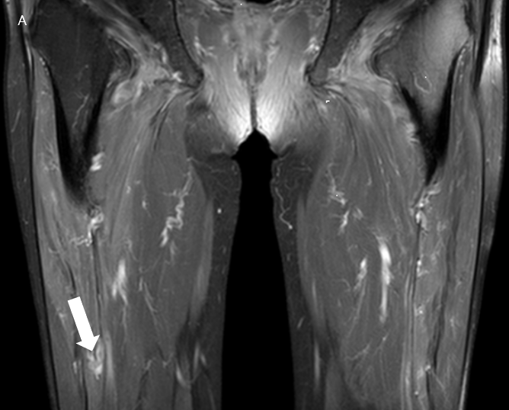
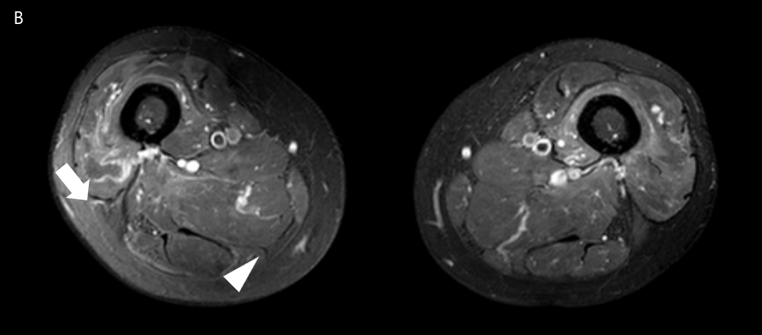
Figure 1 Enhanced T1-weighted image of both thigh muscles. A: Coronal section shows enhancement of the right rectus femoris muscle (arrow); B: Transverse section shows heterogeneous enhancement of the vastus lateralis (arrow) and adductor magnus (arrow head) muscles.

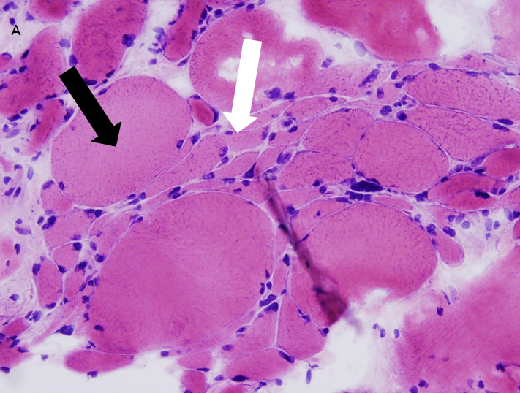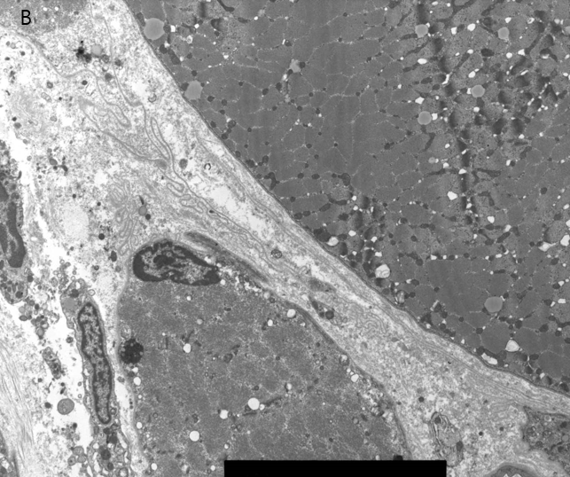
Figure 2 Muscle biopsy of the right vastus lateralis muscle. A: Light microscopy shows atrophic myofiber (white arrow) and compensatory hypertrophy (black arrow). Increased endomysial connective tissue is also seen (hematoxylin and eosin, 200 ×); B: Electron microscopy shows atrophic small myofiber with redundant basal lamina.

Table 1 Distribution of muscular involvement in Behçet’s disease
Ref. | Age | Sex | Involved muscles
Garcin et al^{[22]}, 1967 | 24 | Male | Myalgia of both calves
Afifi et al^{[23]}, 1980 (n = 7) | 19 (1), 21–32 | Female, male | Muscle weakness and peripheral neuropathy in two cases (Variation in muscle fiber size, electron microscopy: thickened basement membrane of capillaries, myofibrillar loss)
Arkin et al ^{[24]}, 1980 | 55 | Male | Myalgia of the right arm
Yazici et al^{[25]}, 1981 | 23 | Male | Myalgia of the right upper leg
Di Giacomo et al^{[26]}, 1982 | 42 | Male | Myalgia of both legs
Finucane et al^{[27]}, 1985 | 27 | Male | Myalgia of both calves and the neck
Frayha et al^{[15]}, 1985 | 11 | Male | Progressive weakness in the lower extremities with multiple cranial nerve palsies (Neurogenic atrophy)
Eveleigh et al^{[28]}, 1987 | 27 | Male | Myalgia of all extremities; Later: both calves
Hamza^{[29]}, 1987 | 34 | Male | Myalgia of both calves
Theoharis et al^{[30]}, 1988 | 31 | Male | Myalgia of the right calf
Lang et al^{[31]}, 1990 | 15 | Female | Recurrent myalgia unilaterally and bilaterally in the calves
Lingenfelser et al^{[32]}, 1992 | 19 | Male | General progressive muscle weakness and pain
Uziel et al^{[33]}, 2000 | 12 | Male | Myalgia of the right calf
Sarui et al^{[11]}, 2002 | 29 | Male | Myalgia of both legs
Akansel et al^{[10]}, 2004 | 23 | Male | Myalgia of the left calf
Dursun et al^{[34]}, 2004 | 18 | Female | Vision loss of the right eye; Redness and orbital pain of both eyes
Kang et al^{[35]}, 2006 | 33 | Female | Pain and swelling of the left preauricular and temporal area
Roh et al^{[36]}, 2006 | 63 | Female | Progressive orbital pain of the right eye
Stubbs et al^{[37]}, 2008 | 45 | Female | Myalgia and swelling of the right hand
Ogose et al^{[38]}, 2010 | 16 | Female | Myalgia and swelling of the left calf
Conway et al^{[39]}, 2012 | 30 | Male | Myalgia of the left upper leg
Jo et al^{[40]}, 2012 | 35 | Female | Myalgia and swelling of both legs
Chebbi et al^{[41]}, 2014 | 45 | Male | Orbital pain and swelling of the left eye
Ng et al^{[42]}, 2016 | 40 | Female | Generalized proximal myalgia
Eun et al^{[43]}, 2017 | 23 | Male | Recurrent right lower abdominal pain

