Name of Journal: World Journal of Gastrointestinal Surgery
Manuscript NO: 59641
Manuscript Type: CASE REPORT

Individualized treatment for gastric cancer with rib metastasis: A case report

Zhang Y et al. Treatment for GC with metastasis

Yu Zhang, Zhen-Xing Zhang, Zeng-Xin Lu, Fang Liu, Geng-Yuan Hu, Feng Tao, Min-Feng Ye

Yu Zhang, Zhen-Xing Zhang, Geng-Yuan Hu, Feng Tao, Min-Feng Ye, Department of Gastrointestinal Surgery, Shaoxing People's Hospital, Shaoxing Hospital of Zhejiang University, Shaoxing 312000, Zhejiang Province, China

Zeng-Xin Lu, Department of Radiology, Shaoxing People's Hospital, Shaoxing Hospital of Zhejiang University, Shaoxing 312000, Zhejiang Province, China

Fang Liu, Department of Pathology, Shaoxing People's Hospital, Shaoxing Hospital of Zhejiang University, Shaoxing 312000, Zhejiang Province, China

Author contributions: Zhang Y, Zhang ZX, Hu GY, Tao F, and Ye MF performed the treatment; Liu F provided the pathological diagnosis; Lu ZX provided the radiological diagnosis and Zhang Y wrote the manuscript.

Corresponding author: Min-Feng Ye, MD, Surgical Oncologist, Department of Gastrointestinal Surgery, Shaoxing People's Hospital, Shaoxing Hospital of Zhejiang University, No. 568 Zhongxing North Road, Shaoxing 312000, Zhejiang Province, China. minfeng_ye@yeah.net

Received: September 25, 2020
Revised: November 3, 2020
Accepted: November 10, 2020
Published online:

Abstract
BACKGROUND
Gastric cancer (GC) with bone metastasis is rare, and rib metastasis is even less common. The clinical prognosis of GC with bone metastasis is poor given the lack of an effective treatment.

CASE SUMMARY
A 70-year-old man was referred to Shaoxing People’s Hospital with left chest pain and slight dyspnea. Chest computed tomography (CT) revealed a metastatic lesion in the left 3rd rib. Esophagogastroduodenoscopy revealed several ulcers in the angle and antrum of the stomach, and tumor biomarkers including CEA and CA-199 were clearly increased. In addition, lymph node metastasis in the lesser curvature of the stomach was identified by positron emission tomography/CT scanning. Further pathological examination confirmed metastatic adenocarcinoma in the rib and medium-low differentiated adenocarcinoma in the gastric space. The patient had GC with rib metastasis, and was clinically staged as T₃N_{x}M₁ (IVB). Based on multidisciplinary team opinions, the patient received five courses of chemotherapy (CAPOX plus aptinib), and then underwent rib resection and laparoscopic radical distal gastrectomy. The patient started four courses of chemotherapy after surgery, and then capecitabine and aptinib were administered orally for 3 mo. Follow-up was performed on an outpatient basis using abdominal/chest CT and tumor biomarkers. The patient exhibited an overall survival greater than 2 years, and the disease-free survival was approximately 18 mo. His adverse events were tolerable.

CONCLUSION
The incidence of GC with rib metastases is extremely low, and patients can obtain more benefits from individualized treatment formulated by multidisciplinary team. Chemotherapy plus surgery might represent an alternative option for GC with rib metastasis.

Key Words: Gastric cancer; Rib metastasis; Chemotherapy; Apatinib; Surgery; Case report

Zhang Y, Zhang ZX, Lu ZX, Liu F, Hu GY, Tao F, Ye MF. Individualized treatment for gastric cancer with rib metastasis: A case report. World J Gastrointest Surg 2020; In press

Core Tip: Gastric cancer (GC) with bone metastasis is uncommon, and rib metastasis is even rarer. The prognosis of patients suffering from GC with rib metastasis is extremely poor. We treated a patient with rib oligometastasis of GC individually and surgically, which led to a long-term tumor-free survival. This case revealed a new idea for the treatment of GC with rib metastasis or other bone metastases.
INTRODUCTION
Gastric cancer (GC) with bone metastasis is infrequent, and rib metastasis is even less common. The clinical prognosis of GC with bone metastasis is poor given lack of an effective treatment^{[1,2]}. It has been reported that the incidence of bone metastasis in GC is 0.9%-2.1%, and the incidence of bone metastasis in postoperative GC is approximately 0.9%-1.8%^{[3-6]}. As a special bone metastasis in GC, rib metastasis is relatively rare clinically, and its treatment options are limited. To our knowledge, there is still no large retrospective report about the incidence of rib metastasis in GC. Only a few cases have been mentioned in clinical analysis. Mikami et al^{[7]} reported ten patients who were radiologically diagnosed as having GC with rib metastasis between January 2010 and December 2015. Wen et al^{[8]} reported 31 GC cases with rib metastasis that were identified from a retrospectively conducted gastric cancer database in their institute between April 2008 and April 2018. Thus, there are a variety of rib metastasis patients who were included in the reports about the incidence of GC with bone metastasis. Correspondingly, there is no specialized report about the treatment for GC with rib metastasis. We present a successful treatment case of GC with rib metastasis, via chemotherapy and surgery under the guidance of multidisciplinary team (MDT) that led to a long-term tumor-free survival in the patient.

CASE PRESENTATION
Chief complaints
A 70-year-old man was referred to Shaoxing People’s Hospital with left chest pain and slight dyspnea but without significant loss of body weight.

History of present illness
On September 6, 2018, the patient was admitted to our hospital with outpatient chest CT indicating a lump of approximately 10.0 cm × 5.2 cm in the left 3rd rib with an unclear surrounding boundary, mainly growing into the pleural cavity. Positron emission tomography (PET)/CT examination showed that the maximum standardized uptake values (SUV) in the gastric antrum and left 3rd rib were abnormally increased. Further esophagogastroduodenoscopy confirmed several ulcers in the angle and antrum of the stomach, and pathology suggested HER-2(-) low-grade adenocarcinoma. Puncture biopsy of the rib was performed, which confirmed metastatic adenocarcinoma by pathology (Figure 1). CAPOX pus apatinib were selected as the chemotherapy regimen for five courses. Left 3rd rib resection and laparoscopic distal gastrectomy D2 lymph node dissection were performed. The patient recovered well, and was administered four courses of the same chemotherapy half a month after the operation. Then capecitabine and aptinib were given orally for 3 mo.

History of past illness
The patient suffered from hypertension, asthma, and chronic bronchitis for years.

Personal and family history
No family history was identified.

Physical examination
Physical examination revealed mild tenderness in the left chest.

Laboratory examinations
Routine blood and biochemical examinations showed no obvious abnormalities. Tumor biomarkers were present at the following levels: CEA = 60.51 ng/mL, CA199 = 2773.4 U/mL, CA242 > 300 IU/mL, and CA50 > 500 IU/mL. Then, these levels gradually returned to normal levels with chemotherapy (Figure 2).

Imaging examinations
PET/CT examination showed that the maximum SUV in the gastric antrum (SUV_{max} = 3.6) and the left 3rd rib (SUV_{max} = 8.05) were abnormally increased. After five courses of chemotherapy, PET/CT suggested that the activity of gastric lesions was moderately reduced, whereas metastatic lymph nodes were devitalized. The activity of metastatic tumors in the rib was significantly reduced (Figure 3).

FINAL DIAGNOSIS
The preoperative diagnosis was GC with left 3rd rib metastasis, and the tumor was clinically staged as T3NxM1 (IVB). The final pathologic report was ypT₁N₁M₀ (IB).

TREATMENT
CAPOX pus apatinib was selected as the chemotherapy regimen. Capecitabine (1500 mg/m² per day) was orally administered twice daily for the first 2 wk of a 3-wk course, and aptinib (started with 500 mg/body per day, then decreased to 250 mg/body per day) was administered orally throughout the 3-wk course. Oxaliplatin was given as an intravenous infusion of 130 mg/m² per day on day 1 of each course. Zoletriphosphate was used to alleviate chest pain, and chest and abdominal CT were used to evaluate changes in the size of primary and metastatic lesions after every two courses of chemotherapy. After five courses of chemotherapy, left 3rd rib resection was performed on February 4, 2019, and postoperative pathology suggested complete regression of rib metastasis. Laparoscopic distal gastrectomy and D2 lymph node dissection were performed on March 4, 2019, and postoperative pathology suggested ulcerative gastric adenocarcinoma with moderate differentiation (Figure 4). The patient started the same chemotherapy as previously noted for four courses half a month after the operation. Then, capecitabine and aptinib were administered orally for 3 mo.

OUTCOME AND FOLLOW-UP
The patient’s overall survival was > 2 years, and the disease-free survival was approximately 18 mo. The patient has been monitored regularly in the outpatient department and no tumor recurrence has been noted to date.

DISCUSSION
Currently, the most effective treatment for GC is radical gastrectomy with D2 lymph node dissection. Once GC transfers to bone tissues, the prognosis is extremely poor. The survival time is typically less than half a year because GC with bone metastasis is mostly found in those types with poor pathological differentiation, a large number of lymph node metastases, and late T stage. Studies have reported that the 8-mo and 1-year survival rates of patients with GC with bone metastasis were 18.3% and 3.3%, respectively. A survival rate of greater than 2 years has not been reported^{[9,10]}. In recent years, the diagnosis and treatment of GC with bone metastasis have greatly improved. It has been reported that the survival of GC with bone metastasis patients can be improved by systemic chemotherapy^{[11]}. S-1 plus oxaliplatin, docetaxel plus S-1, and FOLFOX were the most common regimens for first-line chemotherapy. Case reports from Japan revealed good therapeutic effects of S-1 plus cisplatin for bone metastasis^{[12,13]}. In addition to chemoradiotherapy, the available treatment options for GC with bone metastasis can also be combined with other treatment methods, such as targeted therapy, biotherapy, and immunotherapy. Therefore, for GC with bone metastasis, individualized treatment formulated according to the actual situation can obtain more benefit and maximize the survival time.
For GC patients with metastasis, radical resection of primary and metastatic lesions can also improve overall survival. A retrospective study enrolled 414 patients with GC associated with a single distant metastasis. In total, 333 patients only received palliative chemotherapy, and 81 patients underwent gastrectomy + D2 lymph node dissection after conversion chemotherapy. The study demonstrated that patients with liver metastasis may benefit from aggressive surgery^{[14]}. In this patient, the metastatic lesion was simple and localized to one rib compared to spinal, pelvis, skull, and femur metastases, and the rib was looser and easily subject to radical resection. The primary lesion and metastasis were both potentially resectable when viewed separately. However, radiography examination revealed that the primary lesion had perigastric lymph node metastasis, whereas rib metastasis boundary with surrounding tissue was unclear. Thus, radical resection was difficult. In patients with liver metastases from GC who underwent resection for primary cancer and metastasis, 55 research centers in 17 European countries and Japan conducted a questionnaire survey and found that most centers recommend that patients undergo resection of the primary lesion and metastasis after preoperative chemotherapy^{[15]}. Based on these experiences, MDT first suggested neoadjuvant chemotherapy.
Fluorouracil, platinum, and paclitaxel are the primary chemotherapeutic agents for advanced GC. The first-line chemotherapy is usually a two- or three-drug regimen based on fluorouracil, combined with platinum and/or paclitaxel^{[16-19]}. Evidence in the literature has confirmed that chemotherapy with a two-drug combination is routinely recommended for advanced GC in first-line treatment^{[20-23]}. Meanwhile, oral fluorouracil (S-1, capecitabine) is tantamount to intravenous 5-FU and oxaliplatin can substitute for cisplatin. In China, the priority for platinum is oxaliplatin due to better toleration in patients and the real-world clinical application^{[24,25]}. Therefore, we selected a two-drug combination of oxaliplatin and capecitabine. The patient was simultaneously administered apatinib to improve the effect of chemotherapy based on some studies by Chinese scholars, which demonstrated that apatinib can improve the therapeutic effect of advanced GC. Peng et al^{[26]} reported a real-world study of apatinib for GC in first-line therapy and suggested that the median PFS was 3.33 mo and 5.03 mo for apatinib alone vs apatinib plus chemotherapy, respectively, which was statistically significant. Cheng et al^{[27]} conducted a phase II clinical study (Ahead-G325) and showed that patients with unresectable advanced GC could benefit from conversion therapy with apatinib in combination with S-1/paclitaxel/cisplatin/5-FU. The median-survival time was 30.2 mo in the surgical group compared to 8.9 mo in the nonsurgical group.
After five courses of chemotherapy, the evaluation suggested that chemotherapy was effective. Both the primary tumor and metastatic tumor exhibited a partial response, indicating the possibility for surgical resection, and the patient smoothly received radical distal gastrectomy and left third rib resection. Postoperative pathology demonstrated that the rib metastasis had a complete response and the gastric lesion showed a partial response, suggesting that CAPOX plus aptinib was highly effective in this patient.
On the other hand, based on the data from the phase III study, apatinib was approved in October 2014 by the China Food and Drug Administration for patients with metastatic gastric or gastroesophageal junction adenocarcinoma after second-line chemotherapy^{[28]}. We must note that the use of apatinib in GC with rib metastasis in first-line treatment is currently controversial because the benefit from apatinib is unclear statistically.

CONCLUSION
We provide a very special case of GC with simultaneous rib metastasis. Fortunately, the patient had a very good outcome after MDT-guided individualized treatment. Chemotherapy plus surgery represents a potential alternative option for GC with rib metastasis, but the role of apatinib in this type of treatment needs to be further investigated.

REFERENCES
1 Yoshikawa K, Kitaoka H. Bone metastasis of gastric cancer. Jpn J Surg 1983; 13: 173-176 [PMID: 6632389 DOI: 10.1007/BF02469472]
2 Turkoz FP, Solak M, Kilickap S, Ulas A, Esbah O, Oksuzoglu B, Yalcin S. Bone metastasis from gastric cancer: the incidence, clinicopathological features, and influence on survival. J Gastric Cancer 2014; 14: 164-172 [PMID: 25328761 DOI: 10.5230/jgc.2014.14.3.164]
3 Park HS, Rha SY, Kim HS, Hyung WJ, Park JS, Chung HC, Noh SH, Jeung HC. A prognostic model to predict clinical outcome in gastric cancer patients with bone metastasis. Oncology 2011; 80: 142-150 [PMID: 21677462 DOI: 10.1159/000328507]
4 Ahn JB, Ha TK, Kwon SJ. Bone metastasis in gastric cancer patients. J Gastric Cancer 2011; 11: 38-45 [PMID: 22076200 DOI: 10.5230/jgc.2011.11.1.38]
5 Park JM, Song KY, O JH, Kim WC, Choi MG, Park CH. Bone recurrence after curative resection of gastric cancer. Gastric Cancer 2013; 16: 362-369 [PMID: 22961057 DOI: 10.1007/s10120-012-0193-y]
6 Silvestris N, Pantano F, Ibrahim T, Gamucci T, De Vita F, Di Palma T, Pedrazzoli P, Barni S, Bernardo A, Febbraro A, Satolli MA, Bertocchi P, Catalano V, Giommoni E, Comandone A, Maiello E, Riccardi F, Ferrara R, Trogu A, Berardi R, Leo S, Bertolini A, Angelini F, Cinieri S, Russo A, Pisconti S, Brunetti AE, Azzariti A, Santini D. Natural history of malignant bone disease in gastric cancer: final results of a multicenter bone metastasis survey. PLoS One 2013; 8: e74402 [PMID: 24204569 DOI: 10.1371/journal.pone.0074402]
7 Mikami J, Kimura Y, Makari Y, Fujita J, Kishimoto T, Sawada G, Nakahira S, Nakata K, Tsujie M, Ohzato H. Clinical outcomes and prognostic factors for gastric cancer patients with bone metastasis. World J Surg Oncol 2017; 15: 8 [PMID: 28061855 DOI: 10.1186/s12957-016-1091-2]
8 Wen L, Li YZ, Zhang J, Zhou C, Yang HN, Chen XZ, Xu LW, Kong SN, Wang XW, Zhang HM. Clinical analysis of bone metastasis of gastric cancer: incidence, clinicopathological features and survival. Future Oncol 2019; 15: 2241-2249 [PMID: 31215231 DOI: 10.2217/fon-2019-0039]
9 Kim YJ, Kim SH, Kim JW, Lee JO, Kim JH, Bang SM, Lee JS, Lee KW. Gastric cancer with initial bone metastasis: a distinct group of diseases with poor prognosis. Eur J Cancer 2014; 50: 2810-2821 [PMID: 25201165 DOI: 10.1016/j.ejca.2014.08.003]
10 D'Angelica M, Gonen M, Brennan MF, Turnbull AD, Bains M, Karpeh MS. Patterns of initial recurrence in completely resected gastric adenocarcinoma. Ann Surg 2004; 240: 808-816 [PMID: 15492562 DOI: 10.1097/01.sla.0000143245.28656.15]
11 Sudo H, Takagi Y, Katayanagi S, Hoshino S, Suda T, Hibi Y, Ito K, Tsutida A, Aoki T. [Bone metastasis of gastric cancer]. Gan To Kagaku Ryoho 2006; 33: 1058-1060 [PMID: 16912521]
12 Migita K, Watanabe A, Sakamoto C, Nakamura T, Ohyama T, Ishikawa H, Yamamoto K. [A case of multiple bone metastases from gastric cancer treated with combination chemotherapy of S-1 and CDDP]. Gan To Kagaku Ryoho 2007; 34: 929-931 [PMID: 17565259]
13 Fujishima Y, Yoneda R, Iwai M, Fukunaga H, Miura M, Koide M, Fukuda T. [A case of advanced gastric cancer with disseminated carcinomatosis of bone marrow treated by S-1 and CDDP]. Gan To Kagaku Ryoho 2009; 36: 2653-2655 [PMID: 20009474]
14 Wang Y, Yu YY, Li W, Feng Y, Hou J, Ji Y, Sun YH, Shen KT, Shen ZB, Qin XY, Liu TS. A phase II trial of Xeloda and oxaliplatin (XELOX) neo-adjuvant chemotherapy followed by surgery for advanced gastric cancer patients with para-aortic lymph node metastasis. Cancer Chemother Pharmacol 2014; 73: 1155-1161 [PMID: 24748418 DOI: 10.1007/s00280-014-2449-1]
15 Kataoka K, Kinoshita T, Moehler M, Mauer M, Shitara K, Wagner AD, Schrauwen S, Yoshikawa T, Roviello F, Tokunaga M, Boku N, Ducreux M, Terashima M, Lordick F; EORTC GITCG Group and JCOG SCGC Group. Current management of liver metastases from gastric cancer: what is common practice? New challenge of EORTC and JCOG. Gastric Cancer 2017; 20: 904-912 [PMID: 28150070 DOI: 10.1007/s10120-017-0696-7]
16 Kang YK, Kang WK, Shin DB, Chen J, Xiong J, Wang J, Lichinitser M, Guan Z, Khasanov R, Zheng L, Philco-Salas M, Suarez T, Santamaria J, Forster G, McCloud PI. Capecitabine/cisplatin versus 5-fluorouracil/cisplatin as first-line therapy in patients with advanced gastric cancer: a randomised phase III noninferiority trial. Ann Oncol 2009; 20: 666-673 [PMID: 19153121 DOI: 10.1093/annonc/mdn717]
17 Lu Z, Zhang X, Liu W, Liu T, Hu B, Li W, Fan Q, Xu J, Xu N, Bai Y, Pan Y, Xu Q, Bai W, Xia L, Gao Y, Wang W, Shu Y, Shen L. A multicenter, randomized trial comparing efficacy and safety of paclitaxel/capecitabine and cisplatin/capecitabine in advanced gastric cancer. Gastric Cancer 2018; 21: 782-791 [PMID: 29488121 DOI: 10.1007/s10120-018-0809-y]
18 Wang J, Xu R, Li J, Bai Y, Liu T, Jiao S, Dai G, Xu J, Liu Y, Fan N, Shu Y, Ba Y, Ma D, Qin S, Zheng L, Chen W, Shen L. Randomized multicenter phase III study of a modified docetaxel and cisplatin plus fluorouracil regimen compared with cisplatin and fluorouracil as first-line therapy for advanced or locally recurrent gastric cancer. Gastric Cancer 2016; 19: 234-244 [PMID: 25604851 DOI: 10.1007/s10120-015-0457-4]
19 Boku N, Yamamoto S, Fukuda H, Shirao K, Doi T, Sawaki A, Koizumi W, Saito H, Yamaguchi K, Takiuchi H, Nasu J, Ohtsu A; Gastrointestinal Oncology Study Group of the Japan Clinical Oncology Group. Fluorouracil versus combination of irinotecan plus cisplatin versus S-1 in metastatic gastric cancer: a randomised phase 3 study. Lancet Oncol 2009; 10: 1063-1069 [PMID: 19818685 DOI: 10.1016/S1470-2045(09)70259-1]
20 Al-Batran SE, Hartmann JT, Probst S, Schmalenberg H, Hollerbach S, Hofheinz R, Rethwisch V, Seipelt G, Homann N, Wilhelm G, Schuch G, Stoehlmacher J, Derigs HG, Hegewisch-Becker S, Grossmann J, Pauligk C, Atmaca A, Bokemeyer C, Knuth A, Jäger E; Arbeitsgemeinschaft Internistische Onkologie. Phase III trial in metastatic gastroesophageal adenocarcinoma with fluorouracil, leucovorin plus either oxaliplatin or cisplatin: a study of the Arbeitsgemeinschaft Internistische Onkologie. J Clin Oncol 2008; 26: 1435-1442 [PMID: 18349393 DOI: 10.1200/JCO.2007.13.9378]
21 Luo HY, Xu RH, Wang F, Qiu MZ, Li YH, Li FH, Zhou ZW, Chen XQ. Phase II trial of XELOX as first-line treatment for patients with advanced gastric cancer. Chemotherapy 2010; 56: 94-100 [PMID: 20357440 DOI: 10.1159/000305256]
22 Yamada Y, Higuchi K, Nishikawa K, Gotoh M, Fuse N, Sugimoto N, Nishina T, Amagai K, Chin K, Niwa Y, Tsuji A, Imamura H, Tsuda M, Yasui H, Fujii H, Yamaguchi K, Yasui H, Hironaka S, Shimada K, Miwa H, Hamada C, Hyodo I. Phase III study comparing oxaliplatin plus S-1 with cisplatin plus S-1 in chemotherapy-naïve patients with advanced gastric cancer. Ann Oncol 2015; 26: 141-148 [PMID: 25316259 DOI: 10.1093/annonc/mdu472]
23 Ajani JA, Rodriguez W, Bodoky G, Moiseyenko V, Lichinitser M, Gorbunova V, Vynnychenko I, Garin A, Lang I, Falcon S. Multicenter phase III comparison of cisplatin/S-1 with cisplatin/infusional fluorouracil in advanced gastric or gastroesophageal adenocarcinoma study: the FLAGS trial. J Clin Oncol 2010; 28: 1547-1553 [PMID: 20159816 DOI: 10.1200/JCO.2009.25.4706]
24 Hall PS, Swinson DE, Lord S, Marshall H, Ruddock S, Allmark C, Cairns D, Waters J, Wadsley J, Falk S, Roy R, Joseph M, Nicoll J, Kamposioras KV, Tillett T, Cummins S, Grumett S, Stokes Z, Seymour M. Optimizing chemotherapy for frail and elderly patients (pts) with advanced gastroesophageal cancer (aGOAC): The GO2 phase III trial. J Clin Oncol 2019; 37 suppl 15: 4006 [DOI: 10.1200/JCO.2019.37.15_suppl.4006]
25 Van Cutsem E, Moiseyenko VM, Tjulandin S, Majlis A, Constenla M, Boni C, Rodrigues A, Fodor M, Chao Y, Voznyi E, Risse ML, Ajani JA; V325 Study Group. Phase III study of docetaxel and cisplatin plus fluorouracil compared with cisplatin and fluorouracil as first-line therapy for advanced gastric cancer: a report of the V325 Study Group. J Clin Oncol 2006; 24: 4991-4997 [PMID: 17075117 DOI: 10.1200/JCO.2006.06.8429]
26 Peng W, Zhang F, Wang Z, Li D, He Y, Ning Z, Sheng L, Wang J, Xia X, Yu C, Wang Z, Zhao Y, Liang H, Hu B, Sun C, Wang D, Cheng Y, Pan M, Xia L, Guo X, Zhang Y, Hu Z, Li X, Lu L, Zhang J, Qian H, Xie H, Sun G. Large Scale, Multicenter, Prospective Study of Apatinib in Advanced Gastric Cancer: A Real-World Study from China. Cancer Manag Res 2020; 12: 6977-6985 [PMID: 32821164 DOI: 10.2147/CMAR.S249153]
27 Cheng XD, Xu ZY, Du YA, Ping Hu P, Hu CG. Phase II study of conversion therapy using S1/paclitaxel chemotherapy plus apatinib in unresectable gastric cancer (Ahead-G325 trial). Journal of Clinical Oncology 2017; 35 suppl 4: 53-53 [DOI: 10.1200/JCO.2017.35.4_suppl.53]
28 Li J, Qin S, Xu J, Xiong J, Wu C, Bai Y, Liu W, Tong J, Liu Y, Xu R, Wang Z, Wang Q, Ouyang X, Yang Y, Ba Y, Liang J, Lin X, Luo D, Zheng R, Wang X, Sun G, Wang L, Zheng L, Guo H, Wu J, Xu N, Yang J, Zhang H, Cheng Y, Wang N, Chen L, Fan Z, Sun P, Yu H. Randomized, Double-Blind, Placebo-Controlled Phase III Trial of Apatinib in Patients With Chemotherapy-Refractory Advanced or Metastatic Adenocarcinoma of the Stomach or Gastroesophageal Junction. J Clin Oncol 2016; 34: 1448-1454 [PMID: 26884585 DOI: 10.1200/JCO.2015.63.5995]

Footnotes
Informed consent statement: Informed written consent was obtained from the patient for publication of this report and any accompanying images.

Conflict-of-interest statement: The authors have no conflicts of interest to declare.

CARE Checklist (2016) statement: The authors have read the CARE Checklist (2016), and the manuscript was prepared and revised according to the CARE Checklist (2016).

Open-Access: This article is an open-access article that was selected by an in-house editor and fully peer-reviewed by external reviewers. It is distributed in accordance with the Creative Commons Attribution NonCommercial (CC BY-NC 4.0) license, which permits others to distribute, remix, adapt, build upon this work non-commercially, and license their derivative works on different terms, provided the original work is properly cited and the use is non-commercial. See: http://creativecommons.org/Licenses/by-nc/4.0/

Manuscript source: Unsolicited manuscript

Peer-review started: September 21, 2020
First decision: October 27, 2020
Article in press:

Specialty type: Oncology
Country/Territory of origin: China
Peer-review report’s scientific quality classification
Grade A (Excellent): A
Grade B (Very good): 0
Grade C (Good): 0
Grade D (Fair): 0
Grade E (Poor): 0

P-Reviewer: Tanabe S S-Editor: Zhang L L-Editor: Wang TQ P-Editor:

Figure Legends
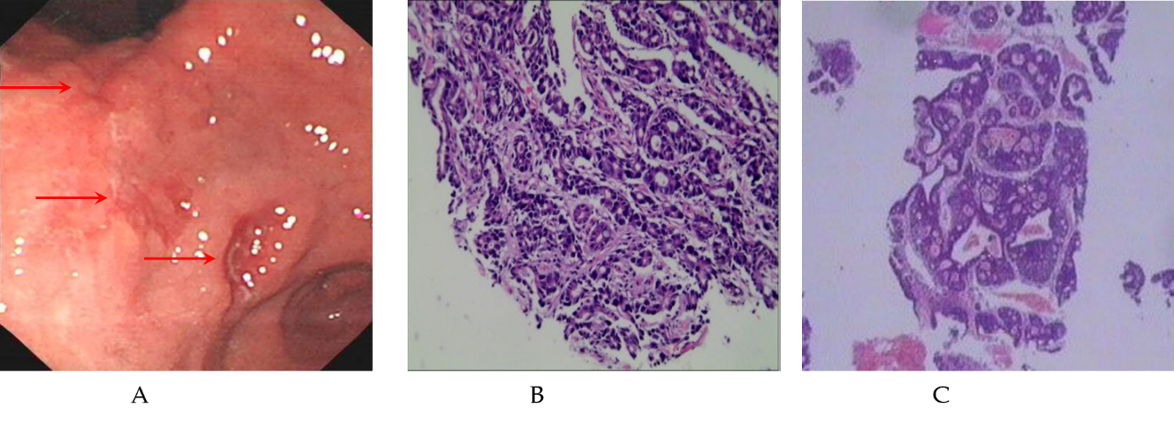
Figure 1 Initial endoscopic and pathology examination. A: Esophagogastroduodenoscopy revealed several ulcers in the angle and antrum of the stomach; B: Pathology suggested low grade adenocarcinoma (× 100). Immunohistochemistry revealed HER-2(-); C: The biopsy pathology of the rib suggested metastatic adenocarcinoma (× 100). Immunohistochemistry showed CK7(-), CK20(+), CDX2(+), TTF-1(-), NapsinA (-), and TG (-).

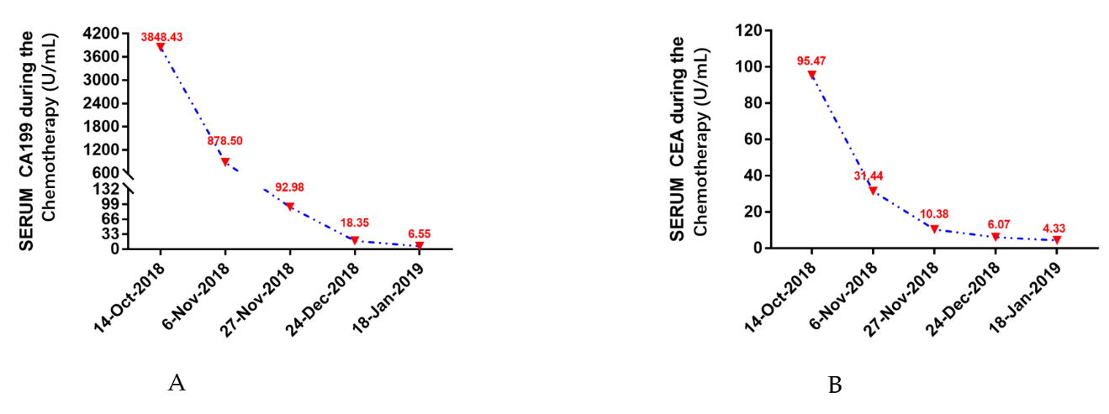
Figure 2 Changes in the levels of tumor biomarkers during adjuvant chemotherapy.

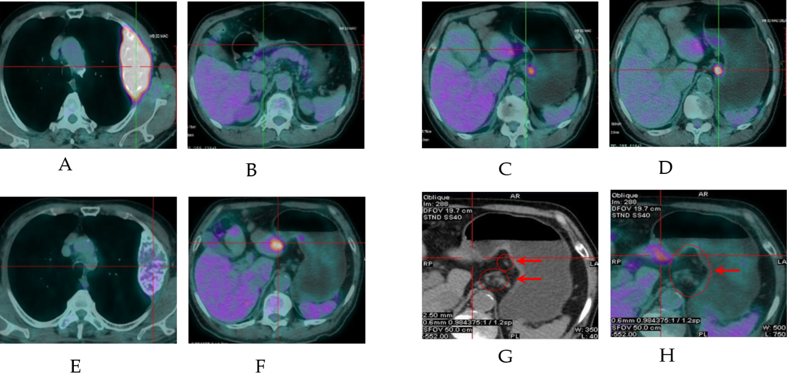
Figure 3 Positron emission tomography/chest computed tomography scanning presentation at different times. A-D: Baseline lesions. A: Rib bone metastasis, SUV_{max} = 8.08; B: Gastric tumor, SUV_{max} = 3.65; C: Metastatic lymph nodes 1, SUV_{max} = 6.5; D: Metastatic lymph nodes 2, SUV_{max} = 3.2. E-H: Changes in the target lesions after five courses of chemotherapy. E: Rib metastasis, SUV_{max} = 2.65; F: Gastric tumor, SUV_{max} = 3.58; G and H: Metastatic lymph nodes, SUV_{max} = 0.

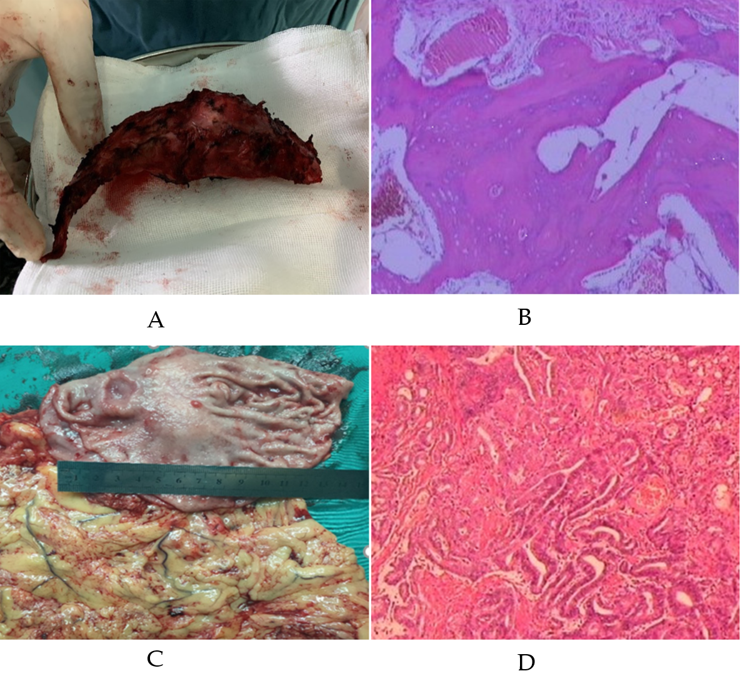
Figure 4 Postoperative specimens and pathologies. A: Left 3rd rib metastasis; B: Pathology of metastasis, with complete regression and no metastatic tumor left (tumor regression grade classification: 0, × 100); C: Gastric cancer; D: Pathology of ulcerative gastric moderately differentiated adenocarcinoma that infiltrated into the submucosa and adjacent to the superficial muscle layer locally, low-grade intraepithelial neoplasia of some glands in the surrounding mucosa, and tumor stroma infiltrated with a small amount of inflammatory cells, with 1/36 lymph node metastasis (partial response, tumor regression grade classification: 2, × 100). Immunohistochemistry revealed CD34(+), blood vessels(+), CDX2(+), CgA(-), CK20(-), CK7(+), CKpan(+), CyclinD1(+), EGFR(+), Ki-67 (+75%), P53(+), Survivin(+), Syn(-), CerbB-2(2+), MLH1(+), MSH2(+), MSH6(+), and PMS2(+).

