Name of Journal: World Journal of Clinical Cases
Manuscript NO: 85470
Manuscript Type: CASE REPORT

Epithelioid malignant peripheral nerve sheath tumor of the bladder and concomitant urothelial carcinoma: A case report

Ozden SB et al. Bladder EMPNST and concomitant urothelial carcinoma

Sami Berk Ozden, Muhammed Fatih Simsekoglu, Ipek Sertbudak, Cetin Demirdag, Iclal Gurses

Sami Berk Ozden, Muhammed Fatih Simsekoglu, Cetin Demirdag, Istanbul University-Cerrahpasa, Cerrahpasa School of Medicine Department of Urology, Istanbul 34100, Fatih, Turkey

Ipek Sertbudak, Iclal Gurses, Istanbul University-Cerrahpasa, Cerrahpasa School of Medicine Department of Pathology, Istanbul 34100, Fatih, Turkey

Author contributions: Demirdag C was head surgeon; Gurses I was head pathologist; Ozden SB wrote the manuscript; Sertbudak I constructed the study design; Şimşekoğlu MF revised the text and collected patient data.

Corresponding author: Sami Berk Ozden, MD, Academic Research, Researcher, Istanbul University-Cerrahpasa, Cerrahpasa School of Medicine Department of Urology, Cerrahpaşa Tıp Fakültesi Yerleşkesi Kocamustafapaşa Caddesi No: 53 Cerrahpaşa 34098 Fatih/İstanbul, Istanbul 34100, Fatih, Turkey. s.berkozden@gmail.com

Received: April 28, 2023
Revised: August 8, 2023
Accepted: August 17, 2023
Published online: January 26, 2024

Abstract
BACKGROUND
Epithelioid malignant peripheral nerve sheath tumor (EMPNST) of the bladder is a rare entity with devastating features. These tumors are thought to originate from malignant transformation of pre-existing schwannomas of pelvic autonomic nerve plexuses, and unlike the conventional malignant peripheral nerve sheath tumor (MPNST), are not associated with neurofibromatosis. The tumor has distinctive morphological, immunohistochemical and molecular features. Additionally, it tends to be more aggressive and have a higher mortality. This is the first case that presents with a synchronous urothelial carcinoma of the bladder and the epithelioid variant of MPNST in the literature. It’s also the second reported case of EMPNST originating from the bladder wall.

CASE SUMMARY
In this case report, we present the detailed clinical course of a 71-year-old patient with EMPNST of the bladder alongside a literature review.

CONCLUSION
During the management of EMPNST cases, offering aggressive treatment modalities to the patient, such as radical cystectomy, is appropriate for the best chance to contain the disease, regardless of the tumor stage and the extent of local disease at initial diagnosis.

Key Words: Epithelioid; Peripheral nerve sheath tumor; Bladder; Case report; Urothelial; Cystoprostatectomy

©The Author(s) 2024. Published by Baishideng Publishing Group Inc. All rights reserved.

Citation: Ozden SB, Simsekoglu MF, Sertbudak I, Demirdag C, Gurses I. Epithelioid malignant peripheral nerve sheath tumor of the bladder and concomitant urothelial carcinoma: A case report. World J Clin Cases 2024; 12(3): 551-559
URL: https://www.wjgnet.com/2307-8960/full/v12/i3/551.htm
DOI: https://dx.doi.org/10.12998/wjcc.v12.i3.551

Core Tip: In this case report, we describe a patient diagnosed with epithelioid variant of malignant peripheral nerve sheath tumor of the bladder wall after thorough pathologic examination. The case is noteworthy, as it is the second reported case that provides information regarding the patient’s prognosis.

INTRODUCTION
Malignant peripheral nerve sheath tumors (MPNSTs) are sarcomas that originate from peripheral nerves from a pre-existing benign nerve sheath tumor or seldomly from a neurofibroma in neurofibromatosis type 1 (NF1) patients^{[1]}. In the absence of these settings, particularly in sporadic de novo or radiotherapy-associated tumors, the diagnosis is based on the histological and immunohistochemical features suggesting Schwannian differentiation^{[2]}. The incidence of the neoplasm is thought to be 0.001 percent in the general population^{[3]}. Epithelioid variant of the MPNST (EMPNST) is a rare subtype of MPNST with distinctive morphological, immunohistochemical and molecular changes^{[4]}. Among the MPNST subtypes, EMPNST occurs in approximately 5% of cases and has only been reported as case series^{[4]}. Because of its rarity, there are no high-volume studies that clearly report the disease characteristics. Although it is hard to make solid statements regarding the course of the disease, there are strong clinical opinions supported by observation. In contrast to conventional MPNST, EMPNST is not associated with neurofibromatosis. It is thought to originate from the malignant transformation of pre-existing epithelioid schwannomas of deep neural tissues with loss of genes like SMARCB/INI1^{[5,6]}. EMPNSTs rarely have genetic alterations in the neurofibromin (NF1), p16/p15 (CDKN2A/CDKN2B), and PRC2 pathways. EMPNST typically shows diffuse strong staining with S100 and SOX10 in contrast to conventional MPNST^{[5,7]}. SMARCB1 gene inactivation resulting in SMARCB1 loss by immunohistochemistry is observed in approximately 75% of cases^{[6]}. In addition, EMPNSTs tend to be more aggressive and have higher mortality^{[5,7]}.
The first case published on this specific neoplasm was described to have a non-neoplastic bladder mucosa and occurred as an isolated EMPNST^{[8]}. Our case is unique, as it is the first case that presents with a synchronous urothelial carcinoma of the bladder and the epithelioid variant of MPNST in the literature. It is also the second EMPNST case reported originating from the bladder wall.

CASE PRESENTATION
Chief complaints
A 71-year-old elderly patient presenting with 1 mo of painless intermittent macroscopic hematuria with a history of the frequency with intermittency was admitted to our outpatient clinic. The patient was an ex-smoker (50 pack/year) and had diabetes and chronic kidney disease. He was on routine surveillance for an incidental tubulo-villous adenoma on the sigmoid colon by our general surgery department. The patient had no history of a previous radiotherapy or neurofibromatosis disease.
On physical examination, there was no remarkable finding during the inspection. No skin lesions (neurofibromas, café-au-lait spots) were noted. On digital rectal examination, prostate was found to be moderately enlarged with no stiffness or irregularities. Blood samples were collected at admission; the prostate-specific antigen (PSA) level (2.46 ng/mL) was within normal range (0-4 ng/mL), while the levels of blood urea nitrogen (BUN) (69 mg/dL; normal range: 10-50 mg/dL) and creatinine (1.30 mg/dL; normal range: 0.3-1.1 mg/dL) were elevated. The collected urine sample revealed microscopic hematuria (33 erythrocyte/hpf; normal range: 0-5 erythrocyte/hpf).
A urinary ultrasound scan was conducted revealing a diverticulum with a 45 mm × 35 mm diameter harboring a suspicious papillary projection with a dimension of 30 mm × 20 mm on the posterior bladder wall. A prompt cystoscopy was performed revealing one papillary lesion with a 30 mm × 30 mm diameter on the prementioned diverticulum wall and another 10 mm × 10 mm lesion on the right posterolateral bladder wall. Transurethral resection of bladder tumor (TURBT) was performed on both lesions. Because one of the lesions was located on the diverticulum wall, the resection was performed superficially. On pathological evaluation, both resection materials were found to be non-invasive low grade papillary urothelial carcinoma (Figure 1).
After the initial procedure, the patient’s hematuria regressed. The patient then underwent a routine control cystoscopy session 3 mo after the primary resection. Suspicious papillary projections on both old resection sites and in proximity to the right ureteric orifice were identified. Complete resection was performed with respective deep resection biopsies. On pathological examination, both lesions had non-invasive low grade papillary urothelial carcinoma. The tissue sample resected near the right ureteric orifice was found to have atypical mesenchymal cell infiltration in the lamina propria. The cells stained positive with S100, SOX10 and vimentin, suggesting that the cells had a neural origin (Figure 1). The blood sample was sent to our Genetics department for NF-1 mutation analysis, but it was not detected on fluorescent in situ hybridization.
A re-TURBT was planned 2 wk later for the proper reassessment of the tumor. However, due to lack of adherence by the patient, it was performed 4 mo later. The patient had weight loss and intermittent hematuria with clot passage during the time span. On cystoscopic examination, suspicious bladder wall irregularities including diffuse solid lesions protruding into the bladder lumen were observed in a 5 cm × 5 cm area extending from one lateral wall to the other, including the bladder trigone. An incomplete resection could have been performed due to the tumor size. Microscopically, the tumor comprised a relatively uniform but clearly atypical population of epithelioid cells and a smaller proportion of fascicle-forming spindle cells. The epithelioid tumor cell population showed a multilobular growth pattern with lobules, nests and cords surrounded by fibrous and focal myxoid stroma. The polygonal tumor cells had round vesicular nuclei, prominent nucleoli and abundant pale eosinophilic to amphophilic cytoplasm. Mitotic rate was 42/10 HPF and atypical mitotic figures were seen. Necrosis was present. The background was occasionally infiltrated with neutrophils. The tumor was highly dedifferentiated and was in concordance with grade 3 sarcoma according to FNCLCC (Fédération Nationale des Centres de Lutte Contre le Cancer) sarcoma grading system^{[9]}. Immunohistochemically, the tumor cells showed strong and diffuse staining for S100, SOX10, vimentin, p16 and focal staining for cytokeratin 7 (CK7), epithelial membrane antigen (EMA), collagen type 4 (Figure 2). There was no expression of the melanocytic markers Myo-D1, desmin, CD34, smooth muscle actin (SMA), myogenin, CD117, GATA3 or ALK. No loss of INI1 expression was observed. Ki67 proliferative index was 10%. The pathological diagnosis was in concordance with high-grade EMPNST. A sample was sent to the molecular pathology laboratory for BRAFv600 mutation analysis for evaluating the availability of novel systemic treatment agents, but it was not detected.
A full body fluorodeoxyglucose positron emission tomography computed tomography (FDG-PET CT) scan was performed to rule out distant metastases and for local staging. On abdominopelvic cross-sectional images, an intrapelvic mass was bordering the posterior bladder wall and causing compression and distortion of pelvic structures. No distinctive border could be identified between the mass and the bladder wall. Increased FDG uptake on both the right external iliac and right common iliac lymph nodes was noted. An isolated paracaval lymph node just above the right iliac bifurcation had increased FDG uptake. On cross-sectional thoracal images, a nodular lesion on the right upper lobe of the lung with a 14 mm × 13 mm diameter was observed. The lesion also had nuclear material uptake, making it a candidate for metastases of the primary lesion (Figure 3).
The patient was discussed in a multidisciplinary uro-oncology meeting with the participation of urology, oncology, pathology, and radiation oncology departments. It had been decided to perform a radical cystoprostatectomy and extended lymph node resection for providing local disease control. The patient underwent radical cystoprostatectomy with ileal loop repair and bilateral ilioinguinal lymph node dissection. During the surgery, no notable adhesions, stiff tissues, or pathologic bodies along the perivesical spaces, rectovesical borders, and retropubic area were noted. These perioperative findings indicated that the tumor anatomically originated from the bladder rather than the pelvic plexuses. There were no operation-related complications during the hospital stay. The patient was discharged 7 d after the surgery following the drain removal.
Through the pathologic examination of the cystoprostatectomy specimen, full-thickness infiltrating EMPNST into the bladder wall was identified. There was also a heterologous component (mature bone) in the focal area within the tumor. No other peripheral nerve sheath-associated tumor types (schwannoma, neurofibroma or perineuroma) were noted. In addition, acinar adenocarcinoma (Gleason score 3 + 3 = 6) was detected incidentally in the prostate. EMPNST metastases were detected in 2 of 11 right pelvic lymph nodes removed. The number of bilaterally excised lymph nodes was 18.
An intravenous contrast-enhanced CT scan was performed 3 mo after the cystectomy. The lesion located on the apical portion of the right lung was found to be increased in diameter (13 mm × 14 mm) and another nodular lesion with contrast uptake was added to the inferior lobe of the right lung. The patient could not receive any additional systemic therapy due to frailty. The patient passed away 4 mo after the cystectomy and 12 mo after the initial diagnosis due to emerging type 1 respiratory failure causing cardiac arrest after intensive care unit (ICU) admission.

History of present illness
Tubulovillous adenoma of sigmoid colon was detected prior to endourological intervention.

History of past illness
Patient has known diabetes and chronic kidney disease.

Personal and family history
The patient was an ex-smoker (50 pack/year). No remarkable family history of chronic illness was recorded.

Physical examination
On physical examination, there was no remarkable finding during the inspection. No skin lesions (neurofibromas, café-au-lait spots) were noted. On digital rectal examination, the prostate was moderately enlarged with no stiffness or irregularities.

Laboratory examinations
Blood samples were collected at admission. The PSA level was within normal range 2.46 ng/mL (0 to 4), and BUN and creatinine levels were elevated (69 mg/dL and 1.30 mg/dL, respectively). The collected urine sample indicated microscopic hematuria (33 erythrocyte/hpf).

Imaging examinations
A urinary ultrasound scan was conducted revealing a diverticulum with a 45 mm × 35 mm diameter harboring a suspicious papillary projection with a dimension of 30 mm × 20 mm on the posterior bladder wall.
A full body FDG-PET CT scan was performed to rule out distant metastases and for local staging. On abdominopelvic cross-sectional images, an intrapelvic mass was bordering the posterior bladder wall and causing compression and distortion of pelvic structures. No distinctive border could be identified between the mass and the bladder wall. Increased FDG uptake on both the right external iliac and right common iliac lymph nodes was noted. An isolated paracaval lymph node just above the right iliac bifurcation had increased FDG uptake. On cross-sectional thoracal images, a nodular lesion on the right upper lobe of the lung with a 14 mm × 13 mm diameter was observed. The lesion also had nuclear material uptake, making it a candidate for metastases of the primary lesion.

MULTIDISCIPLINARY EXPERT CONSULTATION
It was decided to perform a radical cystoprostatectomy and extended lymph node resection for local disease control.

FINAL DIAGNOSIS
The pathological diagnosis was in concordance with high-grade EMPNST of the bladder.

TREATMENT
The patient underwent radical cystoprostatectomy with ileal loop repair and bilateral ilioinguinal lymph node dissection.

OUTCOME AND FOLLOW-UP
The patient passed away 4 mo after the cystectomy and 12 mo after the initial diagnosis due to emerging type 1 respiratory failure causing cardiac arrest after ICU admission.

DISCUSSION
Mesenchymal tumors comprise 0.04% of all malignant tumors of the whole urinary system^{[10]}. Bladder-originating MPNST is a lesser-known entity that originates from pelvic autonomic nerve plexuses. MPNST is only occasionally documented in the case reports in the literature, making the process of diagnosis and treatment harder due to a lack of evidence-based data. Most reported patients are diagnosed with NF-1 disease and are below the age of 40. Published cases mostly presented with hematuria, suprapubic mass, and urinary retention. Most cases were not distinguished from urothelial carcinoma during cystoscopy and transurethral resection^{[8,11,12]}.
Even though EMPNST has been known since 1957, EMPNST alone only constitutes 5% of all MPNSTs. Due to its rarity, information regarding the clinical presentation and prognosis remains the same. Yet, the understanding of the tumor's histopathologic features has evolved through the years by the refinement of histopathological diagnostic tools^{[4-6]}. EMPNST of the bladder alone is a much rarer entity with aggressive features and a very poor prognosis, making it hard to be studied under prospective randomized clinical trials. The two known risk factors for conventional MPNSTs are radiation exposure and neurofibromatosis type 1^{[3]}. Though in a comprehensive case series, no EMPNST patients had neurofibromatosis and some had benign schwannoma areas in resected tumor samples, suggesting that the tumor originates from a benign neoplasm in contrast to conventional MPNSTs^{[4]}. They are thought to originate from malignant transformation of pre-existing epithelioid schwannomas of the deep neural tissues.
It is challenging to differentiate EMPNST from urothelial carcinoma by clinical evaluation. Ultrasonography, CT, or magnetic resonance imaging cannot differentiate EMPNST from urothelial carcinoma. Therefore, it is important to evaluate the pathology in detail with appropriate methods^{[8,13]}.
Typically, EMPNSTs are composed of spindle cells growing in a haphazard manner consisting of interlacing sheets and nodules accompanied by atypical round polygonal ovoid cells with eosinophilic cytoplasm^{[14]}. More than 50% of tumor cells should be in polygonal morphology. In addition to these features, they present with interstitial infiltration of inflammatory cells namely mononuclear cells, neutrophils, and eosinophils^{[4]}.
This entity has a distinct immunophenotypic characteristic. Unlike conventional MPNSTs, EMPNSTs show strong and diffuse staining for S100 and SOX10, alongside the absence of melanoma markers. They may also be positive for keratin and retain expression of H3K27me3^{[4,5,8]}. Molecular distinction of EMPNSTs from conventional MPNSTs can be further elaborated. SMARCB1 gene inactivation resulting in SMARCB1 loss by immunohistochemistry is observed in approximately 75% of cases^{[6]}. They rarely have genetic alterations in the neurofibromin (NF1), p16/p15 (CDKN2A/CDKN2B), and PRC2 pathways^{[4,7]}. In addition, they tend to be more aggressive and have higher mortality than MPNSTs^{[4-6]}.
Sarcomatoid urothelial carcinoma, leiomyosarcoma, epithelioid angiosarcoma, melanoma and perivascular epithelioid cell tumors (PEComas) fall into pathological differential diagnosis of this neoplasm. The first tumor to be considered in the differential diagnosis of our case was sarcomatoid urothelial carcinoma. No macroscopic or microscopic relationship was identified between the urothelial tumor in the bladder mucosa and the tumor in the bladder wall. Furthermore, the mucosal tumor consisted entirely of non-invasive low grade papillary urothelial carcinoma; no high grade foci or lamina propria invasion was observed. The EMPNST in the bladder wall was diffusely positive for SOX10 and S100, while urothelial tumors stain negative for these markers. Epithelial markers (EMA, CK7) were focally positive, in contrast to anticipated diffuse staining in urothelial carcinomas. GATA3 was also negative in the tumor, whereas urothelial carcinoma specimens are GATA3+. The lobular growth pattern in the epithelioid component and the presence of myxoid stroma, albeit focal in the periphery, were other microscopic findings supporting the EMPNST diagnosis.
The patient has no history of melanoma, and no in situ melanocytic lesion in the bladder was observed. Some nuclei were wavy in the spindle areas of the tumor and no pigment (melanin) was detected. In melanoma, positivity of epithelial markers is not expected, whereas focal positivity can be seen in EMPNST, as in our case. In addition to morphological findings, leiomyosarcoma and angiosarcoma were ruled out due to negative muscle and vessel markers. PEComas are composed of epithelioid and/or spindle cells with clear to eosinophilic granular cytoplasm. Epithelioid cells are arranged in dyscohesive nests surrounded by delicate thin-walled vessels and/or in sheets, whereas spindle cells often form fascicles. Radial/perivascular distribution of tumor cells is a valuable finding. Conventional PEComas express HMB45, mela-A and smooth muscle markers with variable intensity and extent. HMB45 is a more sensitive marker, being positive in nearly all PEComas, whereas melan-A is a more specific marker, being positive in at least half of the tumors^{[15]}. Melanocytic markers were exclusively negative in the tumor within the bladder wall.
Primary treatment modality for conventional MPNSTs is surgical resection if no gross solid organ metastases are present. Adjuvant radiotherapy can be given to provide local disease control after resection. Unfortunately, the distant metastases are almost always present or may become evident within 2 mo after initial diagnosis. Although the effectiveness is still controversial, patients with unresectable tumors on the trunk or extremities may benefit from anthracycline regimens plus doxorobucin, ifosfamide, etoposide regimens^{[16,17]}. Furthermore, since the sarcoma deploys from a neural crest originated stem cell, it may express BRAFv600E mutations, which may respond to targeted systemic therapy with vemurafenib^{[18,19]}. There are some continuing molecular and in vitro cell culture studies to identify tumor vulnerability in advance for a potential targeted therapy^{[19-21]}.
For the MPNST of the bladder, the data regarding the disease stems from cases reported at different clinics around the globe. There is no high-volume study covering patient demographics, prognosis, or clinical data, such as overall survival or disease-free survival after undergoing different treatment modalities.
Nevertheless, the disease has mostly been recorded in patients younger than the fourth decade of their lives. The majority of patients have type 1 neurofibromatosis with the exception of a few sporadic cases^{[14]}. The youngest patient reported in the literature had neurofibromatosis type 1 disease and was 9-years-old at the time of diagnosis. The patient underwent cystectomy and was treated with systemic therapy^{[22]}. The disease may present with painless hematuria, abdominal mass, weight loss or nonspecific irritative urinary symptoms. No clinically significant tumor-specific centricity has been noted in the literature, and the neoplasm may arise from the trigone, dome, or the lateral walls of the bladder. Although long-term follow ups are not disclosed in case reports, it is known that the prognosis is poor and that the disease is generally at an advanced stage at the time of diagnosis^{[8,9,11,23,24]}. Even though there is a single reported case cured with transurethral resection of the tumor, the patient’s long-term follow-up is unknown. Moreover, the epithelial variant of the tumor has only been reported once in the literature, and very little is known regarding the prognosis of the reported patient^{[8]}. Our case is unique because the patient presents with a synchronous EPMNST and urothelial carcinoma, the first known report of such a case. The patient was initially diagnosed with non-invasive bladder carcinoma, and the EPMNST was identified 7 mo after admission. Cystectomy was performed 8 mo after the initial admission. During the pathological evaluation of the cystoprostatectomy material, a metachronous Gleason score (3 + 3) 6 prostate adenocarcinoma was in addition to the EPMNST and urothelial carcinoma. The patient passed away 12 mo after diagnosis due to respiratory failure related to lung metastases. It is unknown whether the tumor would have had any response to systemic therapy since the patient was unable to receive any treatment.
Our presented case is unique; it is the first case that presents with a synchronous urothelial carcinoma of the bladder and epithelioid variant of MPNST. It is the second reported case of bladder EMPNST.

CONCLUSION
In conclusion, during the management of EMPNST cases, offering aggressive treatment modalities such as radical cystectomy to the patient is appropriate for the chance of containing the disease, regardless of tumor stage and the extent of local disease at the initial diagnosis. There is no oncological consensus or evidence-based data on the use of systemic therapy for MPNST originating from the urogenital system. It is not known whether performing radical surgery has any effect on prognosis and it should be further investigated on studies with higher patient volume.

REFERENCES
1 Perrin RG, Guha A. Malignant peripheral nerve sheath tumors. Neurosurg Clin N Am 2004; 15: 203-216 [PMID: 15177319 DOI: 10.1016/j.nec.2004.02.004]
2 Miettinen MM, Antonescu CR, Fletcher CDM, Kim A, Lazar AJ, Quezado MM, Reilly KM, Stemmer-Rachamimov A, Stewart DR, Viskochil D, Widemann B, Perry A. Histopathologic evaluation of atypical neurofibromatous tumors and their transformation into malignant peripheral nerve sheath tumor in patients with neurofibromatosis 1-a consensus overview. Hum Pathol 2017; 67: 1-10 [PMID: 28551330 DOI: 10.1016/j.humpath.2017.05.010]
3 Kim DH, Murovic JA, Tiel RL, Moes G, Kline DG. A series of 397 peripheral neural sheath tumors: 30-year experience at Louisiana State University Health Sciences Center. J Neurosurg 2005; 102: 246-255 [PMID: 15739552 DOI: 10.3171/jns.2005.102.2.0246]
4 Laskin WB, Weiss SW, Bratthauer GL. Epithelioid variant of malignant peripheral nerve sheath tumor (malignant epithelioid schwannoma). Am J Surg Pathol 1991; 15: 1136-1145 [PMID: 1746681 DOI: 10.1097/00000478-199112000-00004]
5 Lee W, Teckie S, Wiesner T, Ran L, Prieto Granada CN, Lin M, Zhu S, Cao Z, Liang Y, Sboner A, Tap WD, Fletcher JA, Huberman KH, Qin LX, Viale A, Singer S, Zheng D, Berger MF, Chen Y, Antonescu CR, Chi P. PRC2 is recurrently inactivated through EED or SUZ12 loss in malignant peripheral nerve sheath tumors. Nat Genet 2014; 46: 1227-1232 [PMID: 25240281 DOI: 10.1038/ng.3095]
6 Schaefer IM, Dong F, Garcia EP, Fletcher CDM, Jo VY. Recurrent SMARCB1 Inactivation in Epithelioid Malignant Peripheral Nerve Sheath Tumors. Am J Surg Pathol 2019; 43: 835-843 [PMID: 30864974 DOI: 10.1097/PAS.0000000000001242]
7 Jo VY, Fletcher CDM. SMARCB1/INI1 Loss in Epithelioid Schwannoma: A Clinicopathologic and Immunohistochemical Study of 65 Cases. Am J Surg Pathol 2017; 41: 1013-1022 [PMID: 28368924 DOI: 10.1097/PAS.0000000000000849]
8 Eltoum IA, Moore RJ 3rd, Cook W, Crowe DR, Rodgers WH, Siegal GP. Epithelioid variant of malignant peripheral nerve sheath tumor (malignant schwannoma) of the urinary bladder. Ann Diagn Pathol 1999; 3: 304-308 [PMID: 10556478 DOI: 10.1016/s1092-9134(99)80027-6]
9 Neuville A, Chibon F, Coindre JM. Grading of soft tissue sarcomas: from histological to molecular assessment. Pathology 2014; 46: 113-120 [PMID: 24378389 DOI: 10.1097/PAT.0000000000000048]
10 Dotan ZA, Tal R, Golijanin D, Snyder ME, Antonescu C, Brennan MF, Russo P. Adult genitourinary sarcoma: the 25-year Memorial Sloan-Kettering experience. J Urol 2006; 176: 2033-8; discussion 2038-9 [PMID: 17070247 DOI: 10.1016/j.juro.2006.07.021]
11 Petracco G, Patriarca C, Spasciani R, Parafioriti A. Malignant peripheral nerve sheath tumor of the bladder A case report. Pathologica 2019; 111: 365-368 [PMID: 31965114 DOI: 10.32074/1591-951X-33-19]
12 Karatzoglou P, Karagiannidis A, Kountouras J, Christofiridis CV, Karavalaki M, Zavos C, Gavalas E, Patsiaoura K, Vougiouklis N. Von Recklinghausen's disease associated with malignant peripheral nerve sheath thmor presenting with constipation and urinary retention: a case report and review of the literature. Anticancer Res 2008; 28: 3107-3113 [PMID: 19031965 DOI: 10.1111/j.1601-0825.1999.tb00310.x]
13 Jiwani S, Gokden M, Lindberg M, Ali S, Jeffus S. Fine-needle aspiration cytology of epithelioid malignant peripheral nerve sheath tumor: A case report and review of the literature. Diagn Cytopathol 2016; 44: 226-231 [PMID: 26646298 DOI: 10.1002/dc.23401]
14 Cheng L, MacLennan GT, Bostwick DG. Urologic Surgical Pathology. Fourth edition. Elsevier; 2020. (pp 300-302) [DOI: 10.1016/b978-0-323-54941-7.09992-8]
15 Hamza A, Guo CC. Perivascular Epithelioid Cell Tumor of the Urinary Bladder: A Systematic Review. Int J Surg Pathol 2020; 28: 393-400 [PMID: 31865807 DOI: 10.1177/1066896919895810]
16 Kroep JR, Ouali M, Gelderblom H, Le Cesne A, Dekker TJA, Van Glabbeke M, Hogendoorn PCW, Hohenberger P. First-line chemotherapy for malignant peripheral nerve sheath tumor (MPNST) versus other histological soft tissue sarcoma subtypes and as a prognostic factor for MPNST: an EORTC soft tissue and bone sarcoma group study. Ann Oncol 2011; 22: 207-214 [PMID: 20656792 DOI: 10.1093/annonc/mdq338]
17 Bradford D, Kim A. Current treatment options for malignant peripheral nerve sheath tumors. Curr Treat Options Oncol 2015; 16: 328 [PMID: 25777573 DOI: 10.1007/s11864-015-0328-6]
18 Rekhi B, Kosemehmetoglu K, Tezel GG, Dervisoglu S. Clinicopathologic features and immunohistochemical spectrum of 11 cases of epithelioid malignant peripheral nerve sheath tumors, including INI1/SMARCB1 results and BRAF V600E analysis. APMIS 2017; 125: 679-689 [PMID: 28452074 DOI: 10.1111/apm.12702]
19 Yang K, Du J, Shi D, Ji F, Ji Y, Pan J, Lv F, Zhang Y, Zhang J. Knockdown of MSI2 inhibits metastasis by interacting with caveolin-1 and inhibiting its ubiquitylation in human NF1-MPNST cells. Cell Death Dis 2020; 11: 489 [PMID: 32606289 DOI: 10.1038/s41419-020-2703-x]
20 Terribas E, Fernández M, Mazuelas H, Fernández-Rodríguez J, Biayna J, Blanco I, Bernal G, Ramos-Oliver I, Thomas C, Guha R, Zhang X, Gel B, Romagosa C, Ferrer M, Lázaro C, Serra E. KIF11 and KIF15 mitotic kinesins are potential therapeutic vulnerabilities for malignant peripheral nerve sheath tumors. Neurooncol Adv 2020; 2: i62-i74 [PMID: 32642733 DOI: 10.1093/noajnl/vdz061]
21 Gampala S, Shah F, Zhang C, Rhodes SD, Babb O, Grimard M, Wireman RS, Rad E, Calver B, Bai RY, Staedtke V, Hulsey EL, Saadatzadeh MR, Pollok KE, Tong Y, Smith AE, Clapp DW, Tee AR, Kelley MR, Fishel ML. Exploring transcriptional regulators Ref-1 and STAT3 as therapeutic targets in malignant peripheral nerve sheath tumours. Br J Cancer 2021; 124: 1566-1580 [PMID: 33658640 DOI: 10.1038/s41416-021-01270-8]
22 Bouty A, Dobremez E, Harper L, Harambat J, Bouteiller C, Zaghet B, Wolkenstein P, Ducassou S, Lefevre Y. Bladder Dysfunction in Children with Neurofibromatosis Type I: Report of Four Cases and Review of the Literature. Urol Int 2018; 100: 339-345 [PMID: 29514154 DOI: 10.1159/000487193]
23 Somatilaka BN, Sadek A, McKay RM, Le LQ. Malignant peripheral nerve sheath tumor: models, biology, and translation. Oncogene 2022; 41: 2405-2421 [PMID: 35393544 DOI: 10.1038/s41388-022-02290-1]
24 O'Brien J, Aherne S, Buckley O, Daly P, Torreggiani WC. Malignant peripheral nerve sheath tumour of the bladder associated with neurofibromatosis I. Can Urol Assoc J 2008; 2: 637-638 [PMID: 19066687 DOI: 10.5489/cuaj.985]

Footnotes
Informed consent statement: Informed consent was obtained from all participants included in the study.

Conflict-of-interest statement: All the authors declare that they have no conflict of interest.

CARE Checklist (2016) statement: The authors have read the CARE Checklist (2016), and the manuscript was prepared and revised according to the CARE Checklist (2016).

Open-Access: This article is an open-access article that was selected by an in-house editor and fully peer-reviewed by external reviewers. It is distributed in accordance with the Creative Commons Attribution Non-Commercial (CC BY-NC 4.0) license, which permits others to distribute, remix, adapt, build upon this work non-commercially, and license their derivative works on different terms, provided the original work is properly cited and the use is non-commercial. See: https://creativecommons.org/Licenses/by-nc/4.0/

Provenance and peer review: Unsolicited article; Externally peer reviewed.
Peer-review model: Single blind

Corresponding Author's Membership in Professional Societies: European Association of Urology, No. 110323.

Peer-review started: April 28, 2023
First decision: July 27, 2023
Article in press: August 17, 2023

Specialty type: Urology and nephrology
Country/Territory of origin: Turkey
Peer-review report’s scientific quality classification
Grade A (Excellent): 0
Grade B (Very good): B
Grade C (Good): 0
Grade D (Fair): 0
Grade E (Poor): 0

P-Reviewer: Alkhatib AJ, Jordan S-Editor: Liu JH L-Editor: Filipodia P-Editor: Liu JH
Figure Legends
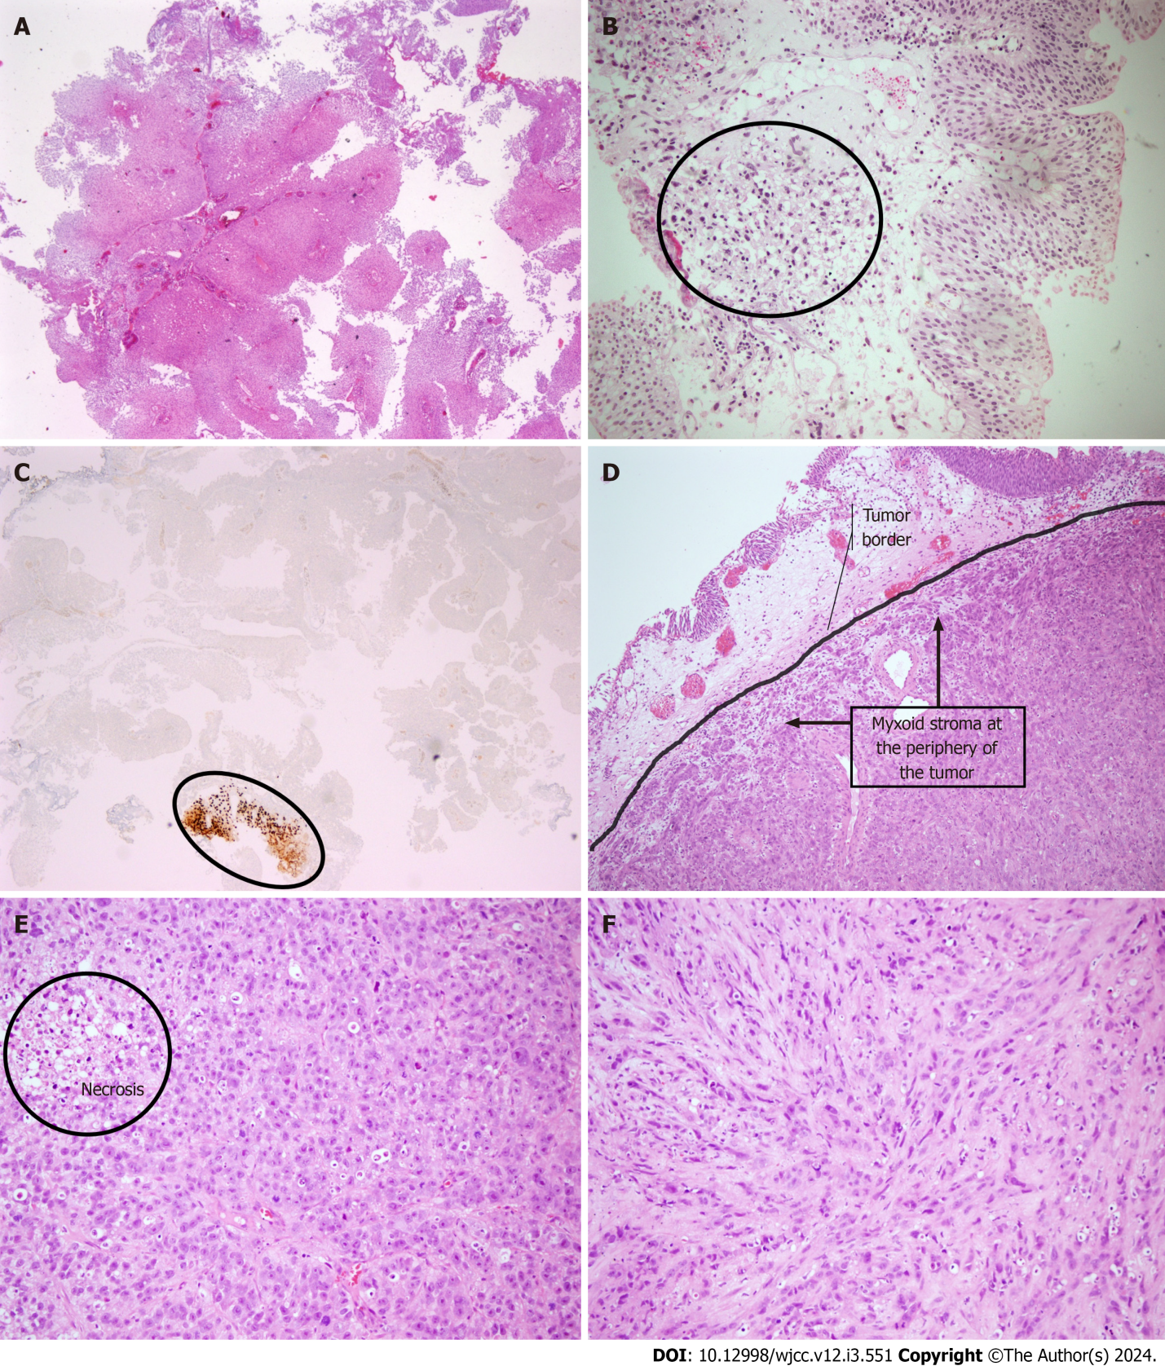
Figure 1 Epithelioid malignant peripheral nerve sheath tumor of the bladder. A: Non-invasive low grade papillary urothelial carcinoma seen on initial biopsy; B: Non-invasive low grade papillary urothelial carcinoma and atypical mesenchymal cell infiltration in the lamina propria determined on second biopsy (the area within the circle); C: SOX-10 immunopositivity in atypical mesenchymal cells (the area annotated with ellipse) located in the lamina propria in one of the tissue fragments representing the non-invasive papillary urothelial carcinoma; D: Focal myxoid stroma at the periphery of the tumor with a lobular growth pattern (an arc is used to distinguish normal urothelium from tumoral tissue); E: Epithelioid tumor cells with round vesicular nuclei, prominent nucleoli and abundant eosinophilic cytoplasm; necrosis in the upper left corner; F: Spindle tumor cells with fascicular growth (hematoxylin and eosin, SOX10, × 40, × 100 and × 200).
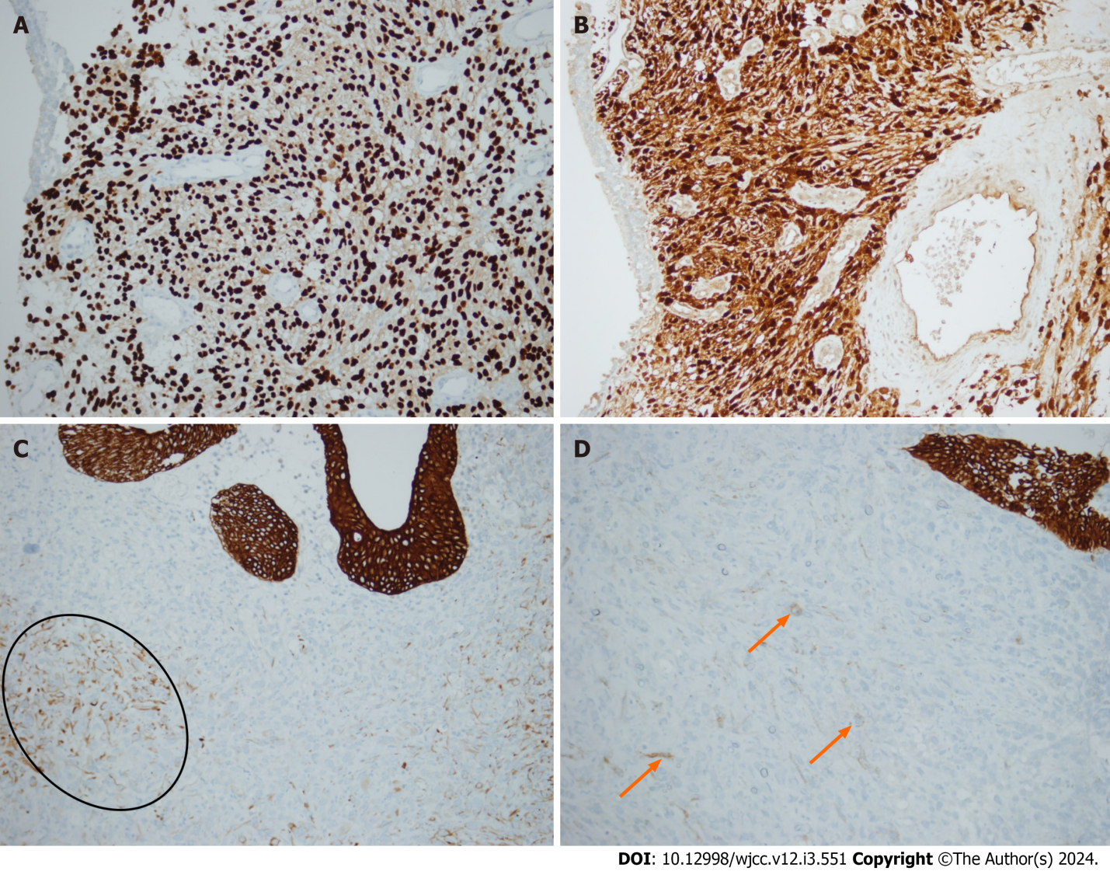
Figure 2 Immunohistochemical findings of epithelioid malignant peripheral nerve sheath tumor. A: Immunohistochemistry for SOX10 showing strong nuclear positivity of epithelioid tumor cells; B: Diffuse and strong immunopositivity for S100; C: CK7 immunohistochemistry shows patchy cytoplasmic positivity (staining cells are annotated with an ellipse); D: Occasional cells are positive for EMA (x 200). Arrows used to denote dispersed tumoral cells positively stained.
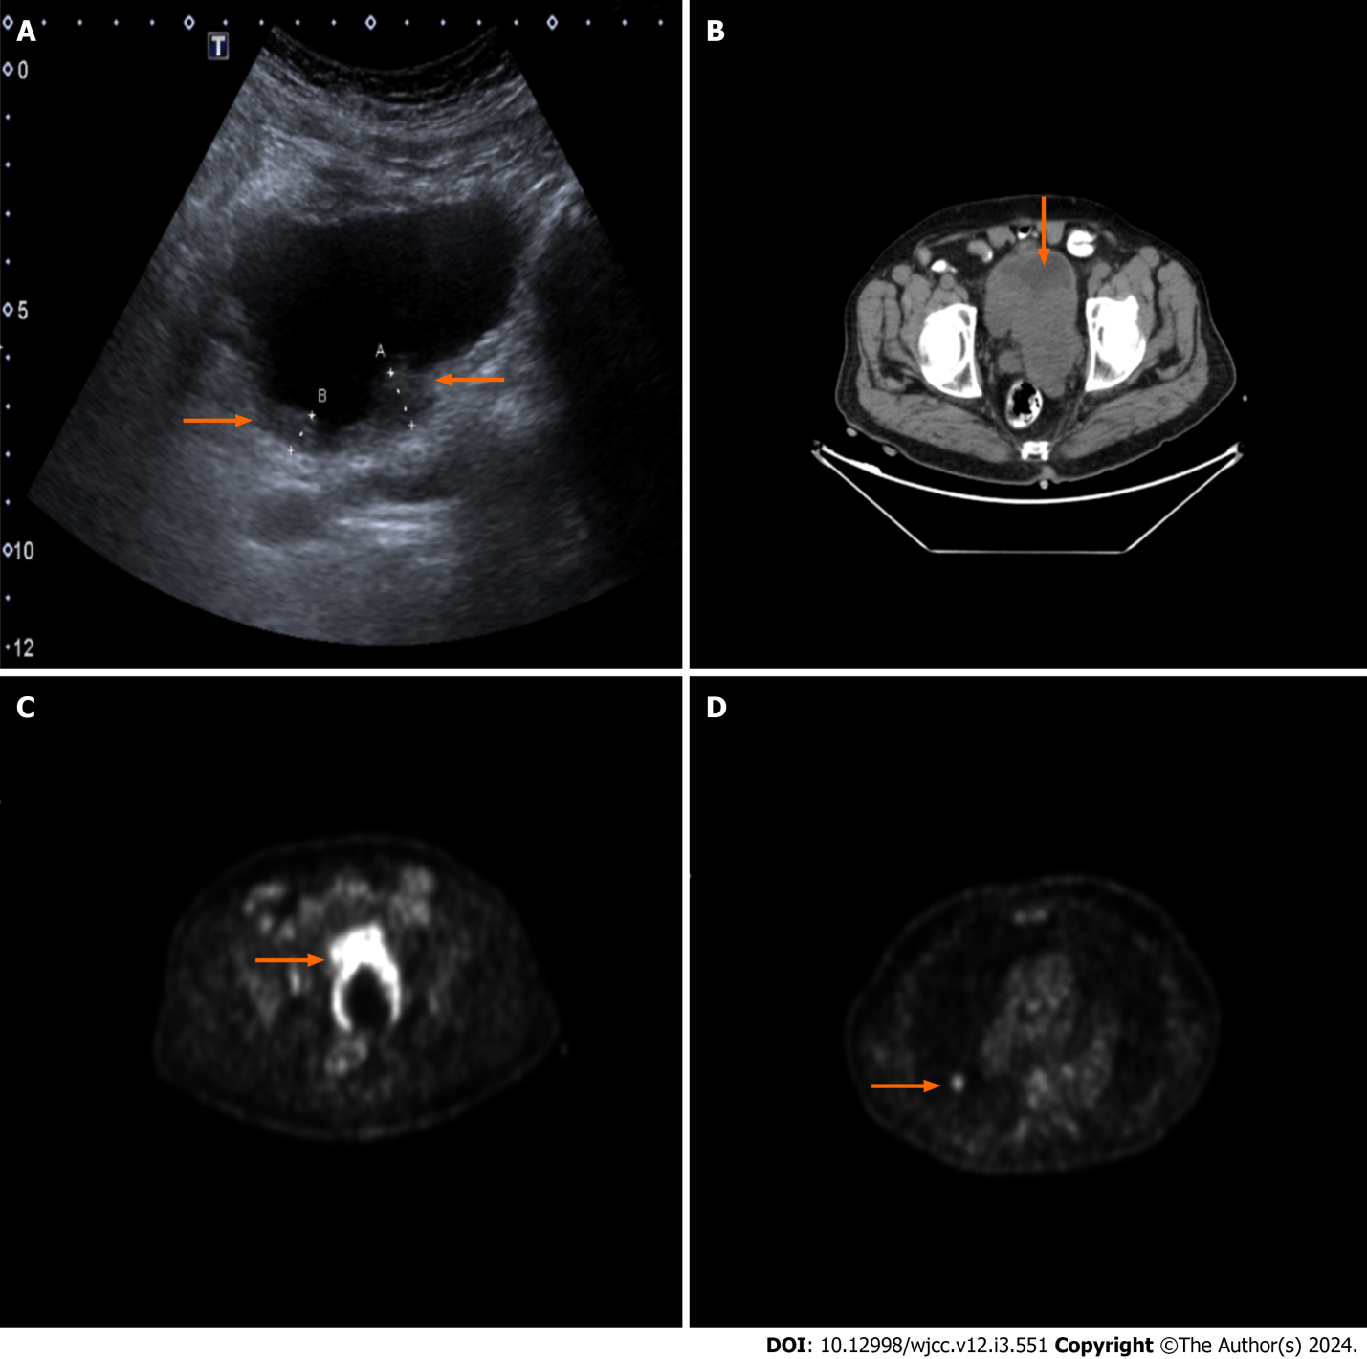
Figure 3 Radiological findings of epithelioid malignant peripheral nerve sheath tumor. A-B: Ultrasonography and computed tomography images of patient; B-C: The positron emission tomography computed tomography slices of the patient show a large radiodense mass filling the diverticulum and extending through the posterior wall of the bladder with significant fluorodeoxyglucose (FDG) uptake; D: Foci of metastasis on right lung detected on FDG-positron emission tomography scan (arrows on A-D used to annotate the descriptions).

Published by Baishideng Publishing Group Inc
7041 Koll Center Parkway, Suite 160, Pleasanton, CA 94566, USA
Telephone: +1-925-3991568
E-mail: office@baishideng.com
Help Desk: https://www.f6publishing.com/helpdesk
https://www.wjgnet.com

© 2024 Baishideng Publishing Group Inc. All rights reserved.

