Name of Journal: World Journal of Gastroenterology
Manuscript NO: 46231
Manuscript Type: ORIGINAL ARTICLE

Case Control Study
Interleukin-22 receptor 1 is expressed in multinucleated giant cells: A study on intestinal tuberculosis and Crohn's disease

Yu ZQ et al. IL-22R1 expression in multinucleated giant cells

Zi-Qi Yu, Wen-Fei Wang, You-Chao Dai, Xin-Chun Chen, Jian-Yong Chen

Zi-Qi Yu, Jian-Yong Chen, Department of Gastroenterology and Hepatology, Jiangxi Provincial People’s Hospital, Nanchang 330006, Jiangxi Province, China

Zi-Qi Yu, Jiangxi Medical College, Nanchang University, Nanchang 330006, Jiangxi Province, China

Wen-Fei Wang, You-Chao Dai, Xin-Chun Chen, Department of Microbiology and Immunology, Shenzhen University Health Science Center, Shenzhen 518000, Guangdong Province, China

Wen-Fei Wang, Department of Pharmaceutical/Medicinal Chemistry, Institute of Pharmacy, Friedrich Schiller University, Jena 07743, Germany

ORCID number: Zi-Qi Yu (0000-0003-0235-2993); Wen-Fei Wang (0000-0003-3422-2384); You-Chao Dai (0000-0002-6586-2627); Xin-Chun Chen (0000-0002-9052-5024); Jian-Yong Chen (0000-0001-6679-0912).

Author contributions: Chen JY, Chen XC, Wang WF, and Yu ZQ designed the research; Yu ZQ, Wang WF, and Dai YC performed the research; Yu ZQ and Wang WF analyzed the data; Yu ZQ wrote the paper.

Supported by Key R&D Plan of Science and Technology Department of Jiangxi Province, No. 20171BBG70087.

Institutional review board statement: The study was reviewed and approved by the Jiangxi Provincial People's Hospital Institutional Review Board.

Informed consent statement: All study participants, or their legal guardian, provided informed written consent prior to study enrollment.

Conflict-of-interest statement: To the best of our knowledge, no conflict of interest exists.

STROBE Statement: The authors have read the STROBE Statement—checklist of items, and the manuscript was prepared and revised according to the STROBE Statement—checklist of items.

Open-Access: This article is an open-access article which was selected by an in-house editor and fully peer-reviewed by external reviewers. It is distributed in accordance with the Creative Commons Attribution Non Commercial (CC BY-NC 4.0) license, which permits others to distribute, remix, adapt, build upon this work non-commercially, and license their derivative works on different terms, provided the original work is properly cited and the use is non-commercial. See: http://creativecommons.org/licenses/by-nc/4.0/

Manuscript source: Unsolicited manuscript

Corresponding author: Jian-Yong Chen, MD, PhD, Chief Doctor, Professor, Department of Gastroenterology and Hepatology, Jiangxi Provincial People’s Hospital, 92 Aiguo Road, Donghu district, Nanchang 330006, Jiangxi Province, China. cjyacy69@163.com
Telephone: +86-180-70088908
Fax: +86-791-86895621

Received: February 12, 2019
Peer-review started: February 15, 2019
First decision: April 4, 2019
Revised: April 20, 2019
Accepted: April 29, 2019
Article in press:
Published online:

Abstract
BACKGROUND
It is challenging to distinguish intestinal tuberculosis from Crohn’s disease due to dynamic changes in epidemiology and similar clinical characteristics. Recent studies have shown that polymorphisms in genes involved in the interleukin (IL)-23/IL-17 axis may affect intestinal mucosal immunity by affecting the differentiation of Th17 cells.

AIM
To investigate the specific single-nucleotide polymorphisms (SNPs) in genes involved in the IL-23/IL-17 axis and possible pathways that affect susceptibility to intestinal tuberculosis and Crohn's disease.

METHODS
We analysed 133 patients with intestinal tuberculosis, 128 with Crohn’s disease, and 500 normal controls. DNA was extracted from paraffin-embedded specimens or whole blood. Four SNPs in the IL23/Th17 axis (IL22 rs2227473, IL1β rs1143627, TGFβ rs4803455, and IL17 rs8193036) were genotyped with TaqMan assays. The transcriptional activity levels of different genotypes of rs2227473 were detected by dual luciferase reporter gene assay. The expression of IL-22R1 in different intestinal diseases was detected by immunohistochemistry.

RESULTS
The A allele frequency of rs2227473 (P = 0.030, odds ratio = 0.60, 95% confidence interval: 0.37-0.95) showed an abnormal distribution between intestinal tuberculosis and healthy controls. The presence of the A allele was associated with a higher IL-22 transcriptional activity (P < 0.05). In addition, IL-22R1 was expressed in intestinal lymphoid tissues, especially under conditions of intestinal tuberculosis, and highly expressed in macrophage-derived Langhans giant cells. The results of immunohistochemistry showed that the expression of IL-22R1 in patients with Crohn's disease and intestinal tuberculosis was significantly higher than that in patients with intestinal polyps and colon cancer (P < 0.01).

CONCLUSION
High IL-22 expression seems to be a protective factor for intestinal tuberculosis. IL-22R1 is expressed in Langhans giant cells, suggesting that the IL-22/IL-22R1 system links adaptive and innate immunity.

Key words: Crohn’s disease; Intestinal tuberculosis; Single-nucleotide polymorphism; Interleukin-22; Interleukin-22 receptor 1; Multinucleated giant cells

© The Author(s) 2019. Published by Baishideng Publishing Group Inc. All rights reserved.

Core tip: The interleukin-22 (IL22) gene promoter SNP rs2227473 G allele is a risk factor for intestinal tuberculosis. High IL-22 expression seems to be a protective factor for intestinal tuberculosis. IL-22R1 is not only highly expressed in epithelial cells but also, unexpectedly, expressed in Langhans giant cells, contradicting the previous view that IL-22R1 is expressed only in non-haematopoietic cells. Importantly, these data provide a premise for elucidating the role of the IL-22/IL-22R1 system in the crosstalk between innate and adaptive immunity under conditions of chronic inflammation. Researchers should pay more attention to the immunological side effects of therapeutic modulation of the IL-22/IL-22R1 axis.

Yu ZQ, Wang WF, Dai YC, Chen XC, Chen JY. Interleukin-22 receptor 1 is expressed in multinucleated giant cells: A study on intestinal tuberculosis and Crohn's disease. World J Gastroenterol 2019; In press

INTRODUCTION
Intestinal tuberculosis (ITB) is chronic granulomatous inflammation caused by Mycobacterium tuberculosis (M. tuberculosis) invading the gut. Crohn’s disease (CD) is a chronic non-specific intestinal inflammatory disease. Although the pathogenesis of CD is still not clear, it is believed that genetic and environmental factors cause excessive mucosal immune responses to normal intestinal flora, causing intestinal pathological damage^{[1]}. Asia was previously considered a low endemic area for CD, but the incidence has increased considerably over recent decades due to industrialization and the Westernization of lifestyle^{[2]}. Moreover, due to the increase in floating population and HIV and M. tuberculosis infections, as well as the prevalence of multidrug-resistant strains, the prevention and control of tuberculosis (TB) are facing severe challenges^{[3,4]}. It is challenging to distinguish ITB from CD due to dynamic changes in epidemiology and similar clinical characteristics, especially in developing countries^{[5,6]}. After a misdiagnosis of ITB as CD, treatment with immunosuppressive agents may aggravate the TB infection and cause systemic dissemination. Upon misdiagnosis of CD as ITB, anti-TB treatment results in serious drug side effects, and appropriate treatment is delayed.
There is a large amount of mucosa-associated lymphoid tissue in the intestine, which plays a vital role in the pathogenesis of ITB and CD^{[7,8]}. Th17 cells, named for their production of interleukin (IL)-17, have recently attracted much attention in the study of mucosal immunity. Th17 cells are a subset of CD4⁺ T lymphocytes^{[9,10]}, which are critical in mucosal defence and autoimmune diseases^{[11]}. Previous studies have reported that the lamina propria of the small intestine has abundant Th17 cells and that its unique microenvironment is beneficial for the differentiation of Th17 cells^{[12,13]}. The coordination of Th17 cell differentiation and maintenance is complex (Figure 1); naïve T cells induce RORγt expression by activating the STAT3 signalling pathway in response to IL-23, IL-6, and TGF-β after dendritic cell presentation or antigen stimulation, thereby promoting the differentiation of Th17 cells into CD4⁺IL-17⁺ cells^{[14-19]}. IL-1β also plays an important role in this process^{[20-23]}. The regulatory network through which Th17 cells exert physiological functions is called the IL-23/IL-17 axis.
Important active products of Th17 cell function are IL-17 and IL-22. Because of the unique role of IL-22 in the intestinal barrier system, we are particularly interested in it. IL-22 is a member of the IL-10 family and is produced by Th-17 cells, γδ T cells, natural killer T cells, and innate lymphoid cells^{[24,25]}. IL-22 binds to a heterodimeric receptor complex consisting of IL-22R1 and IL-10R2 to activate the JAK-STAT signalling pathway^{[26,27]}. IL-22–IL-22R1 interactions can induce the expression of genes encoding molecules involved in tissue inflammation, immunosurveillance, and homeostasis^{[28-31]}, suggesting that the IL-22–IL-22R1 pathway plays a key role in maintaining normal barrier homeostasis, especially in intestinal mucosal immunity. The protective function of IL-22 is evidenced by the observation that IL22^{−/−} mice are susceptible to Citrobacter rodentium infection^{[32]}.
Mechanical, chemical, immune, and biological barriers together constitute the intestinal mucosal barrier; each barrier plays a substantial role in the defence of the enteric mucous membrane. IL-22 maintains these barriers through a variety of mechanisms. To maintain the mechanical barrier, IL-22 activates STAT3 to enhance the transcription of anti-apoptotic and pro-proliferative genes, thereby promoting mucosal healing^{[33]}, and regulates the integrity of intestinal epithelial cells by upregulating tight junction proteins in the human intestinal epithelium^{[34,35]}. To maintain the chemical barrier, IL-22 stimulates Mucin 1 expression and glycosylation to produce a firm inner mucus layer that prevents bacterial invasion^{[36,37]}. Regarding the immune barrier, IL-22 induces the production of innate antimicrobials, including defensins, Reg family molecules, and S100 proteins^{[38]}. Regarding the biological barrier, IL-22 plays an important role in the shaping of body immunity and colonic flora balance^{[39,40]}.
Polymorphisms in genes involved in the IL-23/IL-17 axis have been reported to influence inflammatory bowel disease (IBD) susceptibility. A genome-wide association study based on a Japanese population showed that multiple genes in this pathway are associated with IBD^{[41]}, and similar studies have been conducted in Korean populations^{[42]}. Our previous studies in sizable samples of Chinese Han populations found that through an single-nucleotide polymorphism (SNP) selection strategy, IL22 rs2227473 was associated with susceptibility to TB^{[43]}; eleven polymorphic loci were also screened in the IL6 promoter region, and only rs1800795 was found to be associated with TB susceptibility^{[44]}. Similarly, IL1β promoter polymorphism rs1143627 is associated with susceptibility to M. tuberculosis infection, the genotype of which affects the severity of TB^{[45]}. Therefore, we aimed to study ITB and CD and to determine whether SNPs in genes involved in the IL-23/IL-17 axis differ between these two diseases.

MATERIALS AND METHODS
Study participants
This case-control study was conducted between January 2008 and December 2017 at the Jiangxi Provincial People’s Hospital (Nanchang, China). A total of 133 patients with ITB, 128 with CD, and 500 healthy controls (HCs) were included. All of the patients and HCs were randomly selected, and all of the subjects were local people from Jiangxi Province. The inclusion criteria for patients with ITB were as follows: Age 18 years or older; ITB diagnosed by clinical manifestations, endoscopy, X-ray imaging, pathological changes, positive acid-fast staining, and/or response to anti-TB treatment; and no other infectious, chronic, or autoimmune diseases. The inclusion criteria for patients with CD were as follows: Age 18 years or older; CD diagnosed based on clinical symptoms, X-ray findings, serological examination results, endoscopic findings, and histopathology following the Chinese Society of Gastroenterology consensus on the diagnosis and management of IBD; and no infectious or non-infectious colitis. The inclusion criteria for HCs were as follows: Age 18 years or older; negative TB-specific interferon gamma release assay; no clinical manifestations of TB (no abnormalities in chest radiology); and no other infectious, chronic, malignant, or autoimmune diseases. The present study protocol was reviewed and approved by the institutional review board of Jiangxi Provincial People's Hospital and complied with the principles of the Declaration of Helsinki.

Genotyping of polymorphisms in IL-23/IL-17 axis genes
We obtained formalin-fixed paraffin-embedded (FFPE) specimens from ITB and CD patients. We sectioned each FFPE sample into three sections at 20-μm thickness and transferred the sections into Eppendorf tubes for immediate storage at - 20 °C. Lithium heparin anti-coagulated whole blood (2 mL) was collected from HCs and stored at 4 °C. Genomic DNA was extracted from paraffin-embedded specimens from the ITB and CD patients described above using an FFPE DNA Kit (Omega, United States) and from whole blood from HCs using a DNeasy Blood and Tissue Kit (QIAGEN, United States). Four SNPs in genes involved in the IL23/Th17 axis (IL22 rs2227473, IL1β rs1143627, TGFβ rs4803455, and IL17(A) rs8193036) were genotyped with TaqMan assays in a 20-μL reaction volume using the ABI 7500 Real-time PCR system (ABI, United States). The cycling parameters were as follows: Pre-PCR processing at 60 °C for 1 min; hold at 95 C for 10 min; 40 cycles of 95 ℃ for 15 s and 60 °C for 1 min; and post-PCR processing at 60 °C for 1 min. The results were analysed by using ABI 7500 PCR software.

Dual-luciferase assays
DNA fragments of the rs2227473_G (-1810G) allele of the IL22 gene were amplified by PCR using human genomic DNA and were subsequently modified by site-directed mutagenesis (Beyotime, China) to generate rs2227473_A (-1810A). All amplicons were verified by direct sequencing and inserted into a pGL3-basic reporter vector (Promega, United States) harbouring a genetically engineered firefly luciferase gene without a promoter. 293T cells (2 × 10⁵) were cultured in antibiotic-free Dulbecco’s modified Eagle medium containing 10% foetal bovine serum (Gibco, Australia) and plated in 12-well plates 24 h before transfection. Plasmid constructs were transfected into 293T cells with Lipofectamine 2000 reagent (Life Technology, United States). At 24 h post-transfection, luciferase reagent was added to the culture medium in each well, and the resulting solution was mixed. After 15 min, firefly luminescence was measured with a Multi-Mode Microplate Reader (Bio-Tek, United States). Then, Stop and Glo Reagent was added to the original culture medium in each well, and the resulting solution was mixed. After 10 min, Renilla luminescence was measured. Relative promoter activity is expressed as the ratio of firefly luciferase to Renilla luciferase signal. Three independent transfections and duplicate luciferase assays were performed for each condition, and the pGL3-basic vector was used as a control.

Immunohistochemistry
To compare the immunohistochemistry results of IL-22R expression in different intestinal diseases, we randomly selected 20 FFPE specimens of colon polyps and colon cancer patients according to the following criteria. The inclusion criteria for patients with colonic polyps were as follows: Age 18 years or older; pathological diagnosis of colon polyps; and no other infectious, chronic, malignant, or autoimmune diseases. The inclusion criteria for patients with colon cancer were as follows: Age 18 years or older; pathological diagnosis was colon cancer; no prior radiotherapy or chemotherapy; and no other infectious or autoimmune diseases. Twenty FFPE gut biopsies of colon polyps, colon cancer, ITB, and CD were cut with a rotary microtome (Leica RM2235, Germany) as three serial sections (4 μm) on the microslide. Unstained sections were placed in a 67 °C drying oven for 2 h of deparaffinization, rehydrated through two changes of xylene and a graded alcohol series, and then rinsed in dH₂O. Antigens were retrieved by immersing sections in a pressure cooker containing boiling 1 × R-BUFFER B Solution (Electron Microscopy Sciences, United States) for 3 min at 100 °C. Sections were then rinsed in dH₂O and processed for immunostaining using the EXPOSE rabbit-specific HRP/DAB detection IHC kit (Abcam, United States) according to the manufacturer's protocol. The primary antibody was rabbit/IgG polyclonal anti-IL22 receptor alpha antibody ab5984 (1:200; Abcam, United States). Negative controls consisted of phosphate buffered saline instead of primary antibodies. Mouse kidney tissue was used as a positive control according to the manufacturer's protocol. Sections were counterstained with Modified Harris Haematoxylin solution (Solarbio, China), dehydrated through a graded alcohol series and xylene, and mounted with neutral balsam (Solarbio, China). Images were captured at 200 × magnification using a Nikon Eclipse Ni microscope with NIS-Elements AR ver. 4.40.00 software (Nikon, Japan). The expression of IL-22 receptor 1 (IL-22R1) in intestinal tissues was semi-quantitatively evaluated using Image-Pro Plus version 6.0 (Bethesda, United States). Integrated optical density (IOD) was measured in five fields from each slice randomly selected by two senior pathologists. The capture conditions were strictly maintained across all the photographs.

Statistical analysis
In this case-control study, we first compared the baseline characteristics of the study population. The categorical variables were analysed by the chi-square test or Fisher’s exact test, and the continuous variables were compared using an independent sample t-test. The goodness-of-fit χ² test was performed to check if the genotype frequencies of case and control groups conformed to Hardy-Weinberg equilibrium. Power calculations were performed using Power and Sample Size Calculation Statistical Software^{[46]}. Unconditional logistic regression analysis was used to compare the genotype and allele frequencies among the three groups. Covariates such as gender, age, smoking, and drinking were included to adjust the odds ratio (OR) value. The disease-associated additive genetic model was evaluated by the Cochran-Armitage trend test. For the disease with significant results in the additive model text, logistic regression analysis was used to analyse the three genetic models (dominant, recessive, and co-dominant) that the SNP may follow in the disease; the OR and 95% confidence interval (CI) were then calculated and adjusted by using the above covariates. One-way ANOVA was used for comparisons among multiple groups. All statistical analyses were performed using SPSS (statistical software version 24). The statistical tests were two-tailed, and statistical significance was evaluated at P < 0.05.

RESULTS
Clinical characteristics of the study population
As shown in Table 1, no significant difference was found between the ITB and CD groups in mean age, smoking or drinking history, white blood cell count, haemoglobin, erythrocyte sedimentation rate (ESR), purified protein derivative skin test, or disease-related surgery (P > 0.05). However, both the T cell spot test positive rate and abnormal lung imaging findings showed a significant difference (P < 0.05) between the two groups, indicating their potential utility in identifying ITB and CD.

Genotype distributions of the SNPs in the case and control groups conform to the Hardy-Weinberg equilibrium
Retrieving rs2227473, rs1143627, rs4803455, and rs8193036 from the dbSNP database, we found that the MAFs (minor allele frequencies) of the East Asian population were 0.072, 0.547, 0.348, and 0.267, respectively. The statistical power of this polymorphism study exceeded 0.80. The genotype and allele frequency distributions of the SNPs rs2227473 and rs1143627 are shown in Tables 2-7. After adjusting for gender, age of diagnosis, and the history of drinking and smoking, the GA genotype (P = 0.046, OR = 0.57, 95%CI = 0.33-0.99) and the A allele frequency (P = 0.030, OR = 0.60, 95%CI = 0.37-0.95) of rs2227473 were significantly abnormally distributed in ITB patients compared with HCs; similarly, the CT genotype (P = 0.033, OR = 1.81, 95%CI = 1.05-3.13), the TT genotype (P = 0.011, OR = 2.17, 95%CI = 1.19-3.95), and the T allele frequency (P = 0.014, OR = 1.43, 95%CI = 1.07-1.89) of rs1143627 were significantly abnormally distributed in ITB patients compared with HCs. The genotype and allele frequency distributions of the SNPs rs4803455 and rs8193036 were not significantly different among the three groups, and the results are shown in the Supplementary material.

Cochran-Armitage trend test
After the Cochran-Armitage trend test, the additive model fit IL22 rs2227473 in ITB (χ² = 5.47, P = 0.019) and CD (χ² = 1.91, P = 0.167); and the additive model fit IL1β rs1143627 in ITB (χ² =6.53, P = 0.011) and CD (χ² = 2.54, P = 0.111). Therefore, we mainly analysed the genetic models that the above two SNPs may follow in ITB, and the results are shown in Tables 8 and 9. We found a significant difference between the wild-type and the mutant-type under the dominant model in rs2227473, and the difference was still statistically significant after adjusting for the covariates (P = 0.040, OR = 0.58, 95%CI = 0.34-0.98); rs1143627 had a significant difference in the dominant, recessive, and co-dominant genetic models.

Association of haematological features with genotype
Some data, particularly ESR data, were missing because the corresponding examinations were not performed for the patients. There was no significant difference in the three clinical indicators among the different genotypes at the four examined loci in both ITB and CD patients (Supplementary material).

Dual-luciferase assay
As shown in Figure 2, the firefly/renilla luciferase values were significantly different between the recombinant vector and empty vector transfected groups, and pGL3-rs2227473_A was associated with significantly increased Firefly/Renilla luciferase values relative to those of pGL3-rs2227473_G.

Immunohistochemistry
As shown in Figure 3, IL-22R1 expression in CD and ITB was not restricted to epithelial cells; high IL-22R1 expression was observed in intestinal lymphoid tissues. However, it was difficult to ascertain whether expression was confined to the cell membrane because ITB samples showed many aggregated immune cells that were completely stained by diaminobenzidine (DAB).

High IL-22R1 expression in Langhans giant cells
Langhans giant cells are a typical component of tuberculous nodules, and cells in the central part of a tuberculous granuloma undergo caseous necrosis. As shown in Figure 4, epithelioid cells and Langhans multinucleated giant cells were observed around the necrotic area. Lymphocytes infiltrated the outer nodule regions, and fibroblasts and collagen fibres were distributed around these nodules. In addition, these multinucleated giant cells were ubiquitous and exhibited strong DAB staining. Average IOD (total IOD/total area) of IL-22R1 in gut tissues from colon polyps, colon cancer, ITB, and CD was calculated (Figure 5). Compared with colon polyps and colon cancer, both ITB and CD showed significantly higher IL-22R1 expression.

DISCUSSION
In this study, we analysed four SNP loci in genes involved in the IL23/IL17 axis and found that the frequency distributions of SNPs in IL22 (rs2227473) and IL1β (rs1143627) were significantly different between ITB patients and HCs. Although larger sample size is better in a genetic study, ITB and CD are both low-incidence diseases. Fortunately, all patients are local Han people, which provides a good genetic background for genetic research; and the genotype distributions of the four SNPs in the control groups conformed to the Hardy-Weinberg equilibrium, indicating that the study participants can be considered as random subjects from the population. Therefore, this polymorphism study has enough statistical power to prove its reliability. Our previous research confirmed that the rs1143627 T allele increases IL-1β production^{[45]}. Therefore, we focused on IL22 (rs2227473) and found that the presence of the A allele is a protective factor for ITB; moreover, dual-luciferase assays indicated that the A allele is associated with high IL-22 expression.
However, as "a sheep in wolf's clothing"^{[47]}, IL-22 has dual roles as a protective and pathological factor at mucosal sites. The nature of IL-22 behaviour depends mainly on whether its expression is normal at different stages of the inflammatory response^{[25]}. Although IL-22 has a maintenance effect on the intestinal barrier, as described above, it also activates various pro-inflammatory factors^{[48]}. In patients with CD, IL-22 expression levels in serum and intestinal tissues are significantly increased, with IL-22 expression being positively correlated with disease activity^{[49]}. The role of IL-22 in TB remains unclear. Research by Wilson et al showed that IL-22 is dispensable for the development of immunity in host defence after infection with M. tuberculosis or Mycobacterium avium^{[50]}. Given this observation, it is difficult to explain why IL-22 is abundant at disease sites in TB patients and to clarify why IL-22-producing γδ T cells can migrate into granulomas during M. tuberculosis infection^{[51,52]}. This may require analysis based on different stages of the disease.
It is generally accepted that while IL-10R2 is ubiquitously expressed by most cell types, IL-22R1 expression is restricted to non-haematopoietic cells such as epithelial cells, hepatocytes, and fibroblasts^{[25,28,29,53]}. However, in our study, we observed IL-22R1 expression in intestinal lymphoid tissues. Macrophage-derived Langhans giant cells, especially those from ITB patients, expressed high levels of IL-22R1. This finding suggests that IL-22 may affect adaptive immunity by regulating macrophages as well as enhancing innate immunity.
Three independent studies reported that M. tuberculosis induces IL-22R1 expression in infected macrophages^{[54]}. In the first study, Rohan Dhiman et al found that human monocyte-derived macrophages had basal IL-22R1 expression that can be increased by stimulation with M. tuberculosis (H37Rv strain)^{[55]}. Subsequently, Zeng et al^{[56]} found that CD4⁺ T cells infected with M. tuberculosis can differentiate into T effector cells that carry membrane-bound IL-22. Membrane-bound IL-22+CD4+ T effector cells matured in vivo and maintain membrane distribution during M. tuberculosis active infection. This finding may explain the immunohistochemistry results in this study which indicated that IL-22R1 expression in ITB did not appear to be confined to the cell membrane and that cells were likely to show widespread staining. Although it cannot be ruled out that these staining results may be caused by macrophage uptake of IL-22R1-positive epithelial cell debris, this possibility is unlikely considering that the positive cells were in an unusual aggregated state. A recent study from TB reported that IL-22-reactive cells are predominantly epithelial cells during acute M. tuberculosis infection in mice and humans, whereas epithelial cells and accumulated macrophages in tuberculous granulomas in the chronic disease stage possibly expressed IL-22R. Interestingly, as caseous necrosis in tuberculous granulomas leads to the gradual deterioration of cells, the accumulation of IL-22R1-positive macrophages also gradually decreases, and these cells mainly localize on the rim of necrotic granulomas^{[57]}. This finding is consistent with the phenomenon we observed in the ITB immunohistochemistry analysis, suggesting that IL-22R1 expression levels in macrophages might be related to TB severity.
The IL-22-IL-22R axis also affects the pathogenesis of CD. Stephan et al found that IL-22R1 mRNA expression was upregulated after stimulation of intestinal epithelial cell culture system with pro-inflammatory cytokines such as lipopolysaccharide, IL-1β, or tumour necrosis factor (TNF), which, however, had no effect on IL-10R2 mRNA expression. This is also confirmed by the increased expression of IL-22R1 mRNA in the colonic biopsy of the inflammatory site of CD patients compared with the non-inflammatory site; binding of IL-22 to its receptor complex activates multiple phosphorylated protein kinases based on STAT1/3 and affects downstream signalling, promoting intestinal epithelial cell recovery and intestinal barrier integrity^{[58]}.
IL-22 can directly activate macrophages by inducing the production of TNF, an extremely important cytokine in the immune response to TB^{[57]}. TNF seems to be a central mediator in different chronic inflammatory disorders, including CD^{[59]}. Widely used anti-TNF antibodies (such as infliximab) have positive effects in CD but cause unwanted immunosuppression, increasing the risk of M. tuberculosis infection. Many researchers have focused on systemic treatment targeting the IL-22/IL-22R1 axis because of the abovementioned role of IL-22 in the protective function of intestinal epithelial cells and the view that IL-22 does not affect the immune system^{[60,61]}. However, in patients with CD, we found that IL-22R1 was primarily expressed in epithelial cells, with IL-22R1 expression occurring within non-caseating granulomatous. This finding cautions against therapeutic targeting of the IL-22/IL-22R1 axis.
In conclusion, in this study of polymorphisms in genes within the IL-23/IL-17 axis, we found that the frequency of the G allele of IL22 (rs2227473) was significantly higher in ITB patients than in the HC population. Low IL-22 expression may be a risk factor for ITB. Further research revealed that the ITB and CD groups had higher IL-22R1 expression than the polyp and cancer groups. Importantly, we observed IL-22R1 expression in multinucleated giant cells; this finding is inconsistent with those of previous studies and may indicate that IL-22 is not dispensable in host immunity to TB. These data provide a premise for elucidating the role of the IL-22/IL-22R1 axis in the crosstalk between innate and adaptive immunity under conditions of chronic inflammation. Researchers should pay more attention to the immunological side effects of therapeutic modulation of the IL-22/IL-22R1 axis.

ARTICLE HIGHLIGHTS
Research background
Intestinal tuberculosis (ITB) and Crohn’s disease (CD) are two kinds of intestinal granulomatous diseases with very similar clinical manifestations. In recent years, with the changes in epidemiology, these two diseases have often been difficult to identify during clinical work in developing countries. Misdiagnosis can have serious consequences for the patients. The impact of individual genetic diversity on ITB and CD susceptibility and the specific mechanism are still not clear.

Research motivation
Recent studies have shown that Th17 cells play a key role in mucosal immune responses. Differentiation of Th17 cells is regulated by the interleukin (IL)-23/IL-17 axis. We hypothesized that this axis-related gene functional polymorphism sites can affect the susceptibility to ITB and CD.

Research objectives
To determine the difference in genetic susceptibility between ITB and CD and to further elucidate the specific mechanism of action of differentially distributed genes in the occurrence and development of diseases, which will contribute to the identification of diseases and the implementation of individualized treatment.

Research methods
This case-control study was conducted by investigating ITB and CD patients who were admitted to the Jiangxi Provincial People's Hospital in the past 10 years. A total of 133 ITB, 128 CD, and 500 healthy patients were included, and their clinical data were recorded. Based on our previous findings, four single-nucleotide polymorphisms (SNP) loci located in genes involved in the IL-23/IL-17 axis were screened for genotyping of the subjects. Based on the results of the typing, we focused on the study of IL22 rs2227473. The dual luciferase reporter assay system was used to determine the transcriptional regulatory effect of rs2227473 on IL-22, and the IL-22-IL-22R axis was analysed by immunohistochemistry in different intestinal diseases.

Research results
According to our study, T cell spot test positive rate and abnormal lung imaging are helpful for identifying ITB and CD. Using unconditional logistic regression analysis to adjust covariates suggests that rs2227473 and rs1143627 polymorphisms affect ITB susceptibility instead of CD. Dual luciferase assay showed that the rs2227473 locus affects the transcriptional activity of the IL22 gene. Immunohistochemical staining suggests that the expression of IL-22R1 is significantly increased in ITB and CD compared with intestinal polyps and colon cancer. This differential expression may be used to identify intestinal diseases; more importantly, IL-22R1 is expressed in intestinal lymphoid tissues, especially in multinucleated giant cells. This finding breaks the notion that IL-22R1 expression is generally restricted to non-haematopoietic cells.

Research conclusions
IL22 SNP rs2227473 G allele is a risk factor for developing ITB. This finding is informative for further studies of the pathogenesis of tuberculosis. Furthermore, by analysing the baseline characteristics of the surveyed population, we discovered that the findings from T cell spot test and lung imaging were valuable for the differential diagnosis between ITB and CD, providing evidence-based support for clinical diagnosis. Finally, we found that IL-22R1 is expressed in multinucleated giant cells and that the IL-22-IL-22R axis may play an important role in the coordination of innate and adaptive immunity.

Research perspectives
The IL-23/IL-17 axis gene polymorphisms may affect the occurrence and development of tuberculosis by affecting the differentiation of Th17 cells and the expression of related cytokines. IL-22R1 plays an important role not only in maintaining mucosal barrier function in innate immunity but also in the adaptive immunity of inflammatory diseases, indicating that previous views on the safety of IL-22-IL-22R1 systemic therapy need to be reassessed.

ACKNOWLEDGEMENTS
The authors thank all of the staff for their excellent work in the Pathology Department of Jiangxi Provincial People's Hospital, Nanchang, China.

REFERENCES
1 Torres J, Mehandru S, Colombel JF, Peyrin-Biroulet L. Crohn's disease. Lancet 2017; 389: 1741-1755 [PMID: 27914655 DOI: 10.1016/S0140-6736(16)31711-1]
2 Ng SC, Shi HY, Hamidi N, Underwood FE, Tang W, Benchimol EI, Panaccione R, Ghosh S, Wu JCY, Chan FKL, Sung JJY, Kaplan GG. Worldwide incidence and prevalence of inflammatory bowel disease in the 21st century: A systematic review of population-based studies. Lancet 2018; 390: 2769-2778 [PMID: 29050646 DOI: 10.1016/S0140-6736(17)32448-0]
3 Horvath KD, Whelan RL. Intestinal tuberculosis: Return of an old disease. Am J Gastroenterol 1998; 93: 692-696 [PMID: 9625110 DOI: 10.1111/j.1572-0241.1998.207_a.x]
4 Sibartie V, Kirwan WO, O'Mahony S, Stack W, Shanahan F. Intestinal tuberculosis mimicking Crohn's disease: Lessons relearned in a new era. Eur J Gastroenterol Hepatol 2007; 19: 347-349 [PMID: 17353702 DOI: 10.1097/MEG.0b013e328012122b]
5 Almadi MA, Ghosh S, Aljebreen AM. Differentiating intestinal tuberculosis from Crohn's disease: A diagnostic challenge. Am J Gastroenterol 2009; 104: 1003-1012 [PMID: 19240705 DOI: 10.1038/ajg.2008.162]
6 Ma JY, Tong JL, Ran ZH. Intestinal tuberculosis and Crohn's disease: Challenging differential diagnosis. J Dig Dis 2016; 17: 155-161 [PMID: 26854750 DOI: 10.1111/1751-2980.12324]
7 Cader MZ, Kaser A. Recent advances in inflammatory bowel disease: Mucosal immune cells in intestinal inflammation. Gut 2013; 62: 1653-1664 [PMID: 24104886 DOI: 10.1136/gutjnl-2012-303955]
8 Zumla A, Raviglione M, Hafner R, von Reyn CF. Tuberculosis. N Engl J Med 2013; 368: 745-755 [PMID: 23425167 DOI: 10.1056/NEJMra1200894]
9 Wu W, Chen F, Liu Z, Cong Y. Microbiota-specific Th17 Cells: Yin and Yang in Regulation of Inflammatory Bowel Disease. Inflamm Bowel Dis 2016; 22: 1473-1482 [PMID: 27057688 DOI: 10.1097/MIB.0000000000000775]
10 Schön MP, Erpenbeck L. The Interleukin-23/Interleukin-17 Axis Links Adaptive and Innate Immunity in Psoriasis. Front Immunol 2018; 9: 1323 [PMID: 29963046 DOI: 10.3389/fimmu.2018.01323]
11 Yang Y, Torchinsky MB, Gobert M, Xiong H, Xu M, Linehan JL, Alonzo F, Ng C, Chen A, Lin X, Sczesnak A, Liao JJ, Torres VJ, Jenkins MK, Lafaille JJ, Littman DR. Focused specificity of intestinal TH17 cells towards commensal bacterial antigens. Nature 2014; 510: 152-156 [PMID: 24739972 DOI: 10.1038/nature13279]
12 Ivanov II, McKenzie BS, Zhou L, Tadokoro CE, Lepelley A, Lafaille JJ, Cua DJ, Littman DR. The orphan nuclear receptor RORgammat directs the differentiation program of proinflammatory IL-17+ T helper cells. Cell 2006; 126: 1121-1133 [PMID: 16990136 DOI: 10.1016/j.cell.2006.07.035]
13 Ivanov II, Frutos Rde L, Manel N, Yoshinaga K, Rifkin DB, Sartor RB, Finlay BB, Littman DR. Specific microbiota direct the differentiation of IL-17-producing T-helper cells in the mucosa of the small intestine. Cell Host Microbe 2008; 4: 337-349 [PMID: 18854238 DOI: 10.1016/j.chom.2008.09.009]
14 Acosta-Rodriguez EV, Napolitani G, Lanzavecchia A, Sallusto F. Interleukins 1beta and 6 but not transforming growth factor-beta are essential for the differentiation of interleukin 17-producing human T helper cells. Nat Immunol 2007; 8: 942-949 [PMID: 17676045 DOI: 10.1038/ni1496]
15 Wilson NJ, Boniface K, Chan JR, McKenzie BS, Blumenschein WM, Mattson JD, Basham B, Smith K, Chen T, Morel F, Lecron JC, Kastelein RA, Cua DJ, McClanahan TK, Bowman EP, de Waal Malefyt R. Development, cytokine profile and function of human interleukin 17-producing helper T cells. Nat Immunol 2007; 8: 950-957 [PMID: 17676044 DOI: 10.1038/ni1497]
16 Yang L, Anderson DE, Baecher-Allan C, Hastings WD, Bettelli E, Oukka M, Kuchroo VK, Hafler DA. IL-21 and TGF-beta are required for differentiation of human T(H)17 cells. Nature 2008; 454: 350-352 [PMID: 18469800 DOI: 10.1038/nature07021]
17 Manel N, Unutmaz D, Littman DR. The differentiation of human T(H)-17 cells requires transforming growth factor-beta and induction of the nuclear receptor RORgammat. Nat Immunol 2008; 9: 641-649 [PMID: 18454151 DOI: 10.1038/ni.1610]
18 Volpe E, Servant N, Zollinger R, Bogiatzi SI, Hupé P, Barillot E, Soumelis V. A critical function for transforming growth factor-beta, interleukin 23 and proinflammatory cytokines in driving and modulating human T(H)-17 responses. Nat Immunol 2008; 9: 650-657 [PMID: 18454150 DOI: 10.1038/ni.1613]
19 Zielinski CE, Mele F, Aschenbrenner D, Jarrossay D, Ronchi F, Gattorno M, Monticelli S, Lanzavecchia A, Sallusto F. Pathogen-induced human TH17 cells produce IFN-γ or IL-10 and are regulated by IL-1β. Nature 2012; 484: 514-518 [PMID: 22466287 DOI: 10.1038/nature10957]
20 Ghoreschi K, Laurence A, Yang XP, Tato CM, McGeachy MJ, Konkel JE, Ramos HL, Wei L, Davidson TS, Bouladoux N, Grainger JR, Chen Q, Kanno Y, Watford WT, Sun HW, Eberl G, Shevach EM, Belkaid Y, Cua DJ, Chen W, O'Shea JJ. Generation of pathogenic T(H)17 cells in the absence of TGF-β signalling. Nature 2010; 467: 967-971 [PMID: 20962846 DOI: 10.1038/nature09447]
21 Sutton C, Brereton C, Keogh B, Mills KH, Lavelle EC. A crucial role for interleukin (IL)-1 in the induction of IL-17-producing T cells that mediate autoimmune encephalomyelitis. J Exp Med 2006; 203: 1685-1691 [PMID: 16818675 DOI: 10.1084/jem.20060285]
22 Chung Y, Chang SH, Martinez GJ, Yang XO, Nurieva R, Kang HS, Ma L, Watowich SS, Jetten AM, Tian Q, Dong C. Critical regulation of early Th17 cell differentiation by interleukin-1 signaling. Immunity 2009; 30: 576-587 [PMID: 19362022 DOI: 10.1016/j.immuni.2009.02.007]
23 Gulen MF, Kang Z, Bulek K, Youzhong W, Kim TW, Chen Y, Altuntas CZ, Sass Bak-Jensen K, McGeachy MJ, Do JS, Xiao H, Delgoffe GM, Min B, Powell JD, Tuohy VK, Cua DJ, Li X. The receptor SIGIRR suppresses Th17 cell proliferation via inhibition of the interleukin-1 receptor pathway and mTOR kinase activation. Immunity 2010; 32: 54-66 [PMID: 20060329 DOI: 10.1016/j.immuni.2009.12.003]
24 Witte E, Witte K, Warszawska K, Sabat R, Wolk K. Interleukin-22: A cytokine produced by T, NK and NKT cell subsets, with importance in the innate immune defense and tissue protection. Cytokine Growth Factor Rev 2010; 21: 365-379 [PMID: 20870448 DOI: 10.1016/j.cytogfr.2010.08.002]
25 Dudakov JA, Hanash AM, van den Brink MR. Interleukin-22: Immunobiology and pathology. Annu Rev Immunol 2015; 33: 747-785 [PMID: 25706098 DOI: 10.1146/annurev-immunol-032414-112123]
26 Bleicher L, de Moura PR, Watanabe L, Colau D, Dumoutier L, Renauld JC, Polikarpov I. Crystal structure of the IL-22/IL-22R1 complex and its implications for the IL-22 signaling mechanism. FEBS Lett 2008; 582: 2985-2992 [PMID: 18675809 DOI: 10.1016/j.febslet.2008.07.046]
27 Wolk K, Witte E, Witte K, Warszawska K, Sabat R. Biology of interleukin-22. Semin Immunopathol 2010; 32: 17-31 [PMID: 20127093 DOI: 10.1007/s00281-009-0188-x]
28 Wolk K, Kunz S, Witte E, Friedrich M, Asadullah K, Sabat R. IL-22 increases the innate immunity of tissues. Immunity 2004; 21: 241-254 [PMID: 15308104 DOI: 10.1016/j.immuni.2004.07.007]
29 Sonnenberg GF, Fouser LA, Artis D. Border patrol: Regulation of immunity, inflammation and tissue homeostasis at barrier surfaces by IL-22. Nat Immunol 2011; 12: 383-390 [PMID: 21502992 DOI: 10.1038/ni.2025]
30 Zenewicz LA, Yancopoulos GD, Valenzuela DM, Murphy AJ, Karow M, Flavell RA. Interleukin-22 but not interleukin-17 provides protection to hepatocytes during acute liver inflammation. Immunity 2007; 27: 647-659 [PMID: 17919941 DOI: 10.1016/j.immuni.2007.07.023]
31 Aujla SJ, Chan YR, Zheng M, Fei M, Askew DJ, Pociask DA, Reinhart TA, McAllister F, Edeal J, Gaus K, Husain S, Kreindler JL, Dubin PJ, Pilewski JM, Myerburg MM, Mason CA, Iwakura Y, Kolls JK. IL-22 mediates mucosal host defense against Gram-negative bacterial pneumonia. Nat Med 2008; 14: 275-281 [PMID: 18264110 DOI: 10.1038/nm1710]
32 Zheng Y, Valdez PA, Danilenko DM, Hu Y, Sa SM, Gong Q, Abbas AR, Modrusan Z, Ghilardi N, de Sauvage FJ, Ouyang W. Interleukin-22 mediates early host defense against attaching and effacing bacterial pathogens. Nat Med 2008; 14: 282-289 [PMID: 18264109 DOI: 10.1038/nm1720]
33 Pickert G, Neufert C, Leppkes M, Zheng Y, Wittkopf N, Warntjen M, Lehr HA, Hirth S, Weigmann B, Wirtz S, Ouyang W, Neurath MF, Becker C. STAT3 links IL-22 signaling in intestinal epithelial cells to mucosal wound healing. J Exp Med 2009; 206: 1465-1472 [PMID: 19564350 DOI: 10.1084/jem.20082683]
34 Kim CJ, Nazli A, Rojas OL, Chege D, Alidina Z, Huibner S, Mujib S, Benko E, Kovacs C, Shin LY, Grin A, Kandel G, Loutfy M, Ostrowski M, Gommerman JL, Kaushic C, Kaul R. A role for mucosal IL-22 production and Th22 cells in HIV-associated mucosal immunopathogenesis. Mucosal Immunol 2012; 5: 670-680 [PMID: 22854709 DOI: 10.1038/mi.2012.72]
35 Mizuno S, Mikami Y, Kamada N, Handa T, Hayashi A, Sato T, Matsuoka K, Matano M, Ohta Y, Sugita A, Koganei K, Sahara R, Takazoe M, Hisamatsu T, Kanai T. Cross-talk between RORγt+ innate lymphoid cells and intestinal macrophages induces mucosal IL-22 production in Crohn's disease. Inflamm Bowel Dis 2014; 20: 1426-1434 [PMID: 24991784 DOI: 10.1097/MIB.0000000000000105]
36 Pham TA, Clare S, Goulding D, Arasteh JM, Stares MD, Browne HP, Keane JA, Page AJ, Kumasaka N, Kane L, Mottram L, Harcourt K, Hale C, Arends MJ, Gaffney DJ; Sanger Mouse Genetics Project, Dougan G, Lawley TD. Epithelial IL-22RA1-mediated fucosylation promotes intestinal colonization resistance to an opportunistic pathogen. Cell Host Microbe 2014; 16: 504-516 [PMID: 25263220 DOI: 10.1016/j.chom.2014.08.017]
37 Goto Y, Obata T, Kunisawa J, Sato S, Ivanov II, Lamichhane A, Takeyama N, Kamioka M, Sakamoto M, Matsuki T, Setoyama H, Imaoka A, Uematsu S, Akira S, Domino SE, Kulig P, Becher B, Renauld JC, Sasakawa C, Umesaki Y, Benno Y, Kiyono H. Innate lymphoid cells regulate intestinal epithelial cell glycosylation. Science 2014; 345: 1254009 [PMID: 25214634 DOI: 10.1126/science.1254009]
38 Liang SC, Tan XY, Luxenberg DP, Karim R, Dunussi-Joannopoulos K, Collins M, Fouser LA. Interleukin (IL)-22 and IL-17 are coexpressed by Th17 cells and cooperatively enhance expression of antimicrobial peptides. J Exp Med 2006; 203: 2271-2279 [PMID: 16982811 DOI: 10.1084/jem.20061308]
39 Zenewicz LA, Yin X, Wang G, Elinav E, Hao L, Zhao L, Flavell RA. IL-22 deficiency alters colonic microbiota to be transmissible and colitogenic. J Immunol 2013; 190: 5306-5312 [PMID: 23585682 DOI: 10.4049/jimmunol.1300016]
40 Fatkhullina AR, Peshkova IO, Dzutsev A, Aghayev T, McCulloch JA, Thovarai V, Badger JH, Vats R, Sundd P, Tang HY, Kossenkov AV, Hazen SL, Trinchieri G, Grivennikov SI, Koltsova EK. An Interleukin-23-Interleukin-22 Axis Regulates Intestinal Microbial Homeostasis to Protect from Diet-Induced Atherosclerosis. Immunity 2018; 49: 943-957.e9 [PMID: 30389414 DOI: 10.1016/j.immuni.2018.09.011]
41 Fuyuno Y, Yamazaki K, Takahashi A, Esaki M, Kawaguchi T, Takazoe M, Matsumoto T, Matsui T, Tanaka H, Motoya S, Suzuki Y, Kiyohara Y, Kitazono T, Kubo M. Genetic characteristics of inflammatory bowel disease in a Japanese population. J Gastroenterol 2016; 51: 672-681 [PMID: 26511940 DOI: 10.1007/s00535-015-1135-3]
42 Kim SW, Kim ES, Moon CM, Park JJ, Kim TI, Kim WH, Cheon JH. Genetic polymorphisms of IL-23R and IL-17A and novel insights into their associations with inflammatory bowel disease. Gut 2011; 60: 1527-1536 [PMID: 21672939 DOI: 10.1136/gut.2011.238477]
43 Zhang G, Chen X, Chan L, Zhang M, Zhu B, Wang L, Zhu X, Zhang J, Zhou B, Wang J. An SNP selection strategy identified IL-22 associating with susceptibility to tuberculosis in Chinese. Sci Rep 2011; 1: 20 [PMID: 22355539 DOI: 10.1038/srep00020]
44 Zhang G, Zhou B, Wang W, Zhang M, Zhao Y, Wang Z, Yang L, Zhai J, Feng CG, Wang J, Chen X. A functional single-nucleotide polymorphism in the promoter of the gene encoding interleukin 6 is associated with susceptibility to tuberculosis. J Infect Dis 2012; 205: 1697-1704 [PMID: 22457277 DOI: 10.1093/infdis/jis266]
45 Zhang G, Zhou B, Li S, Yue J, Yang H, Wen Y, Zhan S, Wang W, Liao M, Zhang M, Zeng G, Feng CG, Sassetti CM, Chen X. Allele-specific induction of IL-1β expression by C/EBPβ and PU.1 contributes to increased tuberculosis susceptibility. PLoS Pathog 2014; 10: e1004426 [PMID: 25329476 DOI: 10.1371/journal.ppat.1004426]
46 Dupont WD, Plummer WD Jr. Power and sample size calculations for studies involving linear regression. Control Clin Trials 1998; 19: 589-601 [PMID: 9875838 DOI: 10.1016/S0197-2456(98)00037-3]
47 Laurence A, O'Shea JJ, Watford WT. Interleukin-22: A sheep in wolf's clothing. Nat Med 2008; 14: 247-249 [PMID: 18323844 DOI: 10.1038/nm0308-247]
48 Seiderer J, Brand S. IL-22: A two-headed cytokine in IBD? Inflamm Bowel Dis 2009; 15: 473-474 [PMID: 18668680 DOI: 10.1002/ibd.20625]
49 Schmechel S, Konrad A, Diegelmann J, Glas J, Wetzke M, Paschos E, Lohse P, Göke B, Brand S. Linking genetic susceptibility to Crohn's disease with Th17 cell function: IL-22 serum levels are increased in Crohn's disease and correlate with disease activity and IL23R genotype status. Inflamm Bowel Dis 2008; 14: 204-212 [PMID: 18022867 DOI: 10.1002/ibd.20315]
50 Wilson MS, Feng CG, Barber DL, Yarovinsky F, Cheever AW, Sher A, Grigg M, Collins M, Fouser L, Wynn TA. Redundant and pathogenic roles for IL-22 in mycobacterial, protozoan, and helminth infections. J Immunol 2010; 184: 4378-4390 [PMID: 20220096 DOI: 10.4049/jimmunol.0903416]
51 Matthews K, Wilkinson KA, Kalsdorf B, Roberts T, Diacon A, Walzl G, Wolske J, Ntsekhe M, Syed F, Russell J, Mayosi BM, Dawson R, Dheda K, Wilkinson RJ, Hanekom WA, Scriba TJ. Predominance of interleukin-22 over interleukin-17 at the site of disease in human tuberculosis. Tuberculosis (Edinb) 2011; 91: 587-593 [PMID: 21767990 DOI: 10.1016/j.tube.2011.06.009]
52 Yao S, Huang D, Chen CY, Halliday L, Zeng G, Wang RC, Chen ZW. Differentiation, distribution and gammadelta T cell-driven regulation of IL-22-producing T cells in tuberculosis. PLoS Pathog 2010; 6: e1000789 [PMID: 20195465 DOI: 10.1371/journal.ppat.1000789]
53 Ouyang W, Rutz S, Crellin NK, Valdez PA, Hymowitz SG. Regulation and functions of the IL-10 family of cytokines in inflammation and disease. Annu Rev Immunol 2011; 29: 71-109 [PMID: 21166540 DOI: 10.1146/annurev-immunol-031210-101312]
54 Ronacher K, Sinha R, Cestari M. IL-22: An Underestimated Player in Natural Resistance to Tuberculosis? Front Immunol 2018; 9: 2209 [PMID: 30319650 DOI: 10.3389/fimmu.2018.02209]
55 Dhiman R, Indramohan M, Barnes PF, Nayak RC, Paidipally P, Rao LV, Vankayalapati R. IL-22 produced by human NK cells inhibits growth of Mycobacterium tuberculosis by enhancing phagolysosomal fusion. J Immunol 2009; 183: 6639-6645 [PMID: 19864591 DOI: 10.4049/jimmunol.0902587]
56 Zeng G, Chen CY, Huang D, Yao S, Wang RC, Chen ZW. Membrane-bound IL-22 after de novo production in tuberculosis and anti-Mycobacterium tuberculosis effector function of IL-22+ CD4+ T cells. J Immunol 2011; 187: 190-199 [PMID: 21632708 DOI: 10.4049/jimmunol.1004129]
57 Treerat P, Prince O, Cruz-Lagunas A, Muñoz-Torrico M, Salazar-Lezama MA, Selman M, Fallert-Junecko B, Reinhardt TA, Alcorn JF, Kaushal D, Zuñiga J, Rangel-Moreno J, Kolls JK, Khader SA. Novel role for IL-22 in protection during chronic Mycobacterium tuberculosis HN878 infection. Mucosal Immunol 2017; 10: 1069-1081 [PMID: 28247861 DOI: 10.1038/mi.2017.15]
58 Brand S, Beigel F, Olszak T, Zitzmann K, Eichhorst ST, Otte JM, Diepolder H, Marquardt A, Jagla W, Popp A, Leclair S, Herrmann K, Seiderer J, Ochsenkühn T, Göke B, Auernhammer CJ, Dambacher J. IL-22 is increased in active Crohn's disease and promotes proinflammatory gene expression and intestinal epithelial cell migration. Am J Physiol Gastrointest Liver Physiol 2006; 290: G827-G838 [PMID: 16537974 DOI: 10.1152/ajpgi.00513.2005]
59 Nikolaus S, Raedler A, Kühbacker T, Sfikas N, Fölsch UR, Schreiber S. Mechanisms in failure of infliximab for Crohn's disease. Lancet 2000; 356: 1475-1479 [PMID: 11081530 DOI: 10.1016/S0140-6736(00)02871-3]
60 Sabat R, Ouyang W, Wolk K. Therapeutic opportunities of the IL-22-IL-22R1 system. Nat Rev Drug Discov 2014; 13: 21-38 [PMID: 24378801 DOI: 10.1038/nrd4176]
61 Li LJ, Gong C, Zhao MH, Feng BS. Role of interleukin-22 in inflammatory bowel disease. World J Gastroenterol 2014; 20: 18177-18188 [PMID: 25561785 DOI: 10.3748/wjg.v20.i48.18177]
P-Reviewer: Triantos C S-Editor: Yan JP
L-Editor: Wang TQ E-Editor:
Specialty type: Gastroenterology and hepatology
Country of origin: China
Peer-review report classification
Grade A (Excellent): 0
Grade B (Very good): 0
Grade C (Good): C
Grade D (Fair): 0
Grade E (Poor): 0

Table 1 Baseline characteristics of the study population
HCs (n = 500) |  | ITB (n = 133) | CD (n = 128) | P-value
Gender (Female/male) | 237/263 | 37/96 | 42/86 | 0.42
Age of diagnosis (yr) | 38.5 ± 12.8 | 41.0 ± 17.2 | 37.4 ± 16.1 | 0.06
Smokers, n (%) | 103/500 (20.6) | 32/133 (24.1) | 22/128 (17.2) | 0.22
Drinkers, n (%) | 56/500 (11.2) | 17/133 (12.8) | 15/128 (11.7) | 0.85
WBC (10⁹/L) |  | 7.08 ± 4.0 | 7.95 ± 3.5 | 0.10
Hb, g/L |  | 113.56 ± 23.1 | 109.83 ± 25.8 | 0.28
ESR, mm/h |  | 37.43 ± 25.6 | 34.60 ± 25.6 | 0.50
PPD (positive), n (%) |  | 34/49 (69.4) | 11/35 (31.4) | 0.06
T-SPOT (positive), n (%) |  | 20/26 (76.9) | 3/27 (11.1) | 0.002
TB not examined |  | 58 | 62
Abnormal lung imaging findings, n (%) |  | 50/133 (37.6) | 3/128 (2.3) | < 0.0001
Remission rate: n (%)
5-ASA |  |  | 77/128 (60.2)
Glucocorticoids |  |  | 31/128 (24.2)
Immunosuppressors |  |  | 5/128 (3.9)
Anti-TNF |  |  | 8/128 (6.2)
Non-remission |  |  | 7/128 (5.5)
Disease related surgery, n (%) |  | 21/133 (15.8) | 29/128 (22.7) | 0.21
Location of ITB, n (%)
Small intestine |  | 11/133 (8.3)
Ileocecus |  | 77/133 (57.9)
Colon |  | 37/133 (27.8)
Data not available |  | 8/133 (6.0)
Location of CD, n (%)
L1 ± L4 |  |  | 60/128 (46.9)
L2 ± L4 |  |  | 36/128 (28.1)
L3 ± L4 |  |  | 29/128 (22.7)
L4 |  |  | 3/128 (2.3)
Behavior of CD, n (%)
B1—Inﬂammatory |  |  | 81/128 (63.3)
B2—Stricturing |  |  | 37/128 (28.9)
B3—Penetrating |  |  | 10/128 (7.8)
p—Perianal |  |  | 35/128 (27.3)
Smokers: Subjects who had smoked more than one cigarette per day for at least one year; Drinkers: Subjects who had drunk alcohol per week for more than six months; WBC: White blood cells; Hb: Haemoglobin; ESR: Erythrocyte sedimentation rate; T-SPOT: T cell spot test; PPD: Purified protein derivative; 5-ASA: 5-Aminosalicylic acid; CD: Crohn’s disease; L1: Terminal ileum (phenotype defined by the Montreal Classification System); L2, Colonic; L3, Ileocolonic; L4: Upper gastrointestinal tract; TNF: tumour necrosis factor. Bold indicates the statistical significance (P < 0.05).

Table 2 Genotype and allele frequency distributions of rs2227473 in the intestinal tuberculosis and healthy control groups
Genotype and allele | HC groups | ITB groups | OR (95%CI) | P-value | OR (95%CI)¹ | P-value¹
GG | 373 | 112 | 1.00 |  | 1.00
GA | 110 | 19 | 0.58 (0.34-0.98) | 0.041 | 0.57 (0.33-0.99) | 0.046
AA | 17 | 2 | 0.39 (0.89-1.72) | 0.215 | 0.39 (0.09-1.77) | 0.224
G | 856 | 243 | 1.00 |  | 1.00
A | 144 | 23 | 0.59 (0.37-0.93) | 0.023 | 0.60 (0.37-0.95) | 0.030
The major genotype or allele was used as the baseline. ¹Adjusted for gender, age, smoking and drinking history. Bold indicates the statistical significance (P < 0.05). HC: Healthy control; ITB: intestinal tuberculosis; OR: Odds ratio; CI: Confidence interval.

Table 3 Genotype and allele frequency distributions of rs2227473 in the Crohn's disease and healthy control groups
Genotype and allele | HC group | CD group | OR (95%CI) | P-value | OR (95%CI)¹ | P-value¹
GG | 373 | 101 | 1.00 |  | 1.00
GA | 110 | 26 | 0.87 (0.54-1.41) | 0.579 | 0.83 (0.51-1.36) | 0.466
AA | 17 | 1 | 0.22 (0.03-1.65) | 0.140 | 0.24 (0.03-1.87) | 0.174
G | 856 | 228 | 1.00 |  | 1.00
A | 144 | 28 | 0.73 (0.48-1.12) | 0.152 | 0.72 (0.49-1.12) | 0.146
The major genotype or allele was used as the baseline. ¹Adjusted for gender, age, smoking and drinking history. CD: Crohn's disease; HC: Healthy control; OR: Odds ratio; CI: Confidence interval.

Table 4 Genotype and allele frequency distributions of rs2227473 in the intestinal tuberculosis and Crohn's disease groups
Genotype and allele | ITB group | CD group | OR (95%CI) | P-value | OR (95%CI)¹ | P-value¹
GG | 112 | 101 | 1.00 |  | 1.00
GA | 19 | 26 | 1.43 (0.75-2.72) | 0.276 | 1.67 (0.81-3.42) | 0.164
AA | 2 | 1 | 0.55 (0.05-6.15) | 0.627 | 0.67 (0.06-8.22) | 0.757
G | 243 | 228 | 1.00 |  | 1.00
A | 23 | 28 | 1.24 (0.70-2.20) | 0.466 | 1.37 (0.74-2.53) | 0.314
The major genotype or allele was used as the baseline. ¹Adjusted for gender, age, smoking and drinking history. CD: Crohn's disease; ITB: Intestinal tuberculosis; OR: Odds ratio; CI: Confidence interval.

Table 5 Genotype and allele frequency distributions of rs1143627 in the intestinal tuberculosis and healthy control groups
Genotype and allele | HC group | ITB group | OR (95%CI) | P-value | OR (95%CI)¹ | P-value¹
CC | 137 | 22 | 1.00 |  | 1.00
CT | 240 | 69 | 1.79 (1.06-3.02) | 0.029 | 1.81 (1.05-3.13) | 0.033
TT | 123 | 42 | 2.13 (1.20-3.76) | 0.010 | 2.17 (1.19-3.95) | 0.011
C | 514 | 113 | 1.00 |  | 1.00
T | 486 | 153 | 1.43 (1.09-1.88) | 0.010 | 1.43 (1.07-1.89) | 0.014
The major genotype or allele was used as the baseline. ¹Adjusted for gender, age, smoking and drinking history. Bold indicates the statistical significance (P < 0.05). HC: Healthy control; ITB: Intestinal tuberculosis; OR: Odds ratio; CI: Confidence interval.

Table 6 Genotype and allele frequency distributions of rs1143627 in the Crohn’s disease and healthy controls groups
Genotype and allele | HC group | CD group | OR (95%CI) | P-value | OR (95%CI)¹ | P-value¹
CC | 137 | 28 | 1.00 |  | 1.00
CT | 240 | 61 | 1.24 (0.76-2.04) | 0.387 | 1.24 (0.75-2.04) | 0.402
TT | 123 | 39 | 1.55 (0.90-2.67) | 0.113 | 1.53 (0.88-2.65) | 0.131
C | 514 | 117 | 1.00 |  | 1.00
T | 486 | 139 | 1.26 (0.95-1.66) | 0.104 | 1.25 (0.94-1.65) | 0.121
The major genotype or allele was used as the baseline. ¹Adjusted for gender, age, smoking and drinking history. CD: Crohn's disease; HC: Healthy control; OR: Odds ratio; CI: Confidence interval.

Table 7 Genotype and allele frequency distributions of rs1143627 in the intestinal tuberculosis and Crohn's disease groups
Genotype and allele | ITB group | CD group | OR (95%CI) | P-value | OR (95%CI)¹ | P-value¹
CC | 22 | 28 | 1.00 |  | 1.00
CT | 69 | 61 | 0.70 (0.36-1.34) | 0.276 | 0.61 (0.30-1.26) | 0.180
TT | 42 | 39 | 0.73 (0.36-1.48) | 0.383 | 0.59 (0.27-1.33) | 0.205
C | 113 | 117 | 1.00 |  | 1.00
T | 153 | 139 | 0.88 (0.62-1.24) | 0.459 | 0.82 (0.57-1.19) | 0.298
The major genotype or allele was used as the baseline. ¹Adjusted for gender, age, smoking and drinking history. CD: Crohn's disease; ITB: Intestinal tuberculosis; OR: Odds ratio; CI: Confidence interval.

Table 8 Genetic model analysis of rs2227473 in the intestinal tuberculosis population
Genetic model | Genotype | HCs (n) | ITB (n) | OR (95%CI) | P-value | OR (95%CI)¹ | P-value¹
Dominant | GG | 373 | 112 | 1.00 |  | 1.00
 | GA + AA | 127 | 21 | 0.58 (0.35-0.96) | 0.034 | 0.58 (0.34-0.98) | 0.040
Recessive | GA + GG | 483 | 131 | 1.00 |  | 1.00
 | AA | 17 | 2 | 0.43 (0.10-1.90) | 0.268 | 0.45 (0.10-1.99) | 0.291
Co-dominant | GG | 373 | 112 | 1.00 |  | 1.00
 | AA | 17 | 2 | 0.40 (0.09-1.74) | 0.219 | 0.50 (0.11-2.33) | 0.379
 | GG | 373 | 112 | 1.00 |  | 1.00
 | GA | 110 | 19 | 0.61 (0.36-1.03) | 0.064 | 0.63 (0.37-1.08) | 0.091
HCs: Healthy controls; ITB: Intestinal tuberculosis; OR: Odds ratio; CI: Confidence interval. ¹Adjusted for gender, age, smoking and drinking history. Bold indicates the statistical significance (P < 0.05).

Table 9 Genetic model analysis of rs1143627 in the intestinal tuberculosis population
Genetic model | Genotype | HCs (n) | ITB (n) | OR (95%CI) | P-value | OR (95%CI)¹ | P-value¹
Dominant | CC | 137 | 22 | 1.00 |  | 1.00
 | CT + TT | 363 | 111 | 1.90 (1.16-3.13) | 0.011 | 1.93 (1.14-3.25) | 0.014
Recessive | CT + CC | 377 | 91 | 1.00 |  | 1.00
 | TT | 123 | 42 | 1.42 (0.93-2.15) | 0.104 | 1.41 (0.92-2.18) | 0.118
Co-dominant | CC | 137 | 22 | 1.00 |  | 1.00
 | TT | 123 | 42 | 2.13 (1.20-3.76) | 0.010 | 3.46 (1.73-6.91) | 0.000
 | CC | 137 | 22 | 1.00 |  | 1.00
 | CT | 240 | 69 | 1.79 (1.06-3.02) | 0.029 | 2.14 (1.22-3.77) | 0.008
HCs: Healthy controls; ITB: Intestinal tuberculosis; OR: Odds ratio; CI: Confidence interval. ¹Adjusted for gender, age, smoking and drinking history. Bold indicates the statistical significance (P < 0.05).

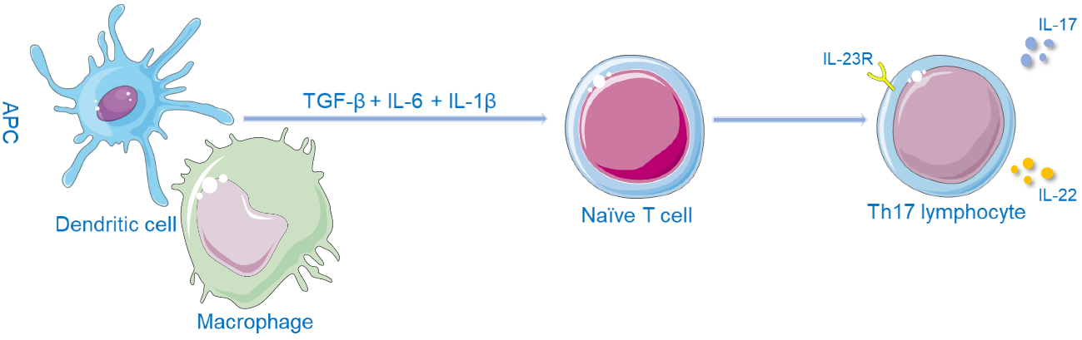
Figure 1 Schematic diagram of the Th17 cell differentiation pathway. APC: Antigen-presenting cells; TGF-β: transforming growth factor β; IL: Interleukin; IL-23R: Interleukin-23 receptor 1.

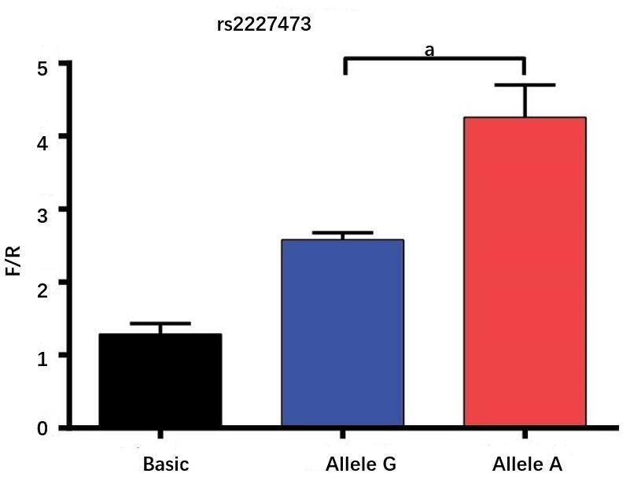
Figure 2 Fluorescence detected in cells transfected with the recombinant or empty vector. Allele G and allele A indicate the fluorescence results of cells transfected with the pGL3-rs2227473_G and pGL3-rs2227473_A plasmids, respectively. F/R: Firefly/renilla luciferase values; ªP < 0.05.

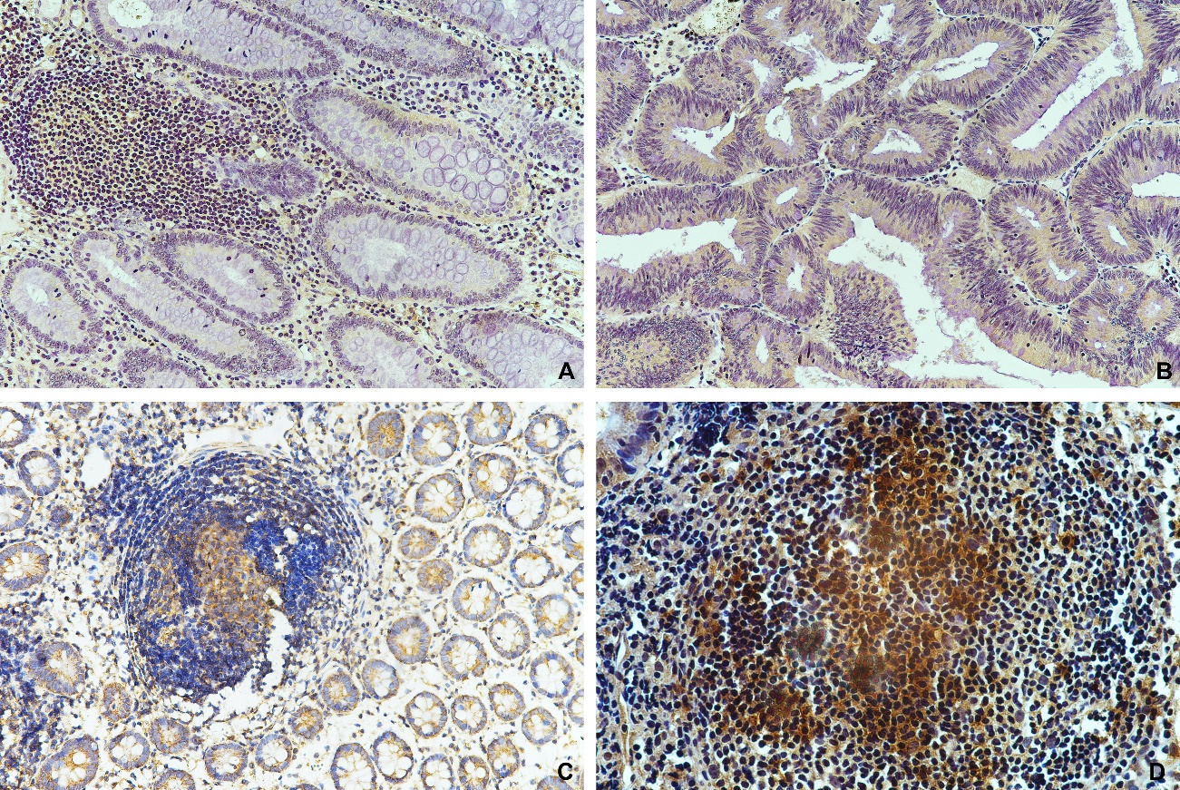
Figure 3 Immunohistochemical staining for interleukin-22 receptor 1 in intestinal biopsy tissues. A: Colon polyps; B: Colon cancer; C: Crohn's disease; D: Intestinal tuberculosis. Magnification, 100×.

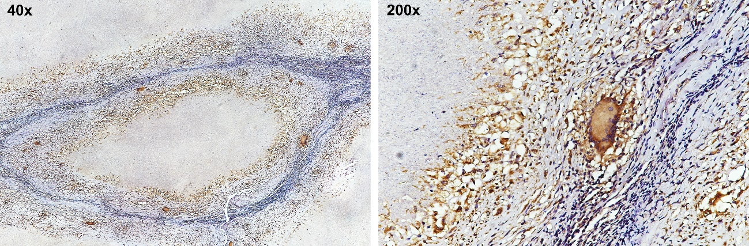
Figure 4 In typical caseous necrotic granulomas, Langhans giant cells with high interleukin-22 receptor 1 expression are present at the edge of granulomas.

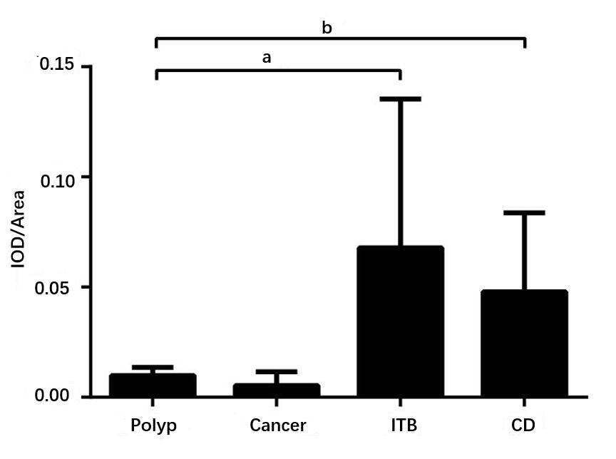
Figure 5 Total integrated optical density/total area of immunohistochemical images. IOD: Integrated optical density; CD: Crohn's disease; ITB: Intestinal tuberculosis; ªP < 0.05, ^{b}P < 0.01.

