Name of journal: World Journal of Radiology
ESPS Manuscript NO: 7812
Columns: CASE REPORT

Psoas muscle metastasis from carcinoma cervix: Correlation and comparison of diagnostic features on FDG-PET/CT and diffusion weighted MRI

Basu S et al. Psoas muscle metastasis FDG-PET/CT and DWI-MRI

Sandip Basu, Abhishek Mahajan

Sandip Basu, Radiation Medicine Centre, Bhabha Atomic Research Centre, Tata Memorial Hospital Annexe, Parel, Mumbai 400012, India

Abhishek Mahajan, Department of Radiology, Tata Memorial Hospital, Mumbai 400012, India

Author contributions: Basu S and Mahajan A designed the study and wrote the manuscript.

Correspondence to: Dr. Sandip Basu, Radiation Medicine Centre, Bhabha Atomic Research Centre, Tata Memorial Hospital Annexe, Parel, Mumbai 400012, India drsanb@yahoo.com
Telephone: +91-22-24149428 Fax: +91-22-24157098

Received: November 30, 2013 Revised: March 10, 2014
Accepted: March 17, 2014
Published online:
Abstract
Psoas muscle metastasis, though unusual, forms the commonest site of skeletal muscle involvement in carcinoma cervix. The appropriate clinical management of this condition, particularly of which the pain related to malignant psoas syndrome, is still evolving and the diagnostic features on conventional morphological imaging modalities are often non specific with the differential diagnosis lying between sarcoma, hematoma, and abscess. In this report, a comparison of various morphofunctional imaging modalities was made. Fludeoxyglucose-positron emission tomography (FDG-PET)/computed tomography (CT) was the first to suspect the disease involvement of the psoas muscle demonstrating intense FDG uptake unilaterally (when compared to the opposite sided muscle), while the ultrasound showed heterogeneous echotexture and magnetic resonance imaging (MRI) showed subtle altered signal intensity in the right psoas muscle. Both the anatomical imaging modalities and the non contrast CT of PET-CT examination demonstrated bulky psoas muscle, without any focal abnormality. On diffusion weighted imaging of MRI (DWI-MRI), restricted diffusion of the involved muscle was an important observation. The psoas muscle metastatic involvement was proven histopathologically. Thus, enhanced glucose metabolism and restricted diffusion in the newer non-invasive molecular imaging modalities (e.g., PET/CT and DWI-MRI) could serve as valuable adjunct parameter in diagnosing this entity in the absence of focal abnormality on the anatomical modalities. In the treatment response monitoring scenario, FDG-PET/CT demonstrated near complete resolution following administration of 3 cycles of systemic chemotherapy and local external radiotherapy.

© 2014 Baishideng Publishing Group Co., Limited. All rights reserved.

Key words: Psoas muscle metastasis; Carcinoma cervix; Fludeoxyglucose-positron emission tomography/Computed tomography; Diffusion weighted magnetic resonance imaging

Core tip: Psoas muscle metastasis, though unusual, forms the commonest site of skeletal muscle involvement in carcinoma cervix. The present communication describes the comparative diagnostic features of this relatively unusual but important entity on newer non-invasive molecular imaging modalities such as fludeoxyglucose-positron emission tomography (FDG-PET)/computed tomography (CT) and diffusion weighted imaging of MRI (DWI-MRI) as well as the conventional imaging modalities (e.g., ultrasound, CT and MRI). Presently, there is lack of characteristic diagnostic imaging features on conventional imaging modalities which have been nonspecific in this domain and the differential diagnosis includes sarcoma, hematoma, and abscess, thus the newer molecular imaging approaches need critical exploration and comparison.

Basu S, Mahajan A. Psoas muscle metastasis from carcinoma cervix: Correlation and comparison of diagnostic features on FDG-PET/CT and diffusion weighted MRI.

Available from: URL:
DOI:
INTRODUCTION
Skeletal muscle metastasis from carcinoma cervix is a rare event (less than 1% incidence), the most common among them being the involvement of psoas muscle. There is lack of characteristic diagnostic imaging features on conventional imaging modalities which have been nonspecific in this domain and the differential diagnosis includes sarcoma, hematoma, and abscess^{[1-6]}. Thus the features of this relatively unusual but important entity on newer non-invasive molecular imaging modalities (e.g., PET/CT and DWI-MRI) need critical exploration and comparison.

CASE REPORT
A 52 year old female, who presented with bleeding per vaginum 2 years back and was diagnosed of squamous cell carcinoma cervix grade III B, had undergone external radiation therapy (40 Gy over 20#) over pelvis and cisplatinum based chemotherapy (concluded in 2011). She recently complained of pain in both thighs which was not relieved by analgesics and was referred for fludeoxyglucose-positron emission tomography (FDG-PET)/computed tomography (CT) for evaluation of disease status. On the whole-body survey with a full-ring dedicated LYSO based time of flight PET-CT scanner, intense FDG uptake (Figure 1) was noted in the right psoas muscle (SUVmax-13.79 gm/mL), in addition to foci in the prevertebral (SUVmax-4.26 gm/mL), left paraaortic (SUVmax-3.64 gm/mL), peribronchial and hilar lymph nodes. Metabolically active lesion in the right psoas muscle was further correlated radiologically: Transverse and longitudinal grey scale ultrasound images (Figure 2) revealed bulky right psoas muscle showing heterogenous echotexture. On magnetic resonance imaging (Figure 3), axial T1W and coronal T2 W sequence revealed bulky right psoas muscle (arrowhead) and altered signal intensity. On axial diffusion weighted images there was evidence of restricted diffusion in the involved muscle (Figure 3C and D). The ultrasound guided FNAC of the right psoas muscle confirmed presence of squamous cell carcinoma in the described lesion. Follow-up FDG-PET/CT was undertaken in the treatment response monitoring scenario, where FDG-PET/CT (Figure 4) demonstrated near-complete resolution of the FDG uptake in the psoas muscle as well as the other foci following administration of 3 cycles of systemic chemotherapy and palliative local external radiotherapy (20Gy over 5# and 1 wk).

DISCUSSION
The various factors attributed for the relative rarity of skeletal muscle metastasis in a malignant process include (1) contractility of muscles leading to turbulent blood flow; (2) unfavorable pH; and (3) presence of protease inhibitors^{[2]}. The peer-reviewed literature on psoas muscle metastasis in the context of carcinoma cervix is limited, primarily emphasizing the diagnostic dilemma in differentiating this entity mainly from post-irradiation abscess and sarcoma^{[1-6]}. The challenges and refractoriness of the pain related to malignant psoas syndrome arising in the background of carcinoma cervix has been another aspect that has been described in the form of case reports^{[7-9]} with one report describing good outcome with combined surgical excision and adjuvant radiation therapy.
The psoas muscle involvement mimicking abscess and an aggressive course has been primarily described in the context of HIV positive women, though recently reports have also demonstrated this in HIV negative women as well^{[3-5]}. The contrast enhanced CT, MR imaging and ultrasound all have have been utilized in this area with variable success and non-specific findings. In one report^{[3]}, ceCT demonstrated well-defined hypo-dense lesion with peripheral enhancement suggesting psoas abscess. MRI too was suggestive of abscess though FDG-PET imaging was not undertaken in this case. In our case, FDG-PET/CT demonstrated intense FDG uptake corresponding to the lesion that was clearly distinctive in demonstrating the lesion (when compared with the opposite sided muscle), while the ultrasound showed heterogeneous echotexture and MRI showed subtle altered signal intensity in the right psoas muscle. Both the anatomical imaging modalities and the non contrast CT of PET-CT examination demonstrated bulky psoas muscle. Restricted diffusion of the involved segment on DWI-MRI was an important observation in addition to altered signal intensity on conventional MR imaging. Thus in the absence of any focal abnormality on the anatomical modalities, enhanced glucose metabolism and restricted diffusion in the newer non-invasive molecular imaging modalities (e.g., PET/CT and DWI-MRI) could serve as a valuable adjunct parameter in diagnosing this important entity.
COMMENTS
Clinical diagnosis
The patient presented with bleeding per vaginum 2 years back and was diagnosed of squamous cell carcinoma cervix grade III B, had undergone radiation therapy and cisplatinum based chemotherapy (concluded in 2011).

Differential diagnosis
Disease recurrence in a case of carcinoma cervix.

Pathological diagnosis
Ultrasound guided FNAC of the right psoas muscle confirmed presence of squamous cell carcinoma in the described psoas muscle lesion.

Treatment
The patient underwent 3 cycles of systemic chemotherapy following the diagnosis of disease recurrence in the psoas muscle.

Related reports
Follow-up fludeoxyglucose-positron emission tomography (FDG-PET)/computed tomography (CT) demonstrated near-complete resolution of the FDG uptake in the psoas muscle as well as the other foci following administration of 3 cycles of systemic chemotherapy and local external radiotherapy.

Experiences and lessons
In addition to demonstrating a relative unusual site of metastasis, the present report illustrates the comparative diagnostic features of this relatively unusual but important entity on newer non-invasive molecular imaging modalities such as FDG-PET/CT and diffusion weighted imaging of magnetic resonance imaging (DWI-MRI) as well as the conventional imaging modalities (e.g., ultrasound, CT and MRI).

Peer review
This is an interesting case. Well written, good length as case report. The author should double space the references.

REFERENCES
1 Hong JH, Song SH, Lee JK, Lee NW, Lee KW. Metastatic cervical adenocarcinoma mimicking retroperitoneal sarcoma of the psoas muscle on imaging. Eur J Gynaecol Oncol 2011; 32: 221-223 [PMID: 21614923]
2 Kamal M, Touiti D, Jouhadi H, Benider A. Iliopsoas Metastasis from Cervix Carcinoma Masquerading as Psoas Abscess. J Cancer Sci Ther 2012; 4: 075-76.
3 Kalra N, Aiyappan S, Nijhawan R, Sharma SC, Khandelwal N. Metastatic carcinoma of cervix mimicking psoas abscess on imaging: a case report. J Gynecol Oncol 2009; 20: 129-131 [PMID: 19590727 DOI: 10.3802/jgo.2009.20.2.129]
4 Devendra K, Tay SK. Metastatic carcinoma of the cervix presenting as a psoas abscess in an HIV-negative woman. Singapore Med J 2003; 44: 302-303 [PMID: 14560863]
5 Bar-Dayan Y, Fishman A, Levi Z, Rachmani R. Squamous cell carcinoma of the cervix with psoas abscess-like metastasis in an HIV-negative patient. Isr J Med Sci 1997; 33: 674-676 [PMID: 9397142]
6 Smith RW, Gooneratne NS. Psoas bed gallium uptake in a patient with carcinoma of the cervix post irradiation--abscess or metastasis. Clin Nucl Med 1978; 3: 230 [PMID: 679578 DOI: 10.1097/00003072-197806000-00009]
7 Stevens MJ, Atkinson C, Broadbent AM. The malignant psoas syndrome revisited: case report, mechanisms, and current therapeutic options. J Palliat Med 2010; 13: 211-216 [PMID: 20053159]
8 Komatsu S, Iseki M, Morita Y, Inada E. [A case of malignant psoas syndrome diagnosed while treating sciatica]. Masui 2013; 62: 863-866 [PMID: 23905413]
9 Strauss JB, Shah AP, Chen SS, Gielda BT, Kim AW. Psoas muscle metastases in non-small cell lung cancer. J Thorac Dis 2012; 4: 83-87 [PMID: 22295171]

P-Reviewers: Kim YS, Peitsidis P, Socea B S-Editor: Wen LL L-Editor: E-Editor:

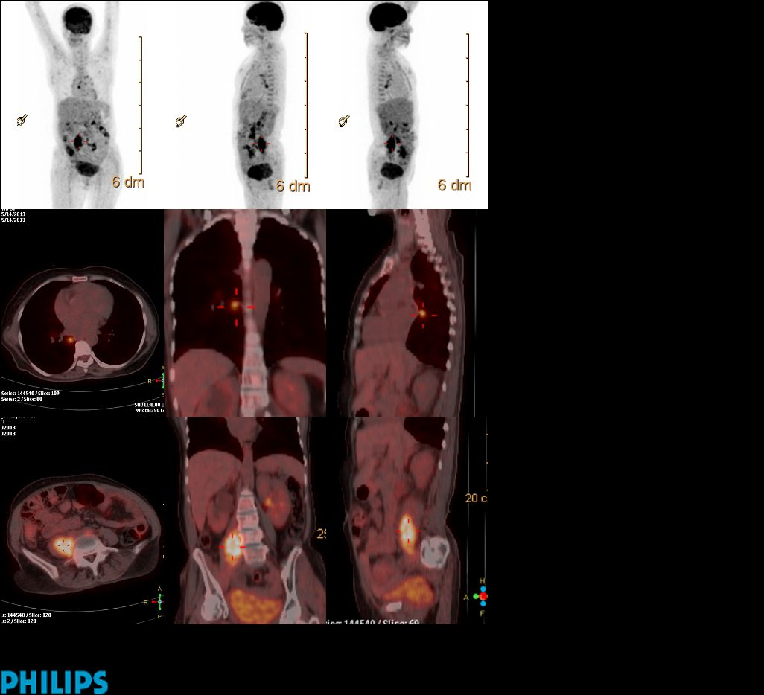
Figure 1 Whole body fludeoxyglucose-positron emission tomography/computed tomography was the first to suspect the disease involvement of the psoas muscle demonstrating intense fludeoxyglucose-positron emission tomography uptake unilaterally (when compared to the opposite sided muscle). In addition, fludeoxyglucose-positron emission tomography avid foci are noted in the prevertebral, left paraaortic, peribronchial and hilar lymph nodes.

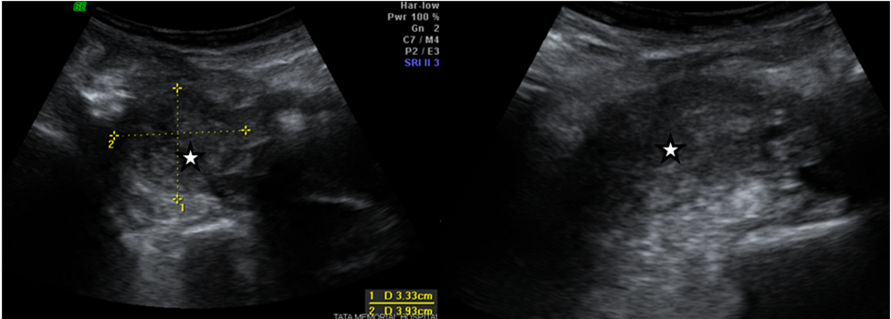
Figure 2 Ultrasound of the abdomen demonstrating bulky right psoas muscle with heterogenous echotexture.

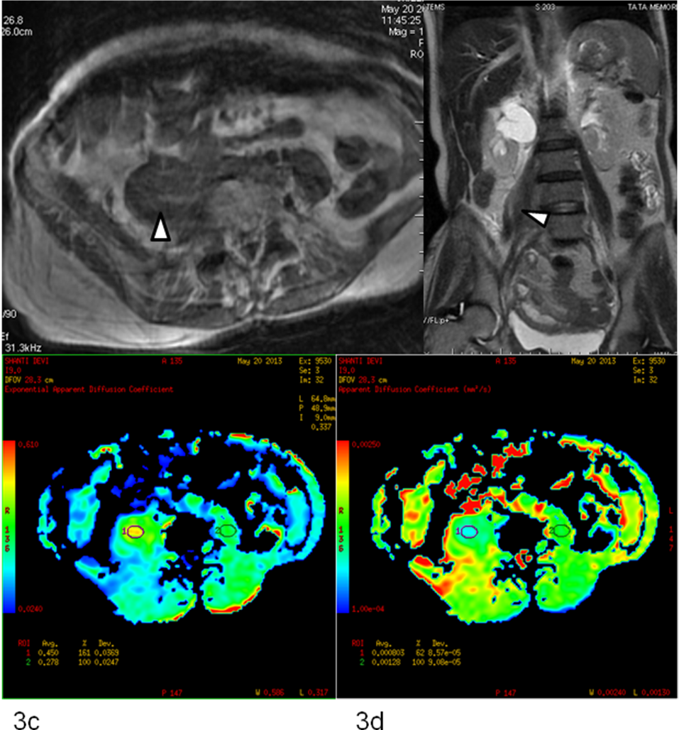
Figure 3 Magnetic resonance imaging. Axial T1W and coronal T2W MR sequence (A and B) reveals bulky right psoas muscle (arrowhead) and shows altered signal intensity. On axial diffusion weighted images (C and D) there is e/o restricted diffusion in the involved segment.

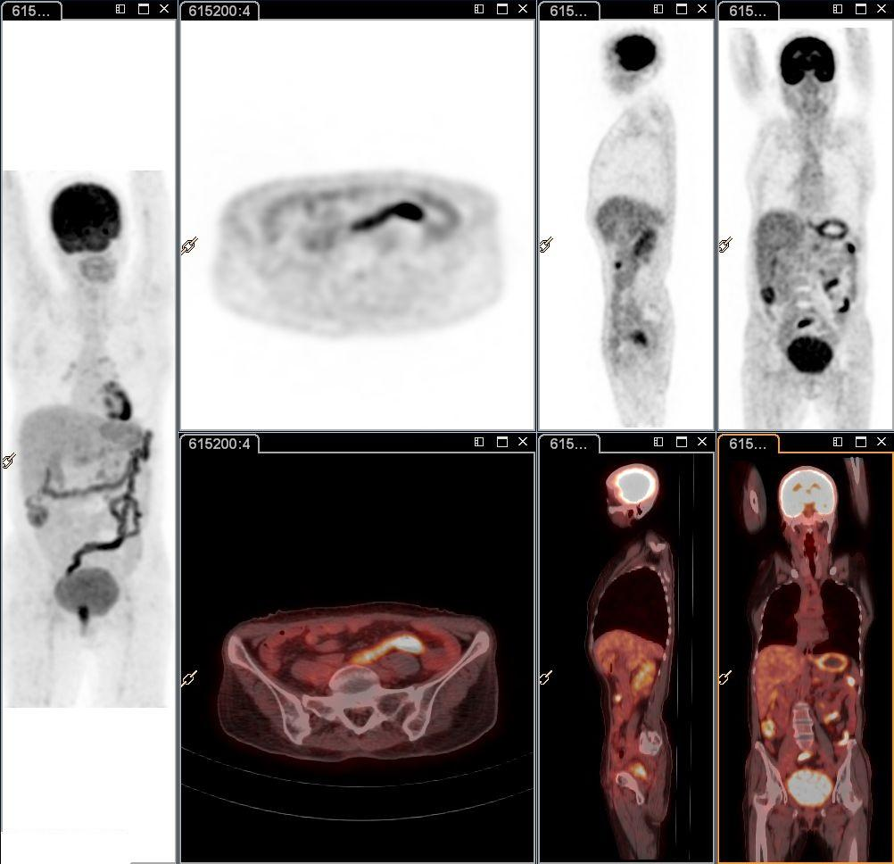
Figure 4 Follow up fludeoxyglucose-positron emission tomography/computed tomography following administration of 3 cycles of systemic chemotherapy and local external radiotherapy demonstrating near-complete resolution of the fludeoxyglucose-positron emission tomography uptake in the psoas muscle as well as the other foci.

