Name of journal: World Journal of Gastrointestinal Endoscopy
ESPS Manuscript NO: 12567
Columns: Review

Endoscopic treatment for gastrointestinal stromal tumor: Advantages and hurdles

Kim HH. Endoscopic treatment for GIST

Hyung Hun Kim

Hyung Hun Kim, Department of Internal Medicine, The Catholic University of Korea College of Medicine, Seoul 137-701, South Korea

Author contributions: Kim HH solely contributed to this paper.

Supported by The Science Research Program through the National Research Foundation of Korea (NRF); the Ministry of Science, ICT and Future Planning, No. NRF-2013R1A1A1009682

Conflict-of-interest: There are no conflicts of interest regarding this article.

Open-Access: This article is an open-access article which selected by an in-house editor and fully peer-reviewed by external reviewers. It distributed in accordance with the Creative Commons Attribution Non Commercial (CC BY-NC 4.0) license, which permits others to distribute, remix, adapt, build upon this work non-commercially, and license their derivative works on different terms, provided the original work is properly cited and the use is non-commercial. See: http://creativecommons.org/licenses/by-nc/4.0/

Correspondence to: Hyung Hun Kim, MD, Division of Gastroenterology, Department of Internal Medicine, The Catholic University of Korea College of Medicine, Seoul St. Mary's Hospital, 222 Banpodaero, Seocho-Gu, Seoul 137-701, South Korea. drhhkim@gmail.com

Telephone: +82-2-22586065
Fax: +82-2-22582089

Received: July 15, 2014
Peer-review started: July 16, 2014
First decision: November 3, 2014
Revised: December 4, 2014
Accepted: December 18, 2014
Article in press:
Published online:

Abstract
One of the most prominent characteristics of gastrointestinal stromal tumors (GISTs) is their unpredictable and variable behavior. GISTs are not classified as “benign” or “malignant” but are rather stratified by their associated clinical risk of malignancy as determined by tumor size, location, and number of mitoses identified during surgical histology. The difficulty in assessing the malignant potential and prognoses of GISTs as well as the increasing incidence of “incidental GISTs” presents challenges to gastroenterologists. Recently, endoscopic enucleation has been actively performed as both a diagnostic and therapeutic intervention for GISTs. Endoscopic enucleation has several advantages, including keeping the stomach intact after the removal of GISTs, a relatively short hospital stay, a conscious sedation procedure, relatively low cost, and fewer human resources required compared with surgery. However, a low complete resection rate and the risk of perforation could reduce the overall advantages of this procedure. Endoscopic full-thickness resection appears to achieve a very high R0 resection rate. However, this technique absolutely requires a very skilled operator. Moreover, there is a risk of peritoneal seeding due to large active perforation. Laparoscopy endoscopy collaborations have been applied for more stable and pathologically acceptable management. These collaborative procedures have produced excellent outcomes. Many procedures have been developed and attempted because they were technically possible. However, we should first consider the theoretical basis for each technique. Until the efficacy and safety of sole endoscopic access are proved, the laparoscopy endoscopy collaborative procedure appears to be an appropriate method for minimally destructive GIST surgery.

Key words: Gastrointestinal stromal tumor; Endoscopy; Laparoscopy; Efficacy; Safety

© The Author(s) 2015. Published by Baishideng Publishing Group Inc. All rights reserved.

Core tip: Several endoscopic approaches have recently been investigated for removing gastrointestinal stromal tumors. Endoscopic enucleation has several advantages. However, there is the possibility of peritoneal seeding when accidental perforation occurs. Furthermore, the rate of R0 resection is not yet acceptable. While endoscopic full-thickness resection has a more solid theoretical basis than endoscopic enucleation in terms of R0 resection, the possibility of tumor cell shedding into the peritoneum would increase when capsule injury results from the procedure. Compared with endoscopy only procedures, laparoscopy endoscopy cooperative surgery and LAFTR provide a higher complete resection rate and a more stable process, which are accordant with the purpose of minimally destructive surgeries.

Kim HH. Endoscopic treatment for gastrointestinal stromal tumor: Advantages and hurdles. World J Gastrointest Endosc 2015; In press

INTRODUCTION
Gastrointestinal stromal tumors (GISTs) constitute an unusual tumor type that is poorly understood by medical and surgical oncologists. GISTs are the most common mesenchymal tumor of the gastrointestinal tract and are believed to originate from the interstitial cells of Cajal regulating gastrointestinal motility. In the medical literature, GISTs have been confused with true smooth muscle tumors due to their similar features under light microscopy. Once a poorly recognized disease, GISTs have gained increasing interest following advances in diagnostics, both in terms of immunohistochemistry and the characteristic gain of functional mutations in either the c-KIT or PDGFRa genes, which have been identiﬁed as hallmarks of their pathogenesis^{[1-3]}. The presence of c-KIT has been shown through its receptor in approximately 80% of GISTs^{[4]}, and8% of GISTSs have mutations in PDGFRa, which encodes a c-KIT-homologous receptor tyrosine kinase^{[1,2]}.
The range of clinical feature of GISTs ranges from symptomatic bleeding to incidental detection during an routine endoscopy^{[5]}. In general, 10%-30% of GISTs are clinically malignant^{[6]}, but all GISTs are alleged to have some degree of malignant potential^{[5]}. Despite size and location of GISTs are imperative factors facilitating an estimation of the risk of malignancy prior to operation^{[4,7]}, dependable preoperative examination for predicting malignancy are not readily available. Endoscopic ultrasonography is useful for obtaining some specimens^{[8]}, and the risk of GISTs can be stratified according to several factors^{[5,7]}; for instance, micro-GISTs (no more than 1 cm) generally show benign behavior irrespective of the mitotic rate^{[9]}. However, the difficulty in estimating the malignant potential and the increasing incidence of ‘incidental GISTs’ are particularly challenging for gastroenterologists, who must make decisions regarding patient care and management of this disease; in the case of micro-GISTs, regular endoscopic follow up is generally accepted^{[10]}, but R0 resection is frequently considered in cases with larger tumors.
Endoscopic enucleation and related variations of this treatment have recently been introduced for managing GISTs, most often in incidentally detected cases. There are several advantages of endoscopic treatment, but it presents some risks as well. Endoscopic full-thickness resection (EFTR), laparoscopy endoscopy cooperative surgery (LECS), laparoscopy-assisted endoscopic full-thickness resection (LAEFR), and non-exposed wall-inversion surgery (NEWS) have been applied for more pathologically acceptable management. This article provides an overview of the theoretical basis and technical feasibility of gastric GIST treatment in terms of an endoscopic approach with or without laparoscopic collaboration, considering the imperative points of conventional surgical resection.

THEORETICAL BASIS
Incidental GIST
Endoscopic enucleation is typically performed for asymptomatic GISTs. Approximately 15%-30% of GISTs were incidentally discovered without presenting any symptoms^{[6,11,12]}. In these studies, the incidental discovery of GISTs primarily occurred after surgical resection for other reasons or during postmortem examination. Several studies have noted the existence of subclinical microscopic gastric GISTs^{[13-16]}. Microscopic gastric GISTs were discovered in 22.5% of consecutive autopsies conducted on patients aged no less than 50 years old^{[15]}. Kawanowa et al^{[16]} presented evidence that microscopic GISTs were observed in 35% of whole stomachs that were surgically resected due to gastric carcinoma. As upper gastrointestinal examination by endoscopy has been increased, the incidental recognition of subepithelial lesions has also substantially increased. According to one retrospective study, the prevalence of subepithelial gastric lesions was 0.36% during routine exanimation^{[17]}. These studies show that GISTs are far more common than previously presumed. Considering this suggestion, a gastroenterologist may frequently encounter GISTs in normal clinical practice, and a practical guide should be established to avoid irregular management of incidentally detected GISTs.

Malignant potential
Importantly, all GISTs are thought to have some degree of malignant potential. Approximately 20%-25%of GISTs in the stomach demonstrate malignant behavior^{[4]}. One of the most prominent features of GISTs is unpredictable and variable behavior. Large, presumably aggressive GISTs can progress in an indolent manner, whereas small, incidentally discovered GISTs can show malignant behavior. Thus, GISTs are not classified as “malignant” or “benign” but are rather stratified by the clinical risk of malignancy depending on mitotic count, size, location (Table 1)^{[7]}. A preoperative estimation of risk can be induced from size and location, but reliable criteria for surgery do not currently exist. Unlike gastric adenocarcinomas, regional lymph node metastasis of GIST is unusual; the prevalence has been reported to range from 1.1% to 3.4%^{[18-20]}. Because it is difficult to predict the malignant behavior of GISTs, together with the rarity of lymph node metastasis, the theoretical basis for endoscopic removal can be reasonably supported if this method results in complete resection and does not cause peritoneal seeding.

Gross appearance and location in the gut wall
To estimate the feasibility of endoscopic procedures, it is important to understand the gross findings. GISTs range in size from a few mm to 35 cm, with a median size between 5 and 8 cm^{[11,21]}. The targets of endoscopic enucleation and related procedures are small- to medium-sized gastric GISTs less than 5 cm in size. Small- to medium-sized GISTs typically form a well-delineated spherical or hemispherical mass, arising mostly from the proper muscle (PM) layer beneath the mucosa and pushing into the lumen to form a smooth-contoured elevation (Figure 1A and B).Focal mucosal ulceration is common in GISTs at all sites (Figure 1C) and is not related to tumor malignancy. GISTs are usually well circumscribed and surrounded by a pseudocapsule. The presence of a pseudocapsule contributes to the indication for complete resection in endoscopic enucleation.
When considering endoscopic enucleation, GISTs must be classified into several types according to their locations in the gastric wall (Figure 2).Type I is a GIST that has a very narrow connection with the PM and protrudes into the luminal side, similar to polyps (Figure 2A). Type II has a wider connection with the PM and protrudes into the luminal side at an obtuse angle (Figure 2B). Type III is located in the middle of the gastric wall (Figure 2C).Type IV protrudes mainly into the serosal side of the gastric wall (Figure 2D). Of the four types, type I is the best candidate for endoscopic enucleation due to its narrow connection with the PM layer, and it seems possible to remove type II lesions by endoscopic enucleation. However, it is nearly impossible to achieve complete resection of type III and type IV GISTs by endoscopic enucleation. Thus, EFTR, LECS, LAEFR, or NEWS should be considered for type III and IV GISTs.

Surgical resection and follow-up program
Surgical removal is the primary treatment for a localized GIST in the majority of cases. Prior to evaluating the feasibility of therapeutic endoscopic procedures for GISTs, it is necessary to understand the surgical procedures and outcomes as a conventional standard strategy. The primary goal of surgery is complete tumor removal with clear resection margins. Avoiding pseudocapsule rupture is very important because intra-abdominal dissemination and a poor prognosis have been seriously associated with its occurrence^{[22]}. It seems not necessary to perform routine lymphadenectomy due to rare nodal metastasis^{[23]}.
Depending on the location of the lesion, the type of surgery is determined. In cases of esophageal, small intestinal, and rectal GISTs, wide resections are the surgery of choice^{[24]}. Gastric wedge resection is the most frequently performed procedure for gastric GISTs, and it is recommended as the treatment of choice; however, in some cases, tumor size and location may indicate extensive surgery, including a partial or total gastrectomy. Laparoscopic wedge resection, which is less invasive than the traditional technique, has been demonstrated to have comparable results in terms of efficacy, safety profile, and length of hospitalization^{[25-32]}. Short- and long-term outcomes of laparoscopic wedge resection have been shown to be equivalent to the open surgical approach. Guidelines suggest that laparoscopic wedge resection can be used for tumors ≤ 5 cm^{[22]}. Laparoscopic approaches to GIST management continue to expand and should adhere to standard oncological principles, including avoidance of direct grasping and tumor rupture, and an extraction bag is recommended when tumors are removed^{[31,33-37]}. Although a microscopically positive margin was not found to be a significant adverse factor in some studies^{[23,38]}, one study did find it to be an adverse factor for survival^{[39]}.
The guidelines of the national comprehensive cancer network recommended abdominal and pelvic CT scan every 3-6 mo for 3-5 years and annually thereafter following completer resection^{[22]}. Less frequent surveillance may be acceptable for small tumors (< 2 cm). Currently, Imatinib is approved both in the United States and the EU as an adjuvant therapy for GIST after surgical resection.

TECHNICAL FEASIBILITY OF THE ENDOSCOPIC APPROACH
Nearly all interventions have been performed for submucosal tumors originating from the PM layer without validating preoperative histological findings. Therefore, it is realistic to estimate the feasibility of an endoscopic approach for GIST by accessing data acquired from submucosal lesions originating from the PM layer.

ENDOSCOPIC ENUCLEATION
Submucosal endoscopic dissection
GISTs originating from the PM layer are not likely to be removed completely and safely using standard or modiﬁed endoscopic submucosal dissection (ESD). In such cases, deep submucosal dissection and PM layer resection should be performed. Moreover, the PM layer under the lesion must be carefully dissected (Figure 3). Thus, perforation risk is inevitably high. Furthermore, the margin seems to be minimal and easily involved in tumor cells (Figure 3F); there is also a potential risk of injury to the pseudocapsule. Several studies presented similar rates of successful en bloc resection (64%-94%) and perforation rates from 0% to12% using ESD for GISTs originating from the PM layer (Table2) (n = 11, 25, and 22)^{[40-42]}. The imperative point, which should be noted, is that not all studies assessed pathologic evaluation, although they insisted on complete resection (n = 11 and 25)^{[40,41]}. One recent study (n = 86)reported a 5.8%local recurrence rate after endoscopic enucleation of 86 GISTs, although all of the GISTs were completely removed endoscopically^{[43]}.

Endoscopic muscularis dissection
Liu et al^{[44]} introduced another endoscopic technique, called endoscopic muscularis dissection (EMD), for tumors originating from the PM layer (n = 31, 14 esophageal and 17 gastric tumors)^{[44]}. Of these tumors, 97% (30/31) were completely resected. The perforation rate was 13% (4/31)^{[44]}. A longitudinal incision may have advantages inclosing the mucosa with clips and promoting wound healing (Figure 4).

Endoscopic submucosal tunnel dissection
Endoscopic submucosal tunnel dissection (ESTD) is an innovative method that provides a solution for perforation, which frequently occurs during proper muscle dissection. The first case was reported by Inoue et al^{[45]}, submucosal endoscopic tumor resection for cardial and esophageal subepithelial tumors (n = 7)^{[45]}. Submucosal tunnel dissection includes four major procedures (Figure 5): (1) creating a submucosal tunnel; (2) dissecting the tumor from the mucosa or submucosa; (3) dissecting the PM layer attached to the tumor; and (4) retrieving the specimen and closing the mucosal entry site with clips (n = 7, 12, and 85)^{[45-47]}. The imperative advantage of ESTD is maintaining mucosal integrity during en bloc resection of subepithelial tumors (n = 143)^{[48]}. ESTD may possibly decrease the risk of gastrointestinal tract leakage and subsequent infection^{[48]}. Therefore, this technique may be a promising novel method for selected^{[46]} GISTs arising from the PM layer at the cardia, particularly because endoscopic enucleation in this area can result in pneumothorax and subcutaneous emphysema^{[46,47]}.

Advantages and drawbacks
Given the safety and efficacy of endoscopic enucleation, these emerging techniques can be preferable options for GISTs arising from the PM layer who are admitted to institutions with experienced operators. Endoscopic enucleation has several advantages, such as an intact stomach after GIST removal, a relatively short hospital stay, a conscious sedation procedure, relatively low cost, and fewer human resources required compared with surgery.
However, it should be noted that several disadvantages also exist, which must be overcome to ensure the efficacy and safety of these advanced endoscopic techniques. First, there have been no data showing whether or not there was remnant GIST tissue at dissection sites when R1 resection was conducted; most studies have only validated en bloc resection^{[40,41,44,46,47,49]}. The dissection surface was ablated by an electrical knife or snare, so there may not be remnant GIST cells, although R1 resection was achieved. Although this assertion seems logical, there have been no data proving this hypothesis. Moreover, one of the latest studies reported that a 5.8% local recurrence was observed even though complete endoscopic resection was achieved in all cases. To address this hypothesis, surgical resection of the dissected area should be obtained, and a careful pathological examination of the dissected surface must be conducted. Although several studies have shown that a microscopically positive margin was not a significant adverse factor^{[23,38]},we should understand that these were surgical outcomes. In laparoscopic surgery, staples are used for the procedure, and the additional tissue from the resection line is essentially removed, indicating that R1 resection of GIST specimens during surgical procedures includes cases with R0 resection in a remnant stomach. In contrast, endoscopic enucleation does not involve this additionally removed area. There has alsobeen disagreement regarding this result even in conventional surgical procedures^{[39]}.Considering this information, R1 resection in endoscopic enucleationshould be regarded as true R1 resection until appropriate studies demonstrate contrasting evidence. Currently, post-procedural management ofR1 resection should be additional surgery, particularly for R1 resection of intermediate- to high-risk GISTs.
Second, because perforation is usually accompanied by pseudocapsule injury, the possibility of peritoneal seeding increases. Peritoneal seeding is accompanied by a high recurrence rate and can result in a poor prognosis. If PM layer dissection doesnot cause perforation, capsule injury may not be a serious problem; the tumor cells will shed into the lumen of the gut and will be destroyed. However, there is some likelihood of concomitant perforation and capsule rupture or injury during the procedure, particularly in cases where there is difficulty in conducting the procedure. In such situations, shedding of tumor cells into the peritoneal cavity is predicted. Currently, no comparative data with conventional surgical outcomes exist.

ENDOSCOPIC FULL-THICKNESS RESECTION WITHOUT LAPAROSCOPIC ASSISTANCE
The first case of EFTR using a snaring technique was reported in 2001^{[50]}. Ikeda et al^{[51]} recently presented EFTR by ESD in a swine stomach. This trial demonstrates an important step forward in endoscopic surgery, but it is currently not likely applicable in clinical settings. The risk of peritoneal infection and skeptical views of complete closure cause potentially major concerns in endoscopy-only procedures. Thus, EFTR should overcome the prevalent idea that perforation is a serious complication. However, Zhou et al^{[52]} (n = 26) and Feng et al^{[49]} (n = 48) succeeded in the use of EFTR for resecting gastric SMTs originating from the PM layer without laparoscopic assistance (Table 2). Their EFTR technique was based on standard ESD and consisted of four major procedures (Figure 6): (1) a circumferential incision as deep as the PM layer; (2) Creating active perforation by serosal layer incision; (3) removing a tumor and its surrounding PM and serosal layers by snare; and (4) closing active perforation site by several clips^{[49,52]}. En bloc resection was achieved in all cases^{[49,52]}. Furthermore, there were no serious complications^{[49,52]}. According to these two studies, EFTR appears to be an ideal minimally destructive measure for gastric GISTs. One thing that should be noted is that EFTR essentially creates a large active perforation, which can result in the shedding of tumor cells into the peritoneum when the pseudocapsule is not intact. Thus, gentle maneuvering is required to maintain an intact pseudocapsule. The efficacy and safety of EFTR must be validated in multicenter studies to standardize this promising technique.

LAPAROSCOPIC ENDOSCOPIC COLLABORATIVE PROCEDURES
For the first time, a combination of gastrointestinal endoscopy and laparoscopy has been reported for removing esophageal subepithelial tumor by Izumi et al^{[53,54]}. In this technique, a subepithelial tumor was pushed out by a balloon on an endoscope, and thoracoscopic enucleation was performed to removed the protruded tumor^{[53,54]}. Hiki et al^{[55]} (n = 7) reported the successful use of ESD for assisting local laparoscopic gastric resection to remove a GIST. In their technique, named LECS, laparoscopic multiple staplers were used for resection after approximately three-fourths cutline was completed by ESD. Tsujimoto et al^{[56]} presented satisfactory surgical outcomes after LECS for gastric subepithelial tumor also (n = 20). Reducing the resected gastric wall volume is an important advantage of LECS compared with conventional laparoscopic wedge resection solely using a linear stapler^{[57]}.
LAEFR, i.e., EFTR with laparoscopic assistance, is an effective treatment for selected patients with gastric subepithelial tumors (n = 4 and 25)^{[58,59]}. There are four major steps in LAEFR (Figure 7): (1) deep submucosal incision using ESD^{[57]}; (2) endoscopic seromuscular layer incision, three-fourths or two-thirds of the circumference; (3) laparoscopic seromuscular incision for remaining circumference; and (4) hand-sewn closure. The different point of LAEFR from LES is a hand-sewn closure without linear staples. LECS affords easier and more accurate resection, and the LAFTR results in minimal resection^{[57]}. LECS and LAFER showed excellent outcomes. All reports have shown 100% complete resection rates and no complications (Table 3)^{[55,56,58,59]}. The best indication for LECS and LAEFR may be intraluminal growing types of gastric GISTs originating from the PM layer. Such lesions cannot be well identified from the serosal side of the stomach; therefore, there is a high probability that conventional laparoscopic wedge resection will cause a larger-than-expected resection and bring about a gastric deformity or stenosis, or conversely, can produce a positive surgical margin^{[57]}. LECS or LAEFR can avoid such problems. Full-thickness resection procedures are derived from ESD. Therefore, both can be applied regardless of tumor size, and a pathologically acceptable resection margin can be more easily accomplished^{[57-60]}.
NEWS is a newly suggested technique developed to minimize the resected tissue volume as well as prevent peritoneal contamination (n = 6)^{[61]}. There are 7 major steps in NEWS (Figure 8)^{[61,62]}: (1) marking the mucosa around a lesion; (2) serosal marking using laparoscopy on the side opposite the mucosal markings; (3) injecting hyaluronate solution endoscopically into the submucosal layer; (4) laparoscopic circumferential seromuscular layer incision; (5 suturing the seromuscular layer; (6) spontaneous inversion of the lesion; and (7) circumferential incision of the mucosubmucosal layer. Theoretically, this technique nearly perfectly prevents peritoneal contamination because seromuscular layer suture and closure is performed before mucosubmucosal layer cutting (Figure 9)^{[61]}. However, this innovative technique contains a few downsides compared with LECS or LAEFR. Mitsui et al^{[61]} reported 2 perforations in 6 cases: one laparoscopic mucosal injury during the seromuscular incision and musculoserosal tearing by ESD. Two cases out of 6also converted due to poor recognition of the tumor margin^{[61]}. Selecting appropriate lesions, type III and type IV, and advancement of this technique would be necessary to apply NEWS in ordinary clinical fields.

IMATINIB AS AN ADJUVANT TREATMENT
Although a significant proportion of patients will be cured with surgery alone, approximately 40% will eventually have a relapse of disease, with the majority of these relapses occurring within the first 5 years. The ACOSOG Z9001 trial^{[63]} compared 12 mo of imatinib treatment with a placebo and showed an estimated 1-year recurrence-free survival (RFS) of 98% in the Imatinib group compared with 83% in the placebo group (HR: 0.35). More recently, the Phase III Scandinavian Sarcoma Group Trial^{[64]} reported that patients affected by GISTs with a high risk of recurrence treated with adjuvant Imatinib for 36 mo had longer RFS (5-year RFS, 65.6% vs 47.9%; HR: 0.46) and improved overall survival (5-year survival, 92% vs 81.7%; HR: 0.45) compared with those receiving 12 mo of treatment. These trials provided Level 2 evidence, according to the latest edition of the Oxford Centre for Evidence-Based Medicine (OCEBM) Levels of Evidence, for the role of adjuvant imatinib in patients with resected GISTs. Together, the current evidence supports at least 3 years of adjuvant imatinib as a new standard for patients with resected, high-risk GISTs, although the optimal duration of therapy remains unknown^{[65]}. In endoscopic enucleation, imatinib treatment appears to often be neglected, possibly for the following reasons. First, a lesion removed by endoscopic enucleation is typically small- to medium-sized. Second, most GISTs were incidentally detected in asymptomatic patients unlike gastric cancer cases, which are typically more serious and draw greater attention from doctors and surgeons. However, it is absolutely desirable for practitioners to follow the guidelines for adjuvant usage of imatinib, based on the risk level of the GISTs.

CONCLUSION
Unpredictable malignant potential and rare lymph node metastasis provided the theoretical basis for the concept of minimally destructive surgery for incidentally detected asymptomatic GISTs. Under this theoretical concept, technical advances have been made based on ESD-enabled surgeons performing endoscopic enucleation of GISTs. However, there is the possibility of simultaneous occurrence of perforation and pseudocapsule injury, which can cause peritoneal seeding. Furthermore, the rate of R0 resection is not yet acceptable, although one study reported a high R0 resection rate. Well-trained surgeons and a more secure endoscopic enucleation technique are needed to justify the implementation of this procedure. Moreover, long-term results of endoscopic enucleation will be necessary to conﬁrm the true efficacy and safety because reports on the use of endoscopic enucleation are currently limited to case reports and small, retrospective, orpilot series. While EFTR has a much better theoretical basis than endoscopic enucleation in terms of R0 resection, the possibility of tumor cell shedding into the peritoneum would substantially increase when capsule injury results from the procedure. Moreover, a surgeon needs advanced skills to close a large iatrogenic perforation. In contrast with procedures that employ only endoscopy, LECS and LAFTR provide safer procedures, a higher complete resection rate, and a more stable process. Although LECS and LAFTR require more resources, including more people, more devices, and even additional machines, LECS and LAFTR could represent more acceptable procedures in terms of conventional surgical purposes, because they result in complete resection andavoid peritoneal seeding.
Various endoscopic procedures have challenged conventional surgery with the aid of advances in modern medical technology. Many procedures were invented and attempted because they were technically possible. However, we should consider the aim of conventional surgery, which has accumulated vast data. Until the efficacy and safety of sole endoscopic access are demonstrated in multiple ways, LECS and LAFTR appear to be appropriate procedures for pursuing secure and effective surgical outcomes that conform to the concept of minimally destructive surgery.

ACKNOWLEDGEMENTS
I would like to express special gratitude to Professor Kyung Oh Kim for providing his valuable case for this paper. I also appreciate Professor Han Mo Yoo, a general surgeon, for kindly providing me with surgical knowledge and his experience.

REFERENCES
1 Hirota S, Isozaki K, Moriyama Y, Hashimoto K, Nishida T, Ishiguro S, Kawano K, Hanada M, Kurata A, Takeda M, Muhammad Tunio G, Matsuzawa Y, Kanakura Y, Shinomura Y, Kitamura Y. Gain-of-function mutations of c-kit in human gastrointestinal stromal tumors. Science 1998; 279: 577-580 [PMID: 9438854]
2 Heinrich MC, Corless CL, Duensing A, McGreevey L, Chen CJ, Joseph N, Singer S, Griffith DJ, Haley A, Town A, Demetri GD, Fletcher CD, Fletcher JA. PDGFRA activating mutations in gastrointestinal stromal tumors. Science 2003; 299: 708-710 [PMID: 12522257 DOI: 10.1126/science.1079666]
3 Hirota S, Ohashi A, Nishida T, Isozaki K, Kinoshita K, Shinomura Y, Kitamura Y. Gain-of-function mutations of platelet-derived growth factor receptor alpha gene in gastrointestinal stromal tumors. Gastroenterology 2003; 125: 660-667 [PMID: 12949711]
4 Miettinen M, Lasota J. Gastrointestinal stromal tumors: review on morphology, molecular pathology, prognosis, and differential diagnosis. Arch Pathol Lab Med 2006; 130: 1466-1478 [PMID: 17090188]
5 Miettinen M, Sobin LH, Lasota J. Gastrointestinal stromal tumors of the stomach: a clinicopathologic, immunohistochemical, and molecular genetic study of 1765 cases with long-term follow-up. Am J Surg Pathol 2005; 29: 52-68 [PMID: 15613856]
6 Miettinen M, Sarlomo-Rikala M, Lasota J. Gastrointestinal stromal tumors: recent advances in understanding of their biology. Hum Pathol 1999; 30: 1213-1220 [PMID: 10534170]
7 Miettinen M, Lasota J. Gastrointestinal stromal tumors: pathology and prognosis at different sites. Semin Diagn Pathol 2006; 23: 70-83 [PMID: 17193820]
8 Rodriguez SA, Faigel DO. Endoscopic diagnosis of gastrointestinal stromal cell tumors. Curr Opin Gastroenterol 2007; 23: 539-543 [PMID: 17762560 DOI: 10.1097/MOG.0b013e32829fb39f]
9 Rossi S, Gasparotto D, Toffolatti L, Pastrello C, Gallina G, Marzotto A, Sartor C, Barbareschi M, Cantaloni C, Messerini L, Bearzi I, Arrigoni G, Mazzoleni G, Fletcher JA, Casali PG, Talamini R, Maestro R, Dei Tos AP. Molecular and clinicopathologic characterization of gastrointestinal stromal tumors (GISTs) of small size. Am J Surg Pathol 2010; 34: 1480-1491 [PMID: 20861712 DOI: 10.1097/PAS.0b013e3181ef7431]
10 Scherübl H, Faiss S, Knoefel WT, Wardelmann E. Management of early asymptomatic gastrointestinal stromal tumors of the stomach. World J Gastrointest Endosc 2014; 6: 266-271 [PMID: 25031785 DOI: 10.4253/wjge.v6.i7.266]
11 Nilsson B, Bümming P, Meis-Kindblom JM, Odén A, Dortok A, Gustavsson B, Sablinska K, Kindblom LG. Gastrointestinal stromal tumors: the incidence, prevalence, clinical course, and prognostication in the preimatinib mesylate era--a population-based study in western Sweden. Cancer 2005; 103: 821-829 [PMID: 15648083 DOI: 10.1002/cncr.20862]
12 Tryggvason G, Kristmundsson T, Orvar K, Jónasson JG, Magnússon MK, Gíslason HG. Clinical study on gastrointestinal stromal tumors (GIST) in Iceland, 1990-2003. Dig Dis Sci 2007; 52: 2249-2253 [PMID: 17420941 DOI: 10.1007/s10620-006-9248-4]
13 Abraham SC, Krasinskas AM, Hofstetter WL, Swisher SG, Wu TT. "Seedling" mesenchymal tumors (gastrointestinal stromal tumors and leiomyomas) are common incidental tumors of the esophagogastric junction. Am J Surg Pathol 2007; 31: 1629-1635 [PMID: 18059218 DOI: 10.1097/PAS.0b013e31806ab2c3]
14 Agaimy A, Wünsch PH, Dirnhofer S, Bihl MP, Terracciano LM, Tornillo L. Microscopic gastrointestinal stromal tumors in esophageal and intestinal surgical resection specimens: a clinicopathologic, immunohistochemical, and molecular study of 19 lesions. Am J Surg Pathol 2008; 32: 867-873 [PMID: 18408593 DOI: 10.1097/PAS.0b013e31815c0417]
15 Agaimy A, Wünsch PH, Hofstaedter F, Blaszyk H, Rümmele P, Gaumann A, Dietmaier W, Hartmann A. Minute gastric sclerosing stromal tumors (GIST tumorlets) are common in adults and frequently show c-KIT mutations. Am J Surg Pathol 2007; 31: 113-120 [PMID: 17197927 DOI: 10.1097/01.pas.0000213307.05811.f0]
16 Kawanowa K, Sakuma Y, Sakurai S, Hishima T, Iwasaki Y, Saito K, Hosoya Y, Nakajima T, Funata N. High incidence of microscopic gastrointestinal stromal tumors in the stomach. Hum Pathol 2006; 37: 1527-1535 [PMID: 16996566]
17 Hedenbro JL, Ekelund M, Wetterberg P. Endoscopic diagnosis of submucosal gastric lesions. The results after routine endoscopy. Surg Endosc 1991; 5: 20-23 [PMID: 1871670]
18 Arber DA, Tamayo R, Weiss LM. Paraffin section detection of the c-kit gene product (CD117) in human tissues: value in the diagnosis of mast cell disorders. Hum Pathol 1998; 29: 498-504 [PMID: 9596274]
19 Aparicio T, Boige V, Sabourin JC, Crenn P, Ducreux M, Le Cesne A, Bonvalot S. Prognostic factors after surgery of primary resectable gastrointestinal stromal tumours. Eur J Surg Oncol 2004; 30: 1098-1103 [PMID: 15522557 DOI: 10.1016/j.ejso.2004.06.016]
20 Tashiro T, Hasegawa T, Omatsu M, Sekine S, Shimoda T, Katai H. Gastrointestinal stromal tumour of the stomach showing lymph node metastases. Histopathology 2005; 47: 438-439 [PMID: 16178904 DOI: 10.1111/j.1365-2559.2005.02133.x]
21 Tryggvason G, Gíslason HG, Magnússon MK, Jónasson JG. Gastrointestinal stromal tumors in Iceland, 1990-2003: the icelandic GIST study, a population-based incidence and pathologic risk stratification study. Int J Cancer 2005; 117: 289-293 [PMID: 15900576 DOI: 10.1002/ijc.21167]
22 Demetri GD, Benjamin RS, Blanke CD, Blay JY, Casali P, Choi H, Corless CL, Debiec-Rychter M, DeMatteo RP, Ettinger DS, Fisher GA, Fletcher CD, Gronchi A, Hohenberger P, Hughes M, Joensuu H, Judson I, Le Cesne A, Maki RG, Morse M, Pappo AS, Pisters PW, Raut CP, Reichardt P, Tyler DS, Van den Abbeele AD, von Mehren M, Wayne JD, Zalcberg J. NCCN Task Force report: management of patients with gastrointestinal stromal tumor (GIST)--update of the NCCN clinical practice guidelines. J Natl Compr Canc Netw 2007; 5 Suppl 2: S1-29; quiz S30 [PMID: 17624289]
23 DeMatteo RP, Lewis JJ, Leung D, Mudan SS, Woodruff JM, Brennan MF. Two hundred gastrointestinal stromal tumors: recurrence patterns and prognostic factors for survival. Ann Surg 2000; 231: 51-58 [PMID: 10636102]
24 Blay JY, Bonvalot S, Casali P, Choi H, Debiec-Richter M, Dei Tos AP, Emile JF, Gronchi A, Hogendoorn PC, Joensuu H, Le Cesne A, McClure J, Maurel J, Nupponen N, Ray-Coquard I, Reichardt P, Sciot R, Stroobants S, van Glabbeke M, van Oosterom A, Demetri GD. Consensus meeting for the management of gastrointestinal stromal tumors. Report of the GIST Consensus Conference of 20-21 March 2004, under the auspices of ESMO. Ann Oncol 2005; 16: 566-578 [PMID: 15781488 DOI: 10.1093/annonc/mdi127]
25 Catena F, Di Battista M, Fusaroli P, Ansaloni L, Di Scioscio V, Santini D, Pantaleo M, Biasco G, Caletti G, Pinna A. Laparoscopic treatment of gastric GIST: report of 21 cases and literature's review. J Gastrointest Surg 2008; 12: 561-568 [PMID: 18040747 DOI: 10.1007/s11605-007-0416-4]
26 Bédard EL, Mamazza J, Schlachta CM, Poulin EC. Laparoscopic resection of gastrointestinal stromal tumors: not all tumors are created equal. Surg Endosc 2006; 20: 500-503 [PMID: 16437270 DOI: 10.1007/s00464-005-0287-2]
27 Choi SM, Kim MC, Jung GJ, Kim HH, Kwon HC, Choi SR, Jang JS, Jeong JS. Laparoscopic wedge resection for gastric GIST: long-term follow-up results. Eur J Surg Oncol 2007; 33: 444-447 [PMID: 17174060 DOI: 10.1016/j.ejso.2006.11.003]
28 Huguet KL, Rush RM, Tessier DJ, Schlinkert RT, Hinder RA, Grinberg GG, Kendrick ML, Harold KL. Laparoscopic gastric gastrointestinal stromal tumor resection: the mayo clinic experience. Arch Surg 2008; 143: 587-90; discussion 591 [PMID: 18559753 DOI: 10.1001/archsurg.143.6.587]
29 Lai IR, Lee WJ, Yu SC. Minimally invasive surgery for gastric stromal cell tumors: intermediate follow-up results. J Gastrointest Surg 2006; 10: 563-566 [PMID: 16627222 DOI: 10.1016/j.gassur.2005.08.028]
30 Nguyen SQ, Divino CM, Wang JL, Dikman SH. Laparoscopic management of gastrointestinal stromal tumors. Surg Endosc 2006; 20: 713-716 [PMID: 16502196 DOI: 10.1007/s00464-005-0435-8]
31 Novitsky YW, Kercher KW, Sing RF, Heniford BT. Long-term outcomes of laparoscopic resection of gastric gastrointestinal stromal tumors. Ann Surg 2006; 243: 738-745; discussion 745-747 [PMID: 16772777 DOI: 10.1097/01.sla.0000219739.11758.27]
32 Rivera RE, Eagon JC, Soper NJ, Klingensmith ME, Brunt LM. Experience with laparoscopic gastric resection: results and outcomes for 37 cases. Surg Endosc 2005; 19: 1622-1626 [PMID: 16222466 DOI: 10.1007/s00464-005-0290-7]
33 Nishida T, Hirota S, Yanagisawa A, Sugino Y, Minami M, Yamamura Y, Otani Y, Shimada Y, Takahashi F, Kubota T. Clinical practice guidelines for gastrointestinal stromal tumor (GIST) in Japan: English version. Int J Clin Oncol 2008; 13: 416-430 [PMID: 18946752 DOI: 10.1007/s10147-008-0798-7]
34 Otani Y, Furukawa T, Yoshida M, Saikawa Y, Wada N, Ueda M, Kubota T, Mukai M, Kameyama K, Sugino Y, Kumai K, Kitajima M. Operative indications for relatively small (2-5 cm) gastrointestinal stromal tumor of the stomach based on analysis of 60 operated cases. Surgery 2006; 139: 484-492 [PMID: 16627057 DOI: 10.1016/j.surg.2005.08.011]
35 Nishimura J, Nakajima K, Omori T, Takahashi T, Nishitani A, Ito T, Nishida T. Surgical strategy for gastric gastrointestinal stromal tumors: laparoscopic vs. open resection. Surg Endosc 2007; 21: 875-878 [PMID: 17180273 DOI: 10.1007/s00464-006-9065-z]
36 Wilhelm D, von Delius S, Burian M, Schneider A, Frimberger E, Meining A, Feussner H. Simultaneous use of laparoscopy and endoscopy for minimally invasive resection of gastric subepithelial masses - analysis of 93 interventions. World J Surg 2008; 32: 1021-1028 [PMID: 18338207 DOI: 10.1007/s00268-008-9492-1]
37 De Vogelaere K, Van Loo I, Peters O, Hoorens A, Haentjens P, Delvaux G. Laparoscopic resection of gastric gastrointestinal stromal tumors (GIST) is safe and effective, irrespective of tumor size. Surg Endosc 2012; 26: 2339-2345 [PMID: 22350238 DOI: 10.1007/s00464-012-2186-7]
38 McCarter MD, Antonescu CR, Ballman KV, Maki RG, Pisters PW, Demetri GD, Blanke CD, von Mehren M, Brennan MF, McCall L, Ota DM, DeMatteo RP. Microscopically positive margins for primary gastrointestinal stromal tumors: analysis of risk factors and tumor recurrence. J Am Coll Surg 2012; 215: 53-9; discussion 59-60 [PMID: 22726733 DOI: 10.1016/j.jamcollsurg.2012.05.008]
39 Catena F, Di Battista M, Ansaloni L, Pantaleo M, Fusaroli P, Di Scioscio V, Santini D, Nannini M, Saponara M, Ponti G, Persiani R, Delrio P, Coccolini F, Di Saverio S, Biasco G, Lazzareschi D, Pinna A. Microscopic margins of resection influence primary gastrointestinal stromal tumor survival. Onkologie 2012; 35: 645-648 [PMID: 23147540 DOI: 10.1159/000343585]
40 Lee IL, Lin PY, Tung SY, Shen CH, Wei KL, Wu CS. Endoscopic submucosal dissection for the treatment of intraluminal gastric subepithelial tumors originating from the muscularis propria layer. Endoscopy 2006; 38: 1024-1028 [PMID: 17058168 DOI: 10.1055/s-2006-944814]
41 Hwang JC, Kim JH, Kim JH, Shin SJ, Cheong JY, Lee KM, Yoo BM, Lee KJ, Cho SW. Endoscopic resection for the treatment of gastric subepithelial tumors originated from the muscularis propria layer. Hepatogastroenterology 2009; 56: 1281-1286 [PMID: 19950778]
42 Białek A, Wiechowska-Kozłowska A, Pertkiewicz J, Polkowski M, Milkiewicz P, Karpińska K, Ławniczak M, Starzyńska T. Endoscopic submucosal dissection for treatment of gastric subepithelial tumors (with video). Gastrointest Endosc 2012; 75: 276-286 [PMID: 22032850 DOI: 10.1016/j.gie.2011.08.029]
43 Wang Y, Li Y, Luo H, Yu H. [Efficacy analysis of endoscopic submucosal excavation for gastric gastrointestinal stromal tumors]. Zhonghua Wei Chang Wai Ke Za Zhi 2014; 17: 352-355 [PMID: 24760644 DOI: 100001882012]
44 Liu BR, Song JT, Qu B, Wen JF, Yin JB, Liu W. Endoscopic muscularis dissection for upper gastrointestinal subepithelial tumors originating from the muscularis propria. Surg Endosc 2012; 26: 3141-3148 [PMID: 22580875 DOI: 10.1007/s00464-012-2305-5]
45 Inoue H, Ikeda H, Hosoya T, Onimaru M, Yoshida A, Eleftheriadis N, Maselli R, Kudo S. Submucosal endoscopic tumor resection for subepithelial tumors in the esophagus and cardia. Endoscopy 2012; 44: 225-230 [PMID: 22354822 DOI: 10.1055/s-0031-1291659]
46 Gong W, Xiong Y, Zhi F, Liu S, Wang A, Jiang B. Preliminary experience of endoscopic submucosal tunnel dissection for upper gastrointestinal submucosal tumors. Endoscopy 2012; 44: 231-235 [PMID: 22354823 DOI: 10.1055/s-0031-1291720]
47 Ye LP, Zhang Y, Mao XL, Zhu LH, Zhou X, Chen JY. Submucosal tunneling endoscopic resection for small upper gastrointestinal subepithelial tumors originating from the muscularis propria layer. Surg Endosc 2014; 28: 524-530 [PMID: 24013472 DOI: 10.1007/s00464-013-3197-8]
48 Li QL, Yao LQ, Zhou PH, Xu MD, Chen SY, Zhong YS, Zhang YQ, Chen WF, Ma LL, Qin WZ. Submucosal tumors of the esophagogastric junction originating from the muscularis propria layer: a large study of endoscopic submucosal dissection (with video). Gastrointest Endosc 2012; 75: 1153-1158 [PMID: 22459663 DOI: 10.1016/j.gie.2012.01.037]
49 Feng Y, Yu L, Yang S, Li X, Ding J, Chen L, Xu Y, Shi R. Endolumenal endoscopic full-thickness resection of muscularis propria-originating gastric submucosal tumors. J Laparoendosc Adv Surg Tech A 2014; 24: 171-176 [PMID: 24555874 DOI: 10.1089/lap.2013.0370]
50 Suzuki H, Ikeda K. Endoscopic mucosal resection and full thickness resection with complete defect closure for early gastrointestinal malignancies. Endoscopy 2001; 33: 437-439 [PMID: 11396763 DOI: 10.1055/s-2001-14269]
51 Ikeda K, Mosse CA, Park PO, Fritscher-Ravens A, Bergström M, Mills T, Tajiri H, Swain CP. Endoscopic full-thickness resection: circumferential cutting method. Gastrointest Endosc 2006; 64: 82-89 [PMID: 16813808 DOI: 10.1016/j.gie.2005.12.039]
52 Zhou PH, Yao LQ, Qin XY, Cai MY, Xu MD, Zhong YS, Chen WF, Zhang YQ, Qin WZ, Hu JW, Liu JZ. Endoscopic full-thickness resection without laparoscopic assistance for gastric submucosal tumors originated from the muscularis propria. Surg Endosc 2011; 25: 2926-2931 [PMID: 21424195 DOI: 10.1007/s00464-011-1644-y]
53 Izumi Y, Inoue H, Endo M. Combined endoluminal-intracavitary thoracoscopic enucleation of leiomyoma of the esophagus. A new method. Surg Endosc 1996; 10: 457-458 [PMID: 8661804]
54 Inoue H, Ikeda H, Hosoya T, Yoshida A, Onimaru M, Suzuki M, Kudo SE. Endoscopic mucosal resection, endoscopic submucosal dissection, and beyond: full-layer resection for gastric cancer with nonexposure technique (CLEAN-NET). Surg Oncol Clin N Am 2012; 21: 129-140 [PMID: 22098836 DOI: 10.1016/j.soc.2011.09.012]
55 Hiki N, Yamamoto Y, Fukunaga T, Yamaguchi T, Nunobe S, Tokunaga M, Miki A, Ohyama S, Seto Y. Laparoscopic and endoscopic cooperative surgery for gastrointestinal stromal tumor dissection. Surg Endosc 2008; 22: 1729-1735 [PMID: 18074180 DOI: 10.1007/s00464-007-9696-8]
56 Tsujimoto H, Yaguchi Y, Kumano I, Takahata R, Ono S, Hase K. Successful gastric submucosal tumor resection using laparoscopic and endoscopic cooperative surgery. World J Surg 2012; 36: 327-330 [PMID: 22187132 DOI: 10.1007/s00268-011-1387-x]
57 Abe N, Takeuchi H, Ooki A, Nagao G, Masaki T, Mori T, Sugiyama M. Recent developments in gastric endoscopic submucosal dissection: towards the era of endoscopic resection of layers deeper than the submucosa. Dig Endosc 2013; 25 Suppl 1: 64-70 [PMID: 23368096 DOI: 10.1111/j.1443-1661.2012.01387.x]
58 Abe N, Takeuchi H, Yanagida O, Masaki T, Mori T, Sugiyama M, Atomi Y. Endoscopic full-thickness resection with laparoscopic assistance as hybrid NOTES for gastric submucosal tumor. Surg Endosc 2009; 23: 1908-1913 [PMID: 19184206 DOI: 10.1007/s00464-008-0317-y]
59 Hoteya S, Haruta S, Shinohara H, Yamada A, Furuhata T, Yamashita S, Kikuchi D, Mitani T, Ogawa O, Matsui A, Iizuka T, Udagawa H, Kaise M. Feasibility and safety of laparoscopic and endoscopic cooperative surgery for gastric submucosal tumors, including esophagogastric junction tumors. Dig Endosc 2014; 26: 538-544 [PMID: 24355070 DOI: 10.1111/den.12215]
60 Sakon M, Takata M, Seki H, Hayashi K, Munakata Y, Tateiwa N. A novel combined laparoscopic-endoscopic cooperative approach for duodenal lesions. J Laparoendosc Adv Surg Tech A 2010; 20: 555-558 [PMID: 20578925 DOI: 10.1089/lap.2009.0392]
61 Mitsui T, Niimi K, Yamashita H, Goto O, Aikou S, Hatao F, Wada I, Shimizu N, Fujishiro M, Koike K, Seto Y. Non-exposed endoscopic wall-inversion surgery as a novel partial gastrectomy technique. Gastric Cancer 2014; 17: 594-599 [PMID: 23974429 DOI: 10.1007/s10120-013-0291-5]
62 Goto O, Mitsui T, Fujishiro M, Wada I, Shimizu N, Seto Y, Koike K. New method of endoscopic full-thickness resection: a pilot study of non-exposed endoscopic wall-inversion surgery in an ex vivo porcine model. Gastric Cancer 2011; 14: 183-187 [PMID: 21394421 DOI: 10.1007/s10120-011-0014-8]
63 Dematteo RP, Ballman KV, Antonescu CR, Maki RG, Pisters PW, Demetri GD, Blackstein ME, Blanke CD, von Mehren M, Brennan MF, Patel S, McCarter MD, Polikoff JA, Tan BR, Owzar K. Adjuvant imatinib mesylate after resection of localised, primary gastrointestinal stromal tumour: a randomised, double-blind, placebo-controlled trial. Lancet 2009; 373: 1097-1104 [PMID: 19303137 DOI: 10.1016/S0140-6736(09)60500-6]
64 Joensuu H, Eriksson M, Sundby Hall K, Hartmann JT, Pink D, Schütte J, Ramadori G, Hohenberger P, Duyster J, Al-Batran SE, Schlemmer M, Bauer S, Wardelmann E, Sarlomo-Rikala M, Nilsson B, Sihto H, Monge OR, Bono P, Kallio R, Vehtari A, Leinonen M, Alvegård T, Reichardt P. One vs three years of adjuvant imatinib for operable gastrointestinal stromal tumor: a randomized trial. JAMA 2012; 307: 1265-1272 [PMID: 22453568 DOI: 10.1001/jama.2012.347]
65 Serrano C, George S. Recent advances in the treatment of gastrointestinal stromal tumors. Ther Adv Med Oncol 2014; 6: 115-127 [PMID: 24790651 DOI: 10.1177/1758834014522491]
66 Hiki N. [Feasible technique for laparoscopic wedge resection for gastric submucosal tumor-laparoscopy endoscopy cooperative surgery (LECS)]. Gan To Kagaku Ryoho 2011; 38: 728-732 [PMID: 21566431]

P-Reviewer: Grignani G, Mazeh H, Sandblom G, Tsuji Y S-Editor: Ji FF L-Editor: E-Editor:

Table 1 Prognostication of gastrointestinal stromal tumor atdifferent sites by tumor size and mitotic rate based on follow-up studies of over 1700 gastrointestinal stromal tumors prior to imatinib

Tumor parameters |  |  | Percentage of patients with progressive disease during  long-term follow-up and quantitative characterization  of the risk for metastasis
Group | Size | Mitotic  Rate | Gastric  GISTs | Small  intestinal  GISTs | Duodenal  GISTs | Rectal  GISTs
1 | ≤ 2 cm | ≤ 5/50  HPFs | 0 none
2 | > 2 ≤ 5 cm |  | 1.9 (very low) | 4.3 (low) | 8.3 (low) | 8.5 (low)
3a | > 5 ≤ 10 cm |  | 3.6 (low) | 24 (moderate) | 34 (high) ¹ | 57 (high) ¹
3b | > 10 cm |  | 12 (moderate) | 52 (high)
4 | ≤ 2 cm | > 5/50  HPFs | 0¹ | 50¹ | ² | 54 (high)
5 | > 2 ≤ 5 cm |  | 16 (moderate) | 73 (high) | 50 (high) | 52 (high)
6a | > 5 ≤ 10 cm |  | 55 (high) | 85 (high) | 86 (high) ¹ | 71 (high) ¹
6b | > 10 cm |  | 86 (high) | 90 (high)
¹Small number of cases.Groups combined or prognostic prediction less certain; ²No tumors encountered with these parameters. (Adapted from Miettinen et al^{[4]}). HPF: High power field; 50 high: Power fields equal approximately 5 mm². GIST: Gastrointestinal stromal tumor.

Table 2 Recent publications reporting endoscopic enucleation and endoscopic full-thickness resection for upper gastrointestinal tumors originating from the proper muscle layer
Ref. | No | Method | Mean operation time (min) | Mean tumor diameter (mm) | Complete resection rate (%) | Complications / recurrence
Wang et al^{[43]} (2014) | 86 | Standard ESD | - | - | 100 | 4 delayed bleedings  9 perforations  5 local recurrences
Ye et al^{[47]} (2014) | 85 | ESTD | 57 | 19 | 100 | 4 pneumothorax and subcutaneous emphysema  2 pneumothorax  2 subcutaneous emphysema
Feng et al^{[49]} (2014) | 48 | EFTR | 60 | 16 | 100 | 0
Li et al^{[48]} (2012) | 143 | ESD (134), EFTR (6), ESTD (3) | 45 | 18 | 94¹ | 2 pneumothorax,  1 subcutaneous emphysema
Białek et al^{[42]} (2012) | 22 | Standard ESD | - | - | 68¹ | 2 perforations
Liu et al^{[44]} (2013) | 31 | EMD | 77 | 22 | 97 | 4 perforations
Inoue et al^{[45]} (2012) | 7 | SET | 152 | 19 | 100 | 0
Gong et al^{[46]} (2012) | 12 | ESTD | 48 | 20 | 83 | 2 pneumothorax  and subcutaneous emphysema
Zhou et al^{[52]} (2011) | 26 | EFTR | 105 | 28 | 100 | 0
Hwang et al^{[41]} (2009) | 25 | ESD | - | 29 | 64 | 3 perforations
Lee et al^{[40]} (2006) | 11 | ESD | 61 | 21 | 75 | 0
¹Pathologically evaluated. EFTR: Endoscopic full-thickness resection; EMD: Endoscopic muscularis dissection; ESD: Endoscopic submucosal dissection; ESTD: Endoscopic submucosal tunnel dissection; SET: Submucosal endoscopic tumor resection.

Table 3 Publications reporting laparoscopic and endoscopic cooperative surgery, laparoscopy-assisted endoscopic full-thickness resection, and non-exposed wall-inversion surgery for submucosal tumors in the upper gastrointestinal tract
Ref. | No | Method | Mean operation time (min) | Mean tumor diameter (mm) | Complete resection rate (%) | Complications
Mitsui et al^{[61]} (2014) | 6 | NEWS | 306 | 34 | 100 | 0
Hoteya et al^{[59]} (2013) | 25 | LAFER | 156 | 32 | 100¹ | 0
Tsujimoto et al^{[56]} (2012) | 20 | LECS | 157 | 38 | 100¹ | 0
Hiki et al^{[66]} (2011) | 38 | LECS |  |  | 100 | 0
Abe et al^{[58]} (2009) | 4 | LAEFR | 201 | 30 | 100¹ | 0
Hiki et al^{[55]} (2008) | 7 | LECS | 169 | 46 | 100 | 0
¹Pathologically evaluated. LAEFR: Laparoscopy-assisted endoscopic full-thickness resection; LECS: Laparoscopic and endoscopic cooperative surgery; NEWS: Non-exposed wall-inversion surgery.

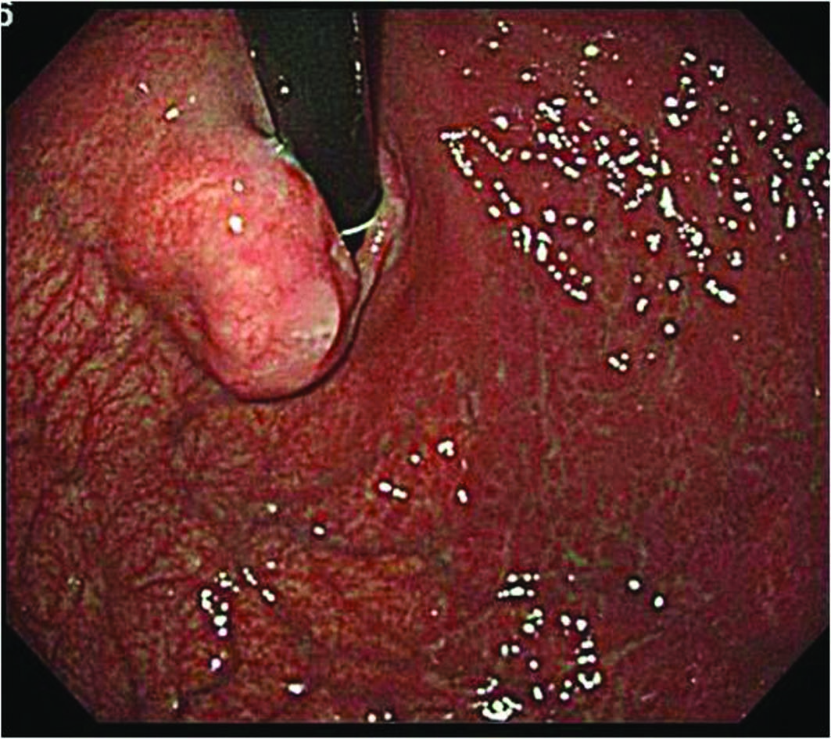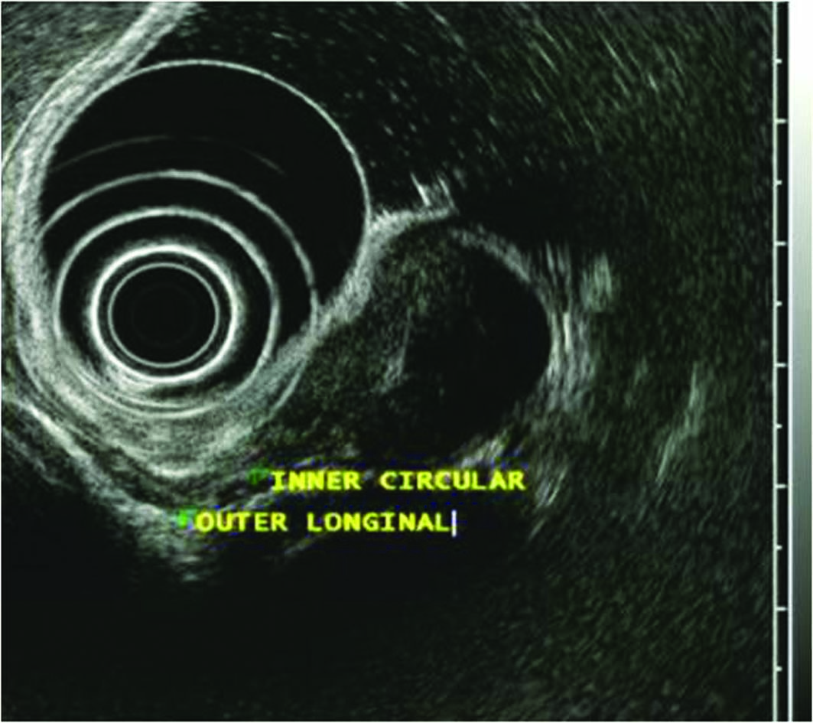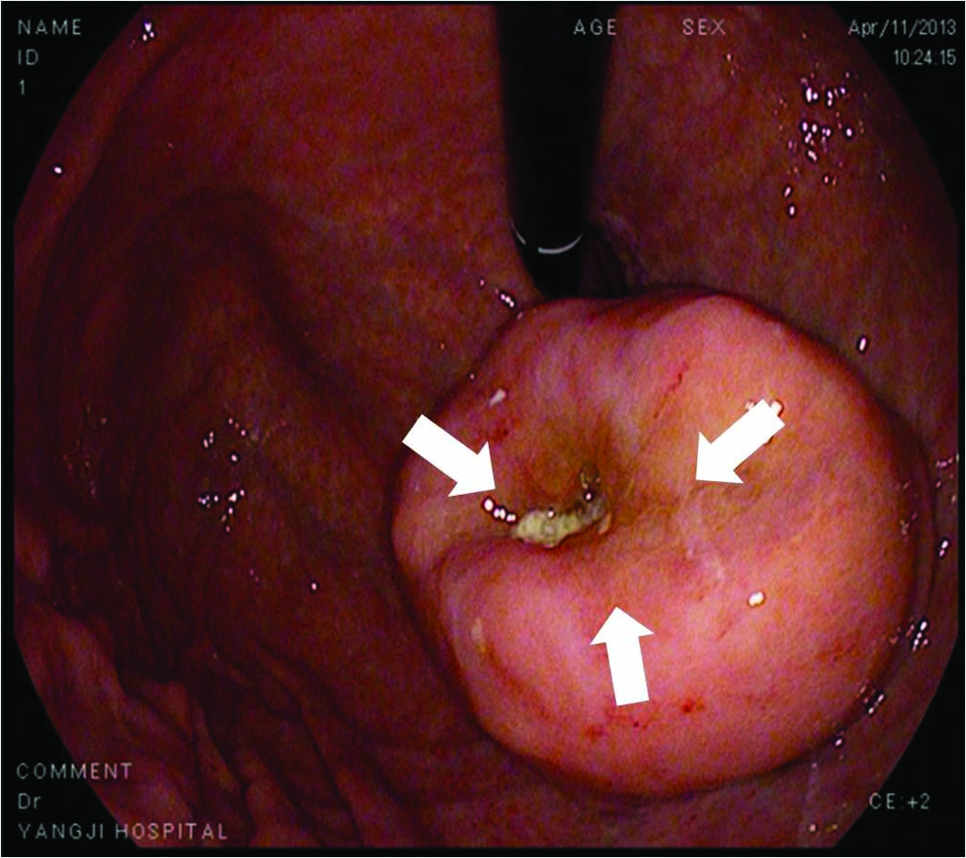

Figure 1 Features of gastrointestinal stromal tumors. A: An approximately2-cmelevated lesion covered with nearly intact mucosa was observed at the cardia; B: EUS demonstrated a 21-mm, generally homogenous hypoechoic, well circumscribed pear-shaped lesion originating from the inner circular layer of the proper muscle layer. Inside the lesion, a hyperechoic septum-like structure was noticed; C: There was a small deep focal ulceration at the center of the gastrointestinal stromal tumor (GIST) (white arrows).

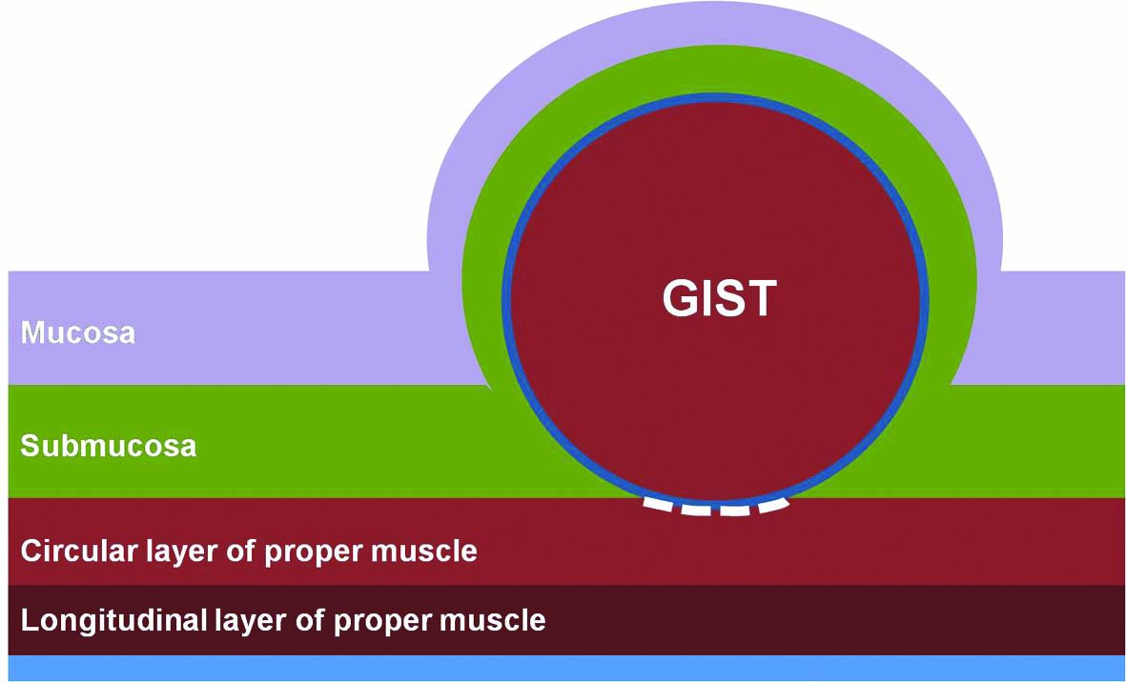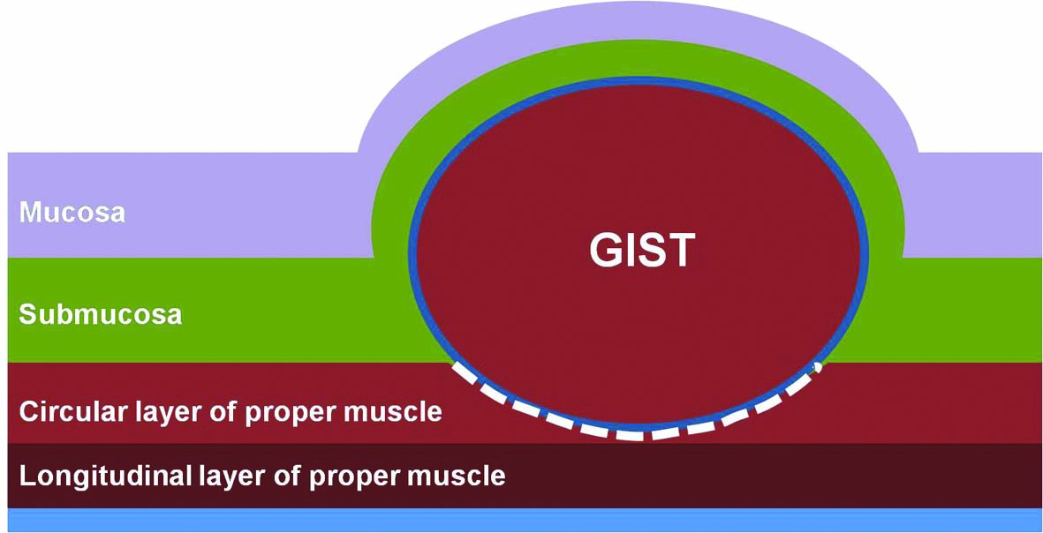
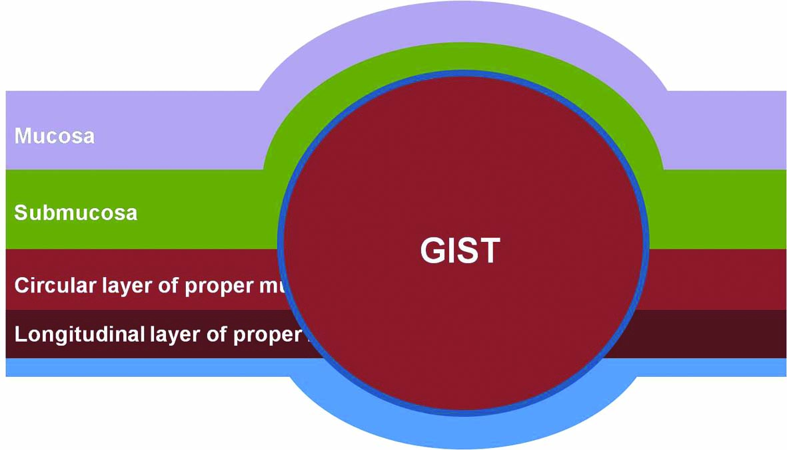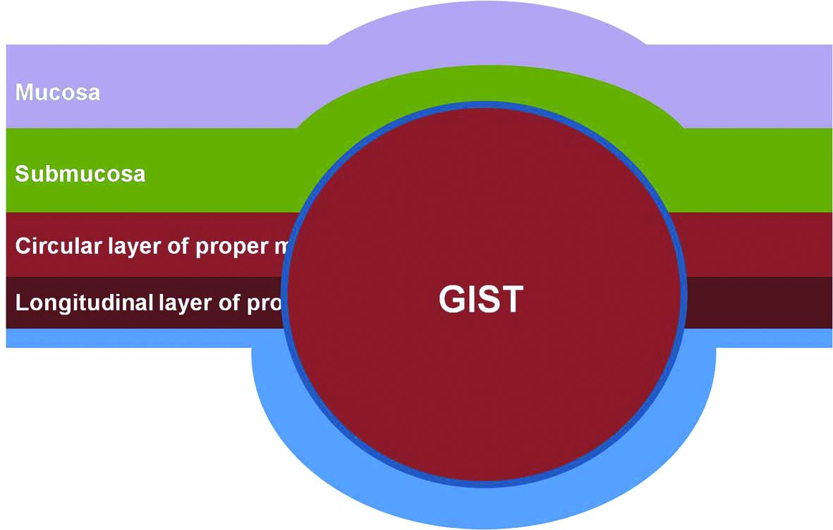
Figure 2 Classification of gastrointestinal stromal tumors according to the location in the gastric wall. A: Type I is a gastrointestinal stromal tumor (GIST) that has a very narrow connection with the proper muscle layer and protrudes into the luminal side like a polyp; B: Type II has a wider connection with the proper muscle layer and protrudes into the luminal side atan obtuse angle; C: Type III is located in the middle of the gastric wall; D: Type IV protrudes mainly into the serosal side of the gastric wall. White dotted lines indicate the area dissected from the proper muscle layer
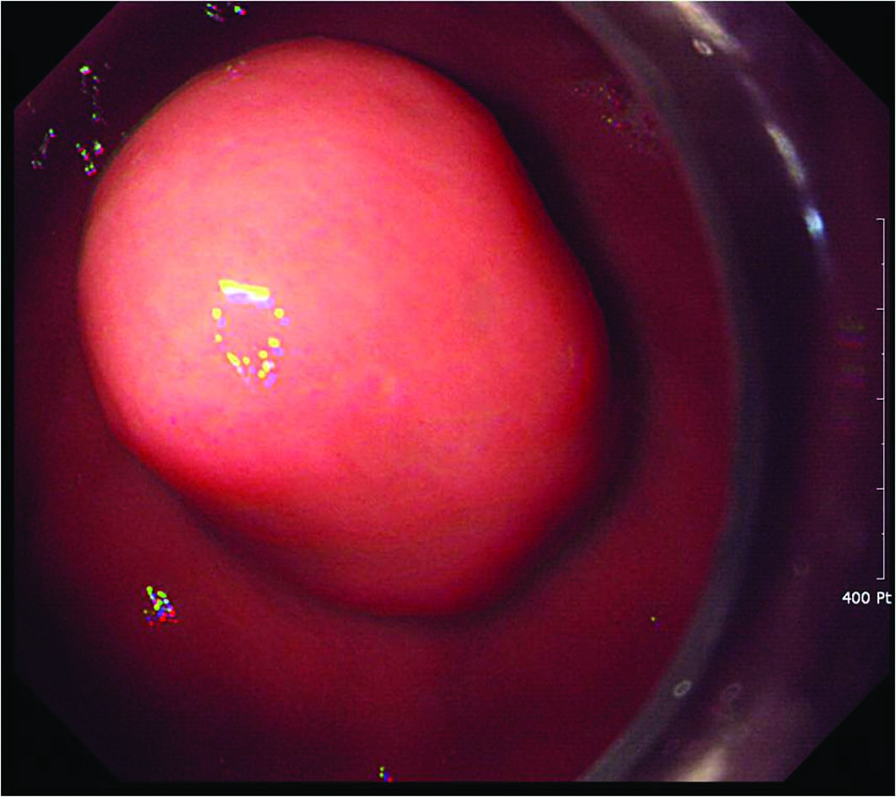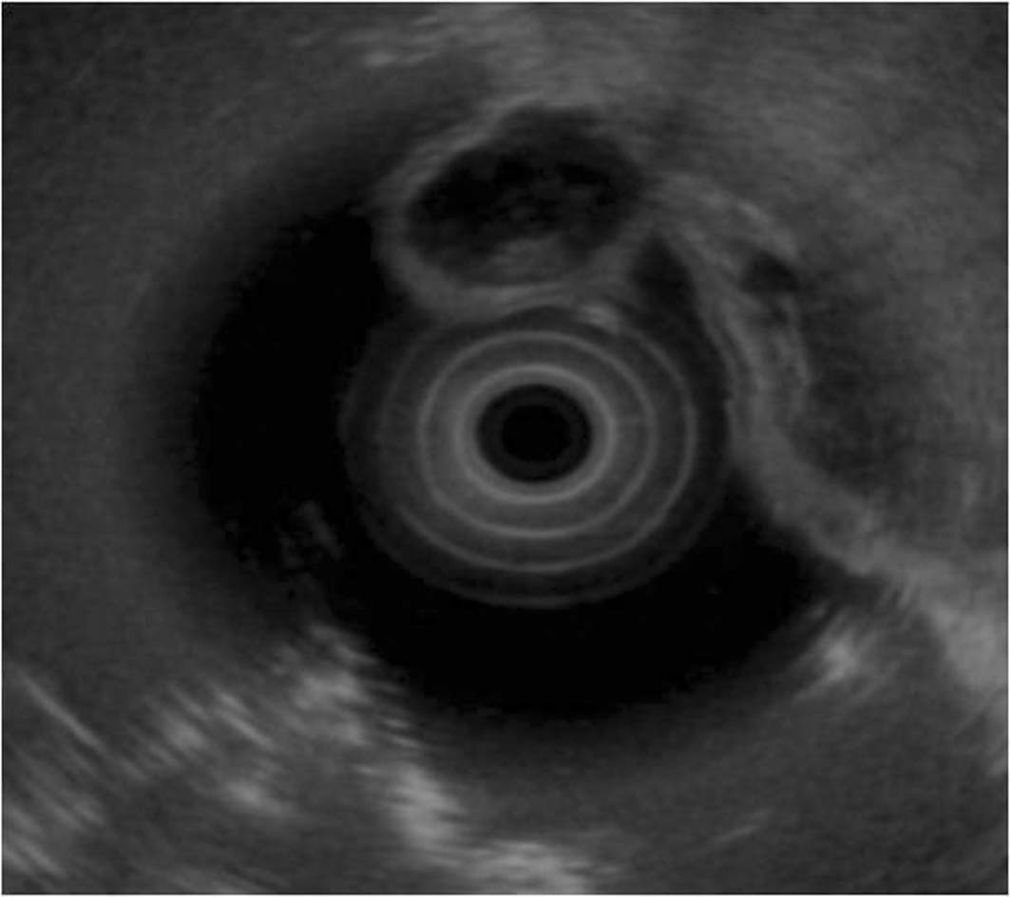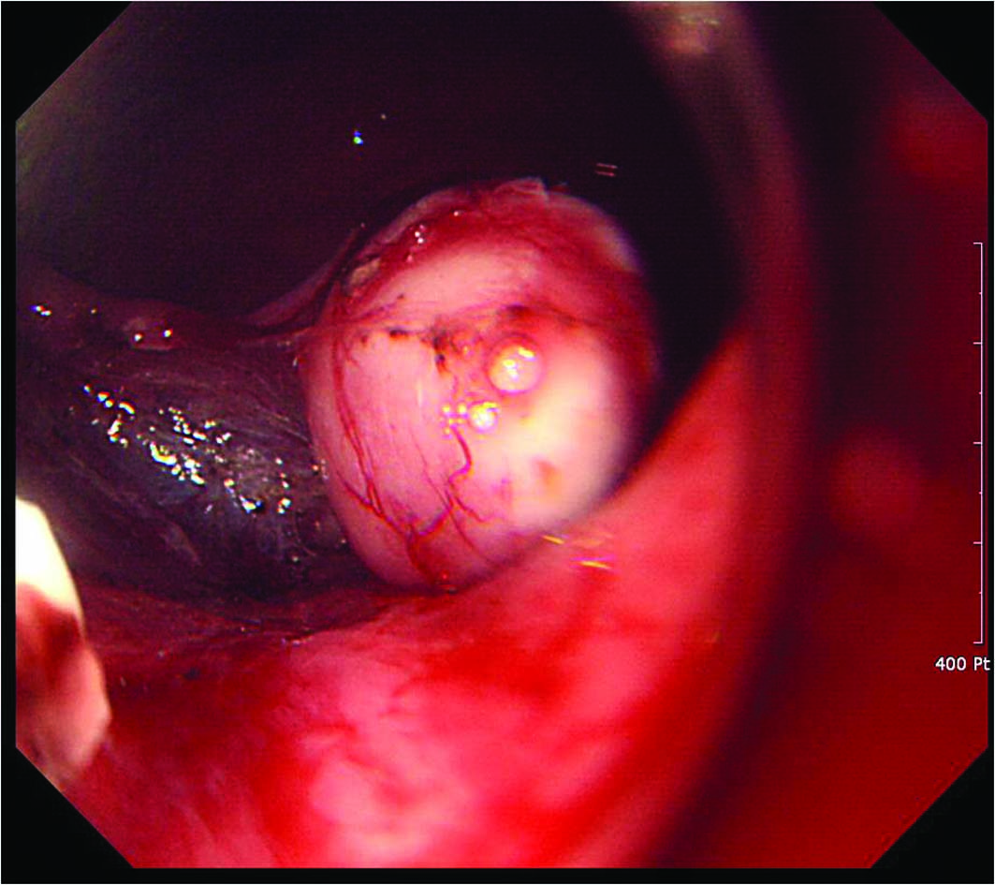
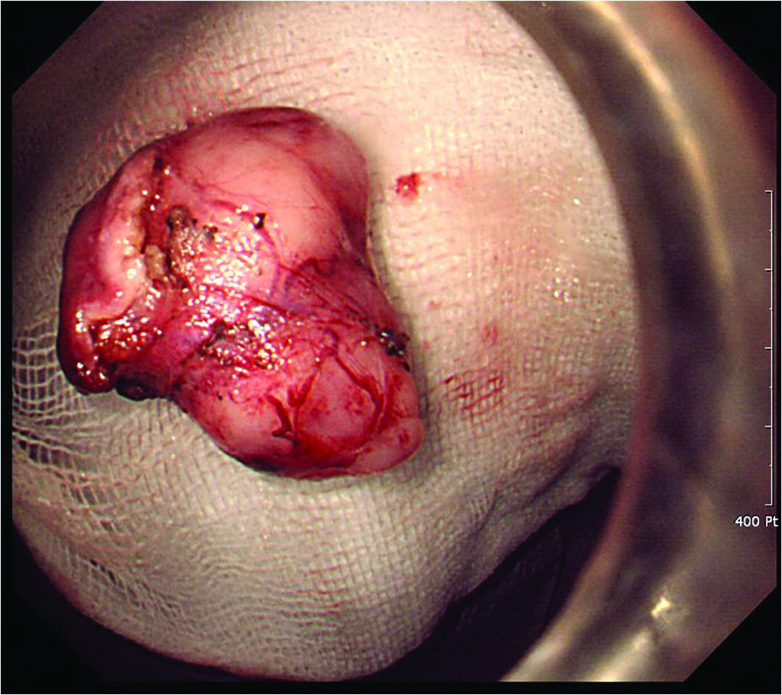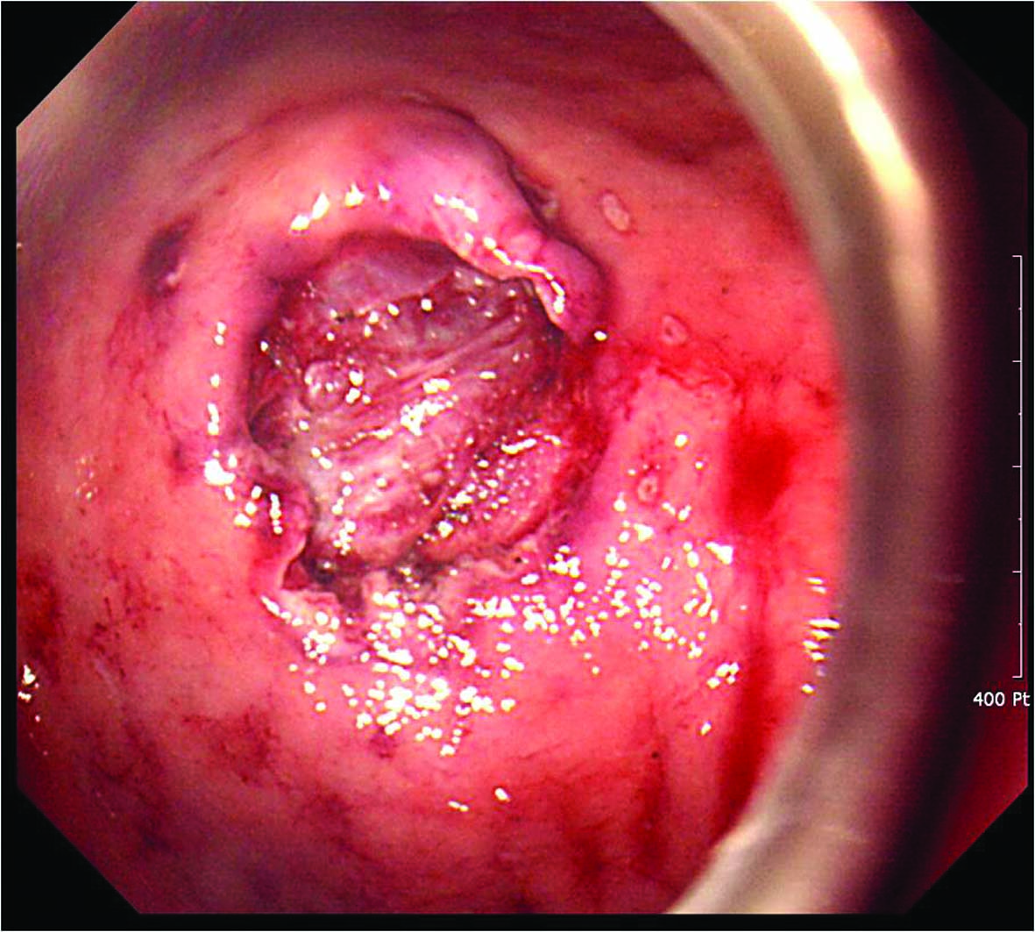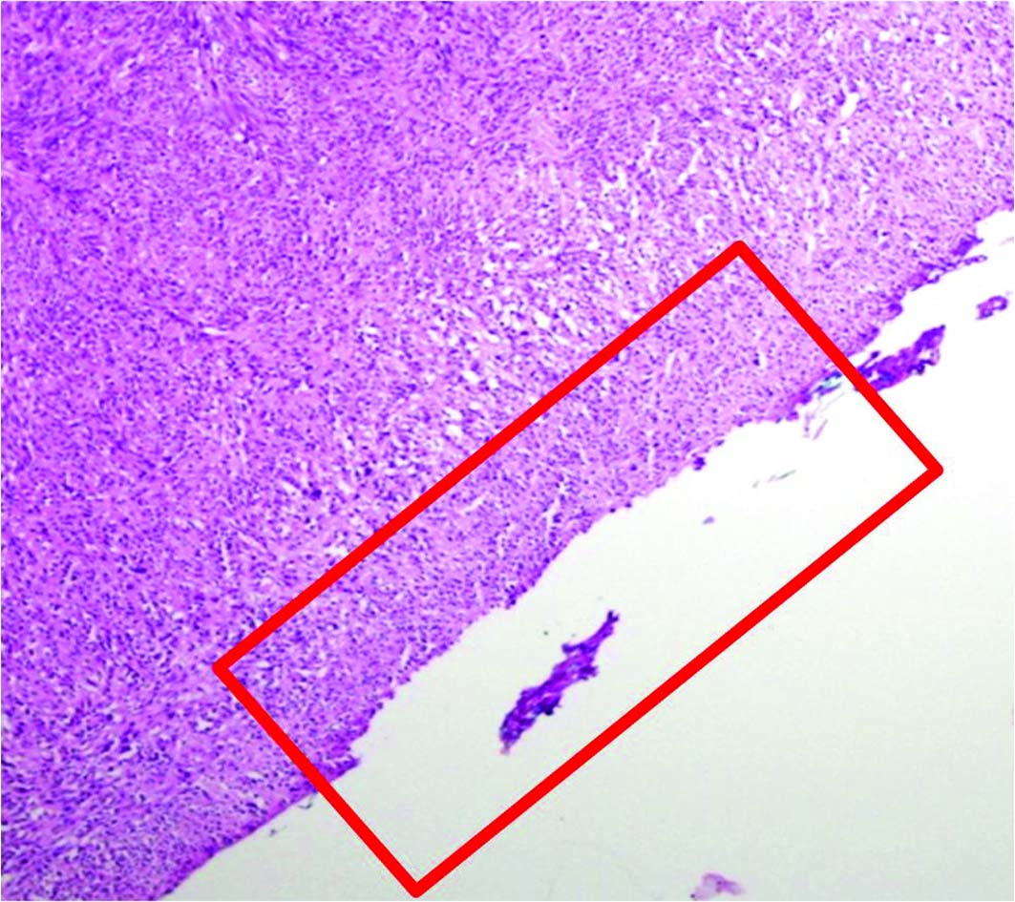
Figure 3 Endoscopic enucleation using the standard endoscopic submucosal dissection technique. A: An approximately 2.5-cm subepithelial tumor was identified at the greater curvature side of the upper body of the stomach; B: A 2.6-cm mixed echogenic tumor with a slightly irregular border arising from the proper muscle layer was noticed; C: Endoscopic enucleation using the endoscopic submucosal dissection technique was performed; D: En bloc resection was achieved; E: There was no perforation at the operation site; F: On pathologic examination, a vertical resection margin was apparently involved with tumor cells (red boxed area); R1 resection was confirmed. (Courtesy of Kyung Oh Kim, Gil hospital, Incheon, Korea)

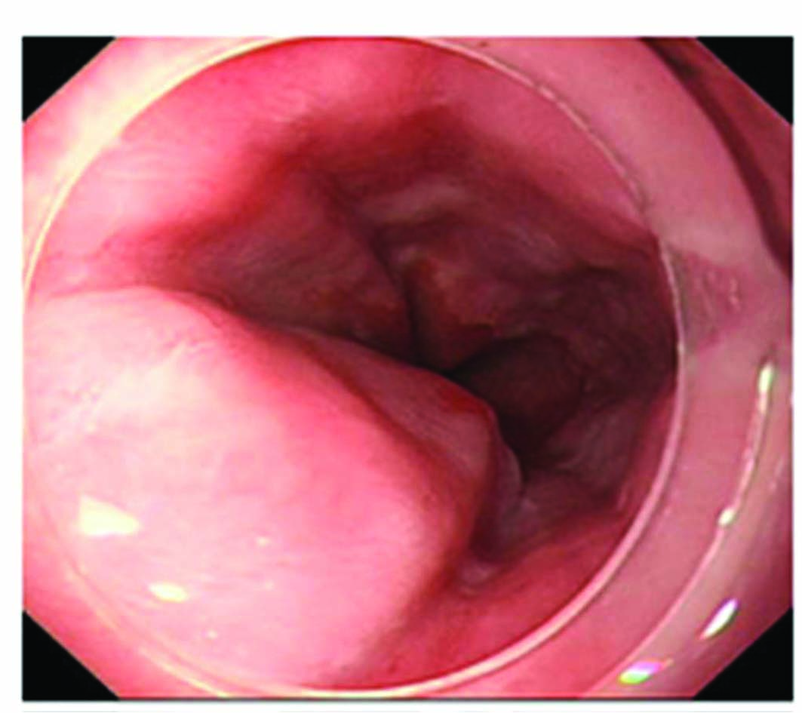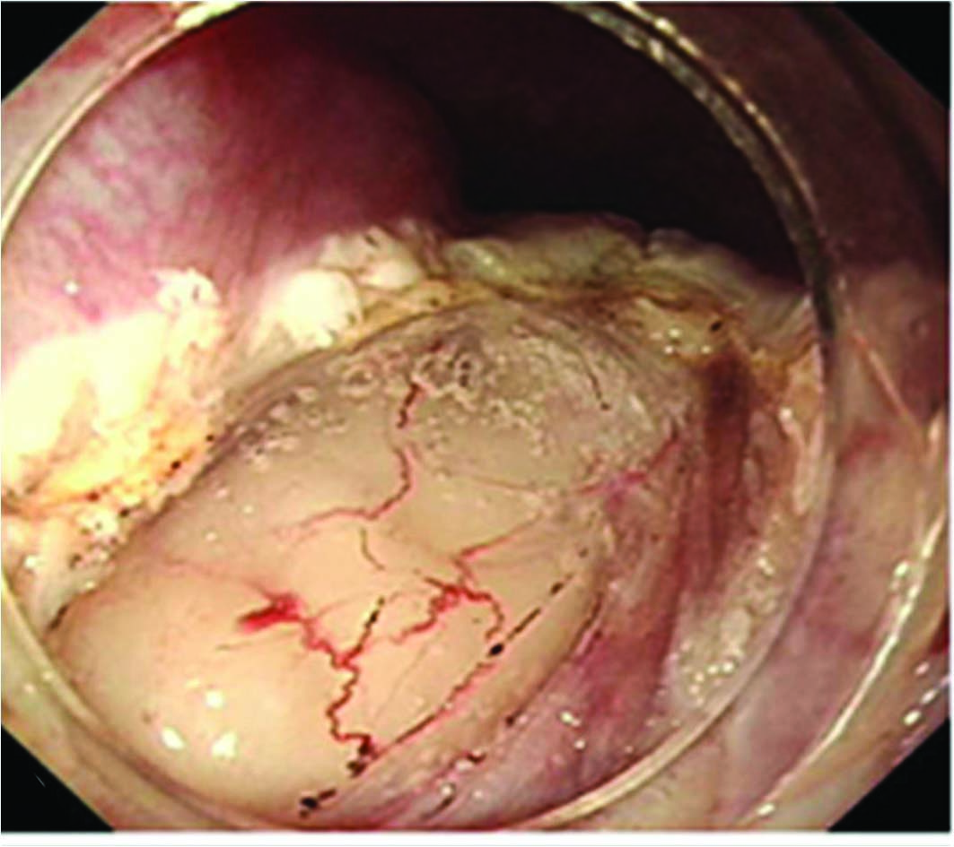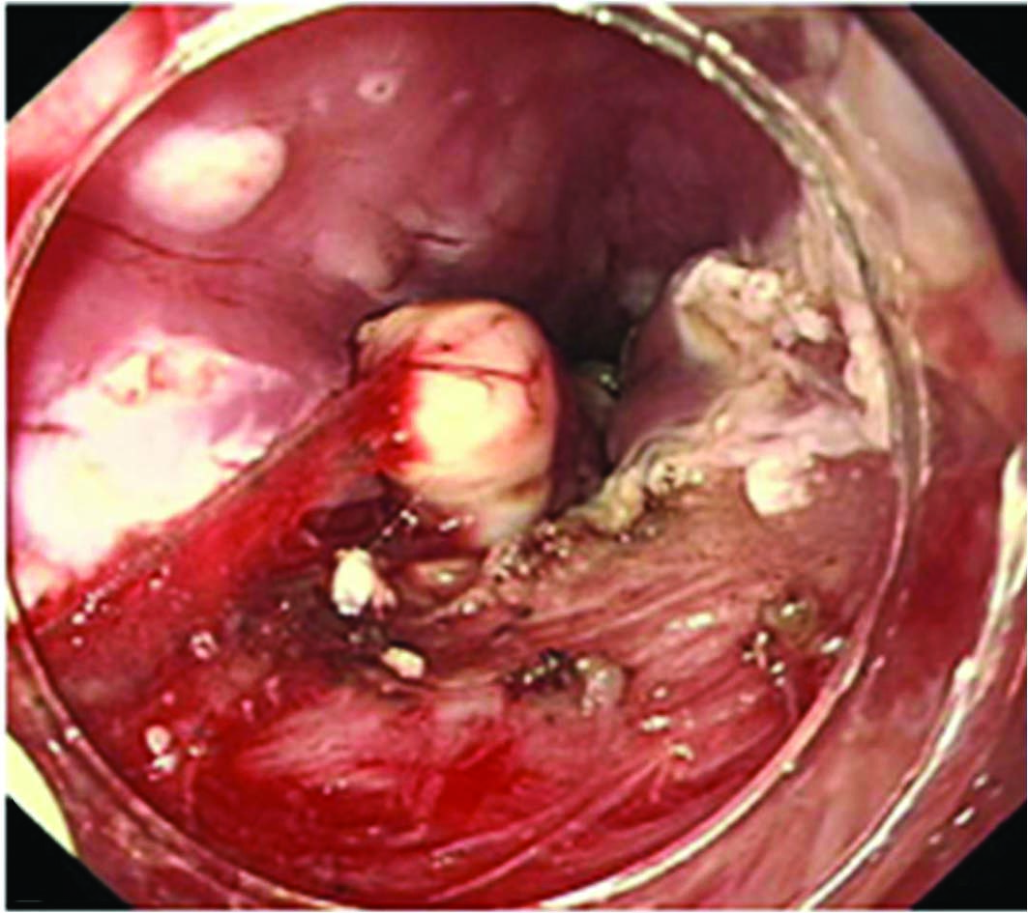
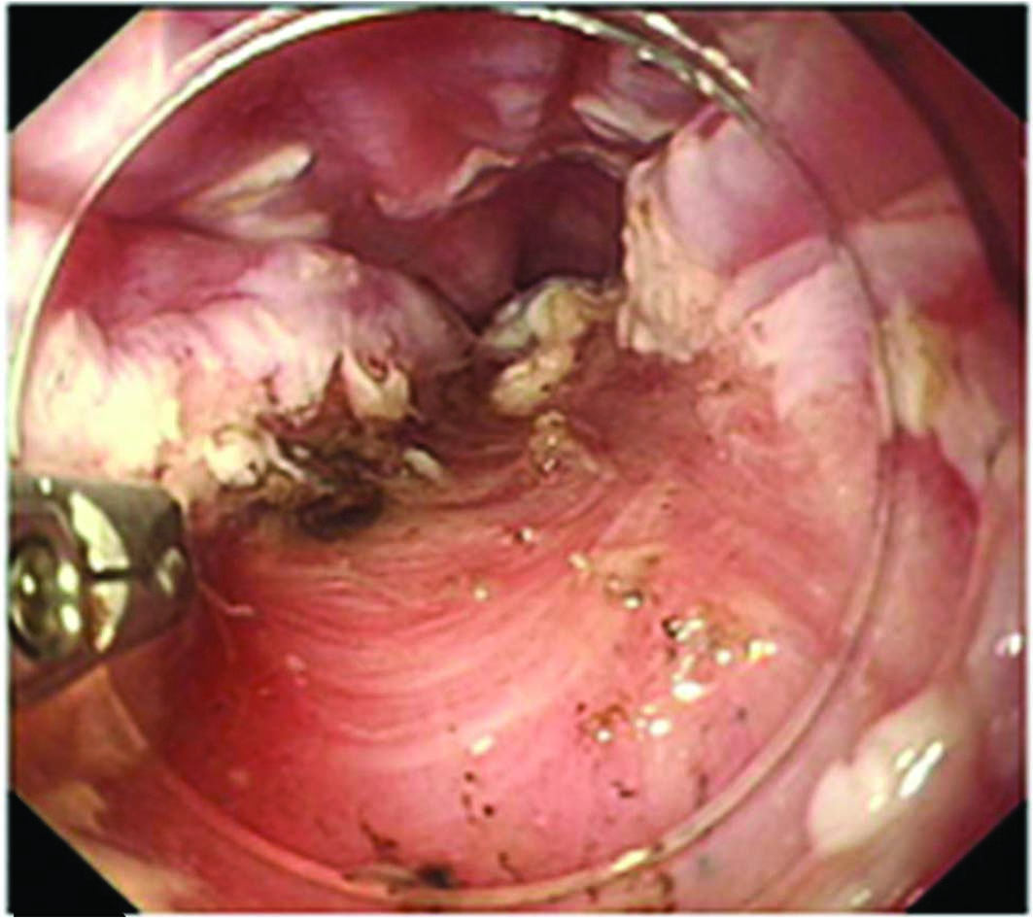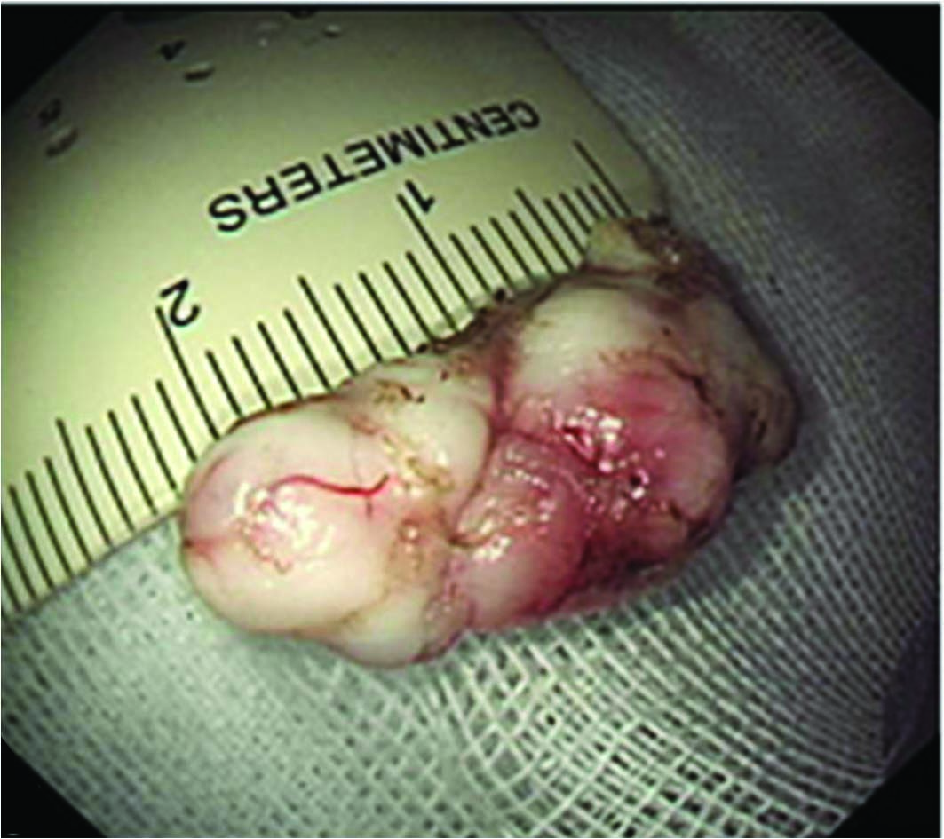
Figure 4 Endoscopic muscularis dissection of an esophageal subepithelial tumor originating from the proper muscle layers (A) Endoscopic view of the esophageal submucosal tumor. B: Exposure of the tumor using a longitudinal incision; C: Blunt dissection of the tumor as deep as the proper muscle layer with a transparent hood; D: Stopping bleeding after blunt dissection; E: The whole tumor was removed F: Linear clipping was performed to close the submucosal entry site (adopted from Liu et al^{[44]}).

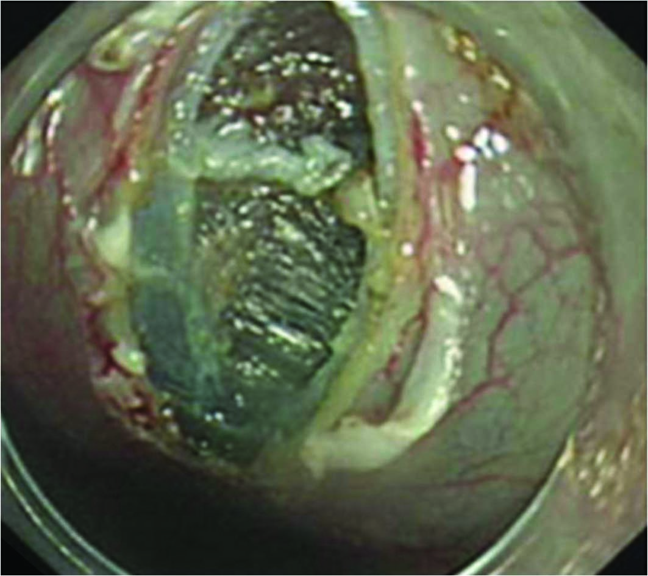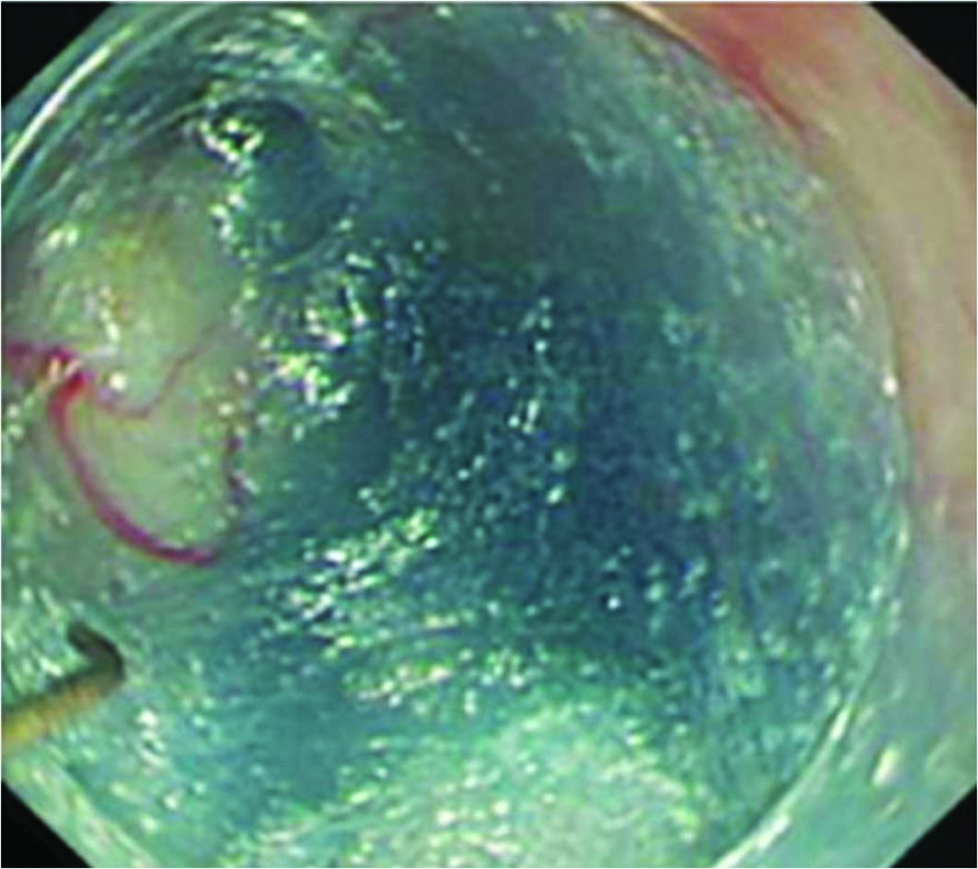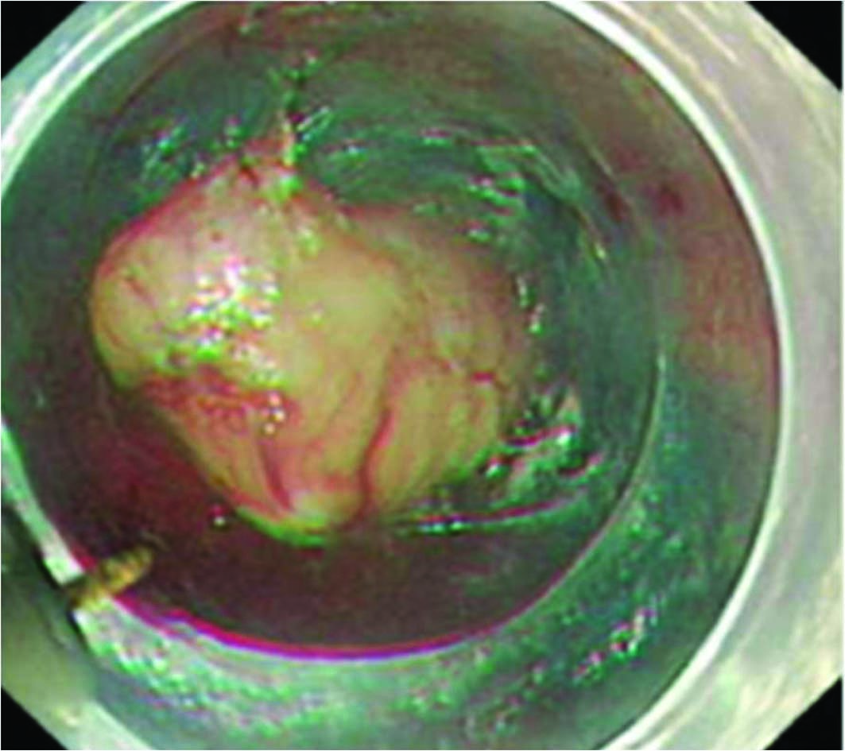

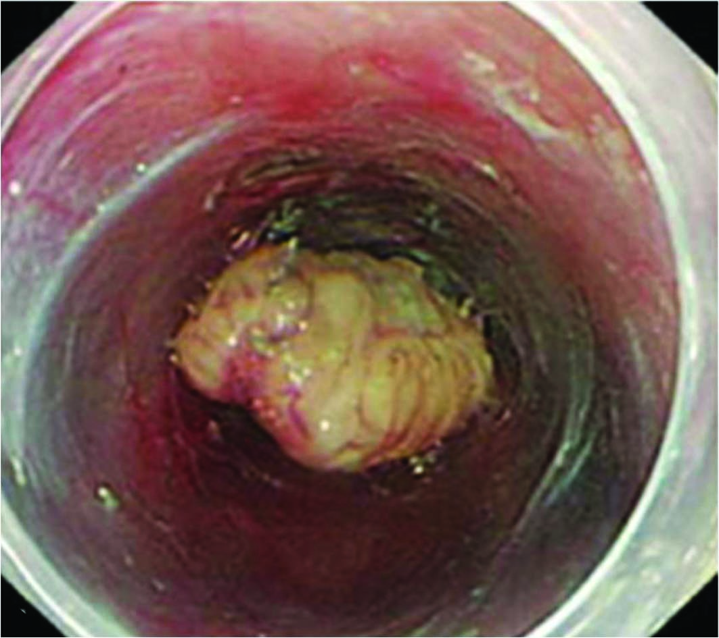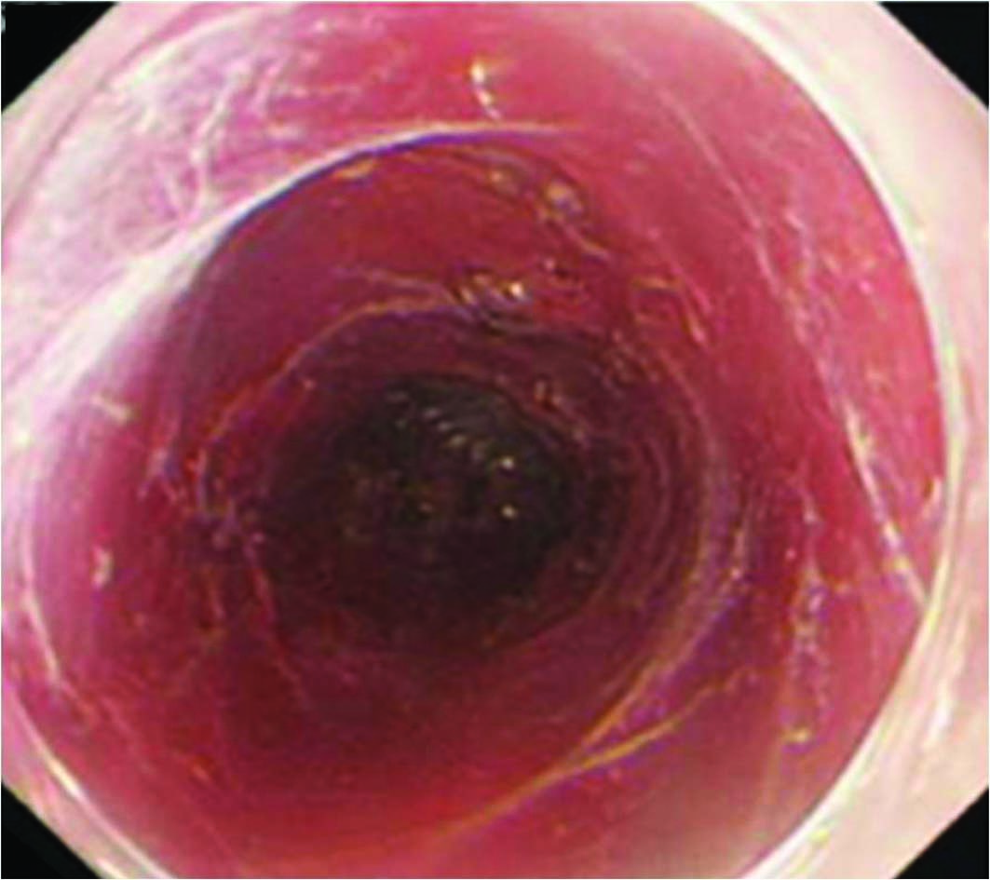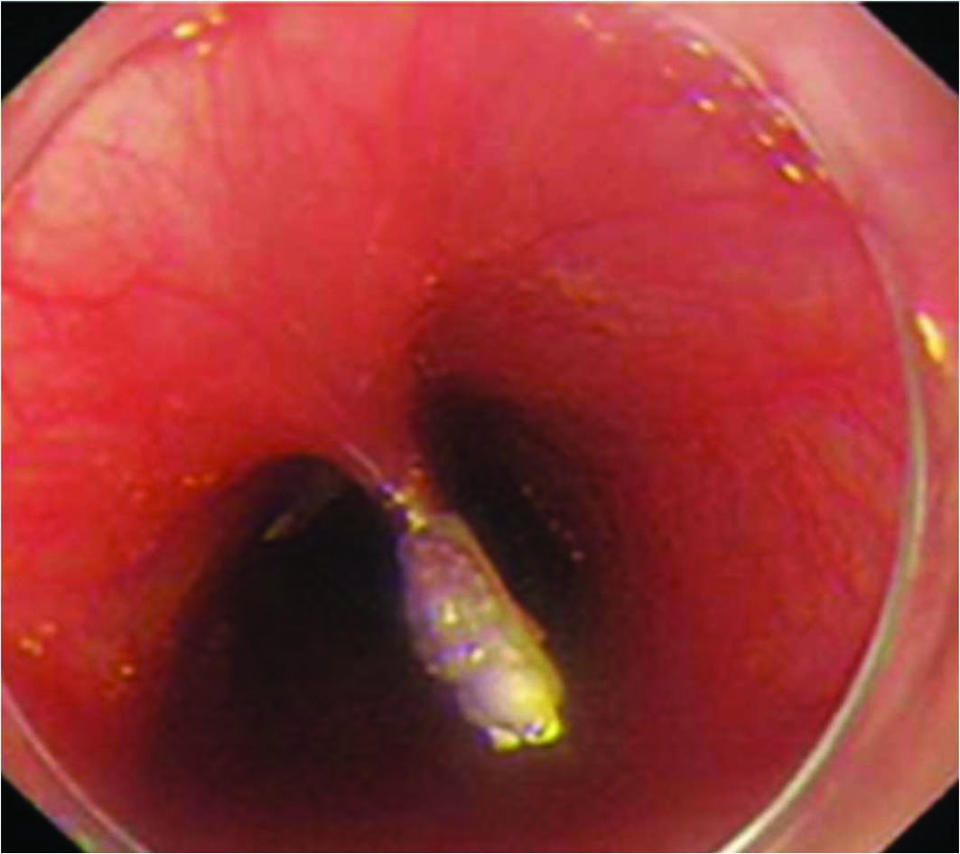
Figure 5 Endoscopic submucosal tunnel dissection procedure with longitudinal access. A: A 2-cm longitudinal mucosal incision was created, approximately 5 cm over the submucosal tumor; B: Submucosal dissection was performed, making a submucosal tunnel until the tumor was visible; C: Dissection was performed along the margin of the tumor; D: Dissection was completed; E: After removing the tumor, potential bleeding foci were coagulated; F: Closing the entry with clips (adopted from Gong et al^{[46]}).
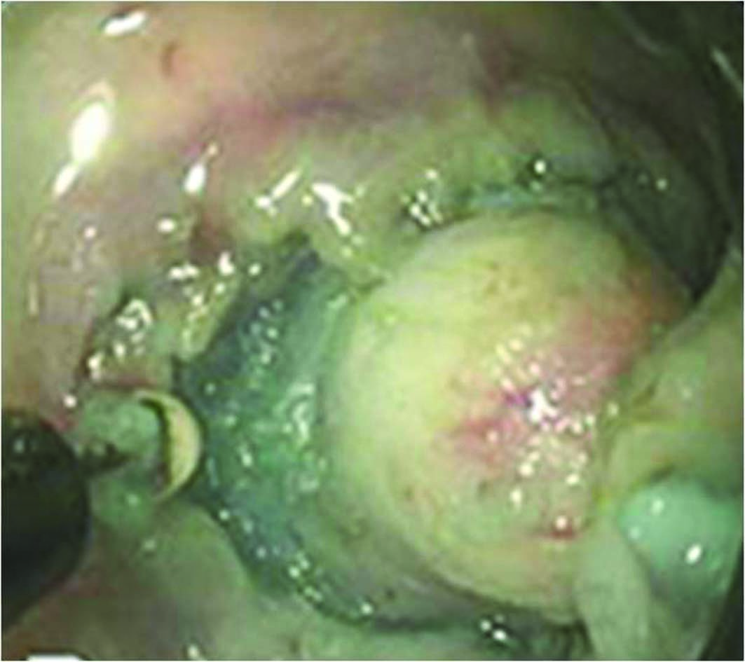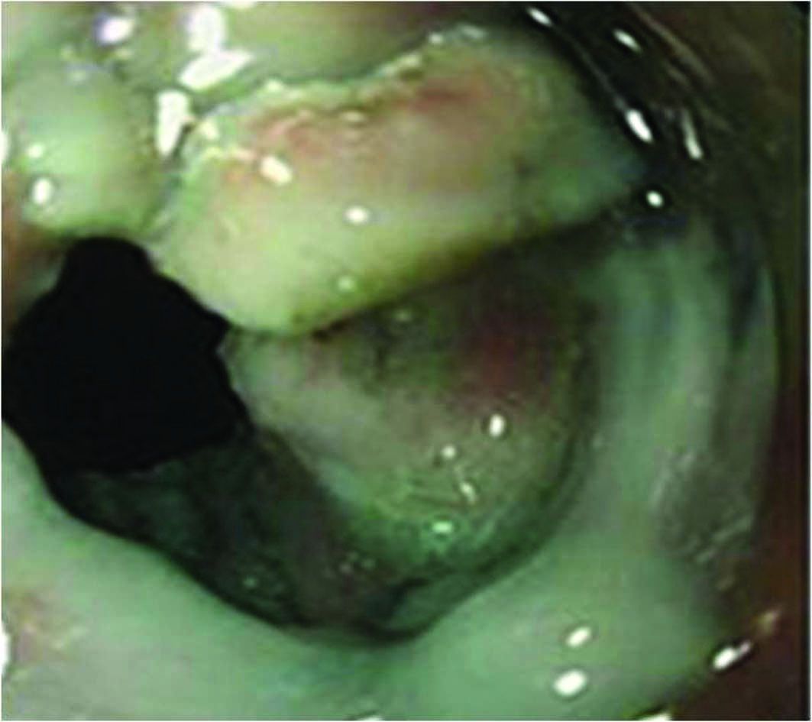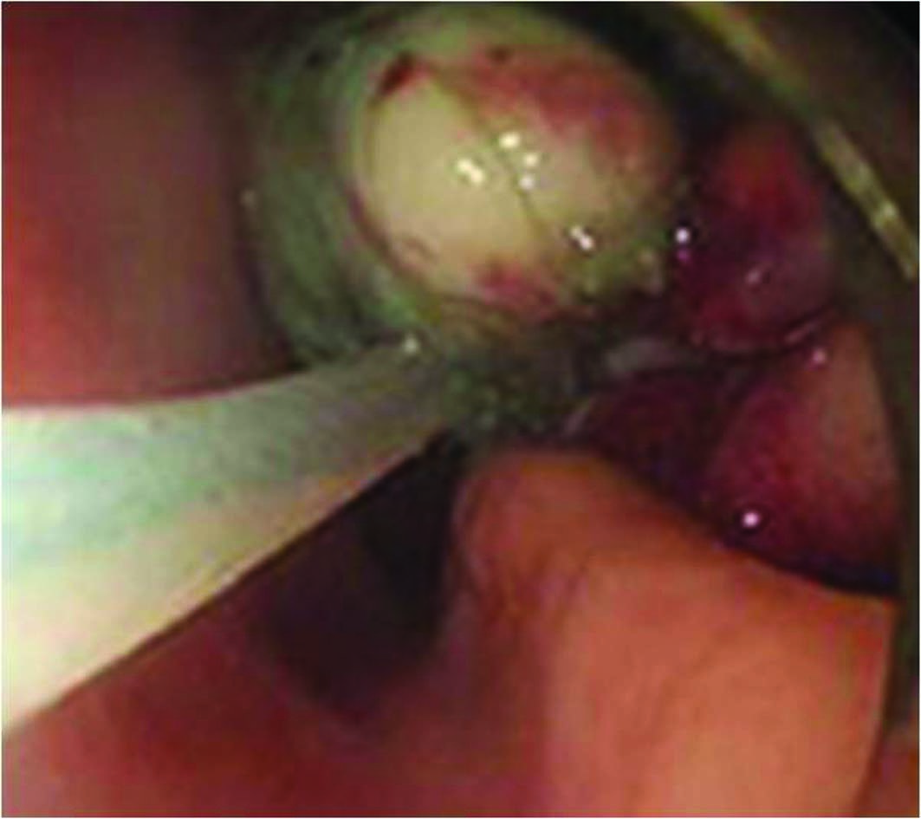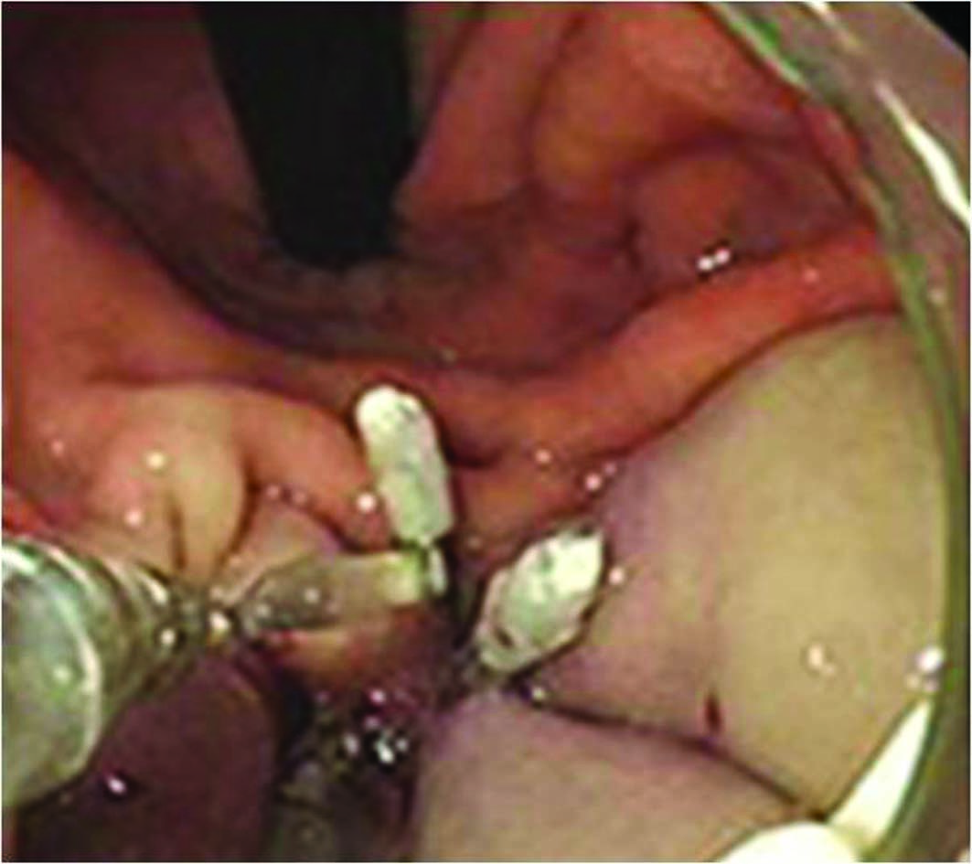
Figure 6 Procedure for endoscopic full-thickness resection of gastric subepithelial tumors originating from the proper muscle layer. A: A circumferential incision was made as deep as the proper muscle layer around the lesion with an IT knife; B: The tumor protruded into the peritoneal cavity after active perforation due to the incision into the serosal layer around the lesion; C: The tumor and surrounding tissue were pulled into the gastric cavity; D: The gastric wound was successfully closed with several metallic clips (adopted from Zhou et al^{[52]}).

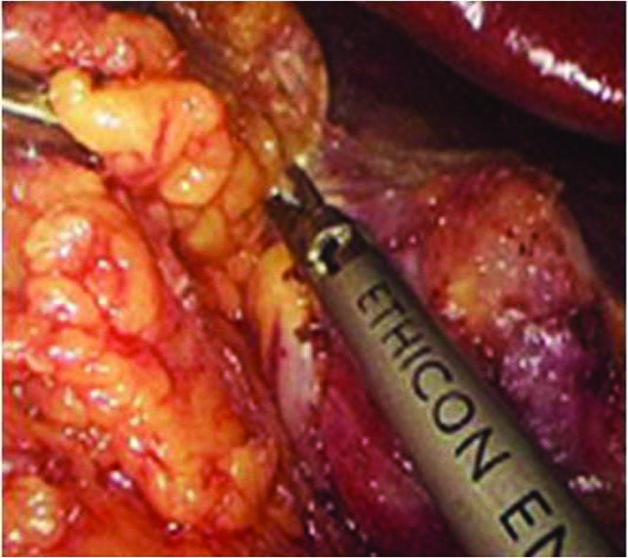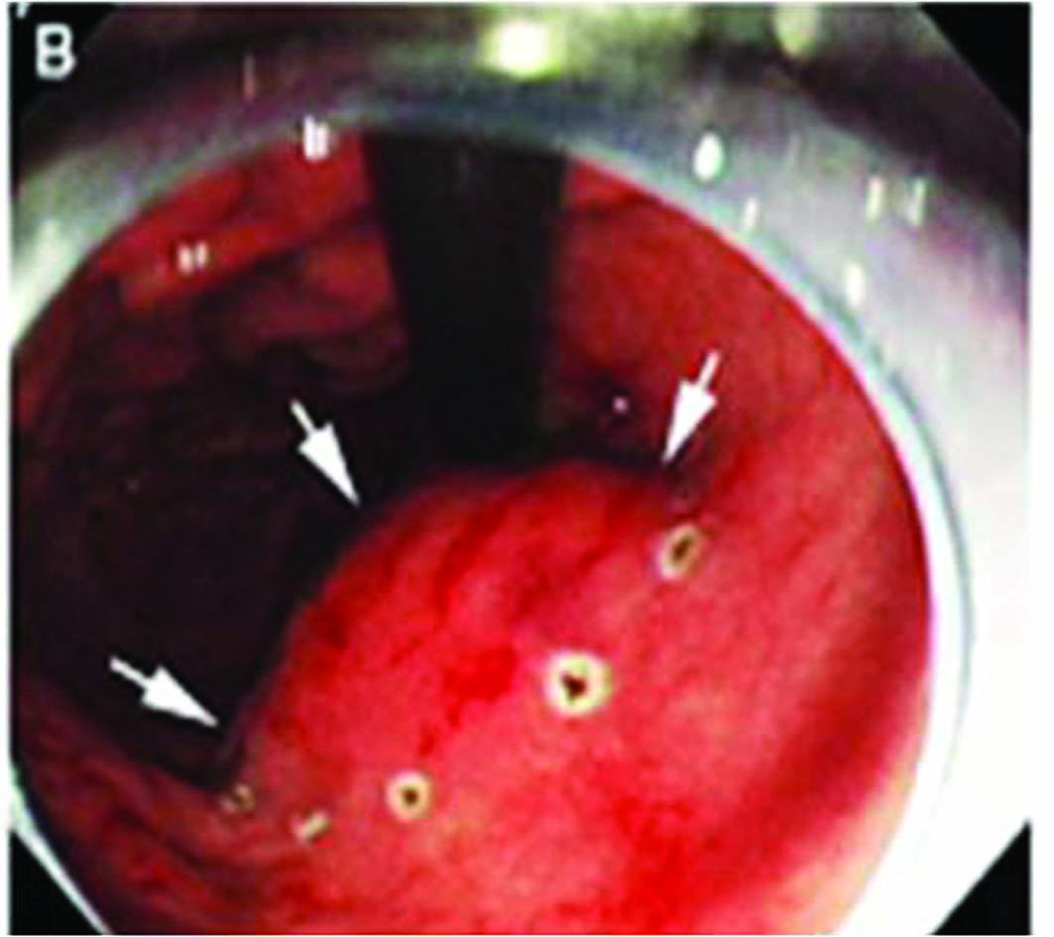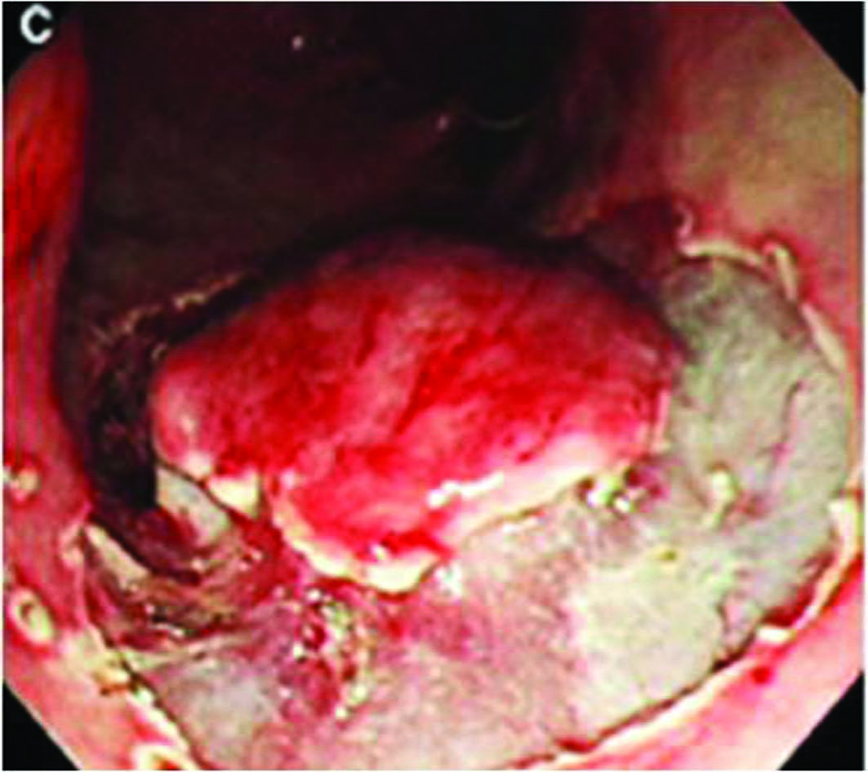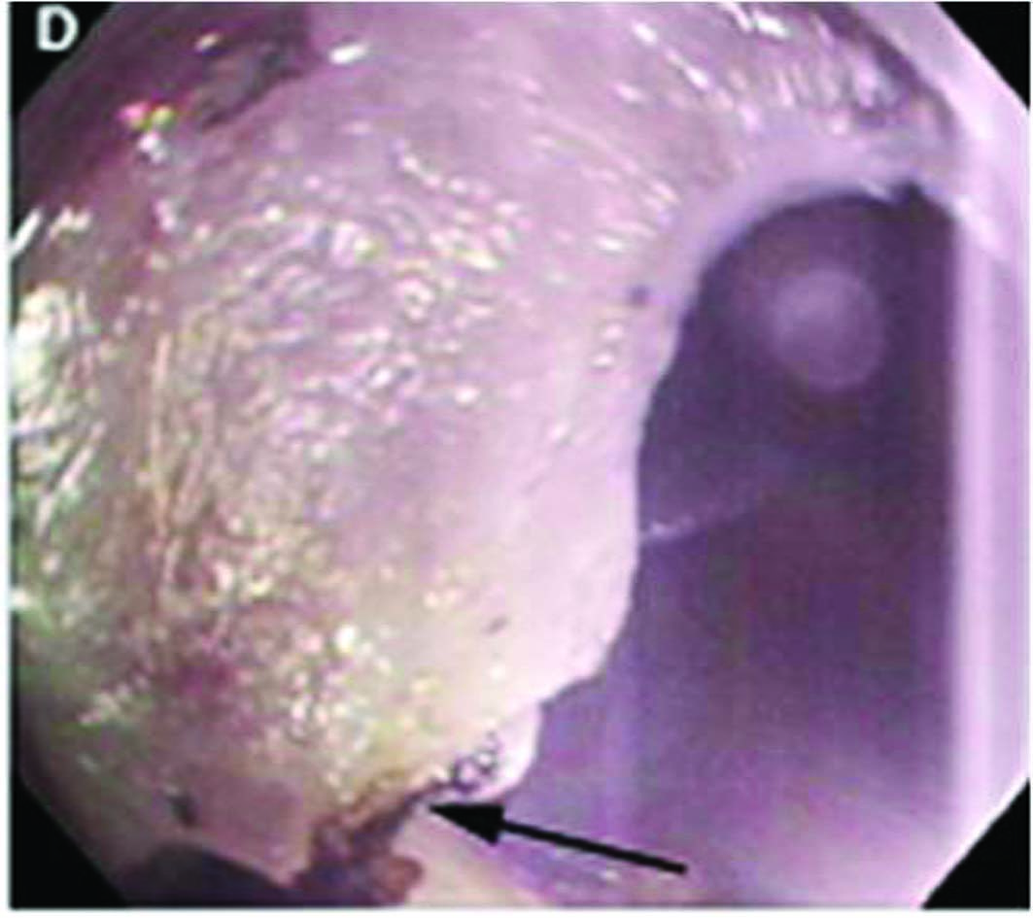
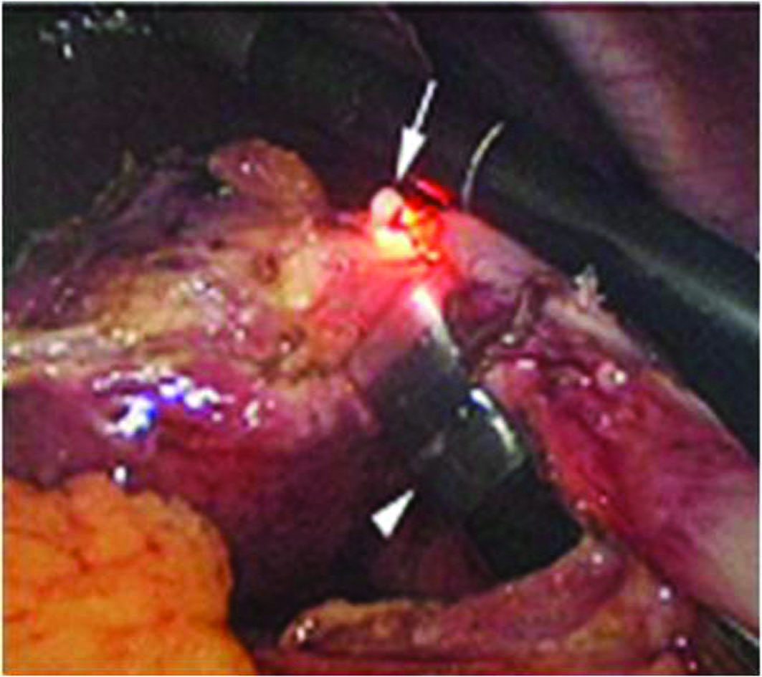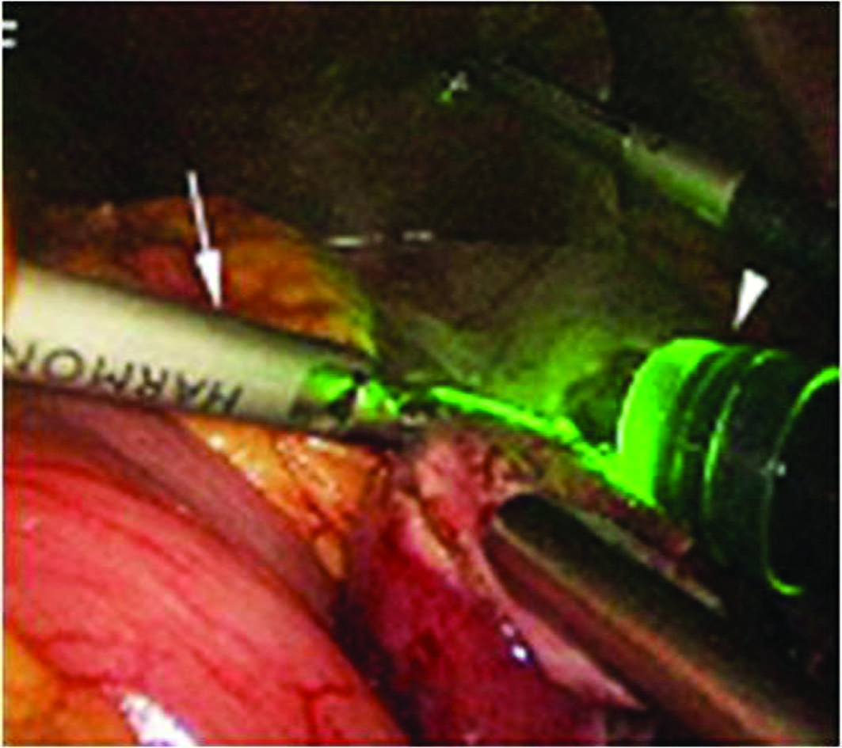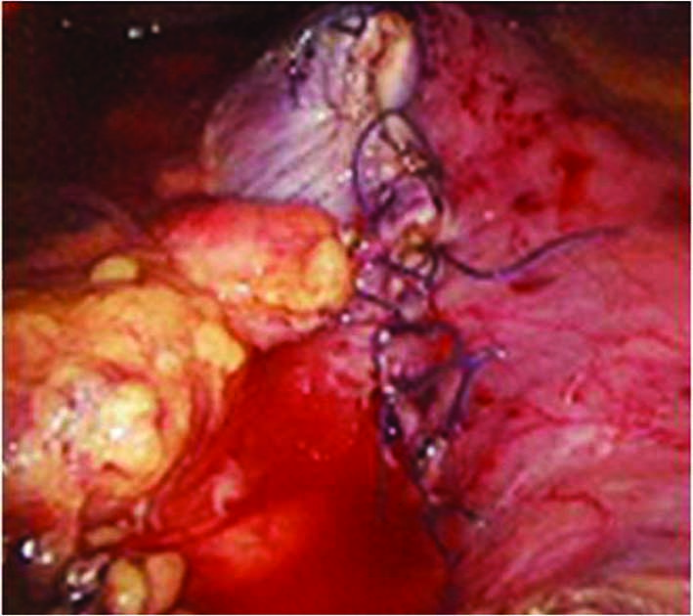
Figure 7 Procedure for laparoscopy-assisted endoscopic full-thickness resection. A: Laparoscopic view while the lesser omentum attached around the tumor site was dissected; B: Endoscopic view after marking around the gastric subepithelial tumor (white arrows) located on the lesser curvature side of the gastric body; C: Gastroscopic view after incision as deep as the submucosal layer around the lesion; D: Gastroscopic view of the full-thickness incision from inside the stomach using the IT knife (white arrow); E: Laparoscopic view of the full-thickness incision from inside the stomach using the IT knife (arrow, the tip of the IT knife; arrowhead, the gastroscope); F: Laparoscopic view of the remaining full-thickness incision from outside the stomach using a Harmonic ACE (arrow); G: Laparoscopic view after laparoscopic hand-sewn closure of the gastric-wall defect (adopted from Abe et al^{[58]}).

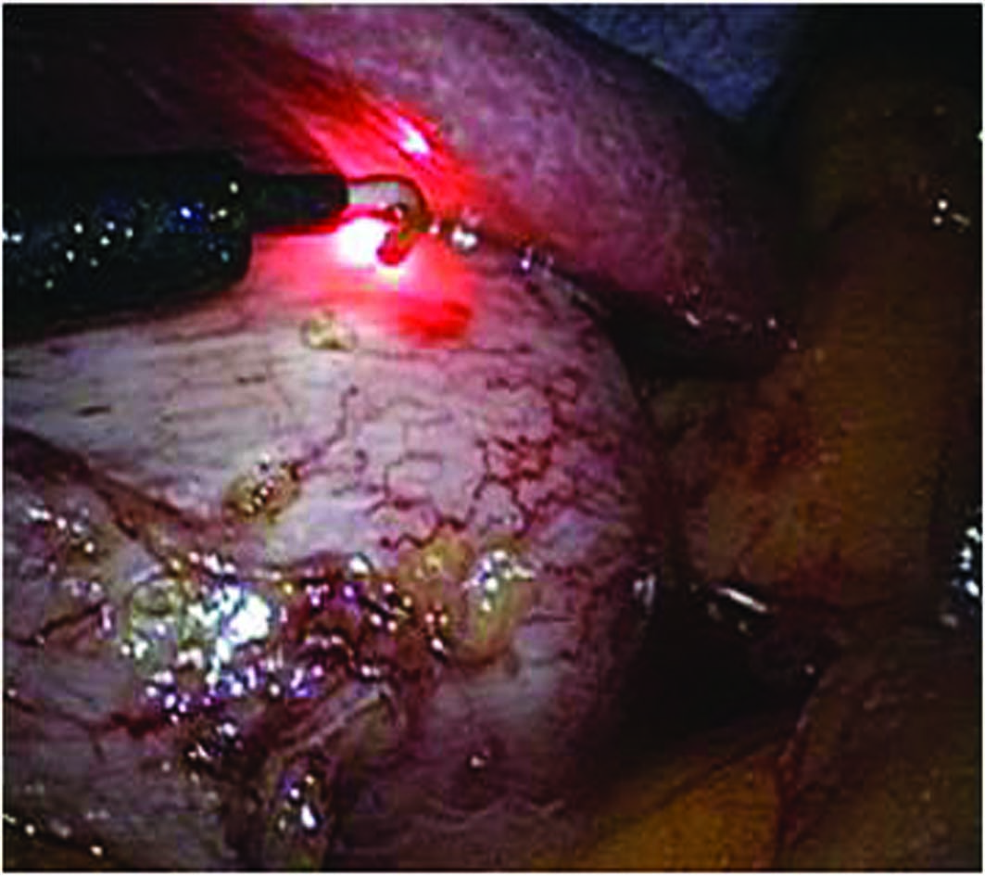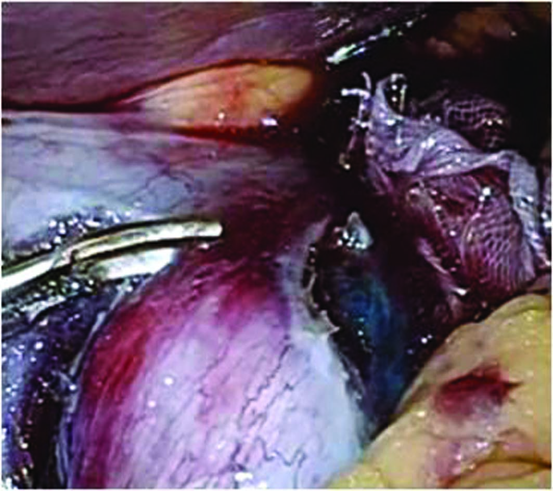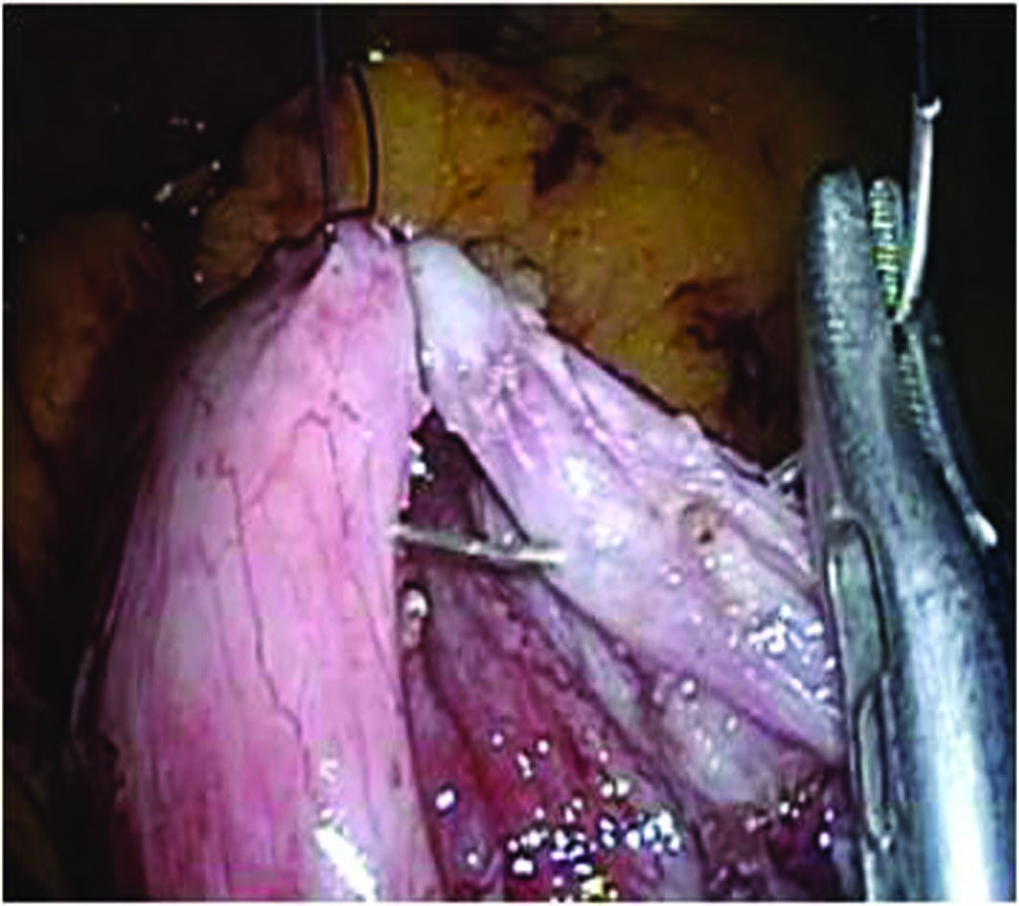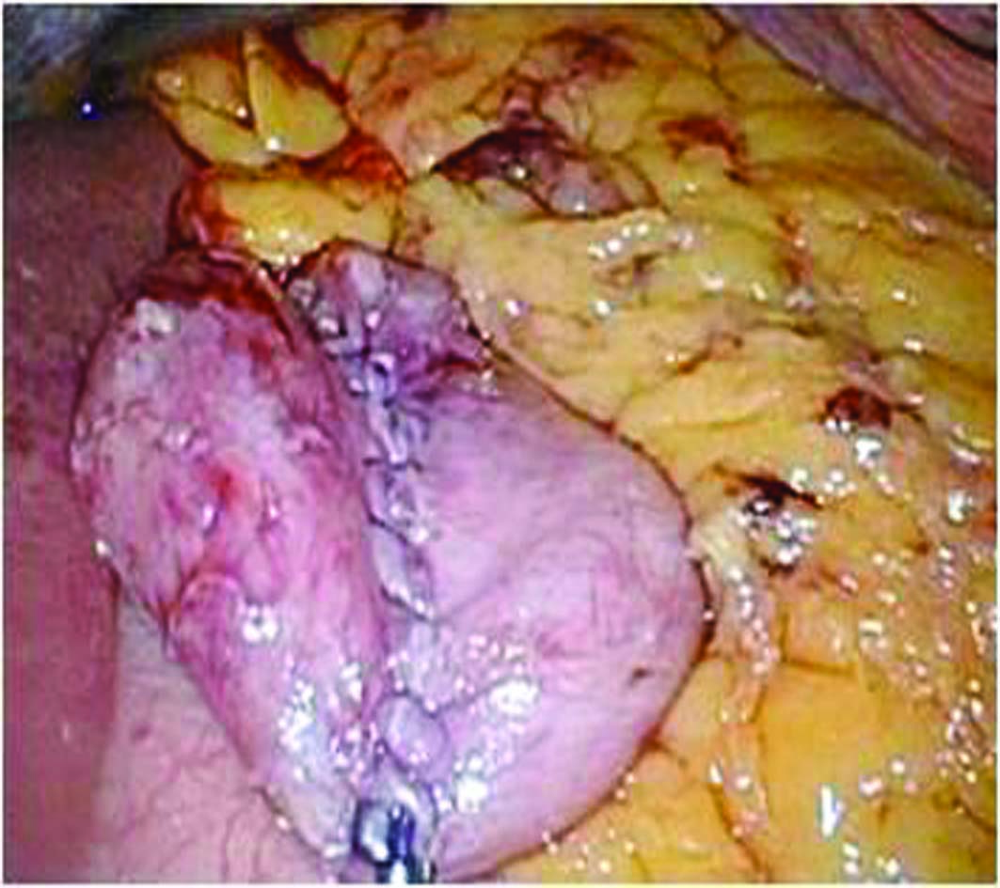
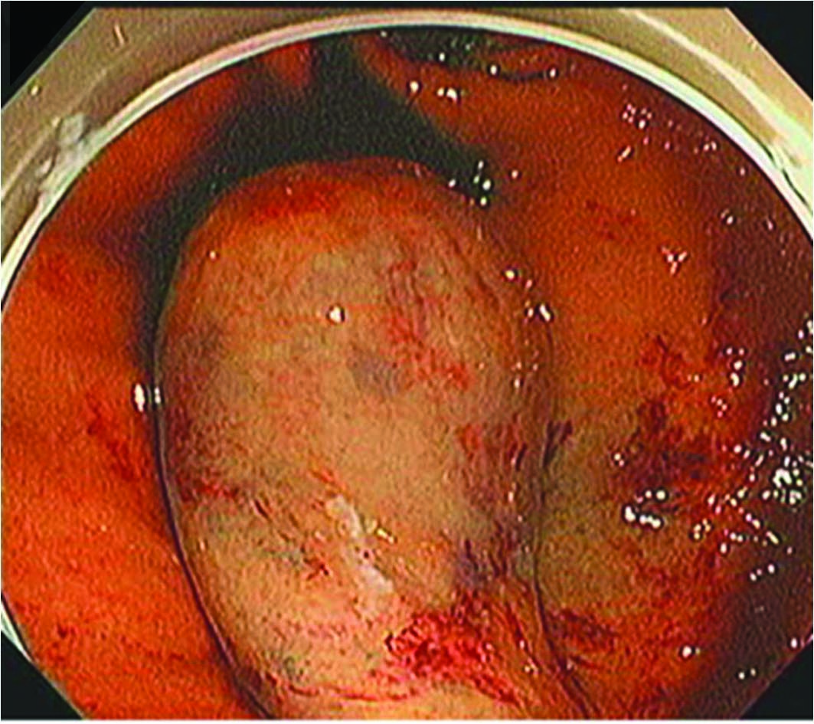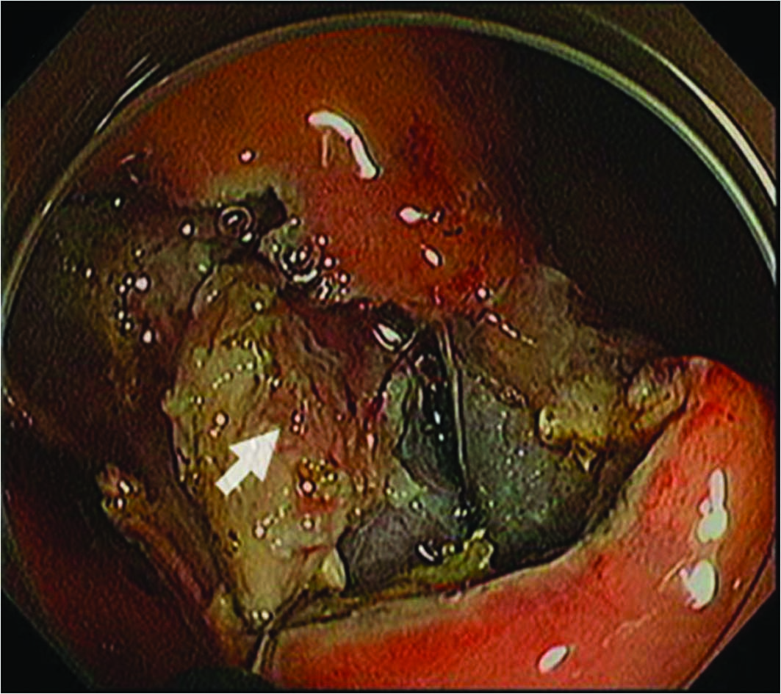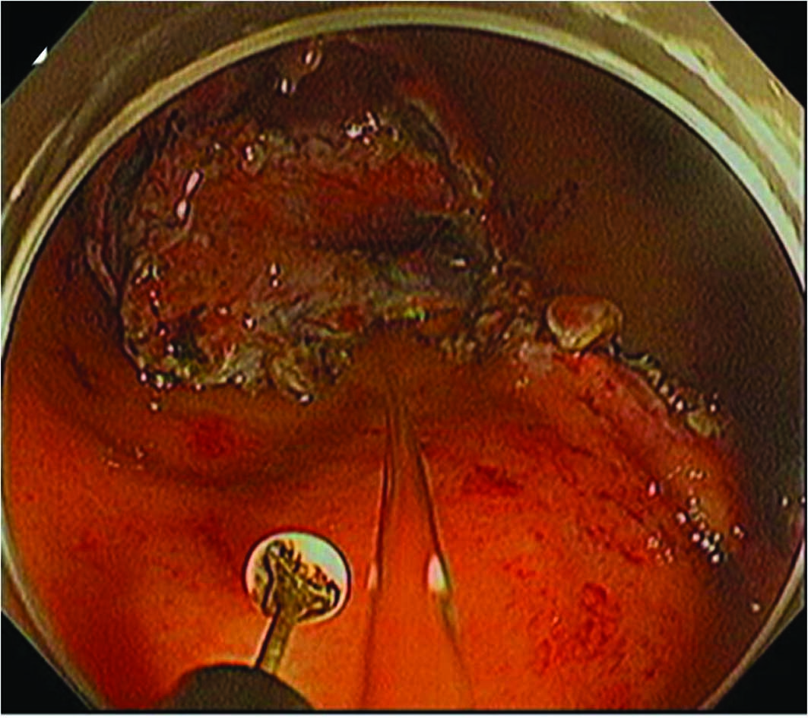
Figure 8 Procedure for non-exposed wall-inversion surgery. A: Laparoscopic markings on the serosal surface guided by light from the ﬁber-optic probe shining through the gastric endoscope; B: Circumferential seromuscular layer dissection outside the serosal markings; C: Seromuscular layer suture closure; D: Laparoscopic view of inversion of the dissected area; E: Endoscopic view of massive protrusion of the inverted tissue; F: Serosal surface (arrow)identiﬁed duringmucosubmucosallayer dissection; G: Flipped tissue to be resected (adopted from Mitsui et al^{[61]}).

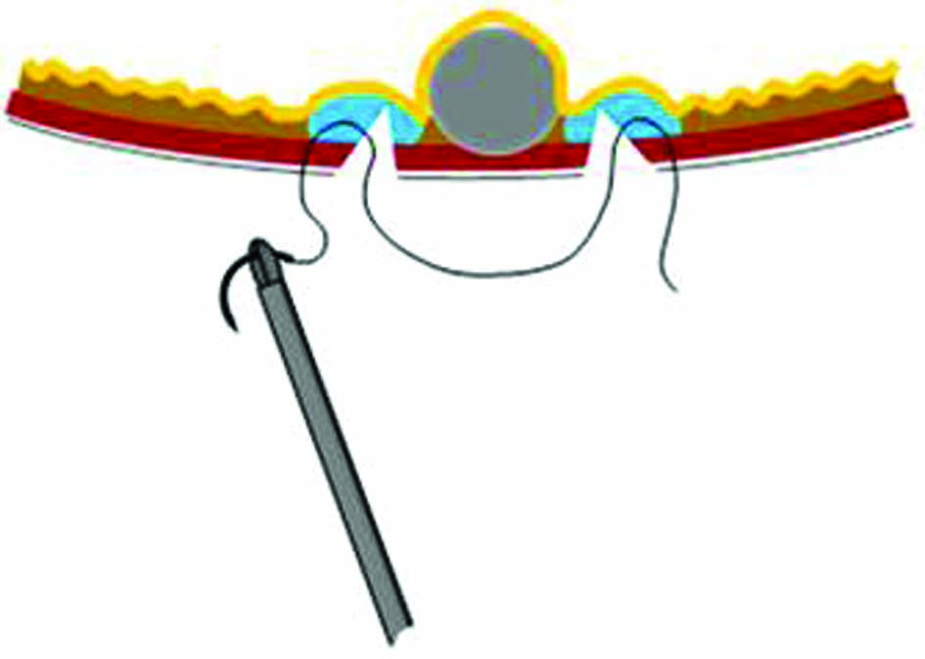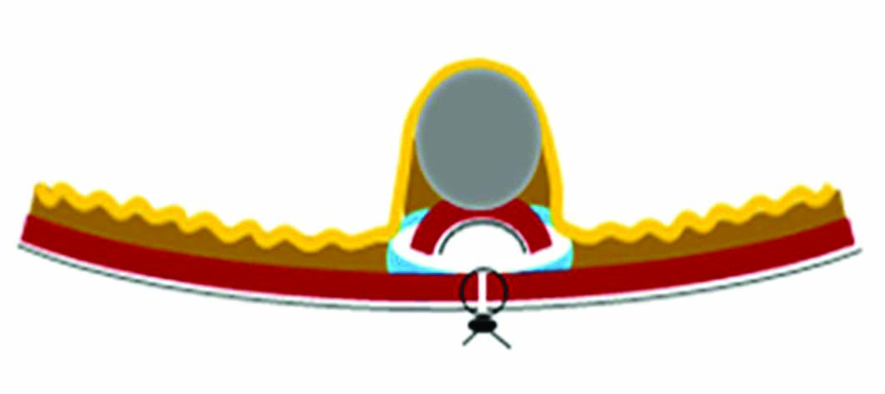
Figure 9 Scheme of the procedure for non-exposed wall-inversion surgery. A: Seromuscular layer suture after submucosal injection and seromuscular cutting; B: Divided seromuscular layer inversion after laparoscopic seromuscular closure; C: Mucosubmucosal layer dissection (adopted from Mitsui et al^{[61]}).

