Name of Journal: World Journal of Hepatology
Manuscript NO: 62602
Manuscript Type: EDITORIAL

New Year’s greeting and overview of World Journal of Hepatology in 2021

Hu KQ et al. New year’s greeting and overview of WJH in 2021

Ke-Qin Hu, Koo Jeong Kang, Nikolaos Pyrsopoulos, Xiang Li

Ke-Qin Hu, Division of Gastroenterology and Hepatology, University of California, Irvine Medical Center, Orange, CA 92868, United States

Koo Jeong Kang, Division of Hepatobiliary Pancreatic Surgery, Department of Surgery, Keimyung University Dong-San Medical Center, Daegu 41931, South Korea

Nikolaos Pyrsopoulos, Medicine-Gastroenterology and Hepatology, Rutgers-New Jersey Medical School, Newark, NJ 07103, United States

Xiang Li, Production Department, Baishideng Publishing Group Inc, Pleasanton, CA 94566, United States

Author contributions: Hu KQ and Li X drafted the editorial; Kang KJ and Pyrsopoulos N reviewed and revised the editorial.

Corresponding author: Xiang Li, BSc, Director, Production Department, Baishideng Publishing Group Inc, 7041 Koll Center Parkway, Suite 160, Pleasanton, CA 94566, United States. x.li@wjgnet.com

Received: January 13, 2021
Revised: January 21, 2021
Accepted: January 23, 2021
Published online: January 27, 2021

Abstract
The World Journal of Hepatology (WJH) was launched in October 2009. It mainly publishes articles reporting research findings in the field of hepatology, covering a wide range of topics, including viral hepatitis B and C, non-alcoholic fatty liver disease, alcoholic liver disease, autoimmune and chronic cholestatic liver disease, drug-induced liver injury, cirrhosis, liver failure, hepatocellular carcinoma, coronavirus disease 2019-related liver conditions, etc. As of December 31, 2020, the WJH has published 1349 articles, among which, the total cites is 18995 and the average cites per article is 14. In celebrating the New Year, we are pleased to share with you special a New Year’s greeting from the WJH Editors-in-Chief, along with a detailed overview of the journal’s submission, peer review and publishing metrics from 2020. In all, we are appreciative for the substantive support and submissions from authors worldwide, and the dedicated efforts and expertise provided by our invited reviewers and editorial board members.

Key Words: World Journal of Hepatology; New Year’s greeting message; Editors-in-Chief; Editorial Board; Highly influential scientists; Baishideng Publishing Group Inc

©The Author(s) 2021. Published by Baishideng Publishing Group Inc. All rights reserved.

Citation: Hu KQ, Kang KJ, Pyrsopoulos N, Li X. New Year’s greeting and overview of World Journal of Hepatology in 2021. World J Hepatol 2021; 13(1): 1-5
URL: https://www.wjgnet.com/1948-5182/full/v13/i1/1.htm
DOI: https://dx.doi.org/10.4254/wjh.v13.i1.1

Core Tip: The World Journal of Hepatology (WJH) mainly publishes articles reporting research results obtained in the field of hepatology and covering a wide range of topics, including a variety of different liver diseases, cirrhosis, hepatocellular carcinoma, and more recently coronavirus disease 2019-related liver conditions and management, and so on. Since its launch in October 2009, the WJH has published 1349 articles. As of December 31, 2020, the total cites among these articles is 18995 and the average cites per article is 14. The enthusiastic and excellent support and submissions from authors worldwide, complemented by the dedicated efforts and expertise of our invited reviewers, Editorial Board members, and Editorial Office staff, have been invaluable.

INTRODUCTION
The World Journal of Hepatology (WJH, ISSN 1948-5182, https://www.wjgnet.com/1948-5182/index.htm) is a high-quality, monthly, online, open-access, single-blind peer-reviewed journal published by the Baishideng Publishing Group Inc (BPG). The primary aim of WJH is to provide scholars and readers from various fields of hepatology with a platform to publish high-quality basic and clinical research articles and communicate their research findings online. The WJH is abstracted and indexed in PubMed, PubMed Central, Emerging Sources Citation Index (Web of Science), and Scopus.
Since its launch in October 2009, the WJH has published 1349 articles^{[1]}. As of December 31, 2020, the total cites among these articles is 18995 and the average cites per article is 14.

A NEW YEAR’S GREETING FROM THE WJH EDITORS-IN-CHIEF
For all of us, 2020 was a very tough year due to coronavirus disease 2019 (COVID-19). As Editors-in-Chief of WJH, it is now our great pleasure to take this opportunity to wish all our authors, readers, Editorial Board members, independent expert referees, and staff of the Editorial Office a Very Happy New Year. On behalf of the Editorial Team, we would like to express our gratitude to all authors who contributed their valuable manuscripts, as well as all independent referees and readers for their continuous support, dedication, and encouragement. Together with an excellent team effort by our Editorial Board members and staff of the Editorial Office and BPG, WJH was able to advance in 2020 despite the ongoing COVID-19 pandemic.
As the chief editors, we strive to work with the journal’s Editorial Office and BPG staff to make the manuscript submission process as simple as possible and ensure an efficient communication with the authors to provide our support and answer their questions. We are also open to any suggestions that could improve WJH’s operation and publication. Please feel free to contact us at (editorialoffice@wjgnet.com) with any question on your submission or suggestions for the journal in general.

OVERVIEW OF THE WJH IN 2020
In celebrating WJH’s 12-year anniversary and the 2021 New Year, we are very proud to share with you that we completed the following endeavors in submission, peer review and publishing in 2020.

Submission and acceptance
From 2013 to 2020, the WJH has received 2302 manuscripts, including invited manuscripts and unsolicited manuscripts, and the average submissions per year is 288. The submissions of unsolicited manuscripts are stable in recent years (Figure 1).
In 2020, we received 204 submissions from authors around the world and published 112 articles in 12 issues. Among those 112 articles, 57 (50.9%) were original articles, 31 (27.7%) were review articles, 1 was an editorial (0.9%), 15 (13.4%) were case reports and 8 (7.1%) were articles of ‘other’ types (Figure 2). The authors hailed from 32 countries, including 32 (28.6%) from the United States, 10 (8.9%) from Brazil, 6 (5.4%) each from Italy, Japan and Spain, and 5 (4.5%) each from the United Kingdom and France; the remaining 26 (23.2%) were from various individual countries (Figure 3).

Invitation for 2021
In November and December, invitations to contribute high-quality articles to WJH were sent out to distinguished scientists in the field of hepatology. As of December 31, 2020, WJH has accepted a total of 327 proposed titles for those invited manuscripts; these articles, to be submitted for publication in 2021, include 85 (26.0%) original articles, 215 (65.7%) review articles, 15 (4.6%) editorials, and 12 (3.7%) ‘other’ types (Figure 4). We are currently inviting highly influential scientists to submit Topic Highlight articles, commenting on and discussing hot topics in the field of hepatology. As of December 31, 2020, we have already received 14 submissions online.

Conducting peer review statistics
As of December 31, 2020, WJH had sent out 6120 invitations to peer reviewers and Editorial Board members to conduct peer review of manuscripts. Among the peer reviewers and Editorial Board members who accepted the invitation, 428 (35.0%) submitted the peer review report on time, 425 (34.7%) failed to submit the peer review report on time, and 370 (30.3%) have not submitted the peer review report yet.

Editorial Board members of WJH
The 2020 Editorial Board of WJH was composed of 195 members^{[2]}. Among them, 3 were Editors-in-Chief (Professor Ke-Qin Hu, Professor Koo Jeong Kang, and Professor Nikolaos Pyrsopoulos), 5 were Associate Editors, and 187 were Editorial Board Members. The members were based in 45 countries and areas, including 23 (11.8%) in China, 22 (11.3%) in Italy, 19 (9.7%) in the United States, 18 (9.2%) in Turkey, 11 (5.6%) in Egypt, and 102 (52.3%) in various other countries (Figure 5). A total of 86 (44.1%) of the Editorial Board Members served as peer reviewers in 2020.
We are pleased to have received 71 applications for Editorial Board membership (up to December 2020), which are currently under evaluation.

Journal metrics
According to data from the Web of Science (up to January 4, 2021), WJH published 258 articles between 2017 and 2018. These articles were cited 830 times in 2019, with a mean citation of 3.217 for each. On behalf of WJH, BPG will submit an application to Clarivate Analytics for abstracting and indexing in Science Citation Index Expanded (SCIE), in the near future. WJH’s Scopus CiteScore for 2019 is 5.8, ranking 22/61 in the category of Hepatology.

Accurately pushing WJH articles and authors ahead
To enable more peers to read, share, and cite WJH authors’ published research results and to help enhance their global academic influence and reputations, thereby also promoting the overall development of the field of hepatology, BPG sends WJH’s published articles to 1000-10000 highly influential experts in a topically-accurate manner. After completing this outreach activity, BPG formally notifies the paper’s authors of the number of experts to whom their manuscript was sent via email. As of December 31, 2020, WJH articles included in the push email campaign were sent to 19905 in October, 5308 in November, and 11023 in December.

Challenges facing WJH in 2021
The development and growth of WJH rely on a large amount of high-quality manuscripts. We appreciate and encourage all authors to submit their topically-relevant manuscripts to WJH, to enjoy the benefits of this great platform and sharing resource in disseminating their medical research results. Our Editorial Board members are encouraged to continue their support by actively serving as peer reviewers, authors contributing articles, and journal representatives inviting high-quality articles from others. WJH Editorial Board members are also encouraged to communicate with the Editors-in-Chief actively, provide suggestions and analyze discipline hotspots to promote their academic influence through the WJH.

CONCLUSION
In 2021, WJH will publish more high-quality original and review articles, consistently improving its academic influence and moving closer towards its next goal of inclusion in the SCIE as soon as possible, which will ultimately promote the overall development of the field of hepatology. WJH’s Editors-in-Chief and Editorial Office staff expect to be more productive and have committed to working diligently with all of you to raise the academic rank of WJH in 2021. In order to achieve these goals, we recognize the importance of substantive support and submissions from authors like you in tandem with the dedicated efforts and expertise of our invited reviewers, many of whom also serve on our Editorial Board. Please feel free to contact our Editorial Office (editorialoffice@wjgnet.com) if you have further questions, need support, or wish to share your suggestions.

REFERENCES
1 World Journal of Hepatology. All published articles of World Journal of Hepatology from its launch in October 2009 to present. Available from: https://www.wjgnet.com/1948-5182/archive.htm
2 The 2020 Editorial Board of World Journal of Hepatology. Available from: www.wjgnet.com/1948-5182/editorialboard.htm

Footnotes
Conflict-of-interest statement: The authors declare having no conflicts of interest.

Open-Access: This article is an open-access article that was selected by an in-house editor and fully peer-reviewed by external reviewers. It is distributed in accordance with the Creative Commons Attribution NonCommercial (CC BY-NC 4.0) license, which permits others to distribute, remix, adapt, build upon this work non-commercially, and license their derivative works on different terms, provided the original work is properly cited and the use is non-commercial. See: http://creativecommons.org/Licenses/by-nc/4.0/

Manuscript source: Invited manuscript

Peer-review started: January 13, 2021
First decision: January 16, 2021
Article in press: January 23, 2021

Specialty type: Gastroenterology and hepatology
Country/Territory of origin: United States
Peer-review report’s scientific quality classification
Grade A (Excellent): 0
Grade B (Very good): 0
Grade C (Good): C
Grade D (Fair): 0
Grade E (Poor): 0

P-Reviewer: Jin C S-Editor: Wang JL L-Editor: Filipodia P-Editor: Wang LL

Figure Legends
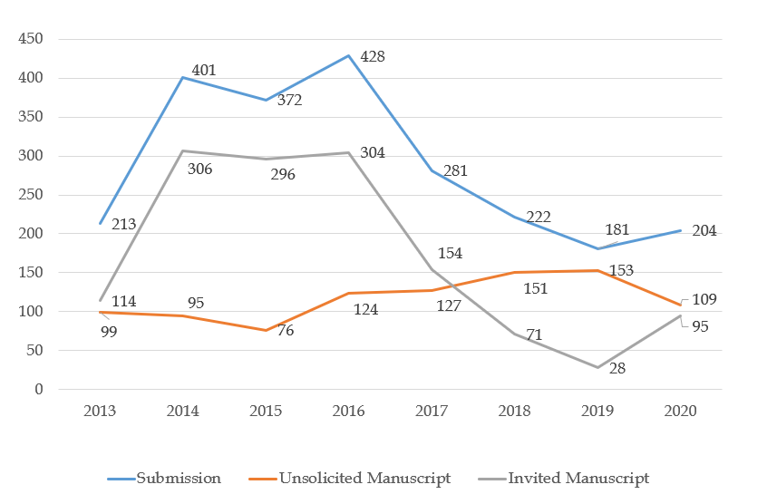 Figure 1 Annual submissions of World Journal of Hepatology from 2013 to 2020.

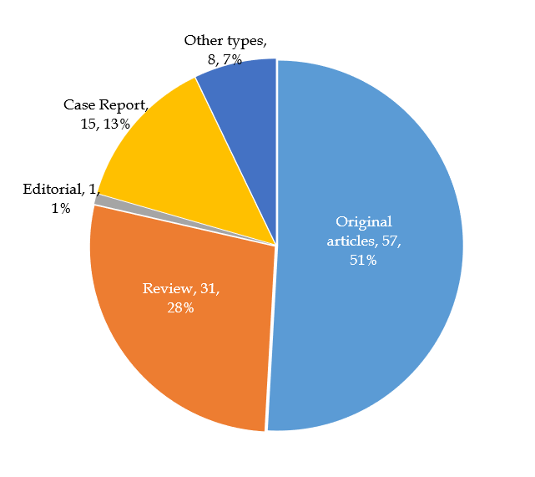 Figure 2 Article types among the 112 manuscripts published by World Journal of Hepatology in 2020.

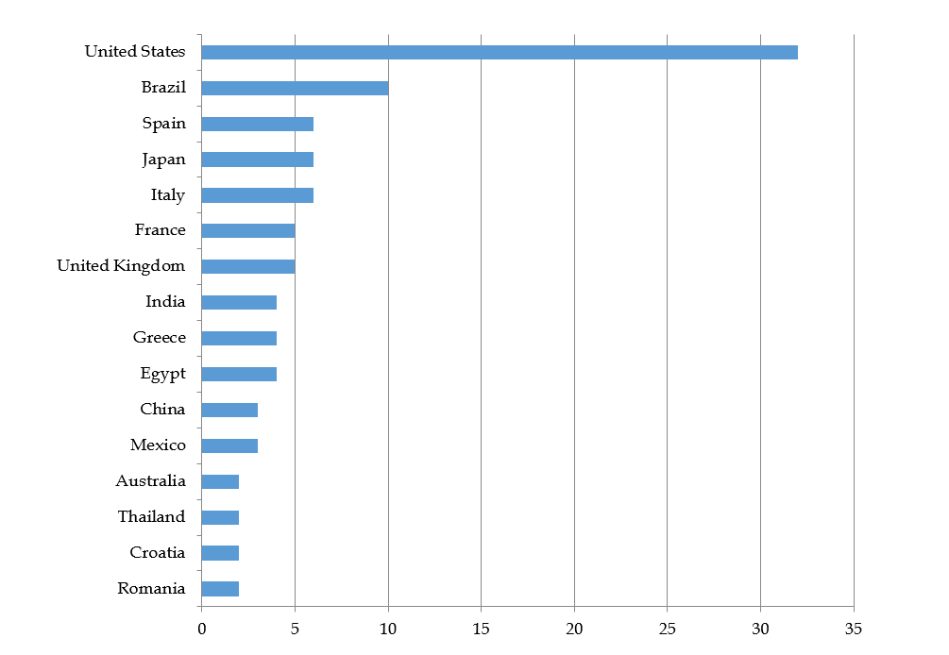 Figure 3 Top 16 countries by number of World Journal of Hepatology published manuscripts in 2020.

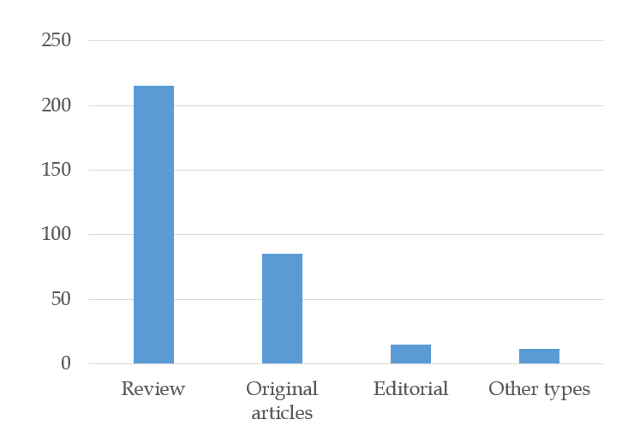 Figure 4 Article types of World Journal of Hepatology invited manuscripts for 2021.

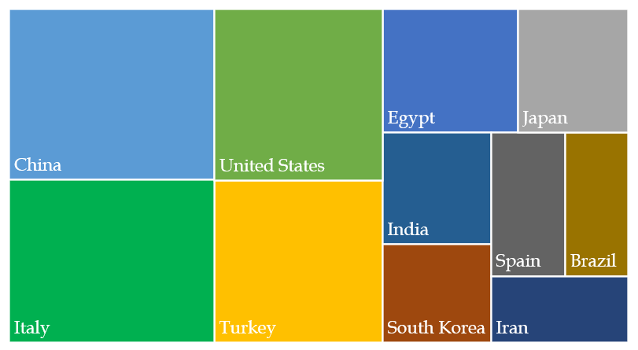 Figure 5 Countries of World Journal of Hepatology Editorial Board Members in 2020. Top 11 countries by the number of editorial members, where no less than five members are located in each country.

Published by Baishideng Publishing Group Inc
7041 Koll Center Parkway, Suite 160, Pleasanton, CA 94566, USA
Telephone: +1-925-3991568
E-mail: bpgoffice@wjgnet.com
Help Desk: https://www.f6publishing.com/helpdesk
https://www.wjgnet.com

© 2021 Baishideng Publishing Group Inc. All rights reserved.

