Name of Journal: World Journal of Pharmacology
Manuscript NO: 75116
Manuscript Type: MINIREVIEWS

Botanical, chemical, and pharmacological characteristics of Lomatogonium rotatum: A review

Dai LL et al. Botanical, chemical, and pharmacological characteristics of L. rotatum

Li-Li Dai, Rong-Gui Eni, Ming-Hai Fu, Gen-Na Ba

Li-Li Dai, Ming-Hai Fu, Gen-Na Ba, School of Mongolian Medicine, Inner Mongolia Minzu University, Tongliao 028000, Inner Mongolia Autonomous Region, China

Rong-Gui Eni, NMPA Key Laboratory of Quality Control of Traditional Chinese Medicine (Mongolian Medicine), Inner Mongolia Minzu University, Tongliao 028000, Inner Mongolia Autonomous Region, China

Author contributions: Dai LL and Eni RG performed the data collection and wrote the manuscript; Fu MH and Ba GN wrote and reviewed the manuscript.

Supported by National Natural Science Foundation of China, No. 81803845; Natural Science Foundation of Inner Mongolia Autonomous Region, No. 2018MS08040; Construction Project of "Inner Mongolia Autonomous Region Mongolian Medicine and Food Source Protection and Utilization Innovation Team", No. 190301; and Graduate Research Project of Inner Mongolia Minzu University, No. NMDBS1901.

Corresponding author: Gen-Na Ba, PhD, Professor, School of Mongolian Medicine, Inner Mongolia Minzu University, No. 996 Xilamulun Street, Horqin District, Tongliao 028000, Inner Mongolia Autonomous Region, China. bagenna@126.com

Received: January 18, 2022
Revised: February 19, 2022
Accepted: May 17, 2022
Published online: June 16, 2022

Abstract
Lomatogonium rotatum (L. rotatum) Fries ex Nym, a dry whole grass belonging to the family Gentianaceae, is widely used to treat liver diseases in Mongolian medicine. In Mongolian medicine, L. rotatum Fries ex Nym, also known as Digeda, is a rare medicinal herb with low yield and widespread clinical use. Currently, it is included in over 25 traditional Mongolian medicine prescriptions that help reduce heat, dispel xieri, enhance stomach function, and heal wounds. Recent studies have shown that L. rotatum Fries ex Nym contains a variety of metabolites, including flavonoids, xanthone compounds, terpenoids, organic acids, steroids, and alkaloids. In addition, its anti-hepatitis B, anti-inflammatory, anti-acute liver injury, and anti-obesity effects have been proven by pharmacological studies. In this review, we summarize the ecological resources, traditional pharmacodynamics, chemical constituents, and pharmacological actions of L. rotatum Fries ex Nym, with an aim to provide a theoretical basis for future applied research and new product development.

Key Words: Mongolian medicine; Lomatogonium rotatum; Chemical composition; Pharmacological action; Research progress

©The Author(s) 2022. Published by Baishideng Publishing Group Inc. All rights reserved.

Citation: Dai LL, Eni RG, Fu MH, Ba GN. Botanical, chemical, and pharmacological characteristics of Lomatogonium rotatum: A review. World J Pharmacol 2022; 11(2): 6-15
URL: https://www.wjgnet.com/2220-3192/full/v11/i2/6.htm
DOI: https://dx.doi.org/10.5497/wjp.v11.i2.6

Core Tip: As a highly distinctive Mongolian medicinal herb, Lomatogonium rotatum (L. rotatum) Fries ex Nym is traditionally used to prevent and treat liver and gallbladder diseases. However, its clinical application value and further development are limited by strict requirements on its growing environment, high demand for medicinal materials, decrease in wild resources, and insufficient scientific and technological availability in ethnic minority areas. Currently, a total of 38 compounds have been isolated and identified from L. rotatum Fries ex Nym, with flavonoids, xanthones, and terpenoids being the main metabolites. Pharmacological studies have mainly focused on hepatitis, liver injury, and weight loss, but mechanisms of pharmacological activity remain elusive and further comprehensive in vivo and in vivo experimental designs are needed to elucidate these issues.

INTRODUCTION
Lomatogonium rotatum (L. rotatum) Fries ex Nym is a dry whole grass belonging to the family Gentianaceae. L. rotatum Fries ex Nym, also known as Habirigen-Digeda or Temuri-Digeda, is a commonly used Mongolian medicine to treat liver diseases. In traditional Mongolian medicine, L. rotatum Fries ex Nym is believed to clear heat, remove xieri, strengthen the stomach, treat poisoning, and heal wounds. It is widely used to prevent and treat influenza and fever, hepatobiliary disease, typhoid fever, and jaundice. It also has a therapeutic effect on heatstroke symptoms^{[1,2]}. In addition, it is clinically effective in the prevention and treatment of liver and gallbladder diseases. Recent chemical and pharmacological studies have shown that L. rotatum Fries ex Nym contains organic compounds (xanthones), swertiamarin, oleanolic acid, luteolin, and other metabolites that play a role in enhancing the liver and biliary tract functions^{[3]}.

Morphology, resources, and breeding
Floral morphology of L. rotatum Fries ex Nym
L. rotatum Fries ex Nym is a 30- to 50-cm-high annual herb with an erect stem, four prisms, and a few branches. The leaves are sessile and opposite, and the leaf blades are narrowly lanceolate, 1.5 to 3 cm long, 0.4 to 0.6 cm wide, and apically acute, with a wider base. It has five calyces, deep, lanceolate lobes, and an equally long corolla. The corolla has five deeply lobed segments; the lobes are spheric and obtuse, with a toothed tube on each side of the base (Figure 1). The plant usually grows on hillsides and wetlands at an altitude of 2500 m. After picking the grass in the autumn flowering season, adherent soil and moisture are removed, and it is mashed or sun-dried before use.

Resources and geographical distribution of L. rotatum Fries ex Nym
L. rotatum Fries ex Nym for medicinal use primarily grows in the wild. However, the yield is low because of environmental factors and excessive mining, necessitating artificial breeding, which also has a low yield. A survey found wild L. rotatum Fries ex Nym in Xilingol League, Horqin, and Hulun Buir of the Inner Mongolia Autonomous Region, but observed a decreasing growth trend year on year^{[4]}. The shortage of L. rotatum Fries ex Nym has led to the use of Viola yedoensis Makino of the family Violaceae as a substitute medicine in most Mongolian hospitals. It is, therefore, crucial to immediately protect and direct increasing efforts toward improving resources required for growing L. rotatum Fries ex Nym. Currently, several challenges, such as the low germination rate of group embryos and the low success rate of inoculation, which affect the large-scale cultivation of L. rotatum Fries ex Nym, continue to persist in artificial cultivation and domestication of the plant^{[4]}. Li^{[4]} conducted a field investigation and found that the plant shows optimum growth during the dry season in February, with an average temperature of -13 to 18 °C and precipitation of 6-19 mm. The vegetation growth types include temperate grasses, mixed grasses meadow, halophytic meadow, temperate deciduous shrub, and broad-leaved forest^{[5]}. According to the literature, L. rotatum Fries ex Nym is widely distributed in Inner Mongolia, Gansu, Yunnan, Xinjiang, Qinghai, Tibet, Sichuan, and other regions^{[6]}, usually on grassy slopes of hillsides and shrublands below an altitude of 4200 m^{[7]}. Li^{[4]} pointed out that L. rotatum Fries ex Nym is scattered in shrublands, alpine meadows, grassland wetlands, flat meadow grasslands associated with rivers, and alpine and hillside meadows in Xilingol, Inner Mongolia, Heilongjiang, Hebei, and other regions^{[4]}.

Characteristics of breeding and pollen viability of L. rotatum Fries ex Nym
Li et al^{[7]} set up fixed points in the field to monitor the morphology and characteristics of L. rotatum Fries ex Nym organs, dynamics during flowering, and types of pollinators. A systematic inspection and measurement of its growth and reproduction were conducted by calculating pollen viability, pollinable characteristics such as stigma, estimation of pollen-to-ovule ratio, and hybridization index, and artificially controlled pollination^{[7]}. The results demonstrated that the flowering time of a single L. rotatum Fries ex Nym flower was 6-7 d and that the flowering time of a single plant could be classified into a common bud stage followed by the initial flowering, blooming, wilt, and litter periods. During this process, the open stigma was always higher than the anther, and the pollen vitality and stigma receptivity were relatively strong at 2-3 d after anthesis. In addition, the researchers also observed that the breeding system was mainly outcrossing, and some were self-compatible, which may require insect thrips as the primary pollinators. In the case of bagging without pollination after emasculation, the seed setting rate of the fruit was 0, indicating a lack of fusion reproduction^{[8]}. Zhu et al^{[9]} investigated the effects of different storage times and temperatures and the use of gibberellin reagents in promoting the flowering and growth rates of L. rotatum Fries ex Nym seeds. They found that changes in outdoor temperature and gibberellin immersion significantly promoted the germination and flowering of L. rotatum Fries ex Nym seeds^{[9]}.
Similarly, Li et al^{[10]} intervened in the L. rotatum Fries ex Nym germination rate by adopting different temperatures and germination sites. They found that the highest germination index was on sand, under which condition the rot rate of the seeds was the lowest. Furthermore, the germination rate was highest at 40 °C. Therefore, the optimal conditions for L. rotatum Fries ex Nym seed germination may be the temperature of 40 °C and planting on sand^{[10]}.

Traditional applications
L. rotatum Fries ex Nym is a typical medicinal plant used for internal applications to prevent and treat various liver and gallbladder diseases. In 1998, it was recorded in the Drug Standard (Mongolian Medicine Volume) of the Ministry of Health. The plant helps degrade xieri and clears heat. In Mongolian medicinal prescriptions, L. rotatum Fries ex Nym is either combined with Herpetospermum caudigerum Wall and Ixeris Chinensis (Thunb.) Nakai to formulate a Lidan powder containing 28 medicinal herbs, or it is used alone to degrade the xieri heat of the gallbladder. In addition, it is used as a prescription combination of Digeda-15, Digeda-20, and Digeda-25 to treat common clinical diseases such as liver and gallbladder heat, redness, yellow appearance of the eye and skin, gallbladder stasis, and stasis of xieri, which may lead to organ injury^{[11]}. In addition, Digeda-4, a combination of L. rotatum Fries ex Nym and Coptidis rhizoma, Gardenia jasminoides Ellis, and Dianthus superbus L., is used to reduce problems such as inflammation, sore throat, liver and gallbladder heat, blood heat, thirst, and irritability^{[2]}. Furthermore, L. rotatum Fries ex Nym is used as an adjuvant, subordinate, or auxiliary medicine in several compound preparations. There are a total of 24 Mongolian medicine prescriptions that include L. rotatum Fries ex Nym, including three where L. rotatum Fries ex Nym is used as a monarch medicine, four where L. rotatum Fries ex Nym is used as a minister medicine, 16 as assistant medicines, and one as a guide medicine.

Chemical composition
Research on the pharmacodynamic substances and chemical components of L. rotatum Fries ex Nym is still in the initial stages. To date, 38 compounds have been isolated and identified, mainly including flavonoids and xanthones, with a small number of iridoids, alkaloids, steroids, organic acids, amongst others.

Flavonoids
Flavonoids are abundant in most herbaceous plants, especially in higher plants, and possess a plethora of biological activities. According to the literature, L. rotatum Fries ex Nym contains about 16 flavonoids, including luteolin^{[12]}, apigenin, 5,7,3',4',5'-pentahydroxy flavonoids, quercetin, kaempferol, luteolin-7-O-glucoside, apigenin-7-O-glucoside^{[13]}, swertisin^{[14]}, swertianolin^{[15]}, isoorientin, mangiferin, isovitexin^{[16]}, carinoside A^{[17]}, carinoside B, carinoside C, and carinoside D^{[18]} (Table 1 and Figure 2).

Xanthones
Ten xanthone compounds have been identified in L. rotatum Fries ex Nym: 6,8-dihydroxy-1,2-dimethoxy xanthone^{[19]}, 1,8-dihydroxy-3,4,5-trimethoxyxanthone, 1-hydroxy-3,7,8-trimethoxy xanthone, 8-hydroxy-1,3,5-trimethyl xanthone, 1-hydroxy-3,5,8-trimethoxy xanthone^{[13]}, 1,8-dihydroxy-4,5-dimethoxy-6,7-methylenedioxy xanthone, 5-O-D-gluco-pyranosyl-1,3,8-trihydroxy-5,6,7,8-tetrahydroxanthone, 1,3,5,8-tetrahydroxy-5,6,7,8-tetrah-ydroxanthone^{[20]}, 1,2,6-trihydroxyl xanthone-8-O-β-D-glucoside, and 1,4,8-trimethoxyxanthone--6-O-β-D-glucoronyl-(1→6)O-β-D-glucoside^{[21]} (Table 1 and Figure 2).

Terpenoids
Terpenoids are a class of compounds derived from methylcarboxylic acid with ≥ 2 isoprene units in the basic carbon frame. According to the literature, three iridoids (i.e., swertiamarin^{[22-25]}, ursolic acid 3β-hydroxy-ursol-11,12-ene-28,13β-lactone^{[14]}, and amarogentin^{[16,26]}), as well as two pentacyclic triterpenes, oleanolic acid^{[20]}, 2a-hydroxyoleanolic acid^{[13]}, lomacarinoside A, and lomacarinoside B^{[27]} are present in L. rotatum Fries ex Nym (Table 1 and Figure 2).

Other compounds
L. rotatum Fries ex Nym also contains organic acids, steroids^{[14]}, alkaloids^{[28,29]}, and other compounds (erythrocentaurin), in addition to the above-mentioned metabolites^{[13]}. However, current research on this aspect is inadequate, warranting further studies (Table 1 and Figure 2).

Study on extraction process of L. rotatum Fries ex Nym
Chen et al^{[30]} investigated the primary factors affecting total flavonoid extraction in L. rotatum Fries ex Nym using single-factor experiments. They then optimized the extraction method for the total flavonoids in L. rotatum Fries ex Nym by an orthogonal test using the rutin concentration as the standard and formulated the optimal extraction process for the total flavonoids. The results demonstrated that the optimal parameters for total flavonoid extraction from L. rotatum Fries ex Nym were: Ethanol concentration, 60%; solvent volume, 150 mL; extraction time, 8 h; total flavonoid extraction rate from L. rotatum Fries ex Nym, about 3.47%.
In addition, single-factor experiments were conducted to explore the effects of the ethanol percentage and volume used for extraction, the ultrasonic extraction time, and the liquid-to-sample ratio on the total saponin concentration extracted from L. rotatum Fries ex Nym. Response surface methodology was used to optimize the experimental conditions for ultrasonic extraction of L. rotatum Fries ex Nym, resulting in a gradual increase in the total saponin extraction yield. The experimental results demonstrated that the optimal experimental conditions for the extraction of total saponins from L. rotatum Fries ex Nym were as follows: Average volume content fraction of ethanol, 77%; average liquid-to-solid ratio, 40 mL/g; ultrasound duration, 33 min. Under these conditions, the researchers found that the average total saponin concentration extracted from L. rotatum Fries ex Nym was 27.36 mg/g, which was close to the theoretically predicted value^{[31]}. However, the optimization of the extraction process, using 65% ethanol, a solid-to-liquid ratio of 20 mL/g, and an extraction time of 20 min, defined by Liu et al^{[32]}’s study, is considered the best method^{[32]}.

Fingerprint and mineral elements of L. rotatum Fries ex Nym
Sun et al^{[33]} used high-performance liquid chromatography to determine the fingerprint of L. rotatum Fries ex Nym plants from 15 different places and cultivation areas. The results showed 15 common peaks, of which the five most common were swertiamarin, isoorientin, swertisin, apigenin, and luteolin. In addition, Yuan et al^{[34]} measured the mineral elements in two Lomatogonium species using inductively coupled plasma-optical emission spectrometry, finding 21 mineral elements in Lomatogonium macranthum and 18 elements in Lomatogonium carinthiacum. Both Lomatogonium species had relatively high Ca, Mg, and Fe contents while the greatest difference was seen in the Co concentrations and the least difference was found in the Ti contents^{[34]}.

pharmacological action of L. rotatum Fries ex Nym
Effects of L. rotatum Fries ex Nym powder on hepatitis B
Bai et al^{[35]} investigated the anti-hepatitis B effect of L. rotatum Fries ex Nym powder and found that L. rotatum Fries ex Nym had a relatively low cytotoxicity to HepG2 cells, with some inhibitory effect on the number of hepatitis B virus (HBV) DNA copies in the cells. In addition, in vitro experiments showed that L. rotatum Fries ex Nym is able to counteract HBV to some degree. This may be because L. rotatum Fries ex Nym acts against HBV by directly inducing apoptosis, thereby blocking HBV replication in HepG 2 cells.

Anti-inflammatory effects of L. rotatum Fries ex Nym
Ethyl acetate has been found to be the active component responsible for the anti-inflammatory effect of L. rotatum Fries ex Nym, which has significant antibacterial activity against both Gram-positive and -negative bacteria such as Escherichia coli, Staphylococcus alba, drug-resistant Staphylococcus aureus, S. aureus, and Pseudomonas aeruginosa^{[36]}. L. rotatum Fries ex Nym also contains several anti-inflammatory compounds, including sweroside, swertiamarin, and luteolin. Chen et al^{[37]} reported that swertiamarin had anti-inflammatory, antioxidant, and anti-fibrotic effects in rats with smoking-exposed prostate dysfunction^{[37]}. Aziz et al^{[38]} also reported that luteolin had strong anti-inflammatory effects in both in vivo and in vitro experiments^{[38]}.

Anti-acute liver injury effect
L. rotatum Fries ex Nym extracts with different polarities were reported to have pharmacological effects on acute liver injury^{[39]}. In a drug interaction study of L. rotatum Fries ex Nym prescription medication, an L. rotatum Fries ex Nym water extract was found to significantly protect liver function in rats with carbon tetrachloride (CCl₄)-induced liver astrocyte damage^{[40]}. In a further study, the urine of rats with liver injury was analyzed after L. rotatum Fries ex Nym administration, showing 19 common peaks, one of which was the drug itself, 14 were metabolites passed through the body, and the rest were endogenous components of urine^{[41]}. In addition, the study found that the Digeda-4 decoction had a protective action in mice with pyloric ligation-induced liver injury. It has been suggested that L. rotatum Fries ex Nym may affect the protein expression of MRP3 and MRP4 by regulating the nuclear receptors CAR and PXR, resulting in liver protection^{[42]}. An experimental metabolomics study found that L. rotatum Fries ex Nym administration restored several disturbed metabolic pathways, including those involving linoleic acid and glycerolipid metabolism. The use of another eight metabolites as potential biomarkers was proposed to help clarify the liver protective mechanism of L. rotatum Fries ex Nym^{[43]}. Zhao et al^{[44]} also proposed that the liver protective activity of L. rotatum Fries ex Nym may be related to metabolites in rat plasma and liver^{[44]}.

Anti-obesity effect
Bao et al^{[45]} investigated the effect of L. rotatum Fries ex Nym on weight loss based on the function of bitter receptors in rats with obesity induced by a high-fat and high-energy diet. The L. rotatum Fries ex Nym extract significantly reduced body weight, Lee’s index, epididymal fat, perirenal fat, and mesenteric fat deposition in the rats. It also reduced serum triglyceride and total cholesterol levels to a certain extent, indicating its potential for lipid-lowering, cholesterol-lowering, and weight-loss effects. Chemical analysis demonstrated that flavonoids, glycosides, and alkaloids were the primary components of L. rotatum Fries ex Nym, and the main source of bitterness was base substances. The effects of L. rotatum Fries ex Nym on fat metabolism and its bitter receptor activation mechanism require further investigation^{[46]}.

CONCLUSION
As a highly distinctive Mongolian medicinal herb, L. rotatum Fries ex Nym is traditionally used to prevent and treat liver and gallbladder diseases. However, its clinical application value and further development are limited by the strict requirements of its growing conditions, high demand for medicinal materials, decrease in natural resources, and insufficient scientific and technological expertise in ethnic minority areas. To date, a total of 38 compounds have been isolated and identified from L. rotatum Fries ex Nym, with flavonoids, xanthones, and terpenoids being the main metabolites. While pharmacological studies on L. rotatum Fries ex Nym have mainly focused on hepatitis, liver injury, and weight loss, the mechanisms of its pharmacological activity remain elusive and further comprehensive in vivo and in vivo experimental studies are necessary. Thus, our study may provide a foundation for further research on L. rotatum Fries ex Nym and its clinical applications.

REFERENCES
1 Health Department of Inner Mongolia Autonomous Region. Inner Mongolia Mongolian medicinal materials standard. Chifeng: Inner Mongolia Science and Technology Press; 1987: 162-163
2 Pharmacopoeia Committee, Ministry of Health, PRC. Drug standard of the Ministry of Health of the People's Republic of China•Mongolian Part. China; 1998: 91
3 Bai MR, Gao YF, BA GN. Study on Lomatogonium rotatum powder and its anti-hepatitis B virus in vitro. Zhongyaocai 2010; 33: 789-791 [DOI: 10.13863/j.issn1001-4454.2010.05.045]
4 Li ZH. The Ecology Suitability and Wildlife Tending Studies of Lomatogonium rotatum (L.) Fries ex Nym. Neimenggu Minzu Daxue 2015; 3
5 Chen SL, Wei JH, Sun CZ, Liu ZQ, Zhao RH, Wang JY, Zhou YQ, Xiao XH. The development of geographic information system and the study on the suitability of origin of astragalus mongolicus. Shijie Kexue Jishu-Zhongyiyao Xiandaihua 2006; 3: 47-53
6 Sun CZ, Liu ZQ, Chen SL, Wei JH, Zhao RH, Wang JY, Zhou YQ. Design and implementation of a GIS-based suitability analysis system for Chinese medicinal materials. Shijie Kexue Jishu-Zhongyiyao Xiandaihua 2006; 3: 112－117
7 Li XX, Ba GN, Yang HS, Sun DZ, Bao JH. Comparison on Pollen Germination and Viability Determination Method of Lomatogonium rotatum. Anhui Nongye Kexue Xuebao 2017; 45: 127-129
8 Li XX, Ba GN, Yang HS, Zhang SJ. Studies on Flowering Dynamics and Breeding System of Mongolian Medicine Lomatogonium rotatum. Yuanyi Xuebao 2018; 45: 1393-1401 [DOI: 10.16420/j.issn.0513-353x.2018-0168]
9 Zhu Hong, Zhang CH, Wei KH, Zhang L, Li WH, Zhou LS. Study on Influencing Factor of Lomatogonium rotatum Seed Germination. Xiandai Zhongyiyao 2015; 17: 232-235
10 Li XX, Yang HS, Ba GN, Bao JH, Sun DZ. Seed Germination Condition of Mongolia Medicine Plant Lomatogonium rotatum. Nongye Xuebao 2017; 7: 48-51
11 Luo BS. Mongolian pharmacy. Beijing: Ethnic Publishing House; 1989: 149-151
12 Wang XM, Ba GN, Bai MG. Determination of luteolin in Lomatogonium rotatum by HPLC. Zhonghua Minzu Yixue Zazhi 2009; 38-39
13 Jia LY, Yuan JZ, Sun QS. Isolation and identification of chemical constituents of flower of Lomatogonium rotatum(L.)Fries ex Nym(2). Shenyang Yiyao Daxue Xuebao 2011; 28: 260-263
14 Wang ZW, Long P, Zhang CH, Wu GD, Zhang N, Li MH. HPLC Determination of Swertiamain and Swertisin in Herba Lomalogonium rotatum by HPLC. Zhonghua Shiyan Fangji Zazhi 2013; 19: 106-108 [DOI: 10.11653/syfj2013100106]
15 Zhang ZH, Zeng QY, Lin PC, Zhao Y. Content Analysis of Three Constituents in Tibetan Herb Lomatogonium rotatum (L.) Fries es Nym by RP－HPLC. Hubei Nongye Kexue 2015: 54: 687-689 [DOI: 10.14088/j.cnki.issn0439-8114.2015.03.047]
16 Li YL, Suo YR, Liao ZX, Ding LS. The glycosides from Lomatogonium rotatum. Nat Prod Res 2008; 22: 198-202 [PMID: 18266146 DOI: 10.1080/14786410500462603]
17 Bao B, Wang Q, Wu X, Tai W. The isolation and structural elucidation of three new biflavonoid glycosides from Lomatogonium carinthiacum. Nat Prod Res 2015; 29: 1358-1362 [PMID: 25812750 DOI: 10.1080/14786419.2015.1025399]
18 Wang Q, Han N, Wu X, Tai W, Dai N, Wu R, Wu J, Bao B. A biflavonoid glycoside from Lomatogonium carinthiacum (Wulf) Reichb. Nat Prod Res 2015; 29: 77-81 [PMID: 25260189 DOI: 10.1080/14786419.2014.959009]
19 Bao L, Hu L, Zhang Y, Wang YI. Hypolipidemic effects of flavonoids extracted from Lomatogonium rotatum. Exp Ther Med 2016; 11: 1417-1424 [PMID: 27073459 DOI: 10.3892/etm.2016.3038]
20 Jia LY, Li Q, Yuan JZ, Sun QS. Isolation and identification of chemical constituents of whole plant of Lomatogonium rotatum(L.)Fries ex Nym. Shenyang Yiyao Daxue Xuebao 2010; 29: 704-706
21 Wang Q, Bao B, Chen Y. Structure elucidation and NMR assignments of two unusual xanthones from Lomatogonium carinthiacum (Wulf) Reichb. Magn Reson Chem 2014; 52: 37-39 [PMID: 24347400 DOI: 10.1002/mrc.4024]
22 Chen YL. Study of the Chemical Contituents of a Lomatogonium rotatum Turez. Neimenggu Minzu Daxue 2014; 6
23 Wang XM, Ba GN, Bai MG. Determination of Swertiamain Content in Herba Lomatogonii by HPLC. Neimenggu Minzu Daxue 2007; 22: 320-322
24 Bao TLG. Contents Determination of Swertiamarin from Lomatogonium Rotatum of Different Origins by HPLC. Liaoning Zhongyi Zazhi 2013; 40: 2558-255 [DOI: 10.13192/j.issn.1000-1719.2013.12.066]
25 Song P, Wu QX, Yu XR. HPLC simultaneous determination of swertiamarin in Lomatogonium rotatum (L.) Fries ex Fern. Yaowu Fenxi Zazhi 2009; 29: 1013-1015
26 Ba GN, Bao ML, Wang XM, Wu YG, Ao WLJ, Wang XL. Study on Quality Standard of Mongolian Medicine Lomatogonium rotatum. Zhongguo Minzu Yiyao Zazhi 2018; 24: 40-42 [DOI: 10.16041/j.cnki.cn15-1175.2018.04.026]
27 Wang QH, Dai NYT, Han NRCGT. The structural elucidation and antimicrobial activities of two new monoterpene gluco-side derivatives from Lomatogonium carinthiacum (Wulf) Reichb. Magn Reson Chem 2014; 52: 511-514 [DOI: 10.1002/mrc.4095]
28 Yu QF, Lin PC. Determination of Amarogerth in Lomatogonium Rotatum by RP-HPLC. Anhui Nongye Kexue 2007; 35: 967-968
29 Xi HS, Xu L, Wang ZM, Na RH. Determination of Content of Berberine Hydrochloride in the Mongolian Medicine Leizhuhua by RP-HPLC. Guangpu Shiyanshi 2008; 25: 1281-1283
30 Chen YL, Ye RG, Tong YF, Ba DRH, Ba GN. Study on the extraction technology of total flavonoids from Lomatogonium rotatum(L.)Fries ex Nym. Shizhen Guoyi Guoyao 2014; 25: 1544-1546 [DOI: 10.3969/j.issn.1008-0805.2014.07.003]
31 Li HJ, Liu T, Sun xj, Fan P, Li X. Optimization of Ultrasonic－Assisted Extraction of Total Saponins from Lomatogonium Rotatum by Response Surface Method*. Zhongguo Yaoye 2018; 27: 26-30 [DOI: 10.3969/j.issn.1006-4931.2018.02.007]
32 Liu T, Gao YH, Ge CJ, Yan CH, Liang YQ, Li X. Optimization of ultrasonic-assisted extraction of total flavonoids from Lomatogonium rotatum by response surface analysis*. Beijingdaxue Xuebao 2016; 39: 502-507
33 Sun XJ, Xi LTY, Na SS, Li HJ, Li Y, Xiang CL, Li X. HPLC fingerprint of Lomatogonium rotatum. Zhongcaoyao 2019; 50: 1703-1707 [DOI: 10.7501/j.issn.0253-2670.2019.07.031]
34 Yuan YY, Sun J, Wang YH, Zhou YB, Ye RR, Deng J, Peng M, Lu XF. Measurement of 21 mineral elements in two Lomatogonium by ICP-OES. Gansu Nongye Daxue Xuebao 2016; 51: 79-83 [DOI: 10.13432/j.cnki.jgsau.2016.02.014]
35 Bai MR, Gao YF, Ba GN. In vitro study on anti - hepatitis b virus of Lomatogonium rotatum powder. Zhongyaocai 2010; 33: 789-791
36 Sun JJ, Dong Y, Yu DS, Hu Y. Studies on antibacterial effective fraction of Lomatogonium rotatum. Neimenggu Yike Daxue Xuebao 2014; 36: 452-454 [DOI: 10.16343/j.cnki.issn.2095-512x.2014.05.004]
37 Chen J, Liu J, Lei Y, Liu M. The anti-inflammation, anti-oxidative and anti-fibrosis properties of swertiamarin in cigarette smoke exposure-induced prostate dysfunction in rats. Aging (Albany NY) 2019; 11: 10409-10421 [PMID: 31739286 DOI: 10.18632/aging.102467]
38 Aziz N, Kim MY, Cho JY. Anti-inflammatory effects of luteolin: A review of in vitro, in vivo, and in silico studies. J Ethnopharmacol 2018; 225: 342-358 [PMID: 29801717 DOI: 10.1016/j.jep.2018.05.019]
39 He NL. Lomatogonium different extracts of pharmacological effects of anti acute liver injury research. Neimenggu Minzu Daxue 2016
40 Bao ML, Su RGLT, Aa LS, Yu H, Wang H. Mongolian medicine lomatogonium rotatum antibody-induced CCl4 Study on the injury of rat hepatic stellate cells. Zhongguo Minzu Minjian Yiyao 2019; 25: 42-45
41 Tong YF, Ba GN, Bai MR, Bao ML, Ye RG, La XNMJL. Chemical composition analysis of Herba Lomatognii in the urine from ratmodel of D－GlaN induced acute liver injury by LC－MS. Zhongguo Minzu Yixueyuminzuyixue Zazhi 2015; 12-16
42 Wang H, Hong M, Tu L, Bai MR, Bao ML, Ba GN. Effect and Mechanism of “Digda － 4 Decoction”in Acute Liver Injury Induced by Pylorus Ligation. Zhongguo Zhongyi Dangan 2017; 35: 29-32
43 Chen R, Wang Q, Zhao L, Yang S, Li Z, Feng Y, Chen J, Ong CN, Zhang H. Lomatogonium Rotatum for Treatment of Acute Liver Injury in Mice: A Metabolomics Study. Metabolites 2019; 9 [PMID: 31615066 DOI: 10.3390/metabo9100227]
44 Zhao L, Ouyang H, Wang Q, Fan D, Wang Y, Yang S, Li Z, Pan L, Feng Y. Chemical fingerprint analysis and metabolic profiling of 50% ethanol fraction of Lomatogonium rotatum by ultra-performance liquid chromatography/quadrupole-time of flight mass spectrometry. Biomed Chromatogr 2019; 33: e4651 [PMID: 31313844 DOI: 10.1002/bmc.4651]
45 Bao TRGL. The study of anti-obesity effect of bitter Mongolian Medicine Digeda on high-fat high-energy diets induced obese rats. Neimenggu Minzu Daxue 2019
46 Wu QZ, Bao BTE, Bai HH. Research Development of Traditional Mongolian Medicine Herba lomatognii. Shizhen Guoyi Guoyao 2004; 15: 366-367

Footnotes
Conflict-of-interest statement: All the authors report no relevant conflicts of interest for this article.

Open-Access: This article is an open-access article that was selected by an in-house editor and fully peer-reviewed by external reviewers. It is distributed in accordance with the Creative Commons Attribution NonCommercial (CC BY-NC 4.0) license, which permits others to distribute, remix, adapt, build upon this work non-commercially, and license their derivative works on different terms, provided the original work is properly cited and the use is non-commercial. See: https://creativecommons.org/Licenses/by-nc/4.0/

Provenance and peer review: Unsolicited article; Externally peer reviewed.

Peer-review model: Single blind

Peer-review started: January 18, 2022
First decision: February 8, 2022
Article in press: May 17, 2022

Specialty type: Pharmacology and pharmacy
Country/Territory of origin: China
Peer-review report’s scientific quality classification
Grade A (Excellent): 0
Grade B (Very good): B, B
Grade C (Good): 0
Grade D (Fair): 0
Grade E (Poor): 0

P-Reviewer: Khidhir ZK, Iraq; Ortiz LT, Spain A-Editor: Liu X, China S-Editor: Fan JR L-Editor: Wang TQ P-Editor: Chen YX

Figure Legends
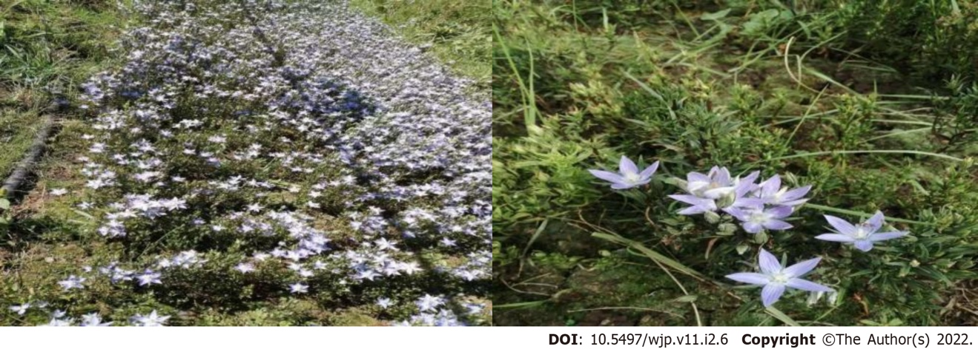
Figure 1 The whole plant of Lomatogonium rotatum.

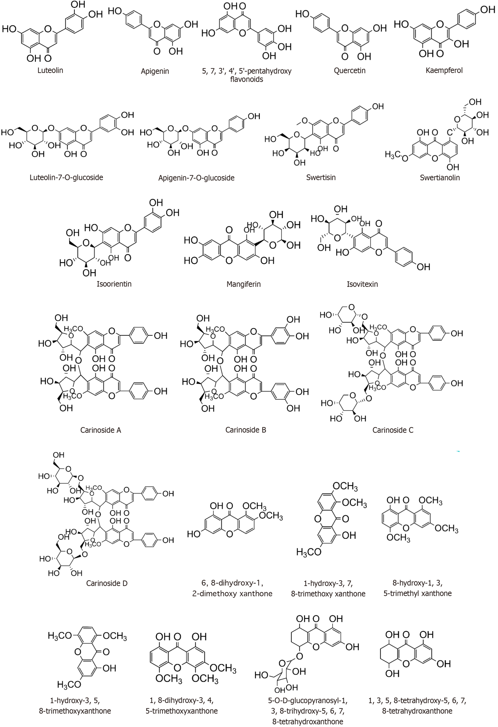
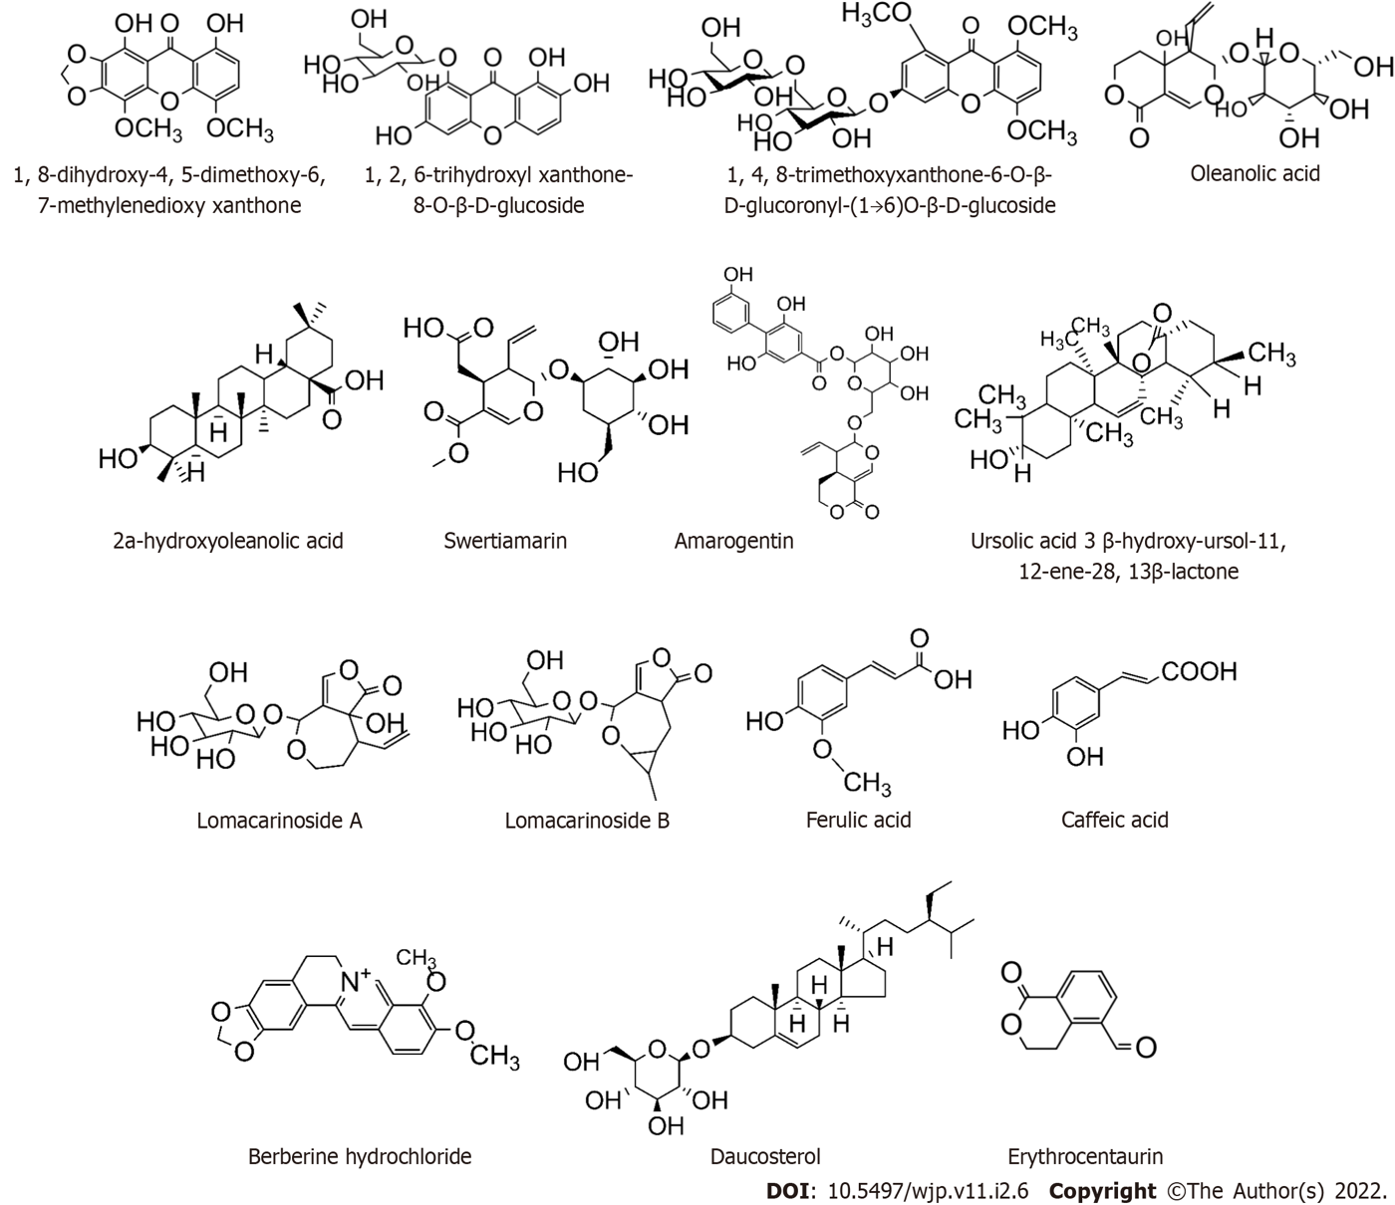

Figure 2 Structure of compounds 1-38 from Lomatogonium rotatum.
Table 1 Chemical composition of Lomatogonium rotatum
No. | Compound | Ref.
Flavonoids
1 | Luteolin | ^{[12]}
2 | Apigenin | ^{[13]}
3 | 5,7,3’,4’,5’-pentahydroxy flavonoids | ^{[13]}
4 | Quercetin | ^{[13]}
5 | Kaempferol | ^{[13]}
6 | Luteolin-7-O-glucoside | ^{[13]}
7 | Apigenin-7-O-glucoside | ^{[13]}
8 | Swertisin | ^{[14]}
9 | Swertianolin | ^{[15]}
10 | Isoorientin | ^{[16]}
11 | Mangiferin | ^{[16]}
12 | Isovitexin | ^{[16]}
13 | Carinoside A | ^{[17]}
14 | Carinoside B | ^{[18]}
15 | Carinoside C | ^{[18]}
16 | Carinoside D | ^{[18]}
Xanthones
17 | 6, 8-dihydroxy-1, 2-dimethoxy xanthone | ^{[19]}
18 | 1-hydroxy-3,7, 8-trimethoxy xanthone | ^{[13]}
19 | 8-hydroxy-1,3, 5-trimethyl xanthone | ^{[13]}
20 | 1-hydroxy-3,5, 8-trimethoxy xanthone | ^{[13]}
21 | 1, 8-dihydroxy-3, 4, 5-trimethoxyxanthone | ^{[13]}
22 | 5-O-D-glucopyranosyl-1,3,8-trihydroxy-5,6,7,8-tetrahydroxanthone | ^{[20]}
23 | 1,3,5,8-tetrahydroxy-5,6,7,8-tetrah-ydroxanthone | ^{[20]}
24 | 1, 8-dihydroxy-4, 5-dimethoxy-6, 7-methylene dioxy xanthone | ^{[20]}
25 | 1,2, 6-trihydroxyl xanthone-8-O–β-D-glucoside | ^{[21]}
26 | 1,4,8-trimethoxyxanthone-6-O–β-D-glucoronyl-(1→6)O-β-D-glucoside | ^{[21]}
Terpenoids
27 | Oleanolic acid | ^{[20]}
28 | 2a-hydroxyoleanolic acid | ^{[13]}
29 | Swertiamarin | ^{[22-25]}
30 | Amarogentin | ^{[16,26]}
31 | Ursolic acid 3 β-hydroxy-ursol-11, 12-ene-28, 13β-lactone | ^{[14]}
32 | Lomacarinoside A | ^{[27]}
33 | Lomacarinoside B | ^{[27]}
Organic acids
34 | Ferulic acid | ^{[12]}
35 | Caffeic acid | ^{[29]}
Alkaloids
36 | Berberine hydrochloride | ^{[28]}
Steroid
37 | Daucosterol | ^{[14]}
Other
38 | Erythrocentaurin | ^{[13]}

Published by Baishideng Publishing Group Inc
7041 Koll Center Parkway, Suite 160, Pleasanton, CA 94566, USA
Telephone: +19253991568
Email: bpgoffice@wjgnet.com
Help Desk: https://www.f6publishing.com/helpdesk
https://www.wjgnet.com

© 2022 Baishideng Publishing Group Inc. All rights reserved.

