Name of Journal: World Journal of Gastrointestinal Oncology
Manuscript NO: 72612
Manuscript Type: CORRECTION

Correction to “Novel long non-coding RNA LINC02532 promotes gastric cancer cell proliferation, migration, and invasion in vitro”

Zhang C et al. Correction to “The oncogenic role of LINC02532 in GC”

Cheng Zhang, Ming-Hui Ma, Yu Liang, Kun-Zhe Wu, Dong-Qiu Dai

Cheng Zhang, Ming-Hui Ma, Yu Liang, Dong-Qiu Dai, Department of Gastrointestinal Surgery, The Fourth Affiliated Hospital of China Medical University, Shenyang 110032, Liaoning Province, China

Kun-Zhe Wu, Scientific Research Center, China-Japan Union Hospital of Jilin University, Changchun 130000, Jilin province, China

Author contributions: Dai DQ contributed to this correction; all authors have read and approve the final manuscript.

Corresponding author: Dong-Qiu Dai, PhD, Chief Doctor, Department of Gastrointestinal Surgery, The Fourth Affiliated Hospital of China Medical University, No. 4 Chongshan Road, Shenyang 110032, Liaoning Province, China. daidq63@163.com

Received: October 21, 2021
Revised: April 21, 2022
Accepted: June 4, 2022
Published online: July 15, 2022

Abstract
We have replaced the misapplied images and the revised Figure 3 is provided.

Key Words: Correction; Gastric cancer; LINC02532; Prognosis; Bioinformatics

©The Author(s) 2022. Published by Baishideng Publishing Group Inc. All rights reserved.

Citation: Zhang C, Ma MH, Liang Y, Wu KZ, Dai DQ. Correction to “Novel long non-coding RNA LINC02532 promotes gastric cancer cell proliferation, migration, and invasion in vitro”. World J Gastrointest Oncol 2022; 14(7): 1372-1374
URL: https://www.wjgnet.com/1948-5204/full/v14/i7/1372.htm
DOI: https://dx.doi.org/10.4251/wjgo.v14.i7.1372

Core Tip: This is a correction to “Novel long non-coding RNA LINC02532 promotes gastric cancer cell proliferation, migration, and invasion in vitro”. We found that the result of Si-LINC02532 #2 group in the MGC-803 cell invasion assay was displayed by a mistake in Figure 3A. The revised Figure 3 was uploaded.

TO THE EDITOR
We recently read our manuscript^{[1]} published in the World Journal of Gastrointestinal Oncology (manuscript No. 43472, DOI: 10.4251/wjgo.v11.i2.91), and we found that the result of Si-LINC02532 #2 group in the MGC-803 cell invasion assay was displayed by a mistake in Figure 3A. Therefore, we are writing to apply for the modification of Figure 3A. The revised Figure 3 was uploaded in the attachment (Figure 1). This mistake has no influence on the interpretation of the results or conclusion in this study.

REFERENCES
1 Zhang C, Ma MH, Liang Y, Wu KZ, Dai DQ. Novel long non-coding RNA LINC02532 promotes gastric cancer cell proliferation, migration, and invasion in vitro. World J Gastrointest Oncol 2019; 11: 91-101 [PMID: 30788037 DOI: 10.4251/wjgo.v11.i2.91]

Footnotes
Conflict-of-interest statement: All the authors report no relevant conflicts of interest for this article.

Open-Access: This article is an open-access article that was selected by an in-house editor and fully peer-reviewed by external reviewers. It is distributed in accordance with the Creative Commons Attribution NonCommercial (CC BY-NC 4.0) license, which permits others to distribute, remix, adapt, build upon this work non-commercially, and license their derivative works on different terms, provided the original work is properly cited and the use is non-commercial. See: https://creativecommons.org/Licenses/by-nc/4.0/

Provenance and peer review: Unsolicited article; Externally peer reviewed.
Peer-review model: Single blind

Peer-review started: October 21, 2021
First decision: April 17, 2022
Article in press: June 4, 2022

Specialty type: Oncology
Country/Territory of origin: China
Peer-review report’s scientific quality classification
Grade A (Excellent): A
Grade B (Very good): B
Grade C (Good): C, C
Grade D (Fair): 0
Grade E (Poor): 0

P-Reviewer: Chiba T, Japan; Morozov S, Russia; Preda SD, Romania; Ribeiro IB, Brazil A-Editor: Liu X, China S-Editor: Gao CC L-Editor: A P-Editor: Gao CC

Figure Legends
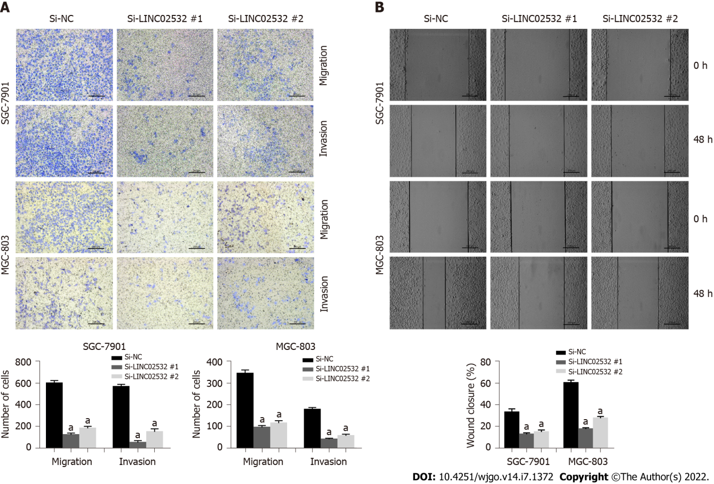
Figure 1 Transwell assays with or without Matrigel were performed to assess the capacity of cell invasion and migration, respectively. A: Transwell assays with or without Matrigel were performed to assess the capacity of cell invasion and migration, respectively. The results revealed that LINC02532 knockdown promoted gastric cancer cell migration and invasion; B: The wound healing assay further displayed that LINC02532 knockdown promoted gastric cancer cell migration. ªP < 0.05 was considered statistically significant.

Published by Baishideng Publishing Group Inc
7041 Koll Center Parkway, Suite 160, Pleasanton, CA 94566, USA
Telephone: +1-925-3991568
E-mail: bpgoffice@wjgnet.com
Help Desk: https://www.f6publishing.com/helpdesk
https://www.wjgnet.com

© 2022 Baishideng Publishing Group Inc. All rights reserved.

