Name of Journal: World Journal of Clinical Cases
Manuscript NO: 41997
Manuscript Type: META-ANALYSIS

Scoring systems for the prediction of mortality in decompensated liver cirrhosis: A meta-analysis of test accuracy

Wu SL et al. Scoring systems for prediction: A meta-analysis

Shi-Lan Wu, Yi-Xiang Zheng, Zheng-Wen Tian, Meng-Shi Chen, Hong-Zhuan Tan

Shi-Lan Wu, Zheng-Wen Tian, Meng-Shi Chen, Hong-Zhuan Tan, Department of Epidemiology and Health Statistics, Xiangya School of Public Health, Central South University, Changsha 410000, Hunan Province, China

Yi-Xiang Zheng, Department of Infectious Diseases, Xiangya Hospital, Central South University, Changsha 410000, Hunan Province, China

ORCID number: Shi-Lan Wu (0000-0003-0473-1313); Yi-Xiang Zheng (0000-0003-3913-8691); Zheng-Wen Tian (0000-0003-3734-669X); Meng-Shi Chen (0000-0002-9100-0967); Hong-Zhuan Tan (0000-0002-4292-5947).

Author contributions: Wu SL contributed to the study inception and design, literature search and selection, data acquisition, analysis and writing of the manuscript; Zheng YX contributed to the study inception, literature selection, data analysis and discussion; Tian ZW contributed to the literature search and selection, language editing and manuscript revision; Chen MS contributed to the quality assessment and manuscript revision; Tan HZ contributed to the study design, manuscript revision and study supervision; all authors approved the final version of the manuscript.

Conflict-of-interest statement: The authors declare that they have no conflicts of interest.

PRISMA 2009 Checklist statement: The authors have read the PRISMA 2009 Checklist, and the manuscript was prepared and revised according to the PRISMA 2009 Checklist.

Open-Access: This article is an open-access article which was selected by an in-house editor and fully peer-reviewed by external reviewers. It is distributed in accordance with the Creative Commons Attribution Non Commercial (CC BY-NC 4.0) license, which permits others to distribute, remix, adapt, build upon this work non-commercially, and license their derivative works on different terms, provided the original work is properly cited and the use is non-commercial. See: http://creativecommons.org/licenses/by-nc/4.0/

Manuscript source: Unsolicited manuscript

Correspondence to: Hong-Zhuan Tan, PhD, Professor, Department of Epidemiology and Health Statistics, Xiangya School of Public Health, Central South University, 110 Xiangya Road, Changsha 410000, Hunan Province, China. tanhz99@qq.com
Telephone: +86-731-88858435
Fax: +86-731-84805454

Received: September 14, 2018
Peer-review started: September 14, 2018
First decision: December 1, 2018
Revised: November 8, 2018
Accepted: November 14, 2018
Article in press:
Published online:

Abstract
AIM
To compare the accuracy of the following scoring systems: Child–Turcotte–Pugh (CTP), Model for End-stage Liver Disease score (MELD), MELD-Na, and MELD to Serum Sodium ratio (MESO) to predict the mortality in decompensated liver cirrhosis.

METHODS
The PubMed, Web of Science, Cochrane Library, EMBASE, and Ovid databases were systematically searched from inception to September 2018 for relevant articles, and we evaluated the quality of the included studies. The accuracy of scoring systems was analyzed by Stata 12 and MetaDiSc 1.4.

RESULTS
Sixteen studies involving 2337 patients were included. The pooled area under summarized receiver operating characteristic (AUROC) of CTP, MELD, MELD-Na and MESO to predict mortality was 0.81, 0.78, 0.85, and 0.86, respectively, within 3 mo. The AUROC of CTP, MELD, and MELD-Na in predicting mortality was 0.78, 0.76 and 0.89, respectively. The 3-mo period AUROC of CTP, MELD, and MELD-Na was 0.86, 0.78, and 0.86, respectively. The 6-mo period AUROC of CTP, MELD, and MELD-Na was 0.91, 0.83 and 0.90, respectively. The 12-mo period AUROC of CTP, MELD, and MELD-Na was 0.72, 0.75 and 0.84, respectively. In cirrhotic patients with bleeding, the AUROC of CTP and MELD was 0.76 and 0.88, respectively.

CONCLUSION
MESO had the highest AUROC in all assessed scoring systems. Considering the different time points, MELD-Na had good prediction accuracy in predicting the mortality of decompensated liver cirrhosis. Compared to CTP, MELD was better at predicting variceal bleeding.

Key words: Liver cirrhosis; Decompensated; Mortality; Accuracy; Meta-analysis

© The Author(s) 2018. Published by Baishideng Publishing Group Inc. All rights reserved.

Core tip: Liver cirrhosis, especially decompensated liver cirrhosis, is a common chronic disease that is also the leading cause of death among nonmalignant diseases worldwide. The poor survival of decompensated cirrhosis has pushed doctors to find more accurate prognostic scoring systems to recognize and manage patients. No meta-analysis has focused on comparison of the prediction accuracy for those patients in the past. This study aimed to compare the test accuracy of all four systems [Child–Turcotte–Pugh, Model for End-Stage Liver Disease score (MELD), MELD-Na, and MELD to Serum Sodium ratio] quantitatively and to pinpoint the more reliable scoring system for forecasting the mortality of decompensated liver cirrhosis patients clinically.

Wu SL, Tian ZW, Chen MS, Tan HZ. Scoring systems for the prediction of mortality in decompensated liver cirrhosis: A meta-analysis of test accuracy. World J Clin Cases 2018; In press

INTRODUCTION
Liver cirrhosis is a common chronic disease that is also the leading cause of deaths among nonmalignant diseases worldwide. Its development includes an asymptomatic phase called “compensated” cirrhosis, followed by a progressive phase characterized by hypertension and/or liver dysfunction, including ascites, spontaneous bacterial peritonitis, hepatic encephalopathy, variceal hemorrhage, hepatorenal syndrome, and hepatocellular carcinoma, which is called “decompensated” cirrhosis^{[1]}. Decompensated cirrhosis is associated with a risk of death that is 9.7 times higher than the risk in the general population^{[2]}. The poor survival of decompensated cirrhosis has pushed doctors to explore more efficient treatment methods and to find more accurate prognostic scoring systems to recognize and manage patients^{[3-5]}. On the one hand, accurate prognostic scoring systems could help clinicians to make better diagnoses and select effective therapies with less time, thus improving the prognosis of patients. In addition, the mathematical model could be used as a tool to better allocate donated organs to recipients in need among the liver transplantation community^{[6, 7]}.
Until now, various scoring systems have been used to predict the mortality of liver decompensated cirrhosis, including the Child–Turcotte–Pugh (CTP), Model for End-stage Liver Disease score (MELD), MELD-Na, MELD to Serum Sodium ratio (MESO) and so on. The CTP^{[8]} is a “modified Child score” that was first proposed in 1964, and it has been widely used for several decades for the prognostication of patients with cirrhosis^{[9]}. Due to the lack of statistical weighting and factors resulting from complications, such as renal and pulmonary dysfunction, CTP is limited in predicting the mortality of decompensated cirrhosis patients^{[10]}. Thus, in 2001, MELD was established by UNOS for allocation. This scoring system added serum creatinine, total serum bilirubin, International Normalized ratio for prothrombin time evaluation, and the etiology of cirrhosis as predicting factors. Compared to CTP, MELD is more objective and clinically useful for defining disease severity^{[11,12]}.
In the following years, research emerged claiming that serum Na was a predictor of mortality in patients with cirrhosis and might improve the accuracy of MELD^{[13-15]}. Then, based on MELD, refined models were established for prediction of mortality in liver disease. Biggins et al^{[16]} developed an evidence-based model, “MELD-Na,” which was calculated with the formula “MELD-NA = MELD + 1.59 (135-Na)”. Huo et al^{[17]} invented the MELD to serum sodium ratio index (MESO) to enhance the precision of MELD’s predictions in compensated and decompensated patients. It is expressed as “MESO index = (MELD Score/SNa mEq/l)*10”. The performances of all scoring systems are diverse in their application, and it remains unknown which scoring system is better. Previous meta-analyses, which used simple pooling to evaluate prediction accuracy, for the assessment of the prognostic value in liver cirrhosis have only compared CTP and MELD, which made the conclusions less convincing^{[18]}.
To our knowledge, no meta-analysis has focused on the comparison of the prediction accuracy of mortality in all four scoring systems in decompensated liver cirrhosis patients. This study aimed to quantitatively compare the test accuracy of all four systems (CTP, MELD, MELD-Na, and MESO) and to pinpoint the more reliable scoring system to forecast the mortality of decompensated liver cirrhosis patients clinically.

MATERIALS AND METHODS
Literature search and study selection
The PubMed, Web of Science, Cochrane Library, EMBASE, and Ovid databases were systematically searched from inception to September 2018. For the literature search, the following keywords or corresponding terms were used: (“Child-Turcotte-Pugh score” OR “CTP” OR “Child score” OR “Child-Pugh score” OR “Model for End-stage liver disease score” OR “MELD” OR “MELD-Na” OR “MELD to Serum sodium ratio” OR MESO) AND “Decompensated liver cirrhosis” AND (“outcome” OR “prediction” OR “sensitivity” OR “specificity” OR “diagnostic accuracy”). In addition, relevant original articles were retrieved through literature review. Studies that met the following requirements were included in our research: (1) The study population included decompensated liver cirrhosis patients with various causes; (2) Scoring systems were used to predict the mortality of decompensated liver cirrhosis patients; and (3) It provided sufficient data with evaluation outcomes such as true negativity (TN), true positivity (TP), false negativity (FN), and false positivity (FP), or data that could be used to calculate these results. Language, publication year, sample size and study design were not strictly limited in the inclusion criteria.
When the same patient population was studied in more than one publication, only the one with most relevant data was included in this review. Two investigators, Wu and Tian, independently reviewed the potentially eligible studies and then cross-checked their results. Disagreements between them were resolved by discussion. Unsettled disagreements were referred to a third researcher, Zheng, for a final decision.

Data extraction
Apart from evaluation outcomes such as TN, TP, FN, and FP, we also extracted the following data from the selected studies: first author, country, sample size, etiology, endpoint, cut-off values of the scoring system, sex and age of the population.

Quality assessment
The Quality Assessment of Diagnostic Accuracy Studies 2 scale^{[19]} was used to evaluate the quality of the included studies. Four domains were related to bias (patient selection, index text, reference standard, flow and timing) and 3 domains were related to applicability (patient selection, index text, and reference standard). For quality assessment, 14 of 16 articles were graded as having low bias in more than 4 domains, which indicated that the quality was good. The detailed results of the quality assessment of all included studies is shown in Figures 1 and 2.

Statistical analysis
Due to the diversity of the cut-off values in different scoring systems, a bivariate model (a random model) was used to estimate the summary diagnostic odd ratios (DORs), summary sensitivities and specificities. The summarized receiver operating characteristic (SROC) and the area under SROC (AUROC) were used to measure the predictive value of each scoring system. When the number of studies was ≤ 3, we considered simple pooling to evaluate the above results.
Statistical heterogeneity among studies included the threshold effect and the non-threshold effect. Spearman correlation analysis of the sensitivity logarithm and (1-specificity) logarithm [logic (TPR) vs logic (FPR)] was used to assess the effect of the threshold. The merge sensitivity, specificity, and DOR would be used to evaluate the diagnostic efficiency when the effect of threshold was removed (P > 0.1); otherwise, fitting SROC and computing AUROC were alternatives. Cochrane’s Q-test and the I² statistic were used to assess the non-threshold effect. I² > 50% indicates substantial heterogeneity between studies; if so, a random effects model was used in simple pooling. Subgroup analyses were conducted according to the end-points to identify the potential source of heterogeneity. Further, we used Deek’s funnel plot asymmetry to assess potential publication bias.
Stata 12.0, Meta-DiSc 1.4 and Review Manager 5.3 were used to analyze the data and calculate all the parameters. All comparisons were considered statistically significant if P ≤ 0.05 (two-sided test). To our knowledge, no protocol of the present review has been published or registered.

RESULTS
Basic information
Sixteen eligible^{[20-35]} studies involving 2337 decompensated liver cirrhosis patients were included in this meta-analysis, and the flow diagram for the selection of the articles is shown in Figure 3.
Overall, there were 12 studies involving 1722 decompensated liver cirrhosis patients for the analysis of CTP; 14 studies involving 2034 patients for MELD; 8 studies involving 1340 patients for MELD-Na; and 3 studies involving 422 patients for MESO. The characteristics of the included studies are listed in Table 1.

Overall analysis
Twelve studies assessed the performance of CTP in predicting the mortality of patients. The spearman correlation for logit (TPR) vs logit (FPR) for CTP was 0.34 (P = 0.28), indicating no effect of threshold. The summary sensitivity was 0.73 (95%CI: 0.64, 0.81) and the summary specificity was 0.75 (95%CI: 0.67, 0.82). The forest plot is shown in Figure 4A. The AUROC of CTP was 0.81 (95%CI: 0.77, 0.84) (Figure 5A). The linear regression of funnel plot asymmetry found no publication bias for the performance of CTP (P = 0.50) (Figure 6A).
Fourteen studies assessed the performance of the MELD score in predicting the mortality of patients. The spearman correlation for MELD was -0.10 (P = 0.74), indicating no effect of threshold. The summary sensitivity was 0.65 (95%CI: 0.59, 0.71) and the summary specificity was 0.82 (95%CI: 0.76, 0.86). The forest plot is shown in Figure 4B. The AUROC of the MELD score was 0.78 (95%CI: 0.74, 0.81) (Figure 5B). The linear regression of funnel plot asymmetry found no publication bias for the performance of MELD (P = 0.60) (Figure 6B).
Eight studies assessed the performance of MELD-Na in predicting the mortality of patients. The Spearman correlation for MELD-Na was 0.67 (P = 0.07), indicating the threshold effect; thus, the sensitivity and specificity were not calculated. The AUROC of the MELD-Na score was 0.85 (95%CI: 0.81, 0.88) (Figure 5C). The linear regression of funnel plot asymmetry found no publication bias for the performance of MELD-Na (P = 0.51) (Figure 6C).
There were only 3 studies available to assess the prediction value of MESO. We used simple pooling to evaluate the ability for prediction. The Spearman correlation coefficient was 0.50 (P = 0.67), indicating no threshold effect. The I² was 66.0%, indicating high heterogeneity, so we used a random model. The summary sensitivity was 0.67 (95%CI: 0.58, 0.74) and summary specificity was 0.84 (95%CI: 0.79, 0.88). The AUROC of MESO was 0.86 (95%CI: 0.79, 0.93).
Overall, MESO was the best model in predicting the mortality of the decompensated cirrhosis patients according to the AUROC.

Subgroup analysis
We analyzed the prediction ability at different time points for CTP, MELD, and MELD-Na. The time points were divided as within 3 mo, 3 mo, 6 mo and 12 mo. The results of analysis in different time points are shown in Table 2. In all models (CTP, MELD, MELD-Na), AUROC was the highest at 6 mo and the lowest at 12 mo. For the prediction ability at different time points, MELD-Na had the highest AUROC in the within 3 mo group (0.89) and the 12-mo group (0.84). Both MELD-Na and CTP had the highest AUROC in the 3-mo group (0.86) among the four models. The AUROC of CTP was the highest in the 6- mo group (0.91).
Furthermore, the overall mortality rates of variceal hemorrhage patients have been reported to be up to 30%-50% and 1-year mortality as high as 70% historically^{[36]}. Thus, we conducted subgroup analysis to assess the performance of CTP and MELD score in predicting short-term mortality between variceal hemorrhage and others. The results showed that the AUROC of MELD was higher than that of CTP score (0.88 vs 0.76) in variceal hemorrhage patients. The detailed results are shown in Table 3.

DISCUSSION
The systematic review of the prognostic accuracy of CTP, MELD, MELD-Na, and MESO index included 16 studies involving 2337 patients. All their AUROC values were greater than 0.7, which demonstrated that the CTP, MELD, MELD-Na and MESO index had certain prognostic values. MESO has highest AUROC in all assessed scoring systems.
CTP, as a reference for cirrhosis prognosis, has been used for more than 30 years. The drawback was that its indexes were subjective and unstable. Compared with the CTP score, MELD has some advantages. On one hand, three in four parameters were from a laboratory, which was more objective, stable, and easy, and only the index “etiology of cirrhosis” was affected by subjective factors explained by a clinician^{[37]}. Additionally, the MELD score value was constant, and there was no “top value” or “bottom value” to predict the state of an illness. As a tool for allocation^{[12,38]}, MELD was based on verifiable measures of disease severity with minimal emphasis on waiting time^{[39]}. Based on this meta-analysis with decompensated liver cirrhosis patients, MELD cannot replace CTP completely, and CTP still had good values for clinical application, particularly in 6-mo and 12-mo mortality prediction. CTP remains a reliable model to predict, and it might be suitable for the individual assessment of decompensated liver disease in daily clinical practice due to its simplicity and practicality^{[40]}. Although CTP seemed subjective to some extent, clinical experience may be used to estimate the real state of illness rapidly and exhaustively, while some objective laboratory measurement parameters cannot. After all, there is significant clinical uncertainty.
Our meta-analysis results demonstrated that the prognostic accuracy of MELD-Na and MESO was higher than MELD. At different end-points, all the AUROC of MELD-Na was greater than or equal to 0.84. MELD-Na was superior to CTP and MELD for predicting mortality after 12 mo, indicating that MELD-Na was a good model to predict long-term mortality in decompensated liver cirrhosis patients than CTP and MELD. As hyponatremia was associated with increased morbidity and mortality in cirrhosis^{[41]}, MELD-Na and MESO were developed by incorporating the important parameter “serum Na” and using the novel algorithm in the MELD score, considering the deficiency of MELD. Some academics also confirmed that MELD-Na was a valid model to predict mortality in short- or long-term liver disease^{[42-44]}, and so did MESO^{[17,45]}.
When comparing CTP with MELD in variceal hemorrhage patients, the better choice has been inconsistent^{[46,47]}. In our results, we found that the MELD was seemingly superior to CTP. The AUROC of MELD was 0.88 while CTP was 0.76 in predicting short-term mortality in variceal hemorrhage patients. The specific application of MELD would help the clinical management of variceal hemorrhage patients and suggest the prognostic evaluation.
The AUROC was the largest for 6-mo mortality among all end-points for all models (including CTP, MELD, MELD-Na), which indicated that different end-points may affect the prediction accuracy of the scoring systems in decompensated patients. This result implied that the scoring systems would have the best effect for predicting the 6-mo mortality of decompensated cirrhosis patients.
According to our result and clinical practice, the indicators included in CTP is subjective, however, CTP is easy for doctors to get in daily practice and has high prognosis accuracy in medium term (6-mo). As for MELD, the score is presented in a continuous manner and the indicators are objective, but it does not consider the complication which doctors think might put threat on patients directly. There is no denying that MELD has prognosis value in variceal hemorrhage patients in this study. MELD-Na and MESO both think about that the effect of serum Na for mortality of patients, and their prognosis accuracy is high. To be noticed, the number of studies about the MESO for prognosis in decompensated cirrhosis patients are not enough, further study can be validated with more original researches taken into consideration.
Limitations
There were still some limitations in our meta-analysis. First, the number of the included studies was relatively small, which restricted the detailed analysis for heterogeneity. Second, several closely related studies were not included in the analysis because of the lack of necessary data.

Conclusion
Overall, MESO showed a promising value with the highest AUROC in all assessed scoring systems. MELD-Na had the best performance for predicting mortality at various time points. In particular, MELD had a unique advantage for patients with variceal hemorrhage.
In the future, more sensitive indicators could be added into the model for optimizing the original scoring system, or a more accurate model should be proposed for prognosis. Multicenter and long-term studies with larger samples would be helpful for the scoring systems to predict the mortality more precisely in decompensated liver cirrhosis patients.

ARTICLE HIGHLIGHTS
Research background
Liver cirrhosis is a common chronic disease worldwide and decompensated cirrhosis is associated with a high risk of death. To find accurate prognostic scoring system not only could help clinicians to make better decisions but also has a wide significance in the context of organ allocation for decompensated cirrhosis patients.

Research motivation
There are so many scoring systems to predict the mortality of decompensated cirrhosis patients, while it is uncertain that which scoring system is better. We performed a meta-analysis to compare the accuracy of four scoring systems: Child–Turcotte–Pugh (CTP), Model for End-stage Liver Disease score (MELD), MELD-Na, and MELD to Serum Sodium ratio (MESO) for predicting the mortality in decompensated liver cirrhosis. It is beneficial for confirming a high accuracy scoring system to use in clinical.

Research objectives
The main objective is to quantitatively compare the test accuracy of scoring systems and to pinpoint the more reliable scoring systems to forecast the mortality of decompensated cirrhosis patients. It will help us to assess the state of an illness and make better decision.

Research methods
We searched PubMed, Web of science, Cochrane Library, EMBASE and Ovid databases from inception to September 2018 for relevant articles and evaluated the quality of original articles by the Quality Assessment of Diagnostic Accuracy Studies 2 scale. As for statistical heterogeneity, threshold effect and non-threshold effect were assessed by Spearman correlation and Cochrane’s Q test respectively. And optimum model was chosen to estimate the accuracy like diagnostic odd ratios, area under summarized receiver operating characteristic (AUROC). We used Deek’s funnel plot asymmetry to assess potential publication bias. Stata 12.0, Meta-DiSc 1.4 and Review Manager 5.3 were tools to be used.

Research results
Sixteen eligible studies involving 2337 decompensated liver cirrhosis patients were included in this meta-analysis. The overall analysis showed MESO had a promising value with highest AUROC in all assessed scoring systems. MELD-Na had the best performance for predicting mortality at various time points. MELD had a unique advantage for patients with variceal hemorrhage.

Research conclusions
The study confirmed the best model in predicting the mortality of the decompensated cirrhosis patients at different time points, and MELD or CTP which one is better for predicting short-term mortality in variceal hemorrhage patients. Additionally, the number of the included studies was relatively small, which restricted the detailed analysis for heterogeneity.

Research perspectives
Further researches would focus on more sensitive indicators that could be added into the model for optimizing the original scoring system, and a new model should be proposed for prognosis more accurately. In addition, multicenter and long-term studies with larger samples could answer the question more convincingly.

REFERENCES
1 Ge PS, Runyon BA. Treatment of Patients with Cirrhosis. N Engl J Med 2016; 375: 767-777 [PMID: 27557303 DOI: 10.1056/NEJMra1504367]
2 Fleming KM, Aithal GP, Card TR, West J. All-cause mortality in people with cirrhosis compared with the general population: a population-based cohort study. Liver Int 2012; 32: 79-84 [PMID: 21745279 DOI: 10.1111/j.1478-3231.2011.02517.x]
3 D'Amico G, Garcia-Tsao G, Pagliaro L. Natural history and prognostic indicators of survival in cirrhosis: a systematic review of 118 studies. J Hepatol 2006; 44: 217-231 [PMID: 16298014 DOI: 10.1016/j.jhep.2005.10.013]
4 Tsochatzis EA, Bosch J, Burroughs AK. Liver cirrhosis. Lancet 2014; 383: 1749-1761 [PMID: 24480518 DOI: 10.1016/s0140-6736(14)60121-5]
5 Singh S, Fujii LL, Murad MH, Wang Z, Asrani SK, Ehman RL, Kamath PS, Talwalkar JA. Liver stiffness is associated with risk of decompensation, liver cancer, and death in patients with chronic liver diseases: a systematic review and meta-analysis. Clin Gastroenterol Hepatol 2013; 11: 1573-84.e1-2; quiz e88-9 [PMID: 23954643 DOI: 10.1016/j.cgh.2013.07.034]
6 Papatheodoridis GV, Cholongitas E, Dimitriadou E, Touloumi G, Sevastianos V, Archimandritis AJ. MELD vs Child-Pugh and creatinine-modified Child-Pugh score for predicting survival in patients with decompensated cirrhosis. World J Gastroenterol 2005; 11: 3099-3104 [PMID: 15918197 DOI: 10.3748/wjg.v11.i20.3099]
7 Lee M, Lee JH, Oh S, Jang Y, Lee W, Lee HJ, Yoo JJ, Choi WM, Cho YY, Cho Y, Lee DH, Lee YB, Yu SJ, Yi NJ, Lee KW, Kim YJ, Yoon JH, Suh KS, Lee HS. CLIF-SOFA scoring system accurately predicts short-term mortality in acutely decompensated patients with alcoholic cirrhosis: a retrospective analysis. Liver Int 2015; 35: 46-57 [PMID: 25203221 DOI: 10.1111/liv.12683]
8 Pugh RN, Murray-Lyon IM, Dawson JL, Pietroni MC, Williams R. Transection of the oesophagus for bleeding oesophageal varices. Br J Surg 1973; 60: 646-649 [PMID: 4541913 DOI: 10.1002/bjs.1800600817]
9 Forman LM, Lucey MR. Predicting the prognosis of chronic liver disease: an evolution from child to MELD. Mayo End-stage Liver Disease. Hepatology 2001; 33: 473-475 [PMID: 11172352 DOI: 10.1053/jhep.2001.22481]
10 Durand F, Valla D. Assessment of the prognosis of cirrhosis: Child-Pugh versus MELD. J Hepatol 2005; 42 Suppl: S100-S107 [PMID: 15777564 DOI: 10.1016/j.jhep.2004.11.015]
11 Everson GT. MELD: the answer or just more questions? Gastroenterology 2003; 124: 251-254 [PMID: 12512049 DOI: 10.1053/gast.2003.50031]
12 Kamath PS, Wiesner RH, Malinchoc M, Kremers W, Therneau TM, Kosberg CL, D'Amico G, Dickson ER, Kim WR. A model to predict survival in patients with end-stage liver disease. Hepatology 2001; 33: 464-470 [PMID: 11172350 DOI: 10.1053/jhep.2001.22172]
13 Heuman DM, Abou-Assi SG, Habib A, Williams LM, Stravitz RT, Sanyal AJ, Fisher RA, Mihas AA. Persistent ascites and low serum sodium identify patients with cirrhosis and low MELD scores who are at high risk for early death. Hepatology 2004; 40: 802-810 [PMID: 15382176 DOI: 10.1002/hep.1840400409]
14 Ruf AE, Kremers WK, Chavez LL, Descalzi VI, Podesta LG, Villamil FG. Addition of serum sodium into the MELD score predicts waiting list mortality better than MELD alone. Liver Transpl 2005; 11: 336-343 [PMID: 15719386 DOI: 10.1002/lt.20329]
15 Biggins SW, Rodriguez HJ, Bacchetti P, Bass NM, Roberts JP, Terrault NA. Serum sodium predicts mortality in patients listed for liver transplantation. Hepatology 2005; 41: 32-39 [PMID: 15690479 DOI: 10.1002/hep.20517]
16 Biggins SW, Kim WR, Terrault NA, Saab S, Balan V, Schiano T, Benson J, Therneau T, Kremers W, Wiesner R, Kamath P, Klintmalm G. Evidence-based incorporation of serum sodium concentration into MELD. Gastroenterology 2006; 130: 1652-1660 [PMID: 16697729 DOI: 10.1053/j.gastro.2006.02.010]
17 Huo TI, Wang YW, Yang YY, Lin HC, Lee PC, Hou MC, Lee FY, Lee SD. Model for end-stage liver disease score to serum sodium ratio index as a prognostic predictor and its correlation with portal pressure in patients with liver cirrhosis. Liver Int 2007; 27: 498-506 [PMID: 17403190 DOI: 10.1111/j.1478-3231.2007.01445.x]
18 Peng Y, Qi X, Guo X. Child-Pugh Versus MELD Score for the Assessment of Prognosis in Liver Cirrhosis: A Systematic Review and Meta-Analysis of Observational Studies. Medicine (Baltimore) 2016; 95: e2877 [PMID: 26937922 DOI: 10.1097/MD.0000000000002877]
19 Whiting PF, Rutjes AW, Westwood ME, Mallett S, Deeks JJ, Reitsma JB, Leeflang MM, Sterne JA, Bossuyt PM; QUADAS-2 Group. QUADAS-2: a revised tool for the quality assessment of diagnostic accuracy studies. Ann Intern Med 2011; 155: 529-536 [PMID: 22007046 DOI: 10.7326/0003-4819-155-8-201110180-00009]
20 Radisavljevic MM, Bjelakovic GB, Nagorni AV, Stojanovic MP, Radojkovicn MD, Jovic JZ, Ignjatovic AM, Radisavljevic MM, Simonovic MM. Predictors of Mortality in Long-Term Follow-Up of Patients with Terminal Alcoholic Cirrhosis: Is It Time to Accept Remodeled Scores? Med Princ Pract 2017; 26: 169-175 [PMID: 27676412 DOI: 10.1159/000451057]
21 Iino C, Shimoyama T, Igarashi T, Aihara T, Ishii K, Sakamoto J, Tono H, Fukuda S. Usefulness of the Glasgow-Blatchford score to predict 1-week mortality in patients with esophageal variceal bleeding. Eur J Gastroenterol Hepatol 2017; 29: 547-551 [PMID: 28350744 DOI: 10.1097/MEG.0000000000000844]
22 Barosa R, Roque Ramos L, Patita M, Nunes G, Fonseca J. CLIF-C ACLF score is a better mortality predictor than MELD, MELD-Na and CTP in patients with Acute on chronic liver failure admitted to the ward. Rev Esp Enferm Dig 2017; 109: 399-405 [PMID: 28467096 DOI: 10.17235/reed.2017.4701/2016]
23 Cheng XP, Zhao J, Chen Y, Meng FK, Xu B, Yu HW, Meng QH, Liu YM, Zhang SB, Meng S, Zhang JY, Zhang JY, Duan ZP, Zheng SJ. Comparison of the ability of the PDD-ICG clearance test, CTP, MELD, and MELD-Na to predict short-term and medium-term mortality in patients with decompensated hepatitis B cirrhosis. Eur J Gastroenterol Hepatol 2016; 28: 444-448 [PMID: 26649802 DOI: 10.1097/MEG.0000000000000538]
24 Bal CK, Daman R, Bhatia V. Predictors of fifty days in-hospital mortality in decompensated cirrhosis patients with spontaneous bacterial peritonitis. World J Hepatol 2016; 8: 566-572 [PMID: 27134704 DOI: 10.4254/wjh.v8.i12.566]
25 Silva PE, Fayad L, Lazzarotto C, Ronsoni MF, Bazzo ML, Colombo BS, Dantas-Correa EB, Narciso-Schiavon JL, Schiavon LL. Single-centre validation of the EASL-CLIF consortium definition of acute-on-chronic liver failure and CLIF-SOFA for prediction of mortality in cirrhosis. Liver Int 2015; 35: 1516-1523 [PMID: 24840673 DOI: 10.1111/liv.12597]
26 Fayad L, Narciso-Schiavon JL, Lazzarotto C, Ronsoni MF, Wildner LM, Bazzo ML, Schiavon Lde L, Dantas-Corrêa EB. The performance of prognostic models as predictors of mortality in patients with acute decompensation of cirrhosis. Ann Hepatol 2015; 14: 83-92 [PMID: 25536645]
27 Suk KT, Kim CH, Park SH, Sung HT, Choi JY, Han KH, Hong SH, Kim DY, Yoon JH, Kim YS, Baik GH, Kim JB, Kim DJ. Comparison of hepatic venous pressure gradient and two models of end-stage liver disease for predicting the survival in patients with decompensated liver cirrhosis. J Clin Gastroenterol 2012; 46: 880-886 [PMID: 22810110 DOI: 10.1097/MCG.0b013e31825f2622]
28 Li JY, Deng Q, Wang Y, Xu MY, Lu LG. [Prognostic value of the model for end-stage liver disease combined with serum sodium levels in patients with decompensated cirrhosis]. Zhonghua Gan Zang Bing Za Zhi 2012; 20: 896-901 [PMID: 23522249 DOI: 10.3760/cma.j.issn.1007-3418.2012.12.005]
29 Shaikh S, Ghani H, Memon S, Baloch GH, Jaffery M, Shaikh K. MELD era: is this time to replace the original Child-Pugh score in patients with decompensated cirrhosis of liver. J Coll Physicians Surg Pak 2010; 20: 432-435 [PMID: 20642940]
30 Boursier J, Cesbron E, Tropet AL, Pilette C. Comparison and improvement of MELD and Child-Pugh score accuracies for the prediction of 6-month mortality in cirrhotic patients. J Clin Gastroenterol 2009; 43: 580-585 [PMID: 19197195 DOI: 10.1097/MCG.0b013e3181889468]
31 Hyun JJ, Seo YS, Yoon E, Kim TH, Kim DJ, Kang HS, Jung ES, Kim JH, An H, Kim JH, Yim HJ, Yeon JE, Lee HS, Byun KS, Um SH, Kim CD, Ryu HS. Comparison of the efficacies of lamivudine versus entecavir in patients with hepatitis B virus-related decompensated cirrhosis. Liver Int 2012; 32: 656-664 [PMID: 22099071 DOI: 10.1111/j.1478-3231.2011.02676.x]
32 Peng Y, Qi X, Dai J, Li H, Guo X. Child-Pugh versus MELD score for predicting the in-hospital mortality of acute upper gastrointestinal bleeding in liver cirrhosis. Int J Clin Exp Med 2015; 8: 751-757 [PMID: 25785053]
33 Sempere L, Palazón JM, Sánchez-Payá J, Pascual S, de Madaria E, Poveda MJ, Carnicer F, Zapater P, Pérez-Mateo M. Assessing the short- and long-term prognosis of patients with cirrhosis and acute variceal bleeding. Rev Esp Enferm Dig 2009; 101: 236-248 [PMID: 19492899]
34 Teng W, Chen WT, Ho YP, Jeng WJ, Huang CH, Chen YC, Lin SM, Chiu CT, Lin CY, Sheen IS. Predictors of mortality within 6 weeks after treatment of gastric variceal bleeding in cirrhotic patients. Medicine (Baltimore) 2014; 93: e321 [PMID: 25546678 DOI: 10.1097/MD.0000000000000321]
35 Wang J, Wang AJ, Li BM, Liu ZJ, Chen L, Wang H, Shi F, Zhu X. MELD-Na: effective in predicting rebleeding in cirrhosis after cessation of esophageal variceal hemorrhage by endoscopic therapy. J Clin Gastroenterol 2014; 48: 870-877 [PMID: 24296420 DOI: 10.1097/MCG.0000000000000043]
36 Rajoriya N, Tripathi D. Historical overview and review of current day treatment in the management of acute variceal haemorrhage. World J Gastroenterol 2014; 20: 6481-6494 [PMID: 24914369 DOI: 10.3748/wjg.v20.i21.6481]
37 Pagliaro L. MELD: the end of Child-Pugh classification? J Hepatol 2002; 36: 141-142 [PMID: 11804679 DOI: 10.1016/S0168-8278(01)00302-6]
38 Lee J, Kim DG, Lee JY, Lee JG, Joo DJ, Kim SI, Kim MS. Impact of the Model for End-Stage Liver Disease Score Based Allocation System in Korea. Transplantation 2017; 101: S82 [DOI: 10.1097/01.tp.0000525107.09342.d2]
39 Freeman RB Jr, Wiesner RH, Harper A, McDiarmid SV, Lake J, Edwards E, Merion R, Wolfe R, Turcotte J, Teperman L; UNOS/OPTN Liver Disease Severity Score, UNOS/OPTN Liver and Intestine, and UNOS/OPTN Pediatric Transplantation Committees. The new liver allocation system: moving toward evidence-based transplantation policy. Liver Transpl 2002; 8: 851-858 [PMID: 12200791 DOI: 10.1053/jlts.2002.35927]
40 Zheng YX, Zhong X, Li YJ, Fan XG. Performance of scoring systems to predict mortality of patients with acute-on-chronic liver failure: A systematic review and meta-analysis. J Gastroenterol Hepatol 2017; 32: 1668-1678 [PMID: 28303605 DOI: 10.1111/jgh.13786]
41 Ginès P, Guevara M. Hyponatremia in cirrhosis: pathogenesis, clinical significance, and management. Hepatology 2008; 48: 1002-1010 [PMID: 18671303 DOI: 10.1002/hep.22418]
42 Zhang JY, Qin CY, Jia JD, Wang BE. [Serum sodium concentration profile for cirrhotic patients and its effect on the prognostic value of the MELD score]. Zhonghua Gan Zang Bing Za Zhi 2012; 20: 108-111 [PMID: 22464781 DOI: 10.3760/cma.j.issn.1007-3418.2012.02.008]
43 Wong VW, Chim AM, Wong GL, Sung JJ, Chan HL. Performance of the new MELD-Na score in predicting 3-month and 1-year mortality in Chinese patients with chronic hepatitis B. Liver Transpl 2007; 13: 1228-1235 [PMID: 17763399 DOI: 10.1002/lt.21222]
44 Ahmed R, Santhanam P, Rayyan Y. MELD-Na as a prognostic indicator of 30- and 90-day mortality in patients with end-stage liver disease after creation of transjugular intrahepatic portosystemic shunt. Eur J Gastroenterol Hepatol 2015; 27: 1226-1227 [PMID: 26111072 DOI: 10.1097/MEG.0000000000000412]
45 Lv XH, Liu HB, Wang Y, Wang BY, Song M, Sun MJ. Validation of model for end-stage liver disease score to serum sodium ratio index as a prognostic predictor in patients with cirrhosis. J Gastroenterol Hepatol 2009; 24: 1547-1553 [PMID: 19686416 DOI: 10.1111/j.1440-1746.2009.05913.x]
46 Benedeto-Stojanov D, Nagorni A, Bjelaković G, Stojanov D, Mladenović B, Djenić N. The model for the end-stage liver disease and Child-Pugh score in predicting prognosis in patients with liver cirrhosis and esophageal variceal bleeding. Vojnosanit Pregl 2009; 66: 724-728 [PMID: 19877551 DOI: 10.2298/VSP0909724B]
47 Reverter E, Tandon P, Augustin S, Turon F, Casu S, Bastiampillai R, Keough A, Llop E, González A, Seijo S, Berzigotti A, Ma M, Genescà J, Bosch J, García-Pagán JC, Abraldes JG. A MELD-based model to determine risk of mortality among patients with acute variceal bleeding. Gastroenterology 2014; 146: 412-19.e3 [PMID: 24148622]
P-Reviewer: Koksal AS, Kreisel W, Ruiz-Margáin A
S-Editor: Wang JL L-Editor: E-Editor:

Specialty type: Medicine, research and experimental
Country of origin: China
Peer-review report classification
Grade A (Excellent): 0
Grade B (Very good): B, B
Grade C (Good): C
Grade D (Fair): 0
Grade E (Poor): 0

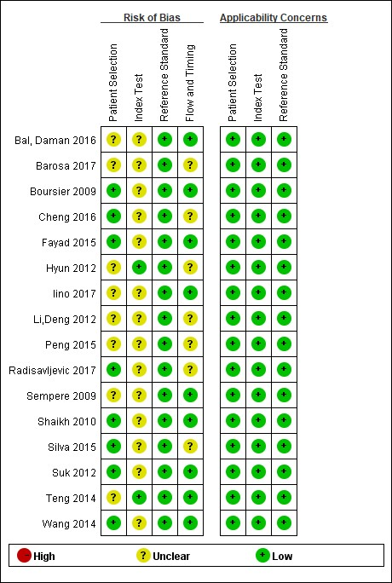
Figure 1 Results of quality assessment of included studies using the Quality Assessment of Diagnostic Accuracy Studies 2 scale.

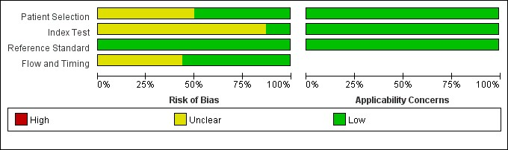
Figure 2 The overall quality of included study.

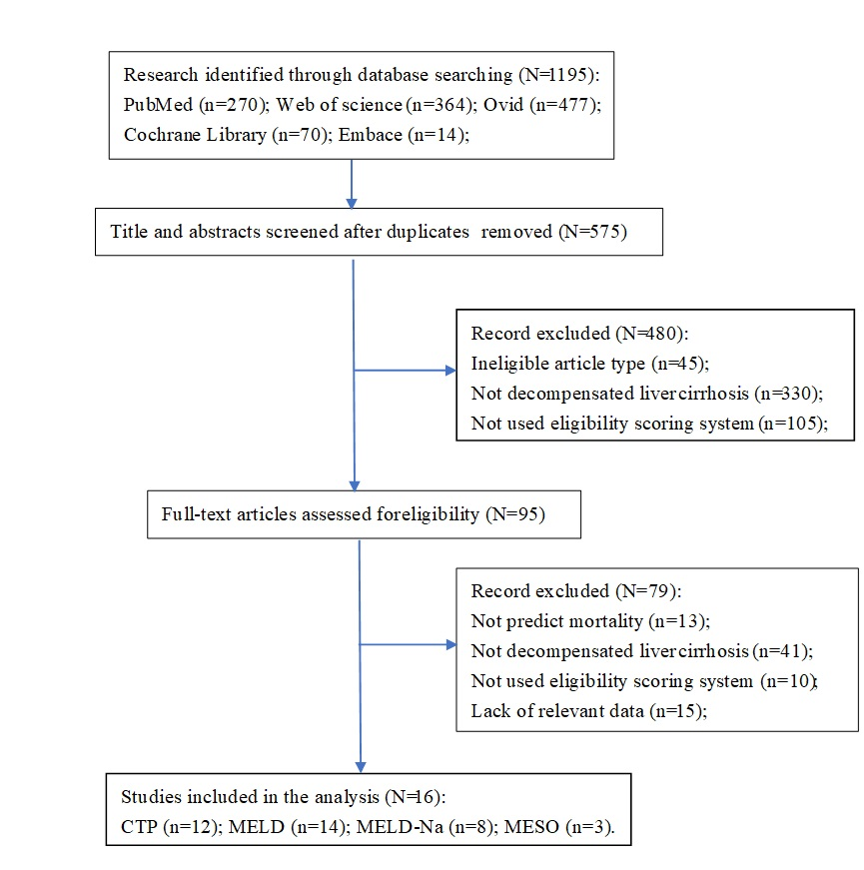
Figure 3 Flow diagram of study selection. CTP: Child–Turcotte–Pugh; MELD: Model for End-stage Liver Disease score; MESO: MELD to Serum Sodium ratio.
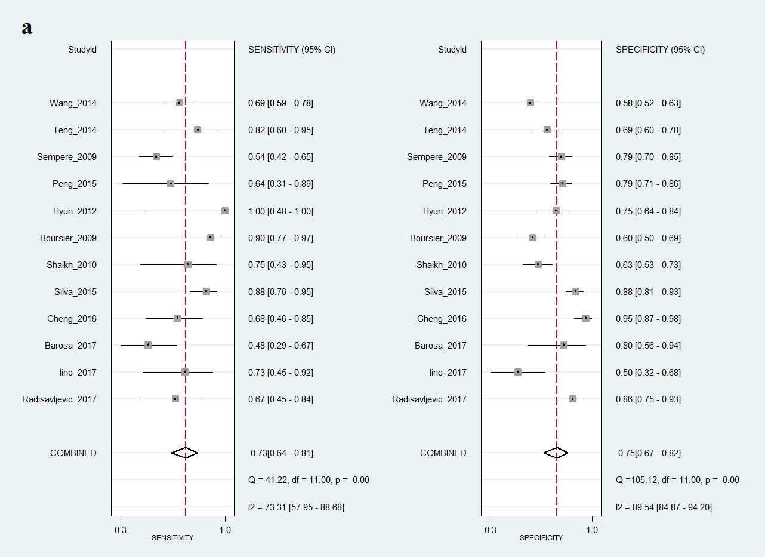

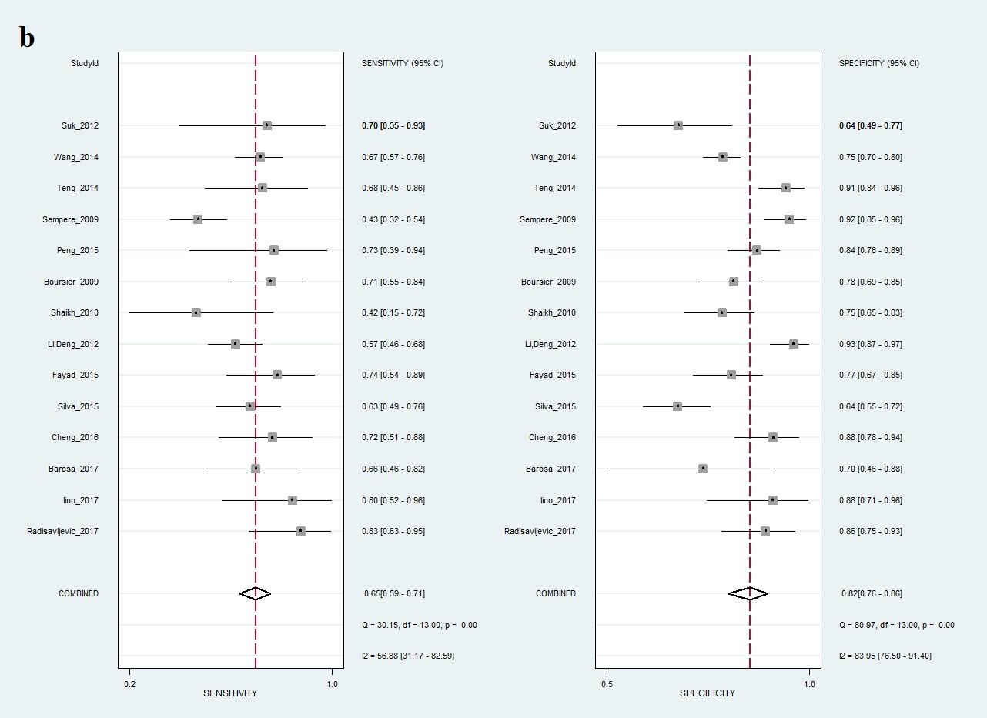
Figure 4 Forest plots of pooled results of different scoring systems. A: Child–Turcotte–Pugh score; B: Model for End-stage Liver Disease score.

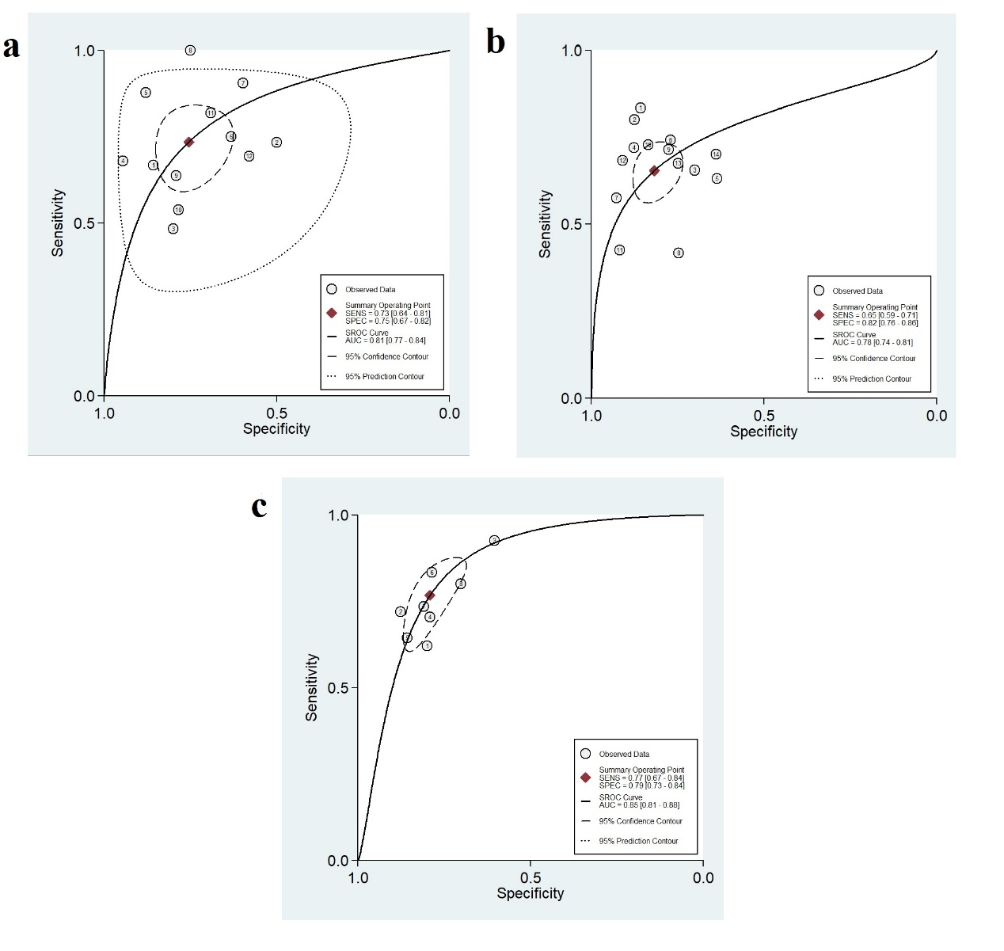Figure 5 The summarized receiver operating characteristic curves of different scoring systems. A: Child–Turcotte–Pugh; B: Model for End-stage Liver Disease (MELD) score; C: MELD-Na.

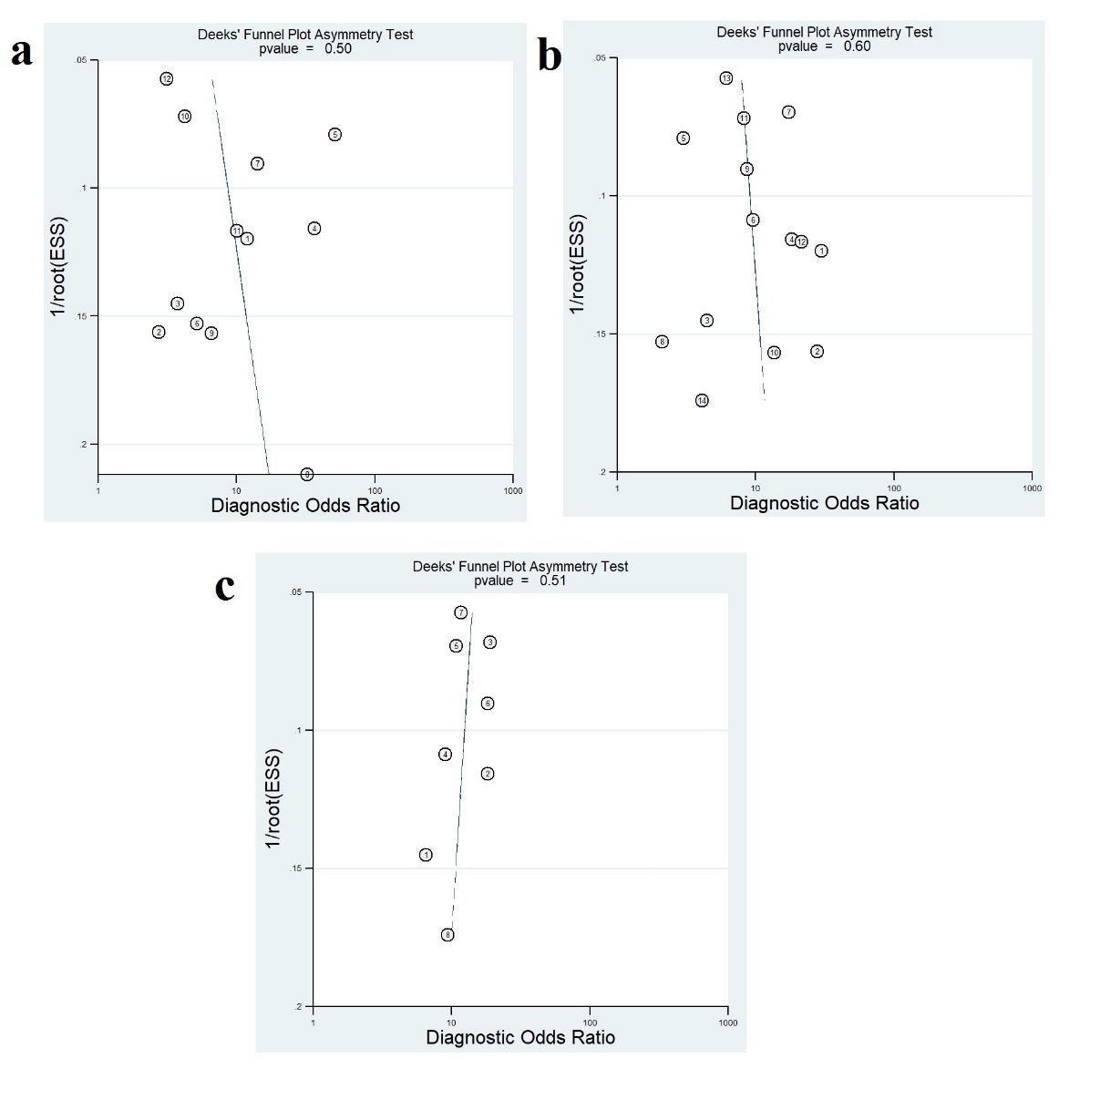
Figure 6 Results of linear regression test of funnel plot asymmetry for publication bias. A: Child–Turcotte–Pugh; B: Model for End-stage Liver Disease (MELD) score; C: MELD-Na.

Table 1 The characteristics of studies included in the meta-analysis
Study | Country | Study style | Sex  (M/F) | Age (yr) | Number of patients | End-point of observation | Scoring system | Etiology
Radisavljevic et al^{[20]}, 2017 | Peru | p | 79/8 | 54 | 87 | 29 mo | CTP, MESO, MELD | Alcohol
Iino et al^{[21]}, 2017 | Japan | r | 39/8 | 60 | 47 | 1.5 mo | CTP, MELD | HBV, HCV, Alcohol, Other
Barosa et al^{[22]}, 2017 | Portugal | r | unknown | 62 | 49 | 1, 3 mo | CTP, MELD, MELD-Na | Alcohol, HCV
Cheng et al^{[23]}, 2016 | china | p | 87/12 | 48 | 98 | 1, 3, 6, 12 mo | CTP, MELD, MELD-Na | HBV
Bal et al^{[24]}, 2016 | India | r | 177/41 | 50 | 218 | 1.6 mo | MELD-Na | Ethanol, Crypto/NAFLD,HCV
Silva et al^{[25]}, 2015 | Brazil | p | 140/52 | 54 | 192 | 1 mo | MELD, CTP | Alcohol, HBV, HCV, Cryptogenic, Others
 |  |  |  |  | 189 | 3 mo | MELD, CTP
Fayad et al^{[26]}, 2015 | Brazil | p | 94/29 | 54 | 123 | in hospital | MELD, MELD-Na, MESO | HBV, HCV, Alcohol, Cryptogenic, Other
Suk et al^{[27]}, 2012 | Korea | p | 46/11 | 48 | 57 | 36 mo | MELD, MELD-Na | Alcohol, viral, Alcohol+viral
Li et al^{[28]}, 2012 | china | r | 133/79 | 56 | 212 | 3, 6, 12 mo | MELD, MELD-Na, MESO | HBV, HCV, Alcohol, Primary biliary cirrhosis, Other
Shaikh et al^{[29]}, 2010 | India | p | 72/38 | 47 | 110 | in hospital | MELD, CTP | HBV, HCV
Boursier et al^{[30]}, 2009 | France | p | 93/61 | 59 | 154 | 6 mo | CTP, MELD, MELD-Na | Alcohol, Viral, Others
Hyun et al^{[31]}, 2012 | Korea | r | 63/23 | 54 | 83 | 6 mo | CTP | HBV
Peng et al^{[32]}, 2015 | China | r | 94/51 | 57 | 145 | in hospital | MELD, CTP | HBV, HCV, Alcohol, unknown, others
Sempere et al^{[33]}, 2009 | Spain | r | 142/59 | 59 | 201 | 1.5, 3, 12, 36 mo | MELD, CTP | Alcohol, Viral, Others
Teng et al^{[34]}, 2014 | China | r | 110/22 | 51 | 132 | 1.5 mo | MELD, CTP | Alcohol, HBV, HCV,
Wang et al^{[35]}, 2014 | China | p | 340/89 | 49 | 429 | 3, 12 mo | CTP, MELD-, MELA-Na | HCV, HBV, Alcohol, Biliary, Other
p: Prospectively study; r: Retrospectively study; CTP: Child–Turcotte–Pugh; MELD: Model for End-stage Liver Disease score; MESO: MELD to Serum Sodium ratio; HBV: Hepatitis B virus; HCV: Hepatitis C virus; NAFLD: Nonalcoholic fatty liver disease.

Table 2 The results of subgroup analysis in different time-points of Child–Turcotte–Pugh, Model for End-stage Liver Disease score, and Model for End-stage Liver Disease-Na score in predicting mortality
End-point  (mortality) | Number of study |  | Sensitivity  (95% CI) | Specificity (95% CI) | Positive  (95% CI) | Negative  (95% CI) | DOR  (95% CI) | I² | AUROC
CTP
< 3 mo | 8 | 0.72 (0.61, 0.81) |  | 0.73 (0.65, 0.79) | 2.6 (1.9, 3.7) | 0.39 (0.26, 0.58) | 7 (3, 14) | 0 | 0.78
3 mo | 5 | 0.79 (0.60, 0.91) |  | 0.79 (0.59, 0.90) | 3.7 (1.8, 7.6) | 0.26 (0.13, 0.55) | 14 (4, 46) | 96 | 0.86
6 mo | 3 | 0.90 (0.80 0.96) |  | 0.69 (0.64, 0.75) | 3.0 (2.1, 4.5) | 0.16 (0.08, 0.33) | 18 (8, 40) | 0 | 0.91
12 mo | 3 | 0.68 (0.58,0.72) |  | 0.68 (0.64, 0.72) | 3.3 (1.5, 7.3) | 0.49 (0.40, 0.60) | 7 (3, 20) | 84 | 0.72
MELD
< 3 mo | 9 | 0.66 (0.59, 0.73) |  | 0.87 (0.81, 0.91) | 5.1 (3.4, 7.7) | 0.39 (0.31, 0.48) | 13 (7, 24) | 6 | 0.76
3 mo | 6 | 0.70 (0.60, 0.78) |  | 0.78 (0.65, 0.87) | 3.1 (2.0, 4.9) | 0.39 (0.29, 0.52) | 8 (4, 15) | 95 | 0.78
6 mo | 3 | 0.74 (0.65, 0.82) |  | 0.83 (0.79, 0.87) | 4.4 (2.4, 8.2) | 0.30 (0.23, 0.43) | 15 (7, 34) | 56 | 0.83
12 mo | 4 | 0.60 (0.51, 0.68) |  | 0.88 (0.79, 0.93) | 4.8 (3.0, 7.7) | 0.46 (0.39, 0.55) | 10 (6, 17) | 92 | 0.75
MELD-Na
< 3 mo | 4 | 0.82 (0.69, 0.91) |  | 0.82 (0.64, 0.92) | 4.6 (2.2, 9.8) | 0.21 (0.12, 0.37) | 22 (9, 53) | 89 | 0.89
3 mo | 4 | 0.75 (0.63, 0.84) |  | 0.84 (0.80, 0.87) | 4.6 (3.5, 6.0) | 0.30 (0.20, 0.46) | 15 (8, 30) | 0 | 0.86
6 mo | 3 | 0.82 (0.73, 0.88) |  | 0.85 (0.80, 0.88) | 5.3 (3.7, 7.7) | 0.22 (0.15, 0.32) | 25 (14, 43) | 0 | 0.9
12 mo | 3 | 0.72 (0.63, 0.76) |  | 0.83 (0.80, 0.86) | 4.2 (3.4, 5.1) | 0.37 (0.30, 0.45) | 12 (8, 18) | 0 | 0.84
CTP: Child–Turcotte–Pugh; MELD: Model for End-stage Liver Disease score; DOR: Diagnostic odd ratio; AUROC: Area under summarized receiver operating characteristic.

Table 3 The results of Child–Turcotte–Pugh and Model for End-stage Liver Diseases core for predicting mortality in variceal hemorrhage patients within 3-mo
Subgroup | Number of study | Sensitivity (95% CI) | Specificity  95% CI) | Positive  (95% CI) | Negative  (95% CI) | DOR  (95% CI) | I² | AUROC
CTP
Variceal hemorrhage | 4 | 0.70 (0.58, 0.80) | 0.71 (0.62, 0.78) | 2.4 (1.8, 3.1) | 0.42 (0.30, 0.60) | 6 (3, 10) | 19 | 0.76
others | 4 | 0.78 (0.46, 0.94) | 0.74 (0.61, 0.84) | 3.1 (1.5, 6.3) | 0.30 (0.09, 1.02) | 10 (1, 72） | 0 | 0.81
MELD
Variceal hemorrhage | 4 | 0.66 (0.53, 0.77) | 0.87 (0.84, 0.90) | 5.2 (3.9, 7.1) | 0.39 (0.27, 0.56) | 13 (7, 24) | 0 | 0.88
others | 5 | 0.68 (0.57, 0.77) | 0.87 (0.75, 0.93) | 5.1 (2.4, 10.7) | 0.37 (0.25, 0.54) | 14 (5, 40) | 0 | 0.79
CTP: Child–Turcotte–Pugh; MELD: Model for End-stage Liver Disease score; DOR: Diagnostic odd ratio; AUROC: Area under summarized receiver operating characteristic.

