Name of Journal: World Journal of Hepatology
Manuscript NO: 36968
Manuscript Type: Case Report

Primary hepatic peripheral T-cell lymphoma associated with Epstein-Barr viral infection

Ramai D et al. Primary hepatic peripheral T-cell lymphoma

Daryl Ramai, Emmanuel Ofori, Sofia Nigar, Madhavi Reddy

Daryl Ramai, Emmanuel Ofori, Sofia Nigar, Madhavi Reddy, Division of Gastroenterology and Hepatology, Brooklyn Hospital Center, Brooklyn, NY 11201, United States

Daryl Ramai, Department of Anatomical Sciences, St. George’s University School of Medicine, Grenada 999166, West Indies

ORCID number: Daryl Ramai (0000-0002-2460-7806); Emmanuel Ofori (0000-0002-4373-0885); Sofia Nigar (0000-0003-3960-9414); Madhavi Reddy (0000-0002-3359-1172).

Author contributions: Ramai D, Ofori E and Nigar S designed the report; Ramai D and Reddy M collected the patient’s clinical data; Ramai D wrote the paper; Ofori E, Nigar S, and Reddy M edited the manuscript for intellectual content.

Informed consent statement: Regarding consent, we contacted our patient's spouse who reported that the patient has since passed.

Conflict-of-interest: No potential conflicts of interest relevant to this article were reported.

Open-Access: This article is an open-access article which was selected by an in-house editor and fully peer-reviewed by external reviewers. It is distributed in accordance with the Creative Commons Attribution Non Commercial (CC BY-NC 4.0) license, which permits others to distribute, remix, adapt, build upon this work non-commercially, and license their derivative works on different terms, provided the original work is properly cited and the use is non-commercial. See: http://creativecommons.org/licenses/by-nc/4.0/

Manuscript source: Unsolicited Manuscript

Correspondence to: Daryl Ramai, MD, Research Fellow, Division of Gastroenterology and Hepatology, Brooklyn Hospital Center, 121 Dekalb Avenue, Brooklyn, NY 11201, United States. dramai@sgu.edu
Telephone: +1-718-2508867
Fax: +1-718-250758

Received: October 31, 2017
Peer-review started: November 1, 2017
First decision: December 1, 2017
Revised: December 20, 2017
Accepted: January 23, 2018
Article in press:
Published online:

Abstract
Primary hepatic peripheral T-cell lymphoma (H-PTCL) is one of the rarest forms of non-Hodgkin lymphoma. We report a patient who presented with worsening jaundice, abdominal pain, and vomiting. Laboratory values were significant for elevated total bilirubin, alkaline phosphatase, and liver enzymes. Following a liver biopsy, histopathology revealed several large dense clusters of atypical T-lymphocytes which were CD2+, CD3+, CD5+, CD7-, CD4+, CD8-, CD56-, CD57-, CD30+ by immunohistochemistry. The proliferation index was approximately 70% by labeling for ki67/mib1. The above histological profile was consistent with peripheral T-cell lymphoma of the liver. Epstein-Barr viral serology indicated a remote infection, a likely risk factor for PTCL. Bone marrow biopsy was negative for malignancy, further supporting hepatic origin.

Key words: Primary lymphoma; Liver cancer; Non-Hodgkin’s lymphoma; T-cell lymphoma

© The Author(s) 2018. Published by Baishideng Publishing Group Inc. All rights reserved.

Core tip: Primary hepatic peripheral T-cell lymphoma (H-PTCL) is one of the rarest forms of non-Hodgkin lymphoma. We report a patient who presented with worsening jaundice, abdominal pain, and vomiting. Laboratory values were significant for elevated total bilirubin, alkaline phosphatase, and liver enzymes. Liver biopsy followed by histopathology confirmed the diagnosis of H-PTCL. Furthermore, bone marrow biopsy was negative for malignancy, further supporting hepatic origin. Our patient’s medical history reported a prior Epstein-Barr viral infection, a risk factor for H-PTCL. In the setting of risk factors, H-PTCL should be born in mind when a patient presents with symptoms of malignancy, and an enlarged and infiltrating liver.

Ramai D, Ofori E, Nigar S, Reddy M. Primary hepatic peripheral T-cell lymphoma associated with Epstein-Barr viral infection. World J Hepatol 2018; In press

INTRODUCTION
Peripheral T-cell lymphoma (PTCL) is the rarest of all cases of non-Hodgkin lymphoma (NHL). It constitutes approximately 0.0016% of all extranodal lymphomas^{[1-3]}. PTCL not otherwise specified (NOS) is a heterogeneous subset of nodal T-cell lymphomas which does not satisfy the criteria for the other subtypes of PTCLs, namely, angioimmunoblastic T-cell lymphoma, and follicular T-cell lymphoma^{[4]}. The annual incidence rate for PTCL is 1.56 per 100000 persons in non-Hispanic Whites, 1.32 per 100000 in Blacks, 0.89 per 100000 in Asians/Pacific Islanders, 0.63 per 100000 in American Indians/Alaskan natives, and 0.96 per 100000 in Hispanic whites^{[5]}. The distribution of PTCL NOS among racial groups is reported to be highest amongst non-Hispanic Whites (2689), followed by Blacks (661), Hispanic Whites (418), Asian/Pacific Islanders (322), and lowest in American Indians/Alaskan natives (20)^{[5]}. When the lesion is localized or arises from the liver, it may also be referred as primary hepatic peripheral T-cell lymphoma (H-PTCL). We present a 37-year-old male with worsening jaundice, abdominal pain, and vomiting who was diagnosed with hepatic peripheral T-cell lymphoma with a Ki-67 of 70%.

CASE REPORT
A 37-year-old male with a past medical history of Epstein-Barr Virus (EBV) infection was admitted for jaundice and right upper quadrant abdominal pain. He reported having worsening symptoms for one month duration. The patient was a non-smoker and non-alcohol drinker. Review of systems was positive for decreased appetite and weight loss of 10 lbs. over the past two months. His family history was unknown. Physical examination was significant for mild scleral icterus and abdominal distension. Heart rate was 92/min, blood pressure was 107/67 mm Hg, respiratory rate was 20/min, oxygen saturation was 94% on room air, and temperature was 98.1 °F. Laboratory results were within normal limits with a white blood count (WBC) of 11.4/uL, hemoglobin of 12.2 g/dL, hematocrit of 37%, and platelet count of 291 k/cmm. Total bilirubin was 5.7 mg/dL, alkaline phosphatase (ALP) was 1005 U/L, LDH was 830 U/L, albumin was 3.2 g/dL, aspartate aminotransferase (AST) was 257 U/L and alanine aminotransferase (ALT) was 239 U/L. EBV serology was negative for IgM, and positive for IgG and EBV nuclear antigen, consistent with prior infection.
Abdominal magnetic resonance imaging (MRI) showed mild intrahepatic ductal dilatation, peripheral areas of arterial enhancement in liver felt to be related to vascular shunting, periportal edema, a cut off in the course of the biliary tree at the bifurcation, a simple liver cyst, and enlarged left retroperitoneal nodes. Upper endoscopy showed gastropathy in the gastric fundus and body. Endoscopic ultrasound was unremarkable. Following a liver biopsy, histopathology showed several large dense clusters of atypical T-lymphocytes, which appeared to be centered in the portal areas. The atypical lymphocytes were medium to large in size and were CD2+, CD3+, CD4+, CD5+, CD7-, CD8-, CD56-, CD57-, CD30+, by immunohistochemistry (Figure 1).
The proliferation index was approximately 70% by labeling for ki67/mib1. Labeling for CD68 was seen in Kupffer cells, and in a few scattered histiocytes only. There were rare, scattered, unremarkable small B-lymphocytes (CD20+, CD79a+). Stains for CD138, kappa, lambda, were noncontributory. The above histological profile was consistent with hepatic peripheral T-cell lymphoma. The patient was subsequently transferred to a tertiary care center for further management where he had a bone marrow biopsy which was negative for malignancy, further supporting hepatic origin.

DISCUSSION
H-PTCL is mainly diagnosed by the presence of a hepatic mass in the absence of lymphadenopathy, splenomegaly, bone marrow involvement, and associated with normal tumor markers^{[6]}. After six months following diagnosis, other tissues may become involved including the spleen, lymph nodes, peripheral blood, and/or bone marrow^{[7]}. According to literature, H-PTCL commonly occurs around the fifth decade of life^{[8]}.
While the etiology of H-PTCL remains unclear, certain risk factors have been described such as Hepatitis C virus (HCV), Hepatitis B virus (HBV), and Epstein-Barr virus (EBV)^{[9-12]}. In patients diagnosed with H-PTCL, HCV was identified in 20%-60% of cases^{[9]}. This finding hints that viruses such as HCV may play a role in the pathogenesis of H-PTCL. Furthermore, H-PTCL has been diagnosed in immunocompromised patients with Human Immunodeficiency Virus (HIV), Human T-Lymphotropic Virus (HTLV), systemic erythematous lupus (SLE), and immunosuppressive therapy^{[13]}. Our patient was negative for HCV and HBV infections, but his medical history indicated a prior EBV infection. While the tumor was CD30+, we did not pursue in-situ hybridization for Epstein–Barr virus-encoded RNA in lymphoma cells. Peng et al^{[14]} reported the first case of EBV-associated CD30-positive peripheral T-cell lymphoma of cytotoxic phenotype. Our case provides further confirmation of an association of EBV infection and PTCL.
The clinical presentation of H-PTCL is non-specific, with the most reported symptom being abdominal pain in 40%-70% of patients, similar to our patient^{[3]}. About 35% of PTCL patients experience systemic B symptoms including fever, night sweats, and weight loss^{[15]}. Tumor markers alpha fetoprotein (AFP) and carcinoembryonic antigen (CEA) are typically normal in these patients^{[16]}. Abnormal laboratory findings include elevated liver function enzymes, bilirubin, γ-glutamyl transferase, ALP, and LDH. Approximately 70% of cases present with abnormal liver function enzymes, 30 to 80% with elevated LDH, 90% with elevated β2-microglobulin, and 80% with elevated ALP^{[17-20]}. Mitarnun et al^{[20]} reported that out of 100 patients with EBV associated H-PTCL, ALP was found elevated in 80%, while LDH was elevated in 65% of cases. Our patient presented with significantly notable ALP, LDH, total bilirubin, and liver function enzymes.
The proliferation index measured by Ki-67 has traditionally been used in assessing patient prognosis and response to therapy. Went et al^{[21]} proposed a prognostic model which incorporated age (> 60 years), high lactate dehydrogenase, poor performance status, and Ki-67 greater or equal to 80%. Their model was significantly associated with patient outcome (P < 0.0001). Weisenburger et al^{[15]} reported a Ki-67 > 25% was an adverse predictor of survival.
Our case was classified as PTCL-NOS according to guidelines outlined by the World Health Organization^{[4]}. The running differential diagnosis included extranodal NK/T-cell lymphoma, nasal type and adult T-cell leukemia/lymphoma. Extranodal NK/T-cell lymphoma, nasal type, was considered due to a prior EBV infection, however, it was ruled out after being CD56 negative. CD56 is a diagnostic requisite for extranodal NK/T-cell lymphoma, nasal type^{[22]}. Adult T-cell leukemia/lymphoma was ruled out given that the patient’s calcium levels and WBC were within normal limits^{[23]}.
Treatment for PTCL requires an aggressive course of chemotherapy, typically cyclophosphamide, hydroxydaunorubicin, oncovin, and prednisone (CHOP). A recent study by Kim et al^{[24]} reported that patients with whole blood EBV-DNA were more likely to have aggressive clinical characteristics and inferior survival. Overall, H-PTCL has a poor prognosis due to life threatening complications and tumor progression. Clinical studies report that CHOP therapy can provide up to 60% complete remission, and a 30%–50% five-year survival rate^{[24-26]}.
More recently, a prospective study of 499 patients showed that patients who received doxorubicin had a significantly longer survival than those who did not (P = 0.03)^{[27]}. Furthermore, in a study involving 775 patients, better survival outcomes were seen in one third of patients who remained in remission 2 years after diagnosis, especially in younger patients less than 60-years of age^{[28]}. However, Abramson et al^{[29]} reported that the most dominant prognostic factor was response to initial therapy, with no overall survival difference based on the choice of upfront regimen. These studies further reemphasizes the need for early detection and treatment.
In conclusion, we report a rare case of H-PTCL in a 37-year old male with a medical history of EBV infection who presented with worsening jaundice, abdominal pain, and vomiting. H-PTCL is an aggressive form of NHL which requires early diagnosis and a robust treatment regimen. However, the diagnosis of H-PTCL remains challenging due to the presence of multiple granulomas, histiocytosis, and focal neoplastic infiltrates. In the setting of worsening symptoms and abnormal liver enzymes of unknown etiology, clinicians should consider performing a differential liver biopsy.

ARTICLE HIGHLIGHTS
Case characteristics
A 37-year-old male with a past medical history of Epstein-Barr Virus infection reported having jaundice, right upper quadrant pain, and decreased appetite and weight loss of 10 lbs over the past two months.

Clinical diagnosis
Abdominal magnetic resonance imaging showed mild intrahepatic ductal dilatation, peripheral areas of arterial enhancement in the liver felt to be related to vascular shunting, periportal edema, a cut off in the course of biliary tree at the bifurcation, simple liver cyst, and enlarged left retroperitoneal nodes.

Differential diagnosis
Cirrhosis, hepatocellular carcinoma, cholangiocarcinoma.

Laboratory diagnosis
Laboratory was significant for total bilirubin of 5.7 mg/dL, alkaline phosphatase of 1005 U/L, albumin of 3.2 g/dL, and AST/ALT of 257/239 U/L.

Imaging diagnosis
Upper endoscopy showed gastropathy in the gastric fundus and body. Endoscopic ultrasound was unremarkable.

Pathological diagnosis
A liver biopsy showed several large dense clusters of atypical T-lymphocytes, which appeared to be centered in portal areas. The atypical lymphocytes were medium to large in size and were CD2+, CD3+, CD5+, CD7-, CD4+, CD8-, CD56-, CD57-, CD30+, by immunohistochemistry. The proliferation index was approximately 70% by labeling for ki67/mib1. Labeling for CD68 was seen in Kupffer cells, and in a few scattered histiocytes only. There were rare, scattered, unremarkable small B-lymphocytes (CD20+, CD79a+). Stains for CD138, kappa, lambda, were noncontributory. The above histological profile was consistent with hepatic peripheral T-cell lymphoma (H-PTCL).

Treatment
The patient was transferred to a tertiary center for chemotherapy (CHOP) treatment.

Related reports
H-PTCL has a poor prognosis due to life threatening complications and tumor progression. Clinical studies reports that CHOP therapy can provide up to 60% complete remission, and a 30%–50% five-year survival rate.

Term explanation
H-PTCL is one of the rarest forms of non-Hodgkin lymphoma. It constitutes approximately 0.0016% of all extranodal lymphomas.

Experiences and lessons
In the setting of worsening symptoms and abnormal liver enzymes of unknown etiology, clinicians should consider performing a differential liver biopsy. Clinicians should also be aware of the risk factors for H-PTCL.

REFERENCES
1 Lei KI. Primary non-Hodgkin's lymphoma of the liver. Leuk Lymphoma 1998; 29: 293-299 [PMID: 9684927 DOI: 10.3109/10428199809068566]
2 Yang XW, Tan WF, Yu WL, Shi S, Wang Y, Zhang YL, Zhang YJ, Wu MC. Diagnosis and surgical treatment of primary hepatic lymphoma. World J Gastroenterol 2010; 16: 6016-6019 [PMID: 21157979 DOI: 10.3748/wjg.v16.i47.6016]
3 Noronha V, Shafi NQ, Obando JA, Kummar S. Primary non-Hodgkin's lymphoma of the liver. Crit Rev Oncol Hematol 2005; 53: 199-207 [PMID: 15718146 DOI: 10.1016/j.critrevonc.2004.10.010]
4 Swerdlow SH, Campo E, Pileri SA, Harris NL, Stein H, Siebert R, Advani R, Ghielmini M, Salles GA, Zelenetz AD, Jaffe ES. The 2016 revision of the World Health Organization classification of lymphoid neoplasms. Blood 2016; 127: 2375-2390 [PMID: 26980727 DOI: 10.1182/blood-2016-01-643569]
5 Adams SV, Newcomb PA, Shustov AR. Racial Patterns of Peripheral T-Cell Lymphoma Incidence and Survival in the United States. J Clin Oncol 2016; 34: 963-971 [PMID: 26962200 DOI:10.1200/JCO.2015.63.5540]
6 El-Sharkawi D, Ramsay A, Cwynarski K, Hughes D, Prentice A, Davies N, Goode A, Wylie P, Malhotra A, Warbey V, Dooley J, McNamara C. Clinico-pathologic characteristics of patients with hepatic lymphoma diagnosed using image-guided liver biopsy techniques. Leuk Lymphoma 2011; 52: 2130-2134 [PMID: 21702647 DOI: 10.3109/10428194.2011.589546]
7 Caccamo D, Pervez NK, Marchevsky A. Primary lymphoma of the liver in the acquired immunodeficiency syndrome. Arch Pathol Lab Med 1986; 110: 553-555 [PMID: 3010899]
8 Hu HJ, Qu YJ, Tian ZX, Zhang ZP. Clinical and radiographic observations from four patients with primary hepatic lymphoma. Exp Ther Med 2016; 11: 381-386 [PMID: 26893619 DOI: 10.3892/etm.2015.2940]
9 Bronowicki JP, Bineau C, Feugier P, Hermine O, Brousse N, Oberti F, Rousselet MC, Dharancy S, Gaulard P, Flejou JF, Cazals-Hatem D, Labouyrie E. Primary lymphoma of the liver: clinical-pathological features and relationship with HCV infection in French patients. Hepatology 2003; 37: 781-787 [PMID: 12668970 DOI: 10.1053/jhep.2003.50121]
10 Kuroda J, Omoto A, Fujiki H, Okugawa K, Tamai H, Yamagishi H, Kobayashi Y, Yoshikawa T. Primary hepatic Burkitt's lymphoma with chronic hepatitis C. Acta Haematol 2001; 105: 237-240 [PMID: 11528098 DOI: 10.1159/000046571]
11 Yago K, Shimada H, Itoh M, Ooba N, Itoh K, Suzuki M, Muro H, Nakamura S. Primary low-grade B-cell lymphoma of mucosa-associated lymphoid tissue (MALT)-type of the liver in a patient with hepatitis C virus infection. Leuk Lymphoma 2002; 43: 1497-1500 [PMID: 12389636 DOI: 10.1080/1042819022386734]
12 Aozasa K, Mishima K, Ohsawa M. Primary malignant lymphoma of the liver. Leuk Lymphoma 1993; 10: 353-357 [PMID: 8220134 DOI: 10.3109/10428199309148560]
13 Avlonitis VS, Linos D. Primary hepatic lymphoma: a review. Eur J Surg 1999; 165: 725-729 [PMID: 10494635 DOI: 10.1080/11024159950189474]
14 Peng Y, Cai J, Yue C, Qing X. Primary hepatic Epstein-Barr virus-associated CD30-positive peripheral T-cell lymphoma of cytotoxic phenotype. Exp Mol Pathol 2016; 100: 207-211 [PMID: 26778690 DOI: 10.1016/j.yexmp.2016.01.002]
15 Weisenburger DD, Savage KJ, Harris NL, Gascoyne RD, Jaffe ES, MacLennan KA, Rüdiger T, Pileri S, Nakamura S, Nathwani B, Campo E, Berger F, Coiffier B, Kim WS, Holte H, Federico M, Au WY, Tobinai K, Armitage JO, Vose JM; International Peripheral T-cell Lymphoma Project. Peripheral T-cell lymphoma, not otherwise specified: a report of 340 cases from the International Peripheral T-cell Lymphoma Project. Blood 2011; 117: 3402-3408 [PMID: 21270441 DOI: 10.1182/blood-2010-09-310342]
16 Lei KI, Chow JH, Johnson PJ. Aggressive primary hepatic lymphoma in Chinese patients. Presentation, pathologic features, and outcome. Cancer 1995; 76: 1336-1343 [PMID: 8620406]
17 Nagral A, Jhaveri A, Kalthoonical V, Bhat G, Mahajan P, Borges A. Primary Liver Sinusoidal Non-Hodgkin's Lymphoma Presenting as Acute Liver Failure. J Clin Exp Hepatol 2015; 5: 341-343 [PMID: 26900276 DOI: 10.1016/j.jceh.2015.10.007]
18 Hüfner M, Döhner H, Schmidt J, Möller P, Ho AD, Hunstein W. Evidence for an osteoblast-activating factor in a patient with peripheral T-cell lymphoma and osteosclerosis. Klin Wochenschr 1989; 67: 402-407 [PMID: 2787445 DOI: 10.1007/BF01711269]
19 Alsohaibani FI, Abdulla MA, Fagih MM. Hepatosplenic T-cell lymphoma. Indian J Hematol Blood Transfus 2011; 27: 39-42 [PMID: 22379294 DOI: 10.1007/s12288-010-0051-1]
20 Mitarnun W, Suwiwat S, Pradutkanchana J, Saechan V, Ishida T, Takao S, Mori A. Epstein-Barr virus-associated peripheral T-cell and NK-cell proliferative disease/lymphoma: clinicopathologic, serologic, and molecular analysis. Am J Hematol 2002; 70: 31-38 [PMID: 11994979 DOI: 10.1002/ajh.10094]
21 Went P, Agostinelli C, Gallamini A, Piccaluga PP, Ascani S, Sabattini E, Bacci F, Falini B, Motta T, Paulli M, Artusi T, Piccioli M, Zinzani PL, Pileri SA. Marker expression in peripheral T-cell lymphoma: a proposed clinical-pathologic prognostic score. J Clin Oncol 2006; 24: 2472-2479 [PMID: 16636342 DOI: 10.1200/JCO.2005.03.6327]
22 Kim YR, Kim SJ, Cheong JW, Chung H, Jang JE, Kim Y, Yang WI, Min YH, Kim JS. Pretreatment Epstein-Barr virus DNA in whole blood is a prognostic marker in peripheral T-cell lymphoma. Oncotarget 2017; 8: 92312-92323 [PMID: 29190917 DOI: 10.18632/oncotarget.21251]
23 Matutes E. Adult T‐cell leukaemia/lymphoma. J Clin Pathol 2007; 60: 1373-1377 [PMID: 18042693 DOI:10.1136/jcp.2007.052456]
24 Avilés A, Castañeda C, Neri N, Cleto S, Talavera A, González M, Huerta-Guzmán J, Nambo MJ. Results of a phase III clinical trial: CHOP versus CMED in peripheral T-cell lymphoma unspecified. Med Oncol 2008; 25: 360-364 [PMID: 18247163 DOI: 10.1007/s12032-008-9046-2]
25 Morabito F, Gallamini A, Stelitano C, Callea V, Guglielmi C, Neri S, Lazzaro A, Orsucci L, Ilariucci F, Sacchi S, Vitolo U, Federico M. Clinical relevance of immunophenotype in a retrospective comparative study of 297 peripheral T-cell lymphomas, unspecified, and 496 diffuse large B-cell lymphomas: experience of the Intergruppo Italiano Linformi. Cancer 2004; 101: 1601-1608 [PMID: 15378507 DOI: 10.1002/cncr.20531]
26 Sonnen R, Schmidt WP, Müller-Hermelink HK, Schmitz N. The International Prognostic Index determines the outcome of patients with nodal mature T-cell lymphomas. Br J Haematol 2005; 129: 366-372 [PMID: 15842660 DOI: 10.1111/j.1365-2141.2005.05478.x]
27 Carson KR, Horwitz SM, Pinter-Brown LC, Rosen ST, Pro B, Hsi ED, Federico M, Gisselbrecht C, Schwartz M, Bellm LA, Acosta MA, Shustov AR, Advani RH, Feldman TA, Lechowicz MJ, Smith SM, Lansigan F, Tulpule A, Craig MD, Greer JP, Kahl BS, Leach JW, Morganstein N, Casulo C, Park SI, Foss FM. A prospective cohort study of patients with peripheral T-cell lymphoma in the United States. Cancer 2017; 123: 1174-1183 [PMID: 27911989 DOI: 10.1002/cncr.30416]
28 Maurer MJ, Ellin F, Srour L, Jerkeman M, Bennani NN, Connors JM, Slack GW, Smedby KE, Ansell SM, Link BK, Cerhan JR, Relander T, Savage KJ, Feldman AL. International Assessment of Event-Free Survival at 24 Months and Subsequent Survival in Peripheral T-Cell Lymphoma. J Clin Oncol 2017; 35: 4019-4026 [PMID: 29072976 DOI: 10.1200/JCO.2017.73.8195]
29 Abramson JS, Feldman T, Kroll-Desrosiers AR, Muffly LS, Winer E, Flowers CR, Lansigan F, Nabhan C, Nastoupil LJ, Nath R, Goy A, Castillo JJ, Jagadeesh D, Woda B, Rosen ST, Smith SM, Evens AM. Peripheral T-cell lymphomas in a large US multicenter cohort: prognostication in the modern era including impact of frontline therapy. Ann Oncol 2014; 25: 2211-2217 [PMID: 25193992 DOI: 10.1093/annonc/mdu443]

P-Reviewer: Zhu YL S-Editor: Cui LJ L-Editor: E-Editor:

Specialty type: Gastroenterology and hepatology
Country of origin: United States
Peer-review report classification
Grade A (Excellent): 0
Grade B (Very good): 0
Grade C (Good): C
Grade D (Fair): 0
Grade E (Poor): 0

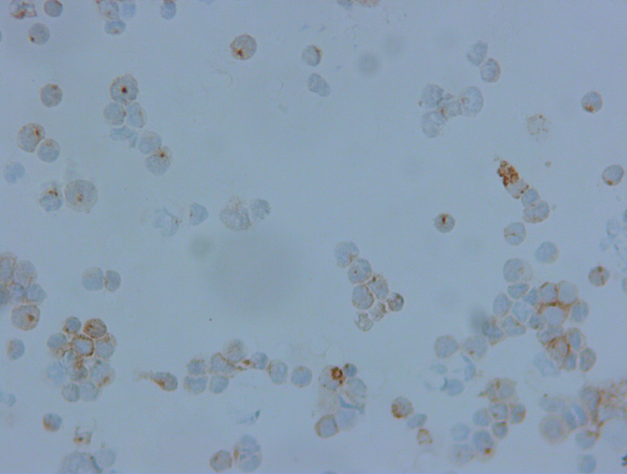
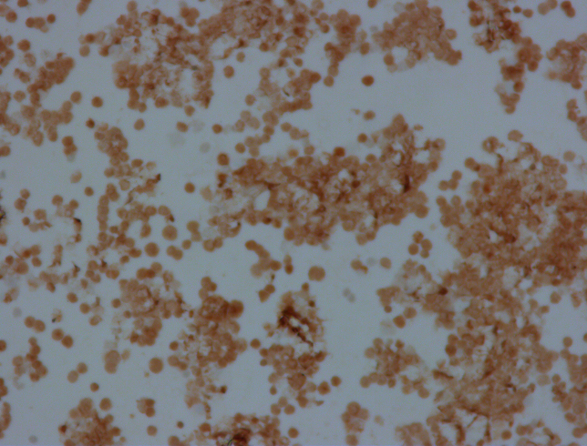
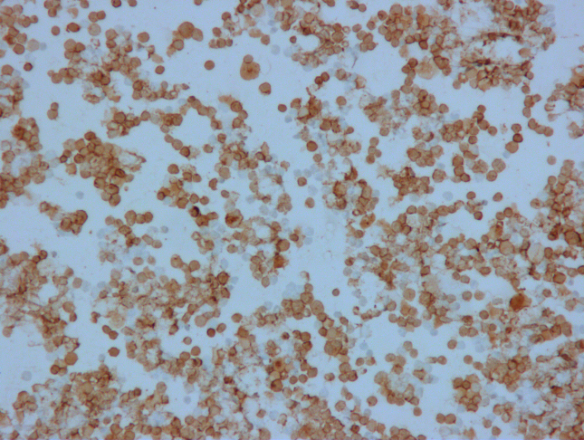
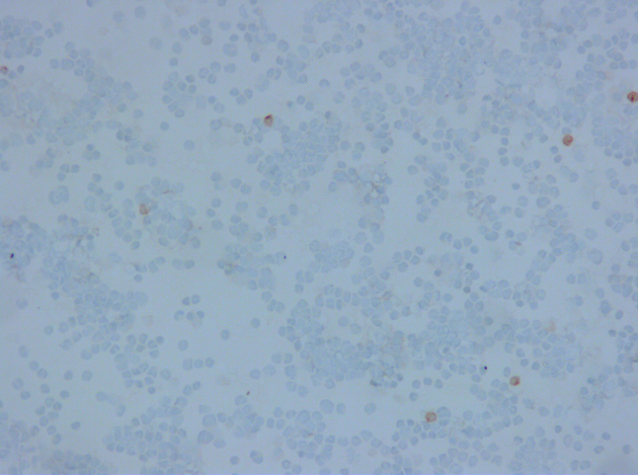
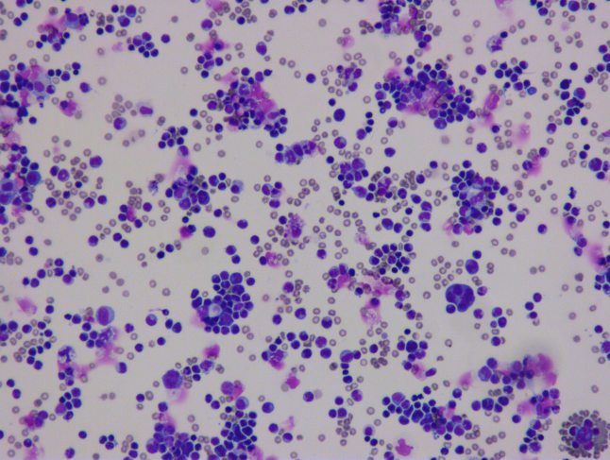
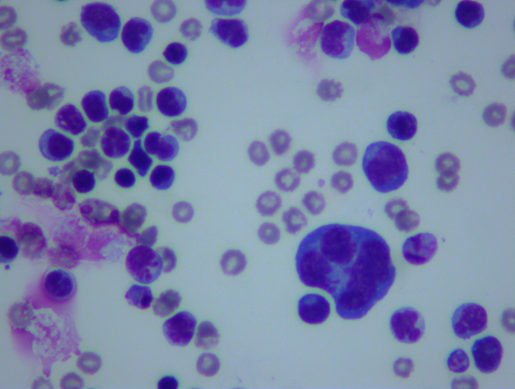
A
B
C
D
E
F

Figure 1 Biopsy results. A: large dense clusters of atypical T-lymphocytes 20 x; B: atypical T-lymphocytes 40 x; C: CD2 positive 40 x; D: CD3 positive 20 x; E: CD4 positive 20 x; F: Scantly positive CD79a 20 x.

