Name of Journal: World Journal of Hepatology
Manuscript NO: 64821
Manuscript Type: MINIREVIEWS

Indeterminate liver lesions on gadoxetic acid-enhanced magnetic resonance imaging of the liver: Case-based radiologic-pathologic review

Noreikaite J et al. Indeterminate liver lesions radiological-pathological correlation

Jurate Noreikaite, Dekan Albasha, Vijay Chidambaram, Ankur Arora, Ashok Katti

Jurate Noreikaite, Dekan Albasha, Vijay Chidambaram, Ankur Arora, Ashok Katti, Department of Radiology, Liverpool University Hospitals NHS Foundation Trust, Liverpool L7 8XP, United Kingdom

Author contributions: Noreikaite J performed the majority of the writing, literature review and analysis and prepared the figures; Albasha D contributed with design of study, literature review and drafting; Chidambaram V, Arora A and Katti A contributed to this paper with critical revision, editing and final approval of the final revision; Katti A has also provided majority of the case examples; all authors have read and approve the final manuscript.

Corresponding author: Jurate Noreikaite, MD, Doctor, Department of Radiology, Liverpool University Hospitals NHS Foundation Trust, Prescot Street, Liverpool L7 8XP, United Kingdom. jurate.noreikaite@liverpoolft.nhs.uk

Received: February 24, 2021
Revised: June 24, 2021
Accepted: August 6, 2021
Published online: September 27, 2021

Abstract
Different histopathological manifestations of focal liver lesions show varying common and uncommon imaging findings and some pathologies may show similar appearance despite of different histopathology. It is necessary to characterise focal liver lesions accurately as not only benign and malignant lesions are managed differently, but also certain benign lesions have differing management. These lesions are increasingly being detected due to rapid growth of use of cross-sectional imaging as well as improvement in image quality and new imaging techniques. Contrast enhanced magnetic resonance imaging (MRI) is considered the gold standard technique in characterising focal liver lesions. Addition of gadoxetic acid has been shown to significantly increase diagnostic accuracy in the detection and characterization of liver abnormalities. Classic imaging characteristics of common liver lesions, including their behaviour on gadoxetic acid enhanced MRI, have been described in literature over recent years. It is important to be familiar with the typical aspects of these lesions as well as know the uncommon and overlapping imaging features to reach an accurate diagnosis. In this article, we will review the well-described characteristic imaging findings of common and rare focal liver lesions and present several challenging cases encountered in the clinical setting, namely hepatocellular adenoma, focal nodular hyperplasia, hepatic angiomyolipoma, hepatocellular carcinoma, intrahepatic cholangiocarcinoma, neuroendocrine tumours as well as a pleomorphic liposarcoma of the liver.

Key Words: Indeterminate liver lesions; Magnetic resonance imaging; Gadoxetic acid; Hepatobiliary phase; Hepatocellular carcinoma

©The Author(s) 2021. Published by Baishideng Publishing Group Inc. All rights reserved.

Citation: Noreikaite J, Albasha D, Chidambaram V, Arora A, Katti A. Indeterminate liver lesions on gadoxetic acid-enhanced magnetic resonance imaging of the liver: Case-based radiologic-pathologic review. World J Hepatol 2021; 13(9): 1079-1097
URL: https://www.wjgnet.com/1948-5182/full/v13/i9/1079.htm
DOI: https://dx.doi.org/10.4254/wjh.v13.i9.1079

Core Tip: Being familiar with the typical magnetic resonance imaging aspects of focal liver lesions as well as knowing the uncommon and overlapping imaging features can help reach an accurate diagnosis without the need for further interventions. Gadoxetic acid has been shown to significantly increase diagnostic accuracy in the detection and characterization of liver abnormalities, although in certain challenging cases it may be prudent to seek histological confirmation.

INTRODUCTION
Recent years have seen a rapid growth of the use of cross-sectional imaging as well as an increase in image quality and new imaging techniques. This has led to a rise in the detection of a variety of benign and malignant focal liver lesions. It is necessary to characterise focal liver lesions accurately as not only benign and malignant lesions are managed differently, but also certain benign lesions have differing management. The ability to accurately identify various liver lesions on imaging also saves the patient from biopsy or other invasive interventions needed to reach a diagnosis, which carry associated complications such as bleeding, abdominal pain, or even mortality^{[1,2]}.
Contrast enhanced magnetic resonance imaging (MRI) is considered the gold standard technique in characterising focal liver lesions because it provides superior tissue contrast resolution, safe contrast agent profile and is ionising radiation free. Gadoxetate disodium (Primovist, Bayer Schering Pharma), also known as gadoxetic acid, in particular, has been shown to significantly increase diagnostic accuracy in the detection and characterisation of focal liver lesions^{[3,4]}. It provides dynamic vascular phases [arterial phase (AP), portal venous phase (PVP) and equilibrium phases] and due to its progressive distribution into functional hepatocytes and bile ducts also a hepatobiliary phase (HBP). Gadoxetic acid has been demonstrated to be invaluable in detecting hepatocellular carcinoma (HCC) in the cirrhotic liver and distinguishing between focal nodular hyperplasia (FNH) and hepatocellular adenoma (HCA)^{[4–6]}.
Different histopathological manifestations of focal liver lesions show varying common and uncommon imaging findings and some pathologies may show similar appearance despite different histopathology. Classic imaging characteristics of common liver lesions, including their behaviour on gadoxetic acid enhanced MRI, have been described in literature over recent years. It is important to be familiar with the typical aspects of these lesions as well as know the uncommon and overlapping imaging features to reach an accurate diagnosis. In this article, we will review the well-described characteristic imaging findings of focal liver lesions and present several challenging cases encountered in the clinical setting.

BENIGN LESIONS
HCA
HCA is a rare benign liver tumour which occurs predominantly in young and middle-aged women and is associated with the use of oral contraceptives or other steroid medications. In contrast to other benign liver tumours, an HCA may be complicated by malignant transformation or bleeding^{[7]}. As such, because of its serious clinical consequences, an HCA is often treated with surgical resection while FNH is managed conservatively in the majority of cases, without the need for surgical intervention. Therefore, accurate diagnosis is important. The use of MRI with a hepato-specific contrast agent, specifically gadoxetic acid, makes the diagnosis relatively easy to reach^{[5,8,9]}.
Generally, typical MRI findings seen in HCA include mild to moderate high signal intensity on T2 weighted imaging (T2-WI), sometimes with small cystic areas or diffuse homogeneous steatosis of the lesion and it may show internal bleeding or atoll sign. FNH classically shows the presence of a T2-weighted (T2-W) hyperintense central scar. Both lesions show enhancement on the AP imaging and tend to be isointense in the PVP^{[10]}. In particular, when compared with background liver parenchyma, on the HBP image an HCA is hypointense in the majority of cases whereas FNH is hyper- or isointense. FNH is composed of functional hepatocytes with abnormal biliary ductules and is therefore expected to accumulate hepatobiliary specific contrast agents, while HCA traditionally has been thought of as not having bile ductules and would often be expected to not retain such contrast^{[8]}.
The diagnostic conundrums are usually encountered when differentiating between HCA and malignant entities and characterising different molecular types of HCA (Figures 1 and 2). HCAs are classified into few major molecular subtypes: HNF1α inactivated HCA (H-HCA), inflammatory HCA (IHCA), β-catenin activated HCA (β-HCA) and β-catenin activated inflammatory HCA (β-IHCA) and sonic hedgehog HCA. The term Unclassified HCA is applied to those HCAs in which no specific mutation is identified^{[11]}. The highest risk of malignant transformation was shown in mixed β-catenin-activated and inflammatory and β-catenin-activated forms^{[11]}. Hepatobiliary contrast agent retention in the HBP can be seen in 83% of β-HCAs, 29% of IHCAs and not been demonstrated in H-HCA and unclassified HCAs^{[12]}. Hyperintensity on HBP of HCAs could potentially help identify HCAs at high risk of malignancy^{[13]}. However, this feature of high-risk HCAs makes it harder to differentiate radiologically from FNH which is hyperintense on HBP. Other MRI features may be helpful such as the presence of a central scar, the heterogeneous “periseptal” uptake of FNH on HBP, or other MR phases features. In addition, β-HCA typically demonstrates a subtle heterogenous hyperintense signal on T2-WI MRI, unlike FNH^{[12]}. It is suggested that in patients with inflammatory HCA risk factors (such as obesity, metabolic syndrome, and alcohol use), relying on MRI features alone to differentiate FNH from inflammatory HCA may not be appropriate^{[8]}. Histopathological analysis may be required in certain cases still, in order to achieve the final diagnosis.

FNH
FNH is the second most frequent benign hepatic tumour (haemangioma being the most common). It is found most typically in women in their 3rd-5th decades of life. FNH is rarely symptomatic and usually found incidentally^{[14]}, unless very large in which case it can cause vague abdominal pain. There is some debate whether FNH is caused by or associated with use of oral contraceptives, but it may promote the growth of FNH. An FNH, contrary to HCA, has no malignant potential or life-threatening complications, and as such a surgical resection or further evaluation is not required if a diagnosis can be made confidently on imaging.
FNH is believed to represent a local hyperplastic response of hepatocytes to a congenital vascular anomaly. It is a proliferation of normal, non-neoplastic hepatocytes that are abnormally arranged. Normal portal venous structures are not present, but most lesions contain thick-walled arterial vessels that provide outstanding arterial supply; therefore haemorrhage, infarction and necrosis would be extremely rare^{[14]}. Although the lesions have well-demarcated margins, they do not have a true capsule, which is consistent with their hyperplastic rather than neoplastic nature.
Typical MR features of FNH are iso- or mild hypointensity on T1-weighted imaging (T1-WI) and an iso- or slightly hyperintense lesion on T2-W sequences. FNH is known to have a classic central stellate fibrovascular scar, which is only seen in about 50% of cases and when present usually shows a high signal intensity on T2-WI. FNH is homogeneously and strongly enhanced on AP except for the central scar. It becomes isointense to the liver parenchyma during portal phase, with the central scar remaining relatively hypointense. The central scar typically shows enhancement in delayed phase. On the HBP FNH becomes iso- to hyperintense compared to surrounding liver without or with hypointense central scar^{[10]}. Size of > 5 cm, presence of multiple lesions and evidence of haemorrhage and necrosis are considered atypical^{[15]}. Rarely FNH may contain fat. Cases mimicking HCC, for example complete perfusion defect on HBP^{[16]}, and various enhancement patterns (Figure 3), such as a peripheral ring-like enhancement without a visible central scar, have also been described^{[16,17]}.

Hepatic angiomyolipoma
Hepatic angiomyolipoma (HAML) is a rare, hepatic mesenchymal neoplasm which more frequently occurs in the kidneys, with the liver representing the second most common site of involvement^{[18]}. It is found in both males and females, and in a majority of cases is asymptomatic. The tumour consists of 3 components: fat, vascular and smooth muscle. These components can vary significantly within each lesion and it is this heterogeneity that proves the preoperative diagnosis by imaging difficult (Figure 4).
The presence of fatty areas and solid tissue components is considered typical, however due to a significant overlap of the imaging features, most HAMLs are misdiagnosed as HCC with fatty metamorphosis. Both of these lesions show comparable dynamic enhancement patterns during the AP, followed by low signal intensity on PVP or late dynamic phases^{[19,20]}. Generally, HAMLs are lacking hepatocytes, whereas HCCs contain hepatocytes with various degrees of malignant change, which in turn leads to a more homogeneous hypointensity on HBP compared with that of the spleen and sharper margins in HAML, compared to heterogeneous signal intensity and the ill-defined margin of HCCs at the HBP^{[19]}.
In a study by Wang et al^{[21]}, absence of a pseudo capsule, presence of an early draining vein and tumour vessels, and a higher apparent diffusion coefficient (ADC) in the hypervascular hepatic tumour on the MRI were helpful to distinguish a HAML from fat-containing HCC. The presence of an early draining vein is considered a conspicuous dilated or non-dilated vessel originating from the tumour with draining to the portal vein, hepatic vein, or inferior vena cava. A tumour pseudo capsule is defined as a thin hyperintense rind in the equilibrium phase.
Although historically HAML is considered a benign lesion, few case reports have discovered a potential for malignant transformation with evidence of recurrence^{[20,22,23]}. As such, the potential risk of malignant changes of HAML needs to be recognised and some authors suggest that these lesions should be followed up after surgery.

MALIGNANT LESIONS
HCC
HCC is the commonest primary hepatic malignancy, showing an increasing worldwide prevalence^{[24,25]}. Cirrhosis constitutes a crucial risk factor for the development of HCC with the estimated prevalence of cirrhosis among patients with HCC of 80%-90%^{[26]}. Having an underlying liver disease impacts the management and therapeutic options. Due to high rates of intrahepatic recurrence, the prognosis for patients with advanced HCC remains poor^{[27]}, however when diagnosed at an early stage, curative treatments such as surgical resection, liver transplantation, and radiofrequency ablation are possible. Hence, precise imaging diagnosis in patients with early-stage HCC is crucial.
To address this, the Liver Imaging Reporting and Data System (LI-RADS) was created. It is a comprehensive system for standardising the terminology, technique, interpretation, reporting, and data collection of liver imaging. The primary blood supply of normal hepatocytes is via the portal venous system, in contrast to HCC which is supplied by abnormal hepatic arteries. Consequent imaging features are of a lesion which enhances during the late AP (non-rim) with subsequent progressive washout of contrast relative to background liver parenchyma and a peripheral rim of enhancement (pseudocapsule) on either PVP or delayed phase imaging^{[28,29]}. Apparent hypointensity relative to liver in the transitional phase may potentially represent hyperenhancement of liver rather than reduced enhancement of the mass, therefore it is recommended that when gadoxetate disodium is administered as contrast media, washout is evaluated only in the PVP^{[30]}. Additional major LI-RADS features include threshold growth (increase in size of 50% or more within 6-mo time during follow-up imaging) and size.
Hypointensity on HBP is considered an ancillary feature favouring malignancy and HBP isointensity an ancillary feature suggesting benignity^{[28]}. However, hyperintensity on HBP phase has been demonstrated in 8.8%–13.6% of HCCs^{[31,32]}. Such HCCs are rather difficult to differentiate from FNH on gadoxetic acid enhanced MR (Figures 5-9).
A study by Kitao et al^{[33]} found that the washout pattern was observed in only 57% of HBP hyperintense HCCs at dynamic MRI vs 95.8% on dynamic computed tomography (CT). The reason for this is thought to be that gadoxetic acid is already taken up into tumour cells in the transitional phase by hyperintense HCCs. Therefore, the addition of CT may be helpful as AP enhancement and washout pattern at dynamic CT, as well as a decrease in ADC ratio, were shown to be independent predictors of hyperintense HCC^{[33]}. Overall, hyperintense HCCs seem to have clinical and histologic features that might be related with more favourable outcomes^{[31]}.
An appearance of smooth hypointense rim in the HBP could also improve the detection of tumour capsule and the diagnosis of HCC^{[34]}.

Intrahepatic cholangiocarcinoma
Intrahepatic cholangiocarcinoma (ICC) is the second most common primary hepatic tumour. Although it accounts for only 3% of gastrointestinal malignancies, the incidence of ICC has been rising worldwide^{[35]}. Risk factors include chemical exposure, liver flukes, biliary tract disease (primary sclerosing cholangitis, hepatolithiasis, Caroli’s disease), viral hepatitis, metabolic syndrome, cirrhosis, smoking and alcohol^{[35,36]}. Of note, a large proportion of ICC patients (38.9%) have no identifiable risk factors^{[36]} and further studies are required to explore this.
ICC can be classified into three types according to the Liver Cancer Study Group of Japan classification based on morphologic features with each type demonstrating its characteristic imaging features: Mass-forming (the most common, definite mass in the liver parenchyma), periductal-infiltrating (extends longitudinally along the bile duct, often resulting in dilatation of the peripheral bile duct), and intraductal growth (proliferating towards the lumen of the bile duct like a papilla or tumour thrombus)^{[37]}. As part of the focal liver lesions review, we will discuss the appearances of the mass-forming ICC on gadoxetic acid enhanced MRI.
The mass-forming ICC shows an irregular, but well-defined margin with hyperintensity at T2-WI and low signal at T1-WI. Capsular retraction, encasement of vessels without the formation of a grossly perceivable tumour thrombus, and presence of satellite nodules are often seen^{[38]}. The usual enhancement pattern demonstrated by ICC is peripheral irregular enhancement in the AP and gradual centripetal enhancement on subsequent phases. Similarly to HCC, due to the pseudo-washout effect on gadoxetic acid-enhanced MRI, it is recommended that washout is assessed on PVP^{[39,40]}. Histologically the viable tumour cells are often seen at the periphery of the tumour, while the central portion is composed of a variable degree of fibrosis. The majority of the tumours with severe fibrosis show delayed enhancement^{[38]}. Intrahepatic mass-forming cholangiocarcinomas lack hepatocytes and in turn are often hypointense on HBP which helps to delineate the lesion itself, the satellite nodules and intrahepatic metastases due to strong enhancement of normal liver parenchyma on HBP^{[41]}. Tumours with intermediate signal intensity on HBP tend to correlate with poor prognosis and histologically are shown to have more abundant fibrous stroma^{[42]}. Therefore, imaging with gadoxetic acid could be used for prognostication. In a study by Choi et al^{[40]} peritumoral bile duct dilatation and HBP target appearance (peripheral hypointense rim compared with the central area of the lesion) were independent factors suggestive of ICC (Figure 10).

Neuroendocrine tumours
Neuroendocrine tumours (NETs) consist of a vast heterogeneous group of malignancies which are derived from embryonic neural crest tissue found in various organs. The gastrointestinal tract accounts for 54.5%-73.7% of the tumours^{[43,44]}. Within the gastrointestinal tract, the small intestine is the most common site, followed by the rectum, appendix, colon, and stomach. NETs comprise approximately 1%–2% of all gastrointestinal tumours. In the liver, NETs usually represent metastases from other sites, therefore other primary sites should be examined when a NET is suspected in the liver. Tumours with no identifiable primary site typically originate from unrecognised, small or “burned-out” gastroenteropancreatic NETs^{[45]}, however a primary hepatic location, while extremely rare, has been reported in the literature^{[46-48]}.
NET liver metastases generally are hyperintense on T2-WI. Hypervascular metastases regularly show heterogeneous intense enhancement in the AP and ring enhancement is also a frequent finding^{[49]}. Hypovascular metastases are best appreciated on PVP, similar to CT, and appear as low-signal intensity lesions relative to the liver parenchyma (Figures 11 and 12). Perilesional enhancement is frequent in the venous phase. A peripheral low-signal intensity area may be observed on the delayed phase^{[49]}. Because of high signal intensity on T2-WI, NET liver metastases may be difficult to distinguish from cavernous haemangioma, however, unlike NET metastases, haemangiomas do not typically washout and less commonly restrict diffusion. While variable lesion enhancement is seen with dynamic postcontrast images, NET liver metastases generally demonstrate hypoenhancement relative to liver parenchyma on HBP images^{[50]} and HBP imaging is shown to improve detection of NET liver metastases^{[51,52]}.
Primary hepatic NETs (PHNETs) generally grow slowly and only become clinically evident at an advanced stage. They most often appear as an endocrinologically silent hepatic mass and are less frequently associated with typical carcinoid syndrome, unlike extrahepatic NETs^{[47]}. In preoperative imaging, PHNETs are often misdiagnosed as HCC or cholangiocarcinoma. Radiological findings are similar for both primary and metastatic NETs^{[53]}. Similarly to NET liver metastases, PHNETs tend to be hypervascular and markedly enhance, and while they are usually solid, cystic PHNETs have been described. Fluid-fluid levels have also been described in some cases^{[46,54]} (Figure 13). Most lesions demonstrate delayed contrast wash-out due to hypervascularity and central necrosis, but progressive enhancement has also been reported^{[55]}. ADC values typically show restricted diffusion.

Liposarcoma
Liposarcoma is a rare malignant mesenchymal tumour usually located in the retroperitoneal space and the deep soft tissues of the extremities, particularly those of the thigh. Hepatic location is extremely rare, few cases have been reported in the literature^{[56]}. Early diagnosis of primary liposarcoma of liver is difficult. In liver, they are often misdiagnosed as adenomas (Figure 14).
Generally minimal enhancement is seen in liposarcomas that are well-differentiated, and more so with round cell, pleomorphic, and dedifferentiated subtypes^{[56]}. Associated non-adipose masses, thickened or nodular septa, prominent foci of high T2 signal, and areas of enhancement are all features suspicious for liposarcoma^{[57]}. Higher grade liposarcomas commonly contain little to no macroscopic fat and may not confound the MRI diagnosis of predominantly fatty lesions. Areas of haemorrhage and necrosis can be seen.

CONCLUSION
The various types of liver lesions demonstrate diverse imaging appearances due to common and uncommon features as well as overlapping imaging findings. Familiarising with these entities and their characteristic appearances can help in making an accurate diagnosis.

REFERENCES
1 Piccinino F, Sagnelli E, Pasquale G, Giusti G. Complications following percutaneous liver biopsy. A multicentre retrospective study on 68,276 biopsies. J Hepatol 1986; 2: 165-173 [PMID: 3958472 DOI: 10.1016/s0168-8278(86)80075-7]
2 Takyar V, Etzion O, Heller T, Kleiner DE, Rotman Y, Ghany MG, Fryzek N, Williams VH, Rivera E, Auh S, Liang TJ, Hoofnagle JH, Koh C. Complications of percutaneous liver biopsy with Klatskin needles: a 36-year single-centre experience. Aliment Pharmacol Ther 2017; 45: 744-753 [PMID: 28074540 DOI: 10.1111/apt.13939]
3 Huppertz A, Balzer T, Blakeborough A, Breuer J, Giovagnoni A, Heinz-Peer G, Laniado M, Manfredi RM, Mathieu DG, Mueller D, Reimer P, Robinson PJ, Strotzer M, Taupitz M, Vogl TJ; European EOB Study Group. Improved detection of focal liver lesions at MR imaging: multicenter comparison of gadoxetic acid-enhanced MR images with intraoperative findings. Radiology 2004; 230: 266-275 [PMID: 14695400 DOI: 10.1148/radiol.2301020269]
4 Kim HD, Lim YS, Han S, An J, Kim GA, Kim SY, Lee SJ, Won HJ, Byun JH. Evaluation of early-stage hepatocellular carcinoma by magnetic resonance imaging with gadoxetic acid detects additional lesions and increases overall survival. Gastroenterology 2015; 148: 1371-1382 [PMID: 25733098 DOI: 10.1053/j.gastro.2015.02.051]
5 Suh CH, Kim KW, Kim GY, Shin YM, Kim PN, Park SH. The diagnostic value of Gd-EOB-DTPA-MRI for the diagnosis of focal nodular hyperplasia: a systematic review and meta-analysis. Eur Radiol 2015; 25: 950-960 [PMID: 25537979 DOI: 10.1007/s00330-014-3499-9]
6 Liu X, Zou L, Liu F, Zhou Y, Song B. Gadoxetic acid disodium-enhanced magnetic resonance imaging for the detection of hepatocellular carcinoma: a meta-analysis. PLoS One 2013; 8: e70896 [PMID: 23967130 DOI: 10.1371/journal.pone.0070896]
7 Renzulli M, Clemente A, Tovoli F, Cappabianca S, Bolondi L, Golfieri R. Hepatocellular adenoma: An unsolved diagnostic enigma. World J Gastroenterol 2019; 25: 2442-2449 [PMID: 31171888 DOI: 10.3748/wjg.v25.i20.2442]
8 McInnes MD, Hibbert RM, Inácio JR, Schieda N. Focal Nodular Hyperplasia and Hepatocellular Adenoma: Accuracy of Gadoxetic Acid-enhanced MR Imaging--A Systematic Review. Radiology 2015; 277: 413-423 [PMID: 26020440 DOI: 10.1148/radiol.2015142986]
9 Grazioli L, Bondioni MP, Haradome H, Motosugi U, Tinti R, Frittoli B, Gambarini S, Donato F, Colagrande S. Hepatocellular adenoma and focal nodular hyperplasia: value of gadoxetic acid-enhanced MR imaging in differential diagnosis. Radiology 2012; 262: 520-529 [PMID: 22282184 DOI: 10.1148/radiol.11101742]
10 Grazioli L, Ambrosini R, Frittoli B, Grazioli M, Morone M. Primary benign liver lesions. Eur J Radiol 2017; 95: 378-398 [PMID: 28987695 DOI: 10.1016/j.ejrad.2017.08.028]
11 Bioulac-Sage P, Sempoux C, Balabaud C. Hepatocellular adenoma: Classification, variants and clinical relevance. Semin Diagn Pathol 2017; 34: 112-125 [PMID: 28131467 DOI: 10.1053/j.semdp.2016.12.007]
12 Ba-Ssalamah A, Antunes C, Feier D, Bastati N, Hodge JC, Stift J, Cipriano MA, Wrba F, Trauner M, Herold CJ, Caseiro-Alves F. Morphologic and Molecular Features of Hepatocellular Adenoma with Gadoxetic Acid-enhanced MR Imaging. Radiology 2015; 277: 104-113 [PMID: 25985059 DOI: 10.1148/radiol.2015142366]
13 Sciarra A, Schmidt S, Pellegrinelli A, Maggioni M, Dondossola D, Pasquier J, Cigala C, Tosi D, Halkic N, Bulfamante G, Viale G, Bosari S, Balabaud C, Bioulac-Sage P, Sempoux C. OATPB1/B3 and MRP3 expression in hepatocellular adenoma predicts Gd-EOB-DTPA uptake and correlates with risk of malignancy. Liver Int 2019; 39: 158-167 [PMID: 30218633 DOI: 10.1111/liv.13964]
14 Buetow PC, Pantongrag-Brown L, Buck JL, Ros PR, Goodman ZD. Focal nodular hyperplasia of the liver: radiologic-pathologic correlation. Radiographics 1996; 16: 369-388 [PMID: 8966294 DOI: 10.1148/radiographics.16.2.8966294]
15 Darai N, Shu R, Gurung R, Zhang X, Teng G. Atypical CT and MRI Features of Focal Nodular Hyperplasia of Liver: A Study with Radiologic-Pathologic Correlation. Open J Radiol 2015; 05: 131–41 [DOI: 10.4236/ojrad.2015.53020]
16 Yoon JH, Kim JY. Atypical Findings of Focal Nodular Hyperplasia with Gadoxetic Acid (Gd-EOB-DTPA)-Enhanced Magnetic Resonance Imaging. Iran J Radiol 2014; 11: e9269 [PMID: 24693305 DOI: 10.5812/iranjradiol.9269]
17 An HS, Park HS, Kim YJ, Jung SI, Jeon HJ. Focal nodular hyperplasia: characterisation at gadoxetic acid-enhanced MRI and diffusion-weighted MRI. Br J Radiol 2013; 86: 20130299 [PMID: 23873903 DOI: 10.1259/bjr.20130299]
18 Petrolla AA, Xin W. Hepatic angiomyolipoma. Arch Pathol Lab Med 2008; 132: 1679-1682 [PMID: 18834230 DOI: 10.5858/2008-132-1679-HA]
19 Kim R, Lee JM, Joo I, Lee DH, Woo S, Han JK, Choi BI. Differentiation of lipid poor angiomyolipoma from hepatocellular carcinoma on gadoxetic acid-enhanced liver MR imaging. Abdom Imaging 2015; 40: 531-541 [PMID: 25231411 DOI: 10.1007/s00261-014-0244-4]
20 Liu J, Zhang CW, Hong DF, Tao R, Chen Y, Shang MJ, Zhang YH. Primary hepatic epithelioid angiomyolipoma: A malignant potential tumor which should be recognized. World J Gastroenterol 2016; 22: 4908-4917 [PMID: 27239117 DOI: 10.3748/wjg.v22.i20.4908]
21 Wang SY, Kuai XP, Meng XX, Jia NY, Dong H. Comparison of MRI features for the differentiation of hepatic angiomyolipoma from fat-containing hepatocellular carcinoma. Abdom Imaging 2014; 39: 323-333 [PMID: 24389893 DOI: 10.1007/s00261-013-0070-0]
22 Dalle I, Sciot R, de Vos R, Aerts R, van Damme B, Desmet V, Roskams T. Malignant angiomyolipoma of the liver: a hitherto unreported variant. Histopathology 2000; 36: 443-450 [PMID: 10792486 DOI: 10.1046/j.1365-2559.2000.00891.x]
23 Nguyen TT, Gorman B, Shields D, Goodman Z. Malignant hepatic angiomyolipoma: report of a case and review of literature. Am J Surg Pathol 2008; 32: 793-798 [PMID: 18391749 DOI: 10.1097/PAS.0b013e3181607349]
24 Clark T, Maximin S, Meier J, Pokharel S, Bhargava P. Hepatocellular Carcinoma: Review of Epidemiology, Screening, Imaging Diagnosis, Response Assessment, and Treatment. Curr Probl Diagn Radiol 2015; 44: 479-486 [PMID: 25979220 DOI: 10.1067/j.cpradiol.2015.04.004]
25 Fattovich G, Stroffolini T, Zagni I, Donato F. Hepatocellular carcinoma in cirrhosis: incidence and risk factors. Gastroenterology 2004; 127: S35-S50 [PMID: 15508101 DOI: 10.1053/j.gastro.2004.09.014]
26 Heimbach JK, Kulik LM, Finn RS, Sirlin CB, Abecassis MM, Roberts LR, Zhu AX, Murad MH, Marrero JA. AASLD guidelines for the treatment of hepatocellular carcinoma. Hepatology 2018; 67: 358-380 [PMID: 28130846 DOI: 10.1002/hep.29086]
27 Imamura H, Matsuyama Y, Tanaka E, Ohkubo T, Hasegawa K, Miyagawa S, Sugawara Y, Minagawa M, Takayama T, Kawasaki S, Makuuchi M. Risk factors contributing to early and late phase intrahepatic recurrence of hepatocellular carcinoma after hepatectomy. J Hepatol 2003; 38: 200-207 [PMID: 12547409 DOI: 10.1016/s0168-8278(02)00360-4]
28 ACR. CT/MRI LI-RADS® v2018. [cited 3 February 2021]. Available from: https://www.acr.org/Clinical-Resources/Reporting-and-Data-Systems/LI-RADS/CT-MRI-LI-RADS-v2018
29 Choi SH, Byun JH, Lim YS, Yu E, Lee SJ, Kim SY, Won HJ, Shin YM, Kim PN. Diagnostic criteria for hepatocellular carcinoma ⩽3 cm with hepatocyte-specific contrast-enhanced magnetic resonance imaging. J Hepatol 2016; 64: 1099-1107 [PMID: 26820629 DOI: 10.1016/j.jhep.2016.01.018]
30 Choi JY, Lee JM, Sirlin CB. CT and MR imaging diagnosis and staging of hepatocellular carcinoma: part II. Extracellular agents, hepatobiliary agents, and ancillary imaging features. Radiology 2014; 273: 30-50 [PMID: 25247563 DOI: 10.1148/radiol.14132362]
31 Kim JY, Kim MJ, Kim KA, Jeong HT, Park YN. Hyperintense HCC on hepatobiliary phase images of gadoxetic acid-enhanced MRI: correlation with clinical and pathological features. Eur J Radiol 2012; 81: 3877-3882 [PMID: 22954410 DOI: 10.1016/j.ejrad.2012.07.021]
32 Kitao A, Matsui O, Yoneda N, Kozaka K, Shinmura R, Koda W, Kobayashi S, Gabata T, Zen Y, Yamashita T, Kaneko S, Nakanuma Y. The uptake transporter OATP8 expression decreases during multistep hepatocarcinogenesis: correlation with gadoxetic acid enhanced MR imaging. Eur Radiol 2011; 21: 2056-2066 [PMID: 21626360 DOI: 10.1007/s00330-011-2165-8]
33 Kitao A, Matsui O, Yoneda N, Kita R, Kozaka K, Kobayashi S, Gabata T. Differentiation Between Hepatocellular Carcinoma Showing Hyperintensity on the Hepatobiliary Phase of Gadoxetic Acid-Enhanced MRI and Focal Nodular Hyperplasia by CT and MRI. AJR Am J Roentgenol 2018; 211: 347-357 [PMID: 29708786 DOI: 10.2214/AJR.17.19341]
34 An C, Rhee H, Han K, Choi JY, Park YN, Park MS, Kim MJ, Park S. Added value of smooth hypointense rim in the hepatobiliary phase of gadoxetic acid-enhanced MRI in identifying tumour capsule and diagnosing hepatocellular carcinoma. Eur Radiol 2017; 27: 2610-2618 [PMID: 27770230 DOI: 10.1007/s00330-016-4634-6]
35 Gupta A, Dixon E. Epidemiology and risk factors: intrahepatic cholangiocarcinoma. Hepatobiliary Surg Nutr 2017; 6: 101-104 [PMID: 28503557 DOI: 10.21037/hbsn.2017.01.02]
36 Shaib YH, El-Serag HB, Davila JA, Morgan R, McGlynn KA. Risk factors of intrahepatic cholangiocarcinoma in the United States: a case-control study. Gastroenterology 2005; 128: 620-626 [PMID: 15765398 DOI: 10.1053/j.gastro.2004.12.048]
37 Yamasaki S. Intrahepatic cholangiocarcinoma: macroscopic type and stage classification. J Hepatobiliary Pancreat Surg 2003; 10: 288-291 [PMID: 14598147 DOI: 10.1007/s00534-002-0732-8]
38 Chung YE, Kim MJ, Park YN, Choi JY, Pyo JY, Kim YC, Cho HJ, Kim KA, Choi SY. Varying appearances of cholangiocarcinoma: radiologic-pathologic correlation. Radiographics 2009; 29: 683-700 [PMID: 19448110 DOI: 10.1148/rg.293085729]
39 Kim R, Lee JM, Shin CI, Lee ES, Yoon JH, Joo I, Kim SH, Hwang I, Han JK, Choi BI. Differentiation of intrahepatic mass-forming cholangiocarcinoma from hepatocellular carcinoma on gadoxetic acid-enhanced liver MR imaging. Eur Radiol 2016; 26: 1808-1817 [PMID: 26373763 DOI: 10.1007/s00330-015-4005-8]
40 Choi SH, Lee SS, Kim SY, Park SH, Park SH, Kim KM, Hong SM, Yu E, Lee MG. Intrahepatic Cholangiocarcinoma in Patients with Cirrhosis: Differentiation from Hepatocellular Carcinoma by Using Gadoxetic Acid-enhanced MR Imaging and Dynamic CT. Radiology 2017; 282: 771-781 [PMID: 27797675 DOI: 10.1148/radiol.2016160639]
41 Kang Y, Lee JM, Kim SH, Han JK, Choi BI. Intrahepatic mass-forming cholangiocarcinoma: enhancement patterns on gadoxetic acid-enhanced MR images. Radiology 2012; 264: 751-760 [PMID: 22798225 DOI: 10.1148/radiol.12112308]
42 Koh J, Chung YE, Nahm JH, Kim HY, Kim KS, Park YN, Kim MJ, Choi JY. Intrahepatic mass-forming cholangiocarcinoma: prognostic value of preoperative gadoxetic acid-enhanced MRI. Eur Radiol 2016; 26: 407-416 [PMID: 26002136 DOI: 10.1007/s00330-015-3846-5]
43 Maggard MA, O'Connell JB, Ko CY. Updated population-based review of carcinoid tumors. Ann Surg 2004; 240: 117-122 [PMID: 15213627 DOI: 10.1097/01.sla.0000129342.67174.67]
44 Modlin IM, Sandor A. An analysis of 8305 cases of carcinoid tumors. Cancer 1997; 79: 813-829 [PMID: 9024720 DOI: 10.1002/(sici)1097-0142(19970215)79:4<813::aid-cncr19>3.0.co;2-2]
45 Alattia L, Molberg K, Lucas E. Pleomorphic neoplasm in a liver: A potential pitfall for misdiagnosis. Cytojournal 2020; 17: 8 [PMID: 32547628 DOI: 10.25259/Cytojournal_81_2019]
46 DeLuzio MR, Barbieri AL, Israel G, Emre S. Two Cases of Primary Hepatic Neuroendocrine Tumors and a Review of the Current Literature. Ann Hepatol 2017; 16: 621-629 [PMID: 28611270 DOI: 10.5604/01.3001.0010.0313]
47 Song JE, Kim BS, Lee CH. Primary hepatic neuroendocrine tumor: A case report and literature review. World J Clin Cases 2016; 4: 243-247 [PMID: 27574614 DOI: 10.12998/wjcc.v4.i8.243]
48 Nishino H, Hatano E, Seo S, Shibuya S, Anazawa T, Iida T, Masui T, Taura K, Haga H, Uemoto S. Histological features of mixed neuroendocrine carcinoma and hepatocellular carcinoma in the liver: a case report and literature review. Clin J Gastroenterol 2016; 9: 272-279 [PMID: 27384317 DOI: 10.1007/s12328-016-0669-0]
49 Sundin A, Arnold R, Baudin E, Cwikla JB, Eriksson B, Fanti S, Fazio N, Giammarile F, Hicks RJ, Kjaer A, Krenning E, Kwekkeboom D, Lombard-Bohas C, O'Connor JM, O'Toole D, Rockall A, Wiedenmann B, Valle JW, Vullierme MP; Antibes Consensus Conference participants. ENETS Consensus Guidelines for the Standards of Care in Neuroendocrine Tumors: Radiological, Nuclear Medicine & Hybrid Imaging. Neuroendocrinology 2017; 105: 212-244 [PMID: 28355596 DOI: 10.1159/000471879]
50 Morse B, Jeong D, Thomas K, Diallo D, Strosberg JR. Magnetic Resonance Imaging of Neuroendocrine Tumor Hepatic Metastases: Does Hepatobiliary Phase Imaging Improve Lesion Conspicuity and Interobserver Agreement of Lesion Measurements? Pancreas 2017; 46: 1219-1224 [PMID: 28902795 DOI: 10.1097/MPA.0000000000000920]
51 Hayoz R, Vietti-Violi N, Duran R, Knebel JF, Ledoux JB, Dromain C. The combination of hepatobiliary phase with Gd-EOB-DTPA and DWI is highly accurate for the detection and characterization of liver metastases from neuroendocrine tumor. Eur Radiol 2020; 30: 6593-6602 [PMID: 32601948 DOI: 10.1007/s00330-020-06930-6]
52 Tirumani SH, Jagannathan JP, Braschi-Amirfarzan M, Qin L, Balthazar P, Ramaiya NH, Shinagare AB. Value of hepatocellular phase imaging after intravenous gadoxetate disodium for assessing hepatic metastases from gastroenteropancreatic neuroendocrine tumors: comparison with other MRI pulse sequences and with extracellular agent. Abdom Radiol (NY) 2018; 43: 2329-2339 [PMID: 29470627 DOI: 10.1007/s00261-018-1496-1]
53 Baek SH, Yoon JH, Kim KW. Primary hepatic neuroendocrine tumor: gadoxetic acid (Gd-EOB-DTPA)-enhanced magnetic resonance imaging. Acta Radiol Short Rep 2013; 2: 2047981613482897 [PMID: 23986857 DOI: 10.1177/2047981613482897]
54 Wang LX, Liu K, Lin GW, Jiang T. Primary hepatic neuroendocrine tumors: comparing CT and MRI features with pathology. Cancer Imaging 2015; 15: 13 [PMID: 26272674 DOI: 10.1186/s40644-015-0046-0]
55 Takayasu K, Muramatsu Y, Sakamoto M, Mizuguchi Y, Moriyama N, Wakao F, Kosuge T, Takayama T, Hirohashi S. Findings in primary hepatic carcinoid tumor: US, CT, MRI, and angiography. J Comput Assist Tomogr 1992; 16: 99-102 [PMID: 1729316 DOI: 10.1097/00004728-199201000-00018]
56 Naik PR, Kumar P, Kumar PV. Primary pleomorphic liposarcoma of liver: a case report and review of the literature. Case Reports Hepatol 2013; 2013: 398910 [PMID: 25374715 DOI: 10.1155/2013/398910]
57 Gaskin CM, Helms CA. Lipomas, lipoma variants, and well-differentiated liposarcomas (atypical lipomas): results of MRI evaluations of 126 consecutive fatty masses. AJR Am J Roentgenol 2004; 182: 733-739 [PMID: 14975977 DOI: 10.2214/ajr.182.3.1820733]

Footnotes
Conflict-of-interest statement: Authors declare no conflict of interests for this article.

Open-Access: This article is an open-access article that was selected by an in-house editor and fully peer-reviewed by external reviewers. It is distributed in accordance with the Creative Commons Attribution NonCommercial (CC BY-NC 4.0) license, which permits others to distribute, remix, adapt, build upon this work non-commercially, and license their derivative works on different terms, provided the original work is properly cited and the use is non-commercial. See: http://creativecommons.org/Licenses/by-nc/4.0/

Manuscript source: Invited manuscript

Peer-review started: February 24, 2021
First decision: June 4, 2021
Article in press: August 6, 2021

Specialty type: Gastroenterology and hepatology
Country/Territory of origin: United Kingdom
Peer-review report’s scientific quality classification
Grade A (Excellent): 0
Grade B (Very good): 0
Grade C (Good): C
Grade D (Fair): 0
Grade E (Poor): 0

P-Reviewer: Xu Y S-Editor: Fan JR L-Editor: A P-Editor: Li JH

Figure Legends
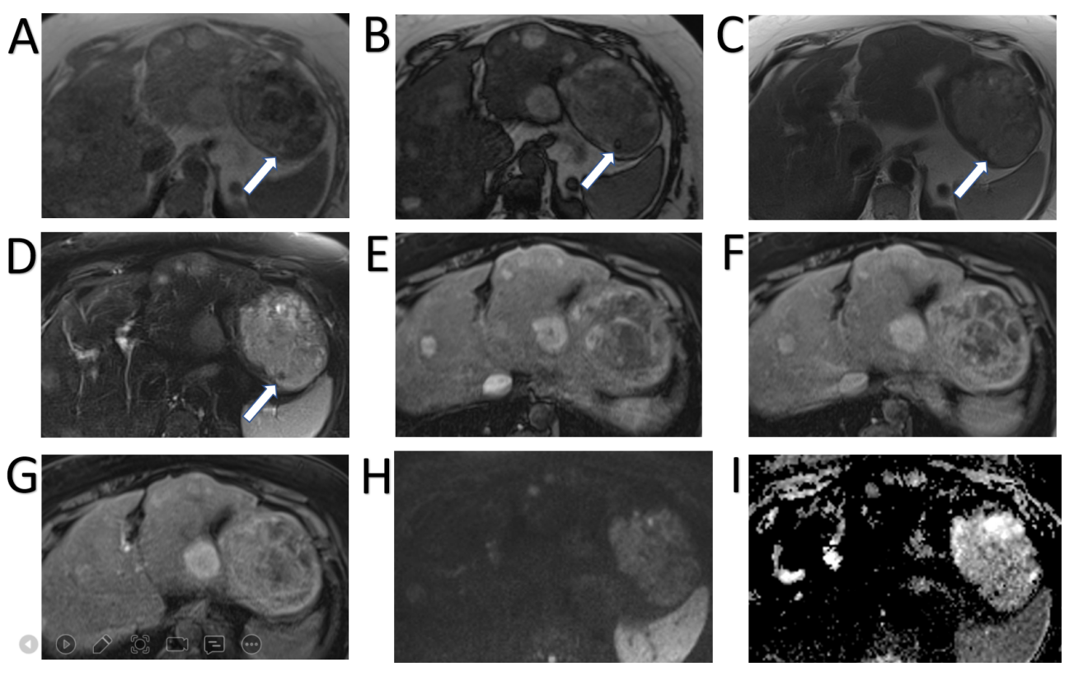
Figure 1 Hepatocellular adenoma. A 42-year-old lady with congenital absence of portal vein and history of use of oral contraceptive medication presented with worsening jaundice. She underwent computed tomography that demonstrated multiple liver lesions that could not be characterised and subsequent magnetic resonance with gadoxetic acid was performed. This demonstrates multiple small lesions showing characteristics those of focal nodular hyperplasia. There is a further exophytic large lesion arising from the left liver lobe. The lesion is well-defined, T2 hyperintense and shows intratumoral fat (arrowed). A: In phase T1; B: Out-of-phase T1; C: T2-weighted imaging (T2-WI); D: Fat suppressed T2-WI; E-G: The arterial (E) and equilibrium (F) phase sequences demonstrates heterogenous enhancement with progressive filling in and there is contrast retention on hepatobiliary phase (G); H and I: Diffusion-weighted imaging (H) and apparent diffusion coefficient (I) sequences show no restricted diffusion. Due to atypical appearances this was resected and histology revealed this to be an adenoma with background steatotic liver.

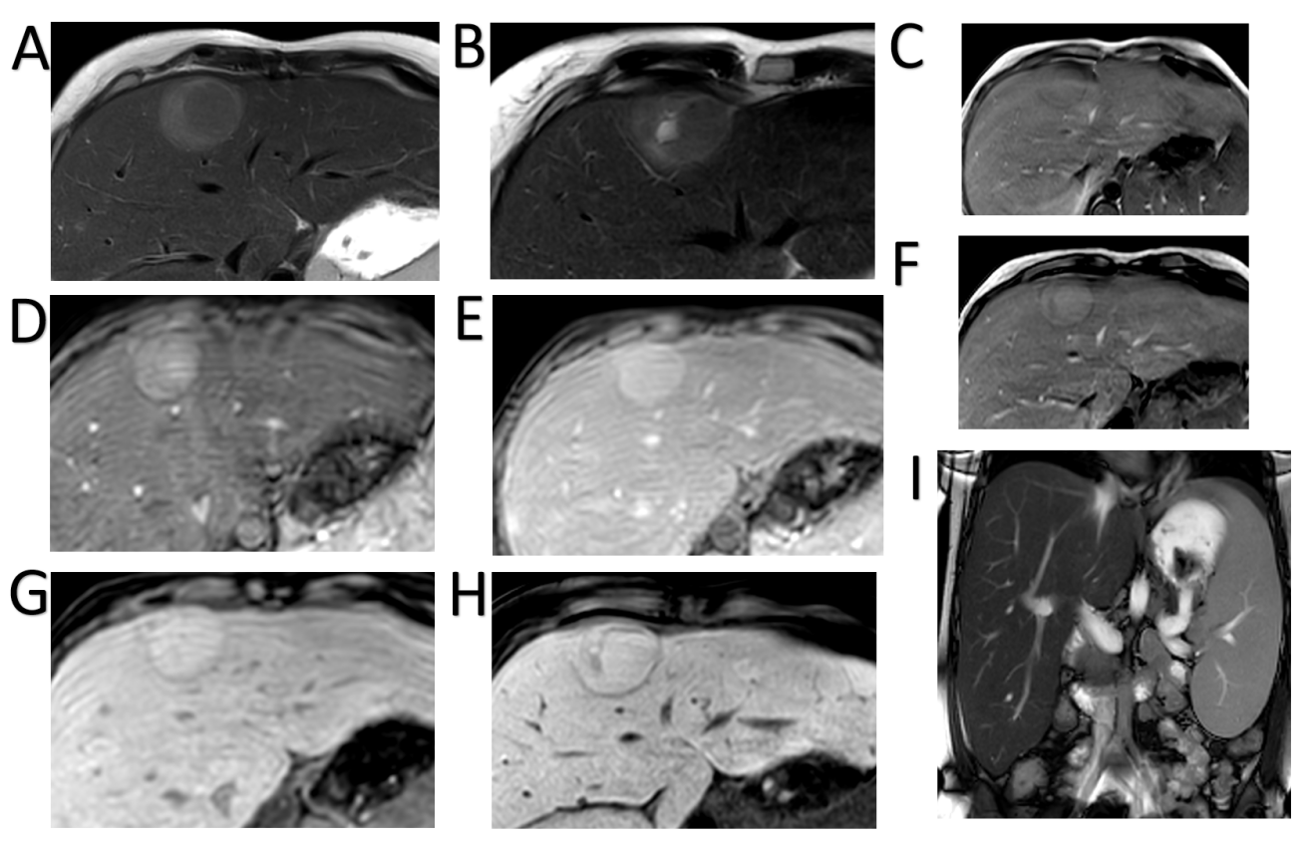
Figure 2 Hepatocellular adenoma. A 27-year-old lady with background of glycogen storage type 1 disease. A and B: Segment IVA liver lesion demonstrating mild T2 hyperintensity with atoll sign (A) and cystic foci (B); C and F: No signal drop out on out-of-phase (F) when compared to in-phase (C) T1-weighted sequence; D, E and G: There is quite homogenous hyperenhancement on arterial phase (D) with no washout on portal venous (E) and delayed (G) phases; H: Hepatobiliary phase shows contrast retention within the lesion; I: Coronal T2-weighted shows hepatosplenomegaly as features of glycogen storage disease type I. The lesion has increased in size and therefore was resected, histology revealed an inflammatory subtype hepatocellular adenoma.

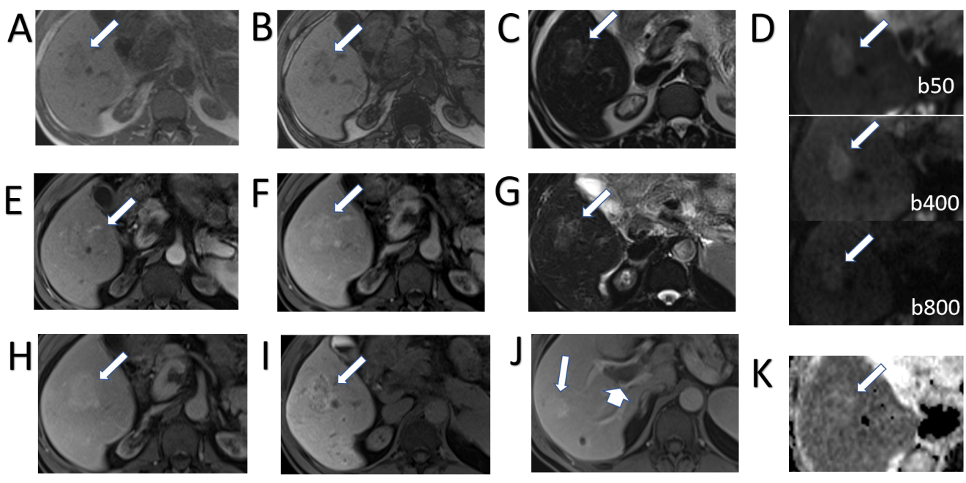
Figure 3 Focal nodular hyperplasia. A 53-year-old woman with background of renal failure with renal transplant and history of autoimmune hepatitis since childhood. She underwent ultrasound (US) of the abdomen after an episode of pancreatitis which identified portal vein thrombosis. Subsequent unenhanced computed tomography (due to poor renal function) demonstrated a liver lesion in segment 5. Initially contrast US was attempted due to renal failure, which showed liver lesions to be multiple, but the lesions were indeterminate and subsequent magnetic resonance with gadoxetic acid was performed. Largest lesion in segment 5 selected as example. A and B: In-(A) and out-(B) of phase imaging shows some signal loss and mildly hypointense T1-weighted signal of the ill-defined right lobe lesion; C and G: T2-weighted without (C) and with fat suppression (G) show mildly hyperintense T2 signal; D and K: Diffusion-weighted imaging (D) and apparent diffusion coefficient (K) images show no diffusion restriction. E, F, and H: There is heterogenous enhancement on arterial phase (E) with no washout and slightly more homogenous contrast enhancement on portal venous (F) and delayed (H) phases; I and J: Heterogenous contrast uptake persists on hepatobiliary phase (I), which is mostly rim-like. Further similar lesion demonstrated on portal venous phase (J) in segment 7 (long arrow) and the known portal vein thrombus (short arrow). Initial radiological diagnosis favoured hepatocellular carcinoma. Liver function tests were normal. Initial non targeted liver biopsy was inconclusive for underlying cirrhosis. Second targeted lesion biopsy was performed. Both specimens were further reviewed in a national liver centre. Histology of the lesion was consistent with focal nodular hyperplasia and background liver demonstrated no cirrhosis, but signs consistent with nodular regenerative hyperplasia.

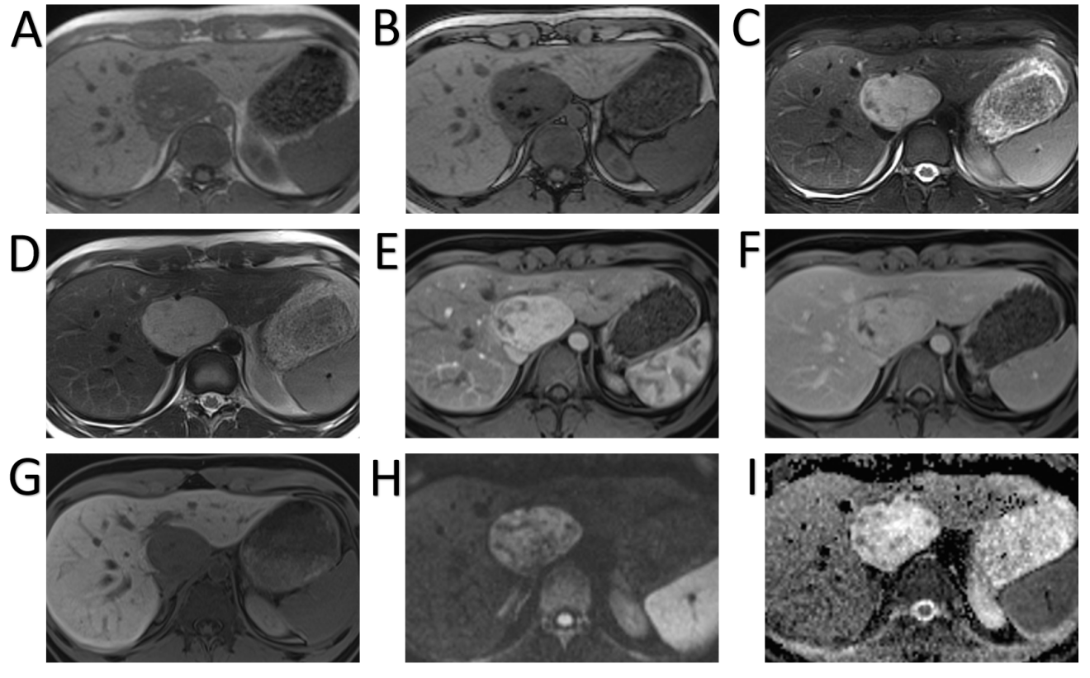
Figure 4 Hepatic angiomyolipoma. A 21-year-old man referred by general practitioner for ultrasound of liver due to 6-mo history of intermittent abdominal pain and isolated raised bilirubin, treated as Gilbert’s syndrome. The patient had no prior medical history, no use of drugs or steroids and was not a heavy drinker. Incidental liver lesion was found and patient underwent subsequent magnetic resonance (MR) with gadoxetic acid to characterise this further. This was initially described as adenoma, but as the lesion increased in size on follow up imaging it was resected. Histology showed this to be an angiomyolipoma. A and B: MR demonstrates well-defined lesion with high signal foci on T1 in-phase (A) showing loss of signal on out-of-phase imaging (B); C and D: There are also hypointense foci on fat suppressed T2-weighted (C) when compared to T2-weighted imaging without fat suppression (D); E and F: The lesion shows enhancement on arterial phase (E) with no washout on equilibrium phase (F) and no pseudocapsule; G: There is no contrast uptake on hepatobiliary phase; H and I: No diffusion restriction as seen on diffusion-weighted imaging (H) and apparent diffusion coefficient (I) sequences.

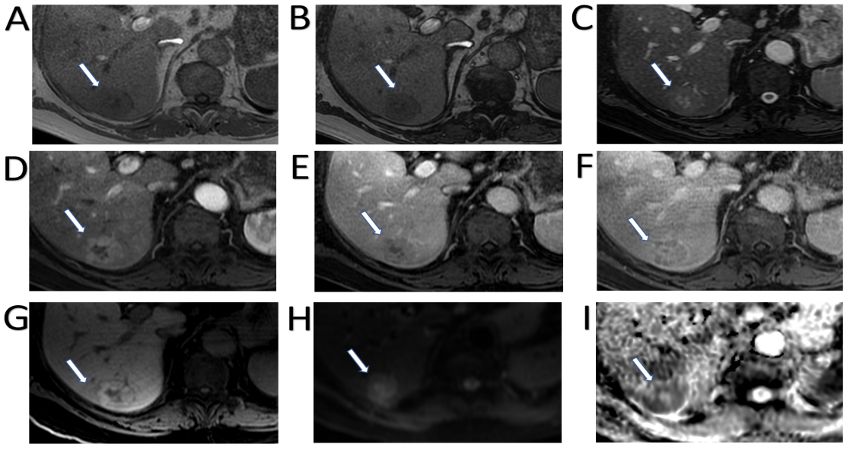
Figure 5 Hepatocellular carcinoma. A 74-year-old man presented with incidental liver lesion found on routine computed tomography colonography. He had normal liver function and alpha-fetoprotein levels. The lesion had undergone further characterisation with magnetic resonance. A and B: There is no evidence of intralesional fat on T1-weighted in-phase (A) and out-of-phase (B) sequences; C: On T2-weighted images, the lesion is nearly isointense to the background liver and shows a hyperintense central scar, which can sometimes be seen in focal nodular hyperplasia; D-F: The lesion then demonstrates enhancement on the arterial phase (D) with evidence of washout as compared to background liver parenchyma on the portal venous (E) and delayed phases (F); there is also subtle peripheral enhancement on the delayed phase, likely representing a capsule, but the central scar remains largely unenhanced throughout; G: Hepatobiliary phase sequence demonstrates uptake of contrast in the majority of the lesion, with no uptake in the central scar and rim; H and I: diffusion-weighted imaging 500 (H) and low apparent diffusion coefficient (I) images suggest areas of diffusion restriction. Due to patient’s age, gender and indeterminate contrast characteristic, the lesion was resected. Histology showed the lesion was a well to moderately differentiated hepatocellular carcinoma. There was no background cirrhosis, but evidence of mild steatosis.

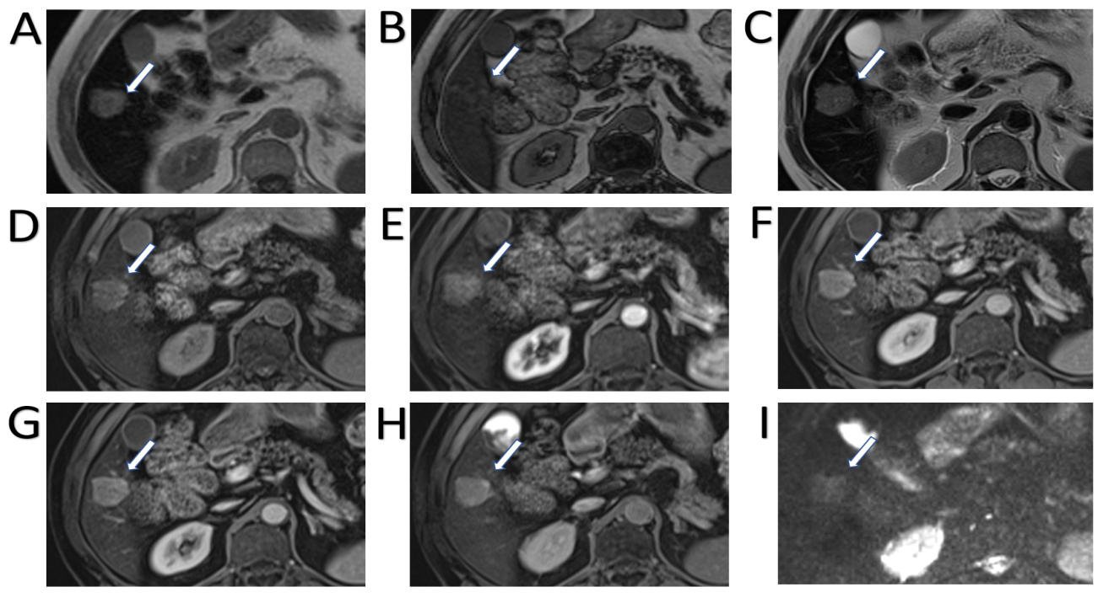
Figure 6 Hepatocellular carcinoma. A 80-year-old man presented with haematuria and was found to have an incidental liver lesion on computed tomography. His liver function tests were normal. A and B: Magnetic resonance demonstrates signal loss throughout the liver, with paradoxical increase in signal on out-of-phase (B) imaging when compared to in-phase (A), suggestive of underlying iron overload; C: Segment 5 liver lesion shows signal loss on out-of-phase sequences suggesting fat contents and is of high T1 and T2 signal; D: Pre-contrast images; E-G: Subtraction sequences were not performed, but allowing for this, there is some enhancement on arterial phase (E), which persists into portal venous (F) and delayed phases (G); H and I: There is contrast retention on hepatobiliary phase (H) and no diffusion restriction (I–b400). Further tests performed confirmed genetic hemochromatosis. Portal venous pressure measurement also showed portal hypertension. Lesional biopsy confirmed this to be a moderately differentiated hepatocellular carcinoma in a background of cirrhosis, which was subsequently ablated.

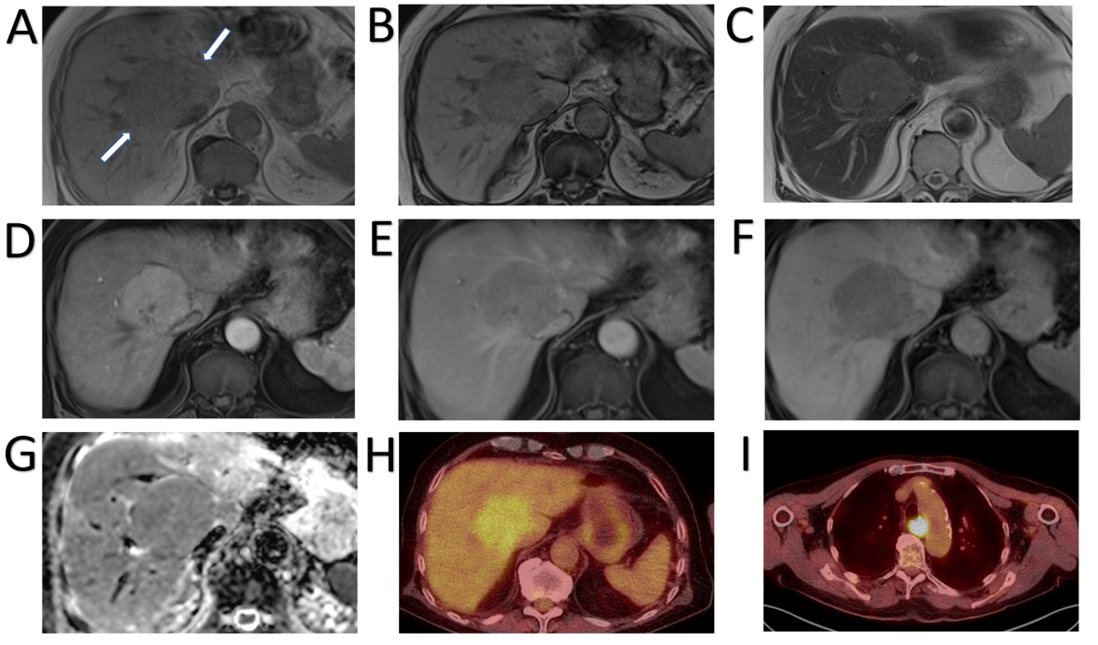
Figure 7 Hepatocellular carcinoma. A 79-year-old with previous prostate cancer has undergone a magnetic resonance (MR) pelvis and was found to have prostatic cancer recurrence and a liver mass. He has undergone staging computed tomography which showed a further area of oesophageal thickening. Endoscopy revealed oesophageal tumour and biopsy confirmed this to be a squamous cell carcinoma. MR liver and positron emission tomography (PET) scan were performed to characterise these and determine whether liver lesion is a metastasis from oesophageal or prostate primary. Alpha-fetoprotein value was 10 at time of diagnosis. A and B: In- (A) and out-of-phase (B) sequences show low T1 signal liver mass with no intratumoral fat; C: It is of mildly high signal on T2 sequences; D and E: There is homogenous arterial enhancement (D) with washout on portal venous (E) phase; F and G: No contrast retention on hepatobiliary phase (F) and isointense to low signal on apparent diffusion coefficient (G); H and I: PET scan shows tracer uptake within the liver lesion (H), however this is of lower standardized uptake value than the oesophageal cancer (I). Targeted liver lesion biopsy confirmed this to be a hepatocellular carcinoma.

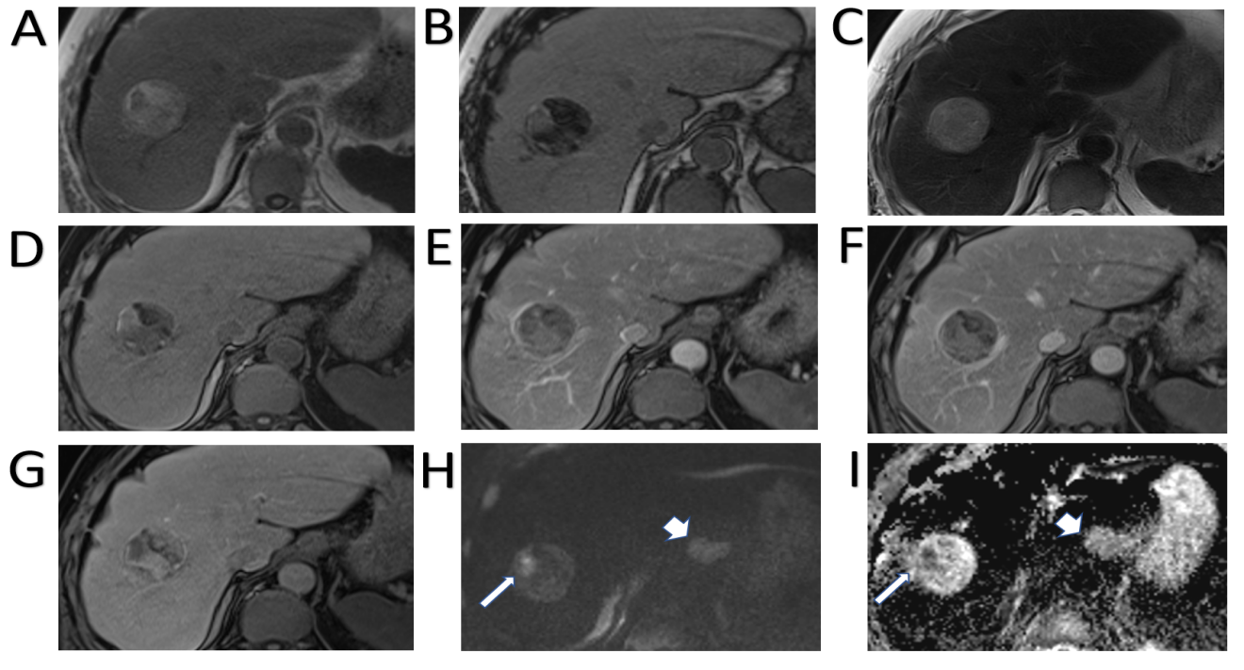
Figure 8 Hepatocellular carcinoma. A 71-year-old underwent computed tomography chest, abdomen and pelvis for anaemia which identified ascending colon thickening and a liver lesion. Colonoscopy confirmed malignant lesion in the ascending colon and histology showed this to be an adenocarcinoma. Magnetic resonance of liver was performed to characterise the liver mass. A and B: This demonstrates a well-defined lesion with the majority of it showing fat component [signal loss on out-of-phase (B) compared to in-phase (A)] except for a small part laterally; C: It is of mildly high signal on T2 sequences; D: Unenhanced sequence; E-G: There are areas of patchy enhancement on arterial (E) and portal venous (F) phases with heterogenous contrast retention on hepatobiliary phase (G); H and I: This part also shows marked diffusion restriction (long arrow, H–diffusion-weighted imaging b800, I–apparent diffusion coefficient). Diffusion sequences also identified a lymph node showing restricted diffusion (short arrow). Subsequent endoscopy was organised which demonstrated an oesophageal lesion, and biopsies of this, and the adjacent lymph node proved it to be a squamous cell carcinoma. Even with two other primaries, the liver lesion was not considered typical for a metastasis radiologically and targeted biopsy was performed. Histology showed well to moderately differentiated hepatocellular carcinoma.

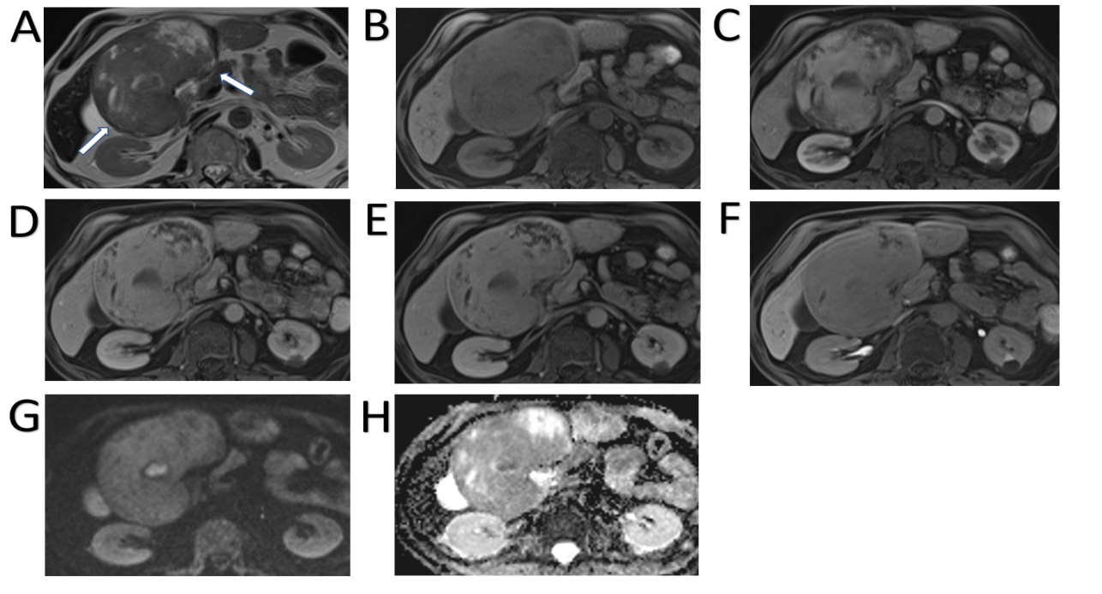
Figure 9 Hepatocellular carcinoma. A 70-year-old man with a transient episode of frank haematuria as part of the investigations into this, was incidentally found to have a large liver mass arising from the left lobe of the liver. He had previous history of tongue cancer. Liver function tests were normal and alpha-fetoprotein was 2 throughout. A: The lesion (arrowed) is mostly hypointense on T2-weighted sequence with heterogenous areas of high signal; B and C: On T1-weighted sequence (B) it shows iso- to hypointense signal and there is heterogenous arterial enhancement (C); D and E: There is some further filling in on portal venous phase (D) where the lesion is now isointense to the liver parenchyma, similarly to delayed phase (E); F: On hepatobiliary phase the mass is hypointense to background liver; G and H: Diffusion-weighted imaging sequence (G) at b value of 800 shows a focal nodule within the lesion that is markedly hyperintense and on apparent diffusion coefficient (H) hypointense in keeping with diffusion restriction. The lesion was resected and histology confirmed moderately differentiated hepatocellular carcinoma.

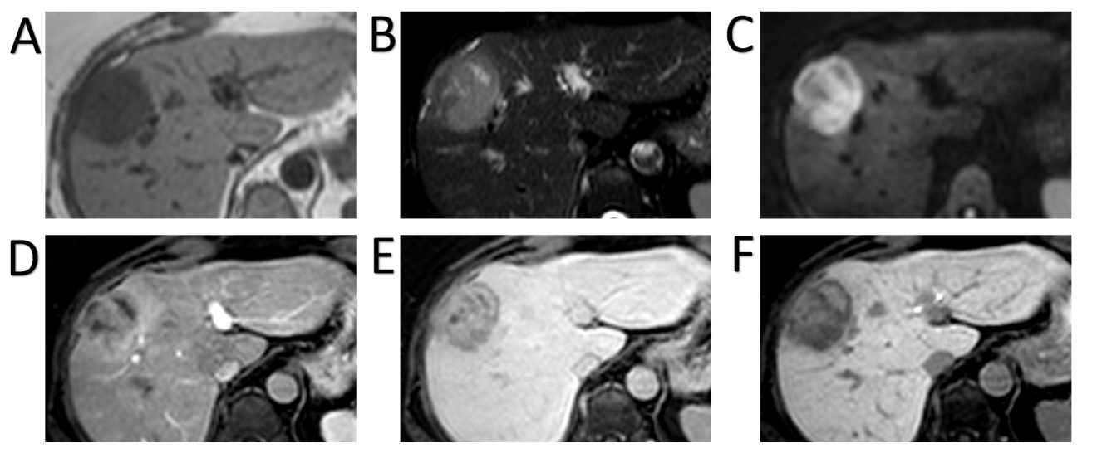
Figure 10 Intrahepatic cholangiocarcinoma. A 64-year-old female with background of hepatitis C cirrhosis was found to have a liver lesion on surveillance ultrasound. Initial magnetic resonance (MR) with extracellular contrast material was reported as likely hepatocellular carcinoma or metastasis. Biopsy confirmed cholangiocarcinoma and gadoxetic acid enhanced MR was organised to exclude satellite lesions and intrahepatic metastases. A-C: MR shows a right liver lobe lesion which is hypointense on T1-weighted imaging (A), hyperintense on T2-weighted imaging (B) and shows diffusion restriction on b800 diffusion-weighted imaging (C); D and E: On arterial phase (D) there is peripheral enhancement with progressive centripetal enhancement on delayed phases (E); F: Hepatobiliary phase shows a hypointense rim with a cloud-like inhomogeneous central enhancement. No further malignant liver lesions demonstrated.

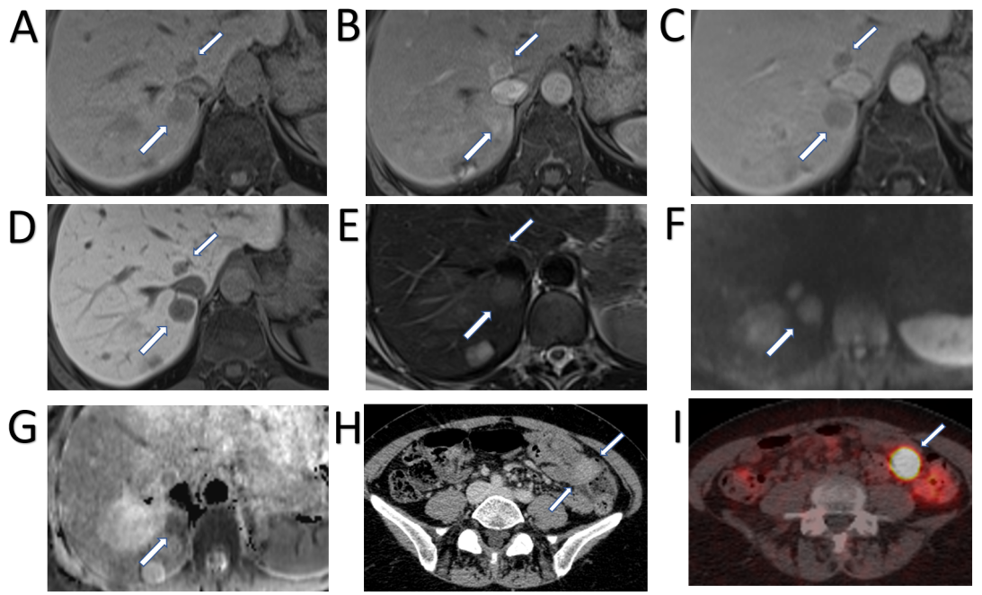
Figure 11 Neuroendocrine carcinoma metastases. A 55-year-old female with anaemia underwent computed tomography (CT) which identified multiple liver lesions. Magnetic resonance liver was performed and confirmed multiple haemangiomas and few other lesions, two of which are shown here, showing atypical appearances. A: Pre contrast phase sequence shows two lesions of low signal on either side of the inferior vena cava; B and C: On arterial phase (B) there is enhancement followed by prompt washout on portal venous (C) phase; D: There is no contrast retention on hepatobiliary phase; E: Lesions are nearly isointense to liver on T2-weighted sequence; F and G: Diffusion weighted imaging (F) at b800 shows hyperintense signal followed by low signal on apparent diffusion coefficient (G) in keeping with diffusion restriction. The nature of these was not clear, but they were suspicious for hypervascular metastases. The patient underwent a number of investigations including oesophago-gastro-duodenoscopy, colonoscopy, CT chest, abdomen and pelvis and an ultrasound scan of pelvis. None of these investigations have identified a primary source of the liver lesions. Targeted liver biopsy was performed and histology revealed well differentiated neuroendocrine carcinoma (Ki-67 = 4%); H: In retrospect, there was an enhancing lesion within the small bowel also present on previous CT; I: Subsequent Ga68-Dotatoc positron emission tomography-CT was performed which confirmed uptake within the small bowel consistent with primary tumour.
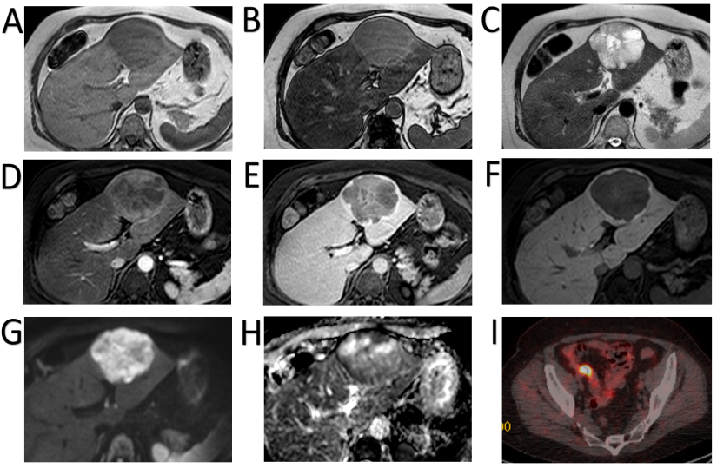
Figure 12 Neuroendocrine carcinoma metastases. A 59-year-old female was found to have a few liver lesions, the dominant lesion in the left lobe demonstrated here. A and B: In-phase (A) and out-of-phase (B) sequences show background hepatic steatosis, but no tumoral fat; C: The lesion shows heterogenous high T2 signal; D and E: There is mainly peripheral enhancement on the arterial phase (D) with washout on delayed phase (E). Delayed phase also shows an enhancing capsule; F: On hepatobiliary phase there is no contrast retention within the lesion except for the thin-rim of presumed capsule; G and H: There is high signal on diffusion weighted imaging b500 (G) with low signal seen on apparent diffusion coefficient (H), especially in the periphery. The other smaller lesions (not demonstrated here) showed similar signal characteristics. Initial staging computed tomography showed no primary tumour to suggest this is metastasis. The lesions were resected and histology confirmed low grade neuroendocrine tumour, with Ki-67 proliferation index of less than 1%; I: The patient underwent subsequent positron emission tomography scan that demonstrated the primary in the distal ileum.

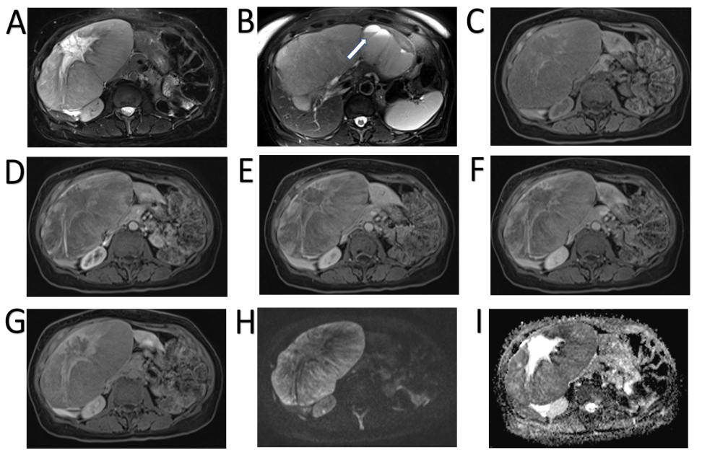
Figure 13 Neuroendocrine carcinoma. A 69-year-old female was found to have incidental large liver lesions in a non-cirrhotic liver while undergoing magnetic resonance (MR) pelvis for a uterine lesion, presumed to be fibroid. A: MR demonstrated large liver masses, the largest exophytic mass showing intermediate to high T2 signal with a high signal stellate scar; B: One of the lesions in the left liver lobe demonstrates a cystic component with fluid-fluid levels, which was presumed to represent previous haemorrhage; C: Majority of the lesions were of low T1 signal with a few hyperintense flecks surrounding the scar; D-F: There was heterogenous enhancement on arterial phase (D) with no washout demonstrated on portal venous (E) and delayed (F) phases; G: Hepatobiliary phase showed no contrast retention within the lesion except for the central scar; H and I: Diffusion weighted imaging at b800 (H) and apparent diffusion coefficient (I) show areas of diffusion restriction. These were biopsied and histology demonstrated well differentiated neuroendocrine carcinoma. The origin of this was not determinable from the immunohistochemical pattern. Overall, this was favoured to represent a primary neuroendocrine tumour of the liver as further imaging did not reveal another primary (although admittedly biopsy of the uterine lesion, radiologically presumed fibroid, was never performed). The patient represented a month later with haemorrhagic brain metastases.

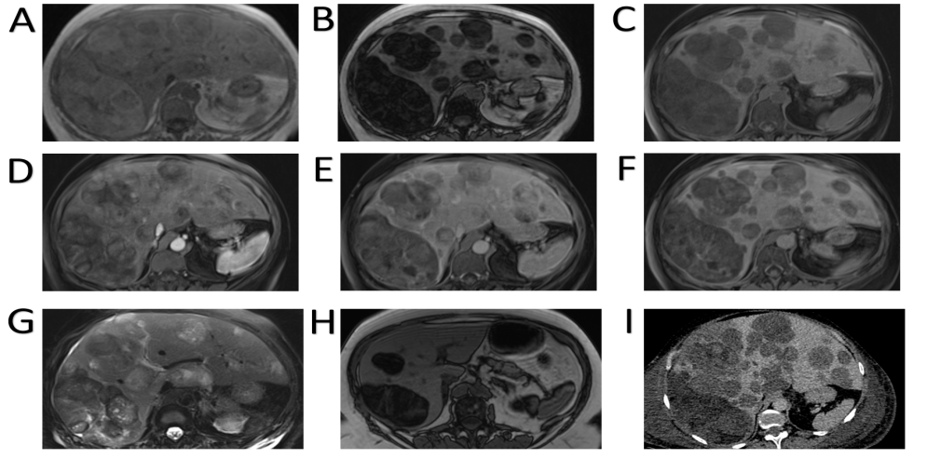
Figure 14 Pleomorphic liposarcoma. A 54-year-old underwent routine ultrasound for re-assessment of gallbladder polyps seen a year ago. Ultrasound revealed multiple liver lesions not present previously and magnetic resonance (MR) of the liver was organised. This showed multiple fat containing liver lesions favoured to represent adenomas. The patient was not on any steroid medication at the time and had no other risk factors for hepatocellular adenoma. A-G: She represented 3 mo later with right sided chest pain and computed tomography (CT) pulmonary angiogram demonstrated increase in the size and number of liver lesions, at which point a second MR liver with gadoxetic acid was performed and is shown here; A-C: MR shows multiple bilobar liver lesions of low T1 signal (C) and predominantly fat component as demonstrated by signal loss on out-of-phase sequence (B) when compared to in-phase (A); D and E: Arterial (D) and delayed phase (E) sequences show a few heterogenous areas of hyperenhancement some of which washout; F: Majority of the lesions did not retain contrast on hepatobiliary phase with only the larger lesions showing some areas of uptake, predominantly within septations; G: T2-weighted sequence (G) shows the lesions are heterogenous and of varied signal intensity; H: Image H demonstrated out-of-phase sequence on the MR performed 3 mo prior for comparison of lesion burden increase in the interim; I: demonstrates portal venous phase CT performed 1 mo since the second MR, again showing quick interval increase in size and number of the lesions. Targeted liver biopsy was performed which confirmed pleomorphic liposarcoma.

Published by Baishideng Publishing Group Inc
7041 Koll Center Parkway, Suite 160, Pleasanton, CA 94566, USA
Telephone: +1-925-3991568
E-mail: bpgoffice@wjgnet.com
Help Desk: https://www.f6publishing.com/helpdesk
https://www.wjgnet.com

© 2021 Baishideng Publishing Group Inc. All rights reserved.

