Name of Journal: World Journal of Clinical Cases
Manuscript NO: 65537
Manuscript Type: CASE REPORT

Primary hepatic neuroendocrine tumor — ¹⁸F-fluorodeoxyglucose positron emission tomography/computed tomography findings: A case report

Rao YY et al. A case report of PHNET

Yan-Ying Rao, He-Jun Zhang, Xiao-Jiang Wang, Min-Feng Li

Yan-Ying Rao, Min-Feng Li, Department of Radiology, Fujian Cancer Hospital and Fujian Medical University Cancer Hospital, Fuzhou 350000, Fujian Province, China

He-Jun Zhang, Xiao-Jiang Wang, Department of Pathology, Fujian Cancer Hospital and Fujian Medical University Cancer Hospital, Fuzhou 350000, Fujian Province, China

Author contributions: Rao YY proposed the study and wrote the first draft; Wang XJ, Zhang HJ and Li MF analyzed the data; all authors contributed to the design and interpretation of the study and to the preparation of further drafts.

Corresponding author: Yan-Ying Rao, MD, Attending Doctor, Department of Radiology, Fujian Cancer Hospital and Fujian Medical University Cancer Hospital, No. 420 Fuma Road, Jin'an District, Fuzhou 350000, Fujian Province, China. yanying.rao@fjzlhospital.com

Received: March 21, 2021
Revised: May 11, 2021
Accepted: June 1, 2021
Published online:

Abstract
BACKGROUND
Primary hepatic neuroendocrine tumors (PHNETs) are rare hepatic tumors. Their diagnosis, which is based on radiological findings, is difficult.

CASE SUMMARY
We present a case of PHNET in a 79-year-old man with no clinical symptoms. Computed tomography (CT) and 2-Deoxy-2-[fluorine-18] fluorodeoxyglucose positron emission tomography/CT (¹⁸F-FDG PET/CT) were performed for further evaluation. A hypoattenuating mass with rim-like enhancement in segment 6 of the liver was detected on contrast-enhanced CT imaging. Increased uptake was also observed on ¹⁸F-FDG PET/CT. Histopathological and immunohistochemical examinations, which revealed a grade 2 neuroendocrine tumor (NET), confirmed the diagnosis.

CONCLUSION
Diagnosing PHNET is challenging, and must be distinguished from other liver tumors. Metastatic NETs should be excluded.

Key Words: Hepatic tumor; Neuroendocrine; Positron emission tomography; Computed tomography; Case report

Rao YY, Zhang HJ, Wang XJ, Li MF. Primary hepatic neuroendocrine tumor — ¹⁸F-fluorodeoxyglucose positron emission tomography/computed tomography findings: A case report. World J Clin Cases 2021; In press

Core Tip: Primary hepatic neuroendocrine tumors (NETs) are rare hepatic tumors. The diagnosis of these tumors, based on radiological observations, is difficult, and requires distinguishing them from other liver tumors and excluding metastasized NETs. ¹⁸F-fluorodeoxyglucose positron emission tomography/computed tomography is helpful when excluding extrahepatic diseases and evaluating the prognosis. Pathological diagnosis based on histological and immunohistochemical evaluation is regarded as the standard diagnosis. Complete surgical resection is the only curative option. For inoperable cases, transarterial chemoembolization, chemotherapy, and radiofrequency ablation are alternative treatment methods.
INTRODUCTION
Neuroendocrine tumors (NETs) are relatively rare. Their incidence in the general population depends on the speciﬁc anatomic location. NETs can arise at almost any anatomical site of the body, and it most commonly develops in the gastrointestinal tract and bronchopulmonary system (73.7% and 25.1%, respectively)^{[1]}. Metastases are the most common diagnostic considerations for hepatic NETs^{[2]}. Primary hepatic NETs (PHNETs) are rare, with a low incidence of 0.3% among all NET cases^{[3]}. Little is known about it because of its rarity. We present the case of a patient with PHNET who underwent 2-deoxy-2-[fluorine-18] fluorodeoxyglucose positron emission tomography/computed tomography (¹⁸F-FDG PET/CT).

CASE PRESENTATION
Chief complaints
A 79-year-old man presented to our hospital with an incidentally identified liver mass during a routine health checkup.

History of present illness
The patient had no clinical symptoms, such as nausea, vomiting, fever, flushing, or abdominal pain.

History of past illness
The patient had a 10-year history of diabetes.

Personal and family history
The patient had no remarkable family history.

Physical examination
The physical examination revealed no abnormal findings.

Laboratory examinations
The blood serum levels of CEA (5.4 ng/mL; reference range 0-4.7), CA19-9 (52.4 U/mL; reference range 0-27), and CA12-5 (141 U/mL; reference range 0-35) were elevated. The alpha fetoprotein serum level was normal.

Imaging examinations
CT and ¹⁸F-FDG PET/CT demonstrated a solitary mass measuring 40 mm × 37 mm in the liver's right lower lobe. Multidetector abdominal CT showed a well-circumscribed, heterogeneous, hypoattenuating mass. After contrast material was injected, the tumor was less enhanced than the adjacent normal liver with mild to moderate peripheral enhancement during the arterial, portal venous, and equilibrium phases (Figure 1). No cirrhosis was observed. ¹⁸F-FDG PET/CT images were obtained using a Gemini TF 64 PET/CT scanner (Philips, The Netherlands). ¹⁸F-FDG PET/CT showed increased uptake in the liver mass with a SUV_{max} of 5.1. The SUV_{max} of the liver background was 2.0 (Figure 2). Except for the liver lesion, no extrahepatic abnormal activities were found on whole-body ¹⁸F-FDG PET/CT.

FINAL DIAGNOSIS
An ultrasound-guided liver biopsy was performed. Histological examination demonstrated a well-differentiated neoplasm with the trabecular and glandular architectural pattern. The Ki-67 proliferation index was about 15% in tumor cells. Immunohistochemical staining revealed positive immunoreactivities for CD56, cytokeratin (CK) AE1/AE3, synaptophysin (Syn), and negative immunoreactivities for CDX-2, chromogranin A (CgA), thyroid transcription factor (TTF-1). Histological and immunohistochemical examinations confirmed that the tumor was NET grade 2, based on the World Health Organization 2019 criteria (Figure 3)^{[4]}.

TREATMENT
Due to severe pulmonary dysfunction, the patient could not tolerate surgery. He underwent one course of transcatheter arterial chemoembolization (TACE) with epirubicin (total dose of 50 mg) mixed with gelatin sponge particles and lipiodol. The patient’s blood serum levels of CEA (5.9 ng/mL; reference range 0-4.7), CA19-9 (109.2 U/mL reference range 0-27), and CA12-5 (166 U/mL reference range 0-35) were elevated. Abdominal magnetic resonance images showed no decrease in tumor size. Thus, the patient was treated by three courses of chemotherapy.

OUTCOME AND FOLLOW-UP
Partial response was achieved, and no extrahepatic lesions were radiologically found during the 18-mo follow-up. The patient was finally diagnosed with PHNET.

DISCUSSION
PHNET is a rare NET entity arising from Kulchitsky cells originating from the neural crest^{[2]}. The total number of PHNET reported in the English literature is less than 200^{[5]}. Due to its rarity, the clinical features and image findings are not well understood.
A classification system for neuroendocrine neoplasms (NENs) was established in 2000 and updated in 2019. Based on their molecular differences, NENs are divided into well-differentiated NETs and poorly differentiated neuroendocrine carcinomas^{[1]}. NETs are classified into three grades (G1, G2, and G3) according to their mitotic rate (mitoses/2 mm²) and Ki-67 proliferation index^{[4]}.
PHNETs are considered foregut carcinoid tumors, which typically grow slowly and have no function. They are commonly detected incidentally, occur in patients between 40-50 years of age, and are located in the liver's right lobe^{[2,6]}.
Previous studies have shown that tumor markers such as alpha-fetoprotein, carcinoembryonic antigen, and CA 19-9 have no diagnostic value for PHNET^{[5]}. Imaging examinations, such as ultrasound, CT, and magnetic resonance imaging, also have low sensitivity and specificity for PHNET. Both primary tumors and metastases appear at a low density on plain CT imaging. Hepatic metastases of NETs demonstrate rim enhancement in the arterial phase with washout in the portal venous and equilibrium phases. A similar enhancement is observed in PHNETs^{[3,7]}.
The pathological diagnosis, which is based on histological and immunohistochemical evaluations, is the standard diagnosis. Liver metastases of NETs are more common than PHNETs, and no significant radiological difference is found between them. Thus, diagnosing PHNET is challenging, and metastatic NETs should have been excluded^{[8]}.
In this study, immunohistochemical examinations revealed positive immunoreactivities for CD56, CK AE1/AE3, Syn, which confirmed the tumor was a NEN. Negative expressions of CDX-2 and TTF-1 helped rule out the possibility of small bowel, appendix, lung, and thyroid origins. Thus, we confirmed the diagnosis by histology and imaging methods, such as ¹⁸F-FDG PET/CT.
A previous study investigated the utility of ¹⁸F-FDG PET in patients with NET grades 1 and 2. The results of ¹⁸F-FDG PET examinations were positive in 57% of patients with NET G1, and 66% of patients with NET G2^{[9]}. Sansovini et al^{[10]} demonstrated that patients with negative FDG PET results had better outcomes than those with positive scans. FDG PET was an independent prognostic factor in advanced pancreatic NETs. Binderup et al^{[11]} showed that compared to traditional markers, such as the Ki-67 index, ¹⁸F-FDG PET had a higher prognostic value. Despite its low diagnostic sensitivity, ¹⁸F-FDG PET/CT has a high prognostic value for NETs. Whole-body ¹⁸F-FDG PET/CT is helpful for excluding extrahepatic diseases^{[12]}.
Complete surgical resection is the only curative option, and it results in a 5-year survival rate of 74%-78%. Up to 85% of tumors are resectable^{[3,13]}. Alternative treatment methods for inoperable cases include TACE, chemotherapy, and radiofrequency ablation. Yao et al^{[14]} reported that hepatic chemoembolization for NETs effectively improved clinical symptoms and achieved tumor control. In our case, the patient had severe pulmonary dysfunction, and surgery was not considered. Therefore, the patient received TACE with epirubicin. After one course of TACE, no decrease of the tumor size was observed, and the patient’s serum levels of CEA, CA19-9, and CA12-5 were increased. The ENETS consensus Guideline for the standards of care in NEN suggests that chemotherapy might be considered in NETs of other sites (lung, stomach, colon, etc.) when the Ki-67 is at a high level (upper G2 range) or after failure of other therapies^{[15]}. Under these circumstances, the patient received three courses of chemotherapy, and partial response was achieved.

CONCLUSION
In conclusion, PHNET is a rare liver tumor that presents with nonspecific clinical symptoms. Its diagnosis should be made based on immunohistochemistry findings, and metastatic NETs need to be excluded. ¹⁸F-FDG PET/CT can help exclude extrahepatic lesions. Surgical resection is the curative treatment, but other methods, such as TACE, can be administered in patients with unresectable PHNET.

REFERENCES
1 Rindi G, Klimstra DS, Abedi-Ardekani B, Asa SL, Bosman FT, Brambilla E, Busam KJ, de Krijger RR, Dietel M, El-Naggar AK, Fernandez-Cuesta L, Klöppel G, McCluggage WG, Moch H, Ohgaki H, Rakha EA, Reed NS, Rous BA, Sasano H, Scarpa A, Scoazec JY, Travis WD, Tallini G, Trouillas J, van Krieken JH, Cree IA. A common classification framework for neuroendocrine neoplasms: an International Agency for Research on Cancer (IARC) and World Health Organization (WHO) expert consensus proposal. Mod Pathol 2018; 31: 1770-1786 [PMID: 30140036 DOI: 10.1038/s41379-018-0110-y]
2 Baxi AJ, Chintapalli K, Katkar A, Restrepo CS, Betancourt SL, Sunnapwar A. Multimodality Imaging Findings in Carcinoid Tumors: A Head-to-Toe Spectrum. Radiographics 2017; 37: 516-536 [PMID: 28287937 DOI: 10.1148/rg.2017160113]
3 Shah D, Mandot A, Cerejo C, Amarapurkar D, Pal A. The Outcome of Primary Hepatic Neuroendocrine Tumors: A Single-Center Experience. J Clin Exp Hepatol 2019; 9: 710-715 [PMID: 31889752 DOI: 10.1016/j.jceh.2019.08.002]
4 Nagtegaal ID, Odze RD, Klimstra D, Paradis V, Rugge M, Schirmacher P, Washington KM, Carneiro F, Cree IA; WHO Classification of Tumours Editorial Board. The 2019 WHO classification of tumours of the digestive system. Histopathology 2020; 76: 182-188 [PMID: 31433515 DOI: 10.1111/his.13975]
5 Li YF, Zhang QQ, Wang WL. Clinicopathological Characteristics and Survival Outcomes of Primary Hepatic Neuroendocrine Tumor: A Surveillance, Epidemiology, and End Results (SEER) Population-Based Study. Med Sci Monit 2020; 26: e923375 [PMID: 32651994 DOI: 10.12659/MSM.923375]
6 Baek SH, Yoon JH, Kim KW. Primary hepatic neuroendocrine tumor: gadoxetic acid (Gd-EOB-DTPA)-enhanced magnetic resonance imaging. Acta Radiol Short Rep 2013; 2: 2047981613482897 [PMID: 23986857 DOI: 10.1177/2047981613482897]
7 Wang LX, Liu K, Lin GW, Jiang T. Primary hepatic neuroendocrine tumors: comparing CT and MRI features with pathology. Cancer Imaging 2015; 15: 13 [PMID: 26272674 DOI: 10.1186/s40644-015-0046-0]
8 Ichiki M, Nishida N, Furukawa A, Kanasaki S, Ohta S, Miki Y. Imaging findings of primary hepatic carcinoid tumor with an emphasis on MR imaging: case study. Springerplus 2014; 3: 607 [PMID: 25392779 DOI: 10.1186/2193-1801-3-607]
9 Severi S, Nanni O, Bodei L, Sansovini M, Ianniello A, Nicoletti S, Scarpi E, Matteucci F, Gilardi L, Paganelli G. Role of 18FDG PET/CT in patients treated with 177Lu-DOTATATE for advanced differentiated neuroendocrine tumours. Eur J Nucl Med Mol Imaging 2013; 40: 881-888 [PMID: 23443937 DOI: 10.1007/s00259-013-2369-z]
10 Sansovini M, Severi S, Ianniello A, Nicolini S, Fantini L, Mezzenga E, Ferroni F, Scarpi E, Monti M, Bongiovanni A, Cingarlini S, Grana CM, Bodei L, Paganelli G. Long-term follow-up and role of FDG PET in advanced pancreatic neuroendocrine patients treated with 177Lu-D OTATATE. Eur J Nucl Med Mol Imaging 2017; 44: 490-499 [PMID: 27704193 DOI: 10.1007/s00259-016-3533-z]
11 Binderup T, Knigge U, Loft A, Federspiel B, Kjaer A. 18F-fluorodeoxyglucose positron emission tomography predicts survival of patients with neuroendocrine tumors. Clin Cancer Res 2010; 16: 978-985 [PMID: 20103666 DOI: 10.1158/1078-0432.CCR-09-1759]
12 Mitamura K, Yamamoto Y, Tanaka K, Sanomura T, Murota M, Nishiyama Y. (18)F-FDG PET/CT Imaging of Primary Hepatic Neuroendocrine Tumor. Asia Ocean J Nucl Med Biol 2015; 3: 58-60 [PMID: 27408882]
13 Morishita A, Yoneyama H, Nomura T, Sakamoto T, Fujita K, Tani J, Miyoshi H, Haba R, Masaki T. Primary hepatic neuroendocrine tumor: A case report. Mol Clin Oncol 2016; 4: 954-956 [PMID: 27284429 DOI: 10.3892/mco.2016.822]
14 Yao KA, Talamonti MS, Nemcek A, Angelos P, Chrisman H, Skarda J, Benson AB, Rao S, Joehl RJ. Indications and results of liver resection and hepatic chemoembolization for metastatic gastrointestinal neuroendocrine tumors. Surgery 2001; 130: 677-682; discussion 682-685 [PMID: 11602899 DOI: 10.1067/msy.2001.117377]
15 Garcia-Carbonero R, Rinke A, Valle JW, Fazio N, Caplin M, Gorbounova V, O Connor J, Eriksson B, Sorbye H, Kulke M, Chen J, Falkerby J, Costa F, de Herder W, Lombard-Bohas C, Pavel M; Antibes Consensus Conference participants. ENETS Consensus Guidelines for the Standards of Care in Neuroendocrine Neoplasms. Systemic Therapy 2: Chemotherapy. Neuroendocrinology 2017; 105: 281-294 [PMID: 28380493 DOI: 10.1159/000473892]

Footnotes
Informed consent statement: Written informed consent was obtained from the patient for publication of this manuscript and any accompanying images.

Conflict-of-interest statement: The authors declare that they have no conflict of interest.

CARE Checklist (2016) statement: The authors have read the CARE Checklist (2016), and the manuscript was prepared and revised according to the CARE Checklist (2016).

Open-Access: This article is an open-access article that was selected by an in-house editor and fully peer-reviewed by external reviewers. It is distributed in accordance with the Creative Commons Attribution NonCommercial (CC BY-NC 4.0) license, which permits others to distribute, remix, adapt, build upon this work non-commercially, and license their derivative works on different terms, provided the original work is properly cited and the use is non-commercial. See: http://creativecommons.org/Licenses/by-nc/4.0/

Manuscript source: Unsolicited manuscript

Peer-review started: March 21, 2021
First decision: April 29, 2021
Article in press:

Specialty type: Medicine, research and experimental
Country/Territory of origin: China
Peer-review report’s scientific quality classification
Grade A (Excellent): 0
Grade B (Very good): 0
Grade C (Good): C
Grade D (Fair): 0
Grade E (Poor): 0

P-Reviewer: Zhang X S-Editor: Gao CC L-Editor: Filipodia P-Editor:

Figure Legends
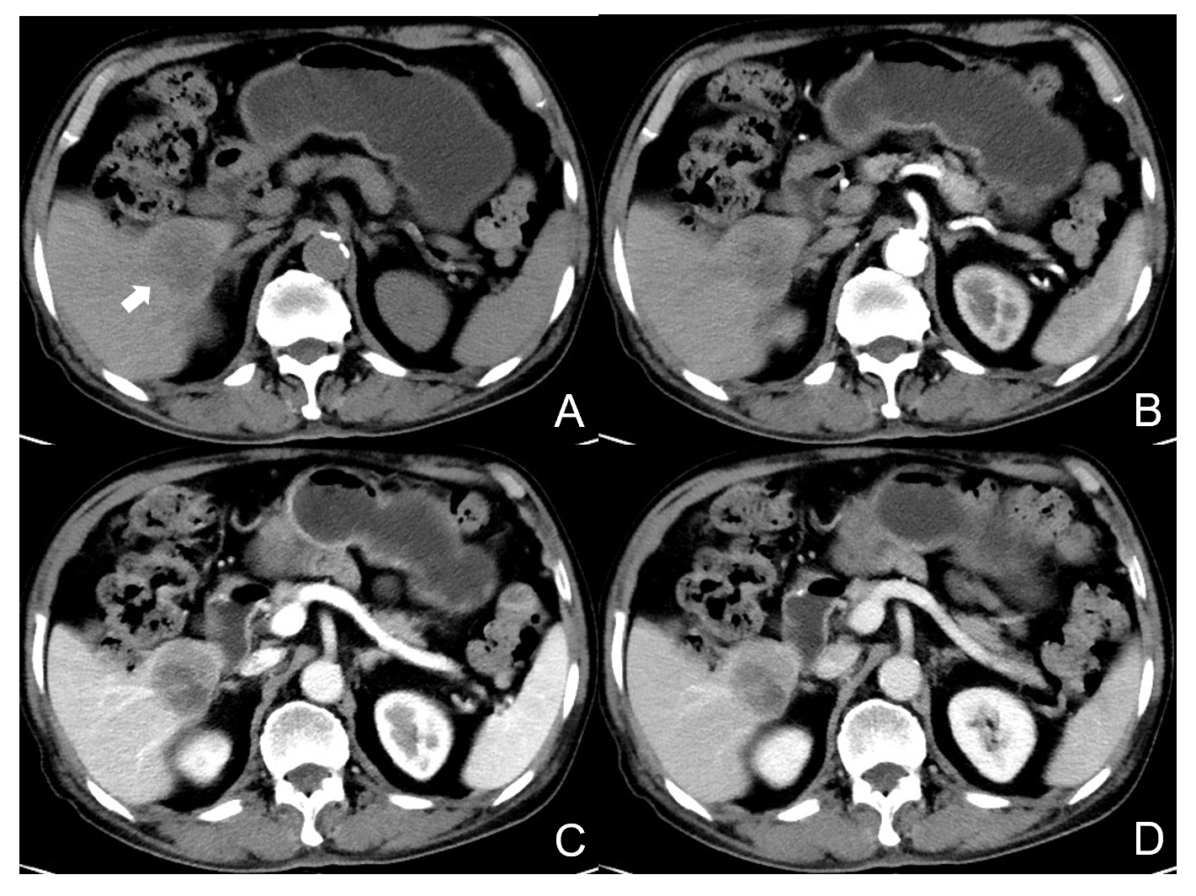
Figure 1 Contrast-enhanced computed tomography images of the tumor. A: Non-contrast-enhanced computed tomography (CT) images reveal a 40 mm × 37 mm, well-circumscribed, heterogeneous hypoattenuating mass in the right lower lobe of the liver (arrow); B-D: Dynamic CT images demonstrate a rim-like enhancement of the tumor in the arterial phase (B); portal venous phase (C); and equilibrium phase (D). The tumor is less enhanced than the adjacent liver.
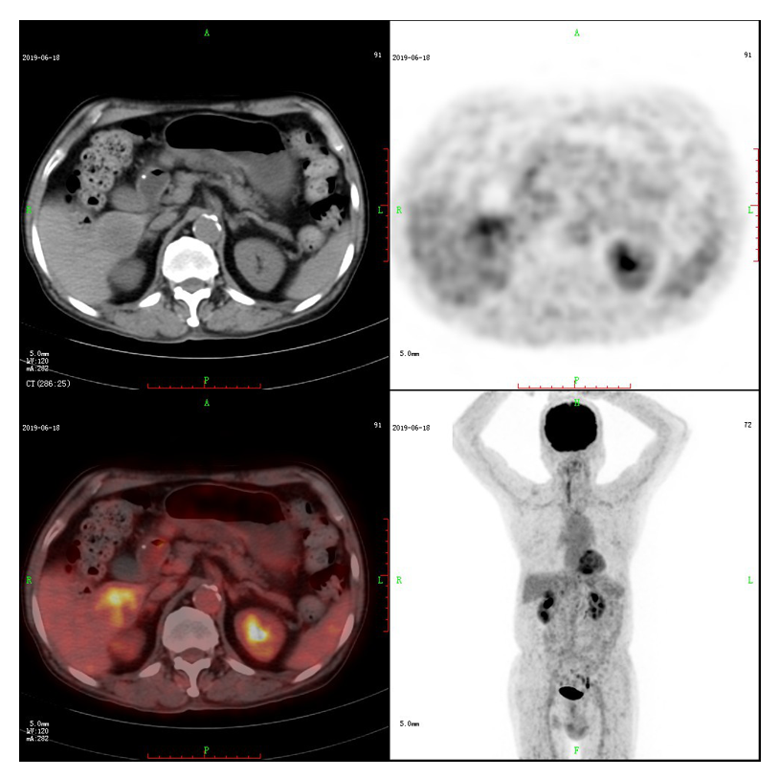
Figure 2 Positron emission tomography (PET) with 2-deoxy-2-[fluorine-18] fluoro-D-glucose images. On ¹⁸F-positron emission tomography/computed tomography imaging, the tumor shows increased uptake with a SUV_{max} of 5.1. Whole-body 2-deoxy-2-[fluorine-18] fluoro-D-glucose positron emission tomography reveals no abnormal extrahepatic activities.
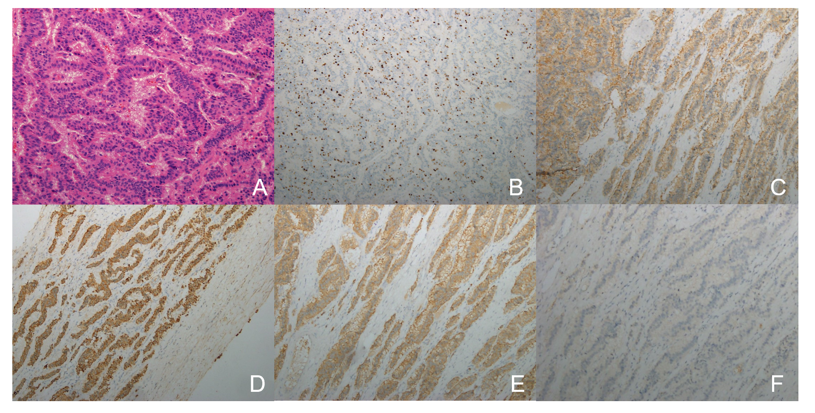
Figure 3 Pathological findings. A: Hematoxylin and eosin-stained sections (× 200 magnification) demonstrate a well-differentiated neoplasm with the trabecular and glandular architectural pattern; B: The Ki-67 proliferation index (× 100 magnification) is 15% in tumor cells; C-F: Immunohistochemical staining (× 100 magnification) reveals positive immunoreactivities for CD56 (C), cytokeratin AE1/AE3 (D), synaptophysin (E), and negative immunoreactivity for chromogranin A (F), respectively.

