Name of Journal: World Journal of Clinical Cases
Manuscript NO: 55349
Manuscript Type: CASE REPORT

Headache and sick sinus syndrome: A case report

Bi YC et al. Headache and sick sinus syndrome

You-Cai Bi, Liang Gong

You-Cai Bi, Department of Neurology, Zigong Fourth People’s Hospital, Zigong 643000, Sichuan Province, China

Liang Gong, Department of Neurology, Chengdu Second People’s Hospital, Chengdu 650017, Sichuan Province, China

Author contributions: Bi YC designed and summarized the literature, drafted and wrote the manuscript; Gong L revised the manuscript critically for intellectual content; All authors provided intellectual input to the study and approved the final version of the manuscript.

Supported by the Sichuan Science and Technology Program, No. 2020YJ0197; and the Chengdu Medical Research Project, No. 2019115.

Corresponding author: Liang Gong, MD, PhD, Assistant Professor, Doctor, Department of Neurology, Chengdu Second People’s Hospital, No. 10, Qinyunnan Road, Chengdu 650017, Sichuan Province, China. cd2gongliang@126.com

Received: March 16, 2020
Revised: May 12, 2020
Accepted: June 3, 2020
Published online:
Abstract
BACKGROUND
Sick sinus syndrome is a common disease in cardiology. Typical symptoms include palpitations, dizziness, shortness of breath, chest tightness, and amaurosis. However, to date, there are no known reports of sick sinus syndrome presenting with headache. Whether there is a correlation between headache and sick sinus syndrome merits further research. In this report, we describe a case of headache induced by sick sinus syndrome.

CASE SUMMARY
A 73-year-old female patient presented to our department with the chief complaint of recurrent paroxysmal headache for more than 7 years. The patient described paroxysmal palpations, usually headache occurring after palpitation. Her blood pressure was normal when the most recent headache occurred. A magnetic resonance imaging study and magnetic resonance angiography of the head at another center were normal. A clinical neurological examination was negative. A 24-h Holter electrocardiogram monitoring study showed sick sinus syndrome. The patient received dual chamber pacing implantation and was administered drug therapy to control ventricular rate. The patient’s paroxysmal headaches and palpitations had resolved within 1 year, confirmed via a follow-up telephone call.

CONCLUSION
After dual-chamber pacing implantation and drug therapy administration to control the ventricular rate, the patient’s paroxysmal headaches and palpitations had resolved within 1 year, confirmed via a follow-up telephone call. We believe that the headaches were related to the patient’s sick sinus syndrome.

Key words: Headache; Palpitations; Sick sinus syndrome; Differential diagnosis; Case report; Electrocardiogram

Bi YC, Gong L. Headache and sick sinus syndrome: A case report. World J Clin Cases 2020; In press

Core tip: We report a patient who had headaches induced by sick sinus syndrome. To the best of our knowledge, this finding has not been previously reported. It provides new ideas for clinical diagnosis and treatment of both headache and sick sinus syndrome in the future.

INTRODUCTION
Headache is a common neurological symptom with a multitude of different causes such as intracranial hemorrhage, infection, and migraine. Sick sinus syndrome is an arrhythmia phenotype attributed to sinus node dysfunction. The clinical symptoms of sick sinus syndrome include palpitations, dizziness, chest tightness, weakness, shortness of breath, amaurosis, and Adams-Stokes syndrome, among others. In this report, we describe a case of headache induced by sick sinus syndrome.

CASE PRESENTATION
Chief complaints
On July 30, 2018, a 73-year-old female patient presented to our department with the chief complaint of recurrent paroxysmal headache for more than 7 years.

History of present illness
The headaches lasted from minutes to hours, and presented with moderate swelling and recurrent paroxysmal pain through the whole brain. The patient had paroxysmal palpations as well, usually followed by the headache episodes. However, headaches did not always occur every time after palpations. The patient’s blood pressure was normal when the headaches occurred.

History of past illness
The patient has documented hypertension and type 2 diabetes, although blood pressure and glucose were well managed.

Personal and family history
The patient’s family history was unremarkable.

Physical examination
The patient′s heart auscultation was absolutely arrhythmic, heart sound intensities differed, and her pulse was deficient. Her blood pressure was 132/75 mmHg. The clinical neurological examination was negative.

Laboratory examinations
The patient′s thyroid function was normal. The liver and kidney function examination was also negative.

Imaging examinations
A magnetic resonance imaging study and magnetic resonance angiography of the head performed at another center were normal (Figure 1).

Electrocardiogram findings
The 24-h Holter electrocardiogram (ECG) monitoring study showed sinus bradycardia, sinus pause, AV junctional escape beats, ventricular escape, paroxysmal atrial flutter, and paroxysmal atrial fibrillation. The longest RR interval was 5.952 s (Figure 2).

FINAL DIAGNOSIS
We arrived at a final diagnosis of sick sinus syndrome.

TREATMENT
The patient received dual-chamber pacing implantation on August 6, 2018. The patient was prescribed Metoprolol Succinate Sustained-Release Tablets 47.5 mg twice a day and Amiodarone Hydrochloride Tablets once a day to control ventricular rate.

OUTCOME AND FOLLOW-UP
The patient’s paroxysmal headaches and palpitations had resolved within 1 year, confirmed by a follow-up telephone call. The ECG was normal after implantation of dual-chamber pacing (Figure 3).

DISCUSSION
In this case, the organic lesion had not been considered when auxiliary examinations and a clinical neurological examination were both negative. Migraine was not considered on account of the patient’s age. When the patient described headaches following palpitations, we hypothesized that the headaches may have been related to an arrhythmia. After dual-chamber pacing implantation and pharmaceutical anti-arrhythmic therapy, the patient was followed up via a telephone call at 1 year. At that time, the patient reported resolution of her symptoms. Therefore, we believe that her headaches were related to sick sinus syndrome.
Common mechanisms of headache include: (1) constriction, dilatation and extension of intracranial blood vessels caused by various pathologies; (2) cranial and cervical nerve stimulation; (3) elevated resting tension of the head and neck muscles; (4) ophthalmologic and otorhinolaryngologic disorders, and cervical spine disease; (5) biochemical factors and endocrine disorders; and (6) neurological disorders.
The incidence of headache as a symptom of sick sinus syndrome was not definite. No similar report was found in the literature.
Asvestas et al^{[1]} reported a case of headache as a primary symptom of acute myocardial infarction. Huang et al^{[2]} reported a similar case of a patient, who had been diagnosed with myocardial infarction and complained of headache without chest discomfort. Furthermore there have been multiple case reports of headache as the sole or cardinal symptom of myocardial infarction^{[3-6]}. Thus, the concept of headache being induced by cardiac factors has been presented.
Cardiac cephalgia is defined in The International Classiﬁcation of Headache Disorders: 2nd edition^{[7]} and The International Classification of Headache Disorders: 3rd edition^{[8,9]}.
There are four theories regarding the proposed pathogenesis of cardiac cephalgia. First, the heart is mediated by the autonomic nerve, visceral, and somatic fibers, which can converge on the same neurons in the spinal cord. Then the information induced by visceral afferents is relayed to the higher somatic region. Second, the reduction of cardiac output elevates left ventricular and right atrial pressure, which decreases cerebral venous refluxing and elevates intracranial pressure^{[10,11]}. Third, neurochemical mediators produced by myocardial ischemia can induce vasodilatation of the cerebral vessels and pain^{[10,11]}. Fourth, it is assumed that vasospasms can concomitantly occur in both coronary and cerebral vessels^{[10,12]}.
In this case, we hypothesized that arrhythmia led to myocardial ischemic and reduction of cardiac output. As a result of the arrhythmias, headache could be induced by stimulating visceral nerves and neurochemical mediators because of myocardial ischemia, and could also be induced by elevated intracranial pressure because of the reduction of cardiac output. Unfortunately, we did not monitor the variation of this patient’s cardiac output; thus, the possibility of other causes remains to be considered.

CONCLUSION
This case provides two novel insights. First, clinicians should pay close attention to predisposing symptoms and conditions. Second, it appears that arrhythmias can cause headaches.

ACKNOWLEDGEMENTS
We thank the cardiologist for the expiation for the ECG.

References
1 Asvestas D, Vlachos K, Salachas A, Letsas KP, Sideris A. Headache: An unusual presentation of acute myocardial infraction. World J Cardiol 2014; 6: 514-516 [PMID: 24976924 DOI: 10.4330/wjc.v6.i6.514]
2 Huang CC, Liao PC. Heart Attack Causes Head-Ache - Cardiac Cephalalgia. Acta Cardiol Sin 2016; 32: 239-242 [PMID: 27122955 DOI: 10.6515/acs20150628a]
3 Dell'Aquila A, Sciatti E, Vizzardi E, Metra M. The brain-heart connection: a multiple sclerosis relapse presenting as Takotsubo Syndrome. A case report and literature review. Monaldi Arch Chest Dis 2020; 90 [PMID: 32241096 DOI: 10.4081/monaldi.2020.1153]
4 Chowdhury AW, Saleh MAD, Hasan P, Amin MG, Khan TA, Sabah KMN, Kabir SR. Cardiac cephalgia: A headache of the heart. J Cardiol Cases 2015; 11: 139-141 [PMID: 30546551 DOI: 10.1016/j.jccase.2015.02.002]
5 Wassef N, Ali AT, Katsanevaki AZ, Nishtar S. Cardiac Cephalgia. Cardiol Res 2014; 5: 195-197 [PMID: 28352454 DOI: 10.14740/cr361w]
6 MacIsaac R, Jarvis S, Busche K. A Case of a Cardiac Cephalgia. Can J Neurol Sci 2019; 46: 124-126 [PMID: 30520397 DOI: 10.1017/cjn.2018.377]
7 Headache Classification Subcommittee of the International Headache Society. The International Classification of Headache Disorders: 2nd edition. Cephalalgia 2004; 24 Suppl 1: 9-160 [PMID: 14979299 DOI: 10.1111/j.1468-2982.2003.00824.x]
8 Headache Classification Committee of the International Headache Society (IHS) The International Classification of Headache Disorders, 3rd edition. Cephalalgia 2018; 38: 1-211 [PMID: 29368949 DOI: 10.1177/0333102417738202]
9 He L, Cheng GS, Du YJ, Zhang YS. Clinical relevance of atrial septal aneurysm and patent foramen ovale with migraine. World J Clin Cases 2018; 6: 916-921 [PMID: 30568946 DOI: 10.12998/wjcc.v6.i15.916]
10 Bini A, Evangelista A, Castellini P, Lambru G, Ferrante T, Manzoni GC, Torelli P. Cardiac cephalgia. J Headache Pain 2009; 10: 3-9 [PMID: 19139804 DOI: 10.1007/s10194-008-0087-x]
11 Lipton RB, Lowenkopf T, Bajwa ZH, Leckie RS, Ribeiro S, Newman LC, Greenberg MA. Cardiac cephalgia: a treatable form of exertional headache. Neurology 1997; 49: 813-816 [PMID: 9305346 DOI: 10.1212/wnl.49.3.813]
12 Ramadan NM. Headache caused by raised intracranial pressure and intracranial hypotension. Curr Opin Neurol 1996; 9: 214-218 [PMID: 8839614 DOI: 10.1097/00019052-199606000-00011]

Footnotes
Informed consent statement: Written informed consent was obtained from the patient for publication of this report and any accompanying images.

Conflict-of-interest statement: The authors declare that they have no conflict of interest.

CARE Checklist (2016) statement: The authors have read the CARE Checklist (2016), and the manuscript was prepared and revised according to the CARE Checklist (2016).

Open-Access: This article is an open-access article that was selected by an in-house editor and fully peer-reviewed by external reviewers. It is distributed in accordance with the Creative Commons Attribution NonCommercial (CC BY-NC 4.0) license, which permits others to distribute, remix, adapt, build upon this work non-commercially, and license their derivative works on different terms, provided the original work is properly cited and the use is non-commercial. See: http://creativecommons.org/licenses/by-nc/4.0/

Manuscript source: Unsolicited manuscript

Peer-review started: March 16, 2020
First decision: April 29, 2020
Article in press:

Specialty type: Medicine, research and experimental
Country/Territory of origin: China
Peer-review report’s scientific quality classification
Grade A (Excellent): 0
Grade B (Very good): 0
Grade C (Good): C
Grade D (Fair): 0
Grade E (Poor): 0

P-Reviewer: Rigatelli G S-Editor: Dou Y L-Editor: Filipodia E-Editor:

Figure Legends
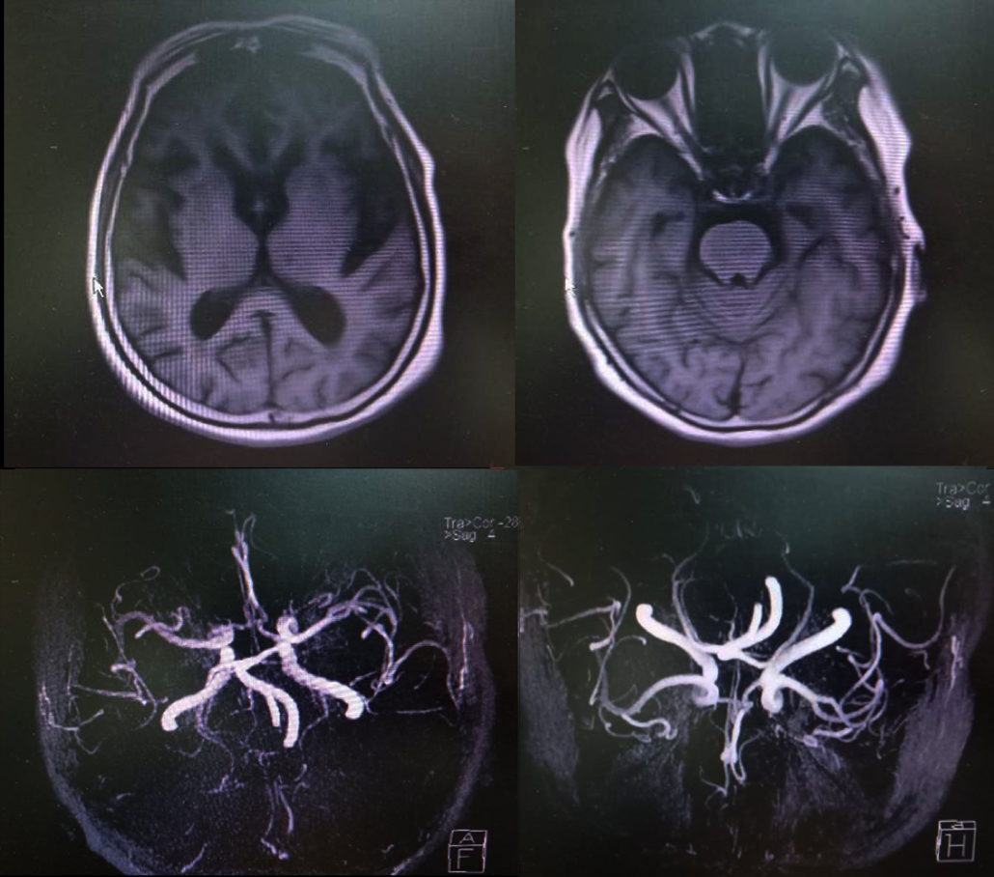
Figure 1 Magnetic resonance imaging and magnetic resonance angiography findings in the patient.

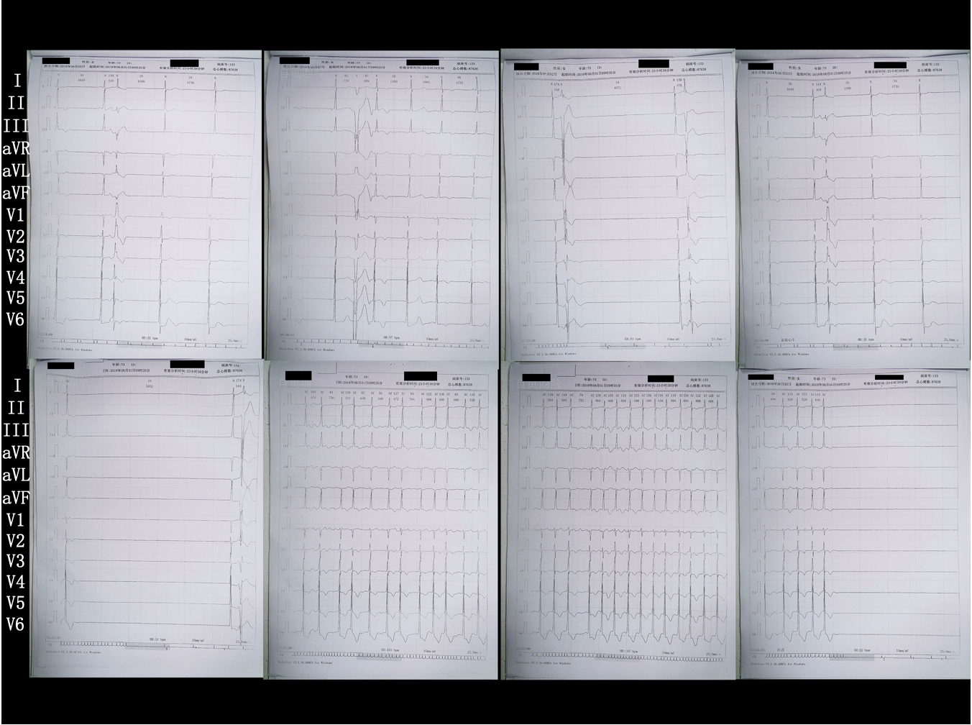
Figure 2 Twenty-four-hour Holter electrocardiogram monitoring results.

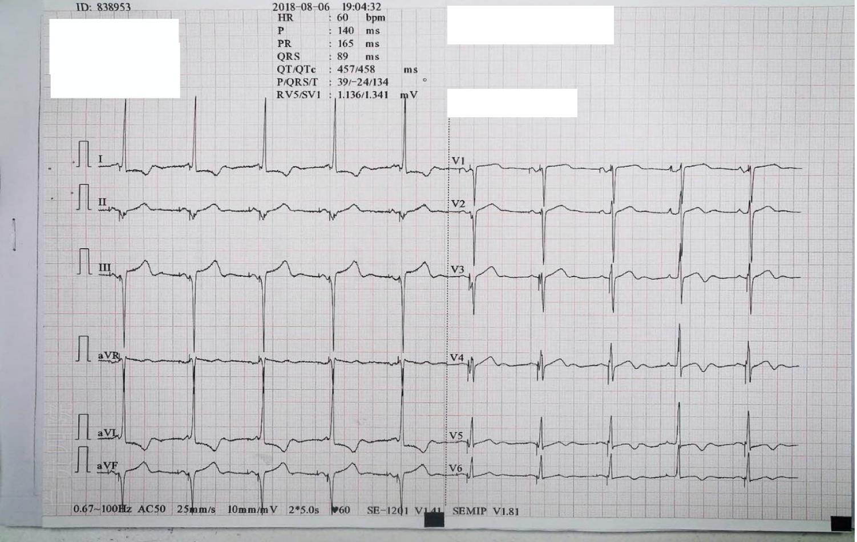
Figure 3 Electrocardiogram after implantation of dual-chamber pacing.

