Name of Journal: World Journal of Clinical Cases
Manuscript NO: 80048
Manuscript Type: CASE REPORT

Short-term prone positioning for severe acute respiratory distress syndrome after cardiopulmonary bypass: A case report and literature review

Yang JH et al. Prone positioning in ARDS after aortic dissection

Jian-Hua Yang, Shu Wang, Yuan-Xiu Gan, Xuan-Yun Feng, Bai-Lin Niu

Jian-Hua Yang, Shu Wang, Bai-Lin Niu, Department of Intensive Care Medicine, Chongqing University Central Hospital, Chongqing Emergency Medical Center, Chongqing Key Laboratory of Emergency Medicine, Chongqing 400016, China

Yuan-Xiu Gan, Xuan-Yun Feng, Department of Intensive Care Medicine, Chongqing University Central Hospital, Chongqing Emergency Medical Center, Chongqing 400016, China

Author contributions: Niu BL contributed to the study conception and design; Yang JH, Gan YX, Feng XY and Wang S contributed to the data collection and analysis; Yang JH wrote the manuscript; Niu BL and Wang S revised the manuscript; All authors have read the manuscript and approved the final version to be published; Yang JH and Wang S contributed equally to this work.

Supported by the Chongqing Medical Scientific Research Project (Joint Project of Chongqing Health Commission and Science and Technology Bureau), No. 2020FYYX163; Chongqing Medical Key Discipline Construction Project, No. ZDXK202103; Fundamental Research Funds for the Central Universities and Advanced Middle-Aged and Young Medical Talents Project in Chongqing, No. 2022CDJYGRH-014.

Corresponding author: Bai-Lin Niu, MD, Department of Intensive Care Medicine, Chongqing University Central Hospital, No. 1 Jiankang Road, Yuzhong District, Chongqing 400016, China. nberlin@126.com

Received: October 20, 2022
Revised: November 22, 2022
Accepted: December 5, 2022
Published online: December 26, 2022
Abstract
BACKGROUND
Aortic dissection is a complex and dangerous cardiovascular disease, with many complications in the perioperative period, including severe acute respiratory distress syndrome (ARDS), which affects prognosis and increases mortality. Despite the effect of prone positioning (PP) in improving oxygenation in patients with severe ARDS, reports about PP early after cardiac surgery are few and such an option may be an issue in cardiac surgery patients because of the recent sternotomy.

CASE SUMMARY
A 40-year-old male patient diagnosed with acute type A aortic dissection on October 22, 2021 underwent ascending artery replacement plus total aortic arch replacement plus stent elephant trunk implantation under cardiopulmonary bypass. Unfortunately, he developed ARDS on postoperative day 1. Despite comprehensive treatment with aggressive pulmonary protective ventilation, fluid management with continuous renal replacement therapy, the condition continued to deteriorate and rapidly progressed to severe ARDS with a minimum oxygenation index of 51. We are ready to implement salvage therapy, including PP and extracorporeal membrane oxygenation (ECMO). Due to the large amount of pericardial mediastinal and thoracic drainage after thoracotomy, ECMO may result in massive postoperative bleeding. Prolonged prone ventilation is often inappropriate after thoracotomy. Therefore, we chose short-term PP for < 6 h. Finally, the oxygenation index greatly improved and the diffuse exudation in both lungs of the patient was significantly reduced with short-term prone positioning.

CONCLUSION
Intermittent short-term PP can improve early postoperative severe ARDS after acute aortic dissection.

Key Words: Aortic dissection; Short-term prone positioning; Acute respiratory distress syndrome; Oxygenation index; Cardiopulmonary bypass; Case report

©The Author(s) 2022. Published by Baishideng Publishing Group Inc. All rights reserved.

Citation: Yang JH, Wang S, Gan YX, Feng XY, Niu BL. Short-term prone positioning for severe acute respiratory distress syndrome after cardiopulmonary bypass: A case report and literature review. World J Clin Cases 2022; 10(36): 13435-13442
URL: https://www.wjgnet.com/2307-8960/full/v10/i36/13435.htm
DOI: https://dx.doi.org/10.12998/wjcc.v10.i36.13435

Core Tip: Severe acute respiratory distress syndrome (ARDS) is often secondary to cardiac macrovascular surgery. Extracorporeal membrane oxygenation (ECMO) and prone positioning (PP) can improve pulmonary ventilation blood flow ratio and survival rate. We report a case of aortic dissection complicated with severe ARDS, in which intermittent short-term PP successfully improved oxygenation in the absence of ECMO. It is not an absolute contraindication to prone ventilation in the early postoperative period after thoracotomy. The use of intermittent short-term PP can improve the condition and avoid the complications caused by early PP after thoracotomy.
INTRODUCTION
Aortic dissection is a complex and dangerous cardiovascular disease, with a high mortality rate, and surgical treatment is an effective way to save life^{[1-3]}. Aortic dissection surgery is traumatic, requiring a long treatment time and deep hypothermia for circulatory arrest^{[1,2]}. A large number of blood transfusions are often required, as well as ischemia-reperfusion due to extracorporeal circulation, so there are many postoperative complications, among which, the incidence of acute respiratory distress syndrome (ARDS) is high, especially in obese patients with acute renal impairment before surgery^{[1,2,4,5]}. ARDS significantly increases postoperative mortality and prolongs ventilator use and intensive care unit (ICU) stay^{[3]}. According to the Berlin definition, ARDS is characterized by acute onset with bilateral lung opacities not explained by cardiac failure and/or ﬂuid overload (Table 1). Although extracorporeal membrane oxygenation (ECMO) and prone positioning (PP) are important parts in the comprehensive treatment plan of severe ARDS^{[6-10]}, ECMO can easily cause fatal bleeding in the case of abnormal coagulation. Standardized and timely PP can effectively improve oxygenation and respiratory mechanics, including increasing functional residual volume, reducing lung shunt, promoting pulmonary secretion discharge, and improving ventilation flow ratio^{[8,11-13]}, so as to reduce mortality rate^{[14]}. Gu et al^{[15]} used PP to treat severe hypoxemia after aortic dissection and achieved good results. Here, we report a case of successful improvement in oxygenation with postoperative severe ARDS with acute type A aortic dissection treated with PP.

CASE PRESENTATION
Chief complaints
A 40-year-old middle-aged man was admitted to hospital with sudden chest and back pain for 5 h.

History of present illness
The patient suddenly developed severe chest and back pain 5 h ago. The tearing-like pain continued without relief. Computed tomography angiography (CTA) of the thoracic and abdominal aorta was performed in a large class III general hospital in Chongqing. The examination showed acute type A aortic dissection.

History of past illness
The patient did not have any other medical history other than hypertension.

Personal and family history
The patient had a 20-year history of heavy smoking, two packs per day, with no specific family history.

Physical examination
Physical examination revealed persistent tearing pain in the chest and back.

Laboratory examinations
Renal function test showed that creatinine rose to 237.6 mmol/L.

Imaging examinations
Thoracic and abdominal aorta CTA (Figure 1) showed aortic false lumen formation.

FINAL DIAGNOSIS
(1) Acute aortic dissection (Standford type A); (2) acute kidney injury (AKI) grade II; (3) coagulation dysfunction; (4) acute myocardial injury; (5) hypoproteinemia; and (6) high-risk stage 3 hypertension.

TREATMENT
After preoperative examination, the patient underwent ascending aortic and total aortic arch replacement plus stented elephant trunk implantation under general anesthesia and cardiopulmonary bypass. He was transferred to the ICU in critical condition for continued treatment after surgery. During the operation and on the day of admission to ICU, 4 U of red blood cells, 850 mL of plasma, 20 U of cryoprecipitate, and 2 U of platelets were transfused.
Despite combined treatment with lung protective ventilation, fluid management with continuous renal replacement therapy, and airway secretion clearance, the disease continued to deteriorate and rapidly progressed to severe ARDS. The oxygenation index (OI) dropped from normal to a minimum of 51. We were ready to give emergency rescue measures, including prone ventilation and ECMO, and immediately assessed the feasibility of both approaches. Due to the large amount of drainage from the mediastinal pericardium and chest cavity after thoracotomy, we ruled out ECMO because of the potential risk of massive bleeding. The patient was treated with PP. Prior to treatment, bedside chest radiography was used to assess the lung condition (Figure 2A). The treatment guidelines suggested that PP time should be ≥ 12 h^{[6]}. Although PP has a positive effect on patients with severe ARDS, it may be difficult in cardiac surgery patients because of the recent sternotomy. Because of the patient’s obesity and large amount of mediastinal pericardial and thoracic drainage fluid after thoracotomy, prolonged PP could have increased the risk of drainage tube compression, resulting in poor drainage. Finally, we chose PP for no more than 6 h, and 12 h after the end of PP, the prone position ventilation treatment was performed again. During this period of treatment, we assessed drain patency every hour and monitored circulatory changes in real time to prevent inadequate drainage leading to fatal acute cardiac tamponade. We dynamically followed-up the patient by blood gas analysis. After 4 d of PP, chest X-ray showed that the diffuse exudation from both lungs was significantly reduced (Figure 2B). OI was significantly improved and showed an overall upward trend during PP (Figure 3).

OUTCOME AND FOLLOW-UP
After intermittent short-term PP, the OI improved greatly and the diffuse exudation in both lungs of the patient was significantly reduced.

DISCUSSION
Surgery is the main treatment for type A aortic dissection^{[2,16]}. Several medical centers have reported that severe hypoxemia is likely to occur after thoracotomy under cardiopulmonary bypass (CPB)^{[17]}, especially in the patients with long-term smoking, obesity, early renal damage and prolonged CPB.
Severe hypoxemia rapidly progresses to severe ARDS, with high mortality^{[4,18-21]}. A study from LUNG SAFE (Large observational study to Understand the Global impact of Severe Acute respiratory Failure) showed a mortality as high as 46% for severe forms of ARDS^{[22]}. ARDS can have pulmonary (pneumonia, aspiration, pulmonary contusion, pulmonary embolism, etc.) or extrapulmonary (sepsis, acute severe pancreatitis, cardiopulmonary bypass, severe trauma, burns, etc.) causes^{[5,22-24]}, and the prominent clinical feature is hypoxemia. It is believed that ischemia–reperfusion injury and the release of large amounts of inflammatory mediators and circulatory arrest during CPB are responsible for ARDS after cardiac surgery^{[17,20]}.
Globally, ARDS accounts for 10% of ICU admissions^{[25]}. Although the pathogenesis of ARDS is gradually being revealed and therapeutic approaches have made significant progress, its morbidity and mortality are still high^{[7,26]}. PP has been proven to effectively improve the prognosis of ARDS patients and reduces ventilator-induced lung injury^{[14,27]}. In addition, PP can shorten the duration of mechanical ventilation and ICU length of stay. When lung protective mechanical ventilation cannot prevent hypoxia or hypercapnia, ECMO may also be considered in patient with severe ARDS^{[9]}. However, even with ECMO support, the mortality rate for severe ARDS is still high. The EOLIA trial showed that in very severe ARDS, the mortality rate was 35% in patients treated with ECMO compared to 46% in patients without ECMO support^{[28]}. Kono et al^{[29]} reported a case that they chose V-V ECMO for Severe Respiratory Failure after Acute Aortic Dissection Surgery. Although PP and ECMO are both options for severe ARDS, ECMO is often not available in general healthcare centers and can easily cause fatal bleeding in patients with abnormal coagulation function. Therefore, PP may be a reliable treatment when ECMO is not an option. Although there are indications and contraindications for the implementation of PP in clinical settings (Table 2), ARDS patients can eventually obtain better therapeutic effect from PP as long as individualized treatment is carried out^{[30,31]}. Gu et al^{[15]} found that PP is a safe and feasible option for severe hypoxemia patients after acute type A aortic dissection surgery. The etiology of severe ARDS after cardiac surgery is different from that caused by severe lung infection. Prolonged prone ventilation is often inappropriate after thoracotomy. Therefore, we chose to perform PP for no longer than 12 h, as recommended by Griffiths et al^{[6]}. On the premise of ensuring the stability of the thoracic structure and the patency of the pericardial mediastinal drainage tube after thoracotomy, we chose PP for < 6 h at a time, and continued prone position ventilation treatment after 12 h in the supine position, and achieved a good therapeutic effect.
Therefore, we believe that it is feasible to perform prone ventilation in the early postoperative period in patients with aortic dissection. However, it is necessary to formulate an individualized plan, which not only achieves a better therapeutic effect, but also minimizes the associated potential risks, such as acute cardiac tamponade due to poor drainage of the diaphragmatic drainage tube.

CONCLUSION
The occurrence of ARDS after aortic dissection is high, and simple lung protective ventilation and fine fluid management are often ineffective. For patients with severe ARDS after CPB for aortic dissection, intermittent short-course PP may be useful when there is no ECMO support or when the risk associated with ECMO is high.

REFERENCES
1 Gawinecka J, Schönrath F, von Eckardstein A. Acute aortic dissection: pathogenesis, risk factors and diagnosis. Swiss Med Wkly 2017; 147: w14489 [PMID: 28871571 DOI: 10.4414/smw.2017.14489]
2 Nienaber CA, Clough RE. Management of acute aortic dissection. Lancet 2015; 385: 800-811 [PMID: 25662791 DOI: 10.1016/S0140-6736(14)61005-9]
3 Morello F, Santoro M, Fargion AT, Grifoni S, Nazerian P. Diagnosis and management of acute aortic syndromes in the emergency department. Intern Emerg Med 2021; 16: 171-181 [PMID: 32358680 DOI: 10.1007/s11739-020-02354-8]
4 Zhou J, Pan J, Yu Y, Huang W, Lai Y, Liang W, Nong L, Liu X, Chen S, Xu Y, He W, Xu Y, Liu X, Li Y, Huang Y, Sang L. Independent risk factors of hypoxemia in patients after surgery with acute type A aortic dissection. Ann Palliat Med 2021; 10: 7388-7397 [PMID: 34263634 DOI: 10.21037/apm-21-1428]
5 Ferguson ND, Fan E, Camporota L, Antonelli M, Anzueto A, Beale R, Brochard L, Brower R, Esteban A, Gattinoni L, Rhodes A, Slutsky AS, Vincent JL, Rubenfeld GD, Thompson BT, Ranieri VM. The Berlin definition of ARDS: an expanded rationale, justification, and supplementary material. Intensive Care Med 2012; 38: 1573-1582 [PMID: 22926653 DOI: 10.1007/s00134-012-2682-1]
6 Griffiths MJD, McAuley DF, Perkins GD, Barrett N, Blackwood B, Boyle A, Chee N, Connolly B, Dark P, Finney S, Salam A, Silversides J, Tarmey N, Wise MP, Baudouin SV. Guidelines on the management of acute respiratory distress syndrome. BMJ Open Respir Res 2019; 6: e000420 [PMID: 31258917 DOI: 10.1136/bmjresp-2019-000420]
7 Confalonieri M, Salton F, Fabiano F. Acute respiratory distress syndrome. Eur Respir Rev 2017; 26 [PMID: 28446599 DOI: 10.1183/16000617.0116-2016]
8 Scholten EL, Beitler JR, Prisk GK, Malhotra A. Treatment of ARDS With Prone Positioning. Chest 2017; 151: 215-224 [PMID: 27400909 DOI: 10.1016/j.chest.2016.06.032]
9 Combes A, Peek GJ, Hajage D, Hardy P, Abrams D, Schmidt M, Dechartres A, Elbourne D. ECMO for severe ARDS: systematic review and individual patient data meta-analysis. Intensive Care Med 2020; 46: 2048-2057 [PMID: 33021684 DOI: 10.1007/s00134-020-06248-3]
10 Copeland H, Levine D, Morton J, Hayanga JWA. Acute respiratory distress syndrome in the cardiothoracic patient: State of the art and use of veno-venous extracorporeal membrane oxygenation. JTCVS Open 2021; 8: 97-103 [PMID: 34723221 DOI: 10.1016/j.xjon.2021.10.003]
11 Johnson NJ, Luks AM, Glenny RW. Gas Exchange in the Prone Posture. Respir Care 2017; 62: 1097-1110 [PMID: 28559471 DOI: 10.4187/respcare.05512]
12 Munshi L, Del Sorbo L, Adhikari NKJ, Hodgson CL, Wunsch H, Meade MO, Uleryk E, Mancebo J, Pesenti A, Ranieri VM, Fan E. Prone Position for Acute Respiratory Distress Syndrome. A Systematic Review and Meta-Analysis. Ann Am Thorac Soc 2017; 14: S280-S288 [PMID: 29068269 DOI: 10.1513/AnnalsATS.201704-343OT]
13 Alessandri F, Pugliese F, Ranieri VM. The Role of Rescue Therapies in the Treatment of Severe ARDS. Respir Care 2018; 63: 92-101 [PMID: 29066591 DOI: 10.4187/respcare.05752]
14 Guérin C, Reignier J, Richard JC, Beuret P, Gacouin A, Boulain T, Mercier E, Badet M, Mercat A, Baudin O, Clavel M, Chatellier D, Jaber S, Rosselli S, Mancebo J, Sirodot M, Hilbert G, Bengler C, Richecoeur J, Gainnier M, Bayle F, Bourdin G, Leray V, Girard R, Baboi L, Ayzac L; PROSEVA Study Group. Prone positioning in severe acute respiratory distress syndrome. N Engl J Med 2013; 368: 2159-2168 [PMID: 23688302 DOI: 10.1056/NEJMoa1214103]
15 Gu J, Feng Y, Chen S, Cao Y, Li K, Du Y, Li N, Li H. Prone Position in Treatment of Hypoxemia in Patients Who Underwent Type A Aortic Dissection Surgery. Heart Surg Forum 2022; 25: E300-E304 [PMID: 35486051 DOI: 10.1532/hsf.4535]
16 Sayed A, Munir M, Bahbah EI. Aortic Dissection: A Review of the Pathophysiology, Management and Prospective Advances. Curr Cardiol Rev 2021; 17: e230421186875 [PMID: 33059568 DOI: 10.2174/1573403X16666201014142930]
17 Chen MF, Chen LW, Cao H, Lin Y. Analysis of risk factors for and the prognosis of postoperative acute respiratory distress syndrome in patients with Stanford type A aortic dissection. J Thorac Dis 2016; 8: 2862-2871 [PMID: 27867562 DOI: 10.21037/jtd.2016.10.10]
18 Rong LQ, Di Franco A, Gaudino M. Acute respiratory distress syndrome after cardiac surgery. J Thorac Dis 2016; 8: E1177-E1186 [PMID: 27867583 DOI: 10.21037/jtd.2016.10.74]
19 Sheng W, Yang HQ, Chi YF, Niu ZZ, Lin MS, Long S. Independent risk factors for hypoxemia after surgery for acute aortic dissection. Saudi Med J 2015; 36: 940-946 [PMID: 26219444 DOI: 10.15537/smj.2015.8.11583]
20 Stephens RS, Shah AS, Whitman GJ. Lung injury and acute respiratory distress syndrome after cardiac surgery. Ann Thorac Surg 2013; 95: 1122-1129 [PMID: 23352419 DOI: 10.1016/j.athoracsur.2012.10.024]
21 Kogan A, Segel MJ, Ram E, Raanani E, Peled-Potashnik Y, Levin S, Sternik L. Acute Respiratory Distress Syndrome following Cardiac Surgery: Comparison of the American-European Consensus Conference Definition versus the Berlin Definition. Respiration 2019; 97: 518-524 [PMID: 30650409 DOI: 10.1159/000495511]
22 Abe T, Madotto F, Pham T, Nagata I, Uchida M, Tamiya N, Kurahashi K, Bellani G, Laffey JG; LUNG-SAFE Investigators and the ESICM Trials Group. Epidemiology and patterns of tracheostomy practice in patients with acute respiratory distress syndrome in ICUs across 50 countries. Crit Care 2018; 22: 195 [PMID: 30115127 DOI: 10.1186/s13054-018-2126-6]
23 Laffey JG, Madotto F, Bellani G, Pham T, Fan E, Brochard L, Amin P, Arabi Y, Bajwa EK, Bruhn A, Cerny V, Clarkson K, Heunks L, Kurahashi K, Laake JH, Lorente JA, McNamee L, Nin N, Palo JE, Piquilloud L, Qiu H, Jiménez JIS, Esteban A, McAuley DF, van Haren F, Ranieri M, Rubenfeld G, Wrigge H, Slutsky AS, Pesenti A; LUNG SAFE Investigators; ESICM Trials Group. Geo-economic variations in epidemiology, patterns of care, and outcomes in patients with acute respiratory distress syndrome: insights from the LUNG SAFE prospective cohort study. Lancet Respir Med 2017; 5: 627-638 [PMID: 28624388 DOI: 10.1016/S2213-2600(17)30213-8]
24 Sanfilippo F, Palumbo GJ, Bignami E, Pavesi M, Ranucci M, Scolletta S, Pelosi P, Astuto M. Acute Respiratory Distress Syndrome in the Perioperative Period of Cardiac Surgery: Predictors, Diagnosis, Prognosis, Management Options, and Future Directions. J Cardiothorac Vasc Anesth 2022; 36: 1169-1179 [PMID: 34030957 DOI: 10.1053/j.jvca.2021.04.024]
25 Peck TJ, Hibbert KA. Recent advances in the understanding and management of ARDS. F1000Res 2019; 8 [PMID: 31824644 DOI: 10.12688/f1000research.20411.1]
26 Yadav H, Thompson BT, Gajic O. Fifty Years of Research in ARDS. Is Acute Respiratory Distress Syndrome a Preventable Disease? Am J Respir Crit Care Med 2017; 195: 725-736 [PMID: 28040987 DOI: 10.1164/rccm.201609-1767CI]
27 Poon WH, Ramanathan K, Ling RR, Yang IX, Tan CS, Schmidt M, Shekar K. Prone positioning during venovenous extracorporeal membrane oxygenation for acute respiratory distress syndrome: a systematic review and meta-analysis. Crit Care 2021; 25: 292 [PMID: 34384475 DOI: 10.1186/s13054-021-03723-1]
28 Sameed M, Meng Z, Marciniak ET. EOLIA trial: the future of extracorporeal membrane oxygenation in acute respiratory distress syndrome therapy? Breathe (Sheff) 2019; 15: 244-246 [PMID: 31508163 DOI: 10.1183/20734735.0363-2018]
29 Kono T, Oda T, Akaiwa K, Nakamura K, Tanaka H. Veno-Venous Extracorporeal Membrane Oxygenation for Acute Lung Injury after Surgery for Aortic Dissection: A Case Report. WJCG 2017; 7: 156-163 [DOI: 10.4236/wjcs.2017.712018]
30 Guérin C, Albert RK, Beitler J, Gattinoni L, Jaber S, Marini JJ, Munshi L, Papazian L, Pesenti A, Vieillard-Baron A, Mancebo J. Prone position in ARDS patients: why, when, how and for whom. Intensive Care Med 2020; 46: 2385-2396 [PMID: 33169218 DOI: 10.1007/s00134-020-06306-w]
31 Mitchell DA, Seckel MA. Acute Respiratory Distress Syndrome and Prone Positioning. AACN Adv Crit Care 2018; 29: 415-425 [PMID: 30523012 DOI: 10.4037/aacnacc2018161]
Footnotes
Informed consent statement: Written informed consent was obtained from the patient’s family for publication of the patient's medical imaging and related test results.

Conflict-of-interest statement: All the authors declare no competing interests.

CARE Checklist (2016) statement: The authors have read the CARE Checklist (2016), and the manuscript was prepared and revised according to the CARE Checklist (2016).

Open-Access: This article is an open-access article that was selected by an in-house editor and fully peer-reviewed by external reviewers. It is distributed in accordance with the Creative Commons Attribution NonCommercial (CC BY-NC 4.0) license, which permits others to distribute, remix, adapt, build upon this work non-commercially, and license their derivative works on different terms, provided the original work is properly cited and the use is non-commercial. See: https://creativecommons.org/Licenses/by-nc/4.0/

Provenance and peer review: Unsolicited article; Externally peer reviewed.
Peer-review model: Single blind

Peer-review started: October 20, 2022
First decision: November 11, 2022
Article in press: December 5, 2022

Specialty type: Critical care medicine
Country/Territory of origin: China
Peer-review report’s scientific quality classification
Grade A (Excellent): 0
Grade B (Very good): 0
Grade C (Good): C, C
Grade D (Fair): 0
Grade E (Poor): 0

P-Reviewer: Al-Ani RM, Iraq; Schoenhagen P, United States S-Editor: Liu JH L-Editor: A P-Editor: Liu JH
Figure Legends
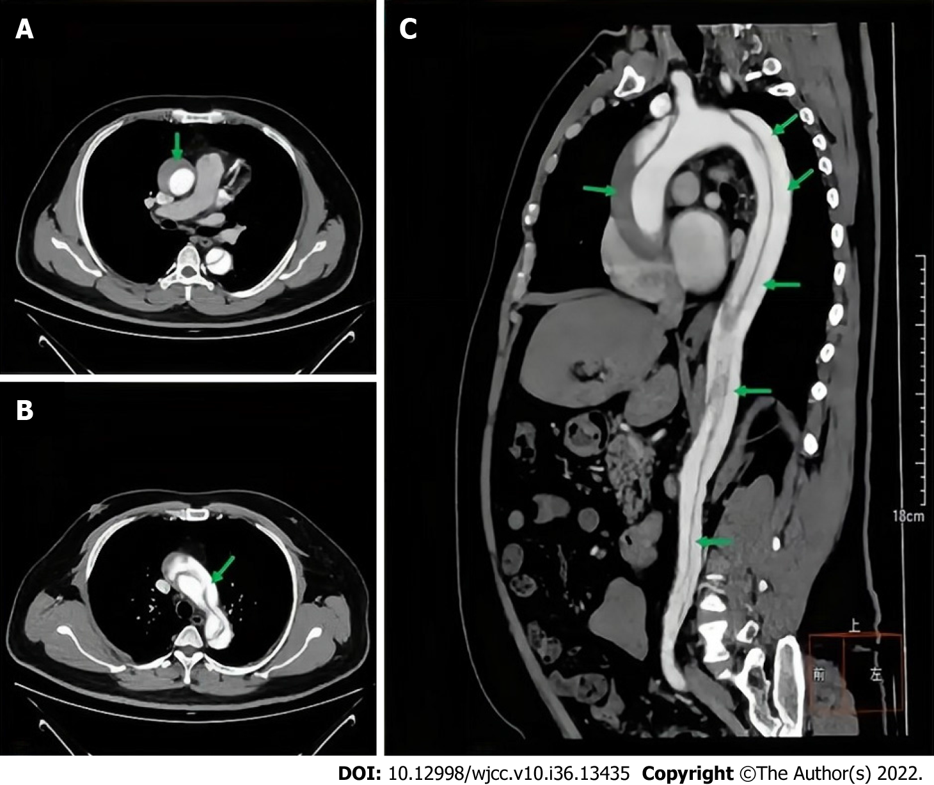
Figure 1 Enhanced computed tomography scan of the patient's aorta. A: Transverse computed tomography (CT) scan of the ascending aorta; B: Cross-sectional CT images of aortic arch; C: Sagittal CT scan of the aorta. The green arrows indicate the aortic dissection.
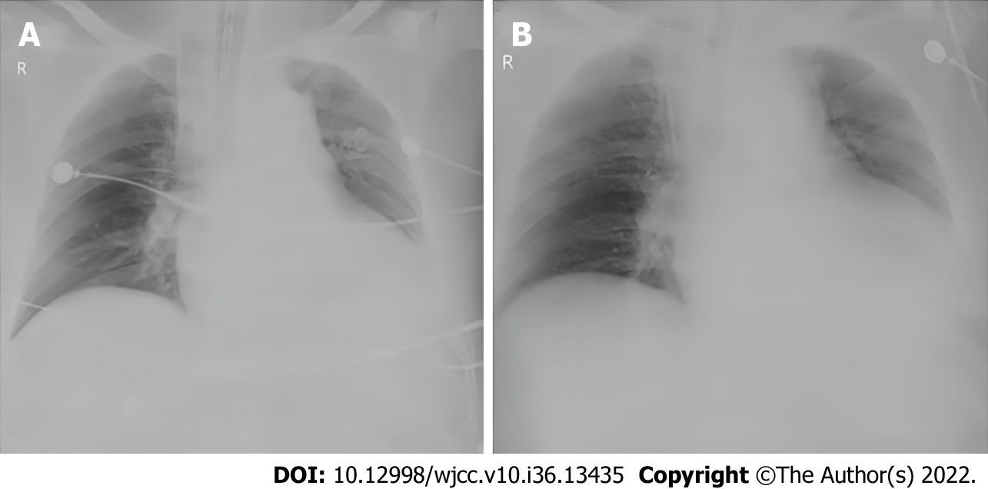
Figure 2 Bedside X-ray images of the patient before and after prone position ventilation. A: X-ray image before prone position ventilation: Diffuse exudation of both lungs; B: X-ray image after three of intermittent prone position ventilation.
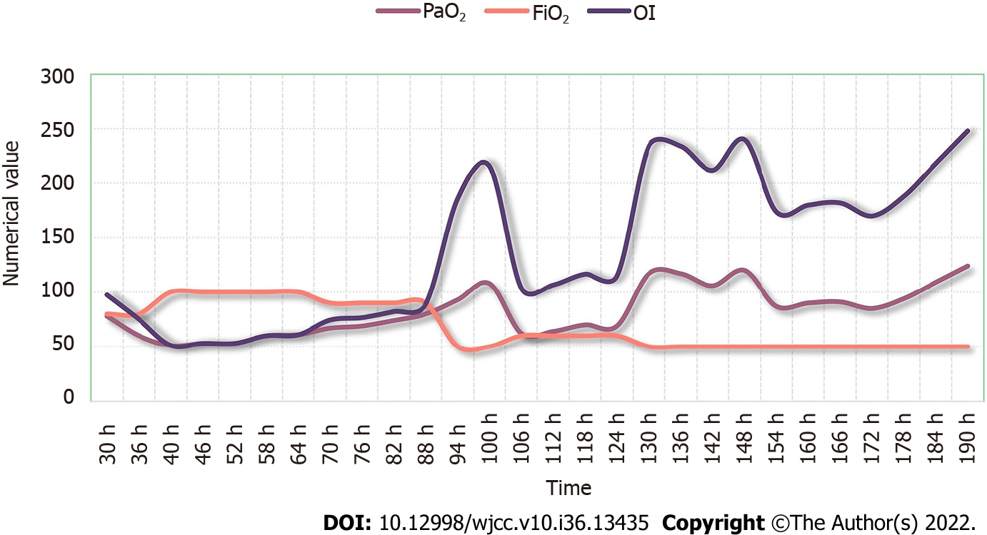
Figure 3 Improvement of oxygenation index with prone position ventilation. PaO₂: Partial pressure of arterial oxygen; FIO₂: Fraction of inspired oxygen; OI: Oxygenation index.
Table 1 Berlin definition and management of acute respiratory distress syndrome
Diagnostic criteria^{[5]} | Onset within 1 wk of known clinical impairment or new/worsening respiratory symptoms; Bilateral shadows (on CXR or CT scan) not fully explained by effusions, lobar/lung collapse, or nodules; Respiratory failure not entirely explained by heart failure or fluid overload
Oxygenation impairment^{[5]} | Mild; 200 mmHg < PaO₂/FiO₂ ≤ 300 mmHg with PEEP or continuous positive airway pressure ≥ 5 cmH₂O | Moderate 100 mmHg < PaO₂/FiO₂ ≤ 200 mmHg with PEEP ≥ 5 cmH₂O | Severe PaO₂/FiO₂ ≤ 100 mmHg with PEEP ≥ 5 cmH₂O
Risk factors for ARDS^{[5,16,17]} | Infectious risk factors: Pneumonia, nonpulmonary sepsis | Noninfectious: Aspiration of gastric contents, severe trauma, pulmonary contusion, noncardiogenic shock, inhalation injury, severe burns, pancreatitis, drug overdose, multiple transfusions or TRALI, pulmonary vasculitis, drowning
Oxygen therapy | Intubation/mechanical ventilation (most patients)  Noninvasive ventilation for mild ARDS
Fluid management | Aim for central venous pressure < 4 mmHg or PAOP < 8 mmHg to ↓ pulmonary; Oedema
Prone positioning
ECMO
Decreased oxygen consumption; Increased oxygen delivery^{[7]} | Antipyretics, sedatives, analgesics and paralysis agents; Inotropics to ↑ filling pressure (if no pulmonary edema); Restrict transfusions to maintain hemoglobin to 7–9 g/dL; Inhaled vasodilators (NO, prostacyclin and prostaglandin E1) to ↑ V′/Q′ matching
ARDS: Acute respiratory distress syndrome; CXR: Chest X-ray; CT: Computed tomography; ECG: Electro-chemical grinding; FIO₂: Fraction inspired oxygen; PaO₂: Partial pressure of arterial oxygen; PAOP: Pulmonary artery occlusion pressure: PEEP: Positive end-expiratory pressure; TRALI: Transfusion-related acute lung injury; V′/Q′: Ventilatory blood flow ratio.
Table 2 Criteria and recommendations for prone ventilation in acute respiratory distress syndrome
Indications | Severe ARDS (PaO₂/FiO₂ ≤ 100 mmHg with PEEP ≥ 5 cmH₂O;); within 48 h after onset of ARDS; mean arterial pressure > 65 mmHg
Contraindications (absolute and relative) | Acial/neck trauma or spinal instability; Raised intraocular pressure or recent ophthalmic surgery, facial trauma, or recent oral maxillofacial surgery in last 15 d; Elevated intracranial pressure; Severe hemodynamic instability, unstable cardiac rhythms; Hemoptysis, unstable airway (double lumen endotracheal tube), new tracheostomy < 15 d, lung transplant; Recent sternotomy or more than 20% body surface burn; Grossly distended abdomen; Second or third trimester pregnancy, grossly distended abdomen; Venous thromboembolism treated < 48 h
Implementation method^{[8]} | Requires 3-5 people, close attention to ETT and central lines; a demonstration video; and checklist are available; Preparation: Preoxygenation, empty stomach, suction; ETT/oral cavity, remove ECG leads and reattach to back, repeated zeroing of hemodynamic transducers; Support and frequently reposition pressure points: Face, shoulder, anterior pelvis
Prone positioning time^{[31]} | 12-16 h per protocol
Possible complications | Vascular catheter kinking; Elevated intraabdominal pressure; Facial pressure ulcers, facial edema, brachial plexus injury (arm extension); Cardiac arrest
Time to stop | PaO₂/FiO₂ remained > 150 mm Hg 4 h after supinating (with PEEP < 10 cm H₂O and FiO₂ < 0.6)
ARDS: Acute respiratory distress syndrome; ETT: Endotracheal tube; ECG: Electrochemical grinding; FIO₂: Fraction inspired oxygen; PaO₂: Partial pressure of arterial oxygen; PEEP: Positive end-expiratory pressure.

Published by Baishideng Publishing Group Inc
7041 Koll Center Parkway, Suite 160, Pleasanton, CA 94566, USA
Telephone: +1-925-3991568
E-mail: bpgoffice@wjgnet.com
Help Desk: https://www.f6publishing.com/helpdesk
https://www.wjgnet.com

© 2022 Baishideng Publishing Group Inc. All rights reserved.

