Name of journal: World Journal of Gastroenterology
ESPS Manuscript NO: 243
Columns: Brief Article

Diversity of Helicobacter pylori genotypes in Iranian patients with different gastroduodenal disorders

Vaziri F et al., Helicobacter pylori genotype diversities in Iran

Farzam Vaziri, Shahin Najarpeerayeh, Masoud Alebouyeh, Mahsa Molaei, Nader Maghsudi, Mohammad Reza Zali

Farzam Vaziri, Department of Bacteriology, School of Medical Sciences, Tarbiat Modares University, Tehran 14115-331, Iran

Farzam Vaziri, Gastroenterology and Liver Diseases Research Center, Shahid Beheshti University of Medical Sciences, Tehran 19835-187, Iran

Shahin Najarpeerayeh, Department of Bacteriology, School of Medical Sciences, Tarbiat Modares University, Tehran 14115-331, Iran

Masoud Alebouyeh, Gastroenterology and Liver Diseases Research Center, Shahid Beheshti University of Medical Sciences, Tehran 19835-187, Iran

Mahsa Molaei, Basic and Molecular Epidemiology of Gastrointestinal Disorders Research Center, Shahid Beheshti University of Medical Sciences, Tehran 19835-187, Iran
Nader Maghsudi, Neuroscience Research Center (NRC), Shahid Beheshti University of Medical Sciences, Tehran 19615-1178, Iran

Mohammad Reza Zali, Gastroenterology and Liver Diseases Research Center, Shahid Beheshti University of Medical Sciences, Tehran 19835-187, Iran

Author contributions: Vaziri F performed the research and wrote the paper; Alebouyeh M and Vaziri F designed the research and analyzed the data; Molaei M helped this project as a pathologist; Alebouyeh M, Najarpeerayeh S, Maghsudi N and Zali MR supervised the research.

Supported by Gastroenterology and Liver Diseases Research Center, Shahid Beheshti University of Medical Sciences, Tehran, Iran; Iran National Science Foundation (INSF) and a PhD grant from the Tarbiat Modares University, Tehran, Iran

Correspondence to: Shahin Najarpeerayeh, PhD, Associate professor, Department of Bacteriology, School of Medical Sciences, Tarbiat Modares University, Tehran 14115-331, Iran. najarp_s@modares.ac.ir

Telephone: +98-021-82883870 Fax: +98-021-82884555
Received: August 19, 2012 Revised: September 11, 2012
Accepted: November 14, 2012
Published online:

Abstract
AIM: To investigate diversity of Helicobacter pylori (H. pylori) genotypes and its correlation with disease outcomes in an Iranian population with different gastroduodenal disorders.

METHODS: Isolates of H. pylori from patients with different gastroduodenal disorders were analyzed after culture and identification by phenotypic and genotypic methods. Genomic DNA was extracted with the QIAamp DNA mini kit (Qiagen, Germany). After DNA extraction, genotyping was done for cagA, vacA (s and m regions), iceA (iceA₁,iceA₂) and babA₂ by specific primers for each allele using PCR. All patients’ pathologic and clinical data and their relation with known genotypes were analyzed by using SPSS ver. 19.0 software. χ²test and Fisher’s exact test were used to assess relationships between categorical variables. The level of statistical significance was set at P<0.05.

RESULTS: A total of 71 isolates from 177 patients with different gastroduodenal disorders were obtained. Based on analysis of the cagA gene (positive or negative), vacA s-region (s₁ or s₂), vacA m-region (m₁ or m₂), iceA allelic type (iceA₁ and iceA₂) and babA₂ gene (positive or negative), twenty different genotypic combinations were recognized. The prevalence of cagA, vacAs₁, vacAs₂, vacAm₁, vacAm₂, iceA₁, iceA₂,iceA₁+iceA₂ and babA₂ were 62%, 78.9%, 19.7%, 21.1%, 78.9%, 15.5%, 22.5%, 40.8% and 95.8%, respectively. Interestingly, evaluation of PCR results for cagA in 6 patients showed simultaneous existence of cagA variants according to their size diversities that proposed mixed infection in these patients. The most prevalent genotypes in cagA positive isolates was cagA+/vacA s₁m₂/iceA₁+A₂/babA₂+ and in cagA negative isolates was cagA-/vacA s₁m₂/iceA-/babA₂+. There were no relationships between the studied genes and histopathological findings (H. pylori density, neutrophil activity, lymphoid aggregation in Lamina propria and glandular atrophy). The strains which carry cagA,vacAs₁/m₁, iceA₂ and babA₂ genes showed significant associations with severe active chronic gastritis (P = 0.011, P = 0.025, P = 0.020, P = 0.031, respectively). The vacA s₁ genotype had significant correlation to the presence of the cagA gene (P = 0.013). Also babA₂ genotype showed the associations with cagA (P = 0.024). In the combined genotypes only cagA+/vacAs₁m₁/iceA₂/babA₂+ genotype showed correlation to the severe active chronic gastritis (P = 0.025).

CONCLUSION: This genotyping panel can be a useful tool for detection of virulent H. pylori isolates and can provide a valuable guidance for prediction of the clinical outcomes.

© 2012 Baishideng. All rights reserved.

Key words: Helicobacter pylori; cagA; vacA; iceA; babA₂

Vaziri F, Najarpeerayeh S, Alebouyeh M, Molaei M, Maghsudi N, Zali MR. Diversity of Helicobacter pylori genotypes in Iranian patients with different gastroduodenal disorders. World J Gastroenterol 2012; 18
Available from: URL: http://www.wjgnet.com/1007-9327/full/v18/
DOI: http://dx.doi.org/10.3748/wjg.v18.

INTRODUCTION

Infection with Helicobacter pylori (H. pylori) causes different clinical disorders such as persistent gastritis, peptic ulcers and Mucosa associated lymphoid tissue(MALT) lymphoma. Current studies suggest that H. pylori infection may be a crucial risk factor in the development of gastric cancer^{[1,2]}. In this regard, this pathogen has been categorized as a group I carcinogen by the International Agency for Research on Cancer^{[3]}. The detailed reasons for these different clinical outcomes are unknown, but they may be related to host genetic factors, exposure to environmental factors (e.g., diet, drug usage, acidity of the stomach, and smoking) and to the bacterial genotypes^{[4]}. H. pylori shows extensive genetic diversity and this variability has a crucial role in pathogenesis of this bacterium^{[5]}. Several H. pylori virulence factor genes related to the risk of gastroduodenal disorders, including cagA, vacA, babA and iceA, have been proposed^{[6]}. A tremendous number of studies proved that CagA and VacA producing strains are related to severe clinical outcomes^{[7]}. In addition to cagA and vacA, the other H. pylori virulence factors, such as iceA and babA₂, also showed such associations in some studies^{[8,9]}. Beyond the role of these factors in progression of the disease, there are several papers which reported a relationship between failure of H. pylori eradication therapy and the strains’ virulence factor genotypes^{[10]}. Analysis of genetic structure of virulence factors among the isolates from different geographic regions will provide new insights regarding the pathogenesis and treatment of H. pylori infection. H. pylori genotyping may have multiple roles including impact on the cure rates of eradication therapy^{[10]}, determination of clinical outcomes^{[11]}, tracking human migration^{[12,13]} and recently, the prediction of progression of gastric preneoplastic lesions^{[14]}. Distribution pattern of H. pylori genotypes and its correlation with disease outcome shows geographic differences. The aim of this study was to assess diversity of H. pylori genotypes in an Iranian population to determine genotypically more associated H. pylori isolates with different gastroduodenal disorders.

MATERIALS AND METHODS

Clinical specimens
Three Gastric biopsies (two were used for histological examination and one for culture) were obtained from 177 adult patients undergoing routine diagnostic endoscopy referred to endoscopy centre of Taleghani hospital of Tehran, Iran, after obtaining informed consent. All subjects were answering to questionnaire related to age, sex, gastric or duodenal peptic ulcer diseases upon endoscopy.

Culture
Antral or body biopsy specimens from each patient were kept in transport medium consisting of thioglycolate with 1.3 g/L agar (Merck) and 3% yeast extract (Oxoid). The endoscopic biopsy specimens were cut into small pieces, homogenized with a sterile scalpel and were smeared on the surface of Brucella agar plates supplemented with 7% horse blood and campylobacter selective supplement (Vancomycin 2.0 mg, Polymyxin 0.05 mg, Trimethoprim 1.0 mg) and Amphotericin B (2.5 mg/L). Incubation was performed in microaerophilic conditions at 37 °C for 5-7 d. Identification of H. pylori isolates were made by analysing colony morphology, Gram staining, oxidase, catalase and urease activities and H. pylori specific PCR (glmM). The isolates were preserved in BHI broth containing 20% glycerol and 10% fetal calf serum and stored at -70°C.

DNA extraction
Genomic DNA was extracted with the QIAamp DNA mini kit (Qiagen, Germany) according to the manufacturer’s instructions. The DNA was stored at -20°C until used for molecular studies.

H. pylori genotyping

After DNA extraction, polymerase chain reactions (PCR) were performed in a volume of 25 μL containing 1x PCR buffer, 1 μM of each primers, 1 μL of genomic DNA (approximately 150 ng), 200 μM of dNTPs mix, 2 mM of MgCl₂, and 0.05 U/μL Taq DNA polymerase. PCR amplifications were performed in an automated thermal cycler (AG 22331; Eppendorf, Hamburg, Germany) under the following conditions: for vacA s/m: 33 cycles of 1 min at 94 °C, 33 seconds at 55 °C, and 1 min at 72°C; for cagA: 33 cycles of 1 min at 94 °C, 1 min at 59 °C, and 1 min at 72 °C; for iceA₁/A₂: 33 cycles of 1 min at 94 °C, 40 seconds at 58 °C, and 1 min at 72 °C, and for babA₂: 35 cycles of 1 min at 94 °C, 40 seconds at 58 °C and 1 min at 72 °C. The amplified genes were detected by electrophoresis in a 1.2 % agarose gel with ethidium bromide. Table 1 summarized the primer sequences, annealing temperatures and the expected size of the PCR products.

Histopathological evaluation
Sections were stained with hematoxylin and eosin to analyze H. pylori -related histology by an expert pathologist. Then the grade of gastritis was scored based on the updated Sydney System.

Statistical analysis
Data were analyzed by using SPSS ver. 19.0.0 software (IBM). χ² test and Fisher’s exact test were used to assess relationships between categorical variables. The level of statistical significance was set at P < 0.05.

RESULTS
Infection rates and clinical disorders
A total of 71 isolates from 177 patients (~40%) with different gastroduodenal disorders were obtained. The H. pylori positive patients were included of 24 males and 47 females, with their ages ranging between 19 and 85 years (mean age, 66 years). All of the isolates showed positive results for common identification test and H. pylori specific PCR (glmM). Most of the infected patients suffered from chronic gastritis (84.6 %), while the others showed duodenitis (9.8 %), intestinal metaplasia(2.8 %), hyperplasia(1.4%) and gastric cancer diseases(1.4%) (Table 2).

Allelic diversities in main putative virulence markers
cagA genotyping: The 400-bp PCR product indicating the presence of the cagA gene was obtained with 44 isolates (62%) and 27 (38%) were negative. Interestingly, evaluation of PCR results for cagA in 6 patients showed simultaneous existence of cagA variants according to their size diversities.

vacA genotyping: The frequency of vacA s₁, vacA s₂, vacA m₁ and vacA m₂ were 78.9 %, 19.7 %, 21.1 % and 78.9 % , respectively. Only one isolate was vacA s₀m₂ (with no PCR product for s region).

iceA genotyping: Sole existence of iceA₁ genotypes were detected in 15.5 % and iceA₂ genotypes in 22.5 % of the colonized patients. Interestingly, out of the total studied samples, 40.8 % were infected with both iceA₁ and iceA₂ genotypes and 21.1% were negative for these genes.

babA₂ genotyping: babA₂ was found in 68 of the patients (95.8% ), however three patients (4.2%) did not show this allelic variant (Figure 1).

Correlation of H. pylori genotypes with pathological data, patients’ age and clinical outcome

Combination of genotypes: Based on the analysis of the cagA gene (positive or negative), vacA s-region (s₁ or s₂), vacA m-region (m₁ or m₂), iceA allelic types (iceA₁ and iceA₂) and babA₂ (positive or negative), twenty different genotypic combinations were recognized. The most prevalent genotypes in cagA positive isolates was cagA+/vacAs₁m₂/iceA₁+A₂+/babA₂+ and in cagA negative isolates was cagA-/vacAs₁m₂/iceA-/babA₂+(Figure 2).

Helicobacter pylori density, neutrophil activity, lymphoid aggregation in lamina propria and glandular atrophy: There was no significant relationship between cagA positivity and H. pylori density, neutrophil activity, lymphoid aggregation in Lamina propria and glandular atrophy in the biopsies. Also no relationships were found between other genes and these histopathological findings.

Patients’ age: There was no significant relationship between the genotypes, clinical, pathological data and patients’ age.

Chronic gastritis: The gastritis was scored as severe active chronic gastritis, moderate active chronic gastritis, mild active chronic gastritis, severe chronic gastritis and moderate chronic gastritis. The strains which carry cagA gene showed significant associations with severe active chronic gastritis (P = 0.011). Also the strains which carry vacA s₁/m₁ gene showed significant associations with severe active chronic gastritis (P = 0.025). babA₂ (P = 0.031) and iceA₂ (P = 0.020), also had significant correlation with the severe active chronic gastritis. In the combined genotypes this association was observed for cagA+/vacAs₁m₁/iceA₂/babA₂+genotype in the case of severe active chronic gastritis (P = 0.025).

Genotype correlation: Interestingly, the vacA s₁ genotype had significant correlation to the presence of the cagA gene (P = 0.013). Also babA₂ genotype showed this associations in cagA positive isolates (P = 0.024).

DISCUSSION
H. pylori infection usually present in 60%-80% of gastric and 95% of duodenal ulcers. However, some conditions affect infection rate of this bacterium in different geographic and socioeconomic regions. The prevalence of infection is typically higher in developing countries (greater than 80%) and lower in the developed ones (typically less than 40%)^{[20]}. It has been demonstrated that prevalence of H. pylori infection in developing countries with low socioeconomic and poor management of drinking water is much higher (>80%) than that in developed countries (< 60%)^{[21]}. In our study the recovery rate of H. pylori was 40% which show the improvement in the living conditions and hygiene in Iran which also reported recently^{[ 22]}.
H. pylori can be divided into cagA-positive and cagA-negative strains, and there is increasing evidence that infection with cagA positive isolates are associated with a greater risk of adverse clinical outcomes than infections with strains lacking this gene. In the current study the strains which carry cagA gene showed significant associations with severe active chronic gastritis. Interestingly, the prevalence of the cagA-positive strain differs among different countries, and more than 90% of H. pylori strains are cagA positive in East Asian countries, irrespective of clinical presentation^{[23]}. Sasaki et al^{[24]} showed that among H. pylori DNA-positive samples, cagA was detected in 45.9% from Ecuador and 20.0% from Panama. In our study the prevalence of cagA positive isolates is 62% which is less than other Asian countries and more than other countries (e.g. Ecuador, Panama). According to Watada et al^{[25]} study, the prevalence of cagA was 65.5% in Colombia and 100% in Japan, which showed that the prevalence of this gene in our study is similar to the Colombian isolates. In another study conducted in Bulgaria, the prevalence of cagA was 84.9% which is more than our results^{[26]}. Interestingly, we had 6 isolates which had two different size of cagA simultaneously, that showed occurrence of the mixed infection in these patients.
Variations of vacA are associated with different risks of gastrointestinal disorders. In general, vacA s₁ and m₁ genotypes produce a large amount of toxin, whereas s₂ and m₂ genotypes show little or no toxin production^{[27]}. Recently, a third polymorphic determinant of vacuolating activity has been described as located between the s-region and m-region, an intermediate (i) region^{[28]}. The frequency of the vacA s₁ and vacA m₁ genotypes in the Middle Eastern countries was 71.5% and 32.8% respectively ^{[11]}, which are in concordance with our study. We didn’t detect any vacA s₂m₁ genotypes in our isolates which had been reported to be rare^{[23]}. The vacA s₁ and m₁ genotypes have been reported to be associated with the H. pylori-related diseases; however vacA s₂ and m₂ strains are rarely associated with peptic ulcer and gastric cancer because of their low or no-vacuolating activities^{[23]}. Genotyping of vacA will be useful in screening individuals for risk factors associated with gastric cancer and peptic ulcer development. Asrat et al^{[29]} showed that vacA s₁m₁ genotype was the most common genotype in Ethiopian adult dyspeptic patients and also the vacA and cagA positive H. pylori strains were detected to a higher degree in patients with chronic active gastritis. Interestingly, similar to our results correlation of the vacA s₁ genotype with the presence of the cagA gene was reported by Atherton et al^{[30]}. The vacA s₁m₂ genotype is more common in our Iranian patients as previously described in Iran^{[31]}. As reviewed by Suzuki et al^{[32]} the predominant vacA genotypes in Asia, Europe and Africa is vacA s₁m₁ and their subtypes, which is in contrast to our genotypes in Iranian isolates.
In spite of the low frequency of vacA s₁m₁ genotypes in our study, isolates which carry vacA s₁m₁ gene showed significant associations with severe active chronic gastritis. In a review by Hosseini et al^{[33]} they concluded that in contrast to vacA, there is no correlation between cagA genotype and disease status in the majority of studies conducted in Iran, but results of our study, however proposed both of these genetic markers as useful indicators for predicting clinical outcomes in the studied population.
The Meta analysis by Shiota et al^{[8]} confirmed the importance of the presence of iceA gene for peptic ulcer, although the significance was controversial. Such different results between the iceA allelic types and clinical disorders could be explained by the difference in geographic regions. In our study we found significant relation between iceA₂ genotype and the clinical outcomes (severe active chronic gastritis); which was also observed by Caner et al^{[34]} in Turkey. As Shiota et al^{[ 35-37]} summarized in their Meta analysis most of the studies showed no association between iceA₁ and cagA status which is in concordance with our study. Interestingly, the prevalence of mixed genotype iceA₁+iceA₂ (40.8%) in our study, was higher than other studies which had detected this mixed genotypes. So this high prevalence with mixed genotypes makes it difficult to analyze potential relationships between the presence of each iceA allelic variant and clinical outcomes. babA₂ genotype was frequently found in H. pylori strains in our study (95.8%),that was associated with severe active chronic gastritis. Although this genotype showed significant correlation with the existence of cagA, but no significant correlation was observed with other virulence factors such as vacA s₁/s₂ ,vacA m₁/m₂ and iceA₁/iceA₂. Chomvarin et al^{[38]} detected the babA₂ gene in 92% (103/112) of the Thai patients, which is almost similar to our results; while in another study conducted in Cuba the prevalence of babA₂ gene was lower (82.3 %)^{[39]}.
In the combination of genotypes, we observed twenty different genotypes which showed vast diversities in the H. pylori isolates in our study. Interestingly there was no any significant association between these combined genotypes and clinical outcomes, except for cagA+/vacAs₁m₁/iceA₂/babA₂+genotype which showed significant association with severe active chronic gastritis.
Genotypes of H. pylori, especially cagA and vacA, are reported to be crucial factors determining the cure rates. So to select an H. pylori eradication regimen, we need to consider H. pylori genotypes^{[10]}. H. pylori genotypes distributions and their correlations with disease outcomes had shown geographical differences. In this regard Yamaoka et al^{[7]} reviewed that within East Asia, where the incidence of gastric cancer is high; vacA m₁ genotype is dominant, whereas in southern parts where the gastric cancer incidence is low, the m₂ genotype, which we observed in our study, is predominant. Dabiri et al^{[31]} showed that there was no statistically an association between the vacA, cagA and cagE status with clinical outcomes in Iranian patients and recommended that other different markers may be more useful for this analysis. In comparison, in the current study, genotyping on the basis of cagA, babA₂, vacA and iceA were considered as useful tool for predicting the clinical outcomes. Therefore analyzing the multiple virulence factors of H. pylori (cagA, vacA, iceA and babA₂) might enable us to predict the patient’s clinical outcome in Iranian patients. This prediction could be more accurate when accompanied by the impacts of environmental factors and host genetic polymorphism such as interleukin-1 receptor antagonist (IL-1RN) gene polymorphism^{[37]}. Nowad concurrent genotyping of H. pylori virulence markers and host factors is becoming increasingly crucial in the prediction of the diseases outcomes^{[40]}.
In conclusion our results showed that most of the H. pylori isolates were highly virulent on the basis of the main clinically allelic variants in three or four virulence factors they could carry. The Iranian isolates predominantly possessed different genotypes which showed vast diversities. Significant association of the noted genotypes with sever active chronic gastritis proposed this genotyping panel as a suitable tool for detection of virulent H. pylori isolates that could provide a valuable guidance for prediction of the clinical outcomes.

ACKNOWLEDGMENTS
The authors would like to thank Tabasom Mirzaei, Leila Shokrzadeh and Ehsan Nazemalhosseini in Gastroenterology and Liver Diseases Research Center, Shahid Beheshti University of Medical Sciences.

COMMENTS
Background
Infection with Helicobacter pylori (H. pylori) causes diverse clinical outcomes such as persistent gastritis, peptic ulcers, MALT lymphoma and gastric cancer. One of the reasons of these different clinical outcomes is genetic diversity of H. pylori; therefore determination of pattern of H. pylori genotypes and its correlation with disease outcome, which shows geographic differences, is crucial.

Research frontiers
The H. pylori genotyping may have multiple roles including prediction of clinical outcomes, impact on the H. pylori infection therapy, tracking human migration, and recently, the prediction of progression of gastricpreneoplastic lesions. Therefore genotyping of H. pylori can be a valuable and multifunctional tool in the clinical field.

Innovations and breakthroughs
In the majority of the previous studies the researchers were not able to detect any significant relationship between their genotyping panels and clinical outcomes for H. pylori infections. Most of these studies had been used few genetic markers. In order to overcome this disadvantage The authors have chosen greater numbers of H. pylori genetic markers for studying this association.

Applications
The genotyping panel which contains eight important genetic markers can be served as a useful tool for typing of H. pylori isolates and to some extent prediction of clinical outcomes.

Peer review
This is an epidemiological paper with statistical analysis, dealing with the important question of association between certain H.pylori genotypes and specific pathologies, and with the problem of predictive value of H.pylori infection genotyping. Although the question of H.pylori genetic diversity in Iranian population was already addressed in at least two publications, in the submitted manuscript this issue is dissected in fine details and using quite extensive clinical material, thus providing novel and more reliable data.

REFERENCES
1 Hatakeyama M. Helicobacter pylori and gastric carcinogenesis. J Gastroenterol 2009; 44: 239-248 [PMID: 19271114 DOI: 10.1007/s00535-009-0014-1]
2 Polk DB, Peek RM. Helicobacter pylori: gastric cancer and beyond. Nat Rev Cancer 2010; 10: 403-414 [PMID: 20495574 DOI: 10.1038/nrc2857]
3 . Schistosomes, liver flukes and Helicobacter pylori. IARC Working Group on the Evaluation of Carcinogenic Risks to Humans. Lyon, 7-14 June 1994. IARC Monogr Eval Carcinog Risks Hum 1994; 61: 1-241 [PMID: 7715068]
4 Fuccio L, Eusebi LH, Bazzoli F. Gastric cancer, Helicobacter pylori infection and other risk factors. World J Gastrointest Oncol 2010; 2: 342-347 [PMID: 21160805 DOI: 10.4251/wjgo.v2.i9.342]
5 Suerbaum S, Achtman M. Helicobacter pylori: recombination, population structure and human migrations. Int J Med Microbiol 2004; 294: 133-139 [PMID: 15493823 DOI: 10.1016/j.ijmm.2004.06.014]
6 Atherton JC, Cao P, Peek RM, Tummuru MK, Blaser MJ, Cover TL. Mosaicism in vacuolating cytotoxin alleles of Helicobacter pylori. Association of specific vacA types with cytotoxin production and peptic ulceration. J Biol Chem 1995; 270: 17771-17777 [PMID: 7629077]
7 Yamaoka Y, Kato M, Asaka M. Geographic differences in gastric cancer incidence can be explained by differences between Helicobacter pylori strains. Intern Med 2008; 47: 1077-1083 [PMID: 18552463 DOI: 10.2169/internalmedicine.47.0975]
8 Shiota S, Watada M, Matsunari O, Iwatani S, Suzuki R, Yamaoka Y. Helicobacter pylori iceA, clinical outcomes, and correlation with cagA: a meta-analysis. PLoS One 2012; 7: e30354 [PMID: 22279585 DOI: 10.1371/journal.pone.0030354]
9 Yamaoka Y. Roles of Helicobacter pylori BabA in gastroduodenal pathogenesis. World J Gastroenterol 2008; 14: 4265-4272 [PMID: 18666312 DOI: 10.3748/wjg.14.4265]
10 Sugimoto M, Yamaoka Y. Virulence factor genotypes of Helicobacter pylori affect cure rates of eradication therapy. Arch Immunol Ther Exp (Warsz) ; 57: 45-56 [PMID: 19219527 DOI: 10.1007/s00005-009-0007-z]
11 Sugimoto M, Zali MR, Yamaoka Y. The association of vacA genotypes and Helicobacter pylori-related gastroduodenal diseases in the Middle East. Eur J Clin Microbiol Infect Dis 2009; 28: 1227-1236 [PMID: 19551413 DOI: 10.1007/s10096-009-0772-y]
12 Yamaoka Y. Helicobacter pylori typing as a tool for tracking human migration. Clin Microbiol Infect 2009; 15: 829-834 [PMID: 19702588 DOI: 10.1111/j.1469-0691.2009.02967.x]
13 Suerbaum S, Josenhans C. Helicobacter pylori evolution and phenotypic diversification in a changing host. Nat Rev Microbiol 2007; 5: 441-452 [PMID: 17505524 DOI: 10.1038/nrmicro1658]
14 González CA, Figueiredo C, Lic CB, Ferreira RM, Pardo ML, Ruiz Liso JM, Alonso P, Sala N, Capella G, Sanz-Anquela JM. Helicobacter pylori cagA and vacA genotypes as predictors of progression of gastric preneoplastic lesions: a long-term follow-up in a high-risk area in Spain. Am J Gastroenterol 2011; 106: 867-874 [PMID: 21285949 DOI: 10.1038/ajg.2011.1]
15 Qiao W, Hu JL, Xiao B, Wu KC, Peng DR, Atherton JC, Xue H. cagA and vacA genotype of Helicobacter pylori associated with gastric diseases in Xi'an area. World J Gastroenterol 2003; 9: 1762-1766 [PMID: 12918116]
16 Russo F, Notarnicola M, Di Matteo G, Leoci C, Caruso ML, Pirrelli M, Caradonna M, Morandi L, Di Leo A. Detection of Helicobacter pylori cagA gene by polymerase chain reaction in faecal samples. Eur J Gastroenterol Hepatol 1999; 11: 251-256 [PMID: 10333197 DOI: 10.1097/00042737-199903000-00008]
17 Mukhopadhyay AK, Kersulyte D, Jeong JY, Datta S, Ito Y, Chowdhury A, Chowdhury S, Santra A, Bhattacharya SK, Azuma T, Nair GB, Berg DE. Distinctiveness of genotypes of Helicobacter pylori in Calcutta, India. J Bacteriol 2000; 182: 3219-3227 [PMID: 10809703 DOI: 10.1128/JB.182.11.3219-3227.2000]
18 Sheu BS, Sheu SM, Yang HB, Huang AH, Wu JJ. Host gastric Lewis expression determines the bacterial density of Helicobacter pylori in babA2 genopositive infection. Gut 2003; 52: 927-932 [PMID: 12801945 DOI: 10.1136/gut.52.7.927]
19 Kauser F, Hussain MA, Ahmed I, Ahmad N, Habeeb A, Khan AA, Ahmed N. Comparing genomes of Helicobacter pylori strains from the high-altitude desert of Ladakh, India. J Clin Microbiol 2005; 43: 1538-1545 [PMID: 15814963 DOI: 10.1128/JCM.43.4.1538-1545.2005]
20 Vale FF, Vítor JM. Transmission pathway of Helicobacter pylori: does food play a role in rural and urban areas? Int J Food Microbiol 2010; 138: 1-12 [PMID: 20122750 DOI: 10.1016/j.ijfoodmicro.2010.01.016]
21 Salih BA. Helicobacter pylori infection in developing countries: the burden for how long? Saudi J Gastroenterol ; 15: 201-207 [PMID: 19636185 DOI: 10.4103/1319-3767.54743]
22 . Farshad S, Japoni A, Alborzi A, Zarenezhad M, Ranjbar R. Changing prevalence of Helicobacter pylori in south of Iran. Iranian Journal of Clinical Infectious Disease 2010; 5(2): 65-69.
23 Yamaoka Y, Orito E, Mizokami M, Gutierrez O, Saitou N, Kodama T, Osato MS, Kim JG, Ramirez FC, Mahachai V, Graham DY. Helicobacter pylori in North and South America before Columbus. FEBS Lett 2002; 517: 180-184 [PMID: 12062433 DOI: 10.1016/S0014-5793(02)02617-0]
24 . Sasaki T, Hirai I, Izurieta R, Kwa BH, Estevez E, Saldana A, Calzada J, Fujimoto S, Yamamoto Y. Analysis of Helicobacter pylori Genotype in Stool Specimens of Asymptomatic People. Lab Med 2009; 40: 412-414. doi: 10.1309/LMZ2WWCD2A9MFTNW
25 Watada M, Shiota S, Matsunari O, Suzuki R, Murakami K, Fujioka T, Yamaoka Y. Association between Helicobacter pylori cagA-related genes and clinical outcomes in Colombia and Japan. BMC Gastroenterol 2011; 11: 141 [PMID: 22189161 DOI: 10.1186/1471-230X-11-141]
26 Boyanova L, Yordanov D, Gergova G, Markovska R, Mitov I. Benefits of Helicobacter pylori cagE genotyping in addition to cagA genotyping: a Bulgarian study. Antonie Van Leeuwenhoek 2011; 100: 529-535 [PMID: 21701821 DOI: 10.1007/s10482-011-9608-8]
27 Letley DP, Atherton JC. Natural diversity in the N terminus of the mature vacuolating cytotoxin of Helicobacter pylori determines cytotoxin activity. J Bacteriol 2000; 182: 3278-3280 [PMID: 10809711 DOI: 10.1128/JB.182.11.3278-3280.2000]
28 Rhead JL, Letley DP, Mohammadi M, Hussein N, Mohagheghi MA, Eshagh Hosseini M, Atherton JC. A new Helicobacter pylori vacuolating cytotoxin determinant, the intermediate region, is associated with gastric cancer. Gastroenterology 2007; 133: 926-936 [PMID: 17854597 DOI: 10.1053/j.gastro.2007.06.056]
29 Asrat D, Nilsson I, Mengistu Y, Kassa E, Ashenafi S, Ayenew K, Wadström T, Abu-Al-Soud W. Prevalence of Helicobacter pylori vacA and cagA genotypes in Ethiopian dyspeptic patients. J Clin Microbiol 2004; 42: 2682-2684 [PMID: 15184452 DOI: 10.1128/JCM.42.6.2682-2684.2004]
30 Atherton JC. The pathogenesis of Helicobacter pylori-induced gastro-duodenal diseases. Annu Rev Pathol 2006; 1: 63-96 [PMID: 18039108 DOI: 10.1146/annurev.pathol.1.110304.100125]
31 Dabiri H, Bolfion M, Mirsalehian A, Rezadehbashi M, Jafari F, Shokrzadeh L, Sahebekhtiari N, Zojaji H, Yamaoka Y, Mirsattari D, Zali MR. Analysis of Helicobacter pylori genotypes in Afghani and Iranian isolates. Pol J Microbiol 2010; 59: 61-66 [PMID: 20568532]
32 Suzuki R, Shiota S, Yamaoka Y. Molecular epidemiology, population genetics, and pathogenic role of Helicobacter pylori. Infect Genet Evol 2012; 12: 203-213 [PMID: 22197766 DOI: 10.1016/j.meegid.2011.12.002]
33 . Hosseini E, Poursina F, Van de Wiele T,Ghasemian Safaei H, Adibi P. Helicobacter pylori in Iran: A systematic review on the association of genotypes and gastroduodenal diseases. J Res Med Sci 2012; 17(3)
34 Caner V, Yilmaz M, Yonetci N, Zencir S, Karagenc N, Kaleli I, Bagci H. H pylori iceA alleles are disease-specific virulence factors. World J Gastroenterol 2007; 13: 2581-2585 [PMID: 17552005]
35 Figueiredo C, Van Doorn LJ, Nogueira C, Soares JM, Pinho C, Figueira P, Quint WG, Carneiro F. Helicobacter pylori genotypes are associated with clinical outcome in Portuguese patients and show a high prevalence of infections with multiple strains. Scand J Gastroenterol 2001; 36: 128-135 [PMID: 11252403 DOI: 10.1080/003655201750065861]
36 Ben Mansour K, Fendri C, Zribi M, Masmoudi A, Labbene M, Fillali A, Ben Mami N, Najjar T, Meherzi A, Sfar T, Burucoa C. Prevalence of Helicobacter pylori vacA, cagA, iceA and oipA genotypes in Tunisian patients. Ann Clin Microbiol Antimicrob 2010; 9: 10 [PMID: 20302630 DOI: 10.1186/1476-0711-9-10]
37 . Pachathundikandi SK, Kumar A, Zacharias P, Madassery J. Analysis of CagA, VacA and IceA genotypes of colonized Helicobacter pylori and Interleukin-1 receptor antagonist (IL-1RN) gene polymorphism among dyspepsia patients. J Med MedSci 2011; 2(9): 1060-1066
38 Chomvarin C, Namwat W, Chaicumpar K, Mairiang P, Sangchan A, Sripa B, Tor-Udom S, Vilaichone RK. Prevalence of Helicobacter pylori vacA, cagA, cagE, iceA and babA2 genotypes in Thai dyspeptic patients. Int J Infect Dis 2008; 12: 30-36 [PMID: 17548220 DOI: 10.1016/j.ijid.2007.03.012]
39 Torres LE, Melián K, Moreno A, Alonso J, Sabatier CA, Hernández M, Bermúdez L, Rodríguez BL. Prevalence of vacA, cagA and babA2 genes in Cuban Helicobacter pylori isolates. World J Gastroenterol 2009; 15: 204-210 [PMID: 19132771 DOI: 10.3748/wjg.15.204]
40 Ryberg A, Borch K, Sun YQ, Monstein HJ. Concurrent genotyping of Helicobacter pylori virulence genes and human cytokine SNP sites using whole genome amplified DNA derived from minute amounts of gastric biopsy specimen DNA. BMC Microbiol 2008; 8: 175 [PMID: 18842150 DOI: 10.1186/1471-2180-8-175]

P-Reviewer Klimovich AV, Takeuchi H S- Editor Jiang L L-Editor E-Editor

Table 1 Primers used in this study
Gene | Primers (5′ 3′) | PCR product (bp) | Annealing temperature (°C) | Ref.
vacA (s₁/S₂) | VA1F: ATGGAAATACAACAAACACAc  VA1R: CTGCTTGAATGCGCCAAAC | 259-286 | 55 | 6
vacA (m₁/m₂) | VACm₁m₂F: CAATCTGTCCAATCAAGCGAG  VACm₁m₂R: GCGTCAAAATAATTCCAAGG | 567-642 | 55 | 15
cagA | CagAF: AATACACCAACGCCTCCAAG  CagAR: TTGTTGCCGCTTTTGCTCTC | 400 | 59 | 16
iceA₁ | iceA₁F: TATTTCTGGAACTTGCGCAACCTGAT  M.Hpy1R: GGCCTACAACCGCATGGATAT | ~900 | 58 | 17
iceA₂ | iceA₂ F: CGGCTGTAGGCACTAAAGCTA  iceA₂ R: TCAATCCTATGTGAAACAATGATCGTT | ~800 | 58 | 17
babA₂ | babA₂F:CCAAACGAAACAAAAAGCGT  babA₂R:GCTTGTGTAAAAGCCGTCGT | 271 | 58 | 18
glmM | GlmM2-F GGATAAGCTTTTAGGGGTGTTAGGGG  GlmM1-R GCTTACTTTCTAACACTAACGCGC | 296 | 52 | 19

Table 2 Association of combined genotypes with pathological conditions in Helicobacter pylori isolates
Combination of genotypes | SCG | SACG² | MACG | MiACG | MCG | H | M | GC | D | Total | P value¹
cagA+/vacAs1m2/iceA1+iceA2/babA2+ | 1 | 12 | 2 | 0 | 0 | 0 | 1 | 0 | 1 | 17
cagA+/vacAs₁m₁/ iceA₂/babA₂+ | 0 | 3 | 0 | 0 | 0 | 0 | 0 | 0 | 1 | 4 | 0.025²
cagA+/vacAs₁m₂/iceA₁ /babA₂+ | 0 | 3 | 1 | 0 | 0 | 0 | 1 | 0 | 2 | 7
cagA+/vacAs₁m₁/iceA₁+iceA₂/babA₂+ | 0 | 6 | 1 | 0 | 1 | 0 | 0 | 0 | 0 | 8
cagA+/vacAs₂m₂/iceA₁+iceA₂/babA₂+ | 0 | 1 | 1 | 0 | 0 | 0 | 0 | 0 | 0 | 2
cagA+/vacAs₀m₂/ iceA₂/babA₂+ | 0 | 0 | 0 | 0 | 0 | 0 | 0 | 0 | 1 | 1
cagA+/vacAs₁m₂/ iceA₂/babA₂+ | 0 | 1 | 0 | 0 | 0 | 0 | 0 | 1 | 0 | 2
cagA+/vacAs₂m₂/iceA₁ /babA₂+ | 0 | 0 | 1 | 0 | 0 | 0 | 0 | 0 | 0 | 1
cagA+/vacAs₂m₂/iceA- /babA₂+ | 0 | 1 | 0 | 0 | 0 | 0 | 0 | 0 | 0 | 1
cagA+/vacAs₁m₂/iceA-_/babA₂+ | 0 | 1 | 0 | 0 | 0 | 0 | 0 | 0 | 0 | 1
cagA-/vacAs1m2/iceA-/babA2+ | 0 | 3 | 2 | 0 | 1 | 0 | 0 | 0 | 1 | 7
cagA-/vacAs1m1/iceA-/babA2+ | 0 | 1 | 0 | 0 | 1 | 0 | 0 | 0 | 0 | 2
cagA-/vacAs2m2/iceA2/babA2+ | 1 | 0 | 0 | 0 | 2 | 0 | 0 | 0 | 0 | 3
cagA-/vacAs1m2/iceA2/babA2+ | 0 | 2 | 2 | 0 | 0 | 1 | 0 | 0 | 0 | 5
cagA-/vacAs2m2/iceA1/babA2+ | 0 | 1 | 0 | 0 | 0 | 0 | 0 | 0 | 0 | 1
cagA-/vacAs1m1/iceA2/babA2+ | 0 | 0 | 1 | 0 | 0 | 0 | 0 | 0 | 0 | 1
cagA-/vacAs2m2/iceA-/babA2+ | 0 | 3 | 1 | 0 | 0 | 0 | 0 | 0 | 0 | 4
cagA-/vacAs1m2/iceA1+iceA2/babA2+ | 0 | 1 | 0 | 0 | 0 | 0 | 0 | 0 | 0 | 1
cagA-/vacAs1m2/ iceA1+iceA2/babA2- | 0 | 0 | 0 | 1 | 0 | 0 | 0 | 0 | 0 | 1
cagA-/vacAs2m2/ iceA1 /babA2- | 0 | 0 | 1 | 0 | 0 | 0 | 0 | 0 | 1 | 2
Total | 2 | 39 | 13 | 1 | 5 | 1 | 2 | 1 | 7 | 71
SCG: Severe chronic gastritis; SACG: Severe active chronic gastritis; MACG: Moderate active chronic gastritis; MiACG: Mild active chronic gastritis; MCG: Moderate chronic gastritis; H:Hyperplasia; M:Metaplasia; GC: Gastric cancer; D:Duodenitis.
¹Only P<0.05 are indicated; ²This P value is related to SACG.

1 2 3 4 5 6 7
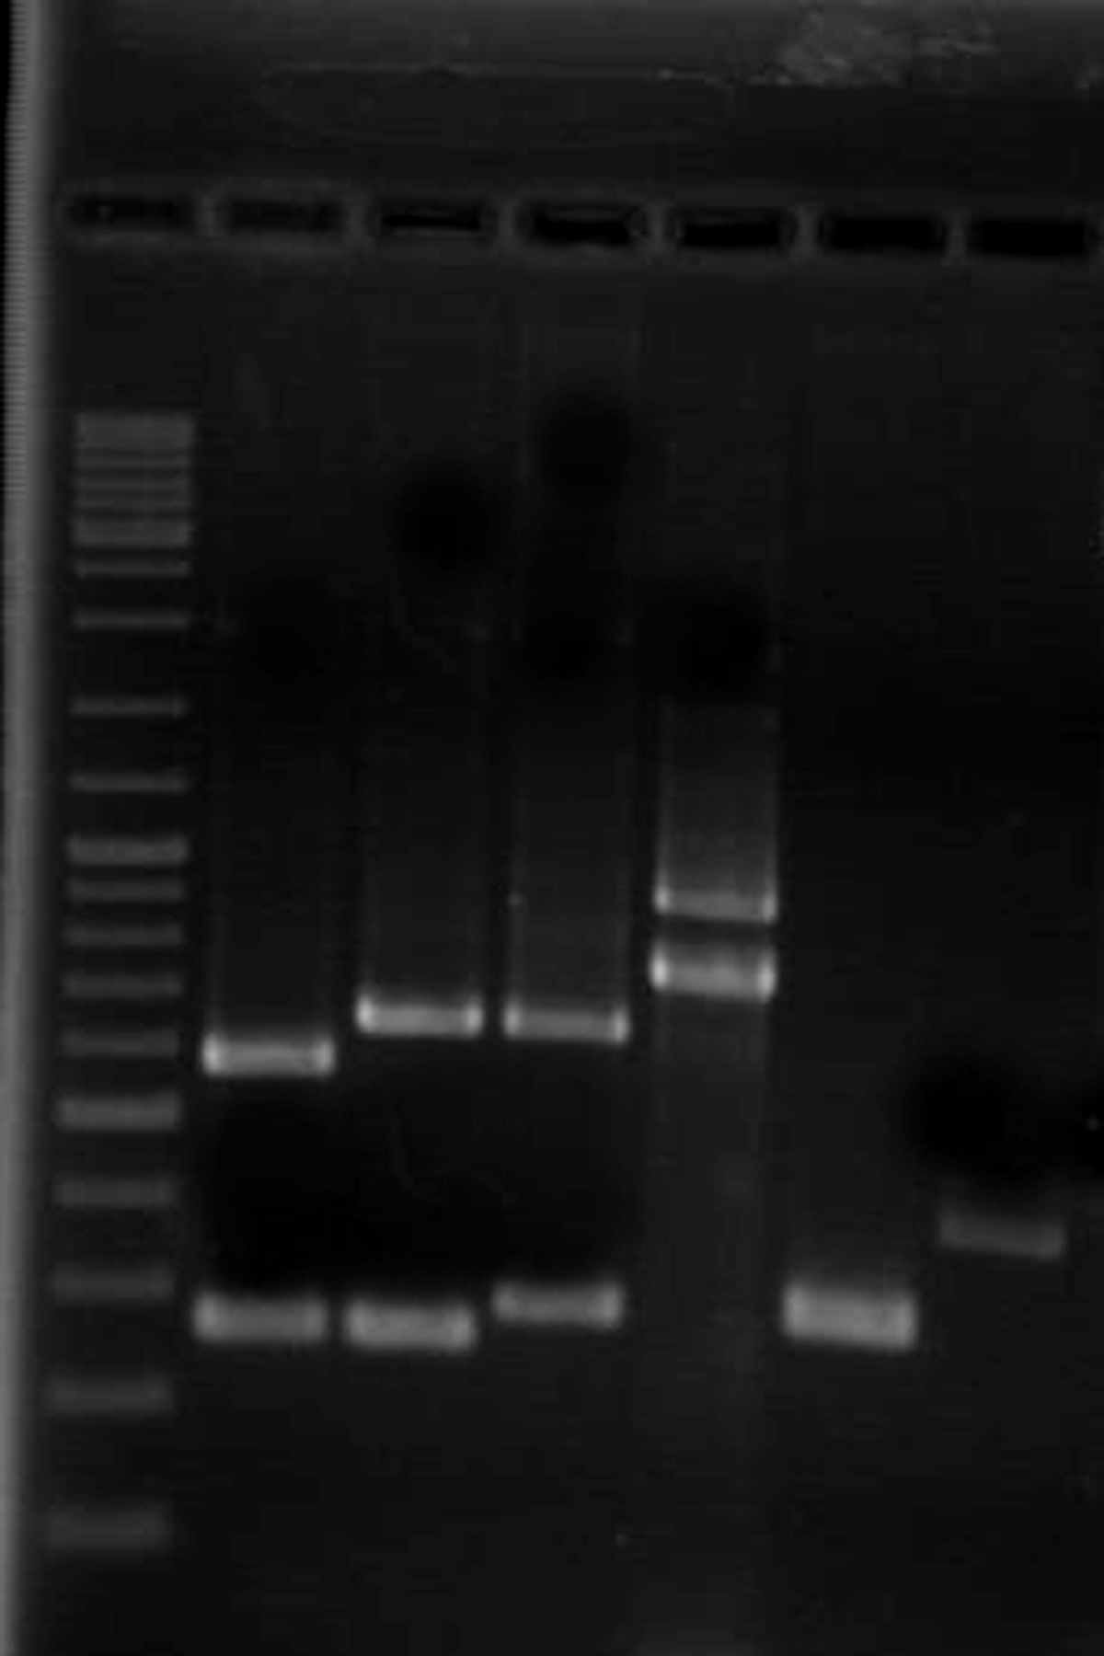
300bp
500bp
1000bp
Figure 1 Polymerase chain reaction products of the main putative virulence markers. Lane 1: DNA ladder mix; Lane 2: vacA s₁m₁ genotype; Lane 3: vacA s₁m₂ genotype; Lane 4: vacA s₂m₂ genotype; Lane 5: iceA₁+iceA₂ genotype; Lane 6: babA₂ genotype; Lane 7: cagA genotype

A
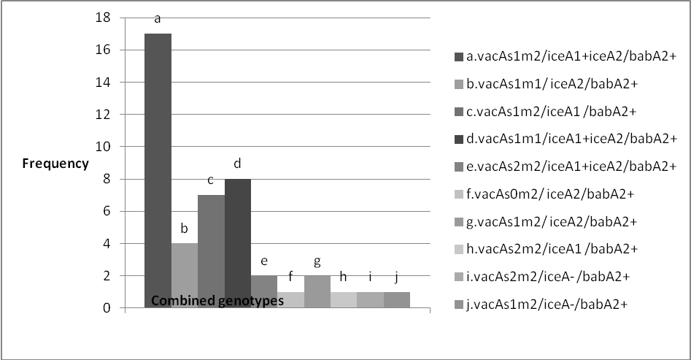
B
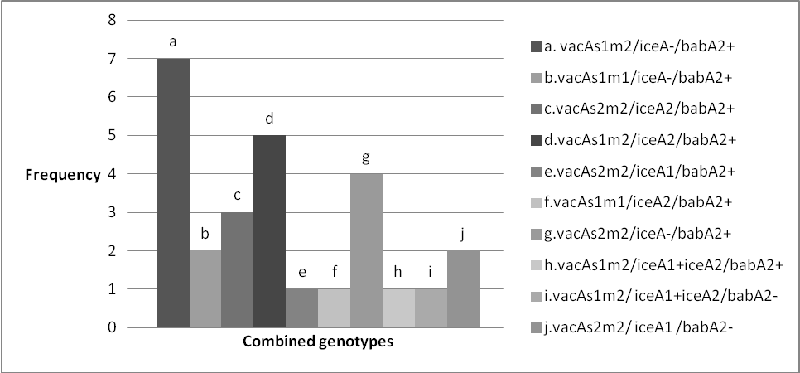

Figure 2 The frequency of combined genotypes. A: Combined vacA, iceA and babA₂ genotypes in 44 cagA positive isolate; B: Combined vacA, iceA and babA₂ genotypes in 27 cagA negative isolates.

